TRADE OF PAINTING & DECORATING

PHASE 2

Module 1
Recoating Surfaces and Sign work

UNIT: 1

Induction/ Health and Safety

Table of Contents
Introduction 1
Learning Outcomes 1
1.0 Safety, Health and Welfare at Work 2
1.1 The Health and Safety Authority 2
1.2 General Policy Statement 3
1.3 Safety Statement 4
2.0 Attendance, Safety and Fire Drill Procedures 6
2.1 Attendance and Timekeeping 6
2.2 Accident Prevention and Reporting 6
2.3 Handling Materials 7
2.4 Eye Protection 9
2.5 Hearing Protection 9
2.6 Breathing Apparatus 9
2.7 Hand tools 9
2.8 First Aid 10
3.0 Unsafe Acts 11
3.1 Causes of Accidents 11
3.2 Reporting of Accidents 14
4.0 Associated Hazards 15
4.1 Working with hazardous substances 15
4.2 Personal protection for skin care 17
4.3 Protective clothing, breathing equipment, eye protection 19
4.4 Using and storing knives and scalpels 22
4.3 Working from ladders, trestles and scaffolding 22
5.0 Identify Fire Extinguishers Suitable for Various Types of Fires. 24
5.1 Smoking –Fire Precautions and procedures 24
5.2 Types of Fire Extinguisher 24
5.3 Electrical Safety 27
6.0 Summary 28
Self Test 28
Training Resources 28
Suggested Exercises 28
Further Reading 28

Introduction
Welcome to this section of your course, which is designed to introduce you, the learner, to the Health and Safety aspects of operating in the Training Centre and the workplace.
Module 1
Recoating Surfaces and Sign Work
Unit 1
Induction/ Health & Safety

Unit 2
Manual Handling

Unit 3
Painting Previously Painted Surfaces

Unit 4
Sign Work
Unit 5
Stenciling

Learning Outcomes
By the end of this unit each apprentice will be able to:
- State the attendance, safety and fire drill procedures for the Training Centre
- Identify hazards associated with various types of Painting and Decorating operations
- Identify fire extinguishers suitable for various types of fires
The information contained in this unit will help you complete your training in a safe and efficient manner. Should you be presented with a hazardous situation you will have the knowledge necessary to avoid injury to yourself or others.

1.0 Safety, Health and Welfare at Work
The primary focus of the Safety, Health and Welfare at Work Act is on the prevention of injuries and deaths in the workplace. The 1989 act was amended in 2005.

1.1 The Health and Safety Authority
The Health and Safety Authority is a state body, which has overall responsibility for the administration and enforcement of health and safety at work in Ireland. It monitors compliance with health and safety legislation at the workplace and can take a wide range of enforcement action, including prosecutions.
It is the national centre for information and advice to employers, employees and self-employed on all aspects of workplace health and safety. The Health and Safety Authority also promotes education, training and research in the field.
The Health and Safety Authority provides the following services to employers, employees and the public:
- Promote good standards of health and safety at work
- Inspect all places of work and monitor compliance with health and safety laws
- Investigate certain serious accidents, causes of ill health and complaints
- Carry out and sponsor research on health and safety at work
- Publish codes of practice, guidance and information
Provide an information service during office hours
Develop new laws and standards on health and safety at work

1.2 General Policy Statement
The objectives of SOLAS:
- To do all that is reasonably practicable to prevent personal injury and damage to property.
- To protect employees and others from foreseeable work hazards.
- To enlist the active support of employees in achieving such conditions.
- To promote standards of health, safety and welfare that complies with the provisions and requirements of current health, safety and welfare legislation and all other statutory provisions and codes of practice.
- To promote and maintain a safe and healthy working environment, safe systems and methods of work and to protect employees and others, in so far as they come into contact with foreseeable work hazards.
- To provide all employees with the information, training and supervision that they need to work safely and efficiently and to develop safety awareness among employees.
- To define all individuals’ responsibility for health and safety matters.
- To encourage full and effective joint consultation on all health and safety matters.
- The Safety Statement identifies the various hazards and sets out the necessary arrangements to reduce risks to a minimum.

1.3 Safety Statement
The Safety Statement is a document, which states how we manage our safety in the Training Centre. The Safety Officer holds the master copy. The Centre Manager and Assistant Managers hold control copies.
All areas and equipment have been assessed for hazards and control measures have been put in place.
The list of documents, which form the Safety Statement, is as follows:
- The Safety Declaration setting out overall policy.
- The Allocation of Responsibility Statements for safety in each appropriate area of the Organisation.
- Procedural documents covering consultation processes and the appointment and functions of Safety Representatives.
- Safety auditing guidelines.
- Methodology statement on the identification of hazards.
- Detailed hazard identification and risk reduction statements for each area of the Organisation.
Any interested parties may view the Safety Statement.
The Policy Statement forms part of the Safety Statement.
The Policy Statement is made by SOLAS in order to state clearly its policy on safety.
The objective is to provide a safe and healthy work environment for all staff, trainees and apprentices.
Where possible SOLAS will attempt to reduce and eliminate any risk or hazard, which exists.
The training cenre will also maintain all safety equipment and provide training on its use.
Under the Safety and Welfare Act 1989 all staff, trainees and apprentices have a duty to co-operate with the policy. Therefore you must:
- Take reasonable care for your own safety
- Use the personal protective equipment required
- Report any defective equipment
- Not intentionally interfere with or misuse any equipment
Please study the hazard sheets located in your area.
Safety is everyone’s concern, if you notice any item in an unsafe state or anyone engaged in unsafe behaviour please inform your Instructor.

2.0 Attendance, Safety and Fire Drill Procedures

Key Learning Points
- Training Centre Layout
- Evacuation assembly points
- Attendance and timekeeping
- Accident reporting
- Conditions of employment responsibilities and rights of apprentices
Training Centre Layout
Check with Instructor
Evacuation Assembly Points
Check with Instructor

2.1 Attendance and Timekeeping
Check with Instructor

2.2 Accident Prevention and Reporting
Tidiness is the foundation of accident prevention. Keep your workplace tidy and, if you see anything in an obviously unsafe place, remove it or report it. There are proper places for rubbish and waste. Dumping things carelessly may lead to a fire or an accident. Tidy up as you go along and remember that the job isn’t finished until you’ve cleared up. A cleaning roster should be in place to ensure that overall tidiness is maintained.

2.3 Handling Materials
Careless handling of materials is a prime cause of accidents. Look out for sharp edges, splinters and nails. Pull out or knock down projecting nails before you pass material on or throw it out for scrap. Don’t try to carry a load that you can’t see over. Containers should be treated with caution, as many liquids are flammable, corrosive or poisonous. Even if empty, assume that they are dangerous unless you are sure that the liquid they contained was harmless. Get help when lifting unduly awkward or heavy objects. Watch your step as you walk about. Watch for traffic and people working overhead. Spilt liquids such as oil causes slips and falls. Wipe them up. Pick up anything that is left lying around. Short cuts are dangerous. Go the safe way even if it means going the longer way. Use the gangways and walkways provided. When passing a place where chips or dust fly about, turn your head away. If possible keep clear of dangerous areas.

2.3.1 Falls
Stack materials so that they are stable and safe. Put tools and other equipment where they cannot fall or be knocked onto someone below. Use a suitable ladder for access. Examine ladders and planks before you use them. Do not stand under suspended loads.

2.3.2 Machinery
Operate and clean machines according to the instructions. Never take short cuts. Check that guards are in place before operating a machine. Disconnect the power supply from the machine before dismantling for cleaning. Handle all cutting tools with extreme care. Ensure that the floor on which you stand is free from grease and is dry. All spillages should be cleaned as they occur. Concentrate on the job and do not be distracted by other activities.

2.3.4 Compressed Air
Compressed air can injure or kill without warning. It can easily damage sensitive organs such as eyes, ears or internal organs. Death can occur if air is forced through the skin into the blood stream.

2.3.5 Fires
Fire-fighting equipment is for use in emergencies. Keep it clear of obstructions so that it can be accessed quickly when required. This also applies to fire doors and exits. Do not wait until there is a fire to find out where these things are and how to use them. Find out now.

2.3.6 Clothing
If the painter is working with or in proximity to machinery, care must be taken in regard to the following. Loose clothing such as ties, open coats, flapping cuffs, bows and scarves are always dangerous when working and particularly near machinery. Smooth shafts, despite their innocent appearance, are dangerous. Avoid loose clothing because the material probably won’t tear if it catches, but will take you into the machine or around the shaft. Wear a neat fitting set of overalls.
Understandably, hands are more prone to injury than any other parts of the body. They are used to handle an endless variety of materials, some quite safe, others dangerous. Protection for the hands is available in many forms and for many purposes.
What is suitable for handling sheet metal will probably be quite unsuitable for working with chemicals. So make sure you use the right type of protection for the job. One important point you should remember is that it is highly dangerous to wear gloves when working with machinery, particularly where there is a risk of the gloves being caught up in moving parts.
Wear good safety boots or shoes at work and keep them in good repair. It pays in the long run because you will get less tired, as well as being less liable to foot injuries and falls.
Loose hair can easily get caught up in moving machinery Apart from the injury and pain, if the hair roots are damaged your hair will never grow again. Always wear your safety hair cap; you will not only be protecting your scalp but it will keep your hair clean too.
The head contains the nerve centre, which controls the body. Damage to that centre can wreck your whole life. That is why it is important to wear a safety helmet whenever there is a risk of your head being injured.
A helmet is absolutely essential on construction sites and its use in many other industries is highly desirable.

2.4 Eye Protection
If some foreign body gets into your eye, you should have it attended to immediately. Your workmate may be willing, and able to get it out, but your eyes are too valuable to trust to any unskilled person. You know how uncomfortable and painful it can be to get a bit of windblown dust in your eye. A bit of metal or stone, a splash of chemical, sparks from grinding wheel or slag from a weld may result in anything from seriously impaired vision to total blindness. The use of a pair of safety glasses or similar protection will prevent this happening. Get into the habit of using eye protection always. Remember, you can get a new pair of safety glasses but you are on your only pair of eyes

2.5 Hearing Protection
Loud noise can damage your hearing. When noise levels are high you must wear ear protectors. If you do not, you will suffer hearing loss and may have to wear a hearing aid later in life. Machines with high noise levels include woodworking machinery, heavy metal guillotines, angle grinders and percussion drills.
You must wear hearing protection while working in an area where they are in operation. If in doubt about noise levels ask your instructor.

2.6 Breathing Apparatus
Some processes produce dust or fumes. These may be harmful or may only be a nuisance. If you work where dust or fumes are produced, dangerous or otherwise, you must wear suitable masks or breathing apparatus to protect your lungs. The type of equipment required will depend on the type of dust or fumes present.

2.7 Hand tools
Keep hand tools in good order Chisels with burred or mushroomed heads, screwdrivers and so on with handles that are damaged, may lead to injury. Misuse of tools also leads to injury. Carrying tools in a safe manner will protect yourself and others. Cutting knives, scissors, scrapers and filling knives all have sharp edges and should be carried with edges protected.

2.8 First Aid
If you are not quite up to the mark, your attention is relaxed and that’s just when an accident happens. Your attention is needed at all times in the training centre or while at work. If you feel unwell, you should report to your instructor. The smallest pinprick can lead to blood poisoning. Get first-aid treatment for all injuries, however slight. Leave any dressing alone after it has been put on. Tampering with it may infect the wound with germs.
If anyone is badly hurt, send for a member of the First-Aid team before moving him / her. Moving an injured person, without the necessary knowledge, may cause further injury.
Injuries are caused by accident.
Accidents are unplanned happenings
Unplanned happenings are initiated by unsafe actions
Unsafe actions are often contributed to by a person’s attitude
In some cases the cause is mechanical or structural failure.
All persons must be aware of the need for a responsible attitude towards accident prevention, which will avoid unsafe actions taking place. Horseplay is strictly forbidden and will lead to dismissal.
In order to be aware of specific hazards in any section, you must read the document on Hazard Identification before you start work.
You must leave a work area in such a way that no one else can get hurt.
Trying to do someone else’s job without authority is wrong and dangerous. There may be risks you cannot foresee.
If someone distracts you, an accident may occur. Think, before you distract anyone else.
Practical jokes and larking about are not safe activities under Training Centre or work conditions. They are liable to have a tragic ending.

3.0 Unsafe Acts

3.1 Causes of Accidents
- Boredom
- Carelessness
- Familiarity with the job
- Frustration and irritability
- Haste
- Horseplay
- Lack of concentration
- Lack of knowledge
- Thoughtlessness

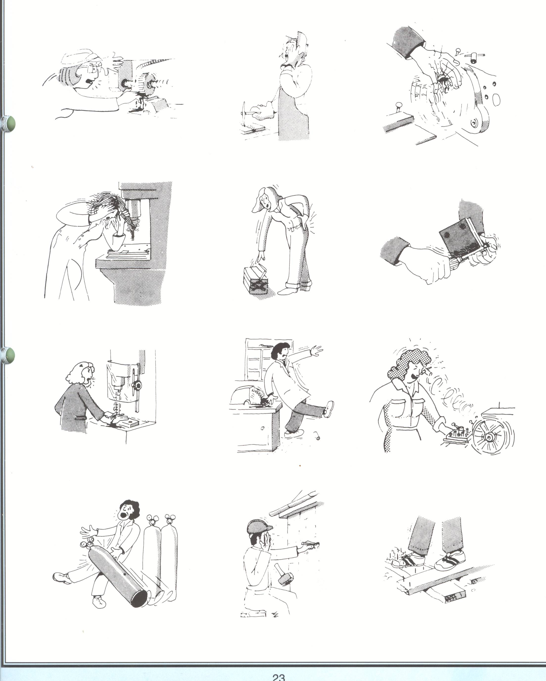

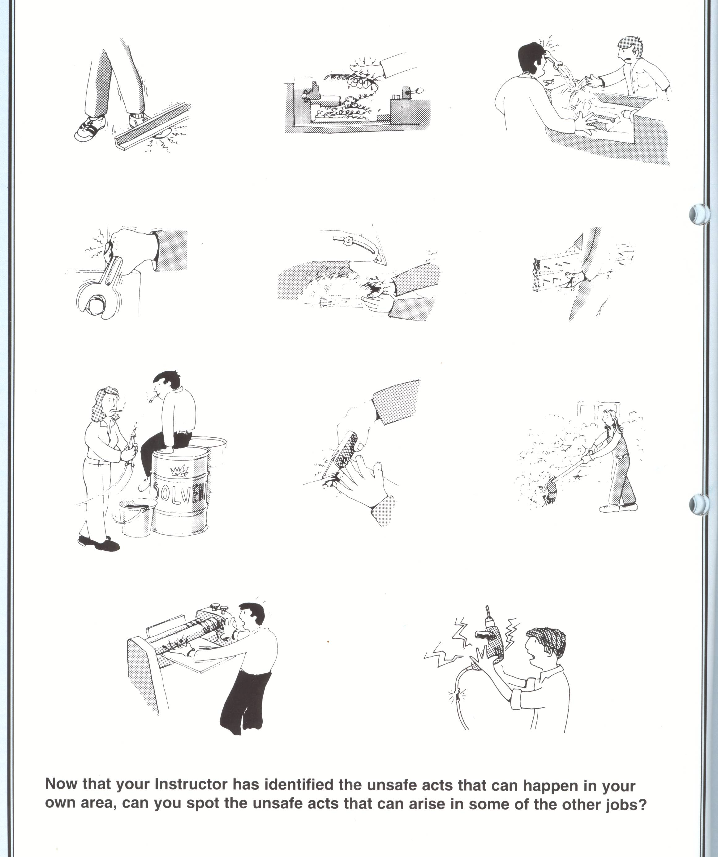

3.2 Reporting of Accidents
All accidents at must be notified to your instructor, who will deal with the situation depending on the extent of the injury involved.
In the event of any accident:
Report it to your instructor who will decide the course of action to be taken.
Category 1 First Aid will be administered on site.
Category 2 First Aid will be administered on site and patient will then be transported to the nearest Accident and Emergency Department.
Category 3 An ambulance will be called and emergency First Aid will be administered on site.

You will be asked to give details of the accident and how it occurred, all of which will be recorded in the Accident Register.
Depending on the extent of your injuries, your next-of-kin will be notified.

4.0 Associated Hazards
Key Learning Points
- Working with hazardous substances
- Personal protection for skin care
- Protective clothing, breathing equipment, eye protection
- Using and storing knives and scalpels
- Working from ladders, trestles and scaffolding
- Workshop cleaning responsibilities

4.1 Working with hazardous substances
Hazards exist in all workplaces and new hazards can be created in a changing environment. Hazards can be identified as: -
- Poor work design.
- Human behaviour.
- Materials or substances.
- Faulty equipment or machinery.
- Inappropriate management systems and procedures.
The use of systematic approach is essential to identify all possible hazards through anticipation or analysis.
Employees should be consulted to ensure all hazards and risks are identified and control measures are appropriate to reduce the associated risk.
It is generally accepted that there are six classes of hazard: -
Biological Bacteria, Fungi, Parasites.
Chemical Acids, Cleaning agents, Dust, fumes.
Environmental Electromagnetic fields, Dust, Noise, Radiation, Spillages, Vibration.
Behavioural Accident, Bullying, Error, Discrimination, Harassment, Stress.
Physical Cranes, Electricity, Floors, Hoists, Ladders, Lighting, Manual Handling, Pressure Vessels, Stairs, Work Platforms.
Hazard identification and risk control documents must be produced for all of the above hazards.

4.2 Personal protection for skin care
Dermatitis is a disease of the skin that can cause a great deal of suffering and hardship. It usually starts with soreness and redness on parts of the body, which have come into contact with some irritating substance whilst at work. Sometimes a swelling may occur on the affected parts. Blisters may appear and when these break, infection is possible.
Where on the body
The hands and arms are the parts most often affected with industrial dermatitis. Irritation around the eyes, face or neck may produce the first warning sign, if continually exposed to a lot of dust or fumes. It is possible to get dermatitis on any part of the body.
What causes Dermatitis
We all have a natural protective film of oil on our skin. If soaps, detergents, chemicals, or other substances remove this film, the skin can become dry and cracked. Further exposure to environmental irritants then causes redness and inflammation. Hand dermatitis is not contagious.
Hand dermatitis is common. Hand rashes usually result from a combination of sensitive skin and irritation or an allergic reaction from materials touched. People with hand dermatitis often have dermatitis elsewhere, and frequently blood relatives have hand dermatitis.
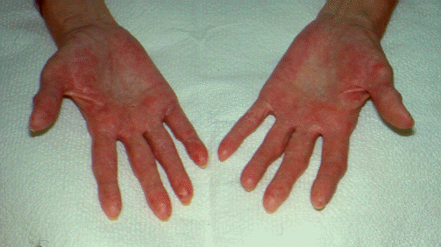
It is caused by contact with many materials in industry. Examples of these materials are : -
- Acids | - Cement
- Chemicals | - Cutting oils
- Diesel oil | - Paraffin
- Solvents | - Tar
- Turpentine
Where certain individuals appear more susceptible to this kind of dermatitis, it is due to other factors that compromise the skin's natural barrier of protection. For example, constant exposure to water can reduce the skin's ability to withstand chemical attack. Cuts and scratches can allow entry of chemicals through the protective outer layers of the skin into the more sensitive layer.
Prevention of Dermatitis
Preventing dermatitis is considerably more preferable than treatment: -
- Avoid exposure to hazardous chemicals.
- Use protective gloves suitable for the operation.
- Broken skin should of course be well protected.
- Rings often worsen dermatitis by trapping irritating materials beneath them.
- Remove your rings while working and before washing your hands.
- Wash thoroughly with special hand cleaning materials for paint, rinse and dry your skin properly.
- Do this at meal breaks and when finished work.
- Apply a barrier cream as extra protection.
- Wear clean clothes.
- Wear overalls to protect your clothes and have them washed regularly.
Prevention of dermatitis is often achieved by the design of safer work practices. Protect your hands for at least four months after they have healed. It takes a long time for skin to recover, and unless you're careful the dermatitis will recur.

4.3 Protective clothing, breathing equipment, eye protection
Study FIGHT FOR SIGHT DVD ROM “A LOT TO LOSE 2 – Prevention of eye injury and loss of sight”
Study CITB Construction Skills DVD ROM “A Brush With Danger” DVD 062
Personal Protective Equipment (PPE) may be defined as “equipment designed to be worn or held by an employee for protection against one or more hazards likely to endanger the employee’s safety and health at work, and any addition or accessory designed to meet this objective”.
It does not include ordinary work clothes and uniforms not specifically designed to protect the safety and health of an employee.
Duties of Employer
- The Safety, Health and Welfare at Work Act states that it is the duty of every employer to provide personal protective equipment for use by his /her employees, where the risks cannot be avoided or sufficiently limited.
- PPE should display the CE approval mark
- PPE should only be used a last line of defence.
- PPE should be appropriate to the risk, without causing any increased risk.
- PPE should fit the wearer correctly after any necessary adjustment.
- Account should be taken of the physical effort required in the use of the PPE, the duration of use, the requirements for visibility and mobility, possible discomfort to the wearer and any potential risks presented by its use.
- All employees must be consulted and involved in the selection of the equipment.
- In circumstances where different items of PPE are worn simultaneously, they must be compatible with each other and continue to be effective against the risks involved.
What is CE marking?
The CE mark is a mandatory European marking for certain product groups to indicate conformity with the essential health and safety requirements set out in European Directives. The letters 'CE' are an abbreviation of Conformité Européenne, French for European conformity. The CE mark must be affixed to a product if it falls under the scope of the approx. 20 so called 'New Approach' Directives. Without the CE marking, and thus without complying with the provisions of the Directives, the product may not be placed in the market or put into service in the fifteen member states of the European Union and Norway, Iceland and Liechtenstein. However, if the product meets the provisions of the applicable European Directives, and the CE mark is affixed to a product, these countries may not prohibit, restrict or impede the placing in the market or putting into service of the product. Thus, CE marking can be regarded as the products trade passport for Europe.
The CE mark is not a quality-mark. First, it refers to the safety rather than to the quality of a product. Second, most quality markings are voluntary opposite to the CE marking, which is mandatory for the products it applies to. CE indicates conformity with mandatory European safety requirements. European conformity is certified by following clear and understandable procedures, the so-called ‘conformity assessment procedures’.
Why CE marking?
The European CE certification procedure has been mainly set up to:
- Harmonize all varying national regulations for consumer and industrial products in European Member States, so that the Single Market is encouraged;
- Bring about cost savings for producers;
- Enhance the safety of products;
- Supply public bodies with a uniform procedure that can be checked.
The steps of the CE marking and CE certification procedure
Before the CE marking may be affixed to a product, the essential requirements of the applicable European Directive must be met. Moreover, the conformity of the product must be proved by following a testing and/or certification procedure. Besides some administrative steps this can mean that a risk analyses must be performed or that the compliance must be tested in a laboratory.
The CE mark is applicable to:
medical devices, machinery, industrial installations, toys, electrical equipment, electronics, domestic appliances, pressure equipment, personal protective equipment, recreational craft, refrigerators, measuring equipment etc.
The CE marking does not apply to:
cosmetics, chemicals, pharmaceuticals, foodstuffs.
Duty of the Employee
Employees are obliged to wear the PPE they have been provided with.
No person shall intentionally or recklessly interfere with or misuse any appliance, protective clothing or other equipment provided in the workplace for health and safety purposes.
Maintenance of PPE
PPE shall be maintained in good working order and in a satisfactory hygienic condition, by means of a programme of storage, maintenance, repair or replacement.
Personal Issue
All PPE is as far as possible for the specific use of one employee only. Where for other reasons the use of shared PPE is necessary, appropriate measures must be taken to ensure that this does not create a health or hygiene problem for the users.
Information
In providing PPE, employers shall ensure that employees are: -
- Informed of the risk(s) the PPE is protecting against.
- Given information on the PPE itself.
- Instructed in its use.
- Appropriately trained in its prescribed use, maintenance, etc.

- Signage will be in place in each work area, where PPE must be worn.
- Failure to wear the appropriate PPE will result in disciplinary action.

Defects / Faults in PPE
All employees must notify their supervisor of any faults / defects with their PPE, so that it can be repaired / replaced.

4.4 Using and storing knives and scalpels
Keep hand tools in good order Chisels with burred or mushroomed heads, screwdrivers and so on with handles that are damaged, may lead to injury. Misuse of tools also leads to injury. Carrying tools in a safe manner will protect yourself and others. Cutting knives, scissors, scrapers and filling knives all have sharp edges and should be carried with edges protected.

4.3 Working from ladders, trestles and scaffolding
Ref. Unit 3 Section 1.2
Read Health and Safety Authority “Guide to the Safety Health and Welfare at Work (Work at Height) Regulations 2006”
Study CITB Construction Skills DVD ROM “Alright at Height?” DVD 060
Workshop cleaning responsibilities
Painting workshops can be a fire or health hazard if not managed safely. They should be kept clean and tidy at all times so that dangerous situations cannot arise. Metal ash bins (not plastic) with covers should be used to keep waste materials contained so that the risk of fire is minimised and when full This is the responsibility of everyone using the workshop and when full bins must be emptied Floors must be kept free of items that could cause someone to trip.
Spillages must be cleaned up and special materials are available to do this. They can be stored in the workshop so that the spillage can be attended to Thinners used for adjusting the paint and brush washing should be kept to minimum and removed to a safe storage area each evening.
Good ventilation is essential in a painting workshop as it helps to remove fumes and assist the drying of the paints.
Cloths
A clean cloth is an essential part of a painters equipment and should be in his/her possession at all times. Old cloths that have been used form wiping during should be dumped immediately after use as they ignite due to spontaneous combustion. Never leave them lying around during lunch breaks or when leaving work at the end of the day. Immerse in a bucket of water if a metal bin is unavailable.
Metal fireproof cabinets should be used to store combustible materials.

5.0 Identify Fire Extinguishers Suitable for Various Types of Fires.

Key Learning Points
- Smoking –Fire Precautions and procedures
- Electrical Safety

5.1 Smoking –Fire Precautions and procedures
Smoking is not allowed in any workshop or within the Training Centre building. Designated smoking shelters are provided and must be used Smoking in areas other than those designated can be hazardous and can be the cause of fire. There are individual fire extinguishers in certain workshops etc. They will be pointed out to those operating in the areas involved.

5.2 Types of Fire Extinguisher
There are four types of fire extinguisher in common use. Each one extinguishes specific classes of fire. Newer fire extinguishers use a picture / labelling system to designate which class of fire they are to be used on. Older fire extinguishers are labelled with coloured geometrical shapes with letter designations. The letter designations may be included in the new picture / labelling system as shown below.
The main types of extinguisher that you will come across are,
- Water ( Red )
- CO2 ( Black )
- Dry Powder ( Blue )
- Foam ( Cream )
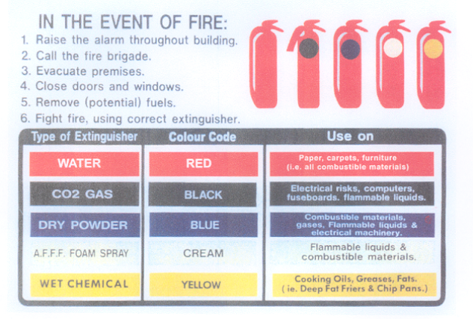
These have been colour coded so that you can identify them quickly and you do not use the wrong extinguisher and put yourself in danger. The main body colour of the extinguisher is red. The identifying colour is either in the form of a coloured band or the writing may be in the specific colour.
Under no circumstances should Fire Extinguishers be tampered with, as these pieces of equipment need to be in good working condition at all times and ready for emergency use.

Classes of Fire
There are five classes of fire. Here we will look at the three more common ones.
Class A

Fires involving solid materials, mainly of organic origin, which normally burn under production of embers, e.g. wood, paper, straw, textiles, coal, car tyres.

Use: Water, Foam or Powder.

Class B

Fires caused by combustion of liquids or materials that liquefy, e.g. petrol, benzene, oils, paints, tar, ether, alcohol, paraffin.

Use: Foam, Powder or CO2

Class C

Fires caused by combustion of gases e.g. methane, propane, hydrogen, acetylene, natural gas, and city gas

Use: Powder, only if the fire has just started and the gas supply can definitely be shut of. Otherwise let it burn out. Get out in case of explosion.
Electrical fires
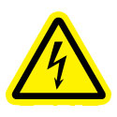
Fires in electrical equipment are considered to be Class B. Use a Carbon Dioxide Extinguisher for electrical fires. CO2 is ideal, as it is non conductive and harmless to electrical equipment. It smothers flames by denying air to the fire.
How to Use a Fire Extinguisher
Even though extinguishers come in a number of shapes and sizes, they all operate in a similar manner.
Here's an easy acronym for fire extinguisher use.
P A S S - Pull, Aim, Squeeze, and Sweep
Pull the pin at the top of the extinguisher that keeps the handle from being accidentally pressed
Aim the nozzle toward the base of the fire.
Squeeze the handle to discharge the extinguisher, while standing approximately 8 feet away from the fire. If you release the handle, the discharge will stop.
Sweep the nozzle back and forth at the base of the fire. After the fire appears to be out, watch it carefully since it may re-ignite!
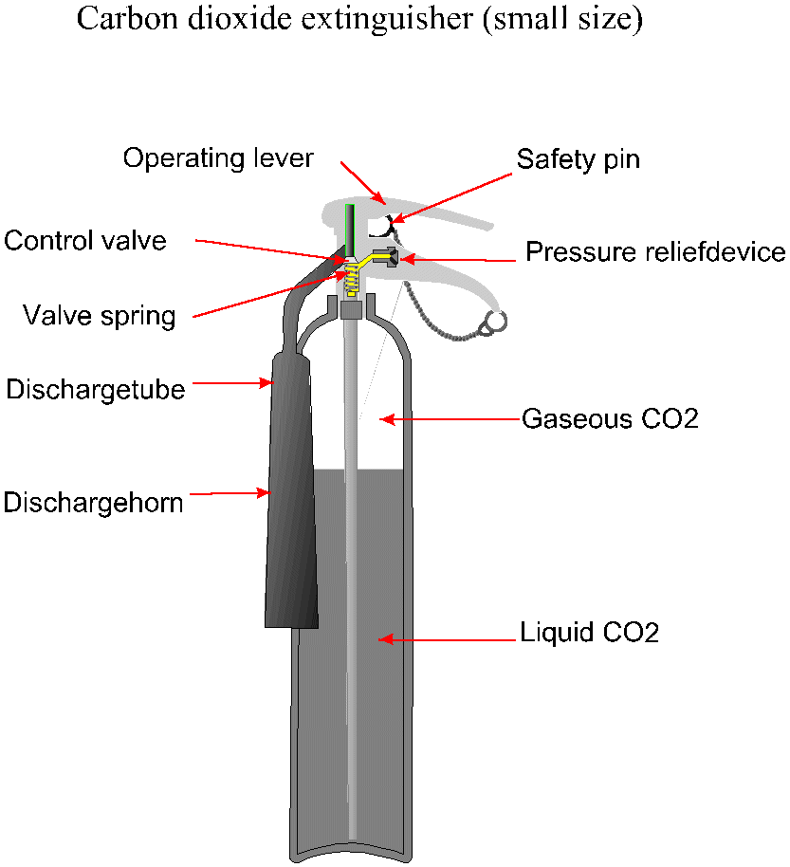

5.3 Electrical Safety
Electricity can injure or kill without warning. If using a portable power tool, for example a needle gun or a sander, always check the following: -
- Is the plug undamaged clean and dry?
- Is it 110 Volt (look at the information plate on the tool).
- Is the lead sound and undamaged with no cuts or makeshift repairs

6.0 Summary
Health and safety is a very important part of our working lives. It is there for our safety, and knowledge and observation of these regulations is vitally important. These regulations are regularly updated by the EU and by Government and a visit to the Health and Safety website is a way of keeping abreast of changes
The working environment can be a place of hazard and danger, and an awareness of Health and safety is vital. Becoming safety conscious is a form of personal development that is critically important and potentially life saving.

Self Test
- What does PPE mean.?
- What is Dermatitis?
- What precautions should you take to prevent Dermatitis?
- What is the recommended fire extinguisher to be used on fires caused by combustion e.g. petrol, paints, alcohol, paraffin?

Training Resources
Induction Manual, safety videos, TV monitor, selection of fire extinguishers and fire blankets, course manual, toolkit, information sheets, paper and pens

Suggested Exercises
1. State procedures in the event of a fire
2. Identify various types of fire extinguishers

Further Reading
Health and safety literature.
Health and safety websites


27-33 Upper Baggot Street
Dublin 4

