TRADE OF PAINTING & DECORATING

PHASE 2

Module 2
Surface Preparation

UNIT: 3

Gloss Paint Systems

Table of Contents
Introduction 1
Learning Outcomes 1
1.0 High Gloss Finish using Solvent Based Paints 2
1.1 Hazards Associated with use and disposal of Solvents 2
1.2 Satisfying Absorbency of Fillers 2
1.3 Characteristics & function of undercoat and gloss Paint 2
1.4 Effects of White Spirit in Paints 5
1.5 Function of 50/50s in oil based paints 5
1.6 Sequence, Application & Brushes for Oil Based Paints 5
2.0 High Gloss Finish Using Water Based Paints 7
2.1 Water based paints 7
3.0 High Gloss Finish on Previously Painted wood surfaces 8
3.1 Advantages of wet abrasion 8
4.0 Sequence for Painting A Panelled Door 9
4.1 Correct sequence when painting flush and panelled door 9
4.2 Cleaning and Storing Brushes. 11
4.3 Safe and Clean Working Practice 11
4.4 Importance of Team Working 12
Summary 13
Suggested Exercises 13
Questions 13
Suggested reading 14
Training Resources 14

Introduction
The production of a high class piece of work is a process that involves good quality preparation, filling undercoating etc, and the final step in this is the skilled application of gloss paint in order to bring the work to an attractive lustre which is not alone aesthetically attractive but is functional and durable thereby offering maximum protection to the substrate.
Module 2
Surface Preparation
Unit 1
Paint Removal

Unit 2
Knotting, Priming and Flush Filling Woodwork

Unit 3
Gloss Paint Systems

Learning Outcomes
By the end of this unit each apprentice will be able to:
- Bring a primed and filled panel to a high gloss finish using solvent based paints
- Bring a primed and filled panel to a high gloss finish using water based paints
- Bring previously painted door, skirting and architrave to a high gloss finish
- State the correct sequence for painting a paneled door

1.0 High Gloss Finish using Solvent Based Paints
Key Learning Points
- Hazards associated with use and disposal of solvents
- Satisfying absorbency of fillers
- Characteristics and functions of undercoats and gloss paints
- Effects of white spirit in paints
- Function of 50/50s in oil based paints
- Sequence, application and brushes required for water based paints

1.1 Hazards Associated with use and disposal of Solvents
Reference Module 1 Unit 3.1

1.2 Satisfying Absorbency of Fillers
Undercoatings are heavy bodied paints with little or no flow. They should not be applied thickly as brushing will be difficult and brush marks which will show through spoiling the finish. Brush marks will be highlighted after the application of the gloss finish. Adjusted by the addition of white spirit and linseed oil to increase its flow and slow its setting up time to accommodate even application and laying off. This will help to keep wet edges alive so that proper brushing can be carried out. Additives are available for this purpose and are very successful addition to the painter’s material list.

1.3 Characteristics & function of undercoat and gloss Paint
Reference Module 1 Unit 3.1.6 & Module 2 Unit 2 1.4
Undercoating: (oil based)
The coating applied to a surface after priming & filling or, in the case of previously painted work, after the preparation. Oil based undercoating is a highly pigmented (titanium white plus extenders) with low film former content. Its film former is alkyd resin and drying oils. It has very good opacity because of its high pigment low film former content.
Function:
- To provide build to the paint film.
- To provide the most suitable ground for the reception of finishing coats.
- Introduces colour to the paint system.
- High opacity

Has excellent adhesion. A non reversible coating. Touch dry 2-4 hrs. Recoat able 6-16 hours (depending on temp. & drying conditions). Suitable for internal & external use. Application by brush roller or spray.
Acrylic primer/undercoat:
A quick drying paint for interior or exterior use on raw timber plaster, concrete, building boards. Film former Acrylic latex. Colour white. Thinner/brush wash water. Application by brush, roller or spray. Good opacity and adhesion. Alkali resistant. Drying method coalescence. Drying time 30 to 40 mins. and is re-coatable when touch dry. This will depend on the temperatures when applying. Nail heads and hinges etc. must be painted with a rust inhibiting primer before applying the acrylic primer undercoat. Do not apply under wet or frosty conditions.
Alkyd gloss paint:
Gloss finish (oil based).The final coating in the paint system applied over a well prepared and dry undercoat. A very tough flexible coating. Drying method is oxidation. A non reversible coating. It has good weather resistance. It can be applied over interior & exterior prepared wood, plaster & metal surfaces. It has a high film former low pigment ratio.
Thinner turps or white spirit. Suitable for hot water radiators. Drying time Touch dry- 4-6 hrs. Recoating time 16-24 hrs. an be applied by brush, roller or spray.
Acrylic gloss
Acrylic gloss paint is a hard wearing finish. It has poor flow and gloss properties compared to oil paint. It dry’s quickly, has low odour and can be re-coated in 2 hours. Brush wash is water. It will withstand frequent washing, and is non reversible It does not yellow like solvent based paints. The great benefit of acrylics is that the complete system can be applied the same day.

Types of paint coating.
Convertible coating (non reversible film)
A coating when drying, and changing from a liquid to a solid state goes through a complete chemical change. It cannot be brought back to its original state by the use of its thinners.
Non convertible coating (reversible film)
Some coatings are formed by dissolving a resin in a solvent (shellac in methylated spirit). On application of the coating the solvent evaporates leaving the resin in its original on the surface. No chemical change has taken place. The coating can be reversed to the liquid state by the application of the solvent

Painting terms
Cissing: When a paint or varnish coating fails to form a continuous film on the surface it has been applied to. The paint gathers in some places and recedes in others.
Flaking: Paint loosing it adhesion on the substrate it has been applied to and peeling away from the surface. It can be caused by trapped moisture, a powdery surface dirty surface poor abrading etc.
Flow: The ability of a coating to level out and spread into a smooth film. Paints that have good flow usually level out uniformly with few brush or roller marks.
Opacity: The covering or hiding power of paint
Viscosity: The fluid thickness of a product. Viscosity is often referred to as consistency. The higher the viscosity, the thicker the fluid. How thick or thin the paint is.
Saponification: When oil paint is applied to an alkaline surface e.g. concrete it is attacked and converted to a soapy substance. The oil paint should be preceded by the use of an alkali resisting primer.

1.4 Effects of White Spirit in Paints
White spirit is a colourless thinner for oil paints that evaporates completely as the paint dries. It’s function is to reduce the viscosity of the paint, thereby making it easier to apply and to assist primers to penetrate wood and other absorbent surfaces such as building boards plaster etc.
While thinning of paint is important, over-thinning can cause reduction of gloss, poor opacity and weakening of the paint system leading to early breakdown especially if used outdoors. It is always important to read the manufacturer’s instructions for the thinning of their product.

1.5 Function of 50/50s in oil based paints
The application of a mixture of 50% undercoating and 50% gloss is sometimes preferred by some painters to assist the flow of undercoats or to first coat over a well rubbed down surface in good condition. It takes the dryness out of the undercoating and gives a nice base after rubbing down for a gloss finish.

1.6 Sequence, Application & Brushes for Oil Based Paints
Reference Unit 3.1.7.
The application of paint by brush even to a small area such as a plain panel must be carried out in a methodical way if a high quality finish is to be achieved. Depending on the size of the panel a 2” or 2½” brush will be suitable.
The paint having been adjusted to the correct viscosity and a good quality worn bristle or synthetic brush selected, the application can commence.
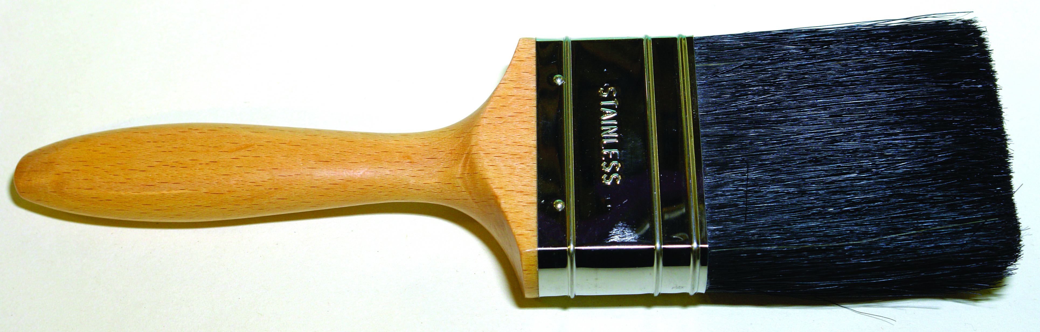
Bristle brush:
Charge the brush well with paint and spread it evenly over an area at one end of the panel. Recharging the brush, begin to apply to the next section and so on until the panel is completed keeping the wet edges alive at all times.
Finish by crossing using some pressure to complete the even spreading of the paint and finally laying off using a light pressure in one direction the length of the panel.

The paint should be applied quickly and evenly before setting up commences. It is important that a full coating of paint is applied so do not brush out the paint too much as a wet coat of 50 microns will dry down to 25 microns.
If the panel is a moulded one then a second brush is required, generally a 1” in order to paint the moulding.
Firstly paint the moulding using the 1” brush. Paint applied to mouldings with a large brush will run as too much paint will have been applied to a small area. Next fill in the panel and then paint the top and bottom rails finishing by painting the two stiles. When a good quality and properly adjusted paint film is applied it offers great durability. If badly applied it is inclined to run, sag, show brush marks and dry patches

2.0 High Gloss Finish Using Water Based Paints
Key Learning Points
- Sequence, application and brushes required for water based paints

2.1 Water based paints
To paint any size surface successfully the selecting the correct size brushes is all important so that work can progress speedily and efficiently. Water based paints dry quickly so the paint must be applied evenly and laid off at a steady pace. Keeping the wet edge ”alive” (workable) is a key element to good finishing so where paint overlaps should not be obvious.
There can be little time for application at times due to the temperature of room being high. Patent additives can be added to the finishing paint to slow the setting up of the paint allowing time for application. They also help the paint to flow reducing the risk of brush marks.
Selecting the correct size brushes is important so that too much or too little paint will be applied. Synthetic brushes are best for the application of acrylic paints as bristles absorbs water causing them to swell distorting the brush. Apply paint to small areas such as mouldings with a 1” fitch to avoid overloading a small area resulting in runs
Good finishing is achieved when the correct film thickness is applied, the paint brushed on evenly crossed and laid off with care.
Applying too much paint will result in runs, brush marks and when dry wrinkling will occur. Applying too little paint will result in misses, dry spots, flashing and lack of gloss or satin of the finish.
Rubbing down with worn abrasives or sanding pads between coats is essential for good adhesion and grit free finish.

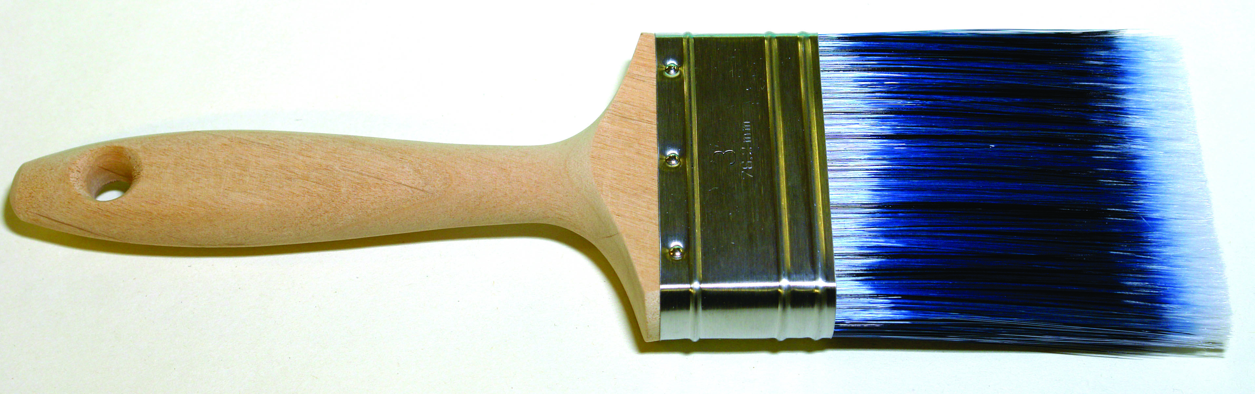
Synthetic filament brush

3.0 High Gloss Finish on Previously Painted wood surfaces

3.1 Advantages of wet abrasion
If flatting down has to be carried to smoothen a poor surface wet abrading with wet or dry abrasive is best. A grade such as 120 or 180 can cut down a surface quickly leaving it smooth and ready for painting. Wet abrading can also be carried out when repainting old gloss painted surfaces to assist adhesion using a finer grade such as 400.
It is a dust free method of abrasion which is of great benefit to the painter. Wet abrading should only be carried out on well hardened coatings.
When preparing previously painted surfaces prior to painting it is important that washing with white spirit is very important on areas around handles hand rails newel posts etc. as these are areas that contain grease from handling and offer poor adhesion if not attended to. Skirtings and architraves should be well rubbed down any surface defects made good and the complete surface undercoated with some gloss paint or additive added to help its flow. When dry a full coat of gloss can be applied.
Denibbing Surfaces Prior to Painting:
New plaster surfaces carry small pieces of plaster on the surface and they must be removed by dry scraping before painting. Previously painted plastered surfaces may be slightly gritty and this can be removed by sanding . This is made easier by using a sanding pole. This activity is known as denibbing.
Previously painted oil paint surfaces can be denibbed by dry or wet sanding.
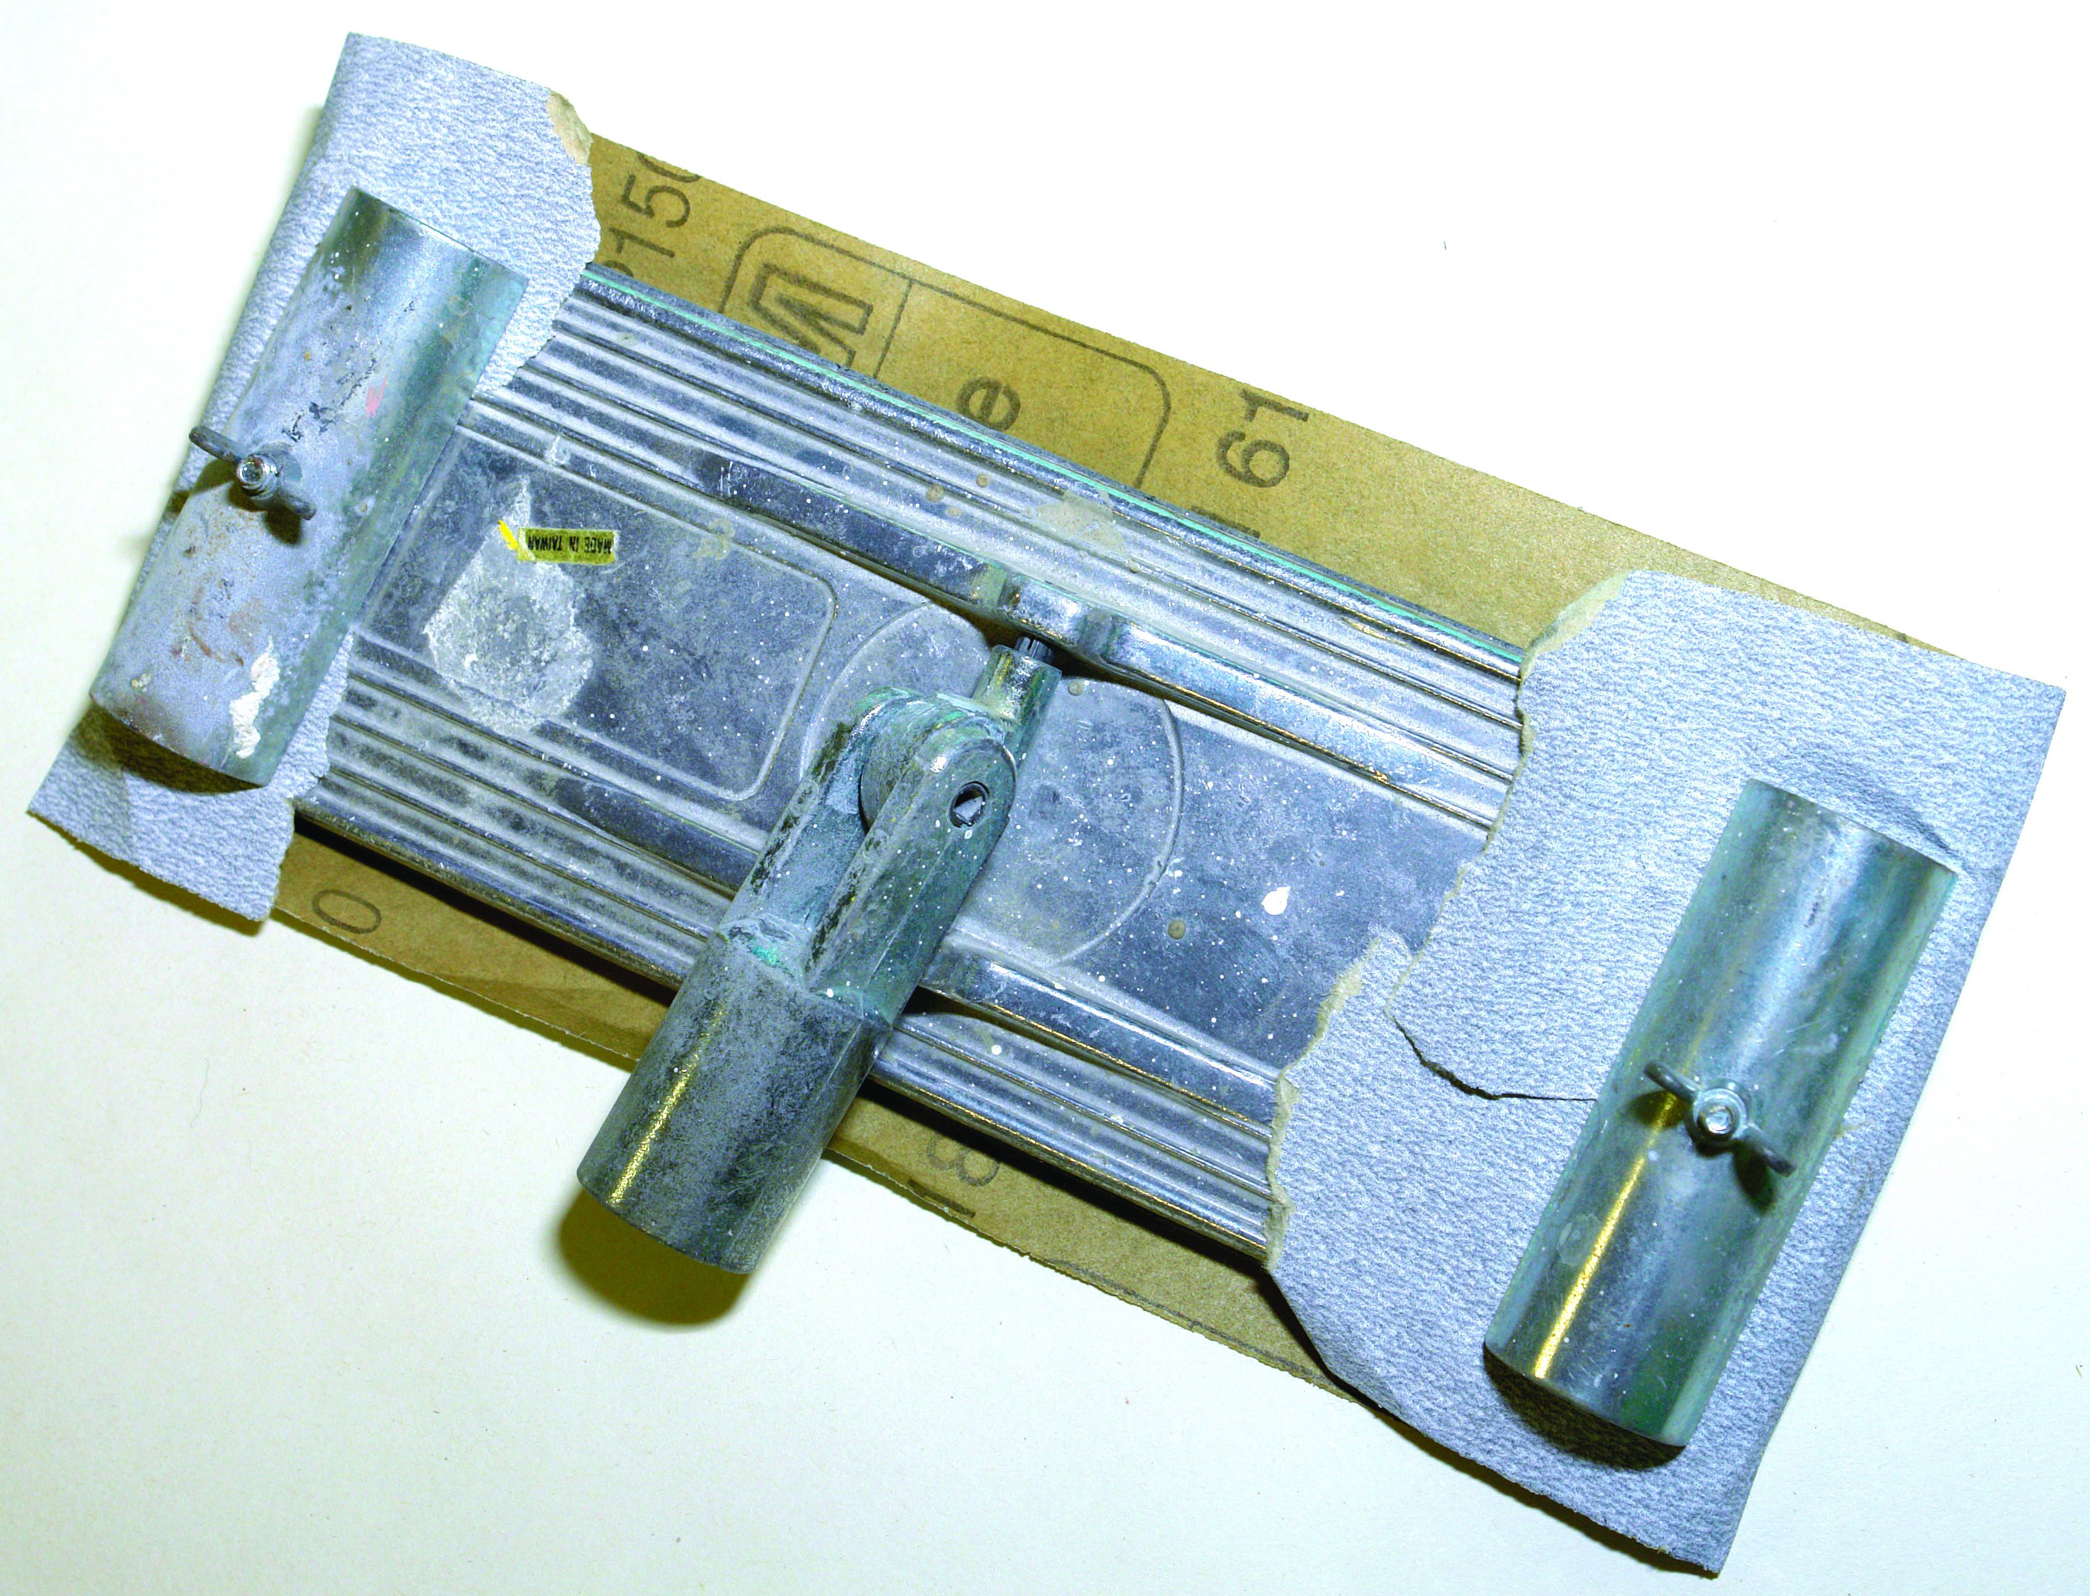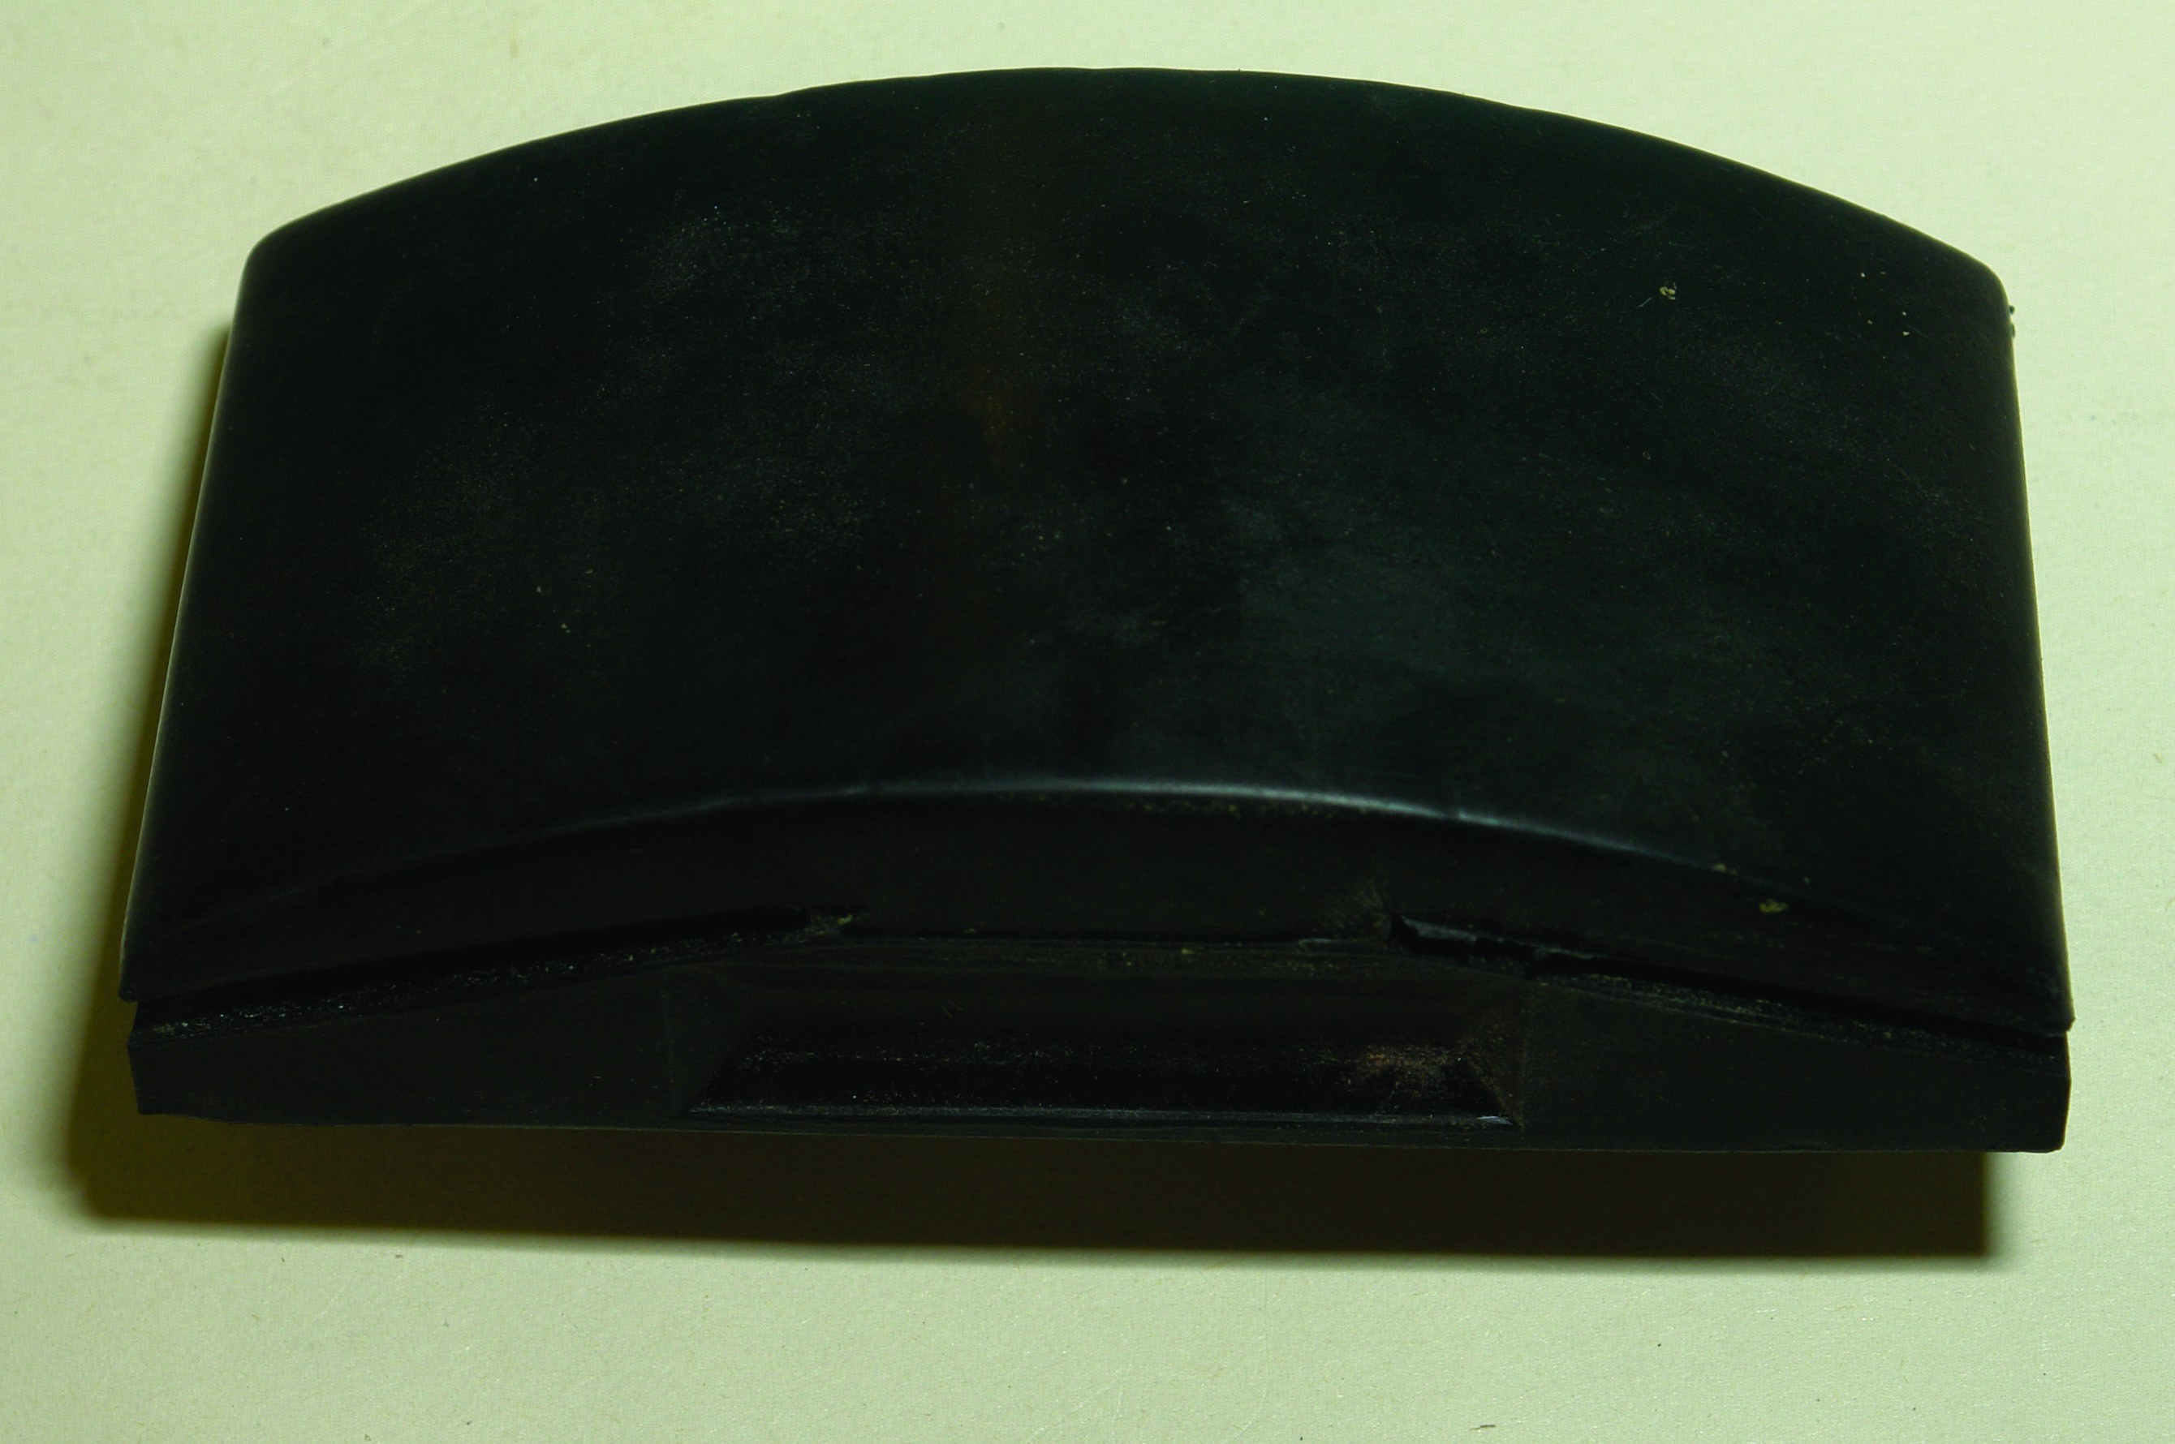
Pole sanding tool Sanding block

4.0 Sequence for Painting A Panelled Door

4.1 Correct sequence when painting flush and panelled door
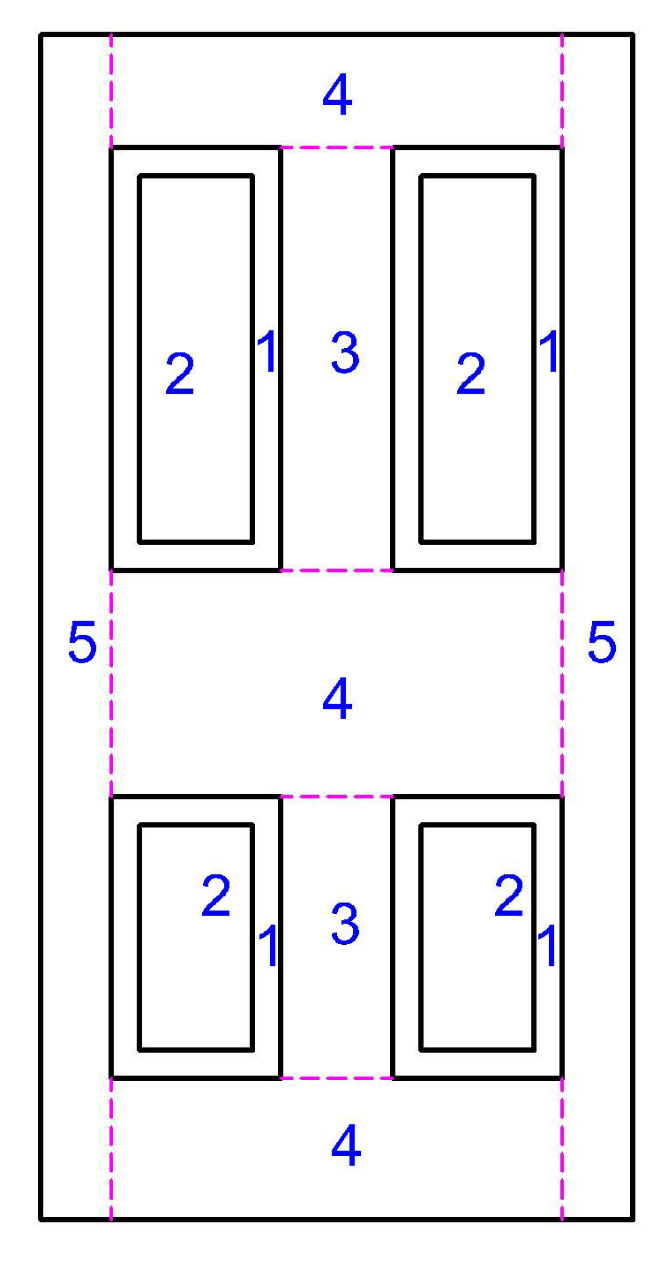
Panelled door
Mouldings 2. Panels 3 Muntins 4. Rails 5 Stiles
Painting doors:
Where possible all door fittings should be removed to enable the painter to paint underneath them and so achieve a clean and satisfactory finish. Cover the floor area under the door and wedge in an open position. The covering has two purposes
- To keep the floor clean.
- To avoid picking up dirt on the brush when painting the bottom rail
When the painting of the door is complete clean and replace the fittings.
Panelled doors:
Begin by painting a panel moulding and then its panel and continue the same procedure with the remaining panels
Next paint the two muntins, followed by the top rail lock rail and bottom rail.
Finally paint the edge and the two stiles. It is important to feather edges as you progress from panel to panel and keep the wet edge alive. Also care when brushing stiles and edges to avoid fatty edges. Avoid having fatty edges on the arises as they stay soft and are unsightly.
Flush panelled Door:
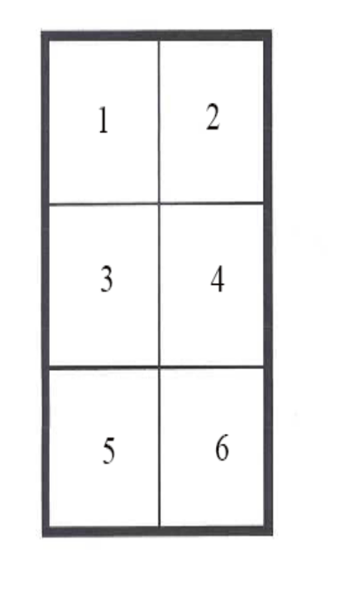
Flush panelled Door
Painting a flush panelled door is more straightforward than painting a panelled one. Divide the door visually into six parts and complete each section fully before moving on to the next one and so on as in above diagram.

4.2 Cleaning and Storing Brushes.
Cleaning and maintaining brushes.
The paint brush is the most important tool in the professional painters tool kit and proper use care and cleaning are very important. Brushes used in oil paint can be kept suspended in a water pot for a short period of time. The excess paint should be knocked out on a flat board before placing them in the water pot. It is better practice to rinse them out in white spirit so that paint does not accumulate around the stock.
Bristle brushes should be washed out in the thinners of the paint being used and the same applies to synthetic filaments. If the synthetic brush has been used in acrylic paint or any water paint wash out in warm water or warm soapy water. A brush comb is a useful tool to use regularly to help clean through the centre of the brush. It also helps with straightening the filling. After washing thoroughly again spin dry by hand or with spinner. Never tap or strike the brush on a hard surface to remove old paint etc. as this action can loosen the setting in the ferrule. Comb through again to help reshape brush, and hang up to dry. Do not store brush standing on its tip as it will distort the shape of the brush.
Brush keeper
They can also be placed in a brush keeper which is designed to hang up the brush on hooks. The large keeper holds a number of brushes but small keepers can accommodate two brushes. A portable metal container fitted with hooks that brushes can be suspended from. They also have as a fixture a bottle and wick. The bottle is filled with a fluid which is transferred on to the wick and the strong fumes of the liquid are circulated in the container.
The fume laden atmosphere keeps the brushes soft without the need to be immersed in water. The keeper must be kept covered at all times for it to be effective. This is a very handy piece of equipment when transporting brushes

4.3 Safe and Clean Working Practice
All work areas should at all times comply with Health and Safety regulations. Wet floors, tools and other equipment lying around, and general untidiness can be a serious safety and/or fire hazard. A sense of order is essential for a clean working environment. Untidy, dirty habits make it very difficult to produce high quality work. A proper system of storage should be in place and used. Another reason the workshop must be kept clean and uncluttered, is that some signboards will be at the preparation stage while others are being finished, and an orderly workplace is the most efficient way of doing this.

4.4 Importance of Team Working
Reference Module 1734
Title: Teamwork, project management and team communication

Summary
To achieve a good finish many elements play a part. Good quality tools and materials are essential as inferior ones can undo all the good preparation. It is essential to maintain a clean and an orderly system of working as this makes for a safer and dust free environment which is necessary for good finishing.
A good example of this is the practice of setting aside a selection of brushes to be used only for the final coat.

Suggested Exercises
- Given a previously painted panelled door, architraves and skirting prepare and bring forward to a oil based gloss finish.
- Given a new plain plywood panel prepare and bring forward to a water based gloss finish.

Questions
Q. 1 Explain the following painting terms.
- Cissing
- Saponification
- Opacity
- Viscosity
Q 2 Explain reversible and non reversible coatings.
Q.3 Why wet abrade?
Q.4 What are the characteristics of oil based undercoating ?

Suggested reading
BS EN 971-1:1996 Glossary of painting and decorating terms
Paint manufacturers websites

Training Resources
Tool kit, panel x 2, undercoating and gloss (oil and water based), abrasive paper,
Paint brushes, white spirit, flush door, paint kettles, panelled door, strainer, classroom and workshop facilities, notes/information sheets


27-33 Upper Baggot Street
Dublin 4

