TRADE OF PAINTING & DECORATING

PHASE 2

Module 4
Wall Coverings

UNIT: 1

Stripping Wall Coverings

Table of Contents
Introduction 1
Learning Outcomes 1
1.0 Hazards using steam/water near electrical points 2
1.1 Electrical safety 2
1.2 Component parts and types of steam strippers 3
1.3 Safety procedures when using steam strippers 4
1.4 Identification of suitable surfaces for steam stripper 4
1.5 Method and sequence of stripping painted papers 5
2.0 Remove wallpaper from surface 6
2.1 Avoiding surface damage 6
2.2 Stripping and preparation for paper 7
2.3 Stripping and preparation for painting 7
2.4 Safe disposal of old wallpaper 7
2.5 Clean and safe working practice 8
2.6 Removal of all old paste and size 8
2.7 Types of pastes, adhesives and mixing 8
Summary 10
Suggested exercises 10
Self Test 10
Suggested reading 11

Introduction
The redecoration side of the painting and decorating trade contains areas of high skill and the removal of wallpaper is one of these. The paper must be removed without damaging the surface as in some cases repairs can be a costly job.
The recognition of types of surfaces is a necessary skill which comes with experience and the correct selection of removal methods will be complemented by efficiency and safety.

Module 4
Wall Coverings
Unit 1
Stripping Wall Coverings
Unit 2
Lining and Vinyl Papers (Walls)
Unit 3
Lining and Finish Paper (Celings)
Unit 4
Application of Emulsions

Learning Outcomes
By the end of this unit each apprentice will be able to:
- State the hazards associated with stripping wallpaper
- Remove wallpaper from surfaces
  - Manually
  - Using a steam stripper

1.0 Hazards using steam/water near electrical points
Key Learning Points
- Hazard when using steam/water around electrical points
- Component parts and types of steam strippers
- Demonstrate and observe safety procedures when using steam strippers
- Identification of suitable surfaces for steam stripper
- Method and sequence of stripping painted papers

1.1 Electrical safety
Great care must be taken when working near or with electrical items as injury or death can be the result of carelessness.
- Leads should always be opened out fully to avoid overheating.
- Do not have loose trailing leads as they can cause people to trip. Use covers to avoid this hazard.
- Great care must be taken when working near electrical sockets. Washing down, using steam strippers, loosening sockets when paperhanging. The fuse removed to isolate the area of work.
- Cover sockets with insulating tape to avoid steam penetration
- Is the plug undamaged clean and dry?
- Is the lead sound and undamaged with no cuts or makeshift repairs
- Always use 110 volt tools and equipment when working outdoors.
- Is it 110 Volt (look at the information plate on the tool).
- Do not use tools or equipment in wet conditions.

1.2 Component parts and types of steam strippers
There are two types available – Electric and gas
The electrical types come in a professional type and small domestic type.
Electric: – The water is heated by an electric element. This type can only be used where an electricity supply is available.
Gas: - Water is heated by L.P.G. Gas. This type is larger than the electric units but it can be moved anywhere.
A stream stripper consists of a
- Water tank: to which a heating burner or element is attached. The heated water is converted to steam and conveyed by a
- Flexible hose: to a perforated plate. The plate has a handle attached so that it can be held against the wall. The steam pouring through the perforations penetrates the wallpaper etc., softening both it and it’s adhesive. The paper can now be easily removed, leaving a clean smooth surface.
- Filler gauge: Shows the level of water in the tank
- Filler cap: removed when filling or emptying the tank.

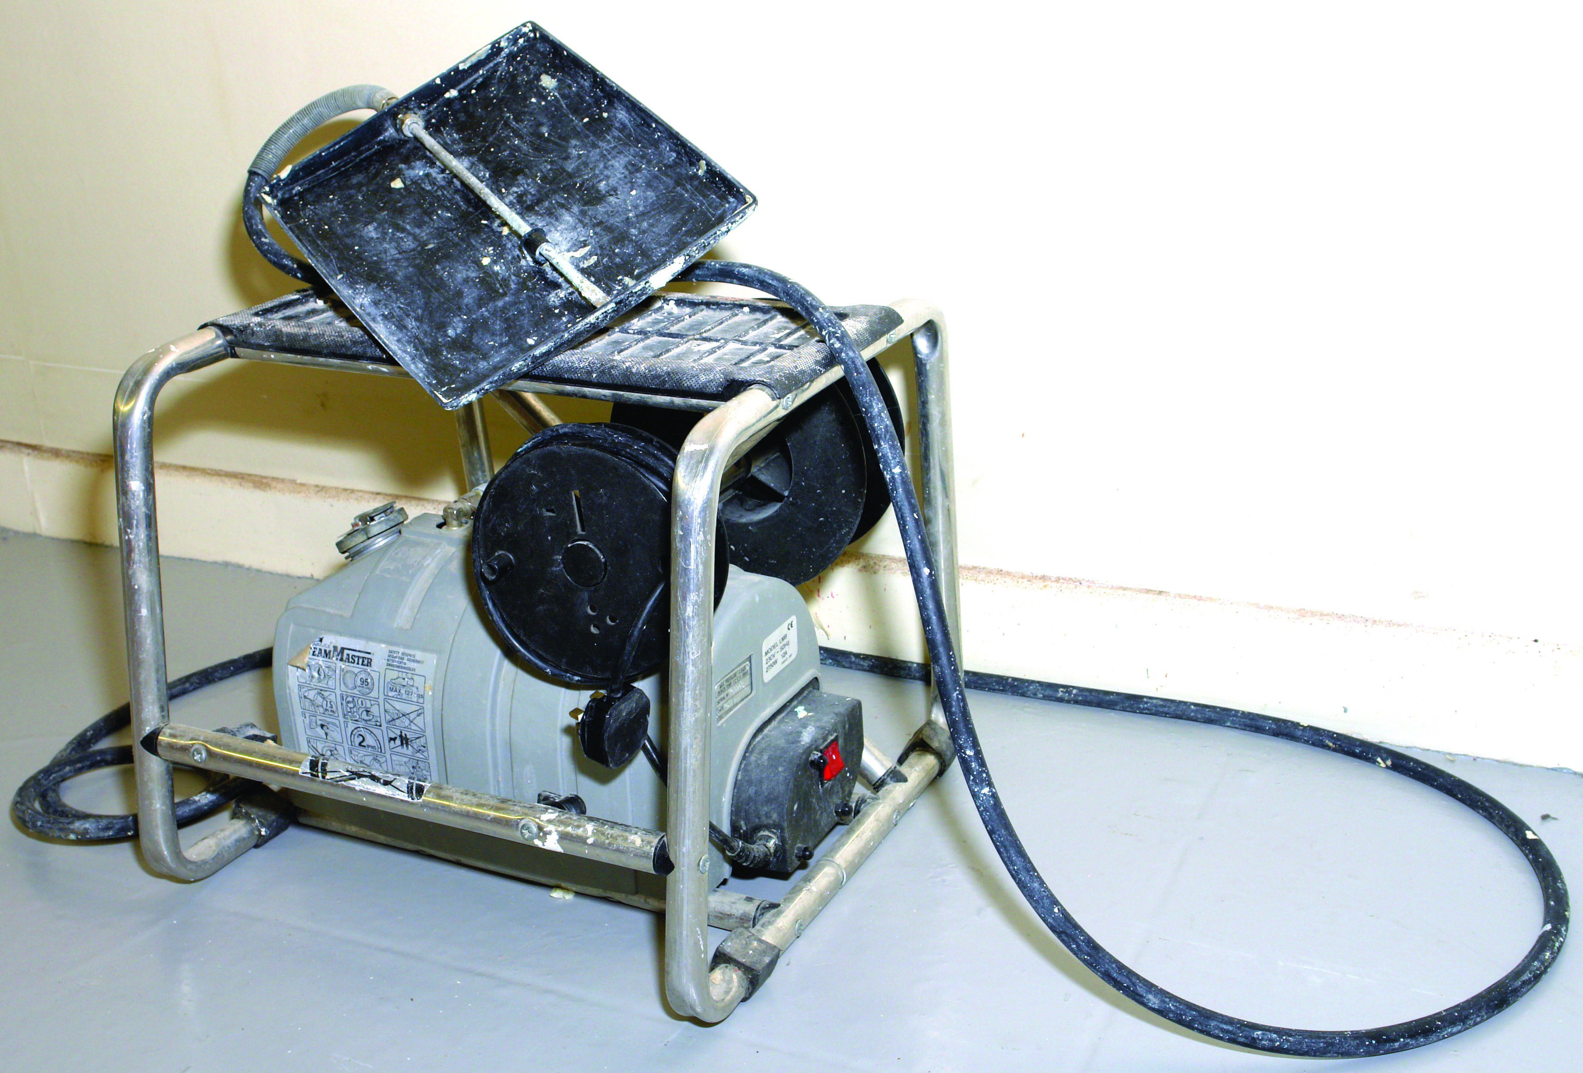
Electric steam stripper

1.3 Safety procedures when using steam strippers
Steam stripping is a method of assisting the removal of wallpapers from walls and ceilings which are difficult to remove by normal soaking and scraping, e.g. washables, lincrusta, painted papers and multi-layers of papers. Also used to remove old water paints, emulsions and textured paints.
When using a steam stripper, the following points should be observed.
- Carefully check all the connections on gas strippers.
- Carefully check leads, plugs etc, in electrical strippers
- Disconnect the unit when filling
- Always wear gloves. The unit will get very hot.
- When working overhead be careful of dripping of hot water. Tilt the plate away from face and body
- Care when working nears others. Avoid holding perforated plate in their direction as they could be burned by the steam
- Never allow the water level to drop too low.
- Avoid kinking the hosepipe. This can obstruct the flow of steam to the perforated plate, causing the safety valve to blow.
- Light the gas type unit with a taper. Place the taper in position before turning on the gas.
- Do not leave the unit too long in any one place, as the steam might damage the plaster, causing it to loosen.
- Do not leave unattended
- Always empty tank when finished
- Only remove filler cap when the unit is not working

1.4 Identification of suitable surfaces for steam stripper
Suitable surfaces.:
- Old walls in good condition
- Recently papered walls in good condition
- Painted wallpaper
Unsuitable surfaces:
- Old plaster in poor condition.
- Wallpapered area near textured work e.g. The texture on a ceiling may be softened and damaged when using the steamer near it.

1.5 Method and sequence of stripping painted papers
Wallpaper removal is a task that must be done sooner or later. It can be laborious and messy if attempted haphazardly.
The best way remove wallpaper is to it wet it well so that it can be scraped off easily and without damaging the substrate. It is crucial that the paper be thoroughly scored using the spiking roller or scoring tools before wetting.
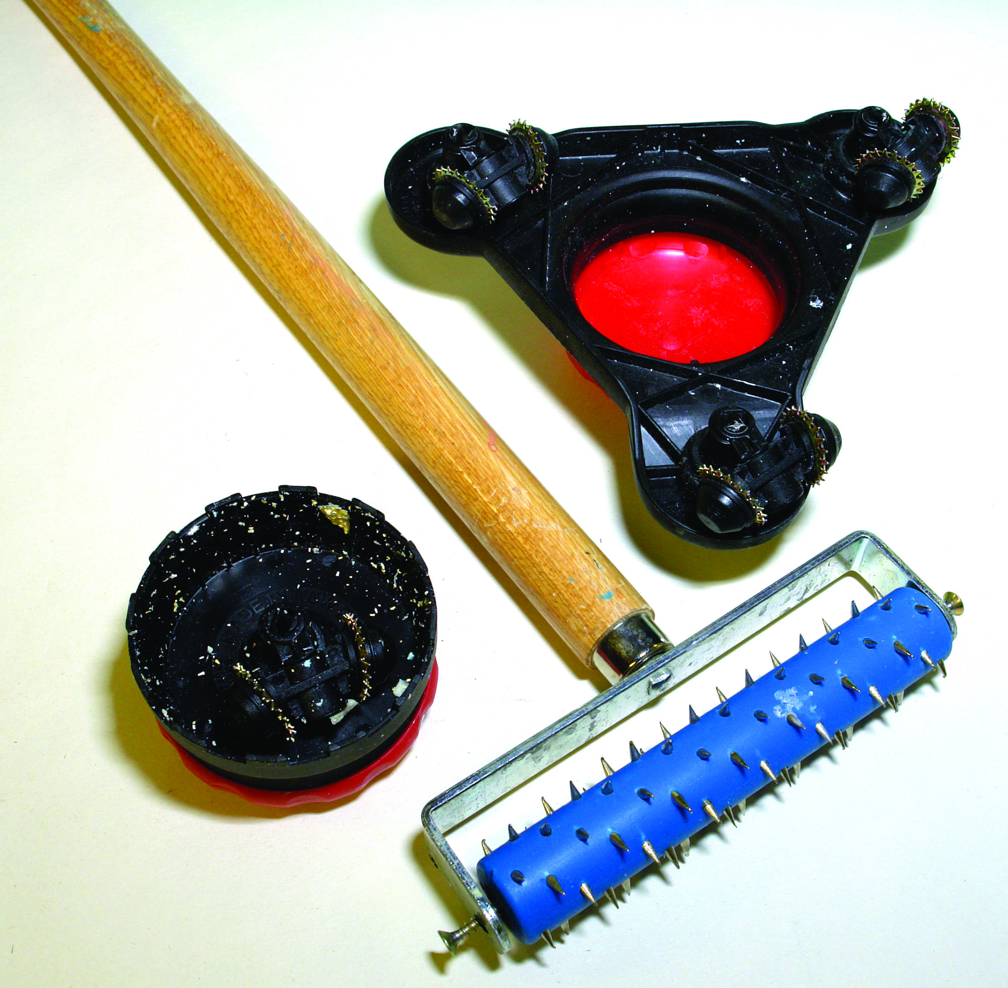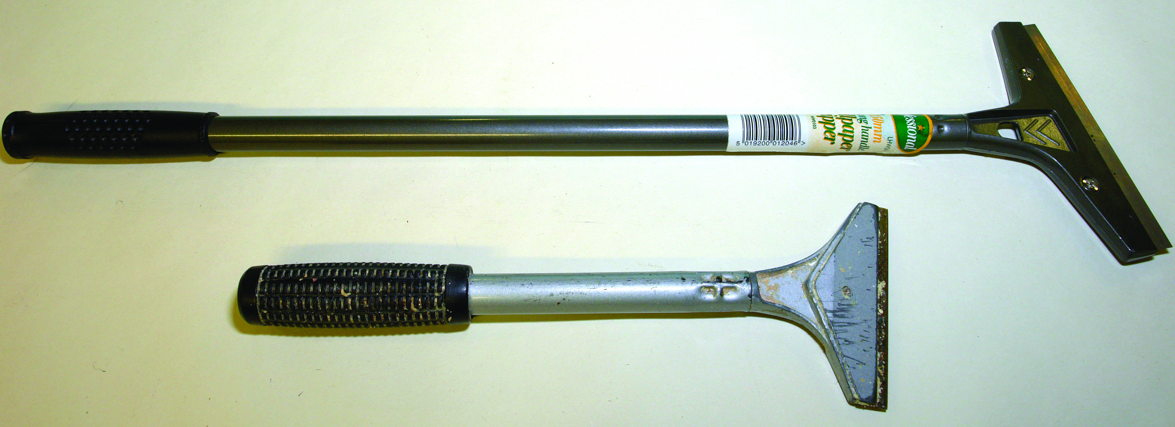
Tools for spiking wallpaper Wallpaper scrapers
Once your wallpaper is properly scored, a chemical wallpaper remover added to water can be brushed on. This can be quite effective. Sufficient time must always be allowed for the wallpaper stripper to work. It may help to coat the area again to ensure thorough softening of the paper. This task takes longer when the paper has been painted but patience at the beginning helps the easy removal without damaging the surface.
When the paper has softened it can be removed by scraping with special wallpaper scrapers that are tapered to avoid digging in to the surface.
Stripping vinyl wallpaper:
The vinyl face of vinyl paper can be removed easily from its backing paper by opening back a corner of the sheet and carefully peeling off the complete sheet. The backing paper can be removed by any of the afore mentioned methods.
Steam stripping:
After scouring the surface the steam stripper can be used. This is a very fast method compared to the water and wallpaper stripper. The steam stripper is set up and the water heated while scouring the walls. Working from a small safe scaffold or by standing on the unit (if it designed to do so) the perforated plate is placed against the surface penetrating through the paper softening it. This can be scraped off easily without damaging the surface. While scraping, place the plate on the next section of the wall and so on until room is complete. By keeping the plate on the wall it avoids filling the room with steam.

2.0 Remove wallpaper from surface
a) Manually
b) Using a steam stripper
Key learning points
- Avoiding surface damage
- Stripping and preparation for paper
- Stripping and preparation for painting
- Safe disposal of old wallpaper
- Clean and safe working practice
- Removal of all old paste and size
- Types of pastes, adhesives and mixing

2.1 Avoiding surface damage
Before deciding on the method to be used to remove wallpaper an examination of the surfaces to be stripped should be undertaken. It is very easy to damage a surface when stripping as wallpaper that is well adhering will take time and patience initially but pays dividends in the long run.
Removal by hand:
- Score the paper well
- Soak with water and wallpaper remover. Apply a couple of times to saturate
- Scrape carefully. If you have to use force soak again
Removal by Steam stripping:
- Dry lining and old plasterwork etc can be easily damaged when stripping so care must be taken at each stage of the work.
- Score the paper well.
- Apply steam. Avoid keeping the plate in one place for too long as damaging the top layer of plaster.

2.2 Stripping and preparation for paper
Stripping must be thoroughly done so that all wallpaper is removed as any pieces that are left on the surface will loosen later causing the finished paper to lift.
- Walls should be well washed with sugar soap to remove paste.
- Rinsed with clean water.
- Surface repaired. Cracks and surface imperfections filled.
- Filled areas sanded smooth and touched up.
- Scrape clean all angles to remove debris that would hinder paper attaching to corners fully
- Sand the wall areas etc. to de nib as these will show through the finished paper
- If stripped walls are shown to be raw plaster then they must be sized or better still prime with plaster primer.

2.3 Stripping and preparation for painting
Very similar treatment to 2.2.
- Thorough cleaning. All paper must be removed.
- All paste must be removed or it will bubble under the paint. Wash with sugar soap and water
- Rinse well with clean water
- Surface repaired. Cracks and surface imperfections filled
- Filled areas sanded smooth and touched up.
- Sand the wall areas etc. to de nib.
- If stripped walls are shown to be raw plaster then they must be primed before painting. The choice primer will depend on the type of finish to be used.

2.4 Safe disposal of old wallpaper
All stripped wallpaper must be bagged and removed outdoors as compacted wallpaper can cause spontaneous combustion.

2.5 Clean and safe working practice
A clean and tidy work place is a safe place and tidying up as the work progresses accomplishes this.
- Remove stripped materials regularly
- Empty steam stripper water tank
- Remove equipment when finished
- Ensure good ventilation
- Wear PPE equipment

2.6 Removal of all old paste and size
As 2 2 and 2.3

2.7 Types of pastes, adhesives and mixing
Adhesives:
Cellullose paste:
- Highly concentrated water soluble powder
- A cold water paste.
- Clear
- Mixes easily. Add to water while stirring with stick or whisk
- Ready for application after a few minutes
- Supplied as a powder in sachets
- Different types. Regular to extra strong
- Offers good slip
- Check manufacturers chart for strength of mix
- Unlikely to stain paper
- Contains fungicide
Starch paste:
- A cold water paste.
- Made from flour
- Strong adhesive
- Supplied as a powder in sachets
- Mixes easily. Add to water while stirring with flat stick or whisk
- Offers good slip
- Contains fungicide
- Can stain paper

Ready made/Tub paste:
- They require no preparation
- Can be thinned with water if required
- Good slip
- Suitable for heavy wallpapers
Overlap adhesive:
- A very strong adhesive for use where vinyl is lapped and must be bonded e.g. internal corners etc.
Border adhesive:
- An ideal adhesive for hanging vinyl borders to walls and vinyl wallpaper.

Summary
Any job involving the removal of wallpapers involves several elements. The craftsperson needs to approach the task in a manner that will produce satisfactory results as quickly and efficiently as possible without ever compromising on safety.
It must be borne in mind that by its nature the job involves the use of sharp tools and electrical equipment which must be used in a moisture laden environment. In these circumstances any failure to pay attention to all relevant health and safety precautions is highly dangerous.
Going about the job the right way in terms of simple procedures such as making sure the old paper is sufficiently wet before removal more than compensates for the small amount of time it takes to do this.

Suggested exercises
- Strip wallpaper from ceiling and walls of cubicle using
  - steam stripper
  - hand method
- Wash down stripped areas thoroughly in preparation for painting

Self Test
Q.1 Name the component parts of a steam stripper
Q.2 How can damage to a plastered surface be avoided when using a steam Stripper
Q.3 Before commencing steam stripping what precautions must be observed.
Q.4 What personal safety precautions must be undertaken when using a steam stripper
Q.5 Why must stripped wallpaper be removed from work area as quickly as possible

Suggested reading
Painting and decorating Author Roy Hughes
ISBN 0-7506- 6737-0


27-33 Upper Baggot Street
Dublin 4

