TRADE OF PLASTERING

PHASE 2

Module 1
SLABBING, RENDERING, FLOATING AND SKIMMING

UNIT: 3

Hop-up and Independent Scaffolding

Produced by

In cooperation with subject matter expert:
Terry Egan
Some images & text courtesy of Gypsum Industries Ltd.
© SOLAS
Table of Contents
Introduction 1
Unit Objective 1
1.0 Basic Scaffolds Used by Plasterers and Safety on Site 2
1.1 Types of Scaffolding and Its Uses 3
1.2 Importance of Safe Scaffolding 7
1.3 Safety Aspects of Lifting 8
1.4 Safety on Site, Protective Clothing and Hazard Awareness 9
2.0 Ladders 10
2.1 Correct Set Up of Ladders 10

Introduction
Welcome to this section of your course which is designed to assist you the learner, understand basic scaffolding and ladders.

Unit Objective
By the end of this unit each apprentice will be able to:
- Identify and name basic scaffolds used by plasterers and the importance of safety on site
- Erect one lift of independent scaffolding
- Erect a simple hop-up scaffold
- Check Ladders

1.0 Basic Scaffolds Used by Plasterers and Safety on Site

Key Learning Points
- Types of scaffolding and its uses
- The importance of safe scaffolding e.g. toe board, planks, handrails etc.
- Safety aspects of lifting
- Safety on site, protective clothing and hazard awareness
- Plan and erect a single lift of independent scaffolding
- Identification of scaffold components and their function
- How to erect, arrange and adjust a simple hop-up scaffold

1.1 Types of Scaffolding and Its Uses
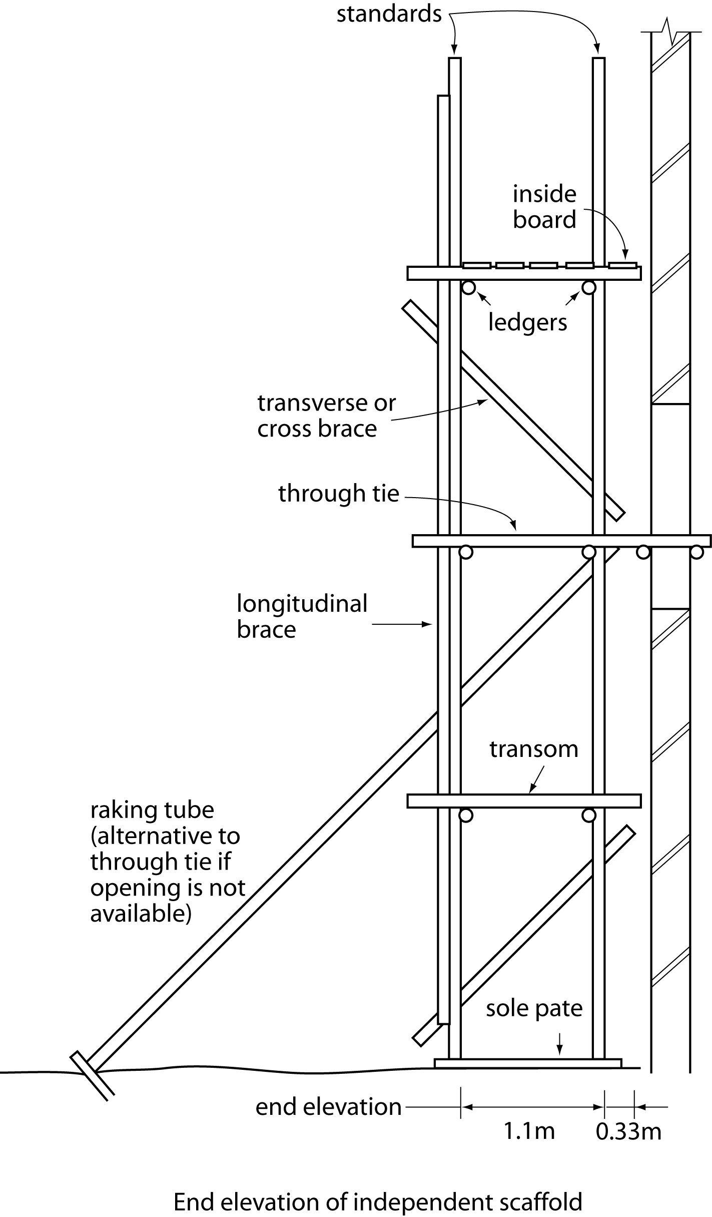
Name indicated parts of scaffold and describe the function of each component.

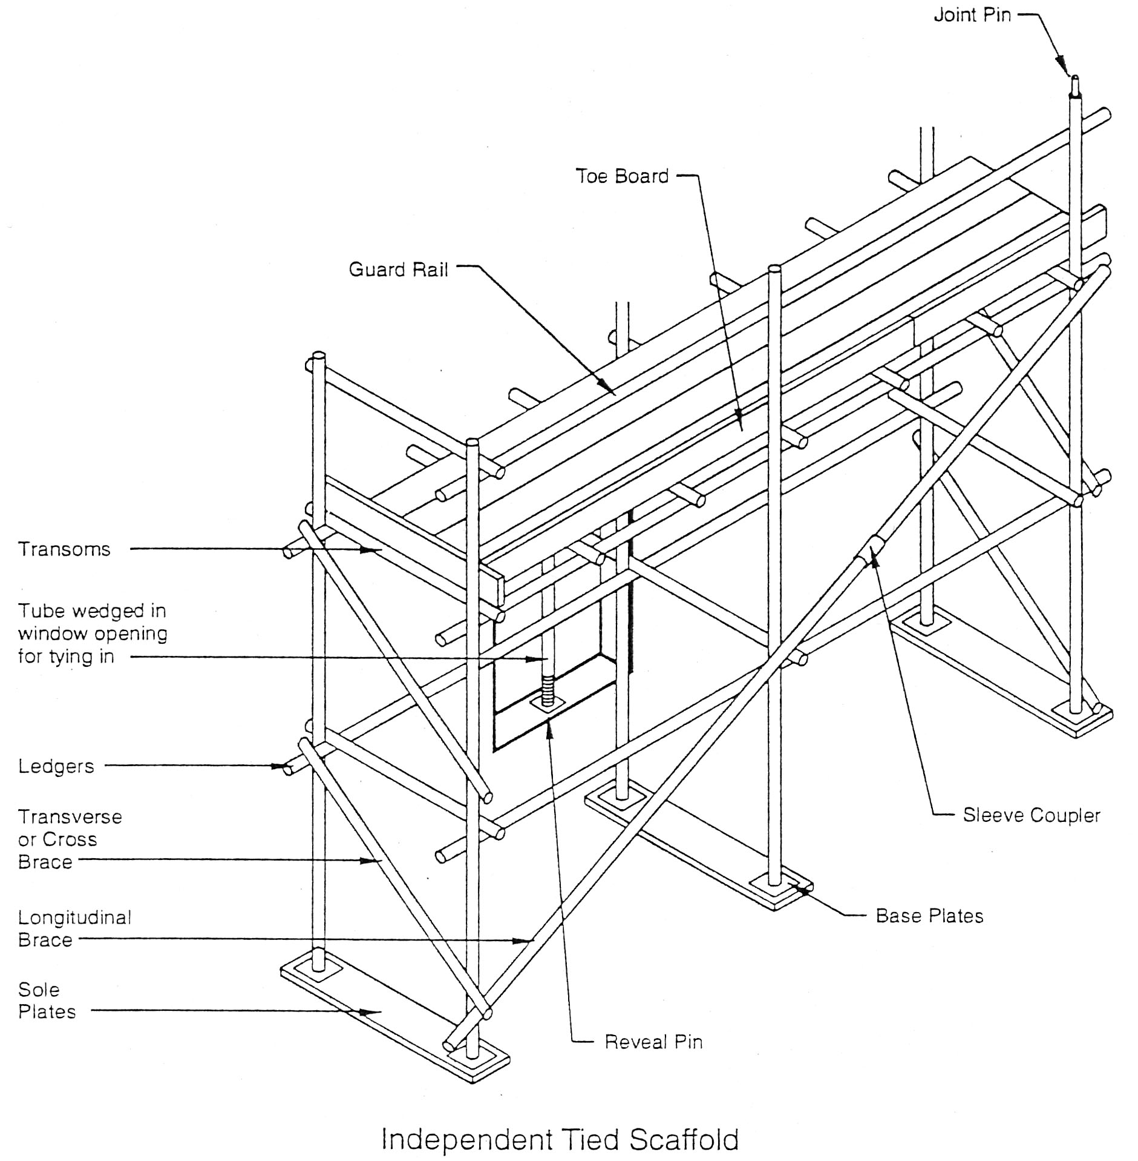
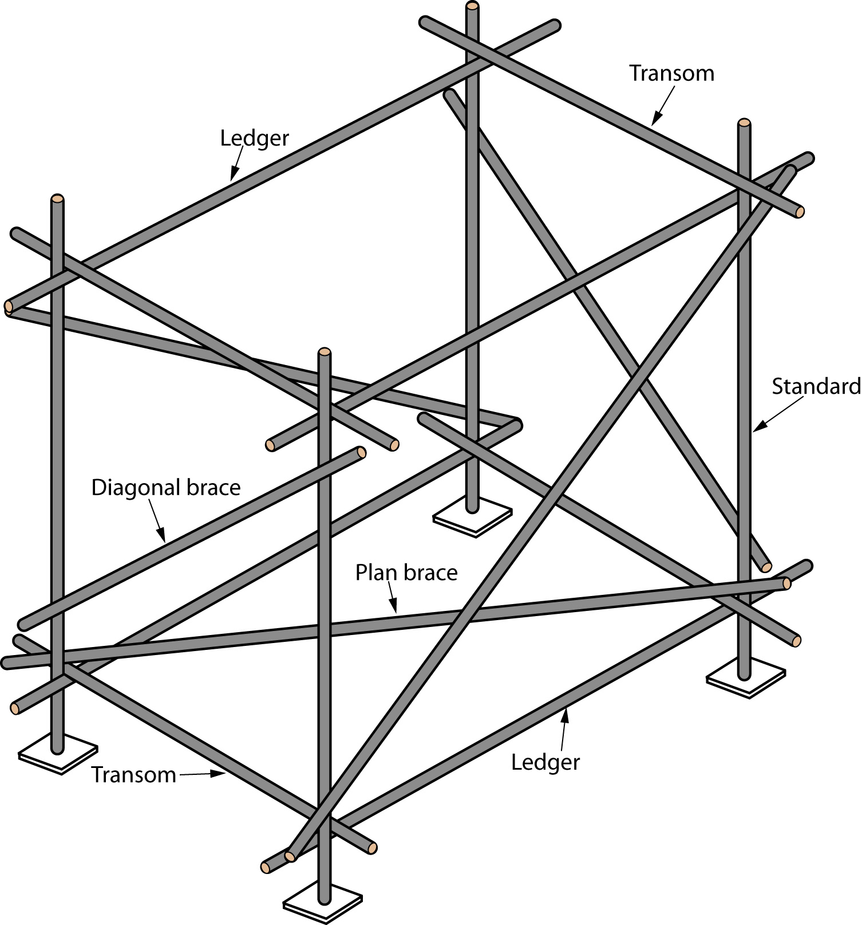
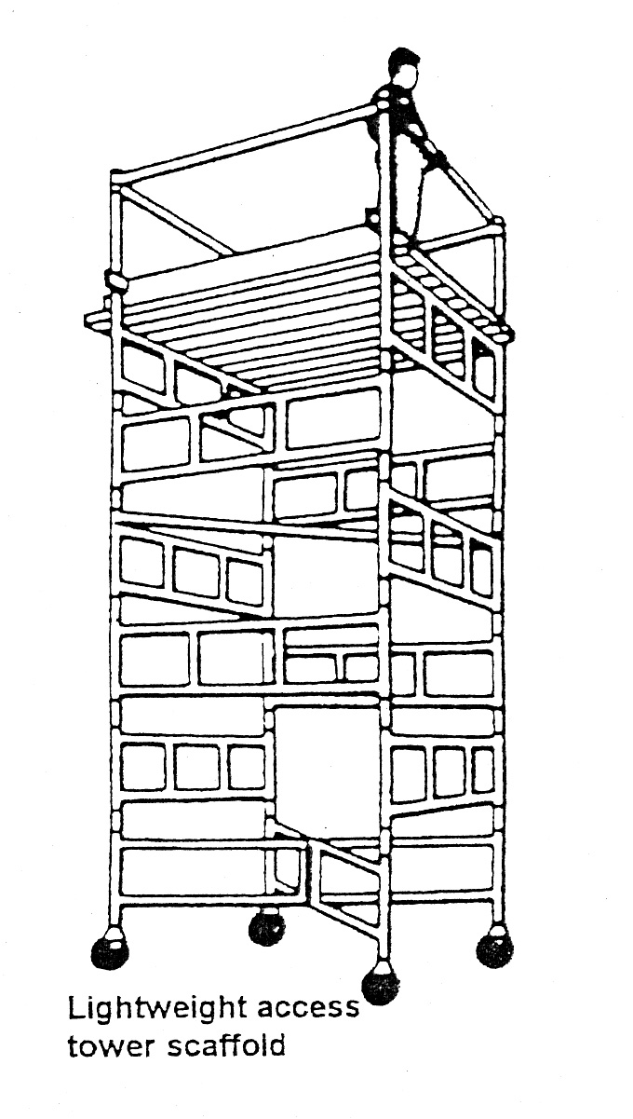
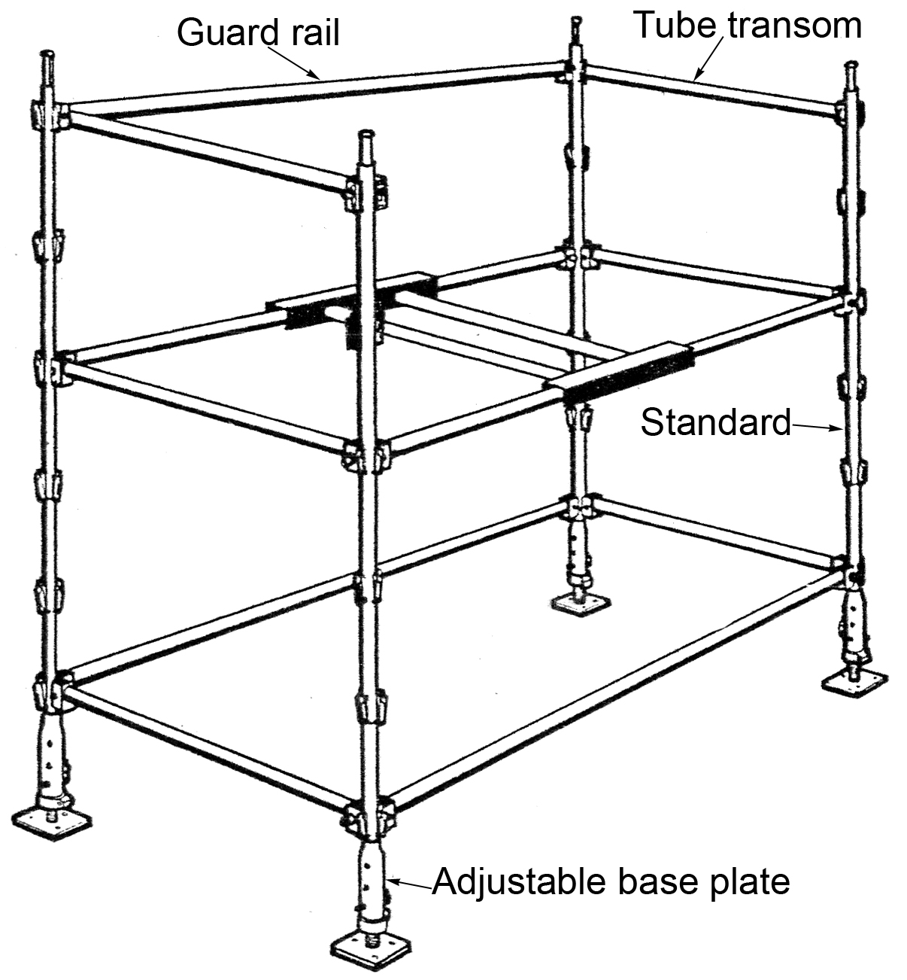
- U.P Scaffolding system
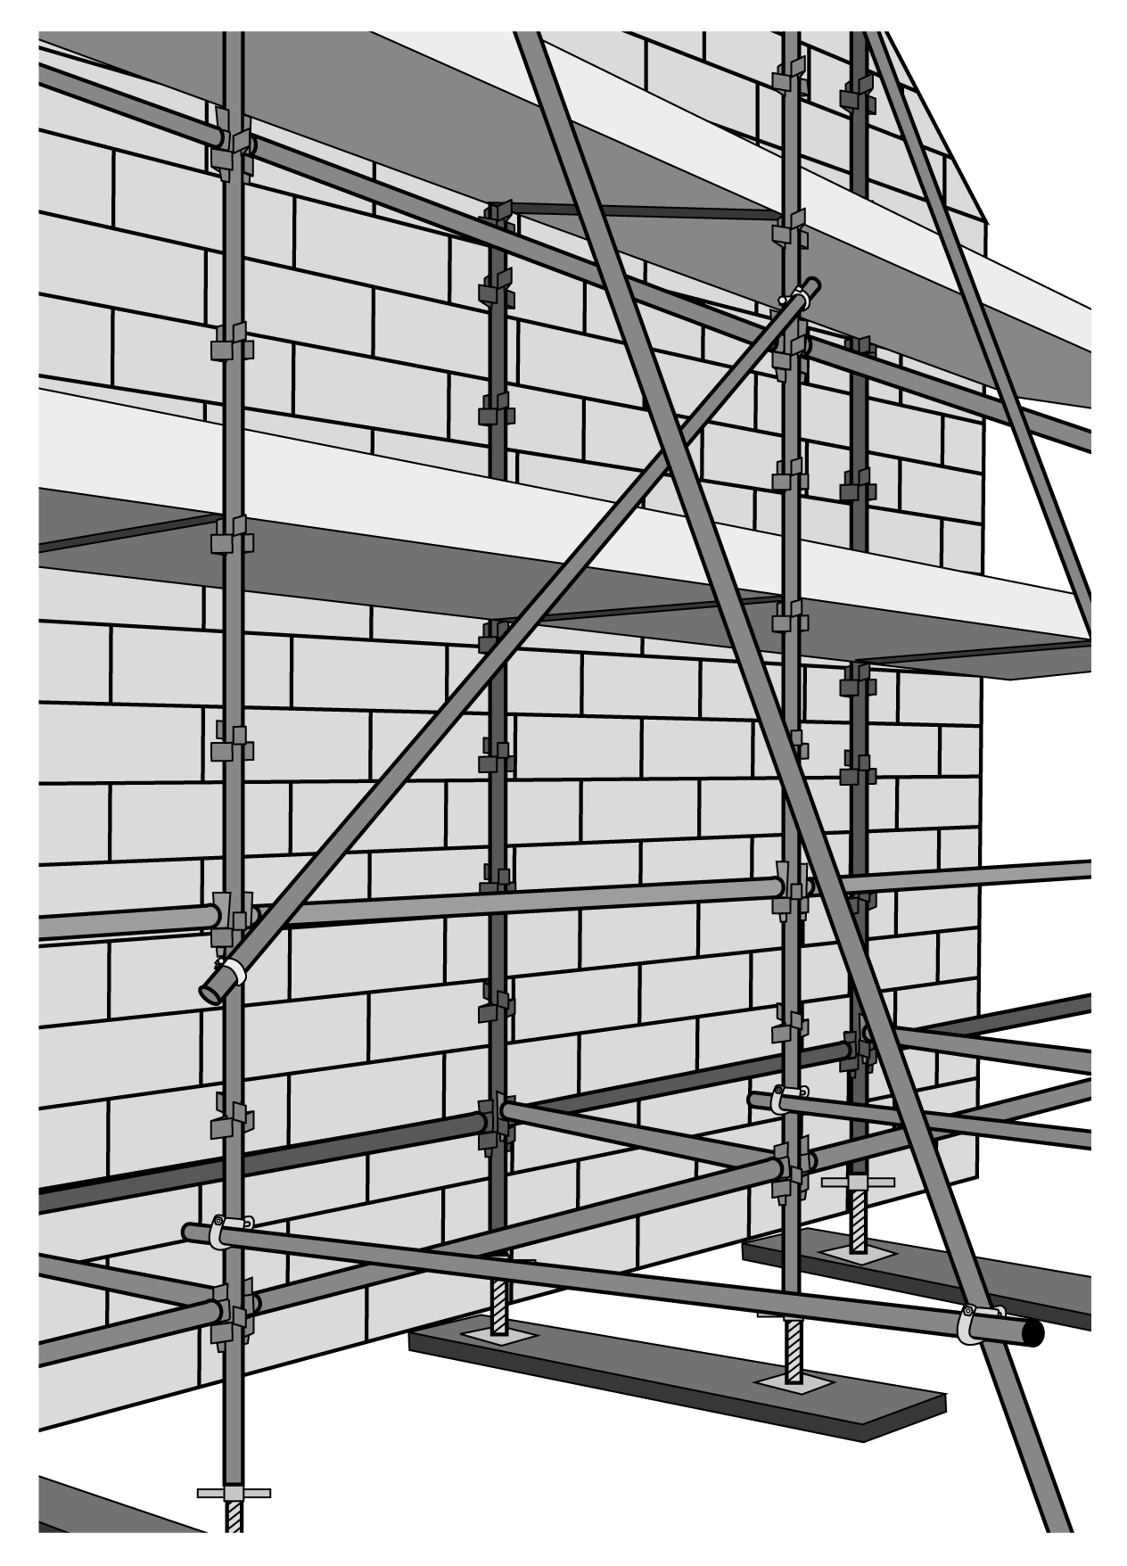
General access scaffold
1.2 Importance of Safe Scaffolding
- Is there proper access to the scaffold platform?
- Are all uprights provided with base plates (and where necessary, timber sole plates, or prevented in some other way from slipping or sinking)?
- Have any uprights, ledgers, braces or struts been removed? If so, have replacements been provided?
- Is the scaffold secured to the building in enough places to ensure stability?
- If any ties have been removed since the scaffold was erected have substitute ties been provided to maintain stability?
- Are the working platforms fully boarded?
- Are there effective barriers or warning notices to stop people using an incomplete scaffold. e.g. one that isn't fully boarded?
- Are there adequate guard rails and toe boards at every side from which a person can fall and in particular where one can fall more than 2.0m (6ft. 6in.)?
- Does the working platform extend at least 600mm beyond the end of the working face?
- Where the scaffold has been designed and constructed for loading with materials, are these evenly distributed?
- Are all wheeled scaffolds used only on firm and even surfaces?
- Are all suspended scaffolds :
  - closely boarded or planked,
  - at least 600mm wide if used as tooting only,
  - at least 800mm wide if used for materials?
- Does a competent person inspect the scaffold before it is brought into use and on a regular basis thereafter, i.e. at least once a week and always after bad weather?
- Are the results of inspections recorded (including defects that were put right during the Inspections) and the records signed by the person who carried out the inspections?

Working on Platforms
Take particular care when working from a platform such as the provided by scaffolding; always consider those below. The scaffold should be erected only by certified operatives, and should it be checked weekly or after adverse weather conditions: thus it's condition should be sound, but always have a visual inspection to identify obvious defects. Above all, never alter or work from ineffective scaffolding platforms. Defects to look for include:
- Missing components, e.g. toe boards or guard rails.
- Poor assembly, e.g. loose, overlapping or protruding boards.
- Damaged scaffolding, e.g. split boards and bent or rusty poles.
- Unstable scaffolding, e.g. no bracing, no tie-ins and no base plates.
- Obstructed or overloaded scaffolding
- Boards and Planks on Working Platforms
- Are boards free from obvious defects such as knots, and are they arranged to avoid tipping or tripping?
- Are all boards and planks on working platforms:
  - at least 200mm wide if less than 50mm thick,
  - at least 150mm wide if more than 50mm thick
- Do these planks extend beyond their end support a distance of at least 50mm and not more than four times their thickness?
- The distance between transoms should not be more than :
  - 1 metre where planks of 32mm thickness are used,
  - 1.5 metres where planks of 38mm thickness are used,
  - 2.4 metres where planks of 50mm thickness are used.

1.3 Safety Aspects of Lifting

Eight Principles of Lifting
- Access – the area
- Access – the load.
- Bend Knees.
- Broad stable base.
- Keep back straight (not necessarily erect)
- Firm palm grip
- Arms close to trunk
- Weight close to centre of gravity
- Point/pivot feet in direction of movement.
- Left with legs

1.4 Safety on Site, Protective Clothing and Hazard Awareness
Over 70,000 people are employed in construction, either on building sites or repair work. It is very easy to be seriously injured or killed at work, yet there is always a safe way to do any job, in building it is also the quickest and cheapest.
The simple message of this section is that it is easy to take the right precautions.
Members are advised that the new Health and Safety regulations to supplement the EC temporary or mobile construction sites directive 92/57/EEC came into force towards the end of 1993. This deals with minimum Health and Safety standards on sites and places additional duties on clients, designers and contractors. Members are referred to the Council Directive 92/57/EEC available from Government Publication Sales Office, Sun Alliance House, Molesworth Street, Dublin 2.

Personal Protective Equipment
Personal Protective Equipment ( PPE ) may be defined as “equipment designed to be worn or held by an employee for protection against one or more hazards likely to endanger the employee’s safety and health at work, and any addition or accessory designed to meet this objective”.
It does not include ordinary work clothes and uniforms not specifically designed to protect the safety and health of an employee.

Duties of Employer
- The Safety, Health and Welfare at Work Act states that it is the duty of every employer to provide personal protective equipment for use by his /her employees, where the risks cannot be avoided or sufficiently limited.
- PPE should only be used a last line of defense.
- PPE should be appropriate to the risk, without causing any increased risk.
- PPE should fit the wearer correctly after any necessary adjustment.
- Account should be taken of the physical effort required in the use of the PPE, the duration of use, the requirements for visibility and mobility, possible discomfort to the wearer and any potential risks presented by its use.
- All employees must be consulted and involved in the selection of the equipment.
- In circumstances where different items of PPE are worn simultaneously, they must be compatible with each other and continue to be effective against the risks involved.

Duty of the Employee
Employees are obliged to wear the PPE they have been provided with. No person shall intentionally or recklessly interfere with or misuse any appliance, protective clothing or other equipment provided in the workplace for health and safety purposes.

Maintenance of PPE
PPE shall be maintained in good working order and in a satisfactory hygienic condition, by means of a programme of storage, maintenance, repair or replacement.

Personal Issue
All PPE is as far as possible for the specific use of one employee only. Where for other reasons the use of shared PPE is necessary, appropriate measures must be taken to ensure that this does not create a health or hygiene problem for the users.

2.0 Ladders

Key Learning Points
- Correct set up of ladders
- Teamwork and planning

2.1 Correct Set Up of Ladders
Incorrect use of ladders kills a lot of people. Make sure the ladder is :
- Right for the job. Would scaffolding be better?
- In good shape.
- Secured near the top.
- On a firm base and footing.
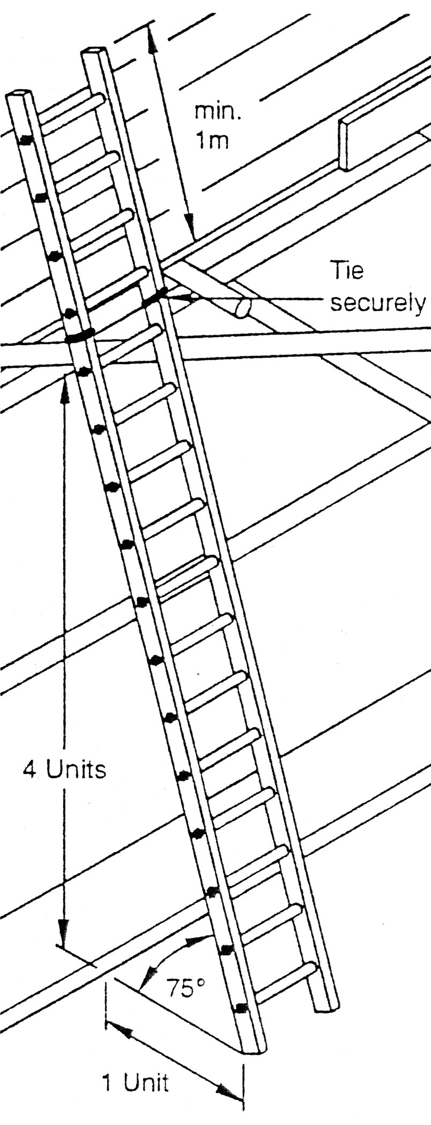
- Rising at least 1m beyond the landing place or that there is a proper hand hold.
- Always have a firm grip on the ladder and keep a good balance.

Never
- Use a makeshift ladder.
- Lean sideways from a ladder.
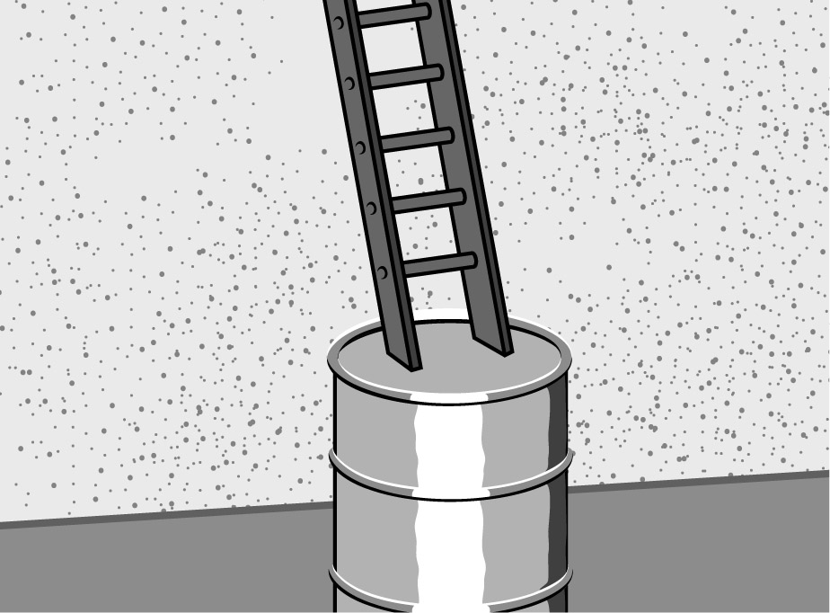
Asking For Trouble

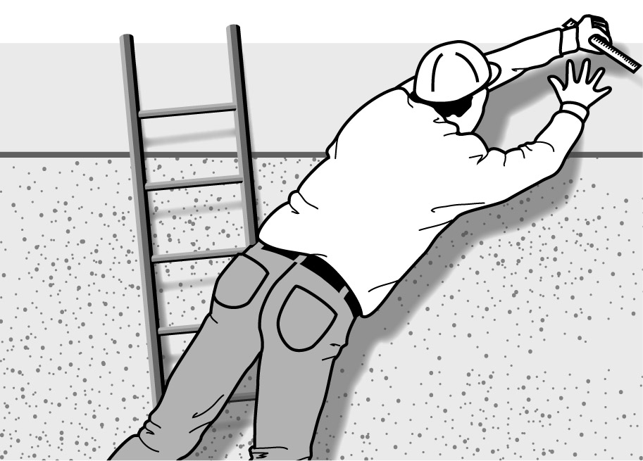
Never Attempt any of the Above

27-33 Upper Baggot Street
Dublin 4

