Trade of Plumbing
Module 2: | Domestic Hot and Cold Water Service
Unit 5: | Bronze Welding
 | Phase 2

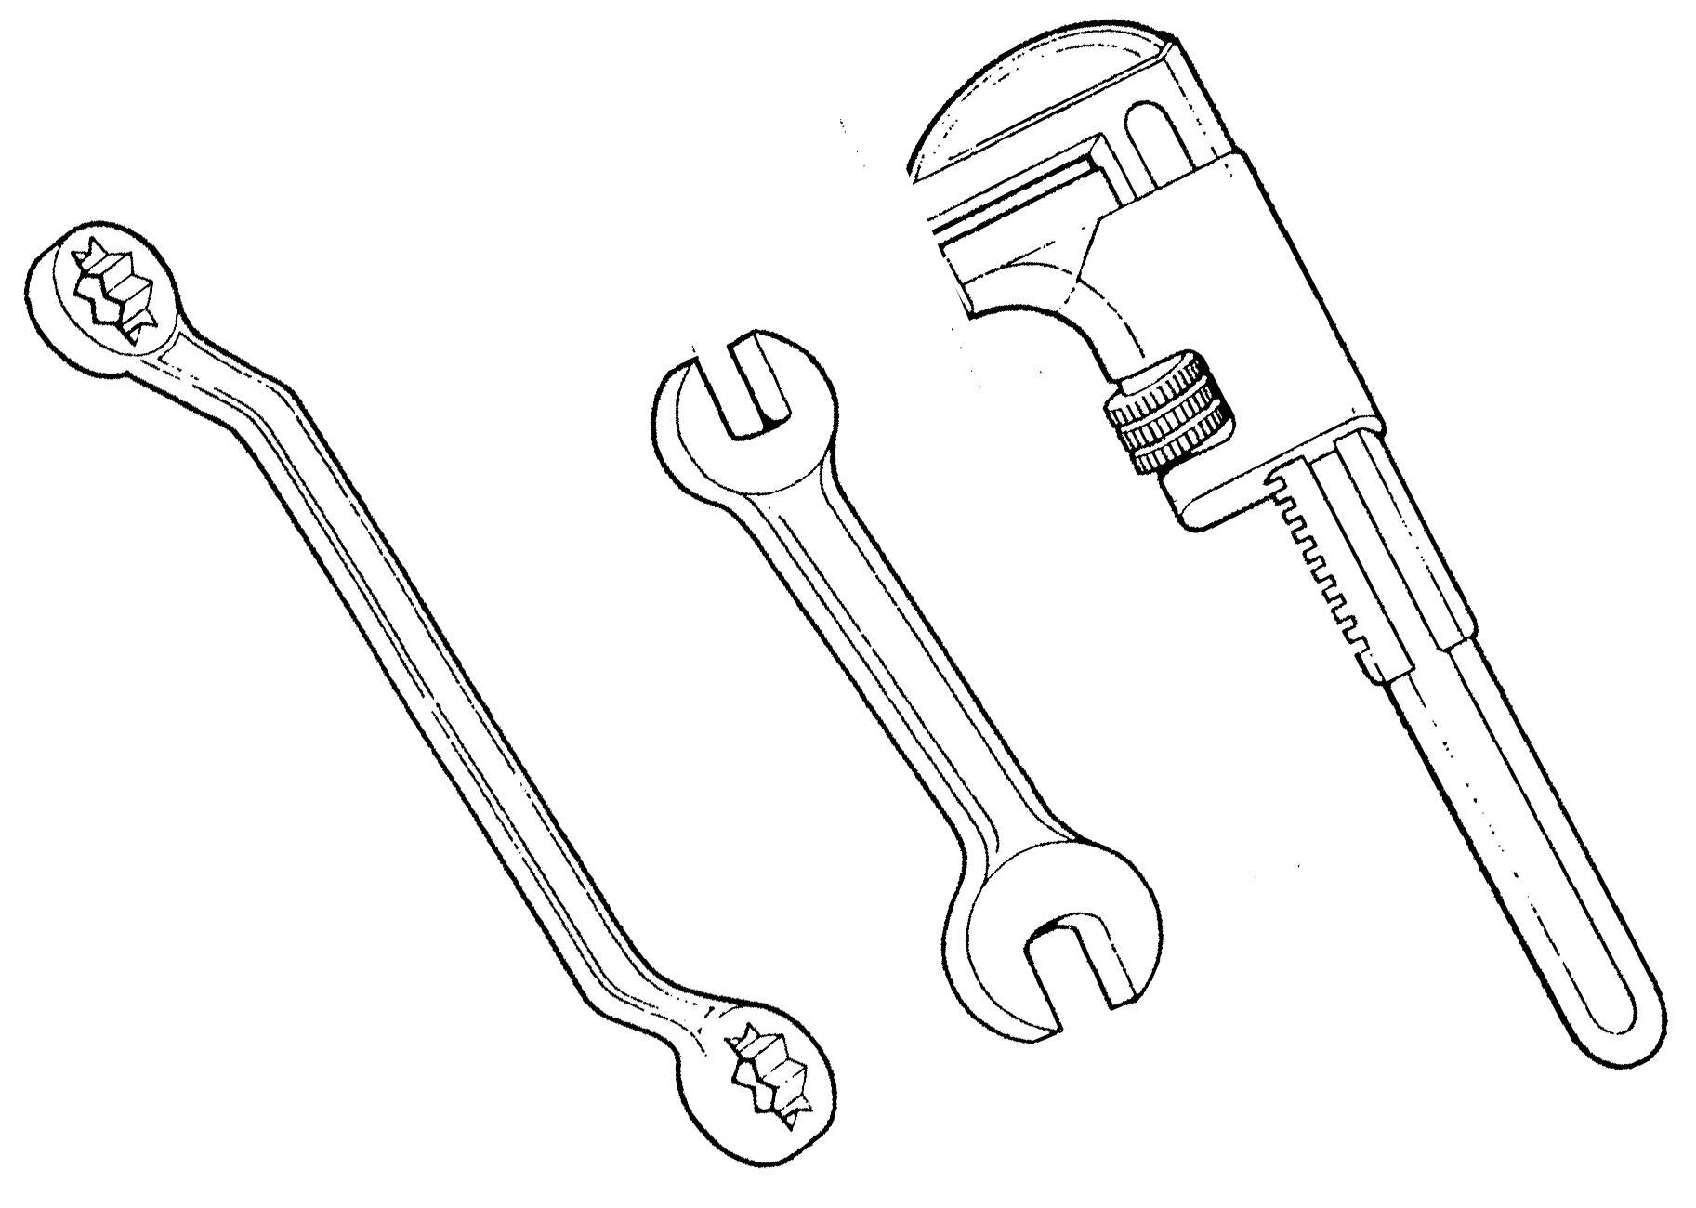

Table of Contents
Document Release History 4
List of Figures 5
List of Tables 6
Module 2 – Domestic Hot and Cold Water Service 7
Unit 5 – Bronze Welding 7
Learning Outcome: 7
Key Learning Points 7
Training Resources 7
Exercise 8
Key Learning Points Code 8
Bronze Welding 9
Self Assessment 16
Exercises 16
Index 17

Document Release History
Date | Version | Comments
June 2006 | V.1.0
17/02/14 | 2.0 | SOLAS transfer

List of Figures
Figure 1. Demonstration 10
Figure 2. Rothenberger “R” System 11
Figure 3. Belled Butt Brazes 12
Figure 4. Blank Weld 13
Figure 5. Figure 19 14
Figure 6. Bronze Welding 15

List of Tables

Module 2 – Domestic Hot and Cold Water Service

Unit 5 – Bronze Welding
Duration – 30 Hours

Learning Outcome:
By the end of this unit each apprentice will be able to:
- Adjust gas pressure regulators for oxy-acetylene bronze welding.
- Bronze weld bell, butt and branch joints on copper pipe.

Key Learning Points
RK | Bronze welding process.
RK | Applications of bronze welding.
Sk | Use of oxy-acetylene welding plant.
Sk | Setting gas pressures.
Sk | Flame adjustment.
Rk | Types and purposes of flux, removal of flux from finished joint.
Rk | Types of joints.
Sk | Preparation of pipe, use of flaring rods.
Rk | Types of bronze welding rods.
Sk | Defects in welded joints.
Sk | Bronze welding bell, butt and branch joints.
H | Hot metal, sparks.
P | Good working practice.
P | Working independently.
Sk | Interpretation of drawings.
Sk | Testing pipework.

Training Resources
- Classroom facilities, workshop facilities.
- Information sheets, sample finished bronze, welded joints, fluxes, rods.

Exercise
Apprentice to bronze weld copper pipe as in Exercise No. 2.2.5a in the curriculum document.

Key Learning Points Code
M = Maths D= Drawing RK = Related Knowledge Sc = Science
P = Personal Skills Sk = Skill H = Hazards

Bronze Welding
A very common way to join copper pipe is a method known as bronze welding. Although it is referred to as “welding”, no melting of the parent metal takes place. However, the bond produced is equal in strength and comparable to a fusion weld.
Oxy-acetylene equipment is most satisfactory for this process as it is able to produce and intensely hot flame that gives controlled local heating.
A special brass rod is used to make the joint. This rod consists of approximately 60% copper and 40% zinc. It is necessary to add flux to the joint to enable the rod to adhere to the copper and to prevent oxidation. The flux may be used in powder form by dipping the heated end of the brass rod into it. An alternative method is to mix the flux with clean water to form a smooth paste which can be applied to the weld area and the filler rod with a small brush. Some brass rods have flux impregnated into them by the manufacturers.
The melting point of copper is 1,080ºC while the melting point of the brass filler rod is 850º-950ºC. A slightly oxidising flame should be used.
The main types of bronze welding joints used on copper pipe are:
- Bell Joint: Used on pipes in the vertical position. The lower pipe end is belled out to receive the top pipe.
- Butt Joint: Used to join pipes in the horizontal position.
- Branch Joint: Used for branch welds. The branch hole may be filled, cut or burned out.
- Reducing Joint: Used where it is necessary to join pipes of different sizes.
- Blank Welds: Used to blank pipe ends.
Note: Many people refer to bronze welding as “brazing”. While the materials and joint process are the same, the technique is slightly different. Brazing uses the principal of capillary attraction in the jointing.
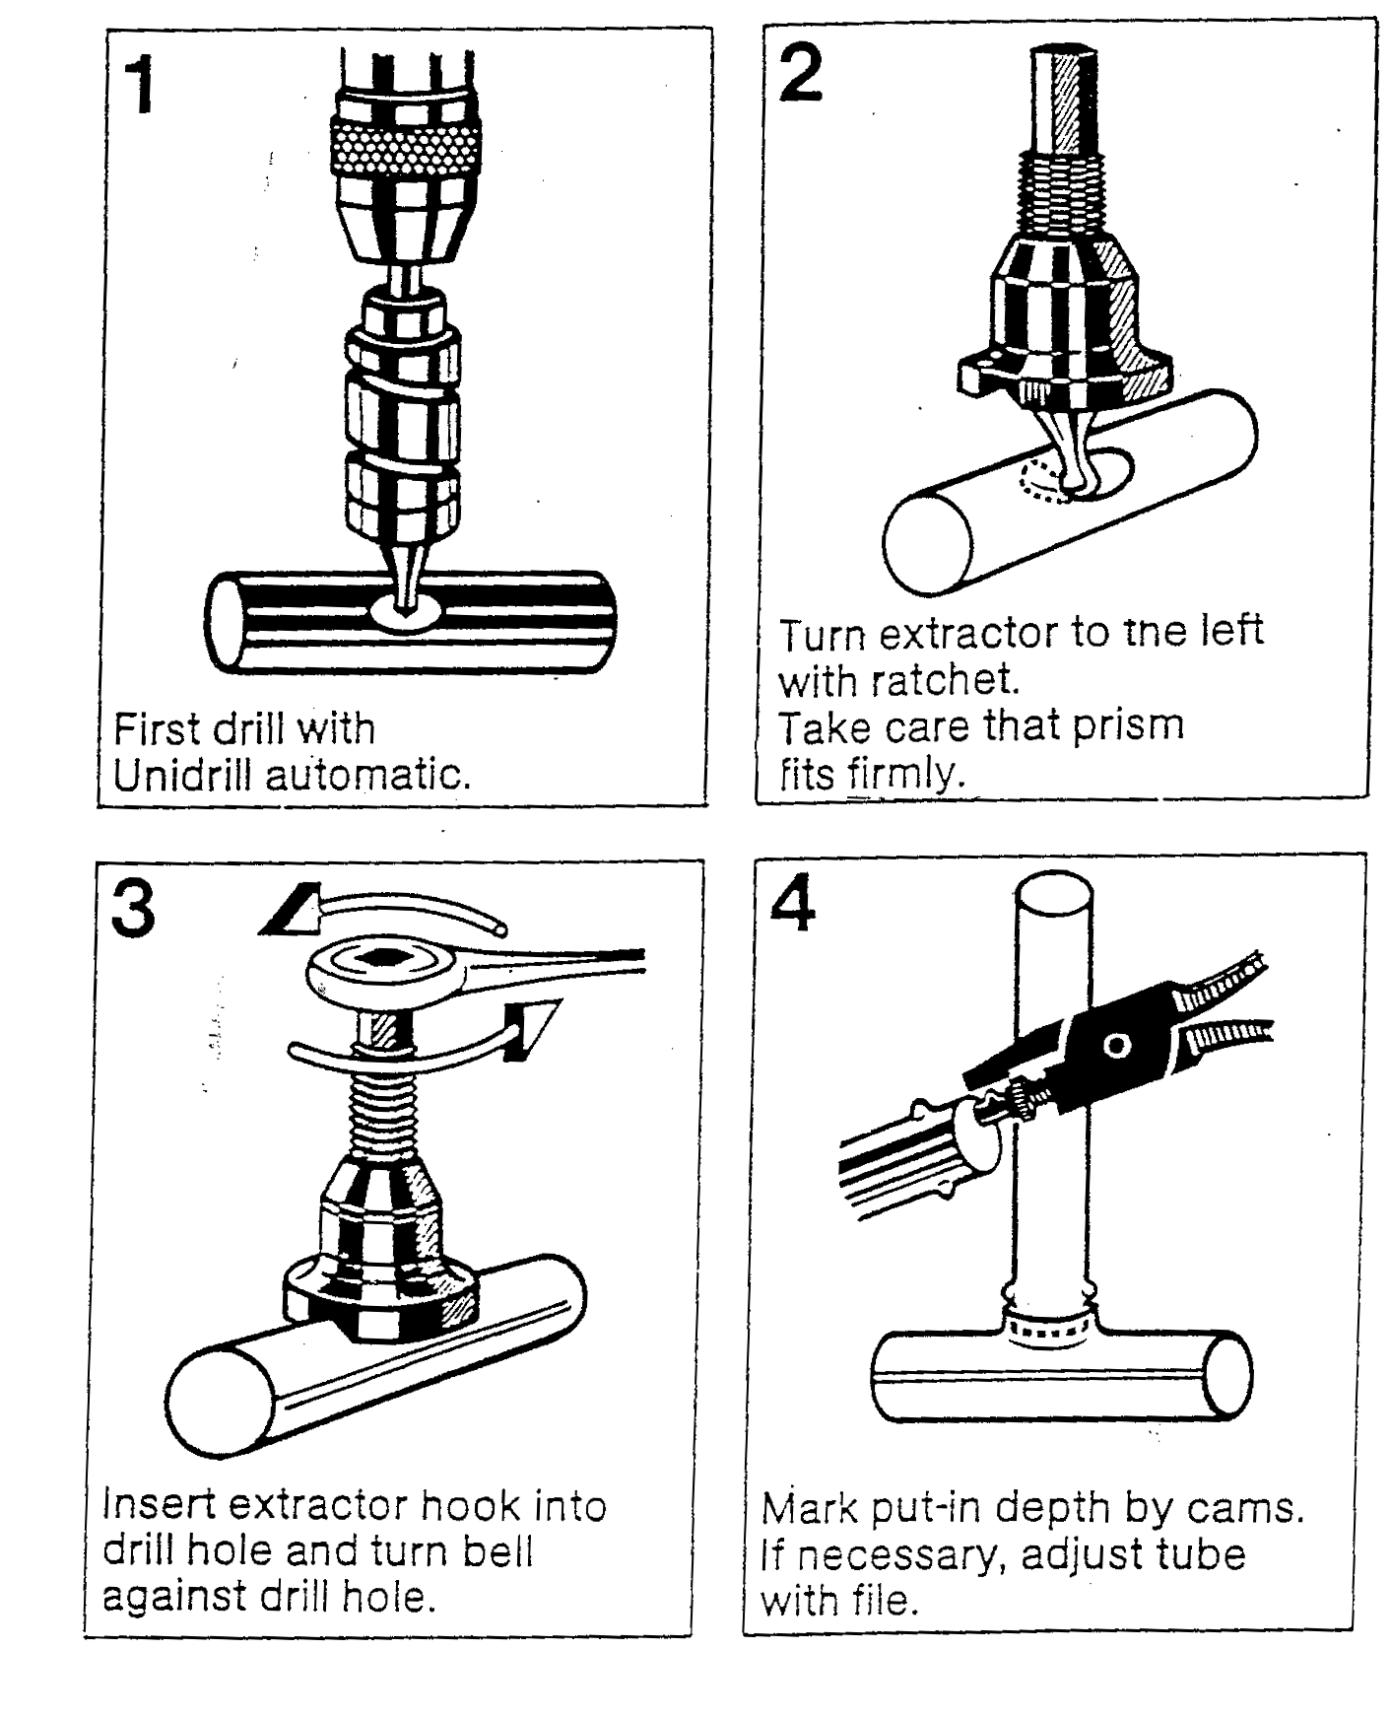
- Demonstration

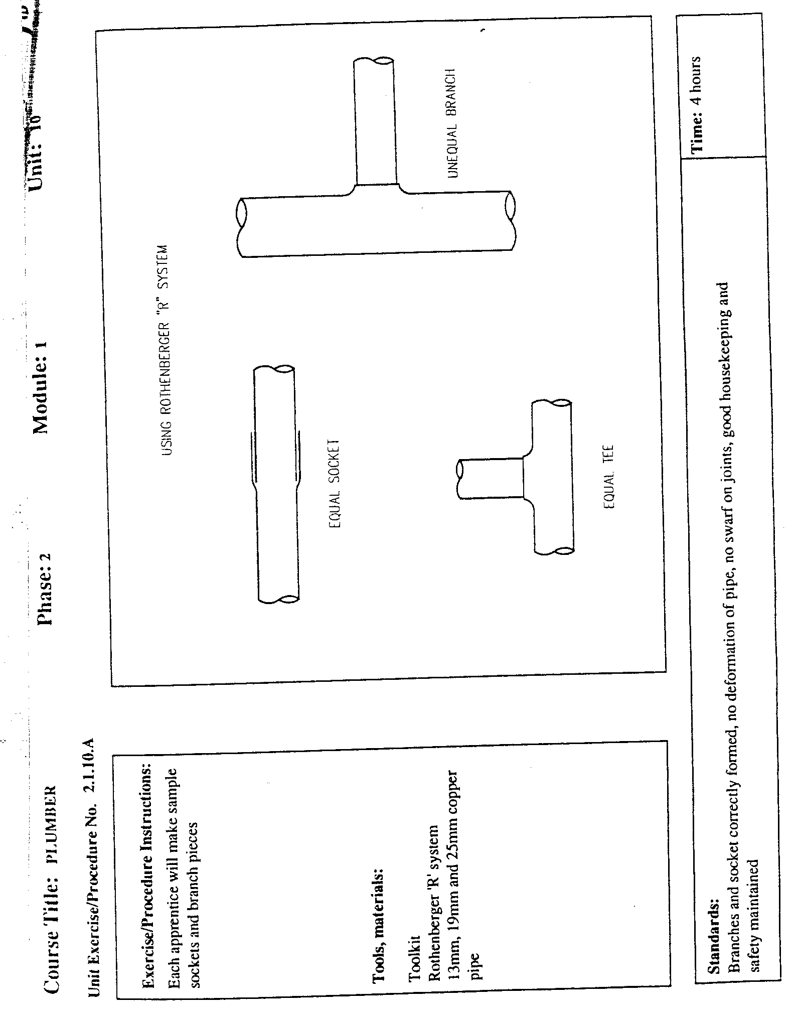
- Rothenberger “R” System
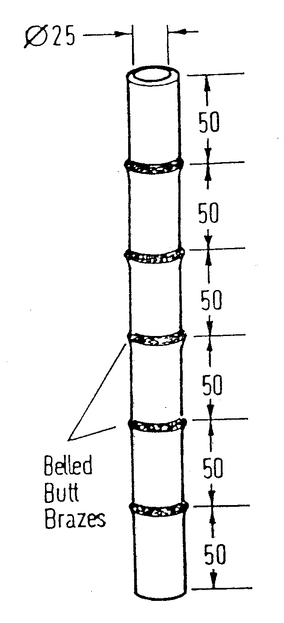
- Belled Butt Brazes
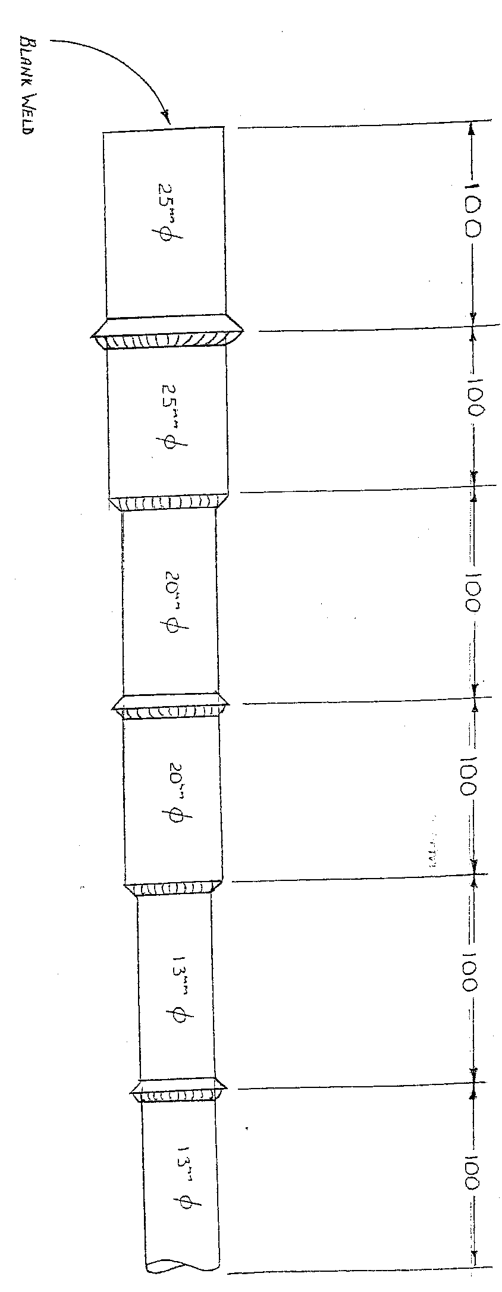
- Blank Weld
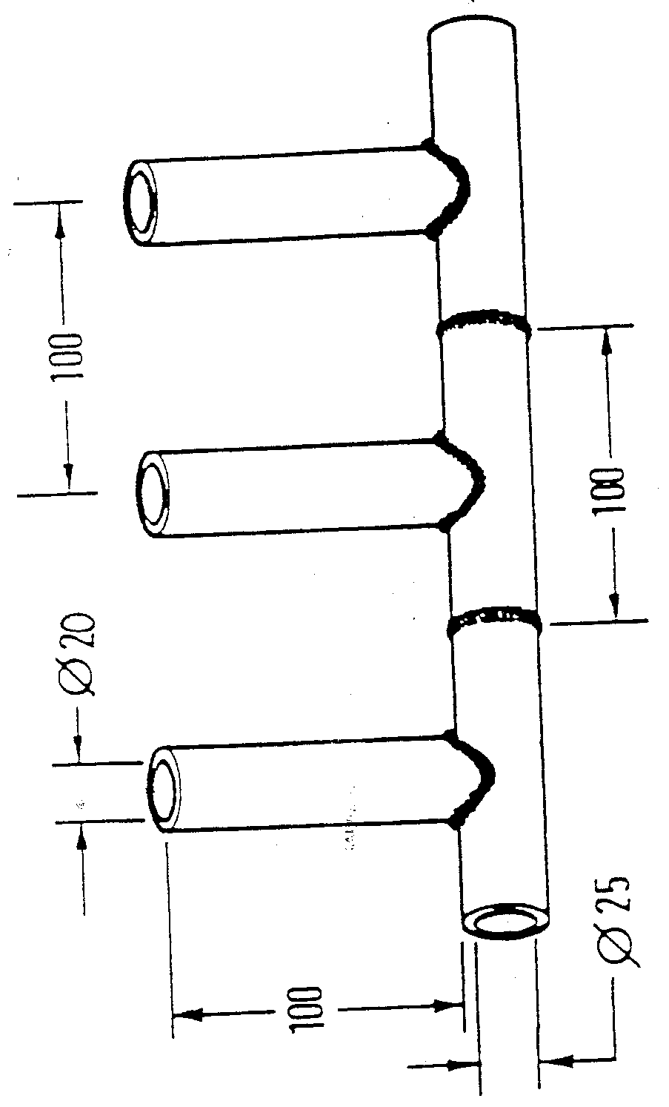
- Figure 19

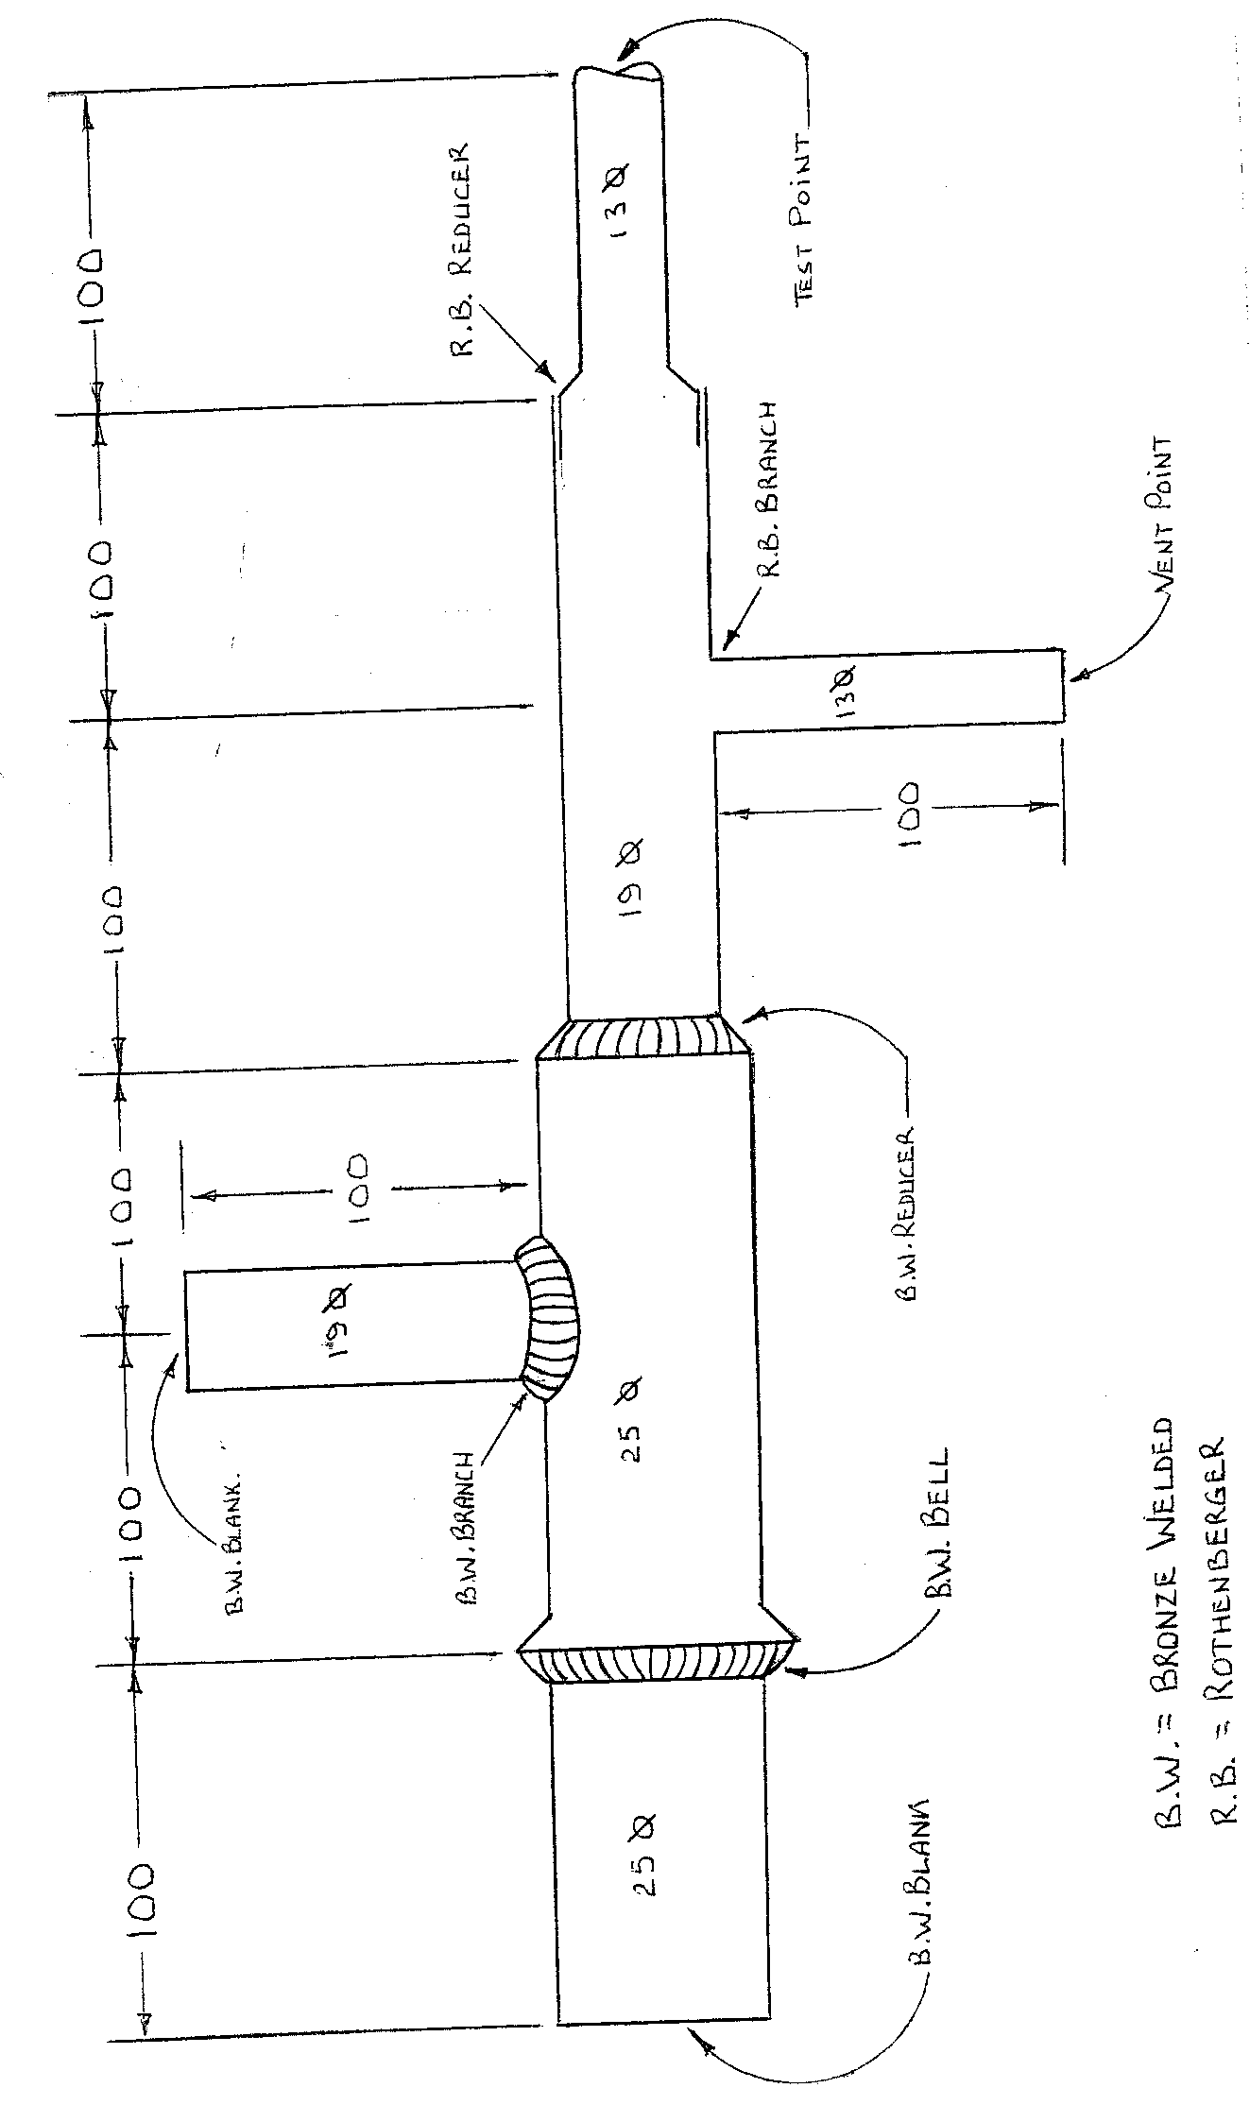
- Bronze Welding

Self Assessment

Exercises
Answer the following:
- Name three types of bronze welded joints.
- What type of flame is recommended for bronze welding?
- Explain the purpose of flux in bronze welding.

Index

B
bell joint 9
blank welds 9
branch joint 9
brazing 9
bronze welding 9
types of 9
butt joint 9
R
reducing joint 9

