Trade of Plumbing
Module 2: | Domestic Hot and Cold Water Service
Unit 10: | Hot Water Supply
 | Phase 2

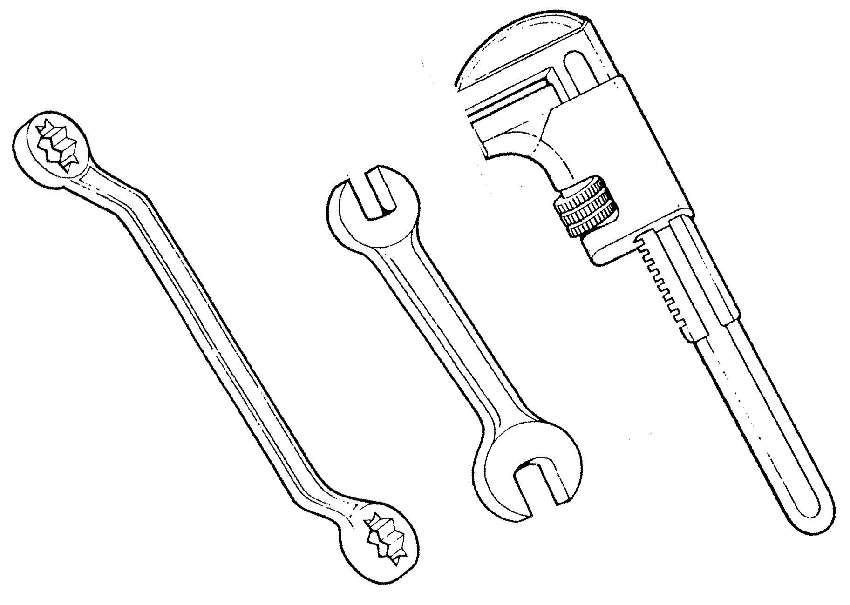

Table of Contents
List of Figures 4
List of Tables 5
Document Release History 6
Module 2 – Domestic Hot and Cold Water Services 7
Unit 10 – Hot Water Supply 7
Learning Outcome: 7
Learning Points: 7
Training Resources: 8
Key Learning Points Code 8
Direct Cylinder System of Hot Water Supply 9
Circulation of Water in Boiler, Pipes, and Cylinders 14
One Pipe Circulation 18
Dead Legs and Secondary Circulation 20
Indirect System of Hot Water Supply 23
Circulation of Water on Boilers, Pipers and Cylinders 24
Fitting Feed and Expansion Tanks 27
Stratification 31
Boilers 33
Defects in Hot Water Systems 35
Air Locks 35
Scale Deposits 35
Cylinder Collapse 37
The Importance of the Vent 37
Self Assessment 38
Exercise: 38
Index 39

List of Figures
Figure 1. Boilers 10
Figure 2. Installing Back Grate Boilers 11
Figure 3. Direct Hot Water Supply 13
Figure 4. Direct Hot Water System 15
Figure 5. Convection Currents 16
Figure 6. Direct Hot-Water Supply System 17
Figure 7. One Pipe Circulation 18
Figure 8. One Pipe Circulation 19
Figure 9. Secondary Circulation 21
Figure 10. Direct Cylinder System 22
Figure 11. Indirect Hot Water Supply System 25
Figure 12. Expansion Tanks 27
Figure 13. Cistern 28
Figure 14. Feed and Expansion Cistern 29
Figure 15. Indirect Cylinder with Immersion Heater 30
Figure 16. Stratification 32
Figure 17. Single Flue & Parkray 34
Figure 18. Defects in Hot Water Systems 36

List of Tables

Document Release History
Date | Version | Comments
June 2006 | V.1.0
19/02/14 | 2.0 | SOLAS transfer

Module 2 – Domestic Hot and Cold Water Services

Unit 10 – Hot Water Supply
Duration – 20 Hours

Learning Outcome:
By the end of this unit each apprentice will be able to:
- Describe the direct and indirect systems of domestic hot water supply.
- Describe the features of hot water storage cylinders.
- Draw a schematic representation of direct and indirect hot water systems.
- Calculate volume and capacities of storage cylinders.
- Calculate intensity of pressure and total pressure in hot water systems.

Learning Points:
RK | Direct system of hot water.
RK | Indirect system of hot water.
RK | Direct and indirect cylinders - capacities, connections, materials, siting, insulation etc.
RK | Horizontal cylinders.
RK | Quick recovery cylinders
RK | Primary flow and return pipework.
Sc | Heat transfer and circulation of hot water.
Sc | Stratification of water.
RK Sc | Expansion of water, vent pipe.
Sc | Collapse of cylinders.
RK | Hot water distribution pipework.
RK | Temperature of hot water.
RK | One pipe circulation.
RK | Dead legs and secondary circulation.
RK | Immersion heaters.
RK | Defects in hot water systems.
P | Problem solving.
D | Schematic drawings.
M | Calculation of storage cylinder volumes and capacities.
M | Calculation of intensity of pressure and total pressure.

Training Resources:
Classroom facilities and information sheets.

Key Learning Points Code
M = Maths D= Drawing RK = Related Knowledge Sc = Science
P = Personal Skills Sk = Skill H = Hazards

Direct Cylinder System of Hot Water Supply
When central heating is not installed in a house the direct cylinder system of hot water supply may be used. In this method of hot water supply all the hot water drawn off at tap has passed through the boiler. The main equipment required for the direct system of hot water supply is as follows:
- A direct back boiler, (see Figure 1).
- A direct cylinder, (see ).
- A cold water storage cistern.
To fully understand the direct system of hot water supply let us visualise it being filled for the very first time.
A 19mm connection is taken from the cold water storage cistern in the roof space to feed the cylinder. A gate valve must be fitted on this pipe to isolate the hot water system in order for repair work to be carried out. The pipe is referred to as the COLD FEED and is fitted to the lowest connection on the cylinder; (A in ).
Water flowing down the cold feed and into the cylinder will then pass through the next lowest connection (B) and on down to fill the boiler which is at the lowest point in the system. This pipe is known as the PRIMARY RETURN to the boiler.
Having filled the boiler, the water will then start to rise up the primary flow pipe and re-enter the cylinder at connection (C).
The cylinder will fill until water rises through the vent pipe at connection (D). Water will continue to rise up the vent pipe until it reaches a height equal to the level of water in the storage cistern.
The vent pipe, which is also known as the expansion pipe, is the pipe from which all connections to hot water appliances are taken. Because the hot water is drawn off at the top of the cylinder, it is impossible to empty the system through the draw of taps.
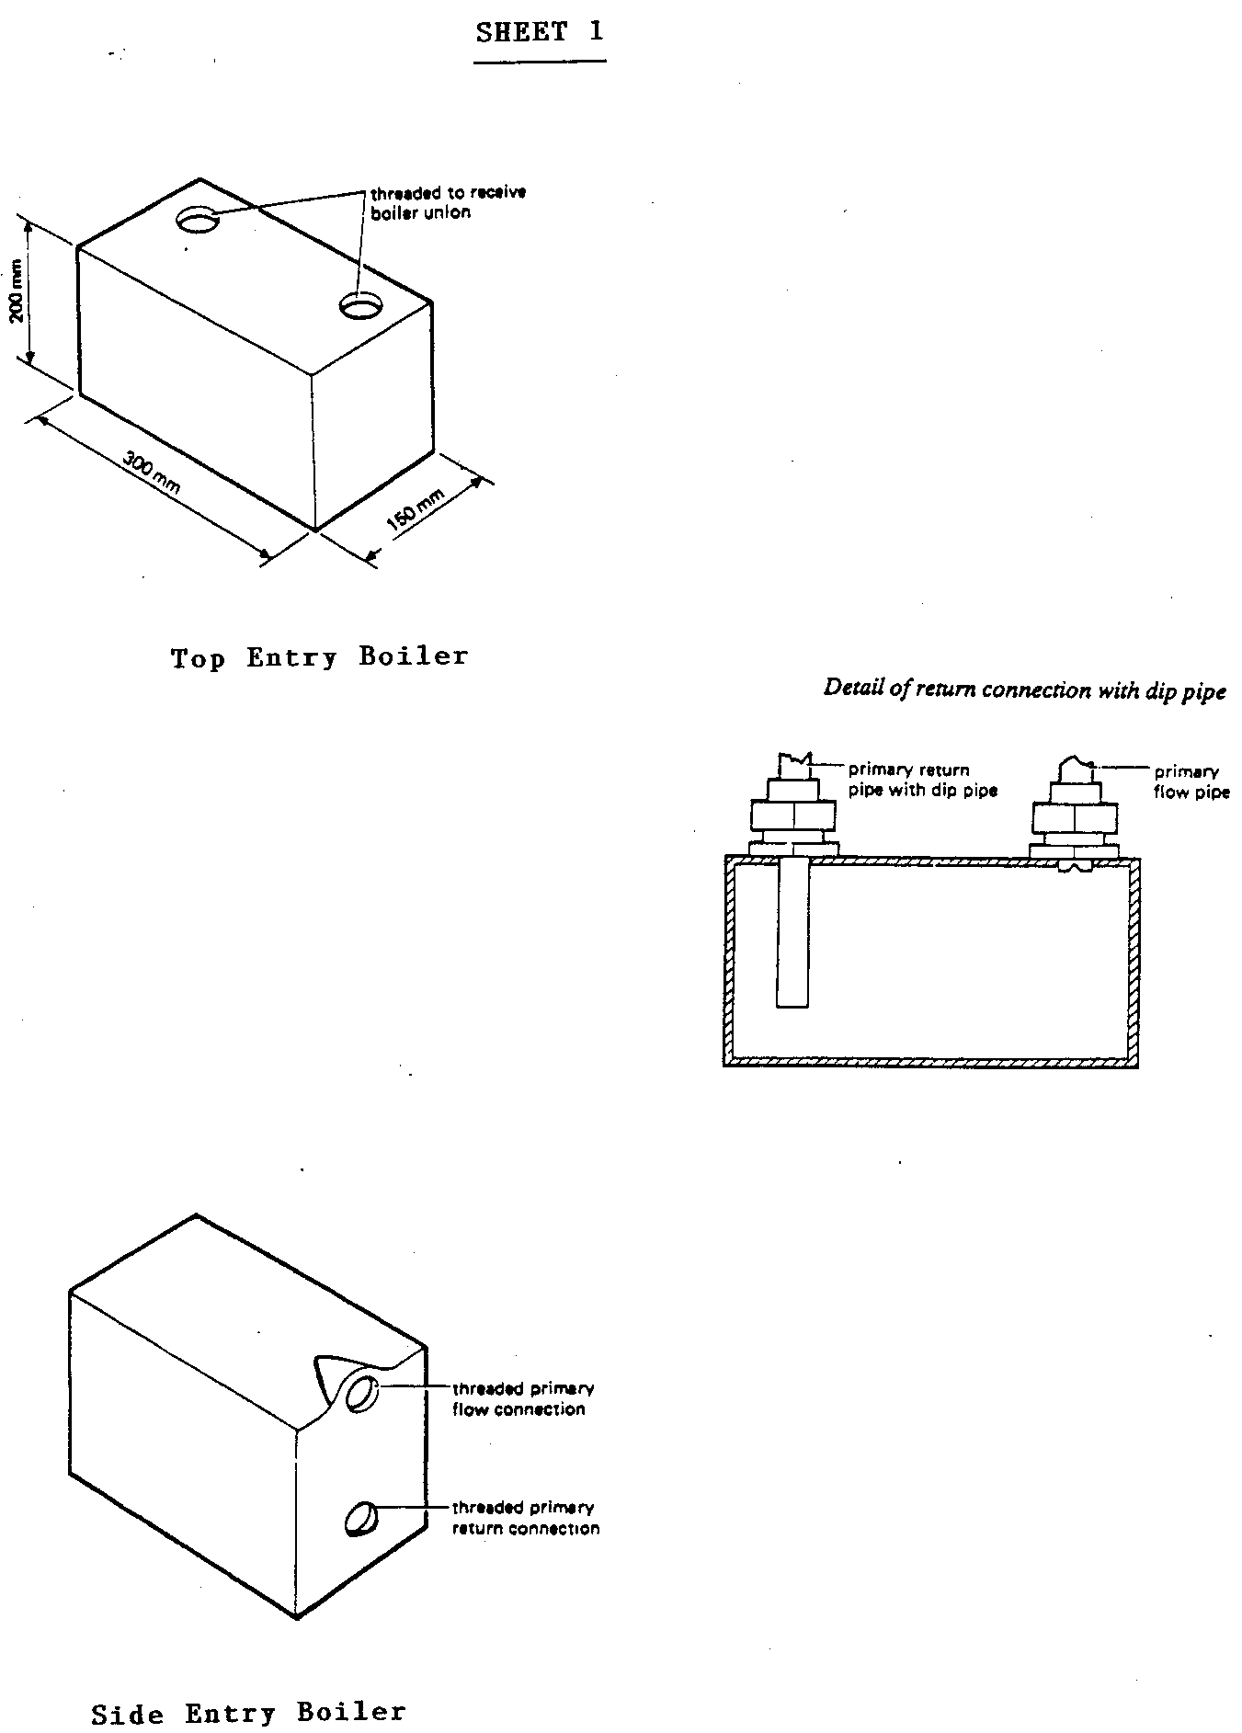
- Boilers

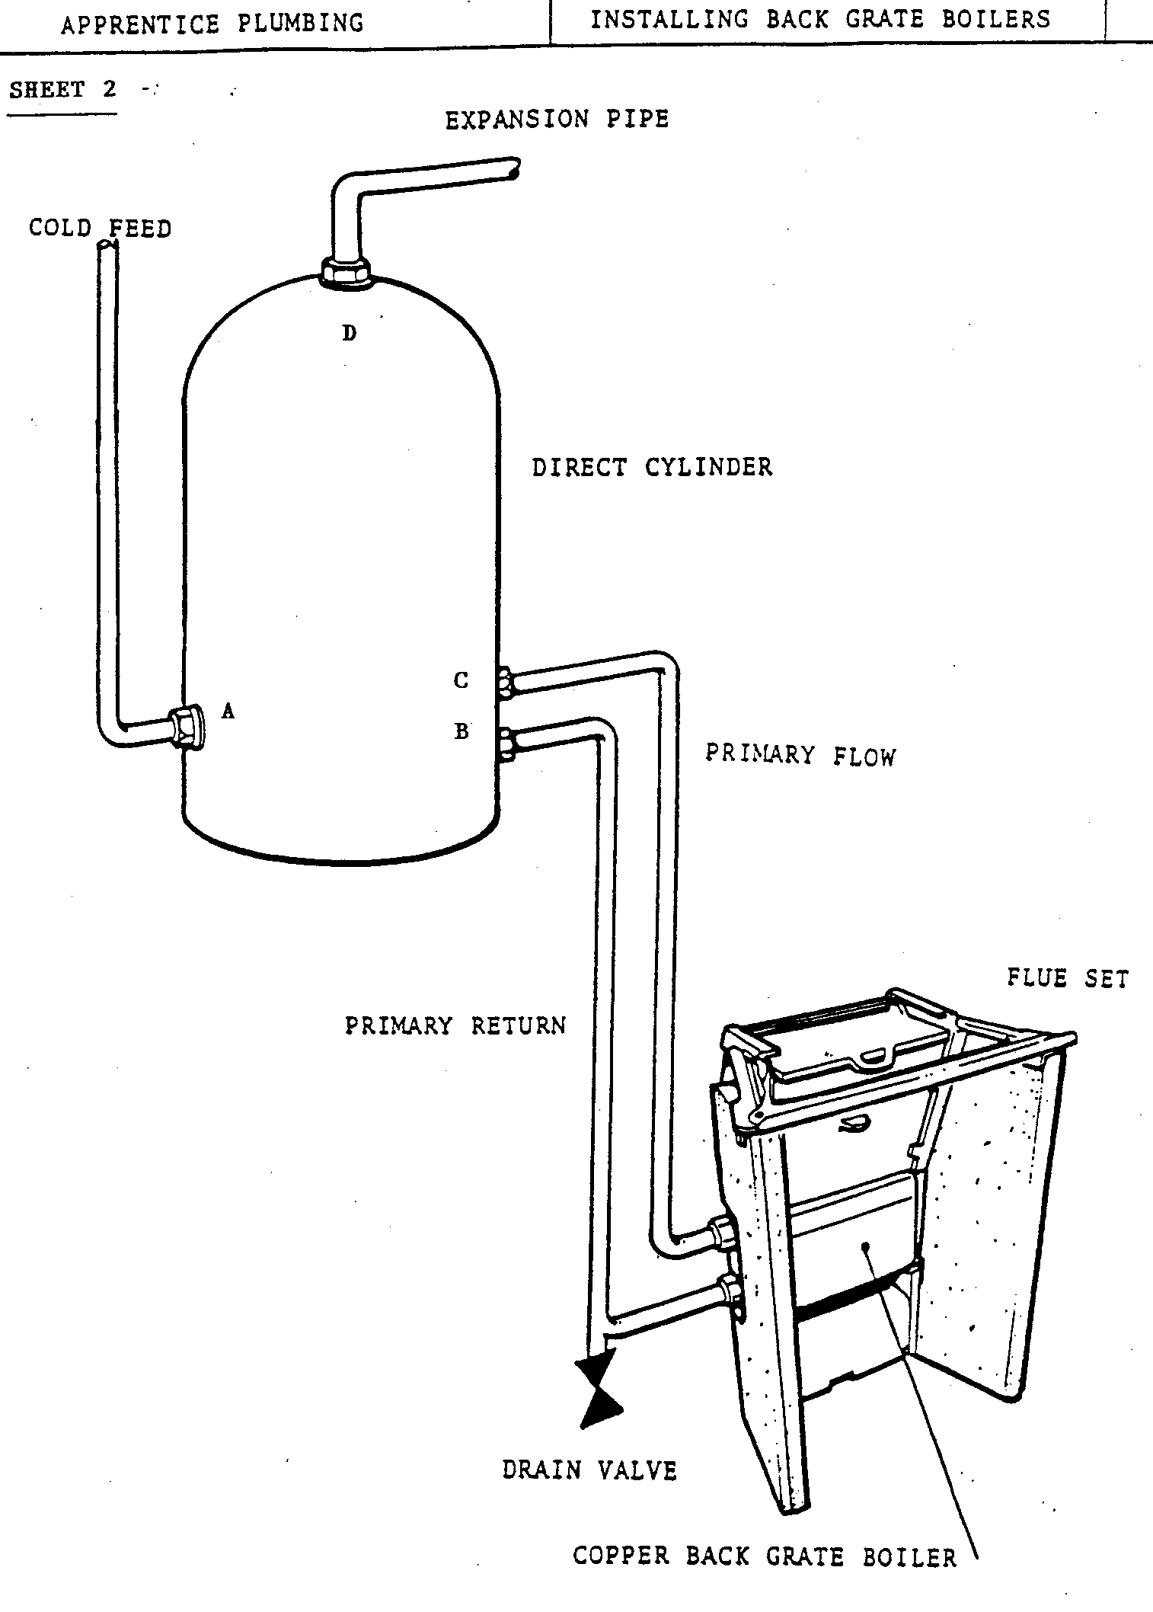
- Installing Back Grate Boilers
In designing the direct cylinder system the following points must be observed:

Position of the Cylinder
The best position for the cylinder is close to the boiler, as it will prevent excessive heat loss from the circulation pipes.

The Boiler
The hot water demand for houses varies widely, but it is usual to assume a heating-up period of 11/2 – 2 hours. There are several methods of heating the water, the most usual being an independent boiler in the kitchen or a back grate boiler behind an open fire.
Direct back boilers are generally manufactured in stainless steel or copper. As this system has a continuous supply of fresh water passing through it, these materials must be used to prevent corrosion and discolouration of the water.

Position of the Cold Water Storage Cistern
Since the pressure of water at the taps is obtained from the cold water storage cistern, the cistern must be placed in the highest possible position either in the roof space or at ceiling level.

Primary Flow and Return Pipes
The two pipes should rise steadily from the boiler to the cylinder to prevent air locks and also to improve circulation.

Hot Water Supply Pipe
This should be connected to the top of the cylinder, and to prevent ‘one pipe’ circulation, run almost horizontally for at least 457mm.

Vent Pipe
This should be continued above the water level in the cistern to the extent of one-sixteenth the height from the bottom of the cylinder to the water level in the cistern.
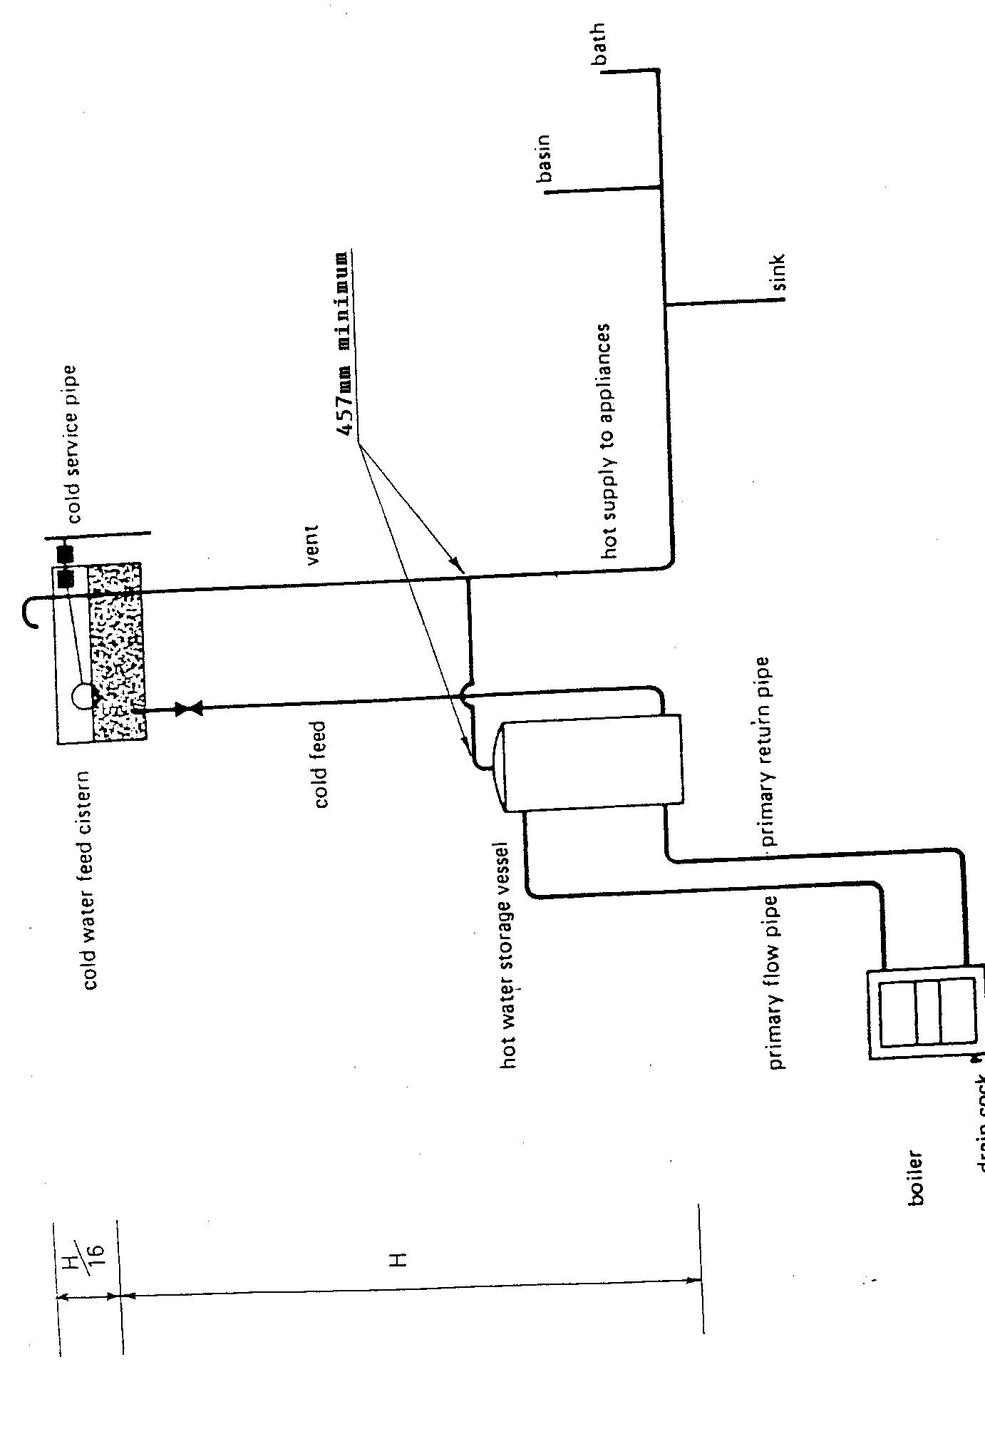
- Direct Hot Water Supply

Circulation of Water in Boiler, Pipes, and Cylinders
The direct cylinder system of hot water supply is based on the principle of gravity circulation. This is the movement of the heated water brought about by convection currents. These currents are set up by the difference in density between water at different temperatures.
Figure 4 below shows a simple system with boiler, circulating pipes and cylinder. The water in the cylinder is heated as follows:
- Radiant heat from the fire is conducted through the boiler plate.
- The water in contact with the boiler plate becomes heated and therefore becomes less dense than the cold water.
- The cold water pushes the heated water to the top of the boiler and as more heat is applied, the water passes up the flow pipe.
- Hot water enters the cylinder and convection currents are set up until warm water eventually passes down the return pipe, and being at a lower temperature than the water in the flow pipe, and therefore heavier, it continues to push the water being heated in the boiler up the flow pipe and into the cylinder until all the water in the cylinder is heated.
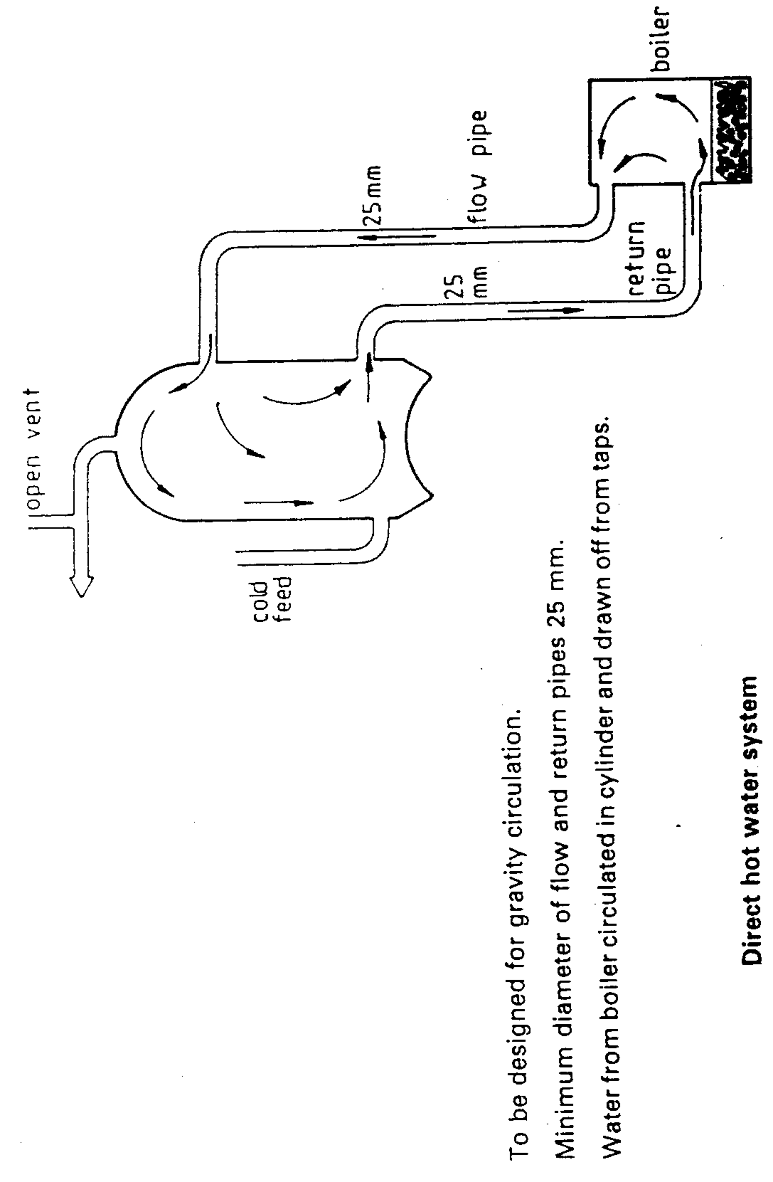
- Direct Hot Water System
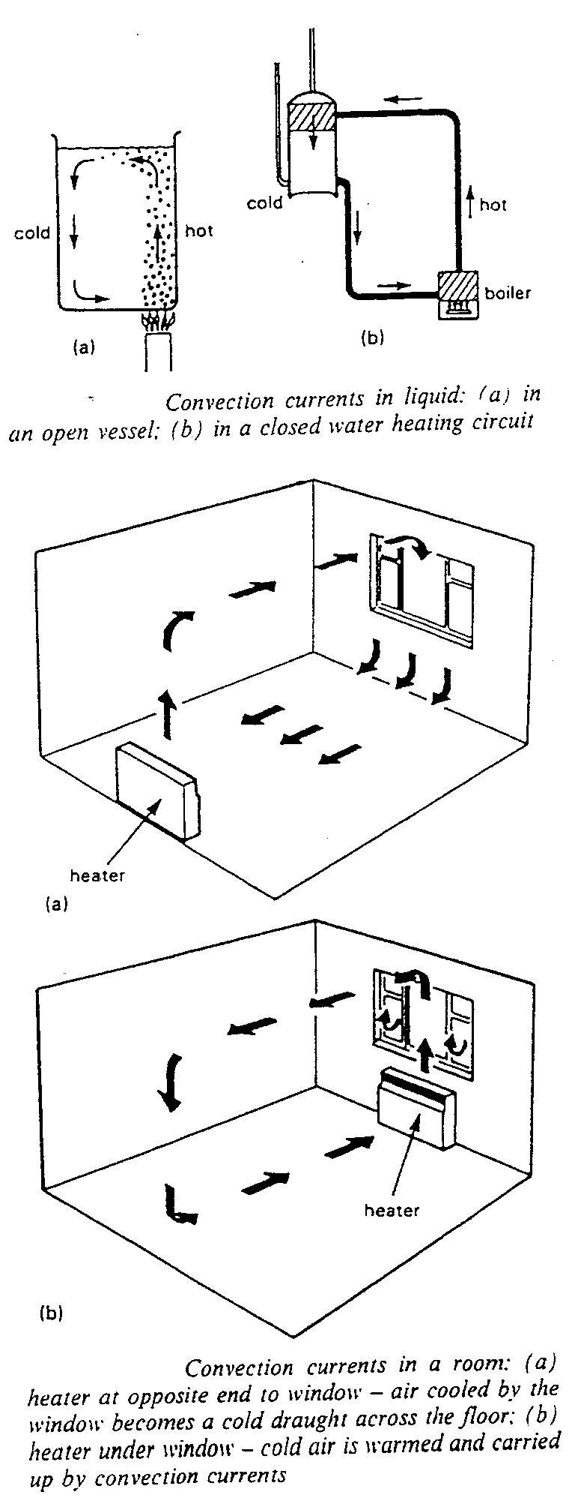
- Convection Currents
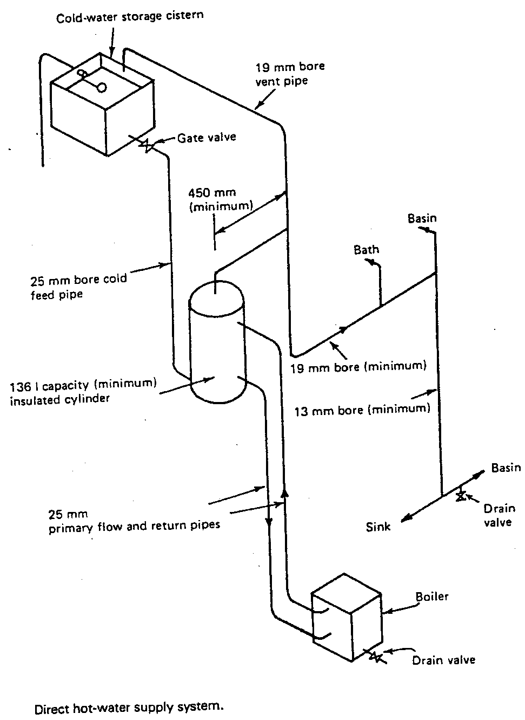
- Direct Hot-Water Supply System

One Pipe Circulation
One pipe circulation is a form of circulation in which the circulatory flow and return of hot water takes place in the same pipe, due to convection currents. See Fig 1 in .
When installing a hot water storage vessel it is advisable to run the vent or hot draw off connection horizontally for at least 457mm. This prevents one pipe circulation and its subsequent waste of heat.
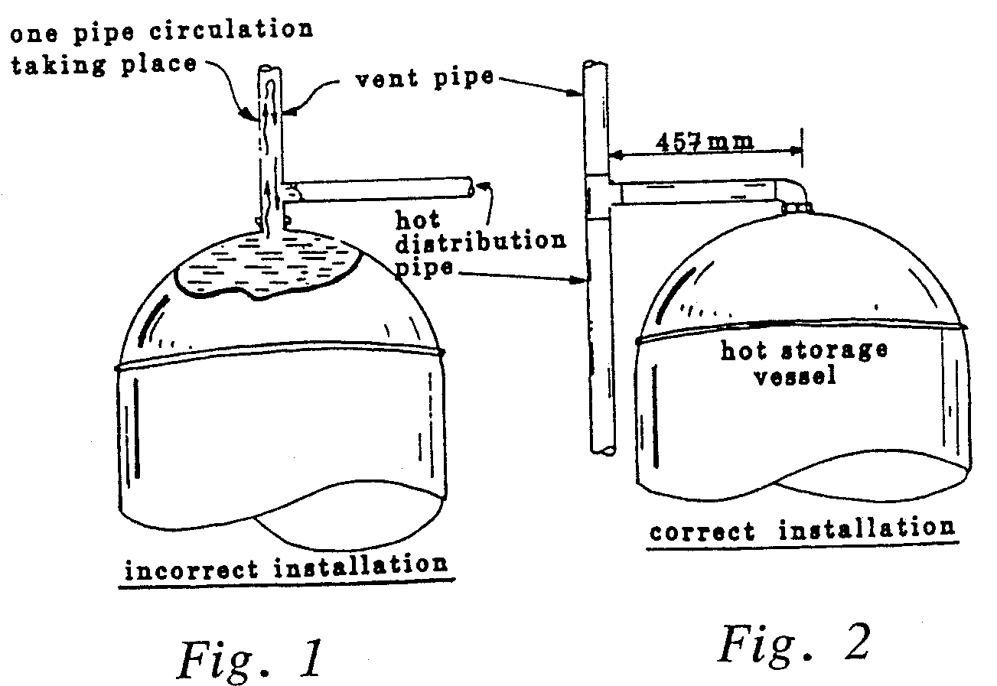
- One Pipe Circulation
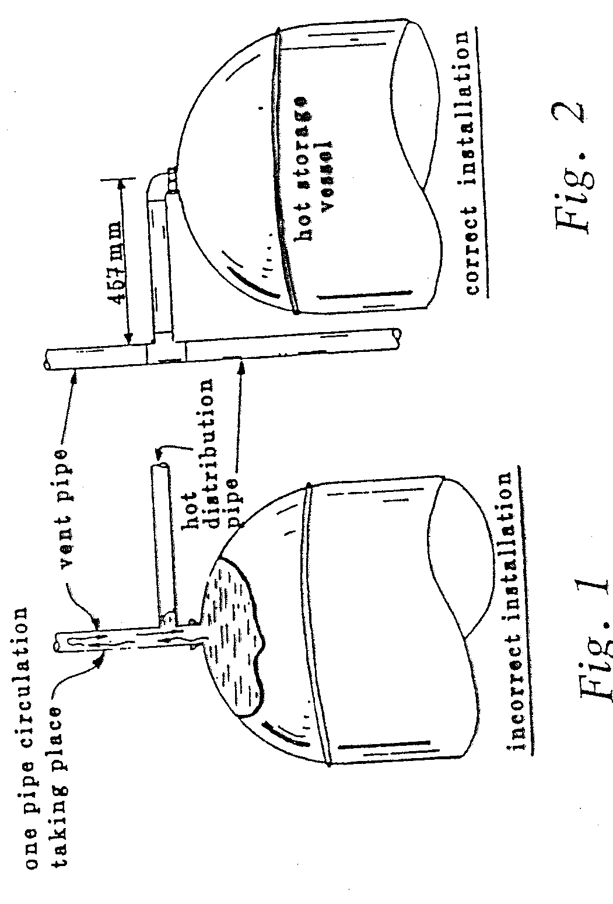
- One Pipe Circulation

Dead Legs and Secondary Circulation
A dead leg is a term used to describe a situation where cold water has to be drawn off from a hot tap before a supply of hot water is obtained. It is caused by the hot storage vessel being fitted a long way away, thus you have an excessively long hot water distribution pipe. Dead legs are not normally a problem in a domestic installation but in larger systems such as hotels, hospitals, factories etc, they are wasteful both of energy and water.
To promote maximum economy of energy and water the hot water distribution system should be designed so that hot water appears quickly at draw-off taps when they are opened. To achieve this it is necessary to install a secondary return.
Secondary circulation is achieved by fitting a secondary return pipe after the last hot water connection on the system. The secondary return should connect to the top third of the hot store vessel; if this is not done the hot water will mix with the cooler water in the vessel reducing its temperature.
In systems where it is not possible to attain secondary circulation by gravity, a non-corroding circulating pump should be installed to ensure that water within the secondary circuit remains hot. The pump should be located on the secondary return pipe close to the cylinder.
Fig 3 in Figure 10 below shows a direct cylinder system with a secondary return fitted.
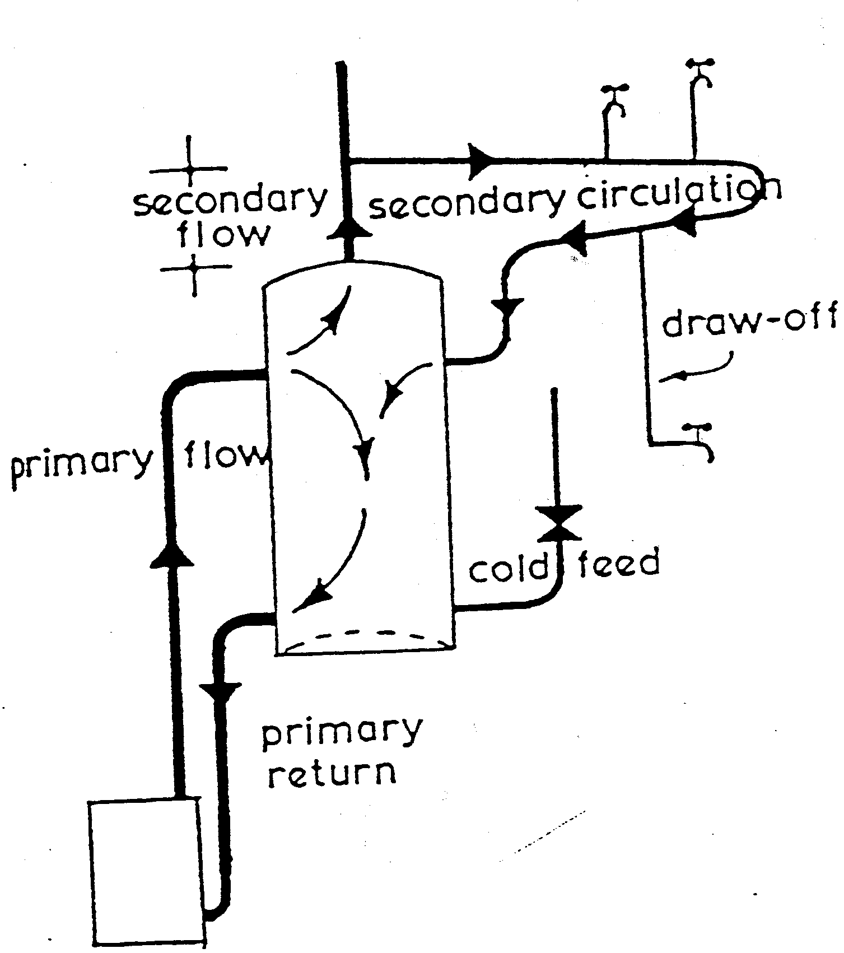
- Secondary Circulation
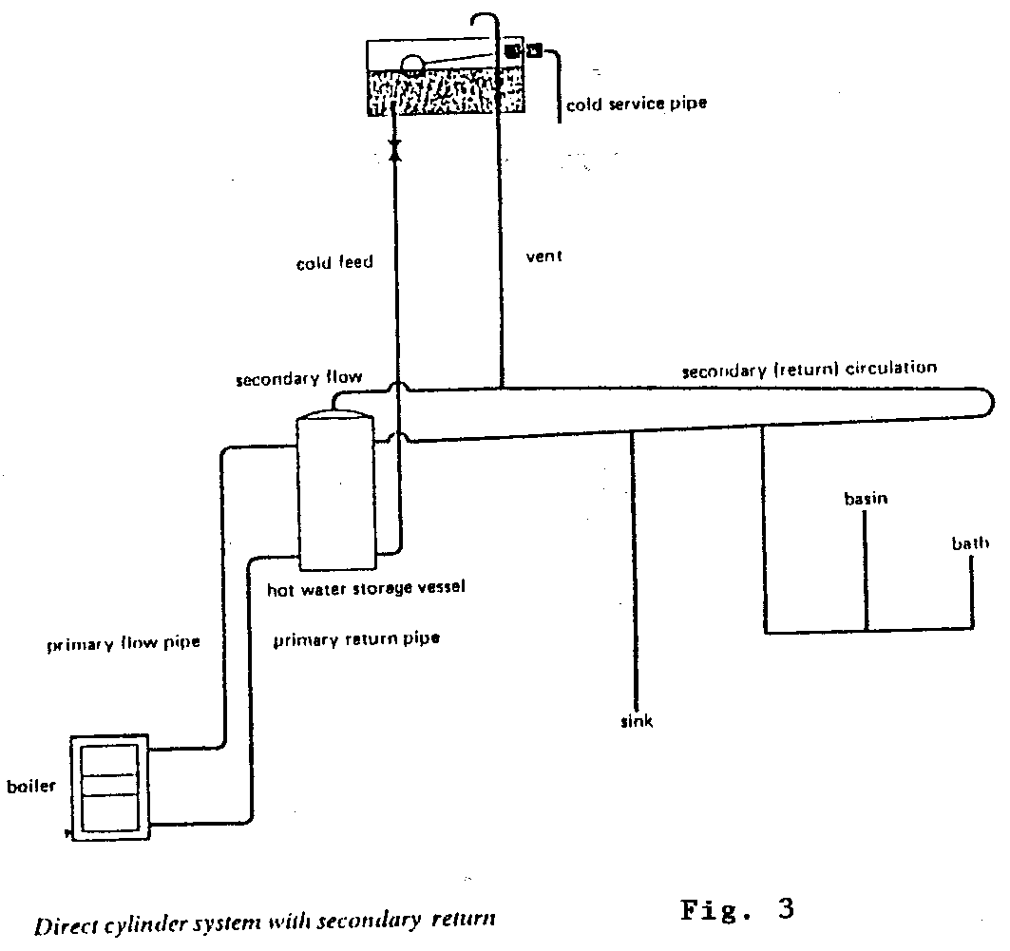
- Direct Cylinder System

Indirect System of Hot Water Supply
When central heating is installed in a house it is not usual to use the direct system of hot water supply. One reason for not using the direct system is that radiators, usually manufactured from mild steel, will rust easily because of the oxygen content of fresh water. This will cause discolouration of the water at the hot water taps. For this reason the indirect system of hot water supply must be used and the main equipment is as follows:
- A boiler.
- An indirect cylinder.
- A feed and expansion cistern.
The system we are about to describe is known as “the open vented indirect hot water heating system”.
To fully understand the indirect system of hot water supply let us visualise it being filled for the very first time.
A 45 litre feed and expansion cistern is located in the roof space to supply the system. A 13mm connection is taken from the cistern and connects to the return pipe close to the boiler at A in Fig 1 below.
When the boiler is full, water will rise through the 25mm diameter primary flow and return pipes filling the coil in the cylinder.
As the system continues to fill the water will rise up the 19mm diameter vent pipe until it reaches the same level as the water in the feed and expansion cistern.

Circulation of Water on Boilers, Pipers and Cylinders
Figure 11 shows a simple system with boiler, circulating pipes and indirect cylinder. An indirect cylinder is a cylinder which has a coil fitted as shown in Figure 15.
The water in the indirect cylinder is heated as follows:
- Radiant heat from the fuel is conducted through the boiler plate.
- The water in contact with the boiler plate becomes heated and therefore becomes less dense than the cold water.
- The cold water pushes the heated water to the top of the boiler and as more heat is applied, the water passes up the flow pipe.
- Hot water enters the coil in the indirect cylinder and transfers its heat by conduction to the cooler water surrounding the coil. Heat will always travel from the hotter to the cooler in any element and will continue to do so until the difference in temperature disappears. In giving off its heat to the surrounding water, the water within the coil cools and becomes heavier than the hot water following from the boiler. The cooler water returns to the boiler via the primary return pipe to be re-heated. This is an ongoing process and will continue until the water in the cylinder reaches the temperature required. This is a basic heating circuit.
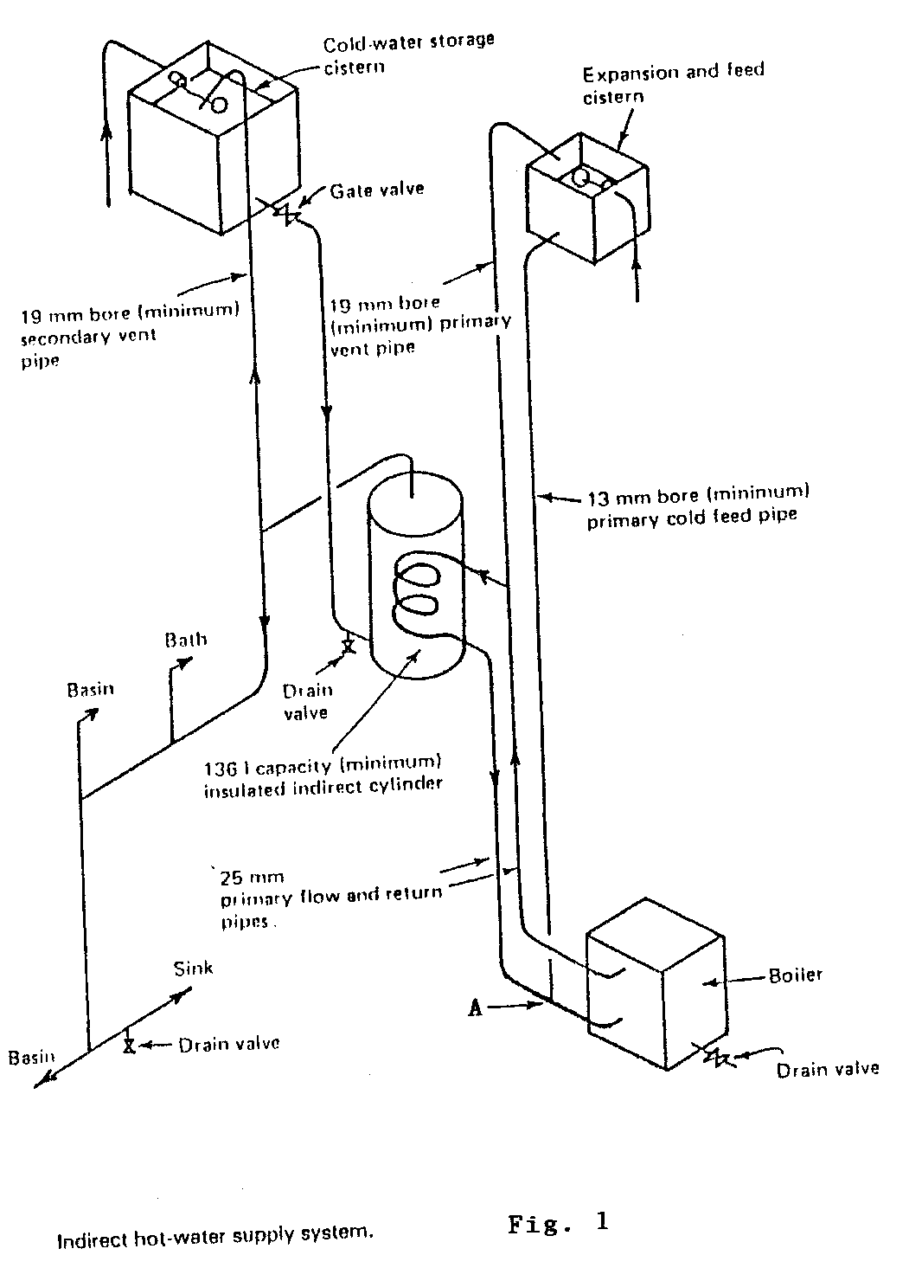
- Indirect Hot Water Supply System
When designing the indirect system of hot water supply the following points must be observed:

Position of the Cylinder
The best position for the cylinder is close to the boiler as this will prevent excessive heat loss from the circulation pipes.

The Boiler
These can be manufactures from cast iron, steel, aluminium and copper. If they are made from cast iron or steel, rusting or discolouration of the water does not cause problems, because the water in this system does not come directly into contact with the domestic hot water which comes through the taps.

Position of the Cold Water Storage Cistern
The cold water storage cistern should be positioned in the attic space in accordance with good plumbing practices.

The Feed and Expansion Cistern
This is used to feed water and to take up the expansion of water from an open vented hot water heating system. It should be noted that the volume of water in a heating system expands by approximately 4% when heated. As shown in Fig 2 in Figure 12 the water level should be set sufficiently low so that when the water heats up and expands it will not rise to a point higher in the cistern than 25mm below the overflow or warning pipe. This ensures that when the system cools the expanded water will return to the system. As can be seen any fresh water that enters the system will be to replace that which has evaporated only. The feed and expansion cistern should be located at the same level as the cold water storage cistern.

Fitting Feed and Expansion Tanks
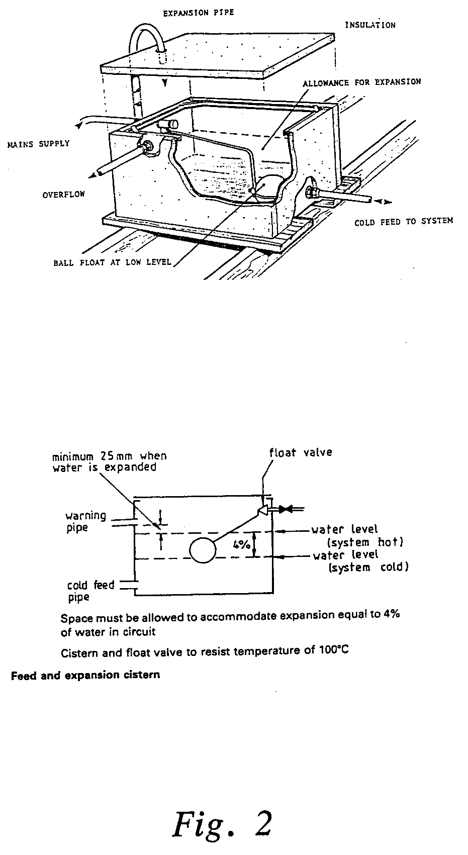
- Expansion Tanks
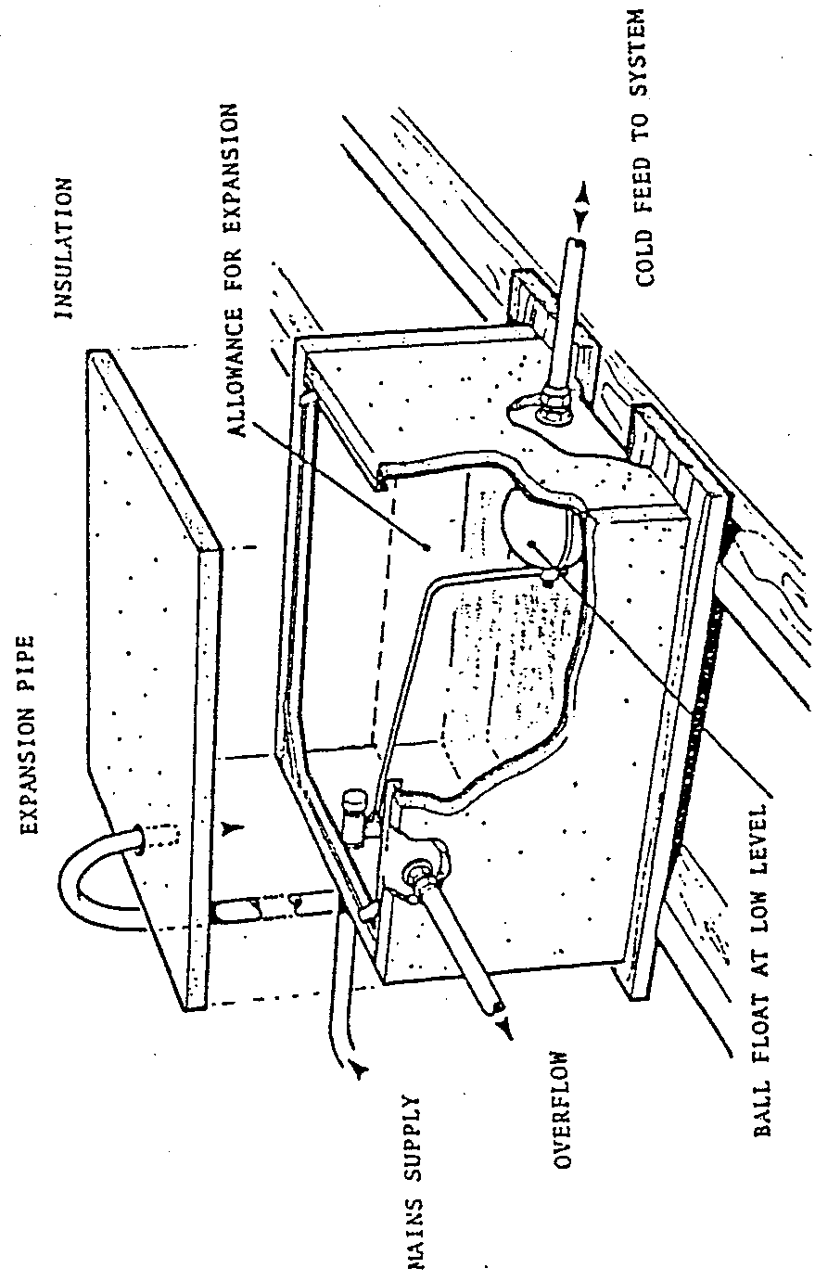
- Cistern

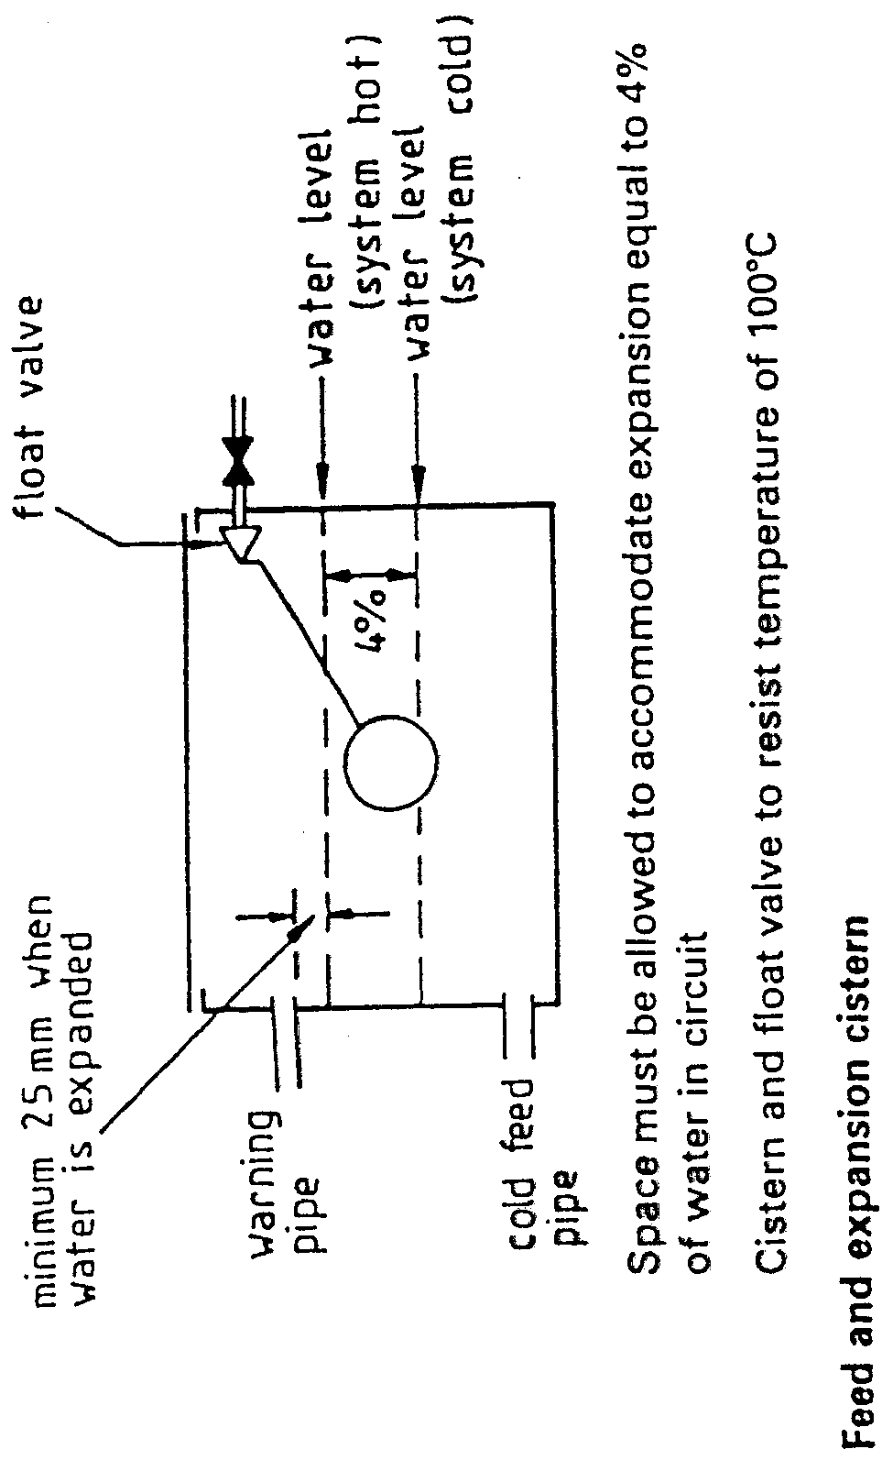
- Feed and Expansion Cistern
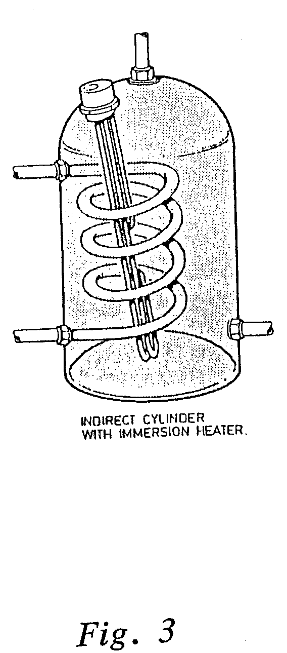
- Indirect Cylinder with Immersion Heater

Stratification
This is the term given to the formation of layers of which in a hot storage vessel from the hottest water at the top down through the temperature range to the coldest water at the bottom.
To enable the system to function to maximum efficiency, this stratification must be encouraged and fostered. Important factors include the shape and size of the hot storage vessel. The best shape is cylindrical. The taller the vessel the better and it should be fitted in a vertical position: horizontally fitted vessels have poor stratification properties.
The next important point is that the entry of the cold feed should always be in a horizontal direction, so that the incoming cold water does not disturb or destroy the existing stratification. In the normal vertical cylinder the cold feed connection ideally is placed in a horizontal position near the base. This is not the case with cylinders fixed in a horizontal position, therefore some modification is necessary. The modification takes the form of a spreader tee fitted inside the vessel, which diverts the flow of water from a vertical to a horizontal direction. The drawings below clearly indicate what is meant by stratification and how the design and connections play such a vital part in obtaining and retaining the supply of water.
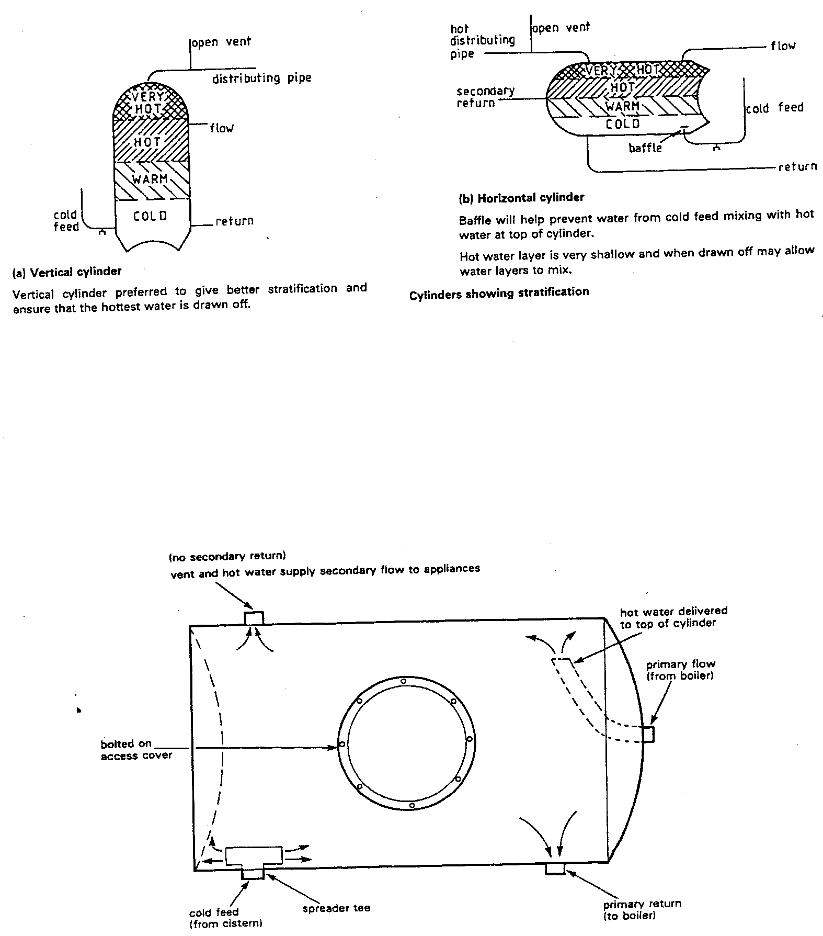
- Stratification

Boilers

What is a boiler?
A boiler is simply an enclosed vessel in which water is heated by the application of heat, which could be either from solid fuel, gas, oil or electricity. There are many types, sizes and shapes of boilers, therefore the examples given are but a few. Information on individual types and makes of boilers can be readily obtained from manufacturers and suppliers.

Solid Fuel Boilers
These include those which burn wood, coal, turf or anthracite. They are not considered to be automatic and consequently the temperature in the heating system can vary widely. Solid fuel boilers are only suitable for the open vented central heating systems.

Gas Boilers
As the name suggests these boilers are heated by gas, which in Ireland is usually natural gas or LPG. Gas is an extremely clean and efficient form of fuel. Gas boilers are automatically controlled which gives an even temperature throughout the system leading to a more economical use of the fuel. These boilers can be used on open vented or sealed heating systems.

Oil Boilers
These boilers are heated by pressure jet oil burners. These can produce excessive carbon deposits (soot), therefore the heat exchanger (boiler) needs regular cleaning. In areas where natural gas is not available oil is a good alternative.

Electric Storage Boilers
These are a new concept which uses cheap rate night-time electricity to heat an element which warms up a series of refractory blocks. During the day when the heat is required, a fan blows air around a closed circuit which warms and in turns blows on to a water filled heat exchanger. Electricity is generally considered to be the cleanest but most expensive method of heating water.
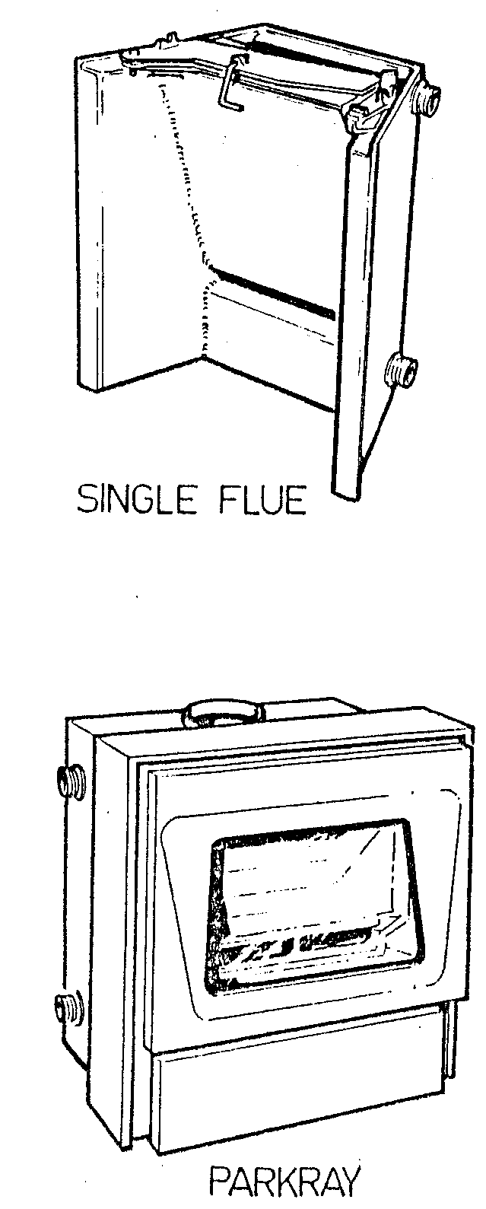
- Single Flue & Parkray

Defects in Hot Water Systems
Generally speaking, most problems in domestic hot water systems are the result of lack o knowledge and appreciation of basic plumbing principles.

Air Locks
Air locks are a very common cause of trouble with both hot water and heating systems. Most air locks are caused by unventilated arches formed in badly fitted pipework. An air lock is a small quantity of air trapped in a pipe which due to the very low circulating pressure available prevents water passing through the pipe.
Even if an air lock does not completely stop the flow of water it can reduce the flow considerably. Air locks are very often the results of pipes sagging, or not being laid truly horizontally or to appropriate falls. Fig 1 in shows how an air lock occurs in a pipe run, although they are not always as obvious as this.
Another common cause of air locks is shown in Fig 2 in where the cold feed, instead of falling away from the cistern, rises causing an unventilated arch in the bend.
Air may also be locked in a boiler due to defective tappings as shown in Fig 3 in . Boiler manufacturers are aware of this and usually the flow connection is the position shown in Fig 4 in . Probably the worst effect of defective tappings would be a rather noisy boiler. Care must therefore be exercised when installing boilers and primary circulating pipes to avoid collections of pockets of air.
Yet another common cause of air locking is shown in Fig5 in where the hot draw off has been badly fitted causing it to sag and create an air trap at the cylinder connection.

Scale Deposits
The formation of scale deposits in temporary hard water areas can obstruct the primary circulating pipes, but this is unlikely to happen to both pipes simultaneously as the flow pipe carrying the hotter water tends to scale up first and the resultant noises in the boiler would prompt and early investigation.

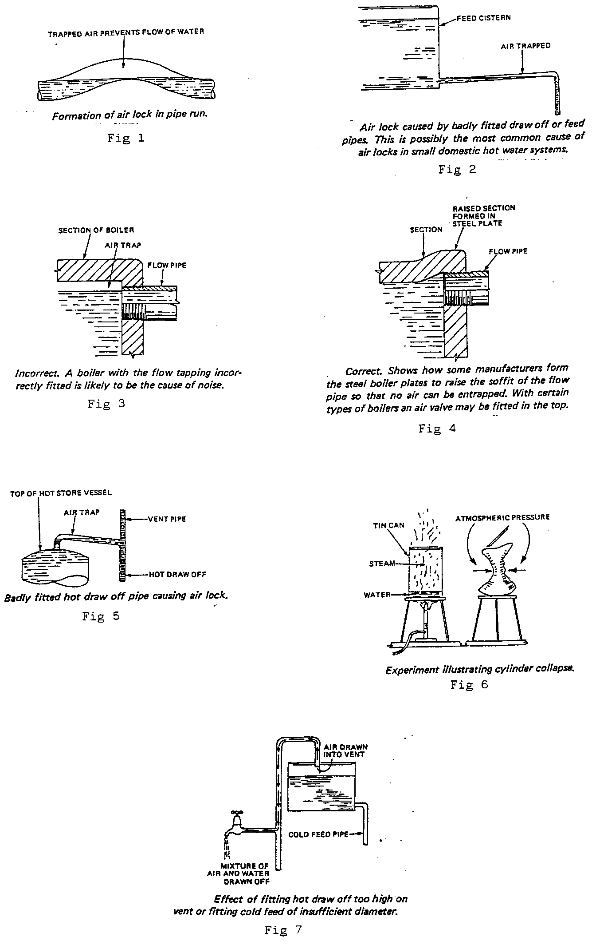
- Defects in Hot Water Systems

Cylinder Collapse
Cylinder collapse is due to the pressure on the inside of the cylinder becoming less than that of the atmosphere. A simple experiment is shown in Fig 6 which illustrates quite clearly the effect of atmospheric pressure. A small amount of water is put into a can which has a close fitting air tight lid. This lid is removed and the water is heated until it boils and gives off steam. When the source of heat is removed the lid is firmly replaced on the can allowing the contents to cool. When the steam condenses and the air in the can cools, it occupies less space, consequently lowering the pressure inside the can. The atmosphere exerts a pressure of approximately 100kN on an area of one square metre, and since this pressure will be far greater than inside the can, the walls of the can will be forced inward until the can has been completely deformed.
Various situations can occur whereby similar conditions can arise in hot water storage vessels causing their collapse. In freezing weather, if the vent pipe is exposed and becomes frozen, any expansion of the water will take place via the cold feed pipe to the storage cistern. As the water temperature increases, steam may form, pushing more water back up the cold feed. Should the water in the cold feed pipe freeze the cylinder now becomes closed to the atmosphere, and a situation now exists similar to that of the tin filled with steam. As the steam in the cylinder condenses the pressure within drops below that of the atmosphere and the cylinder will collapse.
Another cause of cylinder collapse is when a hot water draw off tap at a lower level is opened with both the vent and cold feed frozen. Water will flow from the tap but as none can enter the cylinder to replace it, a siphon is started. As the water is withdrawn the pressure inside the cylinder becomes less than that of the atmosphere so the cylinder sides are crushed inwards.

The Importance of the Vent
In domestic plumbing systems the minimum diameter of the vent pipe is 19mm, as smaller pipes would be more prone to obstruction. The vent is a very important part of the system, its main function being to maintain atmospheric conditions in the pipe-work and permit the escape of air which has entered the system, and more rarely in the event of the water becoming overheated, allows it to discharge over the feed cistern.
Another important factor to observe in relation to vent pipes is to make sure they are terminated well above the flood level, not the overflow level, of the storage cistern. If this is not done, should the vent become submerged, cold water could be siphoned out of the cistern when a hot draw off is opened.
It is also very important to ensure that the vent pipe is well insulated and securely fixed.
If a draw off connection is taken from too high on the vent pipe this could result in a mixture of air and water coming from the taps as shown in Fig 7. A cold feed of insufficient diameter can also be the cause of this problem.

Self Assessment

Exercise:
Apprentice to answer sample question:
- Describe one condition that could lead to the collapse of a domestic hot water cylinder.
- Describe using a sketch how a horizontal indirect cylinder is connected to a boiler, cistern etc., showing all necessary pipework.
- Describe using a sketch the ranges of stratification of water that can occur in:-
a). Vertical indirect cylinders.
b). Horizontal indirect cylinders.
- Describe the conditions that can lead to a poor flow of water at a hot water tap.
- State how noises can occur in hot water systems.
- Give two reasons why insufficient hot water occurs in a building.
- Explain how gravity circulation takes place between the boiler and cylinder in a hot water system.
- Explain how air locks may be eliminated when using high level flow and return pipes.
- Sketch and describe an indirect and direct system of hot water supply for a two storey domestic dwelling showing all components.
- Sketch and describe an indirect system of hot water supply for a single storey domestic dwelling where the cylinder is located 7 metres away from the boiler on the same level.
- Calculate the capacity of water in a hot water cylinder that is 1.2 metres high and has a diameter of 500mm.
- Calculate the capacity of water in a copper pipe that has a 25mm internal diameter and is 2 metres long.
- Calculate the total pressure and intensity of pressure on the base of a hot water storage cylinder that is 500mm in diameter and 1M high.

Index

A
air locks 35
B
back boiler 9
boiler 33
C
central heating 9
cold water storage cistern 9
cylinder collapse 37
D
dead leg 20
direct cylinder 9
direct cylinder system 9
G
gravity circulation 14
I
indirect cylinder 23
O
one pipe circulation 18
S
scale deposits 35
secondary circulation 20
stratification 31
V
vent pipe 37

