Trade of Plumbing
Module 1: | Thermal Process and Mild Steel Pipework
Unit 5: | Drawing
 | Phase 2

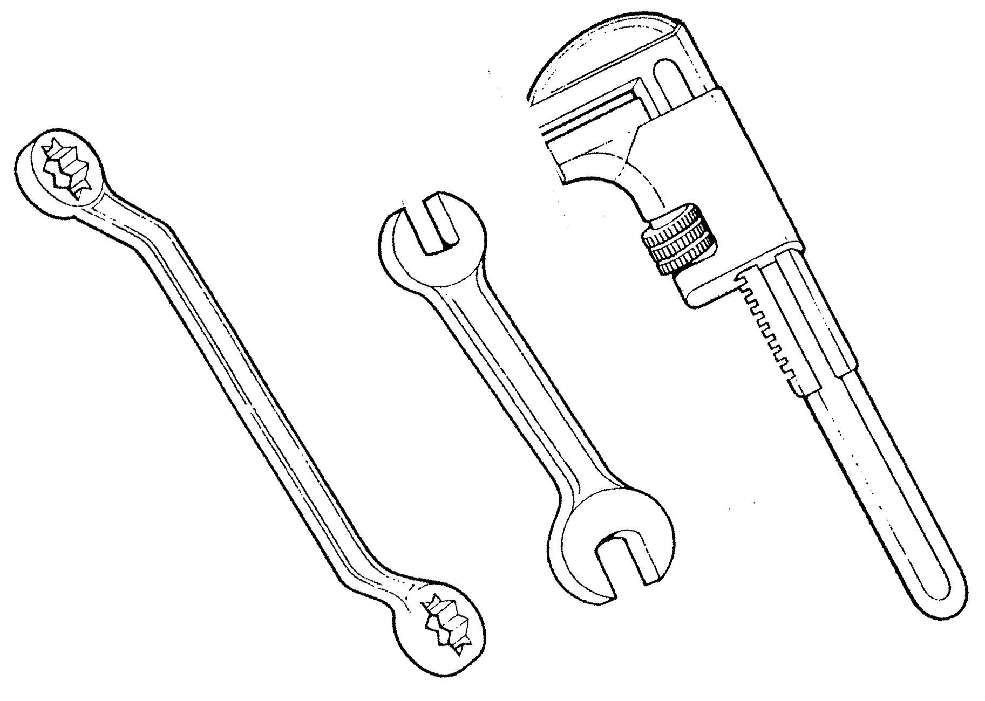

Table of Contents
List of Figures 4
List of Tables 5
Document Release History 6
Module 1 –Thermal Process and Mild Steel Pipework 7
Unit 5 – Drawing 7
Learning Outcome: 7
Key Learning Points: 7
Training Resources: 7
Exercise: 8
Key Learning Points Code: 8
Introduction 9
Materials and Equipment 9
Basic Drawing Equipment 10
Paper Sizes 11
Standards and Conventions 12
Dimensions 12
Letters and Numbers 12
Borders and Title Blocks 13
Scales 14
Scale Rulers 15
Graphical Symbols and Abbreviations 16
Specifications 22
Identification of Pipework 23
Systems of Representation 24
Orthographic Projection 24
Isometric Projection 25
Self Assessment 27
Symbol exercises 27
Index 30

List of Figures
Figure 1. Basic Drawing Equipment 10
Figure 2. Paper Sizes 11
Figure 3. Dimensions 12
Figure 4. Title Block 13
Figure 5. Block Plan 14
Figure 6. Scale Rulers 15
Figure 7. British Standards Institution Symbols 18
Figure 8. Direction of Flow 23
Figure 9. Orthographic Projection 24
Figure 10. Isometric Projection 25
Figure 11. Isometric Projection 26

List of Tables
Table 1. Abbreviations for Pipe Rises/Drops 16
Table 2. Service Abbreviations 17
Table 3. BSI Symbols 19
Table 4. BSI Symbols 20
Table 5. BSI Symbols 21
Table 6. Identification of Pipework 23
Table 7. Symbol Exercises 27

Document Release History
Date | Version | Comments
04/03/14 | 2.0 | SOLAS transfer

Module 1 –Thermal Process and Mild Steel Pipework

Unit 5 – Drawing
Duration – 25 hours

Learning Outcome:
By the end of this unit each apprentice will be able to:
- Produce basic first and third angle orthographic projection drawings.
- Produce basic isometric line drawings.
- Read and interpret working drawings.
- Read and interpret house plans with plumbing details.
- Read and interpret sample industrial mechanical services drawings.

Key Learning Points:
Rk | ‘A’ size drawing sheets.
Rk | Drawing standards and conventions.
Rk D | Borders, title blocks and lettering.
Rk | Dimensioning.
Rk D | Orthographic projection.
D M | Spacing and drawing sheet layout.
Rk D | Isometric projection.
M | Ratios
M | Fractions
Rk D | Reading and interpreting piping drawings.
Rk D | Use of scale rule.
Rk D | Graphical symbols and abbreviations for the plumbing trade.
Rk D | Pipe identification charts.

Training Resources:
Classroom facilities, information sheets, sample working drawings.

Exercise:
Sample Drawing Exercises 2.1.5a, 2.1.5b, 2.1.5c, 2.1.5d, 2.1.5e, 2.1.5f, 2.1.5g, and 2.1.5h shown in the curriculum document.

Key Learning Points Code:
M = Maths D= Drawing RK = Related Knowledge Sc = Science
P = Personal Skills Sk = Skill H = Hazards

Introduction
Drawings are a means of visual communication used to transfer information between people. The ability to read drawings, interpret symbols and understand scales is an essential requisite for the modern craftsperson.

Materials and Equipment
The basic materials and equipment required by the student apprentice are listed below.
- A2 Drawing Board.
- T-Square.
- 45° Set Square.
- 60°/ 30° Set Square.
- Protractor.
- Springbow Compass.
- Metric Scale Rule.
- Selection of Pencils i.e. 2H – 3H – 4H.
- Pencil Sharpener.
- Eraser.
- Drawing Board Clips or Masking Tape.
It should be noted that when purchasing any of these items the standard might vary according to cost. In general however, good equipment may help to produce a better standard of work.

Basic Drawing Equipment
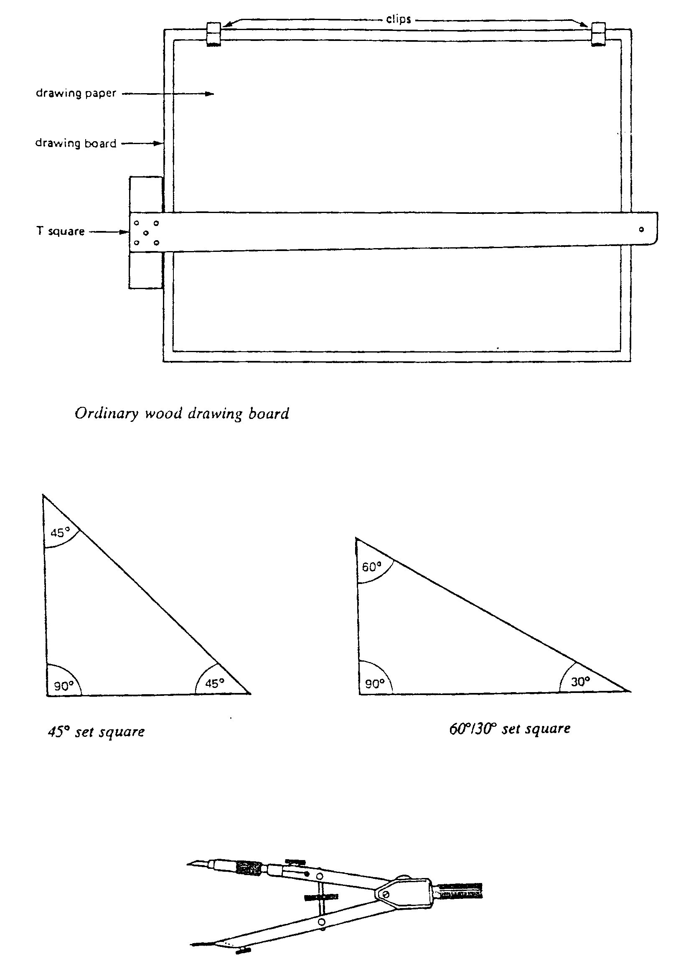

- Basic Drawing Equipment

Paper Sizes
In the metric system the sizes of drawing sheets are referred to as the ‘A’ Series. The largest size is AO and is 1 square metre in area which measures 841mm X 1189mm. If a sheet of AO paper is halved it becomes an A1 size. Similarly if an A1 sheet is halved it in turn becomes A2. This principle follows through whereby if A2 is halved it becomes A3 and if A3 is halved it becomes A4. The drawing below illustrates this principle.
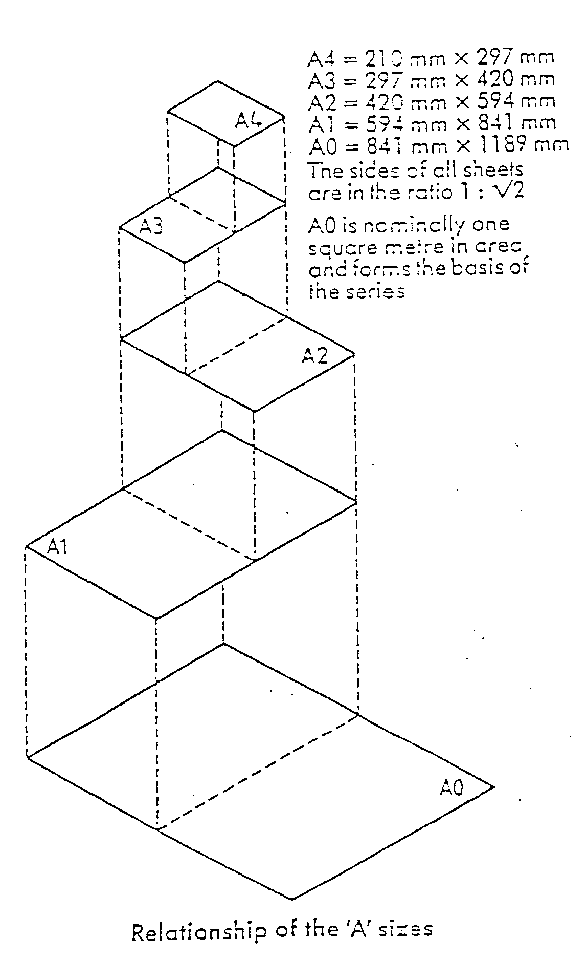

- Paper Sizes

Standards and Conventions
In the construction industry all drawings are carried out to a British Standard referred to as BS 1192. This ensures that every drawing produced within Ireland and the UK relating to a building project will follow the same standard principles.

Dimensions
Dimensions should be shown as follows:

Projection Line

Dimension Line

- Dimensions
The conventions relating to dimensions are as follows:
- State dimensions once only.
- Place in the most appropriate view.
- Keep related dimensions on the same view.
- Select the functional dimensions.
- Avoid redundant dimensions.
Give metric dimensions to the least number of significant figures, for example;
2.5 not 2.50
3 not 3.0
Dimensions less than 1 are expressed with a zero preceding the decimal point;
0.5 not 5

Letters and Numbers
All drawings require some form of lettering and numbers. The principles to remember are:
- They should be legible and clear – especially numbers, as they often have to be read on their own.
- They should be of a suitable size and not less than 3mm tall. Title blocks and relative information are usually larger.
- They should be correctly spaced and positioned. Notes and captions should be placed so that they can be read in the same direction as in the title block. In other worlds it should not be necessary to turn a drawing on its side to read the information.
- Notes should be grouped together and not spread over the drawing.
- Underlining is not recommended.

Borders and Title Blocks
One of the most important features of any drawing is the border and title block. The border (or margin) is a line which follows the outer edge of the drawing and is usually 10 or 20mm inside it. This margin is very important because everything inside it forms part of any contract.
The ‘Title Block’ is locked within the boarder and contains information such as:
- Project title – i.e. New Community School.
- The subject – i.e. Hot and Cold Water Services.
- The date of the original drawing.
- Dates of any revisions.
- Job Number.
- Drawing Number.
- Scale.
- The name of the person who drew up the drawing.
- Name of architects, consultant engineers or surveyors.
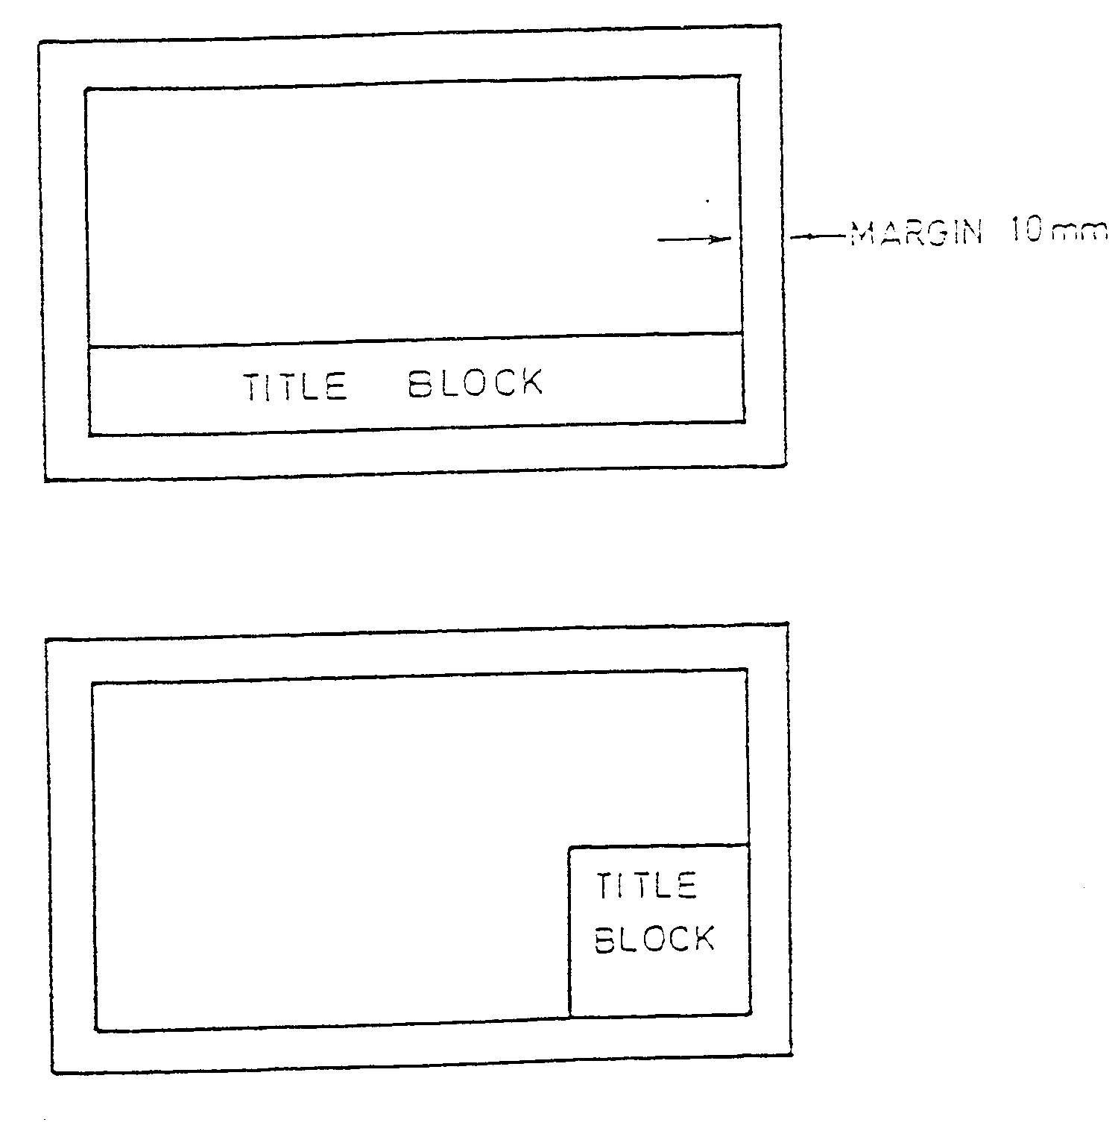
Title Blocks are usually located along the bottom or sides of drawings as shown below:

- Title Block

Scales
A scale can be used to increase the detail of a small object or to accurately represent a large object on a smaller piece of paper. The majority of scaled work done in the construction industry is to reduce objects to a smaller more suitable size that will fit on a sheet of paper.
The list below shows the scales used in BS 1192:
- Block Plans 1:2500 – These show the outlines of buildings and may also indicate roads, railway lines or rivers.
- Site Plans: Between 1:500 and 1:2500 – Although often drawn at the same scale as the block plan site plans only give details relevant to the actual project. These details could relate to landscaping arrangements or show underground drainage pipe-work.
- General Location Drawings 1:200 or 1:100 – These drawings can show pipe runs within the building and the location of radiators and sanitary fixtures.
- When details of boiler houses or plant rooms are given the scale may increase to 1:50. This enables greater detail to be shown.
- Where particular detail is necessary the scale could be as high as 1:20 or 1:10. This could be in the case of a bracket or support for a piece of equipment.
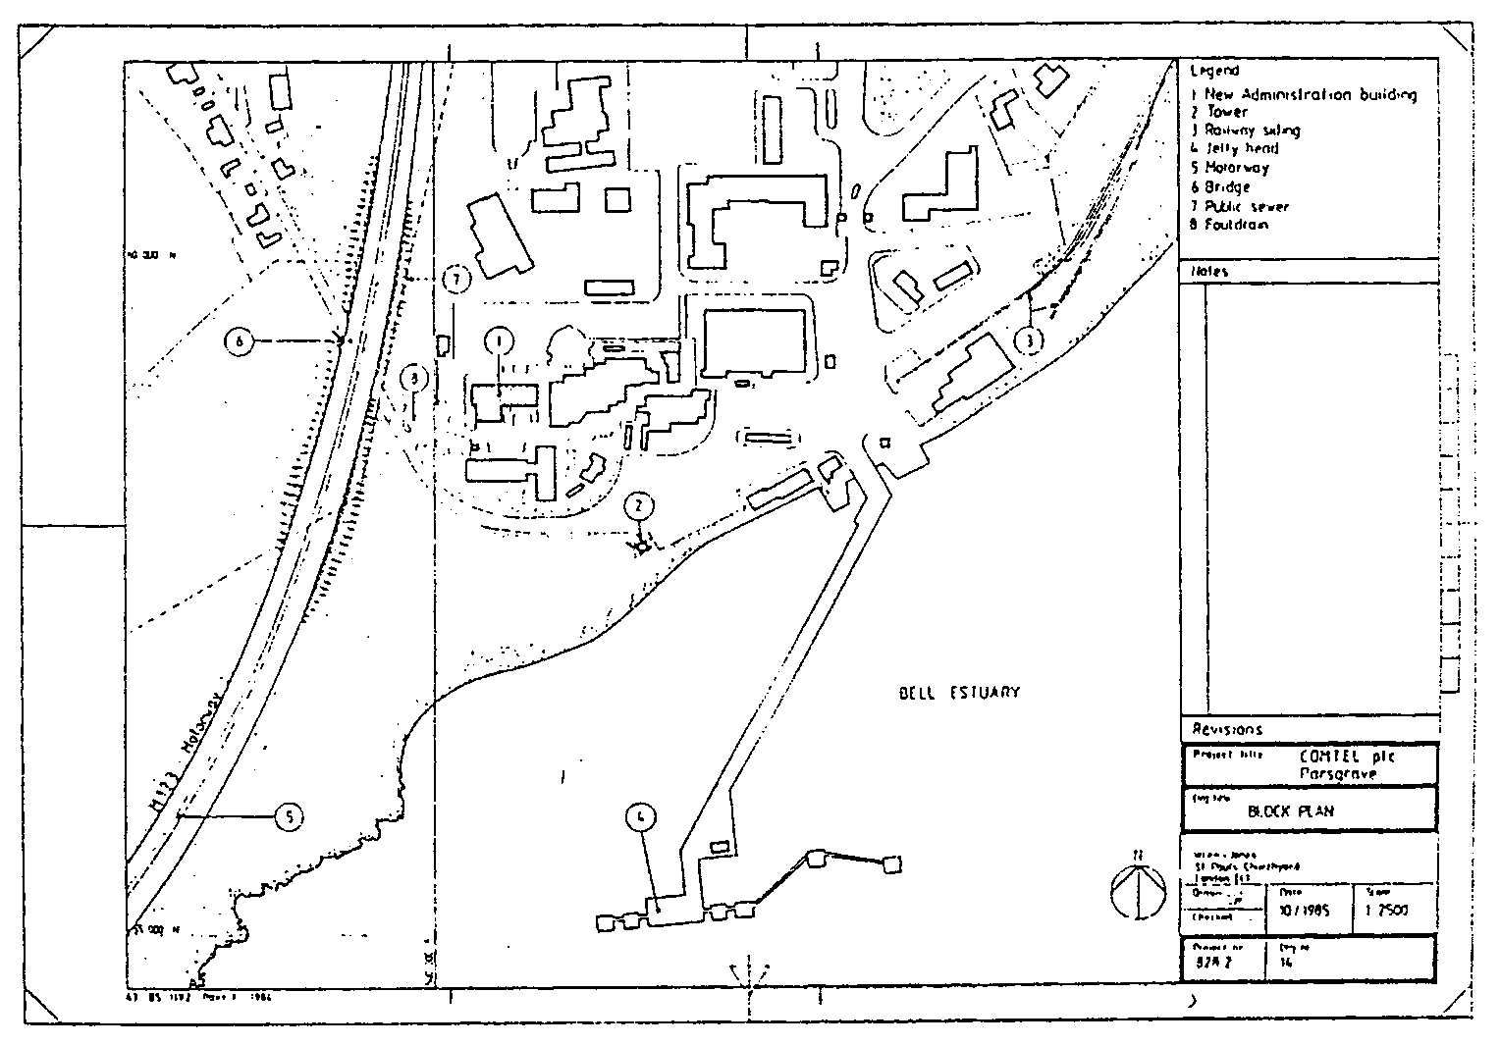
Here is a drawing of Block Plan originally drawn at 1:2500 but printed not to scale (NTS).

- Block Plan

Scale Rulers
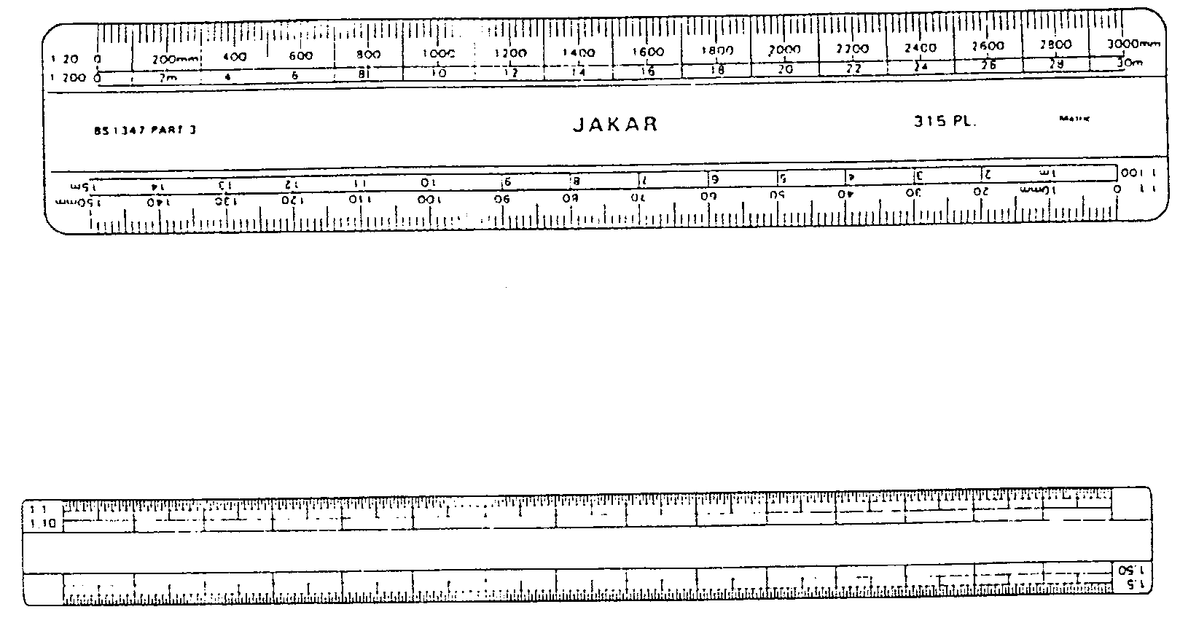
As already stated, the scale of the drawing will be indicated in the block. To take measurements from such a drawing a ‘Scale Rule’ is used. Scale rules are usually manufactured from plastic and have several scales indicated on the ends as shown below.

- Scale Rulers

Graphical Symbols and Abbreviations
In order to read a drawing properly, and to understand what is happening, an agreed set of graphical symbols and abbreviations are used. All the different trades have a set of symbols pertaining to their respective works. The works of the plumber is often referred to as the “Mechanical Services”.
The Mechanical Services includes:
- Hot and Cold Water Services.
- Central Heating Installations.
- Air Conditioning Pipe-work.
- Compressed Air Lines.
- Oil and Gas Supply Lines.
- Above and Below Grounds Drainage.
- Medical Gas Services.
- Sheet Metal Roof Coverings.
When pipes and their relative components are shown on a drawing it is vitally important that the craftsperson can correctly identify their locations and positions. The symbols for the location of pipes in a building are as follows:
Pipes at low level _________________________________
Pipes at high level ___  ___  ___  ___  ___  ___  ___
Pipes in roof or above ceiling ___   ___   ___   ___   ___   __
Pipes below floor or underground _ _ _ _ _ _ _ _ _ _ _ _ _ _ _ _ _
When pipes rise or drop to a different level they are shown

To show the direction of flow
In order to know if the pipe rises or drops the following abbreviations will be used:
- Abbreviations for Pipe Rises/Drops
TA | To Above
FB | From Below
RTA | Rise To Above
DTB | Drop To Below
To identify individual services some of the following abbreviations may be used.
- Service Abbreviations
MWS | Mains Water Services
DW | Drinking Water
CWF | Cold Water Flow
CWS | Cold Water Service
HWSF | Hot Water Service Flow
HWSR | Hot Water Service Return
HWSVP | Hot Water Service Vent Pipe
FF | Fire Fighting Services
HRS | Hose Reel Service
CA | Compressed Air
F&R | Flow and Return
The symbols on the following pages are from the British Standards Institution and are used extensively in drawings relating to mechanical services.

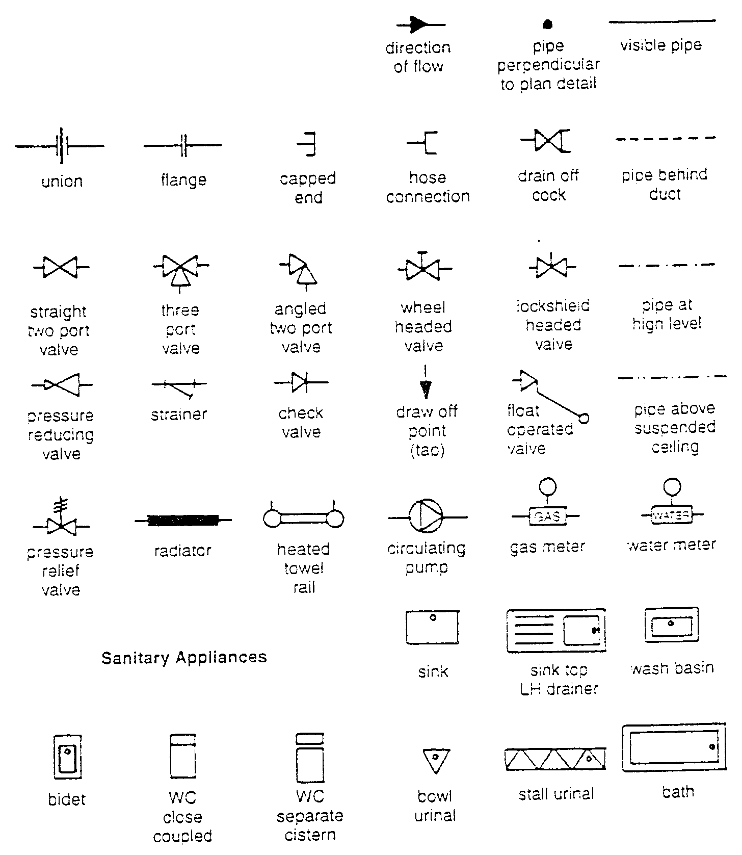

- British Standards Institution Symbols
- BSI Symbols
Symbol | Description | Application
 | Draw-off tap | 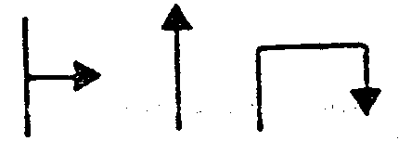
 | Shower head | 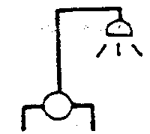
 | Sprinkler head | 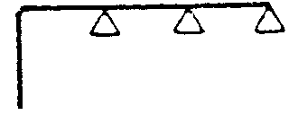
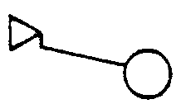 | Float-operated valve | 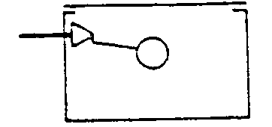
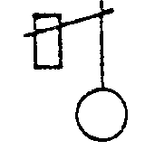 | Float switch (Hydraulic type) | 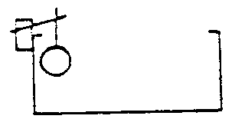
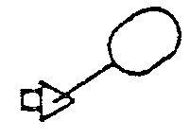 | Float switch (Magnetic type) | 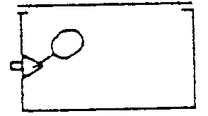
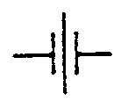 | Filter or screen | 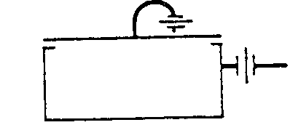
 | Supply stopvalve (SV) | 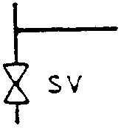
 | Servicing valve (SV) | 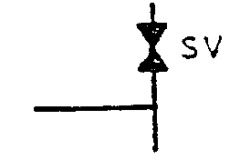
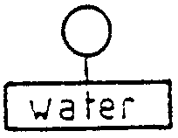 | Water meter | 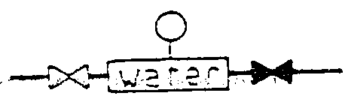
- BSI Symbols
Symbol | Description | Application
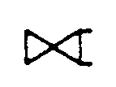 | Draining valve (BS 1192)  (Drain valve) (drain cock) | 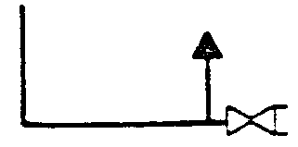
 | Draining valve (Abbreviated version used in this book) | 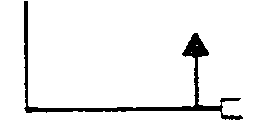
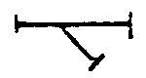 | Line Strainer | 
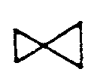 | Pressure reducing valve (Small end denotes high pressure) | 
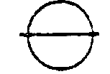 | Expansion vessel | 
 | Pressure relief valve  (Expansion relief valve) | 
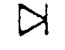 | Check valve or non-return valve (NRV) | 
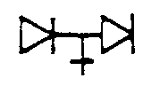 | Double check valve assembly | 
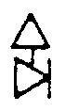 | Combined check and anti-vacuum valve (check valve and vacuum breaker) | 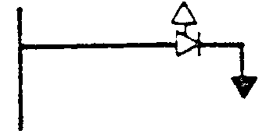
 | Air inlet valve | 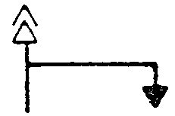

- BSI Symbols
Symbol | Description | Application
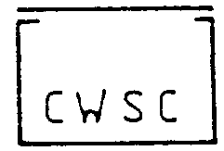 | Cold water storage cistern  (Storage and feed cistern)  (Feed Cistern) | 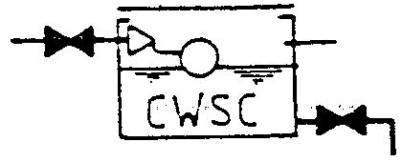
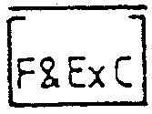 | Feed and expansion cistern | 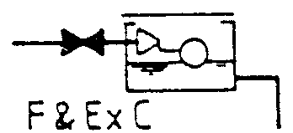
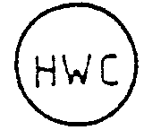 | Hot water storage cylinder or tank (plan) | 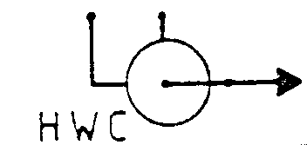
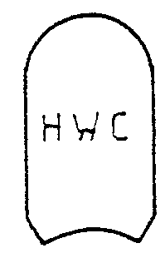 | Hot water storage cylinder or hot store vessel (Direct types)  (elevation) | 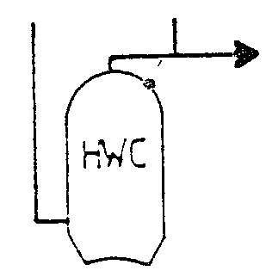
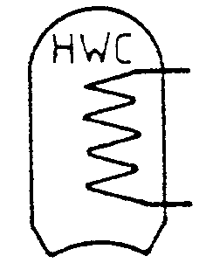 | Hot water storage cylinder or hot store vessel (indirect types) (elevation) | 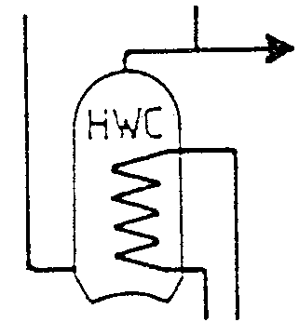
 | Boiler (elevation) | 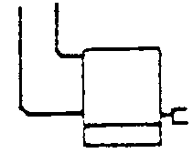
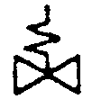 | Temperature relief valve | 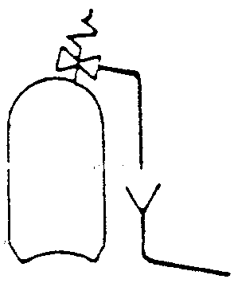
 | Tundish

Specifications
In addition to installing drawings most large construction projects will also have a ‘SPECIFICATION’ to which the craftsman will have to refer. The specification will give more information relating to the installation.
There are many advantages to having a specification for a project, for example:
- When tendering or pricing a job the specified standards must be followed. This ensures that no one can use sub-standard materials to keep a price low.
- The specification is also referred to at the installation stage. This means that the client is guaranteed that all materials are up to the required standard.
Specification will normally include the following information:
- The different materials that pipes and equipment are to be manufactured from.
- The spacing of brackets.
- The type of valves to be used.
- The standard and type of sanitary fixtures.
- The type of radiators.
- Type of boiler, cylinder and storage cistern.

Identification of Pipework
In large plumbing and heating installations it may be difficult to correctly identify what services pipes are supplying. A system of colour coding has been designed which enables pipe contents to be identified. The chart below shows the different colours that apply to the various services.
- Identification of Pipework
Pipe Contents | Basic Colour | Specific Colour | Basic Colour
Untreated Water | Green | Green | Green
Drinking Water | Green | Blue | Green
Hot Water Supply | Green | Whit-Crimson-White | Green
Heating Pipes | Green | White-Crimson-Blue | Green
Steam | Silver Grey | Silver Grey | Silver Grey
Condensate | Green | Crimson-Green-Crimson | Green
Natural Gas | Yellow | Yellow | Yellow
Diesel Fuel Oil | Brown | White | Brown
Compressed Air | Light Blue | Light Blue | Light Blue
Occasionally it will also be necessary to indicate the direction of flow on a pipe. This is shown by an arrow situated close to the colour code. In the case of central heating pipe-work the word FLOW or the letter F may be shown on one pipe and RETURN or R on the other.
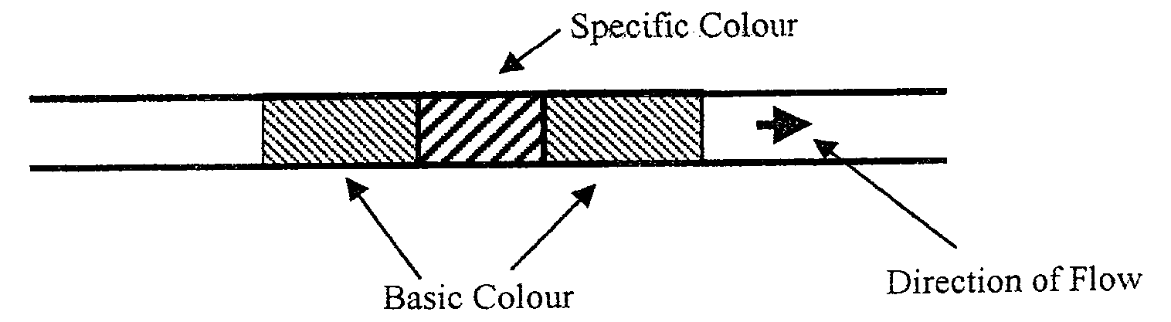

- Direction of Flow

Systems of Representation

Orthographic Projection
Orthographic projection shows the views of an object in three different positions, namely: PLAN – ELEVATION – END VIEW.
The plan is an outline of the object when viewed from above.
The elevation is what is seen when looking from the front.
The end view shows the view from one of the ends.
Orthographic projection is generally not used in the construction industry. It is more commonly found in the engineering sector where precise measurement is essential.
Try drawing the object below in orthographic projection i.e. draw a plan (z) an elevation (x) and an end view (y).
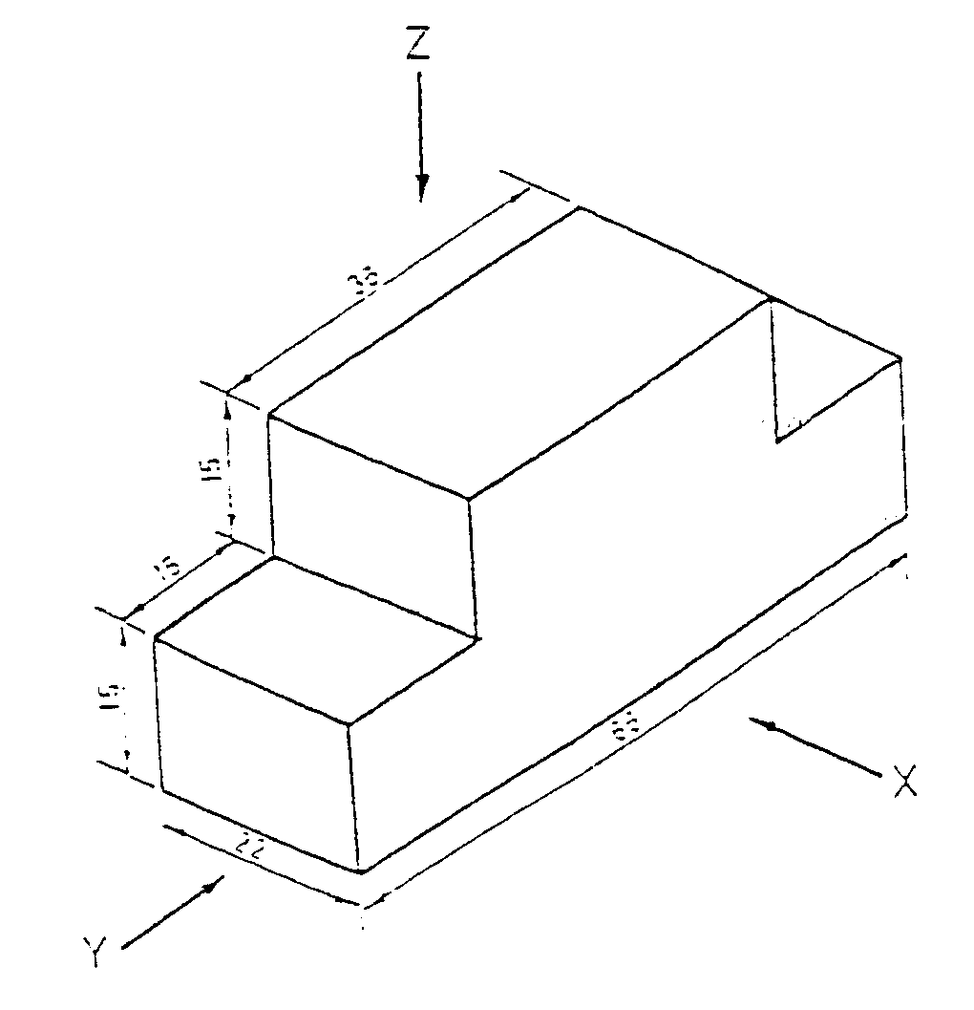

- Orthographic Projection

Isometric Projection
In isometric projection all the horizontal lines are drawn at 30° to the horizontal plane while vertical lines are drawn vertical.
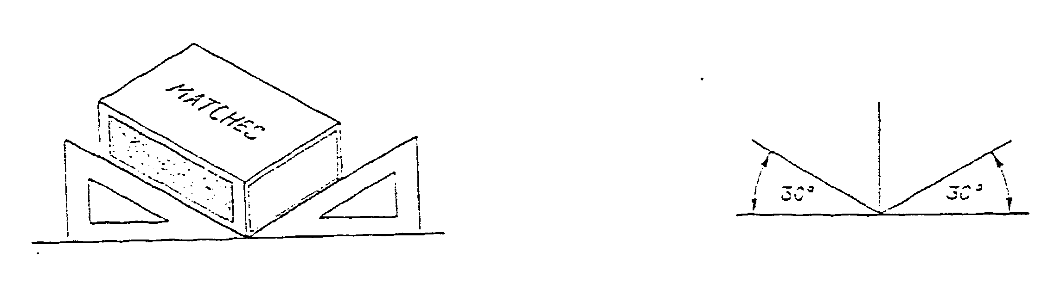
Isometric projection embraces the three views from orthographic projection in the one drawing. In the drawing of the matchbox below you can see the plan, elevation and end view.

- Isometric Projection
Isometric projection is often used in the plumbing industry to show pipe runs.
The drawing on the next page is an extract from BS 1192 Part 2 : 1987 with the pipe-work shown in the isometric projection.

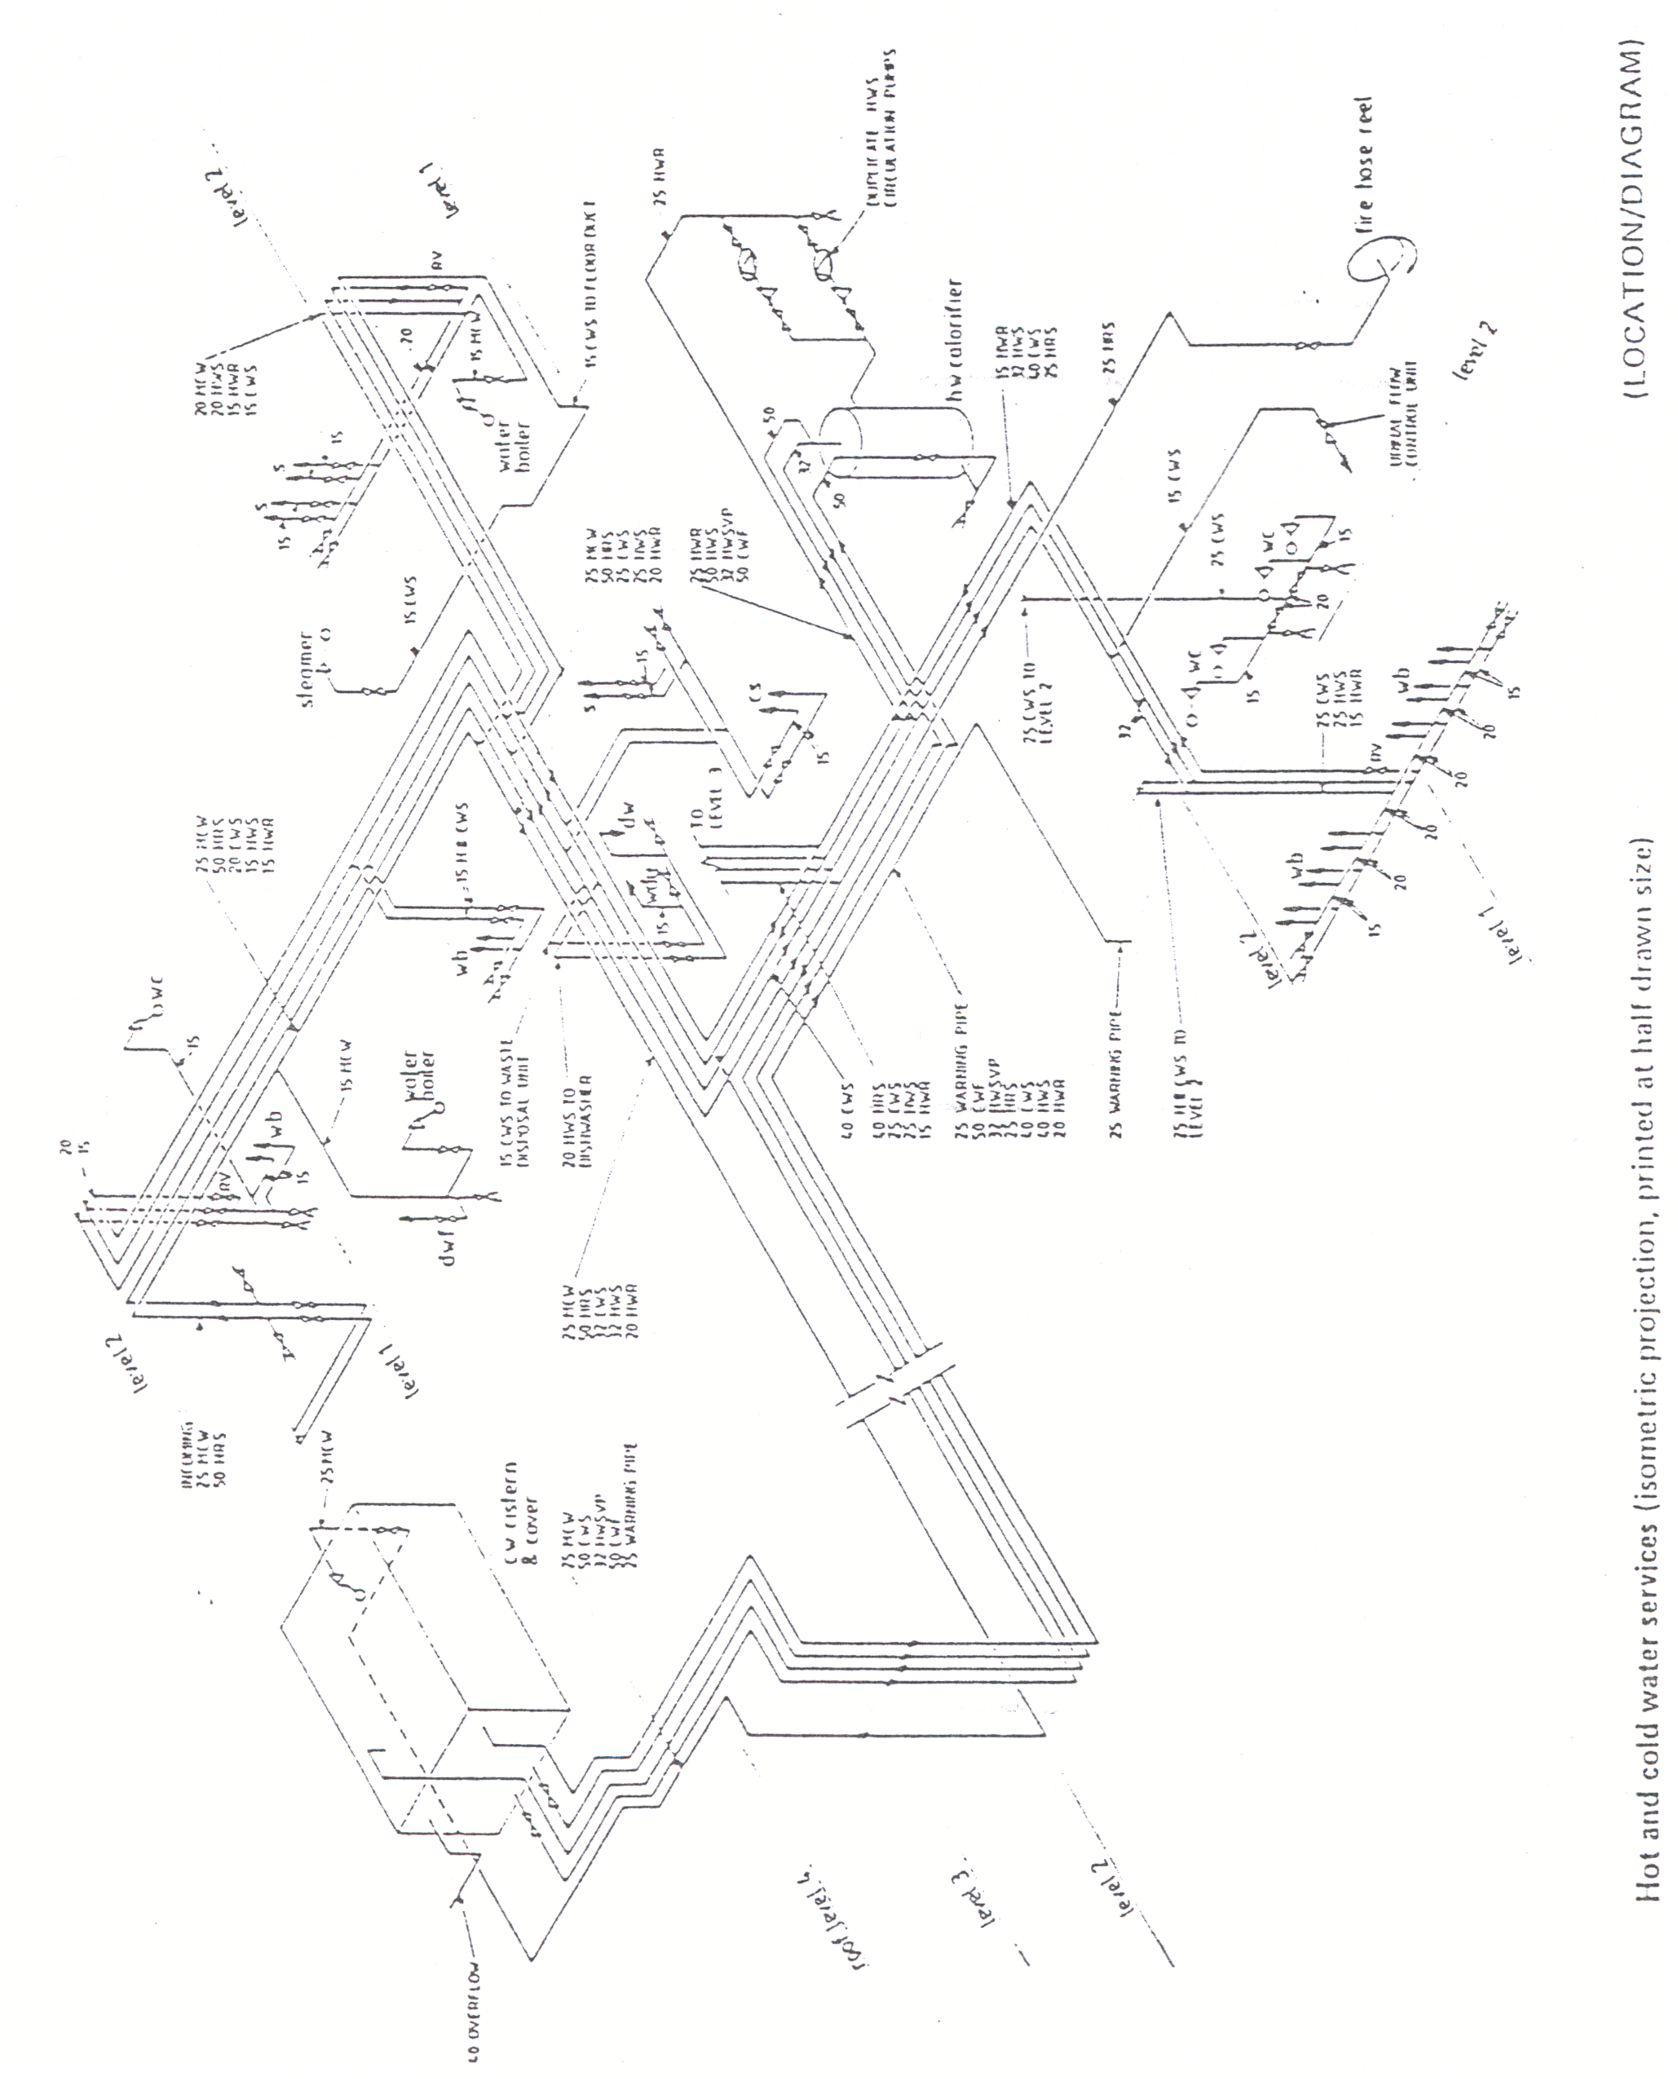

- Isometric Projection

Self Assessment

Symbol exercises
Complete the symbol and applications boxes in the table below.
- Symbol Exercises
Symbol | Description | Application
 | Draw-off tap
 | Shower head
 | Sprinkler head
 | Float-operated valve
 | Float switch (Hydraulic type)
 | Float switch (Magnetic type)
 | Filter or screen
 | Supply stopvalve (SV)
 | Servicing valve (SV)
 | Water meter

Symbol | Description | Application
Draining valve (BS 1192)
(Drain valve) (drain cock)
 | Draining valve (Abbreviated version used in this book)
 | Line Strainer
 | Pressure reducing valve (Small end denotes high pressure)
 | Expansion vessel
Pressure relief valve
(Expansion relief valve)
 | Check valve or non-return valve (NRV)
 | Double check valve assembly
 | Combined check and anti-vacuum valve (check valve and vacuum breaker)
 | Air inlet valve

Symbol | Description | Application
Cold water storage cistern
(Storage and feed cistern)
(Feed Cistern)
 | Feed and expansion cistern
 | Hot water storage cylinder or tank (plan)
Hot water storage cylinder or hot store vessel (Direct types)
(elevation)
 | Hot water storage cylinder or hot store vessel (indirect types) (elevation)
 | Boiler (elevation)
 | Temperature relief valve
 | Tundish

Index

A
A2 drawing board 9
B
block plan 14
borders 13
D
dimensions 12
I
isometric projection 25
L
letters 12
M
metric scale rule 9
N
numbers 12
O
orthographic projection 24
P
pipe
colours 23
protractor 9
S
scale 14
scale rulers 15
Set Square 9
springbow compass 9
T
T-Square 9

