Trade of Electrician

Standards Based Apprenticeship

Manual Handling

Phase 2

Module No. 2.1

Unit No. 2.1.3

COURSE NOTES

Created by Michael Jackson – Dublin HO
Chris Ludlow - Dundalk TC

Revision 1 May 2006 by
Chris Ludlow - Dundalk TC

Revision 2. Feb 2008 by
Chris Ludlow - Dundalk TC

Revision 3, November 2013
SOLAS

Published by


27-33 Upper Baggot Street
Dublin 4
Ireland

© SOLAS - 2013

All rights reserved. No part of this publication may be reproduced, stored in a retrieval system or
transmitted in any form or by any means, electronic, mechanical, photocopying, recording or
otherwise, without the prior permission of the copyright owner.

Table of Contents
TABLE OF CONTENTS 3
INTRODUCTION 9
INTRODUCTION 9
FOREWORD 10
EMPLOYER’S DUTY 10
EMPLOYEE’S DUTY 10
STRUCTURE OF THE SPINE 11
PREGNANT EMPLOYEE 12
HANDLING LOADS 12
MOVING THINGS THE RIGHT WAY 15
MOVING THINGS THE WRONG WAY 16
PREVENT PAIN, INJURIES AND DAMAGE 17
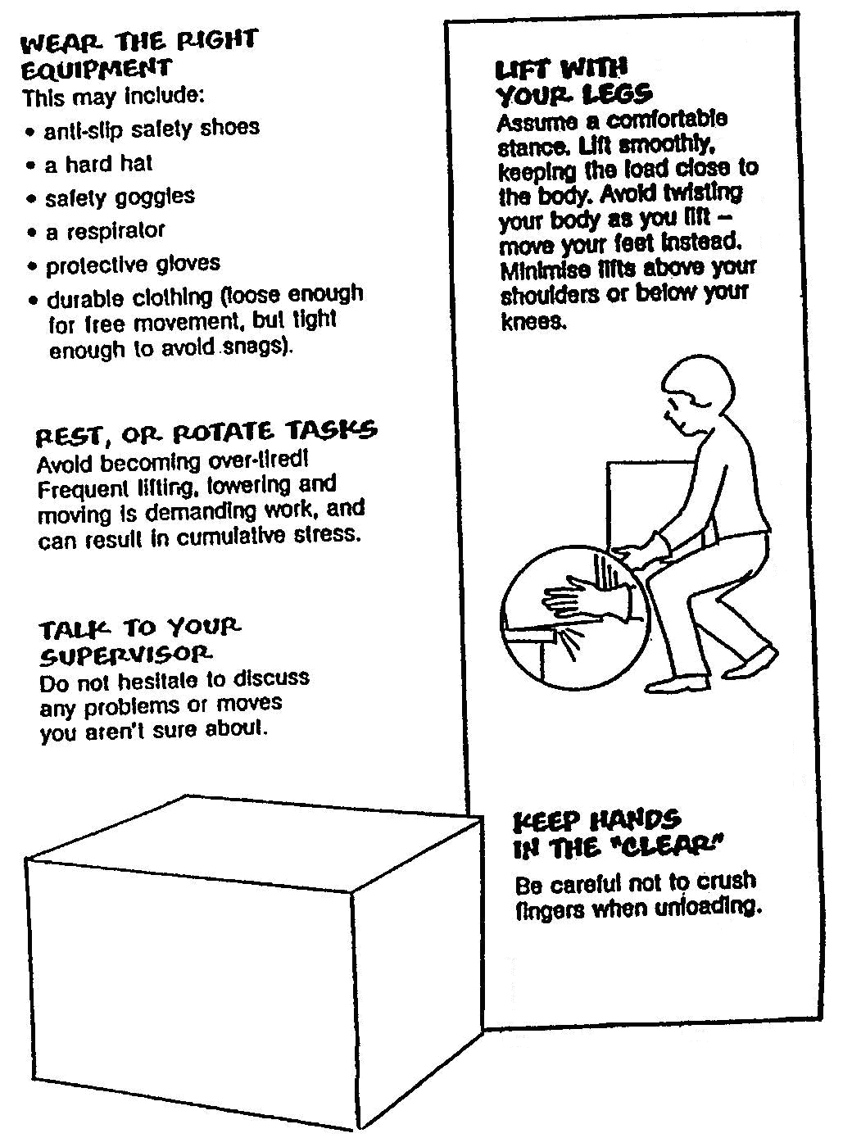LIFTING 18
LIFTING 19
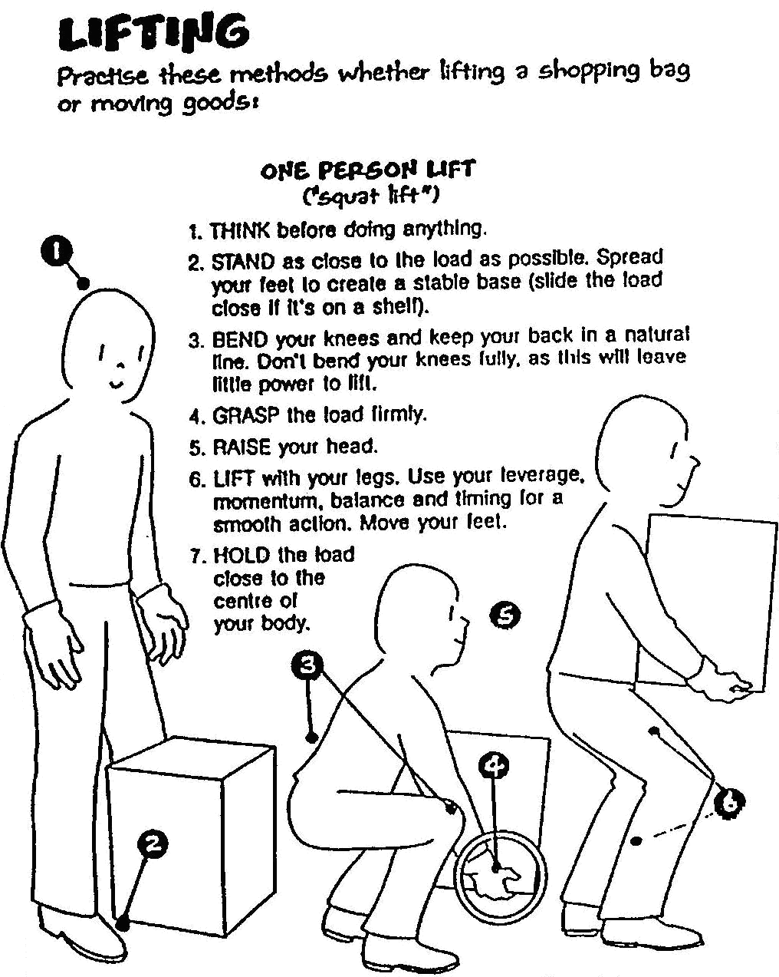CARRYING 19
CARRYING 20
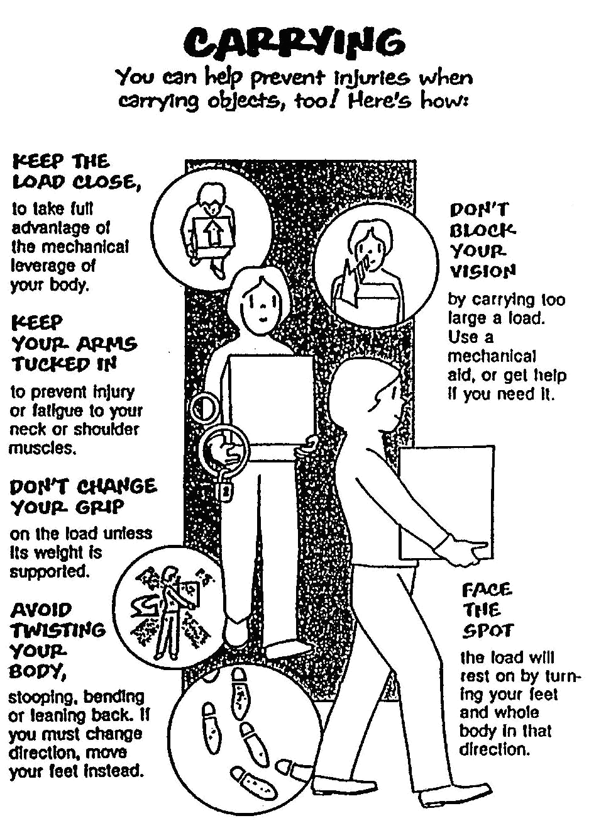UPLOADING 20
UPLOADING 21
SPECIAL LIFTS 22
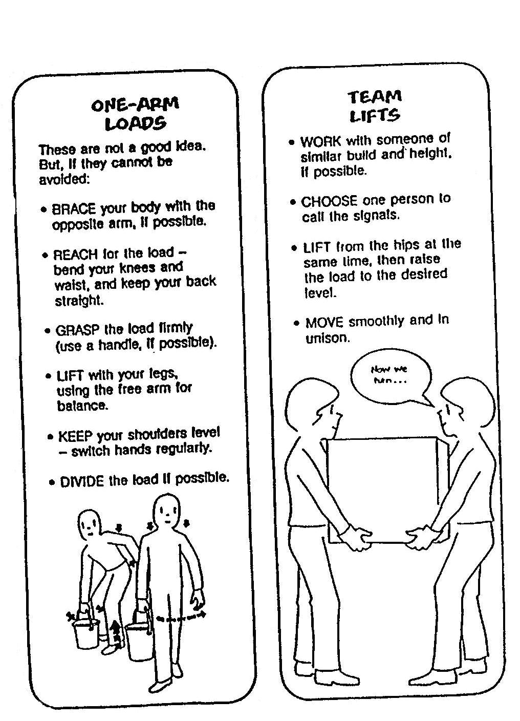AWKWARD OBJECTS AND OVERHEAD LIFTS 22
AWKWARD OBJECTS AND OVERHEAD LIFTS 23
PUSHING AND PULLING SAFETY 24
SPECIAL OBJECTS REQUIRE SPECIAL HANDLING 25
TEAM EFFORT 26
LEGAL OBLIGATIONS 28
EIGHT PRINCIPLES OF LIFTING 29

Introduction

Welcome to this section of your course, which is designed to educate you, the learner, on the proper procedures for lifting carrying and moving loads in a safe and efficient manner.

Objectives

By the end of this unit you will:

- List the main statutory requirements of both employers and employees in relation to manual handling and general safety in the workplace.
- Explain the structure of the spine.
- Explain the functions of muscles, tendons and ligaments.
- Explain the types of injury that may occur from lifting and handling loads.
- Explain the requirement for a pre-lift analysis of a load.
- Explain how the body should be positioned before attempting a lift.
- Explain and demonstrate good handling techniques for lifting workplace objects.
- Explain and demonstrate good handling techniques for pushing and pulling a workplace object.
- Demonstrate the correct procedures for team lifting a load.
- Describe the various types of handling devices and in what situations they may be used.
- Correctly demonstrate how to handle a typical workplace load using a handling aid.

Reasons

The information in this unit is essential, if you are to avoid back injuries when lifting, carrying or moving loads.

Foreword

Approximately 35% of accidents reported to the HSA in the year 2000 resulted from Manual Handling incidents. Four out of five adults will experience back pain at some stage in their lives. About 50% of people off work with back pain have a recurrence of the problem within one year. Roughly 5% of back pain leads to prolonged disability. The problem is equally common among males and females.

It usually results from:-
- Heavy manual work ( forceful exertion, bending, twisting )
- Working in a stooped posture
- Prolonged sitting in a fixed position
- Vibration
- Stress

Employer’s Duty

The duty of the employer towards employees is to:

- Assess manual handling risks.
- Take measures where possible to avoid manual handling.
- Provide manual handling training.
- Carry out risk assessment where manual handling is unavoidable.
- Provide employee with precise information about the load.
- Provide a reasonably safe place of work.
- Provide reasonably safe plant and equipment
- Provide reasonably safe systems of work.

Employee’s Duty

The duty of the employee is to:

- Take reasonable care for his safety and welfare and that of others in the workplace.
- Use any equipment, protective clothing or other means provided by the employer for securing his safety and welfare in the workplace.
- Report to his employer any problems or defects which might endanger health and safety.
- Not intentional or reckless interference with or misuse any equipment.

Structure of the Spine

It is well known that the vertebral column, or spine, has the shape of an elongated S. At chest level it has a slight backward curve, and in the lumbar region it has a slight forward curve. This construction gives the spine elasticity, to absorb the shocks of running and jumping.
The loading on the vertebral column increases from above downwards, and is at its greatest in the lower five lumbar vertebrae. An intervertebral disc separates each pair of vertebrae. Degeneration of a disc first affects the margin of the disc, which is normally tough and fibrous.
A tissue change is brought about by loss of water, with the result that the fibrous ring becomes brittle and fragile and loses its strength. At first the degenerative change merely makes the disc flatter, with the risk of damage to the mechanics of the spine, or even of displacement of the vertebrae. Under these conditions quite small actions such as lifting a weight, a slight stumble or similar incidents may precipitate severe backache and lumbago.
When degeneration of the disc has progressed further, any sudden force upon it may squeeze the viscous internal fluid out through the ruptured outer ring and so exert pressure either on the spinal cord itself or on the nerves running out from it. This is what happens in the case of a “Slipped Disc” or disc herniation.
Pressure on nerves, narrowing of the spaces between vertebrae, pulling and squeezing at adjoining tissues and ligaments of the joints are the causes of the variety of aches, muscular cramps and paralyses including lumbago and sciatica which commonly accompany disc degeneration.
Back troubles are painful and reduce one’s mobility and vitality. They lead to long absences from work, and in modern times are among the main causes of early disability. They are comparatively common in the age group 20 – 40 with certain occupations
( labourer, farmer, porter, nursing staff, etc.) being particularly vulnerable to disc troubles. Moreover, workers with physically active jobs suffer more from ailments of this nature, and their work is more affected as a result.
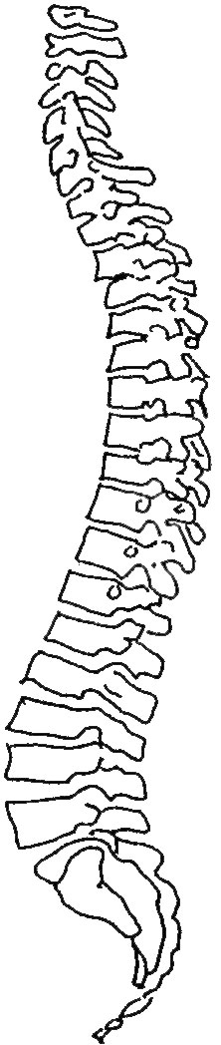

Pregnant Employee

- Risks due to manual work must be assessed for pregnant employees and employees who have recently given birth.
- Health and safety leave must be given if the maternity employee cannot be protected from the risks identified.
- Certification of risk by employer for social welfare purposes.

Handling Loads

Avoid

- Very heavy loads.
- Arching of the spine.
- Excessive or repeated twisting.
- Over-stretching or over-reaching.

Ensure

- A good secure grip
- Awareness of the weight and stability of the load.
- Correct stance and lift posture.
- Smooth quick lift.
- Correct protective clothing and equipment.
- Proper co-ordination of team lifts.

Stooping to Lift

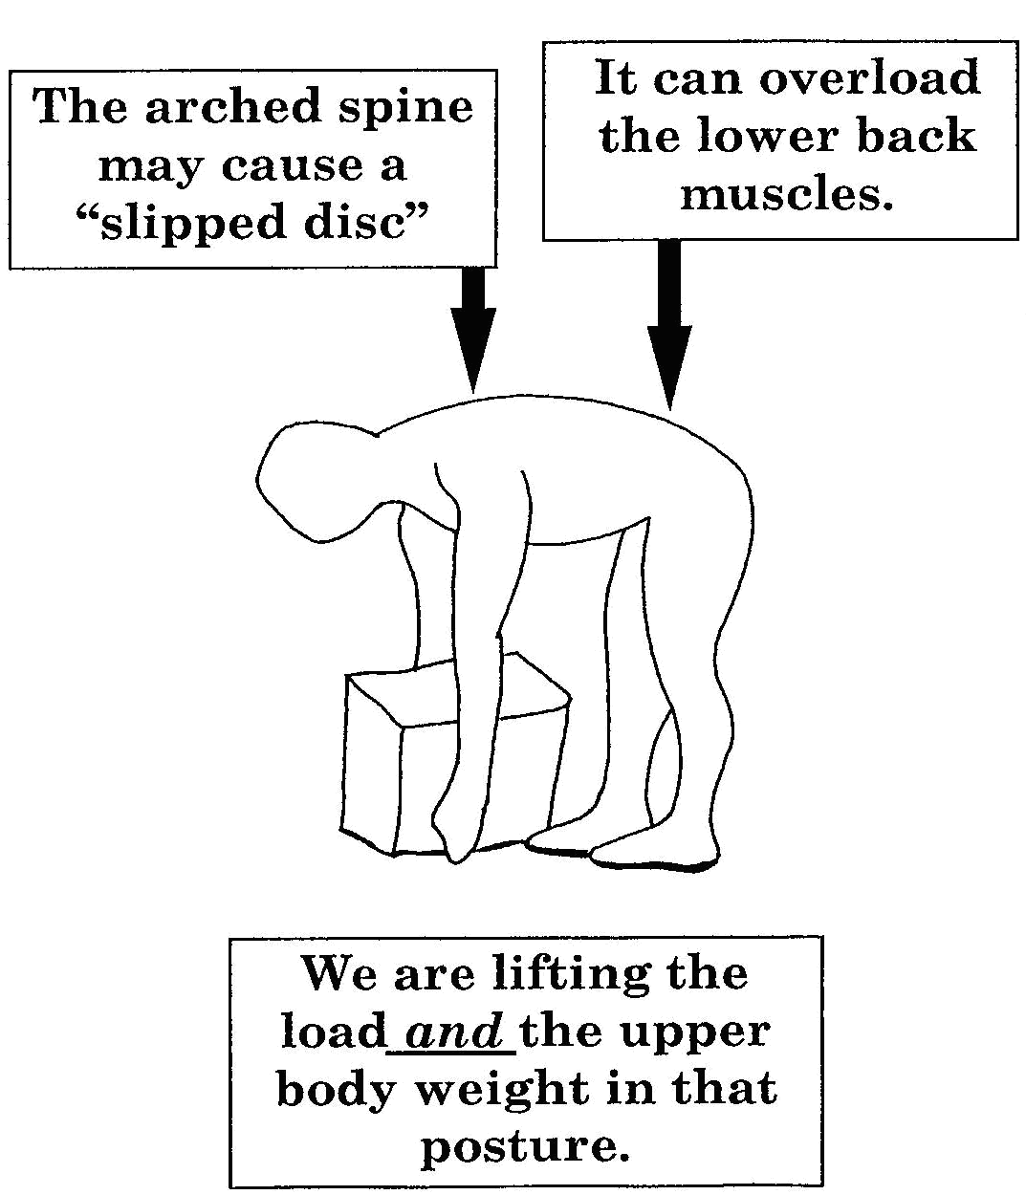

Bending the Knees

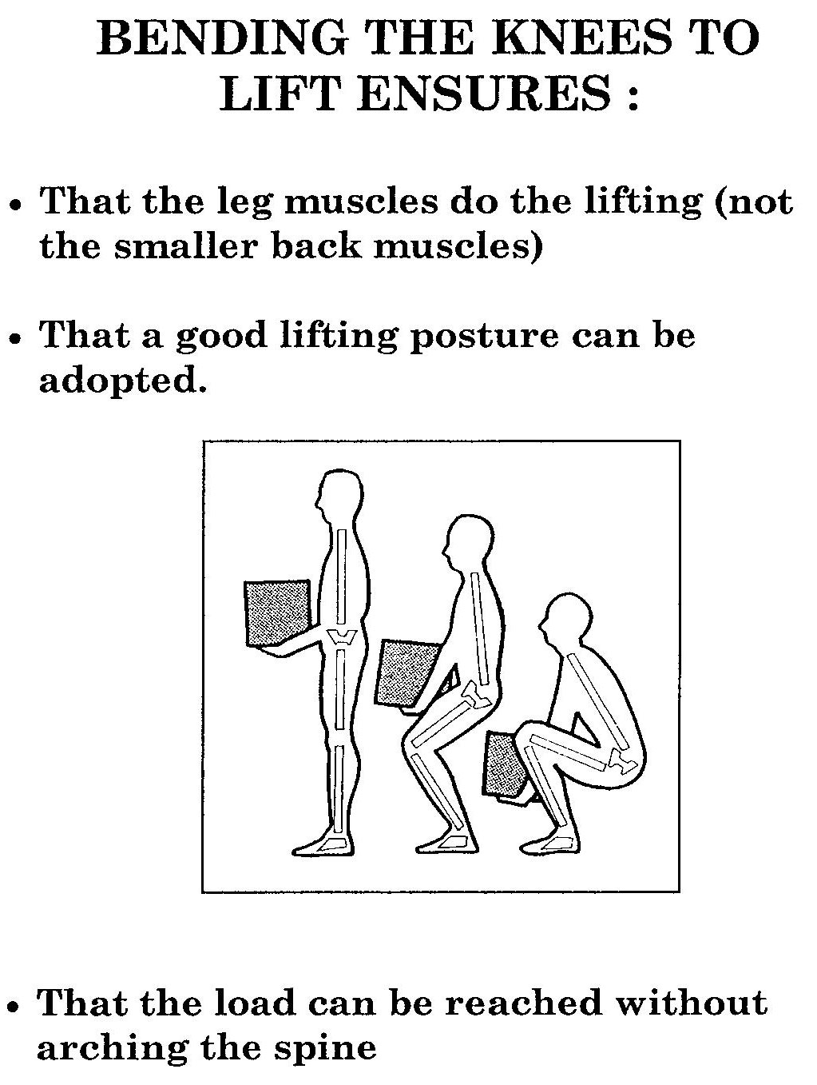

Moving Things the Right Way

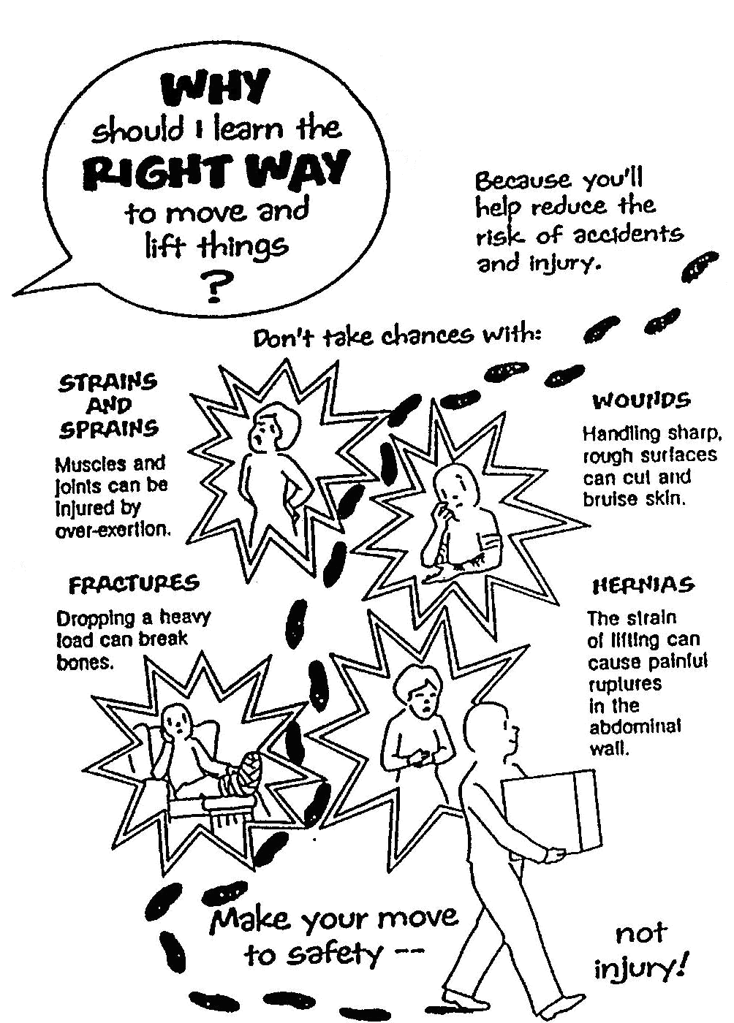

Moving Things the Wrong Way

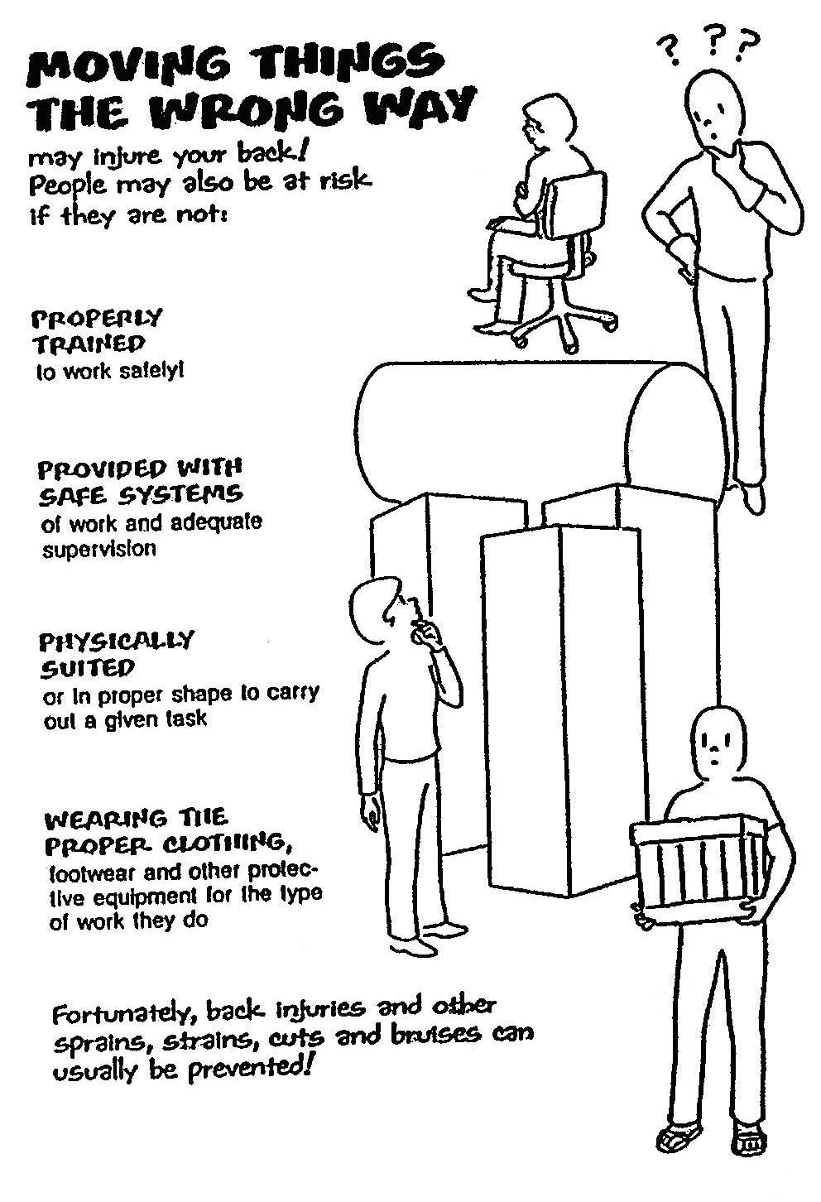

Prevent Pain, Injuries and Damage

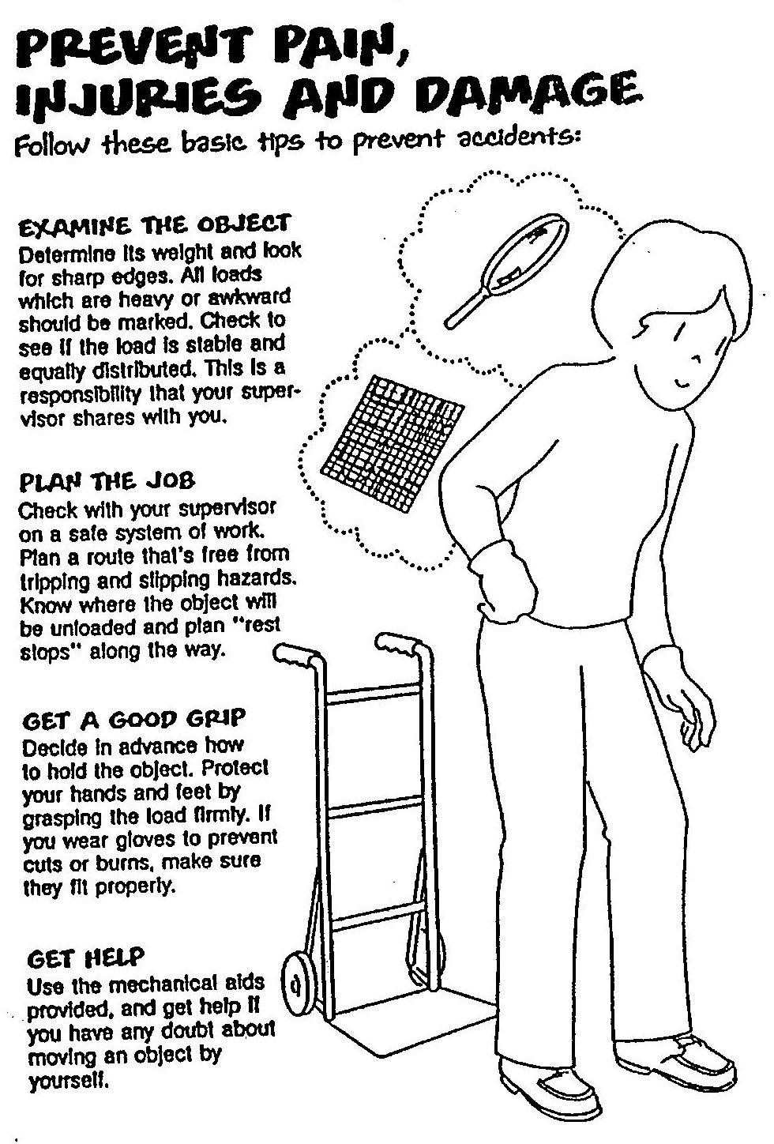

Lifting

To avoid injury do warm-up exercises before lifting.

Carrying

Uploading

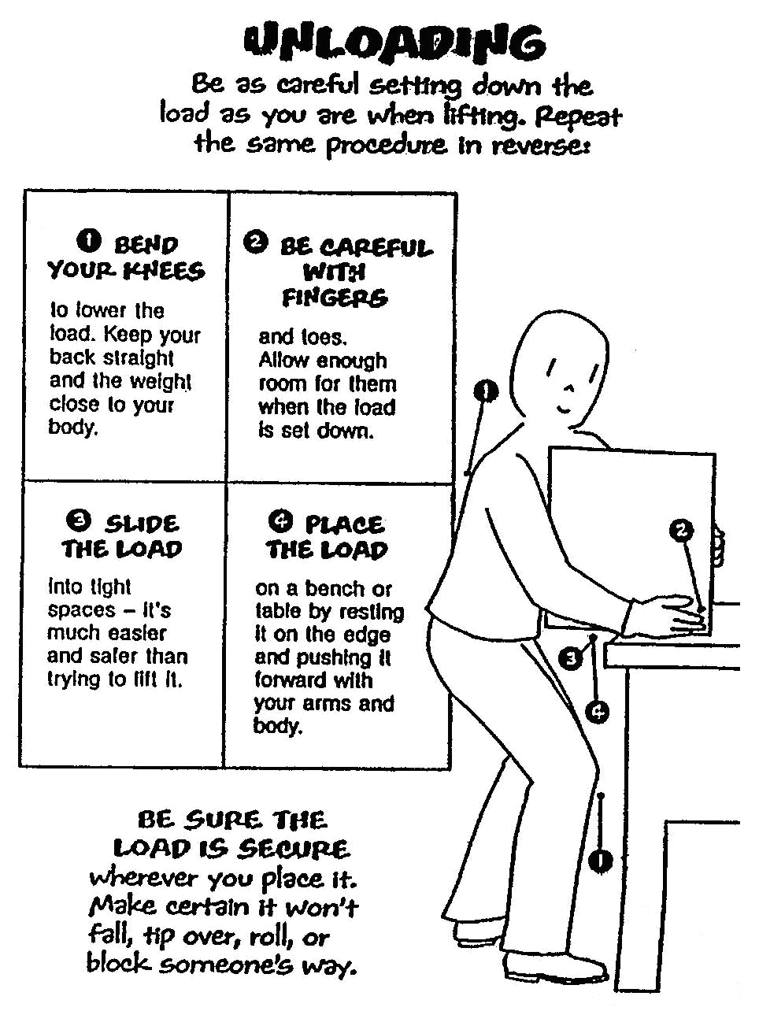

Special Lifts

Awkward Objects and Overhead Lifts

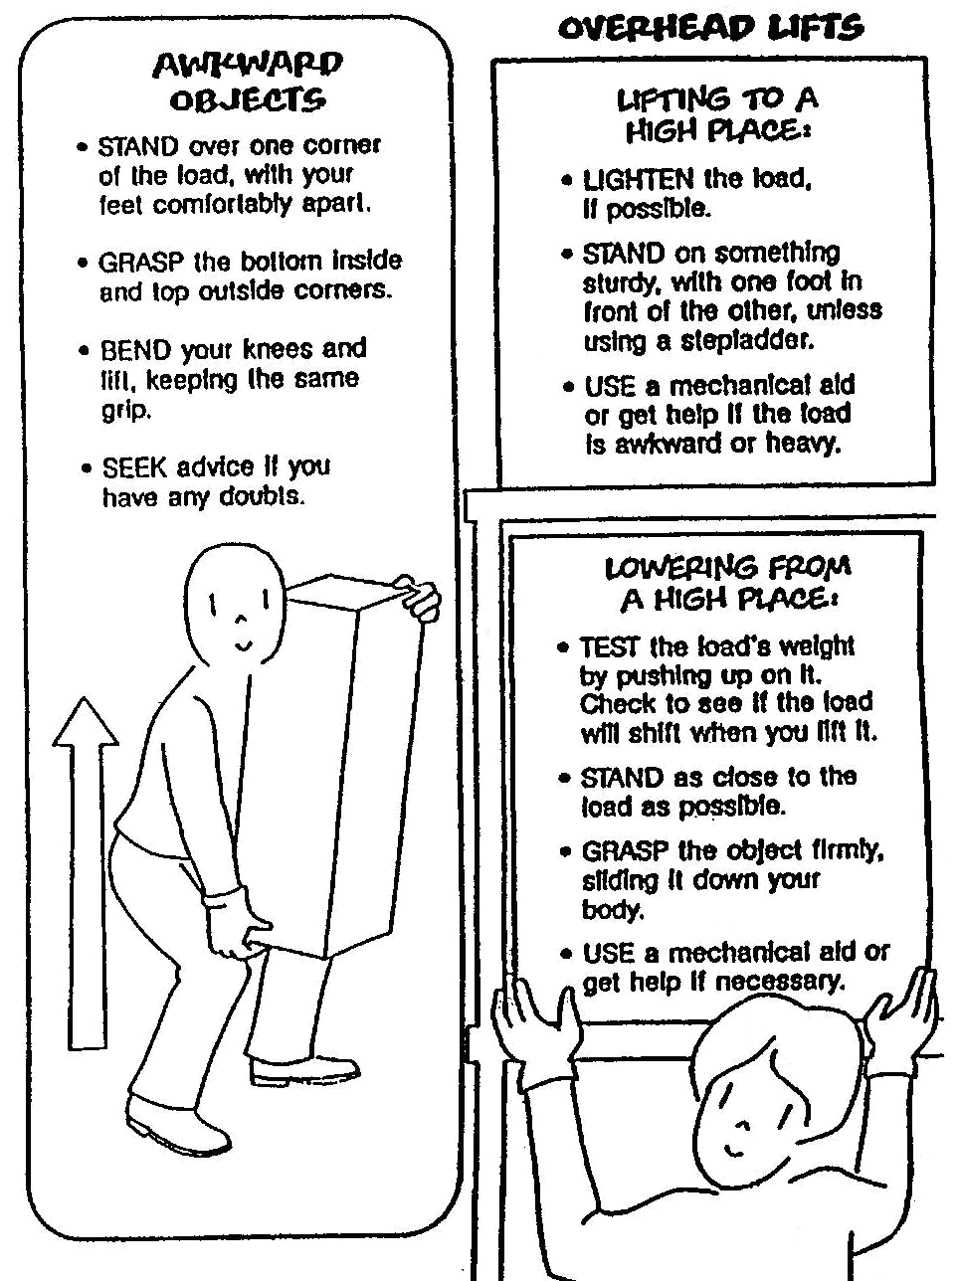

Pushing and Pulling Safety

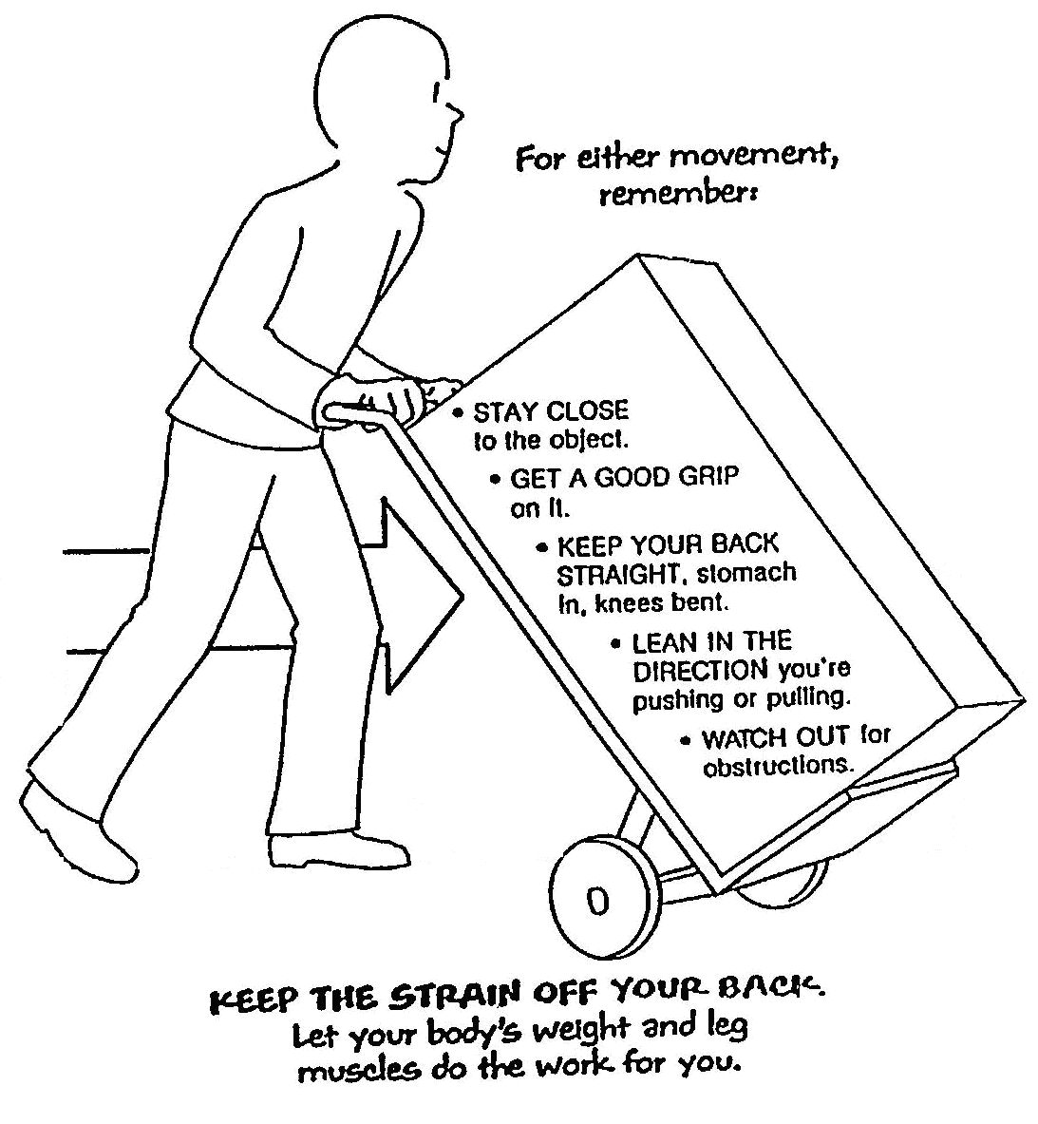

Special Objects Require Special Handling

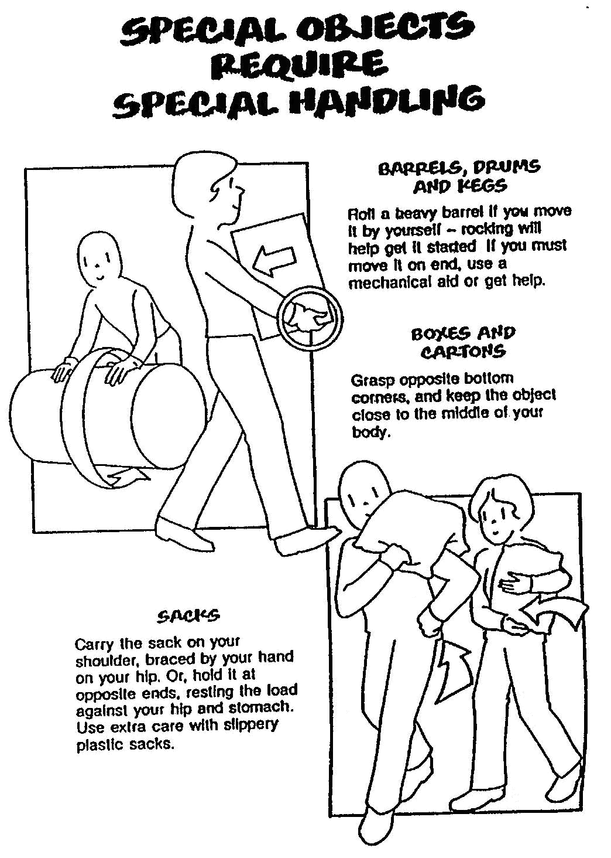

Team Effort

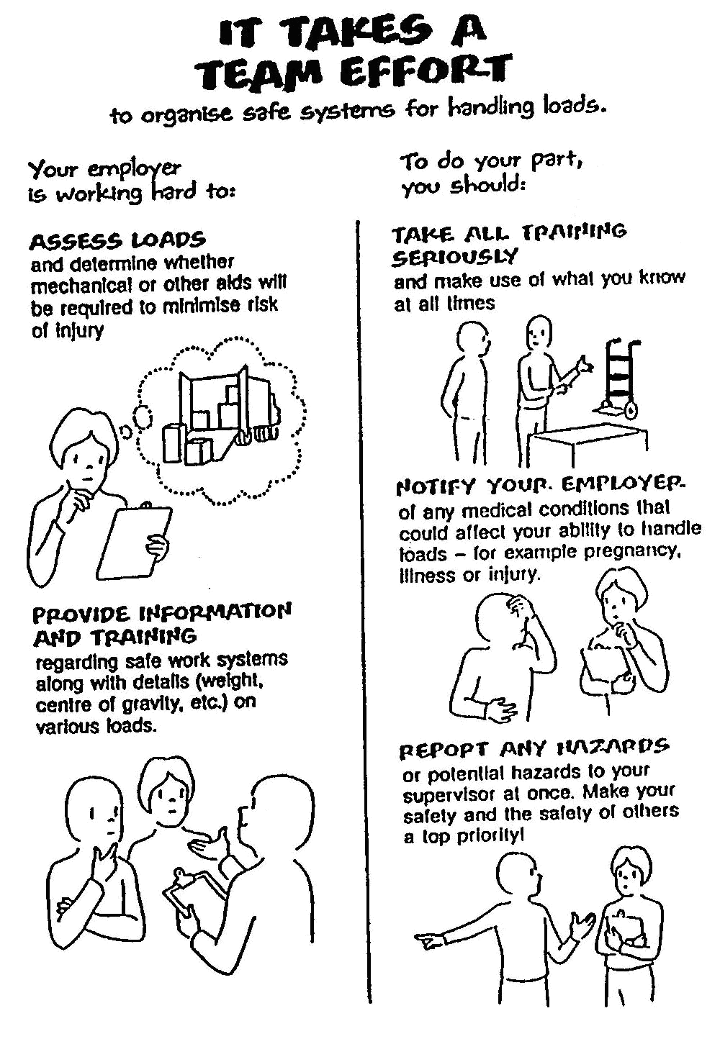

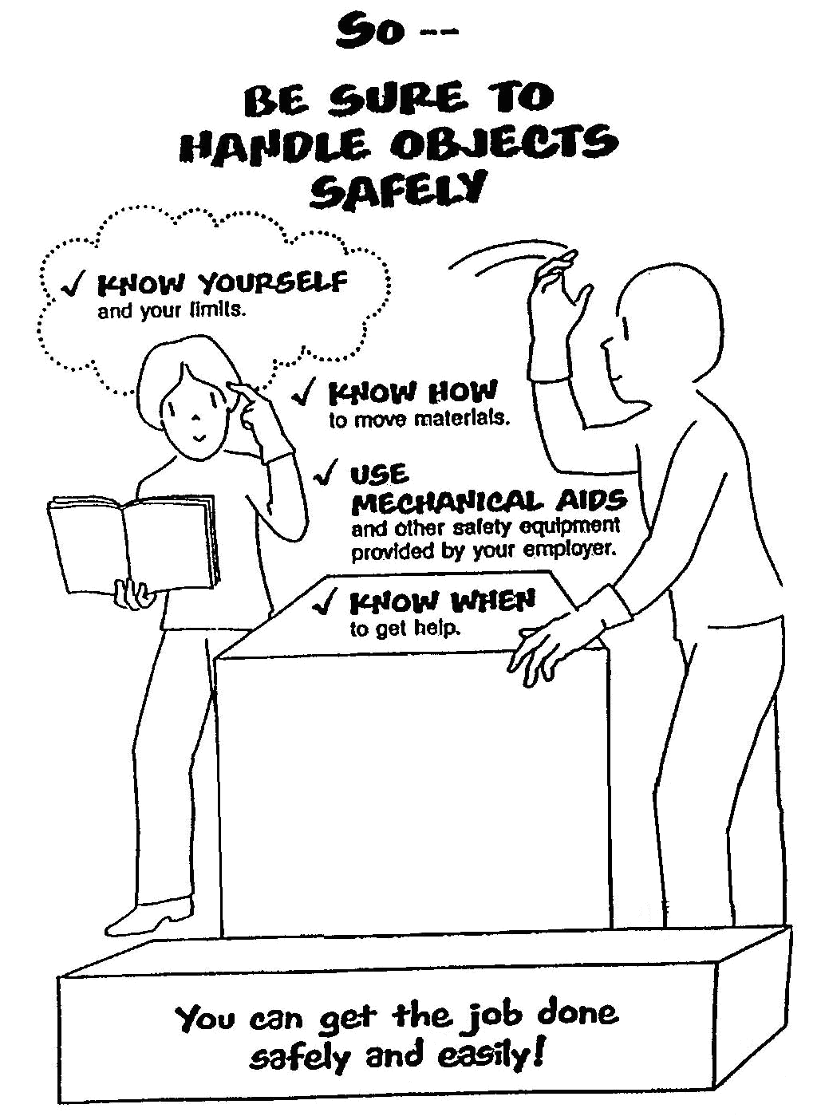

Legal Obligations

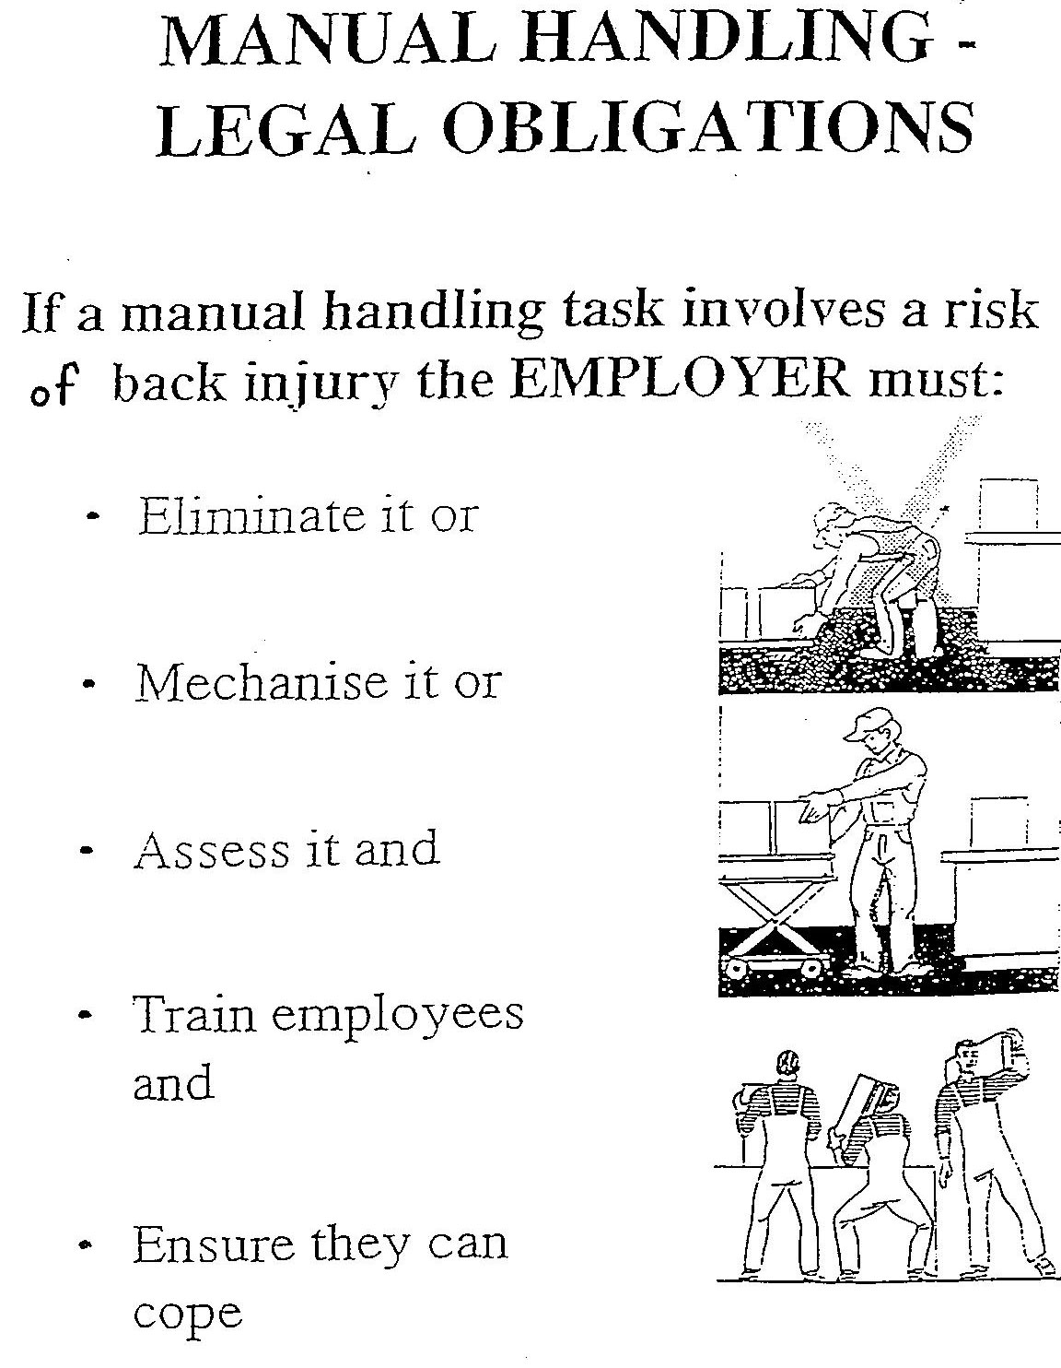

Eight Principles of Lifting

- Assess the task, the area and the load
- Broad stable base - feet flat on floor
- Bend the knees
- Back straight
- Firm grip
- Arms in line with trunk
- Weight close to centre of gravity
- Turn feet in direction of movement

