Trade of Electrician

Standards Based Apprenticeship

Installation Testing

Phase 2

Module No. 2.2

Unit No. 2.2.7.

COURSE NOTES

Created by Eugene Trindles - Cork TC

Revision 1 April 2000 by
Eugene Trindles - Cork TC
Chris Ludlow - Sligo TC
Charlie Walsh – Athlone TC

Revision 2 Nov. 2002 by
Eugene Trindles - Cork TC
Chris Ludlow – Dundalk TC

Revision 3 May 2006 by
Chris Ludlow – Dundalk TC

Revision 4. Feb 2008 By
Chris Ludlow - Dundalk TC

Revision 5. July 2009 By
Chris Ludlow - Dundalk TC

Revision 6. October 2009 By
Chris Ludlow - Dundalk TC

Revision 5, November 2013
SOLAS

Compiled by Liam Carroll – Certification & Standards

Published by


27-33 Upper Baggot Street
Dublin 4
Ireland

© SOLAS - 2013

All rights reserved. No part of this publication may be reproduced, stored in a retrieval system or
transmitted in any form or by any means, electronic, mechanical, photocopying, recording or
otherwise, without the prior permission of the copyright owner.
Table of Contents

Introduction 4
Verification and Certification 5
Testing 8
Continuity of Protective Conductors 9
Continuity of Ring Final Circuit Conductors 15
Insulation Resistance 16
Polarity 21
Hazards Associated with Live Testing 23
Unit Related ETCI Rules 23
Unit Related Exercise 23

Introduction

Welcome to this section of your course, which is designed to enable you, the learner, understand how to perform some of the tests required to be completed on a domestic installation. The majority of electical apprentices are reluctant to use test instruments. This unit will help in this regard.

Objectives

By the end of this unit you will be able to:

- List reasons for testing an electrical installation.
- Perform a visual inspection of a domestic installation
- List the order in which testing must be done
- Understand the tests described in this unit
- Perform a Continuity of Protective Conductors test
- Perform a Continuity of Ring Final Circuit Conductors test
- Perform an Insulation Resistance test
- Perform a Polarity test
- Identify the hazards involved in testing
- Record the test results on a simple form
- State the maximum period between inspections on a domestic installation

Reasons

Understanding this information will provide you with the knowledge and confidence necessary to overcome the initial fear etc. which apprentices attach to the use of test instruments. You will have the ability to fault find and solve problems which confuse many others.
Verification and Certification

New electrical installations and extensions to existing installations must be inspected and tested. This is done to ensure that all electrical equipment has been correctly selected, installed and interconnected in accordance with the ETCI National Rules for Electrical Installations. The rules state that two categories of tests must be carried out on an installation. One test is carried out prior to the installation being made live for the first time, and the other when the installation is live. Both tests must be carried out by competent persons using prescribed test equipment. They also must be carried out in a particular sequence. The results of the tests are recorded and a copy given to the installation owner.

Visual inspection

The quality of visual inspection is dependent on the experience and knowledge of the person carrying out the inspection. It is vitally important that this person understands the ETCI Rules.

Visual inspection should precede testing with instruments and must of course be prior to the installation being made live. It may be necessary to inspect some parts of an installation during the construction phase as these parts may be concealed later. A checklist for a Domestic Installation might read as follows:

Fixed Wiring

- Correct type.
- Correct voltage rating.
- Correct current rating.
- Correct colour coding.
- Diversity correctly applied.
- Permitted volt-drop not exceeded.
- Protected against mechanical damage and abrasion.
- Non-sheathed cables protected by enclosure in conduit, duct or trunking.
- Not exposed to direct sunlight or, if so exposed, of a suitable type.
- Correctly selected and installed for use on exterior walls etc.
- Internal radii of bends in accordance with Annex 52B of the Rules.
- Correctly supported in accordance with Annex 52B of the Rules.
- Not used for connection of equipment which can be moved.

Flexible Cables and Cords

- Correct type.
- Correct voltage rating.
- Correct current rating.
- Correct colour coding.
- Selected for resistance to damage by heat.
- Cable coupler used for joints.
- Final connections to fixed apparatus as short as possible.
- Mass supported by pendants not exceeding values stated.

Terminations

- All terminations enclosed.
- Conductors doubled back where possible.
- All strands securely clamped in terminals.
- No damage to conductor.
- Proper terminal used.
- Braid / sheath cut back to identify core colour and provide flexibility at the termination.
- Braid / sheath not removed outside of enclosure.
- Bare protective conductors sleeved green / yellow.
- Insulation not clamped in terminal.
- Cable clamp / cord grip correctly used.
- No mechanical strain on terminations, slack available
- Terminations accessible for inspection, except as otherwise permitted.
- Tightened sufficiently, mechanically and electrically sound.
- Enclosure cover / lid fitted properly.

Lighting Switches

- Adequate current rating.
- Readily accessible.
- Installed at correct height, e.g. centered at 1100 mm.
- Labelled to indicate purpose, where this is not obvious.
- Single-pole switches connected only in phase conductors.
- Earthing of exposed metalwork, e.g. metal switch plate.
- Protective conductor terminated in an earthing terminal.
- Not installed in the incorrect zone in a shower or bathroom.
- Not within 0.6m of the opening to a shower cubicle in a room other than a bathroom.

Ceiling Roses

- Fixed in position.
- Protective conductor connected to earthing terminal.
- Phase terminal shrouded to prevent accidental contact.
- Switch wires identified as live ( phase ) conductors.
- Suitable for the weight suspended.

Trunking

- Constructed of non-combustible insulating material.
- Securely fixed and adequately protected against mechanical damage.
- Permitted number of cables ( space factor 45% ) not exceeded.
- Covers securely fixed.
- Holes surrounding trunking made good to prevent spread of fire.

Protection

- Distribution board correct and mounted in suitable location.
- Earth Electrode connection accessible and correct.
- Main switch fuse or MCB fitted.
- Sockets for lighting controlled by a switch and protected by an RCD.
- Socket circuits protected by an RCD. ( some exceptions )
- Immersion heater circuit protected by an RCD.
- Shower circuit protected by an RCD.
- Box or other enclosure securely fixed.
- Flush box, level with wall surface to ensure non-combustible enclosure.
- No damage to cables by sharp edges, screw heads etc.
- Switch within 2 metres of cooking appliance(s) and to one side.

Bonding

- Main bonding conductor size correct.
- Main bonding connections correct.
- Main bonding complete.
- Correct bonding clamps used
- Local bonding correct.
Socket Outlets

- Correct type.
- Not less than 100 mm above the floor or working surface.
- Correct polarity.
- Earthing tail from metal box, to earthing terminal of socket outlet.
- Not installed in a shower or bathroom.
- Not within 0.6m of a shower cubicle in a room other than a bathroom.

Joint Boxes

- Fixed in position.
- Accessible for inspection.
- Protected against mechanical damage.
- Protective conductors correctly connected.

Testing

On completion of the visual inspection the following tests must be completed where applicable: They must be carried out in the following order.

Tests before connection of the installation to the supply:

- Continuity of all protective conductors.
- Continuity of ring final circuit conductors ( Step 1 covered at Phase 2 ).
- Insulation Resistance of the electrical installation.
- Protection by separation of circuits ( not covered at Phase 2 ).
- Floor and wall resistance ( not covered at Phase 2 ).
- Polarity test.
- Electrical strength test ( not covered at Phase 2 ).

Tests after connection of the installation to the supply

- Automatic disconnection of supply including earthing and bonding
( not covered at Phase 2 ).
- Functional tests ( not covered at Phase 2 ).

If the installation should fail any test, the fault must be rectified before any further testing is done. That test and any preceding tests that may have been affected by the fault, should now be repeated. If all is satisfactory continue with testing as above.
Continuity of Protective Conductors

This test is to ensure that:
- all protective conductors and bonding conductors are electrically sound and correctly connected and continuous throughout their length. ( Remember that this includes the Main Protective Conductor and the Earthing Conductor ).
- all equipment and accessories are properly connected to the protective conductor where required.
- all bonding connections and clamps are making good electrical contact.

Equipment required to carry out this test.

A low reading DC Ohmmeter or an insulation resistance test meter set on the continuity range. Either meter must be capable of passing a minimum test current of 0.2 Amps. The meter used for this test provides readings to two decimal places.

The following chart provides the resistance of 10 mts. of all the conductor sizes used in a domestic installation.

CSA Resistance of 10 mts.

1.0 mm² 0.1730 R
1.5 mm² 0.1162 R
2.5 mm² 0.0700 R
4 mm² 0.0443 R
6 mm² 0.0296 R
10 mm² 0.0176 R
16 mm² 0.0110 R

This resistance value should be used to check that the readings obtained during testing are correct for the particular CSA and length of cable being tested.

Example:
30 mts. of 1.5 mm² conductor should measure

10 mts. = 0.1162 R
30 mts. = 0.1162 R x 3 = 0.3486 R

Meter should read approximately 0.35 R.

There are two basic methods of performing this test. In Phase 2 we will use the following method:

A long trailing lead of known resistance is required. Also, it will be necessary to know the resistance of the test leads used.

With supply disconnected, connect one end of the long trailing lead to the main earthing terminal of the installation. Using the other end in conjunction with the test meter leads, take readings from all the points around the circuits e.g. switches, luminaries, sockets etc. The resistance of the test leads and also that of the long trailing lead must be subtracted from the readings obtained in order to arrive at the resistance of the protective conductor.

Most test instruments have a facility for nulling the test leads, including the long trailing lead. This means that a direct reading can be obtained.

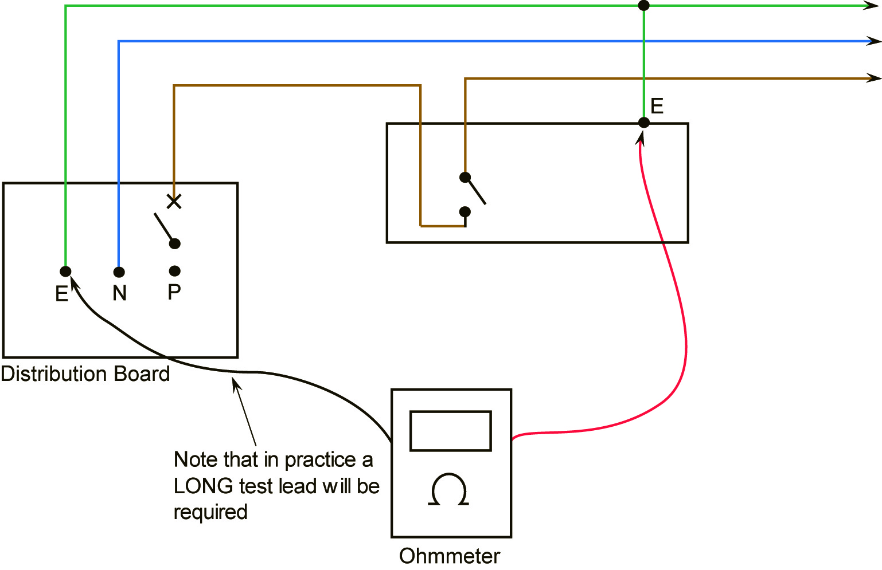

Figure 1

Protective conductor resistance equals Meter reading minus Test lead resistance

0.35R equals 0.66R minus 0.31R

Note: When carrying out this test it is essential to be aware that parallel paths can exist through extraneous conductive parts. If this is the case the conductor under test should be disconnected from its terminal and any other conductor.

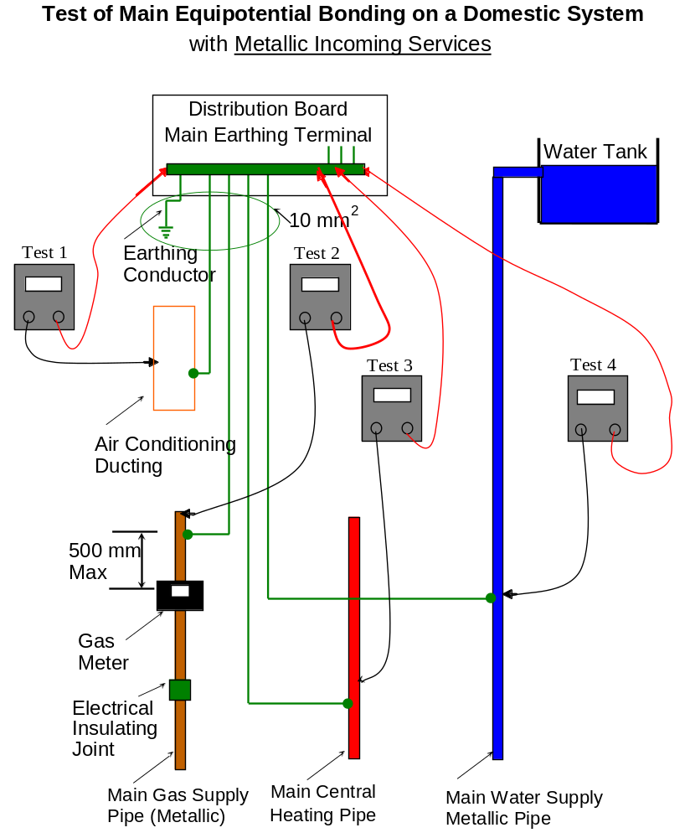

Figure 2

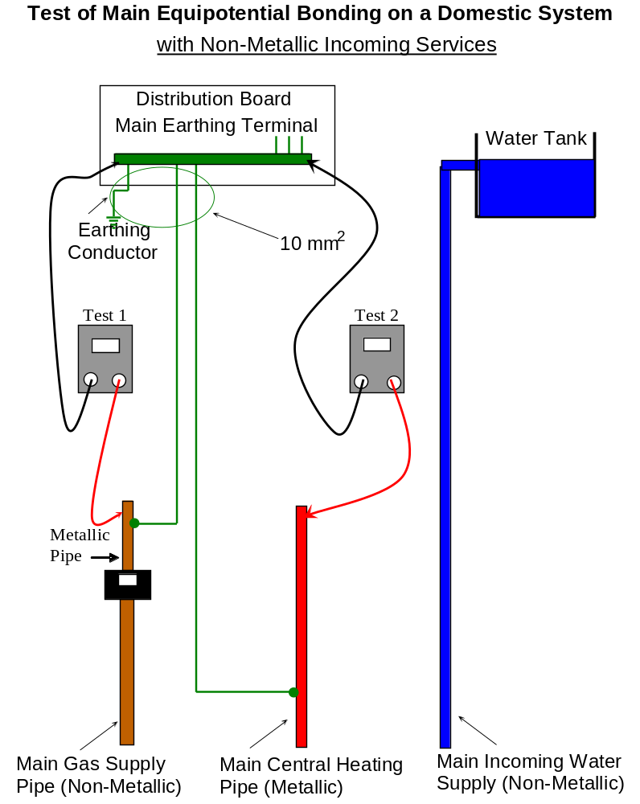

Figure 3

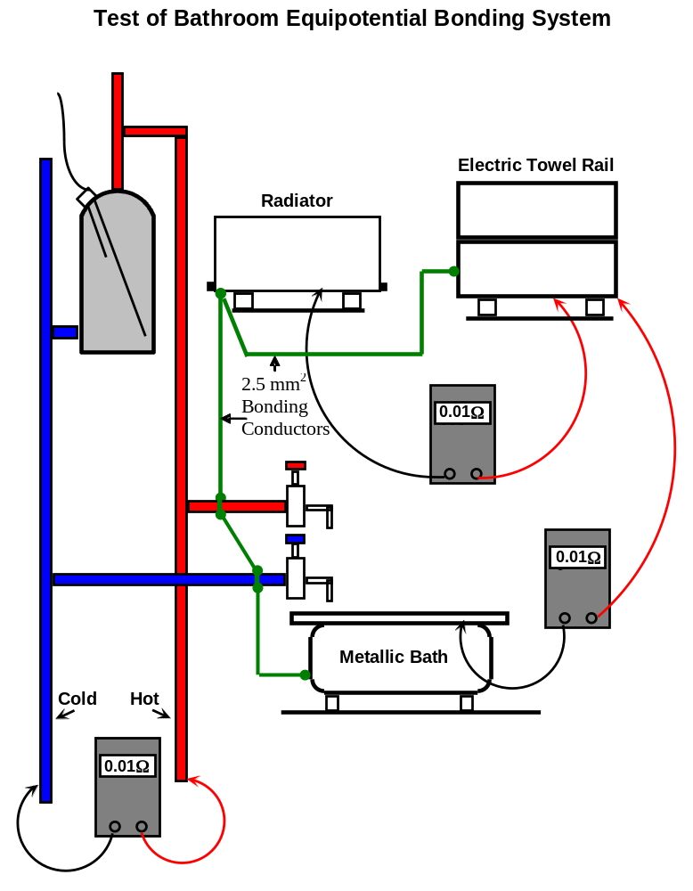

Figure 4

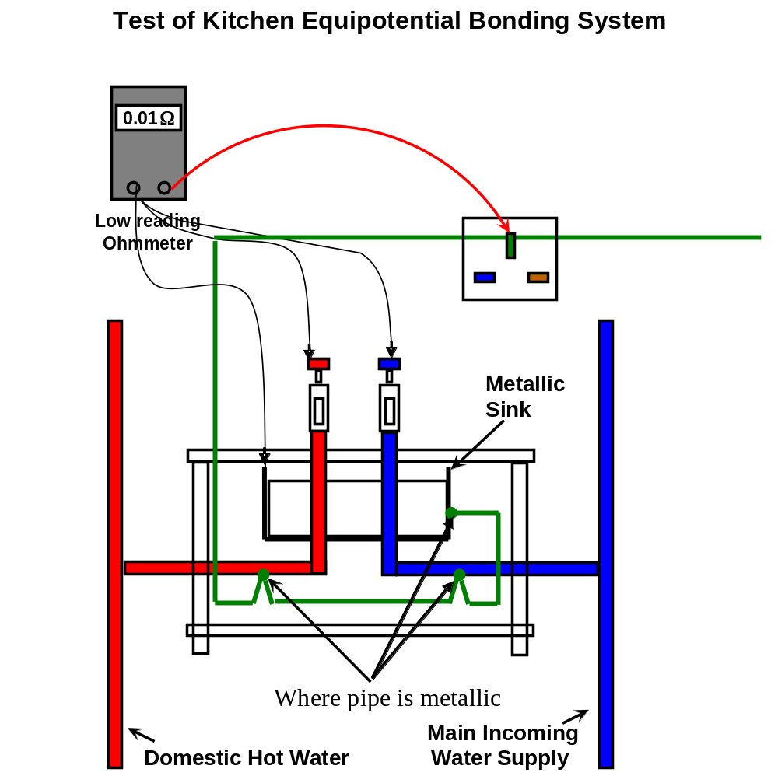

Figure 5

Note:-

The sink must be bonded.even if both pipes are plastic
Continuity of Ring Final Circuit Conductors

This test is to verify that ring final circuits are:
- Correctly wired and connected.
- Continuous throughout. ( Step 1 )
- Their conductors are not interconnected or bridged. ( Step 2 )
Test Instrument Required
A low reading DC Ohmmeter capable of passing a minimum test current of 200 mA.

There are two steps involved in completing this test. In Phase 2 we will complete Step 1.

Method.
Disconnect the phase, neutral and earth conductors from their terminals in the distribution board. Separate them from each other. Measure the resistance of each of the three loops individually and record the readings taken. The phase and neutral readings should be equal. The protective conductor may have a different cross-sectional area to that of the phase and neutral.
A 2.5 mm² Twin and Earth cable has a 1.5 mm² protective conductor. In this case multiply the resistance of the phase or neutral conductor by a factor of 1.67 to cross check the protective conductor reading. ( 2.5 / 1.5 = 1.67 ).

If there is a difference in the loop resistance readings check for a poor or loose connection.

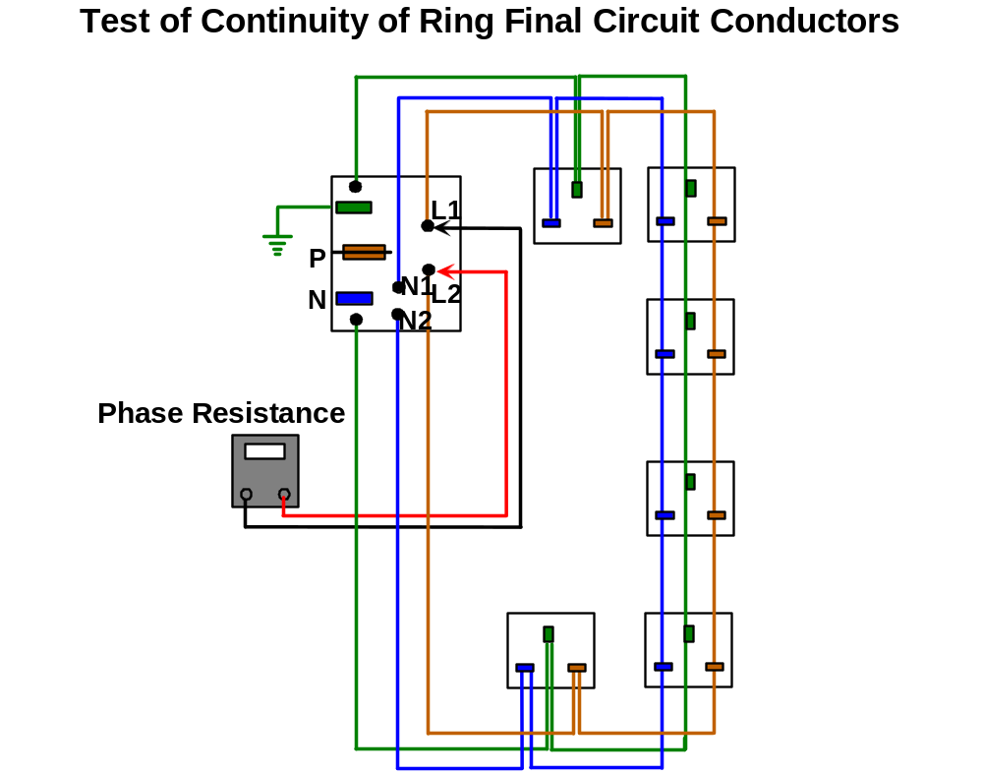
Figure 6
Insulation Resistance

This test is to ensure that there are no short circuits between live conductors or between live conductors and earth, and that there is no deterioration in insulation resistance caused by damage or dampness.

A direct voltage is applied, to test insulation resistance as the capacitive current quickly falls to zero so that it has no effect on the measurement. A high voltage is used because this will often break down poor insulation or surface leakage paths. In other words the high voltage may show up insulation weaknesses which would not be noticed at lower voltage levels.
An insulation resistance tester measures the applied voltage and the resulting leakage current flow. The resistance displayed, is obtained by an internal calculation based on Ohm’s Law.

Test voltage ( V )
Insulation Resistance ( MΩ ) =
Leakage Current ( μA )

As the effective capacitance of the system charges up, the leakage current reduces. A steady insulation resistance reading indicates that the cables are fully charged, and that the capacitive component of the test current has fallen to zero. If a wiring system is wet and / or dirty, the surface leakage component of test current will be high, giving a low insulation resistance reading.
Insulation resistances are all effectively connected in parallel. The total insulation resistance will therefore be lower than that of each individual circuit. In a large electrical installation, the total insulation resistance may be lower than that of a smaller installation.

Test Instrument Required
An insulation resistance tester ( having a DC test voltage which is dependent on the supply voltage in accordance with ETCI Rules ).

Warning:
Ensure that circuits are not live before commencing testing. Never turn the function dial whilst the test button is depressed. This may damage the instrument. Never touch the circuit under test during insulation resistance testing. Before testing always check the following:-
The “battery low” indicator is not showing.
There is no visual damage to the tester or test leads.
Check the continuity of the test leads.

To check the continuity of the test leads:
Select the continuity function- and the lowest resistance range. Short the test leads together.
The reading should be almost Zero Ohms.
An over-range ( OR ) indication will mean that the leads are faulty or the instrument fuse is blown.

Select the required test voltage ( 250 V, 500 V or 1000 V ) by rotating the function dial.

Note:- The test voltage used for low voltage installations is 500 Volts.

Select the required range ( 20 M, 200 M, 2000 MΩ ) by rotating the range selector.

Note:- Start on the highest range and only select a lower range if required.

Attach the test leads to the instrument and to the circuit to be tested. If the voltage warning bleeper sounds do not press the test button or the instrument will be damaged. Disconnect the instrument from the circuit. The circuit is live and must be de-energised before further testing.
If all is well continue the test. The value of insulation resistance will be displayed in megohms.

Note:- The minimum acceptable resistance value is 1 MΩ. A new installation test may produce a reading in excess of 100 MΩ. If a reading of 2 MΩ or less is discovered, the reason should be investigated and corrected.

1t should be noted that the system charges up to the test voltage used. Thus it can be dangerous for people or animals to make contact with an electrical installation which is under test. Even when the test voltage is removed, the wiring system may remain charged for a significant time unless steps are taken to provide a path for discharge current.

When testing is complete ensure that the test button is released before the test leads are disconnected. This is because the system may be charged up and it must be allowed discharge through the test meter internal discharge resistor.

Pre Test Procedures and Observations.

- The installation must be disconnected from the supply.
- The Main Protective Conductor must be disconnected from the supply neutral.
- All fuses are intact and all MCBs and switches are closed. ( exceptions as in 5 and 6 ).
- All current using equipment including lamps, pilot lights, bell transformers, smoke alarm units, PIR units, timers etc. are disconnected or otherwise excluded from the test between live conductors.
- Note:- Where disconnection or removal of these items is impractical the control switches should be in the off position. Items left in circuit will cause false low readings.
- Any equipment containing electronic circuitry must be disconnected or switched off in order to prevent damage by the high test voltage
Insulation Resistance between All Live Conductors and the Protective Conductor

Method
Connect all live and neutral conductors together at the distribution board and test between them and the protective conductor. The reading obtained should be 1 MΩ or greater.

An infinitely high resistance reading would be ideal.

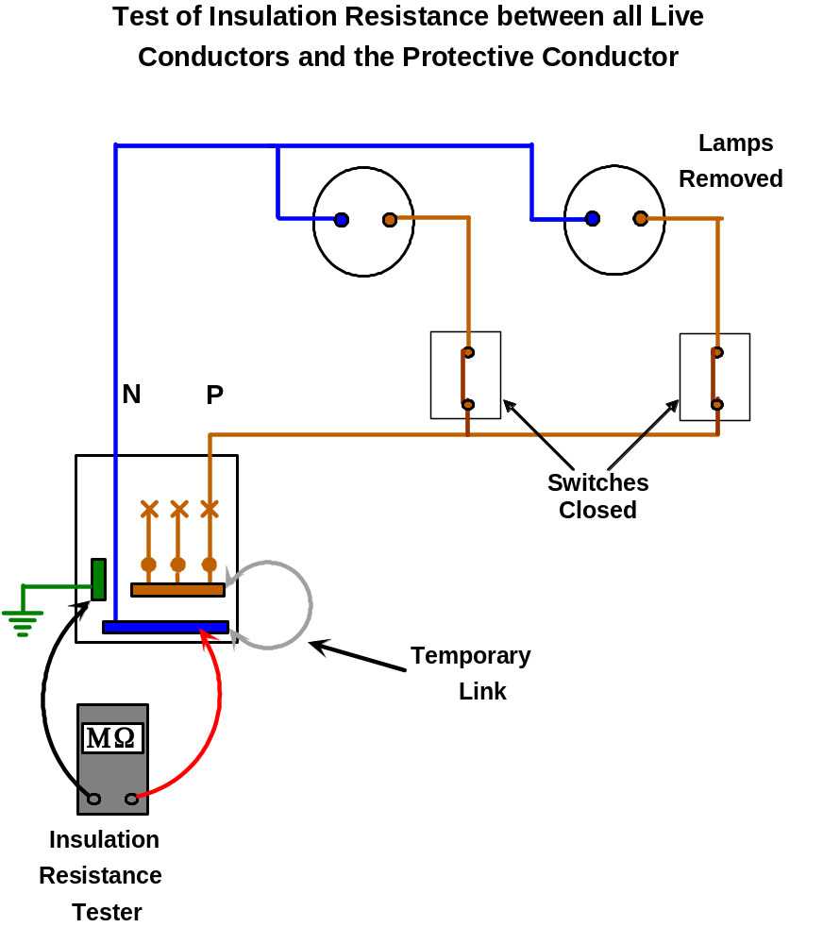

Figure 7

N.B. Do not forget to remove the temporary link.
When testing two way or two way and intermediate lighting circuits, it is essential that both of the two way switches are switched over and the test repeated at each stage. This is to ensure that all strappers and the switch wire are included in the test.

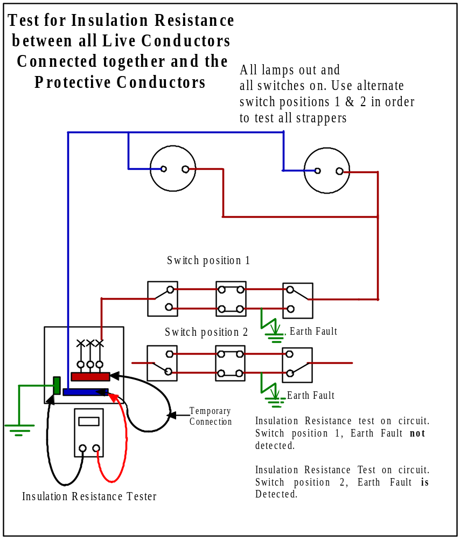

Figure 8
Insulation Resistance between Live Conductors

Method
Test between phase and neutral conductors. The reading obtained should be 1 MΩ or greater.

An infinitely high resistance reading would be ideal.

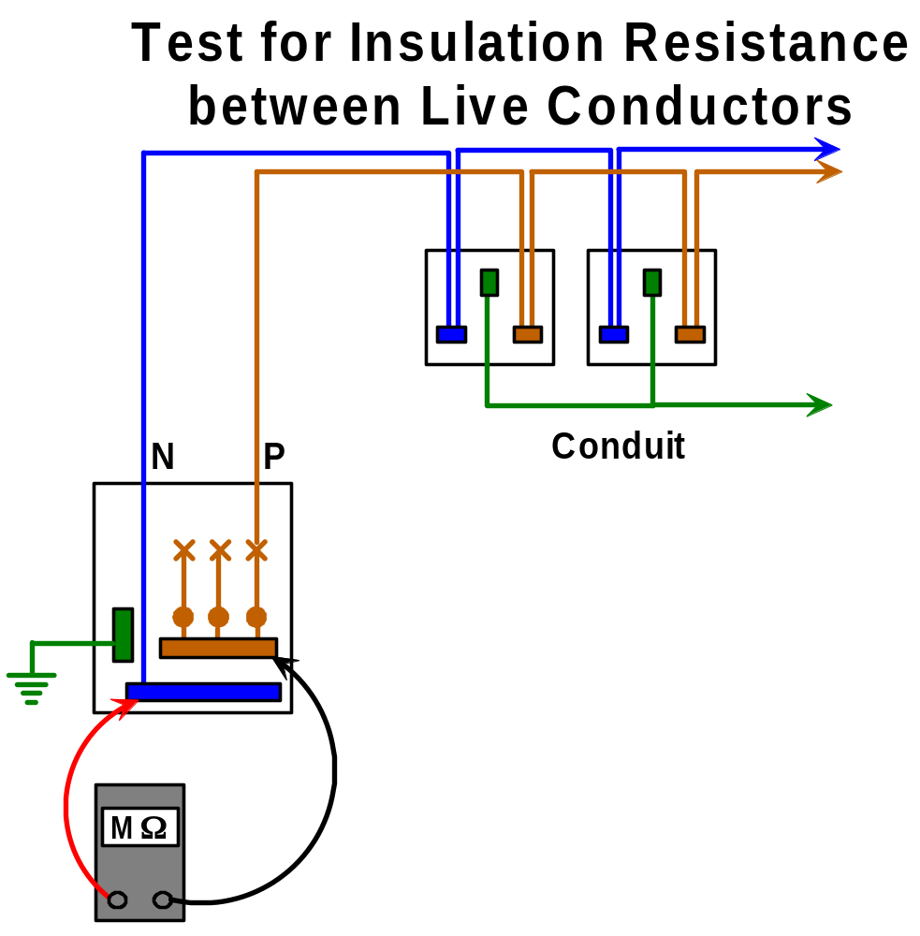

Figure 9
Polarity

This test is carried out to ensure that:

- Polarity at the main supply point is correct.
- The phase conductor is connected to fuses, single pole circuit breakers and switches.
- Incoming supply is connected to back contact of screw in type fuses.
- The phase conductor is connected to the centre contact of ES type lampholders .
- All wiring is correctly connected at socket outlets and other similar accessories.

There is no particular test method specified in the ETCI Rules on how to conduct this test.

The continuity of the protective conductor has already been verified. This test can be completed in basically the same manner.
Ensure that all appliances, lamps etc are unplugged or otherwise removed. With the circuit MCB in the “off” position, connect one end of the long trailing lead to the outgoing terminal of the circuit MCB. Using the other end in conjunction with the test meter leads, take readings from the phase terminal of all the points around the circuit e.g. switches, luminaries, sockets etc. Continuity ( approx. resistance of conductor involved ) at each outlet ensures that polarity is correct.

If the supply is disconnected from the installation the long trailing lead may be connected to the phase busbar and the MCB should then be left in the “on” position.

Test of Polarity of Socket Circuits

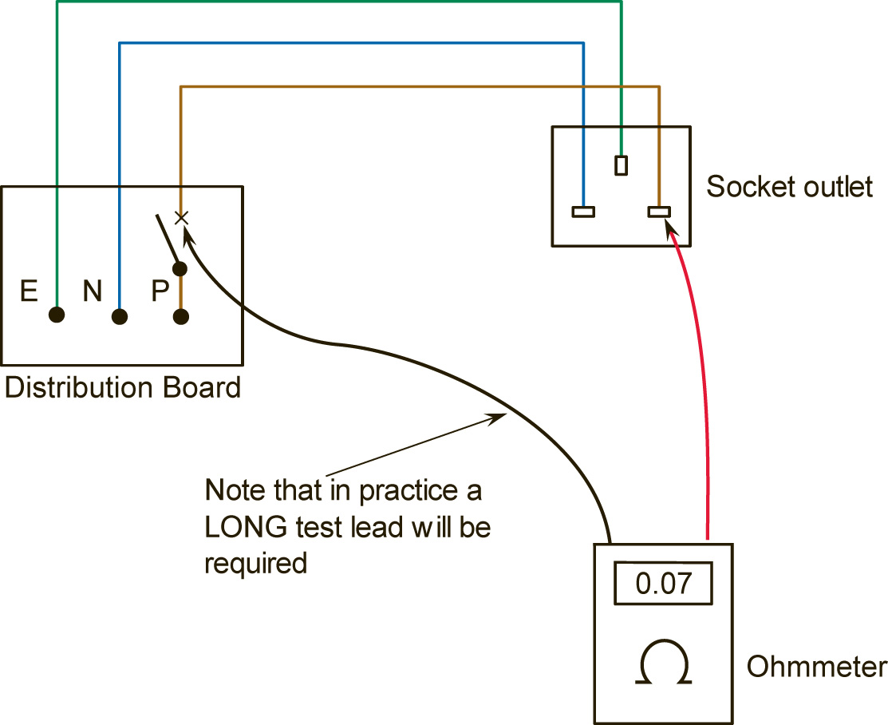

Figure 10
Test of Polarity of Lighting Circuits

This test must be done with the supply disconnected and may be carried out as follows:
Remove circuit FUSE or open MCB. Remove all lamps from relevant circuit. Connect one end of the long trailing lead to the outgoing terminal of the circuit MCB. Using the other end in conjunction with the test meter leads, take readings from the phase terminal at all the points around the circuit e.g. switches and ES lampholders. Continuity ( approx. resistance of conductor involved ) at each point ensures that polarity is correct.
If the supply is disconnected from the installation the long trailing lead may be connected to the phase busbar and the MCB should then be left in the “on” position.

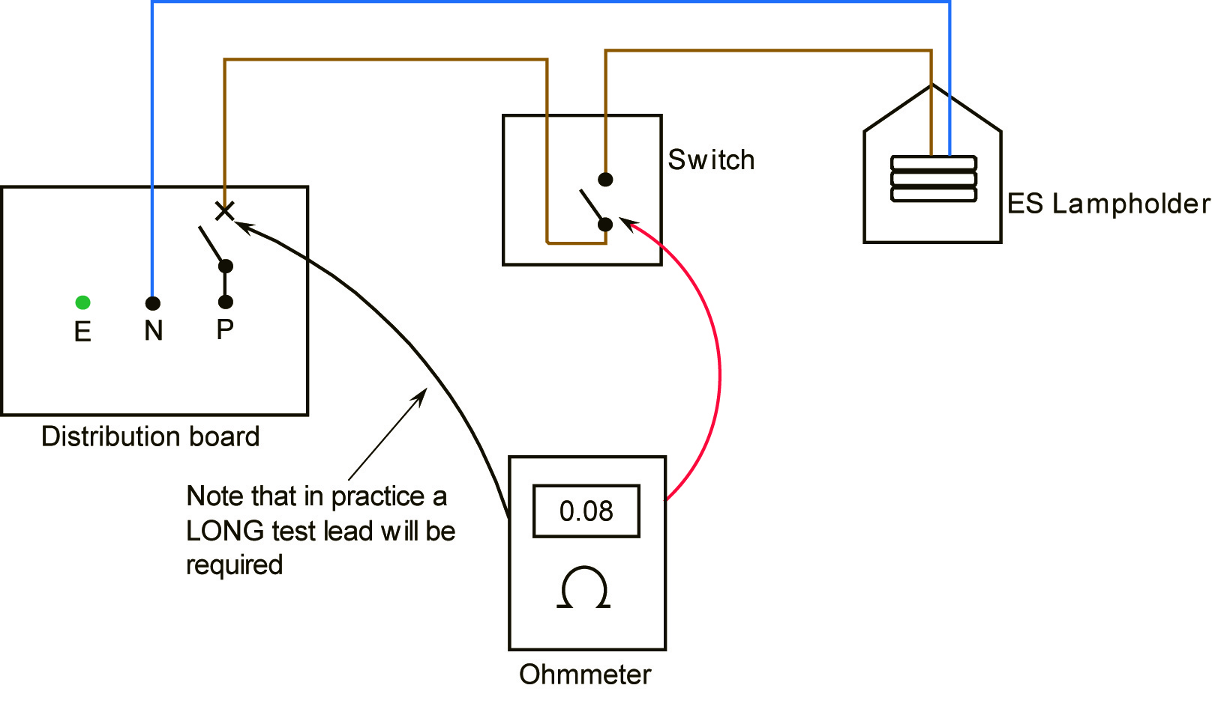

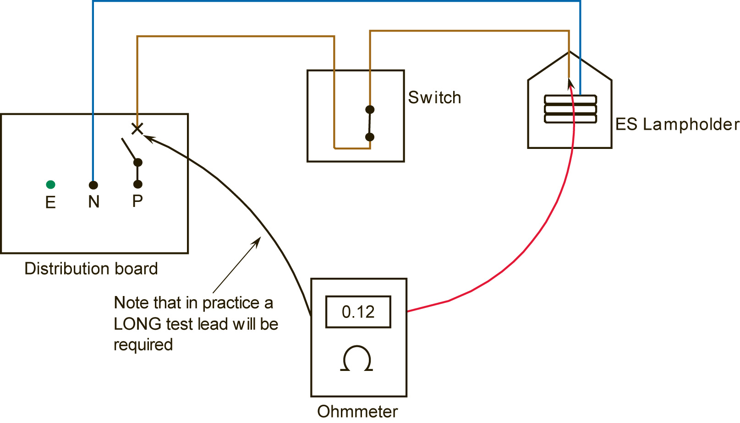

Figure 11
Note:
The circuit switch must be operated when checking polarity of ES lampholder.
Hazards Associated with Live Testing

- The circuit under test should be isolated prior to connecting any test equipment and then made live in order to conduct the test.
- It is essential that all leads and crocodile clips are in good condition.
- Care must be taken to ensure that leads do not short to each other or to earth.

Unit Related ETCI Rules

Verification | 611 all
Visual Inspection | 612 ( domestic installations only )
Testing | 613  613.1 ( items 1, 2, 3, 4 and 8 )  613.2 all  613.3, 613.3.1 ( paragraph 1 only )  613.3.2, 613.3.3, 613.3.4  613.8 all
Periodic Inspection and Testing | 62 all
Certification | 63  63.1  63.2, 63.2.1, 63.2.2, 63.2.3  63.4 ( except 3 and 5 )
Visual Inspection | Annex 61A ( domestic only )
Completion Certificate | Annex 63A ( domestic only )

Unit Related Exercise

- Visually inspect and carry out the following tests on a simulated domestic installation
- Record the test results on the following Test Report Sheet.

TEST RECORD SHEET

Circuit No. | 1 | 2 | 3 | 4 | 5 | 6 | Main Protective Conductor | Earthing  Cond. | Water  System | Gas  System | Bathrom  Bonding | Kitchen Bonding
Circuit Description
Overcurrent Protection Type and Size
Visual Inspection O/K
Resistance of Protective Conds.
Resistance of Main Protective Cond.
Resistance of Earthing Conductor
Resistance of Main Bonding Conds.
Res. of Supplementary Bonding Conds.
Resistance of Ring Circuit Conductors
Max. Res. of Protective Conds.
Polarity Test O/K
Insulation Resistance Between:-
Live Conductors and Protective Conds.
Live Conductors
Comments
Tested By:-
Block Letters
Signature

