Trade of Electrician

Standards Based Apprenticeship

Conduit and Trunking Systems

Phase 2

Module No. 2.3

Unit No. 2.3.1.

COURSE NOTES

Revision 1 April 2000

Created by Charlie Walsh - Athlone TC

Revised by:
Charlie Walsh - Athlone TC
Eugene Trindles - Cork TC
Christy Ludlow - Dundalk TC

Revision 2. Feb 2008 by
Christy Ludlow – Dundalk TC

Revision 3. July 2009 by
Christy Ludlow – Dundalk TC

Revision 4, November 2013
SOLAS

Complied by Liam Carroll – Certification & Standards

Published by


27-33 Upper Baggot Street
Dublin 4
Ireland

© SOLAS - 2013

All rights reserved. No part of this publication may be reproduced, stored in a retrieval system or
transmitted in any form or by any means, electronic, mechanical, photocopying, recording or
otherwise, without the prior permission of the copyright owner.
Table of Contents
Steel Trunking 4
Types and Sizes of Steel Trunking 4
Areas of Application 9
Types of Support 9
Spacing of Supports 10
Cable Capacity and Space Factor 10
Fabrication and Installation of Tees and Bends 10
Forming a Tee Joint 11
Forming an Internal Bend 12
Forming an External Bend 13
Forming a Flat Bend 14
Earthing of Steel Trunking 15
Overview of Conduit Types 16
Steel Conduit System 16
Types and Sizes of Steel Conduit 16
Eddy Currents in Steel Conduit 16
Some Advantages of Steel Conduit 16
Some Disadvantages of Steel Conduit 17
Cable Capacity of Steel Conduit ( Space Factor ) 17
Cutting Steel Conduit 17
Threading Steel Conduit 18
Fitting and Fixing Steel Conduit 18
Spacing of Supports for Conduits 18
Saddles 19
Distance Saddles 20
Multiple Saddles 20
Termination of Steel Conduit to Enclosures 21
Coupling and Male bush Method 21
Locknut and Female Brass Bush Method 21
Galvanised Steel Conduit Accessories 22
Jointing Steel Conduit 23
Bending Steel Conduit 25
Setting up Sequence of a Bending Machine 24
Making a 90º Bend in Steel Conduit 25
Making a Double Set or Offset in Steel Conduit 27
Forming of a 30° Offset 27
Forming a 45° Offset 29
Making a Saddle Set (Jump) in Steel Conduit 30
Making a Double 90º Bend in Steel Conduit 33
PVC Conduit 34
Composition of PVC Conduit 34
Choice of PVC Conduit 34
Jointing PVC Conduit 34
Precautions When Using Adhesives 34
Expansion of PVC Conduit 34
Fitting and Fixing of PVC Conduit 35
Advantages of PVC Conduit 35
Disadvantages of PVC Conduit 35
Working with PVC Conduit 36
Hot Bending of PVC Conduit 37
Unit Related ETCI Rules 38

Steel Trunking

A trunking is an enclosure that provides for the protection of cables. It is normally square or rectangular in cross section, and has a removable lid.

A trunking system offers great flexibility when used in conjunction with conduit systems. Trunking forms the backbone or framework of an installation. Conduits run from the trunking to accessory outlet boxes.

When an alteration or extension is required to an installation it is easy to drill a hole in the side of the trunking and run a conduit to the new accessory point. New wiring can then be drawn through the new conduit and the existing trunking to the supply point.

Types and Sizes of Steel Trunking

There are a number of types of steel trunking such as:-

- Lighting Trunking
- Cable trunking
- Multi-Compartment trunking
- Bus-bar Trunking

Typical surface finishes.

- Hot dipped galvanised coating
- Grey enamel on zinc coating
- Silver enamel on zinc coating
- Stainless steel

Standard Sizes of Trunking

- 50mm x 50mm 150mm x 75mm
- 75mm x 50mm 150mm x 100mm
- 75mm x 75mm 150mm x 150mm
- 100mm x 50mm 200mm x 100mm
- 100mm x 75mm 225mm x 150mm
- 100mm x 50mm 250mm x 150mm
- 100mm x 100mm 300mm x 250mm

Trunking is generally supplied in 3 metre lengths. Lighting trunking is often supplied in 5 metre lengths. Other lengths are available on request.

Lighting Trunking

Steel trunking may be used to install luminaires. This type has quick fit drive-in couplings, which allow for fast, easy installation of long runs. The trunking is installed with the opening downwards as shown in Figure 1.

. 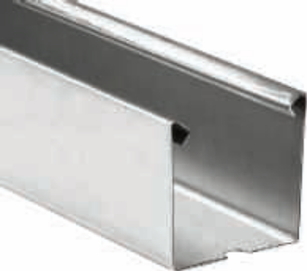 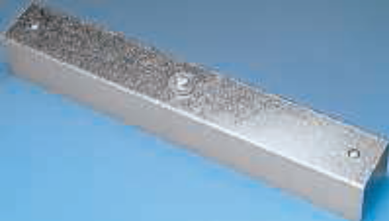
Trunking Drive-in coupling

Figure 1

A range of fittings is available to accommodate changes in direction, tees and intersections. These are bolted in position using at least two bolts depending on trunking size.
See Figure 2

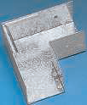
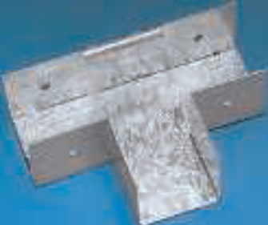

Flat Bend Tee

Figure 2

Cable retainers are used to prevent the cables falling out of the trunking. Special attachments are used to fix the luminaires to the trunking and also to allow the cables enter for connection.
See Figure 3

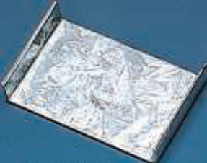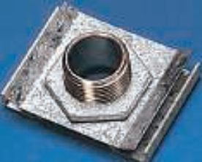
Cable Retainer Attachment

Figure 3

Suspension brackets are used to suspend the trunking at the required height below the ceiling. End caps and either steel or plastic lids are installed to complete the enclosure. The lid is simply clipped into position.
See Figure 4

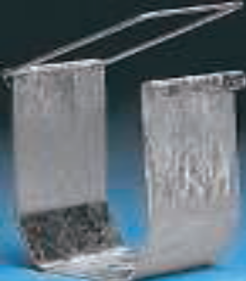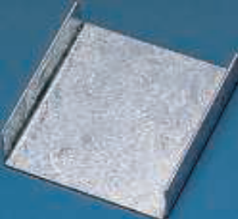
Suspension Bracket End Cap
Figure 4

Cable Trunking

Standard cable trunking is similar in design to lighting trunking. The lid in this case is held in place with turnbuckles. A quarter turn of a large flat screwdriver will either fasten or loosen the turnbuckle.
See Figure 5

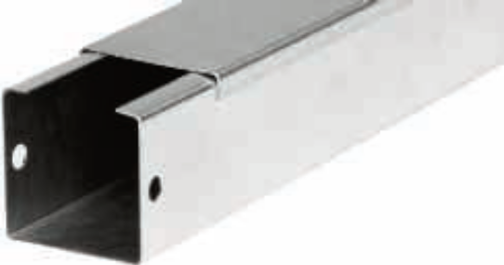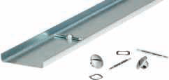
Figure 5

A range of fittings is available to accommodate changes in direction, tees, intersections and to couple lengths together. These are bolted in position using at least two bolts depending on trunking size.
See Figures 6

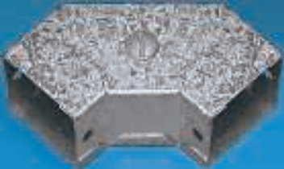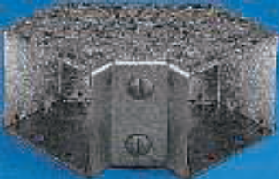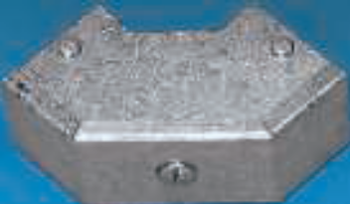

Flat Bend Internal Bend External Bend

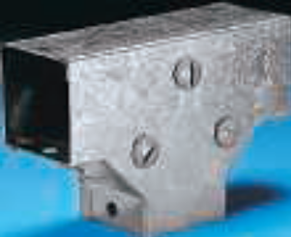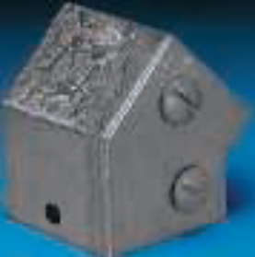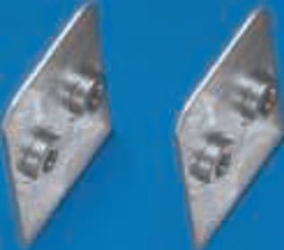

Tee 45° Bend Coupling

Figure 6
Changes in trunking size are simply made by using reducers. Cables are easily kept in place in the trunking with cable retainers. End caps are used to complete the enclosure.
See Figure 7

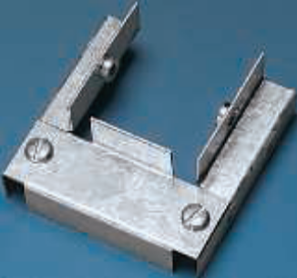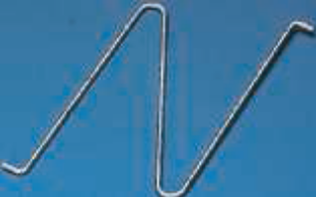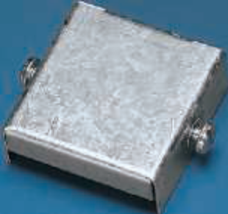

Reducer Cable Retainer End Cap

Figure 7

Multi-Compartment trunking

The increasing use of electronics and differing voltage levels in industrial installations has necessitated the use of multi-compartment trunking, which is designed to segregate ( separate ) the various voltages and services.

Segregation of this nature is a requirement of the ETCI Rules. For example, it prevents an extra low voltage system, coming into contact with a low voltage system even in the event of a fault.

Figure 8 shows a typical section of multi-compartment trunking.

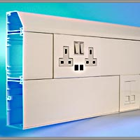
230-400 V
Cables
Computer
Cables
Up to 50 V
Cables

Figure 8

Areas of Application

Steel trunking systems are used in commercial and industrial premises. Lighting trunking is generally used to supply and support fluorescent fittings, which illuminate large floor areas. Cable trunking is installed at a suitable height around the walls of the building. Conduit drops are then used to supply outlet points. Multi-compartment trunking is used where different electrical services are required in close proximity to each other. It is ideal in large offices and classrooms. Here it may be used to accommodate cables for supplying equipment at 230 Volts, plus data cables for computers, printers etc. These supplies must be segregated from each other.

Types of Support

Trunking should be secured by round-headed screws or bolts. This prevents damage to cables during installations. In industrial installations, trunking may be run overhead, supported at intervals by the lower members of the roof trusses. It may be suspended from or fastened directly to right angle brackets. It may also be fixed directly to a wall surface. Figure 9 shows a number of fixings, which may be used to support trunking.

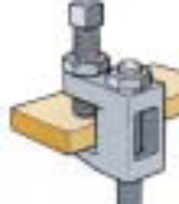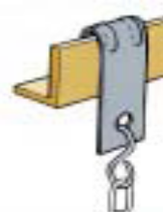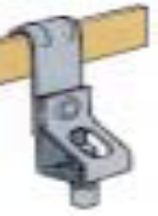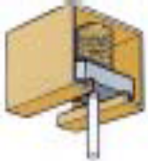
Beam Clamp Vertical Flange Hangers Channel spring Nut

Figure 9

Figure 10 shows a run of trunking supported by suspension brackets. The threaded rod also allows for final height adjustment.

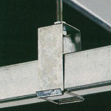

Figure 10

Spacing of Supports

The spacing of trunking supports is not a simple topic as there are so many variables such as: - size of trunking, size and number of cables to be installed, type and strength of support available. However the following table lists the maximum distances between supports for steel trunking.

Maximum Support Spacing for Steel Trunking
Trunking Size | Horizontal | Vertical
50 x 50 | 1.75 | 2.0
75 x 50 | 3.0 | 3.0
Larger Sizes | 3.0 | 3.0

Cable Capacity and Space Factor

Trunking is primarily intended for the installation of PVC insulated cables. The maximum number of cables that can be installed in a trunking system is based on only 45% of the available space being occupied. This does not mean that the trunking should appear to be less than half full of cable. Remember that all the unoccupied space in between the cables is included in the calculation.
The main reason for limiting the number of cables to this level is to eliminate problems associated with an excessive build up of heat inside the trunking. If too many cables are installed the cable insulation will suffer damage due to overheating. There is also the possibility of fire risk.
The ETCI Rules provides a handy guide to aid the calculation of the cable capacity of trunking. It allows for a mixture of all the common cable sizes up to 10 mm². Other cable sizes have to be accounted for on an individual basis. Remember that the overall cable CSA must be used in the calculation ( not the CSA of the conductor alone ).
If multi-core cables are to be installed in trunking the 45% space factor still applies, except in the case of one multi-core cable only.

Fabrication and Installation of Tees and Bends

Tee and bends may be fabricated where required in lengths of trunking. This may be necessary or simply more convenient, particularly if the required bend or set is non-standard. It takes more time to fabricate tees or bends than to bolt on manufactured accessories.

Note-: It is recommended that a 32 TPI hacksaw blade be used for cutting steel trunking.
Forming a Tee Joint

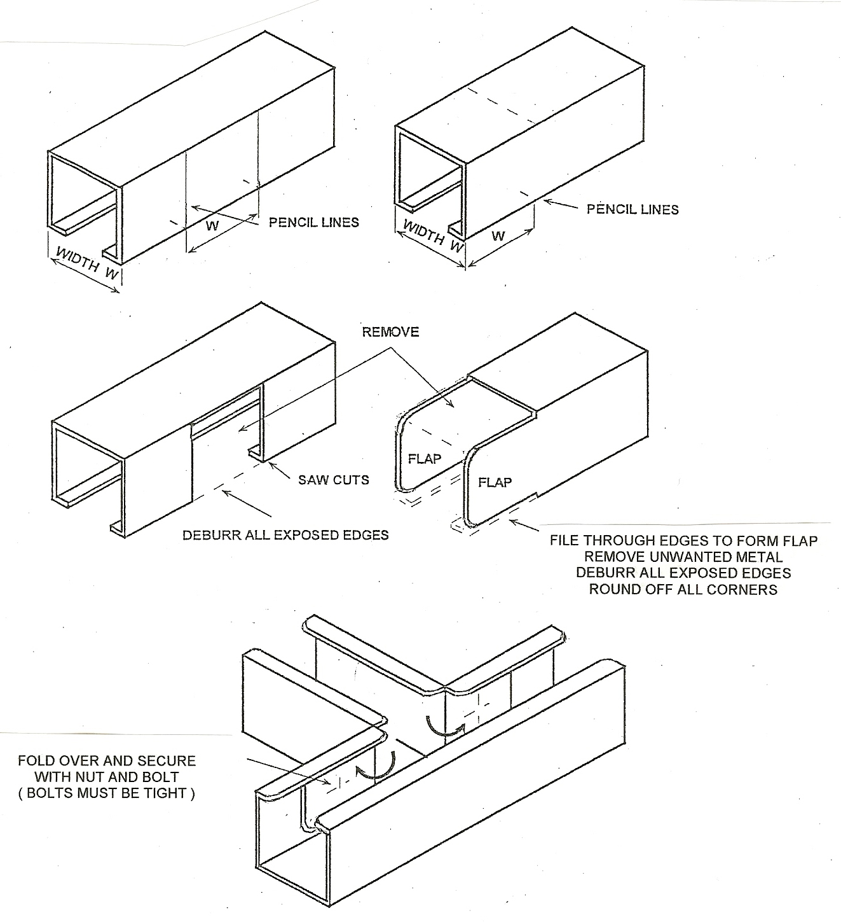

Figure 11
Forming an Internal Bend

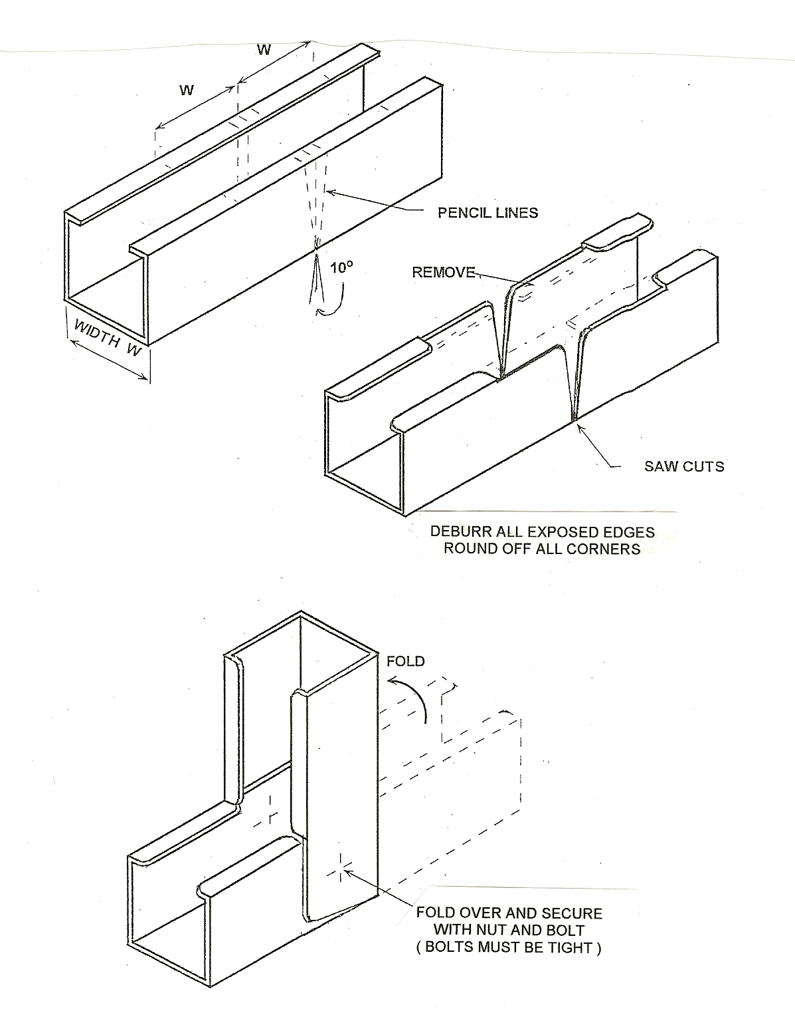

Figure 12
Forming an External Bend

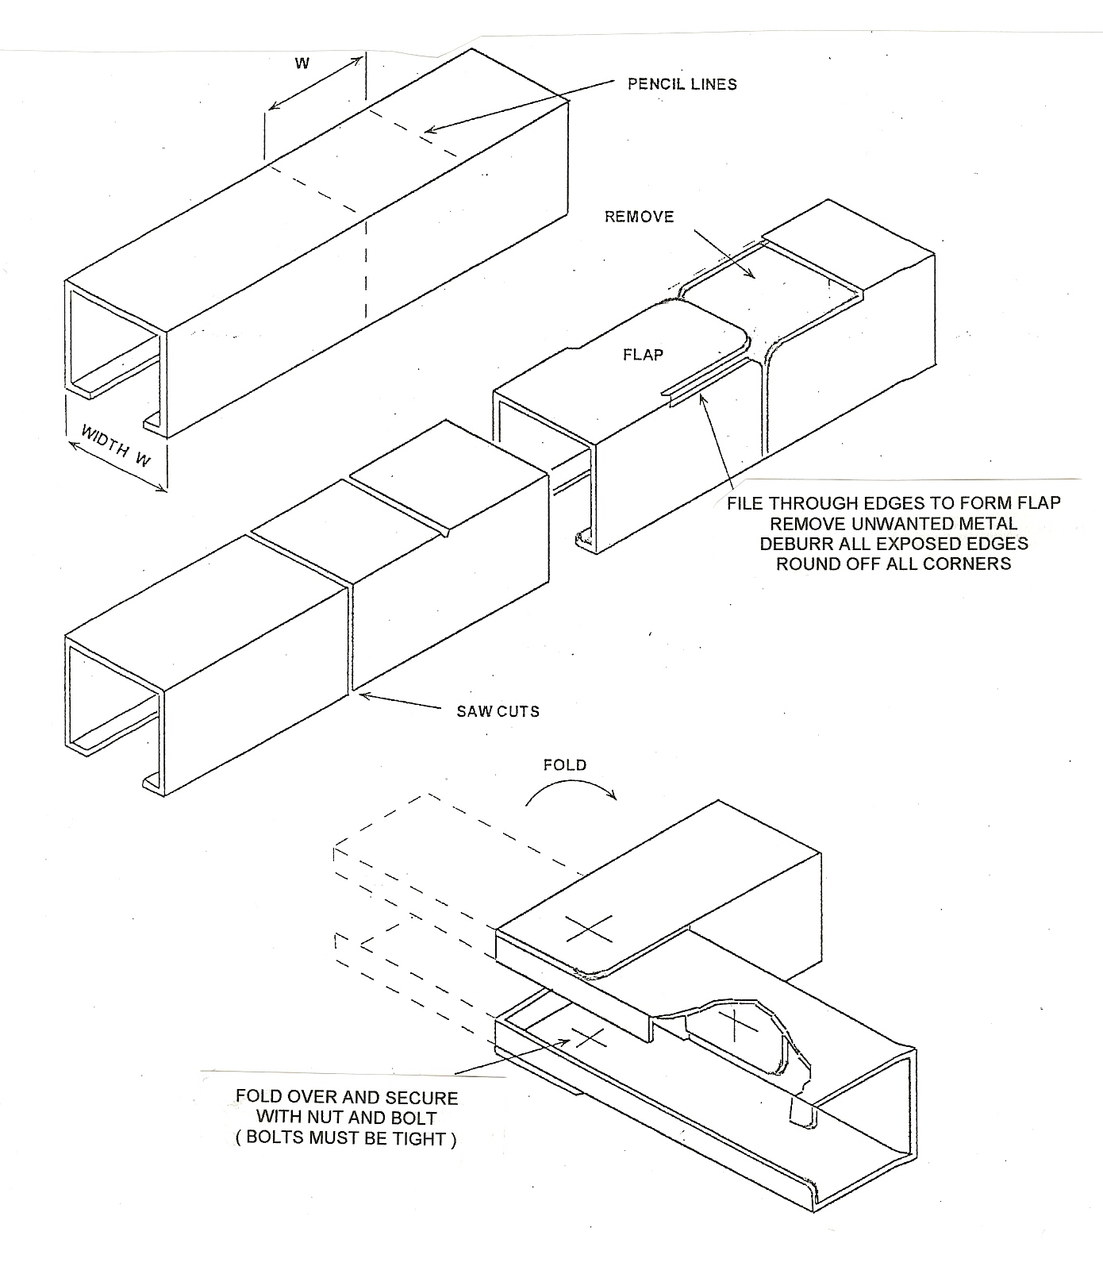

Figure 13
Forming a Flat Bend

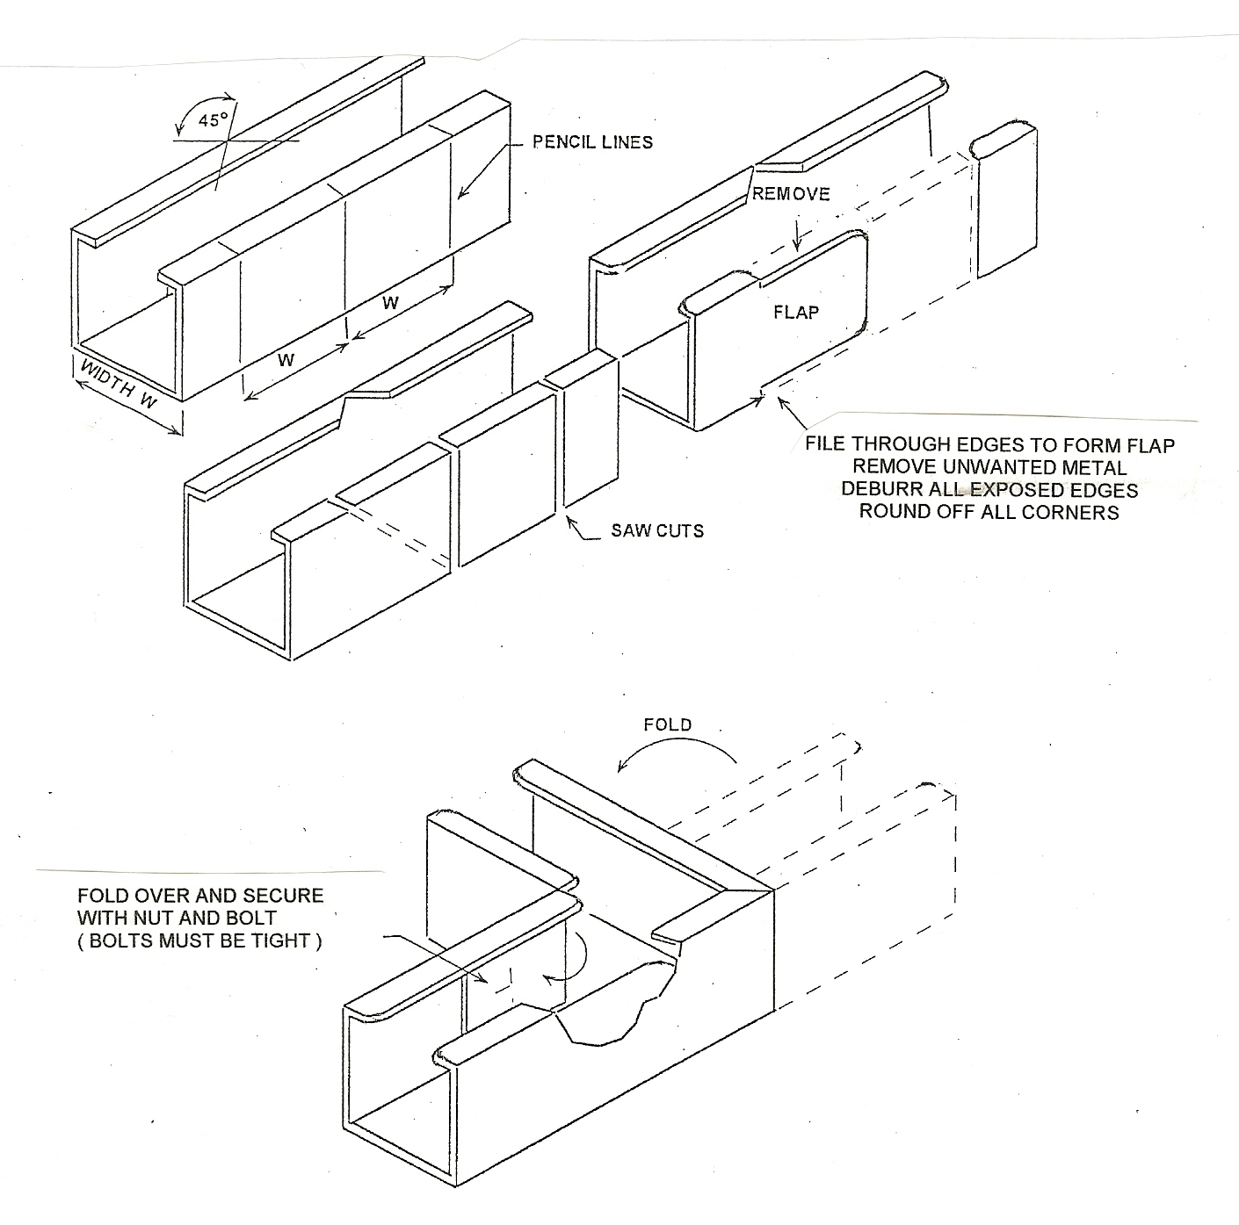

Figure 14
Earthing of Steel Trunking

A trunking installation must be earthed. Earth continuity is ensured by the proper tightening of all bolts used throughout the system. Some manufactures recommend that earth continuity be completed by fixing a copper or aluminium strap across all joints. It is more important that all the bolts involved in the system are tightened. It is not unusual to find that copper or aluminium straps are used, but are left loose, resulting in poor earth continuity. See Figure 15.

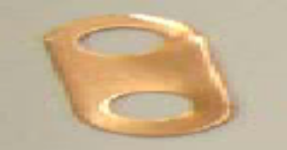
Copper Earth Strap

Figure 15.

Overview of Conduit Types

A conduit is a tube, channel or pipe in which insulated conductors are contained. The conduit in effect replaces the PVC outer sheath of a cable, providing mechanical protection for the insulated conductors. A conduit installation can be rewired easily or altered at any time and this flexibility, coupled with mechanical protection, makes conduit installations popular for commercial and industrial applications.
Examples of types of conduit used in electrical installation work are as follows :
- PVC
- Steel
- Flexible
- Stainless Steel

Steel Conduit System

Types and Sizes of Steel Conduit
Steel conduits are manufactured to specifications defined by the British Standards Institute (BS).
Class 4 conduit has a hot dip galvanized finish. It is of heavy gauge with a welded seam. This conduit is suitable for use in external or damp installations.This is the conduit most widely used in this country.

Note: The galvanized finish on conduit is to prevent the steel from corroding in normal use.

Also manufactured is a solid drawn seamless conduit which is more expensive and only used for special gas tight, explosion proof or flame proof installations.
Conduit is normally supplied in 3 or 3.75 metre lengths and typical conduit external diameters are 16, 20, 25 and 32mm.

Eddy Currents in Steel Conduit
Metal conduits in which a.c. circuit wiring is installed MUST contain all the current carrying conductors of each circuit in the same conduit, to eliminate the possibility of induced eddy currents. Eddy currents could result in the metal conduit and cables becoming hot.

Some Advantages of Steel Conduit
- Affords cables good mechanical protection
- Permits easy rewiring
- Minimises fire risks.
- Can be utilized as the Circuit Protective Conductor. ( CPC )

Some Disadvantages of Steel Conduit
- Under certain conditions moisture is liable to form on the inside wall of the conduit.
- Expensive compared with some other wiring systems.
- Liable to corrosion where subject to acids, alkalis and corrosive fumes.

Cable Capacity of Steel Conduit ( Space Factor )
Having determined the correct number and cross-sectional area of cables for a given load it is necessary to select the size of conduit that will accomodate them.
If a greater number of cables are installed in the conduit, over-heating, insulation damage and fire may result. As a general rule the number of cables drawn into a conduit should not be such as to cause damage to either the cables or the conduit during the installation.
The maximum number of cables which may be drawn into a conduit can be calculated by using the factor system described in the ETCI Rules.

Cutting Steel Conduit
Conduit should be cut with a hacksaw, using a blade having 32 teeth / inch.
The cut should be made at right angles to avoid difficulty in threading the conduit.
Figure 1. illustrates this process.
- Hold conduit to be cut securely in a pipe vice. Avoid damage to the galvanised coating.

- Stand square to the job and make sure your movement is unobstructed.

- Grip the hacksaw lightly and apply light pressure on the forward cutting stroke. Use the full length of the blade.

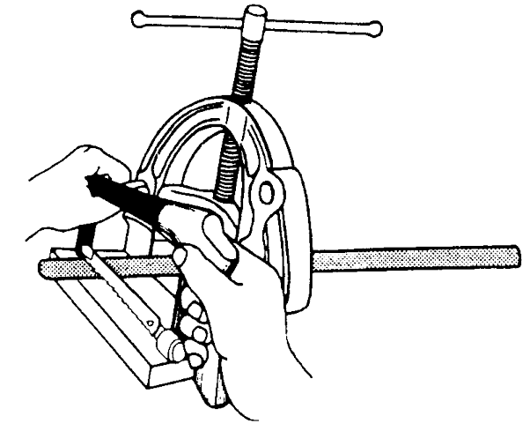

Figure 1.

Threading Steel Conduit
It is necessary to cut threads on the conduit ends in order to screw them into conduit couplings and accessory boxes. The conduit ends are threaded using stocks and dies. After threading the ends, all internal burrs must be removed to ensure that cables are not damaged as they are being drawn into the conduits.
All threaded ends must be screwed up tightly into accessories to ensure earth continuity.

- Hold the conduit securely in a pipe vice ( ensure that pipe vice jaw bolts are tight ).
- While threading keep the die well lubricated preferably with a manufacturer’s paste or tallow.
- Thread to required length and remove any burrs with a file or reamer, this will prevent sharp edges causing damage to cables while being drawn into the conduit.
- To ensure a clean, unbroken thread the die should be rotated counter-clockwise frequently and finally run up and down the threads to remove any swarf ( metal fragments ).

Fitting and Fixing Steel Conduit
Conduit must be securely fixed and where it is liable to mechanical damage, it should be suitably protected.

Drainage outlets must be provided at points where condensation is likely to collect.

Spacing of Supports for Conduits
The table below shows a suggested spacing of supports for steel conduits up to 25mm in diameter. Supports should be positioned within 300mm of bends and fittings. The table assumes that the conduit is not subject to other external mechanical stresses.

Conduit Size  Not exceeding 16mm  20-25mm | Horizontal Runs  750mm  1750mm | Vertical Runs  1000mm  2000mm

Saddles
A range of clips and saddles are available for conduit installations. The spacer bar saddle, is the device most commonly used for fixing conduit, see Figure 2. They provide a very secure method of fixing and generally should be spaced as per the table on the previous page.
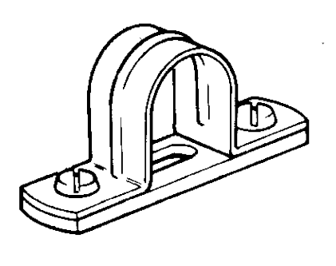

Figure 2.

Spacer bar saddles incorporate a spacing plate. These spacing plates are approximately 5mm thick. This spacing plate tends to align the conduit with the knockouts in switch and socket outlet boxes. On vertical runs ensure that saddles are fitted the correct way round. An important function of the spacer bar saddle is to keep the conduit out of contact with plaster and cement surfaces. Contact between conduit and these surfaces could result in corrosion of the conduit and discolourment of the surfaces.

When a conduit is fixed to concrete, much installation time is spent in plugging the concrete for fixings. Spacer bar saddles have the advantage of a central, single-hole fixing. The additional cost of spacer bar saddles over the plain saddle (see Figure 3.) can be offset against the saving in time and effort required in fixing.
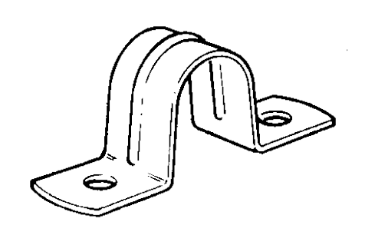

Figure 3.

Distance Saddles
Distance saddles are designed to space the conduit approximately 10mm from the wall or ceiling. These saddles are generally made of malleable cast iron. They are much more substantial than spacer bar saddles and the additional spacing provides greater protection against corrosion. The use of distance saddles eliminates the possibility of dust and dirt collecting behind the conduit. By adequate spacing it is possible to keep the conduits free of dust and it is for this reason distance saddles (Figure 4A) and hospital saddles (Figure 4B) are generally specified.

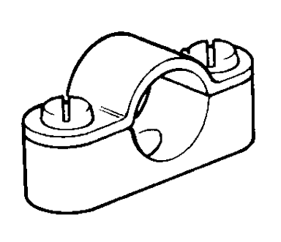 | 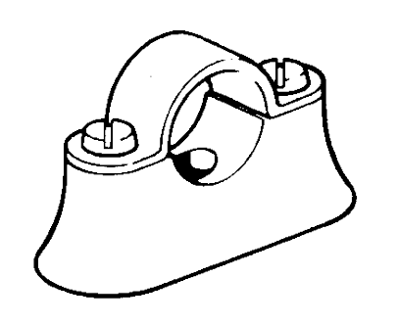
Figure 4A | Figure 4B

Multiple Saddles
Where two or more conduits follow the same route it is generally an advantage to use multiple saddles, see Figure 5. Proper spacing of the conduits ensures that there is no need to set the conduits where they enter conduit accessories
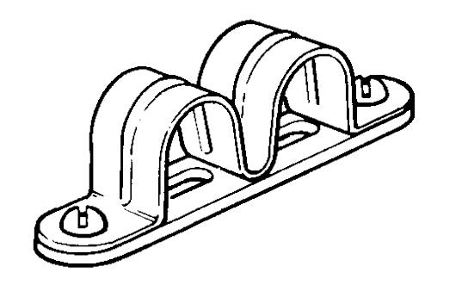

Figure 5

Termination of Steel Conduit to Enclosures
Two methods of terminating steel conduit are commonly used.
- The coupling and male bush method, see Figure 6A (Usually used and preferred)
- The locknut and female bush method, see Figure 6B (Used where space is tight)

Coupling and Male bush Method
The coupling and male bush method is slightly more expensive than the locknut and female bush method but it allows more wiring space and is a stronger form of termination. Using this method a coupling is screwed securely on to a standard threaded conduit end and then butted against the accessory box. A male bush is passed through the box entry and screwed tightly into the coupling using an open-ended spanner or a bushing spanner.
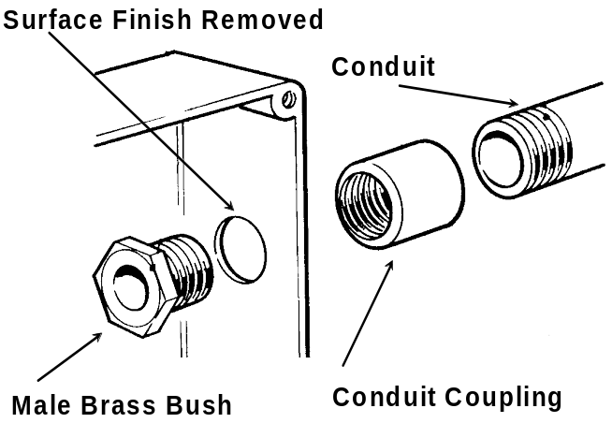
Figure 6A

Locknut and Female Brass Bush Method
Using this method a locknut is screwed tightly onto a standard threaded conduit end and the thread passed through the hole in the accessory box. A second locknut is screwed onto the conduit effectively sandwiching the wall of the box. To prevent damage to cables, from the exposed end of the conduit, a female bush is then screwed onto the conduit thread. One disadvantage in using this method of terminating a conduit to a switch or socket box is that the conduit protrudes into the box and may inhibit the fixing of the switch or socket.
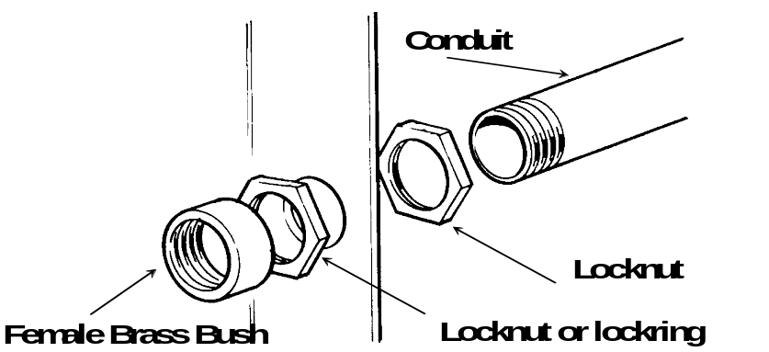
Figure 6B
Note: - These are earth terminations

Galvanised Steel Conduit Accessories
Figure 7A illustrates a range of galvanised steel conduit boxes, reducers and adaptors.

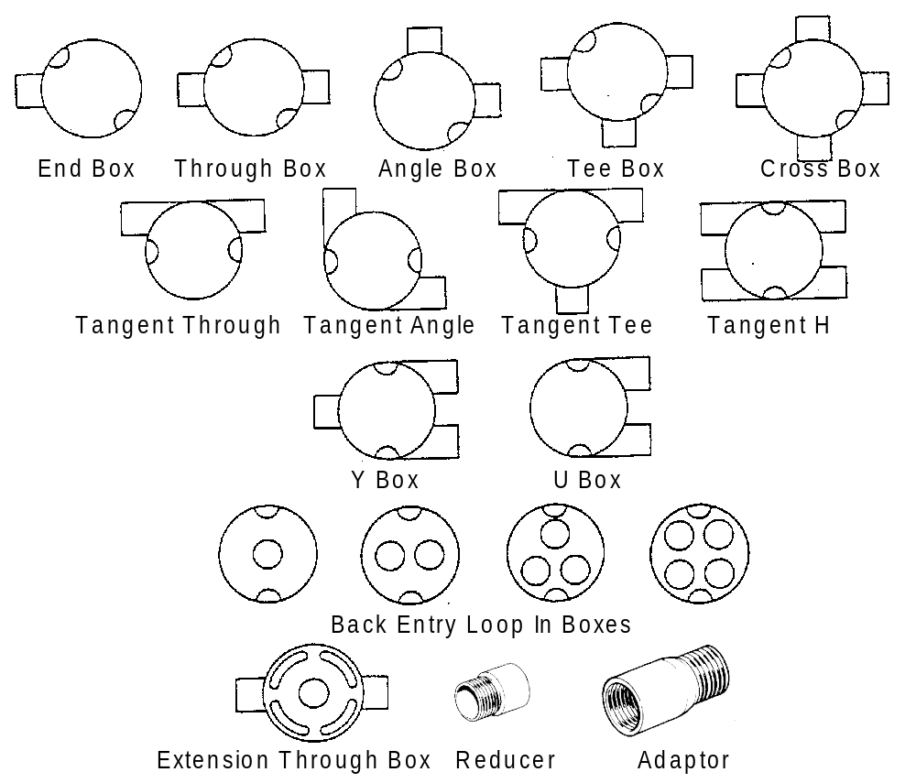

Figure 7A

Jointing Steel Conduit
Where two lengths of conduit are to be joined a plain coupling is used. To ensure good electrical continuity and maximum mechanical strength the tube ends must tighten inside the coupling (Max gap 2 mm), see Figure 7B. Care must be exercised to do this without leaving threads outside the coupling.
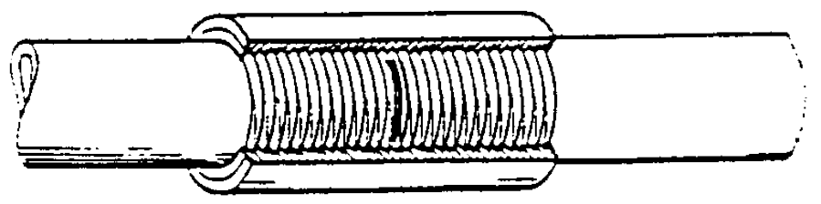
Figure 7B
Where neither tube can be turned it is necessary to resort to the technique known as the “running coupling” , see Figure 7C. After tightening up the lockring the exposed thread must be painted to prevent corrosion.
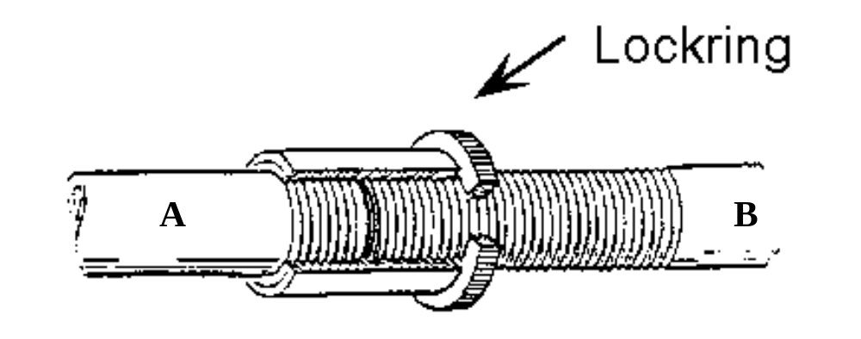
Figure 7C

Setting up Sequence of a Bending Machine
- Place the semi-circular former ‘B’ (to suit the size of conduit to be bent) in position and secure the centre-pin, see Figure 8.
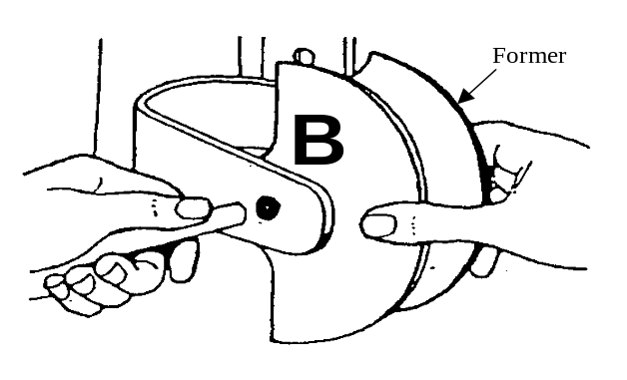

Figure 8.
- Position the stop ‘C’ in the correct position for size of conduit, see Figure 9.

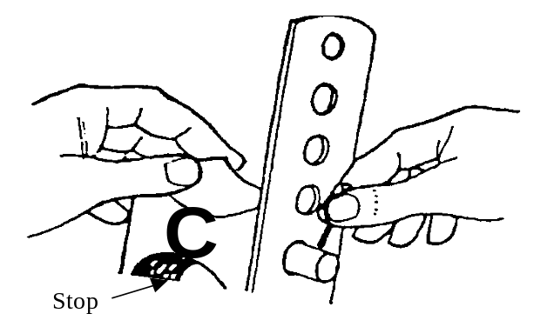

Figure 9.
- Insert the grooved roller in the correct position for size of conduit, see Figure 10.
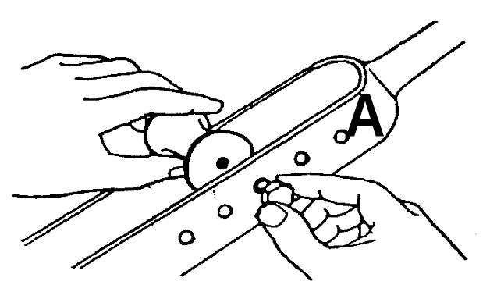

Figure 10.

Bending Steel Conduit
The most common method of bending steel conduit is to use a bending machine. However, for bending 32mm diameter or larger conduits it is recommended to use a portable ratchet bender. The following are the main steps to be taken when using a bending machine.
- Insert the conduit under the stop and into the groove in the former.
- Pull down the handle, allowing the roller to bend the conduit around the former.
- Use a template to compare the angle of the bend formed with the desired angle.

Bends should be formed to an internal radius of not less than 2.5 times the conduit diameter

Making a 90º Bend in Steel Conduit
Figure 11 illustrates a right angle bend in steel conduit, which must be formed to a dimension of 200mm.

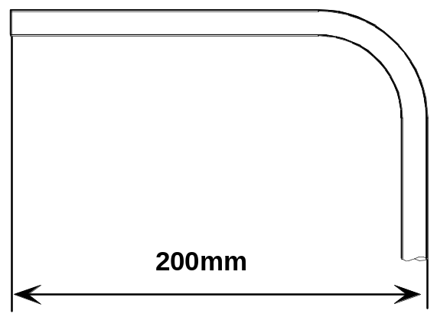

Figure 11.

The first step is to mark off 200mm from the end of the conduit as illustrated in Figure 12.

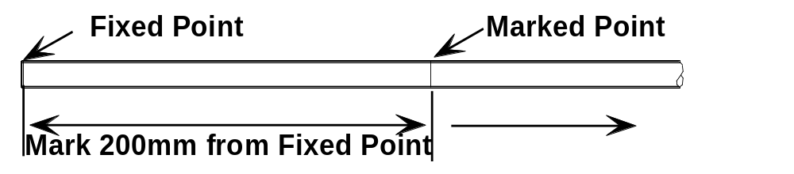

Figure 12.
The next step is to place the conduit in the former with the mark to the rear. Position the conduit so that a try-square, held against the mark touches and forms a tangent to the edge of the former as illustrated in Figure 13.

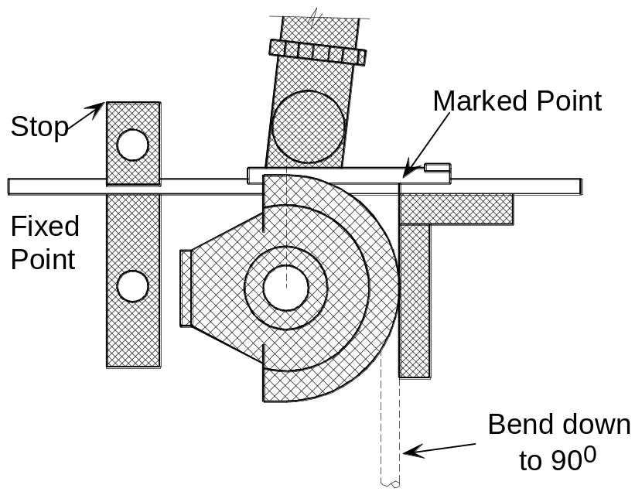

Figure 13.

Next pull the lever down until the 90° angle, is achieved.

Making a Double Set or Offset in Steel Conduit
Normally offsets should be formed at either 30° or 45°.
A 30° offset is preferred for two reasons:

- Ease of measurement.
- Ease of drawing-in cables.

Forming of a 30° Offset
Figure 14 illustrates a 30° offset to be formed in steel conduit. From the illustration it can be seen that the 30° angle is one of three angles forming a right angled triangle.
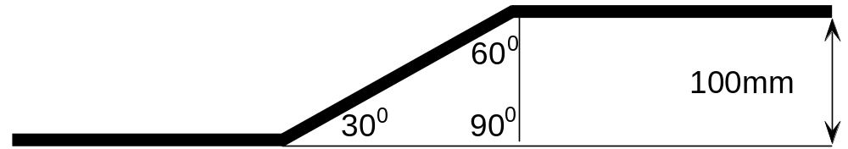

Figure 14.

A rule of thumb for a right angle triangle (30°, 60°, 90°) states that the relationship between the three sides is in the ratio of 1:2:√3, see Figure 15.



Figure 15.

With this information, once we know the dimension of the offset (100mm in this case) we can now calculate and mark off the distance between the two bends. At this point take the straight piece of conduit and mark on it where you want the first bend to start from, then measure 200mm from that point to where the second bend starts, see Figure 16.
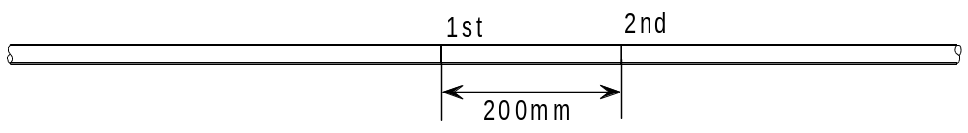

Figure 16.

Now go to the bending machine. Mark a point on the former as shown in Figure 17. Place the conduit in the former matching the first mark on the conduit with the mark on the former and bend to 30° as shown in Figure 18. Now remove the conduit and check the offset angle against a 30° template.
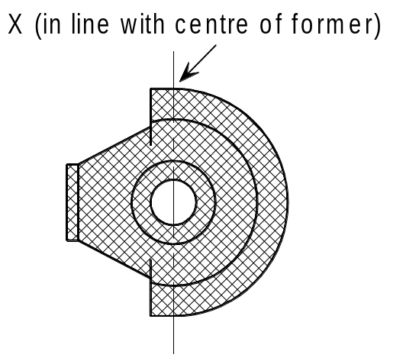
Figure 17.

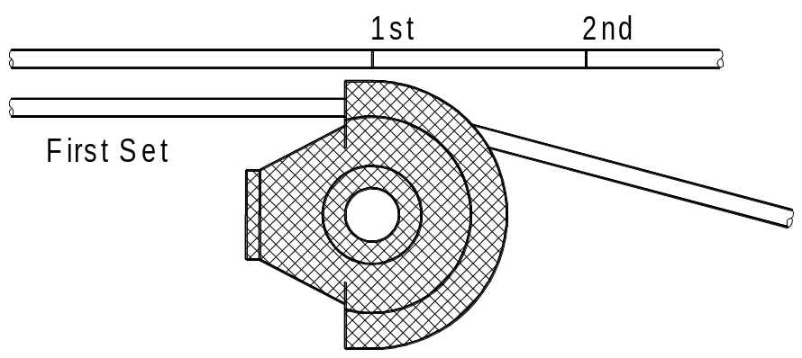

Figure 18.
Place the conduit back in the machine pointing in the same direction as before but inverted and match the second mark on the conduit with the mark on the former, see Figure 19. The second offset is now formed until it is in parallel with the first offset.
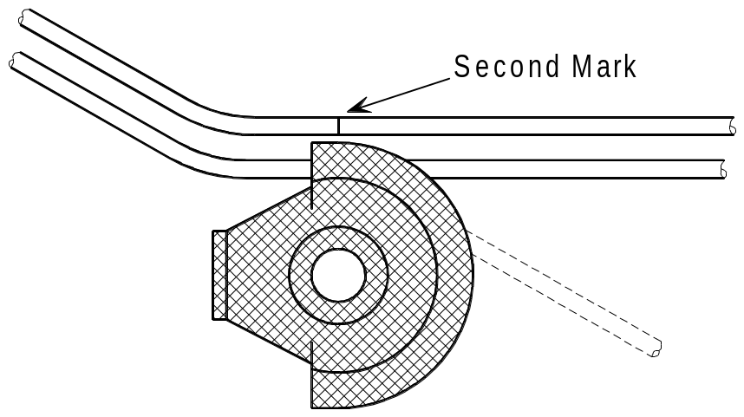

Forming a 45° Offset
A 45° degree offset is formed in exactly the same manner as the 30° version except that the measurements between the first and second bends are calculated using the following formula 1:1:√2. Figure 20 illustrates the use of this formula, in this case √2 =141mm or 100 x √2 = 141mm.

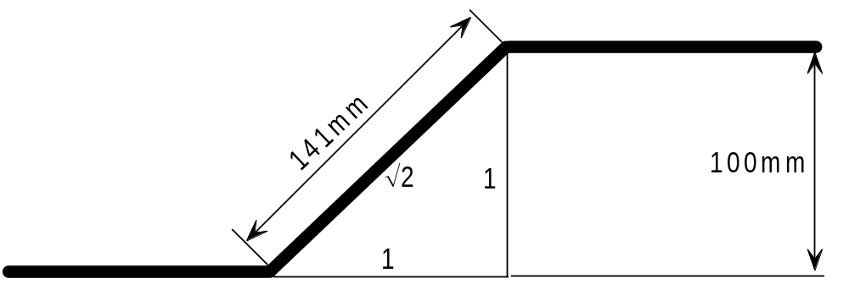

Figure 20.

Making a Saddle Set (Jump) in Steel Conduit
Assume you are required to form a saddle set with a clearance of 30mm as illustrated in Figure 21.
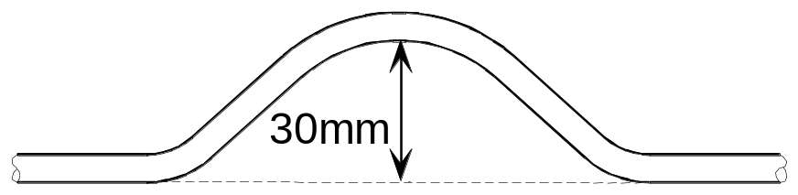

Figure 21.
The first step is to bend the conduit to an angle of 45° as shown in Figure 22.

Figure 22.

The following formula will help you calculate the position of the next two bends which must be formed in order to achieve the 30mm clearance required.
Sine of the Angle = Opposite/Hypotenuse

Sine 22.5 = 30/Hypothenuse
Hypothenuse = 30/Sine 22.5
Hypothenuse = 30/.3827 mm
Hypothenuse = 78mm.

Figure 23 illustrates the application of the formula.

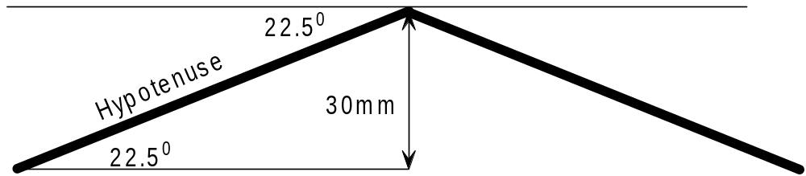

Figure 23.

Mark the conduit as shown in Figure 24.
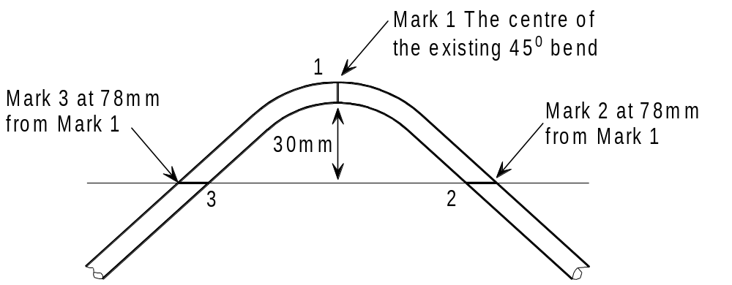

Figure 24.

Marks 2 and 3 may also be located using a straight edge or other method.
Place the conduit in the machine so that mark 2 is opposite the existing mark on the former, and bend downwards as shown in Figure 25.
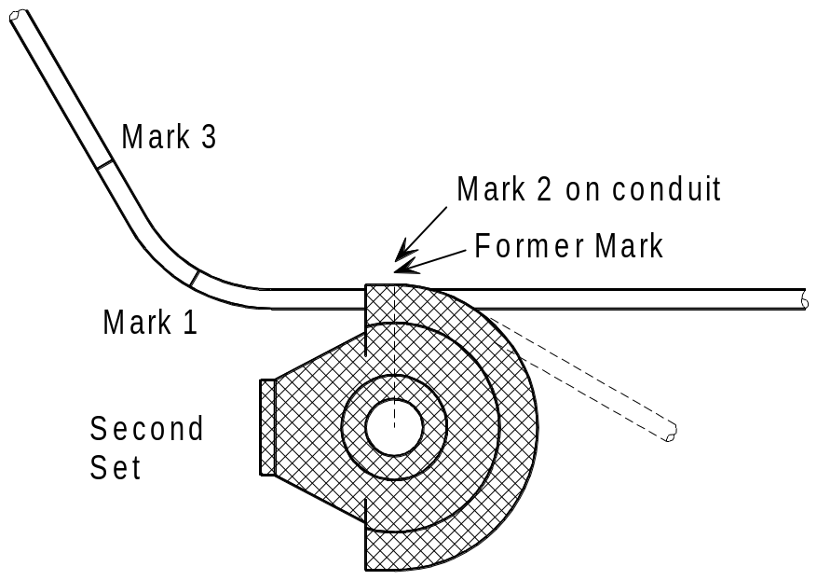
Figure25.
Reverse the conduit in the former and match mark 3 with the existing former mark. Bend down until the edges of the conduit are in line, see Figure 26.
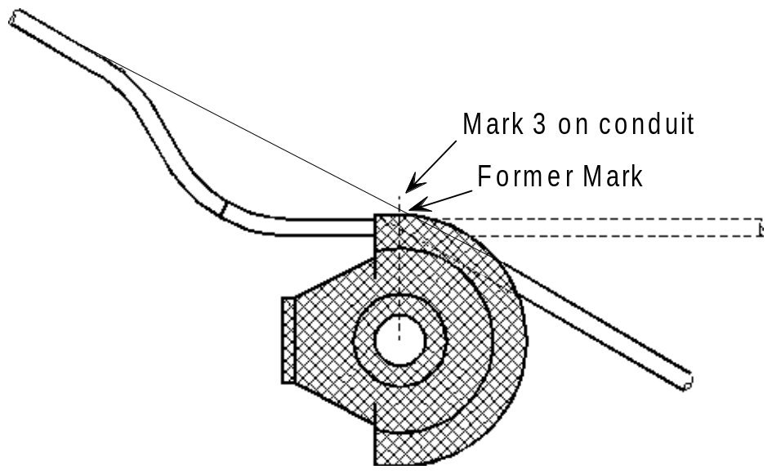

Figure 26.

Making a Double 90º Bend in Steel Conduit
Measurements for a double 90° bend in steel conduit can be taken using any of the three methods shown in Figure 27.

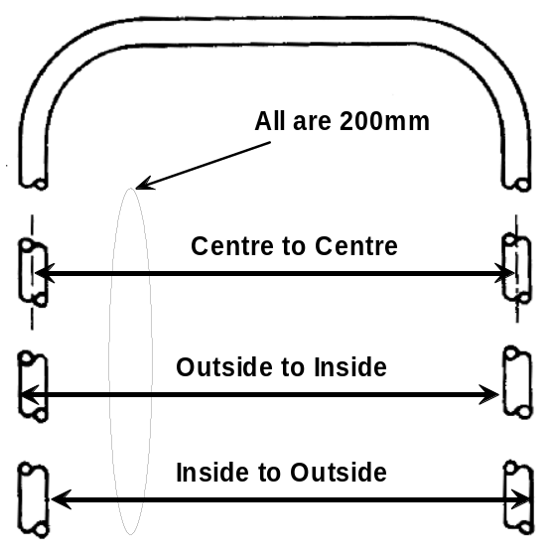
Figure 27.

If you add the outside diameter of the conduit (20mm) to the centre to centre measurments (200mm) we can now mark the position of the second bend (220mm), see Figure 28. Bend down until the 90⁰ angle is achieved.

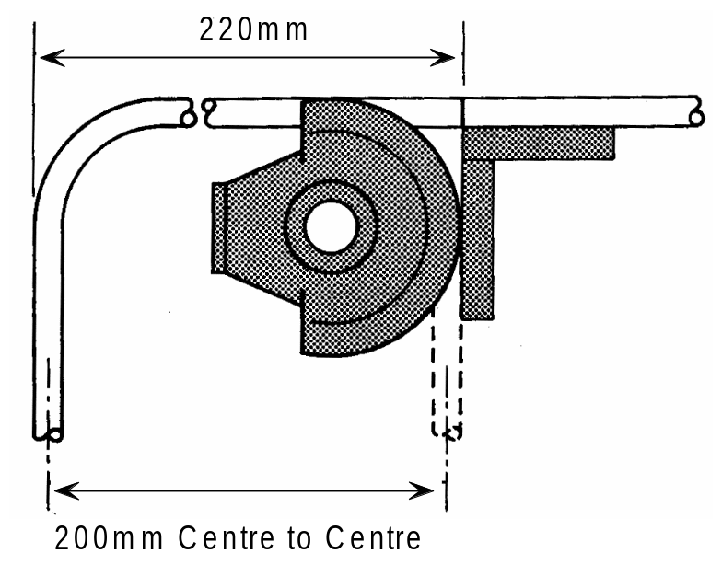

Figure 28.
Note: - The above methods may require adjustments due to manufacturer’s tolerances and wear in different bending machines

PVC Conduit

Composition of PVC Conduit
The basic material is poly-vinyl-chloride ( PVC ) which is produced in both flexible and rigid forms. It is impervious to acids, alkalis, oil, aggressive soils, fungi and bacteria and is unaffected by sea, and air. It withstands all pests and does not attract rodents.
PVC conduit may be buried in lime, concrete or plaster without harmful effects.

Choice of PVC Conduit
The choice is dependant on the type of work being undertaken and the job specification.
- Heavy gauge round conduit is normally used in surface work and for forming on-site.

Light gauge round conduit is suitable for concealed work.
- Oval conduit is normally chosen for use in plaster walls and can be used for drops in surface work.
Typical electrical installations use a heavy guage standard impact tube manufactured to BS 4607. The conduit sizes and range of fittings are the same as those available for metal conduit.

Jointing PVC Conduit
PVC conduit is most often jointed by placing the end of the conduit into the appropriate fitting. Joints into accessories can be easily made dry or by the use of silicone grease or a permanent solvent, dependant on the installation conditions. The silicone grease should be used for expansion couplings and where an installation may be subject to future alteration.

Precautions When Using Adhesives
Care should be taken when using adhesives, which are pro-chemical based, and as such are quite flammable and volatile.

- Replace the lid on the tin immediately after use.
- Use in a ventilated area away from naked flame.
- Under no circumstance should you smoke while working with this adhesive.
- If adhesive should get into your eyes, seek first-aid immediately.

Expansion of PVC Conduit
Expansion couplings should be used for surface installations at a recommended maximum of 4 metre intervals.
Where frequent variations in ambient temperature are likely to occur this distance must be greatly reduced.
Note: PVC conduit is not suitable for installations subject to temperatures below -5oC or above 65oC

Fitting and Fixing of PVC Conduit
A range of fixings for PVC conduit is available as shown in Figure 29.
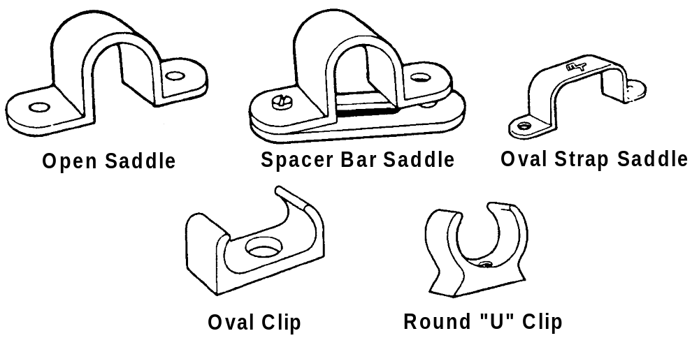

Figure 29.
PVC conduit is fixed in the same way as metal conduit. All horizontal runs should be saddled at not more than 900 mm intervals unless high ambient temperatures or rapid changes in temperature are likely to be encountered, when the intervals should be reduced.
Vertical runs should be saddled at not more than 1200 mm intervals except where directional changes are made. Saddles should be installed approximately 150 mm either side of a bend. Conduit should be able to move freely in the saddle.

Advantages of PVC Conduit
- Lightweight and easy to handle
- Easy to cut and deburr
- Simple to form and bend
- Does not require painting
- Minimal condensation due to low thermal conductivity in wall of conduit.
- Speed of installation
- Excellent electrical and fire resistant properties

Disadvantages of PVC Conduit
- Care must be taken when glueing joints to avoid forming a barrier across the inside of the conduit.
- If insufficent adhesive is used the joints may not be waterproof.
- PVC expands about 5 times as much as steel and this expansion must be allowed for.
- PVC does not offer the same level of mechanical protection as steel.
- A separate Circuit Protective Conductor must be run inside the conduit.

Working with PVC Conduit
PVC conduit is easily cut using a junior hack saw. Any roughness of cut and burrs should be removed with the aid of knife blade or simply by wiping with a cloth. There are proprietary tools available for cutting PVC conduit.

Cold bending of PVC conduit may be carried out on conduit sizes up to 25mm diameter using a bending spring, see Figure 30. It is essential to use the correct size bending spring and it should be noted that springs for heavy guage conduit are colour coded green and those for light gauge conduit are colour coded white. They are not interchangable.
It is important that the spring is not damaged or kinked. A faulty spring can cause the conduit to kink and fracture. The spring can also jam inside the bend.
The radius of the bends should be as near as possible to that of a similar bend formed in steel conduit of a similar size.
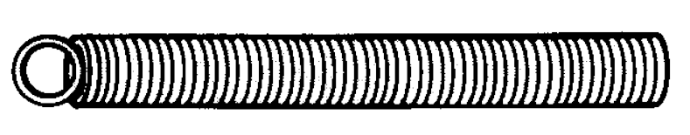

Figure 30.

Having inserted the spring into the conduit, grip the conduit on either side of the proposed bend and bend the conduit slowly, as illustrated in Figure 31.

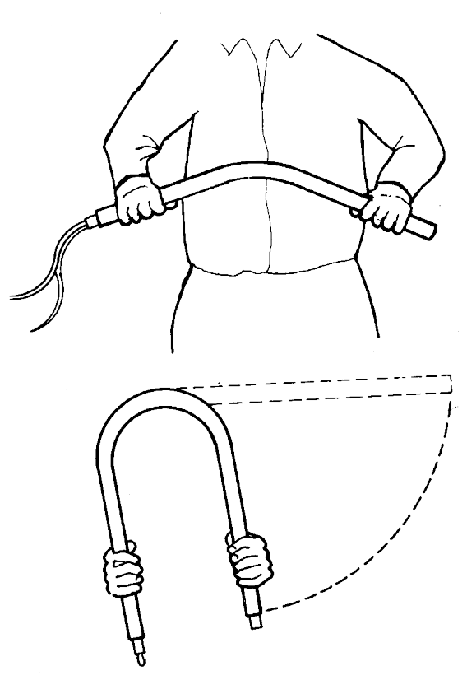

Figure 31.

The conduit should be bent to a more acute angle than the angle finally desired because of the tendency of PVC to “recover” after bending. This tendency lessens as the temperature decreases.
In very cold weather it is recommended that the conduit is warmed slightly by rubbing with a cloth held in the hand. If the conduit is bent too quickly there is a risk of kinking and / or fracturing of the conduit and possible damage to the bending spring.
If the conduit is intended for surface work it should be saddled and fixed as soon as possible after bending. Once a bend has been formed it should not be forced backwards as this can damage both the conduit and the spring.
To remove the spring, twist it in an anti-clockwise direction. This will reduce the diameter of the spring and make it possible to pull the conduit and spring apart. If the spring jams during this operation do not pull hard on it, otherwise the spring will be damaged.

Hot Bending of PVC Conduit
Hot bending of conduit should be carried out on sizes over 25mm diameter. A bending spring of the correct size should be used. Apply a gentle heat preferrably with a hot air torch, electric heating element or hot water. Bend the conduit in accordance with above instructions and Fig. 31.
Care should be taken to avoid the direct application of flame to the conduit. When the conduit is in a pliable state it should be slowly bent around a suitable former and held in position for about one minute until set. After setting, the bending spring may be twisted anti-clockwise and removed.

Unit Related ETCI Rules

Types of Wiring System | 521  521.5, 521.5.1, 521.5.2  521.6, 521.6.1, 521.6.2, 521.6.3  521.6.4, 521.6.5  521.10
Selection and Erection in Relation to External Influences | 522  522.3.2  522.8.2, 522.8.5, 522.8.6, 522.8.11
Electrical Connections | 526  526.2.3  526.3.3
Selection and Erection of Wiring Systems to minimise the spread of Fire | 527  527.1.2, 527.1.3 ( item 2 )  527.2, 527.2.1, 527.2.2, 527.2.3
Precautions against Detrimental Effects from Adjacent Services | 528  528.1, 528.1.1 items a, c, and e
Protective Conductors | 543  543.2.1 ( items 2 and 6 ), 543.2.4
Annex | 52A  52B-2 ( item 3 )
Tables | U  V  W  X  Y  Z

