Trade of Electrician

Standards Based Apprenticeship

Lamps and Light Fittings

Phase 2

Module No. 2.3

Unit No. 2.3.3

COURSE NOTES

Created by Charlie Walsh - Athlone TC

Revision 1 April 2000`by
Charlie Walsh - Athlone TC
Eugene Trindles - Cork TC

Revision 2 Nov. 2002`by
Charlie Walsh - Athlone TC
Eugene Trindles - Cork TC

Revision 3 Aug. 2006`by
Chris Ludlow - Dundalk TC

Revision 4. Feb 2008 by
Chris Ludlow - Dundalk TC

Revision 5. July 2009 by
Chris Ludlow - Dundalk TC

Revision 6, November 2013
SOLAS

Compiled by Liam Carroll – Certification & Standards

Published by


27-33 Upper Baggot Street
Dublin 4
Ireland

© SOLAS - 2013

All rights reserved. No part of this publication may be reproduced, stored in a retrieval system or
transmitted in any form or by any means, electronic, mechanical, photocopying, recording or

otherwise, without the prior permission of the copyright owner.

Table of Contents

Introduction 4
Lamps 5
Tungsten Halogen Lamps 6
Extra Low Voltage Lighting 9
Fluorescent Lighting 13
Switching of Inductive Loads 15
Earthing of Luminaries 20
Safety in Handling Lamps and Light Fittings 20
Grid Switches 21
Master Switching 22
Security Lighting 25
PIR Controlled Lighting 26
Unit Related ETCI Rules 28

Introduction

Welcome to this section of your course which is designed to introduce you the learner, to various types of lamps and light fittings.

Objectives

By the end of this unit you will be able to:

- Recognise types of lampholder in common use
- State the power ratings and life expectancy of various lamps
- Understand the construction and principle of operation of a Tungsten Halogen lamp
- Install a Tungsten Halogen light fitting
- Understand the construction and principle of operation of Extra Low Voltage lamps
- Recognise and use the correct type and rating of electronic transformer
- Explain the problems associated with Extra-Low Voltage lighting in relation to heat
- Understand the construction and principle of operation of a fluorescent lamp
- Install fluorescent light fitting
- Apply appropriate de-rating factor to switches controlling inductive lighting loads
- State what is meant by the stroboscopic effect
- List methods of eliminating the stroboscopic effect
- Apply appropriate earthing techniques to light fittings and ancilliary gear
- State how to dispose of lamps and ancilliary gear safely
- Install lighting circuits controlled by master “Off” and master “On“ switching
- Install PIR controlled security lighting
- Adjust a PIR to provide the required control of a security light fitting

Reasons

Cost effective, efficient, decorative lighting is being installed in all environments nowadays. Knowledge of these lamps and light fittings is necessary from an installation and advice point of view.
Lamps

The most common types of lamp encountered today are:-
- Filament Lamps, known as GLS lamps. ( General Lighting Service ).
- Tungsten Halogen Lamps, known as TH lamps
- Fluorescent Lamps, known as Low Pressure Mercury Vapour lamps sometimes abbreviated to MCF ( M = Mercury, C = Low Pressure, F = Fluorescent ).

Life Expectancy of Lamps

A general rule is that the life expectancy of a GLS lamp is approximately 1000 hours and the life expectancy of a fluorescent lamp is 8000 to as high as 15000 hours.
Note: These are average life expectancies, there are a number of conditions that influence life expectancy e.g. supply voltage, working position, ambient temperature, atmospheric conditions etc.

Types of Lampholder in Common Use

Bi-Pin, Bayonet Cap and Edison Screw type lampholders are commonly used in industrial applications. In these cases the relevant ETCI Rules will apply.

Tungsten Halogen Lamps

Tungsten halogen lamps were introduced in the 1950s. These lamps incorporate tungsten filaments enclosed in a glass guard tube, which contains a carefully controlled amount of a halogen gas. Iodine or bromine gas is frequently used.
Figure 1 shows a single-ended lamp. These have a life expectancy of 3000 Hours and are available in ratings up to 500 Watts. Cap type is usually G4. They are frequently used for display lighting, studio and theatre lighting, spotlighting, traffic lights and modern domestic lighting.

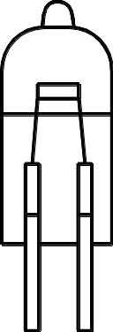

Figure 1

Figure 2 shows a linear double-ended lamp. These have a life expectancy of 2000 Hours and are available in ratings up to 2000 Watts. Cap type is usually R7S. They are frequently used for flood lighting, security lighting and in photocopiers which require a linear light source.

Figure 2

The Halogen Regenerative Cycle

Figure 3 illustrates the Halogen Regenerative Cycle. When the tungsten filament is heated by an electric current, it tends to vaporise. This tungsten vapour is carried to the comparatively cool wall of the lamp by the process of convection. It combines with halogen to form a tungsten halide. This compound then returns to the filament. It is chemically converted back into tungsten. As a result of this process minimal deterioration of the filament occurs through evaporation.

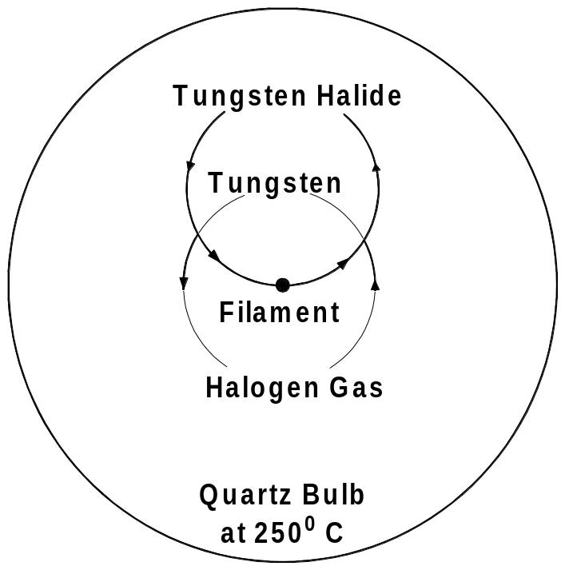

Figure 3

The halogen regenerative cycle is continually repeated and performs a self-cleaning action on the inner surface of the lamp. This contrasts greatly with standard domestic type GLS filament lamp where the evaporation of the filament causes a blackening of the lamp after a period of use.

The tungsten-halogen lamp has a much higher light output per watt and longer life than the standard GLS lamp. However, although it is a compact and easily controlled light source, it should be pointed out that a minimum bulb-wall temperature of 250ºC is needed to maintain the tungsten-halogen cycle. Also, to prevent damage to the lamp fitting, the temperature must not be allowed to exceed 350 ºC. Correct operating voltage is essential.

The linear lamp must be operated within 4º of the horizontal position. If the angle of the lamp is too great, the halogen vapour will migrate to the lower end, leaving the upper end starved. This will result in a rapid blackening of the lamp and correspondingly, reduced lamp life.

Figure 4 shows an example of a linear tungsten-halogen floodlight and lamp. Note the spring-loaded contact, housed in porcelain.

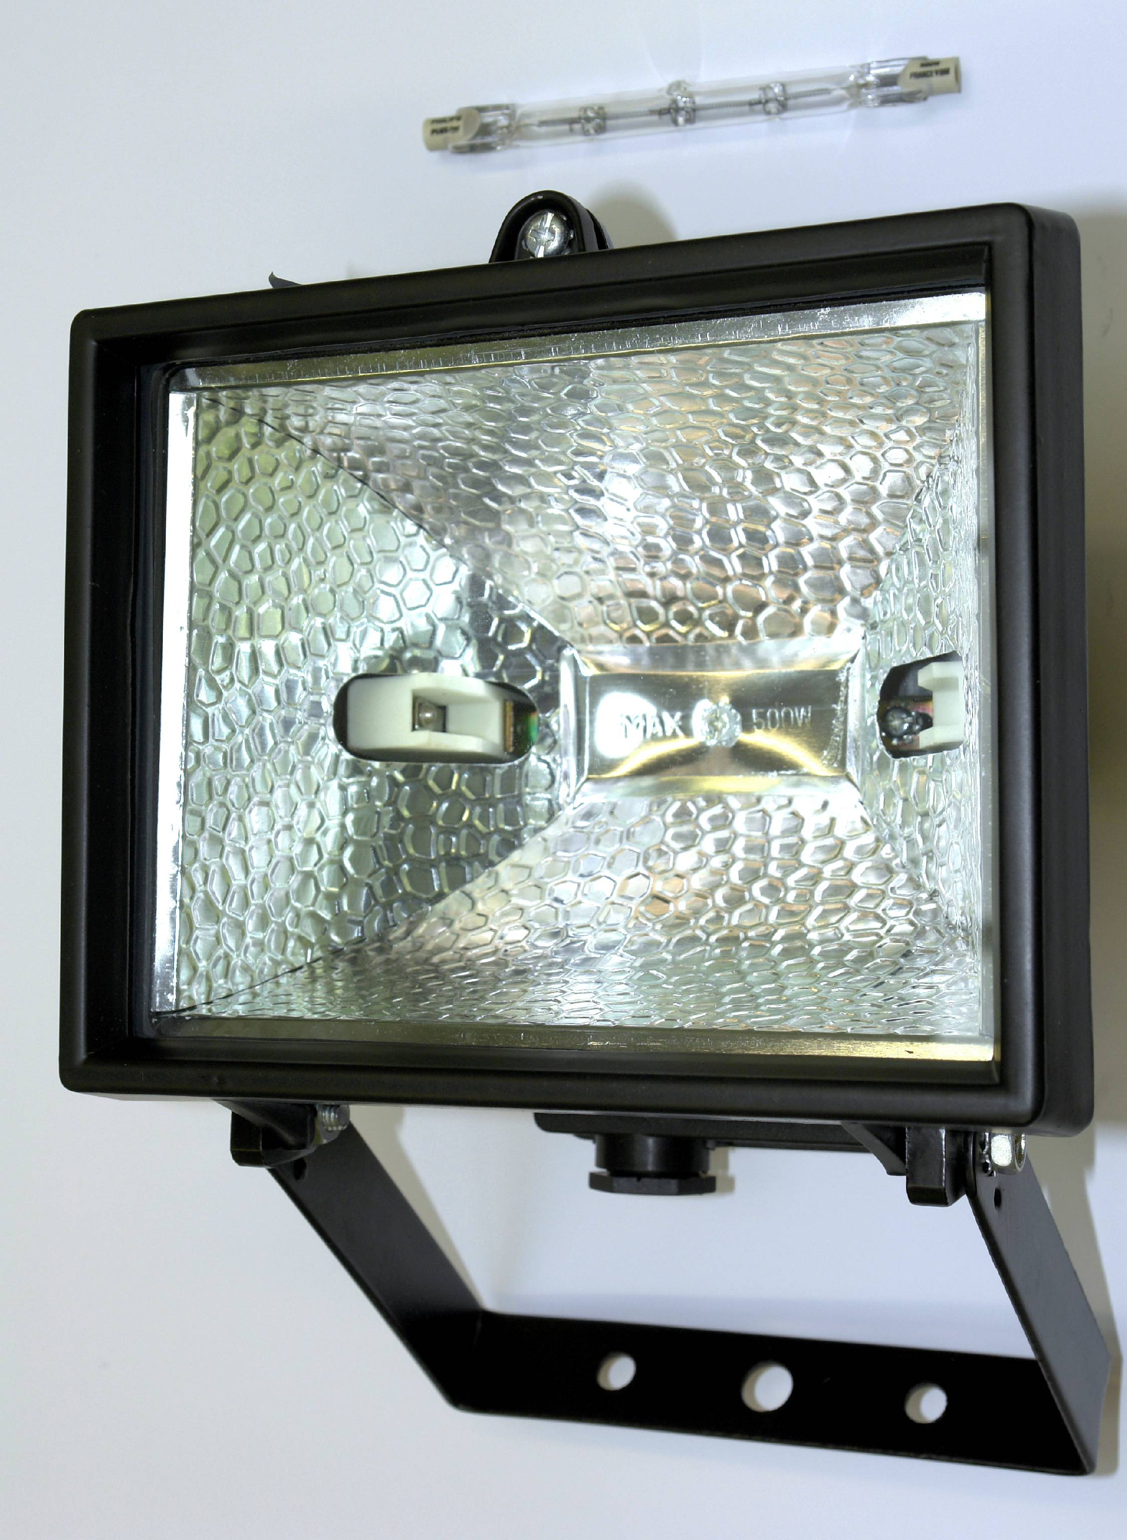
Figure 4.

Handling Tungsten Halogen Lamps

Halogen lamps must be handled carefully, especially when being fitted. It is important not to contaminate the surface of the quartz tube with dirty or greasy hands, as this will result in fine cracks appearing on the lamp, causing premature failure. In practice, it is advisable to use a paper sleeve over the lamp, or handle the lamp by its ends. If the lamp is touched by hand it should be cleaned with a solvent such as industrial spirit or trichloroethylene.

Extra Low Voltage Lighting

Extra low voltage lighting can be attractive, effective, economical and reliable when installed correctly. When not installed correctly it can be extremely dangerous.

The components which make up an extra low voltage lighting installation are as follows:

- The lamp
- The luminaire
- The transformer
- The wiring layout
- The circuit controller

These are packaged and sold as Low Voltage items which is of course wrong. In these notes we use the correct term Extra Low Voltage.

Extra Low Voltage Lamps

Extra low voltage lamps are available in power ratings between 1 and 100 Watts. They are operated at 12 Volts.

The handling and principle of operation of the extra low voltage tungsten halogen type, is similar to that of the linear type.

These lamps have either an aluminium or a dichroic reflector. The dichroic reflector is produced by multi-layering reflective coatings onto the glass. Up to 22 separate coatings are used. Their cumulative effect is to reflect light while allowing two thirds of the heat produced, pass through. This means that only one third of the heat is radiated along the light beam onto the area being illuminated. Articles in this area are thus subjected to less heat.

These lamps have a life expectancy of 3000 Hours and are available in ratings of 20, 35 and 50 Watts. They are used for general domestic lighting and display lighting.

Figure 5 shows a 50 Watt dichroic lamp. Cap type is usually GU5.3. These lamps are now available in square and octagonal format.

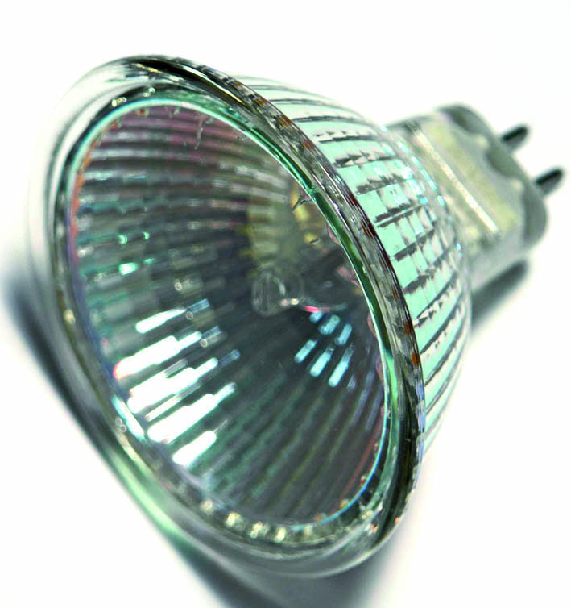
Figure 5

Figure 6 shows a GU5.3 ceramic lampholder complete with 250°C leads.
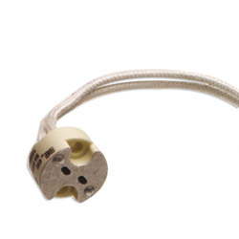
Figure 6
Figure 7 shows a joint box to accommodate the supply cable to a lighting point, loop cable to next lighting point and feed to luminaire. It features push-in connectors for fast, reliable connections.
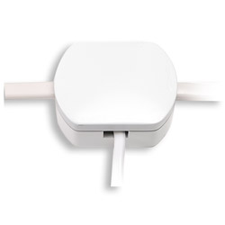
Figure 7

Extra Low Voltage Supply

An electromagnetic transformer may be used to provide the 12 Volt supply. This has been replaced by a unit often referred to as an electronic transformer. The more correct term is a converter as the 230 Volt mains supply is converted to 12 Volts electronically. This transformer / converter must be selected to suit the lamp load.

Figure 8 shows a converter suitable for a load between 20 and 60 Watts. Note the information and symbols on this converter.

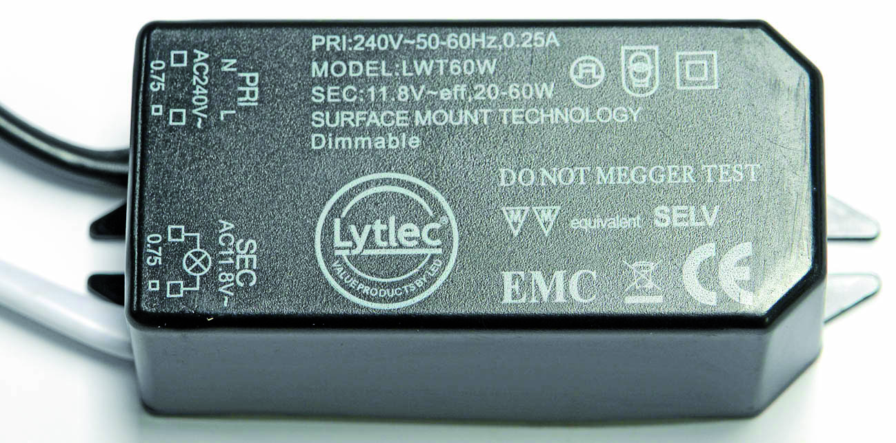
Figure 8

Installation of Extra Low Voltage Lighting

Luminaires and converters must be installed in a safe manner. They must be suitable for the material in / on which they are being installed. Any units suitable for mounting in flammable material such as wood, will be marked with the symbol in Figure 9.

F
Figure 9

A / or an X through the letter F means that the luminaire is not suitable for mounting in flammable material, as it will constitute a fire hazard. The converter must be positioned at least 250mm away from the luminaire. Any thermal insulation must be removed from around the luminaire and converter for a distance of at least 50 mm. The converter must be matched to the lighting load. Correct size cable must be used. Remember that the current drawn by a 12 Volt lamp will be almost 20 times higher than that of a 230 Volt lamp of the same wattage. Overloading may start a fire or simply damage the surroundings

A suitable opening has to be made in the ceiling material. Use a holesaw of the correct diameter. The supply cable is installed and dropped through this opening. The luminaire is connected to the converter and the supply cable is then connected to the converter. The whole arrangement is then passed through the opening in the ceiling. The two spring loaded clamps on the luminaire are used to hold it in position in the ceiling.

Figure 10 shows an extra low voltage recessed luminaire complete with lamp.

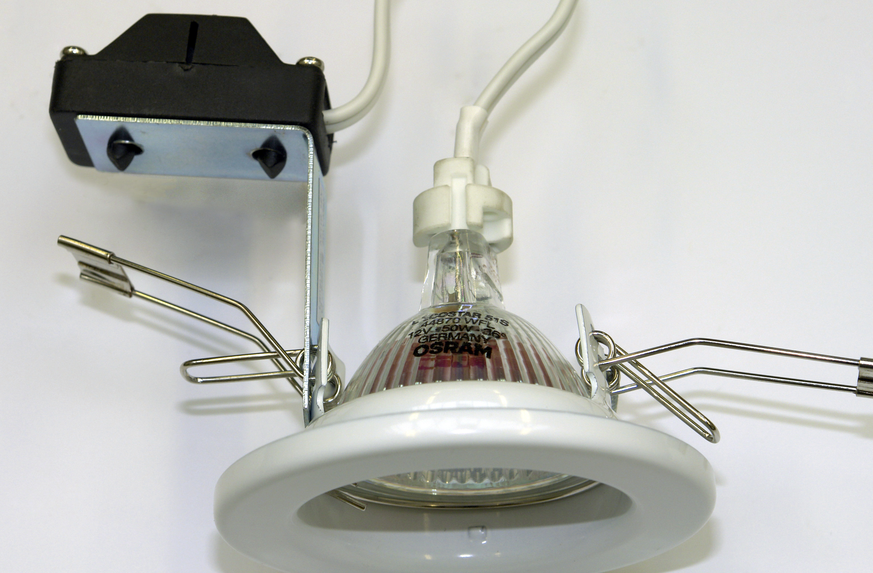

Figure 10
Fluorescent Lighting

These are the most common of the discharge lamps because they are very efficient and are suitable for internal applications. The lamps are made in a variety of lengths from 150 mm up to 2400 mm ( 8 Watt to 125 Watt.) and are filled with mercury vapour at low pressure. Cap type is G5 or G13.

The radiated light is almost invisible but it is converted to visible light by a coating of fluorescent powder on the inner tube surface. By using different combinations of fluorescent powders, it is possible to control the colour of the light produced. White lamps are most efficient, but the appearance of coloured surfaces illuminated by them may be altered ( poor colour rendering ).

A high voltage is needed to cause the tube to strike ( discharge ) and there are several methods of providing this voltage. Oxide coated filaments are situated at each end of the fluorescent tube. The resistance of these two filaments should be approximately the same. Discharge takes place when a high voltage is applied between the two filaments located at each end of the tube.

Figure 11 illustrates the component parts the fluorescent lamp.

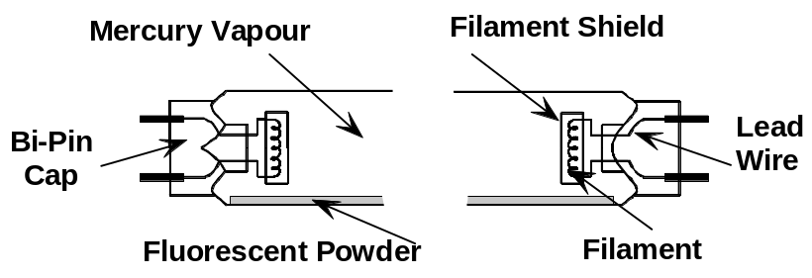

Figure 11

Figure 12 illustrates one end of a fluorescent lamp and includes an exploded view of the tungsten wire filament and the filament shield.

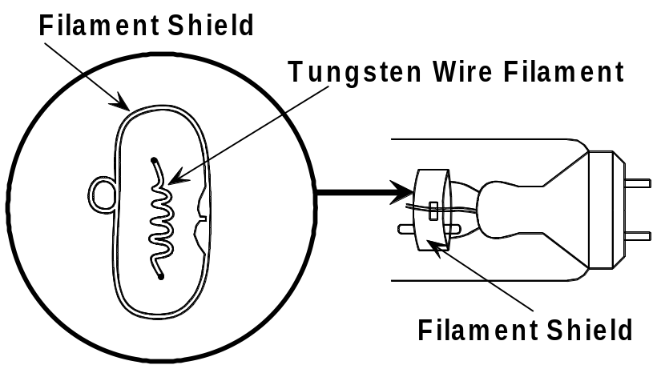

Figure 12
Operation of a Fluorescent Fitting

Refer to Figure 13, when the supply is switched on, the circuit is completed via the phase, circuit switch, ballast ( choke ), lamp filament No.1, starter neon gas ( contact open ), lamp filament No.2, and the neutral.

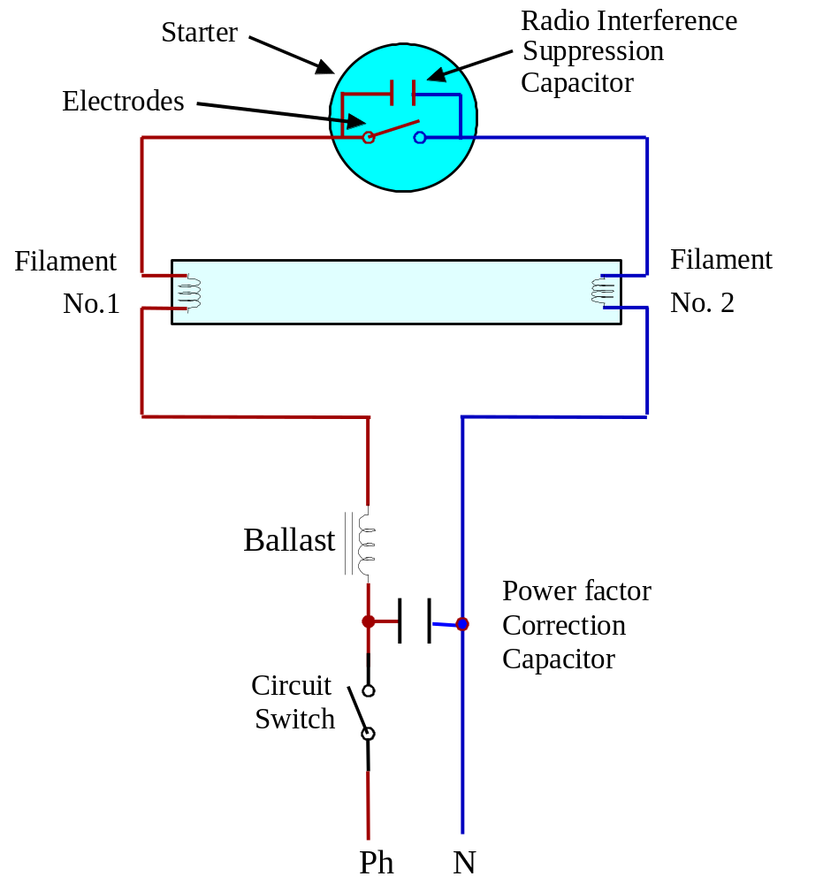
Figure 13

The filaments, which are coated in oxide, become heated and emit an electron cloud. The tube will be seen to glow at each end. The current which is flowing through the filaments and through the starter causes the neon gas in the starter to glow. The construction of the starter is such that it contains a fixed electrode and a bi-metallic electrode. The heat produced by the neon gas causes the bi-metallic electrode to bend and touch the fixed electrode. See Figure 14.

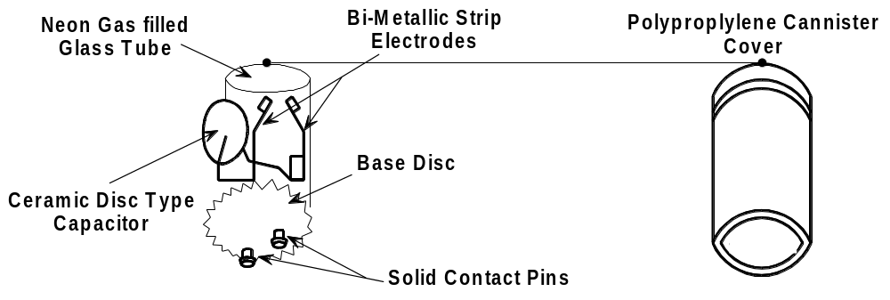

Figure 14

Immediately, the glow ceases and cooling takes place, which in turn causes the electrodes to part. This means that the ballast is now open circuited, and it produces a high voltage. This high voltage is applied across the lamp from Filament No.1 to Filament No. 2 and causes it to strike.

The starter now has a very low voltage across its electrodes and as a result the neon gas does not glow. The contact remains open. The ballast limits the operating current to a pre-determined value. The ballast is an inductive load and it causes power factor problems. To overcome this, a capacitor is connected as shown in Figure 13. This capacitor has no other function in the circuit. The ceramic disc type capacitor across the contact in the starter is for radio interference supression only. The circuit will continue to function if either one, or both capacitors are removed.

Switching of Inductive Loads

It is important to remember that devices used for switching inductive loads may have to be de-rated if not designed for the purpose. This can be checked using the manufacturers documentation.
The de-rating factor to be applied is 0.8.

Example:

A 5 Amp switch must only be used to switch a 4 Amp inductive load.
5 x 0.8 = 4 Amps.

4 Amps is the maximum inductive load that should be controlled by this 5 Amp switch.

The Stroboscopic Effect

When discharge lighting is used where rotating machinery is present, there is a risk that rotating parts may appear to be stationary. This phenomenon is known as the “stroboscopic effect”. This effect occurs only where discharge lamps are installed. Discharge lamps illuminate and extinguish twice every cycle, in harmony with the alternating mains supply voltage.
See Figure 15.

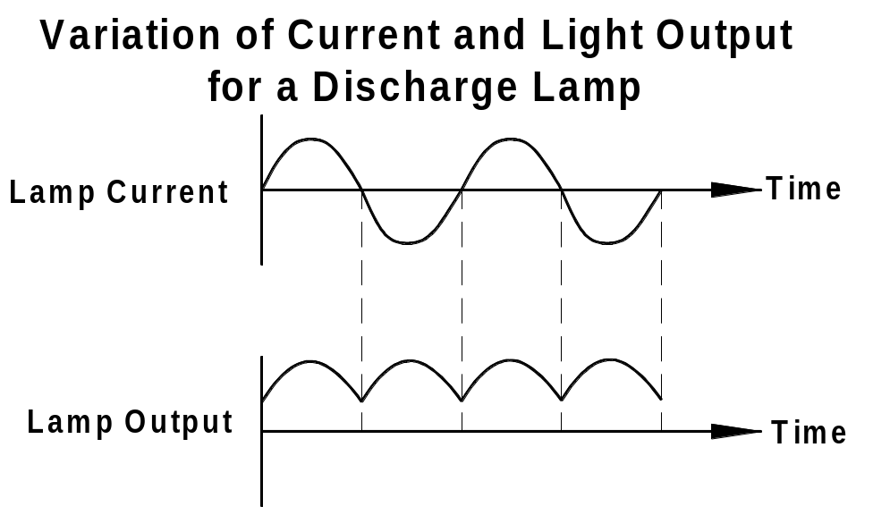
Figure 15

The stroboscopic effect does not occur with incandescent lamp installations. Incandescent lamp filaments do not cool down fast enough to be affected by the mains cycle supply variation.

Examples of the stroboscopic effect can be seen when viewing old movies, where vehicle wheels may appear to be stopped or going in reverse. Flashing lights at discos also illustrate the stroboscopic effect.

The stroboscopic effect is also utilised by motor mechanics to set engine timing electronically. A strobe light is directed at the engine crank-shaft timing marks. With the engine running the crank-shaft timing marks appear to be stationary, thus allowing engine ignition timing adjustments to be made.

To overcome the problems associated with the stroboscopic effect, where rotating machinery is present, twin lamp fittings can be installed. These twin fittings are wired as a lead-lag circuit in such a manner that the current through the first lamp is out of synchronisation with current through the second lamp. This results in both lamps being extinguished at different time intervals during the AC cycle.

High frequency electronic ballasts are used in some fittings. These eliminate the stroboscopic effect as the operating frequency is 30,000 Hz.

Local incandescant lamps may also be used to eliminate this problem.
Figure 16 illustrates the internal wiring of a twin lamp fitting where one lamp is connected in series with a ballast whilst the other lamp is connected in series with a ballast and capacitor. This arrangement helps to eliminate the stroboscopic effect.

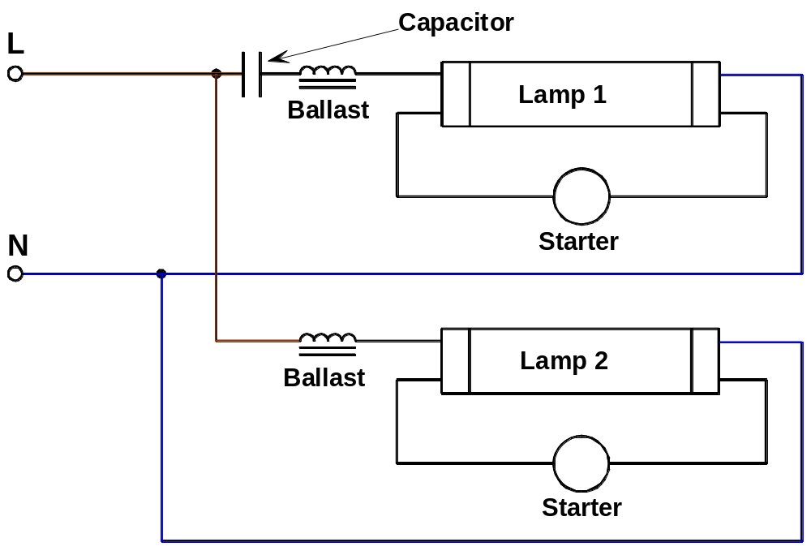

Figure 16

Figure 17 illustrates how the stroboscopic effect can be overcome with a lighting arrangement in industrial installations having three phase supplies. Adjacent lamps or alternate groups of lamps are connected between different phases and neutral. This arrangement also has the advantage of balancing the lighting load over the three phases and decreases the current flowing in the supply neutral.

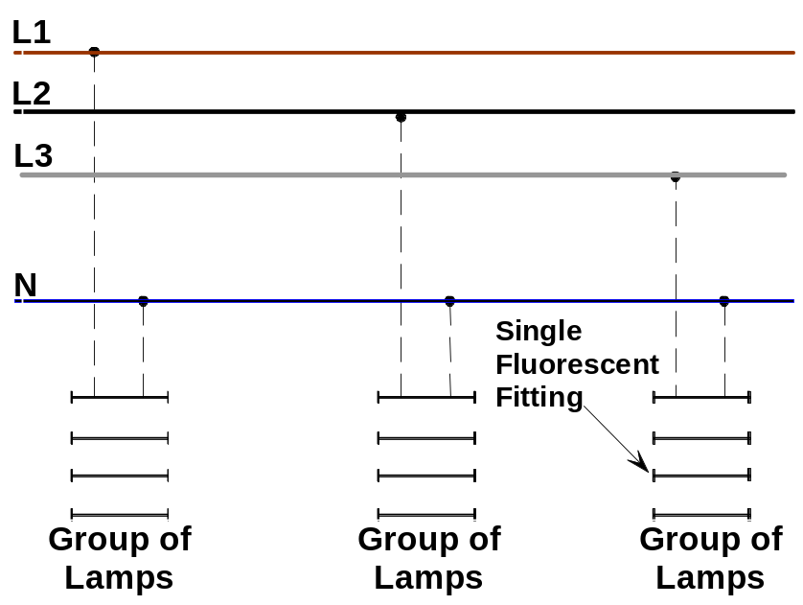

Figure 17
Compact Fluorescent Lamps ( CFL )

Compact fluorescent lamps have become very common. These lamps are designed to replace the GLS lamp and the standard fluorescent tubes frequently used in domestic and small shop premises. Compact fluorescent lamps are available in a selection of designs and ratings. They can be used in any position. They usually have built in starting gear.

Figure 18 shows a 2D 16 Watt CFL. It has an equivalent light output to a 100 Watt GLS lamp. A 28 Watt and 38 Watt is also available. Its life expectancy is about 8000 hours. Cap type is GR10q. They are used for general lighting and emergency lighting applications.

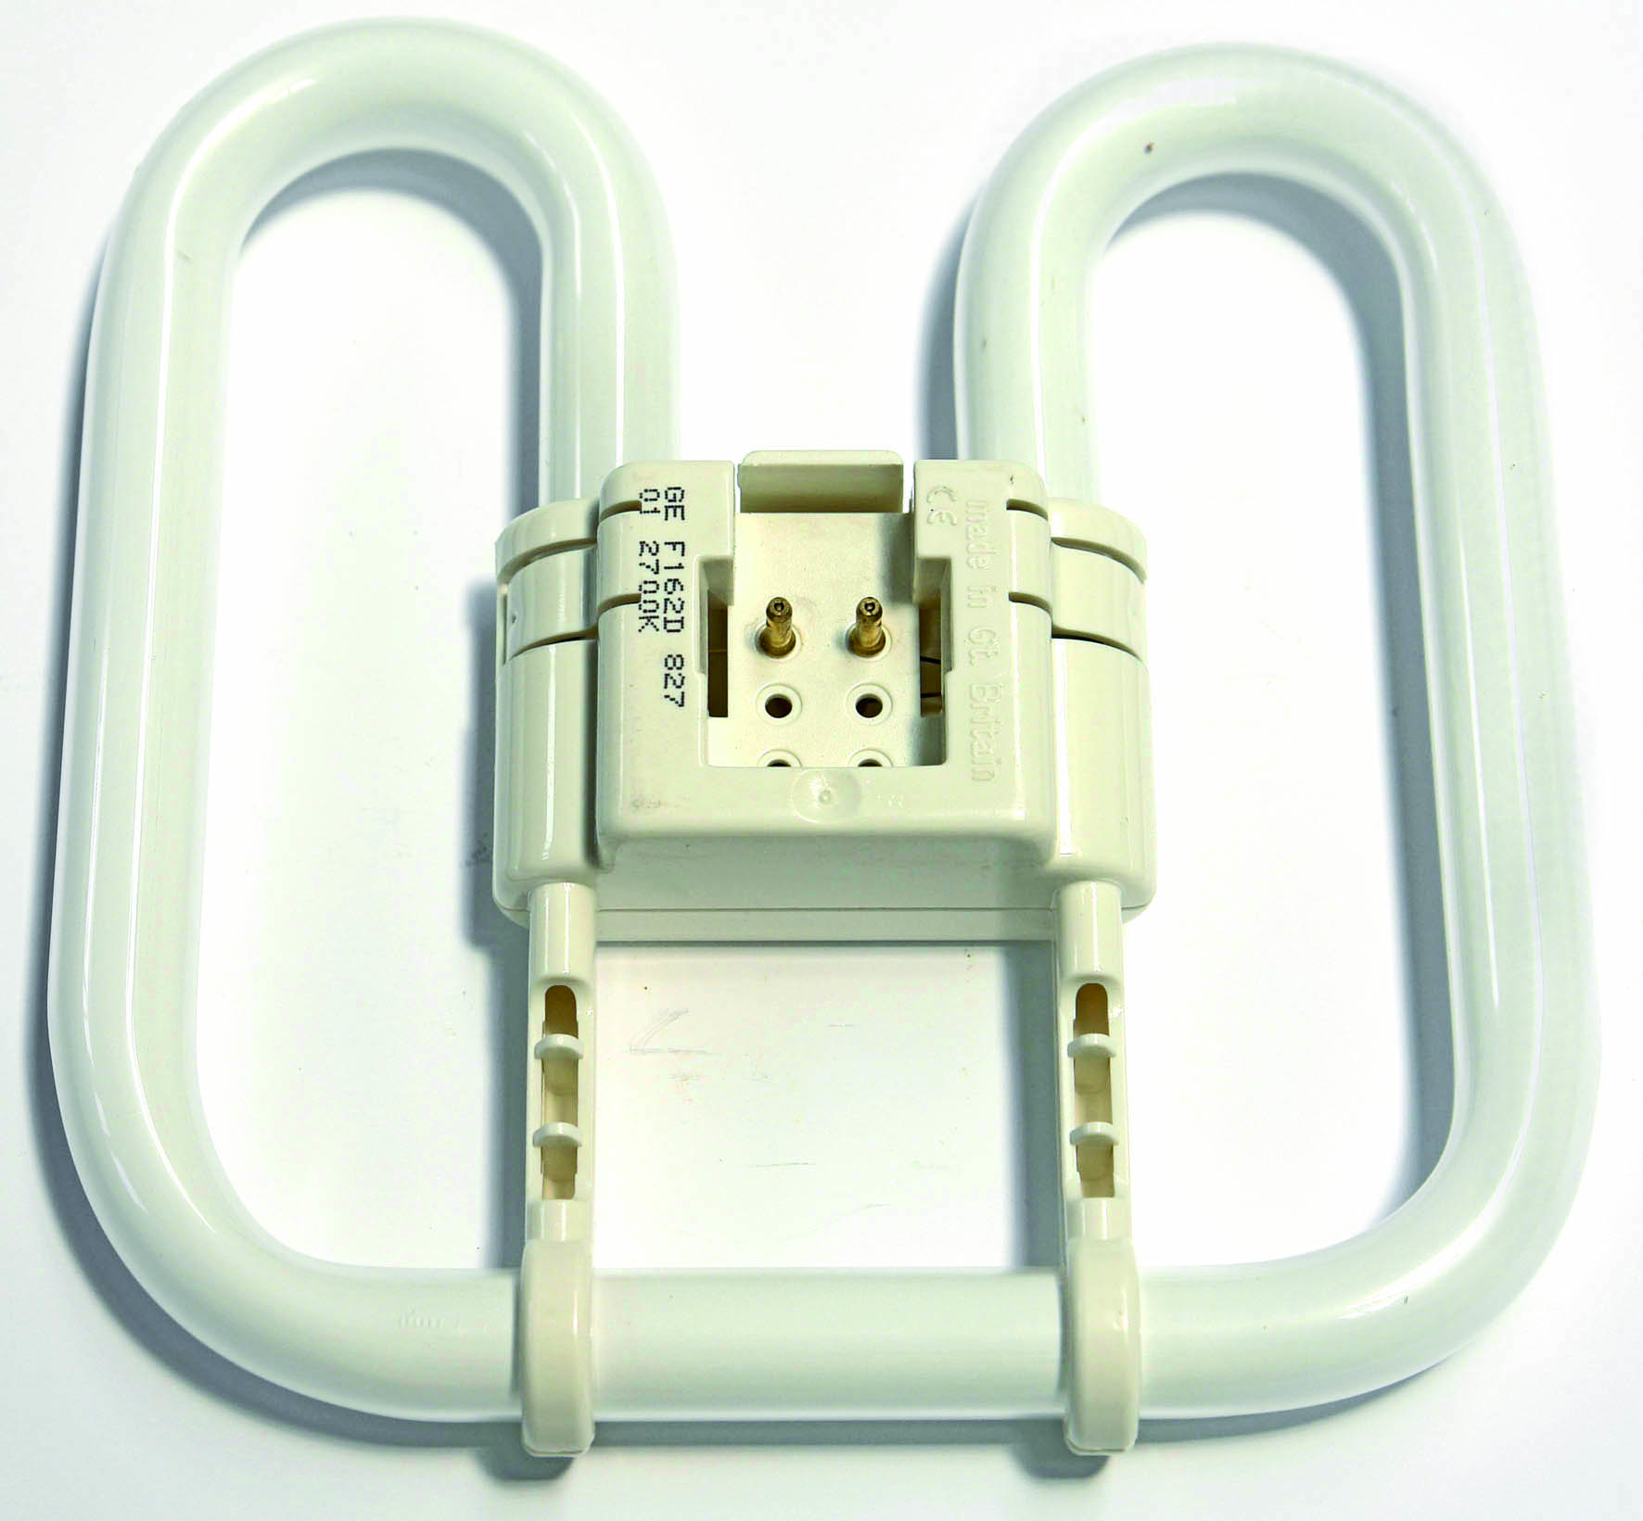

Figure 18
Figure 19 shows compact fluorescent lamps which can directly replace the standard BC incandescent lamp. They are now very popular in domestic situations. The initial cost of the lamp is high. They are slow to reach full brilliance so they are not suitable for situations where they would be switched on and off frequently. A 7 Watt provides the equivalent light output to a 60 Watt incandescent lamp.

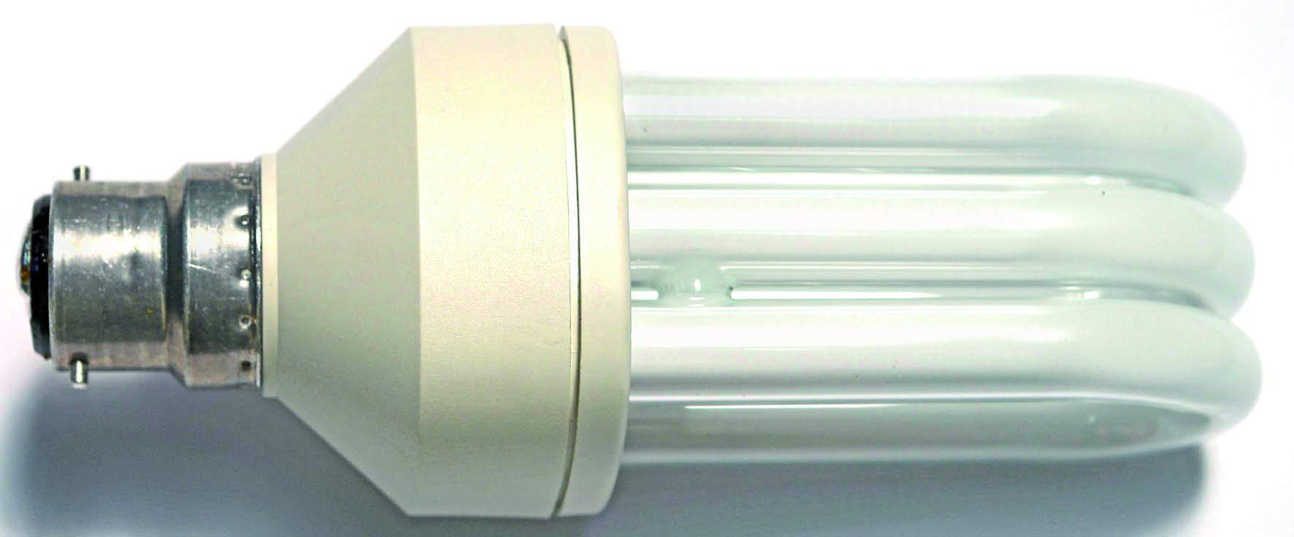

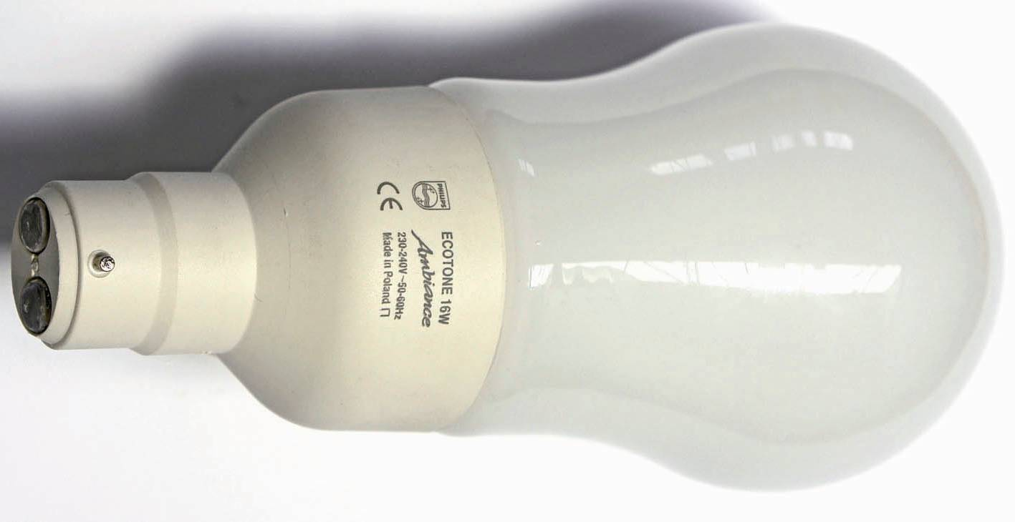

Figure 19

Earthing of Luminaries

It is of the utmost importance that all metallic parts of luminaries are properly earthed. This includes any ancilliary gear which is remote from the fitting itself.

Safety in Handling Lamps and Light Fittings

- Always isolate the circuit before inserting or replacing a lamp
- Check the lamp circuit fuse for suitability
- Check the replacement lamp for correct voltage, wattage and cap fitting
- Take care when inserting a replacement lamp in its fitting
- Protect the lamp against mechanical damage or thermal shock, e.g water splashing on to the lamp; also protect against vibration
- Read the manufactures instructions on installing special lamps, particularly their handling and recommended burning position
- Exercise care when disposing of lamps. Fluorescent lamps should be collected together and then taken away by a specialist disposal company.
- Exercise care when handling control gear, such as transformers / ballasts. These can be quite heavy and could cause personal injury if accidentally dropped on hands or feet.
- Be aware of the high voltage present in ballast units and take care when handling capacitor units in case they are not fitted with discharge resistors to de-energize them.
- Seek manufacturer’s instructions before disposal of control gear, particularly capacitors containing chlorinated diphenol impregnants – they constitute a health and environmental hazard.
Grid Switches

Figure 20 shows a one gang and a two gang grid cover plate, one gang and two gang grid plates, single switch box and grid switch. There must be an earth connection fitted between the switch box and grid plate.

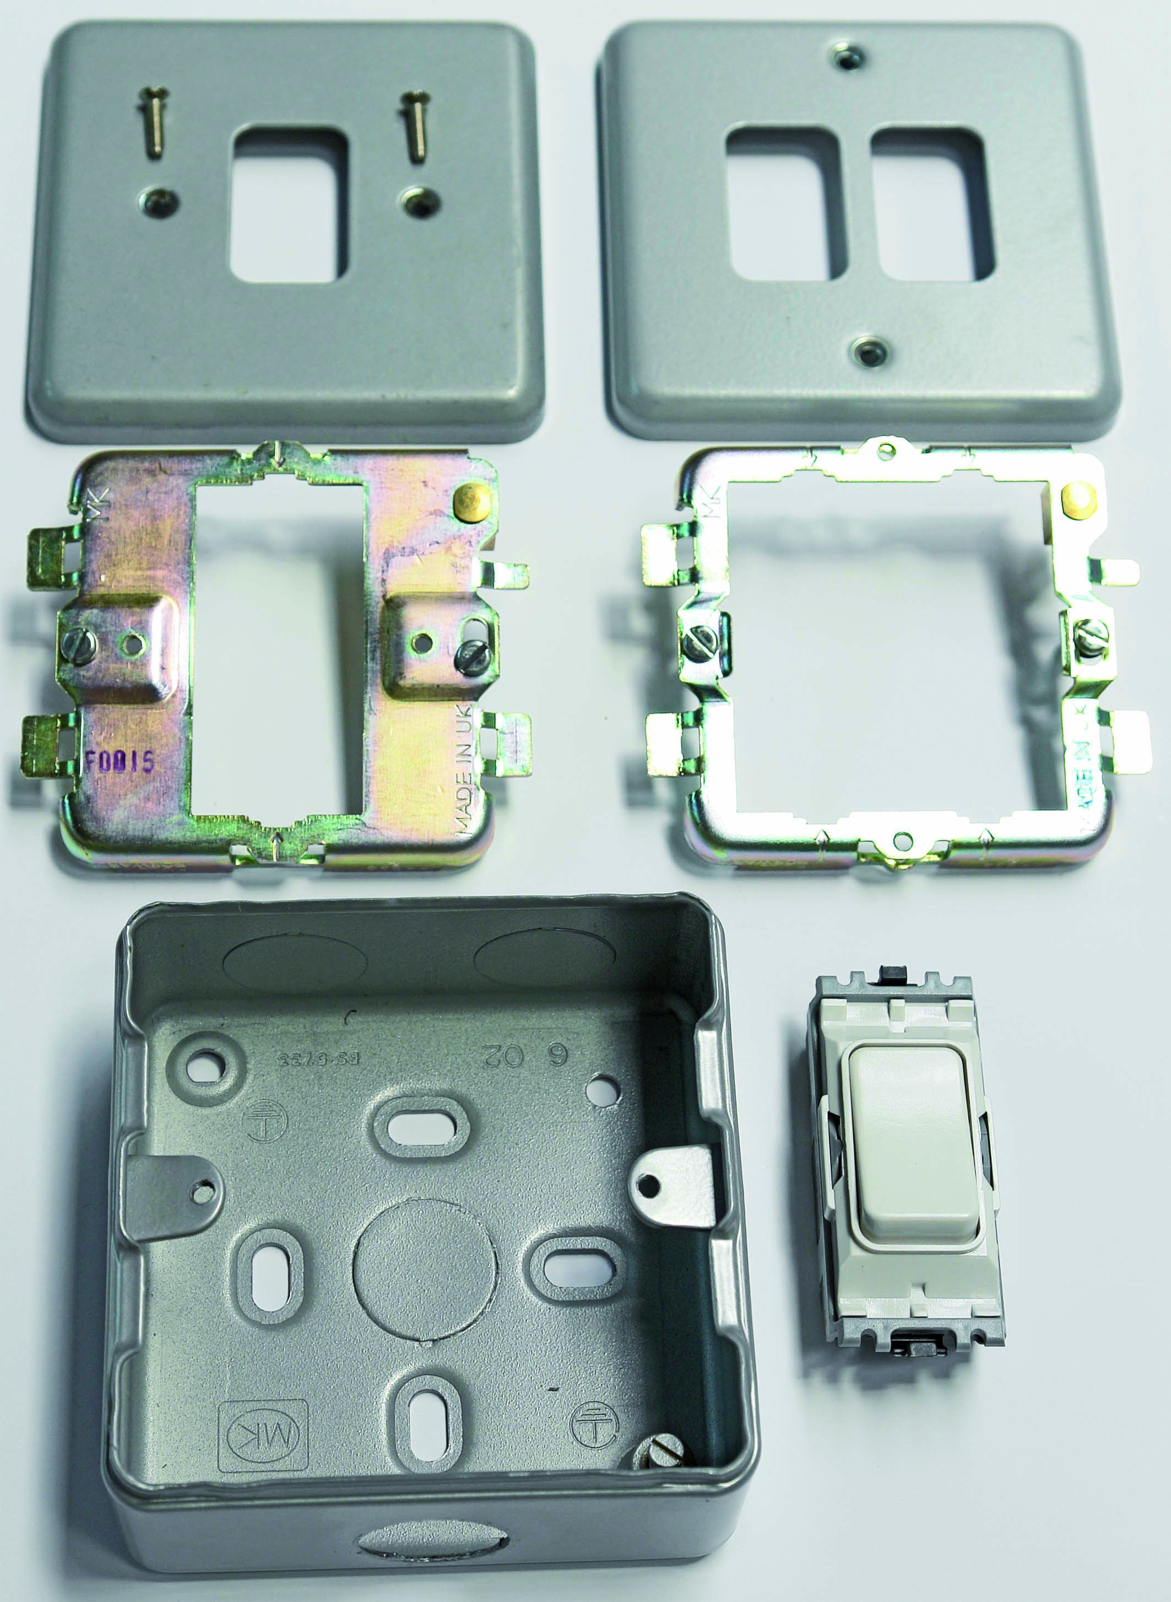
Figure 20
Master Switching

Lighting in public buildings such as hospitals, schools, colleges is often controlled in such a way that a caretaker can lock the lights “OFF” or “ON” or leave them under the control of the normal circuit switches. Master switches should be located in an area such as a caretakers / supervisors office, which is not accessible to the public.

Master “Off” Switching

A master “OFF” switch is used to lock the lights in the “OFF” position. This means that the normal circuit switches cannot switch the lights ”ON”. A simple one way switch can be used to perform this function regardless of how the lighting is controlled by the normal circuit switches. It is connected in series with the normal circuit switch or switches.
Figure 21 shows Two Way plus Master “OFF” control.

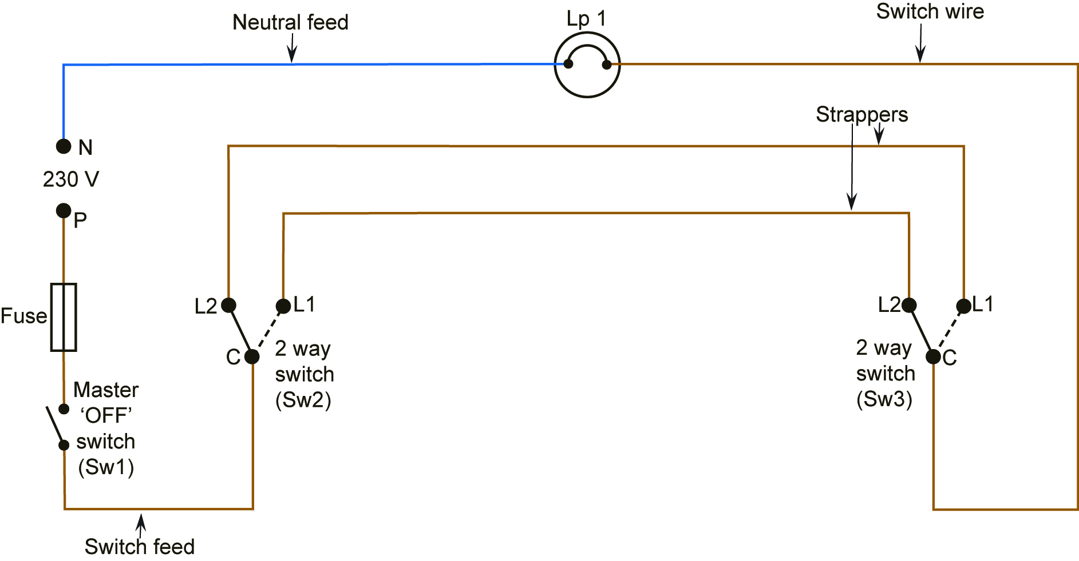

Figure 21

Master “On” Switching

A master “ON” switch is used to lock the lights in the “ON” position. This means that the normal circuit switches cannot switch the lights”OFF”. A simple one way switch can be used to perform this function regardless of how the lighting is controlled by the normal circuit switches. It is connected in parallel with the normal circuit switch or switches.
Figure 22 shows Two Way plus Master “ON” control.

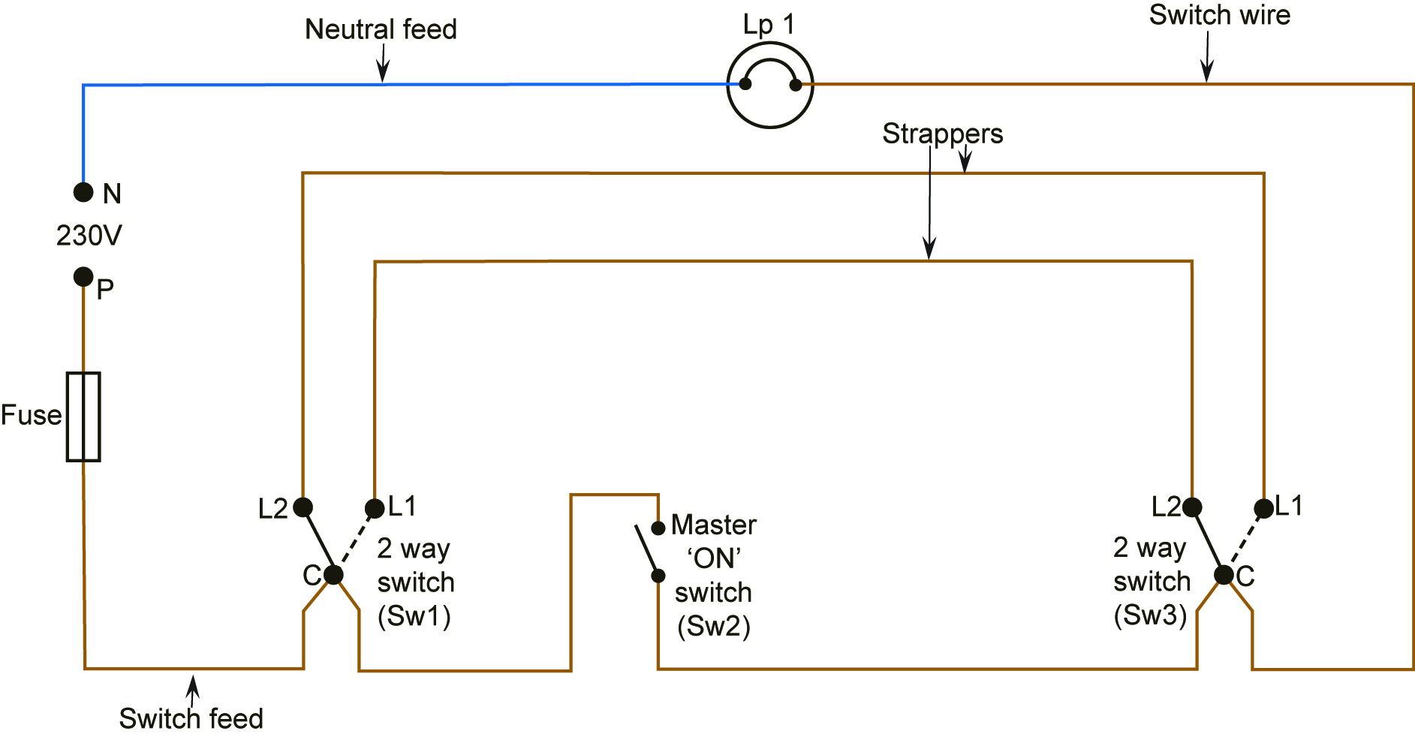
Figure 22

In the case of two way or two way and intemediate switching, a master “ON” switch may be connected in such a way that it shorts out a pair of strappers at either end. This allows for the connection of the master “ON” switch at either of the two way switches or at any intermediate switch.
Figure 23 shows Two Way and Intermediate, plus Master “ON” control.

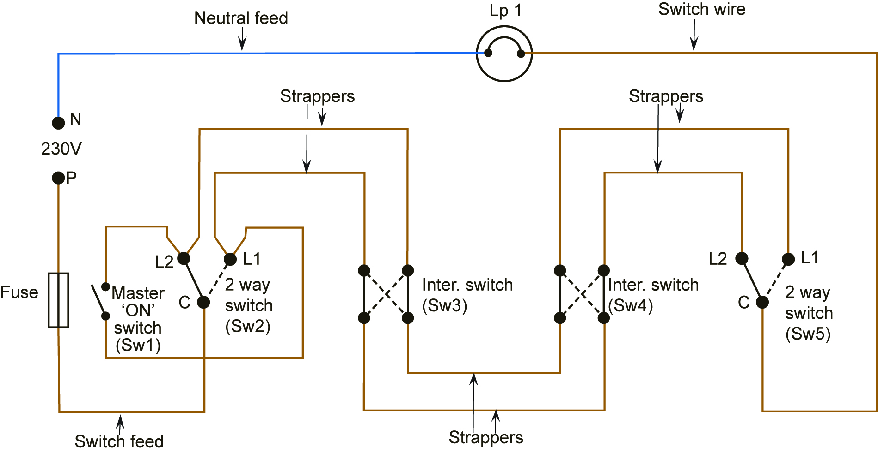

Figure 23

Master “Off” and Master “On” Switching Combined

Master “Off” and Master “On” Switching may be required on the same switching circuit. The master “ON” switch may be connected either way as desired. The master “OFF” switch must override the master “ON”.
Figure 24 shows Two Way and Intermediate, plus Master “OFF” and“ON” control.

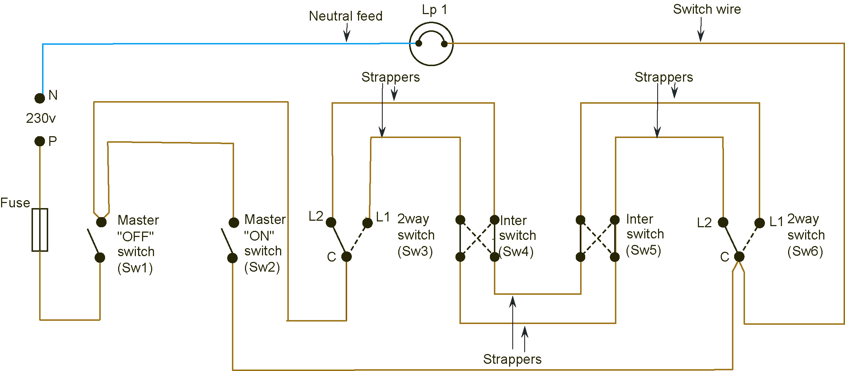

Figure 24

Security Lighting

Security lighting is mainly used to automatically illuminate the approach to a home or garage entrance. This has the advantage of allowing people to gain access without fumbling in the dark. It can be provided by a simple timeswitch. This is only suitable if the lighting is maintained during the hours of darkness. Seasonal changes would of course have to be taken into account.
A PIR ( passive infra red ) sensor will provide the same function more economically. The lighting load will only be switched on when required. It does not require seasonal adjustment. It also provides added security by deterring intruders.

Security light sensors contain a “passive infra red” sensor. When exposed to infra-red light its electrical resistance changes. This resistance change is amplified by an electronic circuit. The output of this circuit operates a small relay. The relay in turn switches power to any lamp or lamps connected to the sensor. The curved white plastic screen on the front acts as an optical collector of infra-red light. The screen angles available vary from 90° to 360°.

The sensor head can be adjusted downwards to reduce the distance scanned. It can also be adjusted from left to right to avoid scanning unwanted areas. Further areas can be avoided by blanking off the plastic screen as required.

These units have a number of features.

- They only react to moving heat.
- A built in photocell deactivates the unit during daylight hours. This means that the light will only be in operation during hours of darkness. The level of light at which it activates is also adjustable.
- The time for which the lamp(s) are “on” is adjustable from approximately 5 seconds to 12 minutes.
- Some models have a sensitivity adjustment. It helps to minimise nuisance operation by for example cats or dogs.
- Adjustment of the unit during daylight hours is often facilitated via the control switch ( See Figure 28 ) as follows:- Turn off the supply for approx. 10 seconds and then turn it on again. Adjustment is now possible.
- The lamp(s) can be locked “on” as follows:- Turn off the supply for approx.1 second and then turn it on again. This may explain why the lamp(s) are sometimes locked “on” accidentally. Most units return to normal operation after 8 hours.
- Return to normal operation is achieved as follows:- Turn off the supply for approx. 5 seconds and then turn it on again.

Typical Specifications
Power supply 230 Volts AC 50Hz.
Lighting load 1100 Watts Resistive
500 Watts Inductive
Detection range 10 Metres
Detection angle 180°
Adjustable angle Horizontal 40°
Vertical 90°
PIR Controlled Lighting

Figure 25 shows a 140° PIR unit.

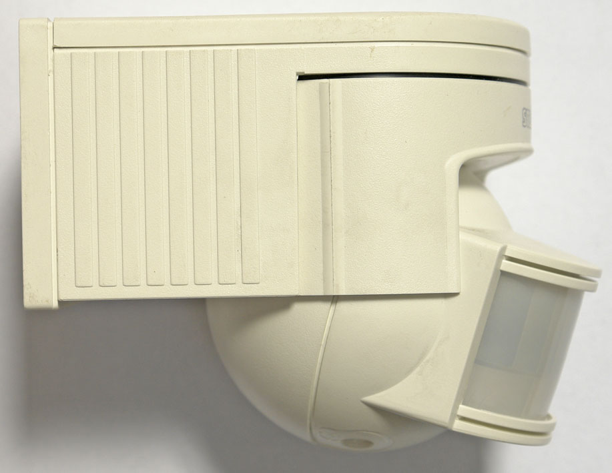

Figure 25

Figure 26 shows the symbol used to represent a PIR in these notes.

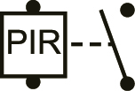

Figure 26

Figure 27 shows a PIR controlling two lamps in parallel. It is more correct to have a switch in the supply to the PIR. See figure 28.

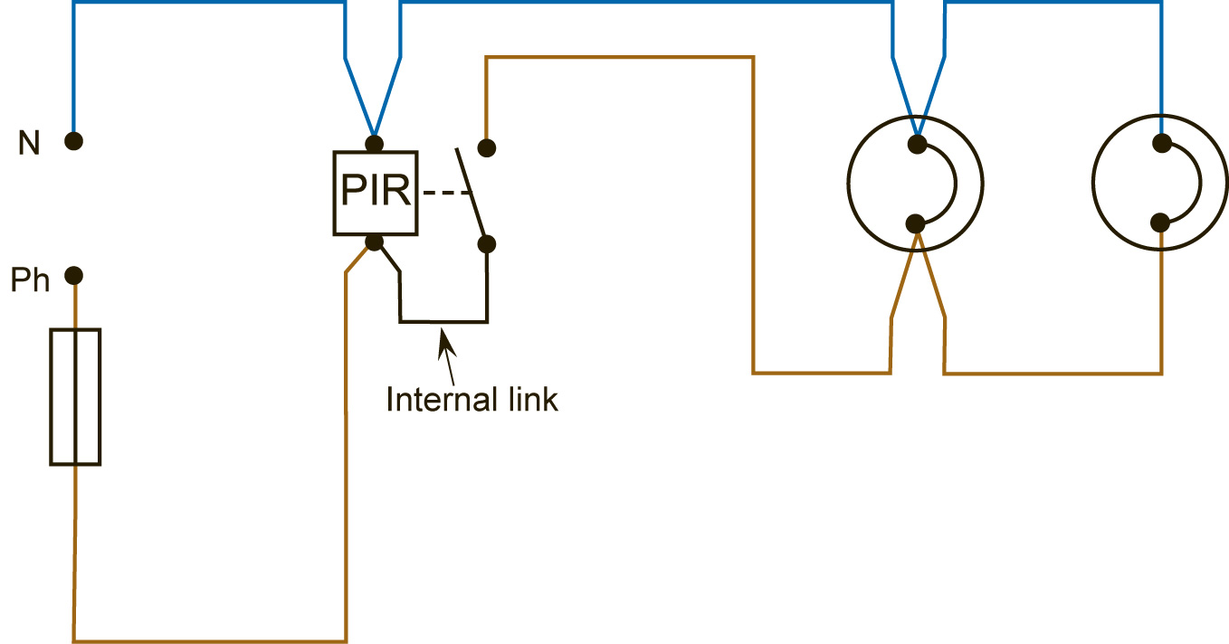

Figure 27
PIR with facility to switch off, or allow the PIR control the lighting

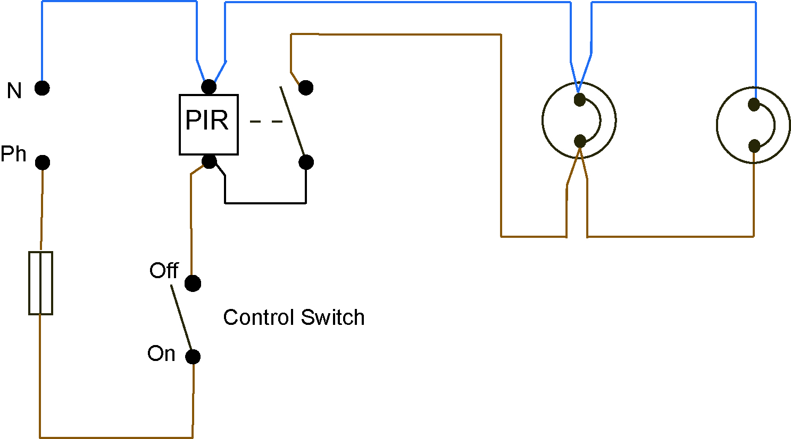
Figure 28

The one way switch in the circuit above will allow the PIR control the lighting directly or prevent the lighting from operating. If the PIR has any of the facilities listed under items 5, 6 or 7 on page 25, this switch may be used to activate any of them.

PIR with facility to switch off, switch on or allow the PIR control the lighting

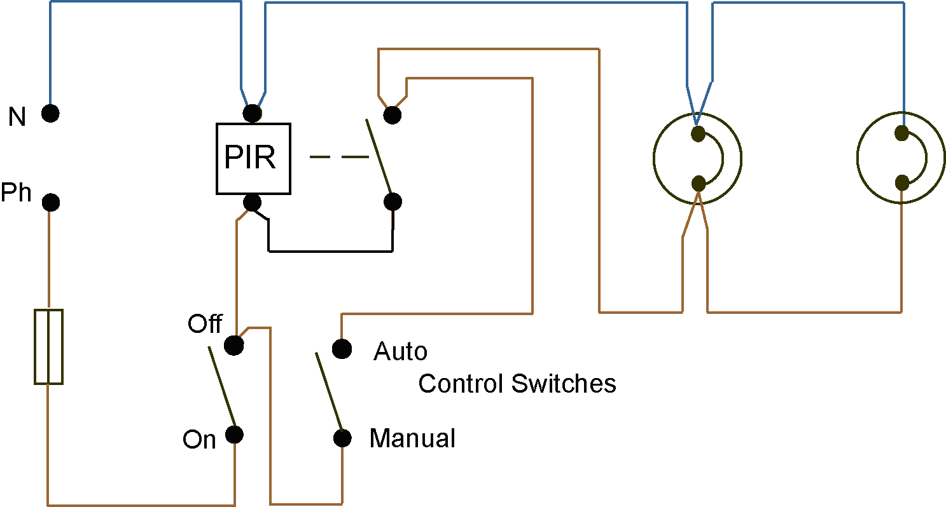

Figure 29

When using a PIR not having the facilities listed under items 5, 6 or 7 on page 25, these switches may be used to provide full control. The lighting may be locked “off”, “on” or left under the control of the PIR.

Unit Related ETCI Rules

Position of Control Devices | 530  530.6
Functional Switching | 537  537.5, 537.5.2.5, ( item 1 only ), 537.5.5
Luminaires and Lighting Installations | 559  559.6, 559.6.6  559.7  559.8  559.10
Extra-low Voltage Lighting Installations  Protection against Electric Shock  Protection against fire  Protection against Overcurrent  Isolation and Switching  Wiring Systems  Protective Devices  Other Equipment | 715  715.1  715.41  715.414, 715.414.01, 715.414.03, 715.414.04  715.42  715.421, 715.421.01  715.43, 715.43.01, 715.43.02  715.46  715.462.01  715.52  715.521, 715.521.01, 715.521.02,  715.521.03, 715.521.04  715.524, 715.524.01 ( item 1 only )  715.525, 715.525.01  715.53  715.533, 715.533.01, 715.533.02, 715.533.03  715.55  715.552, 715.552.01  715.559, 715.559.01, 715.559.02

