Trade of Electrician

Standards Based Apprenticeship

Multicore Cables and Cabletray

Phase 2

Module No. 2.3

Unit No. 2.3.4

COURSE NOTES

Created by Charlie Walsh - Athlone TC

Revision 1 April 2000 by
Charlie Walsh - Athlone TC
Eugene Trindles - Cork TC

Revision 2 Nov. 2002 by
Charlie Walsh - Athlone TC
Chris Ludlow - Dundalk TC

Revision 3 July. 2006 by
Chris Ludlow - Dundalk TC

Revision 4. Feb 2008 by
Chris Ludlow - Dundalk TC

Revision 5. July 2009 by
Chris Ludlow - Dundalk TC

Revision 6, November 2013
SOLAS

Compiled by Liam Carroll – Certification & Standards

Published by


27-33 Upper Baggot Street
Dublin 4
Ireland

© SOLAS - 2013

All rights reserved. No part of this publication may be reproduced, stored in a retrieval system or transmitted in any form or by any means, electronic, mechanical, photocopying, recording or otherwise, without the prior permission of the copyright owner.

Table of Contents

Introduction 4
Cable Tray Installations 5
Cable Tray Types 6
Use of Hand Tools 12
Fabricating Cable Tray on Site 13
NYM-J Cables 22
Fire Performance Cables 25
Steel Wire Armour Cables 27
Power Loss in Cables 31
Termination of Compression Type Lugs 32
Unit Related ETCI Rules 33

Introduction

Welcome to this section of your training course, which is designed to introduce you the learner, to the installation of industrial cables and cable tray.

Objectives

By the end of this unit you will be able to:

- State the construction of NYMJ, SWA and Fire Performance cables
- List applications for NYM-J, SWA and Fire Performance cables
- Install and terminate NYM-J, SWA and Fire Performance cables
- Select and use appropriate types and size of cable tray for application
- Select and use appropriate accessories for cable tray
- Select and use appropriate tools for installing cable tray
- Select and use appropriate supports for cable tray
- Install compression type lugs
- List factors affecting volt drop and current ratings of cables
- State relationship between power loss and heat generated in cables
- Fabricate bends and tees in cable tray
- Decide appropriate treatment for cut ends / edges

Reasons

The use of above cables and cable tray is common in modern installations.

Cable Tray Installations

Cable tray is a sheet steel channel with multiple holes. It is used extensively on large industrial and commercial installations for supporting NYM cables, Steel Wire Armoured cables ( SWA ), Fire Performance cables such as FP200, Mineral Insulated ( MI ) etc. They are laid on the tray and secured at appropriate intervals with cable ties passed through the tray holes.

Fire Performance cables should be clipped to tray or wall etc. using copper or stainless steel clips and brass screws or bolts as suitable.

A wide range of cable tray types and accessories is available to match any cabling requirement. Cabling requirements can range from the lightest instrumentation cables through to the heaviest multi-core power cables.

Cable Tray Finishes

Hot dip galvanised finish is the most frequently used. This finish is suitable for use in environments with high or low ambient temperatures and where normal atmospheric pollutants are likely to be encountered. The galvanising is applied to conform to BS 729 standard.

Other tray finishes less frequently encountered are available e.g. PVC. Cable tray finishes may be selected to suit a particular installation environment e.g. stainless steel tray is available for use in food processing plants.

Cable Tray Types

Light Duty Cable Tray

Standard cable tray is suitable for light and medium duty installation work. It is particularly useful for sheathed cables which can be easily dressed and secured to the tray using the numerous perforations. These perforations also provide ventilation to cool the cables.
See Figure 1.

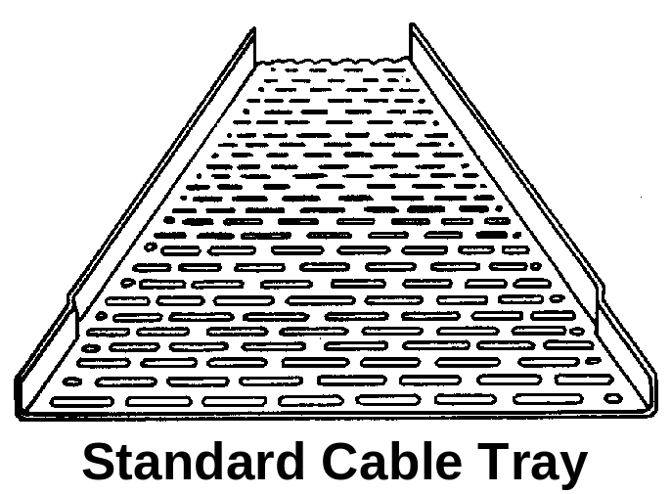

Figure 1

Medium Duty Cable Tray

The design of return flange cable tray differs from the standard type in that the flange has a turned edge, see Figure 2. This makes the tray several times stronger than the standard tray, yet it remains light and easy to install. The flange height is 25mm with a 6mm return.

Return flange cable tray uses patented snap-on couplers which fit over the outside of the tray flanges and are secured by round headed bolts. The heads of the bolts should be inside the tray to prevent damage to the cables

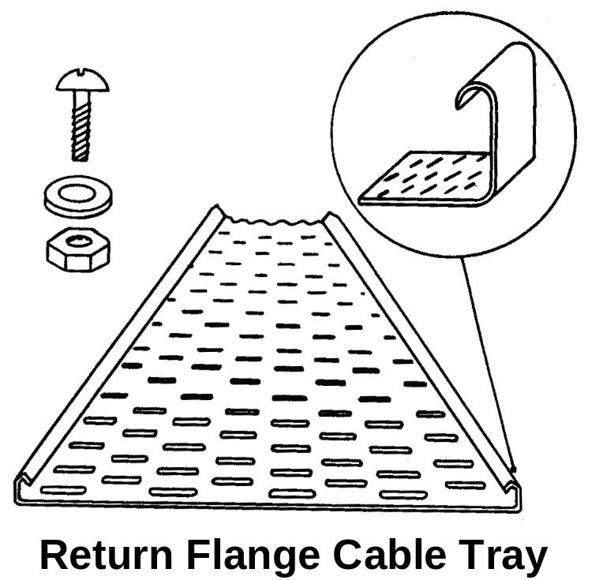

Figure 2

Heavy Duty Cable Tray

Heavy duty cable tray is designed for use in circumstances where high loading or adverse site conditions are experienced. The heavy duty perforation pattern combined with a wide return flange ensures that the tray is rigid and strong. See Figure 3. Patented coupling systems which are convenient to use are usually available.

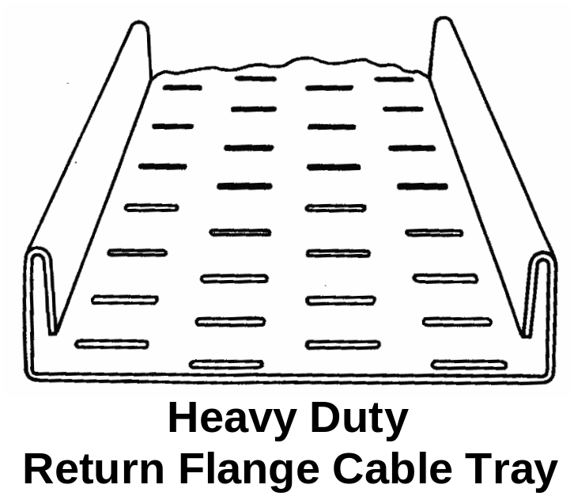

Figure 3

Cable Tray Accessories

A range of factory made accessories is readily available. A selection of these accessories is illustrated in Figures 4, 5, 6 and 7.
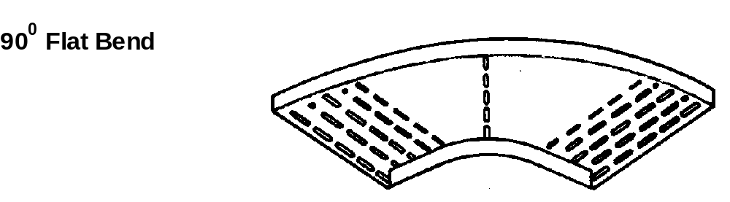
Figure 4

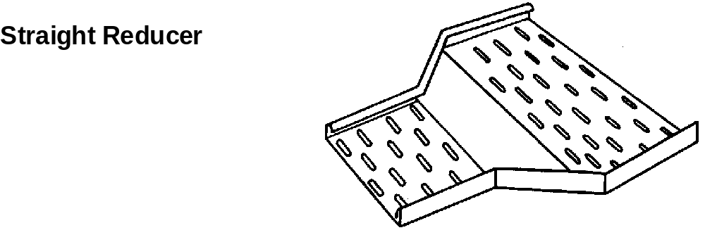
Figure 5

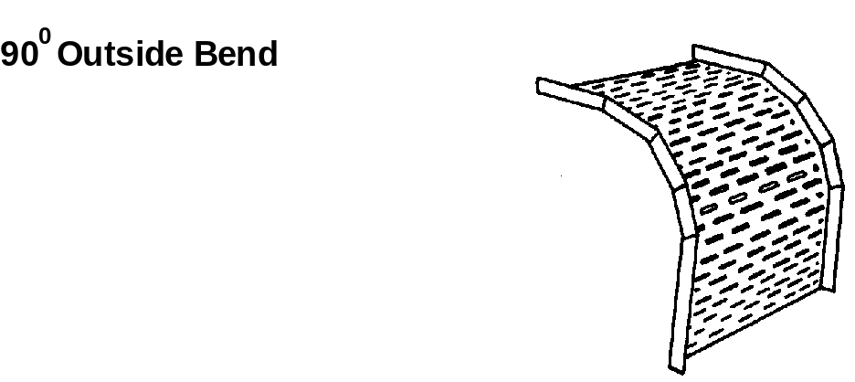
Figure 6

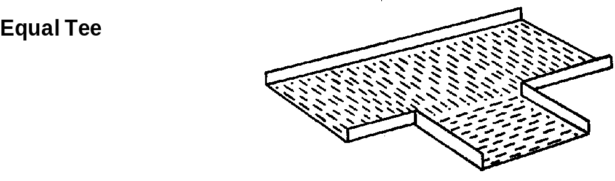
Figure 7

Installing Cable Tray

When installing cable tray it is essential that the tray is well supported and securely fixed. It is possible to complete a cabletray installation by making use of the wide range of factory made accessories. However, it may be necessary to fabricate joints, bends, tees etc., to meet particular installation requirements.

Most types of cable tray jointing involves the use of nuts and bolts. A round head bolt should be used and these bolts should be installed with the head placed inside the tray. This reduces the risk of damage to cables being drawn along the tray.

Cable tray systems have a number of advantages over other types of wiring systems. Some of these advantages are listed below:

- Ease of installation
- Economy of time and materials
- Facility for extending the system to take additional cables
- Position and availability of supports

The type and size of cable tray selected will depend on such factors as environmental conditions, the size and type of cables being installed and any requirement for future extension of the system.

Protecting Cut Edges

Where a tray has been cut, the steel edges must be protected from corrosion by sealing them with zinc rich paint in the case of galvanised tray. An appropriate primer must be used for painted tray and a liquid plastic solution for plastic coated tray.

Site-applied protection cannot normally match the protection qualities of the original factory applied finish. However, the absence of site applied protection can seriously reduce the effectiveness of the original finish and result in corrosion spreading from the point where the tray was cut.

Site-applied protection should be applied as soon as practicable after the tray is cut.

Fitting and Fixing Cable Tray

Cable tray is fixed to building surfaces using three basic methods:

- Brackets fixed directly to the surface with screws or bolts as required. See Figure 8.

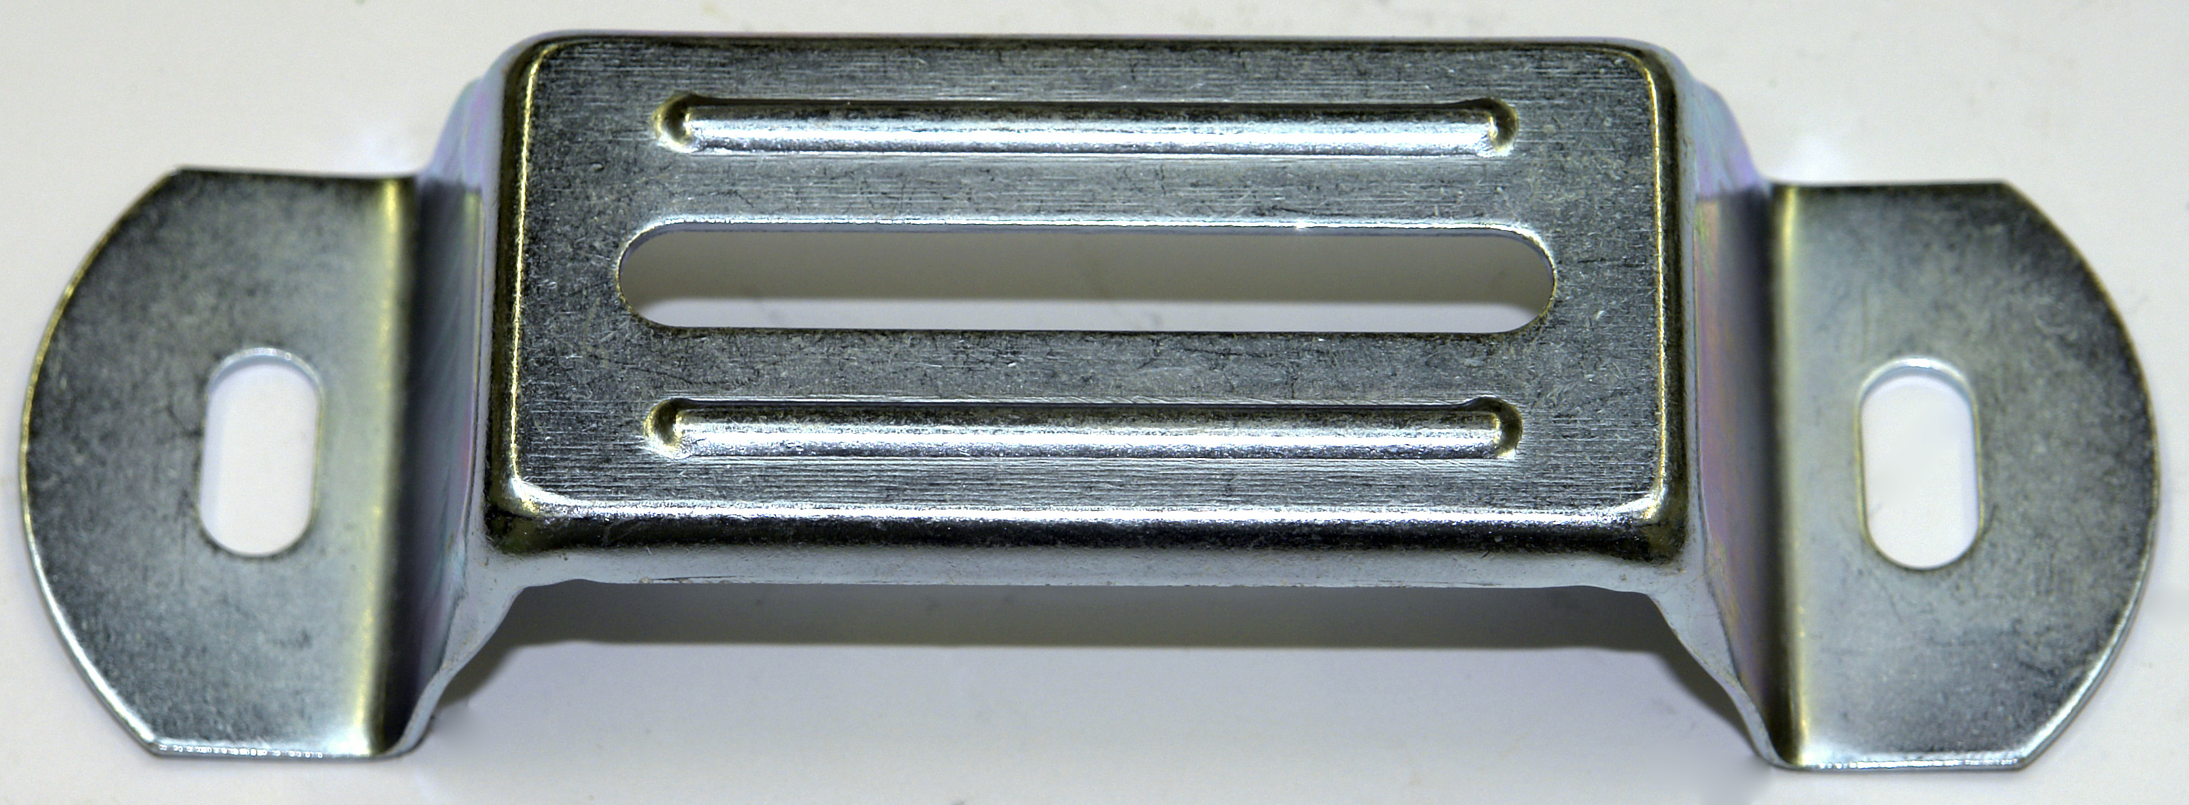
Figure 8.

- Brackets bolted to unistrut which is fixed to the surface. See Figure 9.

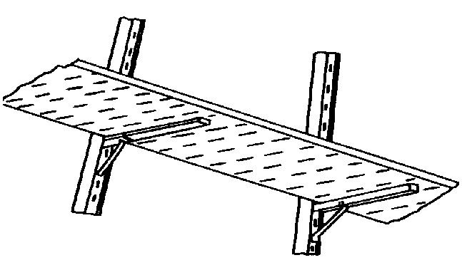
Figure 9.

- Threaded bar and unistrut supporting the underside of the tray when suspended from a ceiling. See Figure 10.

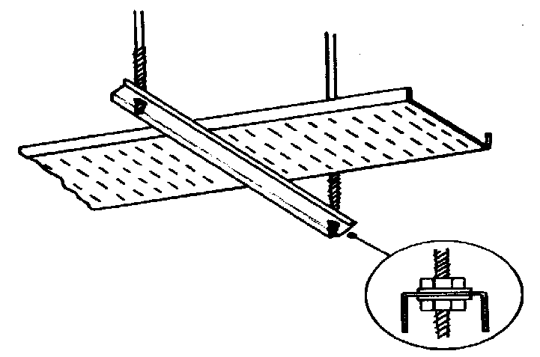
Figure 10.
It is essential that all supports are securely fixed. The most appropriate method will be determined by assessing the following points:

- The number and size of the cables being installed
- Is the tray to be fixed flat along a wall or ceiling
- Is the tray to be fixed horizontally along a wall
- Is the tray to be suspended below a ceiling

Earthing of Metallic Cable Tray

Metallic cable tray is an exposed conductive part and must be earthed. All tray joints must be mechanically and electrically sound to ensure continuity throughout its length. Any break in the run of tray must be bridged over by a suitable conductor to maintain the continuity of the earth path. All bolts must be tightened securely using a screwdriver and spanner.

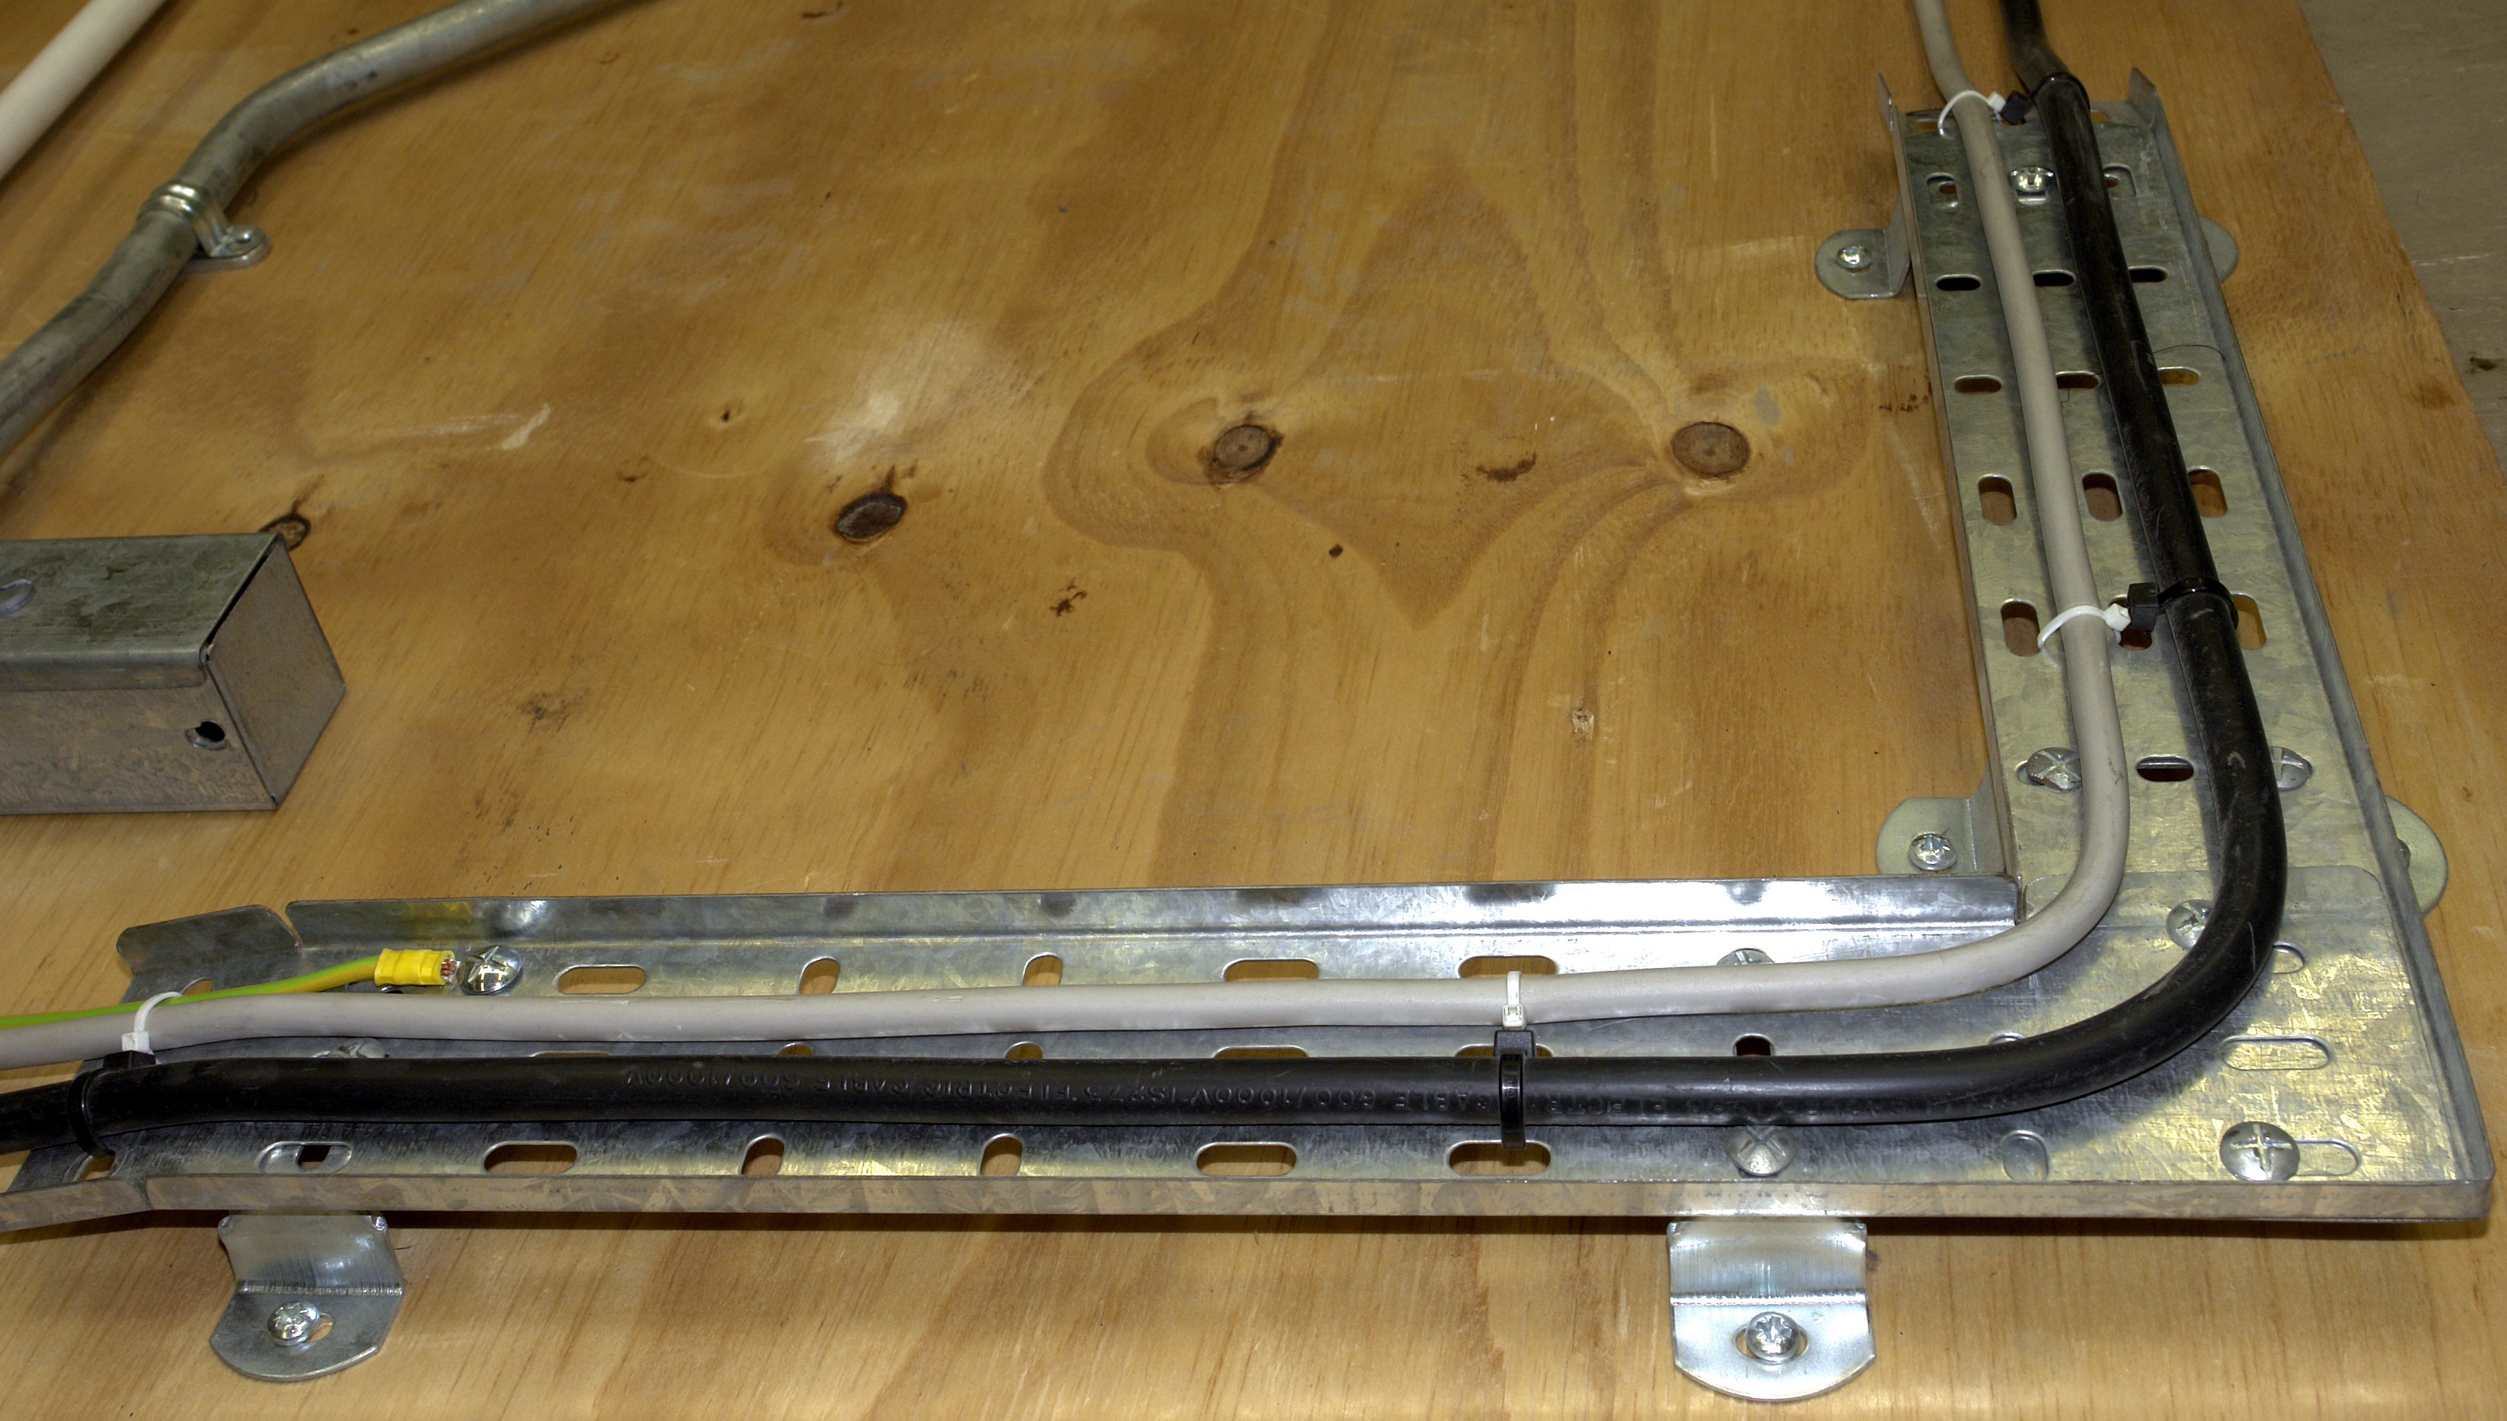

Use of Hand Tools

Figure 11 shows an adjustable spanner. This is used to tighten the nuts on bolts for joining cable tray. It is also used to install hexagonal, cable glands. A pipe grip should not be used on cable glands as it damages the brass or plastic surface. Damaged glands are a sign of bad workmanship.

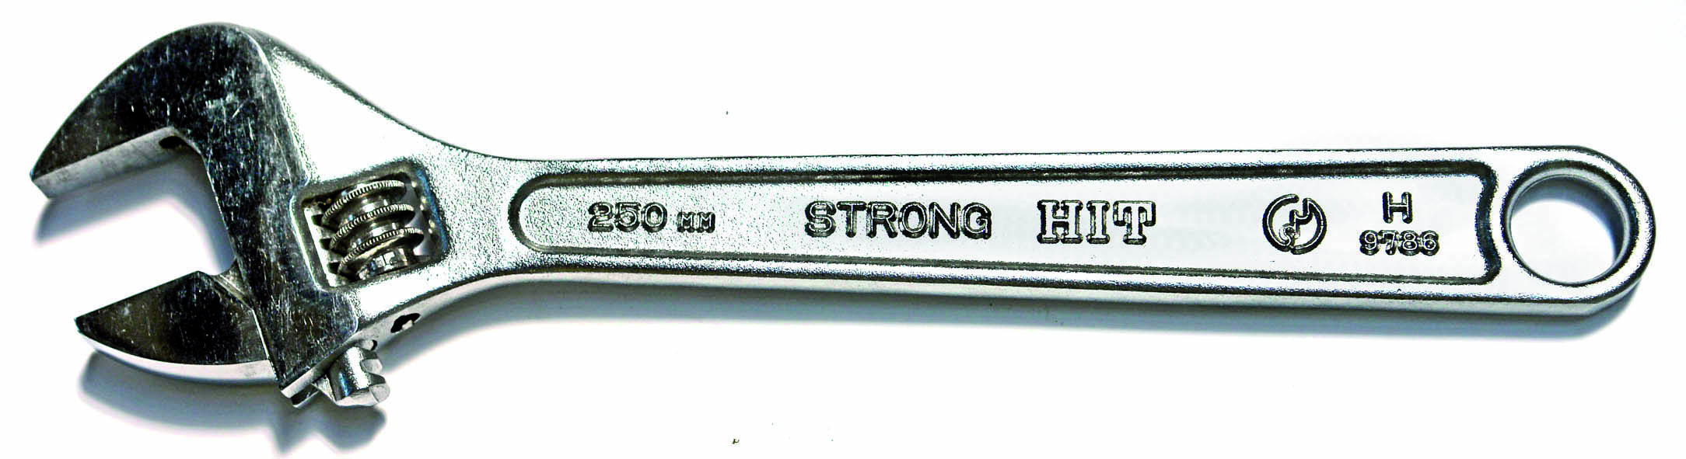
Figure 11

Fabricating Cable Tray on Site

It is sometimes necessary to fabricate joints to meet particular installation requirements, or where a factory made accessory is not readily available.

Cable tray can be cut quite easily with a hacksaw. Careful measurement and marking out is required to obtain a satisfactory fit. Care should be taken to remove any sharp edges or burrs where the cable tray was cut.

Fabricating a Tee Joint

Mark the position of the Tee on the through section of tray. W is the width of the Tee section of tray. Ensure that this measurement is accurate by measuring the width of the tee section. Remember that the tee section may be a different size than the through section. Cut the flange and fold out as shown in Figure 12.
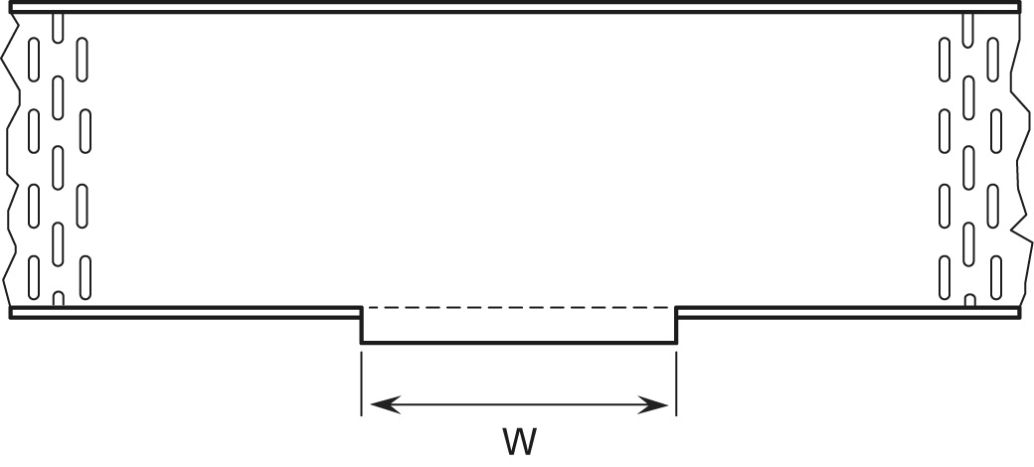
Figure 12

Cut away or fold out both flanges on Tee section of tray. Deburr all cut edges and “round off” all corners as shown in Figure 13.
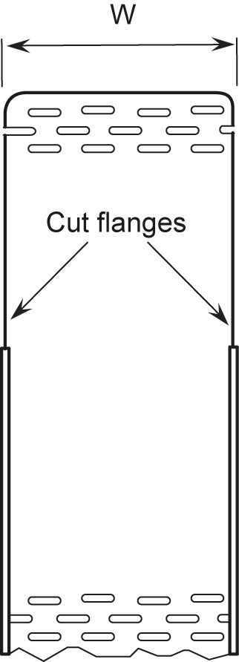

Figure 13
Drill holes as required to secure both pieces together with 6 mm galvanised round head bolts. Ensure that the heads of the bolts are inside the tray to prevent damage to any cable being installed. Tighten all bolts securely. See Figure 14

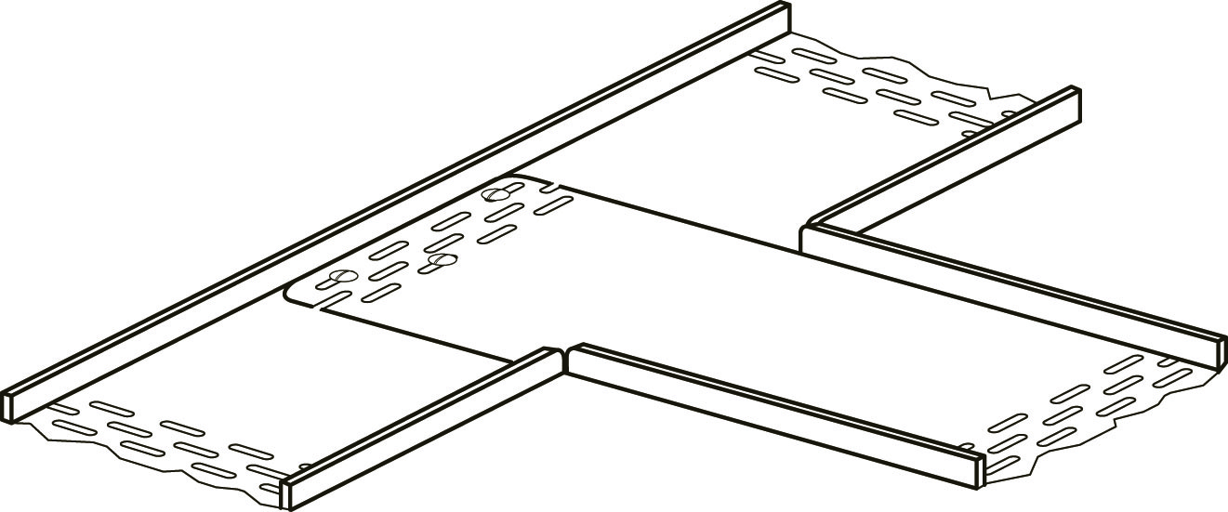

Figure 14

Fabricating a Flat 90° Bend

Place two pieces of tray so that they overlap each other. Mark point of intersection as shown in Figure 15.

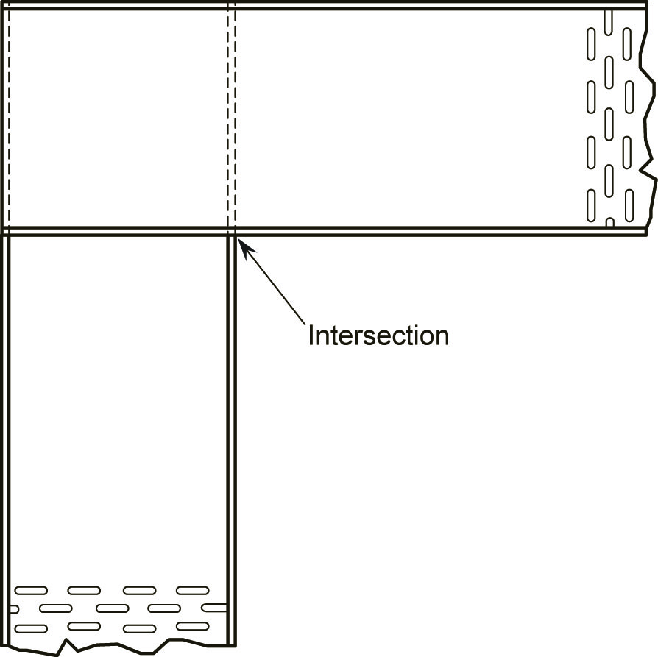
Figure 15

Cut through both flanges at point of intersection as shown in Figure 16.

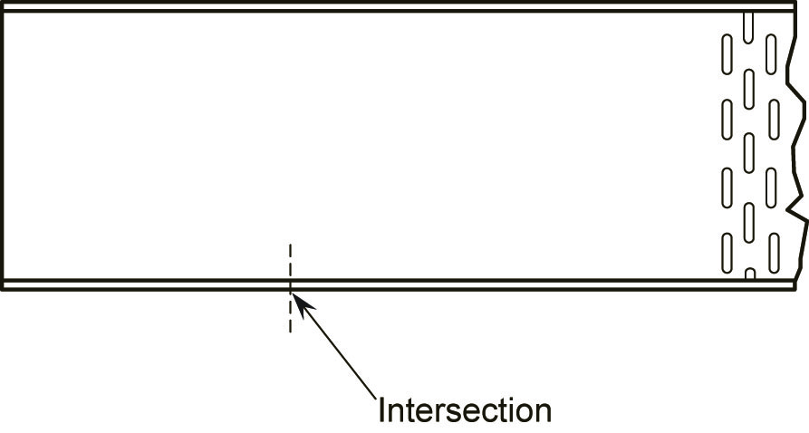
Figure 16

Bend both flanges flat. Deburr all cut edges and “round off” all corners as shown in Figure 17.

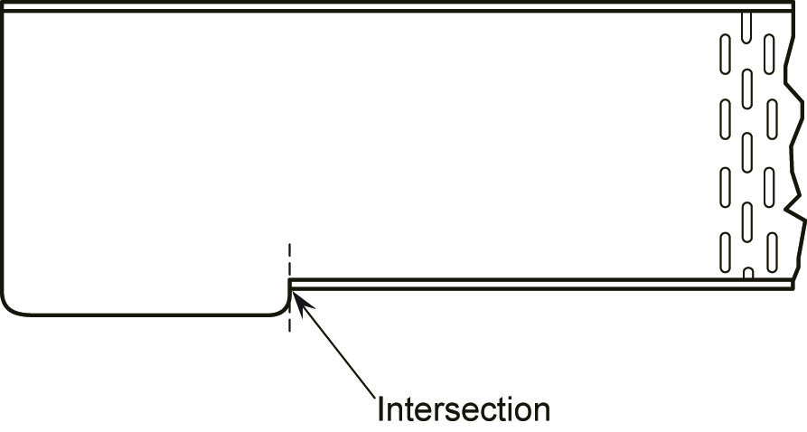
Figure 17

Drill holes as required to secure both pieces together with 6 mm galvanised round head bolts. Ensure that the heads of the bolts are inside the tray to prevent damage to any cable being installed. Tighten all bolts securely. See Figure 18.

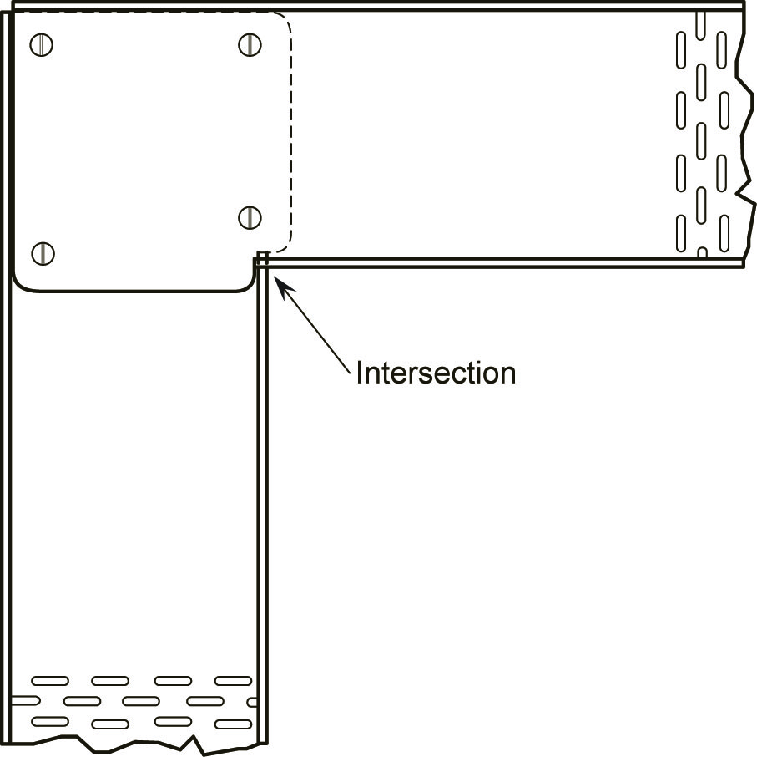
Figure 18

Fabricating a Flat 90° Bend with Gusset

- Refer to Figure 19, measure and mark line Aa ( e.g. 150 mm ).
- Calculate dimension X = √2 ( W ) X = 1.414 x 100 = 141 mm.
- Mark the mid-point 1/2X.

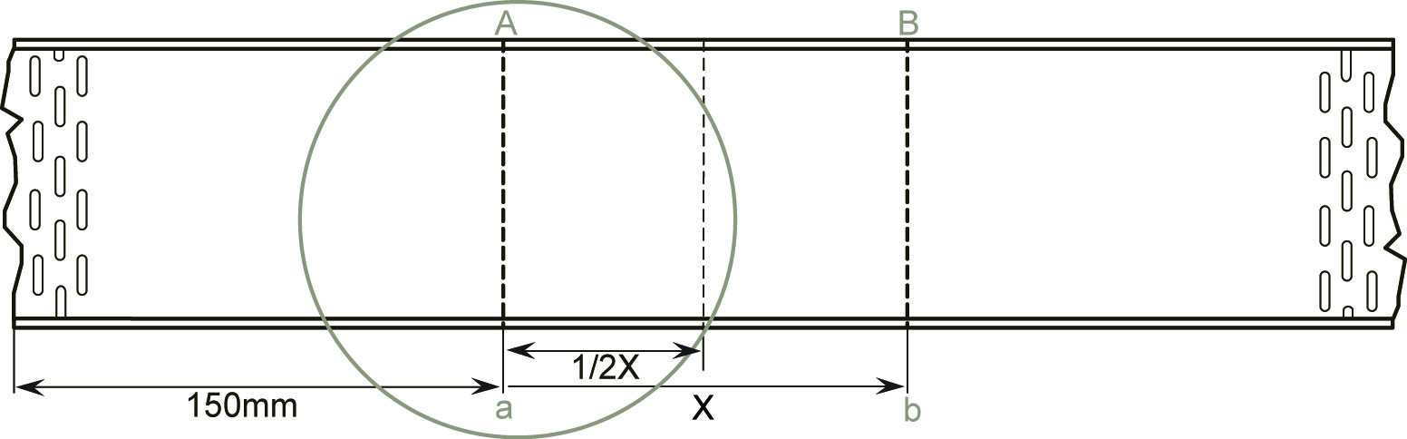
Figure 19

Cut through flange at point A and along line Aa, but do not cut through the opposite flange. Cut Bb in a similar manner.

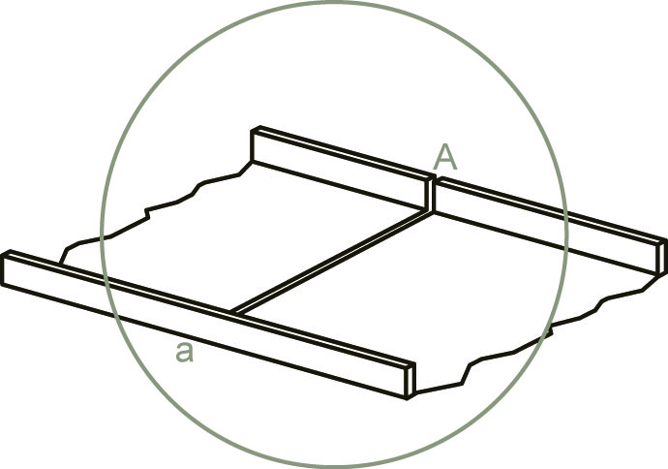
Figure 20

Refer to Figure 21. Bend the two outer sections of the tray together to form a triangle with a 90o angle at the apex and two 45o angles at the base. The apex should correspond with the mid-point line.

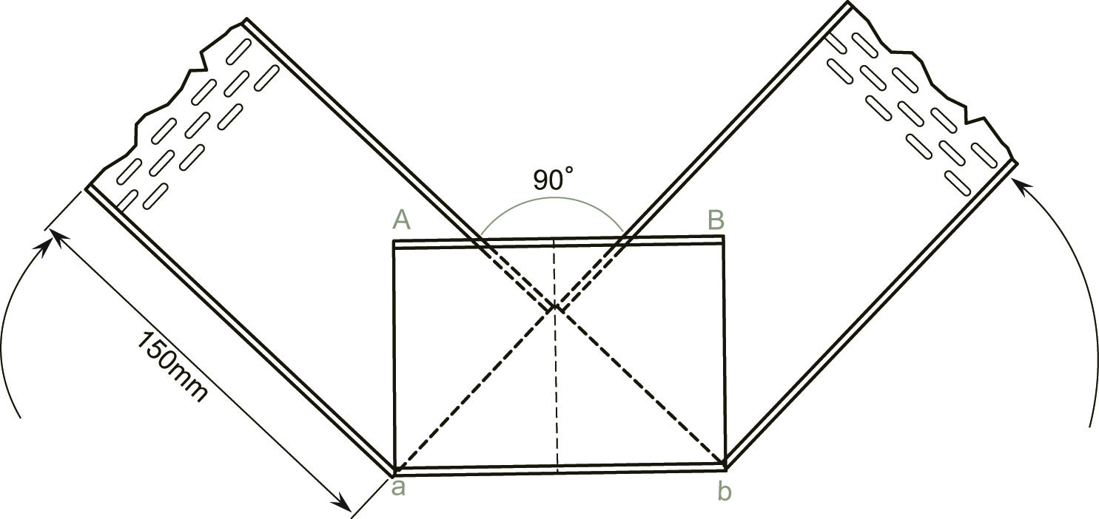
Figure 21
Refer to Figure 22. Mark all four flanges at points of overlap.

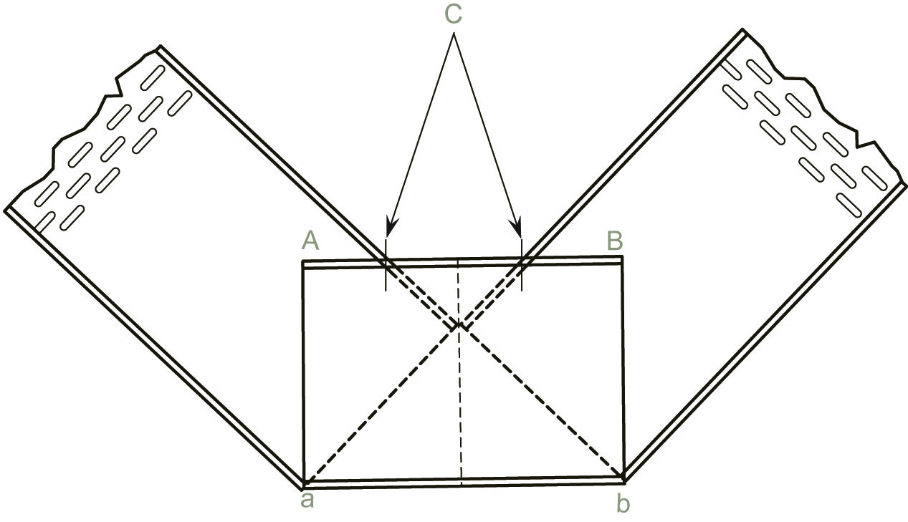
Figure 22

Refer to figure 23. Bend tray back to form a straight line. Cut through flanges at the four marked points.

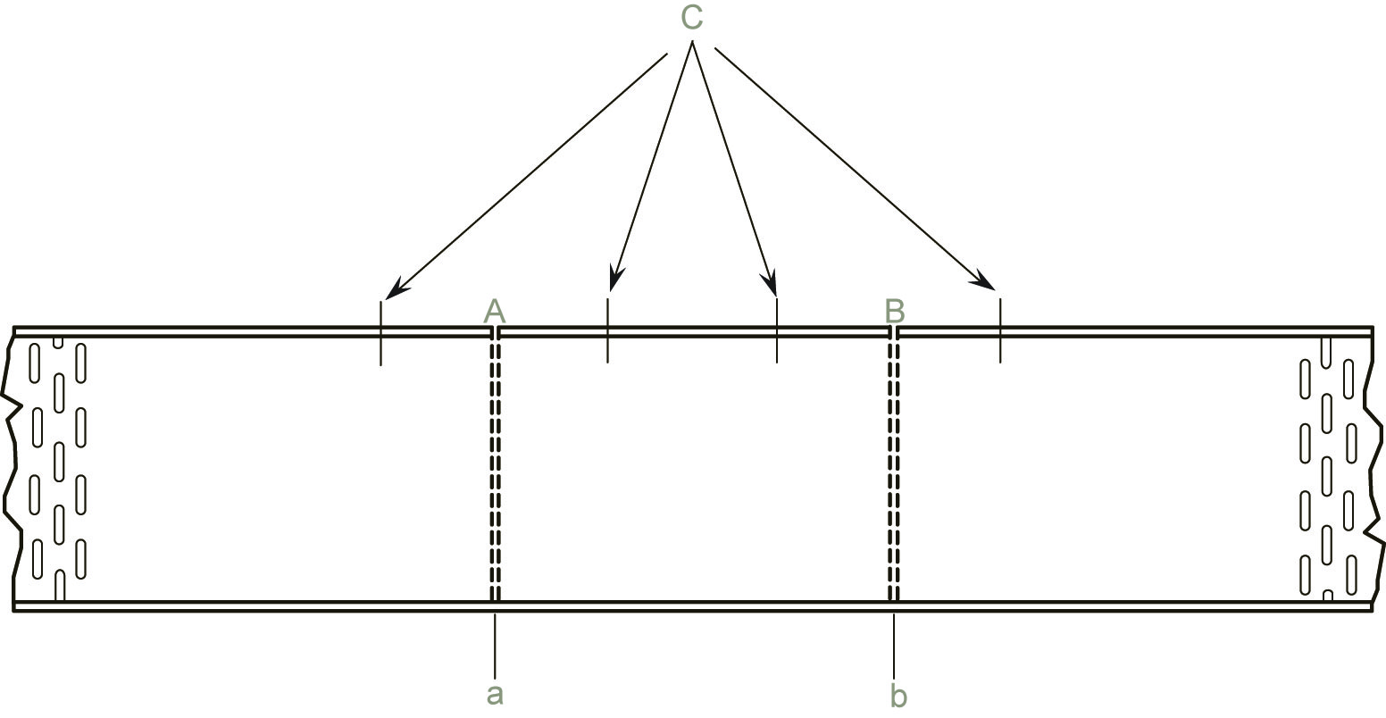
Figure 23

Refer to Figure 24. Bend flanges flat as shown and remove.
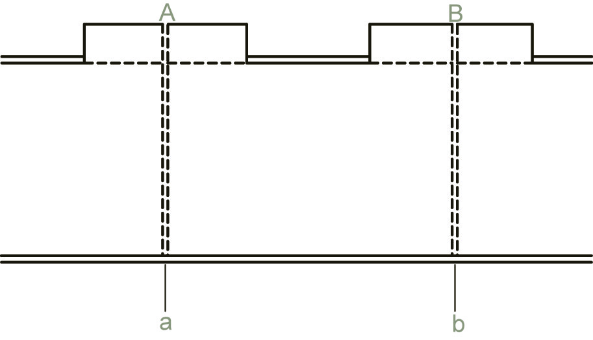
Figure 24
Refer to Figure 25. Round-off all corners, remove all sharp edges and burrs.

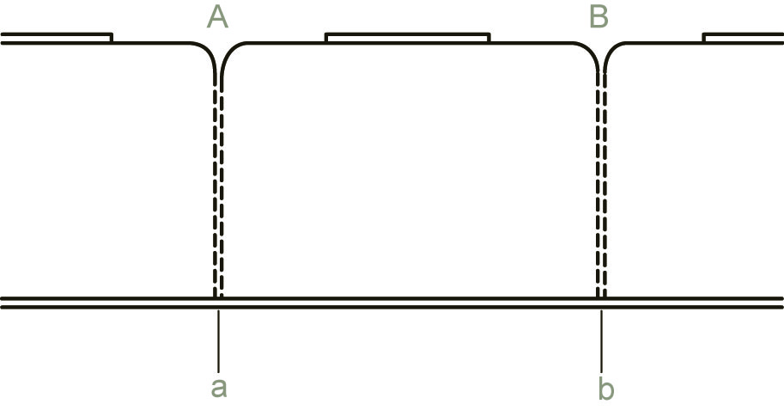
Figure 25

Bend tray to final position. Mark and drill holes as required to secure both pieces together with 6 mm galvanised round head bolts. Ensure that the heads of the bolts are inside the tray to prevent damage to any cable being installed. Tighten all bolts securely. See Figure 26.

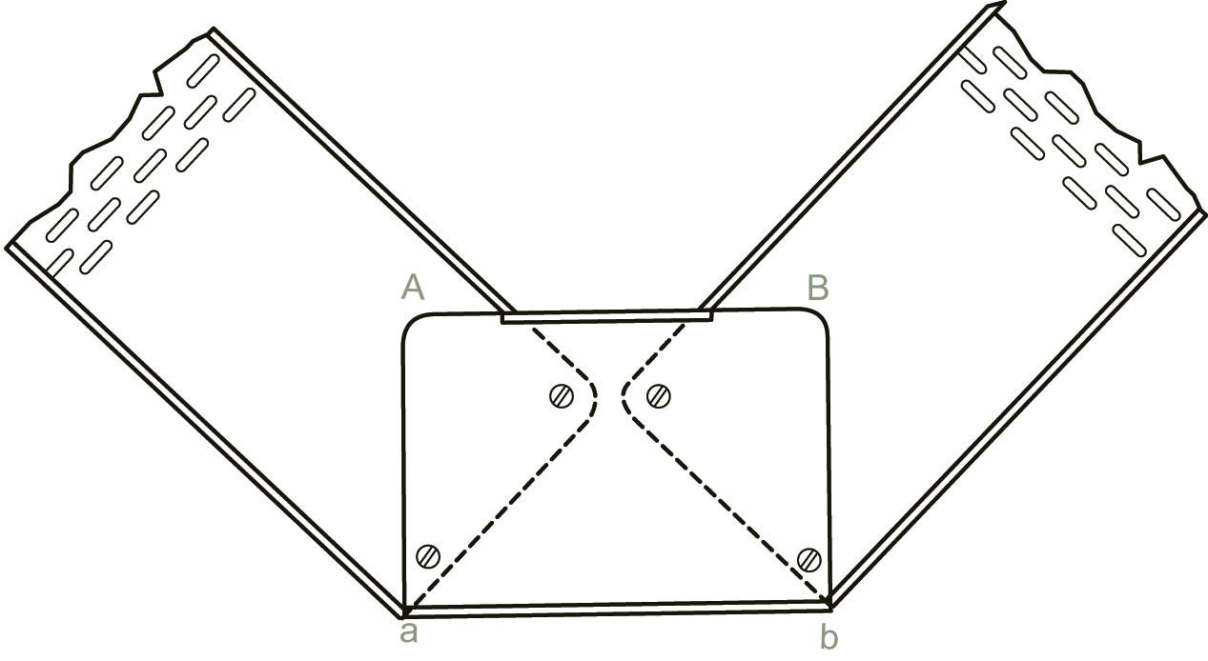
Figure 26

External Bend

An external bend can be made to the required radius and in the correct position on a run of cable tray. It is not necessary to make an external bend and fix in the correct position. Mark the tray as per the example shown in Figure 27. The distance between lines A and B is the length of tray required to form a uniform bend of radius r. Mark the flanges at equal distances of approximately 20 mm between A and B.

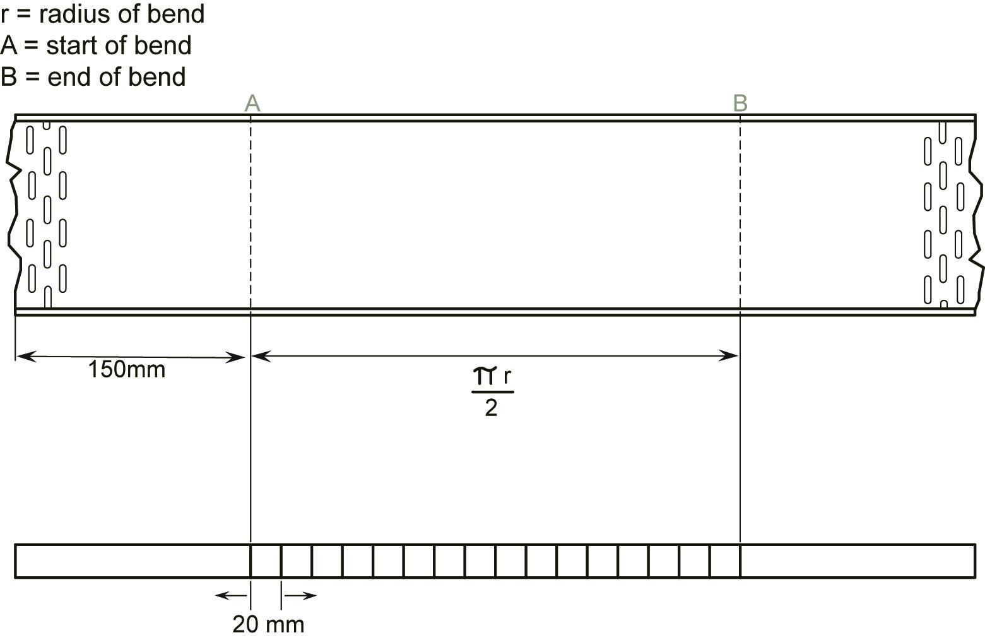
Figure 27

Cut through both flanges at the points marked. Bend the tray a small amount at each saw-cut. Continue bending at each saw-cut in turn until a uniform bend is achieved. The radius of the bend will automatically be correct.

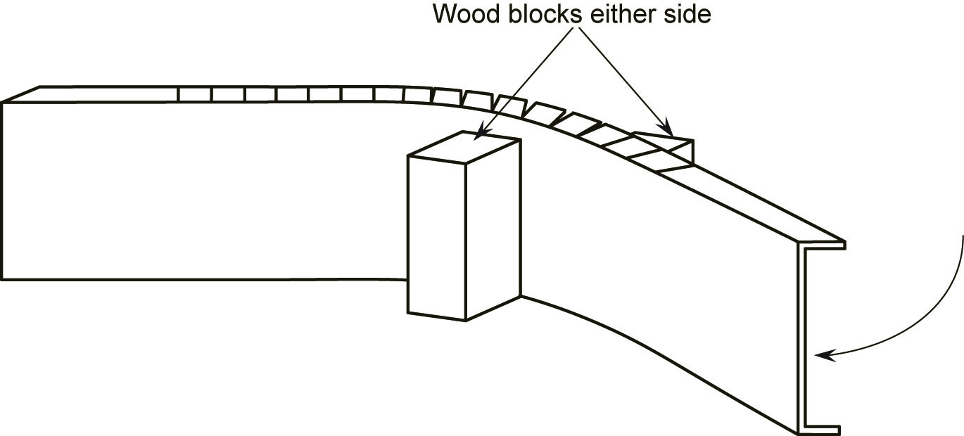
Figure 28

Refer to Figure 29. Round-off all corners, remove all sharp edges and burrs.

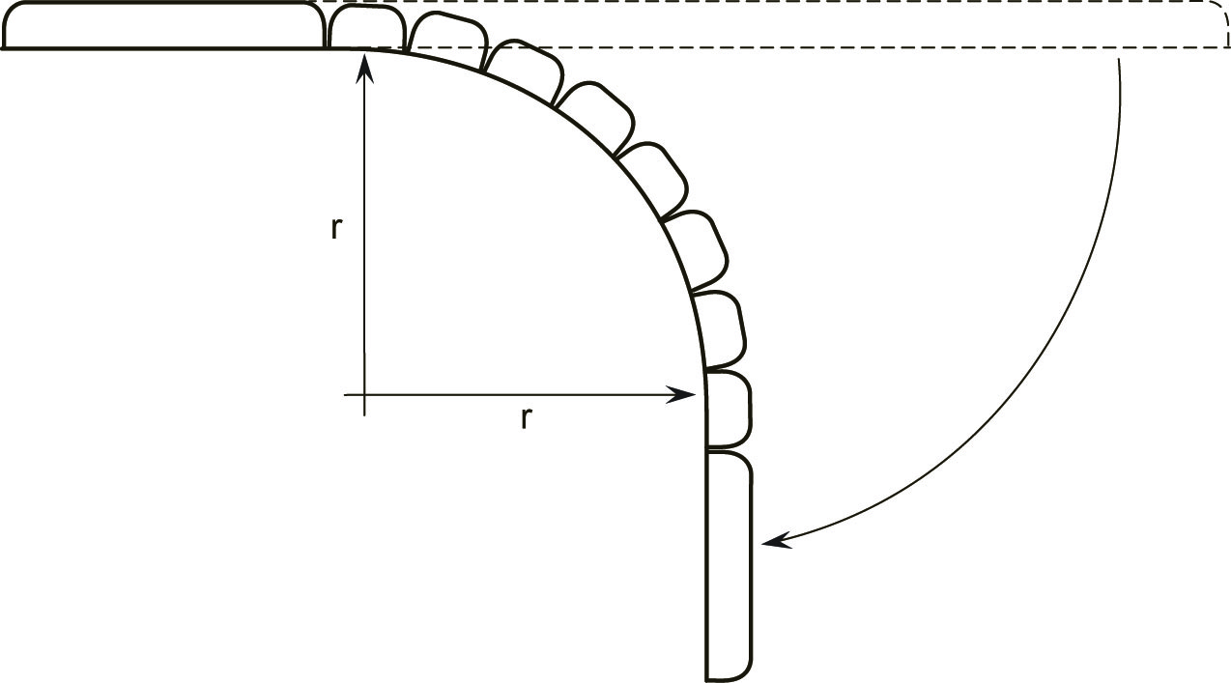

Figure 29

Internal Bend

An internal bend can be made to the required radius and in the correct position on a run of cable tray. It is not necessary to make an internal bend and fix in the correct position. Mark the tray as per the example shown in Figure 30. The distance between lines A and B is the length of tray required to form a uniform bend of radius r.

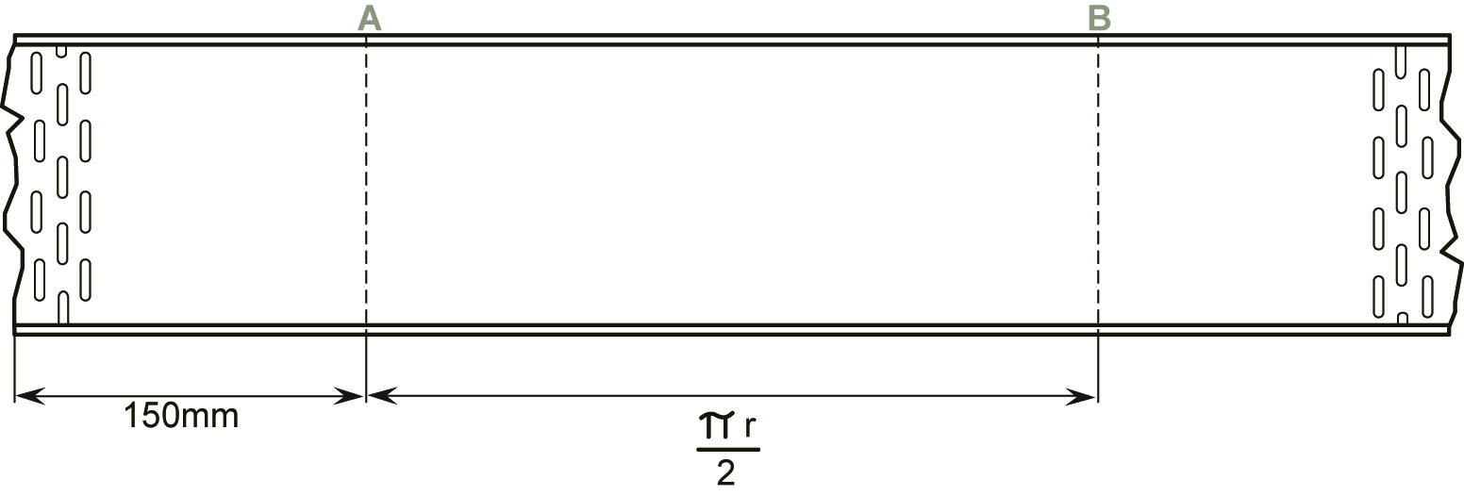
Figure 30

Figure 31 shows a simple tool for forming an internal bend in cable tray. It may be easily fabricated from a piece of mild steel. The groove which is cut in the left hand side, should be slightly wider than the flange of the cable tray. Alternately, an adjustable spanner may be used.

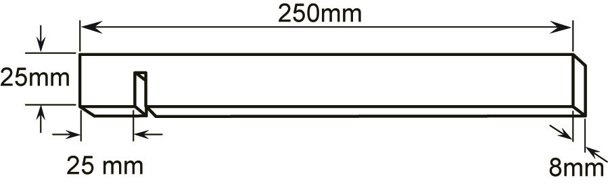
Figure 31
Bend both flanges, a small equal amount at a time as shown in Figure 32. Do not overbend. Let the width of the tool decide the distance between the bends. Continue bending over the distance AB. If a 90° bend is not achieved, simply bend slightly more at each point to maintain a uniform radius.

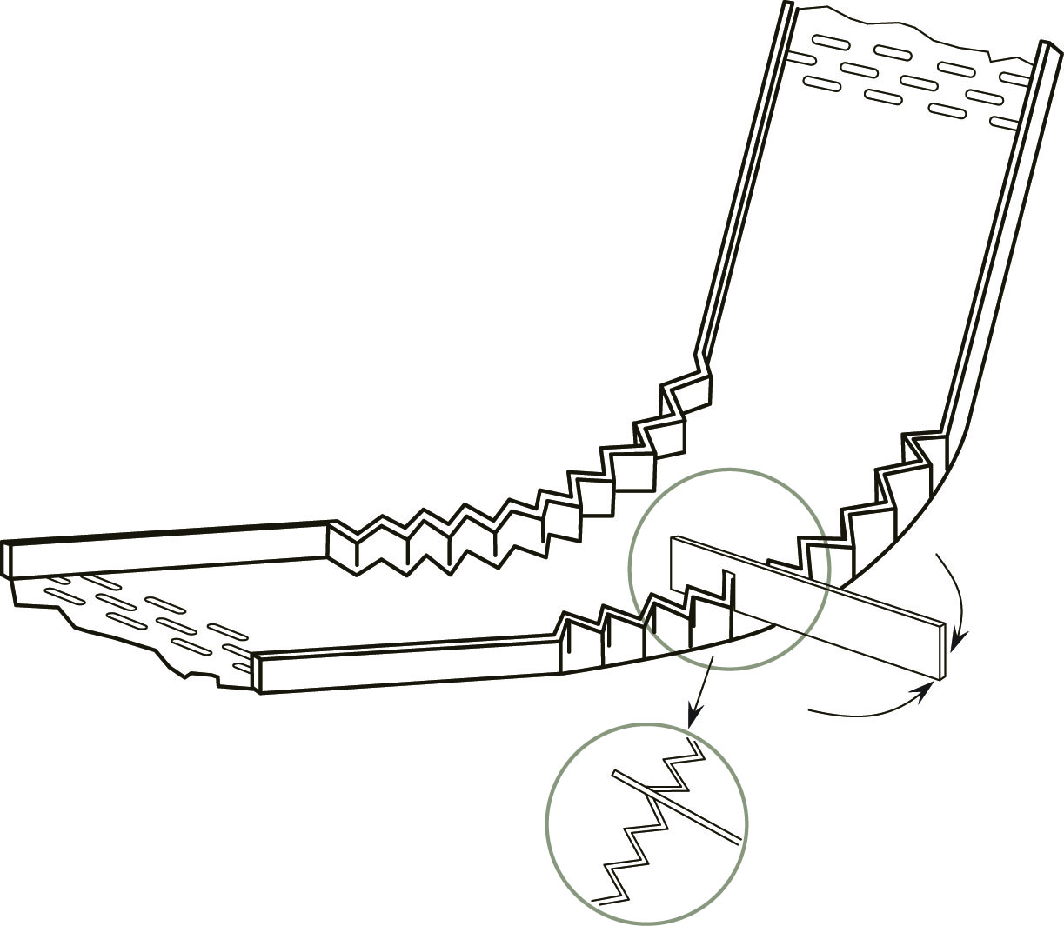
Figure 32

The radius of the bend will automatically be correct as shown in Figure 33.
.
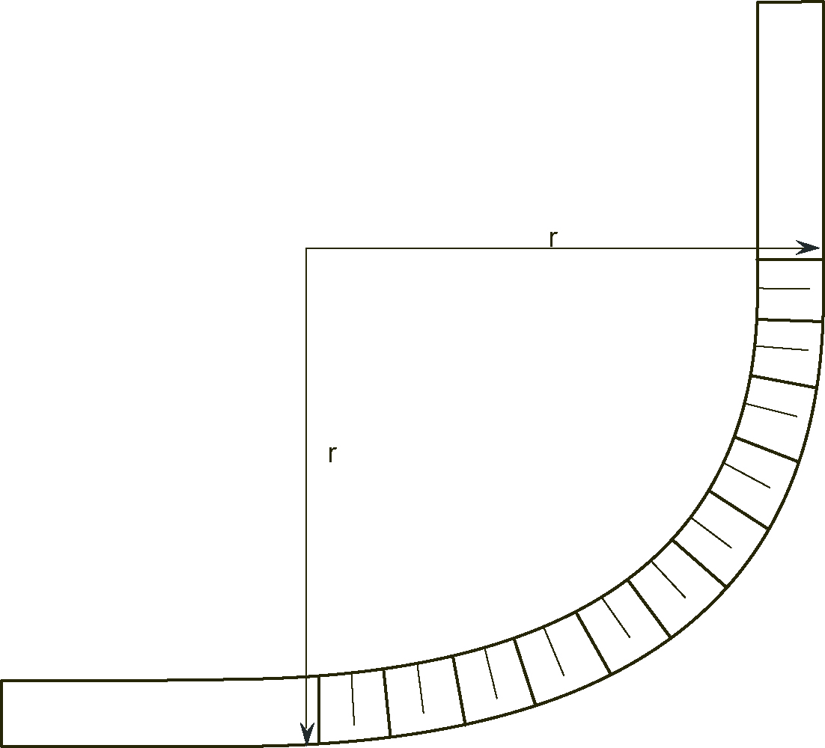

Figure 33

NYM-J Cables

These cables are extremely popular as they offer good mechanical protection and are quite pleasing to the eye. They are very easily installed and can be painted to blend in with the surroundings. The construction of NYM cable is identified by the following code letters:
- N German Standard ( means it meets the German VDE specification )
- Y PVC ( Insulation )
- M Mantle ( German for sheath )
- J CPC ( includes earth wire with green and yellow insulation )

Construction of NYM-J Cable

The conductors, of soft-drawn copper, ( solid up to 10mm² ) are PVC insulated. They are surrounded by a filling compound to produce a circular shape. The sheath of the cable is of Protruder ( polyvinyl chloride based compound ), which is mechanically tough and resistant to most chemical action. It is also flame retardant and self extinguishing. The colour of the NYM-J sheath is grey. It is manufactured in the usual range of conductor sizes up to 35 mm².

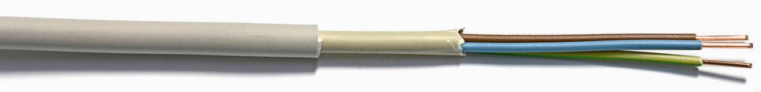
Figure 34

The cable contains a protective conductor which is colour-coded green / yellow and whose cross-sectional area is equal to that of the current carrying conductors.

A particular feature of NYM-J cable is its tough outer sheath, which affords good mechanical protection. The overall cable is pliable which is of significant advantage in installation. The fully insulated “protective conductor” contained in the cable has the same conductance as the current carrying conductors and ensures a direct and secure protective path.
NYM-J cable conforms to specification for double insulation and when used with plastic glands and accessories, it offers the advantage of a double insulated installation.

Application of NYM-J Cable

NYM-J cable is suitable for permanent wiring on the surface. It is particularly suitable in damp and wet locations. It may be used outside but is not suitable for burial directly in the ground. It is primarily intended for use in industrial, commercial and agricultural premises. It is suitable for use in any temperature between -40°C and +60°C.
NYM-J cables have a wide range of applications, some of which are listed below.

- Lighting and power installations in shops
- Lighting and power installations on farms
- Sub-main distribution
- Underground supplies ( must be installed in suitable pipe )

Installation of NYM-J Cables

NYM-J cable can be fixed directly onto walls using cable clips. If several cables are to follow the same route they may best be supported on a cable tray or rack system. The minimum internal bend radius is found by multiplying the overall diameter of the cable by a factor of 4. Most standard fixing accessories are suitable. It should not be worked below 5°C.

Termination of NYM-J Cable

To a small degree this depends on which type of gland is being used. The clamping / sealing arrangement varies from one type of gland to another. Sometimes a waterproof termination is required. Standard plastic or metal Packing Glands ensure speedy and reliable terminations.
For example PG 11, PG 13 etc.

Listed below are the steps to be followed when terminating an NYM-J cable:

- Fix gland in position in enclosure and tighten.
- Adjust rubber seal to suit cable diameter ( Remove rubber rings as required )
- Fit gland nut, washer and rubber seal over cable
- Decide the point to which the cable sheath must be removed
( must protrude beyond the gland into the enclosure to protect the insulation )
- Cut around the circumference of the cable and pull off the outer sheath
( a longitudinal cut of the sheath is not necessary ).
- Remove filling compound.
- Enter cable into gland and work rubber seal into position
- Work washer and gland nut into position and tighten gland nut
( cable sheath should appear 5 – 10 mm inside enclosure )
- Bare the required length of the conductor with the help of suitable stripping pliers.
- Terminate conductors as normal.
Figure 35 shows a 3 x 1.5 NYM-J cable terminated into a surface mounted plastic box using a plastic packing gland.
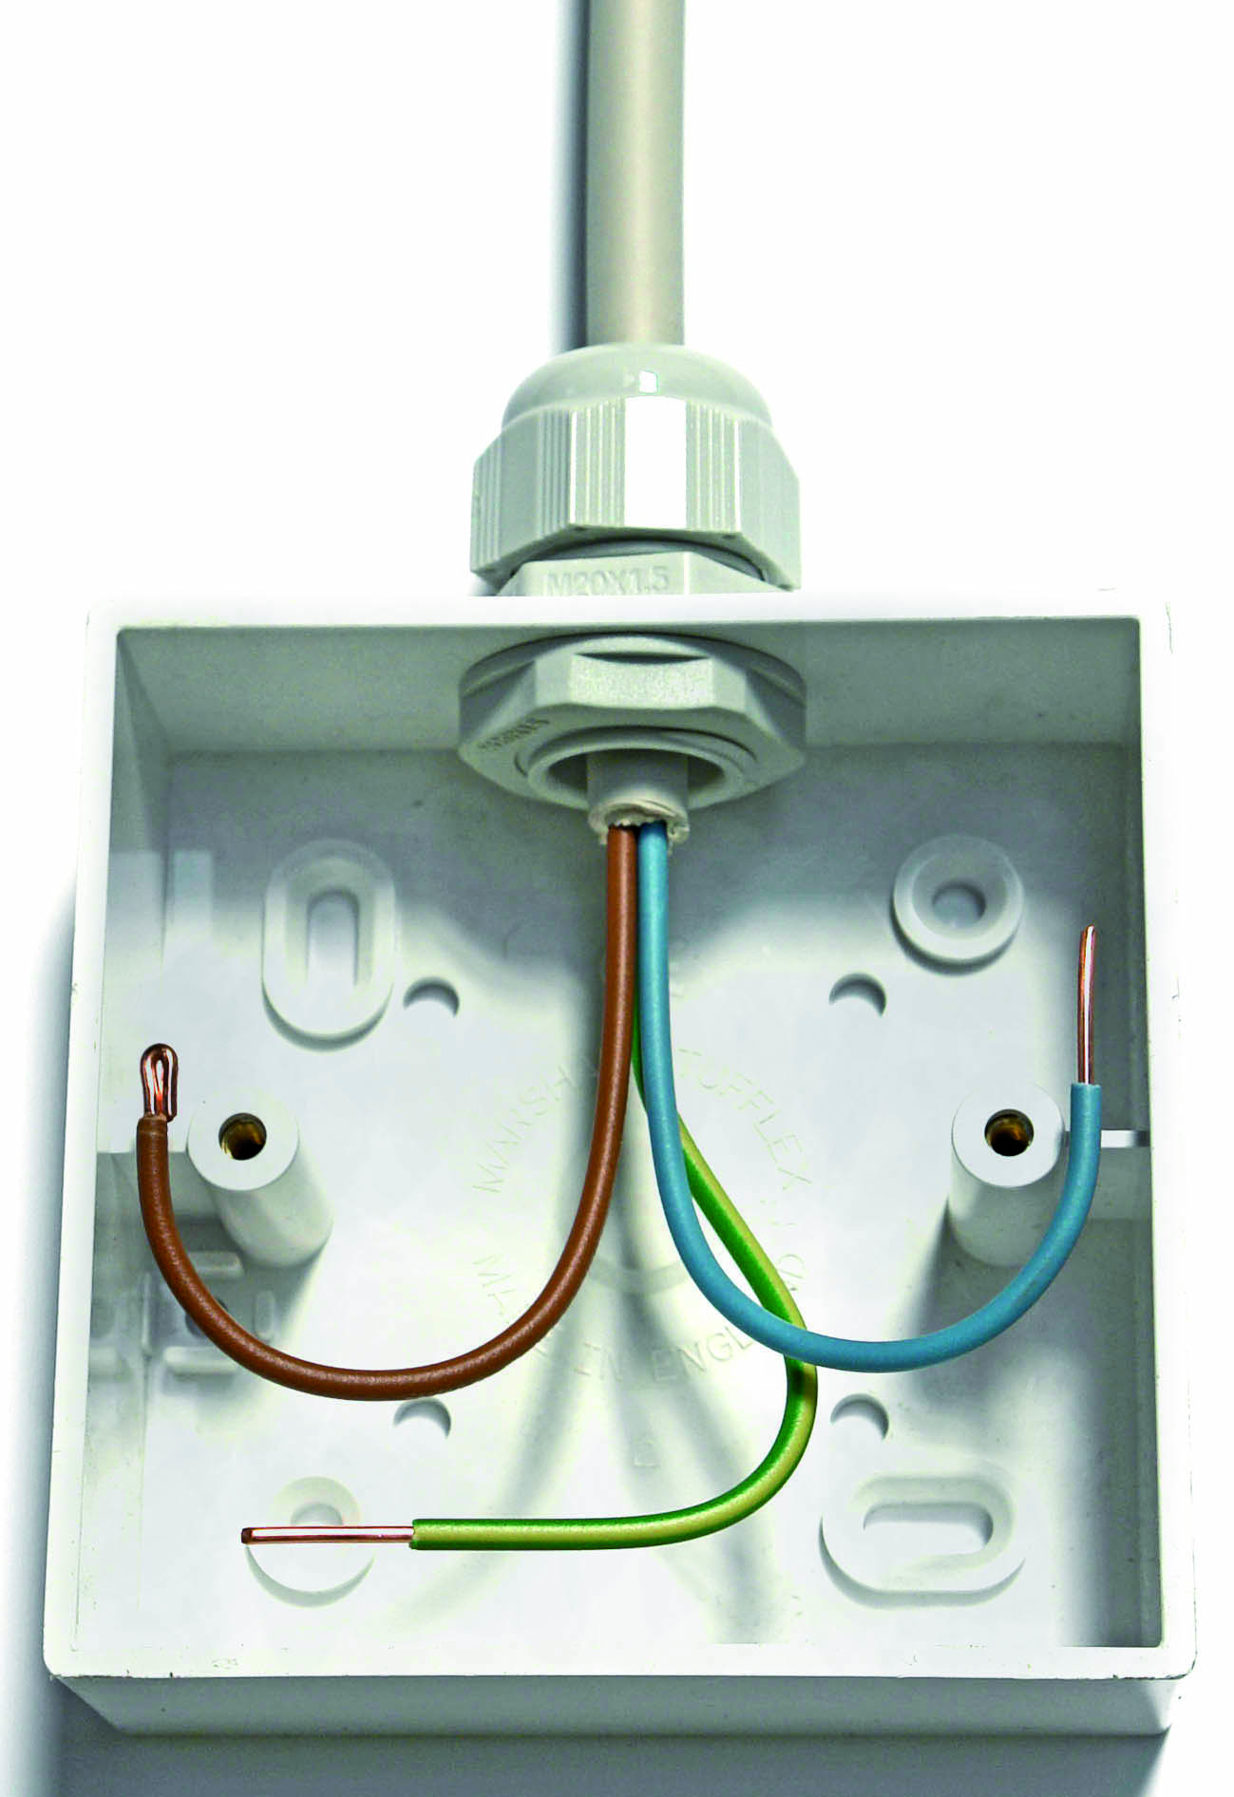
Figure 35
Figure 36 shows a 4 x 1.5 NYM-J cable terminated into a surface mounted metal switch box, using a metal packing gland.

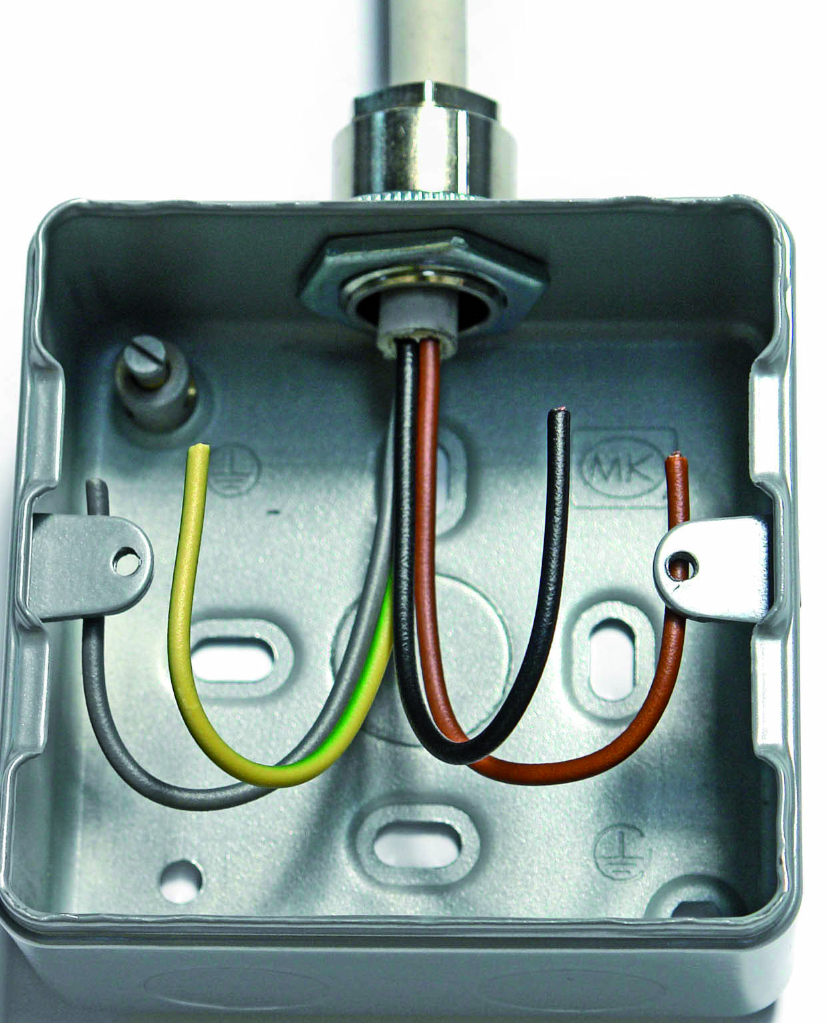
Figure 36

Fire Performance Cables

There is a number of fire performance cables on the market. The types most commonly used in the last ten to twenty years are sometimes referred to as soft skinned cables. This basically means that they differ from the original copper sheathed mineral insulated cable, in that they are flexible and easily terminated. The correct selection and installation of these safety cables is extremely important.

Construction of Fire Performance Cables

Fire performance cables have copper conductors insulated with a high temperature insulation such as Silicone rubber or Insudite. The protective conductor is tinned copper of the same CSA as the insulated conductors. The type shown in Figure 37 has an electrostatic screen, which consists of a laminated aluminum tape bonded to the sheath. This screen is in contact with the bare protective conductor. It is therefore suitable for use where ( EMI ) Elecromagnetic Interference is a threat.

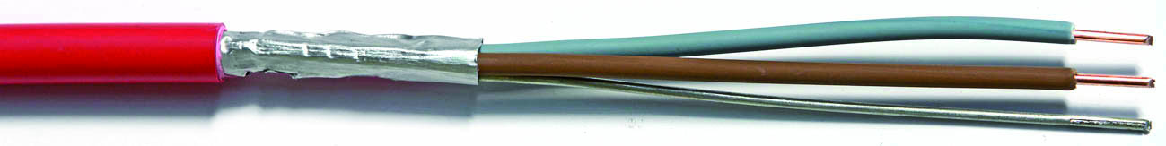
Figure 37

The sheath consists of a robust thermoplastic, which emits Low Smoke and Zero Halogen is Flame Retardant ( LSOH-FR ). This means that both toxic and acidic gases and smoke generation are minimised in the event of a fire. The sheath is available in Red or White. Other colours are available as a special order. It is manufactured in the usual range of conductor sizes up to 4 mm².

Application of Fire Performance Cables

These cables are for use on systems, which must remain operational for a particular duration, in the event of a fire. The cable may not survive the fire. There should be no damage to health or property by acid or corrosive fumes. There should be no propagation of fire from one location to another. If the fire source is removed the cable should self-extinguish. There should be sufficient visibility for evacuation of occupants and for fire fighting.
They are used on:

- Fire alarm systems
- Public address systems
- Emergency lighting systems
- Closed circuit television systems

Some types are suitable for use in any temperature between -40°C and +80°C, while others are limited to temperatures between -20°C and +60°C
Installation of Fire Performance Cables

Fire performance cable should be installed in continuous lengths. Avoid having to make joints in the cable. Avoid damage to the cable, by unrolling it from the reel. Do not bend it too sharp. It can be fixed directly onto walls using special LSOH coated copper clips. These may be fixed in the usual manner or if desired using modern gas nailing technology. Plastic type clips must not be used. If several cables are to follow the same route they may best be supported on a cable tray or rack system. Plastic cable ties must not be used, particularly where cables are fixed to the underside of the tray. It is essential that fire resistant cable ties ( stainless steel ) are used. The minimum internal bend radius is found by multiplying the overall diameter of the cable by a factor of 6. It should not be worked below 0°C.

Termination of Fire Performance Cables

There are no special tools required for terminating this cable.
Listed below are the steps to be followed when terminating fire performance cable:

- Fix gland in position in enclosure and tighten.
- Decide the point to which the cable sheath must be removed ( must protrude 5-10 mm beyond the gland into the enclosure to protect the insulation )
- Cut around the circumference of the cable being careful not to cut the screen
- Bend the cable at this point and pull off the sheath ( complete with screen for most types, a longitudinal cut of the sheath is not necessary ).
- Remove screen to same point ( where not bonded to the cable sheath ).
- Loosen gland nut back fully, enter cable into gland and work through rubber seal
( cable sheath should appear 5–10 mm inside enclosure )
- Bare the required length of the conductor with the help of suitable stripping pliers.

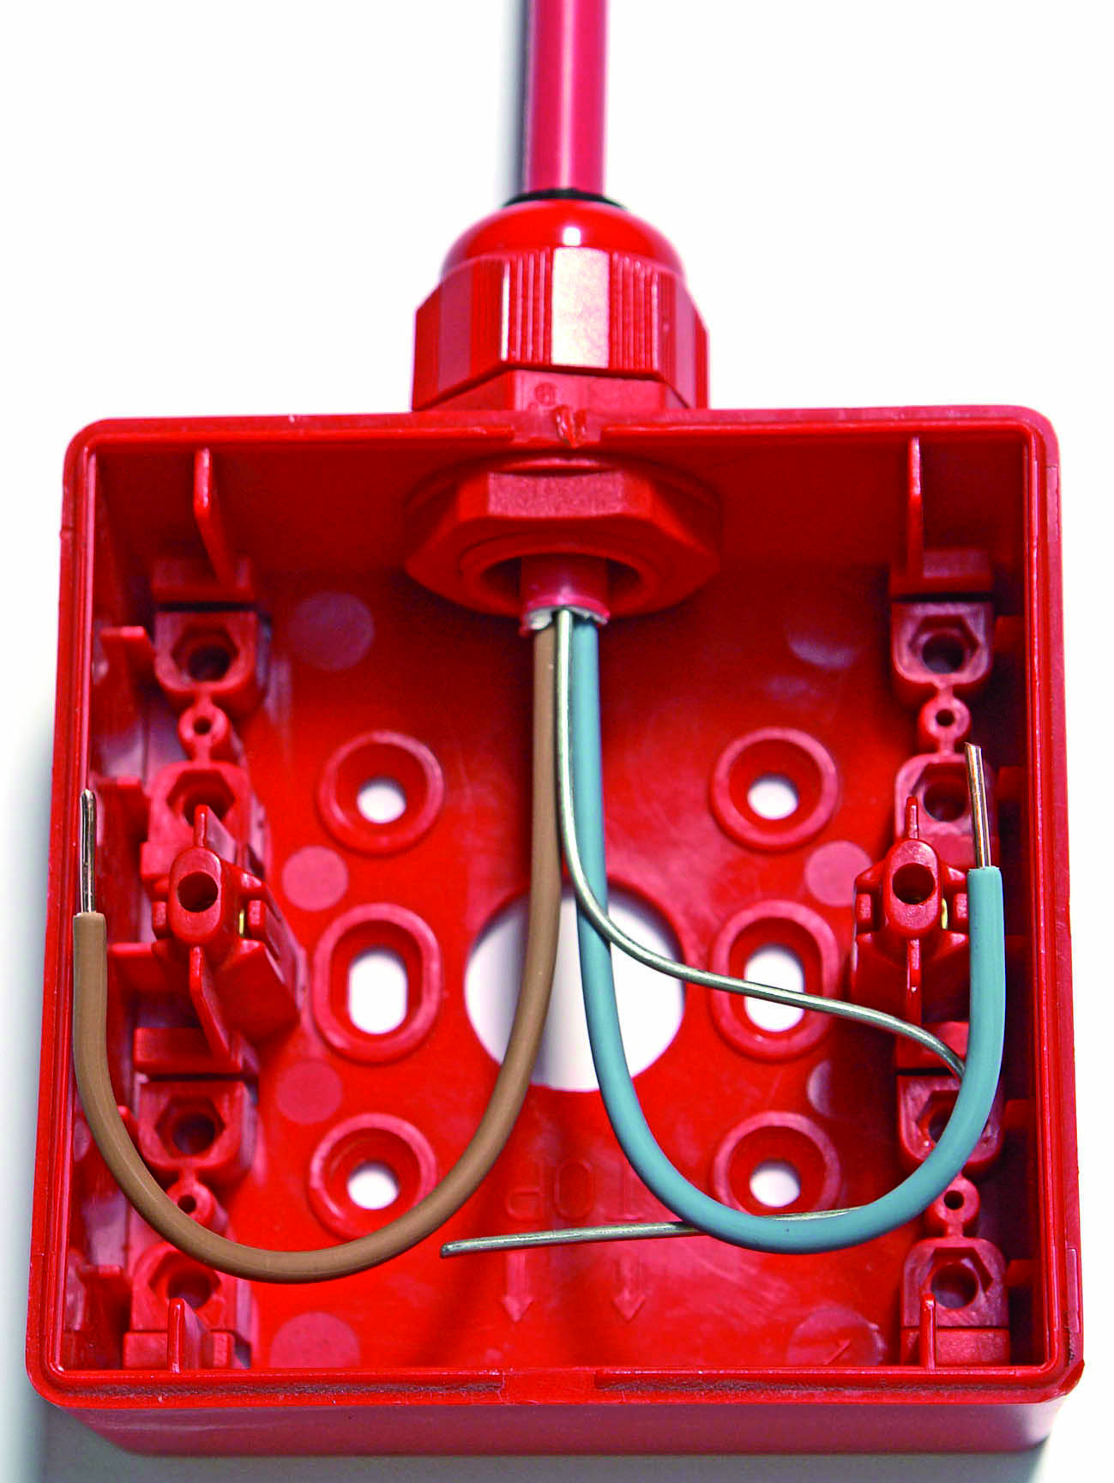
Figure 38

Steel Wire Armour Cables

These cables offer very good mechanical protection. They are known simply as SWA cables. The full name for the type used in this course is XLPE / SWA / PVC. This means that the conductors are insulated by XLPE, there is a layer of steel wire protecting those conductors and there is an overall PVC sheath to complete the cable. It is still possible to get PVC insulated SWA. Its full name is PVC / SWA / PVC.

Construction

The conductors in these cables are made of copper or aluminium. Copper conductor are stranded ( except the smaller sizes ). Aluminium conductors are solid. These conductors are often sector-shaped to fit together more closely. There is a filling compound around the insulated conductors to produce a circular shape. A layer of steel wire or tape is wrapped around this filling compound. The steel armouring protects the cable from mechanical damage whilst in service. The use of the steel armour as the “protective conductor” is limited, see ETCI Rules. It also provides strength to withstand handling during installation.
See Figure 39.
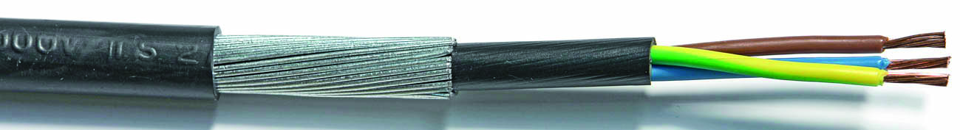
Figure 39

A soft bedding of jute or other suitable material is sometimes applied over the internal sheath to serve as a base for the steel armour.

Application of SWA Cable

SWA cable is suitable for permanent wiring on the surface. It may be used outside and is suitable for burial directly in the ground. It is primarily intended for use in industrial premises.
SWA cables have a wide range of applications, some of which are listed below:

- Heavy sub-main distribution.
- Underground electrical supplies.
- Circuit wiring in environments, where there is a likelihood of mechanical damage.

XLPE insulated cable is suitable for use in any temperature between -25°C and +80°C.
Some manufacturers state that it is suitable down to -40°C.

Installation of SWA Cables

SWA cable can be laid directly in the ground, in ducts or fixed directly onto walls using cable clips. If several cables are to follow the same route they may best be supported on a cable tray or rack system.

- It is not always possible to use the armour as the “sole protective conductor”
- Where the armour is not used as a protective conductor it must still be earthed
- Must be terminated using a gland

The resistance of the steel wire armour is much higher than that of copper therefore a larger CSA of steel wire is required to comply with the ETCI Rules. The CSA of the steel wire armour in some cable sizes is adequate, while in others it is not. Manufacturers are now including a separate core, insulated Green / Yellow for this reason. Otherwise a separate Green / Yellow cable will have to be installed alongside the SWA cable. The minimum internal bend radius is found by multiplying the overall diameter of the cable by a factor of 8. SWA cable should not be worked below 0°C.

Terminating SWA Cable

Where possible the gland should be fixed in the cable entry and the cable then installed through the gland. Good contact must be achieved between the cable armour and earth. A bonding ring is essential for this purpose when terminating SWA into a non-metallic enclosure. Bends close to the gland should be formed before stripping the cable.

Note: Some consultant engineers require a bonding ring at every SWA termination.

If SWA cable is used to connect directly to a motor, a loop should be formed in the cable adjacent to the motor to permit any necessary adjustments and allow for vibration.

Listed below are the steps to be followed when terminating an SWA cable:

- Fix gland in position in enclosure and tighten well
( Use a spanner, not a pipe grips )
- Fit shroud ( if required ) and gland nut over cable
- Decide the point to which the armour must be removed
- Cut half-way through the armour wires at this point using a hacksaw
- Remove cable sheath to same point
- Remove armour wires by bending at point where cut by saw
- Remove outer sheath to expose a short section of armour ( twice length of gland cone )
- Move inner core in a circular outward motion to fan out the armour
- Remove required length of internal sheath ( must protrude 5-10 mm beyond the gland into the enclosure to protect the insulation )
- Enter cable into gland and ensure that all armour wires pass outside the gland cone
- Tighten gland nut over armour wires ( Use a spanner, do not over tighten )
- Fit shroud over gland ( only if required )
Figure 40 shows a 3 x 2.5 SWA cable being terminated into a surface mounted metal socket box, using a BW 20S brass gland. This gland is suitable for use in dry locations. The steel wires are fanned out to allow them fit over the cone of the gland. The gland nut and shroud are in position, ready for use.

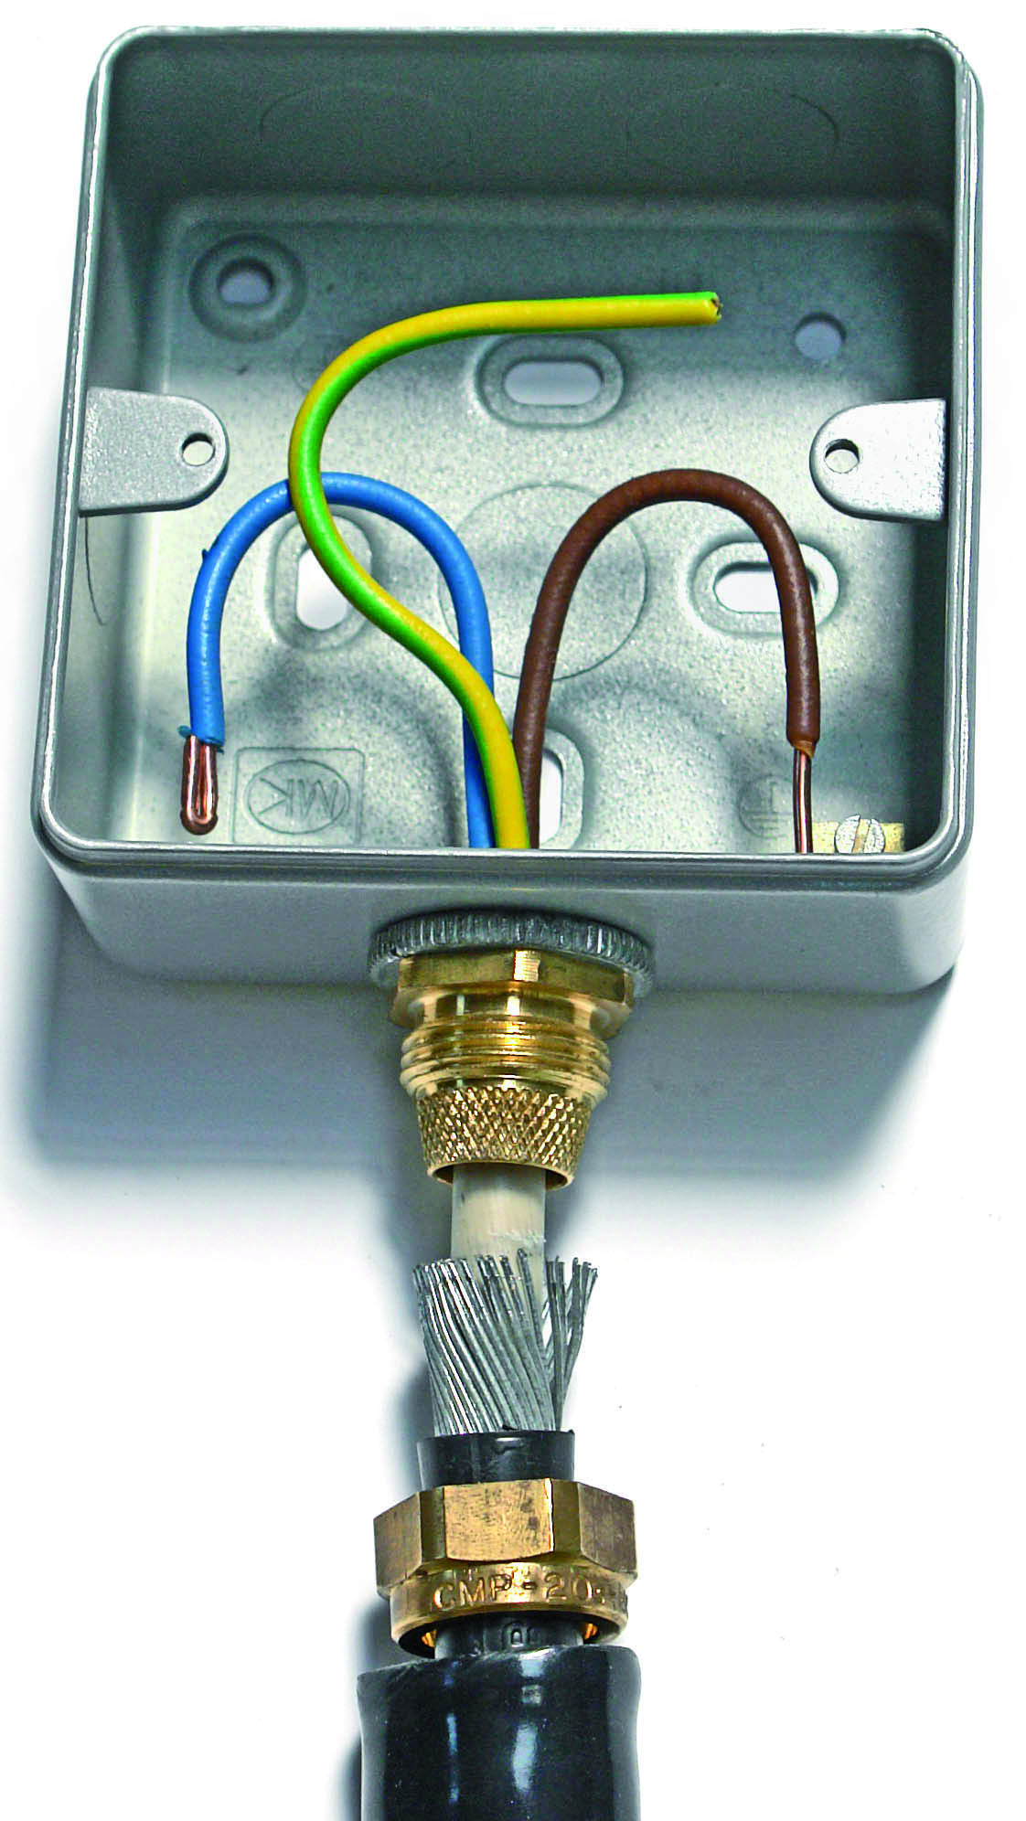
Figure 40

Figure 41 shows a CW 20S brass gland for use in wet locations. It provides a water tight seal around the outer sheath of the cable. A watertight seal must also be provided where the gland is fixed to the enclosure.
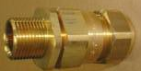

Figure 41

Figure 42 shows a 3 x 2.5 SWA cable being terminated into a surface mounted plastic switch / socket box, using a 20S brass gland and a bonding ring. The connection to the steel wire is made via the bonding ring.

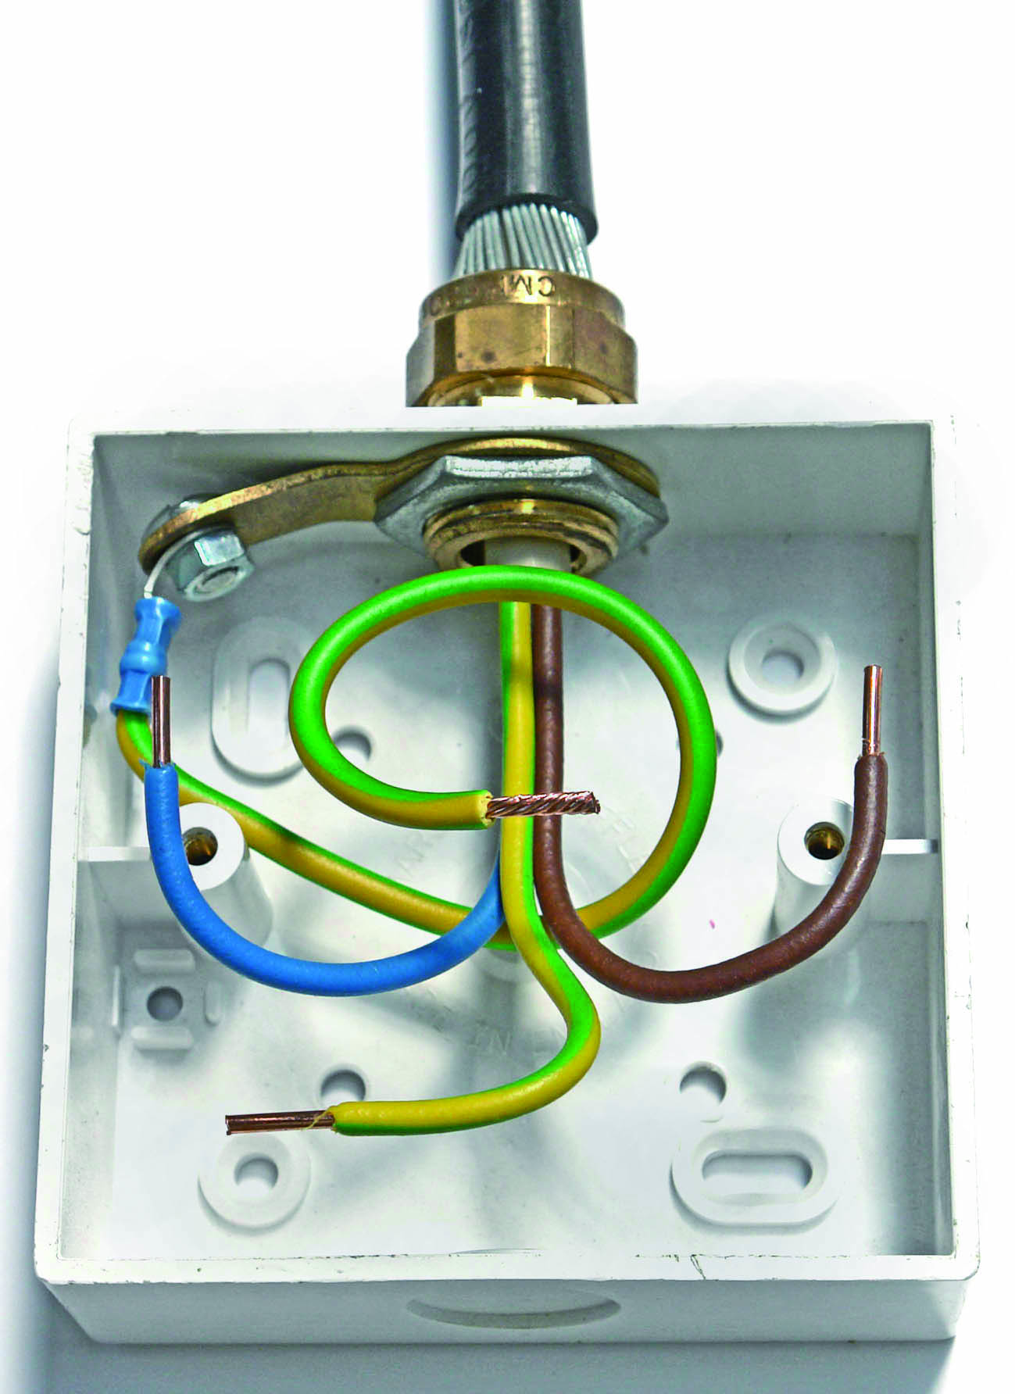

Figure 42

Power Loss in Cables

Voltage Drop in Cables

The ETCI Rules recommend that the voltage drop in a circuit should not exceed 4% of the nominal voltage in installations and parts of larger installations, rated not greater than 80 Amps.
This is to ensure that loads are supplied with the correct operating voltage after cable resistance etc. is taken into account.
For a 230 Volt single phase supply, the volt drop should not exceed 4% of 230 Volts which is equal to 9.2 Volts.
Also for a 400 Volt three phase supply, the volt drop should not exceed 4% of 400 Volts which is equal to 16 Volts.
Calculation of volt drop in cables is necessary in order to decide on the correct size of cable for a given load.

To calculate the correct size of cable the following factors must be considered:-

- The Load current
- The Length of the run in metres
- The Installation Method
- The Type of cable
- The Resistivity of the conductor
- The Cross Sectional Area of the cable ( CSA )
- The Current Carrying Capacity of the cable ( CCC )
- The Temperature of the area ( highest temperature )
- The Grouping Factor ( where cables are grouped together )
- The Volt Drop across the cable

Tables which take these factors into consideration can be found in the ETCI Rules.

Heat Generated in Cables

Current flowing through a cable causes heat to be produced within the cable. This heat will have a damaging effect on the cable insulation. Therefore it must be limited to a value, which the insulation can withstand. Also heat dissipated in a cable is power wasted or lost. This power must be paid for. Correct cable size reduces this power loss to an acceptable level. The greater the power loss the greater the amount of heat generated.

Power Loss equals Current squared multiplied by Cable Resistance

Assume that a current of 40 Amps is flowing through a cable of resistance 0.125 Ohms.
P = I² x R
P = 40² x 0.125
P = 200 Watts.

Termination of Compression Type Lugs

It is common practice for large cables to be connected to switchgear or busbars by fixing lugs to the conductor ends. A method, known as crimping, is used to fix the lug to the cable end, by means of pressure and indentation. The conductor is inserted into the lug, and an indentation made by using a hand crimp tool or hydraulic crimp tool. This pressurises the lug and the cable into a single solid mass, so that the joint is stronger than the cable itself. See Figure 43.
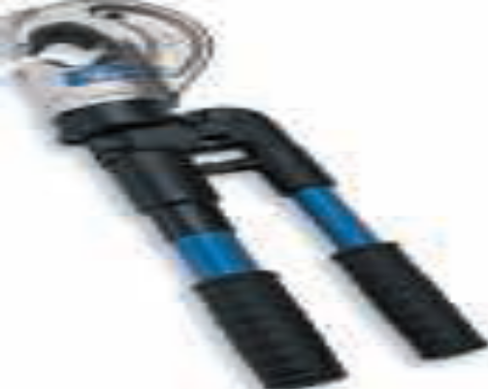
Figure 43

Where compression type lugs are used to terminate cables to switch gear or bus-bars, the following conditions must be observed.

- Use a bolt washer and nut assembly of the correct type and size.
- Install the flat part of the lug against the busbar or switchgear terminal ( surface area ).
- Ensure that the nut is tightened sufficiently.
- ( use a torque spanner for all main connections ).
- Special care must be taken when using dissimilar metals such as copper and aluminium in order to prevent any electrolytic action ( chemical reaction between the two metals ).
See Figure 44.
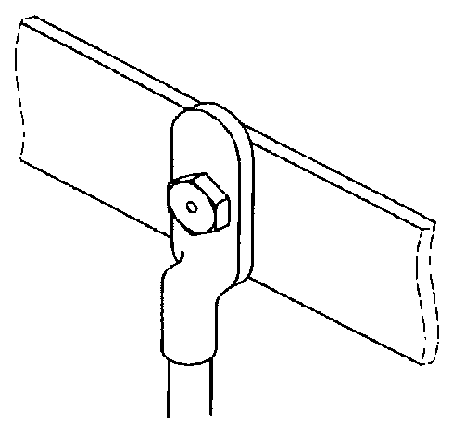
Figure 44

Unit Related ETCI Rules

Identification and Marking | 514  514.3, 514.3.6, 514.3.7, 514.3.10
External Influences | 522  522.6, 522.6..7.2, 522.6..8.1,522.6.8.2,  522.6.8.3, 522.6.8.3, 522.6.8.4  522.6.9, 522.6.10  522.8, 522.8.3, 522.8.4
Current Carrying Capacity of Cables | 523  523.0  523.1  523.4, 523.4.1, 523.4.2  523.5, 523.5.1 ( except 523.6.2 )
Voltage Drop in Consumer Installations | 525  525.1  525.2 ( a only )
Electrical Connections | 526  526.5, 526.5.2
Precautions against Detrimental Effects from Adjacent Services | 528  528.1, 528.1.1 ( items b and d )
Protective Conductors | 543  543.2, 543.2.1 ( items 1 and 5 )  543.2.4 ( item a only )
Annex | 52B  52C  52E
Tables | 51A  52A  52B  52C  A52D  A52E  A52F1  A52F2  A52F10  A52F17  A52G1  A52G2  A52H  A52J1  A52J2  A52J6

Note: It is not necessary to use these tables for calculations in Phase 2. Simply indicate where they are and briefly, what their purpose is.

