TRADE OF
Industrial Insulation

PHASE 2

Module 1

Sheet Metal and Insulation Fundamentals

UNIT: 2

Manual Handling

Produced by

In cooperation with subject matter expert:

Michael Kelly

© SOLAS 2014

Table of Contents
Introduction 1
Unit Objective 2
1.0 Responsibilities 2
1.1 Duty of Employer 2
1.2 Duty of Employee 3
1.3 Structure of the Spine 3
1.4 Muscles, Tendons and Ligaments 4
1.5 Reducing the Risks 5
2.0 Principles of Safe Lifting 6
2.1 Managing Different Types of Load 7
2.2 Team Lifting 8
3.0 Manual Handling Solutions 9
3.1 Consider Changing the Load 9
3.2 Mechanical Handling Devices 9
Suggested Exercises 11

Introduction
Annual statistics published by the HSA show that manual handling continues to be one of the primary causes of injury in the workplace reported to the Authority, with about one in every three accidents falling into this category.
Manual handling tasks carried out using incorrect technique and without due regard to individual capability significantly increases the risk of injury to the back. These injuries range in severity from soft tissue injuries to more serious and permanent injury to discs. However, in all cases they are likely to lead to lost time from work.
Training is only one measure that can be taken to reduce risk of injury from manual handling activities. Any training provided to employees must be relevant to the types of tasks carried out in the workplace and ideally should be provided by an instructor familiar with the particular manual handling activities of the employment.
Module 1
Sheet Metal & Insulation Fundamentals
Unit 1
Introduction to the Workshop Environment
Unit 2
Manual Handling
Unit 3
Measuring, Marking & Cutting Out
Unit 5
General Allowances for Insulation & Cladding
Unit 4
Notching, Folding & Joining
Unit 6
Marking, Cutting, Punching, Rolling, Seam Swagingn & Screwing
Unit 7
Swaging (Basic) Male/Female & Flange Turning
Unit 8
Pipe Cladding (Basic) Fabrication & Application
Unit 9
Metal Cladding Assembly Work
Unit 10
Pipe Insulation (Hot & Cold) Material Selection & Application
Unit 11
Valve & Flange Box Fundamentals

Unit Objective
By the end of this unit each apprentice will be able to:
- List the statutory requirements of both the employer and employees.
- Explain the structure of the spine.
- Explain the functions of muscles, tendons and ligaments.
- Explain the types of injuries that may occur from incorrect lifting.
- Explain the requirement for a pre-lift analysis of a load.
- Correctly position the body before lifting.
- Demonstrate good handling techniques for lifting, pushing and pulling.
- Explain the correct procedure for team lifting of an object.
- Describe various lifting devices.

Responsibilities

Key Learning Points
- Duty of the employer.
- Duty of the employee.
- Structure of the spine.
- Injuries related from lifting heavy loads.
- Workshop obstacles and hazards.
- Factors which may hinder movement.

Both employer’s and employee’s have a statutory responsibility to ensure their own safety in relation to manual handling and to undertake the manual handling training provided.

1.1 Duty of Employer
The duty of the employer towards employees is to:
- Assess manual handling risks.
- Take measures where possible to avoid manual handling.
- Provide manual handling training.
- Carry out risk assessment where manual handling is unavoidable.
- Provide employee with precise information about the load.
- Provide a reasonably safe place of work.
- Provide reasonably safe plant and equipment
- Provide reasonably safe systems of work.

1.2 Duty of Employee
The duty of the employee is to:
- Take reasonable care for his/her safety and welfare and that of others in the workplace.
- Use any equipment, protective clothing or other means provided by the employer for securing his/her safety and welfare in the workplace.
- Report to his/her employer any problems or defects which might endanger health and safety.
- Not intentionally or recklessly interfere with or misuse any equipment.
Note: Current laws and regulations have to be referred to at all times.

1.3 Structure of the Spine
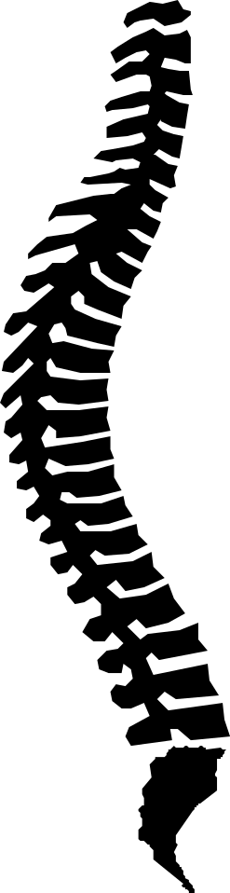
If we know how the spine works, we can avoid putting unnecessary strain on it.
The spine is an S-shaped column of 33 bony vertebrae, the top 24 of which are separated from each other by discs of cartilage and fluid.
Research has shown that an S-shaped spine can withstand shocks one hundred times greater than a spine where the vertebrae are placed in a straight line.
Protected within the vertebrae is the spinal cord, which carries messages from the brain to the rest of the body and back to the brain.
The discs between each vertebrae change shape as the body moves, allowing the spine to bend without the vertebrae rubbing against each other.
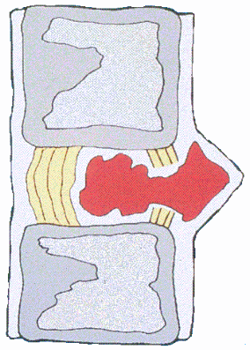
A prolapsed disc (commonly known as a slipped disc) is caused by the outer ring of the disc giving way and part of the jelly-like interior bulging through, causing pressure on spinal nerves and resulting in great pain.

Other common causes of back pain are strains and sprains to the back muscles and ligaments. Back muscles support and protect the spine, stabilizing it and allowing the body to maintain proper posture and movement.

Muscles can be stretched and strengthened through exercise. This brings increased flexibility, making muscles more flexible and joints more mobile, lessening the possibility of injury.
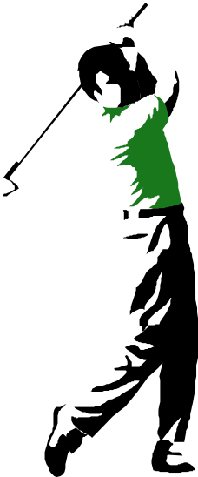
Another way we can care for our backs is by adopting proper posture when standing, sitting and walking. Someone using good posture will maintain the natural S-shaped curve of the spine. Poor posture strains the back and leads to fatigue, discomfort and even permanent problems. It also weakens the back, making injury more likely from sudden twists.

Protect your back by:
- Varying your position when standing for long periods
- Changing foot and posture positions when standing or sitting at work
- Supporting your lower back when sitting
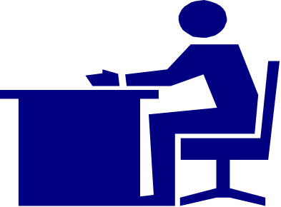

1.4 Muscles, Tendons and Ligaments
Muscles contract (shorten) to bring the ends closer together and relax (lengthen) to let the ends move apart. They are attached to bones by cord-like extensions called tendons.
In the adolescent skeleton, tendons attach to a growthplate called an apopyses (a-pof-i-sez). The area where the tendon attaches may be weaker than the tendon itself. In adults, where the growthplate fuses the tendon is weaker than the bone.

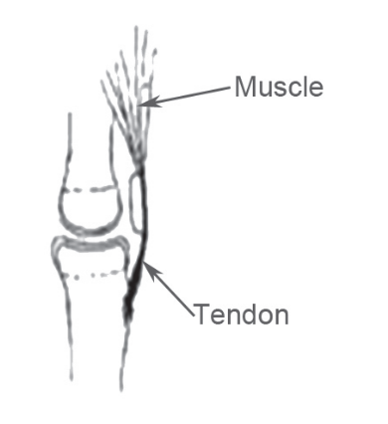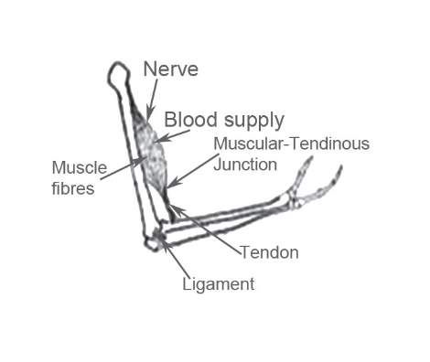

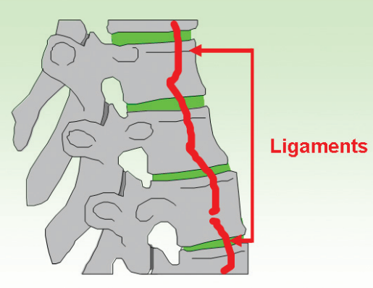
Ligaments are strong bands of tissue that attach to the bones and form a joint. Ligaments provide stability to the joint by restricting movement and holding bones in place.

1.5 Reducing the Risks
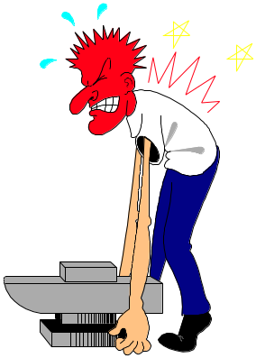
You can reduce the risk of accidents and injury by:
- Not lifting loads that are too heavy.
- Not bending forward for long periods.
- Not twisting the trunk unduly.
- Not using sudden movements.
- Being aware of good posture, fitness & flexibility.
- Following the safe principles of manual handling.
- Ensuring the workplace is free from hazards such as materials left lying around on the floor, that the floor has an even surface, that the lighting conditions are adequate for the work area and the floor is dry and not slippery.
- Clothing and the wearing of personnel protective equipment does not hinder movement or lifting.

Principles of Safe Lifting

Key Learning Points
- Pre-lift analysis of a load.
- Use of good posture before beginning to lift a load.
- Raising the load correctly.
- Putting the load down correctly.
- Coordination of team activity when team lifting.
- Good handling techniques for pushing and/or pulling an object.

Avoid injury when lifting by remembering the eight key points:
- Assess the area and the load.
- Broad, stable base.
- Bend the knees.
- Back straight.
- Firm grip.
- Arms in line with the trunk.
- Weight close to the centre of gravity.
- Turn feet in the direction of movement.

- Assess the task, the area, the load and your capability
Is it too heavy? If you are unsure, move the load forward and sideways. Get help from another person or use a mechanical aid. Ensure you have a clear path and always wear suitable clothing. Check that there is nothing protruding from the load e.g. splinters, and that the load is stable and safe to lift.
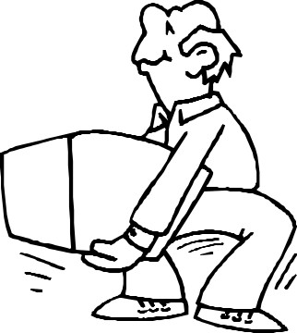
- Broad, stable base
Take a comfortable stance with the feet hip width apart, facing in the direction you are going, and as close to the load as possible.
- Bend the knees
Bend the knees to keep the center of gravity within the base. Use the dynamic thigh muscles for lifting and not the weak postural muscles of the lower back.
- Back straight
This doesn’t mean having an upright back. It shouldn’t be bent, as this places uneven strain on the discs, but you can bend at the hips. Bent knees and straight back mean the central point of gravity remains over the weight, reducing strain. Never twist your back when lifting. Use your feet to change direction.
- Firm Grip
Use the palm of the hand and the roots of the fingers rather than the fingertips. A diagonal hold is best. Place one hand under the object, the other hand at the top of the opposite side. With smaller loads, both hands can be placed under the load.
- Arms in line with the trunk
Keeping your arms close to the sides of the body reduces tension in the arms and shoulders. This, along with the broad base of the feet, gives stability.
- Weight close to the centre of gravity
Keep the load as close to the trunk as possible. You should be balanced and stable yet be able to use your body weight to get the load moving easily. This is why it is important to wear the correct clothing, as holding a dirty load away from you will place unnecessary strain on your back.
- Turn feet in direction of movement
When ready to lift, use your legs for the lift. This requires less force and counterbalances the load. Lift using a smooth action.

2.1 Managing Different Types of Load
Lifting a load from the floor
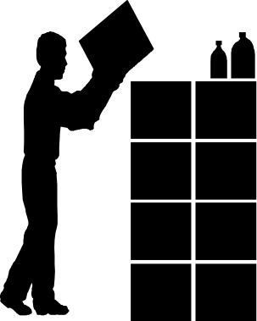Adopt a comfortable stance. Keep the back straight – but not upright – and bend the knees. Keep the arms inside the thighs, grip the load with one hand at an outer corner and the other on the lower opposite corner. Lift smoothly.
Lifting on to a table or bench
When lifting on to a table or bench, use your knees to lower the load while keeping it close to the body.
Lifting from low to high
Lifting anything from low to high should be done in two stages. Firstly, lift the object from the ground to an intermediate height and secondly lift from intermediate to high. If available, use a mechanical aid such as steps or platforms. The same principles apply when lifting from a height.
Handling sacks
Stand at whichever end of the sack is easiest to hold. Get your feet in a good position, bend the knees, keeping the back straight, set the sack upright and grasp with one hand at the bottom and the other at the opposite top corner. Move your feet into the lifting position and lift using your legs, while holding the sack against your body.
Pushing and pulling
Stress on the spine is the same when pushing and pulling. However, pushing is easier as you can see where you are going. Pushing and pulling require the same techniques as lifting. A firm footing is most important, as it allows the leg muscles to do the work. Get a firm grip, with your arms almost straight, keep the back straight, bend the knees, and use your legs [rather than your arms or your back] to move the object.

2.2 Team Lifting
When lifting an item that requires two people to lift it, the following considerations should be taken:
- Work with someone with similar build and height if possible.
- Choose one person to call the signal.
- Lift from the hips at the same time, and raise the load to the desired level.
- Move smoothly and in unison.
Avoid
- Very heavy loads.
- Arching of the spine.
- Excessive or repeated twisting.
- Over-stretching or over-reaching.
Ensure
- A good secure grip
- Awareness of the weight and stability of the load.
- Correct stance and lift posture.
- Smooth quick lift.
- Correct protective clothing and equipment.
- Proper co-ordination of team lifts.
Remember the eight points and avoid years of pain and discomfort!

Manual Handling Solutions

Key Learning Points
- Safe working practices at all times when handling heavy objects.

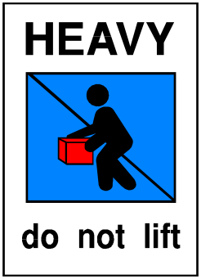
One in four work injuries are caused by manual handling. We are obliged by law to seek alternatives and implement them where reasonably practicable. Where possible avoid manual handling.

3.1 Consider Changing the Load
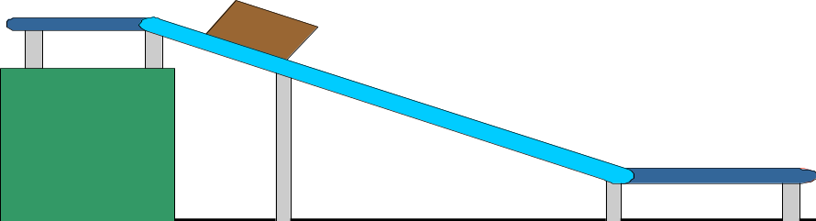
Make the load lighter, the handles more comfortable or put the load on wheels. Providing clear information on the weight of the load helps the person prepare for the load.

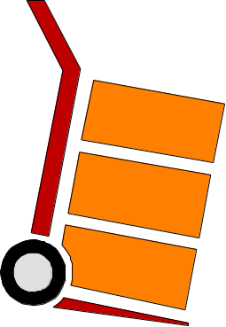
Manual handling injuries come from a range of situations. Sometimes changing the job design will reduce the frequency and type of handling required. For example, carrying distances between workstations can be reduced by re-positioning workstations. The angle that the job is performed at may be changed thus reducing the height of the reach required for the job may be shortened by providing a platform for the worker. Other measures you might consider would be reducing the level of twisting, stooping, pushing and pulling required.

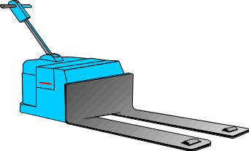
3.2 Mechanical Handling Devices
These represent the most common approach to tackling manual handling situations. Solutions can be simple, e.g. providing a stack truck, drum up ender, or a balance truck.

Handling transport Systems
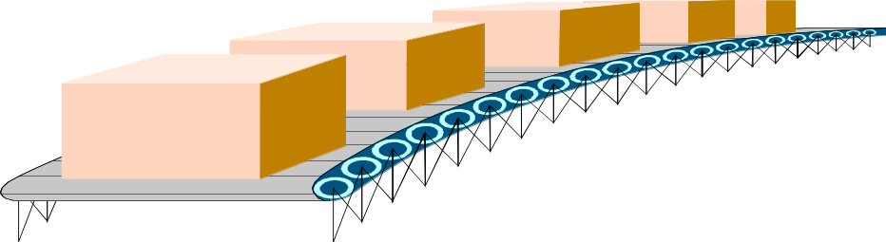
Chutes and tracks come in a variety of formats and are adaptable to many types of work systems. Lifts and hoists also come in a variety of formats and are flexible to many different operational systems. These examples are especially important for heavier loads being transported over long distances or between awkward levels in the workplace.

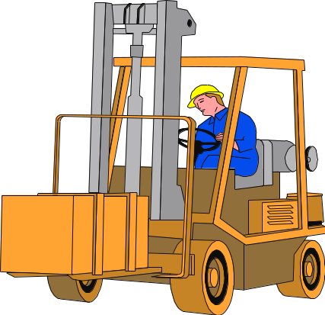
Other transport system solutions for manual handling problems may include fork lift trucks, forms of palletisation and the platform truck.

Automation
Automation in the workplace is becoming more and more common. Savings in terms of labour, welfare benefits and injury prevention may well justify the expense.

Suggested Exercises
Here are six gentle stretches you can do while standing near, or sitting at, your desk.
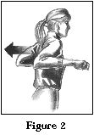
Do these slowly and carefully – you should just feel a gentle stretch but no pain! If you feel uncomfortable or in pain, stop immediately!
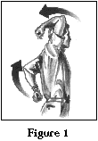
While Standing
- Bend both elbows. Press one above you and the other behind you for a good stretch. (See Figure 1.)
- Press your palms on your lower back for support. Gently arch your back, and hold a moment.
- To loosen stiff shoulders, circle them backward several times, then forward.
- Press your elbows out and back at chest height as far as you can. Hold. (See Figure 2.)
While Sitting
- Sit back against a chair. Exhale and tighten your abdominal muscles for a count of 10
- Sit with your back and bottom pressed firmly against a hard, straight-backed chair. Lift your right arm from the shoulder, reaching your finger tips toward the ceiling. Follow the movement with your neck and eyes. Hold for a few seconds and really feel that stretch. Repeat with left arm. Do each arm several times.

Castleforbes House
Castleforbes Road
Dublin 1

