TRADE OF
Industrial Insulation

PHASE 2

Module 2

Geometry & Pattern Development

UNIT: 5

Cones & Pyramids

Produced by

In cooperation with subject matter expert:

Michael Kelly

© SOLAS 2014
Table of Contents
Unit Objective 1
Introduction 2
1.0 Radial Line Method 3
1.1 Development by Radial Lines 3
1.2 The Right Conic Frustum 4
1.3 True Lengths 4
1.4 The Right Cone Cut Obliquely 5
2.0 The Pyramid 6
2.1 The Pyramid Cut Obliquely 6
2.2 Terminology Associated with Cones and Pyramids 7
3.0 Area and Volume 8
3.1 Calculation of Area, Volume of Cones and Pyramids 8
Summary 8

Unit Objective
By the end of this unit each apprentice will be able to:
- Identify Pyramids and Cones.
- Develop Cones and Pyramids.
- Describe the terms used in radial line development.
- Determine the true shape of obliquely cut planes.
- Project auxiliary views from orthographic views.
Module 2
Geometry & Pattern Development
Unit 1
Basic Construction
Unit 6
One Piece Pyramid
Unit 5
Cones and Pyramids
Unit4
Equal and Unequal Tee Pieces
Unit 3
Parallel Line Development
Unit 2
Orthographic Projections
Unit7
Segmented Radius Bends
Unit 8
Triangulation
Unit 9
Tapered or Conical Tee
Unit 10
Flattened Bends and Straights
Unit 11
Valves and Flanges
Unit 12
Eccentric Reducer - Radial Line and Triangulation

Introduction
The radial line method of pattern development is used to develop patterns for objects that have a tapering form with lines converging to a common point called the apex. Cones and pyramids are developed using radial line development.

1.0 Radial Line Method

Key Learning Points
- Development of cones and conic frustum
- Elevation and half plan layout of right conic frustum and pyramids
- Slant height-true length relationship
- Use of radial lines in development
- Use of stretch out arcs
- True shape development
- Auxiliary projection: projection normal to plane

1.1 Development by Radial Lines
Radial line development is the process used for developing patterns for cones and pyramids. For the radial line method to be used, all lines must radiate from a common centre. In addition, the amount of slant of those lines must be relatively large since most radial line developments are drawn beginning with the side view and then extending the side lines until they meet. Arcs are then projected from this point. If the side taper is so slight that the point is several feet from the fitting, the radius needed to swing the arc is long and consequently difficult to use. Because of these limiting circumstances, the conditionings under which radial line developments may be effectively deployed are sometimes limited.
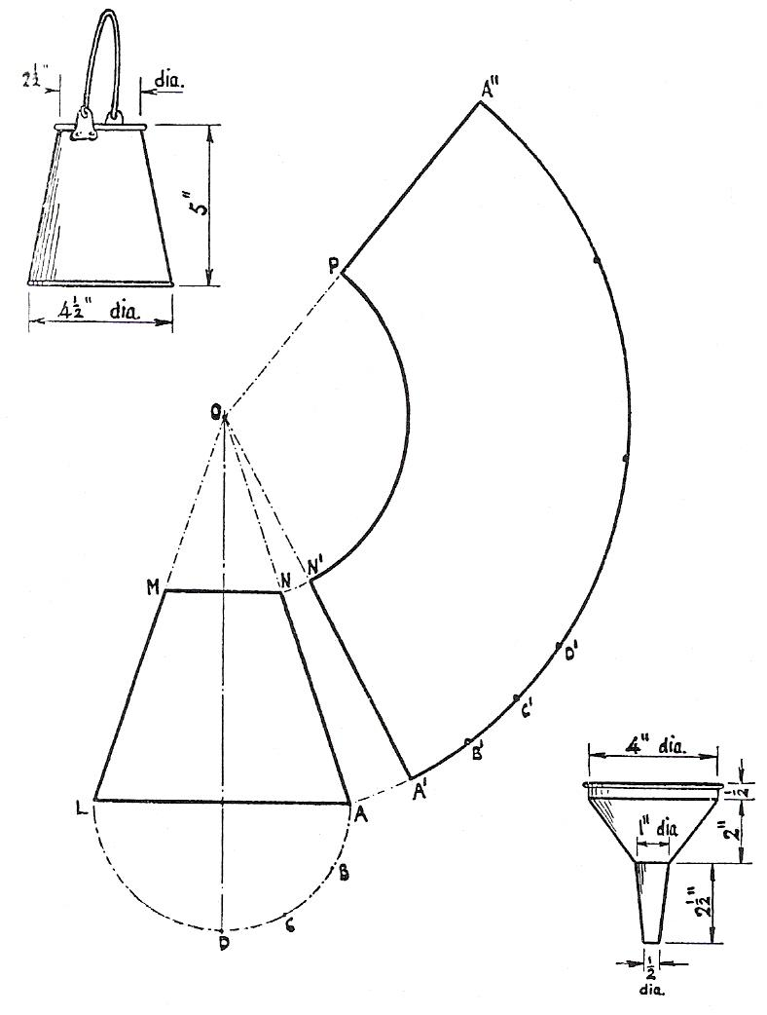
The sides, or the sides produced, of any object belonging to the class of pyramids, and the cone in particular, must converge to an apex.
Development by Radial Lines
Given that condition, it is possible to define a series of lines radiating from the apex down the sides of the pyramid to the base. It is further possible to unfold the surface so that it lies in a flat plane with the lines all radiating from one point, which was the apex.

1.2 The Right Conic Frustum
The right cone is perhaps the most common body, belonging to Class 1, which finds application in sheet metal work.
To obtain the pattern for the frustum of a right cone, first draw the elevation, as at AOL above and mark off MN at the height of the frustum. With centre 0 and radius OA, describe the arc A' A" any length. To obtain the length of the perimeter, describe one quarter of the base of the cone and divide it into three equal parts, as at ABCD. Take one of these divisions, as AB, in the compasses, and mark off three similar distances along the arc A' B' C' D'. Four times the distance A' D' will then give the whole perimeter round the arc, as from A' to A". Join OA". To complete the pattern for the frustum, draw in the arc N'P.
The milk can and the funnel in the top and bottom corners are intended to provide further exercises on this problem.

1.3 True Lengths
With reference to the figure above, it will be seen that the radii of the arcs N' P and A' A" in the pattern are obtained from the slant of the cone, i.e. ON and OA. Distances down the slant of a cone always give true lengths from the apex. Any other lines shown on a cone, which do not appear on the outside slant, are not true lengths.
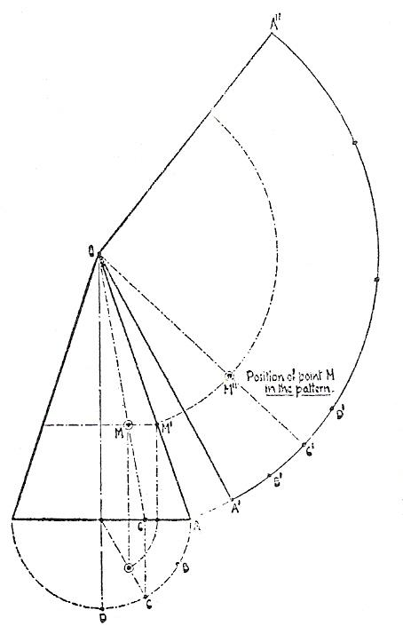
For instance, the line 0C on the cone shown in Error: Reference source not found does not represent its true length, but is foreshortened both in the plan and in the elevation. The true length, however, may easily be obtained by rotating the cone on the centre-point of its base until the point C falls on the slant, as at the position of A. The line 0C then coincides with the slant of the cone and its true length is equal to OA.
Right Cone Frustum
Furthermore, the true length of any portion of OC may be obtained from its new position on OA
Take any point M on OC. The distance OM does not represent its true length, but by rotating the cone on its axis the point M may be made to coincide with the point M', when its true length will be seen to be equal to OM'. To obtain its true position on the pattern, locate the position of point C on the perimeter, as at C', and join to the apex O. Swing round an arc from M' until it cuts OC' in M''. M'' is the position of point M in the pattern.
This principle forms the basis of solution to all the problems of the right cone, and should be clearly grasped at the outset.

1.4 The Right Cone Cut Obliquely
Set out the elevation of the cone AOG below and on its base draw the semicircle ADG. The semicircle thus represents half the perimeter of the base. Divide the semicircle into six equal parts, as at A,B,C,D,E,F,G, and from the points thus obtained draw perpendiculars to the base of the cone, as Bb, Cc, Dd, Ee, Ff. From the points b,c,d,e,f, on the base of the cone, draw lines to the apex O. Draw MN at the position and angle required for the cut-off.
The lines on the cone intersect the plane of the cut-off at M,1,2,3,4,5,N; then, to obtain the true distances of these points from the apex, project them horizontally on to the slant of the cone, and from the points thus obtained on the slant, swing arcs round into the pattern. Next, with radius OA, draw in the arc A' A" for the base of the cone and mark off twelve divisions equal to one of those on the perimeter, at as A',B',C',D', and so on. Connect these points to the apex O.
A curve now drawn through the diagonally opposite points of intersection will complete the pattern for the frustum.
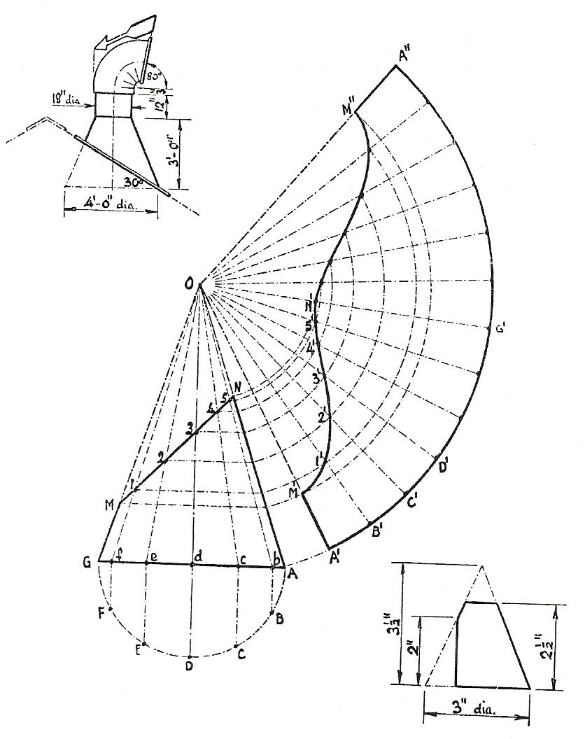
The diagrams in the corners should provide additional examples for practice on this problem.

2.0 The Pyramid

Key Learning Points
- Development of pyramids and truncated pyramids (right pyramid)
- Neatness and accuracy
- Terminology associated with cones and pyramids

2.1 The Pyramid Cut Obliquely
The body of the iron wheelbarrow shown in the figure below is often constructed as the frustum of a pyramid, and may then be developed by the radial line method. The elevation of the complete pyramid is obtained by producing the sides downwards until they meet, as at A, and upwards on the side AC until the base BC is at right angles to, and bisected by, the central axis.
To develop the pattern, set out the elevation as shown at CDEF and produce the sides to CA and AB. On the base CB draw one half of the plan of the full base, as at CGHB. The centre-point A' then represents the apex in the plan. It will be observed that the half-plan and the elevation are drawn the reverse way up to that which is usual, but this should present no difficulty in the solution of the problem if that fact is borne in mind.
From the apex A' draw A'G and A'H. From D draw DI; from E draw EJ, from F draw FK, all vertically upwards. Join GK and IJ. Then CGKf is the half-plan of the actual top of the body, and dIJe the half-plan of the bottom of the body. From the apex A' describe the semicircle LGHM. Join AL and AM, each of which represents the true length projection of the corner lines A'G and A'H. Project the points D,E,F horizontally to the true length line AM, and from A swing them round into the pattern, together with point M.
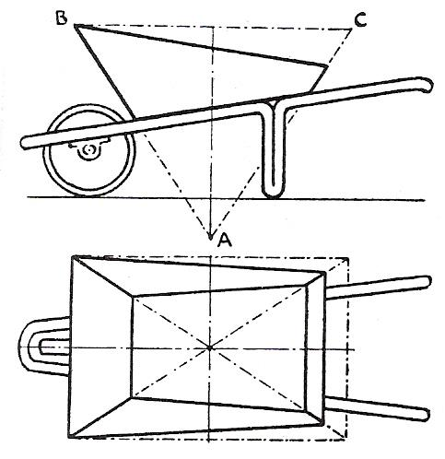
Take the distance gG, which should be twice the length of CG, and mark off g'G' on the outer, or base, curve in the pattern. Next take GH and mark off G'H' in the pattern. Next mark off H'H" in the pattern equal to g'G'. Also mark off H"G" equal to G'H'. Join the points thus obtained to the apex A. It now remains to draw in the pattern, which should be evident from the illustration.
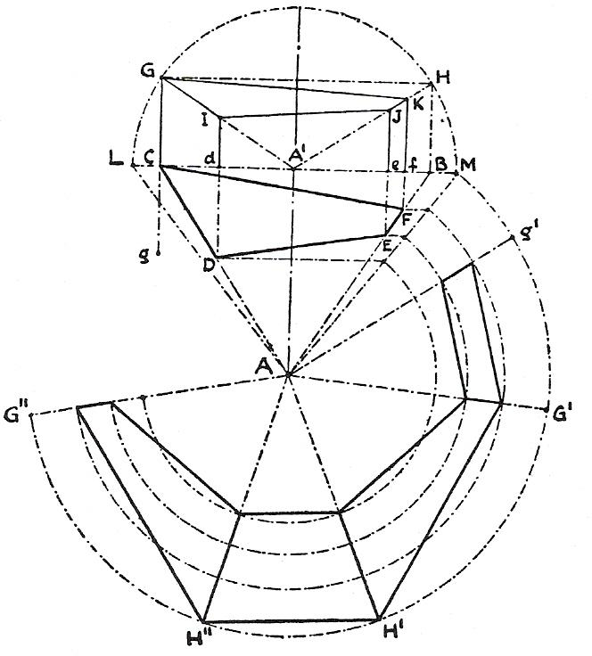
Pyramid Cut Obliquely

2.2 Terminology Associated with Cones and Pyramids
Apex
The apex is the most distant point or vertex in a cone or pyramid.
Frustum
The frustum of a cone or pyramid is one where there is no apex i.e the portion of a cone or pyramid included between the base and a plane parallel to the base.
True Length
The true length of a line is the plan length of that line against the vertical height.
Circumference
The distance around, or the perimeter of a circle or pipe. The formula for the circumference of a circle is πd (pi x diameter).
Right Cone
A cone having its apex perpendicular to the centre of the cone.
Oblique Cone
A cone having its apex off-centre to the base.

3.0 Area and Volume

Key Learning Points
- Calculation of area, volume of cones and pyramids

3.1 Calculation of Area, Volume of Cones and Pyramids

Area and Volume of a Square Based Pyramid
A pyramid is a solid figure with a polygonal base and triangular faces that meet at a common point over the center of the base. The height (h) is the distance from the base to the apex or top of the pyramid. The side length (s) is the height of the face triangles. The perimeter and the area of the base is calculated according to the shape of the base.
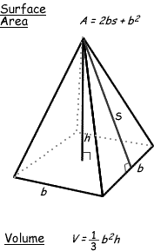
Surface Area: Add the area of the base to the sum of the areas of all of the triangular faces. The areas of the triangular faces will have different formulas for different shaped bases.

Area and Volume of a Right Cone
A cone is a pyramid with a circular base of radius (r) and the side length (s) is the length of the sloping length from the base to the apex.
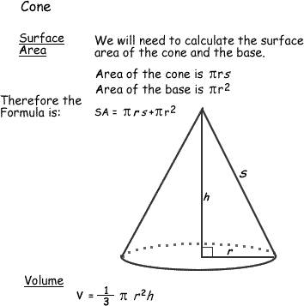

Summary
Radial line development is the process used for developing patterns for cones and pyramids. For the radial line method to be used, all lines must radiate from a common centre. In addition, the amount of slant of those lines must be relatively large since most radial line developments are drawn beginning with the side view and then extending the side lines until they meet.

Castleforbes House
Castleforbes Road
Dublin 1

