TRADE OF
Industrial Insulation

PHASE 2

Module 2

Geometry & Pattern Development

UNIT: 8

Triangulation

Produced by

In cooperation with subject matter expert:

Michael Kelly

© SOLAS 2014
Table of Contents
Unit Objective 1
1.0 Triangulation 2
1.1 The Square to Round Transformer 2
1.2 Developing the Square to Round 2
1.3 Numbering of Points 4
1.4 Terminology in Triangulation 5
1.5 Process of Triangulation 5
2.0 The Rectangular Transition 6
2.1 Developing a Rectangular Transition 6
3.0 The Ellipse 8
3.1 Constructing an Ellipse Using the Trammel Method 8
3.2 Constructing an Ellipse Using the Auxiliary Circle Method 9
3.3 Calculating the Perimeter and Surface Area of an Ellipse 9
Summary 10

Unit Objective
Module 2
Geometry & Pattern Development
Unit 1
Basic Construction
Unit 6
One Piece Pyramid
Unit 5
Cones and Pyramids
Unit4
Equal and Unequal Tee Pieces
Unit 3
Parallel Line Development
Unit 2
Orthographic Projections
Unit7
Segmented Radius Bends
Unit 8
Triangulation
Unit 9
Tapered or Conical Tee
Unit 10
Flattened Bends and Straights
Unit 11
Valves and Flanges
Unit 12
Eccentric Reducer - Radial Line and Triangulation

Triangulation

Key Learning Points
- Use of triangulation
- Pattern development using the triangulation method
- True length diagram
- Construction of the true length of a line
- Terminology used in triangulation

1.1 The Square to Round Transformer
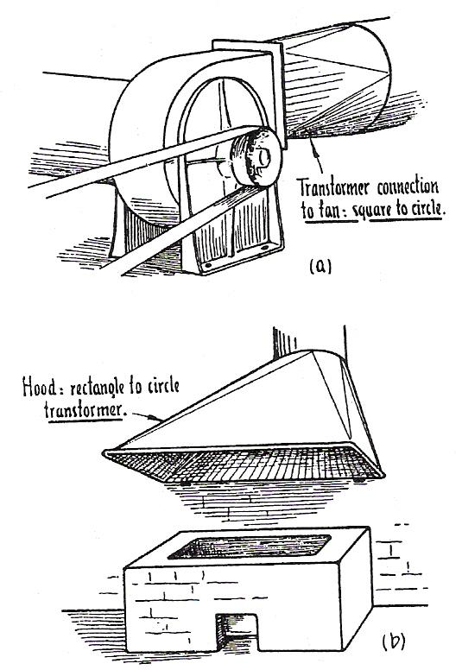
A problem of very common occurrence in metal work, particularly in pipe and ductwork, is that of the square-to-circle transformer, often called a tallboy. Its object in ductwork is to transform a square or rectangular pipe to a round pipe, or to connect a round pipe to a square or rectangular hole, such as the outlet of a centrifugal fan. This type of transformer also takes the form of hoods over hearths and furnaces to collect the fumes, which rise up through the pipe at the top. In general practice it is encountered in a variety of ways, almost too numerous to mention.
Square to Circle and Rectangle to Circle Transformers

1.2 Developing the Square to Round
The simplest example of this class is such as that shown in Error: Reference source not found, in which the centre of the circle in the plan coincides with that of the square, and in which the diameter of the circle is smaller than the width of the square. The method of developing the pattern, however, is the same for every case, whether the circle is the same size or larger than the square, or whether the circle is off-centre one way or both ways with that of the square.
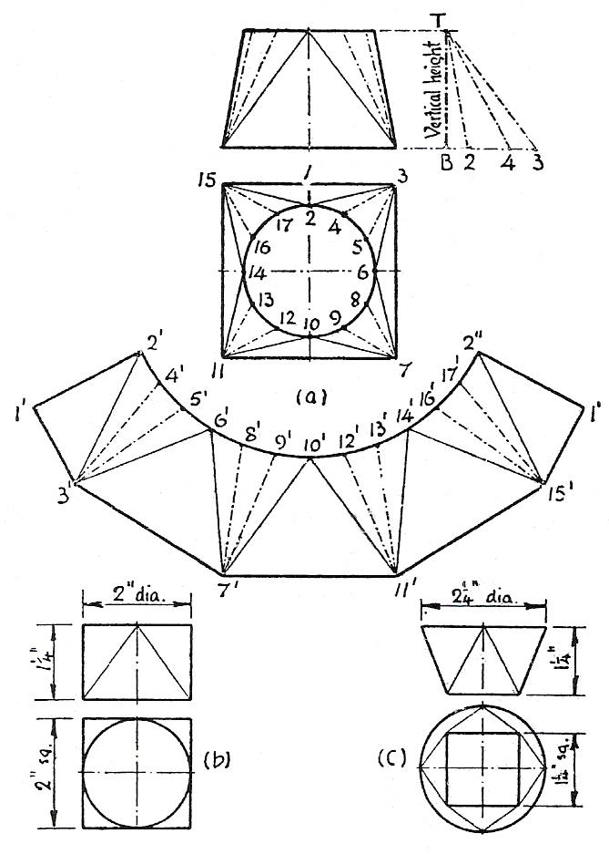
To develop the pattern, divide the circle in the plan into twelve equal parts. Any other number would do as well, but twelve is very convenient, as the divisions can be obtained with the compasses without altering the radius. Assuming the seam to be up the middle of one side as at 1, 2, Error: Reference source not found, number the points, beginning at the seam, as shown at 1, 2, 3, 4…14, 15, 16, 17. Project a vertical height line from the elevation, and extend the base line sufficiently to accommodate the longest plan length.
For the first triangle, take the plan length 1,2 in the compasses, and mark it off from B along the base line at right angles to the vertical height. Take the true length diagonal from 2 to the top T of the vertical height, and set off 1', 2', in the pattern. It will be observed that this first line in the pattern may be set off anywhere and in any position, since the rest of the pattern will follow accordingly. However, a little care and foresight are usually needed to place the first line so that the pattern following up will not run off the sheet or the paper. Next take 2, 3 from the plan, mark it off from B along the base line at right angles to the vertical height, take the true length diagonal from 3 to the top T, and from point 2' in the pattern swing off an arc through point 3'. Next take the true distance 1, 3 from the plan, and from the point l' in the pattern describe an arc cutting the previous arc in point 3'. Join 2', 3' and 1', 3'.
For the second triangle, take 3, 4 from the plan, mark it off along the base line, take the true length diagonal, and from point 3' in the pattern swing off an arc through the point 4'. Next take the true length 2, 4 direct from the plan, and from point 2' in the pattern describe an arc cutting the previous arc in point 4'. Join 3', 4'. For the third triangle, repeat this process with the plan lengths 3, 5 and 4, 5; and again for the fourth triangle with plan lengths 3, 6 and 5, 6. For the fifth triangle, repeat the process with plan lengths 6, 7 and 3, 7; but observe in this case that the triangle is reversed in position. The remainder of the pattern should now be quite easy to follow, since it is a repetition of these processes right through. The line from 2' to 2" should be a curve, and not a series of short straight lines.

1.3 Numbering of Points
One of the best aids to clear development in triangulation is a satisfactory method of numbering the points of division in the plan and elevation. Many different methods are in use, but the preferred method is one in which the consecutive numbers 1,2,3,4 ... and so on, can be used right round the body from seam to seam. In many cases of triangulation, the arrangement of the lines forming the triangles produces a continuous zigzag line on the surface between the top and bottom edges of the body, as shown in the figure below. Examples of this class were given in the previous section, on square-to-square transformers, and many other examples are to follow. The zigzag line need not be regular in form, but may take almost any shape. The chief point to observe is that, beginning at the seam with 1 to 2, the consecutive numbers are placed alternately at top and bottom as the zigzag line forming the triangle passes round the body. This is a very simple method of numbering, and has the advantage that, if the work of development were left for a time, it can be picked up with confidence at the exact spot where it was left off.
Square-to-round transformers introduce a little variation on this arrangement, the principle of which is shown in the figure below. From this diagram it can be seen that the continuous zigzag line is formed by 1, 2, 3, 6, 7, 10, 11, 14, 15.
But there are other lines radiating from points 3, 7 and 11, as 3, 4 and 3, 5. The method of procedure, in a case like this, is to begin at 1 and follow up in zigzag form with 2, 3 and 4. From point 4, there is no return to the base, other than back to 3. Retrace back to 3, and proceed to point 5. Again retrace back to 3, and proceed to point 6.
It is now possible to get back to the base from 6 to 7. From point 7 the process is repeated as from point 3, but this time with 7, 8; 7, 9; and 7, 10; and then back to 11. This is repeated again from point 11.
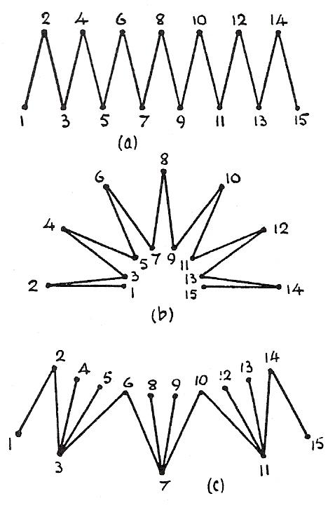
It will be found that this method of numbering can be applied to all cases, and will be of considerable advantage when complicated problems are dealt with.
Method of Numbering the Points

1.4 Terminology in Triangulation
The golden rule in triangulation is the Plan length against the Vertical height. Triangulation is a process of building up the pattern piece by piece in the form of triangles.
Plan Length
Plan length refers to any length in the plan view.
Vertical Height
This is the finished height of the job and is taken from the elevation.
False Length
A false length is a line that can’t be represented properly on a flat sheet of paper/metal. An example of a false length would be the sloping sides on a transformer or reducer.
Transformers
A transformer alters or modifies the shape of the cross section. The cross sectional area remains the same. A reducer, as its name implies, cuts down the area.

1.5 Process of Triangulation
The apprentice will come across true lengths and false lengths many times during their career. It is important to recognise the difference. To obtain the true length of any line, place the plan length against the vertical height at right angles and measure the diagonals. If a line has a plan length but no vertical height, then the true length is the plan length, taken from the plan. If a line has a vertical height but no plan length then its’ true length is taken from the elevation.

2.0 The Rectangular Transition

Key Learning Points
- Types and shapes of transformers
- Transition piece: rectangular to round

2.1 Developing a Rectangular Transition
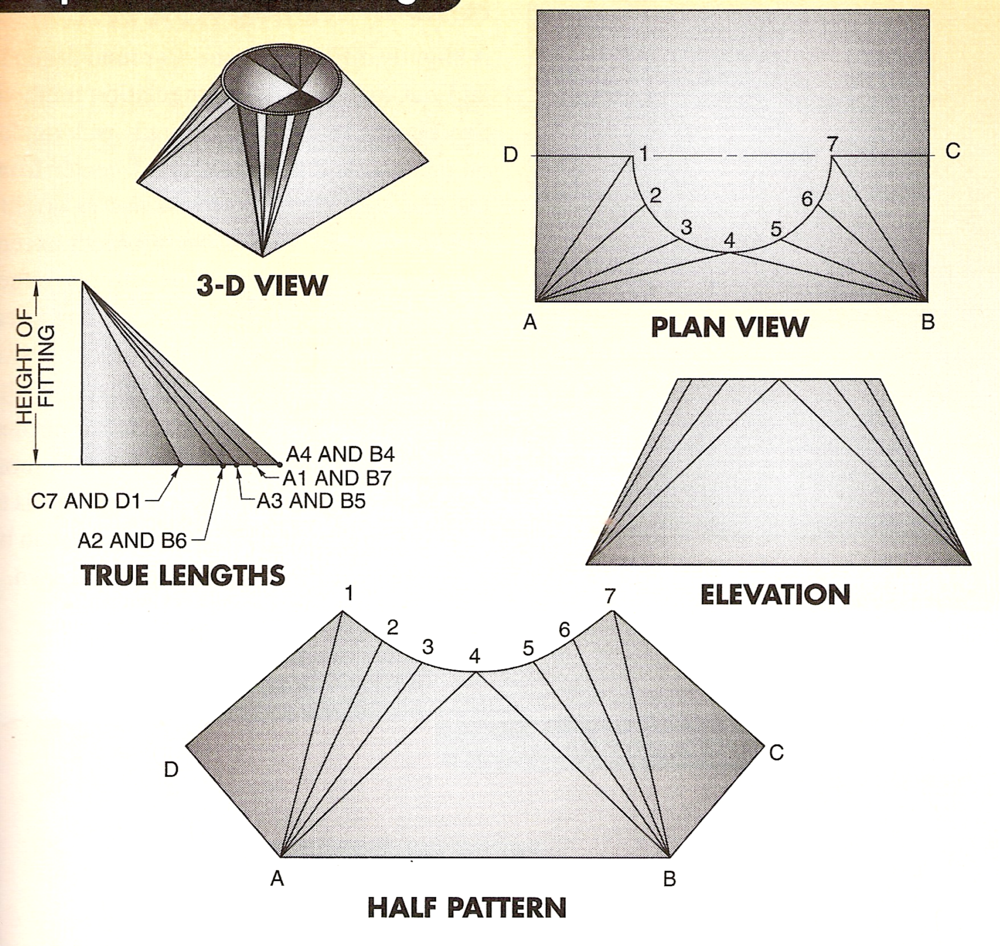
The pattern of a rectangle to round is also developed using triangulation method. As is the square to round fitting, the method of layout is still that of forming triangles on the pattern in their true length. Since the fitting below is a symmetrical fitting, only a quarter of the plan view is necessary. However, one-half is marked with measuring lines to make the pattern layout clearer. The true lengths of the measuring lines are found in the usual way, as shown.

Marking Out the Pattern
The method of starting the pattern in the above diagram is from the centre of the rectangle out. The pattern could also be started from points D1 and working around to C7.
Draw the true length line AB, which can be taken from the plan view.
Next, locate point 4 by swinging the true length of A4 from A, and by swinging the true length of B4 from B.
After point 4 is located, next find point 3. This is done by swinging the true length of A3 from A and by swinging the distance 4-3 from 4 (4-3 can be taken directly from the plan view).
Point 2 is found next and then point 1. After this, the other side of the pattern is laid out by locating points 5, 6, and 7, in that order.
The curve of the pattern is drawn through these points either freehand or by using a flexible curve. A flexible curve is recommended as it is more accurate.
After the curve points 1 to 7 are located, then points C and D must be found to complete the half pattern. To find C, take the distance BC from the plan view and swing it from B on the pattern.
Then take the true length of C-7 and swing it from 7. The intersection of these two arcs gives us point C, and the lines 7C and BC can be drawn in. Point D is located in the same way.
Take AD from the plan view and swing it from point A. Then take the true length of D-1 and swing it from 1. This locates D and the lines can be drawn in.
Note: It is important to layout the pattern as neatly and as accurately as possible. A keen eye for detail and measurements is required as inaccuracies will lead to a poor fit-up of parts when it comes to the final assembly of the fitting.

3.0 The Ellipse

Key Learning Points
- Elliptical construction: major and minor axis
- Calculate the surface area and perimeter of and ellipse

3.1 Constructing an Ellipse Using the Trammel Method
An ellipse is a plane figure bounded by a curved line described about two points in such a manner that the sum of the distances from every point of the curve to the two fixed points is always the same. The two points are called “foci”. The imaginary line running through the ellipse and the foci, splitting the ellipse in half, is called the major axis. The imaginary vertical line splitting the ellipse in half and running perpendicular to the major axis is called the minor axis.
(1) Let AB be the major axis and CD the minor axis of the required ellipse.
(2) Along the straight edge of a piece of thin cardboard mark the points X, Y and Z so that XZ = ½ AB and XY = ½ CD.
(3) Place the piece of cardboard so that point Y is always on the major axis and point Z is always on the minor axis. For every such position the point X defines a point on the ellipse.
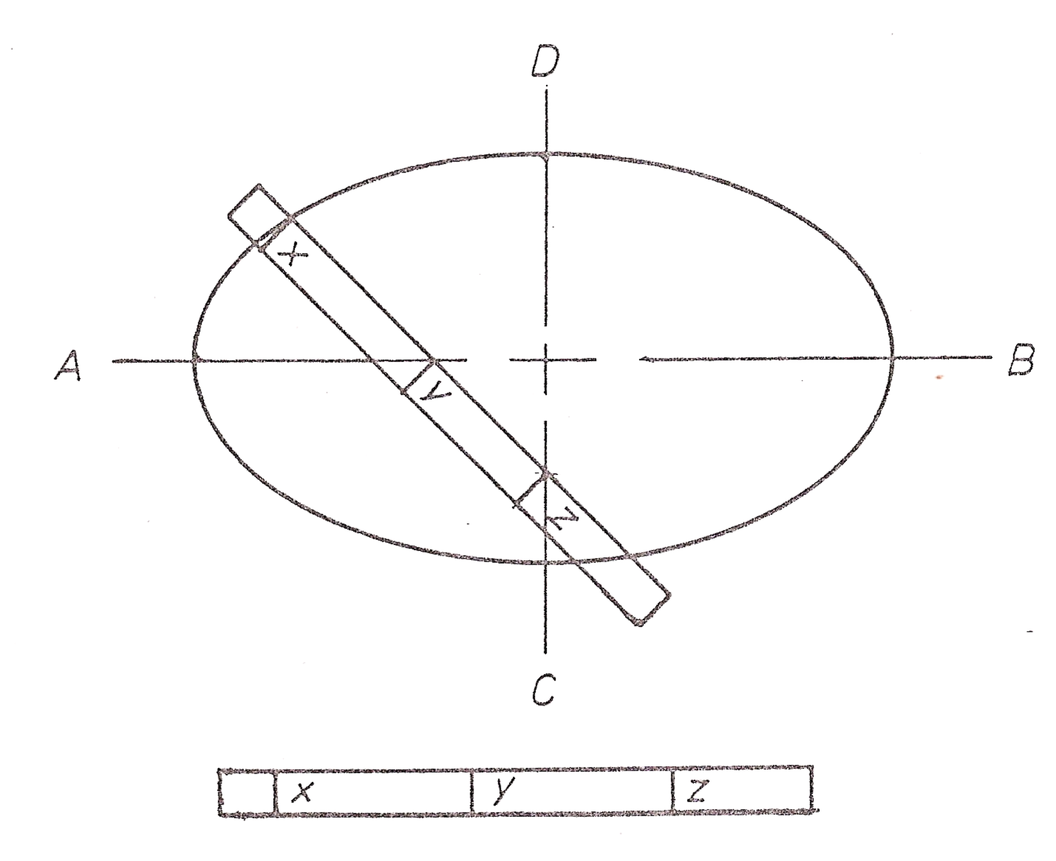
(4) Mark each point separately and join them by a smooth curve. This is an ellipse constructed by the trammel method.

3.2 Constructing an Ellipse Using the Auxiliary Circle Method
- With centre O (intersection of the major and minor axis), and radius AO, draw a circle.
- With the same centre and radius CO, draw another circle.
- Divide the circles into twelve equal sectors.
- Where the radial lines cut the large circle draw verticals.
- Where the radial lines cut the smaller circle draw horizontals to cut the verticals as shown.
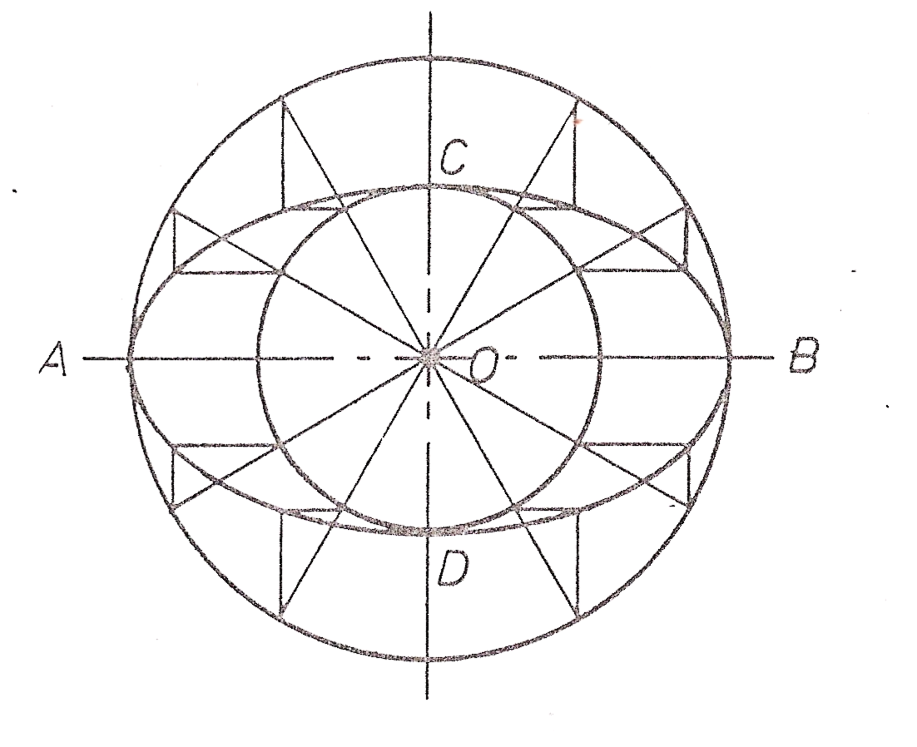
- The Point Of Intersection of these horizontal and vertical lines is a point of the required ellipse. Join these points by a smooth curve to complete the ellipse.

3.3 Calculating the Perimeter and Surface Area of an Ellipse

Perimeter
P = 3.14(pi) √2 (a² + b²)
Where “a” equals half the major axis and “b” equals half the minor axis.

Surface Area.
A = πab = 3.14 ab
Where “a” equals half the major axis and “b” equals half the minor axis.
Refer to Module 2 – Unit 1 – Basic Construction – section 4.

Summary
Triangulation is the systematic process of using multiple methods to gather a range of quantitative estimates for an unknown value. The triangulation method of pattern development is used in metalwork when working with plane surfaces, when identifying true lengths where lengths are not known, and when working on patterns where at least two points are known. Triangulation methods rely on the geometric use of triangles to properly measure and layout sheet metal patterns.
The golden rule of triangulation is “plan length against vertical height” to find the sloping length of a line. Several different patterns or layouts use triangulation methods, including rectangular transitions, round tapers, oval to round fittings, square to round fittings and offset square to round transitions.
When developing patterns, it is important to layout the pattern as neatly and as accurately as possible. A keen eye for detail and measurements is required as inaccuracies will lead to a poor fit-up of parts when it comes to the final assembly of the fitting.

Castleforbes House
Castleforbes Road
Dublin 1

