TRADE OF
Industrial Insulation

PHASE 2

Module 2

Geometry & Pattern Development

UNIT: 9

Tapered or Conical Tee

Produced by

In cooperation with subject matter expert:

Michael Kelly

© SOLAS 2014
Table of Contents
Unit Objective 1
Introduction 2
1.0 Right Conical Saddle Piece 3
1.1 Developing a Right Conical Saddle Piece 3
1.2 Radial Line Development 4
1.3 Comparison Between Conical Tapers and Cones/Pyramids 4
1.4 Orthographic projection 4
2.0 Right Conical Slanted Saddle Piece 5
2.1 Developing a Right Conical Slanted Saddle Piece 5
2.2 Numbering and Lettering of Points 6
3.0 Fabricating a Tapered or Conical Tee 7
3.1 Swage Allowances 7
3.2 Assembly Hole Location 7
3.3 Design of Joint Location for Manufacture 7
Summary 8

Unit Objective
By the end of this unit each apprentice will be able to:
- Identify Tapered/Conical tees and their applications in the insulation industry.
- Identify the similarities and relationship between Tapered/Conical tees and cones/pyramids.
- Develop the pattern for tapered/conical or reducing tee pieces using radial line projections.
Module 2
Geometry & Pattern Development
Unit 1
Basic Construction
Unit 6
One Piece Pyramid
Unit 5
Cones and Pyramids
Unit4
Equal and Unequal Tee Pieces
Unit 3
Parallel Line Development
Unit 2
Orthographic Projections
Unit7
Segmented Radius Bends
Unit 8
Triangulation
Unit 9
Tapered or Conical Tee
Unit 10
Flattened Bends and Straights
Unit 11
Valves and Flanges
Unit 12
Eccentric Reducer - Radial Line and Triangulation

Introduction
Any round or conical taper, provided that it is equally tapering on all sides, can be laid out using radial line development. The round taper is essentially the same as the cone/pyramid, except that the top of the cone/pyramid is cut off to reveal a diameter opening which is smaller than the diameter of the base.

1.0 Right Conical Saddle Piece

Key Learning Points
- Identification and applications of tapered/conical tees
- Use of orthographic projection
- Comparison or similarities between tapered and conical tees and cones/pyramids

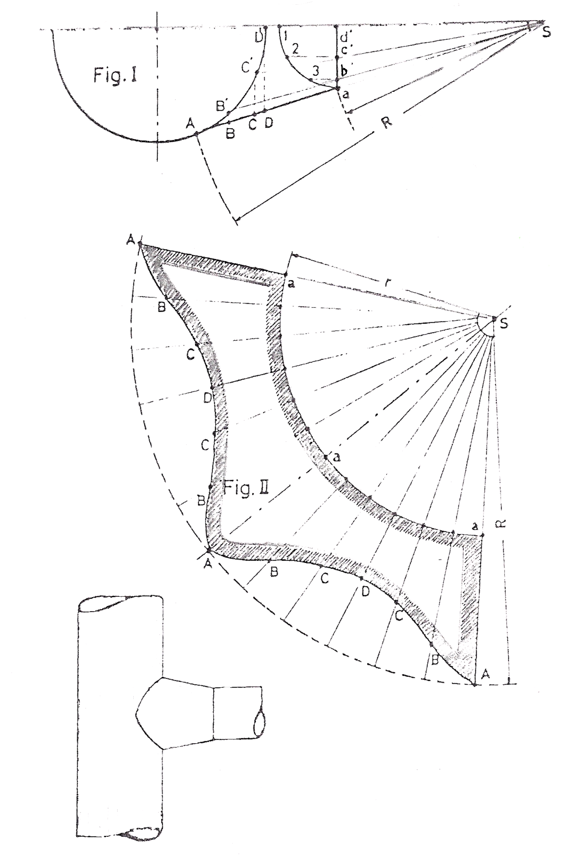
1.1 Developing a Right Conical Saddle Piece
Figure I: Half an elevation.
Figure II: Development of the right conical saddle piece.
After determining the outlines in Figure I, draw a quarter circle with centre d’ and divide it into three equal parts. At points 2 and 3 draw perpendiculars to the base line; they intersect it at points b’ and c’ intersecting the circle at points B’ and C’. Then, at points B’, C’, and D’ draw parallel lines to the base line intersecting the outer lines of the conical saddle piece at points B, C, and D.
For the development in figure II draw an arc with centre S and radius r = Sa, and on it from a random point lay off the division 1 to 2 (figure I) 12 times or full circumference. Rom S draw lines through the new found points and on them lay off true length lines SA, SB, SC, and SD from figure I.

1.2 Radial Line Development
Refer to module 2 – unit 5 – Cones and Pyramids.

1.3 Comparison Between Conical Tapers and Cones/Pyramids

Cones/Pyramids
The pattern for a cone/pyramid is laid out or developed using radial line development. This is a typical operation and serves to illustrate some of the basic principles of radial line development. The pattern for a cone/pyramid is developed according to the following procedure:
- Draw the elevation view showing the true height of the apex.
- Draw the stretch-out arc with a radius equal to the true length of the side or edge of the object.
- Swing the stretch-out arc an infinite length. Then calculate the circumference of the bottom of the cone mathematically (pi times the diameter). Measure the circumference with a flexible rule around the stretch-out arc or step out 12 equal divisions to give you the full circumference. Draw a starting line from the apex to point 1 and the apex to point 12 to give the complete pattern.

Conical Tapers
Any round or conical taper, provided that it is equally tapering on all sides, can be laid out using radial line development. The round taper is essentially the same as the cone/pyramid, except that the top of the cone/pyramid is cut off. When laying out the conical taper apply the following procedures:
- Draw the side view of the taper.
- Extend the side lines until they meet. This forms the apex.
- Use the apex as the centre and swing the arcs from the top and bottom corners of the taper.
- Measure the stretch-out arc. In this case, the stretch-out is the circumference of a circle whose diameter is the bottom of the taper.
- Draw lines from the apex to the ends of the stretch-out arc.

1.4 Orthographic projection
Refer to module 2 – unit 2 – Orthographic projection.

2.0 Right Conical Slanted Saddle Piece

Key Learning Points
- Determination of lines or curves of intersection between cones and straight pipes
- Numbering and lettering for point identification
- Establishment of the true shape of development

2.1 Developing a Right Conical Slanted Saddle Piece
Figure I: Half a vertical elevation.
Figure II: Half a horizontal elevation.
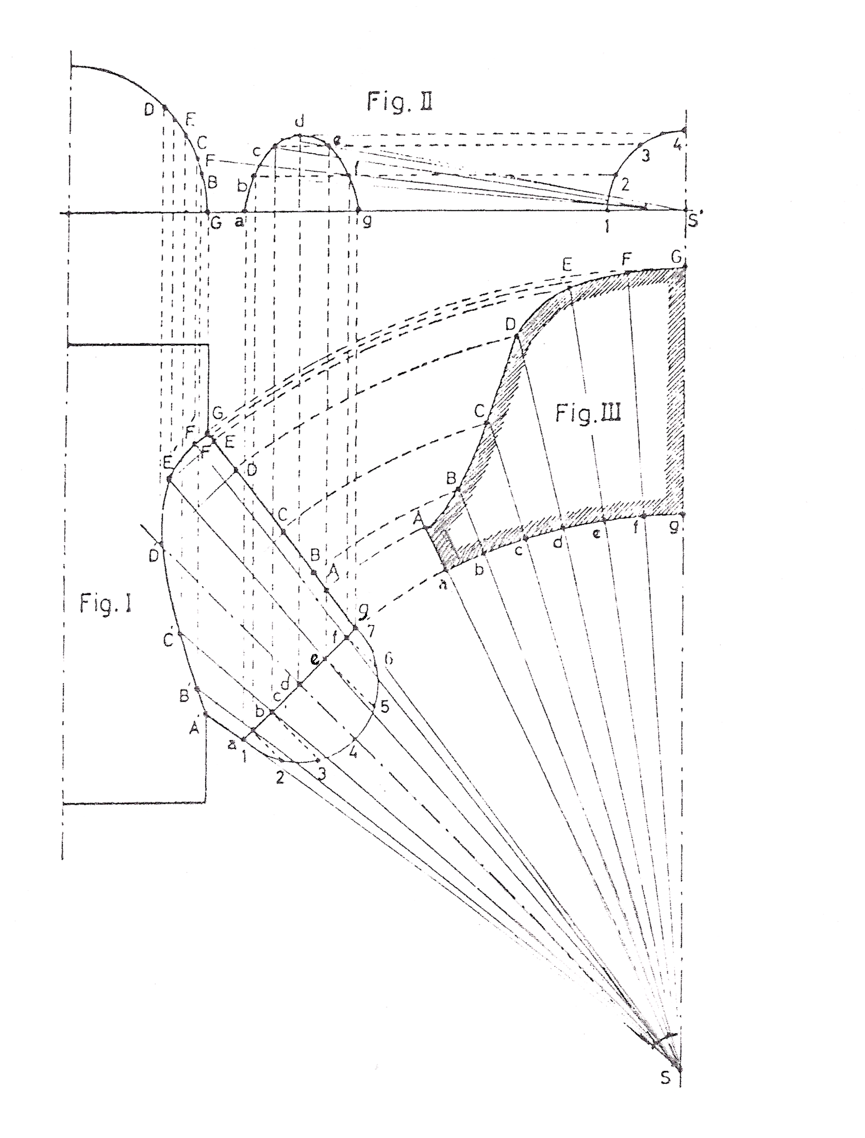
Figure III: Half a development of the slanted saddle piece.
Draw the outlines of figure I with the vertex S. Draw the semicircle with centre d and divide into 6 equal parts , and at points 2 to 6 draw the perpendiculars to the base line ag. Through the thus found points b to f draw the lines from s, which are the generating lines. For finding the joint line or penetration curve figure II is necessary. Draw a base line and the perpendicular to it at point s. Next draw a quarter circle with centre S’ with the same radius as for the semicircle of figure I. Divide the quarter circle into 3 equal parts, and draw the parallel lines to the base line at points 2, 3, and 4. These intersect the parallel lines at points a-g of figure II thus giving us half an ellipse. Through points b to f of this ellipse draw generating lines from S’ until they intersect the circle or main pipe. These intersection points are projected back into figure I, and the perpendiculars at these points intersect the previously drawn generating lines at points B’ to F’ in figure I. The connecting lines of points A’, B’, C’, etc. obtains the required joint line or penetration curve.
To obtain the true lengths of the generating lines of figure I, draw parallel lines to ag at points A’ to F’ intersecting the outer lines at points A-F.
For the development in figure III first draw an arc radius Sa and on it lay off the division 1 to 2 of figure I 6 times for half of the full circumference. Draw lines through points a to g from S and lay off the respective lengths SA, SB, SC etc. on these development lines.

2.2 Numbering and Lettering of Points
One of the best aids in radial line development is a satisfactory method of numbering the points of division in the plan and elevation. Many different methods are in use, but the preferred method is one in which the consecutive numbers 1,2,3,4 ... and so on, can be used right round the body from seam to seam.
Lettering can also be used to identify development points. A combination of both lettering and numbering can be a very effective method as it will distinguish quite clearly different development points on a pattern.
Refer to module 2 – unit 8 – section 1.3.

3.0 Fabricating a Tapered or Conical Tee

Key Learning Points
- Selection of joint location for ease of fabrication
- Lap and flanging allowances. Fixing holes location

3.1 Swage Allowances
Once the development or pattern has been marked out on metal, allowances must be added to the outside of the pattern for joints, seams, swages etc. Depending on the type of joint or seam, the correct amount of material must be added onto the pattern before it is cut out.
Refer to module 1 – unit 5 – General allowances for insulation and cladding.

3.2 Assembly Hole Location
Refer to module 1 – unit 6 – Marking, Cutting, Punching, Rolling, Seam swaging and Screwing.

3.3 Design of Joint Location for Manufacture
When we develop patterns, we generally keep the joint on the shortest side unless otherwise stated on the drawings. The joint location on a fitting should be designed for the location in which it will be installed. Joint location is very important when cladding is installed on exposed pipe work as the ingress of water through the joints will result in damage to the insulation underneath.
From an appearance point of view, it is always best to keep the joints out of view or hidden if possible. The overall appearance of a job may rest on the location of joints and how the job is assembled. A lot of thought and planning is required before starting to manufacture cladding pipe work and fittings.

Summary
Radial line development is used to develop a tapered or conical tee. The round taper is essentially the same as the cone/pyramid, except that the top of the cone/pyramid is cut off to reveal a diameter opening which is smaller than the diameter of the base.
When developing a tapered or conical tee, the following procedures should be followed: Draw the side view of the taper, extend the side lines until they meet, this forms the apex. Use the apex as the centre and swing the arcs from the top and bottom corners of the taper. Measure the stretch-out arc. In this case, the stretch-out is the circumference of a circle whose diameter is the bottom of the taper. Draw lines from the apex to the ends of the stretch-out arc.
One of the best aids in radial line development is a satisfactory method of numbering the points of division in the plan and elevation. Many different methods are in use, but the preferred method is one in which the consecutive numbers 1,2,3,4 ... and so on, can be used right round the body from seam to seam.
Lettering can also be used to identify development points. A combination of both lettering and numbering can be a very effective method as it will distinguish quite clearly different development points on a pattern.

Castleforbes House
Castleforbes Road
Dublin 1

