TRADE OF
Industrial Insulation

PHASE 2

Module 4

Insulation – Materials, Science and Application

UNIT: 6
Cellular Glass or Foamed Glass

Produced by

In cooperation with subject matter expert:

Michael Kelly

© SOLAS 2014

Table of Contents
Introduction 1
Unit Objective 2
1.0 Cellular Glass or Foamed Glass 3
1.1 Product Composition and Characteristics 3
1.2 Properties and Uses of Cellular Glass or Foamed Glass Insulation 3
1.3 Advantages and Disadvantages of Cellular Glass or Foamed Glass Insulation 4
1.4 Forms of Supply and Identification 5
1.5 Temperature Range 5
2.0 Adhesives and Sealants 6
2.1 Application of Adhesive or Sealant 6
2.2 Compatibility of Adhesives and Sealants 6
2.3 Compressive Strength of Foamed Glass or Cellular Glass Insulation 7
2.4 Cutting Cellular Glass or Foam Glass Insulation 7
3.0 Health and Safety 8
3.1 Health Risks Associated with Foamed Glass and Cellular Glass Insulation 8
3.2 First aid Measures 8
3.3 Reaction to Fire 8
3.4 Handling and Storage 9
Summary 10

Introduction
Sustainable design in industrial insulation systems is becoming important, and the demand for sustainable insulating products with low environmental impact continues to grow. Cellular glass or foamed glass insulation products offer a unique combination of physical characteristics, which provide safety, durability, sustainability and long term economic benefits to the end user.

Module 4
Insulation – Materials, Science & Application
Unit 1
Basic Insulation Science & Principles
Unit 2
Insulation Materials & System Design
Unit 3
Insulation Thickness, Thermal Conductivity & Performance Criteria
Unit 8
Sprayed or Blown Fibre & Ceramic Fibre (Blanket)
Unit 7
Calcium Silicate & Magnesia
Unit 6
Cellular Glass or Foamed Glass
Unit 5
Glass Mineral Fibre & Rockwool
Unit 4
Insulation – Terms, Definitions & Formula
Unit 15
Finishing Materials & Cladding
Unit 14
Acoustics/ Noise Abatement
Unit 13
Fire Protection
Unit 12
Asbestos
Unit 11
Polystyrene, Phenolic Foam & Polyisocyanurate Foam
Unit 10
Nitrile Rubber
Unit 9
Vermiculite

Unit Objective
By the end of this unit each apprentice will be able to:
- List and describe the properties, uses and applications of cellular glass and foamed glass insulation.
- Identify cellular glass and foamed glass from samples provided.
- Demonstrate the safe handling and application of these materials.

1.0 Cellular Glass or Foamed Glass

Key Learning Points
- Product composition of cellular glass or foamed glass.
- Compressive strength of cellular glass or foamed glass insulation.
- Use of manufacturers’ data sheets and instructions.
- Advantages and disadvantages of cellular glass and foamed glass insulation.
- Service temperature range.
- Identification of insulation samples.

1.1 Product Composition and Characteristics
Cellular glass or foamed glass is insulation composed of glass processed to form a rigid foam having a predominantly closed-cell structure. It is lightweight, rigid material composed of millions of completely sealed glass cells. Each cell is an insulation entity, which means it is totally independent of the other cells surrounding it.

1.2 Properties and Uses of Cellular Glass or Foamed Glass Insulation

Properties
- Constant insulating efficiency.
- Zero water vapour permeability.
- Moisture resistant.
- Fire protection.
- Corrosion resistant.
- Long term dimensional stability.
- Vermin resistant.

Uses
- Low temperature pipe, equipment, tanks and vessels.
- Medium and high temperature pipes and equipment.
- Hot oil and hot asphalt storage tanks.
- Heat transfer fluid systems.
- Chemical processing systems.
- Above and below ground steam and chilled water pipes.
- Commercial and ductwork pipe work.
- Insulation can be multi-layered to achieve required insulation values.

1.3 Advantages and Disadvantages of Cellular Glass or Foamed Glass Insulation

Advantages
- Because it consists of closed glass cells, cellular glass or closed glass insulation resists moisture in both liquid and vapour forms.
- Cellular glass or foamed glass insulation is 100% glass and contains no binders or fillers. It will not absorb flammable liquids or vapours. If a fire does occur cellular glass or foamed glass insulation can help to contain or suppress it.
- Cellular glass or foamed glass insulation is unaffected by common chemicals and by most corrosive plant atmospheres. It does not promote metal corrosion and its moisture resistance will help keep water from reaching equipment and piping.
- The insulation is unaffected by temperature differentials and humidity. It will not swell, warp, shrink or otherwise distort. The insulation system’s integrity remains intact.
- Cellular glass or foamed glass insulation can withstand loads which crush most other insulating materials. In a properly designed piping system, the insulation eliminates the need for special treatment at pipe cradles. It also provides a firm base for roof membranes, jacketing, vapour retarders, prolonging their life.

Disadvantages
- Cellular glass or foamed glass insulation is fragile.
- It is susceptible to vibration – induced damage.
- The cost of the insulation is expensive compared to other insulations with similar insulation properties
- Installation costs are higher due to the fragile nature of the insulation.

1.4 Forms of Supply and Identification
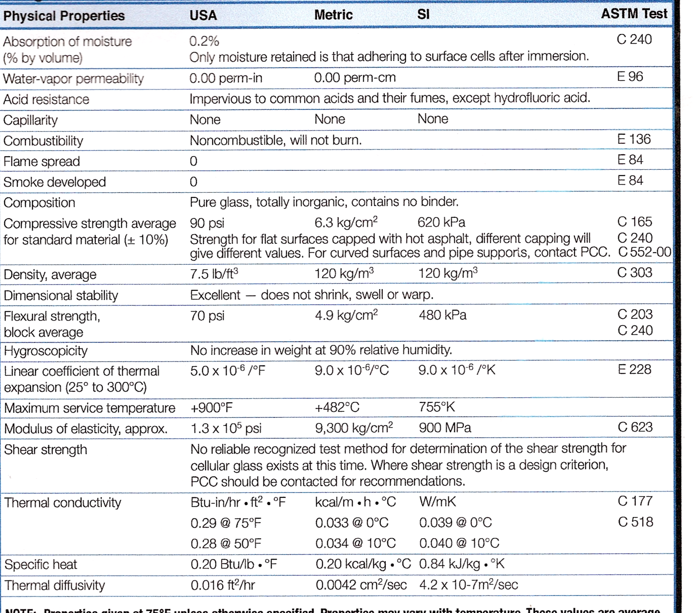
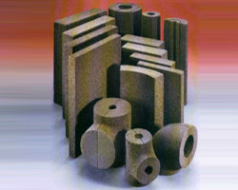
Cellular glass or foamed glass insulation is manufactured in basic block form. Blocks are fabricated into a wide range of shapes, thicknesses and sizes to satisfy industrial insulation requirements. Refer to the data below for further information.

1.5 Temperature Range
The service temperature range of cellular glass or foamed glass insulation is between -268º and 482ºC.

2.0 Adhesives and Sealants

Key Learning Points
- Compatibility of adhesives and sealants.
- Use of adhesive and sealant.
- Thickness and density range.
- Cutting and application methods.

2.1 Application of Adhesive or Sealant
- All surfaces should be dry and free from dust, loose scale, oil, grease and frost.
- Apply sufficient adhesive or sealant using a trowel, knife or sealant gun.
- Apply sufficient material to both surfaces and press together firmly to obtain a complete seal. Joints less than or equal to 3mm are desirable. Do not use sealant to fill large voids due to poor fit up of parts.
- Blocks or joints should be rubbed or sanded to obtain a good fit up.
- When the coating or sealant has been applied, cut away any sealant which may have squeezed out of the joint using a knife and ensure that the sealant is flush with the surface.
- Clean all tools using a mineral spirits after use.
- Always refer to the manufacturer’s safety data sheets before using any sealant products.

2.2 Compatibility of Adhesives and Sealants
There are a number of adhesives which are designed for different applications.
- PC®56 – Two part, solvent adhesive based on bitumen emulsion, improved with synthetic materials for bonding foamed glass and cellular glass insulation to itself and concrete or masonry. Should not be used for bonding insulation to steel work.
- PC®11 – One component cold bitumininous adhesive which is suitable for adhering foamed glass or cellular glass insulation onto metal and timber.
- PC®500 – This is a bitumen emulsion which is suited as a bedding component for cellular glass and foamed glass insulation onto a concrete or timber deck in specific bearing applications. The adhesive remains water tight with a high resistance to water vapour.
- Pittseal®444 – This sealant is a single component, non-hardening butyl composition for sealing joints between foamed glass or cellular glass slabs and boards in a full or partially filled cavity wall and other specialist wall applications.

2.3 Compressive Strength of Foamed Glass or Cellular Glass Insulation
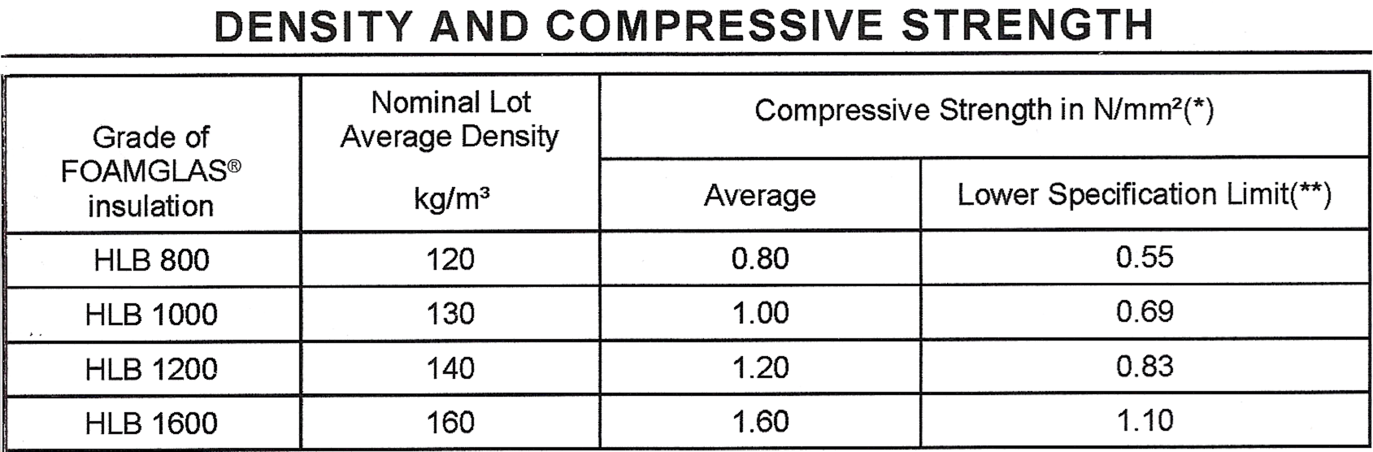

2.4 Cutting Cellular Glass or Foam Glass Insulation
Cellular glass or foam glass insulation can be easily cut and installed on site or is available pre-fabricated. Pre-fabricated segments include T-pieces, elbows, half pipe-shells, valve boxes, vessel domes, ends and cones. Cellular glass or foamed glass insulation can be easily cut on site using a hard-point saw.
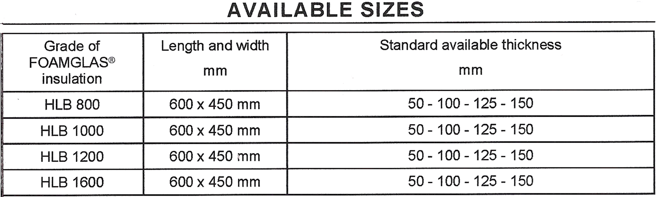

3.0 Health and Safety

Key Learning Points
- Health risks and safe handling techniques.
- Positive attitude to work place and safe disposal of waste.
- Reaction to fire of selected materials.

3.1 Health Risks Associated with Foamed Glass and Cellular Glass Insulation
- Inhalation: Dryness and irritation of the mucous membranes and respiratory tract.
- Prolonged Inhalation: Prolonged or repeated overexposure to airborne glass dust can lead to inflammation or scaring of lung tissue.
- Eyes: Irritation and inflammation of the mucous membrane, tearing, sensitivity to light.
- Skin: Irritation or abrasion from glass particles.
- Ingestion: Possible abrasion of mouth and throat from glass particles.

3.2 First aid Measures
- Inhalation: Move the exposed person to fresh air at once, apply artificial respiration if needed. Encourage the person to cough, spit out, and blow nose to remove dust. If the person has difficult breathing call for medical assistance at once.
- Skin contact: Wash the affected area thoroughly without applying pressure. If irritation persists or the skin is broken seek medical attention.
- Eye contact: Flush the eye with water or eye wash for 15 minutes, do not rub or apply pressure. If the irritation persists seek medical assistance.
- Ingestion: Do not induce vomiting, seek medical assistance at once.

3.3 Reaction to Fire
If foamed glass or cellular glass insulation is burnt it may release hydrogen sulphide and carbon monoxide gas. The small amounts of hydrogen sulphide and carbon monoxide released are not expected to contribute to the intensity of the fire. Wear self contained breathing apparatus and protective clothing. Foamed glass or cellular glass insulation can be extinguished using water, carbon dioxide or dry chemical fire extinguishers.

3.4 Handling and Storage
When cutting, grinding, crushing, or drilling foamed glass or cellular glass insulation, provide general or local ventilation systems, as needed, to maintain airborne dust concentrations below the regulatory limits. Local vacuum collection systems are preferred since it prevents the release of contaminants into the work area by controlling it at source.
- Handling: Avoid generation of dust. Wash hands before eating, drinking, smoking or using the toilet.
- Storage: If storing for long periods, protect the product from the weather.
- Hands: Wear gloves – rubber impregnated canvas – for abrasion protection.
- Eye protection: Wear safety glasses with side shields or dust goggles.
- Ventilation: Use local exhaust ventilation when cutting and use mechanical ventilation when crushing large volumes.
- Work area: Keep the work area clean at all times to avoid trip hazards due to materials left on the floor. Develop a positive attitude towards working with insulation products and know the risks involved.
- Information: Always refer to the manufacturer’s data sheets for information on health and safety and precautions required when using the product.

Summary
Cellular glass or foamed glass insulation is manufactured from crushed glass and carbon, is free from fibres and is environmentally sound. The all-glass, closed cell structure provides an un-matched combination of physical properties which are ideal for industrial piping and equipment. Cellular glass or foamed glass can be used above and below ground as it is resistant to water in both liquid and vapour form and is also noncorrosive. With its constant, and long term energy efficiency, foamed glass or cellular glass insulation provides low, predictable energy costs.

Castleforbes House
Castleforbes Road
Dublin 1

