TRADE OF
Industrial Insulation

PHASE 2

Module 5

Ductwork & Vessels

UNIT: 8

Moving Joints & Support Systems

Produced by

In cooperation with subject matter expert:

Michael Kelly

© SOLAS 2014
Table of Contents
Unit Objective 1
Introduction 2
1.0 Drawings and Works Specifications 3
1.1 Interpretation of a Works Specification 3
1.2 Interpretation of Works Drawings 3
1.3 Properties of Galvanised Steel 3
1.4 Cross Sections of Moving Joints 4
2.0 Moving Joints 5
2.1 Use of Moving Joints and Support Systems 5
2.2 Effects of Thermal Movement on Insulation and Cladding 7
2.3 Movement Absorbing Support Systems 8
2.4 Problems Associated with Moving Surfaces and Fixed Cladding 9
2.5 Loose Wool Packing 9
2.6 Thermal Expansion; Coefficient of Linear Expansion 10
Summary 11

Unit Objective
By the end of this unit each apprentice will be able to:
- Describe the principle and operation of moving joints.
- Read and interpret a works specification.
- Read and interpret a design drawing and specification.
Module 5
Ductwork & Vessels
Unit 1
Measuring: Ductwork & Other Large Areas
Unit 2
Rectangle to Round (Concentric)
Unit 3
Off-Centred Rectangle to Round
Unit 5
Offset (Duct) Rectangular
Unit 4
Radius Bend (Duct)
Unit 6
Hoppers (Rectangle to Rectangle)
Unit 7
Vessels: Storage & High Pressure
Unit 8
Moving Joints & Support Systems
Unit 9
Scale Drawing & Applications
Unit 10
Dressing Pieces
- Fabricate and fit a moving joint and support system to pipe-work.

Introduction
It is an accepted rule of physics that material, when subjected to a change of temperature, will expand or contract directly related to the temperature. Pipe-work is therefore subject to the same principle. There are a number of factors which must be taken into account when dealing with thermal expansion and contraction in a pipe-work system, the amount of temperature change, the overall length of pipe on which the calculations are to be based and the materials co-efficient of expansion.
Moving joints and supports systems are an extremely important part of any cladding system as they allow the materials to expand and contract without damage to the pipe-work or cladding system.

1.0 Drawings and Works Specifications

Key learning points:
- Interpretation of works specification
- Interpretation of works drawings
- Properties of galvanised steel
- Cross sections of moving joint drawings

1.1 Interpretation of a Works Specification
The following are extracts taken from a works specification dealing with expansion joints.
“Due to the difference in expansion coefficients of metals and insulating materials, necessary allowance should be made for the differential movements between the hot surface, the insulant and the finish. As a guide it is recommended that such allowances should be accommodated by expansion joints inserted at the intervals specified in the table below.”
Temperature ºC | Spacing intervals in metres
<200 | 5
200 to 300 | 4
300 to 400 | 3
>400 | 2

“The aluminium cladding circumference lap at expansion joints shall be 75mm. Screws shall not b located in the expansion joint lap area.”

1.2 Interpretation of Works Drawings
A vital part of job planning and works sequencing is understanding the works specification and interpreting the works drawings completely. Failure at this point in not fully understanding the task ahead can be disastrous. It is paramount that if a drawing or specification is unclear, that further information and clarification is sought from the engineer or architect.

1.3 Properties of Galvanised Steel
Galvanised steel is mild steel coated with zinc to give the mild steel very good corrosion resistance. Zinc is highly resistant to corrosion, and as long as it remains intact on the sheet, the mild steel will have a high level of corrosion resistance. However, if the zinc is damaged from scratching, welding or grinding, then the steel will be exposed and this portion of the sheet will rust through very quickly.
Of all the sheet steels, galvanised sheet steel is one of the least expensive. It is used extensively in the sheet metal industry for air-conditioning ductwork, roof flashings, tanks, signs etc. It is also widely used for cladding where its appearance, strength and resistance to corrosion are important factors.
It can be easily cut, bent, rolled, formed, lock-formed, punched and swaged without any damage to the zinc coating. Welding destroys the zinc coating and for this reason galvanised sheet metal is seldom used in applications requiring welded joints.

1.4 Cross Sections of Moving Joints
Refer to section 2.1.

2.0 Moving Joints

Key Learning Points
- Use of moving joints and support systems
- Thermal expansion; co-efficient of linear expansion
- Effects of thermal movement on insulation and cladding
- Movement absorbing support systems
- Flush jointing
- Loose wool packing
- Problems with moving surfaces and fixed cladding
- Fabricate and fit a moving joint

2.1 Use of Moving Joints and Support Systems
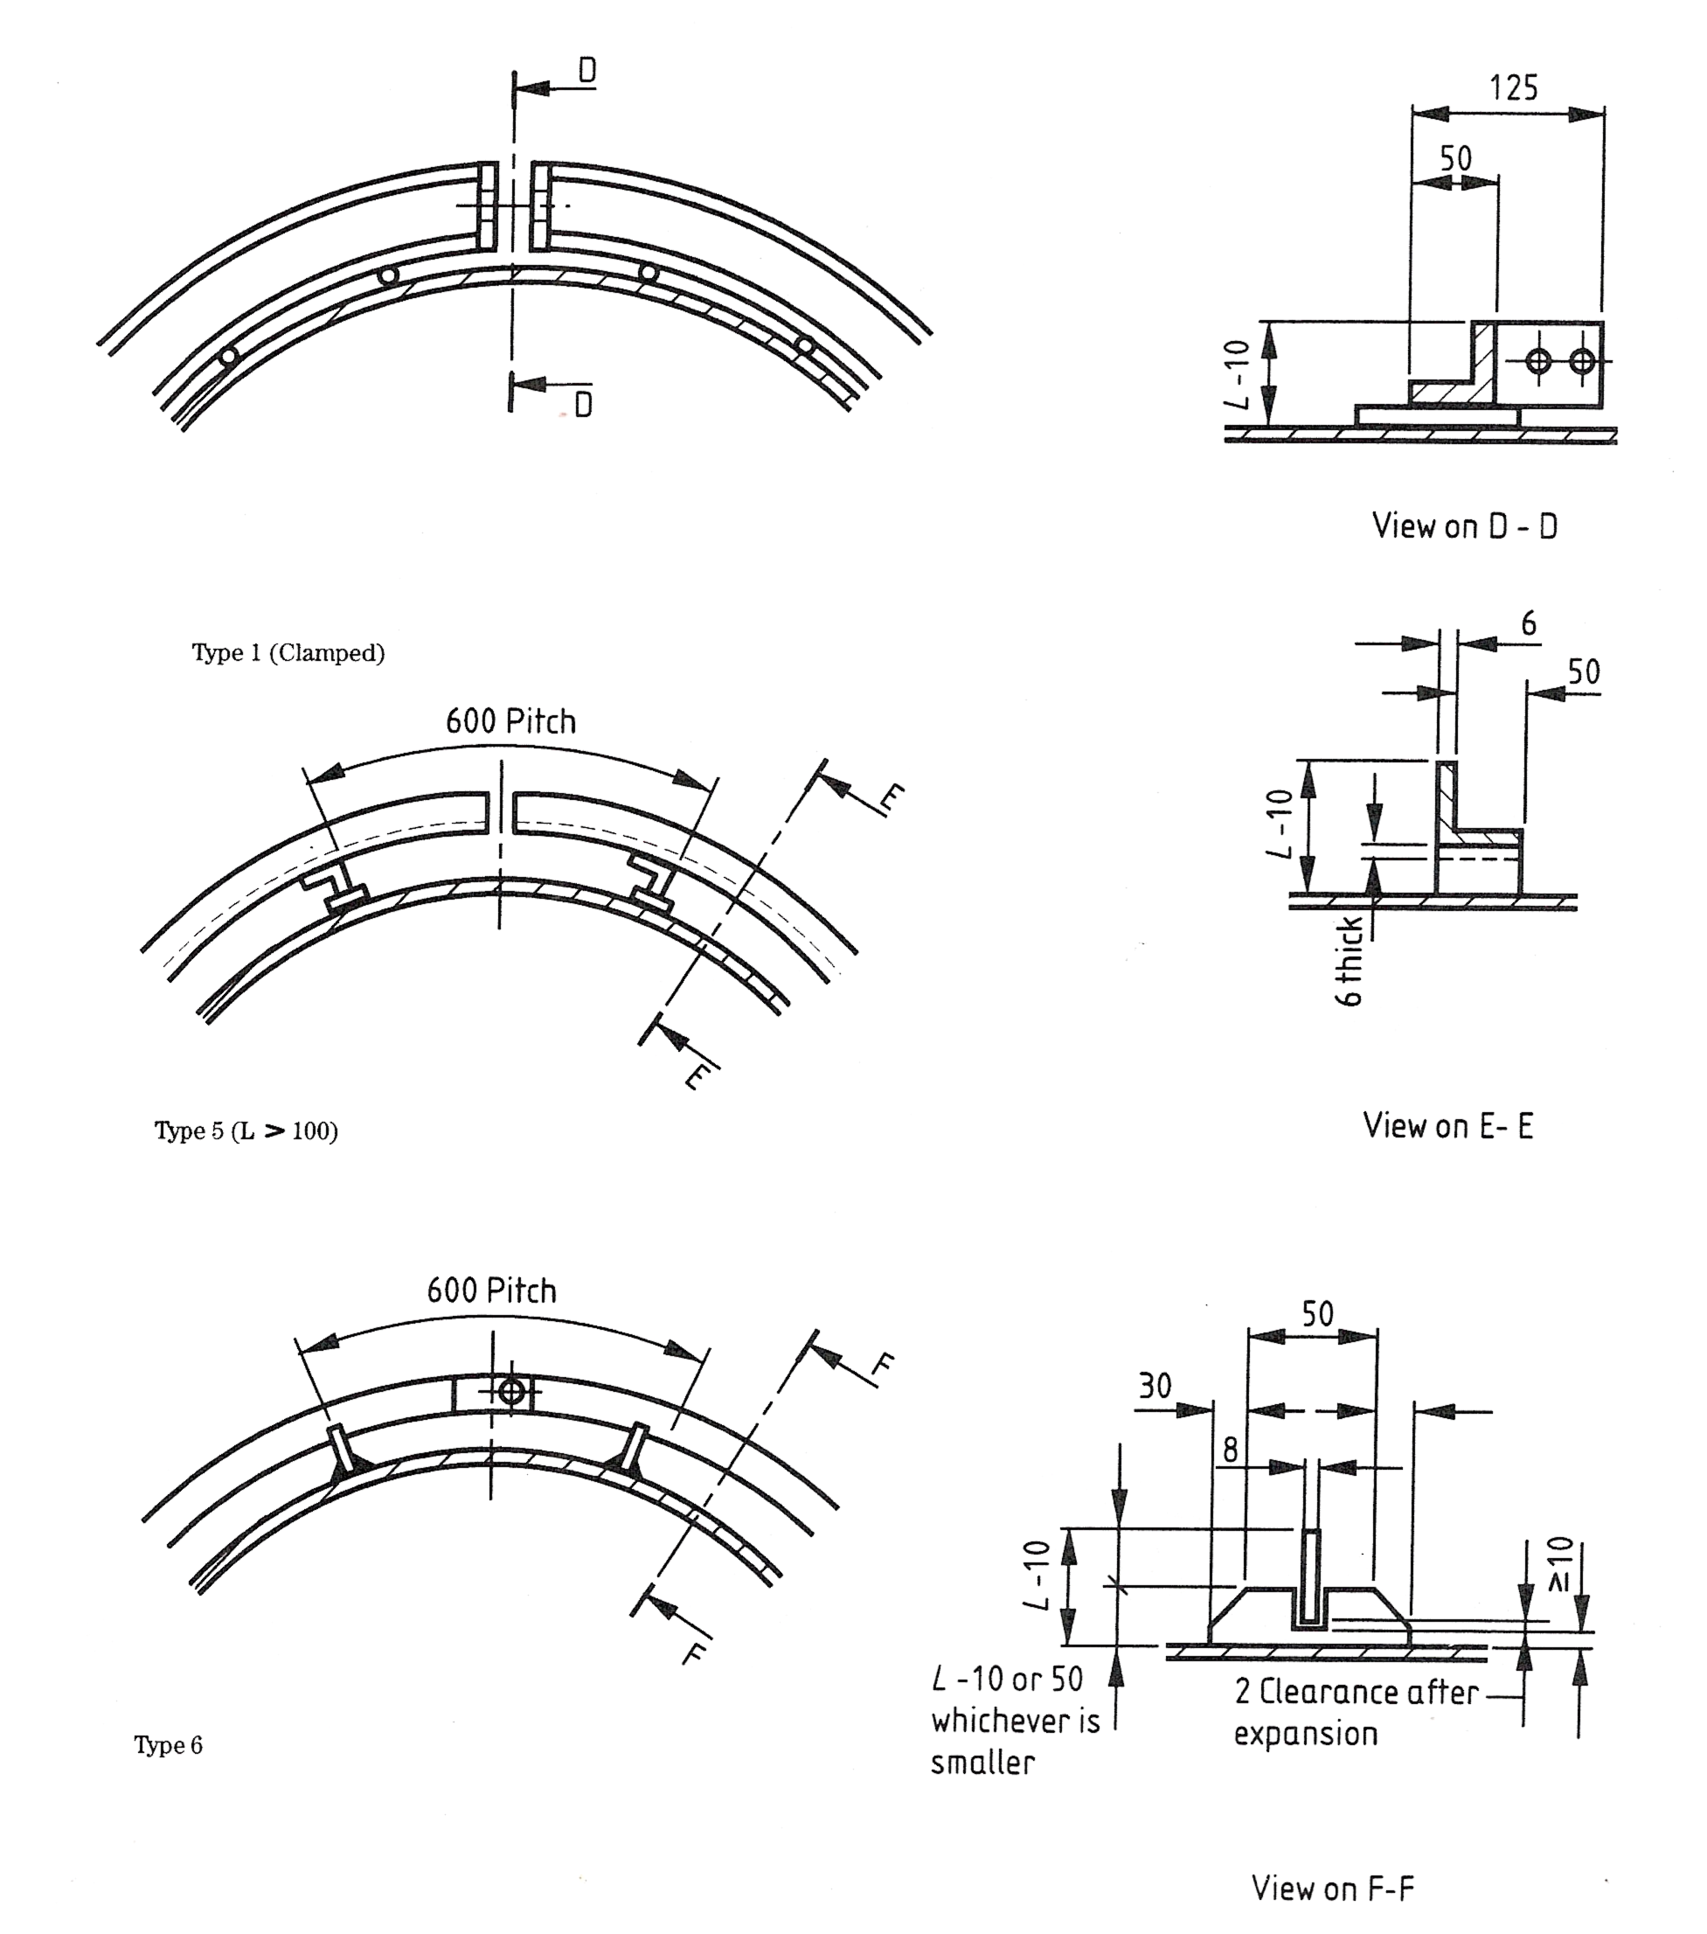
As mentioned in section 1.4, due to the difference in coefficients of metals and insulating materials, allowance should be made for the differential movements between the hot surface, the insulant and the finish. One of the ways in which this movement is allowed for is in the design of the support systems, for example in vessels where the angle rings or flat bar rings are designed to allow for expansion by having gaps in their circumference or a “slip-joint” as shown in the diagram below.
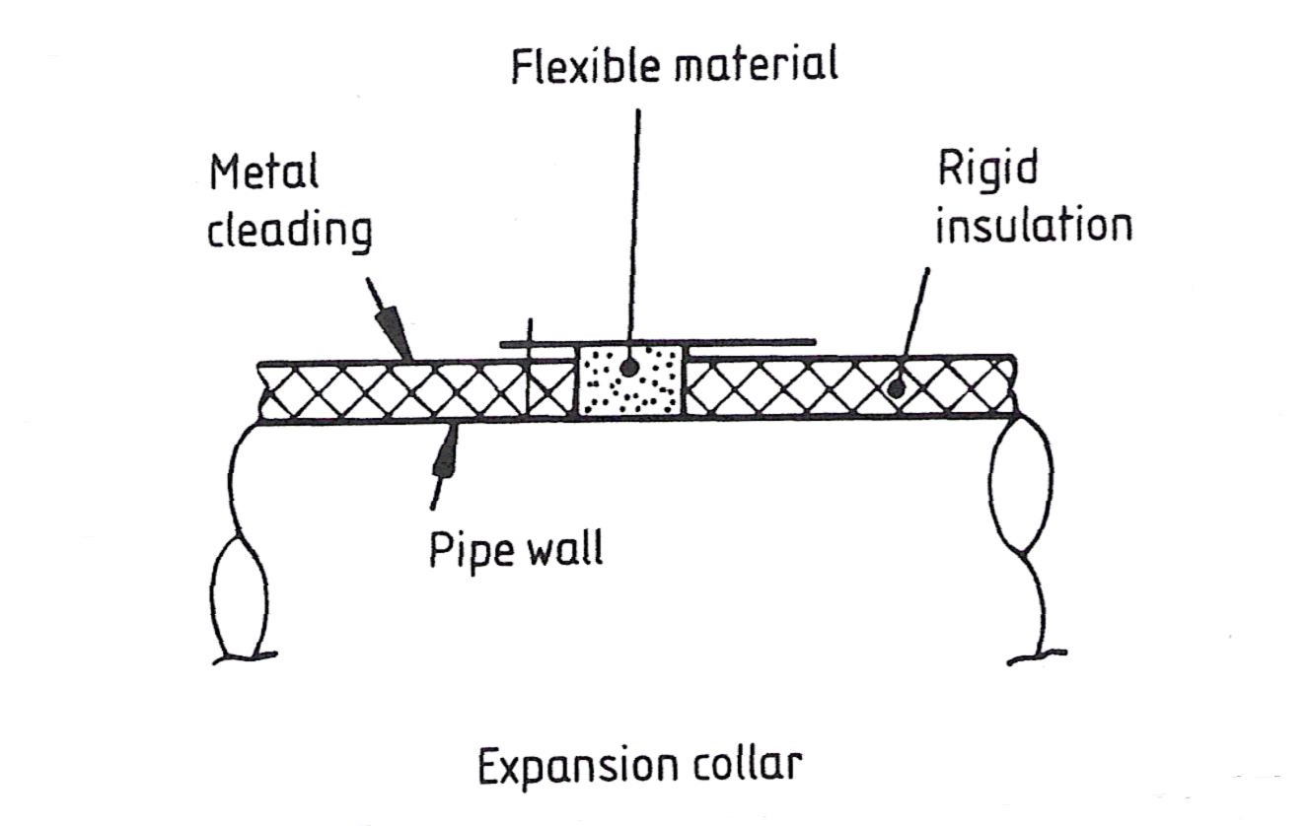
Another way to allow for this expansion is by having an expansion collar as shown:
Expansion joints for vertical and horizontal sheet metal cladding are shown below:
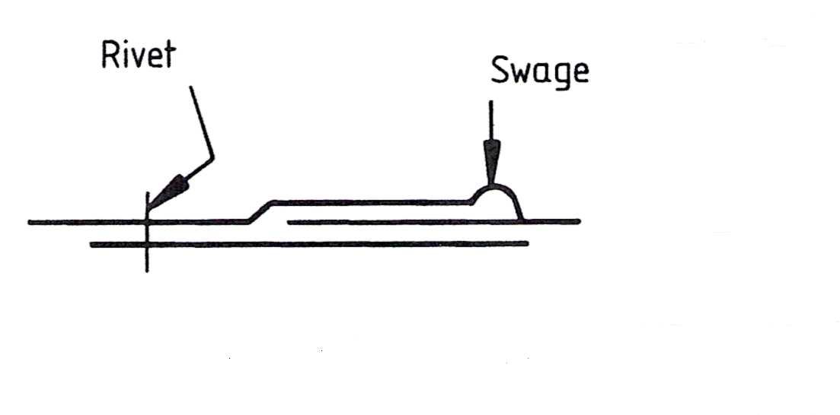
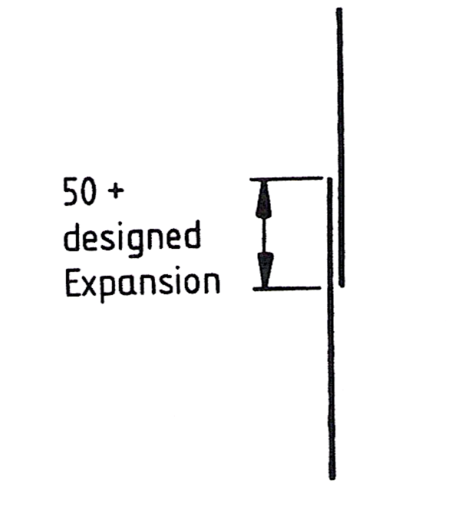
Expansion joint (horizontal)
Expansion joint (vertical)
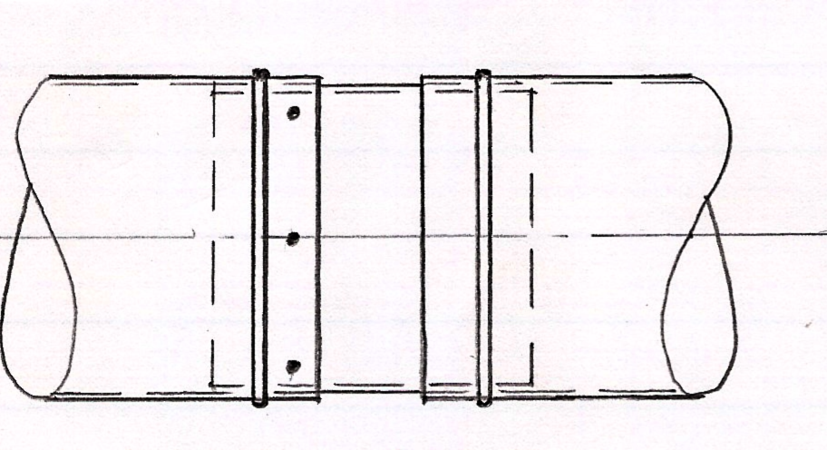
Flush joint
Refer to module 1 – unit 6 – Marking, cutting, punching, rolling, seam swaging and screwing to fabricate a flush joint.
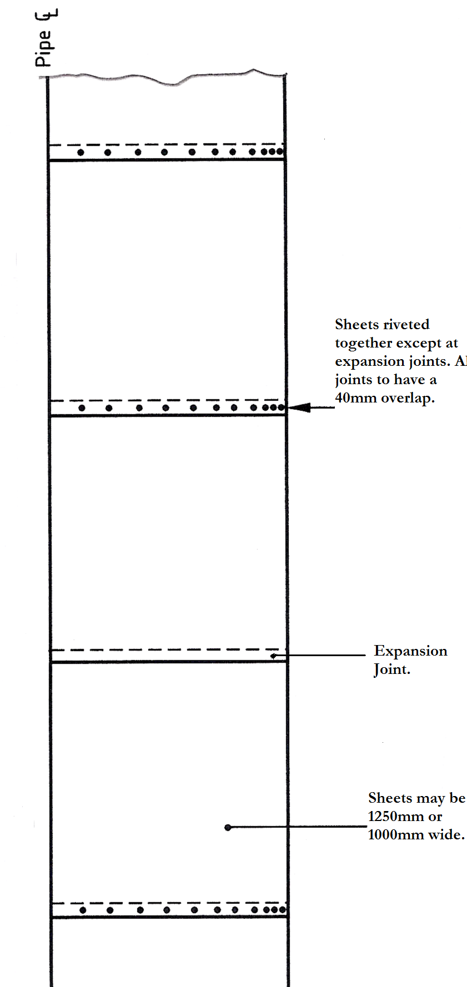
The diagram shows half the elevation of a vertical pipe section for a hot insulation system. One of the joints is not fixed so as to allow for expansion.

2.2 Effects of Thermal Movement on Insulation and Cladding
The effects of thermal movement on an insulation system should be designed into the “system” from the very start. Whether the insulation is to cover very hot or very cold pipe-work or equipment, allowance must be made for expansion or contraction so as to avoid future problems within the “system”.
The design of hot service insulation expansion joints and insulation supports are quite important. With pipe-work for example expanding so many millimetres per metre, and the insulation contracting at its own rate per metre, the total rate of expansion and contraction over a long length could be substantial.
In cold insulation design, contraction joints are just as important as expansion joints are in hot insulation. As the system will have a low operating temperature, the pipe-work will contract so much per metre of length and depending upon the type of insulation being used, this will contract at its own rate as well.
This all adds up to a situation whereby if expansion and contracting joints are not built into the “system” from the design stage, thermal movement will result in possible tearing of the insulation and finishing materials.

2.3 Movement Absorbing Support Systems
As mentioned in unit 8 – section 2.1, insulation and cladding support systems used on vessels for example in the form of angle rings or flat bar rings are designed to allow for expansion by having gaps in their circumference or a “slip-joint” arrangement.
In the case of expansion support systems that allow movement in pipe-work, these can take a number of forms:
- Expansion bellows (axial, angular, lateral).
- Flexible hose or pipe.
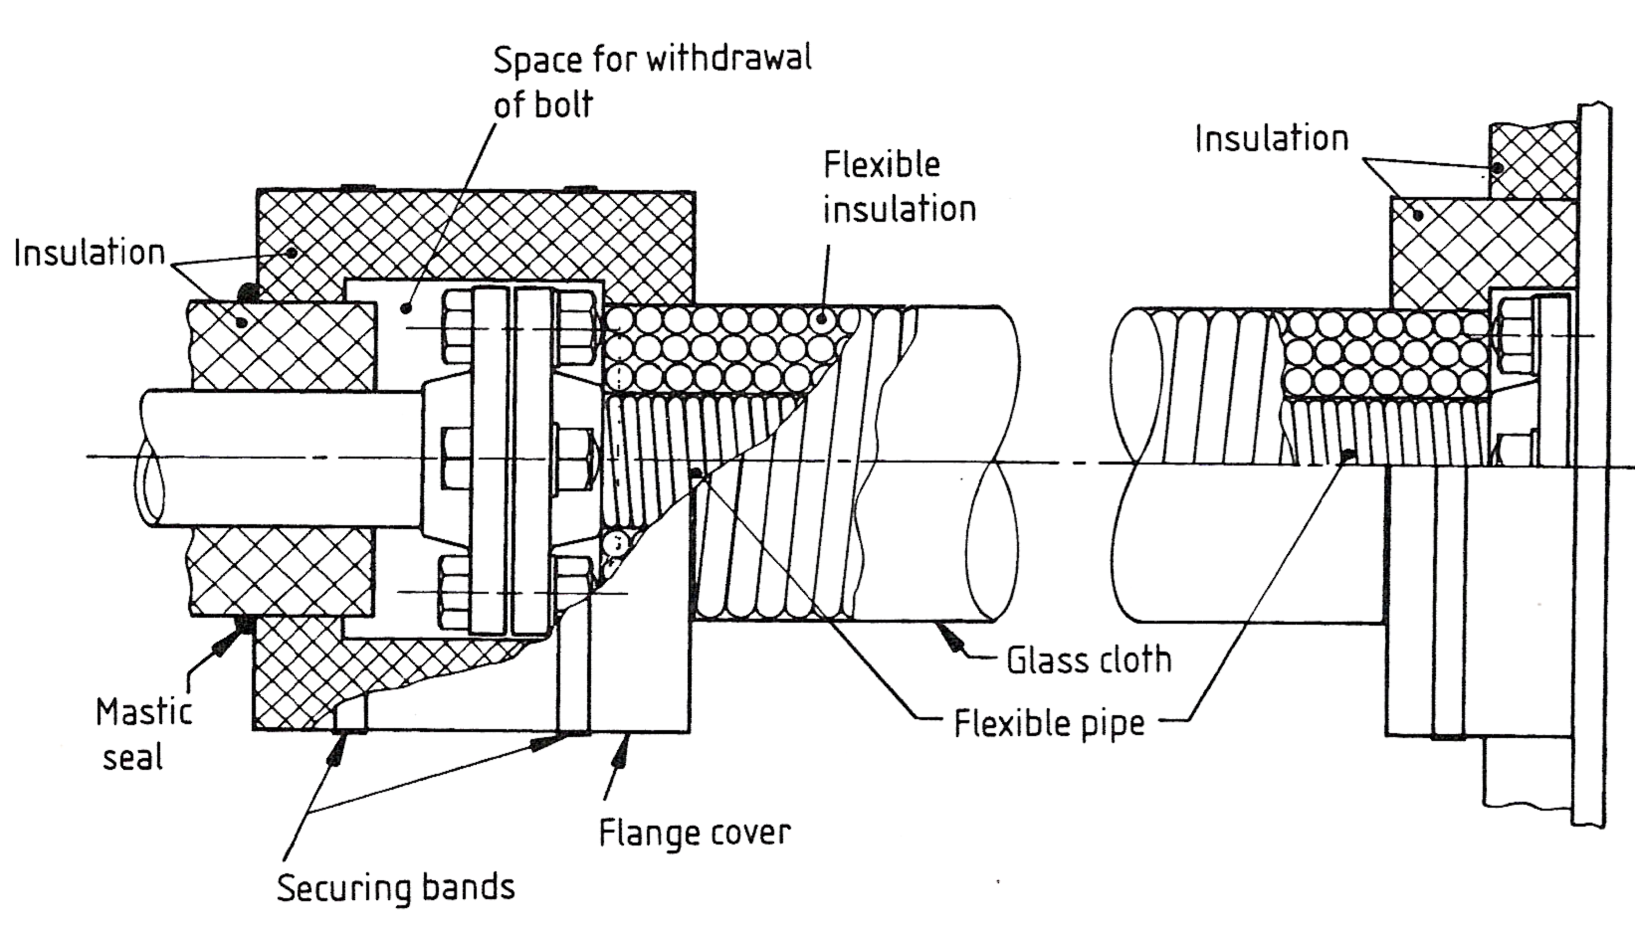
- Pipe-work brackets.
Typical method of insulating flexible pipe.
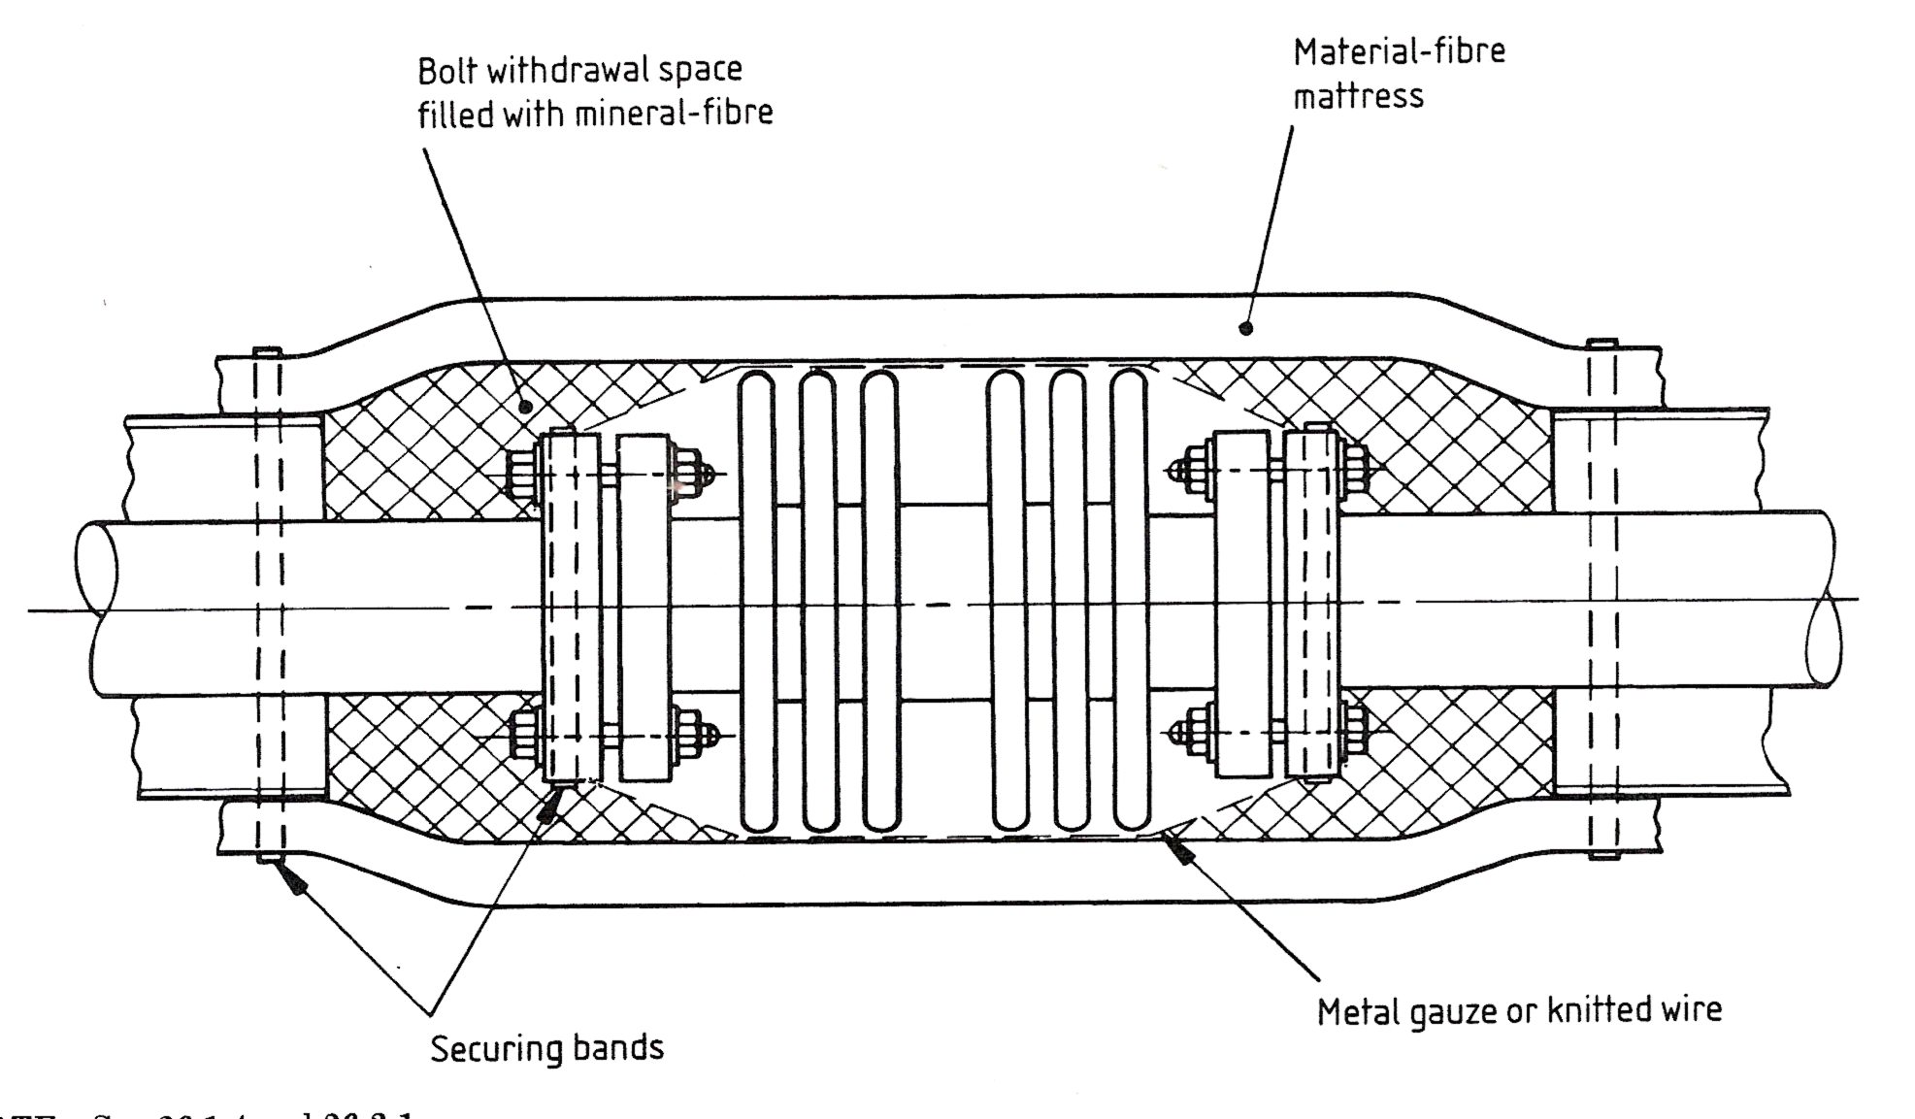
Typical method of insulating expansion bellows.

2.4 Problems Associated with Moving Surfaces and Fixed Cladding
Due to thermal movement in pipe-work and thermal insulation systems in general, problems can arise between moving surfaces and fixed cladding. These problems arise because inadequate provision has being made for expansion and contraction within the pipe-work system. Some of the problems which may occur are:
- Tearing of insulation and cladding leading to leaks and ingress of water. His could lead on to corrosion of pipe-work and equipment with possible detrimental effects.
- Breakdown of sealant material at joints from constant expansion and contraction of the pipe-work system. Proper sealant should be used to accommodate a certain amount of thermal movement.
- Ribbed or corrugated cladding can help to overcome some of the problems of expansion. Because of their design they can flex like an accordion to absorb cross-wise expansion or contraction.
- Problems occur where fasteners hold joints together. Due to expansion and contraction, fatigue usually opens joints or elongates fastener holes over time leading to the breakdown of joints and the ingress of moisture.

2.5 Loose Wool Packing
Loose mineral rockwool is available in normal bulk density from 50kg/m³ to 150 kg/m³ with an approximate operating temperature of 850ºC. Loose wool is used to insulate surfaces that are hard to insulate with other mineral rockwool products, i.e. that are hard to reach, uneven, cavities, voids on top of vessels with curved heads. Loose wool should be placed between two surfaces by kneading and squeezing tightly to get good compaction.

2.6 Thermal Expansion; Coefficient of Linear Expansion
It is an accepted rule of physics that material, when subjected to a change of temperature, will expand or contract directly related to the temperature. Pipe-work is therefore subject to the same principle.
The coefficient of thermal expansion describes how the size of an object changes with a change in temperature. Specifically, it measures the fractional change in size per degree change in temperature at a constant pressure. Several types of coefficients have been developed: volumentric, area, and linear. Which is used depends on the particular application and which dimensions are considered important. For solids, one might only be concerned with the change along a length, or over some area.
If a bar of steel is heated uniformly in a furnace it will expand naturally in all directions if it is not restrained in any way. If allowed to cool evenly and without restraint, it contracts to its original shape and size without distortion. If the original dimensions, the rise in temperature, and the expansion of the metal block are measure, it will be found that they are related to each other. Thus, for a given metal:
- (a) The expansion is proportional to the rise in temperature.
- (b) The expansion is proportional to the original size of the component.
Expressed mathematically this gives the formula:
x = l α t
where:
X = increase in size
L = original length
α = coefficient of linear expansion
t = rise in temperature

Example
A straight length of copper pipeline measures 30 metres at room temperature (15ºC). After hot water has been passing through it for some considerable time, its temperature is raised to 60 ºC. Calculate its increase in length.

Solution
X = l α t
= 30 x 0.000017 x (60-15)
= 30 x 0.000017 x 45
= 0.02295 metres =22.95mm
Increased length = 22.95mm

Summary
The coefficient of thermal expansion describes how the size of an object changes with a change in temperature. Specifically, it measures the fractional change in size per degree change in temperature at a constant pressure. Several types of coefficients have been developed: volumentric, area, and linear. Which is used depends on the particular application and which dimensions are considered important.
Due to thermal movement in pipe-work and thermal insulation systems in general, problems can arise between moving surfaces and fixed cladding. These problems arise because inadequate provision has being made for expansion and contraction within the pipe-work system.
Moving joints and support systems form an integral part of the overall pipe-work, insulation and cladding system. Without the adequate provision of moving joints and supports, a lot of damage can be done including tearing of the insulation and cladding, breakdown of sealed joints and rupture of joints in the pipe-work system.

Castleforbes House
Castleforbes Road
Dublin 1

