TRADE OF
Industrial Insulation

PHASE 2

Module 6

Substructures, Advanced Cold Work and Cladding

UNIT: 4

Substructure & Support Systems

Produced by

In cooperation with subject matter expert:

Michael Kelly

© SOLAS 2014
Table of Contents
Introduction 1
Unit Objective 2
1.0 Measuring and Sketching 3
1.1 Measurement of Vessels for Substructure and Support Systems 3
1.2 Sketching/Drawing of Support Structures 3
1.3 Calculation of Material Requirements 3
1.4 BS 5970: 2001 3
2.0 Fabrication and Attachment of Substructure and Support Systems 5
2.1 Substructure and Support Systems Design 5
2.2 Methods Used to Attach Substructures and Support Systems to Vessels 5
2.3 Selection of Suitable Material for Substructures 5
2.4 Fabrication Equipment for Manufacturing Substructure and Support Systems 5
2.5 Fabricating a Support Ring 7
2.6 Tapping 10
2.7 Aesthetic Appearance of the Finished Structure 11
3.0 Health and Safety 12
3.1 Safe Handling of Materials for Substructure and Support Systems Fabrication 12
3.2 Use of Personnel Protective Equipment 12
Summary 13

Introduction
Substructures and support systems are used to attach and take the load of insulation and cladding systems which are installed around large vessels and tanks. These substructures and support systems are generally manufactured with flat bar, round bar and angle iron and from either mild steel of stainless steel depending on the application.
Module 6
Insulating & Cladding the Training Rig
Unti 1
Measuring the Training Rig
Unit 2
Measuring the Training Rig
Unit 3
Insulation of the Training Rig (Hot & Cold Work)
Unit 5
Cladding of Training Rig
Unit 4
Substructure & Support Systems

Unit Objective
By the end of this unit each apprentice will be able to:
- Select suitable materials to construct substructures and support systems.
- Fabricate and construct substructures and support systems for securing insulation materials to vessels.
- Attach substructures and support systems to vessels.

1.0 Measuring and Sketching

Key Learning Points
- Measurement of vessel for substructure and support systems
- Sketching/drawing of support structures
- Calculation of material requirements

1.1 Measurement of Vessels for Substructure and Support Systems
Refer to Module 5 – Unit 7 – section 1.5.

1.2 Sketching/Drawing of Support Structures
Refer to Module 5 – Unit 7 – section 3.4.

1.3 Calculation of Material Requirements
For calculating the material requirements for the substructure on a cylindrical vessel, firstly calculate the diameter of the tank. This can be done as suggested in module 5 – unit7 – section 1.5, 2.2, 2.3 and 2.4.
After deciding on the design, list how many rings/supports will be required for the job. Next work out the material required and calculate the lengths of round bar, flat bar or angle etc. that will be needed to fabricate the supports. A detailed drawing or sketch will be useful at this stage because you can measure and calculate accurately how much material will be required. Consult with the steel suppliers regarding the available lengths of angle, flat and round bar sections this will tell then you how many lengths you will require (divide your overall lengths by the standard supplied length of steel section required).The 10% rule for cutting and wastage should be added to your calculations.

1.4 BS 5970: 2001
For thermal insulation of pipe-work and equipment in the temperature range of -100ºC to + 870ºC, BS 5970:2001 is a very important document and code of practice to have. The code explains the basic principles that should be followed in selecting insulating systems for special requirements. This document is not a specification but it offers recommendations. This code does not, however, take precedence over a specification for a particular contract. BS 5970:2001 offers recommendations on some of the following:
- Factors affecting planning and programming control of work on site.
- Typical characteristics of insulating materials and systems.
- Selection of thermal insulating materials, securing materials, vapour barriers and finishing materials.
- Provision of storage space, protection and safety during storage.
- Observance of site safety and security regulations.
- Clearing materials from site.
- Health considerations.
- Surface preparation and accessories.
- Cold and hot insulation.
- Indoor finishes and their methods of application.
- Weather resistant finishes.
- Design considerations.
As this document is a very important code of practice, its contents should be read and studied by all concerned within your company.

2.0 Fabrication and Attachment of Substructure and Support Systems

Key Learning Points
- Methods used to attach substructures to vessels
- Methods used to attach support systems to vessels
- Substructure and support system designs
- Forming of mid steel – cutting, bending, drilling and tapping
- Selection of suitable material for substructures
- Fabrication of substructures and support systems
- Attachment of substructures to vessels
- Aesthetic appearance to the finished structure

2.1 Substructure and Support Systems Design
Refer to module 5 – unit 7 – section 3.4.

2.2 Methods Used to Attach Substructures and Support Systems to Vessels
Refer to module 5 – unit 7 – section 3.4.

2.3 Selection of Suitable Material for Substructures
Refer to module 5 – unit 7 – section 3.4.

2.4 Fabrication Equipment for Manufacturing Substructure and Support Systems
As can be seen in module 5 – unit7 – section 3.4 , substructure and support systems come in various designs and materials such as mild steel flat bar, round bar and angle iron. If the material to be used is light gauge, then the equipment in the sheet metal workshop can be used. However if heavier sections such as angle iron and round bar need to be rolled and welded then heavier fabrication equipment will be needed.
The following are some of the machines required to fabricate typical insulation supports used in vessel work:

(1) Universal Steel Shearing Machine
In most fabrication shops, cutting operations on rolled steel sections are carried out on power machines. Machines are available which perform a combination of cutting operations, such as punching, shearing and notching, the shearing operations including not only section shearing, but round and square bar cropping, and plate shearing. Angle section has to be notched in order to permit it to be bent, and most of the notches are of the “Vee”- notch or square notch type. All of these processes can be carried out on a universal steel shearing machine.

(2) Portable Grinding Machines
Portable grinding machines are often used for smoothing down welded joints and seams in fabrication work. When fitted with cutting discs, they can be used for various cutting operations. Safety is paramount when using portable grinding machines. A lot of sparks are given off from these machines during the cutting and grinding processes and extreme care must be taken to ensure that these sparks do not ignite liquids or other materials which may be in the area.
Angle grinders must never be used without their safety guards. Protective goggles or a face shield must be worn at all times. Ear protection should also be worn. Always wait until the disc has stopped rotating before placing the grinder down on a bench. Never try to stop the disc rotating by placing it face down on a bench as this will damage the disc and possibly cause it to shatter.
Other machinery that may be needed from time to time for fabricating heavier substructures could include for example:
- Plate-rolling machine.
- Abrasive wheel cutting off machine.
- Manual metal arc (MMA and metal inert gas (MIG) welding equipment.
- Pedestal drilling machine.
- Press brake.
- Guillotine.

(3) Angle-Ring Bending Rolls
An angle ring-bending roll consists of three rollers arranged in triangular formation. Ach roller can be split into two sections to take the flat flanges of angles or channels as they are been bent.
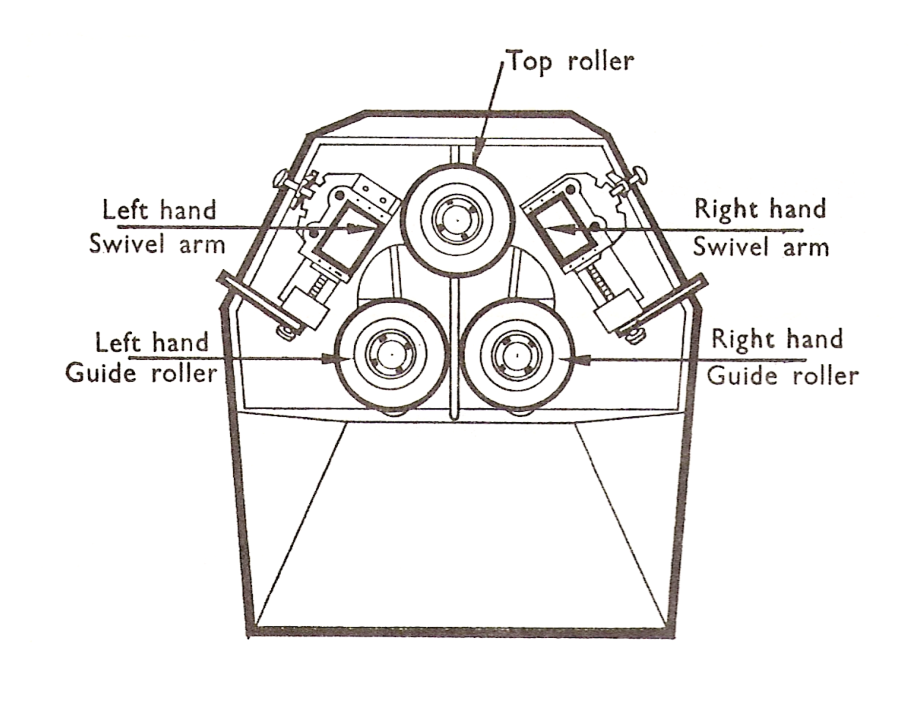
When bending an outside ring, the flat flange of the angle is adjusted in the slots of the two rollers, and for an inside ring the flat flange is adjusted in the slot of the single central roller. “Tee” sections may also be formed on these machines. Pressure is exerted, during rolling, by a screw arrangement which moves the central roller towards the gap between the other two rollers.

2.5 Fabricating a Support Ring
The following procedures should be carried out when fabricating a support ring as part of the substructure and support system.

(1) Safety
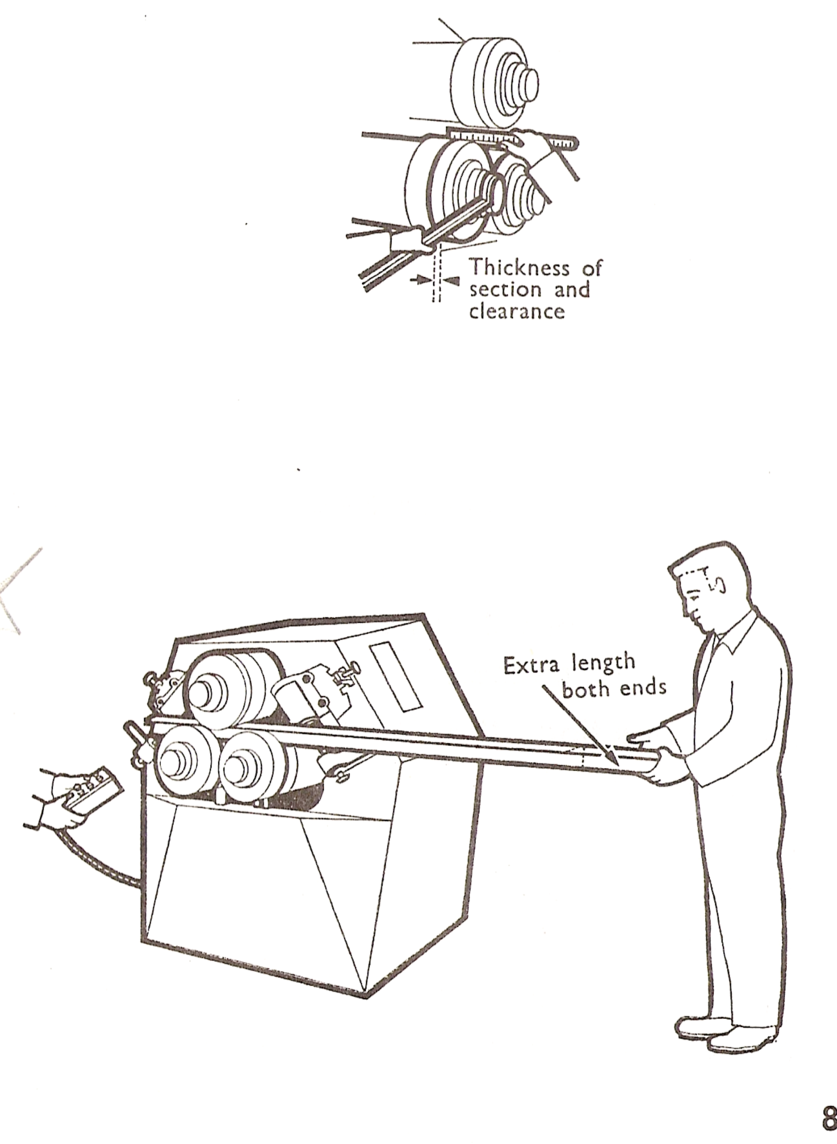
Before using the ring bending machine, its safe operation must be fully understood. Note the position of any emergency stop switches or methods of immobilisation.

(2) Setting the Machine Prior to Initial Bending

- Set the gap between the guide rollers to suit the thickness of the angle section to be bent, using a “C” spanner.
- Operate the swivel arm controls to suit the initial rolling radius.
- Push and hold the button on the control box to adjust the guide roller to suit the initial rolling diameter. Release the button.

(3) Positioning the Angle Section for Initial Rolling
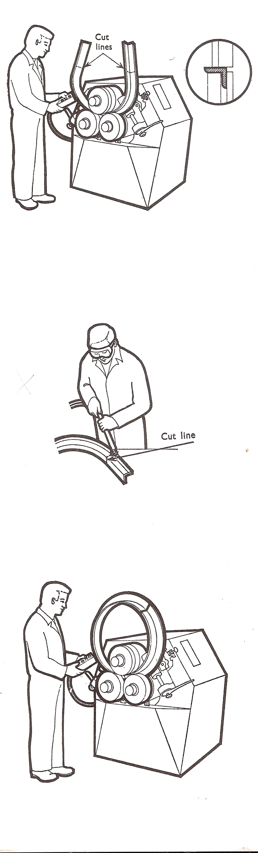
Push the angle section through one end of the machine and between the rollers.

(4) Bending the Angle Section to the Initial Radius
- Push the button on the control box to start the drive motor.
- Push and hold the “forward” button on the control box. Release the button before the end of the angle section passes through the rollers.
- Push and hold the “reverse” button on the control box. Release the button before the end of the angle section passes through the rollers.
- Safety – Ensure that both sides of the machine are clear of people before operating the drive.

(5) Cutting the Extra Material at Both Ends of the Angle
- Remove the angle section from the machine and position for cutting.
- Cut the excess angle off using the grinder or cutting torch.
- Allow to cool and dress if necessary.

(6) Bending the Angle Section to the Final Diameter
- Set the swivel arms and guide rollers to the final diameter.
- Re-position the angle section in the machine.
- Operate the machine as previously described to bend the angle section to its final diameter.
- Remove the formed ring from the machine and check for diameter and flatness.

2.6 Tapping
These are used for cutting internal threads. There are three taps to a set as shown in the diagram.
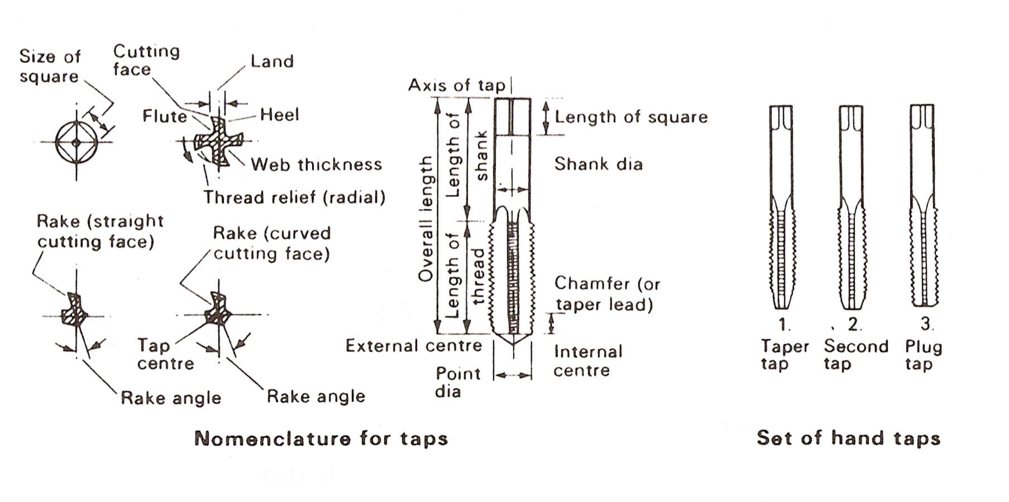
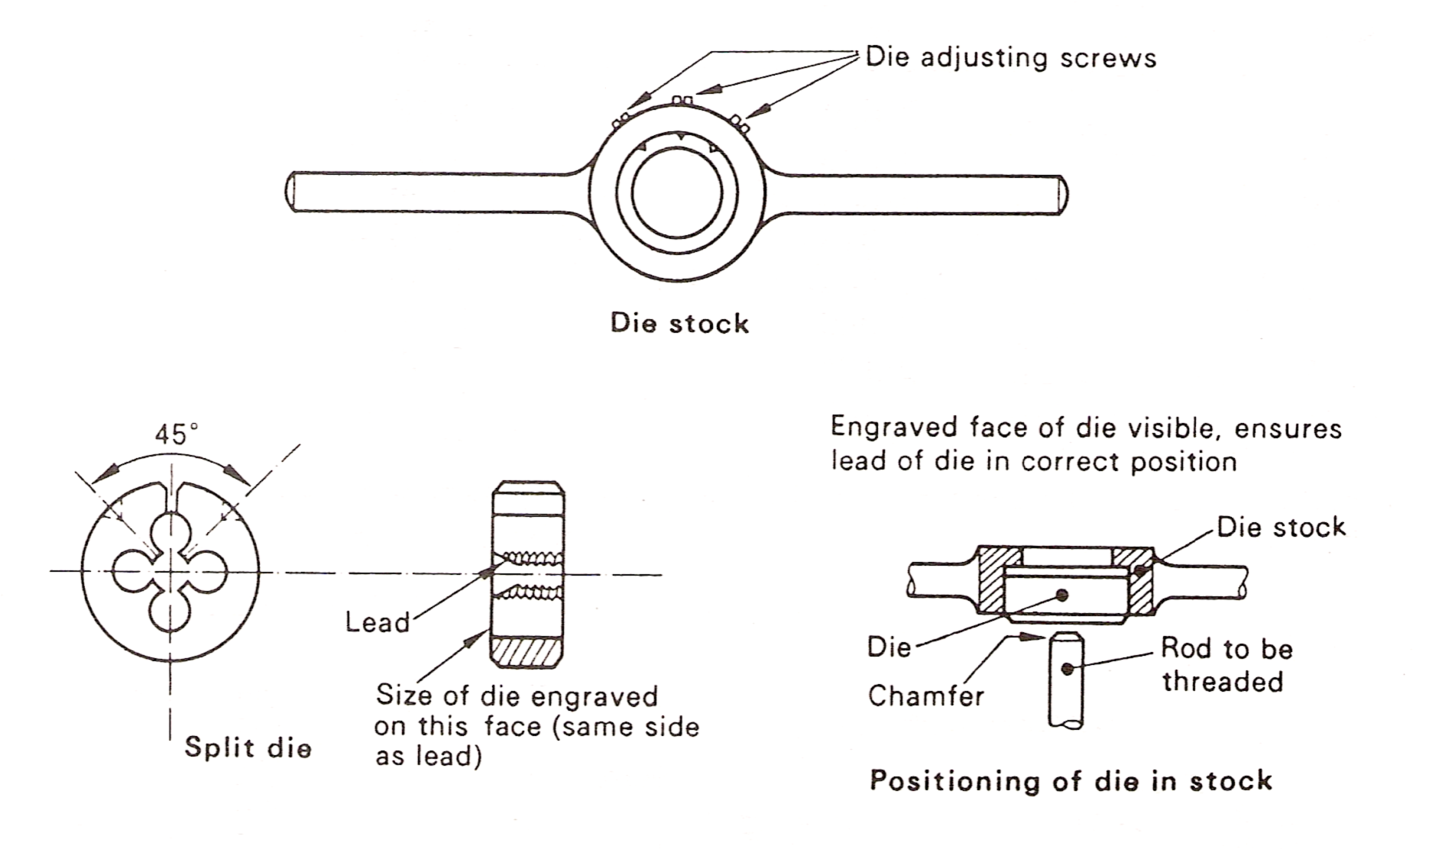
The tap is rotated by a tap wrench. This should be selected to suit the size of the tap. Too small a tap wrench results in excessive force being used to turn the tap. Too large a tap results in a lack of “feel”. In either case there is a lack of proper control that will result in a broken tap. The figure below shows a selection of tap wrenches.

2.7 Aesthetic Appearance of the Finished Structure
It is a very important part of the insulation job that the substructure assembly is well fabricated, accurately fitted and is pleasing to the eye. This is accomplished by accurate measuring of the vessel, designing a proper substructure, accurate marking out, bending, rolling, drilling and tapping if required. The parts can then be assembled by welding or bolting to pre-positioned lugs on the vessel. It is worth noting that no welding should take place on the vessel without prior permission from the designer/ engineer or owner. It is preferred that all attaching lugs and fixing points be welded on during construction of the vessel.
When the substructure has been fitted to the vessel to the correct dimensions to suit the lagging and cladding, it can be painted if required. It is important that expansion joints are built into the substructure to avoid tearing and damage to the cladding later on. The overall substructure should be neatly fabricated, fitted correctly and achieve the purpose for which it is intended.
Refer to module 5 – unit 7 – section 3.4.

3.0 Health and Safety

Key Learning Points
- Health and safety

3.1 Safe Handling of Materials for Substructure and Support Systems Fabrication
When using machinery to manufacture the substructure and support systems mentioned earlier, it is very important that machinery is operated in a safe manner. Before using any of the machines make sure their safe operation is fully understood. Note the position of any emergency stop switches or methods of immobilisation, and make sure that all safety guards are in place before use.
When cutting, drilling, bending or rolling, make sure that materials such as flat bar and angle iron are fully held and supported when machines are been used. Personnel protective should be worn at all times. Be careful when wearing gloves and using the power rolling machine as the gloves and your hands can very easily get caught and pulled into the machine.
When carrying the metal sections in the workshop or on site make sure to use the proper manual handling techniques to avoid back injury.

3.2 Use of Personnel Protective Equipment
As mentioned in section 3.1 above, overalls, safety boots, safety goggles and ear protection should always be used when fabricating the substructure and support systems. If welding is involved make sure a suitable welding shield is used as well as having proper local ventilation to remove fumes from the area.

Summary
Substructures and support systems unless otherwise recommended, are only supports for insulation and cladding, and should only bear relatively light loads. They can consist of flat bar, round bar and angle iron in various lengths and are generally connected to a vessel or tank using metal studs or fastening points pre-welded to the vessel or tank. On large diameter vessels, direct support for the cladding from the vessel is recommended to accommodate wind loading considerations.
Substructure and support systems come in various designs and materials such as mild steel flat bar, round bar and angle iron. If the material to be used is light gauge, then the equipment in the sheet metal workshop can be used. However if heavier sections such as angle iron and round bar need to be rolled and welded then heavier fabrication equipment will be needed.
When using machinery to manufacture the substructure and support systems, it is very important that machinery is operated in a safe manner. Before using any of the machines make sure their safe operation is fully understood. Personnel protective should be worn at all times, and be aware of using gloves when using a powered rolling machine as lose gloves can get caught in the machine very easily.
It is a very important part of the insulation job that the substructure assembly is well fabricated, accurately fitted and is pleasing to the eye. This is accomplished by accurate measuring of the vessel, designing a proper substructure, accurate marking out, bending, rolling, drilling and tapping if required. The accuracy of the substructure and support systems will ultimately affect the overall appearance of the finished cladding job.

Castleforbes House
Castleforbes Road
Dublin 1

