Trade of Metal Fabrication
Module 1: | Basic Fabrication
Unit 15: | Electricity
 | Phase 2

Table of Contents
List of Figures 5
List of Tables 6
Document Release History 7
Module 1 – Basic Fabrication 8
Unit 15 – Electricity 8
Learning Outcome: 8
Key Learning Points: 8
Training Resources: 9
Exercise: 9
Key Learning Points Code: 9
The Simple Electrical Circuit 10
Source of Electricity 11
Conductors and Insulators 12
Conductor 12
Insulator 12
Use of Insulating Materials for Different Purposes 14
Well-Known Insulating Materials and Their Uses 14
Supply Systems 16
Two-Wire D.C. Supply System 16
Two-Wire A.C. Supply System (single phase) 16
Three-Phase Supply Systems 17
Three-Phase A.C. Three-Wire System 17
Three-Phase A.C. Four-Wire System 17
Line Voltage and Line-to-Neutral Voltage 17
Earthing 18
Resistance (Resistors) 20
Types of Welding Plant 21
Direct Current (D.C.) 21
Alternating Current (A.C.) 22
Effect of Short Circuiting 22
Electrical Hazards 23
Personal Safety 23
Protection of Life and Property 23
How a Person May Receive an Electric Shock 23
Procedure in Case of Electric Shock 24
Self Assessment 25
Questions on Background Notes – Module 1.Unit 15 25
Answers to Questions 1-6. Module 1.Unit 15 27
Index 30

List of Figures
Figure 1 - Simple Electric Circuit 10
Figure 2 - Flash Light / Motor Car Battery 11
Figure 3 - Motor Car Generator / Bicycle Dynamo 11
Figure 4 - Two Core Flexible Cable 12
Figure 5 - Electric Plughead 12
Figure 6 - Electric Lamp 13
Figure 7 - Electric Lamp Holder 13
Figure 8 - Insulated Handle (PVC) 14
Figure 9 - Insulated Handle (Plastic) 14
Figure 10 - Armature of D.C. Generator or D.C. Motor 14
Figure 11 - Plastic Light Switch 14
Figure 12 - Plastic Ceiling Rose 14
Figure 13 - 3-Core PVC Sheathed Cable 15
Figure 14 - 3 Core Mineral-Insulated Copper-Sheathed Cable 15
Figure 15 - Terminating Conduit 15
Figure 16 - Electric Drill Not Earthed 18
Figure 17 - Electric Drill Is Earthed 19
Figure 18 - Resistor Symbol 20

List of Tables
Table 1 - Materials Used as Conductors and Insulators 13

Document Release History
Date | Version | Comments
01/09/06 | First draft
13/12/13 | SOLAS transfer

Module 1 – Basic Fabrication

Unit 15 – Electricity
Duration – 4 Hours

Learning Outcome:
By the end of this unit each apprentice will be able to:
- Describe the differences in phases used in the supply of power
- Explain the need for earthing. Fuses and E.L.C.B.
- Describe the disadvantages and advantages of D.C. and A.C. supply
- State the reason for transformers and their uses in metal fabrication
- Describe the different types of insulators used. Identify good and bad conductors

Key Learning Points:
Rk Sc | Single phase to three phase power.
Rk Sc | The flow of current in A.C. and D.C. – advantage and disadvantage.
Rk Sc | Short circuits, earth leakage, circuits breakers and fuses. Why all metal clad equipment needs earthing.
Rk | Conductors, resistors and insulators of electricity.
H | First aid for electric shock, electric fires, safety standards.
P | Communication – safe work practices and attitudes.

Training Resources:
Longman craft studies series.
Basic Engineering – R.L. Timings – Notes and Handouts.

Exercise:
Questions and answers.

Key Learning Points Code:
M = Maths D= Drawing RK = Related Knowledge Sc = Science
P = Personal Skills Sk = Skill H = Hazards

The Simple Electrical Circuit
An electric circuit is an unbroken path around which current can flow.
An electric circuit consists of:
(a) A source of electricity providing the electric current;
(b) One or more appliances or devices which consume the current. The appliance or device is referred to as a load;
(c) Means of conducting the current between the source and the load.

A simple example of an electric circuit is shown in the top diagram, the battery being the source, an electric lamp the consuming appliance and the copper wires forming the conducting path.

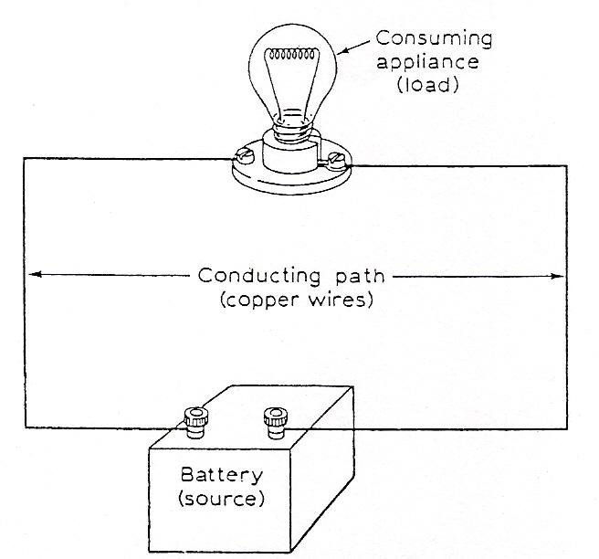
Figure 1 - Simple Electric Circuit

Source of Electricity
This is required in order to push the electrons around the conducting wire and through the load. The source of electricity provides the force causing electron motion and this is called electromotive force (abbreviation e.m.f.). The unit of e.m.f. is the volt.
Well-known sources of electricity are batteries, such as those found in flash-lights, radios and motor cars. Electricity is produced in them by chemical means. A battery is a collection of cells, but very often a single cell is referred to as a battery. Cells will be studied in the supplementary book on electricity.
Two more well-known sources of electricity are generators (dynamos) such as those used on bicycles and motor cars. These, like the generators to be found in generating stations, rely on magnetism to cause an electric current to flow.

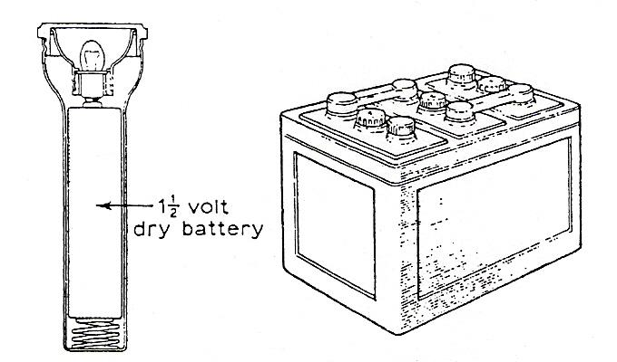
Figure 2 - Flash Light / Motor Car Battery

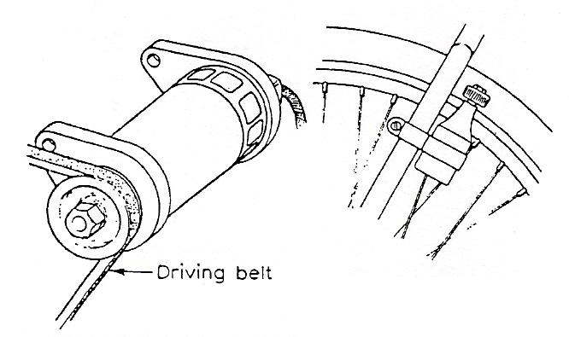
Figure 3 - Motor Car Generator / Bicycle Dynamo

Conductors and Insulators

Conductor
A conductor is a material, usually a metal, which has a large number of free electrons moving around in it, allowing electric current to flow freely. Hence conductors have low values of resistance and are used as a path to carry current. Some examples are shown on the left.
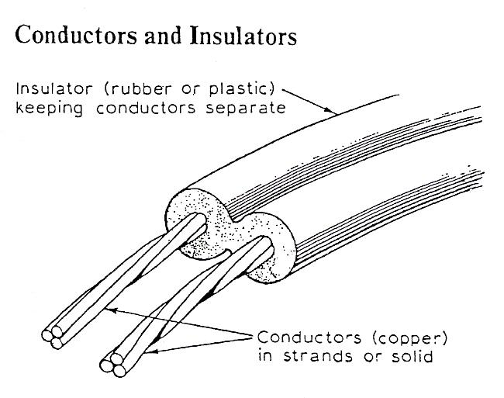
Figure 4 - Two Core Flexible Cable

Insulator
An insulator is a material whose electrons are held tightly to their parent atoms and do not allow current to flow freely. Insulators therefore have very high resistance and are used to separate conductors from each other, as shown in the diagrams.
There is no such thing as a perfect conductor or insulator. Even the best conductor, silver, has some resistance, and the best insulators will allow some current to flow if a high enough voltage is applied to them.

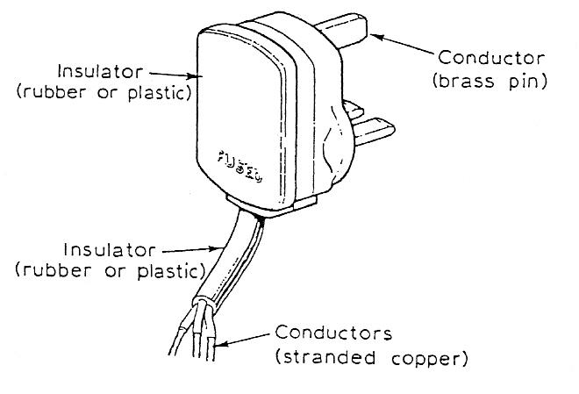
Figure 5 - Electric Plughead
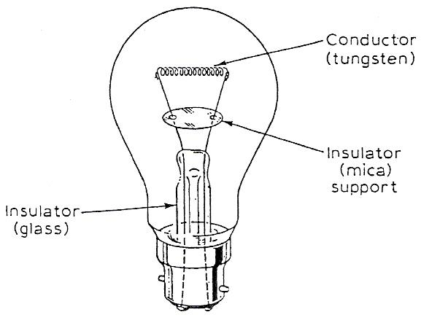
Figure 6 - Electric Lamp

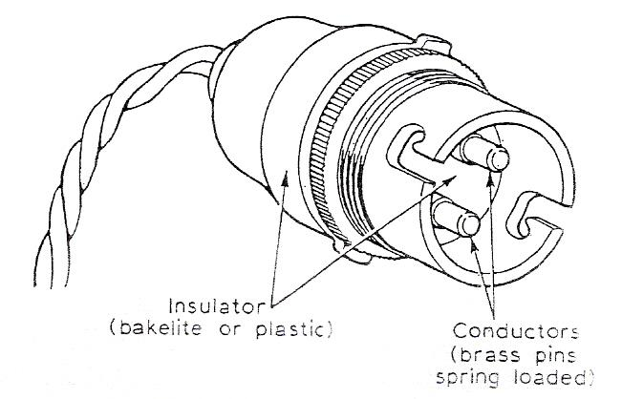
Figure 7 - Electric Lamp Holder

Conductors | Insulators
Silver  Copper  Aluminium  Gold  Brass  Iron  Nickel  Tungsten  Nichrome  Carbon  (non-metallic) | Paraffin wax  Insulating oil  Bakelite  Laminated plastic sheet  Polystyrene  Polythene  Mica  Glass  Ceramics  Dry air
Table 1 - Materials Used as Conductors and Insulators

Use of Insulating Materials for Different Purposes

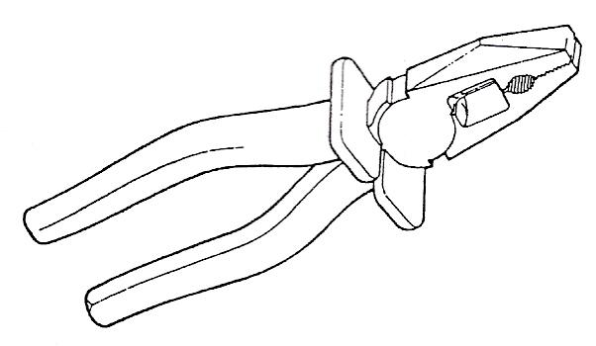
Figure 8 - Insulated Handle (PVC)
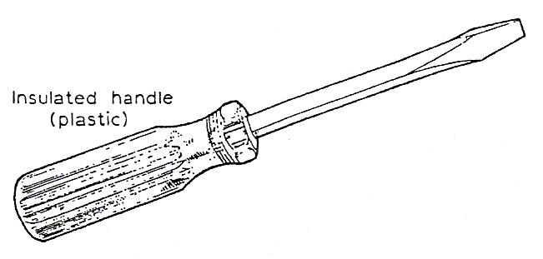
Figure 9 - Insulated Handle (Plastic)
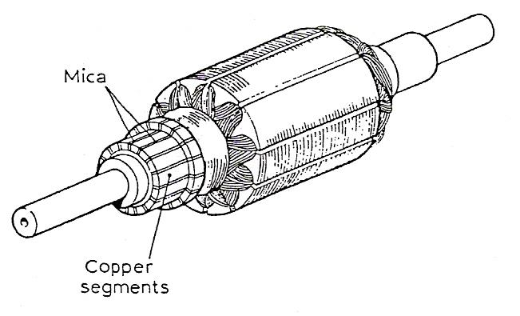
Figure 10 - Armature of D.C. Generator or D.C. Motor
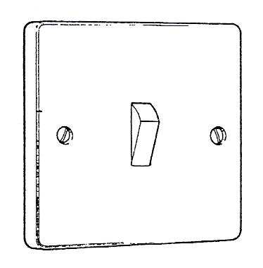
Figure 11 - Plastic Light Switch
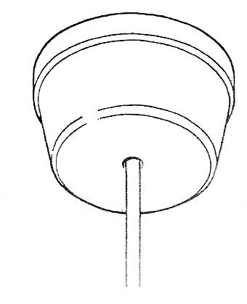
Figure 12 - Plastic Ceiling Rose
Insulating materials are used in electrical work where there is a need to separate conductors from each other. This prevents leakage of electricity and gives protection against electric shock.

Well-Known Insulating Materials and Their Uses
Rubber and most plastics (e.g. polyvinyl chloride, PVC) are good insulating materials and easily worked. They are used to insulate conducting cables, such as those used in domestic buildings. The same materials are used to cover the metal handles of electricians' pliers and screwdrivers to prevent electric shock.
Oil-impregnated paper is used to insulate cables used in heavier industrial installations.
Mica is used as an insulating material where high temperatures occur, e.g. heating elements of electric irons and toasters. It is also used extensively in the commutators of motors and generators.
Laminated plastics and bakelite are used to make equipment such as plugs, sockets, switches and knobs.
Insulating oil is used in transformers where it also serves as a cooling agent.
Paxolin, which is plastics impregnated cloth, and synthetic resin bonded paper (s.r.b.p.) are used to make insulated panels upon which conducting materials are mounted.
Ceramics and glass are mainly used where high voltages occur, such as the supports for cables used in transmission lines, reactor and circuit breaker bushings.

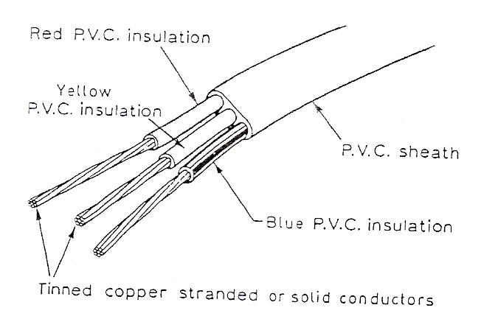
Figure 13 - 3-Core PVC Sheathed Cable

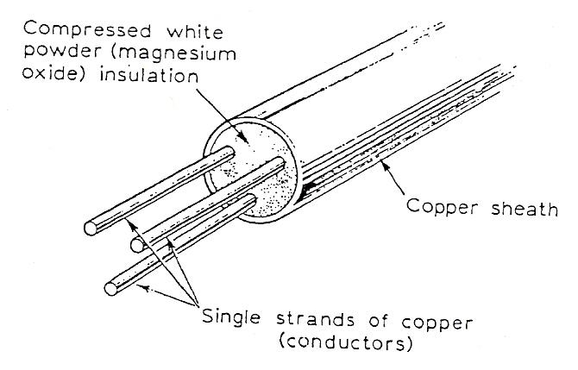
Figure 14 - 3 Core Mineral-Insulated Copper-Sheathed Cable

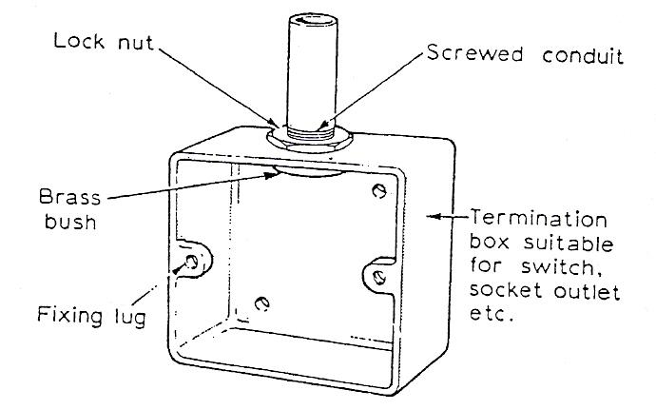
Figure 15 - Terminating Conduit

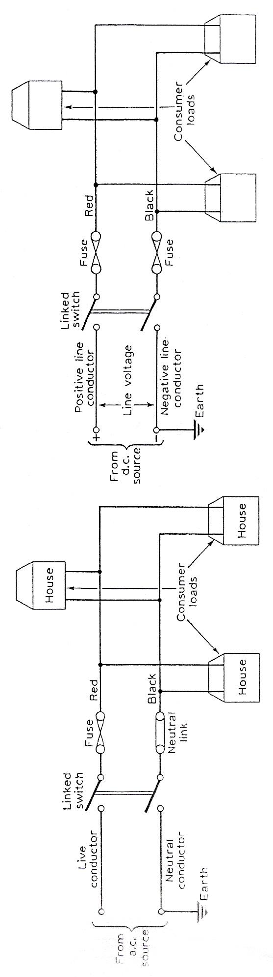
Supply Systems
The method of carrying electricity from the generating station to the consumer, i.e. houses or workshops, is called a supply system.
There are several different types of supply system; the simplest is the two-wire system which may be fed with either direct current (d.c.) or alternating current (a.c.). These systems are normally used to supply small domestic installations.

Two-Wire D.C. Supply System
A direct current is produced when there is a steady flow of electrons in the same direction all the time. So a direct current supply will have two terminals which have fixed polarity (i.e. one positive and one negative).
The two-wire d.c. system consists of two insulated conductors which are fed at one end with d.c. One conductor is positive and the other negative. The negative conductor is usually connected to the general mass of earth (i.e. earthed). A typical system is shown opposite.
The two conductors are called lines and the voltage measured between them is called the line voltage. The standard line voltage for a two-wired d.c. system is 250 V.
Consumer installations are connected to the lines at any desired point as indicated.

Two-Wire A.C. Supply System (single phase)
This diagram shows a two-wire a.c. supply system called a single phase system. This type of supply is produced by a single-phase a.c. generator (called an alternator). The system is the same as the two-wire d.c. system with one difference. A solid copper link replaces the fuse in the line conductor which is earthed. This conductor is called the neutral, and the link is called the neutral link. The other conductor is called the live conductor. The standard voltage for a single phase a.c. system is 240V.

Three-Phase Supply Systems
The large majority of electrical installations are supplied from a three-phase a.c. system of supply and one of the main reasons for this is because the three-phase induction motor may be operated from such a system. This type of electric motor is the one most often used and is very robust, relatively cheap and requires little maintenance.
Three-phase a.c. supply systems are supplied by three-phase alternators which may be arranged to produce electricity for:
(a) three-phase a.c. three-wire systems;
(b) three-phase a.c. four-wire systems.
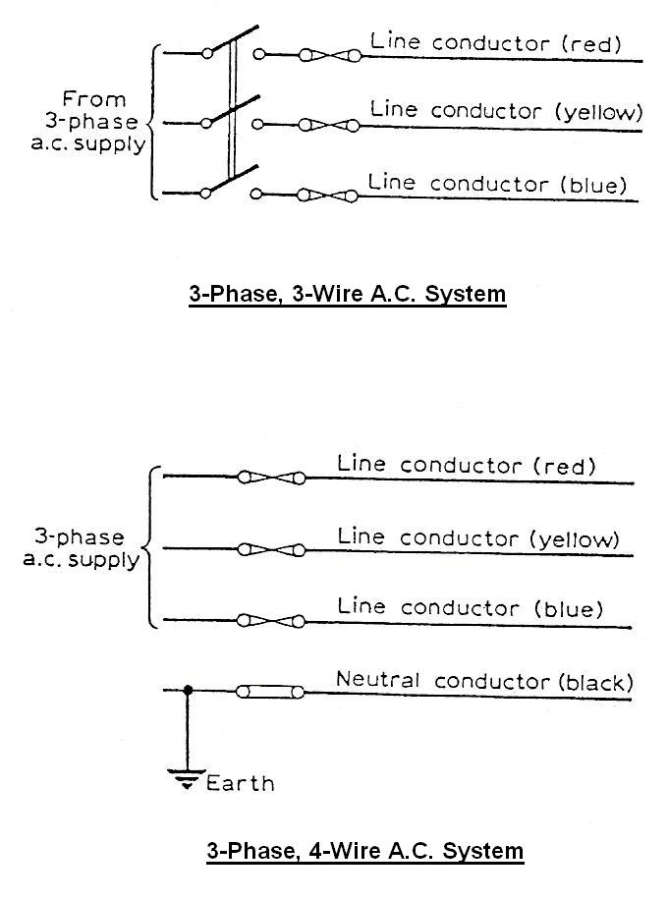

Three-Phase A.C. Three-Wire System
This system consists of three insulated conductors arranged as shown here. It is rarely used because of the advantages to be gained by using the three-phase, four-wire system.

Three-Phase A.C. Four-Wire System
This is the most widely adopted method of supply. Four conductors are used to form the system, as shown here. Three are called line conductors (coloured red, yellow and blue), the fourth is the neutral conductor (coloured black), which is earthed.

Line Voltage and Line-to-Neutral Voltage
The three-phase four-wire system offers a choice of two voltages.
(i) The line voltage-measured between any pair of live line conductors.
or
(ii) The line to neutral voltage-measured between anyone line and the neutral conductor.

The standard voltages used for a three-phase four-wire system are:
- Line voltage-4l5 V.
- Line-to-neutral-240 V (as for single-phase system)

Earthing
One of the conductors in the supply systems is connected to earth. This is done for reasons of safety to persons and property.
For instance, if a fault occurred which caused a live conductor to come into direct contact with the metal frame of an electrical appliance, current would flow through the frame to earth through any available path.
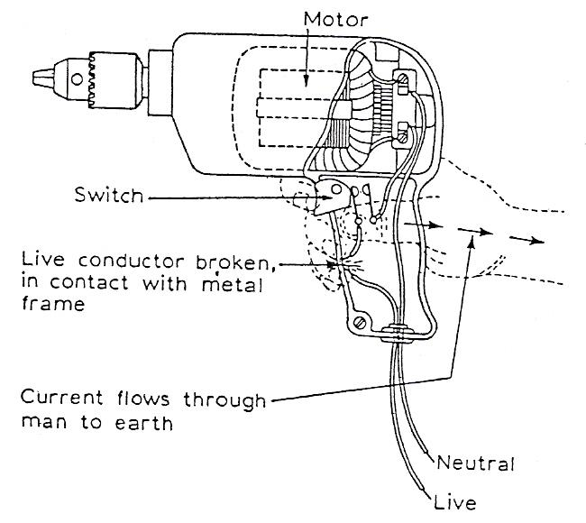
Figure 16 - Electric Drill Not Earthed

Consider the portable electric drill shown here. If the above fault occurred, a man holding the drill would complete a circuit to earth. Current would flow through the man's body giving him an electric shock.
To avoid this dangerous condition, all electrical appliances housed in metal enclosures should be connected to earth. On portable appliances this is done by ensuring that the green and yellow striped wire of a three-core cable is connected between the metal frame of the appliance and the earth pin of the three-pin plug. In this way we provide an alternative path for the current to take.

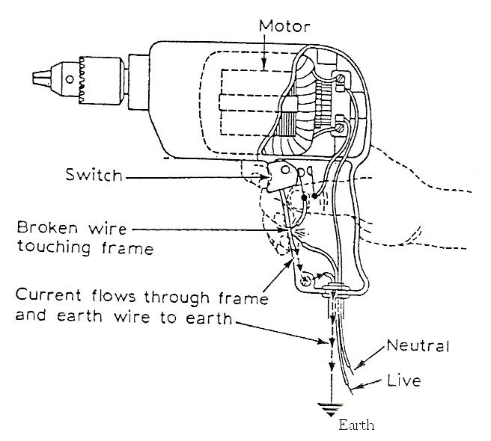
Figure 17 - Electric Drill Is Earthed

If a man touches a 'live' appliance, as indicated here, there are two paths available for current to follow. As the resistance of the human body is much greater than that of the earth wire the current will flow through this wire to earth.

Resistance (Resistors)
For a given voltage the amount of electric current which will flow in a circuit is determined by the ease with which each part of the circuit allows the current to pass. Every circuit offers some opposition to the flow of electric current and this opposition is called resistance. The unit in which resistance is measured is called the ohm (symbol Ω).

A piece of apparatus specially made to have a definite value of resistance is called a resistor. The circuit symbol for a resistor is shown here.

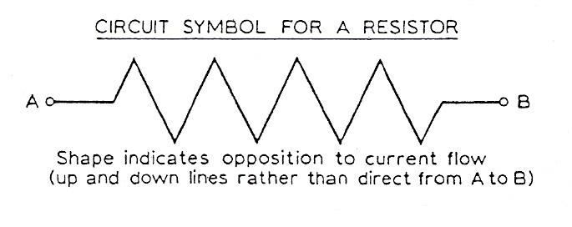
Figure 18 - Resistor Symbol

Types of Welding Plant

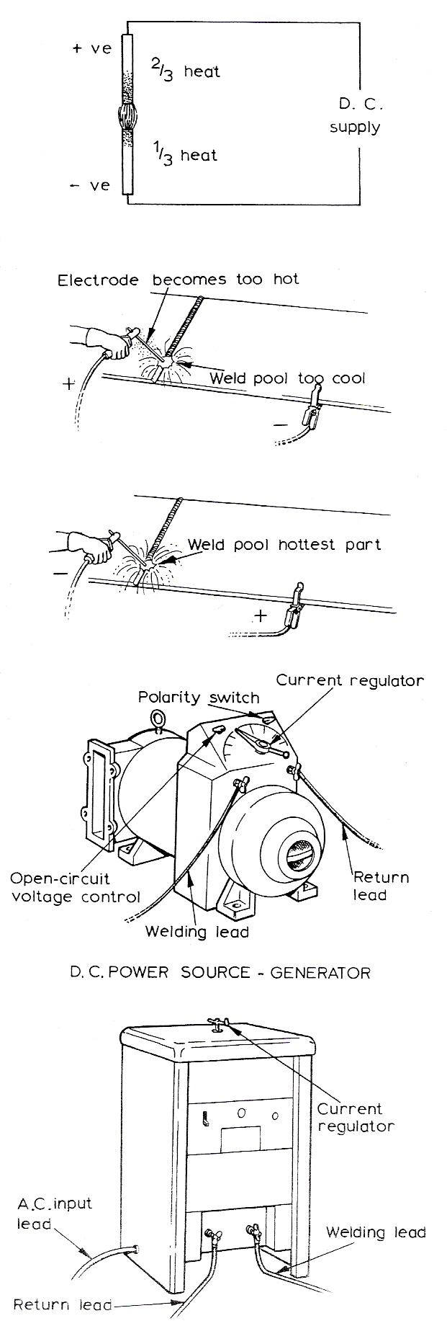
Direct Current (D.C.)
With this system the current passes in one direction only. The heat generated is split into two parts, two-thirds goes to the positive pole and one-third to the negative pole. This is important as it determines the design of the electrode to be used.
If a light-coated electrode is connected to the positive terminal it quickly becomes too hot to use for welding. But if the workpiece is connected to the positive terminal and the electrode to the negative terminal, the weld pool becomes the hottest part and the electrode stays beneath its critical heat value.
The polarity of the electrode, when using d.c. for welding, is most important and the electrode manufacturer's recommendations should be strictly adhered to, except in exceptional circumstances where the work must be kept as cool as possible. The terms used by British Standards for electrodes state that:
Electrodes connected to the positive terminal are called electrode positive, and electrodes connected to the negative terminal are called electrode negative.
Basic equipment:
- a generator driven either from d.c. mains (motor generator) or by a petrol or diesel engine
- an a.c./d.c. motor generator set; or
- rectifying equipment.

The generator must supply an open-circuit voltage of about 60 V, which will drop to approximately 20 V when the arc is struck. Generators can be obtained with various current ratings from 100 to 600 A, and the modern types automatically adjust themselves to allow for the voltage fluctuations of the arc. Normally only one welder can work from a set.

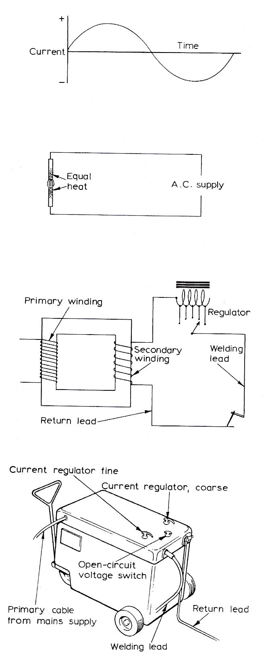
Alternating Current (A.C.)
With a.c., the direction of the current flow continually changes. This reverse in direction takes place 50 times per second. Because of this reversal of the current flow the two poles are maintained at the same temperature, and reversal of the terminals has no effect as is the case with d.c.
The a.c. plant consists of a transformer which will reduce the supply voltage down to the required open-circuit voltage, i.e. 60-100 V.
Various types of set are available giving different current ranges. Depending on the set, current values from 20 A up to 500 A can be obtained.
Alternating-current welding plant is cheaper to buy than the equivalent direct-current set, requires less maintenance, is quieter in operation, and the running costs are lower. The use of a.c. equipment is dependent upon an a.c. supply being available, and therefore when welding on sites it is not usually possible and a d.c. engine-driven generator is used.

Effect of Short Circuiting
When the welder strikes his arc the welding generator is subjected to a short circuit and the current passing through the windings of the generator increases. If this increase in current is not controlled the windings will overheat, resulting in damage to the generator.
In most cases this short-circuit current should not exceed 150% of the normal welding current and overload devices are fitted to protect the equipment.

Electrical Hazards

Personal Safety
When working with electricity always make certain that the circuit is isolated from the supply by switching it off before touching any conductors.
Make sure that ALL the conductors in the circuit are dead by checking with a reliable voltage indicator or test lamp. Frequently test the indicator or test lamp to ensure that they are indicating correctly.

Protection of Life and Property
Always
Ensure first class workmanship on all jobs, no matter how small, and seemingly insignificant.

Never
Have an 'it will do' attitude.
Make protection devices inoperative for any reason.
Replace fuses with incorrect ratings.

Remember
That badly installed electrical circuits can be responsible for fires and even deaths.
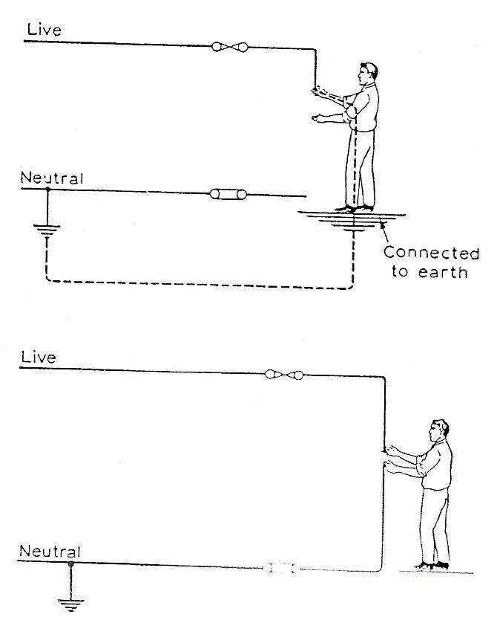

How a Person May Receive an Electric Shock
The human body is able to act as a conductor of electricity and therefore receive a shock.
The amount of current passing through the body will depend upon the applied voltage and the resistance of the body.
A person may receive a shock by touching the live conductor of the supply whilst being in contact with the earth.
A person may receive a shock by touching the live conductor of the supply and the neutral conductor.

Procedure in Case of Electric Shock
- Switch off the electricity, if this can be done quickly.
- Remove the person from contact by pushing him free with a piece of dry non-conducting material.
DO NOT TOUCH HIS BODY WITH BARE HANDS.
- If the injured person is not breathing or there is any doubt, commence artificial respiration IMMEDIATELY. When a person is not breathing the lungs do not reoxygenate the blood supply. If the brain is starved of oxygen for only a few minutes permanent damage may take place.
- Send for medical help.

Self Assessment

Questions on Background Notes – Module 1.Unit 15

1. What does the abbreviation E.M.F stand for and give a simple example of
its use.

2. List two Conductors and two Insulators.

3. In diagram form, show and name the three wires located in a Household Plug.

4. Briefly explain A.C. Current / D.C. Current.

5. Why are all electrical appliances earthed?

6. When dealing with electricity. Give two points on Personal Safety.

Answers to Questions 1-6. Module 1.Unit 15

1.
Electromotive Force.

The unit of the E.M.F is the Volt.

Well-known sources are Batteries found in flash lights, radios
a car battery etc, all have a Electromotive Force.

2.
a. Conductors: Copper, Iron

b. Insulators: Rubber, Glass, Ceramics

3.
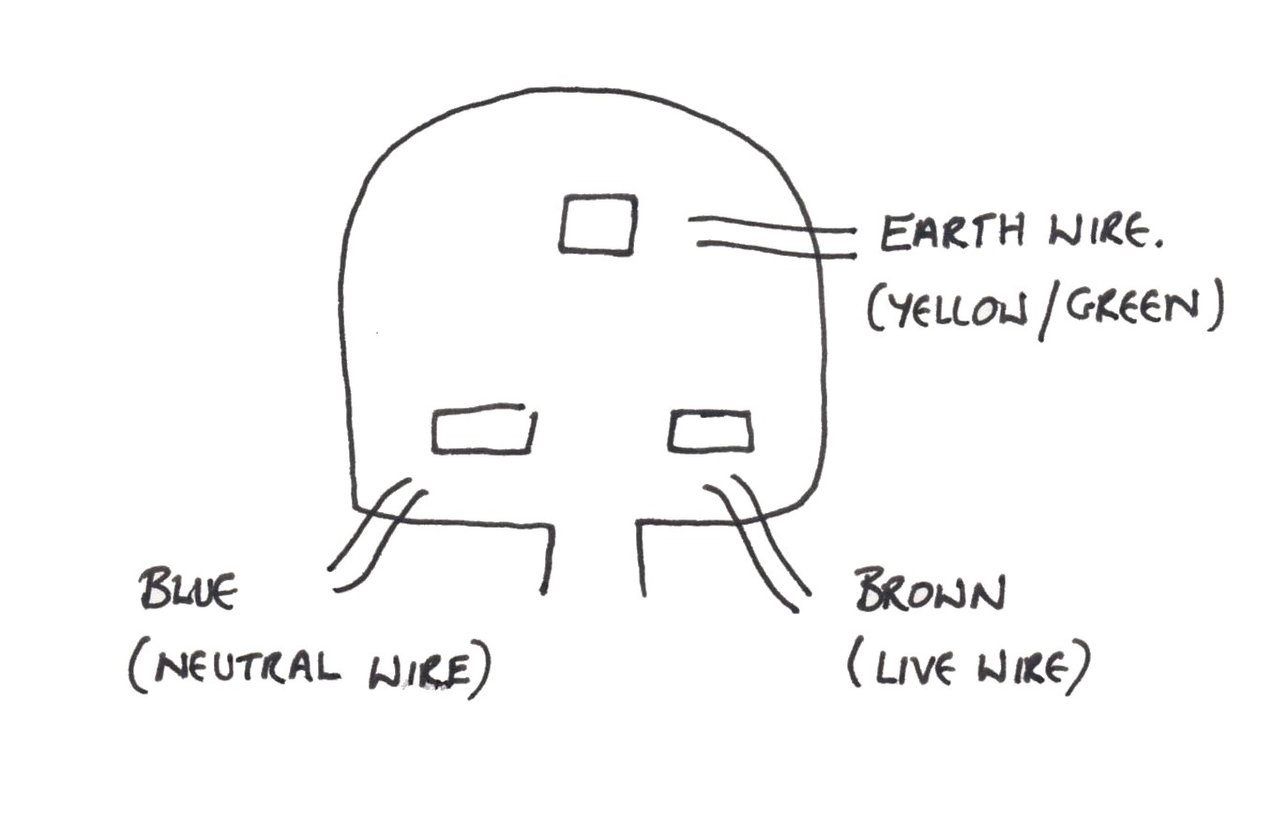

Figure 11.

A.C. Current:

Alternating Current, it alternates continuously, at 50 times per
second, from Positive + to Negative – Pole.

D.C. Current:

Direct Current travels in one direction only, 2/3 of the heat is
generated at the Positive + Pole and 1/3 of the heat is generated
at the Negative – Pole.

4.

5.

One of the conductors in the supply system is connected to
earth. This is done for reasons of safety to persons and property.
If a fault occurred which caused a live conductor to come into contact
with the metal frame of an appliance, current would flow through the
frame to earth through any available path, including a man’s body
giving him a electric shock.
To avoid this, all electrical appliances housed in metal enclosures
should be connected to earth.
On portable appliances this is done by ensuring that the green
and yellow striped wire of a three core cable is connected between
the metal frame of the appliance and the earth pin of the three- pin
plug. This way we provide an alternative path for the current to take.

6.

1. When working with electricity always make sure that the circuit is
isolated / dead from the supply by checking with a reliable volt
meter or test lamp.

2. Pad lock / Tag out the isolator if possible to ensure nobody can turn
it back on whilst you are working on it.

Index

C
Conductors and Insulators
Conductor, 12
Insulator, 12
E
Effect of Short Circuiting, 22
Electrical Hazards, 23
How a Person May Receive an Electric Shock, 23
Personal Safety, 23
Procedure in Case of Electric Shock, 24
Protection of Life and Property, 23
P
Protection of Life and Property
Always, 23
Never, 23
Remember, 23
R
Resistance (Resistors), 20
S
Source of Electricity
Use of Insulating Materials for Different Purposes, 14
Well-Known Insulating Materials and Their Uses, 14
Supply Systems, 16
Earthing, 18
Line Voltage and Line-to-Neutral Voltage, 17
Three-Phase Supply Systems, 17
Two-Wire A.C. Supply System (single phase), 16
Two-Wire D.C. Supply System, 16
T
The Simple Electrical Circuit, 10
Conductors and Insulators, 12
Source of Electricity, 11
Three-Phase Supply Systems
Three-Phase A.C. Four-Wire System, 17
Three-Phase A.C. Three-Wire System, 17
Types of Welding Plant, 21
Alternating Current (A.C.), 22
Direct Current (D.C.), 21

