Trade of Metal Fabrication
Module 5: | Pipe Fabrication
Unit 3: | Flanges
 | Phase 2

Table of Contents
List of Figures 4
List of Tables 5
Document Release History 6
Module 5 – Pipe Fabrication 7
Unit 3 – Flanges 7
Learning Outcome: 7
Key Learning Points: 7
Training Resources: 7
Key Learning Points Code: 7
Piping Design – Organisation and Practice 8
General 8
Cost 9
Flanges 10
Operation 11
Responsibilities 15
Self Assessment 17
Index 18

List of Figures
Figure 1 - Indication of Fall on Isometric 8
Figure 2 - Jacketed Pipe Heating System: Vapour Phase 9
Figure 3 - a) Full Pipe Jacket; b) Swaged Pipe Jacket; c) Insert Piece Jacket 10
Figure 4 - Use of Fitting-to-Fitting Connection to Reduce Fabrication Cost 11
Figure 5 - Isometric as Detailed by Designer and Presented to Fabricator 12
Figure 6 - Isometric Broken Down for Fabrication-Shop Use 13
Figure 7 - Typical Isometric 14

List of Tables

Document Release History
Date | Version | Comments
09/02/07 | First draft
13/12/13 | SOLAS transfer

Module 5 – Pipe Fabrication

Unit 3 – Flanges
Duration – 2 Hours

Learning Outcome:
By the end of this unit each apprentice will be able to:
- Read and interpret drawing of flange conventions
- List use of flanges and identify flange ratings
- Use flange square to check flange fit-up/alignment

Key Learning Points:
Rk D | Read and interpret drawing for flange conventions.
Rk | - Identify flange ratings and terms such as raised face and flat face. Diameters of raised face inside and outside of flange and Pitch Circle Diameters (PCD).  - To correctly identify flanges required. Position flange onto pipe with flange square to pipe.
Sk | Flange square, centre square.
P | Communication, information gathering.

Training Resources:
- Drawing, reading and interpretation
- B.S. flange catalogue
- Various diameter pipes
- Flange square – plate flanges – Instructor Demonstrations

Key Learning Points Code:
M = Maths D= Drawing RK = Related Knowledge Sc = Science
P = Personal Skills Sk = Skill H = Hazards

Piping Design – Organisation and Practice
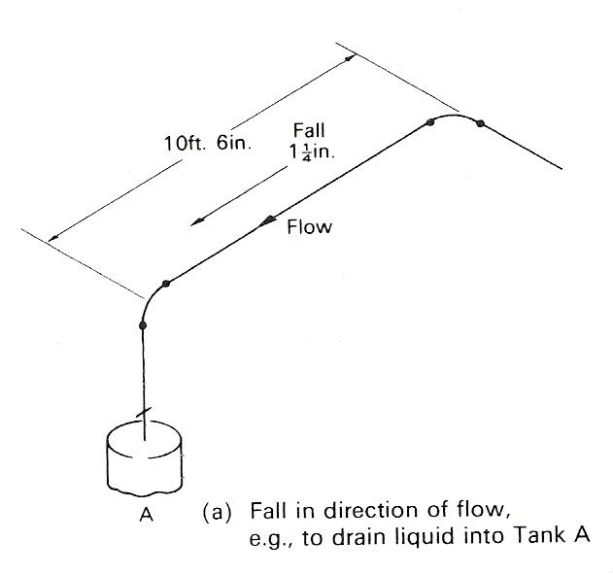
Figure 1 - Indication of Fall on Isometric

General
- Check certified equipment drawings for flange ratings and precise disposition of flange drillings. Ensure that any flange drillings not ‘off centres’ are noted on pipe details.
- Ensure pipe terminal coordinates and connecting nozzle identities are shown.
- Show line diagram and layout drawing numbers for reference on every detail drawing.
- Ensure all continuation points are highlighted and continuation drawing numbers shown.
- Try to show a reference dimension to a stanchion or floor beam to give the erector a locating point, but do not show excessive pictorial detail of adjacent plant or structures.
- Indicate flow direction when pipes slope and when non-return valves are fitted.
- Show special fabrication requirements, e.g. x-ray or heat treatment if required.
- Draw boldly and simply. If using pre-printed isometric grid paper, make sure all drawn lines (including witness lines) are heavier and print clearer than the grid lines.
- Keep lettering and figures to about 5 mm minimum size and easily readable.

Cost
- Avoid use of short radius elbows and thus reduce number of component varieties generally.
- On close nested complex pipes, use as many fitting-to-fitting connections as possible. Never call for short lengths of pipe between adjacent fittings – keep minimum to 150 mm or one pipe diameter whichever is greater.
- Remember a close flanged bend can often be made more cheaply by combining a weld elbow with a weld-neck flange than by using slip-on flanges.
- Establish company or project standards for dimensions of control valve sets, steam trap sets and similar built-up units to save design time.

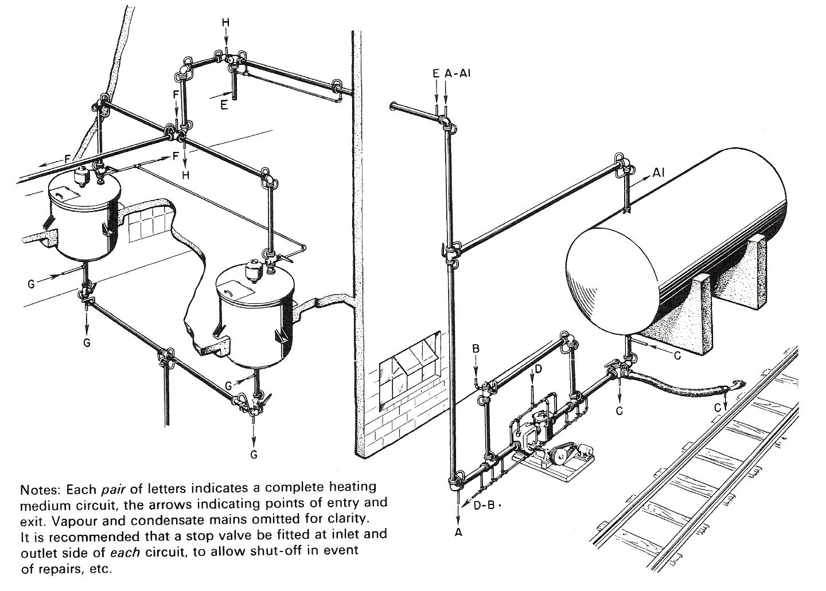
Figure 2 - Jacketed Pipe Heating System: Vapour Phase

Flanges
End connections are flanged and welded (see Figure 3(b)) and normally conform to flange standards and ratings, the 'swaged' end flange suiting the process pipe diameter and the 'standard' end flange the jacket pipe diameter. Figure 3(c) is the 'insert' flange where both process and jacket pipes are welded to an insert piece thus leaving the flange loose to freely align with mating flanges - most useful if the jacketed system is complicated by off branches which lead to difficulties in correct alignment.
Corrosive fluids or vapours in the product-carrying pipe line necessitate the adoption of special materials for that line. Austenitic stainless steels are frequently used and, to a lesser extent, Monel, nickel, and various alloys. As the jacket pipe is not usually required to be corrosion resistant, less costly steel pipe is usually adopted. This requires welding of dissimilar metals which may, with certain materials, present difficulties, but in recent years welding practice has found solutions to most of the problems - particularly carbon steels to stainless steel.
One important point which must be considered when dissimilar metals are in contact is that of electrolytic corrosion.
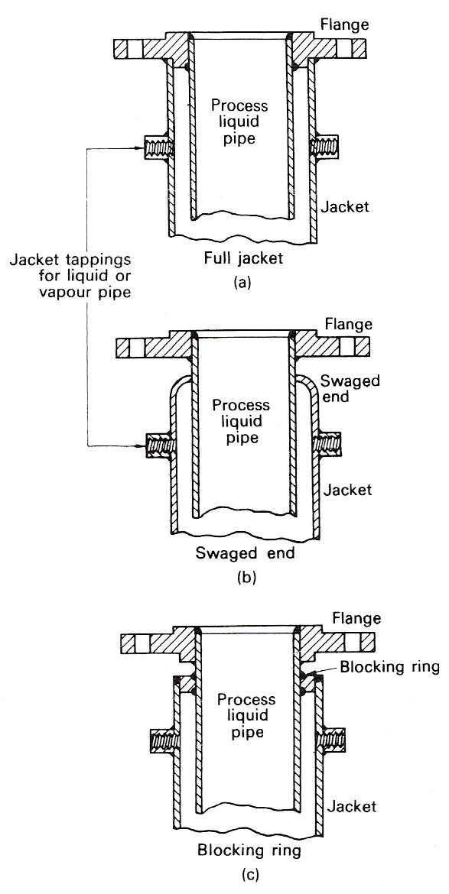
Figure 3 - a) Full Pipe Jacket; b) Swaged Pipe Jacket; c) Insert Piece Jacket
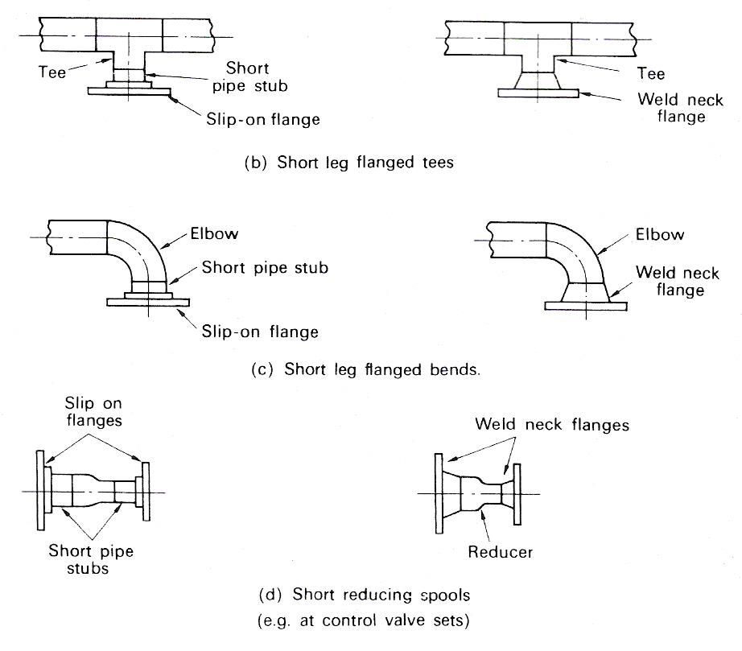
Figure 4 - Use of Fitting-to-Fitting Connection to Reduce Fabrication Cost

Operation
- Look at each pipe individually to check that it can be vented or drained either into another pipe or vessel or by fitting vent and drain points. Never leave undrainable pockets in lines carrying hazardous or corrosive liquids.
- Make sure that valves and fittings are oriented correctly to flow.
- Non-return valves work in correct direction of flow.
- Globe valves have pressure underseat rather than on top.
- Sight glass faces can be seen by operators.
- To prevent solids depositing in glands, try to avoid mounting valves with spindles horizontal or pointing downwards.
Completion of the isometrics, marks in many process industry projects, the end of pipe detailing and it will be useful to consider two other detailing aspects to finalise this section. Firstly, it must be remembered that large quantities of piping are constructed from discrete standard pieces which are either shown in a manufacturer's brochure, or can be drawn up on a project standard detail definition drawing - systems such as cast iron or glass are examples of this method. Since there is no need to tell a fabricator exactly how to make up these pieces, there is little point in detailing as described above, as it is normally sufficient to show on the pipe layout drawing, standard piece reference numbers so that the erector can assemble the pipes correctly from the pipe layout, the material list, and the catalogue or the detail definition drawing. In this case, of course, an accurate material list for each pipe is still essential for material purchase and to give the erector a means of checking that each pipe has been assembled correctly. Provided that the plant and piping is not too complex, individual detail drawings can be omitted, but when the erector finds difficulty in reading the layout drawing quickly and accurately, then the production of pictorial isometrics should be considered.
The second point is that the isometric as described is a comprehensive picture of an entire pipe which, although it contains all the data needed for fabrication, may not be fully suitable for shop floor use on a large scale. This point arises from a consideration of the fabricator's problem in producing pipe segments of sizes suitable for transport and erection and in planning and controlling a fabrication shop engaged on the simultaneous production of a large number of isometrics of different sizes, different materials and for different customers. The pipe shown in Figure 5 is one pipe to the designer, but because certain parts must be split for transport and because other parts are naturally separated by flanges and field welds, the fabricator must make eight segments as shown.
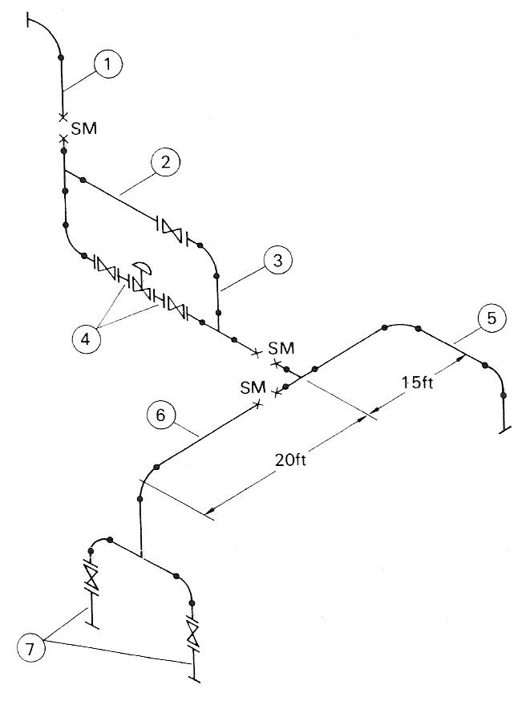
Figure 5 - Isometric as Detailed by Designer and Presented to Fabricator
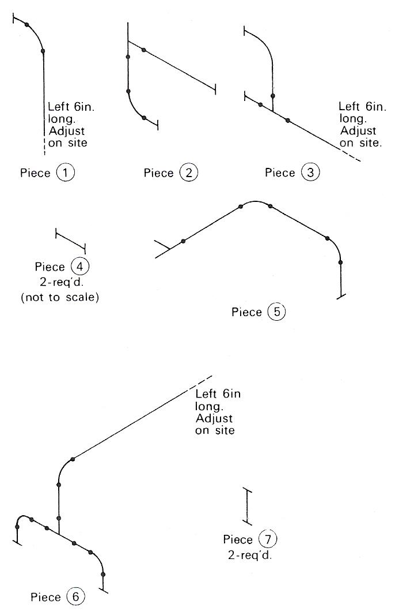
Figure 6 - Isometric Broken Down for Fabrication-Shop Use
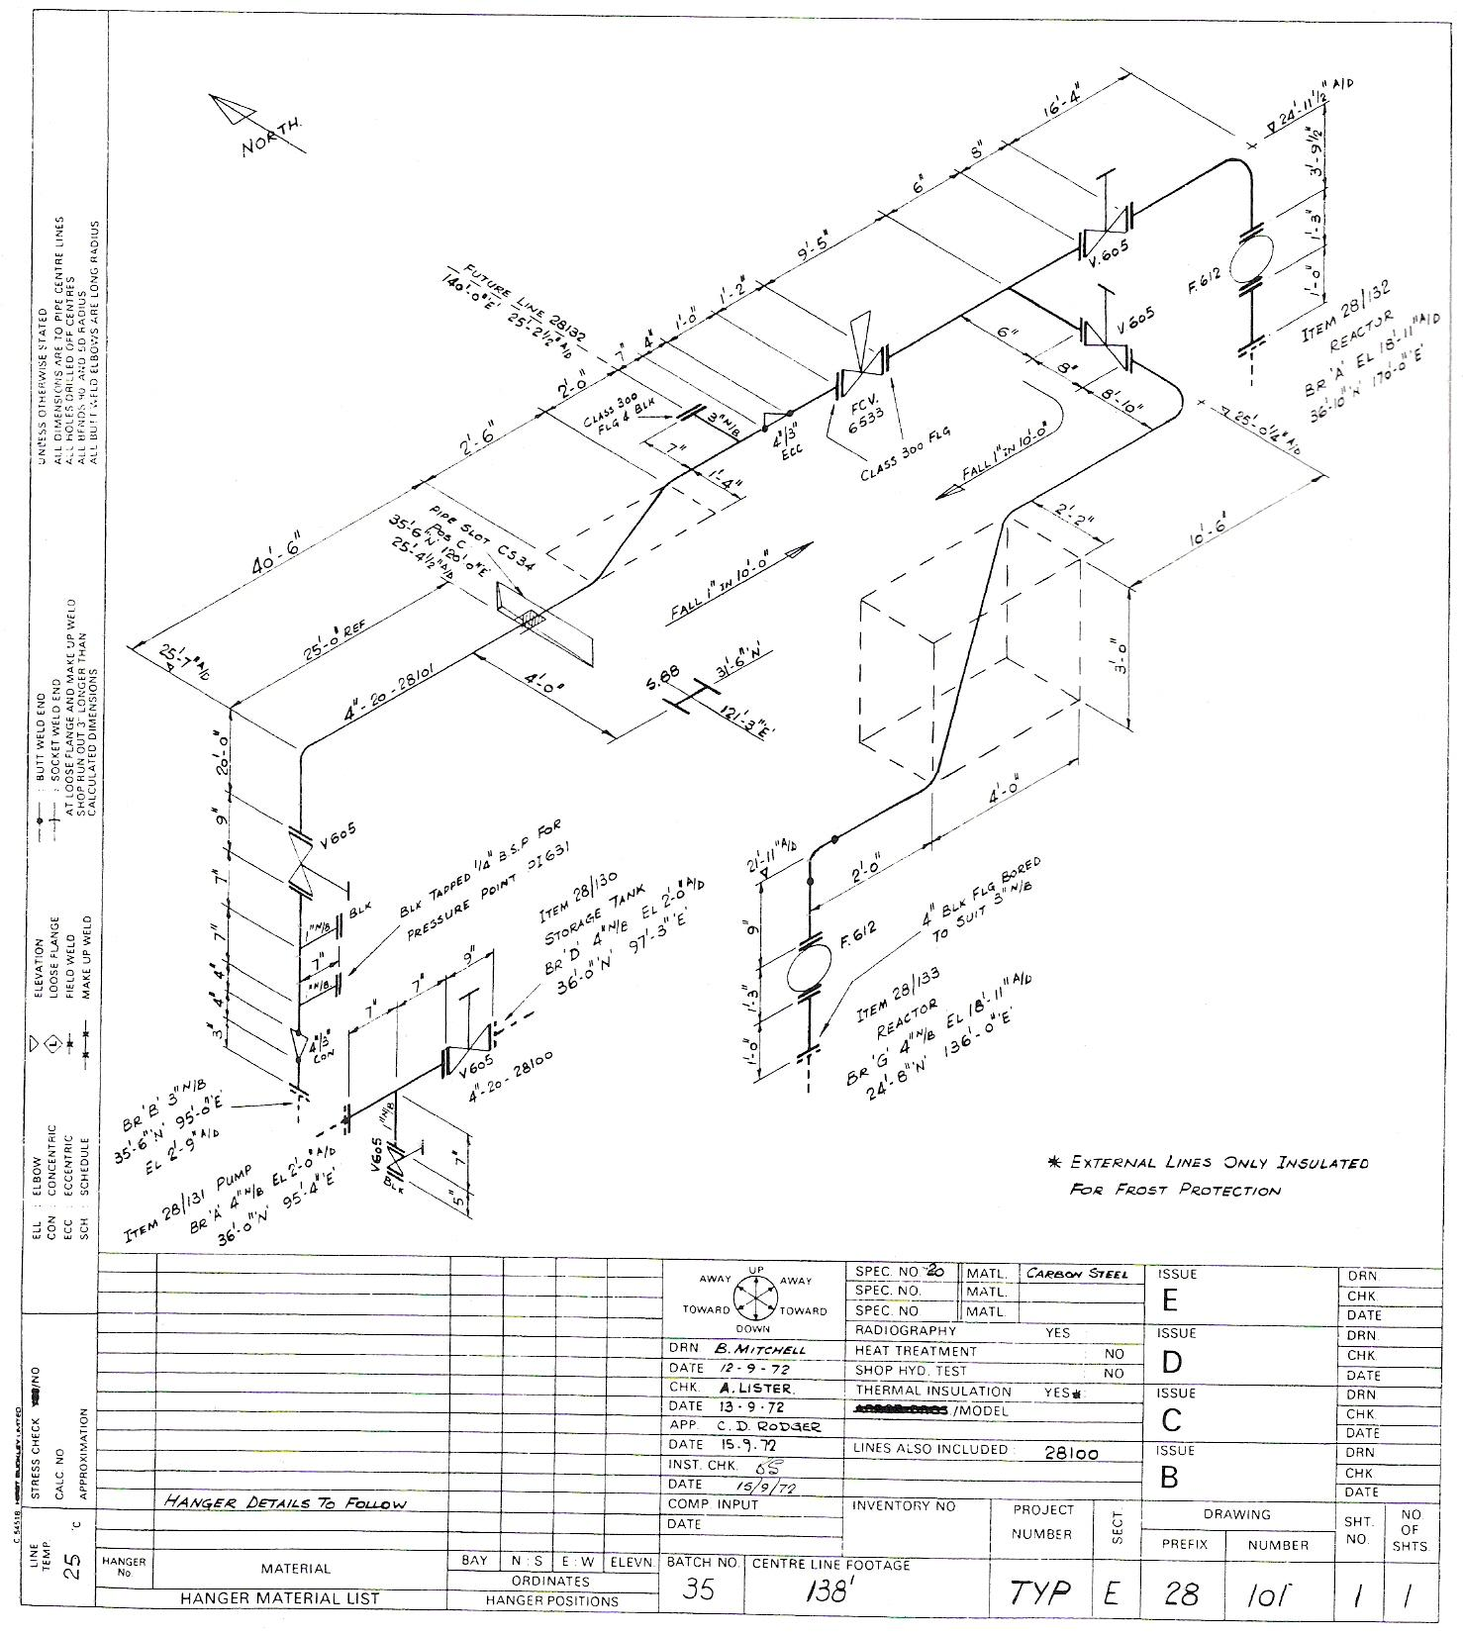
Figure 7 - Typical Isometric

Responsibilities
It is essential to define the responsibilities of the piping design office so that management control can be exercised by comparing achievement with targets. The relationship between plant layout and piping, and the possibility of integrating the two functions, has been discussed where it is suggested that the magnitude and continuity of the design workload can be the dominant factor in deciding for or against the integration. This choice does not affect the other responsibilities of the piping design office, but will affect the cost and manning targets set by management. Suggested functions are listed below as a possible framework around which an office can be set up to suit any company requirement. Unless qualified, all these functions are the direct responsibility of the piping design office.

- Plant layout Develop initial plant layout (including alternative layouts for evaluation) into an agreed final layout acceptable to project management.
- Piping layouts Prepare final layouts of piping systems. Obtain project management agreement to layout but full responsibility for it to be borne by piping design office.
- Line diagrams Prepare final line diagrams subject to approval of process engineers.
- Pipe and valve specifications Draft pipe and valve specifications for project making maximum use of company or national standards.
- Material control Provide all material schedules for procurement by purchase department in the degree of detail required by company organisation.
- Detailing Prepare pipe details as judged necessary by the piping engineer to obtain accurate tenders and give adequate information for construction department.
- Painting and insulation Produce or agree specifications for work with contractors. Provide detail drawings or schedules of work as basis for contracts.
- Project documentation Prepare necessary documents for construction department and start-up. Degree of detail required to be specified by project management.
- Liaison Maintain effective liaison with all other departments during all project stages. This includes not only design and construction departments, but purchase, inspection, progress, estimating and cost control, etc.
- Technical/commercial Be aware of developments in products and material available. Know material suppliers' and fabricators' potential weaknesses.
- Standards Develop piping standards within company to maximum practical degree. If 'Standards' exists as a separate company function, responsibility for technical performance remains with piping design office.
- Techniques Be aware of, and implement, most modern and economic design techniques. Standardise and formalise design methods used for stressing and fluid mechanics within company. Record major calculations for verification by experience and for future guidance.
- Security Control access to and issue of, major project drawings, particularly flowsheets and line diagrams.
- Budgetary
(i) Provide piping systems for projects within budget costs allocated to the project.
(ii) Maintain piping design service to company at satisfactory level within management budget for capital, staff, and ancillary costs.

Self Assessment
Questions on Background Notes – Module 5.Unit 3

No Suggested Questions and Answers.

Index

P
Piping Design – Organisation and Practice, 8
Cost, 9
Flanges, 10
General, 8
Operation, 11
Responsibilities, 15
S
Self Assessment, 17

