Trade of Sheet Metalwork
Module 2: | Geometry and Pattern Development
Unit 9: | Triangulation
 | Phase 2

Table of Contents
List of Figures 4
List of Tables 4
Document Release History 5
Module 2 – Geometry and Pattern Development 6
Unit 9 – Triangulation 6
Learning Outcome: 6
Key Learning Points: 6
Training Resources: 7
Exercise: 7
Key Learning Points Code: 7
Transformers 11
Ellipse 11
Self Assessment 12
Index 13

List of Figures
Figure 1 - Triangulation 1 8
Figure 2 - Triangulation 2 9
Figure 3 - Triangulation 3 10

List of Tables

Document Release History
Date | Version | Comments
01/08/06 | First draft
07/04/14 | 2.0 | SOLAS transfer

Module 2 – Geometry and Pattern Development

Unit 9 – Triangulation
Duration – 30 Hours

Learning Outcome:
By the end of this unit each apprentice will be able to:
- Define the terms used in triangulation
- State the "golden rule" of triangulation
- Develop transformers between parallel planes
- Identify joint line positions
- Construct elliptical and oval shapes

Key Learning Points:
D | Golden rule of triangulation.
D | Pattern development using the triangulation method.
D | Methods used to find the true length of a line.
D | True length diagram.
Rk | Types and shapes of transformers.
D | Determination of joint line positions.
D | Elliptical construction.
D | Major and minor areas.
M | Calculate the surface area and perimeters of the eclipse.

Training Resources:
- Drawing instruments, equipment and materials
- Textbook: The Geometry of Sheet Metalwork
- Instructor handouts, drawings

Exercise:
Sample exercises - Figure 1, Figure 2 and Figure 3.

Key Learning Points Code:
M = Maths D= Drawing RK = Related Knowledge Sc = Science
P = Personal Skills Sk = Skill H = Hazards
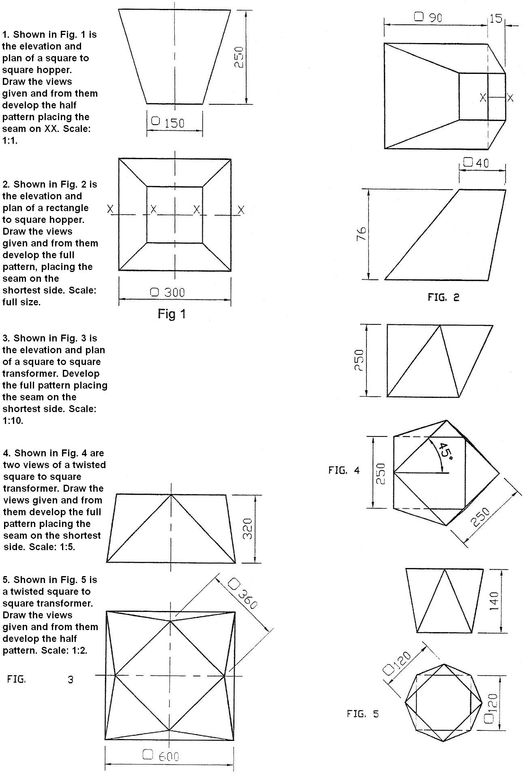
Figure 1 - Triangulation 1
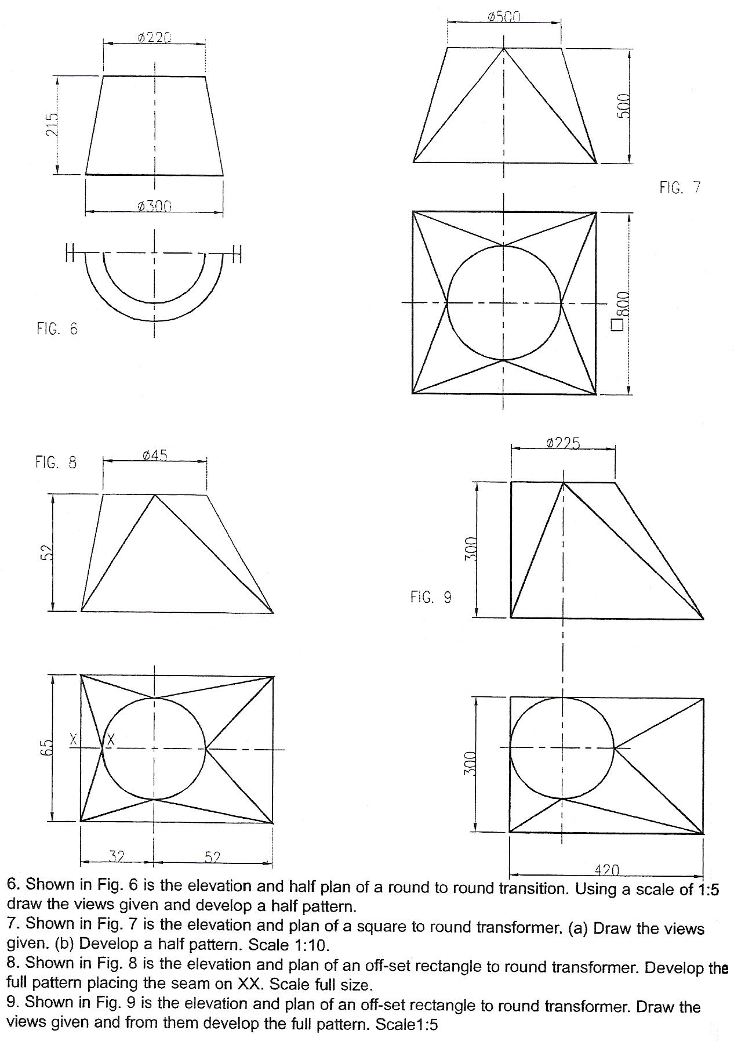
Figure 2 - Triangulation 2
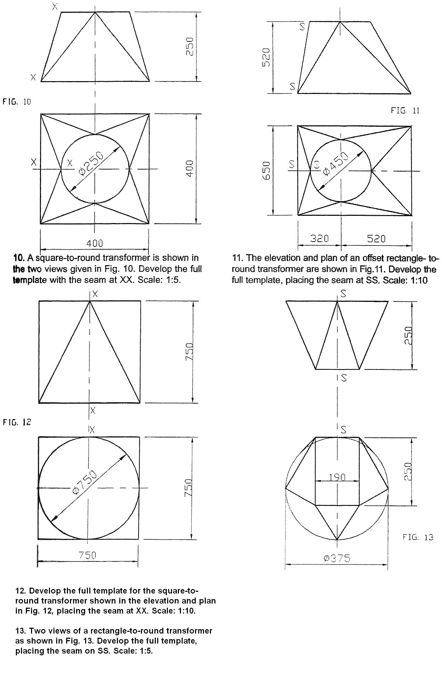
Figure 3 - Triangulation 3

Transformers
Sheet metal workers use the terms ‘transformer’ and ‘reducer’ often. A transformer alters or modifies the shape of the cross section. The cross sectional area remains the same. A reducer, as its name implies, cuts down the area.
The above items come in various shapes, examples being Equal Taper as in Fig. 1, Off Centre as in Fig. 2, Twisted as in Fig. 3 and Flat Backed as the name implies.

Ellipse
The formula for the surface area of an ellipse is = πRr.
The perimeter may be got by placing a light piece of metal around the edge of the ellipse and measuring.
It can also be calculated by dividing the ellipse into its four different curves and calculating the length of each curve.

Self Assessment

Index

E
Ellipse, 12
T
Transformers, 12

