Trade of Sheet Metalwork
Module 5: | Ductwork
Unit 3: | 90° Radius Bend with Proprietary Flanges
 | Phase 2

Table of Contents
List of Figures 5
List of Tables 5
Document Release History 6
Module 5 – Ductwork 7
Unit 3 – 90° Radius Bend with Proprietary Flanges 7
Duration – 3.5 Hours 7
Learning Outcome: 7
Key Learning Points: 7
Training Resources: 7
Key Learning Points Code: 7
Area/Weight of Wrapper 9
Rectangular Duct Sizes 11
Construction 11
General 11
Steel Thickness 11
Longitudinal Seams 11
Sealing of Longitudinal Seams 11
Welded Seams 11
Cross Joints 12
Cross Joint Ratings 12
Sealant in Cross Joints 12
Adjustable/Slip Joints 12
Stiffeners 12
External Stiffeners 12
Internal Stiffeners 13
Fastenings 13
Rivets 13
Set Screws, Nuts and Lock Bolts 13
Self Tapping and Piercing Screws 13
Welding of Sheet 13
Fittings 14
Standardisation of Fittings 14
Stiffeners 14
Splitters 14
Turning Vanes 14
Branches 15
Change Shapes 15
Expansions and Contractions 15
Sealant 15
Longitudinal Seams 18
Self Assessment 20
Answers to Questions 1-2. Module 5.Unit 3 21
Index 23

List of Figures
Figure 1 - 90° Radius Bend 8
Figure 2 - Illustrations of Panel Stiffening 19

List of Tables
Table 1 - Standard Component Drawings - Rectangular 10
Table 2 - Low Pressure (Limited to 500 Pa Positive and 500 Pa Negative) 16
Table 3 - Medium Pressure (Limited to1000 Pa Positive and 750 Pa Negative) 17
Table 4 - High Pressure (Limited to 2000 Pa Positive and 750 Pa Negative) 17
Table 5 - Longitudinal Seams 18

Document Release History
Date | Version | Comments
12/01/07 | First draft
09/04/14 | 2.0 | SOLAS transfer

Module 5 – Ductwork

Unit 3 – 90° Radius Bend with Proprietary Flanges

Duration – 3.5 Hours

Learning Outcome:
By the end of this unit each apprentice will be able to:
- Sketch 90° square bend(front elevation, end view and pictorial)
- Mark out and fabricate 90° square bend with ‘mez’ flanges
- Plan job sequence
- Cost job based on labour and materials

Key Learning Points:
H Sk | Use of power flanging machine.
Sk D | Marking out, cutting, notching, rolling and assembly of bend.
Rk | Pressure/ductwork design.
Rk | Cost of labour and materials.
M | Measure check/wrapper sizes. Measure area/weight of metal in curved bend. Calculate flange requirements.

Training Resources:

- Toolkit
- Tools and machinery/equipment
- 0.6mm galvanised mild steel
- Live example
- DW/143, DW/144, DW/TM2, TR-17, DW-171, BS 5970:2001
- Refer to reference library
- Calculator
- Workshop Drawing
- Safety equipment and protective clothing

Key Learning Points Code:
M = Maths D= Drawing RK = Related Knowledge Sc = Science
P = Personal Skills Sk = Skill H = Hazards

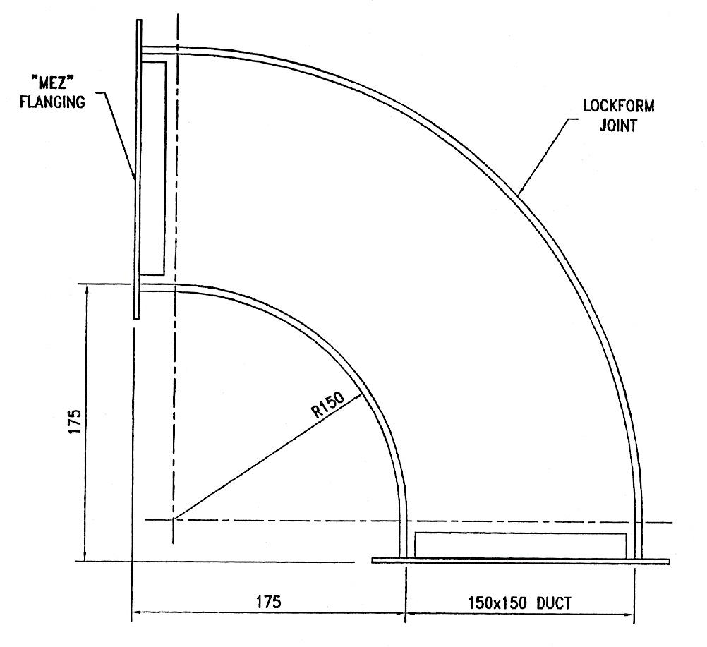
Figure 1 - 90° Radius Bend
DW/144 has certain specifications to follow when making a 90° radius bend. If the duct is 400mm wide the throat should be 100mm. See page 155 of DW/144 for more details.
Wrapper sizes are worked out by getting the circumference of a 150 radius circle for inner throat and divide by 4 as 90° is ¼ of 360°.
300 is the radius of the outer wrapper. Repeat the sequence of the throat wrapper.
To find the weight/area of the cheeks we get the area of the rectangle as follows:

175 + 150 + 8mm [8mm for lockform edge]
[6mm may also do for edge]
= 333mm width of side
333mm x 333mm = area of cheek = 110,889mm

Take the area of the quadrant radius, 175, from the above:

Area of circle = πr² so Area of quadrant = πr²/4
3.142 x 175² 3.142 x 175²/4
= 96,223.75mm² 24,055.93mm²

Area of cheek 110,889 – area of quadrant 24,055
Ans = 86,834mm²

Area/Weight of Wrapper
After getting the circumference of the inner and outer radius remember to add on 50mm for the straight sections. This gives us the length of wrapper. We now multiply that measurement by the width 150 + 70 (for lockform).
For example:

Circumference of throat = 2πr 4
= 2 x 3.142 x 150/4
= 942.6/4
= 235.65
Add on the 50 50 + 235.65 = 285.65mm

Area of throat = 285.65 x 220
= 62,843mm²
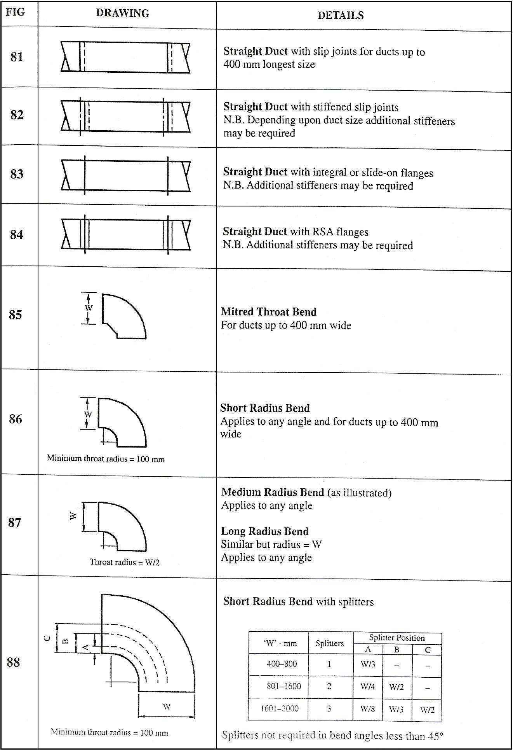
Table 1 - Standard Component Drawings - Rectangular

Rectangular Duct Sizes
This specification covers duct sizes up to a maximum longer side of 3,000 mm. Duct sizes with an aspect ratio greater than 4:1 are not recommended. Although they offer no problems of construction, they increase frictional resistance and the possibility of noise.

Construction

General
The minimum constructional requirements for rectangular ductwork depend upon the pressure classification as set out in Table 2 to Table 4.

Steel Thickness
Minimum steel thicknesses related to duct longer side to pressure classification are given in Table 2 to Table 4.

Longitudinal Seams
Longitudinal seams are illustrated in Table 5. The limits of use, if any, are given with the individual illustrations.

Sealing of Longitudinal Seams
Sealant will be applied using one of the following methods:
- As an edge sealant on the external seam surface.
- As an edge sealant on the internal seam surface.
- Internal to the joint seam itself.

The most appropriate method will be determined by the manufacturer relative to their product and will be associated with either traditional fabrication/assembly methods, factory or site based, and/or proprietary methods. The ultimate proof of a seal is that the ductwork system meets the pressure classification specified.

Welded Seams
A welded seam is acceptable without sealant, provided that the welding is continuous.

Cross Joints

Cross Joint Ratings
For cross joints, a system of rating has been used to define the limits of use. The rating for each cross joint is given with its drawing, and the limits applying to that rating, in terms of duct size longer side and maximum spacing, are given in Table 2 to Table 4. Other limits on use are given with the individual drawings.
Note Proprietary products used in the construction of cross joints should be approved by an independent test house following tests defined in DW/TM1 "Acceptance scheme for new products - Rectangular cross joint c1assification".

Sealant in Cross Joints
Sealant shall be used between sheet and section in all cross joint assemblies.
With socket and spigot joints made on site, sealant shall be applied during or after assembly of the joint. It is permissible to use chemical reaction tape or heat-shrink strip as alternative methods of sealing, provided that close contact is maintained over the whole perimeter of the joint until the joint is completed.
With all flanged joints, the sealant between sheet and section should preferably be incorporated during construction at works, but site applied sealant is acceptable. The joint between sections of ductwork is then made, using approved type of sealant or gasket. With proprietary flanging systems particular attention should be paid to the sealing of corner pieces and flanges, reference should be made to the manufacturer's assembly and sealing instructions.

Adjustable/Slip Joints
In order to accommodate manufacturing/building tolerances, site modifications etc., it is accepted practice to use an adjustable joint.

Stiffeners

External Stiffeners
The sections (including proprietary flanges) suitable for use as single stiffeners have been given a rating from S1 to S6 in terms of duct size longer side and maximum spacing. The limits of use are given in Tables 2 to 4. The stiffeners for socket and spigot joints are also applicable to stiffeners in general.

Internal Stiffeners
Tie bars connecting the flanges of cross joints are the only form of internal stiffening for rectangular ductwork recognised by this specification and reference should be made to HVCA publication DW/TM1.
The use of tie bars or other forms of internal stiffening or bracing shall be acceptable if proved to the designer to be equally satisfactory.
SMACNA (Sheet Metal and Air Conditioning Contractors' National Association), which is the American equivalent to the HVCA Ductwork Group, have produced an Addendum No.1 (November 1997) to their publication “HVAC Duct Construction Standards, Second Edition - 1995". The addendum contains the extensive technical information and data on the subject of mid panel tie rods and SMACNA have given their kind permission for this specification to make reference to this fact. Designers and manufacturers who wish to incorporate this form of internal stiffening into a ductwork system should contact SMACNA direct to obtain copies of their publications.

Fastenings

Rivets
Manufacturers' recommendations to use, size and drill size are to be followed. Rivets resulting in an unsealed aperture shall not be used.

Set Screws, Nuts and Lock Bolts
Materials shall be of mild steel protected by electro-galvanising, sherardising, zinc-plating, or other equal and approved corrosion resistant finish.

Self Tapping and Piercing Screws
Providing an adequate seal can be achieved and the protrusions into the ductwork are unlikely to cause injury, then self-tapping or piercing screws may be used.

Welding of Sheet
The suitability of welding for sheet-to-sheet fastening will be governed by the sheet thickness, the size and shape of the duct or fitting and the need to ensure air tightness. Welded joints shall provide a smooth internal surface and shall be free from porosity. Distortion shall be kept to a minimum.
Areas where the galvanising has been damaged or destroyed by welding or brazing shall be suitably prepared and painted internally and externally with zinc-rich or aluminium paint.

Fittings

Standardisation of Fittings
The terminology and descriptions of rectangular duct fittings are recommended for adoption as standard practice to provide common terms of reference for designers, quantity surveyors and ductwork contractors, and of those using computers in ductwork design and fabrication.
Bends are designated as 'hard' or 'easy', and these terms as used herein have the following meanings:
'Hard' signifies rotation in the plane of the longer side of the cross section.
'Easy' signifies rotation in the plane of the shorter side of the cross section.

Stiffeners
The flat sides of fittings shall be stiffened in accordance with the construction Table 2 to Table 4. On the flat sides of bends, stiffeners shall be arranged in a radial pattern, with the spacing measured along the centre of the bend.

Splitters
If the leading edge of the splitters exceeds 1250mm fit central tie bars at both ends to support the splitters. Leading and trailing edges of splitters must be edge folded and flattened and be parallel to the duct axis.
Splitters shall be attached to the duct by bolts or mechanically-closed rivets at 100mm maximum spacing (or by such other fixing as can be shown to be equally satisfactory, for example proprietary sealed splitter pins).

Turning Vanes
Where specified, or shown on drawings, square throat bends with either duct dimension greater than 200mm shall be fitted with turning vanes.
Turning vanes at 60mm maximum centres shall be fixed at both ends either to the duct or compatible mounting tracks in accordance with manufacturer's instructions, the whole bank being fixed inside the duct with bolts or mechanically-closed rivets at 150mm maximum spacing.
The maximum length of turning vane between duct walls or intermediate support shall be 615mm for single skin vanes and 1250mm for double skin vanes.

Branches
When fitting branch ducts to a main duct, care should be taken to ensure that the rigidity of the duct panel is maintained in terms of the stiffening criteria.

Change Shapes
Where a change shape is necessary to accommodate the duct and the cross-sectional area is to be maintained, the slope shall not exceed 22½° on any side. Where a change in shape includes a local reduction in duct cross-sectional area, the slope should not exceed 15° on any side and the reduction in area should not exceed 20 per cent.

Expansions and Contractions
Where these are required, an expansion shall be made upstream of a branch connection and a contraction downstream of a branch connection. The slope of either an expansion or a contraction should not exceed 22½° on any side. Where this angle is not practicable, the slope may be increased, providing that splitters are positioned to bisect the angle between any side and the centre line of the duct.

Sealant
Sealant shall be used in all longitudinal seams and cross joints of fittings.
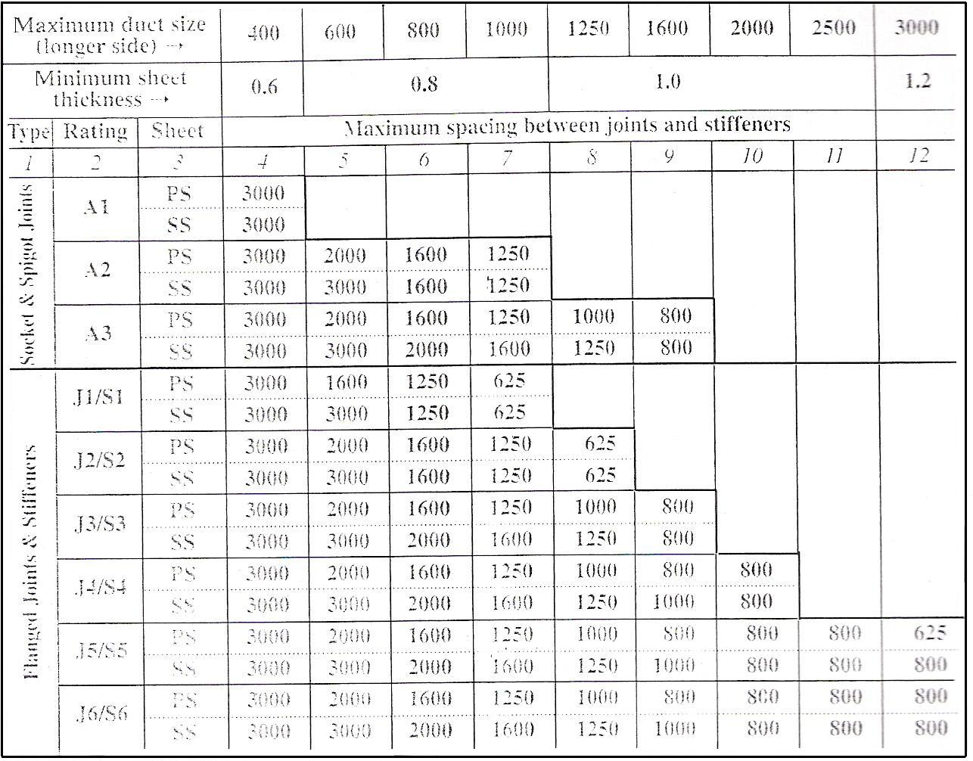
Table 2 - Low Pressure (Limited to 500 Pa Positive and 500 Pa Negative)
Dimensions in mm

Note (applicable to Table 2 to Table 4)
- The joints and stiffeners have been rated in terms of duct longer side and maximum spacing – see section “Cross Joints” for joints and “Stiffeners” for stiffeners.
- In Col. 3:
'PS' = plain sheet
'SS' = stiffened sheet, by means of
(a) beading at 400 mm maximum centres, or
(b) cross-breaking within the frame formed by joints and/or stiffeners, or
(c) pleating at 150 mm maximum centres.
- Stiffened panels may limit the choice of insulation materials.
- Although not covered in this specification due to their relatively infrequent use, cleated cross joints are an accepted constructional practice and the HVCA Ductwork Group should be contacted if details of their ratings and limitations are required.
- Intermediate stiffeners using rolled sheet angle profiles of the appropriate rating may also be utilised ensuring that rigid corners are achieved.
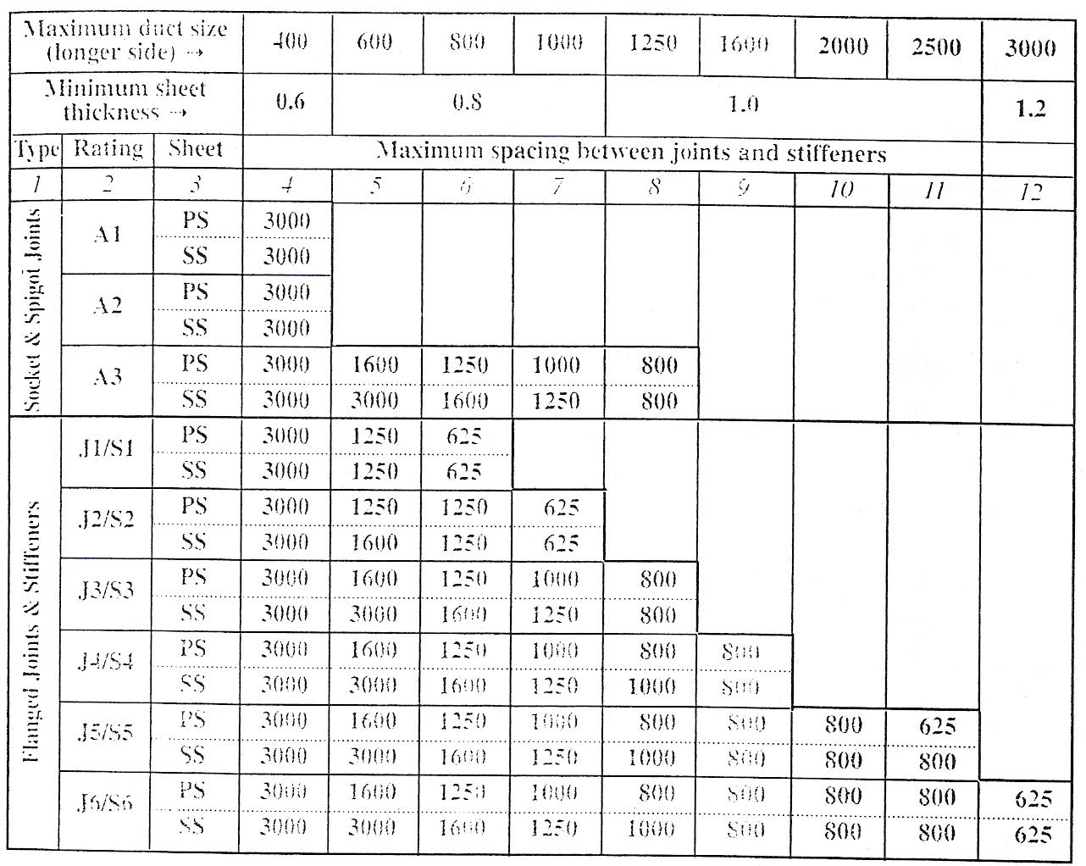
Table 3 - Medium Pressure (Limited to1000 Pa Positive and 750 Pa Negative)

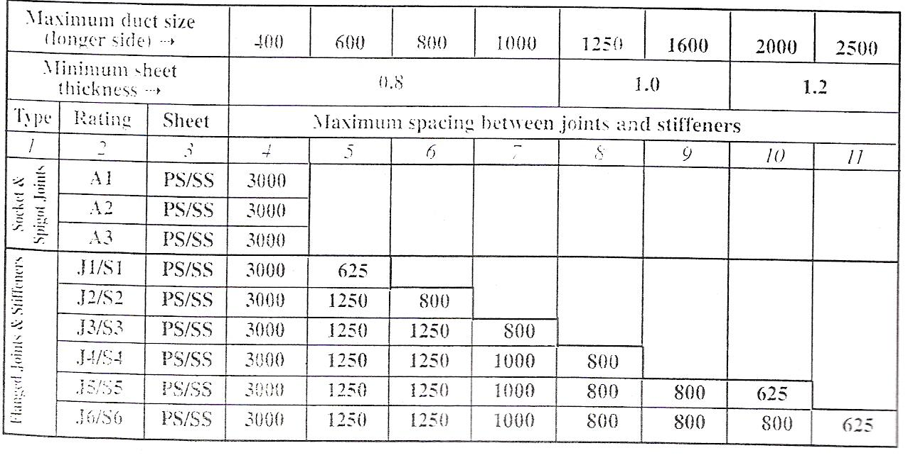
Table 4 - High Pressure (Limited to 2000 Pa Positive and 750 Pa Negative)

Longitudinal Seams
Grooved Seam  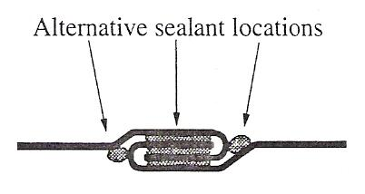 | Returned Standing Seam (Internal or External)  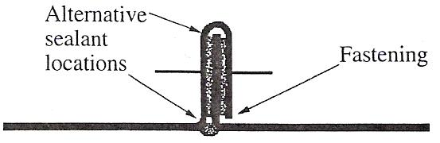
Grooved Corner Seam  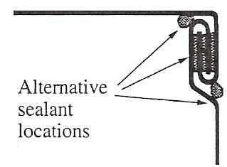 | Capped Standing Seam (Internal or External)  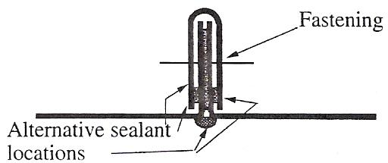
Pittsburgh Lock Seam  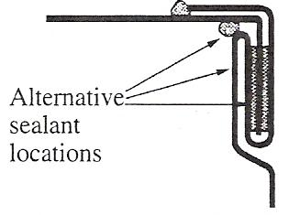 | Tray Standing Seam (Internal or External)  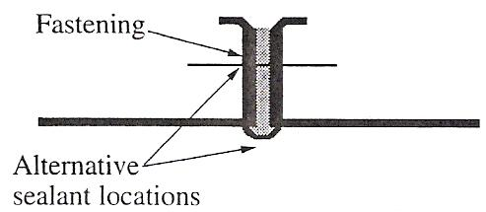
Button Punch Snap Lock Seam  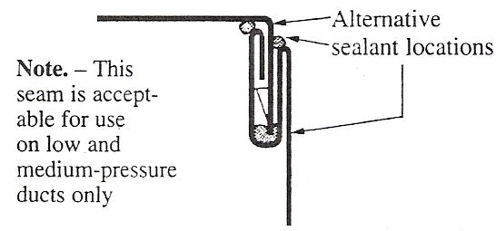 | Lap Seam  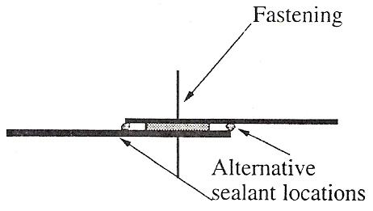
Table 5 - Longitudinal Seams
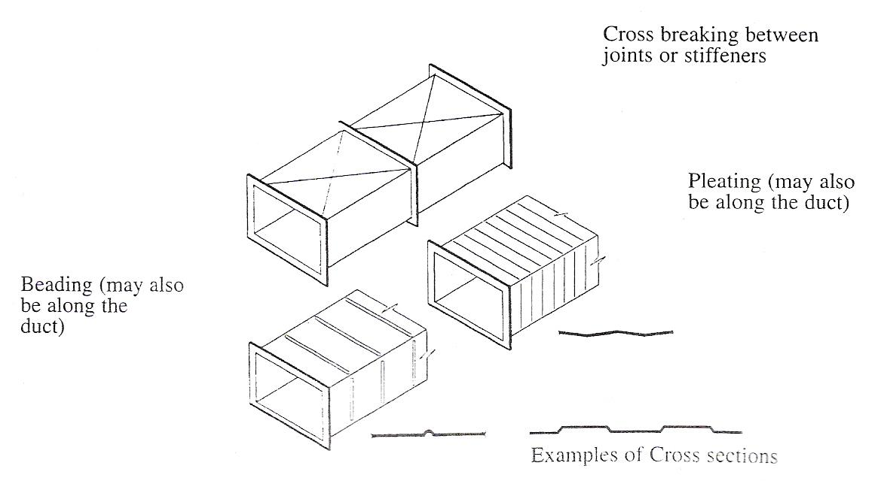
Figure 2 - Illustrations of Panel Stiffening

Self Assessment
Questions on Background Notes – Module 5.Unit 3

1. Work out the area for the main wrapper and give the method/answer to your
instructor.

2. Give two examples of panel stiffening.

Answers to Questions 1-2. Module 5.Unit 3
1.

We need to know the length of the wrapper and the width
i.e. L x B if we add 175 to 150mm we get the radius of the
bend. The length of the wrapper is:

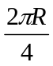 = 2 x 3.142 x 325 ÷ 4

= 2,042.3 ÷ 4

= 510.57mm = Length of wrapper.

Area of wrapper = 510.57 x 220 (150 + 70)

= 112,345.4mm²

We get the 220 by adding 150 to the lock form allowance
i.e. 35mm on either side. We may also add the two flat pieces
to the above answer:

50 x 220 x 2 = 22,000mm²
Hence a more accurate answer is:

112,345.4mm² + 22,000mm² = 134,3454.4mm²

The size of the flat pieces is obtained by subtracting 175 - 150

2.

Panel Stiffening:

- Cross checks
- Cross break
- Swaging
- Bending and rolling

Index

A
Area/Weight of Wrapper, 9
C
Construction, 11
Cross Joints, 12
Fastenings, 13
General, 11
Longitudinal Seams, 11
Steel Thickness, 11
Stiffeners, 12
Cross Joints
Adjustable/Slip Joints, 12
Cross Joint Ratings, 12
Sealant in Cross Joints, 12
F
Fastenings
Rivets, 13
Self Tapping and Piercing Screws, 13
Set Screws, Nuts and Lock Bolts, 13
Welding of Sheet, 13
Fittings, 14
Branches, 15
Change Shapes, 15
Expansions and Contractions, 15
Sealant, 15
Splitters, 14
Standardisation of Fittings, 14
Stiffeners, 14
Turning Vanes, 14
L
Longitudinal Seams, 19
Sealing of Longitudinal Seams, 11
Welded Seams, 11
R
Rectangular Duct Sizes, 11
S
Self Assessment, 21
Stiffeners
External Stiffeners, 12
Internal Stiffeners, 13

