TRADE OF
VEHICLE BODY REPAIR

PHASE 2

Module 5

UNIT: 5
Abrasives and Sanders
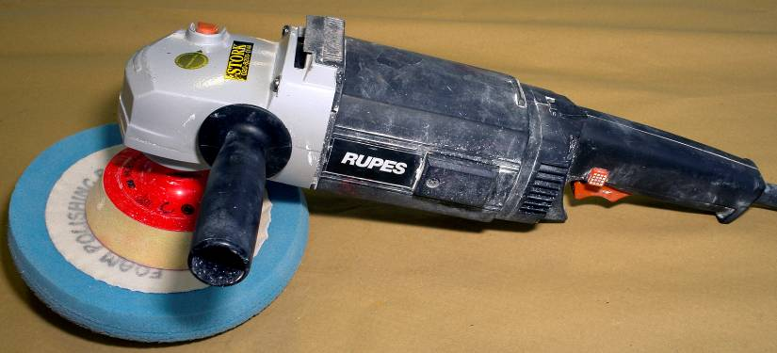

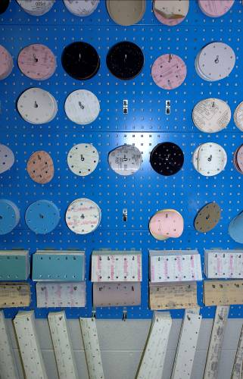

Produced by

In cooperation with subject matter expert:
Maurice Stack
Some material courtesy of CDX Global and
FENC – Further Education National Consortium.
© SOLAS 2014

Table of Contents
Introduction 5
Unit Objective 6

Spray-Painting Material 6
1.0 Correct Abrasives for Preparing Different Substrates 8
1.1 Abrasive Classification Codes 8
1.2 Types of Abrasive Materials 9
2.0 Sanding Machines and Tools 12
3.0 Wet Flat Panels by Hand for Refinishing 14
3.1 Wet Sanding Techniques 14
4.0 Dry Abrade Panels for Refinishing using Power Tools 14
4.1 Dry Sanding Principles 14
5.0 Identify the Most Suitable Polishing Materials for Different Top Coats 15
5.1 Polishing Machines and Pads 15
6.0 Identify the Most Suitable Polishing Materials for Different Top Coats 16
6.1 Silicon Free Polishing Compounds 16
7.0 Dust Vacuum Extractors Machines 18

Summary 20
Self Assessment 21
Suggested Exercise
Training Resources
Table of Figures
Figure 1: Extra Fine (P400-P600) and Ultra Fine (P800-P4000) 7

Introduction
Sanding by hand can prove to be both laborious and expensive. Unfortunately there are many parts of vehicle surfaces where there is no alternative but to carry out these processes without the aid of power tools. However, surfaces such as the roof, bonnet, boot lid and parts of the doors and wings of cars can be rubbed down or polished more economically and efficiently with power tools. Damaged areas of paintwork can be rubbed down very quickly with these machines, but final feather edging is best done by hand. Two types of machine are favoured by the refinishing painter, the oscillating sander and the orbital sander. Both are obtainable as either compressed air operated or electrically driven machines. In addition, oscillating sanders are available which operate with compressed air and can be connected to a water supply so that the worked surface is continually washed with clean water whilst rubbing down takes place.

Unit Objective
Abrasives and Sanders
By the end of this unit each apprentice will be able to:
- Select correct abrasives for preparing different substrates
- Wet flat panels by hand for refinishing
- Dry abrade panels for refinishing using power tools
- Identify the most suitable polishing materials for different top coats

Key Learning Points:
- Sanding by-products
- Abrasive classification codes
- Types of abrasive materials
- Abrasive manufacturing process
- Wet sanding techniques
- Dry sanding principles
- Dust vacuum extractors machines
- Polishing machines and pads
- Silicon free polishing compounds

 | Damaged Panels | New Panels
Paint removal/Metal surface sanding | P40-80
Keying of area prior to polyester stopper | P120-180
Stopper Sanding | P120-240
Stopper Sanding |  | P280-320
Keying surrounding area | P240-320
Filler sanding | 320+p400-600
Matting of surrounding surface incl. filler | P800-1000/Ultra fine pad
Fade-out zone sanding | P2000-4000


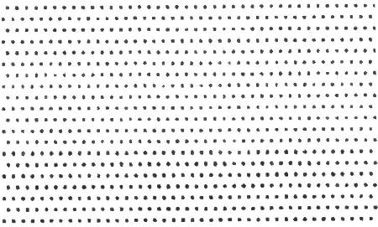

Figure 1: Extra Fine (P400-P600) and Ultra Fine (P800-P4000)

1.0 Correct Abrasives for Preparing Different Substrates
1.1 Abrasive Classification Codes
Grading of Abrasive Papers
In Europe an internationally agreed classification of wet-or dry flatting paper operates. Paper conforming to this classification are identified by the prefix ‘P’. The variation in grit size of these papers is much narrower than with the older types so they have a different grading:-
Choose the right paper for the job in hand, and get it right the first time:
Machine Sanding Dry | Manual Sanding Dry | Manual Sanding Wet
P 80 | P 80 | P 120/P 150
P 120/P 150 | P120/P 150 | P 180/P 220
P240/P 280 | P 240 | P 240/P 320
P320/P360 | P 320 | P 400/P 500
P 400 | P 360/P400 | P 600/P 800
P 500 |  | P 1000/P 1200

Coarse Sanding | 80
 | 100
 | 120
Stopper Sanding | 150
 | 180
 | 220
Fine Sanding | 240
 | 280
 | 320
Filler Sanding | 360 – 800
 | 400 - 1000
How to use a Progression Table
For good results you should not jump more than 2 grain sizes when beginning the next sanding phase.

Example:
P80 should be followed by p150, p50 by p240.
The sanding grooves caused by p80 can best be eliminated with p150, followed by p240 for the final sanding.
Tip
Particularly deep scratches can be removed faster and more easily if you do not leave out any grades. This way, the surrounding material is removed perfectly and efficiently.

1.2 Types of Abrasive Materials
Wet Dry Abrasive Paper
Abrasive paper utilises silicon carbide mineral which gives a particularly sharp cut.

Size | Grit
230mm x 280mm | P 1200
230mm x 280mm | P 1000
230mm x 280mm | P 800
230mm x 280mm | P 600
230mm x 280mm | P 500
230mm x 280mm | P 400
230mm x 280mm | P 360
230mm x 280mm | P 320
230mm x 280mm | P 280
230mm x 280mm | P 240
230mm x 280mm | P 220
230mmx 280mm | P 180
230mmx 280mm | P 150
230mmx 280mm | P 120
230mmx 280mm | P 100
230mmx 280mm | P 80
230mmx 280mm | P 60

Microfine Abrasive Paper
Areas affected by paint imperfections are removed using our highest quality microfine ‘Wetordry’ abrasive paper.

Sheet Size | Grit
138mm x 230mm | 1500
230mmx 280mm | 2000

Micron Abrasive Discs

To ease the removal of small imperfections such as dust nibs in both new and original paint finishes. Available as scalloped 1^{7/16} inch self-adhesive, film-backed discs that are used with a tiny round hand sanding pad.

Production Abrasive Paper
Uses an aluminium oxide mineral with a heavy paper backing. Sold in sheets for hand use and in rolls for cutting and attaching to machines.

Sheet Size | Grit
230mm x 280mm | P 120
230mm x 280mm | P 100
230mm x 280mm | P 80
230mm x 280mm | P 60
230mm x 280mm | P 40
115mm x 280mm | P80
115mm x 280mm | P40

Abrasive Paper
Intended to be used by hand, often as a dry sanding alternative to ‘Wetordry’ abrasive paper.
Sheet Size | Grit
230mm x 280mm
230mm x 280mm
230mm x 280mm
230mm x 280mm
230mm x 280mm
230mm x 280mm
230mm x 280mm
230mm x 280mm
230mm x 280mm
230mm x 280mm
230mm x 280mm

2.0 Sanding Machines and Tools
From roughing to fine-sanding: there are machines and tools for virtually every application.

Sanding machines have become an indispensable aid in every bodyshop. Different machines are suitable for different types of work .In spite of all the support from machines, manual sanding is still required. Especially with regard to minor repairs, it is often not worthwhile to start up a large machine. Also, sanding blocks are ideally suited for reworking edges and profiles.

Sanding blocks make manual sanding work easier and help to avoid mistakes. Their size and shape distribute the pressure evenly and allows for accurate work.

Be sure to inspect both the surface and your tool regularly during the process.

Tips
- Please use the Technical Data Sheets to obtain information about a recommended sanding procedure.

- When using sanding machines and sanding blocks, be sure to use dust extraction to stop the abrasive clogging.

- Ensure machine sanders are used flat to the surface and not on the edge of the pad.

- Try to use clean water if you must use a wet sanding system – dirt can easily be sanded into the surface causing scratches.

- Do not use electrical machines for wet sanding.

- Replace worn abrasives regularly for the best sanding results.

Important: Always wear gloves as well as a protective mask and eye protection to protect your health.

Abrasive Orbital Sander
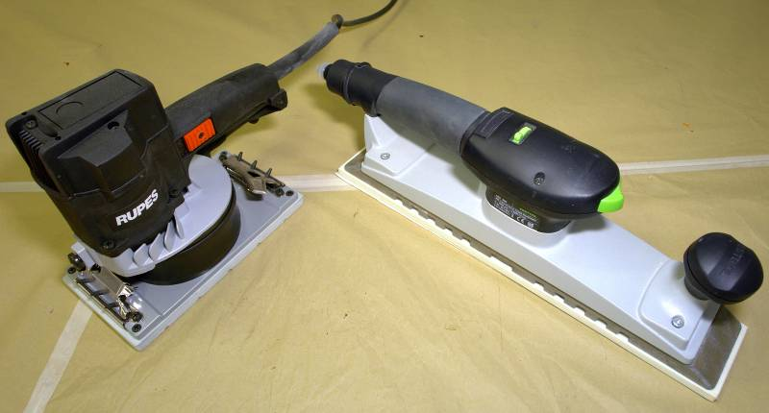


Rectangular sanders swing on the substrate
Available in air or electric

Eccentric Random Orbital Sanders

Random orbital sanders swing and rotate simultaneously on the substrate. The eccentric construction eliminates sanding traces.
For more on sanders see tools, mod 2, unit 1.
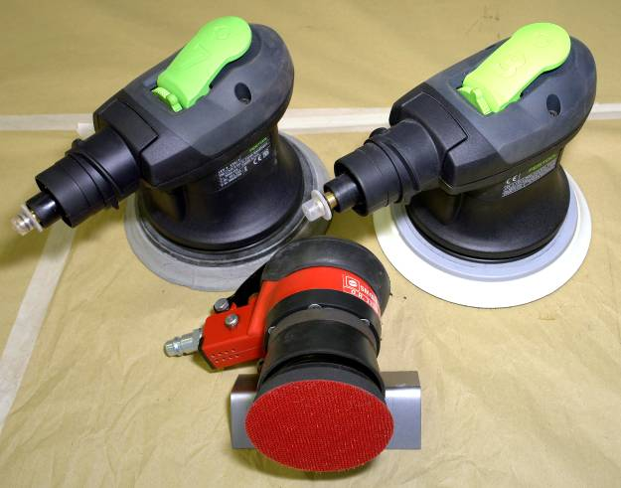
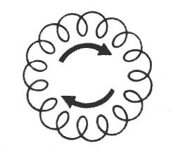

Random orbital sanders swing and rotate simultaneously on the substrate. The eccentric construction eliminates sanding traces.
3.0 Wet Flat Panels by Hand for Refinishing
3.1 Wet Sanding Techniques

Wet Flatting

This is carried out using wet or dry abrasive paper, lubricated with plenty of clean water to keep it cutting freely and to eliminate dust.
If water is allowed to evaporate naturally at the flatting stage it leaves a residue of alkaline salts on the flatted surface which is difficult to remove. The result of this can be humidity blistering. It is therefore vital to sponge off and leather dry thoroughly before flatting the next panel.

4.0 Dry Abrade Panels for Refinishing using Power Tools
4.1 Dry Sanding Principles

Dry Flatting

Open coat abrasive papers are available for dry flatting, some of them incorporating stearate powder as a dry lubricant. These papers will produce a finer surface and last longer than wet or dry papers used dry.
After using stearate lubricated paper, cleaning of the flatted surface is essential. Any stearate powder left on the surface can lead to poor adhesion of the colour coats. This is especially important in the case of primer-fillers, where stearate lubricant is more easily retained on the surface.

5.0 Identify the Most Suitable Polishing Materials for Different Top Coats

5.1 Polishing Machines and Pads

Machine Polishing

Machine polishing requires quite a lot of skill. The operator must take care to keep the mop on the move – preventing the generation of too much heat which can soften or burn some finishes. He /she must also be careful to avoid sharp edges and awkward curves, where the finish can easily be removed.

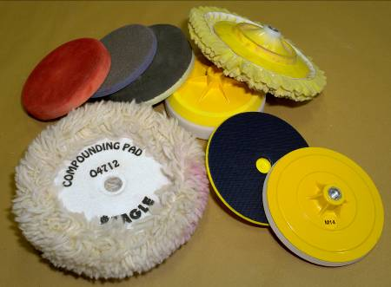
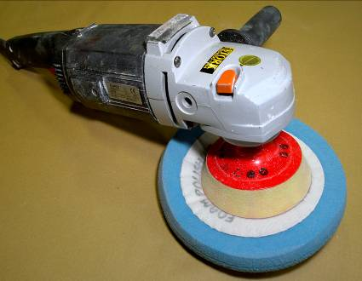
Polishing mops must be kept clean. Excessive compound and paint residues on a mop increase friction and the tendency to burn the finish. Lambs-wool mops can be washed with warm water and soap and then returned to the machine and spun dry.
Mops/Heads Machine
6.0 Identify the Most Suitable Polishing Materials for Different Top Coats
6.1 Silicon Free Polishing Compounds

Polishes

Newly applied lacquer finishes should never be compounded or polished until they are thoroughly hard and a substantial proportion of the solvents have evaporated. Compounding too soon will result in the loss of gloss (hazing) and the finish may be permanently impaired.
Wax polishes must never be used until the finish is at least four weeks old, by which time all solvents will have evaporated from the film. Otherwise the wax can migrate into the finish causing softness, loss of gloss, and a tendency to watermark.
The surface to be polished must be free from dust and dirt, and the compound applied to a small area at a time, using a soft open mesh cloth which easily becomes impregnated with the compound. The cloth may be dampened before use, or the compound thinned with water before application; but solvents or petrol must never be used.
The compound can be applied by hand or by mechanical polishing mop with a greater pressure at first, gradually easing up as the compound dries and the desired effect is obtained.
With hand rubbing, straight strokes must be used following the lines of the bodywork.
Eventually some loss of gloss, and an accumulation of traffic film, will occur, but normal washing and a polish with a good quality liquid polish will restore the original lustre of the paint film.
High gloss and added protection against contamination needs wax polishing. But it must be remembered that a wax polish can only be used successfully on a clean surface. The previous application must be removed with white spirit or a liquid polish cleaner before re-waxing.
Polishes containing silicone repel water and protect a paint film, but they must be kept well away from the paint shop for they cause cratering or ‘fish-eyes’ when applying the refinish paint.

Rubbing Compounds

Rubbing compounds are like flatting papers: the coarser grades cut faster but produce deeper scratches. So the finest grade capable of doing the job should be used.
Heavy polishing should not be carried on thin final coats. In some colours, if a breakthrough occurs and the previous coat is exposed, a dark ring will become apparent.
Particular care is needed when compounding metallic finishes. If the final coat is removed and the previous exposed, a defect called shearing is produced, and this can only be rectified by repainting.

Washing

Many contaminants which will attack a paint film are water soluble. They can be removed before any harm is done by thorough washing with plenty of water, and a few drops of liquid detergent. Frequent washing is the best safeguard against unseen contaminants: at the same time ensuring the regular removal of dirt, dust, and traffic film.
If washing with cold water is not effective, warm water and detergent will remove the gummy deposits exuded by some trees in the summer months. Petrol or white spirit will remove stains of the tar, bitumen and grease type.
If the paint is damaged by thinner or brake fluid it may be permanently damaged.

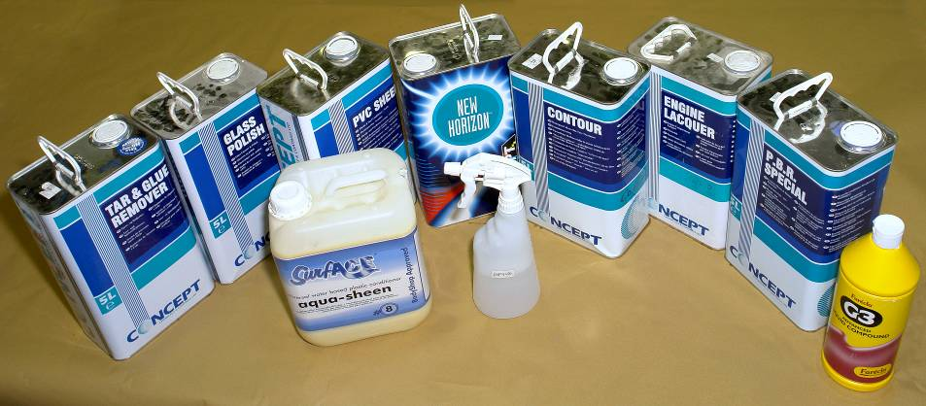
Polishes
7.0 Dust Vacuum Extractors Machines
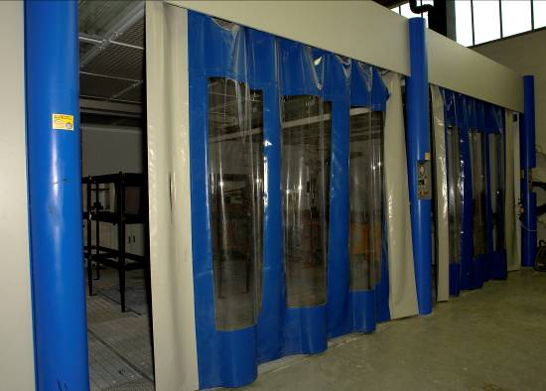
Dust vacuum extraction prevents the accumulation of dust when sanding.

Dust Extraction Prep Bay
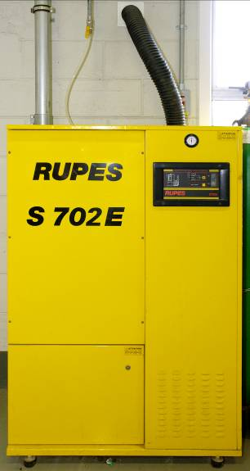
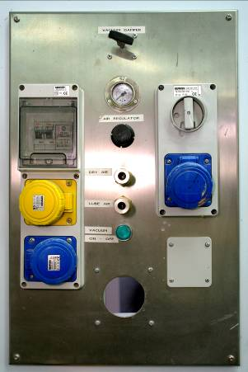
Panel
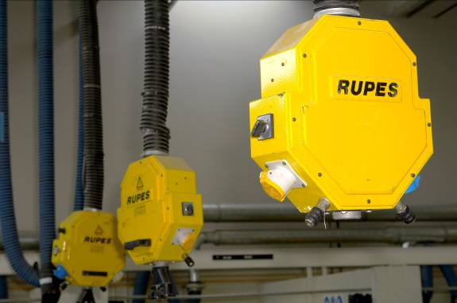
Rupes Extraction System (Hanging)
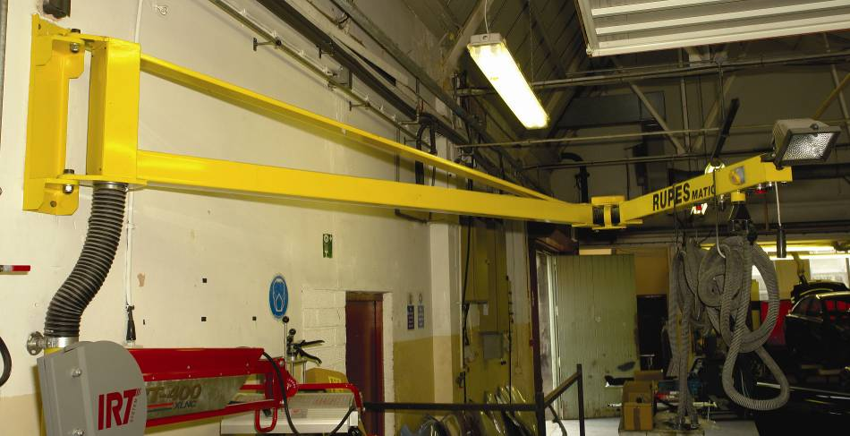
Rupes Swing Arm with Electrical Vaccum
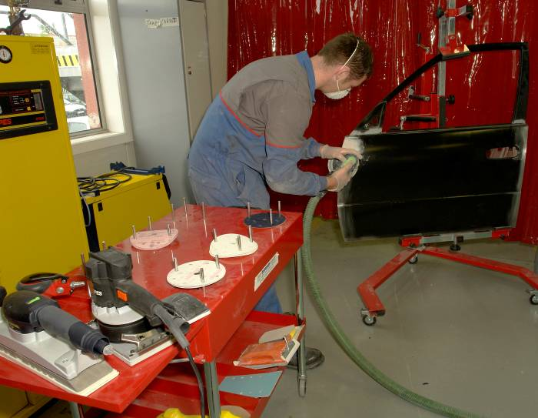

Mobile Dust Extraction
Summary
Whilst the flatting abrasive will remove the high spots to give the overall level surface required, it will leave scratches or score marks behind. Their depth is related to the grade of abrasive paper used.
These scratch marks will be mirrored in the surface of next coat of paint. The way to control and eliminate these scratches is to use progressively finer grades of abrasive paper as the paint system is built up.

Self Assessment
Questions – Module 5. Unit 5
1. Which one of the following grades of paper is the finest P80 or P800?
2. What type of sander should be used to prevent an accumulation of dust?
3. What grade of sand paper should you start with when feather edging coarse or fine?
4. What is meant by progression of grain?
5. Where are scotch pads most useful?

6. What does dust extraction do for sanding discs?
7. Why must polishing mops be kept clean?
8. When hand rubbing with compound what’s the correct procedure?
9. Will brake fluid or thinner permanently damage paint?
10. What safety precautions need to be observed when sanding?

Answers to Questions 1-10. Module 5. Unit 5
1.
P800
2.
Use an exhaust orbital sander.
3.
Coarse
4.
It means not jumping more than 2 grain sizes at a time.
5.
In areas that are difficult to reach.

6.
Stops them from clogging.
7.
Because clogging increases friction and tends to burn

8.
Straight strokes must be used following the lines of the vehicle.

9.
Yes
10.
Respirator and P.P.E gloves made from cotton.

Suggested Exercise
- DA sand a new vehicle panel in preparation for application of two coats of etch primer.
- When flashed off, overcoat with two coats of 2K primer surfacer and force cure.
- Wet flat primer with P.800 grade water paper in preparation for topcoat.

Instructions:
- DA. Abrade a new panel for application of etch primer
- When flashed off apply two coats of two-pack acrylic primer surfacer
- When cured wet flat with P.800 grade waterpaper

Tools and Materials:
- Spray booth
- Mixing room
- Painting tools
- Painting materials and sundries
- DA. sander with dust extraction
- PPE’s
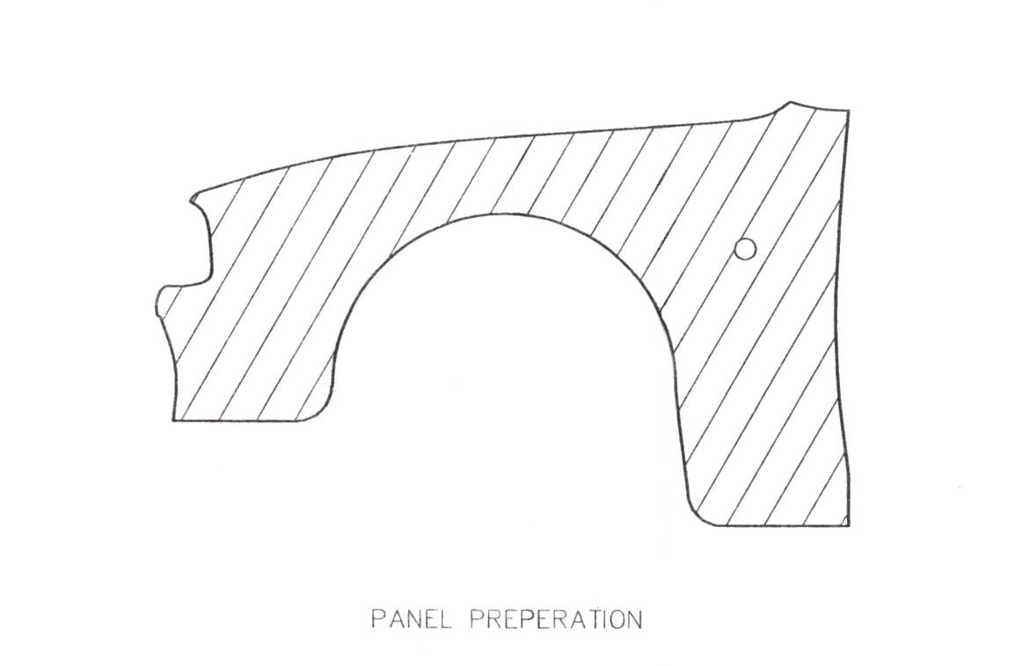

Dimensions | Gen. tol. | Scale | Material
mm |  | nts
SANDERS AND ABRASIVES
SOLAS | Phase 2. Mod 5. Practice 1

Work carried out in a manner that is unlikely to cause injury to apprentice or colleagues. Preparation of panel and application of primer to paint manufacturer’s specifications.

Training Resources
- Classroom/workshop
- Sanding and polishing machines
- Dust extraction unit for DA sander
- Various types and grit abrasive papers
- Various types and grit sanding discs
- Scotch brite pads
- Various polishing compounds
- Technical data material

27-33 Upper Baggot Street
Dublin 4

