TRADE OF
VEHICLE BODY REPAIR

PHASE 2

Module 6

UNIT: 1
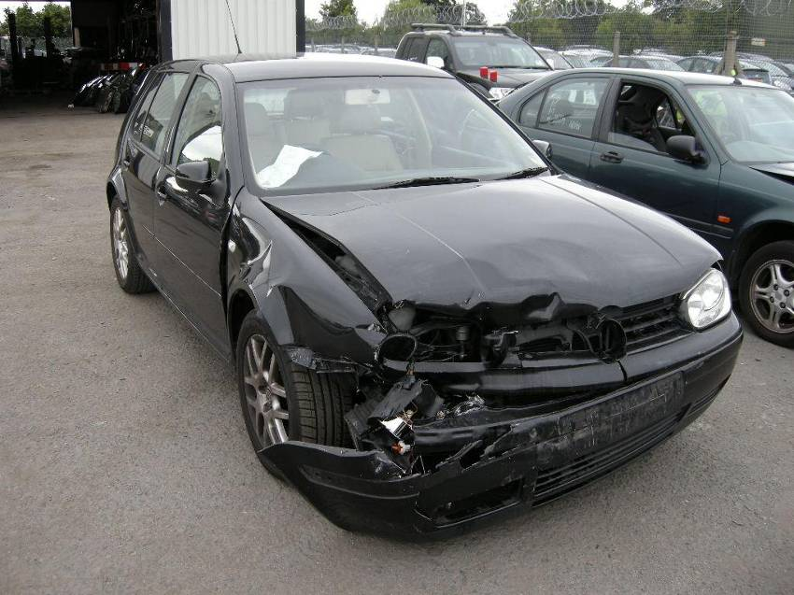
Damage Assessment

Produced by

In cooperation with subject matter expert:
Maurice Stack
Some material courtesy of CDX Global and
FENC – Further Education National Consortium.
© SOLAS 2014

Table of Contents
Introduction 5

Unit Objective 6

Damage Assessment 6

1.0 Assess Minor Vehicle Body Damage 7
1.1 Safety in Relation to Assessing the Vehicle in a Safe Manner 7
2.0 Visually Assess for Primary and Secondary Damage 8
2.1 Assessment (Secondary Damage) Primary Damage 8
3.0 List Parts and Materials Required 12
3.1 Insurance Company Procedures Listed and Followed 13
4.0 What is Thatcham? 16
4.1 Thatcham Combination + Single Panel(s) 27
4.2 Insurance Company Procedures Listed and Followed 31
4.3 Computer Estimating 32
4.4 Insurance Company Procedures Listed and followed 32
5.0 Produce Parts List 34
5.1 General View how Glassmatix Works 34
6.0 Plan Repair Sequence from start to finish 42
6.1 Detailed Repair Plans Parts List 42
6.2 Repair Sequence. Detailed Labour Times 42
Summary 44
Self Assessment 45
Suggested Exercise
Training Resources
Table of Figures
Figure 1: PartBase 34
Figure 2: PartBase 34
Figure 3: PartBase 35
Figure 4: PartBase Vehicle Section 36
Figure 5: PartBase Vehicle Section 36
Figure 6: PartBase 37
Figure 7: Repair Estimate 39
Figure 8: Vehicle Job Card 40

Introduction
The repair of all collision damage can be divided into three different categories:
- Repairing by re-aligning and reshaping the damaged section which can be economically repaired.
- Repairing by removing sections beyond economical repair and replacing them with new sections.
- Repairing by using a combination of re-aligning and reshaping together with the replacement of appropriate sections.
Before deciding whether to repair or replace, consideration must be given to the extent and type of damage, whether it is possible to repair a particular panel or not (this fact is influenced by the equipment which is available) and also whether it will be cheaper to repair or replace any one section. A good body repair worker would probably be able to repair almost any part of a car damaged in a collision; however, the labour and time cost involved in attempting to repair extensively damaged panels would be an uneconomical proposition. Only experience in body repair work will give the ability to estimate the time required to do a particular job. Therefore the final decision depends on what is possible to repair and what is economical to repair. As the construction of the modern vehicles advances, body panel assemblies are becoming very complicated and therefore their cost is constantly increasing. The cost of replacement parts differs between one manufacturer and another, and even between models.

Unit Objective
Damage Assessment
By the end of this unit each apprentice will be able to:
- Assess minor vehicle body damage
- Be able to visually asses for primary and secondary damage
- List parts and materials required
- Produce parts list
- Plan repair sequence from start to finish

Key Learning Points:
- Safety in relation to assessing the vehicle in a safe manner
- Assessment (secondary damage) primary damage
- Repair sequence. Detailed labour times and parts list
- Insurance company procedures listed and followed
- Detailed repair plans

1.0 Assess Minor Vehicle Body Damage
On mono constructed vehicles the correct positioning of new panels, which may incorporate reinforcing members, becomes increasingly important and calls for expensive jigging to ensure the accurate alignment of panels which will have to be fitted with major mechanical components and suspension units. The highest proportion of any repair bill is made up of cost of labour involved in stripping out, to gain access to the damaged area, and re-building up after replacement is effected. In certain cases, therefore, it can be more economical to repair a damaged panel than to replace it because of the time and labour cost involved for the amount of work over and above that required to repair the part. Consequently in any body repair workshop the dividing line between repairing and replacing is not only decided upon according to what is economical to repair, but also by the availability of the most up to date equipment to deal with all types of major collision damage.
On the other hand minor visible damage is easily accessed because it’s only found on exterior panels which is called primary damage. Be careful because some minor primary damage may include secondary damage.

1.1 Safety in Relation to Assessing the Vehicle in a Safe Manner
- If possible put vehicle on a hoist.
- Look out for sharp edges.
- If a hoist is not available, secure on axle stands.
- Look out for leaking fluids as they may be flammable or harmful.
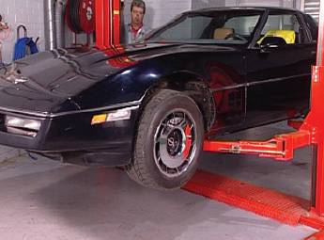
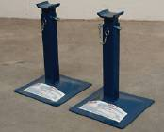

2.0 Visually Assess for Primary and Secondary Damage
2.1 Assessment (Secondary Damage) Primary Damage
Damaged bodywork is corrected by first observing the extent of the damage, then deciding how it was caused and the sequence in which it occurred. The resulting damage can be classified into two groups:
Direct or Primary Damage
This results from the impact on the area in actual contact with the object causing the damage. This will result in the largest area of visible damage and is the cause of all other consequent damage. Primary damage is identified by first determining the direction of the primary impact. This knowledge will help in the search for concealed damage.
Indirect or Secondary Damage
This is usually found in the area surrounding the direct damage which causes it; although in certain cases it may be some distance from the actual point of impact. After the impact, internal damage is caused by the forced movement of objects and passengers towards the point of impact and can be seen in the form of damaged dash panels, broken seat frames and twisted steering wheels.
These two groups can each be subdivided in two further ways:
Visible Damage
This is damage that can be readily seen in the area of actual contact, such as a vehicle having suffered frontal impact causing damage to the bumper, grille, bonnet and front wings. A detailed examination may discover distortion of the inner wing valances, which would indicate visible indirect damage.

Concealed Damage
This is indirect damage, but is not easily detected by visual examination unless the vehicle has been partially dismantled to allow a detailed inspection. In most situations, measuring equipment in the form of body jigs must be used to detect concealed damage, because complicated monoconstructed vehicles may hide further damage such as misalignment, which could therefore affect the steering and roadworthiness of the vehicle.
Direction of Damage
Direction of damage, or line of impact, is particularly important to the body repairer. It is used to identify the sequence and direction in which the damage occurred and consequently the reverse sequence to be followed for the repair. Direct damage marks are usually scratch marks where the paintwork has been damaged; they are an excellent guide to what happened and indicate the possible location of any hidden damage.
By careful study of the damage sustained it should be possible to ascertain the direction and strength of the impact force, and this is always the preliminary stage of a detailed assessment.
Methods of Describing Major Damage
Parallel side damage is caused by the impact object moving parallel to the vehicle and causing substantial damage along the full length of the side of the vehicle, e.g. wing, doors, rear quarter panel.
Direct side damage is caused when the vehicle is struck at an angle to its side, causing substantial damage at the point of contact.
Front-end damage is the result of head on collision, collapsing panels from the bumper to the front bulkhead.
Three-quarter frontal damage is the result of an angled front end collision, sustained damage to one front wing, the grille and bonnet.
Rear-end damage is the result of an impact direct or slightly angled, to the rear end of a vehicle and causing substantial damage to bumper, rear panel, boot lid, boot floor panel and quarter panels.
Roll-over damage is caused by the vehicle rolling completely over and returning to its wheels. In some cases this type of movement could cause damage to almost every panel.

Total write-off is damage so extensive that the vehicle is either unrepairable or the total cost of repair would be greater than the value of the vehicle.
Costing
The determining factor when deciding whether to repair or replace lies in the comparison between the cost of repairing the damaged part as against the cost of a new replacement part. When the owner of a car is personally paying the cost of repairs, the repairer will need to come to an agreement with him concerning an acceptable standard of repair for the amount of money the owner is able to pay. When it is an older car the cost involved in striving for perfection in the repair is not always justified, since these costs could be more then the current value of the vehicle under repair. In cases of this nature a compromise must be arrived at between the repairer and owner as to the quality of repair and cost of repair. When an insurance company pays for repairs to the damage of a new or nearly new car, the quality of work must be such that when the repair is finished there is no indication of the damage having occurred. When an insurance company pays for repairs to an older car and the condition of the car is, in many cases due to corrosion, affects the quality of the repair, the possibility of perfection of appearance is limited and a mutual agreement must be reached between the owner and the insurance company on a satisfactory quality of repair. Time is always an important factor in the repair of collision damage; however, the majority of car owners are not willing to sacrifice quality of repair for speed of repair.
Estimating
The ability to estimate can only be gained through practical experience in the field of body repair work. An estimate must be competitive to be acceptable to both the private care owner and the insurance company, for the majority of collision jobs are paid for by an insurance company. In estimating, the financial gain for the body shop will depend on the estimator’s skill in assessing the damage, his knowledge and experience in repair techniques, and the capabilities of the equipment available. Small body repair establishments have no separate estimator and therefore it is usual for the man who prepares the estimate to be responsible for carrying out the repair work as well. The larger establishments employ one member of staff who is responsible for all estimating, while the actual repair work is carried out by the tradesman on the shop floor. Consequently there must be no lack of coordination and understanding between these two and the jobs they perform.
The decisions of the estimator are all important as they investigate the organization of work on the shop floor but, no matter how skilled the tradesmen are, with bad estimating the financial profits can be drastically affected. In collision work the estimate is considered as a firm commitment to do the work involved for the money shown, and should detailed so that insurance companies or private car owners can determine from the estimate exactly what is proposed to the damaged vehicle. The estimate must include cost of parts and labour costs at the recognised retail rate of the body shop establishment. When preparing an estimate the crash damage should be itemised into the number of damaged panel sections and assemblies, and therefore it is important to have knowledge of vehicle body construction. The outer panels which make up the body shell should be referred to by the manufacturer’s recognized names, such as:
Near side front door (N.S.F. door)
Near side rear door (N.S.R. door)
Off side front door (O.S.F door)
Off side rear door (O.S.R. door)
Roof panel
Boot lid
Bonnet
Near side centre pillar (N.S. centre pillar)
Radiator grille
Near side front wing (N.S.F. wing)
Off side front wing (O.S.F. wing)
Near side sill panel (N.S. sill panel)
Off side sill panel (O.S. sill panel)
Front bumper bar assembly with valance
Rear bumper bar assembly with valance

3.0 List Parts and Materials Required

A typical list for body repairs:

Vehicle Collision Repairers LTD Hood Street. Newcastle
Telephone No. Date.
Everymans Insurance Co Market Square
Repair Quotation for Mr A Robinson’s Austin Martin
Registration No.
Claim No.
To remove and replace O/S rear quarter panel To repair O/S sill panel To repair O/S rear door To remove and replace rear bumper bar assembly To remove and replace parts
Plus rear quarter panel, boot lid, rear bumper bar assembly, to be supplied at current cost prices.
Signed: N. Sanders (Works Manager)

In addition this can be further broken down to all internal panel structures according to the position of the damage. It is essential to determine the exact amount of stripping necessary for either the repair or the removal and replacement of a damaged section. To calculate the actual cost of a job it is necessary to establish a set rate per hour for all repairs done in the repair shop, and therefore an accurate total repair time can be calculated on the time taken to repair each section of the body. This then provides the actual cost estimate for repairing each section or part of the job.
The retail rate or set rate per hour is the amount of money that the repairer charges the customer for labour and is made up of wages paid to the tradesmen; the cost of overheads, which should include such items as supervision, depreciation of equipment, rent, heat, light, electrical power, advertising, telephone accounts, cleaning, office staff, stationary and postage and workshop materials; and also a reasonable amount of profit.
3.1 Insurance Company Procedures Listed and Followed
Under the Road Traffic Act the car owner is obliged to insure his vehicle either under third party insurance cover or fully comprehensive insurance cover and as a direct result of this fact most accident damaged is covered by insurance and therefore repaired in body work establishments. The adopted procedure for dealing with repairs carried out under and insurance claim is as follows:
- The claim form
- The itemised estimate
- The authority to repair
- The clearance certificate
The Claim Form
When involved in an accident which has resulted in vehicle damage, the owner should obtain and complete an insurance claim form and immediately return it to his insurance company, or make a written report on the accident and damaged received.
The Itemised Estimate
According to the extent of the damage, and if the vehicle is still road worthy, the owner takes the vehicle for the inspection of the repairer who will do a visual inspection of the assessed damage, and from the knowledge gained, complete a written, itemized estimate which he will submit as a tender to the insurance company. This estimate will show the total cost of repairs, and where the estimated amount is under a certain figure set by the insurance company, the owner has the right to authorise the repairer to do the work. However, in most repair cases this figure is exceeded and the insurance company’s assessor is the only person authorised to allow the repairs to proceed.

One of the important factors when estimating for insurance claim damage is to examine carefully every section of the vehicle, especially those parts which are a known weakness in the construction and therefore liable to be affected directly or indirectly by a collision. A methodical system of estimating is essential to avoid missing any damage and is usually carried out by noting in order all removal and replacement items, all repair items, all re-spray items and all items to be supplied new at cost, including mechanical parts and any trim. Supply items are usually difficult to price because of the makers’ fluctuating prices, and therefore they should be listed ‘at cost’. Spray painting can be quoted either by itemising each part separately or by a complete price for the total spray operation. While in the owners’ presence, the repairer should point out any rusted sections which may affect the repair work, or any previous un-repaired damage which is not covered under this insurance claim.
The Authority to Repair
It is essential to obtain the authority to repair from the insurance company involved before any work is started on the damaged vehicle. One receiving the repairer’s estimate the insurance company will instruct their own engineer assessor or an independent assessor to examine the vehicle and satisfy himself that the claim is in order and that the estimate submitted by the repairer does not include any labour or material necessary as a result of any other than the accident report. The engineer assessor then agrees the cost of repairs, particularly the labour charges, with the repairer while inspecting the vehicle, and decides whether or not damaged parts shall be repaired or replaced. After this inspection the assessor will send written instructions on behalf of the insurance company, and these are the authority to repair. A condition of these instructions is that the repairer is restricted to repairing the damage as seen and estimated for. Any additional damage disclosed when dismantling the vehicle must have a separate estimate submitted, and work cannot be carried out on this damage until the extra estimate has been agreed and the necessary work authorised by the insurance company.
The Clearance Certificate
This certificate is provided by the insurance company for the vehicle owner to sign when he has seen that all the agreed repairs have been completed satisfactorily, and the damage reinstated to its original condition. The signing of this certificate by the vehicle owner frees the insurance company from any obligation in connection with the claim for damage caused by this particular accident. It is to the repairers advantage for him to ascertain that the clearance certificate has been duly signed before the vehicle is returned to the owner.
The duty of the repairer is to see the damaged part re-instated to its original condition. When garaged safely and when executing the repair he is expected to make full use of his skill and knowledge to affect the best possible repair, as the owner relies on his reputed skill.
4.0 What is Thatcham?
THATCHAM
THE MOTOR INSURANCE REPAIR RESEARCH CENTRE
Motor Insurance Repair Research Centre (Thatcham)
In the 1960s the motor insurance industry became concerned about the escalating cost of vehicle accident damage repair work and its effect on motor insurance premiums. To have some influence on these costs it was recognised that motor insurers required a means of researching the cost of repairing accident damaged cars and light commercial vehicles.
In 1969 motor insurance company members of the British Insurance Association and motor syndicates at Lloyd’s joined in a scheme to create a research centre. The result was Thatcham, named after the small Berkshire town where it is situated, and the only centre of its type in the UK. Thatcham is unique in that it represents an entire motor insurance market. It has been granted research status by the government, and is funded by levies on the members of the Association of British Insurers and Lloyd’s Motor Underwriters Association.
The aims of the centre are as follows:
- To advise on repair methods and prepare accurate job times for panel replacement
- To minimise the effects of road accident damage and liaison with manufacturers in the interests of better vehicle design
- To pioneer quicker, more cost effective methods of damage repair
Thatcham exists to promote cost effective methods for motor vehicle repair. This includes demonstrating the type of equipment and techniques which are available to the repair trade. This effort is backed by a professional approach using skilled workshop personnel and engineers recruited from the repair trade and manufacturers. They are able to provide insurance engineers and repairers with essential repair information, often as soon as new vehicle models become available at the dealers.
Research at Thatcham is divided into two stages
Stage 1
Research determines the best method of removing and replacing the outer cosmetic panels of undamaged vehicles, and the time taken to do this.
Stage 2
Research is more advanced; it relates to vehicles that have been subjected to controlled structural damage, and is concerned with the repair methods and times associated with such damage. Because most research concentrates on pre-launch or recently launched vehicles, accident damage is simulated on the crash test facility. This provides uniformity of impact, irrespective of the model, and provides data based on constant factors, thus making model damage comparison more meaningful. Vehicles can be propelled into a static crash barrier or impacted by a 1000kg mobile crash barrier.
Both stage 1 and 2 research is observed by a work study engineer, who determines the most effective method of repair. This is achieved through consultation with the vehicle manufacturer, other specialist engineers and very often the experienced skilled tradesman carrying out the work. Subsequently, repair methods are established before publication. The evolution of manufacturing techniques inevitably means the introduction of new materials, tools techniques which could have a significant impact on repair methods. Specialised research projects are set up to establish the effect of such materials, tools and equipment on repair methods, times and costs. From time to time, research into specific aspects of vehicle engineering is undertaken for manufacturers.
The result of the centre’s research are published in method manuals, special reports, newsletters and in the form of parts pricing information. Once the work study engineer has evaluated the information obtained through observation and consultation, the data is published in a methods manual. These contain comprehensive data on repair methods and times, welding tables and diagrams, and technical information supplied by the vehicle manufacturer. The results of the specialised research are published through special reports. Newsletters supplement published data, providing information for immediate action within the vehicle repair industry.
Training is seen as an essential and increasingly important part of the work done. Thatcham provides courses for insurance company staff engineers and independent consultant assessors, concentrating on the latest developments in jig technology, welding and refinishing. Help is also offered to develop potential repair talent by encouraging educational institutes, such as technical training colleges, to visit the centre.
Overall, the staff are working towards enhances low-speed impact performances; quicker and more cost-effective repairs; and a better understanding between those who do the repairs and those who pay for them. Thatcham continues to influence and improve repair technology, keeping pace with the ever-increasing sophistication of the modern motor vehicle to the benefit of the motoring public.
Thatcham Approved Software
Estimating Systems
- ARCS
- Auto Claims
- Axiquote
- Bodyshop Direct
- CarCalc
- Glassmatrix
- GMXWeb
- Image Assessor TTStimator
- Inter-est
- Motex Easiest
- Motor Quota
- QuOITS
Brief Points about Thatcham Times
M.E.T
Mechanical, Electrical and Trim. This is removal/replacement of the necessary items to carry out a repair.
Panel
This is the removal and re-welding or re-bolting of panels required to carry out a repair.
Paint
This is the preparation and painting time for the above panels. This includes mixing, gun cleaning and the use of Health and Safety attire. Etc.
Paint Combination
This is time taken to paint an additional panel, once the largest paint time have been taken.
Job Allowance – (J/A)
This is a time given by Thatcham for the vehicle to be moved into place, tools and parts to be collected etc, .50 of an hour for the first panel - .25 of an hour thereafter, rounded up to the nearest decimal place, e.g. Panels – 1 panel 0.5 hours, 2 panels 0.75 hours rounded up to 0.8 hours, 3 panels 1.0 hour.
Set Combinations
Thatcham use set combinations for certain ‘standard’ repairs to vehicles. These range from F1 – F8 for front repairs, S1 - S8 for side repairs and R1 - R8 for rear repairs. Combination 1 – 4 are the same for all models. Combination 5 on are particular to the model selected.
All Vehicles impacted and repaired at Thatcham are new. An age allowance must be added if a vehicle is going to be difficult to disassemble through rust and weathered items.
Most vehicles tested are the base model in the range, although some models tested ate the most popular. Check the Methods Manual before estimating. An allowance must be made for a additional M.E.T. (Mechanical, Electrical and Trim) and Paint items for higher specification models.
Most vehicles tested are only impacted on the offside front corner and nearside rear corner. No impact is made to door, etc. This means that if you come across a severely damaged door that needs cutting apart to remove M.E.T. items, extra allowances must be made.
Thatcham Combinations do not include jig loading times. If you feel that the vehicle needs to be mounted on your jig, then allow 3.8 hours for a bracket system and 2.8 hours for a universal/measuring system.
Single Panel
Thatcham times do not include wheel alignments checks. Combination times do not allow for a geometry check on frontal impacts, but do not allow for setting. Additional allowances must be made for setting steering, etc.
Component Build-Up
Thatcham M.E.T gives you time for removal of large components when removing suspension, radiator assemblies etc. If however an item within that assembly is damaged and needs replacing, then an additional allowance must be made.
Paint Blending
Standard non-metallic (solid) colours and clear over non-metallic (clear over solid) colours are painted edge to edge. If you need to blend into other surrounding panels, extra allowances must be made.
All metallic (C.O.B.) and two stage pearls allow for blending into adjacent panels, but not the removal of trim from those adjacent panels.
Valeting Times
Times do not include cleaning of the vehicle.

Opinion Times
Thatcham only allows time for replacement parts. If a panel is damaged, but repairable, then an opinion time must be given for the repair. You must not use the paint time given by Thatcham for the same panel as this is for new panels only. You can use the M.E.T. total if you are removing all components around that panel.
Thatcham do not allow for final checks, road tests or polishing of paintwork.
If a combination time is used, and a further panel is added to that combination and is not adjacent to it, then an extra allowance is necessary for remote masking.
Paint Cost Guide
This is the average price taken from various Paint Manufacturers. It does not include VAT, ‘Mark-Up’ or Discount. This price takes into account Paint Consumables but does not include body consumables e.g. filler, grinding discs, welding consumables or corrosion protection materials.
Anti-Corrosion
Add 0.1 of an hour for additional panels.
Above is a very brief summary of Thatcham, times, and is by no means a full set of rules by which to work. Additional information can be obtained from the booklet supplied by Thatcham ‘An Introduction to Thatcham Procedures’. A Thatcham Estimating course is the best method of getting the most from vehicle estimating.
All times are obtained under Thatcham workshop conditions and apply to new panels being used. The repairer’s working practices, variations in age and condition of the vehicle and any other associated work must be assessed by the Engineer and Repairer, and adjustments made as necessary.

Thatcham
Application of Times
This course takes into consideration all Thatcham time systems including Manual Paint Adjustment Factor (MPAF). It should noted that Thatcham states it unlikely that a manual and electronic estimates will provide the same results even though they used the same data and rules.
Depending on the vehicle being assessed, the assessor needs to identify which time system is applicable i.e. which system was used by Thatcham when the vehicle research was undertaken. This means the time data could be TTS 1, TTS 2, or MPAF. MPAF starts with the Nissan Primera after April 2003, prior to this date TTS 1 and TTS 2 apply. MPAF uses the same rules as TTS 2; the only change is related to paint times.
Summary of Differences Between the Data Versions

TTS 1 The Job Allowance was included within the combination times. If using this data, the Job Allowance should be removed and a manual Job Allowance should be added. See Job Allowance section.
TTS 2 Job Allowance not included in combination times and needs to be added separately.
See Job Allowance Section.
MPAF Job Allowance not included in combination times and needs to be added separately. See Job Allowance section. Paint time overlaps provided separately.

MET/ Paint/ Panel
Thatcham Times are broken down into three sections:
MET
Mechanical, Electrical and Trim: This is the time given to remove and refit the mechanical, electrical and trim components for any given TTS operation. Where applicable ‘check’ times are included for some activities i.e. geometry check (refer to methods manual for full details).
Note:
The times are generated for a particular trim level, adjustments may be required for higher or lower specification vehicles.
Panel
The panel is the time taken to, either unbolt / re-fix, or drill out the spot welds / cut off a panel and weld on a new panel.
Note:
Times are theoretical, based on undamaged new panels. Time is not included for issues that increase panel replacement times i.e. corrosion or damaged panels.
Paint
The main paint time is the total time given to prepare, prime and top coat a new panel.

Three paint times are provided, one for each paint process:
- Solid colour
- Clear over base solid colour
- Clear over base metallic / pearl (two stage pearl only)

Always use the times provided on the times sheet rather than the method manual. Method manuals sometimes have earlier data; the separate sheets are usually the current information.

Job Allowance
The job allowance is a one-off specific time applied when calculating a repair operation time using Thatcham times. This time is a theoretical period, to cover such operations as:
- Driving vehicle into / out of the workshop
- Collecting parts from stores
- Collections / returning tools
- Collecting and returning instructions / keys / paperwork from the office
A job allowance has been applied to Thatcham times since 1971, it was historically based on the number of panels involved in the repair, the estimator making a subjective adjustment where a small number of panels were involved or in the case of very large repairs. The use of computerised estimating systems has removed the subjectivity from the calculation and Thatcham has been aware that varying policies have been applied by estimators and insurance companies to overcome the anomalies produced. The introduction of a new computerised data collection programme (TTS 2) created an opportunity to check the validity of both the value and application of job allowances.
A wide variety of bodyshops were visited large and small, franchised and non-franchised, to examine the variables included in job allowances. Since job allowances were last calculated some years ago, there have been many changes. Workshops are better planned and more efficient; there are improved tools, and equipment for moving disabled vehicles. With the introduction of computers, paperwork is reduced considerably. Vehicle design has changed and now incorporates damage and reparability features as standard. Computerised estimating systems have proliferated and require strict rules to operate effectively. With these points in mind, and for logistical reasons it is no longer practical to include the job allowance in the hard copy time schedules. However, Thatcham will continue to show its findings below the single panel and combination panel schedules. The new job allowances will of course be included automatically in any Thatcham audited computerised estimating system.
Job Allowance Time
0.3 hour Single Panel (replace or repair) 0.5 hour More than 1 panel or a standard combination. 0.6 hour Bodyshell. After 2007 this is gone.

Note
Time as confirmed by Thatcham January 2004
The Job Allowance for a repaired panel follows the same rules as replacement i.e.
Single Panel Repair 0.3 hours
Single Panel + New Panel or another Repaired Panel 0.5 hours

Single Panels
Replacement of one panel on its own is referred to as a single panel replacement.
If more than one panel is to be replaced, a time overlap occurs, due to the process of multiple panel replacement during the same operation. The main area of overlap is the paint operation, therefore the highest ‘single panel’ paint time must be selected, and the combination paint time applied to any subsequent panels.

Adding Single Panels to Make Manual Combination
To calculate the paint time when two single panels are replaced at the same time (combination) i.e. two or more panels require painting as part of the same operation. First identify the highest single panel paint time, for all additional panels requiring paint; the Combination Paint Time should be adopted.

Example: Peugeot 306 5Dr Hatch 1.4 XN 1993 – COB Metallic Paint (TTS 1)

Panel | Single Panel Paint Time | Combination Paint Time
Front Wing | 5.6 | 1.8
Door Front | 5.2 | 1.5

First take the panel with the highest single panel paint time
Front wing = 5.6 hours
Then add the combination paint time for any additional panels
Front door = 1.5 hours
Total paint time = 7.1 hours

Combination Times
Historically when Thatcham produced paint times manually, a formula was used to calculate a comb time which when added to the longest single panel paint time generated a combination repair time. This philosophy was carried over to the paint calculation for TTS and a paint combination time is published in hard copy schedules.
With the introduction of TTS 2 Thatcham will calculate paint combination electronically, deleting common elements in a job specific manner, thereby obviating the need to publish combination times.
However to assist hard copy users, the combination times will continue to be published in the single panel schedule. It must be noted however that is the combination time is used to calculate a non standard combination the final job will not match the electronically generated combination utilising the same panels – Thatcham recommends the electronic version to be correct.
Therefore a Combination Time is the term used to describe a situation where two or more TTS operations are used to calculate part of an overall repair time. There are two types of combination:
Two single panel times (manually constructed combination)
A standard Thatcham combination plus at least one single replacement or repair panel time.
Standard Thatcham combinations are groups of panels replaced together to simulate damage as sustained in an accident. These are given specific codes, the letter indicates the area of damage the number the severity of impact.
F1: Light Front Corner, Bumper, Front Panel and Wing.
S3: Moderate side impact, B Post, Front Door, Rear Door and Sill Panel.
Adopting a standard Thatcham combination ensures any overlap in MET, panel or paint is removed. It is recommended that when you use a combination you write it into the estimate without the job allowance i.e. take the job allowance out of the combination time, a recommended way to record this is shown below:
Example: Peugeot 306 5Fr Hatch 1.4 XN 1993 – COB Metallic Paint (TTS 1)

 | MET | Panel | Paint | Total
F1 | 2.1 | 1.1 | 5.6 | 8.8
Job allowance | 0.5 |  |  | 0.5
 |  |  |  | 9.3

This layout will enable any alterations to be completed without duplicating the job allowance.

4.1 Thatcham Combination + Single Panel(s)
Although standard combination are based on historical research used to identify the common parts damaged in an impact, there will always be a need to amend the standard combination.
If the damage identified is closely related to a standard Thatcham combination adopt the combination, then add or subtract the relevant Single Panel.
The panel with the highest paint time will determine the total paint time. This means the highest single panel paint time.
First step is to review the paint times listed next to each panel in the combination. Identify the highest paint time listed in the combination is it higher or lower than the Single Panel paint time?

Added panel is higher than any ‘single panel paint’ time in the standard combination.
The single panel paint time is adopted for the additional panel and the original combination paint time is adjusted.
Example
F2 Combination (Front Bumper, Front Panel and Front Wing x 2), damage is also sustained to the front door, and in the first example a new door skin is required.
Therefore the single panel time for the front door skin needs to be incorporated into the overall repair time.

Example: Peugeot 306 5Dr Hatch 1.4 XN 1993 – COB Metallic Paint (TTS 1)

Panel | Single Panel Paint Time | Combination Paint Time
F2 Combination |  | 7.4
F2 Breakdown
Front Wing | 5.6
Front Wing |  | 1.8
Front Panel | n/a | n/a
Front bumper | n/a | n/a
Front Door Skin | 6.0 | 2.0

The Front Door Skin has a higher single panel paint time than the wing within the combination. Therefore the total F2 paint time has to be adjusted:
Remove the single panel paint time from the standard combination: 7.4 - 5.6 = 1.8
Add in the combination time for the wing: 1.8 + 1.8 = 3.6
Add the new panel single paint time: 6.0 + 3.6 = 9.6
Adjusted Combination Time 9.6 hours

Added Panel is Lower than any ‘Single Panel Paint’ Time in the Standard Combination
The combination paint time is adopted for the additional panel and added to the original combination paint time.
Example
F2 combination (Front Bumper, Front Panel and Front Wing x 2), damage is also sustained to the front Door, and in this example a new door assembly is required.
Therefore the combination paint time for the Front Door Assembly is incorporated into the overall repair time.
Again note the relevant times:
Example: Peugeot 306 5Dr Hatch 1.4 XN 1993 – COB Metallic Paint (TTS 1)

Panel | Single Panel Paint Time | Combination Paint Time
F2 Combination |  | 7.4
F2 Breakdown
Front Wing | 5.6
Front Wing |  | 1.8
Front Panel | n/a | n/a
Front bumper | n/a | n/a
Front Door | 5.2 | 1.5

The front door assembly has a lower single panel paint time than the wing within the combination. Therefore the total F2 paint time has to be adjusted by adding the combination paint time as follows:
Note the standard F2 combination:
7.4
Add in the combination time for the door assembly
7.4 + 1.5 = 8.9
Adjusted combination time 8.9 hours

Removing a Panel from A Combination
To remove a panel from a combination, use a similar layout as shown below. List the single panel time to be removed in the line below the combination, deduct the single panel using the combination paint time.
It is strongly recommended that the job allowance is listed separately from the combination calculation.
Example: Peugeot 306 5Dr Hatch 1.4 XN 1993 – COB Metallic Paint (TTS 1)

Panel | MET | Panel | Paint | Total
S4 RH | 8.3 | 19.2 | 16.5 | 44.0
Front Wing RH | 1.0 | 0.6 | 1.8 | -3.4
Job Allowance | 0.5 |  |  | 0.5
 |  |  |  | 41.1

Again the job allowance is shown clearly in a separate line.
The outcome of this calculation is combination time S4 RH, less front wing RH = 44.0 less 3.4 = 41.1 hours.

4.2 Insurance Company Procedures Listed and Followed
Event Accident

Customer Telephones
Insurance Company
Authorised Repairer
Local VBR Repairer
Claim Form No/Details Processed
Customer collects repaired vehicle
Notify Engineer
Order parts
Car at Home/Work
Garage produce estimate
Repair vehicle
Customer Replacement Car
Claim Handler

Car recovered at garage
Engineer rings customer/garage for viewing

View vehicle.
Agree estimate

Final account sent to insurance company

4.3 Computer Estimating
Computers are rapidly losing their mystique and are becoming as indispensable to the bodyshop as the spray booth and chassis jig. Offering benefits in all aspects of bodyshop operation, there are computer and software packages dedicated to quick and easy repair estimates, stock control, invoicing and management accounts, paint and material, parts list, mixing and colour matching, job cards, workshop loading, booking in, job efficiency reports, invoice production, reports and letters. Costs have tumbled and the benefits can be reaped by all bodyshops, regardless of size.
The key to success in any bodyshop is the production of an accurate, well presented estimate. An estimate has to be a clear, concise statement of what you consider to be a fair return for the care and work you carry out on a crash damaged vehicle. By utilising the memory capacity of the computer you will have readily available all necessary details to help you draw up an estimate quickly and accurately.
Your computer system will have the facility to prepare not only a detailed document for the customer, but also a comprehensive breakdown for the insurance company. The documents produced will be tailor made to your own letterhead stationary. The insurance estimate can often be sent direct by fax to the company involved, thereby further reducing the time gap between estimating and authorisation by that company. Apart from the major bonus of speed, a computerised estimating system will greatly enhance your company’s image as a professional organisation. You will have instant access to the progress of any job: most systems include this as standard. The more time and more money you spend at the outset, the more control you will have over staff movement and job completion.
4.4 Insurance Company Procedures Listed and Followed
The insurance company use engineers to assess damaged vehicles. The engineer uses a system called ‘Glassmatrix’ in Ireland to help him/her calculate the total cost of repair.
Glassmatrix 11 is a windows based, computer assisted estimating system that is used by insurance companies and repairers to produce estimates for the repair of accident damaged vehicles. Estimates are produced by bar coding information into the Glassmatrix system from a collision repair estimating guide, (CREG). Entering a bar code to the system gives information on a replacement parts, labour time, part number and part price.
The labour time for a part is derived from information supplied by The Motor Insurance Repair Research Centre, (Thatcham), if they have produced a time for it, or from the vehicle manufacturer’s time, if the item is a mechanical part that Thatcham do not cover within their database of times. The Thatcham information is derived from their TTS data wherever possible and from their ‘Traditional’ data for all other model ranges.
Part numbering and pricing information is derived from manufacturer’s part price tapes and the prices quoted are recommended retail, without any form of discounting structure.
The Glassmatrix 11 software and database is supplied on a CD ROM, which is updated monthly to reflect the changes in software functionality, part prices and labour times. The CREG’s are replaced approximately every 3 months. If a CREG is damaged it can be replaced within 24 hours, upon receipt of a request, to the Glass’s Customer Service Department.
Glassmatrix 11 has a modular design, to enable continued enhancement of the core product in response to customer driven needs. The core product is (Glassmatrix 11), which contains the software and database to produce estimates and transmit them to other locations using the in-built, communications software.
What is Glassmatrix 111?
Glassmatrix 111 has all the functionality of Glassmatrix 11 with the addition of Partbase™. PartBase™ in an application that is used with Glassmatrix to build the repair line information associated with estimates. In essence, it is an on screen version of the Glassmatrix CREGs that removes the need for paper books and bar coding to input the estimate detail.
This document gives basic information about Glass’s PartBase™ and outlines any extra information you may need to use the system efficiently. The software is designed to be easy to use and a comprehensive ‘on line’ Help system is included. This will give you more detailed information, guidelines and hints whilst the system is in use.

5.0 Produce Parts List
5.1 General View how Glassmatix Works
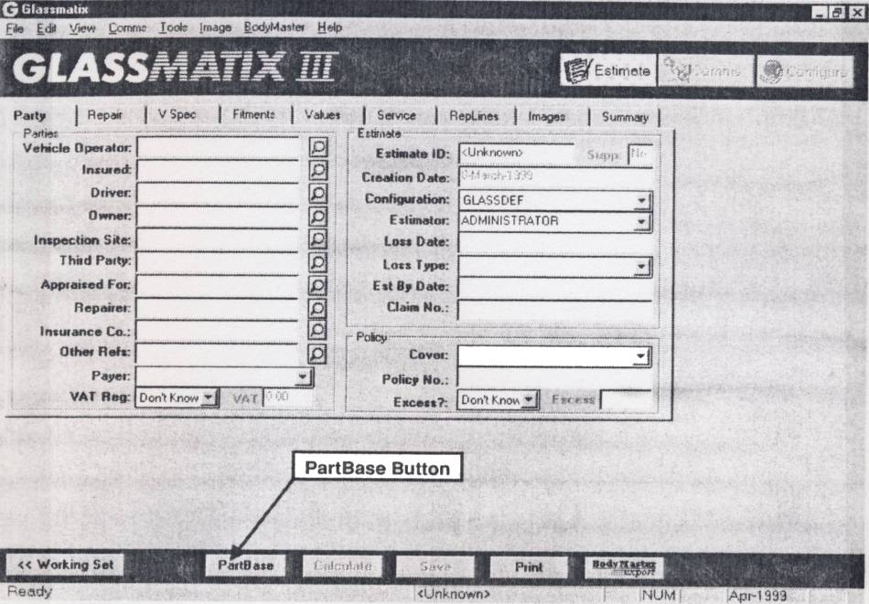
Figure 1: PartBase
Creating an Estimate
When partbase is opened the first screen to be displayed is as follows:
If PartBase is started from within Glassmatrix this screen will not appear.
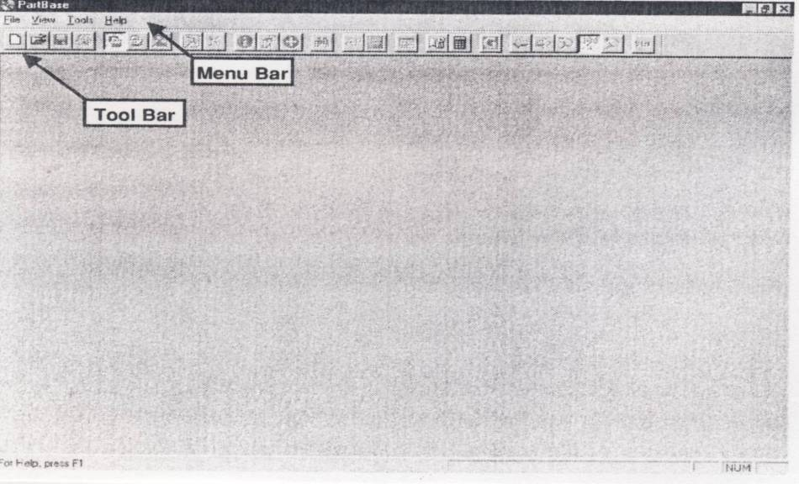
Figure 2: PartBase
The Majority of the tool bar is greyed out and inaccessible except for the first two options in the list of icons.

Click the mouse pointer on this icon to start a new PartBase estimate.

Click the mouse pointer on this icon to open an excisting PartBase estimate.
When a new estimate is started by clicking on the icon, the following screen is shown.
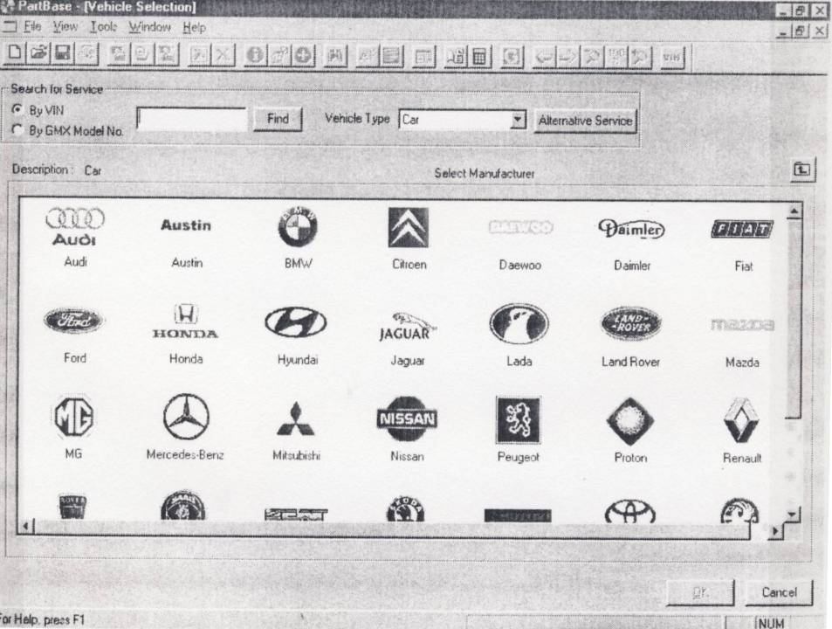
Figure 3: PartBase
This screen is the starting point for choosing a vehicle. If the VIN number of the vehicle is known it can be typed into the ‘search for service’ box and the find button clicked with the mouse pointer. This will identify the vehicle and take the user to the next screen applicable, for finalising their choice. Alternatively, the vehicle can be chosen by double clicking the mouse on the appropriate manufacturer’s logo. This will then show a screen of the manufacturer’s model ranges.

The screen in the example shows the result of double clicking the mouse pointer on the Ford manufacturer’s company logo. The complete range of ford vehicles is shown to give the user the next option, to choose a specific range of vehicles.
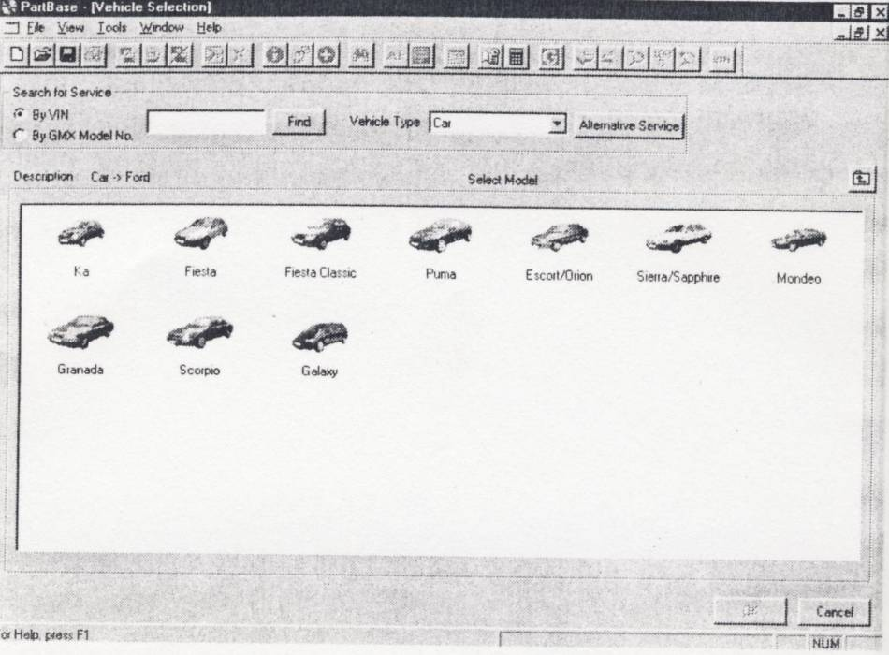
Figure 4: PartBase Vehicle Section
Double click on the vehicle range will then give a screen of model year breaks. In the Ford, example, the Escort/Orion range of vehicles has been chosen.
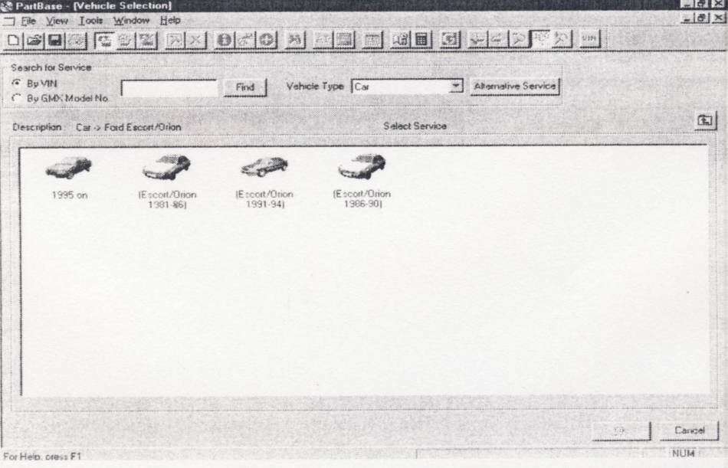
Figure 5: PartBase Vehicle Section

Double clicking the mouse on the model range will either create the new estimate screen or take the user to another screen to pick the specific model if the vehicle range has been covered by ‘Thatcham TTS Data’.
If PartBase has been started, by clicking on the PartBase button within Glassmatrix and the vehicle details have already been entered on the V Spec page, all of these screens will be bypassed and the process will start at the estimate screen, as shown below.
The Estimate Screen
When the vehicle has been chosen the estimate screen will be displayed, as shown below:
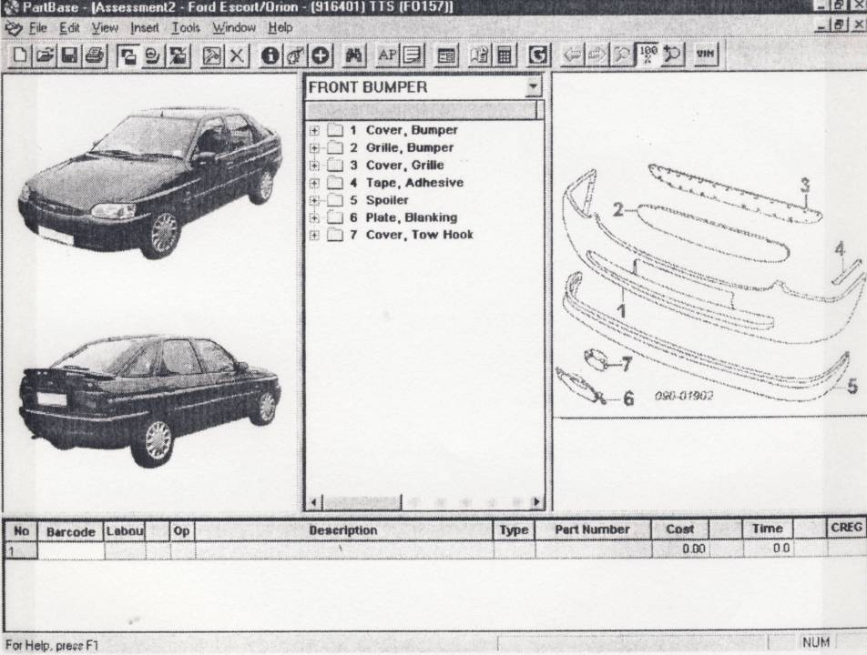
Figure 6: PartBase

The estimate screen is divided into five main parts:
- The Menu and Tool Bar
- Colour Images of the Vehicle
- A Tree structure of the parts
- Parts illustrations
- A list of repair lines
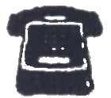
Glassmatrix Communication Lines

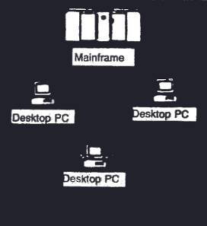
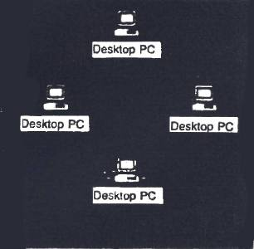
Inspection request with customer details


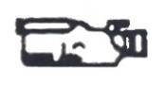
Estimate and Engineer’s report


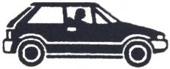
Repairer’s estimate & images
Engineer’s estimate & report
Agreed estimate & images
P.S.T.N (E-mail) or ISDN Line
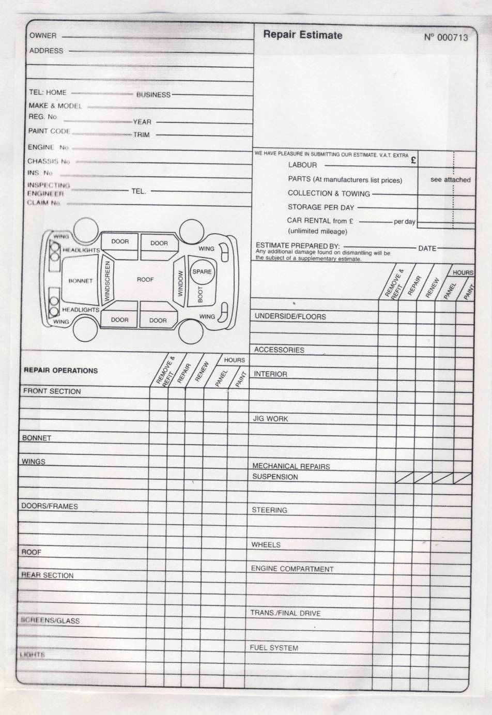
Figure 7: Repair Estimate
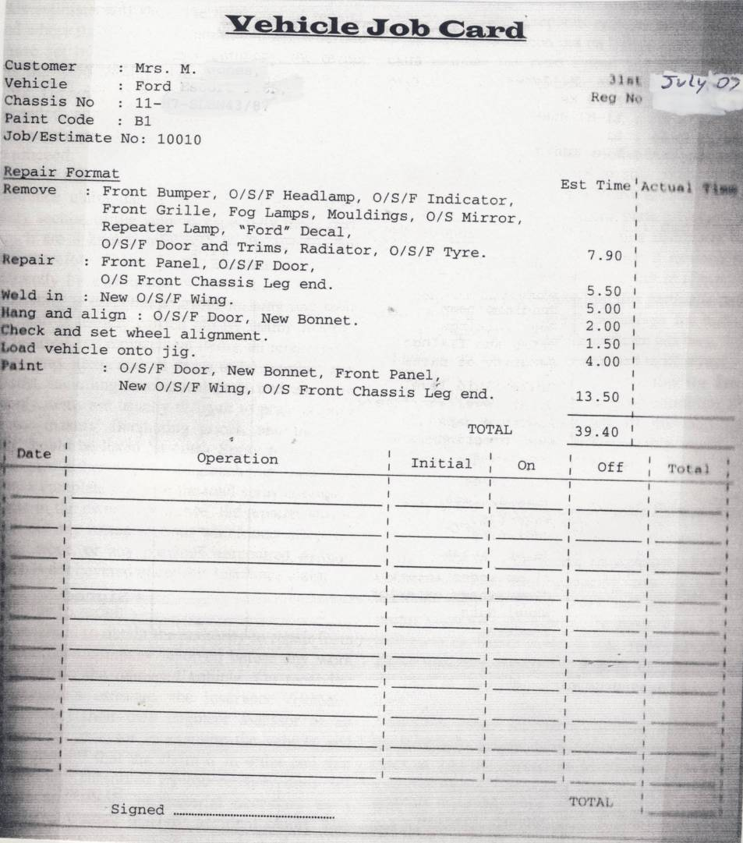
Figure 8: Vehicle Job Card
IDA Industrial Estate ACCIDENT REPAIR CENTRE Cork Rd. Full Jig Facility Waterford Spray Booth Tel. All Insurance Work
VEHICLE CHECKLIST
Customer : Mrs. M Jones 31st July 07 Vehicle : Ford Escort 1.6L Reg No. Chassis No : Paint Code : Job/Estimate No.
ChecklistTickLights Headlamp beam Door workings Trims and fixings Security of parts Brake fluid level Water level/antifreeze Aperture gaps Wax injection Underseal Coachlines Masking tape Blow-ins Overspray Paint finish Cleanliness interior Cleanliness exterior Wheel nuts Roadtest Signed ………………..
Comments on general condition
Official use
Satisfaction Notice Excess Invoice Signed…………………
6.0 Plan Repair Sequence from start to finish
6.1 Detailed Repair Plans Parts List

Name |  |  | Address |  | Phone | Date
Year | Make | Model | License No. | Speedometer | Mtr. No
 |  |  |  |  | Ser.No
Insurance |  |  | Adjuster | Phone | Car Located At
Operations |  |  | Part No. |  | Parts | Labour
Total
Tax
 |  |  | Total of Estimate
Estimate made by:………………………………………………….
6.2 Repair Sequence. Detailed Labour Times
Make & Model |  |  | Labour Hours |  |  | Reg No.
Specification | Act | MET | Panel | Paint | Job All. | Schedule Operation | Hours
 |  |  |  |  |  | Jig Time
 |  |  |  |  |  | Total Schedule Time
 |  |  |  |  |  | MET Opinion
 |  |  |  |  |  | Panel Opinion
 |  |  |  |  |  | Initial Pull
 |  |  |  |  |  | Paint Opinion
 |  |  |  |  |  | Geometry
 |  |  |  |  |  | Anti-Corrosion
 |  |  |  |  |  | Focus Lights
 |  |  |  |  |  | Final Checks
 |  |  |  |  |  | Valeting
Total Hours |  |  |  |  |  | Total Repair Time
Comments:
Estimator……………..Date……………..Reference No…………
Action Code N=Renew RR=Remove Refit S=Straighten P=paintwork C=Check and Report
Summary
The Motor Insurance Repair Research Centre at Thatcham, Berkshire, usually simply referred to as ‘Thatcham’, have produced repair time schedules for most repairs to most cars. The schedules are divided into replacement time schedules for body panels and methodologies for paint refinishing.
And in conjunction with Glassmatrix, a detailed data base is established which forms the basis for all damage assessment in Ireland.
The Insurance companies and engineers rely on this information to estimate damage in their every day work.

Self Assessment
Questions – Module 6. Unit 1
  - What safety precautions need to be put in place to examine a damaged vehicle?
2. What is another name for hidden damage?
3. What is an estimate?
4. What does MET mean?
5. What does job allowance mean?

6. What is a planned repair procedure?
7. What is Thatchems function?
8. What does total right off mean?
9. What is roll over damage?
10. Side damage is also known as?

Answers to Questions 1-10. Module 6. Unit 1
1.
Hoist/safety stands
2.
Concealed damage
3.
An assessment of cost of repairs
4.
Mechanical, electrical, trim
5.
The time it takes to move tool parts and vehicle into place.

6.
A procedure for stripping, repairing or replacing which is structured
7.
Research
8.
A vehicle which has to come to its end of life
9.
A vehicle that has turned on its roof
10.
Banana

Suggested Exercise
- Assess damage to given vehicle.
- Using estimate sheet, collect all relative information of vehicle i.e. parts list, customer details, insurance details and transfer to computer.
- Produce itemized parts list and correct repair sequence of repair to this vehicle.

Training Resources
- Classroom/workshop
- Overhead projector
- Transparencies
- Hoist
- Car jack and stands

27-33 Upper Baggot Street
Dublin 4

