TRADE OF
VEHICLE BODY REPAIR

PHASE 2

Module 6

UNIT: 2
Crash Repairs
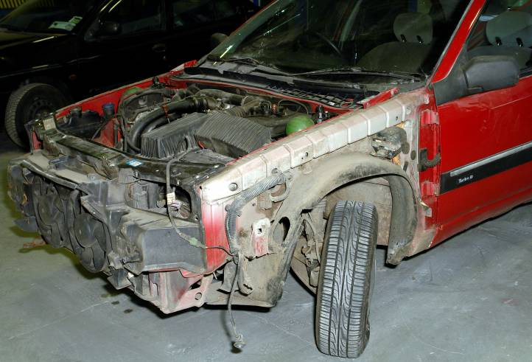

Produced by

In cooperation with subject matter expert:
Maurice Stack
Some material courtesy of CDX Global and
FENC – Further Education National Consortium.
© SOLAS 2014
Table of Contents
Introduction 7

Unit Objective 8

Crash Repair 8

1.0 Safety in Relation to Removing and Refitting of Non Structural Panels 9
1.1 Jacking and Lifting 9
2.0 Storage of parts Safely and Appropriately 11

3.0 Dismantle Damaged Area on Vehicle 12
3.1 Correct Assembly and Alignment of Panels 12
3.2 Fits and Clearances 13
3.3 Front End/Bodyside Clearances 14
3.4 Rear End Clearances 15
4.0 To Carry out Repairs on Non Structural Panels as per Estimate 17
4.1 The Importance of Preparation and Cleaning before Repair 17
5.0 Removing Causes of Corrosion 20
5.1 Repairing Rust Damage 20
5.2 Part Panel Joining Techniques (Patching) and Removing Causes of Corrosion 21
5.3 Structured Repair Procedure 22
5.4 Sealing-Waxing of Panels and Welded Joints 23
5.5 Awareness of the Presence of Airbags, Ribbon Bags, Seat Belt Tensioners and Other Safety Devices 28
6.0 Safety Service and Storage of Airbags 29
6.1 Side Impact Protection System 47
6.2 Description of Components 57
6.3 Recovery of Vehicles Containing Airbags 61
7.0 Emergency Rescue from Vehicles with Airbags 62
7.1 Vehicle Crash Procedures 62
8.0 Vehicle Crash Fire Prevention Procedures 70

Summary 74
Self Assessment 75
Suggested Exercise
Training Resources
Table of Figures
Figure 1: Jacking and Lifting 10
Figure 2: Front Bumper Removal 12
Figure 3: Fits and Clearances 13
Figure 4: Fits and Clearances 13
Figure 5: Front End and Bodyside Clearances 14
Figure 6: Rear End Clearances 15
Figure 7: 1989 Mini Frame 16
Figure 8: Remove Coating near Weld 17
Figure 9: Removing ‘E’ Coat Primer from a new Panel 18
Figure 10: Using Paint Stripper on a Galvanised Panel 19
Figure 11: Using a Special Sander on a Galvanised Panel 19
Figure 12: Repair Patch 21
Figure 13: Airbags 28
Figure 14: Seatbelts - Mondeo Vehicles 34
Figure 15: Seatbelts – Granada Scorpio Models 34
Figure 16: Seatbelt Buckle Pre-Tensioner System 35
Figure 17: Head of Buckle 36
Figure 18: The Ford Supplementary Restraint System 37
Figure 19: Pyrotechnic Seatbelt Pre-Tensioner 37
Figure 20 39
Figure 21: Airbag with the Locations of the Various Components 41
Figure 22: At the point of impact the driver is still in his normal position 43
Figure 23: Gas Generator 45
Figure 24- 25: The driver plunges into the cushion 45
Figure 26: The Airbag Starts to Collapse 46
Figure 27: Driver is Back into Original Position 46
Figure 28: SIPS Bag 47
Figure 29: Senor Unit 47
Figure 30: Gas Generators 49
Figure 31: The SIPS Bag 50
Figure 32: Sensor Unit 51
Figure 33: Unlock SIPS Bag 51
Figure 34 52
Figure 35 52
Figure 36: Remove Front Seat 53
Figure 37: Unlock SIPS Bag 54
Figure 38: Data for SIPS Bag 55
Figure 39: Installing Sensor Unit 55
Figure 40: Installimg SIPS Bag Cushion Module 56
Figure 41 57
Figure 42: Steering Column 57
Figure 43: Airbag 58
Figure 44: Neoprene Coated Airbag 58
Figure 45: Contact Unit 59
Figure 46: Instrument Display 61
Figure 47: Information Label 64
Figure 48: ‘Eurobag’ Components 66
Figure 49: VIN Plate 71

Introduction
Damaged body work is corrected by first observing the extent of the damage, then deciding how it was caused and the sequence in which it occurred. The resulting damage can be classified into two groups:
Direct or Primary Damage
This results from the impact on the area in actual contact with the object causing the damage. This will result in the largest area of visible damage and is the cause of all other consequent damage. Primary damage is identified by first determining the direction of the primary impact. This knowledge will help in the search for concealed damage.
Indirect or Secondary Damage
This is usually found in the area surrounding the direct damage which causes it; although in certain cases it may be some distance from the actual point of impact.
Non Structural Panels
In general non structural panel is a panel that can be removed easily and is fastened by bolts, screws, clips or spot welds. Such panels do not form an integral part of the body shell.

Unit Objective
Crash Repair
By the end of this unit each apprentice will be able to:
- Dismantle damaged area on vehicle
- Store parts safely and appropriately
- Carry out repairs on non-structural panels as per estimate
- Re-finish and assemble removed parts completely and securely
- Determine the level of corrosion
- Carry out suitable repair (patching) and ensure no recurrence of corrosion

Key Learning Points:
- Safety in relation to removing and refitting of non-structural panels
- Importance of preparation and cleaning before repair
- Structured repair procedure
- Selection of tools, MIG and spot welding equipment and materials
- Economic use of materials, paints (blending, etc.)
- Use of materials in a correct and safe manner
- Correct assembly and alignment of panels
- Repair assessment on activities carried out
- Preparation techniques (patching)
- Removing causes of corrosion
- Sealing-waxing of panels and welded joints
- Natural or forced air ventilation. Ventilation drain holes
- Health and safety. Proper breathing apparatus goggles gloves supplied
- Fire hazards check for flammable materials near repair area
- Awareness of the presence of airbags, ribbon bags, seat belt tensioners and other safety devices.
1.0 Safety in Relation to Removing and Refitting of Non Structural Panels
1.1 Jacking and Lifting
Garage Jacking
Trolley Jack
When raising the front of the vehicle, locate a trolley jack beneath the front toeing eye at A in Fig 1. At the rear, place the trolley jack below the towing eye at D.
Vehicle Lifts
When raising a vehicle on a wheel free lift, locate the lifting arms at the standard jacking points B and C.
Axle Stands
Locate axle stands beneath the standard jacking points B and C.

Never work without axle stands.

When raising and supporting the vehicle at points A and B it is necessary to use the suitable hard rubber pads in conjunction with the lifting heads to reduce the risk of vehicle damage.
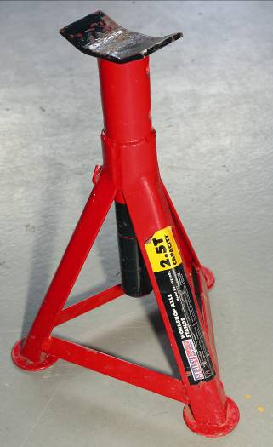
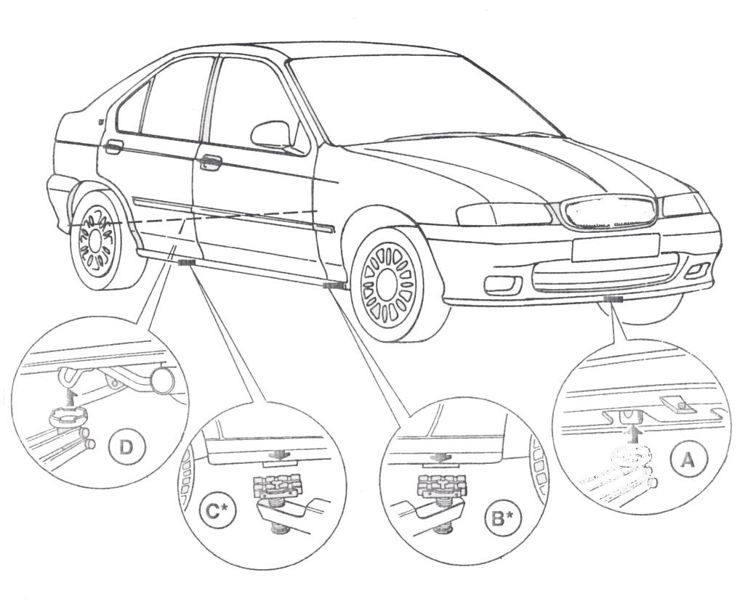
Figure 1: Jacking and Lifting

2.0 Storage of parts Safely and Appropriately

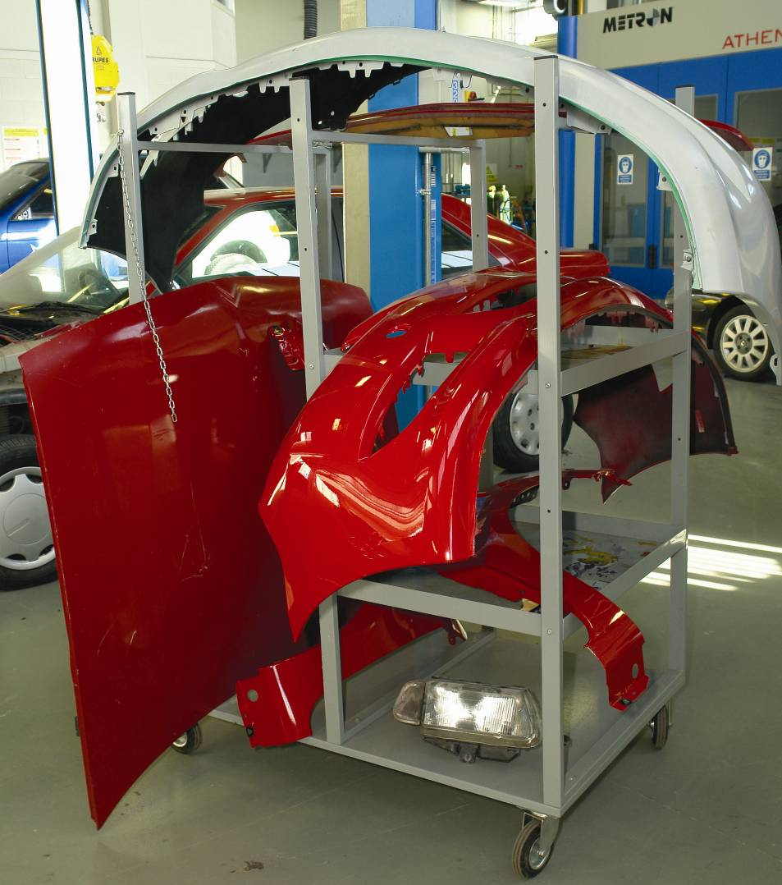

3.0 Dismantle Damaged Area on Vehicle
- Dismantle parts in a safe manner
- Put all bolts/screws in a container
- Store parts appropriately and safely
- Re- assemble in reverse order

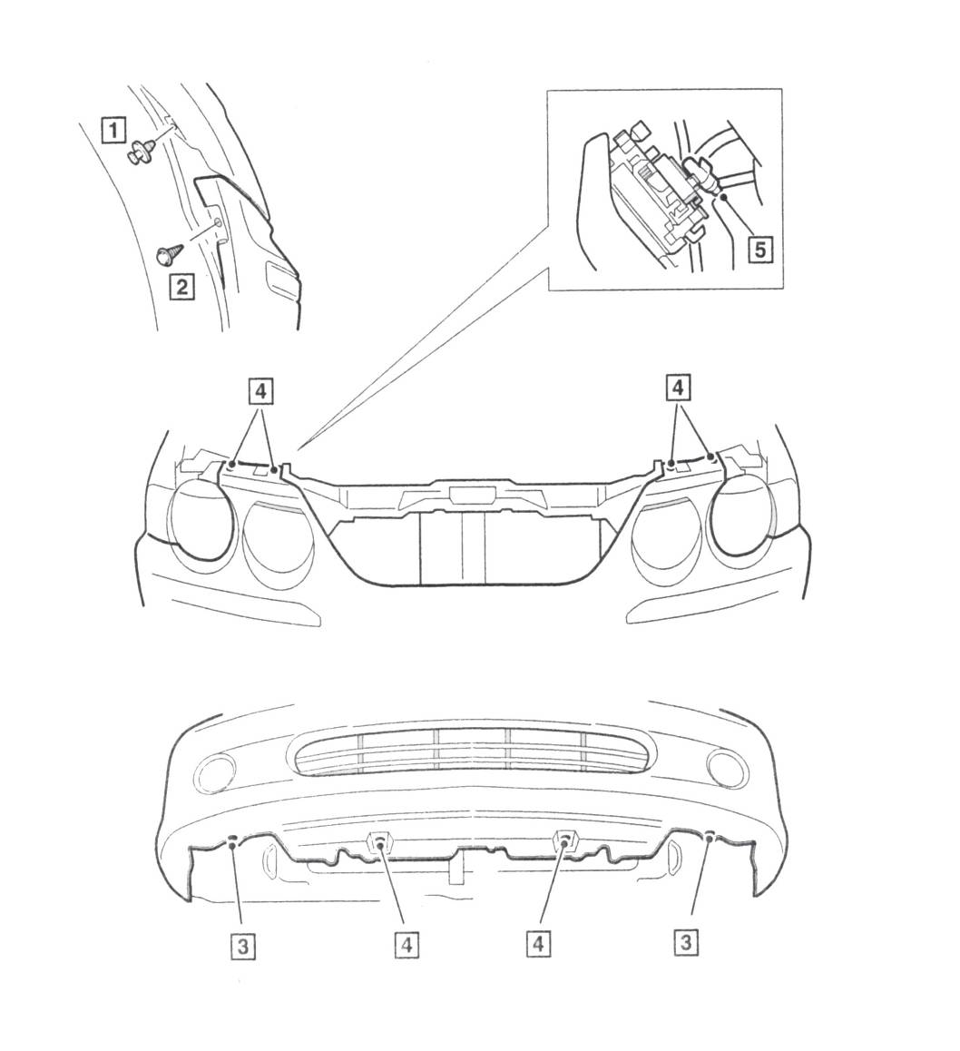
3.1 Correct Assembly and Alignment of Panels

Figure 2: Front Bumper Removal
Front Bumper – Numerical Order of Removal
1 | Raise vehicle and remove 2 off scrivets (1 each side) securing wheel arch liners to wings front) | 4 | Remove 2 off lower bolts securing bumper to front crossmember and 4 off scrivets (2 each side) to release bumper from bonnet landing panel
2 | Release wheel arch liners and remove 2 off screws (1 each side) securing bumper to wings front | 5 | Release bumper and disconnect fog lamp connectors. (if headlamp washers fitted, release clip and disconnect power wash hose)
3 | Remove 2 off lower bolts (1 each side) securing bumper to wheel arch liners | 6 | Protect paintwork and remove bumper

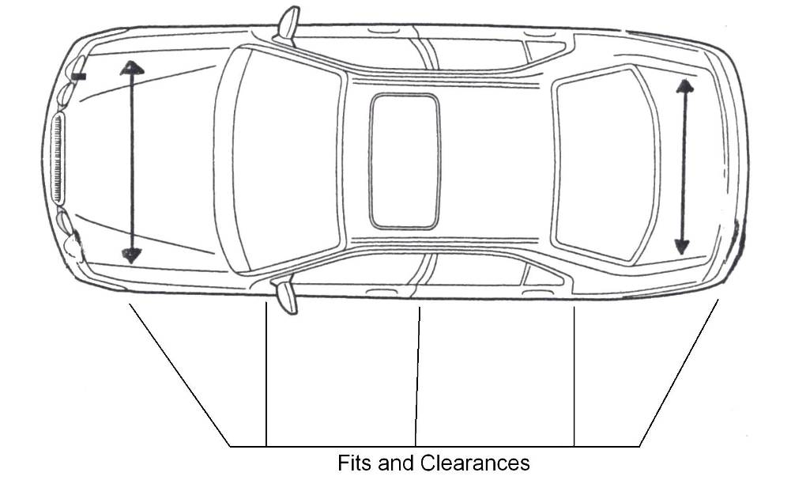
3.2 Fits and Clearances

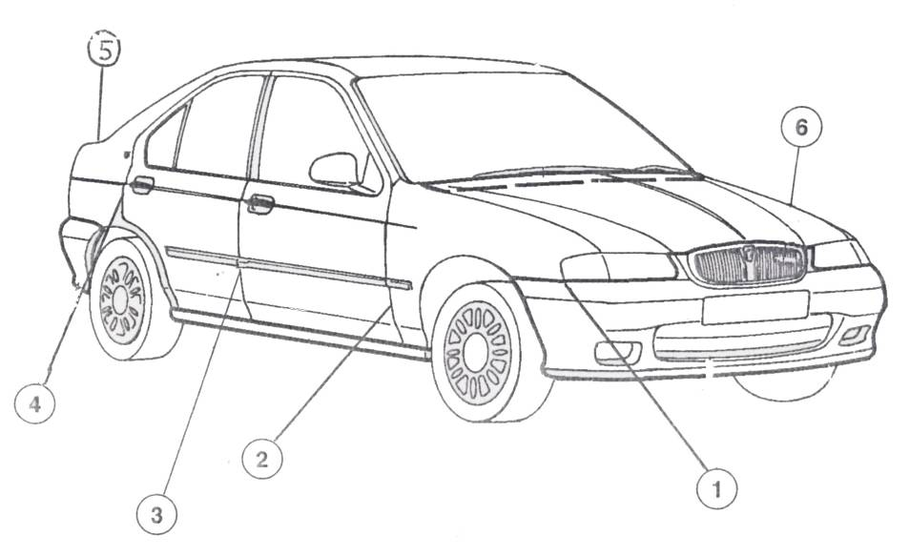
Figure 3: Fits and Clearances Figure 4: Fits and Clearances

- Bumper/Wing
- Wing/Door FR
- Door R/Door FR
- Door R/¼ Panel
- ¼ Panel/Boot Door
- Bonnet/Wing
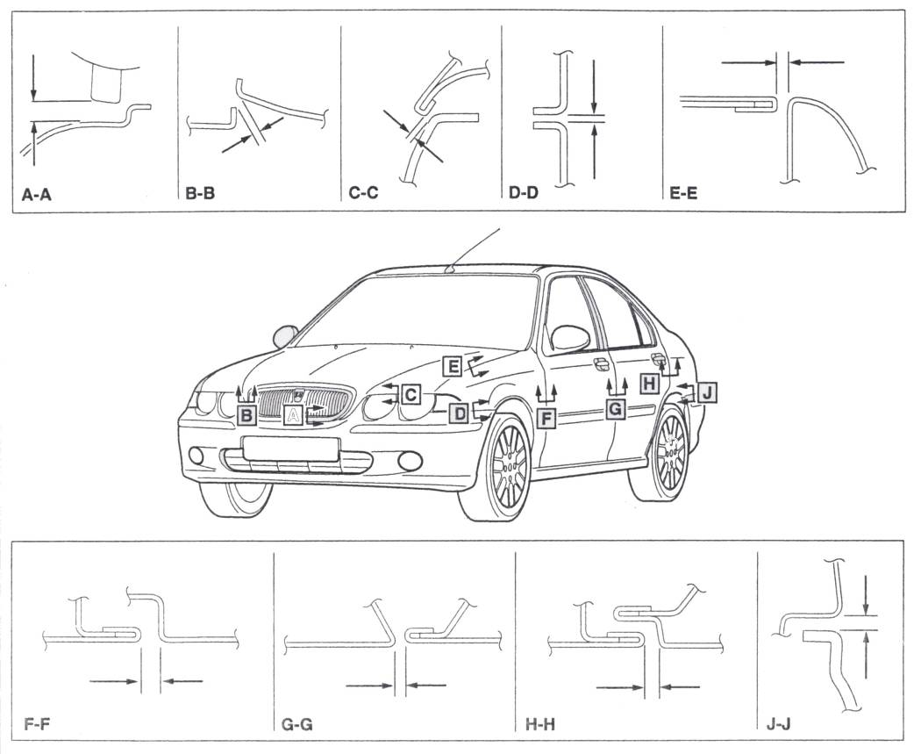
3.3 Front End/Bodyside Clearances
Figure 5: Front End and Bodyside Clearances
Front Section | Gap | Gap Description | Dimension (mm) | Profile | Dimension (mm)
A-A | a | Grille to Bumper | 8.0 ± 1 | - | -
B-B | b | Bonnet to Bumper | 5.5 + 3 to 0 | - | -
C-C | c | Bonnet to Bumper Headlamp Trim | 5.5 +2 to – 0 | - | -
D-D | d | Wing Front to Bumper | 2.5 ± 1.0 | - | -
E-E | e | Bonnet to Wing Front | 3 + 1.0 to -0.5 | - | -
Front Section | Gap | Gap Description | Dimension (mm) | Profile | Dimension (mm)
F-F | f | Wing Front to Door Front | 5.5 ± 0.5 | Wing Front to Door Front | 0 + 0 to -1
G-G | g | Door Front to Door Rear | 5.5 ± 0.5 | Door Front to Rear Door | 0 + 0 to -0
H-H | h | Door Rear to Wing Rear | 4.5 + 0.5 | Door Rear to Wing Rear | 0 + 1 to -0
J-J | j | Bumper Rear to Wing Rear |  | Bumper Rear to Wing Rear | 1.0 + 0.5 to – 1.0
3.4 Rear End Clearances
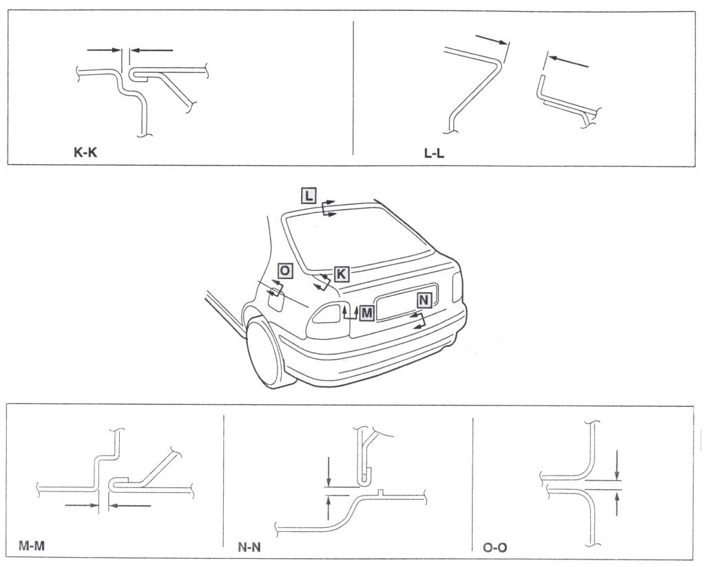
Figure 6: Rear End Clearances

Rear Section | Gap | Gap Description | Dimension (mm) | Profile | Dimension (mm)
K-K | k | Tailgate to Wing Rear | 4 + 1 to -0.5 | Tailgate to Wing Rear | 0 +0 to -1.0
L-L | l | Tailgate to Roof | 18.5 + 1 to -0.5 | Tailgate to Roof | -6.6 + 1. to 0.5
M-M | m | Tailgate to Rear Lamp | 4.0 + 1.0 to -0.5 | Tailgate to Rear Lamp | 0.6 ± 1.0
N-N | n | Tailgate to Bumper Rear | 7.0 + 1.0 to -0.5 | Tailgate to Bumper Rear | 0 ± 1.0
O-O | w | Fuel Flap | 3 + 0.5 | Fuel Flap to Wing Rear at Front Edge Fuel Flap to Wing Rear at Rear Edge | 0 – 0.5  0 + 0.5

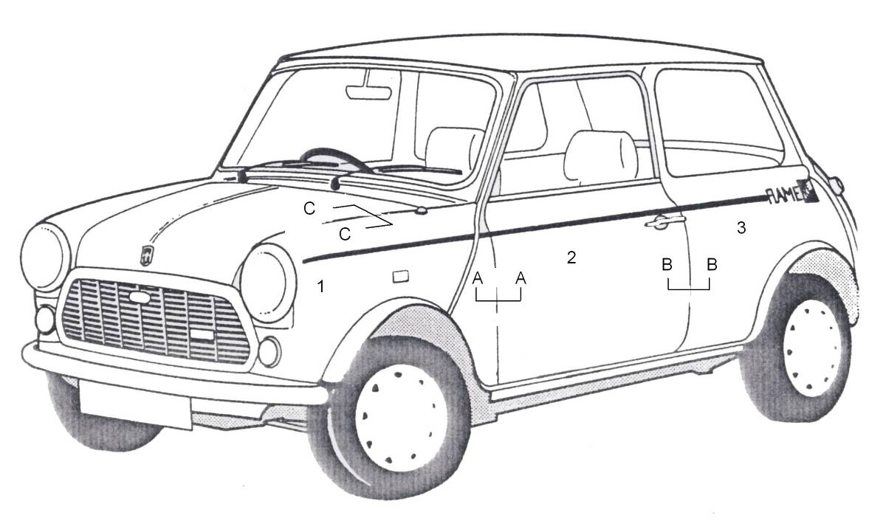
Figure 7: 1989 Mini Frame
To avoid wind noise the wing must be fitted 0.5mm outside the door AA. The door must be 0.5mm outside the ¼ panel BB and so on. The bonnet and wings with left flush CC the same applies to the boot lid.

- Wing
- Door
- ¼ Panel
4.0 To Carry out Repairs on Non Structural Panels as per Estimate
4.1 The Importance of Preparation and Cleaning before Repair
It is important to remove rust, Galvanised coatings and loose material before commencing and repair. Sand blast area surrounding the repair and remove metal that is pitted and replace by patching.
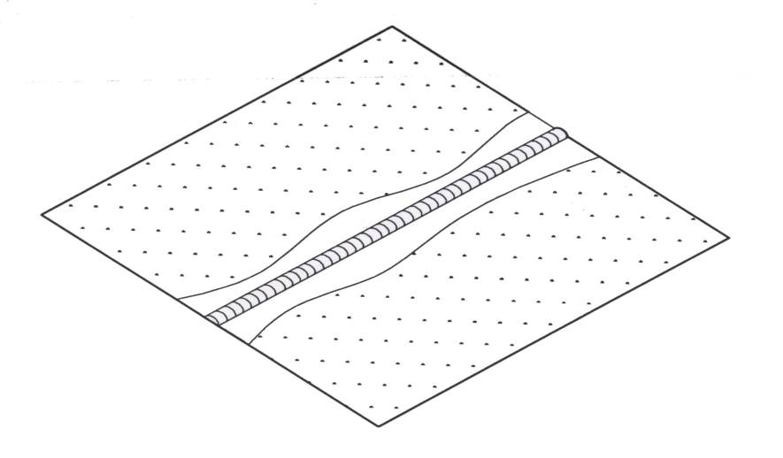
Figure 8: Remove Coating near Weld

Prepare New Panel (Non-Galvanised) – Clean Welded Surfaces of Flanges and Joints
Prior to carrying out MIG welding or resistance spot welding on a new panel it is necessary to remove the ‘E’ coat primer from the panel, to promote good electrical current flow.
Using a rotary wore brush, or a sander fitted with a disc of up to 50 grit maximum, remove the primer from both sides of the panel joint if resistance spot welding and one side only where MIG welds are to be made.

Health and Safety: PROTECT YOURSELF FROM HARM!
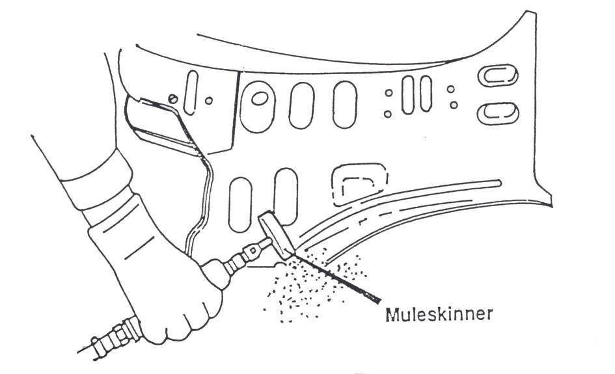

Figure 9: Removing ‘E’ Coat Primer from a new Panel

When using a sander, do not grind into the panel surface.

When sanding, do not work-heat the panel to the point where it turns blue or begins to warp.

Where specified by the manufacturer, ensure that the inner surfaces of the outer panels such as front and rear wings, front and rear panels, sill panels, etc. are top coated before welding.

Prepare New Panel (Galvanised) – Clean Welded Surfaces of Flanges and Joints
When preparing a galvanised panel, it is important to ensure the zinc coating is left intact and the panel prepared according to the manufacturer’s instructions.
Remove the ‘E’ coat primer using either a suitable paint stripper and a scraper or a special sanding medium formulated for the purpose.
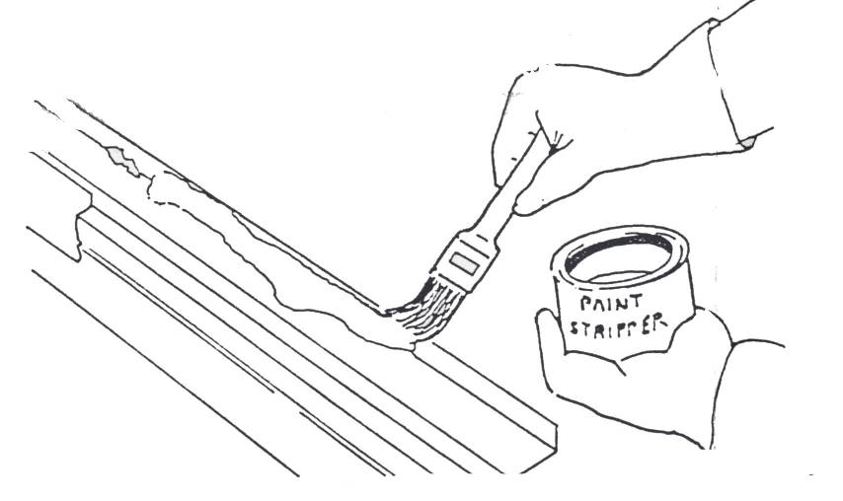
Do not use any other abrasive material for this purpose. Remember: galvanised panels must be treated differently.
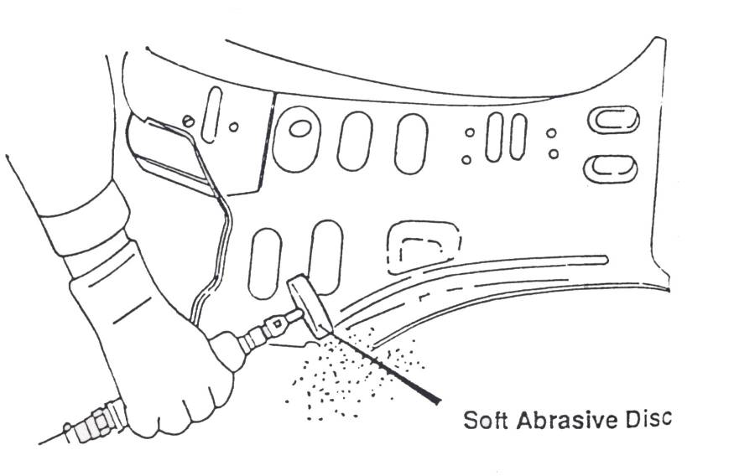
Figure 10: Using Paint Stripper on a Galvanised Panel
Figure 11: Using a Special Sander on a Galvanised Panel

5.0 Removing Causes of Corrosion
5.1 Repairing Rust Damage
In this work the body repairer relies on his own judgement, skill and experience. Rust is a corrosion, known chemically as iron oxide and occurring after exposure to air and moisture, on the surface of iron and the majority of its alloys. In the past the construction of all-steel body shell contained numerous cavities and crevices within the structure which tended to retain moisture carrying matter, thus creating suitable conditions for the rusting process. Rust attacks in particular wings, sill panels, wheel arches, floor of luggage compartments and bottoms of doors, the worst being the sill because of their close proximity to the road. During the past few years some manufacturers have made improvements which have reduced the rusting of bodies. In some cases this has been achieved by good design and in other cases by treating metal prior to painting. The method of repairing rust damage depends upon the extent of the corrosion within the panels, giving the body repair worker a choice between two alternatives methods of repair. The best possible results are obtained by the total removal of all corroded sections, replacing them with either new panels when available or handmade panels or sections when not readily available or cost is restricted. The replacement panels can be fitted by welding them into position and finishing planishing, filing and sanding. In the case of older vehicles where new panels are not available or where the vehicles age or condition make it uneconomical to fit new panels, the method of fabricating or patching these areas, by cutting out and replacing these section from flat sheets fabricated by hand, is adopted. In many cases if the original sections are carefully cut out and not too distorted, they can be used as an excellent guide to manufacture of new sections. Templates can also be made up before the old sections are cut out to check alignment and curvature when fitting the new section. Often double curvature panels such as wheel arch fabrications must be made up in two or three parts for ease of patching onto the original body. The main difficulty experienced in this type of repair is the welding of the new metal onto the old: this is one of the reasons why it is important to cut away all the rusted section so that the new metal can be welded to a rust free section. In cases where the sections are vary badly corroded and welding is difficult, the section can be cleaned of surface rust and sometimes brazed to form the joint. The second method of rust repair, which is only a temporary measure and not recommended for longevity, is to fill the corroded section with either body solder or chemically hardening filler. If the corrosion is only very slight, giving a pinhole effect, the area can be sanded down to bare metal, hammered down carefully to below its original level and then filled up with body solder and filed to a finish. Plastic filler should not be used in this case because the moisture would seep through, parting the filler from the panel. Where the corroded area has turned to holes it can only be repaired by placing a patch over the corrosion and welding or brazing it in place. This patch level is then filled with body solder or plastic filler to obtain the final finish. In some cases where it is difficult to weld a patch, the perforated section can be reinforced by using glass-fibre matting impregnated with resin and bonded to the underside of the repair. The surface can then be filled with plastic filler and finished by filing.

5.2 Part Panel Joining Techniques (Patching) and Removing Causes of Corrosion
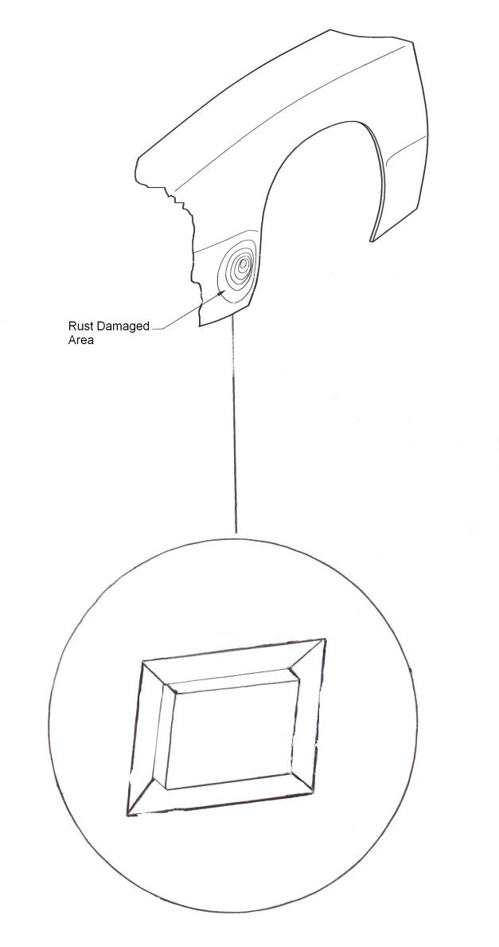

When repairing cut away rust and put a flanged patch behind it, weld in place be sure to continuous weld as it seals joint from moisture.

Figure 12: Repair Patch
5.3 Structured Repair Procedure
- Selection of tools. MIG and spot welding equipment and materials
- Move the vehicle into place and secure safely
- Move tools into place
- Collect all parts for the job
- Plan your repair sequence
- Structure your time
- Remove damaged parts that need replacing
- Carry out repairs on repairable parts
- Prepare new parts, prime and paint and refit
- Prepare required parts, prime and paint
- Use of materials in a correct and safe manner. See Health and Safety Mod 5 Spray Painting (COSHH)(SMDS)
- Health and Safety. Proper breathing apparatus, goggles, and gloves supplied

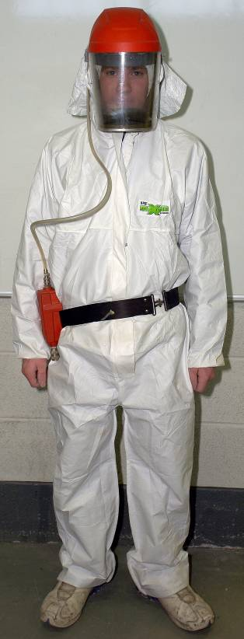
Spray Suit and 3mm Mask Spray suit Air Fed Mask
- Fire hazards. Check for flammable materials near repair area. Se introduction, Mod 1, unit 2
- Economic use of materials, paints (blending, etc.)
- Sealing-waxing of panels and welded joints
- Repair assessment on activities carried out
5.4 Sealing-Waxing of Panels and Welded Joints
Metal to Metal. Metal to Plastic Bonding.
- Use of plastic panels on vehicles is on the increase
E.g. Citroen, Renault, Audi spare wheel well etc.
- Plastic cannot be welded to metal. It must be bonded.

- Terokal 2K-PUR, Teromix 6700. Developed by Teroson for this purpose. The product is also ideally suited to Metal to Metal applications.

- Three C’s - Clean, Compact and Correct.

- Advantages:
Ideal for non-structure parts e.g. door skins, roof skins, rear wheel arches, window panels on vans/jeeps etc.
Can be used where metal welding is difficult or dangerous i.e. near petrol tank, windscreen panels.
No heat warping of panels.
Complete seam is sealed and protected, unlike welding.
2-Pack material, curing time very fast with heat.
Can be spot welded or clamped when applied.
Can be sanded and over-painted once dry.

Sound Deadening
Vehicle Noise Vibration sound
Terodem SP100 Aluminium Backed Bitumen
Application: Doors
Size: 550mm X 250mm

Terodem SP300 Heavy-duty, Large Bitumen boards,
Mallable with heat. (Self-adhesive)
Application: Floors
Size: 500mm X 500mm
And 1000mm X 500mm

Terodem SP200 Soft self-adhesive sound deadening with polyurethane skin. Absorbs sound waves.
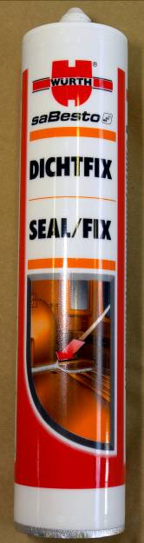
Flame proof.
Application: Under Bonnet.

Size: 1000mm X 500mm.

Sprayable Sound Deadening 9320 Sprayable Sealer Trotex 2000/3000
Underbody Coating / Rust Protection
History of protection Bitumen
PVC Wax
Manufacturers Warranty on Repair Work
Quality of Materials Material Base/ Compatibility
Solid Content Over-painting


Upol Gravitex Black/Grey/White
Under Body Sealer

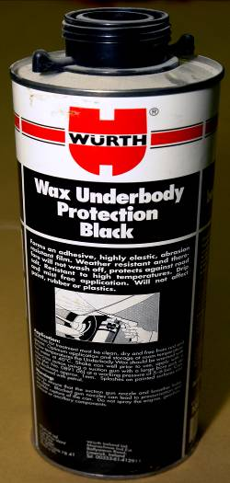 Wurth Underbody protection Black
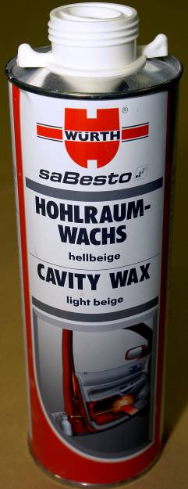 Cavity Protection Wax
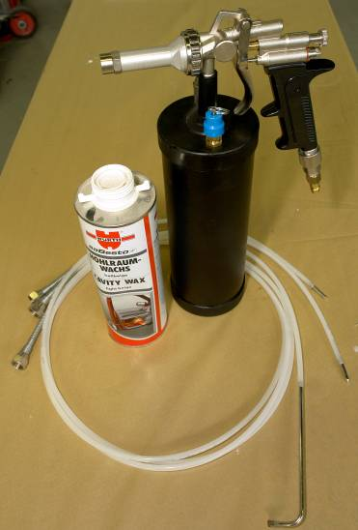
Cavity Protection Wax Gun Air Operated
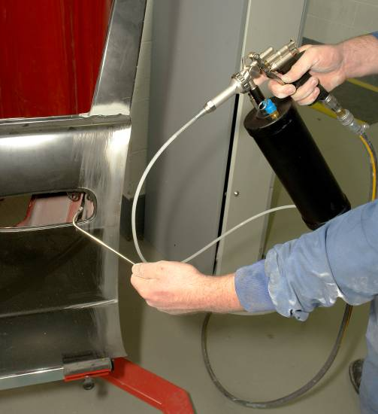 C.P.W Gun in use

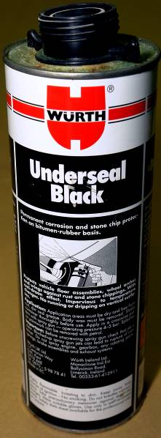
Under Body Wax Sealer Black
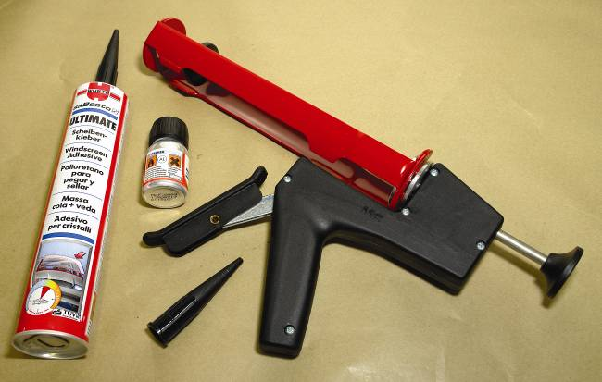
Hand Sealer Gun
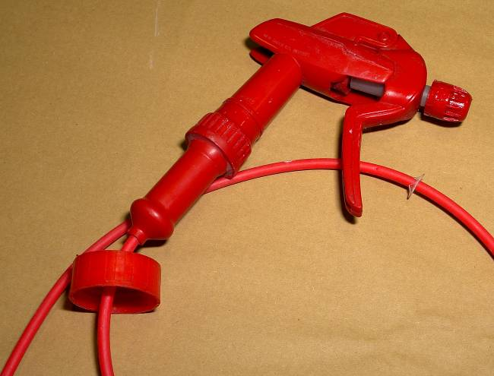
C.P.W Pistol Gun

5.5 Awareness of the Presence of Airbags, Ribbon Bags, Seat Belt Tensioners and Other Safety Devices
Airbags
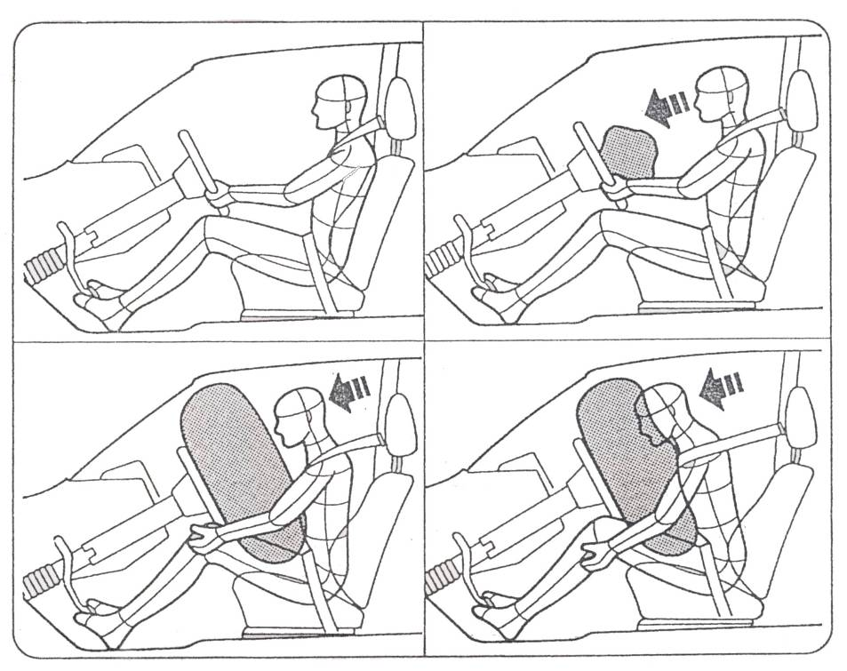
Figure 13: Airbags
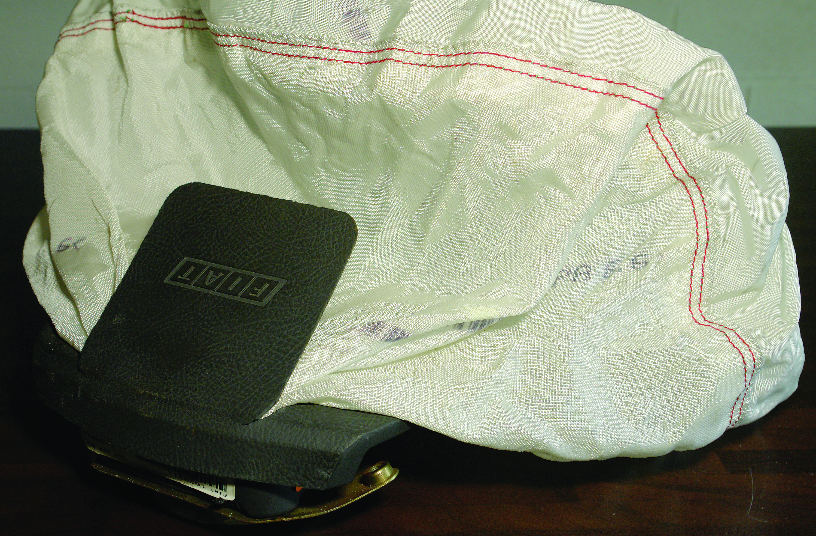

6.0 Safety Service and Storage of Airbags
General – Safety and Storage of Explosive Devices
It must be observed that the airbags and explosive seatbelt tensioners which are now fitted to an increasing number of vehicles are affected by UK Legislation, namely the Explosives Act 1875 to 1976. The Act applies to the storage of these devices as they are fitted with explosive triggers to allow them to operate, with obvious safety implications. In addition to the points made on the following pages, which relate specifically to the service and operation procedures on airbags as fitted to Vauxhall and Ford passenger cars, the following points MUST be noted with regard to the general workshop storage of explosive devices:
The explosive devices used fall within the requirement of the Explosives Acts 1875 to 1976. Because of this, your premises must be registered for keeping Gunpowder/Mixed Explosives. Contact your relevant local County Council Department for details of local requirements.
Ensure that steering wheels/steering column assemblies containing un-deployed airbags are clearly labelled with the job number and the date placed in storage, and a log kept by a responsible person giving this information. In addition, the name of the person placing the device in storage and removing it from storage must be recorded. This procedure must also be followed with seatbelt tensioners fitted with explosive devices.
Obtain the relevant vehicle Manufacturer’s information concerning recommended procedures when working on a vehicle fitted with explosive devices. In certain cases it may be found that disconnection of the vehicle battery alone will not immediately isolate electrical power to the electro-magnetic sensors for the explosive device concerned.
Ensure that the storage cupboard or storage area used is set aside ONLY for explosive devices, is clearly marked for this purpose and is kept firmly locked in a secure area.
Keep the replacement gas generator with the airbag or seatbelt tensioner in the secure store until the device has been refitted to the vehicle. The discharged generator should be returned to the manufacturer as this is a specific requirement.

Always place non-deployed explosive device in a secure position, and located such that if the device deploys accidentally it will not come into contact with surrounding items or hard, fixed surfaces.
Do not drop explosive devices onto hard surfaces.
Complete and return all registration documents supplied with explosive devices. Follow all Manufacturers’ instructions when working on vehicles so fitted.
Ensure that’s all relevant staff are informed of the policy to be adopted whenever handling explosive devices.

Explosive Consequences
There is a downside to the vehicle airbag. The presence of a relatively powerful pyrotechnic device (or many of them, depending on the car) inside the vehicle can have serious consequences for all sorts of different people.
For a start, drivers can run into problems (literally!) if they are in the habit of sitting too close to the steering wheel. The recommended minimum steering wheel-to-driver’s-chest distance is ten inches. Positioning yourself any closer than this will expose you to the danger of being hit as the airbag explodes into life. There have been instances, both here and in America, of drivers being killed by the force of the bag blowing up in their faces. Consideration should also be given to the location of air fresheners and mobile phone mounting brackets.
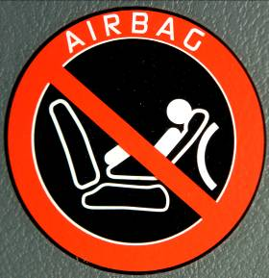
Caution with Small Children and Air Bags
There are also potentially serious issues for drivers who insist on putting their babies or toddlers in the front passenger seat. This can be particularly dangerous if a baby seat is used and faced backwards as normally recommended. An airbag which inflates directly into the back of one of these can do serious damage, so be warned. Some vehicles have a switch (often in the glove-box) which disables the passenger-side airbag specifically for this reason.
Airbags can also represent a danger to workshop technicians and vehicle recovery specialists. The electronic triggering is accomplished with a relatively low voltage and it should be noted that it’s quite possible to fire an airbag with the nine volts generated by a conventional multi-metre during resistance testing. The equipment manufacturers do what they can to warn people off – all airbag wiring is bound in a bright yellow insulation – but people still make mistakes.
Danger when using multi-metre near airbag wiring

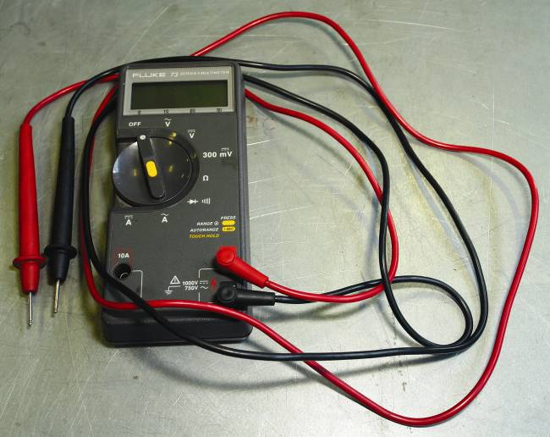
Multi Meter
Airbag Advice
- Never buy second hand replacements.
- Leave bright yellow wiring loom alone.
- Don’t sit in front of the steering wheel while testing airbag related systems.
- Never sit too close to the steering wheel while driving.
- Don’t touch the metal carrier of a recently fired airbag – it’ll be hot!
- Disconnect the vehicle battery and wait 15 minutes for capacitors to drain before starting any airbag related work.

The Supplementary Restraint System (SRS)
In the very early days of motoring in the UK, a person walked in front of each vehicle waving a red flag to warn pedestrians and other road users of the impending danger. This inevitable restricted the speed of vehicles to a walking pace. In general terms, the red flag was the first safety system apart from that essential element, the vehicle brakes.
Modern motoring provides for driving on the roads with an enormous number of other vehicles that can all reach speeds of well beyond those of the red flag days. Not surprisingly, many ‘accidents’ occur, (although many accidents are avoidable) and these frequently result in injuries to the occupants to the vehicle.
Vehicle manufacturers design and construct modern cars with safety in mind, and many safety systems are now standard features in the cars we travel in. The construction of the vehicle is designed so that if involved in a severe accident, the structure of the vehicle protects the occupants of the car.
The front and rear sections of vehicles are designed to collapse in a controlled and progressive manner this absorbing much of the impact caused by crashes. These collapsible sections are usually referred to as the safety cells, which effectively function as shock absorbers to the impact forces. They are also designed so that vehicle components and assemblies do not enter the passenger compartment due to impact.
The force of a vehicle impact also causes any unrestrained articles, including the occupants, to move around the interior of the vehicle. Personal injuries may occur to occupants when they strike solid objects within the interior of the vehicle. Manufacturers therefore often use softer, more impact absorbent materials within the vehicle (e.g. softer dashboards), to limit these types of injuries.
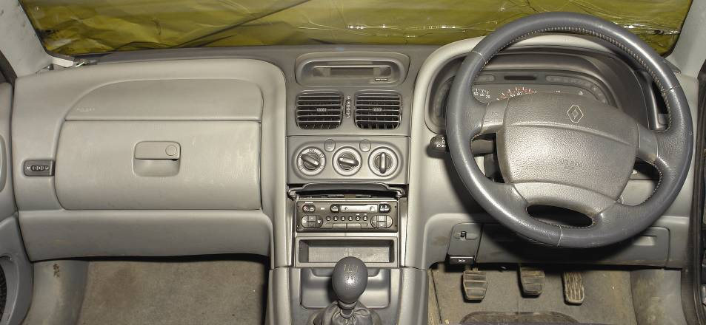
Primary Restraint using Seat Belts
Seat belts are used to provide the primary restraint for the occupants of the vehicle. Both front and rear seatbelts are a mandatory fitment to a vehicle and it is now law in many countries around the world that the seat belts must be actually ‘worn’ by the occupants while the vehicle is being driven.
Most vehicle manufacturers fit three-point seat belts (seat belts having three fixing points). Although many manufacturers used to fit static seat belts, which had to be manually adjusted to suit the person, most seat belts today of are the ‘automatic’ type (inertia reel). The automatic type provides the occupant of the vehicle with an acceptable level of comfort and the freedom to move within limited space, but the seat belt restrains the occupant if the vehicle decelerates quickly.
For front seat applications, the three-point seat belts have three mounting points: one at each side of the seat and one on the B-pillar. The mounting point at the side of the seat adjacent to the centre of the vehicle has a buckle assembly to enable belts to be easily connected, the belt passes across the lap of the occupant from the outside edge if the seat to the inside edge, then up across the chest of the occupant to the B-pillar. A similar arrangement is used for rear seat belts but the seat belt attaches to the C-pillar or to a convenient location. There are slightly different arrangements for those vehicles that do not have B-pillars or C –pillars such as cars with convertible roof body styles.

Inertia Reel
On the old style of fixed seat belts, there was an adjuster on the belt to enable the length of the belt to be altered to suit the size of the occupant. More modern seat belts make use of an automatic adjusting system that also functions as a means of keeping the belt tight during accidents or severe braking. Although these systems still use the three locating points, when the belt passes up to the B-pillar, it then passes down through the pillar to a spring-loaded reel onto which the surplus length of belt is wound. The spring loading will cause the reel to pull in the surplus belt, which ensures that the belt is a comfortable fit for all sizes of occupant. The tension in the spring loaded reel is also weak enough to allow the occupant to move forward against the spring tension.

Within the reel is a mechanism that prevents the reel from unwinding if the belt is pulled rapidly or if the forward forces are too high. In effect, the reel locks if sudden braking forces occur or if severe forces are caused due to an accident. On most inertia reel systems, when the seat belt is pulled quickly, this is enough to lock the seat belts.
Seatbelt Buckle Pre-Tensioner System
The Ford front seatbelt buckle pre-tensioner system is being progressively introduced as standard fitment, firstly on Mondeo vehicles and then on Granada Scorpio and Escort Cosworth models.
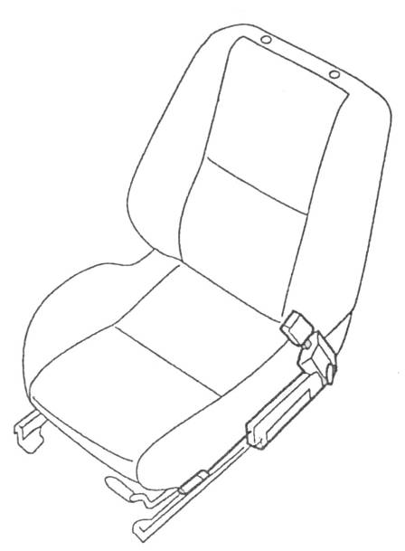

Figure 14: Seatbelts - Mondeo Vehicles

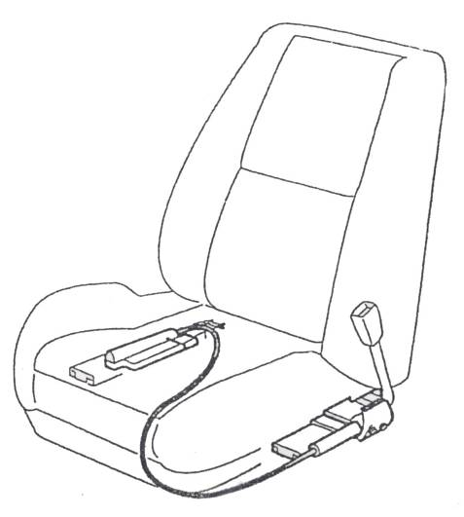

Figure 15: Seatbelts – Granada Scorpio Models
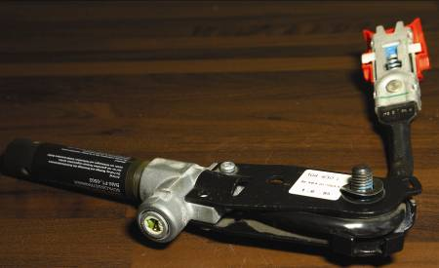

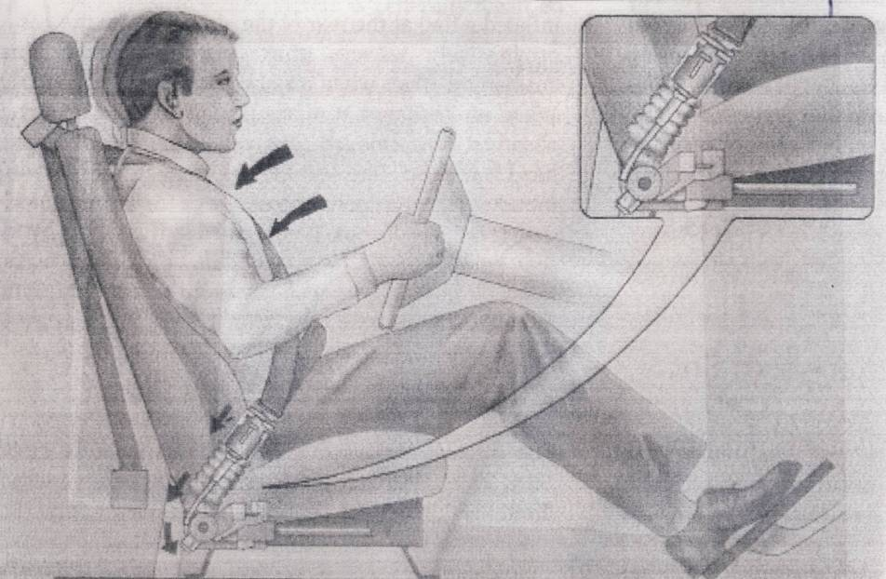

Figure 16: Seatbelt Buckle Pre-Tensioner System
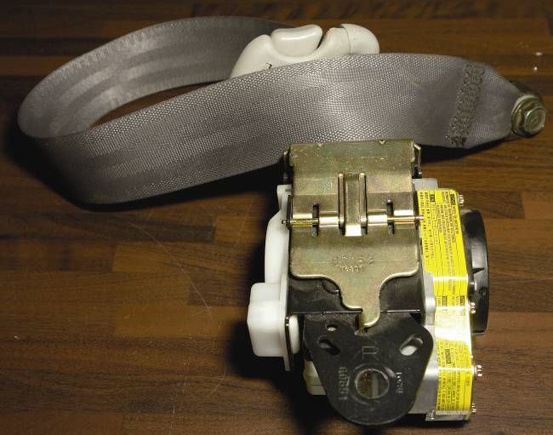
It is a mechanical system, where power is produced by a powerful compression spring which pulls the head of the buckle downwards via a spiral-wrapped steel cable, as shown in Figure 17.
The seatbelt buckle pre-tensioner system works when a mass sensor detects an excessive deceleration of the vehicle caused by full frontal or offset frontal impact. The mass sensor then moves forward and triggers the unit. This process is designed to occur before the front seat occupant has begun to move forward against the restraint of the seatbelt.
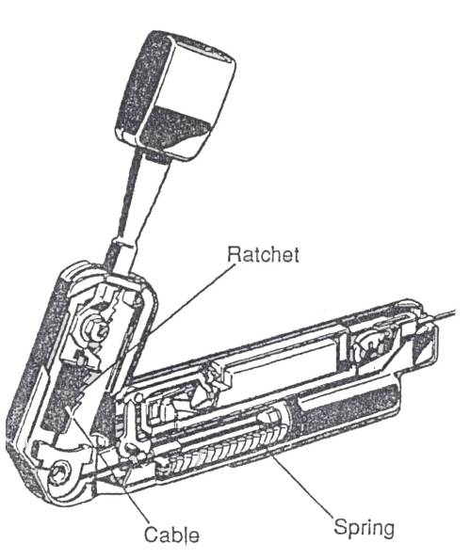
The effect of the unit is to remove approximately 120mm of slack from the seatbelt webbing, divided between the lap and shoulder sections of the belt. The amount of slack removed varies depending on the seatbelt tension at the time together with the bulk of the occupant’s clothing. The system is armed at all times except when all the seat runners are released to allow readjustment of the seat position, at which time the buckle pre-tensioner is automatically disarmed until the seat latch is re-engaged.
Figure 17: Head of Buckle
After the system has been activated, the seatbelt buckle is prevented from returning to its original position by a ratchet mechanism on the Mondeo (Figure 17), and by a deformable locking tube on other Ford vehicles. The downward travel of the buckle is approximately 60mm, which involves the buckle head below the line of the seat cushion.
The seatbelt buckle tensioner is activated only by full frontal and offset frontal impacts against a solid object at speeds in excess of 8mph. It is not designed to activate during side or rear end impacts, or in rollover accidents. It works independently of the airbag system, although in certain marginal cases (e.g. where the impact speed is very low) there is the possibility that one part of the system may activate, or that only one of the tensioners may be triggered. Ford front seatbelt buckle pre tensioners may be used in conjunction with any Ford approved type of child seat, either forward or rearward facing.
Figure 18 below shows the operating sequence of the Ford Supplementary Restraint System.
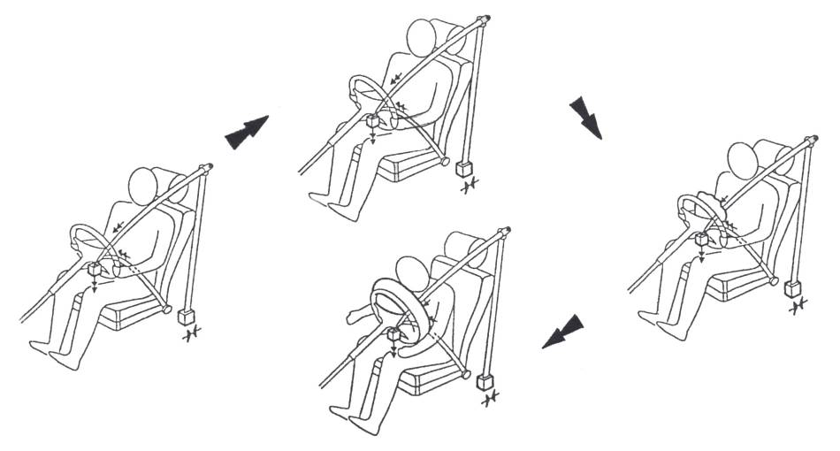

Figure 18: The Ford Supplementary Restraint System

Electronic/Pyrotechnic Seat Belt Pre-Tensioners
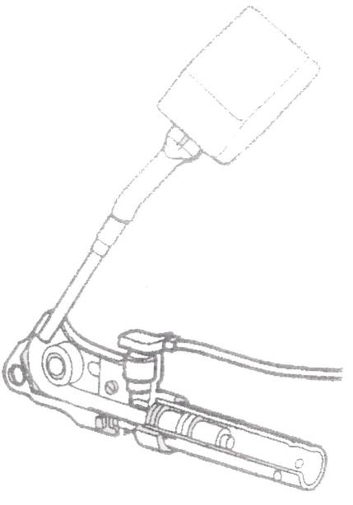
Pyrotechnic pre-tensioners are generally located with the door pillar and are connected to the normal inertia reel mechanism or seat belt fixings. The principle of operation relies on a gas generator in much the same way as an airbag-triggering system. A detonator or igniter (explosive charge) when triggered, causes the gas generator supply to rapidly produce a volume of gas. The gas pressure is then used to activate a mechanical linkage which pulls on the seat belt or rotates the inertia reel, thus tightening the seat belt.
Figure 19: Pyrotechnic Seatbelt Pre-Tensioner
Although some pyrotechnic pre-tensioners operate with a mechanical trigger, most systems utilize the airbag ECU as a trigger. As with the airbag triggering, an electrical signal is passed from the ECU to the igniter system, thus causing the gas to be produced.
ECU-triggered pre-tensioner systems can be controlled to operate just ahead of airbag development to provide a co-ordinated restraint and protection system. When a pyrotechnic pre-tensioner has been deployed, it should be replaced with a new assembly along with a new seat belt.
Vehicle Safety Systems most of us never get to see them. We know they are there but it’s only if things go really, really wrong that they make a fleeting appearance. I’ve never seen one and I hope that few of you have either because, from what I can gather, it’s a pretty shocking experience. When needed, the bags go off with the sort of controlled violence that is guaranteed to leave your ears ringing, nostrils twitching and eyes running. In short, being at the business end of an airbag isn’t a pleasant experience.
Blink and You’ll Miss It
The one saving grace of the airbag experience is that it’s over in a moment; literally a split second. The activation times make for an impressive reading but, as you might imagine, speed is of the essence in a crash situation. TRW Automotive (www.trwauto.com) is one of the leading manufacturers of airbags and seatbelt restraint systems in the world. Airbags are a secondary restraint system designed to be used in conjunction with the vehicle’s seatbelts.
The whole business of airbags is still relatively new in automotive terms. The earliest European examples were first seen on top-spec German vehicles in the early 1900s (Audi, BMW and Mercedes Benz), but the technology quickly became more mainstream with the likes of Ford, Rover, Fiat, Peugeot/Citroen and Jaguar following suit shortly afterwards. The original concept appears to have been dreamt-up in the United States although, as usual, everything was much bigger over there.
Originally, airbag-equipped cars had just one bag that was designed to protect the driver in the event of a head on crash. The front seat passenger was left to take their chances while those in back, well, you’ve all seen the adverts I’m sure. The airbag was packed into a small compartment in the centre of the steering wheel – one of the main reasons why steering wheel bosses became so chunky all of a sudden. The bag was triggered by an impact sensor which measured the severity of the collision, deploying the bag if the deceleration rate breached the predetermined tolerance.
There are lots of misconceptions about airbags and one of the most dangerous is that they provide those in the vehicle with complete and guaranteed protection in the event of a crash.
This, of course, isn’t the case. For a start they can suffer with technical problems, just like all the other computer-managed systems on a modern vehicle, and can fail to deploy at all as a result.
On the Rebound?
Another common belief is that the airbag inflates like a balloon to provide a soft cushion off which the driver will bounce in the event of an accident and, in this way, be protected from steering wheel or windscreen related injuries. In fact, there’s no bouncing involved at all. The bag certainly inflates like a balloon, but there the similarity ends. It’s designed with a number of holes around its base which allows it to start deflating almost as soon as it’s been filled. The idea is that this capacity for controlled deflation provides a cushioning and shock-absorbing effect which helps to prevent injury. Simply bouncing off an inflated airbag would be almost guaranteed to cause all sorts of nasty injuries.
Of course, things have moved on a bit since the early 1900’s. Nowadays, a state-of-the-art saloon has come up to 14 different airbags dotted around its interior. You can find them in the sides of the seats, above the doors (providing inflatable curtains which drop down during side impacts), behind the headlining, in the back of the head rests (to help protect rear seat passengers) and underneath the steering column (to protect injuries to the knees). Each type will have its own, specifically placed impact sensor and the inputs from all will be processed and analysed by a dedicated airbag ECU.
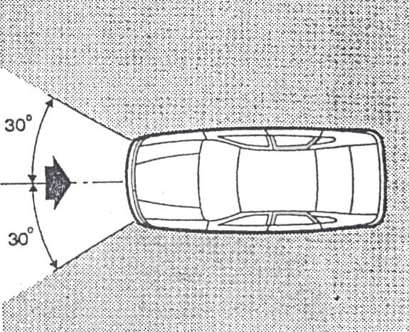
The simplest systems – with just a single steering wheel mounted airbag – are activated by an impact sensor which is often located inside the airbag ECU itself. The ECU is usually found in the vehicle passenger compartment (sometimes within the steering wheel itself). Because systems rely on sensors, correct fitting is a vital factor. For this reason, components are normally marked with an arrow to indicate correct orientation.
Figure 20
But even the most basic systems are direction-sensitive; they will only be triggered by certain types of accident. A driver’s airbag will be activated by a front-end impact from dead ahead, or up to 30º either side. Impacts coming in at angles greater than 30º are classified as side impacts, and will trigger the curtain-type bags (if fitted) but not the steering wheel bag.
In the event of an accident, an electronic crash sensor in the airbag control unit determines if and when the actuation of the gas generator is necessary, and, if so, starts the triggering device.
The driver’s airbag will be triggered only by a frontal impact which occurs within 30º from each side of the head-on position.
Controlled Development
It’s for this reason that the more complex, multi-bag systems used on top-of –the-range vehicles rely on a liberal sprinkle of impact sensors to provide effective (and economic) bag development. It has been calculated that it would cost about £3000 simply to replace all the airbags in a modern, high spec saloon. What’s more, this price excludes the labour cost involved, plus the expense of putting right all the external damage to the vehicle. This sort of cost throws up all sorts of insurance write-of issues, particularly on cars which are two or three years old.
So you can appreciate that it’s important that only the airbags which are actually needed, are deployed. For more example, in a straightforward, relatively low-speed, front-end impact, it should not be necessary to fire any of the side-impact protection airbags. It’s the job of the ECU to interpret the information received from the sensors, and to react accordingly. The sensors themselves are pretty straightforward devices which come in two basic types.
The first, which is the older of the two, is an electro-magnetic device. It utilises a roller or ball-bearing which is thrown along a guide channel in response to the sudden deceleration caused by a collision. If the impact if sufficiently severe, the roller/ball will have enough energy to overcome its damper – usually a precisely specified spring – and will close the electrical contacts to trigger the device. These sensors are carefully calibrated so that the system can only be activated in response to impacts equal to or greater than the predetermined minimum – normally about 17mph – 20mph (30kph) and above. Below this speed triggering is avoided because the occupants will be adequately protected by the seatbelts.
The second type is a fully electronic version, which produces a variable voltage output in response to a moving weight that swings, pendulum-like, inside a damped chamber. But irrespective of the sensor type used, the result is the same.
When a ‘go’ signal is received by the ECU it sets in train a violent and speedy response which ultimately results in the airbag bursting from its housing at a nippy 200mph.
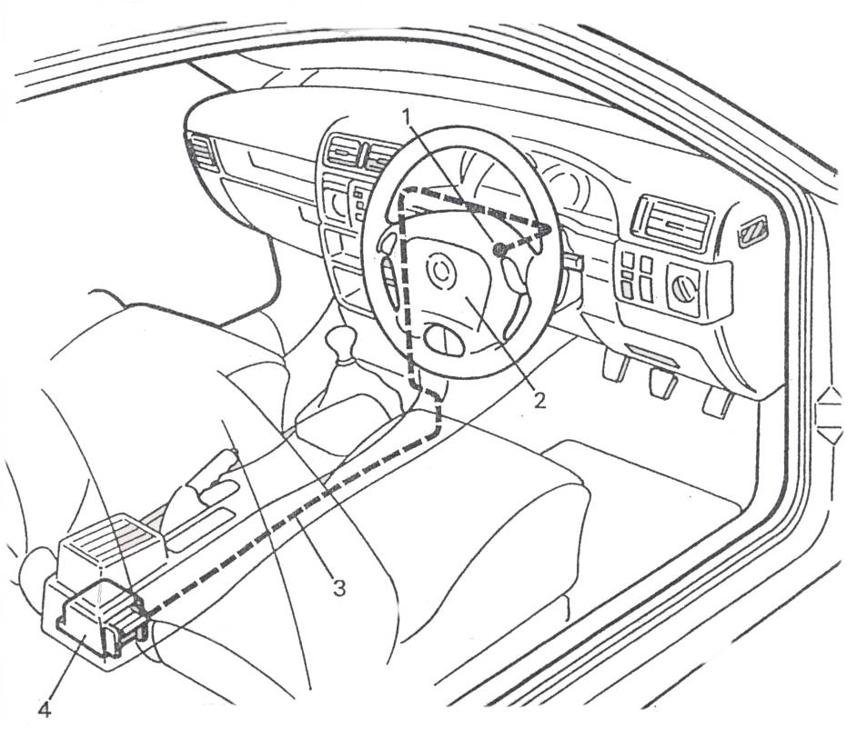
Figure 21: Airbag with the Locations of the Various Components
1. Contact Unit 2. Airbag Unit (Inc triggering device)
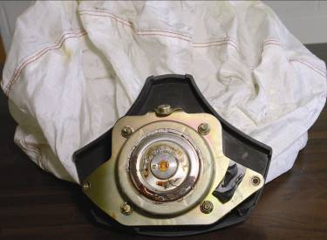
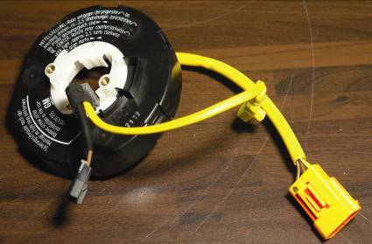

3. Wiring Harness
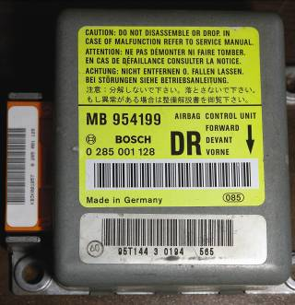 4. Control Unit
Principle of Operation
Airbag System
The Ford Airbag Supplementary Restraint System (SRS) comprises four main elements:
The driver’s side airbag module (and passenger side airbag, if fitted), consisting of:
- Inflator
- Airbag
- Cover

The electronic control module. This monitors the airbag system for faults and disables the system should certain faults be detected. It also contains a backup power supply which provides emergency power to the system if the vehicle battery is damaged before the crash sensors operate.

Crash sensors which detect any sudden deceleration. These consist of a single point electronic sensor mounted within the control module, in conjunction with a mechanical sensor (also mounted in the module) to confirm a crash signal.
An instrument cluster warning telltale lamp which flashes on to warn the driver should a fault occur within the airbag system.
The driver’s side airbag module is located in the steering wheel hub, whilst the passenger’s airbag (where fitted) is in the dashboard above the glovebox. The inflator contains a solid chemical gas generant safely stored inside a chamber inside the airbag module. Each inflator is sealed to exclude moisture.
The sequence begins when an electrical signal from the ECU releases the firing pin. This triggers the detonator which, in turn, ignites a pelleted compound that burns with explosive force at up to 700ºC. This combustion produces a high-pressure source of carbon dioxide and nitrogen gases, and it’s these which are used to inflate the bag.
The bag itself is made from rubber coated nylon and is very tightly folded into its compartment. To guard against the risk of it sticking together – and slowing down the deployment – the whole bag is dusted with a fine talcum powder like substance. The violence of the inflation scatters a suspension of this powder throughout the cabin, and although it might prove a slight irritant to the nose, throat and eyes, it’s not toxic and clears within seconds.

Now for the really amazing bit - just 20 milliseconds (that’s 20 thousandths of a second) after the impact, the detonator will ignite the gas generant compound and the bag, having punched through its specially weakened cover, will start to inflate. After 50 milliseconds the bag will be fully inflated and the driver, having started moving forward following the impact, will be nearing the bag.
After just 80 milliseconds the bag will already be deflating, and the driver’s forward motion will be effectively controlled as the bag collapses. In just 150 milliseconds the whole process will be finished. The bag will be almost fully deflated and the driver will be sitting back in the seat normally.
To put those frantic 150 milliseconds of potentially life-saving activity into some sort of real life perspective, you might be amazed to learn that it takes the human eye a full 200 milliseconds to blink!

Stages of Operation
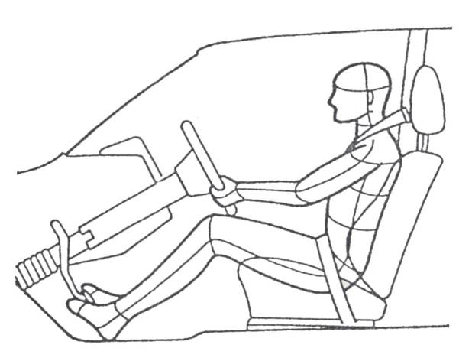

Figure 22: At the point of impact the driver is still in his normal position
Mechanical System
To achieve detonation, a small steel ball is positioned so that when an accident occurs, the ball overcomes spring tension and causes a trigger pin to strike the detonator.
The mechanical airbag system is generally regarded as less stable than the electronic systems that have replaced it.
Electronic System
Electronic airbag systems differ from the mechanical systems in the way which the airbag is triggered. Instead of a mechanical triggering system, the electronic systems make use of electronic sensor and an ECU.
When the sensors detect the impact caused by an accident, the information is received by the ECU which sends an electrical pulse to the airbag igniter assembly. The igniter, when triggered, causes a propellant charge (the gas generator) to rapidly produce gas which inflates the airbag. The igniter and propellant charge assembly is referred to as the inflator.
Additionally, more variation can be built into the electronic system to account for different speeds and types of accident thus making the electronic systems more adaptable and versatile.
A big advantage of the electronic system is that the ECU can receive many items of information from different sensors, which allows for different control sequences or timing to be used. As an example, some modern systems assess the weight of the occupants, whether or not a passenger is sitting in the seat and whether seat belts are being worn.
Importantly, airbags operate in conjunction with the seat belts. Ideally, the seat belt is used to restrain the occupant, i.e. take the main strain of the body weight. The airbag is then inflated just to prevent head and chest injuries which would occur when the occupants head and possibly chest move forward slightly. The Seat belts do not restrain the occupant’s heads and therefore the airbag provides this protection. Airbag deployment can therefore be set to occur slightly later when the seat belts perform the many restraining tasks. After 20 milliseconds, the ignition capsule is activated and after 25 milliseconds the airbag tears the cover open at the predetermined breakpoint. The driver moves forward.
Gas generator
The gas generator is a pyrotechnic device containing an ageing-resistant solid propellant (Sodium Azide, shown at (3) in Figure 23) which is sealed in a combustion chamber (2). An ignition capsule (4) containing its own charge is located in the centre of the gas generator. In the event of an accident this receives an electrical impulse from the control unit which ignites the charge. In turn the combustion of the propellant generates the required quantity of gas (mainly Nitrogen) to inflate the airbag. The gas passes through the lateral slits (1) inside the gas generator, which have a filtering and cooling effect. The quantity of gas is specifically adjusted to suit the size of the airbag and the vehicle in which it is installed.
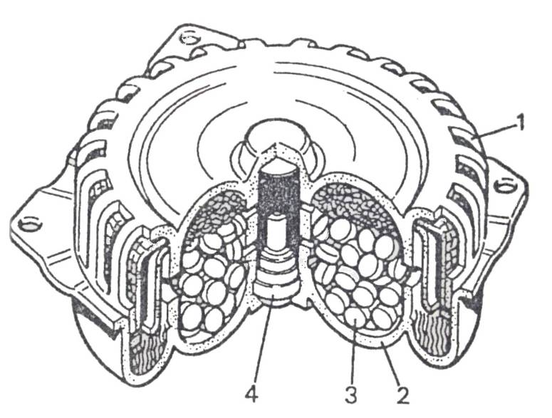

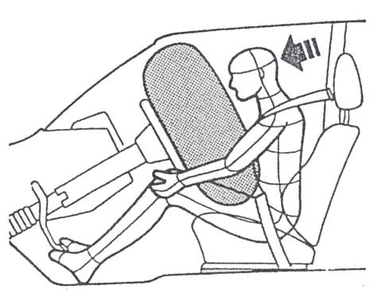
Figure 23: Gas Generator
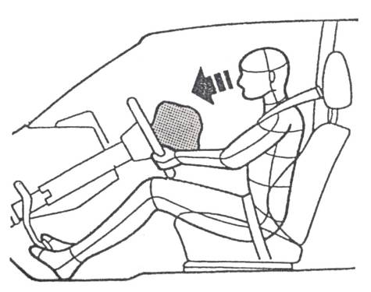
Figure 24- 25: The driver plunges into the cushion
After 50 milliseconds, the airbag is fully inflated. The driver plunges into the cushion
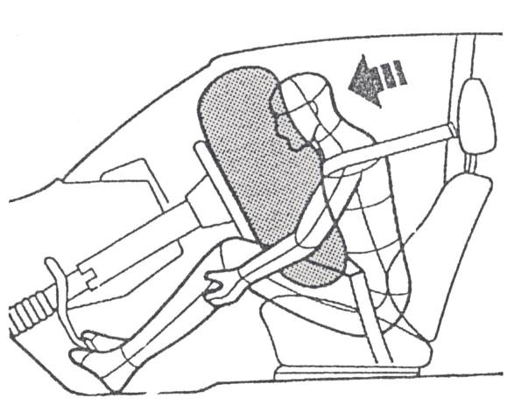

Figure 26: The Airbag Starts to Collapse

After 80 milliseconds, the driver is fully immersed in the airbag. The airbag starts to collapse.
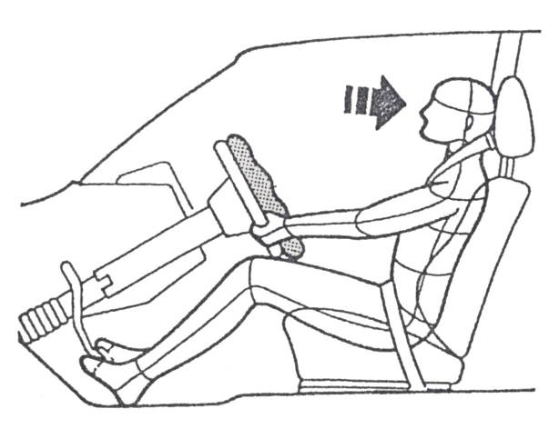

Figure 27: Driver is Back into Original Position

After 500 milliseconds, the crash is complete. The airbag is almost completely deflated and the driver is back into his original position.
By comparison, it takes 200 milliseconds for the human eye to blink.
6.1 Side Impact Protection System
SIPS Bags
The SIPS bag is activated by a side impact to the front door and will proved improved protection to the front seat passengers.
The SIPS bag is being introduced as standard equipment in some markets and as an option in others beginning with model year 1995.
SIPS Bag Installed in Front Seat
The SIPS bag system consists of three main components
- Sensor unit
- Firing circuit
- Cushion module
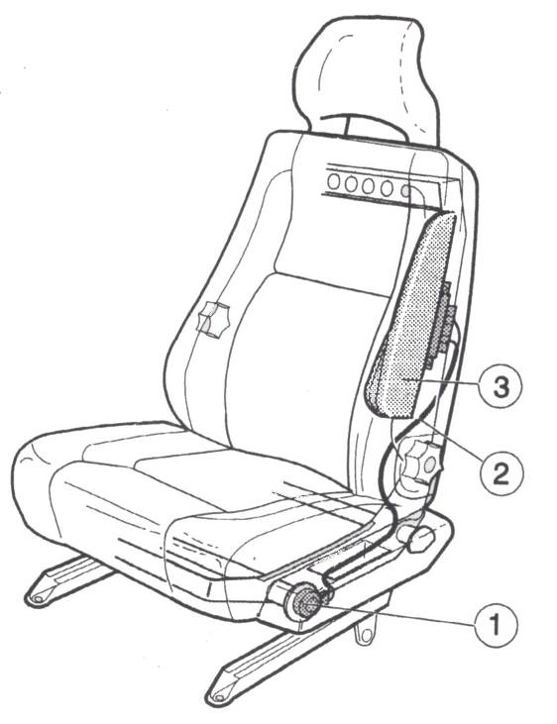

Figure 28: SIPS Bag

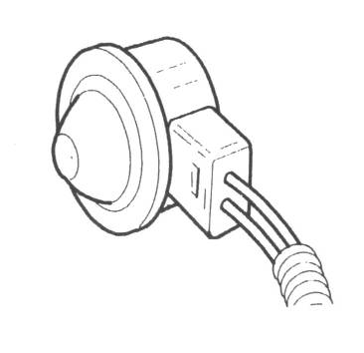

Figure 29: Senor Unit

Note:
Illustrations in service manual show left front seat SIPS bag components for right front seat are identical, except that the pressure plate at the front of the sensor unit is specific to left or right.
Sensor Unit
The sensor unit is located in a sensor mount at the outer end of the forward SIPS tube. The mount is the part of their chair that protrudes the most toward the inside of the door.
A pressure plate is mounted forward of the sensor unit. In the event of a collision, the pressure plate transfers the force from the inside door panel to the sensor unit.
Firing Circuit
The pyrotechnic firing circuit runs through the seat back and under the seat cushion.
The firing circuit consists of two tubes coated on the inside with a pyrotechnic material. When triggered, the signal is transmitted as a shock wave.
The tubes are covered with a black protective sleeve to protect them from mechanical damage.
SIPS Bag Cushion Module
The cushion module is located in the seat back frame to provide protection to the driver/passenger where the rib cage is closest to the inside door panel.
Cushion
The cushion, made of silicone-coated polyamid fabric is folded under a cover. When inflated, the cushion has a volume of about 12 litres (0.4 cubic feet).
Gas Generators
Two gas generators inflate the cushion. When activated, the gas generators produced a harmless gas which inflates the cushion very quickly.

Functional Description, General
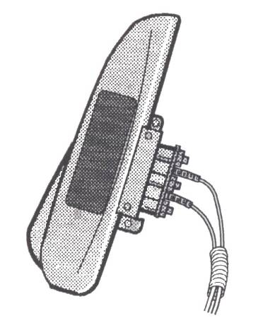
The SIPS gas is a separate system in each front seat. There is no connection between the two SIPS bags. In the event of a collision the SIPS bag will be activated only on the side of the collision. The sensor unit is a pyrotechnic an impact that causes the deformed door to hit the sensor with a speed of about 2 m/s (6.6ft/sec) (this corresponds to a collision speed of about 10 mph). The system is calibrated to avoid unnecessary activation such as by a blow to the door or a light impact with a stationary object.
Figure 30: Gas Generators
In the event of a side collision, the pressure plate will deform the aluminium cover, pushing a firing pin and releasing the ignition charge. The ignition charge creates an impulse which is transmitted through the firing circuit as a shock wave. When the shock wave reaches the cushion module, it ignites the power charge in the gas generator.
When released, the gas blows through a firing chamber tube and into the cushion. Activation of the first gas generator occurs immediately and the second is activated after a delay of about 3 milliseconds. The delay is designed to maintain the pressure and volume of the inflated cushion for an adequate time.
During inflation, the cushion breaks open the cushion module cover, rips open the chair upholstery seam and pushes out to inflate to its full volume. The cushion inflates toward the door panel to protect the passenger rib cage during the collision. There is a vent through a hole in the cushion, so it will collapse slowly enough to act as a brake on the driver/passenger.
There is no diagnostic system or warning lamp connected to the SIPS bags.
The SIPS bags is available only in cars equipped with the SRS system, and is always installed in both front seats.
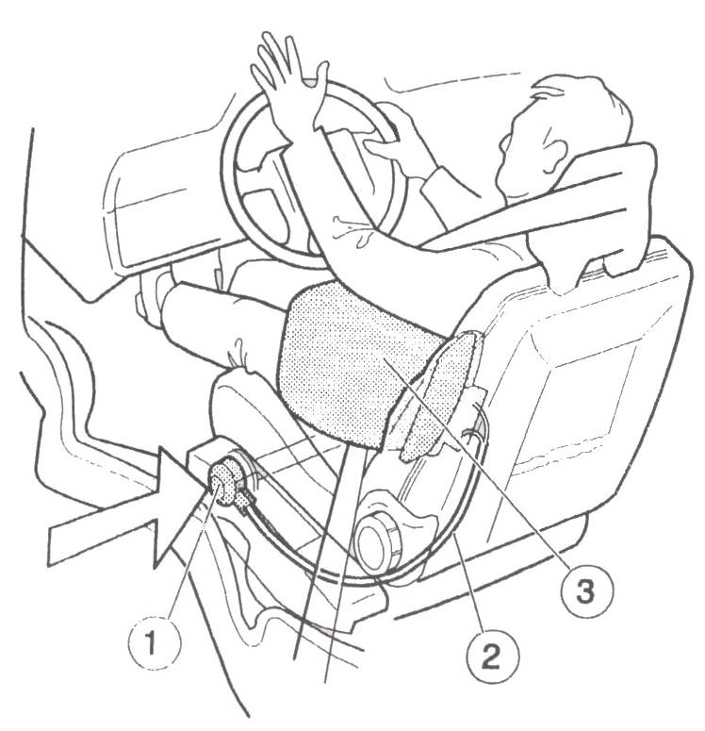

Figure 31: The SIPS Bag
Repair
Service Procedures
Warning: During service which involves front seats always install safety devices in SIPS bag of seat being serviced. Never apply external force to side of seat.
Transport Safety Device
During shipping and handling of a SIPS bag unit or complete front seat with pre-installed SIPS bag unit the transport safety device must always be installed on the sensor unit.
When the transport safety device has been placed over the sensor unit and the SIPS bag is locked, the seat pocket cannot be installed. The size of the transport safety device is deliberately designed so that it prevents installation of the seat pocket to prevent inadvertently leaving the transport safety device on the sensor.

Lock SIPS bag
Before starting service operations
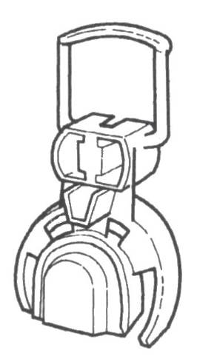
Lock the SIPS bag with the transport safety device according to the following:
- Lift up seat pocket. Lift the front edge and push the pocket backward.
- Remove transport safety device from its holder inside the seat pocket.
- Attach transport safety device to the sensor unit.

Figure 32: Sensor Unit

Unlock SIPS bag
When service operations are completed
Do not forget to unlock the SIPS bag.
- Remove transport safety device from sensor unit.
- Place transport safety device in holder inside seat pocket.
- Replace seat pocket.

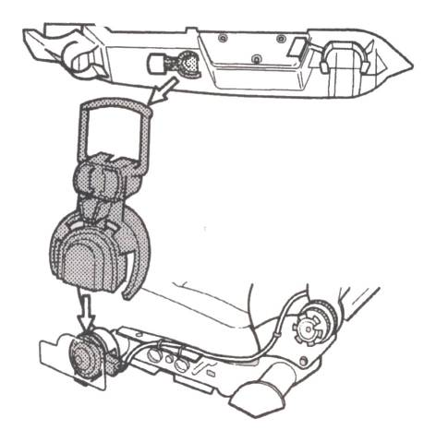

Figure 33: Unlock SIPS Bag
Replacement of front seat with pre-installed SIPS bag

SIPS bag cannot be replaced. Damaged front seat should be replaced complete with pre-installed SIP bag.

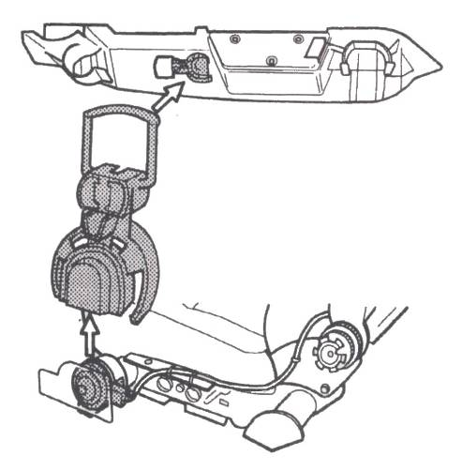

Figure 34
First lock the SIPS bag
- Lift up the seat pocket. Lift the front edge and push pocket backward.
- Remove transport safety device from its holder inside the seat pocket.
- Attach transport safety device to sensor unit.
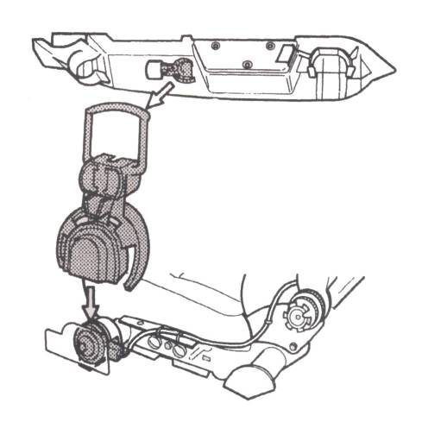

Figure 35
Remove front seat
Preparation
- Turn ignition off
- Disconnect cable from negative battery terminal.
Remove
- Seat pocket (A). Lift front edge and push backwards.
- Seat belt from chair attachment (bolt on out side of seat)
- Cover (B) at front edge of seat rail.
- 4 Attachment bolts (C) in seat rails.
- Disconnect connectors to heating elements (under seat).
- Disconnect connectors to seat belt buckle (under seat) Lift seat straight up (control tabs at front and rear edge).
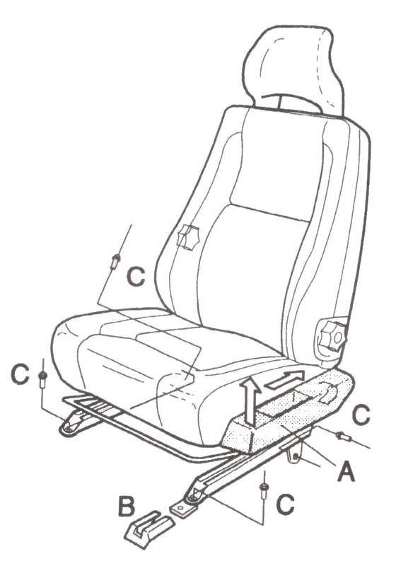

Figure 36: Remove Front Seat

Install front Seat
First make sure that the SIPS bag on the new front seat has been locked with the transport safety device attached to the sensor unit.
- Install the seat in opposite order to C2. Note: The outside rear attachment bolt (C) should be tightened last; otherwise the seat could be installed at an angle.
Tightening Torques
Seat/Floor 40Nm (30ft.ib)
Belt 20 Nm (15 ft.lb)

When front seat is in place
Do not forget to unlock SIPS bag

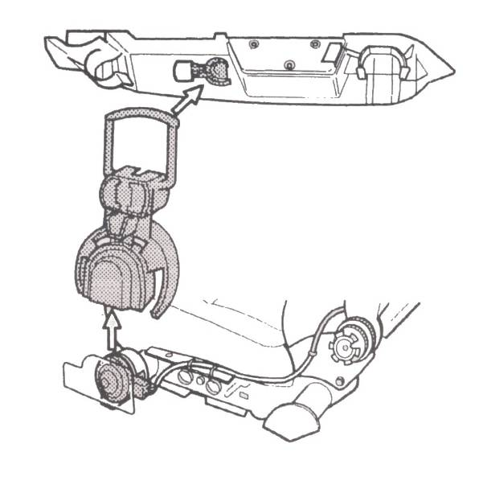

Figure 37: Unlock SIPS Bag
- Remove transport safety device from sensor unit.
- Place transport safety device in holder inside seat pocket.
- Replace seat pocket.
- Change to decal with new date for SIPS bag, left or right side. Located at driver’s side B-post. The new SIPS bag chair comes with the decal.

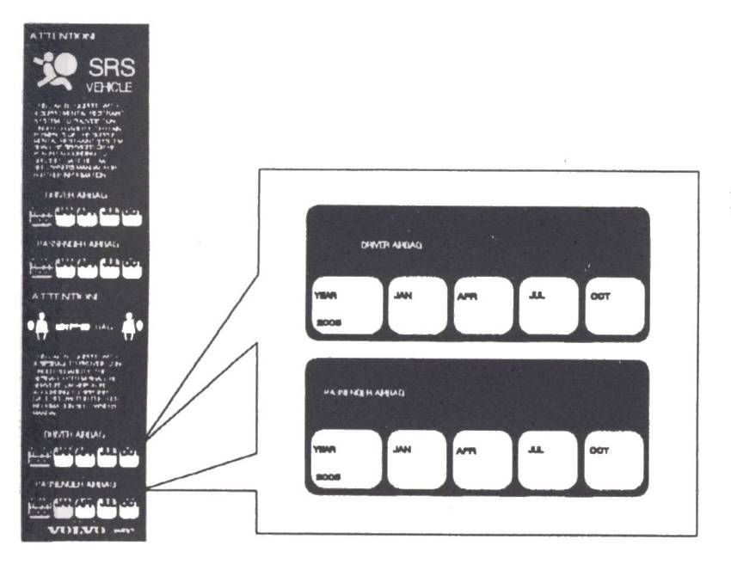

Figure 38: Data for SIPS Bag
Install SIPS Bag in Seat
Make sure the new SIPS bag is locked with transport safety device attached to sensor unit.
Install Sensor Unit
Install sensor unit on forward SIPS tube
- Clips should be in place in SIPS tube sensor housing.
- Install sensor unit.
- Install pressure plate.
- After collision, replace pressure plate.
- Install Torx-25 screw.
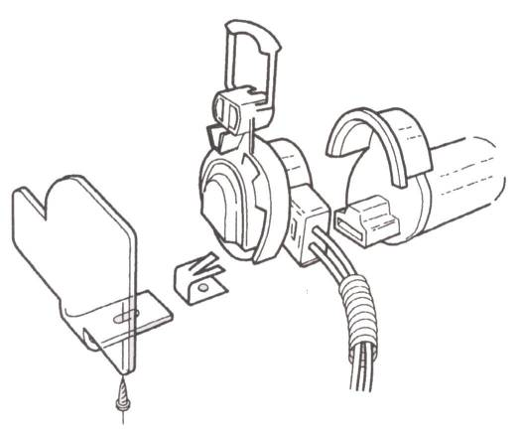
Figure 39: Installing Sensor Unit
Install SIPS Bag Cushion Module
- Install cushion module on seat back frame.
- Install cushion modules.
- Install 2 Torx-25 screws.
If SIPS bag was released, the attachment screws for the cushion module should be replaced. Use new screws of the same type and quality.
Tightening torque for cushion module 2.9 Nm (2.14 ft. lb).
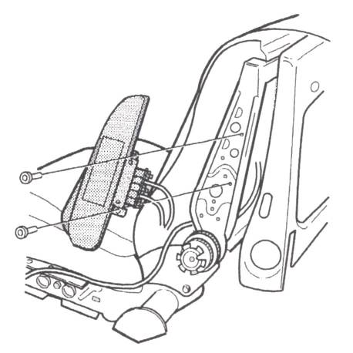
Figure 40: Installimg SIPS Bag Cushion Module

Install firing circuit
Install firing circuit and cable ties in previous location

- Place firing circuit in clips
- Install cable ties (2)

If the car is to be scrapped
For deliberate release of SIPS bag, Volvo recommends the following:

- If the car is to be scrapped, the SIPS bag should be released in place in the car, see step FA.
- If a removed SIPS bag is to be scrapped, the SIPS bag cushion module should be placed in a vice before release.
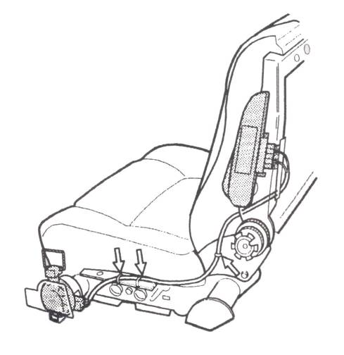

Figure 41
6.2 Description of Components
Steering Column
The steering volume is reinforced to accommodate the extra weight of the airbag; also two braces (shown arrowed in Fig.42) are fitted to the upper section. These braces, which connect the steering column to the centre tunnel and the ‘A’ post, limit the penetration of the steering column into the passenger compartment, ensuring that the airbag remains in the correct position in the event of an accident. This in turn ensures that the driver is protected to the greatest possible degree.
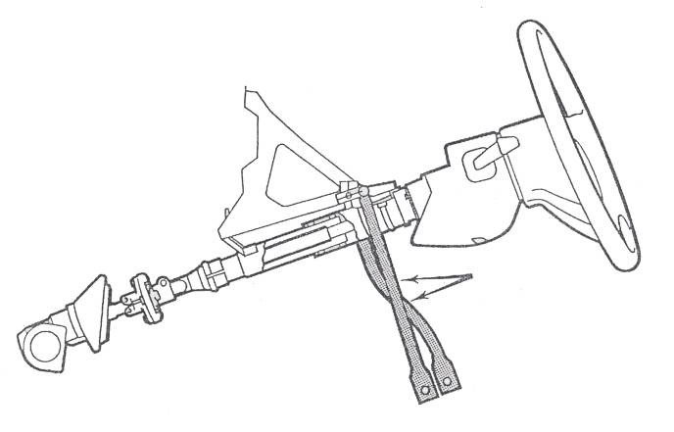
Figure 42: Steering Column
Airbag Cover
This is the uppermost visible safety component of the airbag unit. This cover houses the airbag and gas generator beneath it and, in the event of a frontal impact opens within a few milliseconds along the predetermined split line (arrowed in Fig.43), thus enabling the airbag to unfold and inflate correctly.
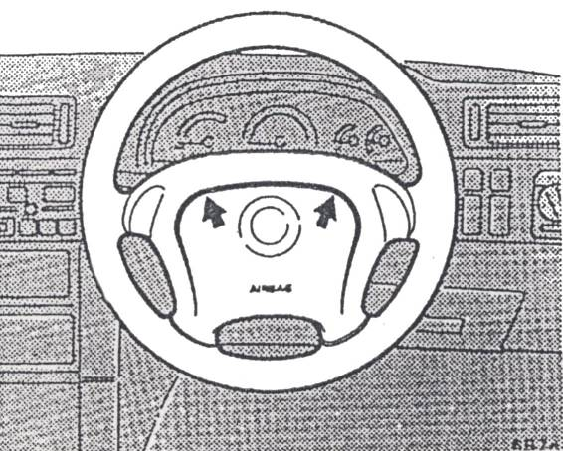

Figure 43: Airbag

Airbag
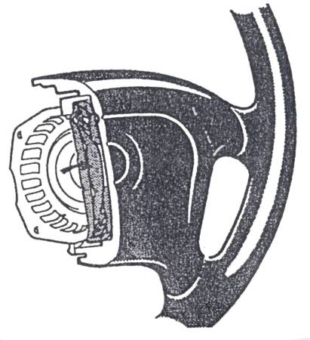
The neoprene-coated airbag (arrowed in Figure.44) is located beneath the airbag cover and tightly folded up inside the generator support. Inside the airbag are four restraining straps to control the correct shape on inflation, and the softness of the airbag is controlled by discharge holes at the rear. On severe frontal impact the airbag unfolds to form a convex air cushion. This supplements the restraining effect of the seatbelts by softly absorbing the head and upper torso of the driver’s body, considerably reducing the risk of injury.
The complete sequence from triggering, through inflation, to the discharge of the cushion by the body sinking into it, takes less than 100 milliseconds.
Figure 44: Neoprene Coated Airbag
Contact Unit
The rotary mounted contact unit (arrowed in Figure.45) is secured to the steering wheel from behind. During rotation of the steering wheel it ensures a direct power supply between the electronic circuitry of the control unit and the ignition capsule in the gas generator.
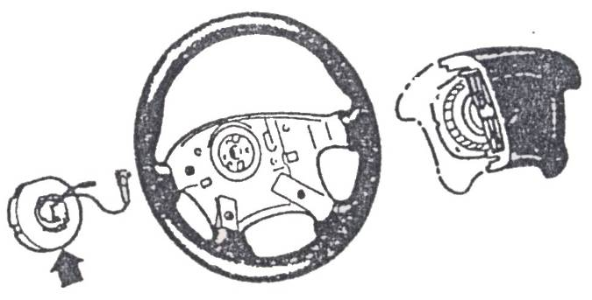

Figure 45: Contact Unit
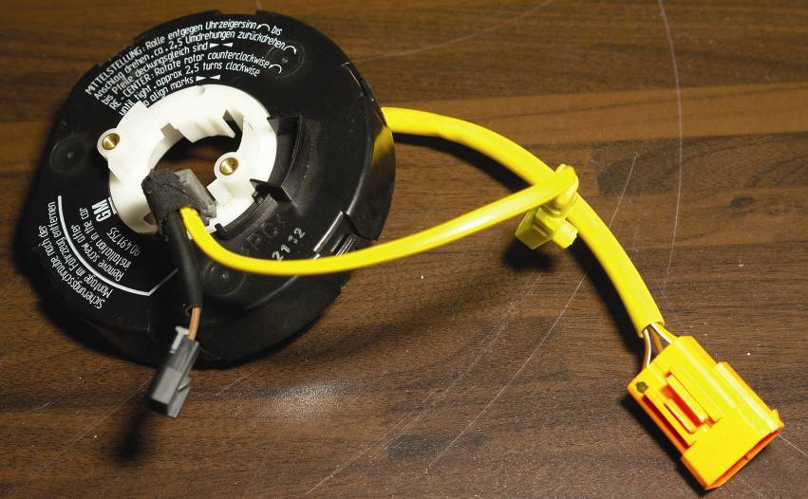

Control Unit
The control unit (Figure. 46) is specific to each model variant and programmed to suit. Control units are not interchangeable.
The control unit comprises four basic components:
- Crash sensor
- Safety sensor
- Capacitor
- Diagnostics
The crash sensor determines whether the circumstances require the airbag to be triggered, and controls the timing of the triggering to effect the greatest possible degree of protection.
The safety sensor is an electro-mechanical switch wired in series with the crash sensor, which prevents unintentional triggering of the airbag. The switching threshold of the safety sensor is adjusted so that triggering is impossible under normal driving conditions.
The capacitor provides the system with adequate residual energy to start the triggering of the airbag in the event of failure of the vehicle’s electrical system due to the accident.
The diagnostics continually monitor the airbag system, and in the event of a fault occurring light up a control indicator panel on the instrument display (arrowed in Figure.47). An automatic system check is also carried out each time the vehicle is started, and if everything is in order the control indicator telltale will extinguish after approximately 4 seconds.
Harness
Most of the cable harness which supplies the airbag system is incorporated in the instrument panel harness. At the upper section of the harness a special plug containing a short circuit bridge is used for the connection at the contact unit. This short circuit bridge comprises a clip which prevents any current from accidentally triggering the airbag by connecting the two contacts in the plug as soon as it is disconnected. When connected, the clip is raised from the contacts to eliminate the short circuit.
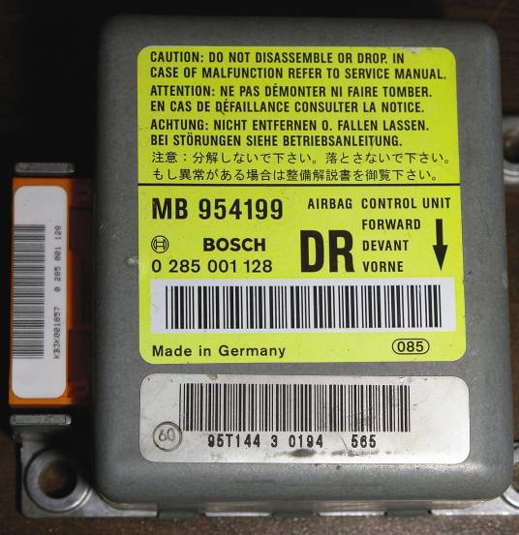
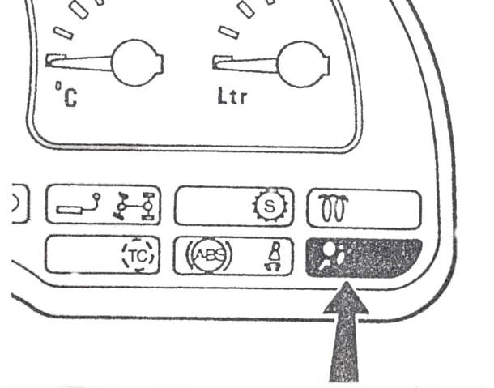

Figure 46: Instrument Display

6.3 Recovery of Vehicles Containing Airbags

Towing a Vehicle with a Non-Deployed Airbag
It is extremely unlikely this would cause an airbag to inflate provided standard towing procedures are being observed. However, as a precaution, the manufacturer recommends that both battery terminals are disconnected.

Towing a Vehicle with a Deployed Airbag
Once a driver’s side airbag has been deployed, any subsequent towing operations must be carried out with the vehicle in a front end suspended tow. When towing, observe the safety precautions detailed below.

7.0 Emergency Rescue from Vehicles with Airbags
The following rescue procedures apply to all vehicles with airbag fitment and cover all conditions whether or not the airbag has been deployed. This should allay any unnecessary concerns regarding airbag-related rescues.
It is important to remember that occupants and rescuers are not exposed to harmful levels of chemical contamination, whether or not the airbag has been deployed.
The gas propellant contains a solid form of Sodium Azide which is securely sealed prior to the deployment and is totally consumed during deployment. Tests have shown that there is no detectable Sodium Azide in the combustion by-products within normal operating conditions.
Rapid burning of propellant during deployment produces Nitrogen gas together with small particles of dust, both of which are cooled and filtered during inflation of the airbag.
The surface of the deployed airbag, and the vehicle interior, may be coated after deployment with a fine powdery residue. This is simply talcum powder used to lubricate the airbag as it deploys. Also present are small amounts of Sodium compounds which are the by-products of the combustion cycle and are mainly Sodium Carbonates (baking soda). There may also be a very small amount of Sodium Hydroxide, which could cause slight irritation to the skin and eyes.
7.1 Vehicle Crash Procedures
Standard fire extinguishing procedures may be carried out on vehicles fitted with airbags. It is permissible to use any type of extinguishant including water, as the Sodium Azide propellant is sealed in a watertight container.
In the rare event of a fire in the vehicle’s passenger compartment, the airbag may deploy. In such a case the inflation will take place in the usual manner. In intense temperatures the airbag is designed to self deploy once its internal temperature reaches approximately 200ºC (390ºF). The gas propellant will burn off rapidly without fragmentation of the component parts. Airbags WILL NOT explode.

Rescue with Undeployed Airbags
Because airbags deploy only in moderate to severe frontal and near-frontal impacts and are not designed to deploy in mild frontal accidents, rear end, side or roll over situations, it is possible that a rescue may be required from a vehicle where the airbag has not deployed. In such a case carry out the following procedure:

- Determine whether an airbag is fitted. Vauxhalls fitted with airbags have a moulded line across the centre of the steering wheel, this being the pre-determined spilt line through which the airbag must emerge during deployment. The word airbag will also be seen towards the lower part of the wheel centre pad. In addition, a label (arrowed in Figure 47) will be shown affixed the rear face of the driver’s door immediately above the lock mechanism.

- Move the seat of a stabilised occupant as far back as possible or, alternatively, lower the seat back.

- Always carry out the rescue from the side of the vehicle, away from the potential deployment path of an airbag.

- Start rescue operations promptly.

- DO NOT position your body, tools, or any other objects, on or in front of a non deployed airbag.

- DO NOT cut or drill into the steering column of a vehicle fitted with an airbag. It is permissible to cut through the steering wheel rim to help in freeing the driver.

- NO NOT strike or drill into the airbag unit or steering wheel assembly.

- DO NOT attempt to attain manual deployment of an airbag in any manner.

- DO NOT apply heat in excess of 90ºC (195ºF) to the steering wheel area.

- Where an airbag is found to be punctured, DO NOT touch any exposed chemicals.
- Disconnect both battery cables at the battery. Note: Disconnecting the battery WILL NOT immediately mobilise the airbag system as a residual energy reserve feature is incorporated in the system to enable the airbag to deploy in the event of battery failure. This has the power to deploy the airbag for up to 1 minute after the battery has been disconnected or the ignition switched off.
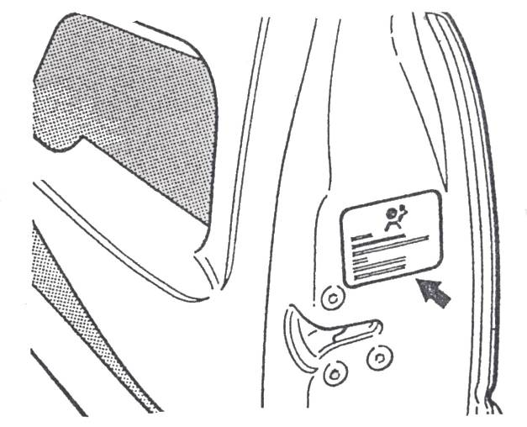

Figure 47: Information Label

Rescue with Deployed Airbags

NOTE: IN THIS CIRCUMSTANCE REPAIR OPERATIONS MUST BEGIN IMMEDIATELY. DO NOT DELAY RESCUE.
- Use normal procedures and equipment. There is no danger of hazardous medical consequences for vehicle occupants or rescue personnel arising from a deployed airbag. Occupants are likely to suffer no more than minor abrasions and/or skin redness from contact with an airbag. In general such minor injuries should occur, will be confined to the inner forearm and the chin.

- Wear normal hand and eye protection. Gloves and safety glasses will guard against possible eye or skin irritation from the powdery residue. If gloves are not worn, wash hands in mild soap and water after handling a deployed airbag. Avoid getting the residue unto eyes or an open wound.

- Beware of possible hot metal components under the deployed airbag fabric. These components are located inside the steering wheel and should present no problem. Note: The fabric itself, the steering wheel column and steering rim and spokes will NOT be hot.

- Airbags deflate immediately after deployment and in this state may be pushed aside to allow occupant removal. It is not necessary to remove or re-pack the airbag during rescue operations.

Crash Repairs
When a vehicle has been involved in a major collision and the airbag has not been deployed, observe the following precautions:
- Do not allow applied hear in the steering column area to exceed 90ºC (195ºF) as the airbag is designed to self-deploy above this temperature.

- Avoid sharp impacts such as hammer blows to areas where the airbag system components are located until the system has been deactivated.
Paint refinishing operations following minor accident damage (including the use of forced air pressure drying systems) will not present any problem.
Precautions
In addition, on Vauxhall cars fitted with airbag systems the following applies:
- Ensure that the telltale light on the control indicator panel comes on with the ignition and extinguishes itself after approximately 4 seconds. If it remains lit for longer or comes on whilst driving there is a fault in the airbag system. The system must be then regarded as inoperative and until the fault has been rectified by one of the Manufacturer’s service dealerships.

- It should be noted that the airbag is not a substitute for the wearing of seatbelts. The driver can only be protected in the manner described if a seatbelt is being worn.
- The seat height should always be adjusted to suit the occupant.

- DO NOT cover or modify the centre of the steering wheel pad in any way. It must be merely kept clean using a dry cloth and a suitable cleaning solvent, if necessary.

Ford – ‘Eurobag’ Air System
Airbag protection is progressively being introduced across the range of European Ford passenger cars. The system used is substantially different from that fitted to American Ford vehicles and is known as the ‘Eurobag’. The Eurobag has been specifically designed to protect the driver and (when fitted with a passenger airbag) the front seat passenger from severe facial and upper body injuries in the event of a serious impact. To ensure full protection, the airbag must be used in conjunction with a conventional 3-point seatbelt.
Description of components
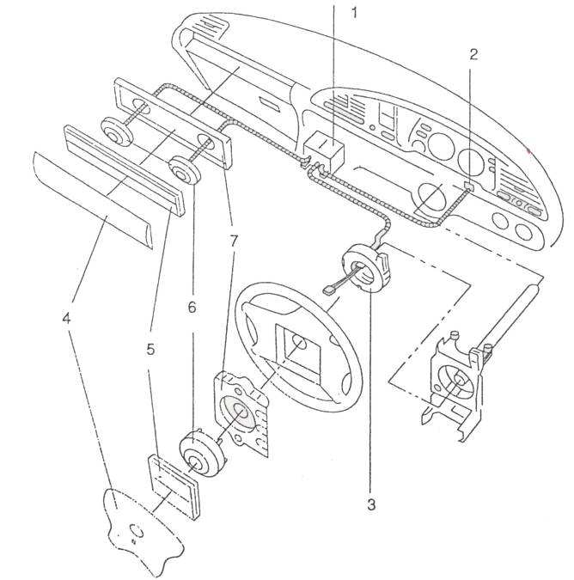
Figure 48 shows the ‘Eurobag’ layout together with the locations of the various components.

Figure 48: ‘Eurobag’ Components
- Electronic Control Module
- Warning Light
- Clock Spring
- Cover
- Bag
- Inflator
- Container
The system comprises of the following components:
- Electronic Control Module
- Wiring harness
- Clock spring
- Warning light
- Airbag assembly(ies)
Electronic control module
The electronic control module governs the operation of the airbag system including the diagnostics element. It contains two sensors: a crash sensor and a safing sensor. The crash sensor produces a signal both during acceleration and deceleration. These two sensors are connected in series and if both sense a deceleration in excess of a predetermined figure they will trigger the airbag.
The electronic control module also performs system checks and, in the event of a fault being discovered will illuminate the warning telltale light either constantly or intermittently depending on the nature of the fault.

Wiring harness
The wiring harness supplies power to the airbag system from the vehicle’s supply.

Clock spring
The clock spring is designed to carry the necessary signals between the electronic control module and the airbag. It is fitted to the steering column switch mounting bracket and comprises both fixed and moving parts connected by a coiled Mylar tape with integral conducting tracks. The Mylar tape is able to ‘wind up’ and ‘unwind’ as the steering wheel (which bears the moving component) is turned, thus maintaining electrical contact at all times between the airbag and the electronic control module. The clock spring also supplies power to the horn and, where fitted, the speed control system switches.

Warning Light
The warning light is located in the instrument cluster. It will illuminate for 4 seconds after the ignition is switched on and will extinguish automatically if no faults are found. Where a system fault is detected the light will flash as described above to remind the driver that the system is not operational.

Airbag Module
The airbag module itself comprises the following components:
- Inflator
- Airbag
- Container
- Cover
The inflator is screwed into a metal, cup-shaped container. The airbag is then folded on top of the inflator and the entire sub-assembly closed off by the cover, which forms the outer face of the steering wheel boss. The module is then fitted to the steering wheel. This module cannot be dismantled.

Inflator
The function of the inflator is to generate the necessary volume of gas to fill the airbag. It comprises a High Strength Steel casing filled with a propellant charge and an electrically-activated igniter. The igniter is activated by a signal from the electronic control module, and in turn ignites the propellant charge. The very rapid burning of the propellant produces sufficient gas to fill the airbag. As the gases expand, they cool thus preventing heat damage to the bag. The driver’s side airbag has a volume of 30 litres and one inflator. The passenger’s side has two inflators and a filled volume of 60 litres.

Airbag
The airbag is a one-piece woven item with a silicon coating to protect it against hot gases and to offer some flame protection in the vicinity of the inflator.
The driver’s side airbag is almost circular in shape, while the shape of the passenger’s side airbag is tailored according to the vehicle type.

Container
The container is a one –piece cup-shaped metal pressing containing the inflator and airbag.

Cover
The cover forms the steering wheel boss. It is permanently bonded to the container and is an integral part of the module (see above). A number of ‘split lines’ are formed in the surface of the cover which, although not visible, form weak stress patterns which permit the airbag to emerge once it has been deployed in an accident.

8.0 Vehicle Crash Fire Prevention Procedures
When tackling fires in a Ford vehicle equipped with airbag and/or seatbelt tensioner systems, it is permissible to use standard fire extinguishing procedures. The gas generant is sealed in a watertight container and will be unaffected by the use of any type of extinguishant including water.
Airbag inflators may possibly deploy involuntarily in the case of a vehicle interior fire, but the inflator will operate normally. The airbag module is designed to deploy in intense fires where its internal temperature reaches approximately 175ºC. In such a situation the gas generant burns rapidly without fragmentation of the inflator. Airbags will not explode in a fire situation.
Vehicle Recovery – Towing

Vehicle with Undeployed Airbag
Standard towing procedures are unlikely to cause involuntary deployment of an airbag. However, when towing a vehicle with an undeployed airbag, the battery must be disconnected.

Vehicle with Deployed Airbag
Use normal procedures and equipment. There are no hazardous medical consequences for occupants or recovery personnel from a deployed airbag. Those entering the vehicle are advised to wear normal protection such as gloves and eyes shields as there is a possibility of skin or eye irritation arising from the powdery airbag residue. If gloves are not worn, wash the hands with mild soap after handling a deployed airbag, or pushing it aside for access. Avoid getting residue in the eyes, or open wounds.
Be aware of hot metal parts beneath the deployed airbag fabric. Such parts are located inside the steering wheel hub and the instrument panel and should pose no threat. The airbag fabric, steering wheel column, rim and spokes will not be hot.

Emergency Rescue from Vehicles Fitted with Airbags
The following information is intended to assist emergency rescue personnel in procedures involving Ford vehicle equipped with airbags and/or seatbelt tensioner systems, whether they have been deployed or not.
It should be noted that occupants and rescuers will NOT be exposed to harmful levels of chemicals with deployed or un-deployed airbags. The gas generant is securely contained and sealed prior to deployment, and is consumed during the deployment process.

Rescuing Occupant/s from Vehicle with Undeployed Airbag
Before carrying out the rescue, check that the vehicle is fitted with airbags. On Ford vehicles this is indicated by a symbol on the VIN plate visible through the lower left hand corner of the front screen. There will also be the initials ‘SRS’ moulded on the cover of the airbag module.
Do not allow the body or rescue equipment/tools to rest on the airbag cover or within the operating range of an undeployed airbag. Start rescue operations immediately.
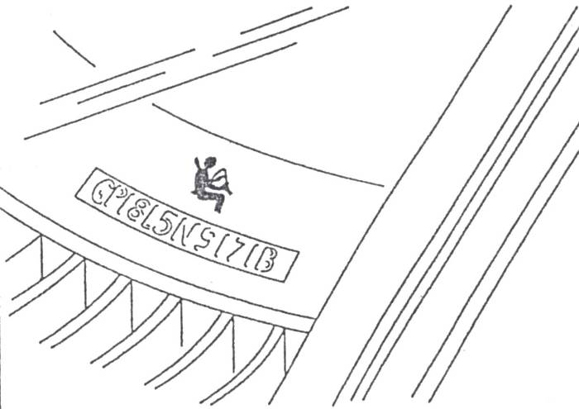
Disconnect the battery before attempting to cut through the steering column for access or to effect release of the driver. This will cut all power supplies to the steering column immediately, including the back up supply.

Figure 49: VIN Plate
Where it is necessary to work on the steering column before it is possible to disconnect the battery, observe the following precautions:
- Do not allow the body or rescue equipment/tools to rest on the airbag cover, or within the possible deployment path of the airbag.
- Do not cut into the steering column.
- Carry out all rescue efforts from the side of the vehicle and away from the possible deployment path of the airbag.
- Move the seated occupant as far back as possible, or lower the seat backrest.

NEVER cut or drill into an undeployed airbag module or attempt to dismantle the module, whether or not the vehicle battery has been disconnected. Where the metal inflator capsule of an undeployed airbag has been accidentally damaged, cut or ruptured, DO NOT touch the exposed chemicals in the container.
Cutting into the steering wheel rim or spokes, or removing the instrument panel, will not cause an airbag to deploy even if the battery is still connected. In general there should be no risk whatsoever of airbag deployment occurring during a rescue, as the control module will disable the airbag system if it detects short circuits in the sensor circuit when the ignition is still switched on. It is also highly unlikely that the airbag module’s combustion chamber will rupture during an accidental impact, as it is sealed and contained within a permanently closed metal inflator located beneath the folded airbag and cover.

Rescuing Occupant/s from Vehicle with Deployed Airbag
Use normal rescue procedures and equipment. There are no hazardous medical consequences for occupants or recovery personnel from a deployed airbag. It is possible that occupants may sustain minor skin redness or abrasion from contact with a deploying airbag, for example on the inside of the forearms or on the chin. Wear normal protective clothing such as eye shields and gloves, as there is a possibility of skin or eye irritation arising from the powdery airbag residue.
If gloves are not worn, wash the hands with mild soap and water after handling a deployed airbag or pushing it aside for access.
Be aware of hot metal parts beneath the deployed airbag fabric. Such parts are located inside the steering wheel hub and the instrument panel and should pose no threat. The airbag fabric, steering wheel column, rim and spokes will not be hot.

Summary
Always secure a vehicle in a manner that will not injure yourself and others when replacing or repairing non structural panels.
It’s very important to carry out repairs in a professional manner. That means economical use of materials this will reduce our carbon foot print and protect all our futures and never use harmful materials without P.P.E.
Modern motoring provides for driving on the roads with an enormous number of other vehicles that can all reach speed beyond 100mph. Not surprisingly, many ‘accidents’ occur, (although many accidents are avoidable) and these frequently result in injuries to the occupants of the vehicle.
Vehicle manufactures design and construct modern cars with safety in mind, and many safety systems are now standard features of the cars we travel in. The construction of the vehicle is designed so that if involved in a severe accident, the structure of the vehicle protects the occupants of the car.
The front and rear sections of vehicles are designed to collapse in a controlled and progressive manner thus absorbing much of the impact caused by crashes. These collapsible sections are usually referred to as shock absorbers to the impact forces. They are also designed so that vehicle components and assemblies do not enter the passenger compartment due to impact.
The force of a vehicle impact also causes any unrestrained articles, including the occupants, to move around the interior of the vehicle. Personal injuries may occur to occupants when they strike solid objects within the interior of the vehicle. Manufacturers therefore often use softer, more impact absorbent materials within the vehicle (e.g. softer dashboards), to limit these types of injuries.
SRS systems are also used to assist in reducing injury to the occupants.
Self Assessment
Questions – Module 6. Unit 2
  - What is the best method of repairing a rusty panel?
2. What is direct damage?
3. What should be done with belts when dismantling?
4. Where is data available for correct re alignment of body panels?
5. When removing galvanised coating what should be worn?

6. What is under body seal?
7. What does S.R.S stand for?
8. What colour is S.R.S wiring?
9. What does SIPS mean?
10. How fast in simple terms does it take for air bags to fully deploy?

Answers to Questions 1-10. Module 6. Unit 2
1.
Cut it out and weld
2.
This is the area of point of impact
3.
Stored in a container
4.
Thatchem
5.
P.P.E and charcoal mask

6.
It’s a substance that protects from salt and rust
7.
Supplementary restraint system
8.
Yellow
9.
Side impact protection system
10.
Blink of an eye

Suggested Exercise
- Repair damaged vehicle as per estimate to manufacturer’s quality standard
- Identify cause of corrosion, rectify if possible
- Remove damaged part weld in new section and surface finish

Training Resources
- Classroom/workshop
- Visual aids
- Training/project vehicle (damaged)
- Hoist, jack and stands
- Tools
- Welding equipment
- Spraying equipment
- Spray booth
- Various repair materials
- Hydraulic jacking/pulling equipment
- Measuring equipment
- Estimate of damaged vehicle
- Parts as stated on estimate
- Air operated hand tools
- Sealing gun
- Welding equipment
- Breathing apparatus equipment

27-33 Upper Baggot Street
Dublin 4

