TRADE OF PAINTING & DECORATING

PHASE 2

Module 1
Recoating Surfaces and Sign work

UNIT: 3

Painting Previously Painted Surfaces

Table of Contents
Introduction 1
Learning Outcomes 1
1.0 Prepare a Previously Painted Surface and Finish in Eggshell Paint 2
1.1 Safety precautions and safe disposal of solvent based paints. 2
1.2 Safety Precautions and Advantages of Lightweight Support 4
1.3 Light scaffolding 15
1.4 Step ladders 15
1.5 Trestles 16
1.6 Scaffold boards 17
1.7 Safe Working Practices When Washing Around Electrical Outlets 22
1.8 Function of Thinners, Driers, Pigments, Extenders and Binders 23
1.9 Properties of Paint and Reasons for Painting, Paint Defects 28
1.10 Characteristics and Function of Undercoat and Eggshell 31
1.11 Use and Care of Paint Brushes and application and Flashing 32
1.12 Types of paint brush: 33
1.13 Adhesion, Reasons for Abrading, Types and Uses of Abrasives. 38
1.14 Preparation of Various Surfaces for Recoating 42
2.0 Mix and apply filler to damaged surface correctly 43
2.1 Functions & Characteristics of Fillers and Stoppers 43
3.0 Calculate the Amount of Paint Required to Coat a Given Surface 48
3.1 Calculate the Amount of Paint Required to Coat a Given Room 48
3.2 Self Awareness, Relationships in the Workplace 52
Summary 53
Training Resources 53
Suggested Exercise 53
Self test 54
Further Reading 54

Introduction
This can present a particular set of challenges compared to painting new surfaces. For instance, previously painted surfaces can have adhesion problems caused by bad preparation and /or painting or breakdown of the old paint system due to chemical reaction, dampness, rot, weathering, etc. In addition, there is a growing awareness of the health and safety issues caused by the presence of lead in old paints, or asbestos in the substrate. All of these are issues that the painter needs to be aware of, able to identify and treat successfully where possible.
Products are changing at an accelerating rate due to advances in technology. The quality and range of paints available has grown spectacularly in recent years, and a particular advance has been made in the area of water based paint and varnishes.
Health and safety regulations have also had an impact on paint manufacture. This can especially be seen in the area of EU regulations on solvent based paint emissions (volatile organic compounds, or VOCs).
Module 1
Recoating Surfaces and Sign Work
Unit 1
Induction/ Health & Safety

Unit 2
Manual Handling

Unit 3
Painting Previously Painted Surfaces

Unit 4
Sign Work
Unit 5
Stenciling

Learning Outcomes
By the end of this unit each apprentice will be able to:
- Prepare a previously painted surface and finish in eggshell paint
- Mix and apply filler to damaged surface correctly
- Calculate the amount of paint required to coat a given surface

1.0 Prepare a Previously Painted Surface and Finish in Eggshell Paint
Key Learning Points
- Safety precautions and safe disposal of solvent based paints.
- Safety precautions for trestles, ladders, scaffold, advantages of lightweight support
- Safe working practices when washing down around electrical outlets
- Properties of paint and reasons for painting, paint defects
- Characteristics and function of undercoat and eggshell
- Correct use and care of paint brushes. Method of application and flashing
- Adhesion, reasons for abrading, types and uses of abrasives
- Preparation of various types of surfaces for recoating
- Work area kept clean at all times

1.1 Safety precautions and safe disposal of solvent based paints.
Solvent Based paints are flammable materials that have to be carefully stored to avoid accidental fire. They must be stored outside in a properly ventilated store that has the recommended type of fire extinguishers in place. If small stocks of paint or thinners need to be stored indoors then a metal fireproof cabinet must be provided.
For environmental reasons it is illegal to discard paint, used paint tins, white spirit or any thinner by placing in refuse bins, pouring down drains or dumping in landfill areas. Specialist firms will dispose of it for you.
These firms are licensed to do this work and they provide special drums and packaging that have been designed for this purpose and which has been assigned by a Dangerous Goods Safety Advisor. Containers must be labelled correctly.
VOC stands for Volatile Organic Compound and has been an important component of the composition of oil based paints. Exposure to VOCs in paint can cause respiratory attacks, and irritation of eyes. Inhalation of VOCs over a long period of time has been linked to many health problems.
The environmental protection agency (EPA) is responsible for the implementation and monitoring of the Solvents Emissions Regulations which is part of the EU directive 2004/42/EC.

This regulation is in regard to the limitation of emissions of volatile organic compounds due to the use of organic solvents in certain paints and varnishes and vehicle refinishing products. The regulations relate to emissions at present.
However there is another part to the directive called the “products directive” which relates to the level of content of VOCs in paints and varnishes. There are no published regulations in Ireland relating to this but the EPA expect the Department of the Environment to publish them in the near future and the EPA will be most likely responsible for the implementation of the regulations.
Under the regulations paint and related product manufacturers in Ireland will be obliged to reduce the VOC s in their products to set limit values in two phases the first will apply from Jan 1 2007 and the second from Jan 1 2010.
The manufactures will be obliged to introduce a labelling system on their products to indicate levels of VOCs compared to levels set under the directive. Many companies already comply as this directive is a European directive and their parent companies in UK and Europe would have to implement the requirements.

1.2 Safety Precautions and Advantages of Lightweight Support
Guide to the Safety Health and Welfare at Work (Work at Height) Regulations2006

1.2.1 Ladders
Ladders, including fixed ladders and stepladders, are commonly used in most employment sectors. However, people often seriously underestimate the risks involved in using them, and falls from ladders account for many of the serious work-related injuries each year. In a typical year, two fatalities and 220 other injuries involving ladders, and resulting in four or more days absence from normal work are reported to the Authority. The actual number of non-fatal injuries is a multiple of this. Most of the injuries were falls from a height but other accident triggers were lifting and carrying the ladder, slipping or falling while carrying it, or the ladder itself collapsing or falling.
Ladders should only be used as work equipment, either for access and egress or as a place from which to work, where a risk assessment shows that the use of other work equipment is not justified because of the low risk and the short duration of the job or unalterable features of the work site. The risk assessment is essential and should consider not only those using the ladder but others who could be affected, such as passers-by. The safety of lone workers who use ladders, such as window cleaners, depends significantly on their correct use and the provision of adequate training is essential. Safety should not be compromised by haste to complete the job. All ladders need to be used in accordance with the manufacturer’s instructions.
The Work at Height Regulations do not ban ladders but require consideration to be given to their use. They require that ladders should only be considered where the use of other more suitable work equipment such as towers, mobile platforms, scaffolds or temporary stairs is not appropriate. Ladders, for example, are frequently used during fit-out installations, but in most cases other work equipment is more appropriate. Where ladders and stepladders are used, they should only be used as a workplace for light work that is low risk and of short duration.
In selecting the most appropriate work equipment for a particular work activity the selection process must take into account the following hierarchy of controls:
- first to avoid work at height where possible;
- then to prevent falls from height, and, failing that;
- to reduce the consequences of a fall.
Where work at height is necessary, you need to justify whether a ladder or stepladder is the most suitable access equipment compared to other access equipment options. You do this by using risk assessment and the hierarchy of controls.
When considering whether it could be appropriate to use a ladder or stepladder, you need to consider whether the activity is suitable for the use of a ladder.
As a guide, only use a ladder or stepladder:
- where the work is of short duration – ladders are not suitable for work where they are in one position for 30 minutes or more;
- where the risk is low, i.e. because the nature of the work makes a fall unlikely or where there is a fall that the nature of the fall would be unlikely to cause injury;
- for ”light work” – ladders are not suitable for strenuous or heavy work;
- for work that does not involve carrying heavy or awkward tools or equipment;
- where a handhold is available both for climbing the ladder and in the working position;
- where you can maintain three points of contact (hands and feet) at the working position.
On a ladder where you cannot maintain a handhold, other than for a brief period of time, other measures will be needed to prevent a fall or reduce the consequences of one. On stepladders where a handhold is not practicable, a risk assessment will have to justify whether it is safe or not.
On a ladder or stepladder
Do not:
- overload it – the person and anything they are taking up should not exceed the highest load stated on the ladder;
- over reach – keep your belt buckle (navel) inside the stiles and both feet on the same rung throughout the task.
When working on ladders and step ladders, you should avoid work that imposes a side loading, such as side-on drilling through solid materials (e.g. bricks or concrete), by having the rungs or steps facing the work activity.
Stepping on or off the top of a ladder onto another surface is high risk unless the ladder is properly secured to prevent it slipping or moving sideways.
Where side-on loadings cannot be avoided, you should prevent the ladder from tipping over, for example by tying the ladder to a suitable point. Otherwise a more suitable type of access equipment should be used.
You should avoid holding items when climbing (for example by using tool belts):
- on a ladder where you must carry something you must have one free hand to grip the ladder;
- on a stepladder where you cannot maintain a handhold (e.g. putting a box on a shelf), the use of a stepladder will have to be justified by taking into account:
  - the height of the task;
  - a safe handhold still being available on the stepladder;
  - whether it is light work;
  - whether it avoids side loading;
  - whether it avoids overreaching;
  - whether the user’s feet are fully supported; and
  - whether you can tie the stepladder.
If ladders are to be used to work from, and not just for access or egress, make sure that:
- a secure handhold and secure support are available at all times;
- the work can be reached without stretching;
- the ladder can be secured to prevent slipping.
It is tempting to try and ensure that all the work is completed without having to go down the ladder and move it, but overreaching while working from a ladder is a major cause of falls even for experienced workers. See also guidance relating to Schedule 6 to the Regulations for more information on ladders.

Schedule 6 regulation 7(i)

Requirements for ladders
- An employer shall ensure that a ladder is used for work at height only if the risk assessment has demonstrated that the use of more suitable work equipment is not justified because of the low risk and –
  - the short duration of use, or
  - existing features on site that he or she cannot alter.
- Any surface upon which a ladder rests shall be stable, firm, of sufficient strength and of suitable composition to support safely the ladder, so that the ladder’s rungs or steps and any loading intended to be placed on it remain horizontal.
- A ladder shall be so positioned as to ensure its stability during use.
- A suspended ladder shall be attached in a secure manner so that, with the exception of a flexible ladder, it cannot be displaced and swinging is prevented.
- A portable ladder shall be prevented from slipping during use by
  - securing the stiles at or near their upper or lower ends,
  - effective anti-slip or other effective stability devices, or
  - any other arrangement of equivalent effectiveness.
- A ladder used for access shall be long enough to protrude sufficiently above the place of landing to which it provides access, unless other measures have been taken to ensure a firm handhold.
- No interlocking or extension ladder shall be used unless its sections are prevented from moving relative to each other while in use.
- A mobile ladder shall be prevented from moving before it is used.
- Where a ladder or run of ladders rises a vertical distance of 9 metres or more above its base, sufficient safe landing areas or rest platforms shall be provided at suitable intervals, where reasonably practicable.
- A ladder shall be used in such a way that –
  - a secure handhold and secure support are always available to the employee, and
  - the employee can maintain a safe handhold when carrying a load unless, in the case of a stepladder, the maintenance of a handhold is not practicable when a load is carried, and the risk assessment has demonstrated that the use of a stepladder is justified because of –
    - the low risk, and
    - the short duration of use.
There are many types and sizes of ladders including portable, suspended, step, interlocking, extension, mobile and fixed ladders. They all, regardless of their use, need to meet the requirements of the Work at Height Regulations. This would include, for example, a portable ladder that is tied in place for many months for access to an office on a building site. Ladders are work equipment as defined in the General Application Regulations and must be suitable for the task. They should, for example, be strong enough to take the loads placed upon them.
New ladders are marked in accordance with their conditions and class of use. Anyone, for example, using a ladder or stepladder for industrial work should ensure that it is marked in accordance with Irish, EN or other appropriate standards, such as:
- EN 131 -1 and EN 131 -2 Ladders;
- Timber BS1129: 1990 Kite marked Class 1 Industrial;
- Aluminium BS2037: 1994 Kite Marked Class 1 Industrial, and;
- Glass Fibre BSEN131: 1993 Kite marked Industrial.
All duty holders considering using a ladder to perform work at height, or as a means of access or egress, should carry out a risk assessment. The assessment should be proportionate to the risks involved. For example, a generic assessment may be quite suitable for simple, routine or repetitive tasks, but more complex work will need specific planning, and doing a written assessment will ensure that the risks are recorded. Such a risk assessment should cover factors such as the height to be negotiated, the site conditions (including weather), the duration and extent of the work, the frequency of access, etc. It is important to remember that:
- ladders should only be used as a place to work when other, potentially safer, means such as tower scaffolds are not reasonably practicable;
- ladders should only be used for access when putting in a staircase is not reasonably practicable.
In addition to the above, when considering whether it could be appropriate to use a ladder or step ladder it is also important to establish that:
- the work is of short duration; and
- the work is low risk, e.g. light work. Ladders are not suitable for strenuous or heavy work.
Many falls from ladders occur because the ladder moves unexpectedly during use. This is very often caused by the user overstretching or the feet of the ladder slipping due to inadequate grip.
Maintenance issues such as ensuring it is free from mud or paint, and that the feet are still providing effective grip are vitally important. Research has indicated that the feet of a ladder are particularly susceptible to damage that can significantly reduce the grip, make them more vulnerable to movement and, as a result, increase the potential for falls.
Portable ladders (not step-ladders) should always be placed at the correct angle, which is around 75 degrees, or roughly one metre out for every four metres up. Portable ladders should be prevented from slipping during use, e.g. by:
- tying the stiles effectively to an existing structure (securing them at the top is the best method; securing at the bottom or middle is not very effective to prevent sideways slip, unless it is done properly with equipment designed for the purpose);
- using an appropriate ladder stabiliser or anti-slip devices;
- having another worker “foot” the ladder (this is where someone stands on the bottom rung, and is only suitable when it is not practicable to secure the ladder in another way, as it is not very effective);
As well as being properly maintained, regular visual checks should be made for damage such as cracked or bent stiles or rungs, corrosion and defective or missing fittings. The surface on or against which a ladder is placed must be strong enough to support any loads placed upon it.
Plastic gutters and glass, for example, are unlikely to be able to support the weight of a ladder and worker. The surfaces onto which ladders are leant must be flat unless special provision is made, such as the use of a levelling device. Weather and other factors will affect the surface, e.g. ice, rain and wet leaves will reduce the friction of the surface. Where a worker needs to gain access to a platform, the stiles of the ladder should protrude sufficiently to enable a safe handhold and, if necessary, have a handhold when working at the higher level. Even a stepladder should not be positioned where there is access to a doorway or where passing traffic is likely to strike it.
As well as the physical strength of the ladder, certain environments require additional thought.
Ladders should not be used within six horizontal metres of overhead power lines unless they have been made dead or protected by insulation. Where it is essential that work be performed, workers in the vicinity of electrical circuitry should be using nonconductive access equipment, e.g. made of glass fibre. However, if the electricity is isolated, workers on an aluminium tower scaffold will get far greater protection from falling than from being on a ladder. In “sterile” industries such as the manufacture of food, computer circuit boards or health products, glass fibre is the preferred material for access equipment. In the chemical and oil industries, 100% glass fibre ladders are suitable where the access equipment needs to be “spark free” as well as non-conductive.
It is also important that the ladder is not only standing on a firm level surface, but also that the rungs remain horizontal whilst in use. There are a number of devices that now help solve this problem allowing for safer working on uneven ground or sloping surfaces. However they should be carefully selected and used as directed by the manufacturer.
Other factors that can improve the safe use of ladders include facing the ladder at all times when climbing or dismounting and maintaining contact with both feet and at least one hand.“ A secure handhold should be available” means that the user can grasp an upper rung or handrail on the ladder or stepladder (if as recommended the user is not working from the topmost two or three rungs or steps this should be possible). It does not mean that the user expected to be holding the rung or handrail at all times as this would clearly make it impossible to carry out many tasks for which two hands are needed. Where two hands are needed to perform work on a ladder, other protective measures, such as fall arrest or restraint systems, should be used to prevent or arrest a fall. In the case of a stepladder, provision is made for the carrying of a load, which makes it impracticable to maintain a handhold, provided that:
- a proper risk assessment has been carried out; and
- the risk assessment demonstrates that the use of other potentially safer equipment is not practicable because of the low level of risk and the short duration of use. Also in the case of a stepladder, consideration should be given to, for example, its suitability for the site conditions and the task (e.g. is it of short duration and light duty). Other factors to consider would be the height of the task, whether the user can balance properly, whether the stepladder can be positioned close to the task to avoid overreaching, whether the task does not involve side loading that could cause the stepladder to fall over, and if it is sited on firm level ground.
Overreaching while working from a ladder is a major cause of falls. Always go down and move the ladder rather than be tempted to over reach. Stepladders can be used sideways, but not for any work that puts a side loading on them of any significance. When it becomes significant depends on the height and the floor type. As a rule of thumb, cable pulling, drilling and sawing should not be undertaken sideways, but inspection work, painting and operating switches may be done with the stepladder sideways. There should never be more than one person on a stepladder and he or she should never try and stand or rest a foot on the top handrails to gain extra height.
When the job is done, a portable wooden ladder needs to be protected from the weather in a covered, ventilated area. A ladder should not be hung by one of its rungs, as this could weaken it.
Fixed ladders should not be provided in circumstances where it would be practical to install a staircase.

1.2.2 Portable ladders
Portable ladders are used to give access to scaffolds, platforms and other places in buildings under construction and places where people have to go for maintenance and repair work.
The design of a ladder depends on the use that is to be made of it. Ladders to be used on building sites have to be more rigid than ladders' for maintenance or repair ladders for window cleaners have the rungs placed at larger intervals (about 350 mm) than is usual for ladders for general purposes (about250mm). As it is desirable to keep the weight of portable ladders down to a minimum the construction is as light as possible; hence ladders should be handled carefully. Aluminium ladders have advantages over wooden ones, for they are extremely light. However, it is dangerous to use metal ladders in the neighbourhood of uninsulated electric wires, for all metals are good conductors of electricity. Fibreglass ladders should be used in these situations.
Portable ladders should not be coupled together. Splicing ladders may considerably increase the strain on the uprights of each and in this way may weaken them. Portable ladders should not be used as a guy, brace or skid or for any other purpose for which they are not intended. It is dangerous to use ladders for purposes which may set up abnormal stresses in the uprights, since concealed defects may result which will one day cause an accident.
Portable ladders shall be so stored that:
- they are easy to access.
- they can be easily and safely withdrawn for use
- they are not exposed to weather, excessive heat or excessive dampness
- they are exposed to good ventilation
- if horizontal, they are sufficiently well supported to avoid sagging and permanent set.

1.2.3 Safe use of ladders
Different grades of ladder are available. Make sure that your ladder is strong enough for the work you do. (The manufacturer or supplier should be able to advise you.) Avoid overloading ladders: they are liable to break. Only one person should be on the ladder at any one time.
Make sure the ladder is in good condition. Do not use a make shift ladder and do not carry out makeshift repairs to a damaged ladder.
Have your ladder examined at regular intervals for defects such as cracked stiles and rungs. Don't use defective ladders.
The ladders should extend at least 1.00 metre above the platform or other landing place or above the highest rung on which the user has to stand unless there is a suitable handhold to reduce the risk of overbalancing.
Place the ladder, at a suitable angle to minimise" the risk of it slipping outwards (ideally at about 75degrees to the horizontal, i.e. lm out from the building for every 4m in height).
Rest the top of the ladder against a solid surface. It should not rest against plastic gutters or other surfaces - appropriate equipment, such as ladder stays, should be used instead. Proprietary spreader, arms or similar equipment can be used to span windows or other openings. NISO

1.2.4 Securing the ladder
The foot of the ladder should be supported on a firm level surface and should not rest either on loose material or on other equipment to gain extra height.
Wherever practicable the top of the ladder should be securely fixed to the structure so that it cannot slip. You can use lashings, straps or proprietary clips. While lashings etc are being secured the ladder... should be 'footed'. A ladder fitted with a proprietary spreader arm may be acceptable, provided certain conditions are met. The ladder should, for example, have non-slip feet, be, based on a firm level surface which is not slippery, and be erected at a 'safe angle'. If you cannot secure the ladder at the top you should try to secure it at the base using fixed blocks or cleats, sandbags, stakes embedded in the ground etc.
Where it is not practicable to do this a second person should foot the ladder until the user has returned to the bottom. Serious accidents have occurred because the person responsible for footing a ladder has wandered off to do other work.
Footing is not considered effective for ladders longer than 5m.

Lifting materials and tools
Never try to carry heavy items such as propane cylinders, rolls of felt or long lengths of material up a ladder, you may overbalance, drop the material onto people below or even break the ladder.
Use a small lifting appliance, hoist or rope as appropriate. Carry 'light' tools in a shoulder bag or holster attached to a belt so that both hands are free to hold the ladder.
Note:
There are many types of ladders available which differ in make and design to the types mentioned.

Examples:
A hollow stile type exists which is specially designed for stairs. The hollow stile houses a telescopic section which can be lowered to make one stile longer, so that it can stand on two steps of the stairs safely.
Another type is designed with a series of hinges that can be used as a straight ladder and also folded to reach over awkward areas and can also fold into a trestle type of scaffold.
A visit to builder's providers can be of interest to the beginner as many modern types of trestles and ladders too numerous to mention here can be seen. (NISO)
On soft ground (garden lawn etc) a strong wide plank of wood can be used as a base for the foot of the ladder to avoid the ladder sinking and becoming unstable
To prevent the ladder slipping special rubber feet can be attached to the ends of the ladder stiles. They are hinged so that they can be set to the correct angle of the ladder.
Metal ladder stays can also be fitted to ladders so that they can be kept away from the building while painting fascia boards, sophist gutters etc. Special muffs can be fitted to the stiles ladders when using indoors to avoid damaging paintwork

Ladder safety awarness
Do’s
- Always inspect ladder before use. Never use a damaged one
- Never paint ladder or fill cracks. Varnish it
- Adhere to the four up one out rule
- Make sure it is tied or secure
- Never over-reach from the ladder
- Must project 1m above landing place on scaffold
- Must be on a sound level base
- Watch for power lines. Use fibreglass ladders if necessary
- Never work with your back to a ladder
- Never more than one person on the same ladder
- Never place against fragile surfaces
- Never loan or borrow ladders

Handholds at the top of the ladder
A common fault is to use ladders that are too short and which offer no proper handhold at the top when the scaffold level is reached. The ladder should raise at least Im above the stepping off point unless there is some other adequate handhold convenient for the person to use while getting on or off the ladder.

Working from ladders
A person working from a ladder will probably use both hands for the job and may have to lean away from the ladder to do it: both of these actions may lead to a fall. Before deciding to use a ladder as a working place it is therefore, necessary to consider carefully the security of the worker on it, and if there is potential danger some other form of support or working stage should be provided instead. e.g. a lightweight scaffold or hoist.

Maintenance
A ladder which has not been properly maintained may be unsafe. Ladders, which have badly worn or broken rungs or split stiles should never be used. They should either be properly repaired or scrapped. It is dangerous to fill shakes cracks or any faults in a ladder and to hide the repairs with paint. The potential weak points are then hidden and may develop dangerously.

1.3 Light scaffolding
The scaffolding normally required for the redecoration of the inside of a small house is two pairs of steps or trestles and two boards for ceiling work, with perhaps a small ladder10-l2 rungs for a long wall or a staircase. Larger rooms where it is not suitable to keep on shifting a step scaffold, will require a running scaffold made up of two runs of scaffold boards supported by a suitable number of trestles so that the scaffold boards or light weight staging units can be moved along as the work proceeds.
Steps are of metal or wood the metal ones being lighter in weight and less liable to damage. Wooden steps should be made of straight grained timber with threads of sufficient strength and wide enough to take a scaffold board. They should be securely hinged at the back with cords or braces long enough to allow the threads to rest in a level position. Tall steps or moving platforms with a platform, guard rail and tool tray at the top are useful for painting isolated units such as lamp standards, etc. Trestles are either of wood or metal. The bars are either level on each side or staggered to give an alternate 220mm - 300mm rise; with wooden trestles they should be mortised and tenoned and reinforced to the stiles Trestles should be wide enough to take two scaffold boards side by side, giving a working platform at least 430mm. wide. Any platform over 1.2m in height must have a guard rail.
A variety of lightweight platforms with guardrails are available for this kind of work. They are easily assembled and are very safe to work from.

1.4 Step ladders
Step ladders are made from timber metal and fibreglass. The timber ones are made from red deal or pine. The treads should be housed into the stiles and supported with steel wire rods for safety. Galvanised hinges, good quality ropes or chains,( keeps the step ladder open when in use) should be used for long life and safety.
Metal types are much lighter, have a variety of fittings to keep it open when in use and the operative should become familiar with them before using. Some can be opened up into a straight ladder. They have rubber feet fitted to avoid slipping and to prevent damage to floorings.
Fibreglass types are used for safety reasons when working near electric wires or where metal to metal may not be allowed.
Stepladders and folding trestles are not designed for any degree of side loading. Workmen have been killed or seriously injured trying to descend from work platforms or landing places using unsecured stepladders.
Do not use the top platform for work (unless it is designed with special handholds) and avoid overreaching. The stepladder is liable to overturn if you do. (NISO)

Safety precautions for step ladders & trestles
Never
- use partly open .
- use in a closed position as a ladder .
- paint it. This will hide cracks varnish it.
- use with, damaged rungs or hinges.
- use with loose / broken or missing rungs.
- use with frayed/missing ropes or stays.
- move it with materials on it.
- use on uneven ground.
- overreach when working on step ladder.
- stand on top rung.
- borrow or loan ladders or trestles.
- Always store standing and covered.

1.5 Trestles
The timber trestle consists of frames hinged together in such away that when they are closed they lie flat and when open form a solid support, resting on four feet like a step ladder. Generally made from red deal or pine. They have rectangular stiles and cross bars which are tenoned and wedged into the stiles with steel wire supports underneath for safety. The cross bars (rungs) are wide enough to take two scaffold planks and are of staggered 'widths on each side to give a variety of heights to the user. They should not be used as a means of access.
Platform must not be more than 1.2 m in height. and must have a guardrail.
Check blocks are attached to two stiles so that when closed the lie together and so avoid putting strain on the hinges. The same safety checks apply as in step ladders.
A variety of metal trestles are available. They vary in weight and many lightweight ones are ideal for the painter for working from both indoors and outdoors

1.6 Scaffold boards
Made from softwood. Should be free from large knots, splits and should not be warped. The corners should be cut off and ends should be banded with metal to protect them from damage. Used to make platforms on scaffolding and with timber trestles. Maximum overhang on scaffold should not exceed 4 times the width of the board. Store these boards raised off the ground, flat, & supported in such a way that warping is avoided.

Staging
Specially constructed platforms that span lengths that would be too much for scaffold boards. Ideal as a staging between metal roof trusses, in factories and buildings that have a lot of fixed machinery and would be difficult to erect scaffolding. Store these stagings raised off the ground, flat, & supported in such a way that warping is avoided.

Hop-ups
A means of access for the painter where height to be reached is low. Can be a simple timber two or three step unit or a lightweight folding aluminium unit. There is a variety of types available and a visit to a supplier is worthwhile so that the one most suitable to your needs is purchased. It is essential that they are kept clean and free from any foreign matter that would cause tripping or slipping while working.
Mobile towers
Tower scaffolds can be mobile or fixed. They are light weight frames that can be slotted together quickly and have standard boards supplied with them to form a working platform.

Never erect
- On uneven ground
- On soft ground
- On unstable objects
- On an incline
- With defective sections
- Over height specified
- Near ESB.lines.
- In the path of vehicles.

Never
- Climb up tower from outside
- Drop items from scaffold
- Move tower which has equipment or people on them
- Exceed manufacturers spec. For load
- Exceed the specified number of people
- Work from ladders erected on the platform
- Hammer sections together

Always
- Make sure wheels are locked
- Have platform at comfortable working height
- Fit toe boards and guard rails.
- Check stability

Construction Summary Sheet No. 6 (National Industrial Safety Organisation)

Tower scaffolds
Many of the serious accidents which occur when tower scaffolds are used, happen when a ladder is put on the top platform to extend the height of the tower. The tower can become very unstable and if a person climbs the ladder his weight may push the tower outwards and make it overturn.

Erecting the tower
There are a number of different types of prefabricated towers available. The manufacturer should provide an adequate instruction manual or erection guide for his particular type. The supplier or hirer should pass this on to the eventual erector/user of the tower, who should make sure that it is available on site and that its instructions are closely followed. Aluminium alloy towers are very light. Make sure that they remain stable and cannot overturn during use or be blown over when left unattended
The manufacturer's instructions should tell you either the maximum height to which the tower should be erected or, for free standing towers, the maximum height to least base ratio (see diagram). These limitations must be followed. Many UK manufacturers of aluminium alloy towers normally recommend a maximum height to least base ratio of 3:1 if the tower is to be used outside.
If information on the maximum height to least base ratio is not available, assume a lower ratio of about 2:1.
Where the scaffold is sheeted or is likely to be exposed to strong winds or where the base is too small for the height of platform needed, the tower must be rigidly connected to the structure it is serving. Ties will also be essential if the tower is to be used for grit blasting, heavy drilling, water jetting or similar operations, or if it is necessary to lift materials and equipment up the outside of the tower. These operations are likely to force the tower over it is not connected to the building.

Access
The platform must have a safe means of access on the narrowest side of the tower. Do not climb the frame unless it has built-in ladder sections with rungs no more than 300mm apart and the stiles not more than 480mm apart. If the frame can be used, climb it from the inside, if not, use internal ladders or stairways fixed firmly to the tower. Never climb up the outside - you may make the scaffold overturn.

Guard rails and toe boards
Scaffold platforms from which a person could fall more than 2m (6ft 6in) should be fitted with guard rails and toe boards. The guard rails should be between 950mm (3ft 2ins) and 1200mm (4ft) above the platform.

Base of tower
The tower must rest on a firm base. Do not erect the tower directly on recently made-up ground, timber spanning excavations etc. When using a mobile tower, make sure the castors are locked.

Moving the tower
Before attempting to move a mobile tower check that there are no power lines in the way or obstructions or holes in the ground. The surface should be firm and level. Only push the tower from the base and do not allow people or materials to remain on the platform while doing so.
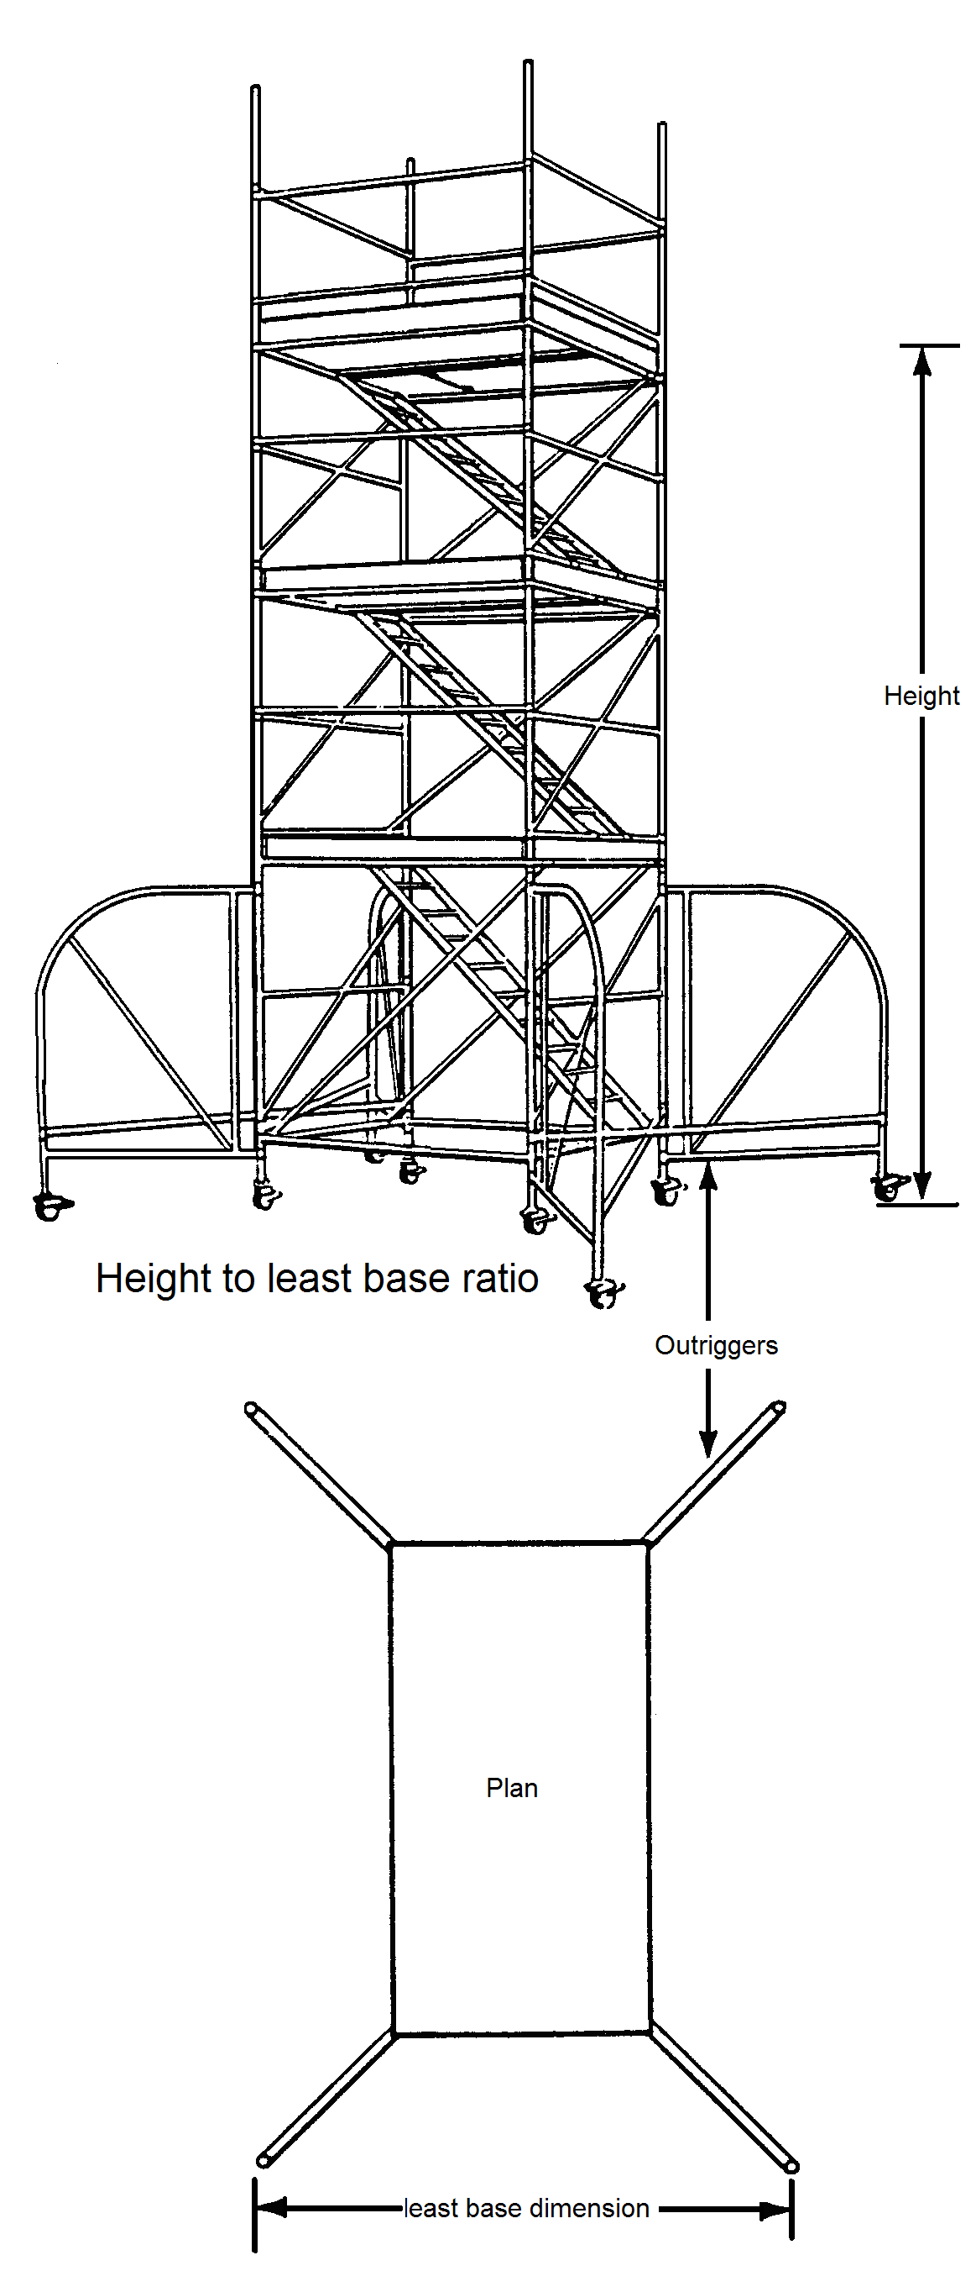

National., Industrial Safety Organisation

Construction Summary Sheet No. 5
Every year many people are injured while using ladders on construction sites. More than half the accidents occur because ladders are not securely placed and fixed, and of these many happen when the work is of 30 minutes' duration or less. Other causes of accidents include climbing ladders while carrying loads, overreaching and overbalancing. This indicates that ladders are being used when other equipment would be safer.

Use of scaffolds
There is a temptation to use a ladder for all sorts or work without considering whether other the risk involved calls for a better method. -It is much safer to work from a properly erected mobile scaffold and tower, for instance, than from a ladder. Jobs such as the removal of cast iron guttering, extensive high level painting, demolition work, or any work which cannot be comfortably reached from a ladder should usually be carried out from scaffolds instead.
Footing is not considered effective for ladders longer than 5m.

1.7 Safe Working Practices When Washing Around Electrical Outlets
Great care must be taken when working near or with electrical items as injury or death can be the result of carelessness.
- Always use 110 volt tools and equipment when working outdoors.
- Do not use tools or equipment in wet conditions.
- Leads should always be opened out fully to avoid overheating.
- Do not have loose trailing leads as they can cause people to trip. Use covers to avoid this hazard.
- Check leads for cracks or breaks. or other damage. If there is any do not attempt to repair it with tape.
- Great care must be taken when working near electrical sockets e.g. washing down or using steam strippers. If fuse cannot be removed cover them with insulating tape.
- Remove fuse if loosening sockets when paperhanging. Put note on fuse box warning people not to replace fuse.
- Do not use equipment if plugs are loose or cracked.
- Do not plug equipment into damaged sockets.

1.8 Function of Thinners, Driers, Pigments, Extenders and Binders

Composition of paint:
Binder Film Former or Vehicle whose purpose is to:
  - Convert the liquid coating to a solid to a dry film.
  - bind the particles of pigment together.
  - give elasticity to the film
  - make the coating adhere to the surface.
  - provide gloss to the coating.
  - To provide resistance to water, chemicals & abrasion
  - To hold the pigment in suspension

DRYING OILS AND RESINS.
Drying oils:
Linseed oil, Tung oil, Soya bean oil, Dehydrated castor oil, Oiticica oil.

DRYING OILS AND MEDIAS
The most important part of any paint is the binder or medium, because if it fails to dry or harden properly the paint rubs off easily or gets washed away. The binders or media used consist of drying oils both refined and cooked. Treated semi-drying oils and resins both natural and synthetic. These materials when spread thinly over a surface change from a fluid to a hard film which forms the actual protective coating.

Linseed Oil:
Comes from the seed of the flax plant. It is a very important oil. The refined oil has a pale colour. It forms a glossy film in 3-4 days. It comes from the seed of the flax plant.
Alkali refined oil: is used for varnish making and acid refined oil for paints.
Blown linseed Oil : in which air is blown through heated oil, dries in 2-4 hours and is used in-flat oil finishes.
Boiled Linseed Oil: (linseed oil boiled) in which drying agents are added during heating there are two types: - pale which dries in 24-48 hours and dark which dries in 16-30 hours. These films are glossier than those produced with refined oil.
Stand Linseed Oil: this is a heat treated oil without any driers added. It dries in B-12 hours and forms films which are paler thicker and more durable than other types. It is used for-making enamels and gloss paints.
Tung or China Wood Oil: has better water and alkali resisting properties than linseed oil. Refined Tung oil dries in two days, but heat treated varieties dry in 4-8 hours. They produce excellent medias for paints, varnishes, cement and plaster primers.
Oiticica Oil: is similar to Tung oil, dries in 1- 2 days, it is best used with synthetic resins.
Treated castor oil: dries in 5 hours and is used for varnishes, stoving paint and is used with synthetic resins.
Mineral Oil: dries in about 2 days. Being perfectly alkali resisting, is mainly used for cement and plaster primers (alkali resisting primers)
Resin oil: is used in the manufacture of emulsions
Fish oil: is used for stove enamels and floor paints.

PIGMENTS
The pigment is the powder component part of paint. A large variety of them are used in the manufacture of paint. They are derived from sources that can be called organic or inorganic
Organic. Material that has at sometime being living
Inorganic. Can be sourced from coloured earths and chemically treated metals
- To provide opacity (covering power) to the paint.
- To provide colour.
- To help the film former in protecting the surface.
- Anti corrosion properties
- Light fastness (resists fading)

Technical Characteristics
With regard to these technical considerations that have a direct bearing on the application of the paint, the painter will be the best judge of these. The painter values a paint that will spread well without leaving brush marks too much in evidence.
These considerations are made in connection with the finished paint but the working qualities of paint largely depend on the pigment. Pigments may be classified under two headings. Natural or chemically prepared (manufactured).

The most popular pigment is titanium white used with a wide variety of coloured pigments and dyes. Great advances have been made with regard to the manufacture of paint and it is not within our scope to deal with these in detail. Many of the new pigments are used today by the manufacturers in the production of proprietary paints and reach the painter in that form.

Extenders:
They help to make paint cheaper as they extend the pigment. They provide key or grip in undercoating paint for finishing paints. They prevent pigments settling on the bottom of the tin, and help to make some paints easier to apply. They improve the flow in some paints.

RESINS:
Copal, Lac, Alkyd, Epoxy, Polyurethane, Polyvinyl Acetate, Acrylic, Silicone.

NATURAL AND SYNTHETIC RESINS:
Natural: Resins are used to reinforce and strengthen the oil films and give additional gloss. They are also used in making varnishes and the varnish or medium obtained depends-upon the amounts of oil and resins. The larger the quantity of oil, the more elastic the material will be. Natural resins are either exudations from living trees and are called copals or fossil deposits.
Copals: get their names from the country of their origin e.g. Congo, Sierra Leone and Zanzibar.
Dammer: is used for oil and spirit varnishes, cellulose and ester products also for paper varnish.
Kauri: for oil varnishes.
Rosin: is the residue left from the extraction of turpentine, it is brittle. When treated with glycerine produces ester gums which are plastic, have good alkali and weather resistance.

Synthetic or Manufactured
Alkyds are the most widely used and different varieties being employed for the majority of painting materials depending on the amount of oil they contain, e.g. those containing 60-70% oil are suitable for brushing, spraying and air drying industrial finishes. Those containing 42-50% are suitable for spraying and dipping.
Epoxy resins are used where hard wearing and anti- corrosive properties are essential.
Vinyl resins are largely used for wash primers, both two pack and self etch primers. They also form the basis for making plastic emulsions.
Other synthetic resins are:- phenolic, maleic, urea, acrylic, melamine and polystyrene.
Plasteicizers are added to paint to give them elasticity.

THINNERS

Thinners Function:
Thinners are added to paint to make it more workable and easier to spread. They are not drying agents but do help in the drying process on occasions. In oil paints, the thinners should not act as a solvent to the dried film. it should be colourless so as not to affect the colour of the paint. It should mix well with paint and most important it should evaporate completely and form no part of the dried paint film.

Thinner/Solvent:
Used to make the coating thin enough to be applied and penetrate into absorbent surfaces. Evaporates completely when the paint is applied.
The most used are: Water, white spirit, turpentine, methylated spirit, naphtha, cellulose thinner, epoxy thinner, chlorinated thinner.
The foregoing three materials mixed together produces a clear material which we call varnish or lacquer. When we add another component called pigment we get paint.
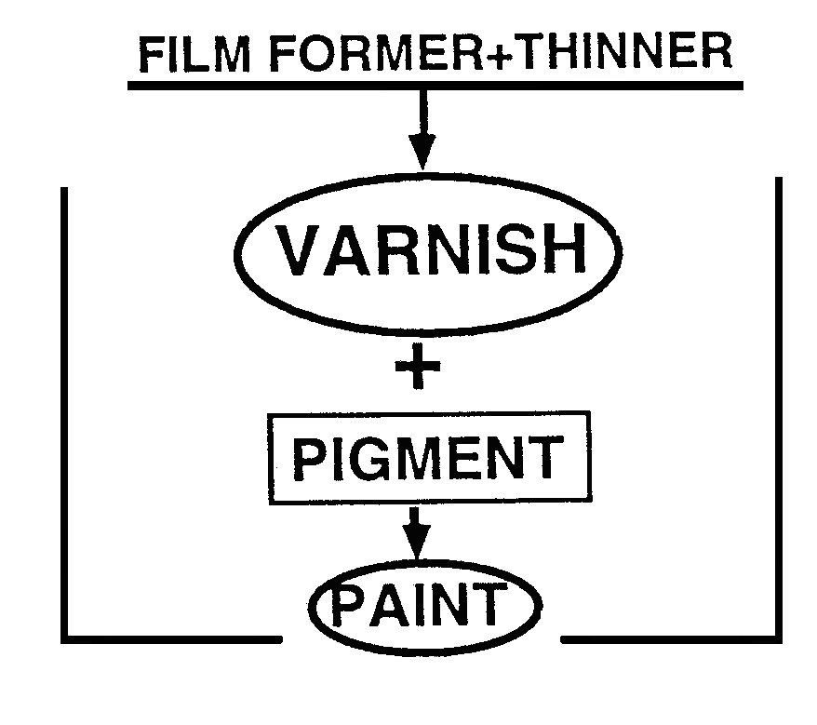

White Spirit:
A solvent produced by the distillation of crude petroleum (petrol) which has now replaced the use of turpentine as a paint solvent in the trade. It is cheaper and just as effective.
Cheap grades of white spirit should be avoided as it could affect the hardening of paint film. White spirit is sometimes known as turps-substitute.

Turpentine:
A valuable solvent obtained by distilling the resin of the pine tree. The main source of supply being America, France, India, Portugal, Spain and-Russia. When the trees fail to yield any further resin they are eventually felled and by steam distillation of the pinewood stumps, a stronger solvent with a sharp smell is obtained and this is known as wood turpentine. Turpentine is avery paint solvent, it is clear, colourless and evaporates completely and very important, it does not disturb previously applied coatings (dried films).

Methylated spirit:
An industrial alcohol with a methyl violet dye added to make it poisonous and so free from excise duty. It is the thinner for spirit varnishes e.g. French polish, button polish, knotting varnish. Evaporates very quickly.

1.9 Properties of Paint and Reasons for Painting, Paint Defects

What are the properties of good quality paint?

Ease of application:
Paint can be applied by brush, roller or spray, and in each case must be of a consistency that will allow the painter to apply it efficiently and easily. The painter must be able to adjust the paint to meet requirements of temperature, substrate and other variable conditions.

Drying.
The paint must dry in a reasonable time. A gloss paint which is to be applied by brush must not dry too fast as the painter must be able to keep wet edges alive so that a continuous film can be applied without edges showing. It must also dry quickly enough so that it will be dry next day in order it can be recoated, or if the job is complete, that the building can be used.

Adhesion:
The paint must grip the surface. Defects such as substrates which are flaking e.g. rusted metal or powdery plaster will lead to breakdown of the paint as they do not provide a surface to which the paint can adhere. Good preparation of the substrate is a key element in this. Even with well prepared substrates, pronounced differences in paint performance can still occur. Some paints adhere better than others because of a chemical action between paint and substrate.

Film strength
The paint must have a built in flexibility to cope with expansion and contraction due to temperature change. At the same time, it must be sufficiently hard to provide protection. If the paint does not have a satisfactory combination of these qualities, flaking, cracking and a general breakdown of the paint film will occur.

Durability
The paint must remain stable over a long period. . Weathering, e.g. sunlight, rain, frost, airborne chemicals etc. can cause paint breakdown by disrupting the balance of the properties already mentioned. For instance, sunlight can dramatically affect the pigments in the paint, thereby reducing the life of the film. This can particularly occur with cheaper pigment, and can be seen by a noticeable fading of the paint colour. If on the other hand, weathering causes a reduction in the film former (binder), the substrate can take on a characteristic chalky appearance.
The reasons for painting are: Preservation, Sanitation Decoration and Identification.

1. Preservation
Painting protects and preserves and the chief building materials requiring preservation are timber and iron. All softwoods and many hardwoods need adequate protection or they will soon rot or disintegrate. Iron and steel rust if exposed to outside atmosphere. They need thorough preparation and must be given protection with properly formulated paints.

2. Decoration
For years, painting was associated with preservation and not enough importance was given to the decorative possibilities. The painter must understand the nature of the surface to which materials are being applied and it is essential that he/she has a good knowledge of these products.

Few people are gifted with a good sense of colour. Training and experience are required to advise clients. The personal wishes of the client should always be considered and the painter may have to execute work which he/she consider to be bad taste. It is here that a sound knowledge of colour and a few well-drawn sketches can be very convincing to everyone's satisfaction.

3. Sanitation
Safe-guarding the health of the public is an important function of the government and the painter plays his/her part in this field. All internal plaster surfaces, patent building boards and woodwork require cleaning. If painted, these surfaces are easier to keep clean. Special paints are formulated for the painting of dairies, bakeries and breweries etc. as they require regular washing.

4. Identification
Painting in industrial/general surroundings require objects to be painted for identification reasons. Examples BS. 1710 specifies colours for industrial pipelines and services. Safety signs are painted to make people aware of hazards. Large moving machinery is generally brightly coloured to make them visible in building sites etc.

Paint Defects
The following are some common paint defects
Bleeding. The discolouring of a paint finish by materials that should have been removed or sealed back before painting
Blistering. Blistering is caused by moisture in the wood, and an increase in temperature turns this moisture into a vapour and in trying to escape is trapped by the paint coating and forms blisters on the surface. It can also be caused by paint having been applied before the previous coat was dry, stopping the thinner from evaporating. Scrape of any blisters or flaking paint allow the substrate to dry out thoroughly before painting.
Cracking. Breaks in the paint film wide enough to expose the underlying surface. this can occur if a hard drying paint is applied over a softer type elastic coating.
Cissing. When a paint or varnish coating fails to form a continuous film on the surface it has been applied to. The paint gathers in some places and recedes in others. Depending on the surface being coated.
Is the surface greasy. Wash thoroughly
Is the surface shiny Abrade (wet preferably) to provide key
Flaking. Small pieces of paint surface coming off. Cracking or blistering usually occurs before flaking. Due to poor preparation of surface prior to painting.
Flashing The appearance of an uneven sheen on a flat or eggshell finishes. It is caused by edges setting before overlapping of joints, mainly on ceilings or large areas.
Sags. Runs or sags in paint film that flows too much during application. Sags are usually caused by applying too heavy a coat of paint or thinning the paint too much.
Wrinkling. Ridges that develop in a paint film when the paint dries. Too much paint applied, the top coating dries while underneath does not

1.10 Characteristics and Function of Undercoat and Eggshell

Undercoating: (oil based)
The coating applied to a surface after priming & filling or, in the case of previously painted work, after the preparation. Oil based undercoating is a highly pigmented (titanium white plus extenders) with low film former content. It has very good opacity because of its high pigment content.

Function:
- To provide build or film.
- To provide the most suitable ground for the reception of finishing coats.
- Introduces colour to the paint system. Colour selected to suit finishing colour.
Generally adjusted by the painter by the addition of thinners and oils to suit the work in hand. Should not be applied thickly as this is where brush marks are in many cases created and are then highlighted by the gloss finish.
Has excellent adhesion. Non reversible coating, touch dry 2-4 hrs. Recoat 6-16 hours. (depending on temp. & drying conditions). Suitable for internal & external use.
Application by brush roller or spray.

Eggshell or semi – gloss finish: (oil based).
Requires no undercoat. Self undercoating. An interior decorative non toxic finish which dries to a washable sheen. Good finish and where regular cleaning is required. Ideal finish for kitchens, bathrooms and radiators as it is domestic steam and heat resistant. suitable for interior woodwork and metalwork where a high gloss would be unsuitable. A similar paint to satinwood. Comes in a wide variety of colours.
Drying method -oxidation. Touch dry in 4-6 hrs. Recoat in 16-24hrs.
Apply by brush roller or spray. woodwork & interior metal fittings. Thinned with white spirit or turpentine.

1.11 Use and Care of Paint Brushes and application and Flashing
Available in ½”, 1”, 1½” 22”, 2½ “ 3” 4” sizes or 12mm, 25mm., 37mm, 50mm, 62mm, 75mm, 100mm.
(flat type as shown in illustration) and a variety of sizes in round type.
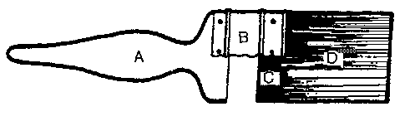

Component parts

A - The handle
Generally a hardwood such as beech or elm . Shaped to allow for easy grip. Coated to make it easy to clean . Can also be made of plastic.

B - The stock
Light polished metal. The method by which the filling is fixed to the handle. The stock is fitted to the handle by one of the following methods:
- Riveted to the handle (Large paint brushes).
- Pressed on to the handle(Round brushes and Pencil brushes)

C - The setting
Epoxy resin. The adhesive that binds the filling together.

D - The filling
There are four types of filling:
- Bristle
- Synthetic fibres
- Natural fibres
- Mixtures of bristle and fibres.
The length out and thickness of filling depends on quality of brush.

Bristle
The hair of the Chinese or Indian wild hog, pig, or boar.
Features:
- Has great resilience and strength. Long lasting and holds the weight of paint well.
- Is tapered from root to tip. Thicker at the ferrule end.
- Has flag or split end This provides a the brush with a soft or fine tip which helps laying off.
- Has serrated edges like saw teeth which help to hold paint.
- Curls inwards and allows the bristle to lie together.

1.12 Types of paint brush:

Bristle brushes
The traditional brush. Good quality flat bristle brush. Has good length out and thickness of filling. Ideal for applying most types of paint. and varnish.They are not suitable for use with water based paints as bristle absorbs too much water which can distort them. They wear well if used carefully and when worn sufficiently are ideal for cutting in and applying finishing paints and varnishes. Always give new brushes a good rinsing out in warm soap and water to remove any loose hairs and also moth repellent that is used by the manufacturer to protect the bristle from moths during storage. New brushes should be used with primers and undercoats on rough surfaces to break them in. They will help to wear them down evenly to a nice taper and makes them suitable for the application and even spreading of gloss paints and fine laying off.

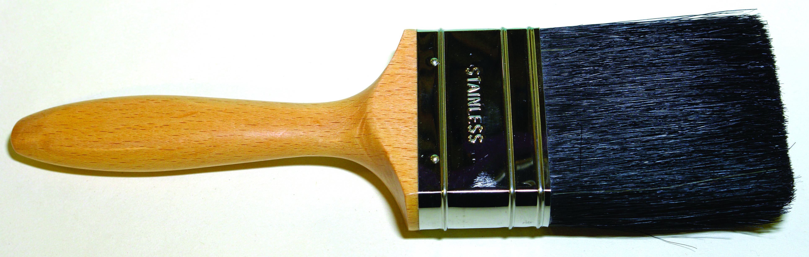

Good quality bristle brush
Poor quality bristle brush. Poor length out and poor thickness of filling. Does not hold or apply paint well. Handy for rough jobs, applying paint removers etc.
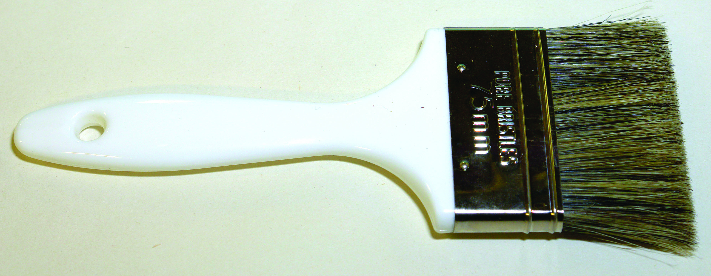
Poor quality bristle brush
Round bristle brush Ideal for painting fine work.
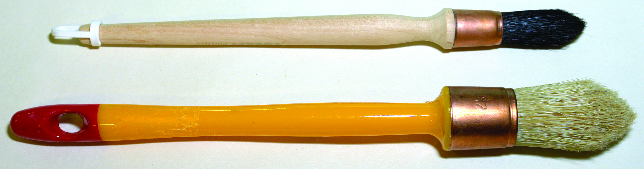
Round bristle brush

Synthetic brush
Orel, Nylon, Tynex & Perlon. These have become popular over the last couple of years. Some types are very expensive. They don’t shed hair. They are excellent for application and finishing. Very good for the application of water based paints and varnishes as they absorb very little water. Some of the good quality brushes have a flag similar to the bristle which helps fine laying off. A wide variety of types available from long to short handled, and some angled for cutting in.
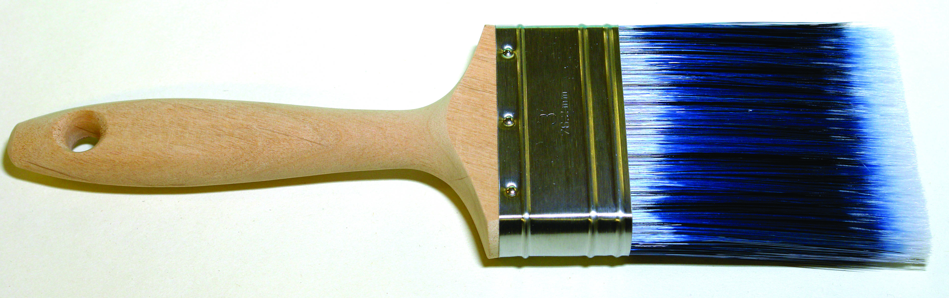

Natural Fibres
Made up of grasses from South America and Mexico. Used as mixtures with horsehair in coarse brushes.

Block brush
A cheap brush. Made from coarse white fibres and set into a timber handle. Used to paint rough surfaces (dashed walls rough brickwork etc) that would ruin a quality paint brush.
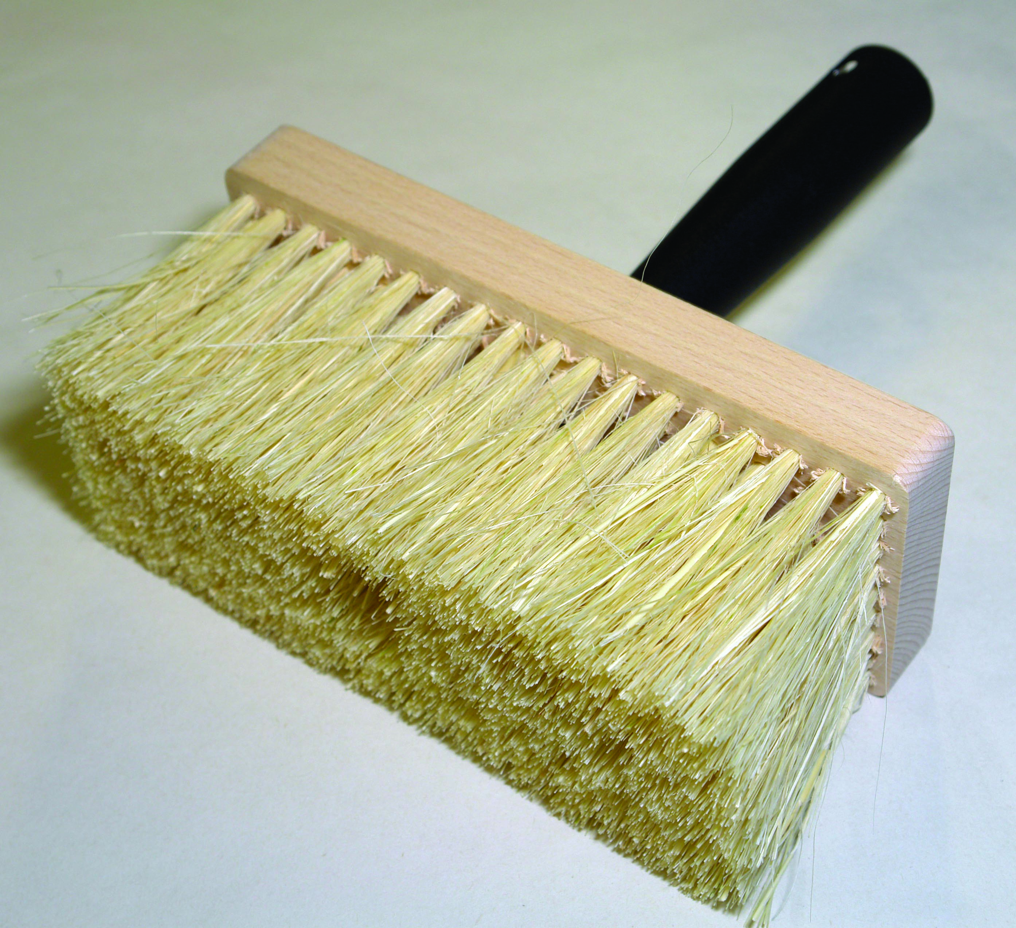
Block brush

Crevice brush
An angled brush designed to reach awkward areas. Comes in a variety of sizes.
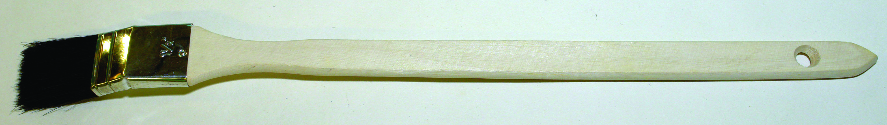
Crevice brush

Dusting brush
Good quality made from pure bristle cheaper type from nylon.

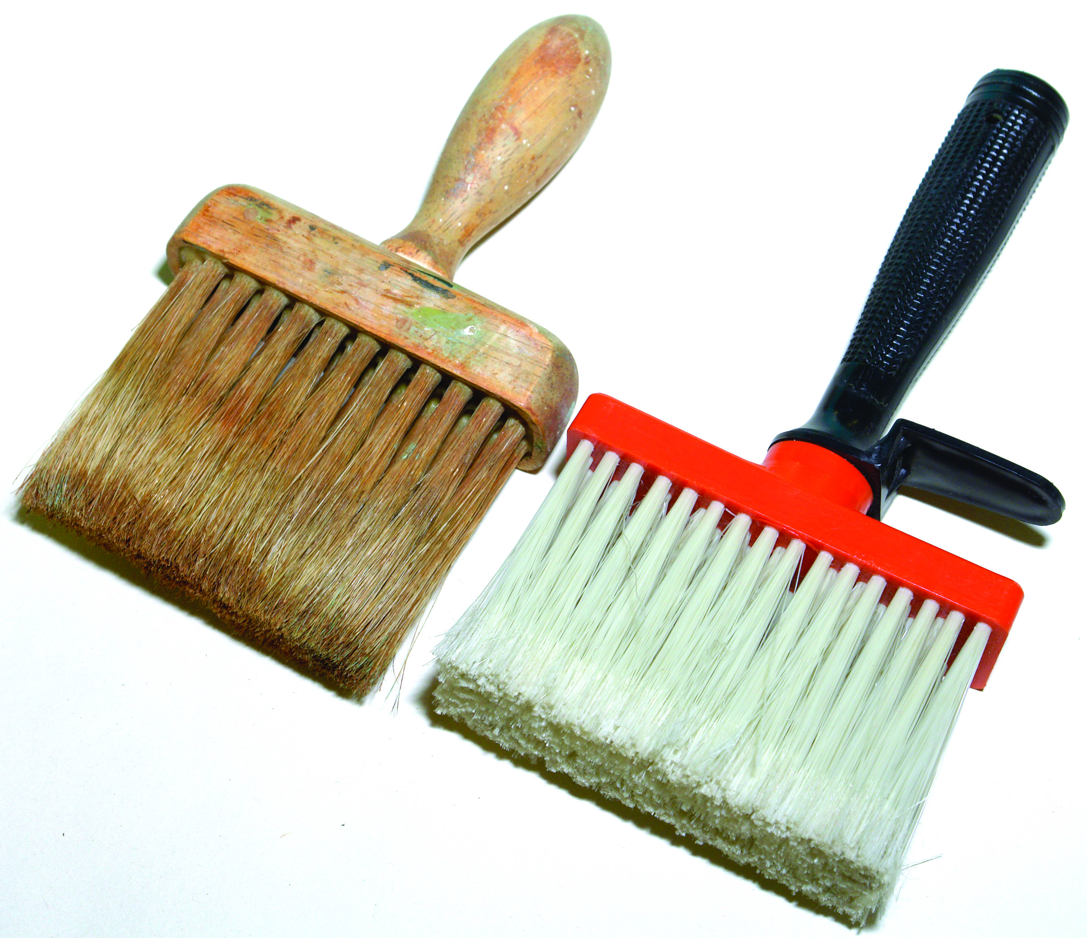
Dusting brush

Brush spinner
A tool designed to spin brushes after rinsing in white spirit or water.

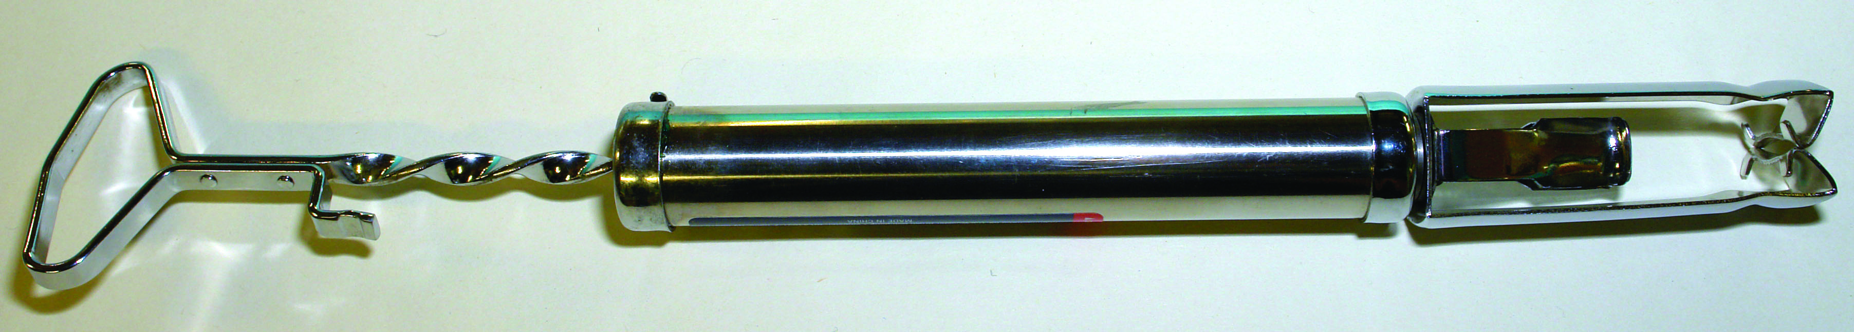
Brush spinner

Cleaning and maintaining brushes.
The paint brush is the most important tool in the professional painters tool kit and proper use care and cleaning are very important. Brushes used in oil paint can be kept suspended in a water pot for a short period of time. The excess paint should be knocked out on a flat board before placing them in the water pot. It is better practice to rinse them out in white spirit so that paint does not accumulate around the stock.
Bristle brushes should be washed out in the thinners of the paint being used and the same applies to synthetic filaments. If the synthetic brush has been used in acrylic paint or any water paint wash out in warm water or warm soapy water. A brush comb is a useful tool to use regularly to help clean through the centre of the brush. It also helps with straightening the filling. After washing thoroughly again spin dry by hand or with spinner. Never tap or strike the brush on a hard surface to remove old paint etc. as this action can loosen the setting in the ferrule. Comb through again to help reshape brush, and hang up to dry. Do not store brush standing on its tip as it will distort the shape of the brush.

Brush keeper
They can also be placed in a brush keeper which is designed to hang up the brush on hooks. The large keeper holds a number of brushes but small keepers can accommodate two brushes. A portable metal container fitted with hooks that brushes can be suspended from. They also have as a fixture a bottle and wick. The bottle is filled with a fluid which is transferred on to the wick and the strong fumes of the liquid are circulated in the container.
The fume laden atmosphere keeps the brushes soft without the need to be immersed in water. The keeper must be kept covered at all times for it to be effective. This is a very handy piece of equipment when transporting brushes

1.13 Adhesion, Reasons for Abrading, Types and Uses of Abrasives.
Adhesion The degree of attachment between a coating film and the underlying paint or other material.

How paint adheres to a surface.
When paint is applied to bare wood or raw plaster some of the paint will penetrate the surface because it is porous. This helps the paint adhere when drying is complete. With a non absorbent surface such as glass, this type of adhesion is not possible and the paint must rely on the stickiness of the binder to grip as abrading the surface is not an option. This is called specific adhesion. Gloss paints and varnish have a high ratio of binder in their composition and on surfaces that cannot be abraded they are better for adhering than undercoats that have a lower binder ratio. More binder will be in contact with the surface. The solvents in some paints such as chlorinated rubber, cellulose, spirit based paints and varnishes are strong enough to soften the existing coating during or shortly after application giving a good bond. These paints are referred to as reversible. Good sanding of surfaces between coatings also helps to give grip or key. This is known as mechanical adhesion. There are acrylic based paints that contain strong adhesion promoters and are ideal for the painting of plastics, tiles or shiny surfaces. Lack of adhesion can be caused by dirt, grease and moisture as these form a barrier between the paint and the surface, so before painting attention must be given to cleaning in order to eliminate any of these problems that could cause the paint system to fail.

Abrasives
Abrasives are specially prepared materials used for rubbing down of wood, plaster ,metal and painted surfaces, They are used to smooth out fillers of all kinds that have been applied to fill cracks and surface imperfections prior to applying paint. They are generally termed "Glasspaper" or "Sandpaper”
They also provide "key" (grip) and assist adhesion by abrading the surface and to remove nibs and other imperfections on a painted surface prior to applying other coats of paint. Worn abrasives are very important when rubbing down in between coats of paint as the need for a cutting edge is not required. This will remove nibs and provide a light key for the succeeding coats of paint.
Proper PPE equipment should always be worn when sanding as dust can be injurious to ones health and on old surfaces it may contain lead.
All Abrasives papers should be stored in a dry area as damp conditions can cause softening of the water soluble adhesive and in turn the deterioration of its abrasive qualities. Abrasives are supplied in sheets rolls pads and discs. Sheets and belts are available to suit vibrating and rotary sanders. The name and grade of the abrasive is printed on the back of the sheet
Dry rubbing papers are generally termed "Glasspaper" or "Sandpaper" The following are the main ones used in the painting and decorating trade.,

Emery Cloth
Fine Emery fixed to a strong paper or cloth with a water soluble adhesive. It comes in three grades: Fine, Medium and coarse.
It can be used dry or with white spirit to rub down small metal surfaces to remove rust where wire brushing would be unsuitable prior to painting. It is long lasting but however it is very expensive.

Glasspaper
Powered glass, flint, and quartzite mineral are fixed to a stiff backing paper with a water soluble adhesive. It comes in a variety of grades coarse, medium and fine.
Also available in 1, 0, and 00 which are very fine grades. It is used for dry rubbing down by hand or mechanical sanding of wood, plaster and filling compounds prior to painting. It can also be used for denibbing between coats of paint.
The drawbacks of glasspaper are that:
    - It is inclined to scratch the surface.
    - It clogs up.
    - It has a short life.

Garnet paper
Powered garnet fixed to stiff paper with a water soluble adhesive. A variety of grades are available from 40 to 240.
It is used for dry rubbing down of wood prior to painting and also for denibbing and flatting down between the coats of paint or varnish.

Aluminium Oxide Paper
Fine Aluminium Oxide fixed to a fine paper with a water soluble adhesive. It has a variety of grades 150, 180, 220, and 240. It is very popular with painters as it has a long life and excellent abrading properties.
Another fast-cutting paper is stearate paper. This is a carbide or aluminium oxide paper that has been coated with a light gray or white compound. This coating keeps it from getting clogged with dust, making it effective on soft wood, which can gum other papers.

Stearate paper
This is a carbide or aluminium oxide paper that has been coated with a light gray or white compound. This coating keeps it from getting clogged with dust, making it effective on soft wood, which can clog other papers

Silicone Carbide Paper
(Self Lubricating) Fine silicone carbide fixed to a fine paper with a water soluble adhesive. The paper is pre-treated with a lubricant which acts as a self lubricating agent when abrading. The grades available include 220, 240, 320, 400 and 500.lt is used to dry rub down filling compounds and paint finishes prior to painting and for denibbing between coats of paint.

Silicone Carbide Paper
(Wet or Dry) Fine Silicon fixed to light waterproofed paper with a waterproof adhesive. It comes in the grades 120, 180 ,240, 320, 400 and 600.The low numbers refer to the coarse grades the high numbers to the fine grades It is used for wet rubbing down of painted surfaces.
It is a very popular as it has excellent abrading properties and does not scratch the surface. .It is used with water for abrading all painted surfaces. Its benefits Include:
- lt is long lasting and does not clog up.
- It can be rinsed out and re-used.
- There is no dust created when rubbing down.
It has replaced pumice stone, soda block, and pumice powder. It can also be used with white spirit as a lubricant.

Steel Wool
Fine Steel wool in tangled strands. One should always wear protective gloves when using. Their are three grades available: Fine, Medium, and Coarse used for:
- Dry Abrading of fine wood finishes.
- Scourging timber after cleaning off with paint remover.
- Degreasing and etching of metal surfaces.

Shot or Grit
Their exists a wide variety of sizes and shapes of shot or grit. An abrasive fired from shot/grit blasting equipment at very high pressure and cleans metal stone etc to a very high standard before painting.
Abrasive sanding pads can also be obtained attached to differing thickness of sponge and are very handy when rubbing down generally and especially mouldings, balusters etc.
Note:
Grades of Abrasives
ABRASIVE | FINE | MEDIUM | COARSE
Silicone Carbide | 600 - 400 | 280 - 240 - 180 | 150 - 120 - 100
Aluminium Oxide | 180 - 150 | 120 - 100 - 50
Glasspaper | 00 - 0 - 1 | 11/2 - F2 - M2 | S2 - 2 1/2 - 3

1.14 Preparation of Various Surfaces for Recoating

Preparation of Previously Painted Surface

Moulded panel in good condition
A painted surface in reasonably good condition needs little preparation. If the surface has been finished with an oil based gloss or eggshell paint it can be washed rubbed down dry with medium glasspaper or if a fine finish is required with a medium grade wet and dry silicone carbide paper. Any surface imperfections must be filled with an appropriate filler and left to dry. Any gaps in the mouldings must be raked out and filled
Sand down filler evenly and touch up with a lightly thinned undercoating, feathering of the edges to avoid creating a ridge of paint around the filler. Leave to dry overnight and rub down lightly with a piece of worn glasspaper and coat surface again with a properly adjusted undercoat. This undercoat should have some gloss paint added to it or a patent additive that helps the paint flow and avoid brush marks. It is important to realise that most brush marks are created at the undercoating stage and are emphasised by the finishing paints.
Selecting the correct size brushes is important so that too much or too little paint will be applied. Apply paint to small areas such as mouldings with a 1” fitch to avoid overloading a small area resulting in runs
Good finishing is achieved when the correct film thickness is applied, the paint brushed on evenly crossed and laid off with care.
Applying too much paint will result in runs, brush marks and when dry wrinkling will occur.
Applying too little paint will result in misses, dry spots, flashing and lack of gloss or satin of the finish.
Keeping the wet edge ”alive” (workable) is a key element to good finishing so where paint overlaps should not be obvious. There can be little time for application at times due to the temperature of room or substrate being high which makes the solvents in the paint evaporate quickly and the paint setting up. Patent additives can be added to the finishing paint to overcome this problem.
It makes the paint more workable, easier to spread keeps the wet edge alive longer resulting in a good finish. Paint cannot be brushed once it has set up.
By observing these basic rules a very good finish will be achieved

2.0 Mix and apply filler to damaged surface correctly

2.1 Functions & Characteristics of Fillers and Stoppers

Introduction
There is a very wide range of fillers on the market and the painter should become familiar with them by visiting decorator’s suppliers and manufacturer’s websites. They range in variety from powder to ready made types and it is important to understand why there is such a wide range On one end of the scale there are fillers that are designed to fill deep cracks, can be drilled or have bolts inserted when dry, while at the other end there are ready made fillers that are very fine and made for the filling of minor imperfections.
It is important to read their labels as they may be suitable for indoor use only.
Health and safety data sheets should be read before using. Always wear CE certified mask when sanding filler.

Filling knives
Designed to apply filler to the open grain of timber, cracks in plaster, and surface indentations. They look like paint scrapers but they have a flexible blade. The edge of the blade must be true so that the filler will be applied without marking. A variety of sizes available. When not in use protect the edge by covering.

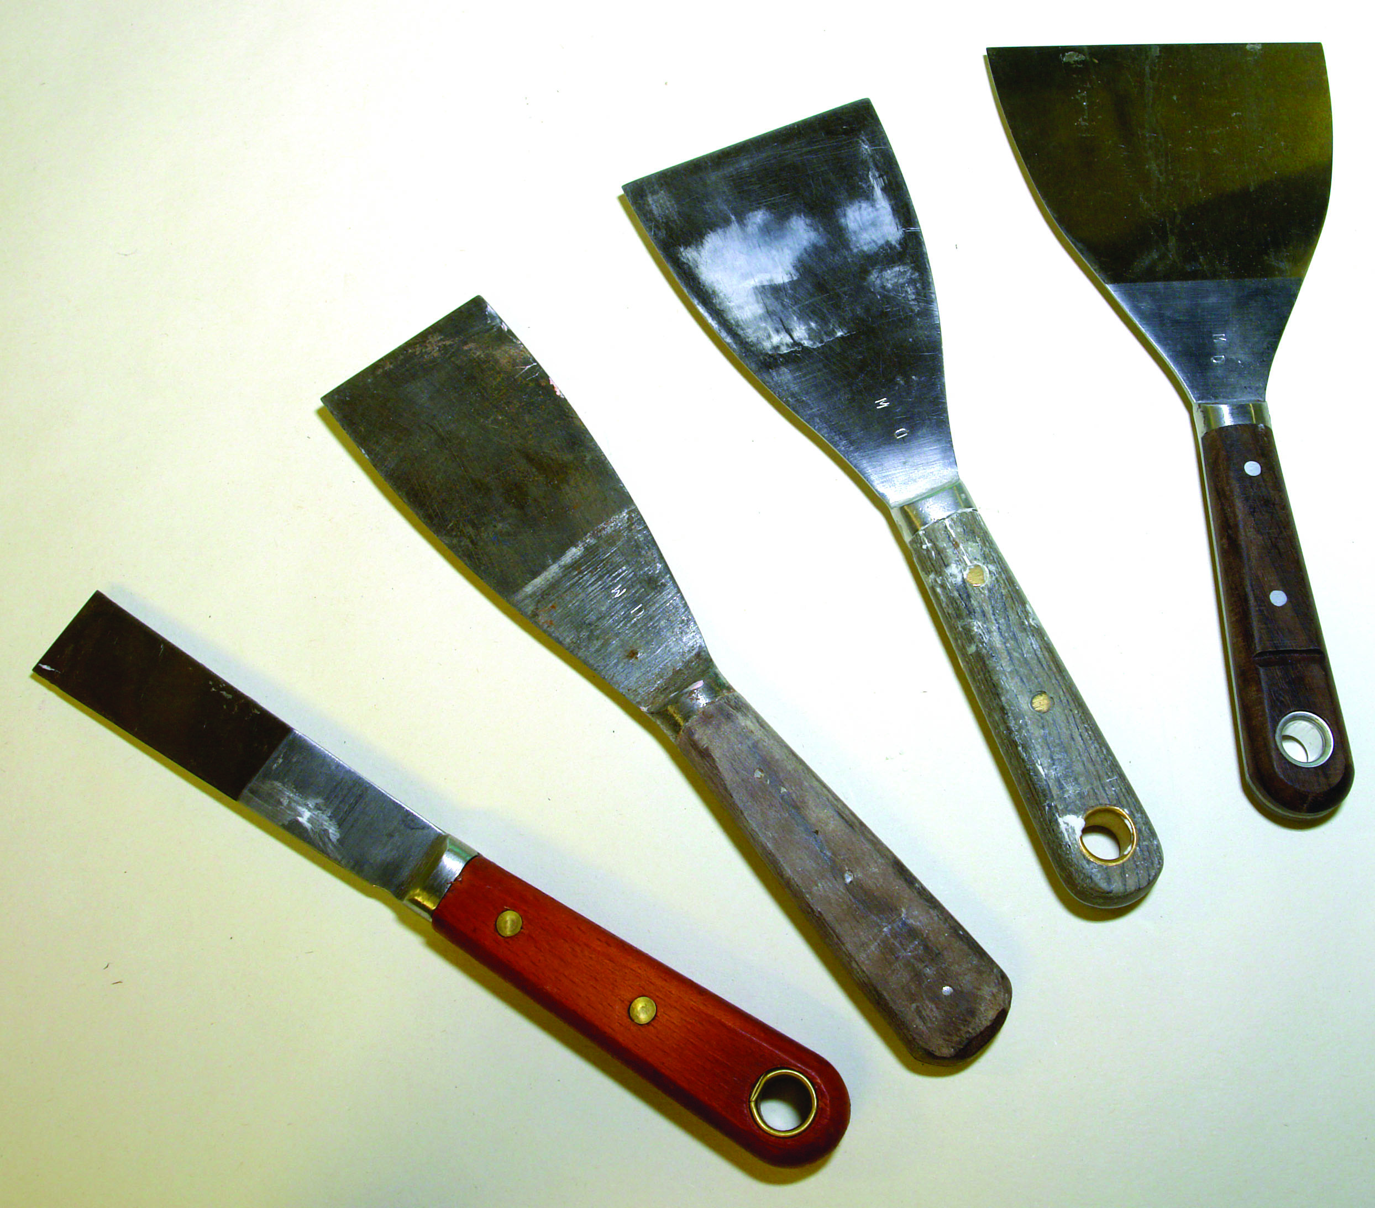
Filling knives

Putty knife
Designed to apply putty or hard stopping into nail holes and cracks and to apply fronting putty to when glazing
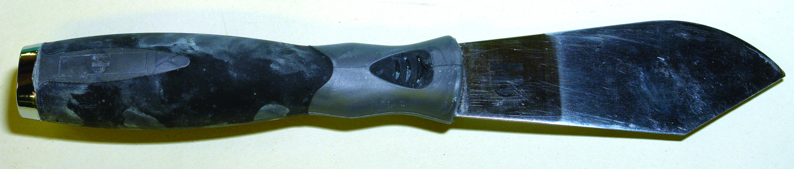
Putty knife
The following are a sample of types of filler available

General plaster based filler
This is the most common type of filler used by the painter. It comes in a variety of pack sizes. Mixed with water to a creamy consistency but at times mixed with a coloured emulsion, especially if the finished colour is a very strong one. It can also be mixed with PVA adhesive to increase adhesion if necessary. Used for filling wood grain and plaster surfaces. Suitable as a general purpose filler. Very absorbent - Good adhesion.

Exterior plaster based filler
A similar type of filler with a cement base mixed with water is designed for external application with very good water resistance.
An all purpose filler is also available for internal and external use. Good water resistance and can be applied to most materials. Many of these fillers shrink on drying and need a light second filling to level off.
Surfaces should be primed and sanded /denibbed before filling. This is important for even application of the filler.

Patching Plaster
Packs of gypsum plaster supplied in small quantities and used where large internal repairs are to be made and the use of regular fillers would be too expensive.

Ready mixed fillers:
A wide range available in pre-packed tubs for direct use as surface fillers. It is important their labels as they may be suitable for indoor use only.

Fine Surface Filler
To fill fine cracks, minor surface defects on plaster and wood grain. It produces a very smooth surface for high class painting.
Unsuitable for deep cracks as it will not dry thoroughly if applied thickly. For indoor use only.

Lightweight Filler:
To fill wood, brick, stone and concrete. Indoor or outdoor use. Fills deep holes without sagging.

Hairline crack filler:
When hairline cracks appear on a surface and raking out could spoil the wall finish hairline crack filler can be brushed into the cracks and sanded smooth when dry. Dries in 10 to15 mins.

Wood Repair filler.
Used to repair wood that has a rotten portion. It is important to follow the manufactures instructions as one type differs from another. The rotten section is chiselled away and the filler applied to fill the gap. It is generally a two pack material mixed as instructed

Flexible Filler ( painters mate)
Comes in a tube with a nozzle fitted for application to gaps around architraves tops of skirtings etc. Must be used from a skeleton/caulking gun. Hand held versions are also available. Sponge off excess evenly with damp sponge as it cannot be sanded when dry.

Skeleton / Caulking gun / Mastic gun
A tool for expelling caulk from a tube. It enables a "bead" of material to be applied to cracks and seams.
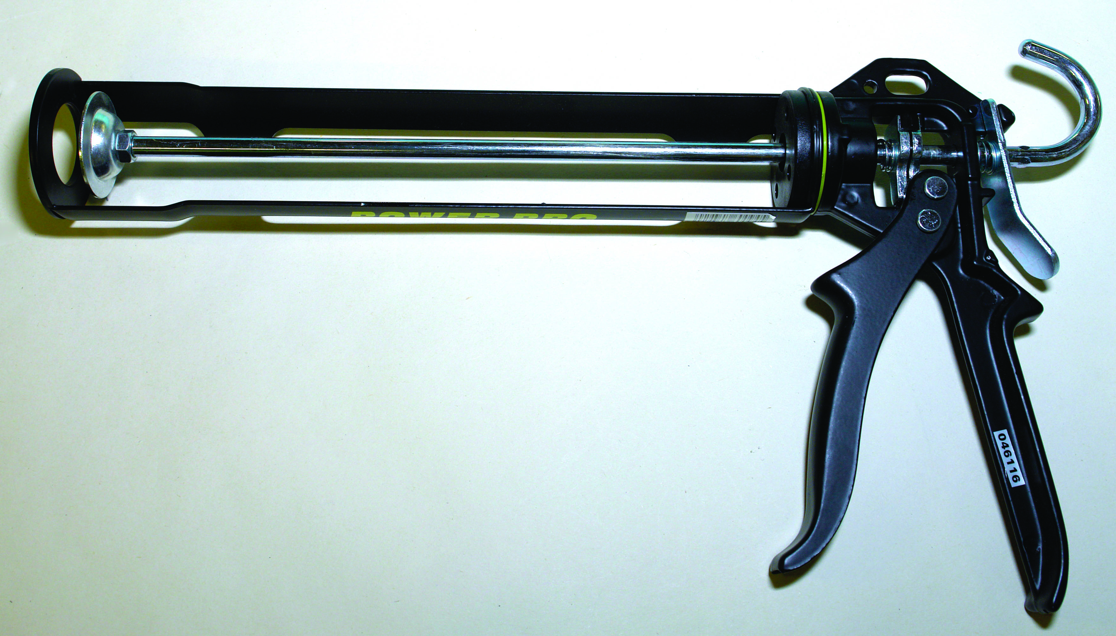
Skeleton / Caulking gun / Mastic gun

Oil Based Filler
Ready mixed for internal and external surfaces and rubbed in with a course of cloth available in natural and also a range of wood colours. Used as a grain filler for surfaces which have to be varnished.

Stoppers
Ready made stoppers made in a range of wood colours for use on internal and external surfaces which are being painted or varnished.

Coloured wood filler (Tube type)
Comes in a tube and applied using a skeleton/caulking gun Similar to painters mate but has a range of wood colours. Ideal for tops of hardwood skirtings, architraves etc prior to staining or varnishing.

Wax filling sticks.
Ideal for filling small areas e.g. nail holes and small cracks in hardwood. A wide range of colours available. It does not shrink. A small piece can be shaved off with a knife and kneaded between the fingers until soft .apply to the area with a putty knife and level off .Buff off area with a cloth.

Metal filler
A quick drying two pack epoxy filler. Ideal for filling small areas. of metal surfaces.

Linseed Oil Putty:
Ready made and used on internal and external surfaces made from linseed oil and whiting. Comes in white and brown. Used to bed and front glass. Used as a stopper over nail heads and cracks in wood. Becomes very brittle with age. Never use on surfaces that will come in contact with wallpapers or emulsions as staining will occur. e.g. top of skirtings.

3.0 Calculate the Amount of Paint Required to Coat a Given Surface
Key learning points
- Calculating the amount of paint required to coat a given area.
- Self awareness, relationships in the workplace

3.1 Calculate the Amount of Paint Required to Coat a Given Room
To calculate the area of a square or a rectangle multiply length x width
Sample 1.
Length = 4m. Width =2m. = 4m x 2m = 8m.²

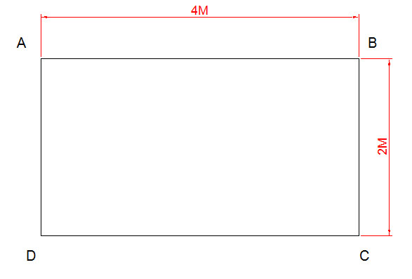
Sample 1
Sample 2
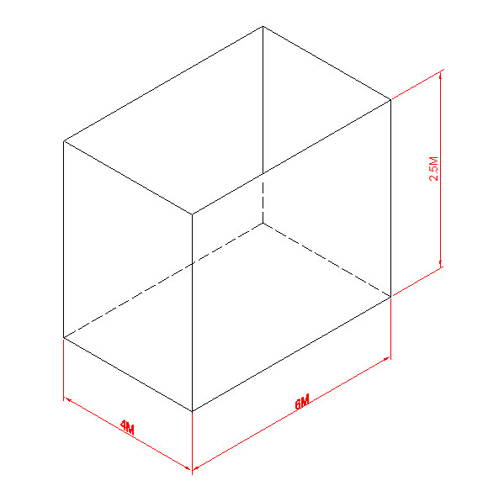
The four walls are to be painted.
2 Walls measure 4m x 2m = (4m x 2m ) x 2.5 = 20.²
2 Walls measure 6m x 2m = (6m x 2m ) x 2.5 = 30m.²
Total wall area = 20m² + 30m.² = 50m.²
Another way of calculating the area of a room is to measure the girth (the measurement around the room) and multiply the result by the height.
Girth = (4+6+4+6) x 2.5
= (20) X 2.5 = 50m²

Area of floor or ceiling are calculated in the same way.
The area dimensions are 6m x 4m = 24m.²
Calculating the amount of paint in litres for the walls in sample 2
The walls require two coats.
Given the spreading rate of the paint as 75m.² per 5 litres.
Spreading rate per litre = 75m² ÷ 5 = 15m² .per litre
The amount of paint required to paint the walls
= Area of walls 50m² ÷ 15 = 3.33 litres
Two coats = 3.33 x 2 = 6.66 litres
To the nearest litre = 7litres

Ans. 7litres
Sample 3
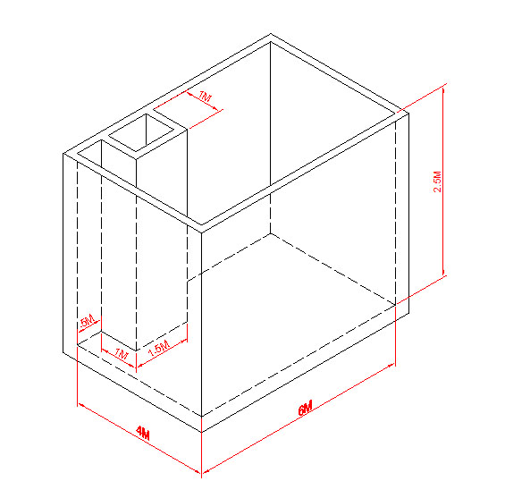
Measuring the girth of sample 3
Girth = 4M + 0.5M + 1m + 1.5m + 1m + 4m + 4m + 6m + = 22m
Area of walls = 22m x 2.5 = 55

3.2 Self Awareness, Relationships in the Workplace
Relationships between people are very important especially when a group of people have to work together for a long time. Within the group everyone is an individual, some are quiet and withdrawn while others are more outgoing and confident in themselves. Some may be from a rural background and away from home for the first time, staying in digs and finding the whole situation daunting. In addition, there may be an unequal gender divide, which can be an issue, particularly for those in the minority.
Getting to know each other is part of working in a group and a simple way of doing this is for each person to say who they are, where they work, and the type of work they have been engaged in before coming on the course. This helps to break the ice and they should be encouraged to ask one another questions to get them to share their interests.
Practical tasks should be arranged so that small groups could work together to develop a team spirit which again helps towards better bonding. Without this type of mixing bullying may take place isolating individuals and making learning difficult.
Bullying must never be tolerated and a victim should know that they can report the matter in confidence so that corrective action can be taken. Bullying in the workplace is a big issue under health and safety and there are procedures in place to take those responsible to task.
It is not only your expertise as a tradesperson that is important. Good manners are also an essential part of development as interaction with others e.g. employers, clients, suppliers etc. is an integral part of the daily activity of the tradesperson while working in private houses, offices hospitals etc. and for example, depending on the way a customer is treated can enhance your standing as a trustworthy person and somebody who can be dealt with on a dependable basis. It also augers well for future contracts.

Summary
The painting of previously painted surfaces is a very important skill as so many different situations can arise. It is crucial that the painter has the ability to recognise the problem or defect and knows the proper materials and procedure to address the issue. Creating a clean area and straining the paint are good habits to develop if high class finishes are to be achieved. The use of cheap equipment and materials will only add to the problem and are to be avoided.
Wearing PPE equipment, developing safe practices on ladders and scaffolds are essential for safe working. The reading of product data sheets and health and safety data sheets prior to using new materials are important habits to develop and keeping these in a folder for future reference.

Training Resources
Tool kit, bucket, sponge, range of abrasive papers, undercoat panel, eggshell paint, fillers and stoppers, paint brush, trestles, paint kettles, classroom and workshop facilities, notes/information, sheets and transparencies

Suggested Exercise
- Prepare and finish panel in eggshell
- Select a pre painted moulded panel 1m.0.5m approx.
- Rub down, fill all surface defects and bring forward to an eggshell finish.
- Pick out the moulding in suitable colour eggshell to match panel.

Self test
- There are differences between a step ladder and a trestle. What are they?
- Bristle has special characteristics Name three
- Why do we paint.
- A brush has four component parts. What are they?
- What is an abrasive?
- Wet and dry paper is graded by what means.
- The ceiling and walls of a room measuring 5m long x 3.5m wide x 2.5m high are to be given two coats of emulsion. The spreading rate of the paint is 60m² per 5litres.Calculate to the nearest litre the amount of paint required.

Further Reading
Painting and Decorating An Information Manual 5th Edition
Author A. Fulcher, B. Rhodes, W. Stewart D. Tickle J. Windsor
BS2015 1992 Glossary of paint terms.
http://ec.europa.eu/environment/air/paints_directive.htm


27-33 Upper Baggot Street
Dublin 4

