TRADE OF PAINTING & DECORATING

PHASE 2

Module 3
Imitative and Decorative Arts

UNIT: 3

Broken Colour

Table of Contents
Introduction 1
Learning Outcomes 1
1.0 Select and apply ground coats 2
1.1 Care and disposal of oil impregnated rags 2
1.2 Spontaneous combustion 2
1.3 Selection of ground coats 3
1.4 Selecting colour combinations 4
1.5 Mixing and application of glaze (water and oil based) 5
1.6 Advantages of stippling glaze 7
2.0 Produce broken coloured effect 8
2.1 Tools for creating broken colour effects 8
2.2 Materials for decorative effects 11
3.0 Broken Colour Effect 12
3.1 Broken colour effects 12
3.2 Sample panels for clients choice and approval 14
3.3 Working alone or as part of a team 15
4.0 Eggshell Varnish 16
4.1 Application and purpose of eggshell varnish 16
4.2 Clean and safe working practice 16
4.3 Measuring and setting out panels and borders for decorative work 17
Summary 19
Suggested exercises 20
Self test: 20
Recommended additional resources: 20

Introduction
The technique of broken colour finishes has been used in the painting and decorating industry for generations.
The basic principle of the work is straight forward. By mixing a glaze which is a thin wash of colour that will retain its pattern when applied over a dry non porous painted ground, manipulating it with brushes, combs, cloths, paper, plastic and sponges to achieve a broken coloured effect.
This type of work was traditionally carried out with oil based glazes as water based ones dried too quickly and patterns were difficult to produce. But for some years acrylic scumble glaze has been developed and this has increased the popularity of the work as the oil based type has strong solvent odours. They also tend to yellow with age or if hidden behind pictures cabinets etc. Water based ones do not yellow are low odour and dry faster. This type of decoration can transform furniture walls and woodwork and can be tailored to suit the client’s needs.
Module 3
Surface Preparation
Unit 1
Colour

Unit 2
Clear Coatings
Unit 3
Broken Colour
Unit 5
Industrial and Special Coatings
Unit 4
Brush Graining

Learning Outcomes
By the end of this unit each apprentice will be able to:
- Select and apply ground coats
- Mix and apply glazes
- Produce broken colour effect
- Apply eggshell varnish

1.0 Select and apply ground coats
Key learning points
- Care and disposal of oil impregnated rags
- Spontaneous combustion
- Selection ground coats
- Selecting colour combinations
- Mixing and application of glaze (water and oil based)
- Advantages of stippling the glaze

1.1 Care and disposal of oil impregnated rags
A clean cloth is an essential part of a painter’s equipment and should be in his/her possession at all times. Old cloths that have been used for wiping should be dampened and dumped immediately after use as they ignite due to spontaneous combustion. Cloths used for broken colour glazes and graining scumble are most dangerous and must be treated as such. Never leave them lying around during lunch breaks or when leaving work at the end of the day. Immerse in a bucket of water if a metal bin with cover is not available.

1.2 Spontaneous combustion
Some materials used by the painter can ignite spontaneously without flame or spark.
- Oil or thinners soaked rag if rolled up and left in a heap or bin
- Paint soaked rubber if placed in an enclosed bin may smoulder or burn
- Recently stripped wallpaper that has been compacted.
Always remove these items from work areas and store outside as soon as possible for removal later.

1.3 Selection of ground coats
The preparation of the surface for broken colour must be carried out thoroughly and any surface defects must be filled, sanded smooth and touched up before applying two coats of eggshell finish paint. The paint must be applied without misses and brush marks. Poor brushing will be highlighted when the glaze is applied as it will gather in any irregularities and will show as a deeper colour spoiling the finished effect. In many cases the painter will line walls with a good quality lining paper to ensure a blemish free surface. If the work is to be carried out with oil based glazes then the ground coat must be oil based as well as they do not work well over acrylic grounds. The ground colour must be allowed to dry hard so that the action of brushing and the high content of solvent in the glaze will not work up the ground colour.
Ready made glazes are available with recommended ground coats and protective glaze coatings in matt or gloss. These are very good products and save a lot of time as their catalogue’s show the finished work.
Water based glazes are best applied to an emulsion or acrylic ground

1.4 Selecting colour combinations
The correct selection of colours for broken colour comes with experience. Care is needed when choosing these and particular attention should be paid to using tones of similar contrast. For example when using a white ground light coloured glazes are best as they do not appear too stark. By using colour harmony rules satisfactory results may be obtained e.g.
Monochrome:

Dark blue-green over light blue-green or vice versa.

Analogous:

Yellow green over Yellow

Yellow orange over Yellow and vice versa

Complimentary:

Orange over blue and vice versa

By adding in a third colour an extra dimension is given to the work. Ready made glazes are available with recommended ground coats. These are very good products and save a lot of trial and error

1.5 Mixing and application of glaze (water and oil based)
Glaze:
A transparent or semi-transparent colour applied over another to give a broken colour effect. It can be oil or water based.
Ratcliffe’s transparent oil glaze:
Transparent Oil Glaze is a medium for producing a glaze or scumble by addition of stainers for broken colour effects such as stippling, rag rolling, dragging, toning and wiped effects, as well as graining and marbling. It is not intended for use untinted as a clear protective film. The material is based on linseed oil and has a natural tendency to yellow.
- Slowly on ageing
- Rapidly on conditions of darkness, e.g. behind pictures, etc.
- Rapidly at elevated temperatures, e.g. on radiators and hot water pipes.
Customers should be advised to this effect.
Stainers:
These should be good quality stainers such as artists’ oil colours, but one should avoid the student range. Certain universal stainers are suitable, such as Kolorit, but users should satisfy themselves as to the lightfastedness and suitability of any stainer employed. Pigments that are affected by acid conditions should be avoided, as the medium of Transparent Oil Glaze is slightly acidic.
Tinting the glaze:
Transparent Oil Glaze has very little reducing power and as a result small additions of stainers will appear to produce a deep tint. It is therefore essential that sufficient stainer be added to ensure adequate colour and colour stability. As a general rule the glaze should be tinted as strongly as possible and applied as sparingly as possible consistent with achieving the desired effect. Remember that a litre of glaze is usually sufficient to cover 30 sq metres and the amount of colour added will be “stretched” to cover that area. If sufficient colour is added to glaze, the “strong” colour in the tin may vanish when brushed out of the wall.
The addition of stainer, unless reduced with white, should never be less than 2% by volume, i.e. 20ml per litre of glaze.
For paler tints of glaze it is advisable to make a white glaze consisting of 20% white oil based undercoat, 80% glaze and tint to shade. This will minimise the natural yellowing of the material and allow a larger addition of tinted to achieve the desired pale shade thus giving greater tinting control. Alternatively, a pre tinted eggshell oil paint from tinter scheme dispenser may be added a 30% tinted eggshell, use a slightly darker shade than that actually required as the “transparency” added by the glaze will cause the ground colour to effectively lighten the colour of the glaze mix.
Thinning: The glaze should never be used unthinned. Thin with white spirit as required (20-25% is a normal addition), but care should be taken not to over-thin, as there is a possibility of causing flocculation of the pigments. On large areas the drying process may be retarded by the addition of small quantities of acid refined linseed oil (100ml per litre maximum addition). Raw linseed may impart a greenish discolouration to pale tints. Alkali refined linseed oil should not be used as it is liable to cause the material to gel.
Drying Time: 7-10 hours. Drying will be slowed by the addition of acid refined linseed oil. Universal Stainers will generally retard drying. Artists’ oil colours will have varying effects according to the pigment employed.
Application: The quantity of glaze needed will vary according to the effect required and the amount of thinners added. Normally spreading rate will vary between 20 and 40 square metres/litre. The basis of all broken colour work is that the ground colour grins through the applied glaze to create effect. The ground colour should be an eggshell finish oil paint that is hard dry. Apply the prepared glaze sparingly over the ground colour using a suitably sized paintbrush; on large areas it may be an advantage to use a mohair or sheepskin roller to apply the glaze and these in turn give pleasing effects. On large unbroken areas it is advisable for one person to apply the glaze while another creates the effect.
Acrylic scumble glaze:
A product that helps the painter produce broken colour effects with water based mediums. There is a variety of these glazes available and they have very similar properties.
By mixing 6 parts acrylic glaze to 1 part emulsion a working material is produced. All broken colour mixes should be tested on sample boards and adjustments made if necessary.
The availability of easily applied ready made products has increased the popularity of this type of decoration. A good selection of colours and a selection of tools for making the pattern are available from good decorating shops.

Spirit washes:
A recently introduced method where coloured spirit stains can be sprayed from small hand held sprayer. This sprayer is similar to ones used for spraying house plants.
The desired colours are sprayed on to the surface, manipulated with Brushes and cloths until desired effect is achieved. This material being spirit based, dries very quickly but can be re activated by spraying a clear glaze over it.
Being spirit based it is a reversible coating which is a great advantage as it can be re activated the day after or a week after and worked on again. Seal with a clear gloss or satin oil based varnish as water based tends to lift it.

1.6 Advantages of stippling glaze
The purpose of the hair stippler is to level out the newly applied coat of paint and to eliminate the brush marks from it. To blend colours together in order to obtain a gentle graduation where a blending of colour from light to dark is required. To level out an area of tinted glaze before any broken colour effects such as rag rolling or rubber stippling are commenced.
The method of use:
When an area of suitable size has been laid in with paint or glaze, the surface of the wet material is patted or struck several times with the force of the stippler, the brush being used with short sharp clean strokes. Each stroke largely overlapping the previous one. It is very important that the stippler is lightly coated with the glaze before commencing to avoid absorbing the glaze with the first strokes.
It is necessary that the stippler is turned at each stroke with a series of strokes and each stroke overlapping the other across the painted surface, and so on.
If it is used in a haphazard fashion with a series of circular motions there is a possibility for some small area to be missed and thus show up very much in the finished work.

2.0 Produce broken coloured effect
Key learning points
- Use of various tools for creating broken colour effects
- Using different materials for decorative effects
- Use of sample panels to present for clients choice and approval

2.1 Tools for creating broken colour effects
The broken colour glazes are applied with flat bristle or synthetic paint brushes therefore it is important to have a selection of sizes available to suit large and small areas. Clean paint kettles for holding glaze and clean lint free cloths for wiping or ragging.
Stipplers
The wet glaze is pounded with the face of a stippling brush that draws the glaze into tiny points of colour. Surplus glaze should be frequently wiped from the brush.
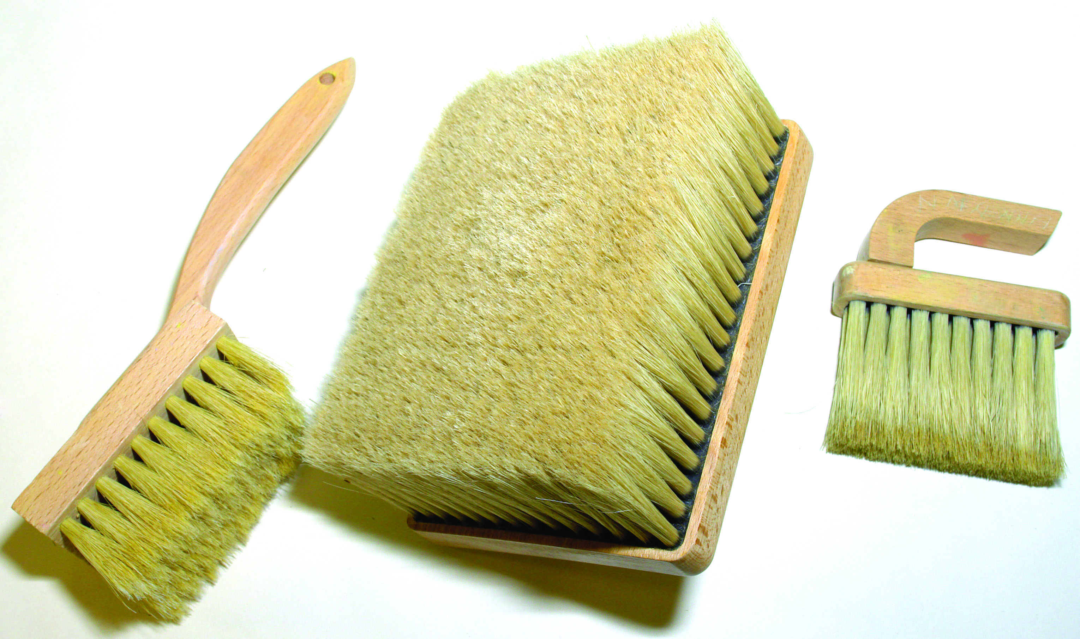
Hair stipplers
Sponges:
Sea sponges are best for this work but some nice effects can be produced by cutting pieces out of the domestic or decorator’s sponge.
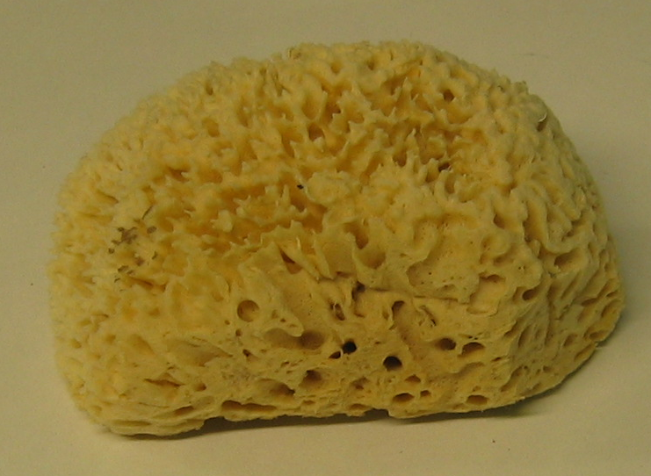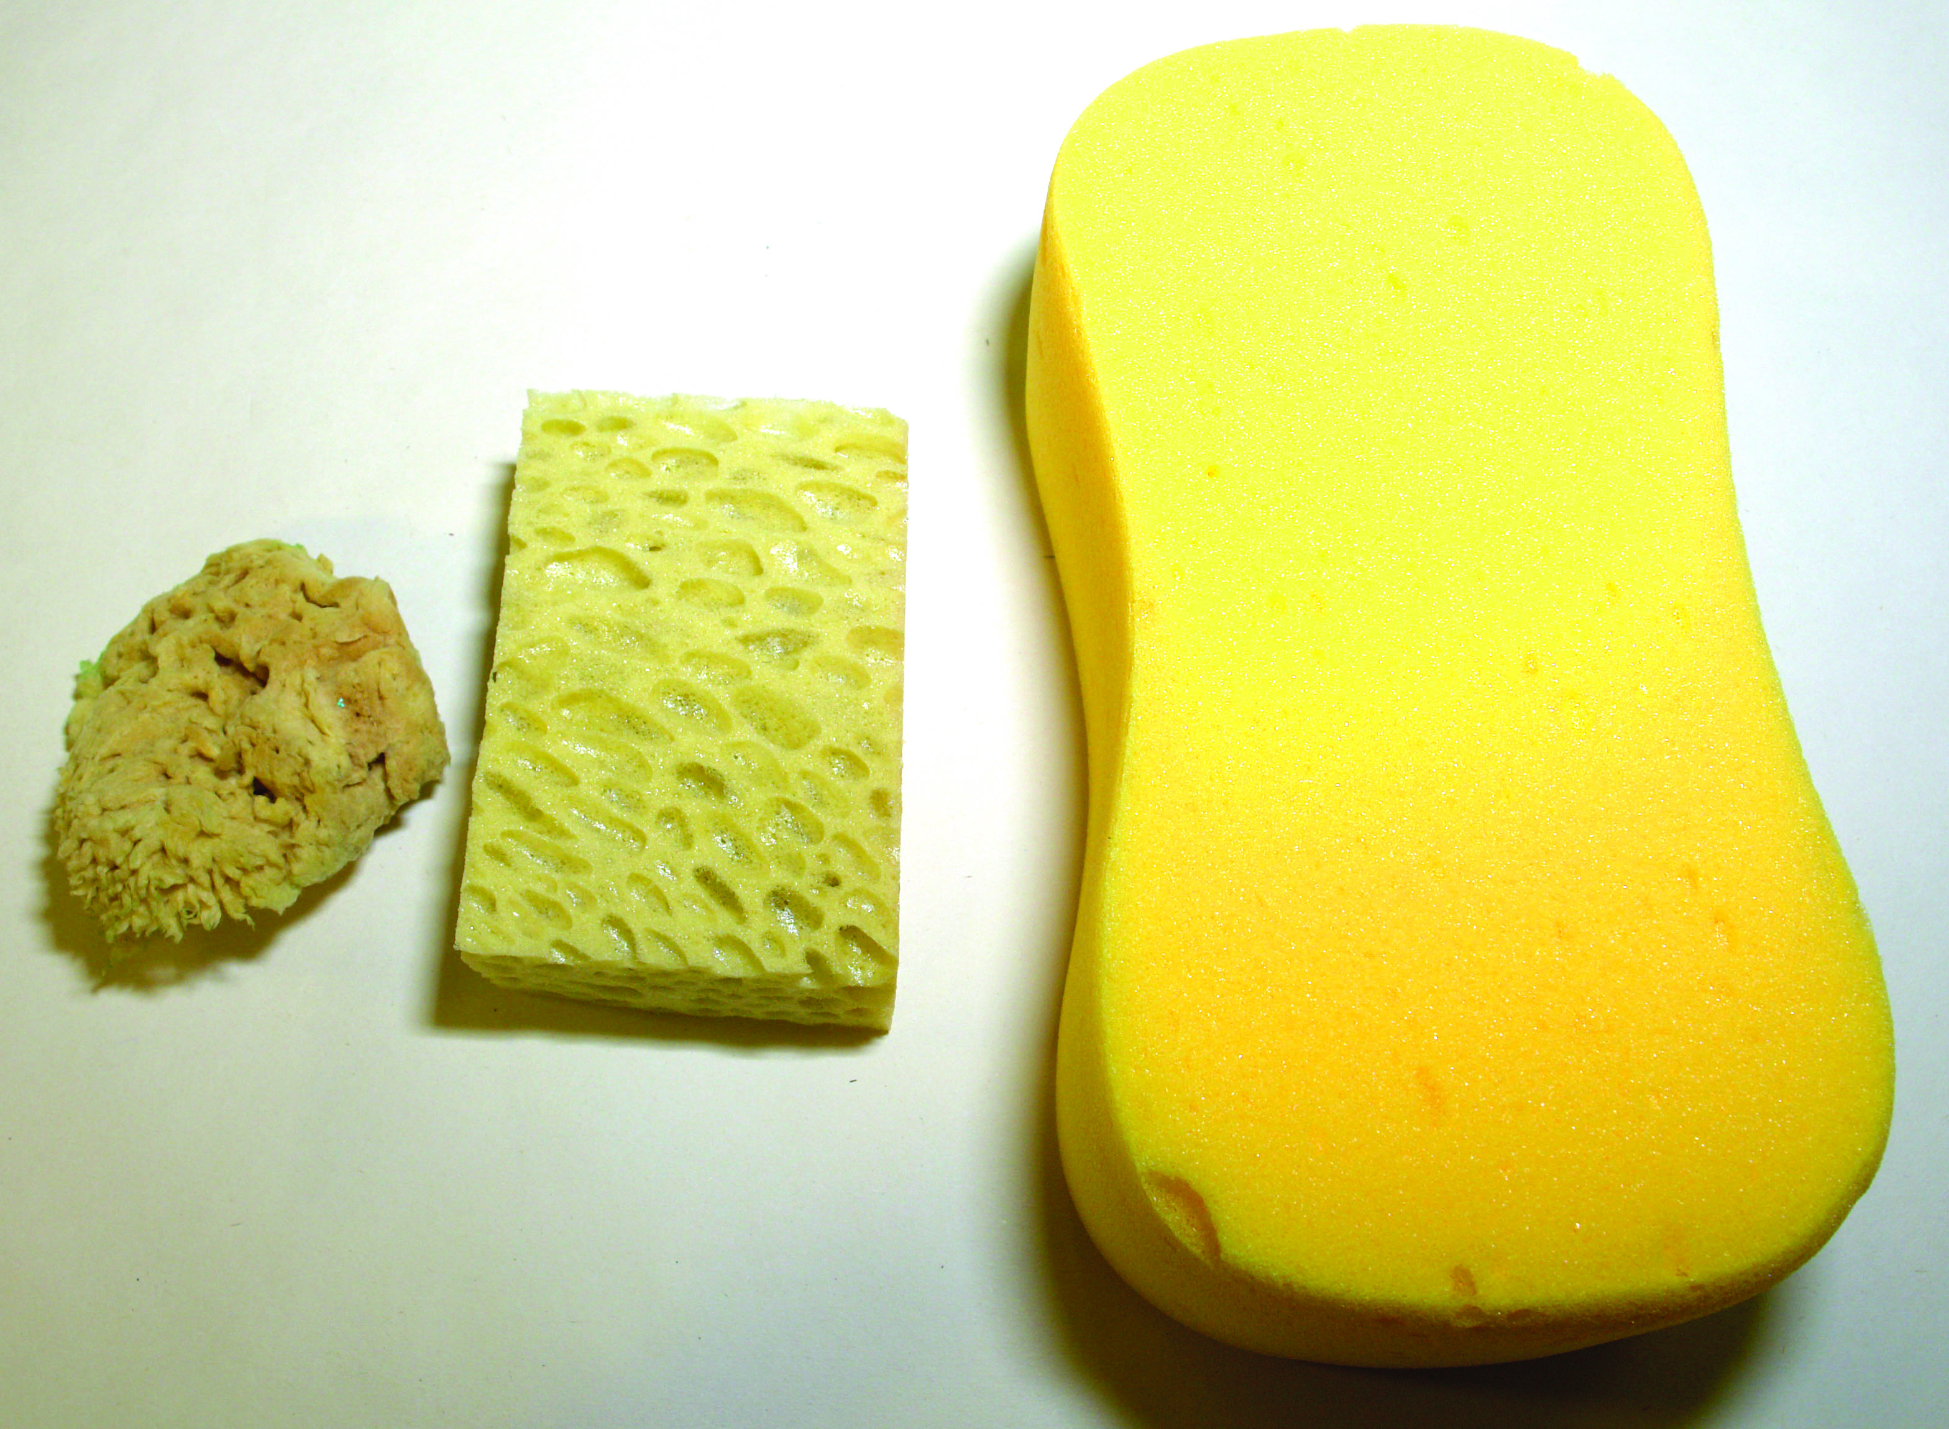
Sponges

Dragging brushes:
Good quality dragging brushes have bristle on side and a stiff nylon type material on the other. This gives variety to the drag lines. A pushing motion gives a much different but softer effect.
The large dragging brush is ideal for use on large wall areas and an extension handle can be attached to make it much easier to achieve an even drag.
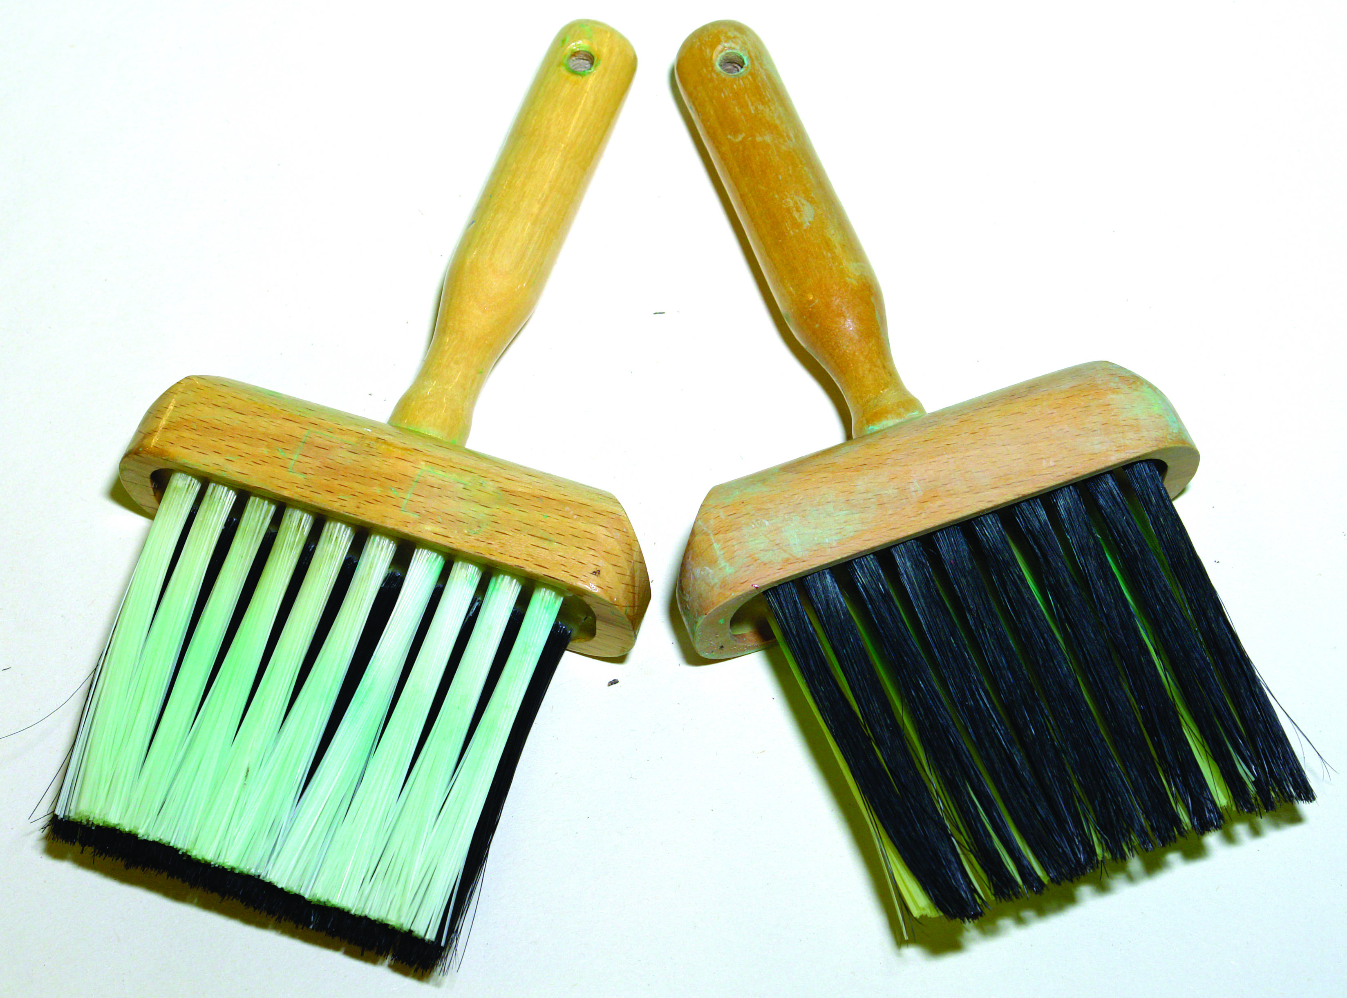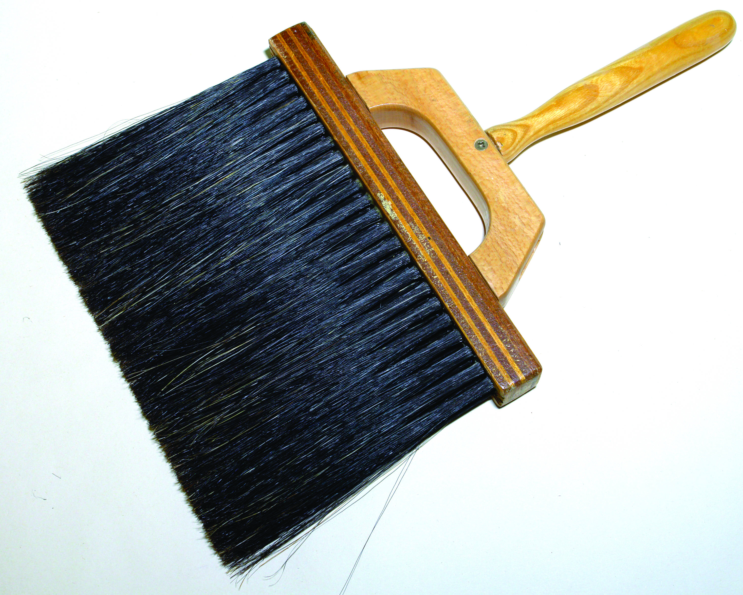
Small dragging brush Large dragging brush
Combs:
Used to create many effects when working with broken colour.
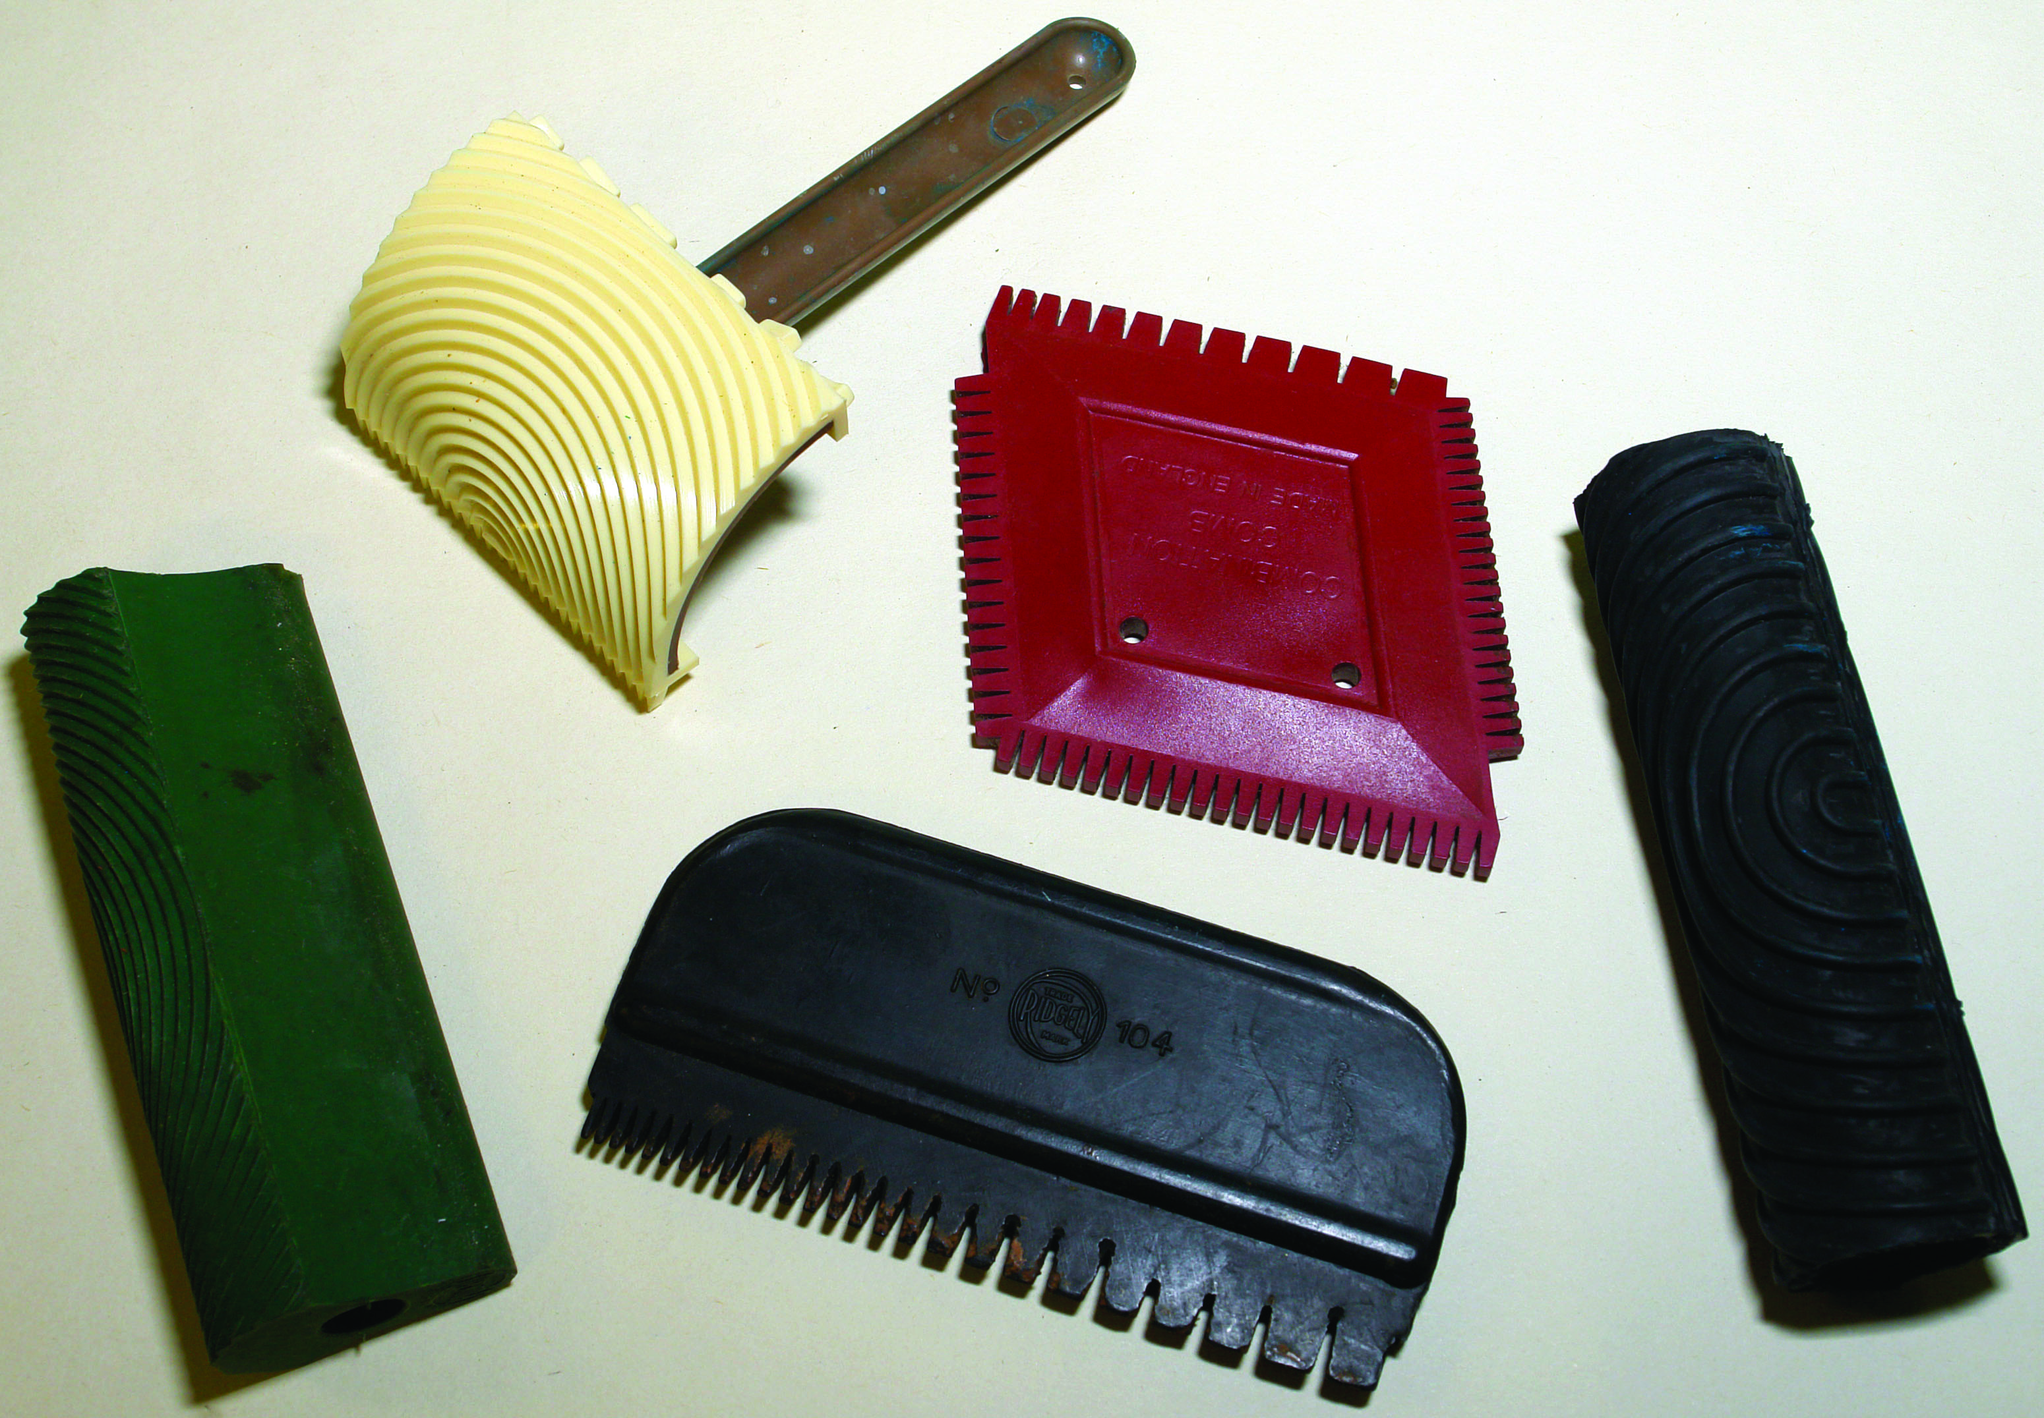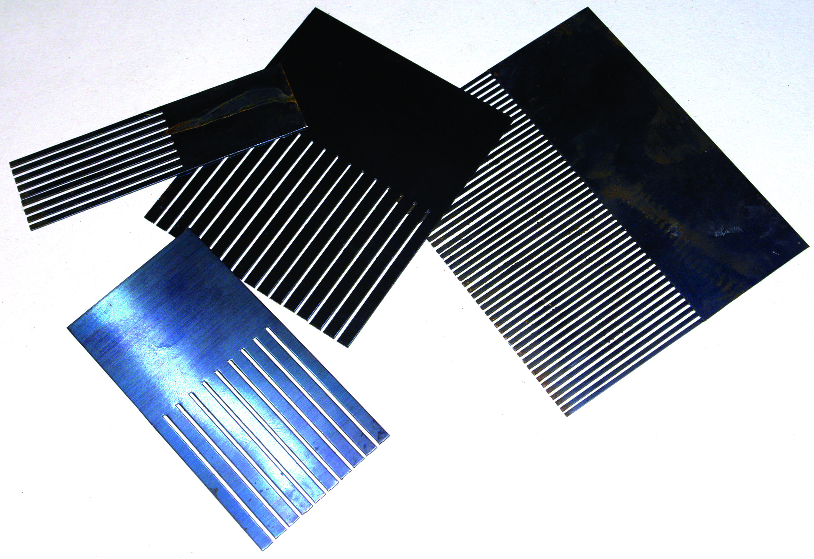
Plastic combs Metal combs
Pattern Rollers:
Rolled through the wet glaze producing an overall pattern
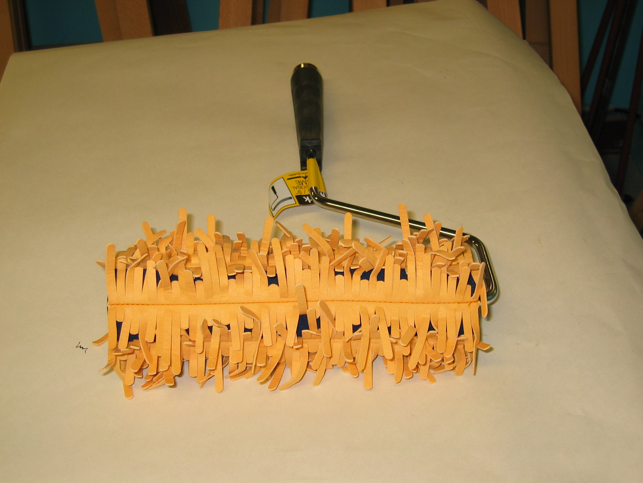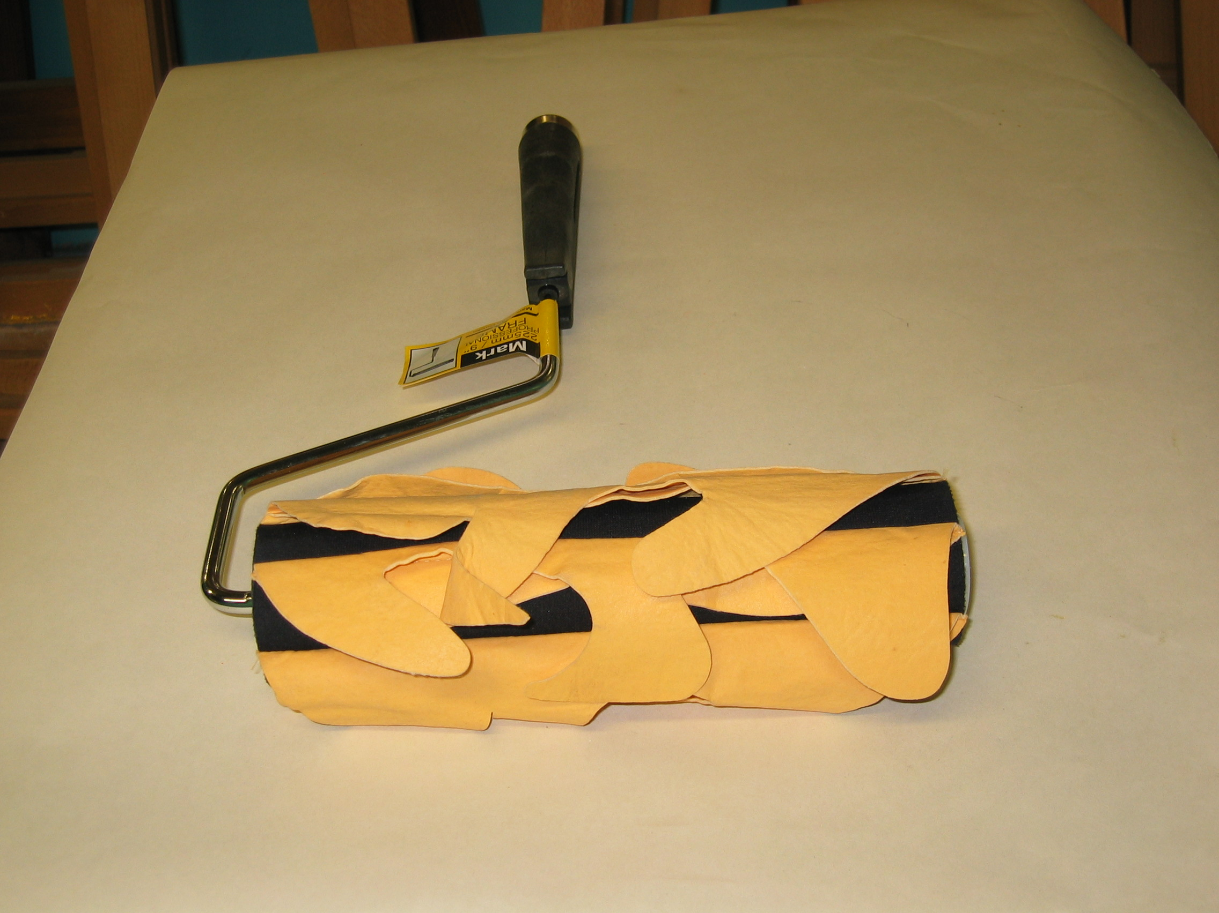
Pattern rollers
Some samples of broken colour work
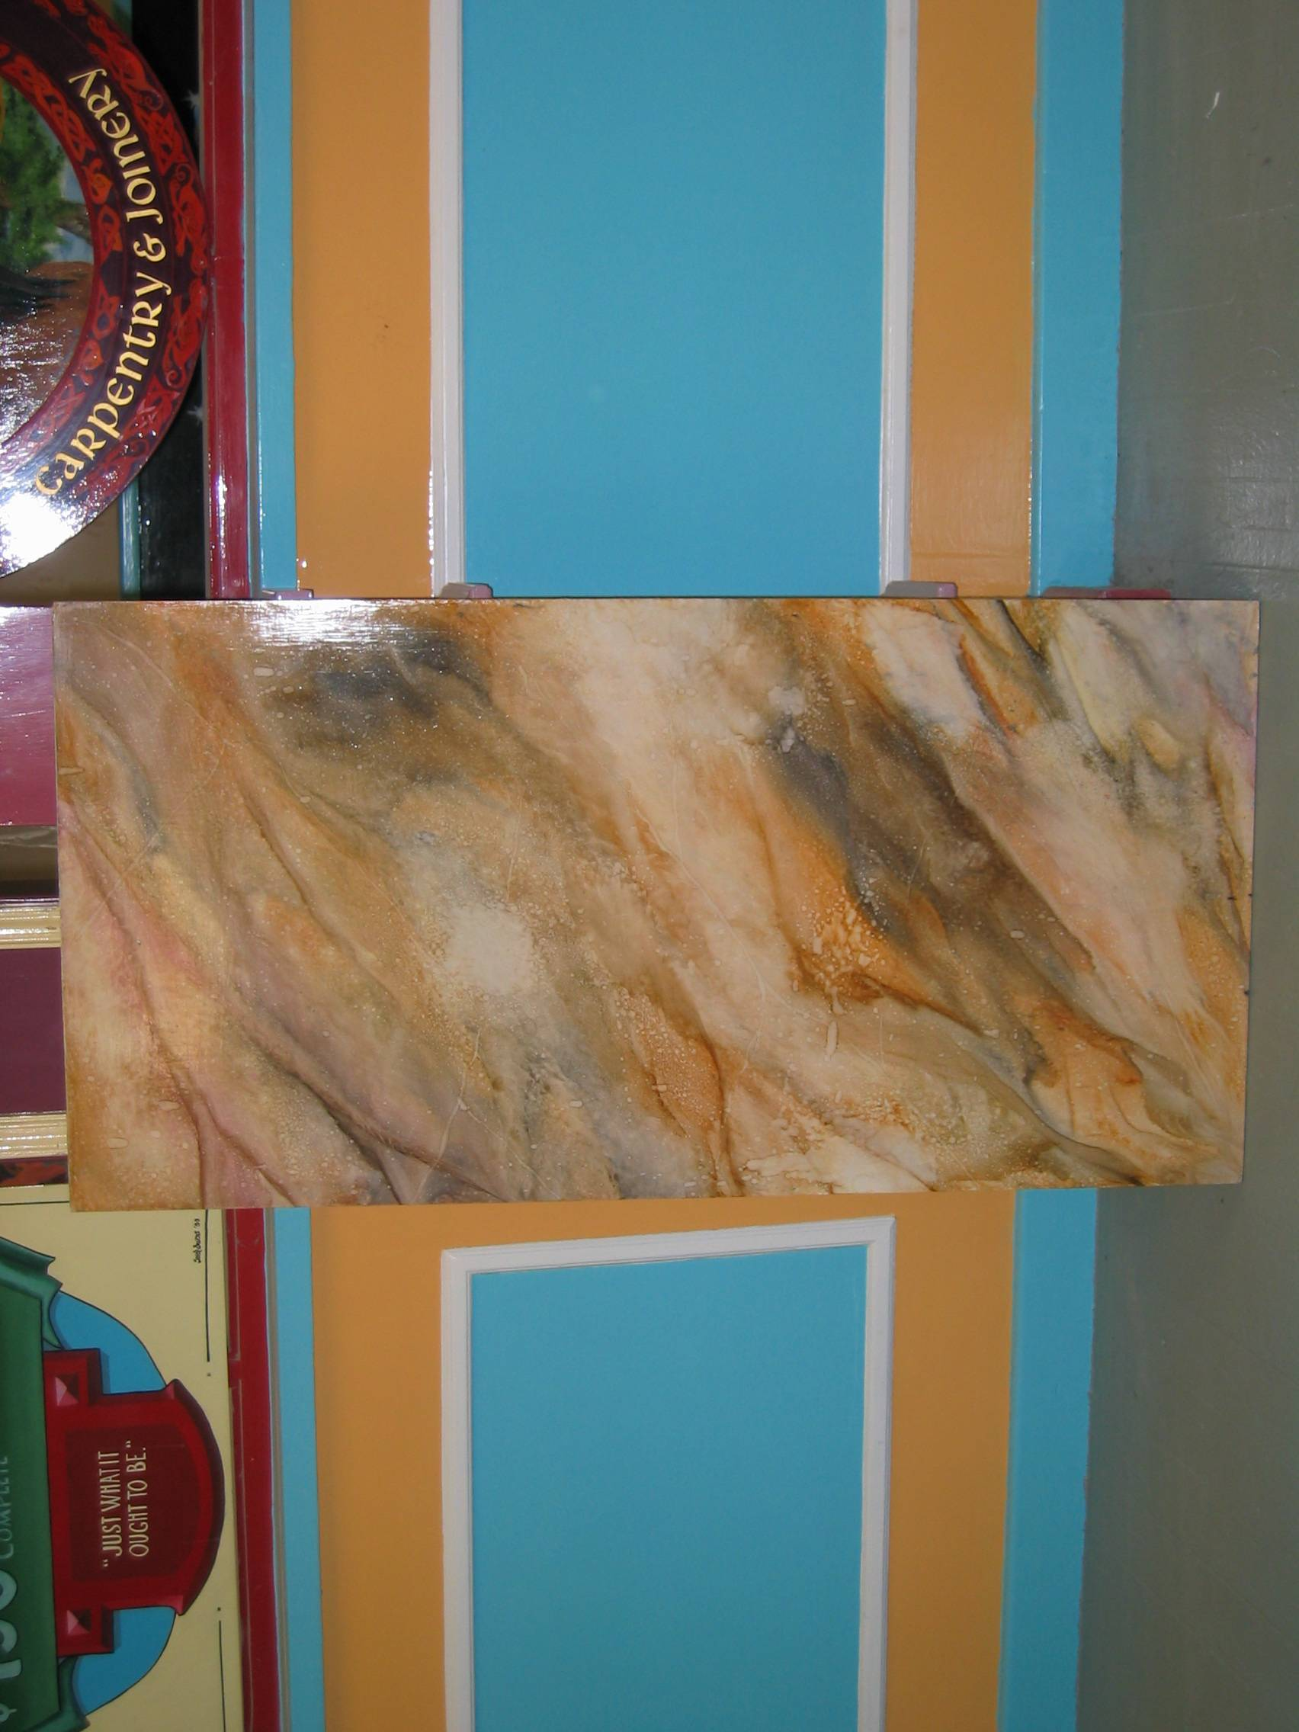
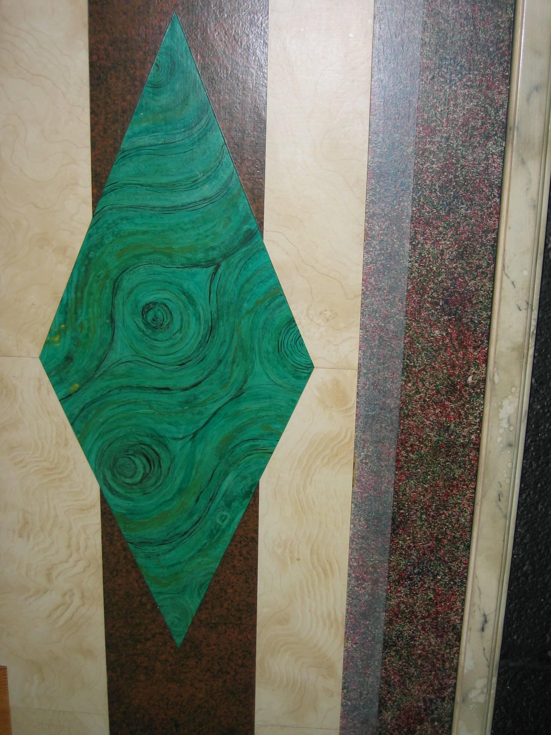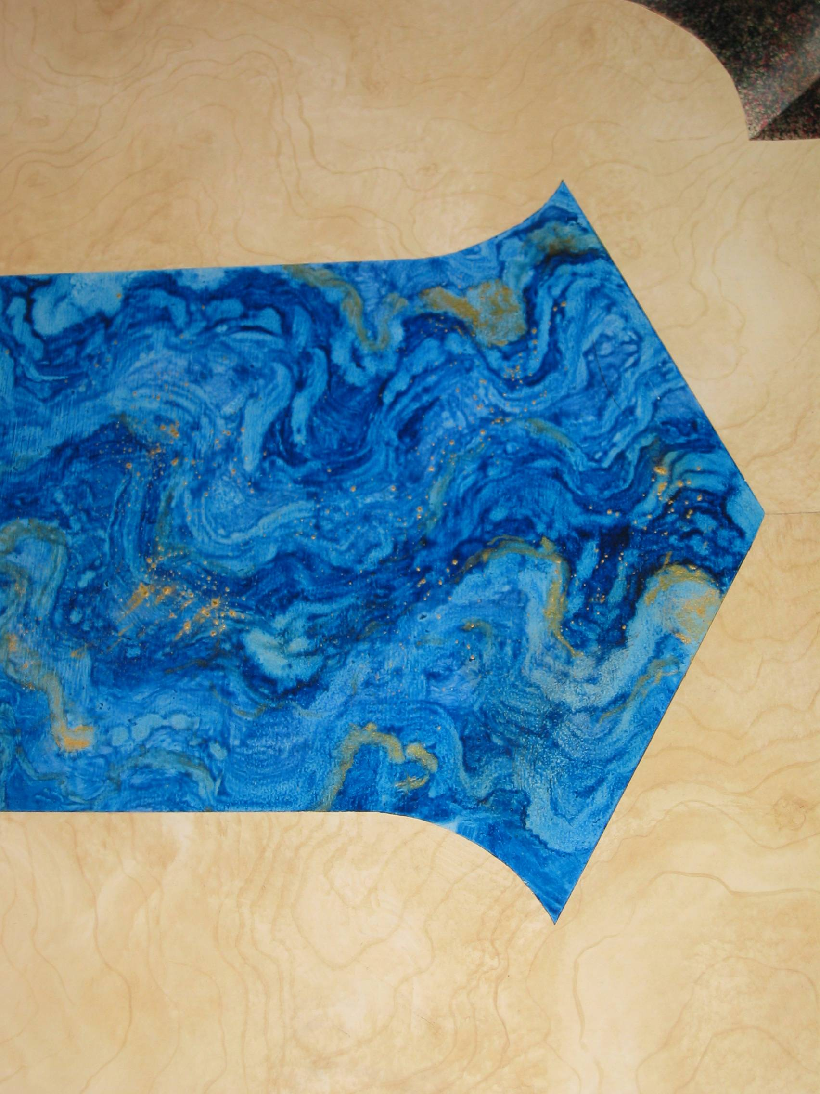
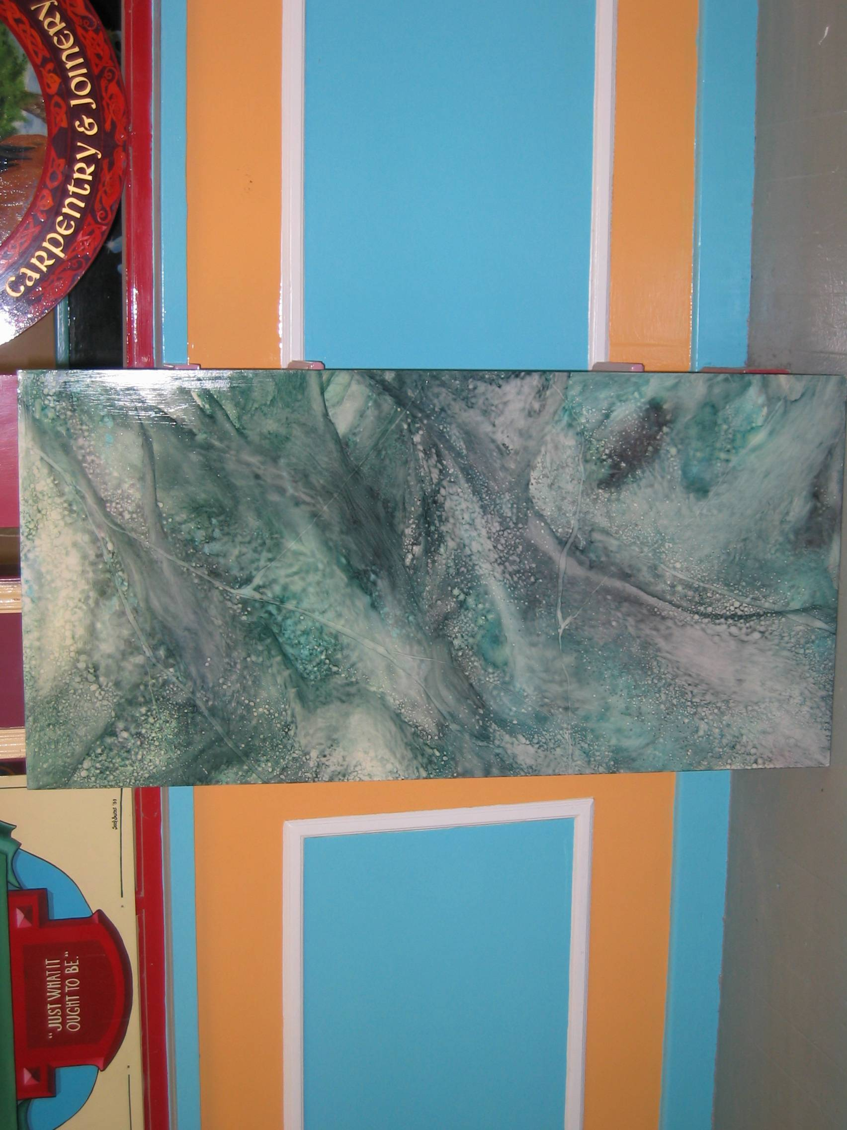
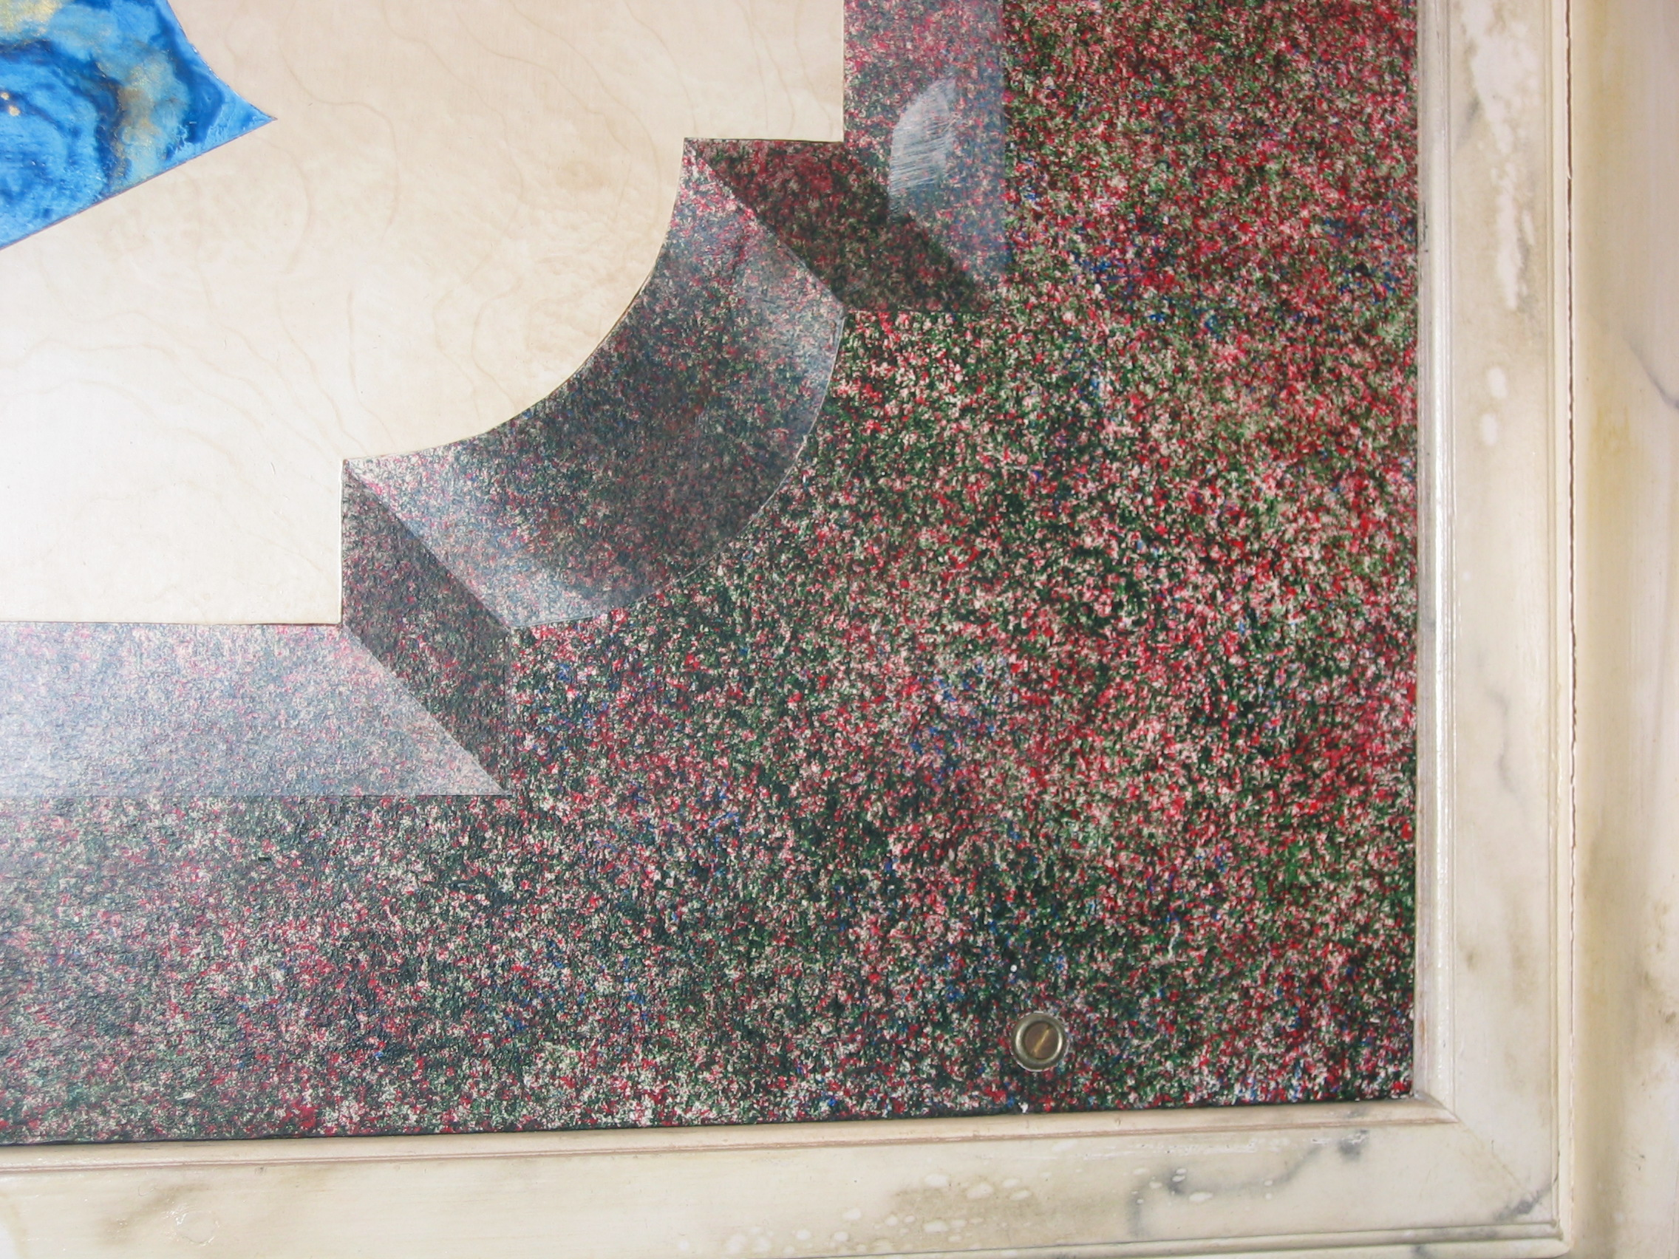
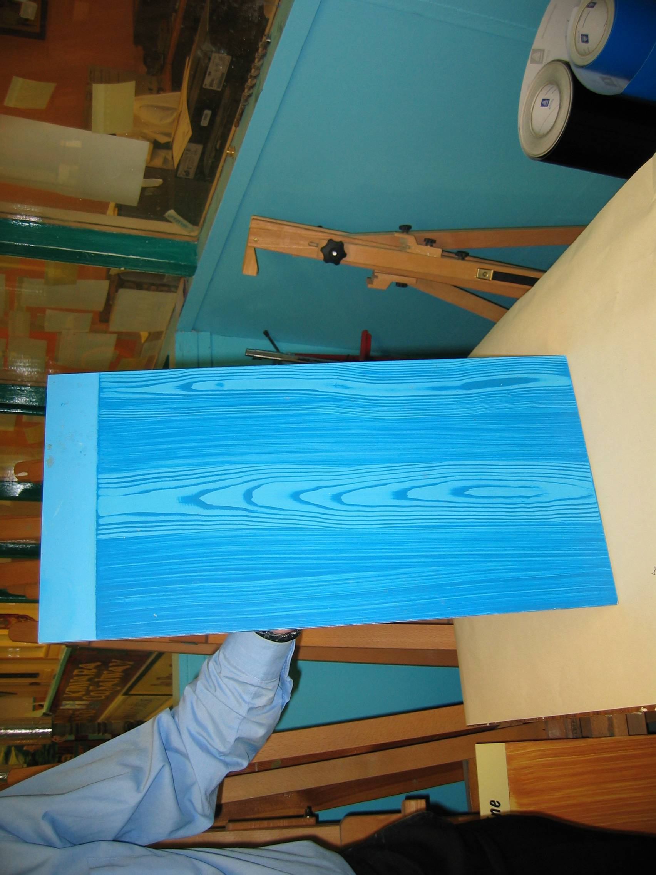

Trompe L’oeil:. Creating the illusion of depth on a flat surface.
This piece of decoration contains a variety of broken colour effects on an accurately drawn architectural feature. Among the effects illustrated are stippling, ragging, marbling, lining, shading, sponging and airbrushing.
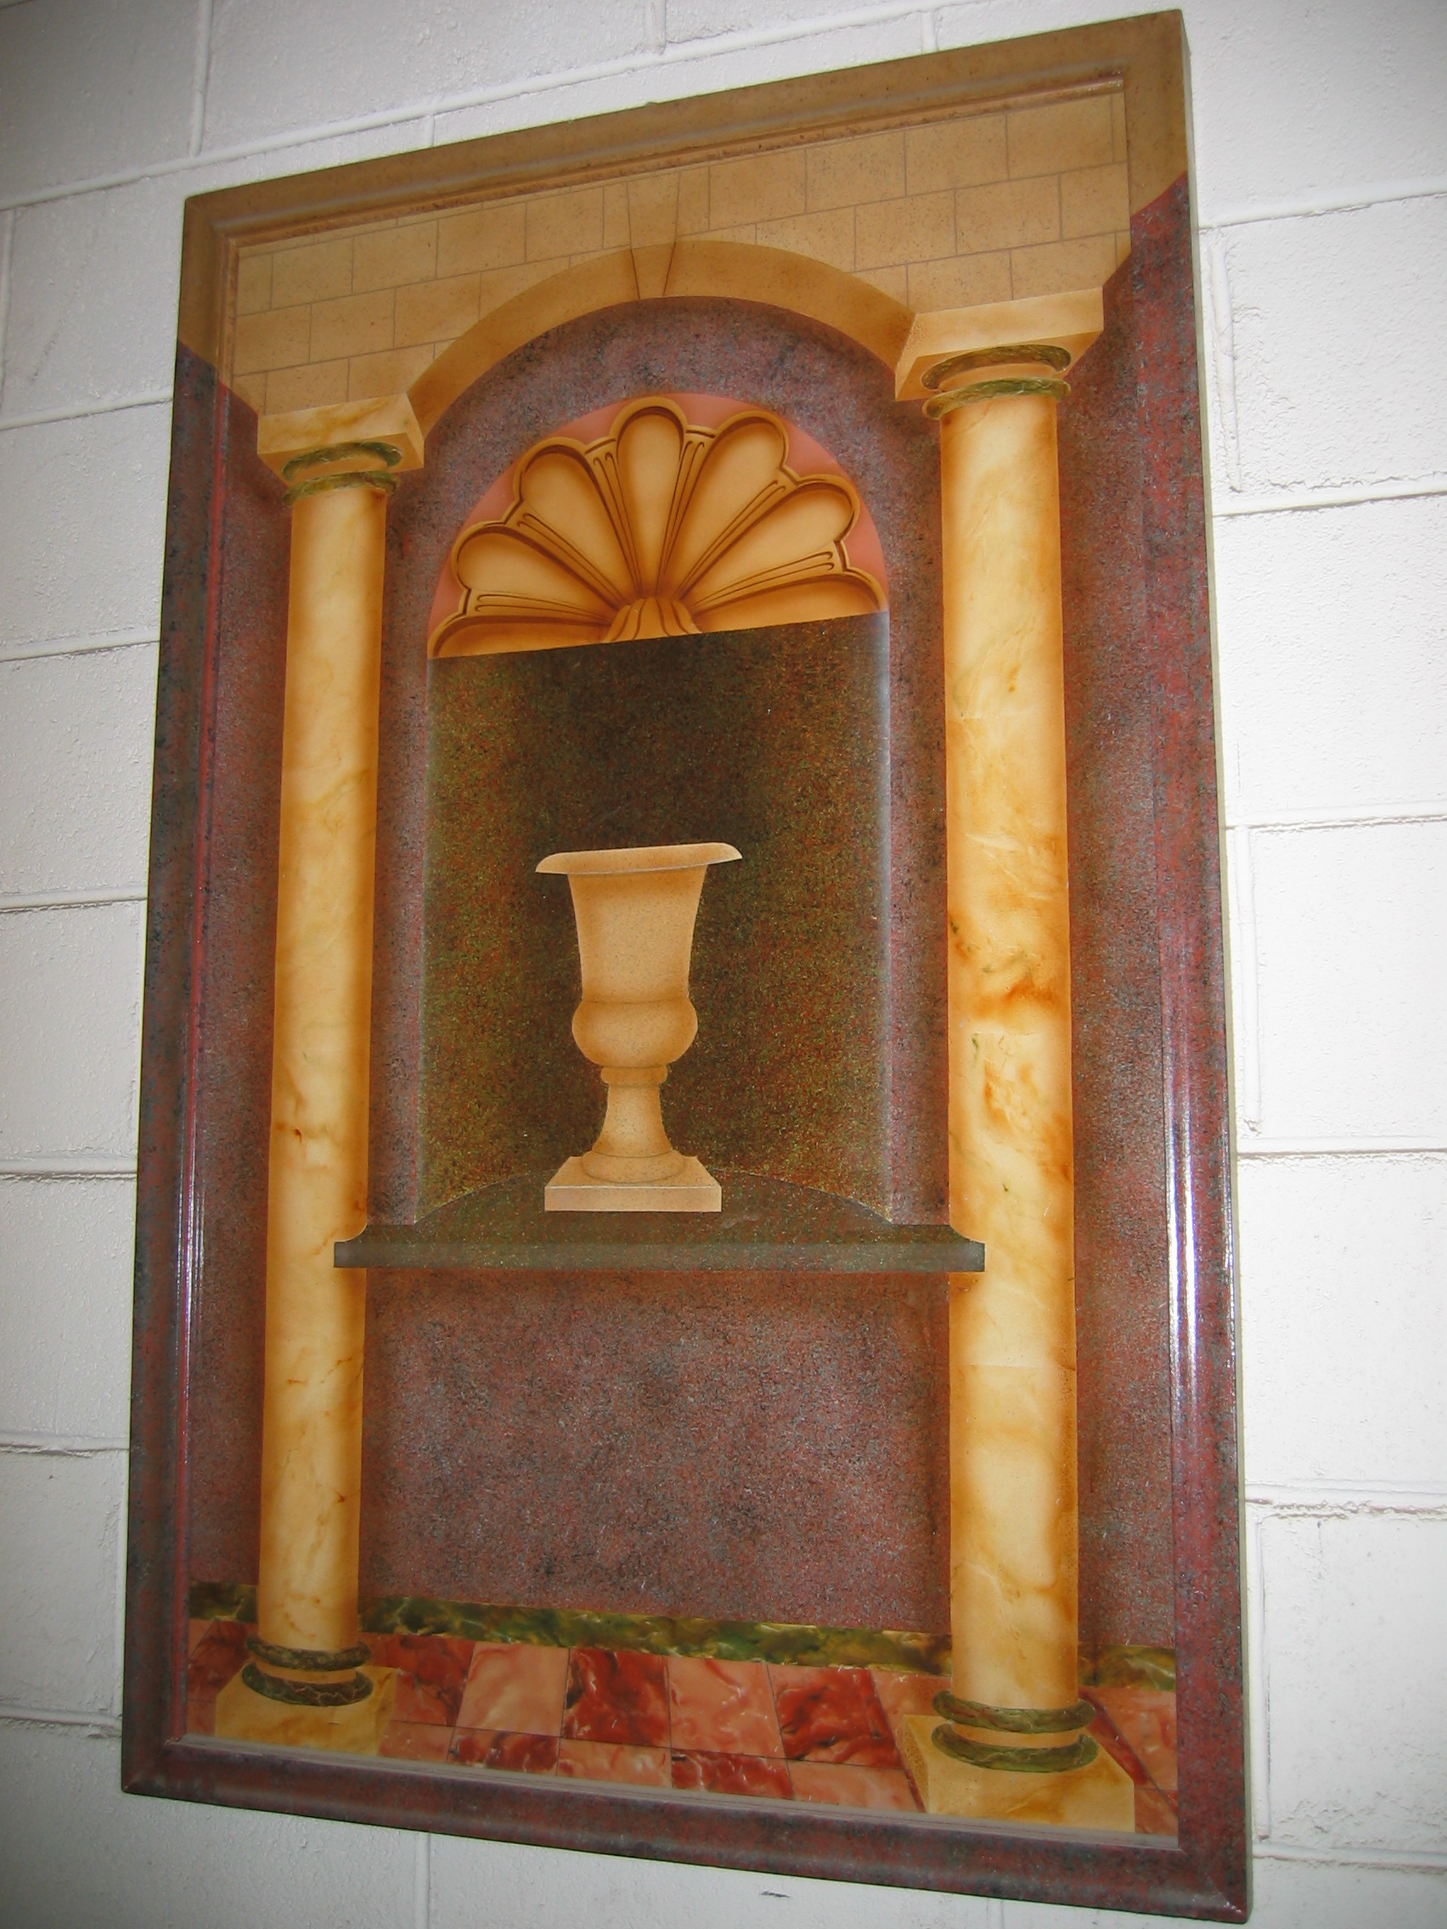
Trompe l’oeil

2.2 Materials for decorative effects
A wide variety of materials can be used when working patterns into broken colour:
- Light plastic
- Lining paper
- Newspaper
- Lint free cloths
- Steel wool
- Sponge
- Chamois leather
- Special Rollers

3.0 Broken Colour Effect
Key learning points
- Broken colour effects
- Use of sample panels to present for clients choice and approval
- Working alone or as part of a team

3.1 Broken colour effects
Rag rolling
An effect produced by applying a semi transparent material over a previously prepared semi gloss or gloss ground to give a two toned coloured effect.
A third or fourth colour can be introduced by the painter having become becomes familiar with the materials involved to achieve a multi-coloured effect.
Procedure: Prepare surface by flush filling and bring forward to semi gloss finish. All materials should be strained to give clean ground for working on.
Making the glaze: Using artist oil colours or universal stainers mix with white undercoating or transparent oil glaze to the desired colour thin to a wash with white spirits or turpentine, raw linseed oil and a little drier. Being of a very thin nature the glaze will dry rapidly so sufficient linseed oil and transparent oil glaze must be used to keep the glaze “open”.
When the ground colour is dry apply the glaze evenly with a full brush and lay off in one direction. Using a hair stippler lightly stipple the material to remove any brush marks.
By rolling up lining paper or lint free cloth and making sure no sharp or loose edges are present roll the paper over the glazed surface in an irregular pattern. Refold the paper or cloth to a clean face and proceed again until the glazed area is completely rag rolled.
Great care should be taken when rag rolling as with all broken colour finishes, touching up is practically impossible. Also do not roll paper over area in straight lines as this will show when dry. The finished work should show no obvious pattern.
To produce a multi coloured effect apply different coloured glazes to the ground and soften into one another before rag rolling and if the painter has taken care with the selection of colours then a very colourful effect can be produced. When dry protect by applying a coat of thinned out clear oil based varnish.

These broken colour effects can also be produced in water colours by mixing artist acrylic colours or universal stainers with acrylic scumble glaze. This will keep the glaze open or workable for 1 hour giving plenty of time to create patterns. When dry protect by applying a coat of thinned out clear varnish.
When dry protect by applying a coat of water based varnish.
Another method is to soak the cloth in the glaze and wring out. Roll over the whole surface in a haphazard fashion. Repeat the process until the whole area is complete. A chamois leather can be used with the water glaze to produce excellent effects.
Bagging;
This is a good effect for large areas as it is easily carried out. The glaze is brushed on evenly to a section of the surface and while wet a pattern is produced by striking with a crumpled piece of plastic. It is very quickly achieved pattern
Ragging:
Similar to bagging but a cloth is used instead of plastic.
Dragging:
A simple but very pleasing decorative effect produced by dragging a specially designed brush or good quality dust brush through a wet glaze. Pushing the brush can give a completely different effect. Drawing a piece of steel wool through the wet glaze gives another dragging effect.
Wiping:
This is a useful technique where a tinted glaze is applied over a textured surface such as decorative plaster, carvings furniture etc. An eggshell finish oil paint is applied as the ground and allowed to dry thoroughly. The tinted glaze is brushed over the surface and surplus material wiped from the highlights using a lint free rag. Bring new areas of the rag into use as it becomes soiled.
Sponging:
A natural sponge is best used for this work and a variety of sized sponges are available. Mix a glaze colour and place it in a small flat tray. Dampen the sponge in the coloured glaze and dab it on paper to avoid applying too much colour at the beginning. Apply the colour randomly over the ground coat and it will transfer in small spots. Another colour can be used in the same way when the first one is dry adding to the effect. A third one can be introduced if necessary.

Blending:
This is a very nice effect and can be used on any surface. This effect is achieved by mixing a glaze of a deep tone of a colour and a light tone of the same colour. Two in between tones can now be made by mixing portions of the light and dark colour together. Select a clean brush for each colour.
Apply a band of the darkest colour to the lower quarter of a prepared panel and a narrower band of the same colour to the top. Do not flood on the colour as it will be difficult to blend.
Apply the next tone of colour against the edge of the dark colour and the same on top. Blend together with a small stippler to achieve a soft effect. Apply the lightest band of colour against the other colour and stipple again to achieve a nice subtle blended effect. A selection of colours can be used in the same way for a more colourful effect.
Combing:
This effect is produced by using steel rubber or plastic graining combs. Suitable for small areas.
.A wide comb can be drawn down straight through the wet glaze and while still wet a smaller sized comb can be drawn through it in a wavy motion creating a pattern.
Many patterns can be produced and practice will develop these skills

3.2 Sample panels for clients choice and approval
Many people do not understand the meaning of broken colour when it is recommended as a decorative effect for their home or premises so it is important that it is explained fully to them. It is an expensive form of decoration therefore it is necessary that they be made aware of exactly what is being recommended. The best way is to show them the finished product so that they are comfortable with the new scheme before it commences. If possible bring them to a previous job. Do not force the choice on them as it never works.
While the preparation of surfaces for broken colour is underway apply the ground colours to piece of good quality lining paper or strong tracing paper. When the glaze is being applied apply to the painted sample. Over a period of time many of these samples can be used as a portfolio which can be produced for your client’s perusal. Photographing the finished rooms etc is another way of showing this type of completed decoration to future customers.

3.3 Working alone or as part of a team
On large or awkward to reach areas it is very difficult to apply and manipulate the glaze successfully on your own as it may set up, thereby showing the dry edges. When this happens the glaze must be removed by wiping and the work restarted.
Working with a partner and planning how the job should be organised will make it easier and more efficiently executed. One painter should apply the glaze and the other work the pattern. Do not swap roles as each individual will produce a very different pattern even though the same materials are being used.
When working on the walls of a large room start on the smallest one to get feel for the material and to check the pattern. Work out from a corner in areas of one square meter keeping edges irregular and maintaining a wet edge at all times.

4.0 Eggshell Varnish
Key learning points
- Application and purpose of eggshell varnish
- Clean and safe working practice
- Measuring and setting out panels and borders for decorative work

4.1 Application and purpose of eggshell varnish
Broken colour finishes are delicate and when applied to doors , wood work, furniture and wall areas they must be protected .
Protecting the Finish:
Areas that are subjected to hard wear and tear must be protected by two coats of either eggshell or gloss varnish. Oil based eggshell varnish is the ideal one for furniture as it gives a nice sheen to the finish while offering protection. While using this product over dark colours presents no problem, it does tend to show some discolouration over light colours. Water based varnish is best used over these.
If oil based glaze has been applied to wall areas it will present a glossy appearance when dry which does not suit curtains, fabrics etc. The application of eggshell varnish to the walls will eliminate the glossy look. The eggshell varnish should be stirred and well thinned out before applying to reduce the risk of discolouration. Flat varnishes can also be used for this purpose.

4.2 Clean and safe working practice
Solvent Based paints are flammable materials that have to be carefully stored to avoid accidental fire. They must be stored outside in a properly ventilated store that has the recommended type of fire extinguishers in place. If small stocks of paint or thinners need to be stored indoors then a metal fireproof cabinet must be provided.
For environmental reasons it is illegal to discard paint, used paint tins, white spirit or any thinner by placing in refuse bins, pouring down drains or dumping in landfill areas. Specialist firms will dispose of it for you.
When working in a domestic environment select a suitable safe area outdoors to store these materials. The working area must be well ventilated and proper PPE equipment used where necessary. Tidiness is very important so that the work proceeds uninterrupted and efficiently. The area should be vacuumed clean regularly as dust will adhere to this slow drying material. A check of the working area must be carried out each day to ensure the removal of used cloths and papers.

Skin Contact:
When working with broken colour a large quantity of white spirit will be used. As white spirit tends to dissolve the skin’s natural oils, barrier creams should be used and PVC gloves worn. Hands should be cleaned with recommended hand cleaners followed by soap and water. White spirit should not be used for this purpose.

4.3 Measuring and setting out panels and borders for decorative work
Panelling can be a very decorative way of breaking up the walls of a large room that would have been boring with a solid coloured finish. When setting out the panels a china marker should be used instead of a pencil to avoid leaving permanent marks. Stencilling can be added to complete the decoration.
Steps in measuring for panelling:
- Measure one wall and draw it to scale on drawing paper.
- Sketch in panels of different shapes and sizes until the one most suitable is arrived at.
- Make a final accurate working scale drawing
- Do exactly the same for the remaining walls
Working on the wall:
Tools and materials required: Plumb bob, level, self chalking line, china marker and low tack masking tape.
- Mark out the top and bottom line measurements and snap lines.
- Taking the measurements from the scale drawing and using plumb bob or level mark out the first panel and check.
- If checked measurements are OK proceed to the next one and so on.
- Tape up panels carefully and accurately.
- Apply broken colour glaze and remove tape.
Note: If working with water based glaze an additive can be mixed with the water based ground colour to increase its adhesion. This is important when using large amounts of masking tape as the surface can be damaged when removing.

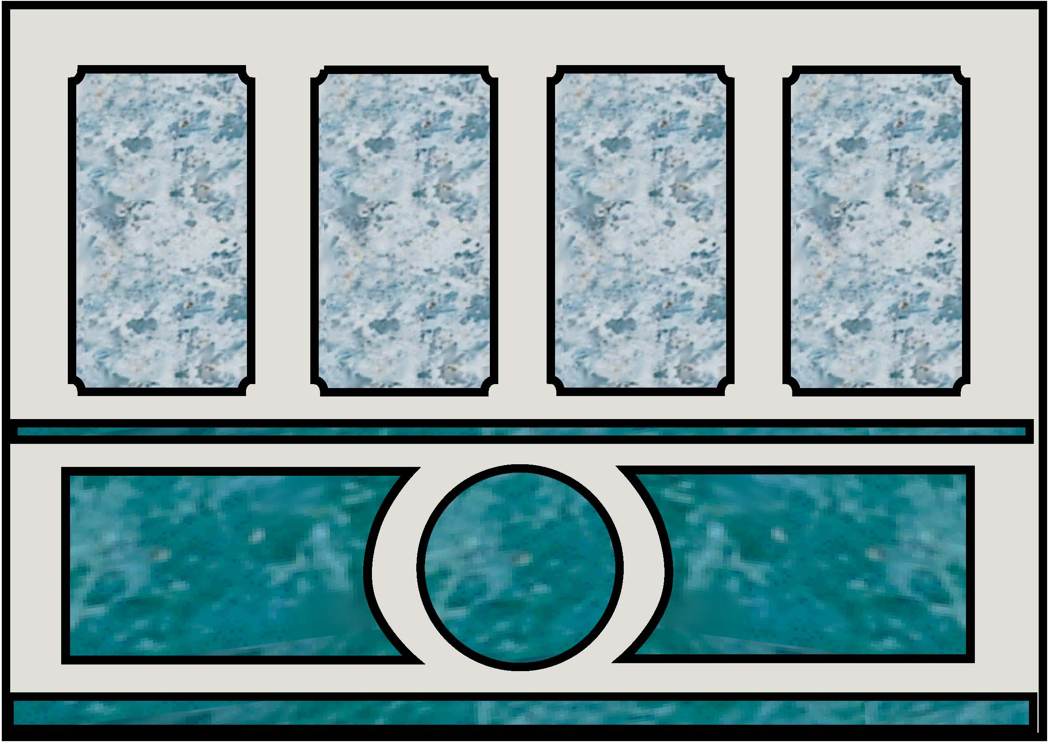
View of suggested panelled wall

Summary
Broken colour as a decorative effect has been with the trade for generations and it has become fashionable and unfashionable as other forms of decorations do. People tire of blank coloured walls and broken colour is one method that can be used to introduce a completely different type of decoration
To prove its popularity paint manufacturers have spent lots of time and money developing workable glazes tools and well presented brochures promoting thei products.
Videos and DVD’s have been produced to encourage furniture painting and wall decoration using the traditional techniques with modern materials.
Extra treatment of broken colour with crackle varnish or antiquing varnish adds another dimension to the finish.
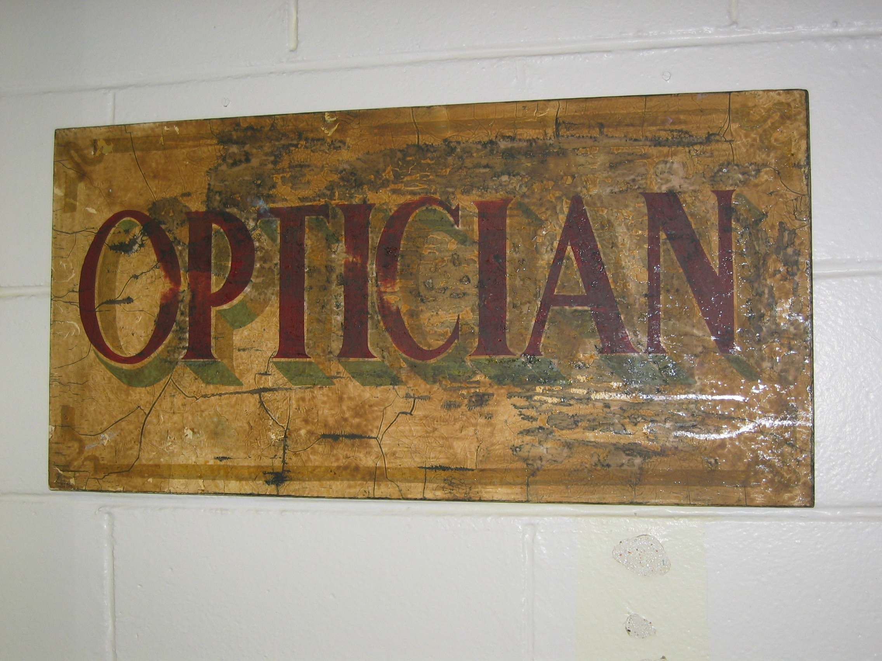
Distressed finish

Suggested exercises
- Prepare three panels and produce three different broken colour techniques.
- Apply eggshell varnish.

Self test:
Q.1 What is a glaze
Q.2 What precautions should be taken to avoid spontaneous combustion.
Q.3 Explain the painting defect blooming
Q.4 Name four different types of broken colour.
Q. 5 Name four materials used to make patterns in broken glaze.
Q.6 List four tools used for manipulating broken colour.

Recommended additional resources:
The Handbook of Painted Decoration ISBN 0-500-01712-3
Authors: Yannick Guegan and Roger Le Puil

The Art of Faux ISBN 0-8230-0858-4
Author: Pierre Finkelstein

Paintability ISBN 0-297-78729-2
Author: Jocasta Innes


27-33 Upper Baggot Street
Dublin 4

