TRADE OF PAINTING & DECORATING

PHASE 2

Module 3
Imitative and Decorative Arts

UNIT: 4

Brush Graining

Table of Contents
Introduction 1
Learning Outcomes 2
1.0 Imitation oak, mahogany and pine 3
1.1 Safety precautions in relation to oil impregnated rags 3
1.2 Spontaneous combustion 3
1.3 Tracing graining samples 4
1.4 Types of graining tools 5
1.5 Function of ground coats in graining 8
1.6 Mixing ground coats and scumbles to a suitable colour 9
2.0 Coat With Eggshell Varnish 11
2.1 Ground coats, scumbles and varnishes 11
2.2 Cleaning and maintenance of brushes and tools 13
2.3 Clean and safe work practice 13
2.4 Geometry-angles and intersecting lines, angles and parallel lines 13
3.0 Brush Graining Representing Oak, Mahogany and Pine 14
3.1 Flogging, combing, dragging and softening 14
3.2 Graining with brush and comb 15
3.3 Matching existing work 17
Summary 18
Suggested exercises 18
Self test 18
Recommended Additional Resources 19

Introduction
The imitation of woods using paints was an art developed by the ancient Chinese and Egyptians. It gained popularity in Britain in the 1800’s and was developed to a very high skill level.
This is a very technical skill that needs to be practiced to attain a competency in the craft. Woods must be studied and patterns drawn so that they are imprinted in the mind and transferred to the work when imitating it. The marking of the graining features should never be overdone as it can appear vulgar, unreal and would never happen naturally. It takes good colour sense, and artistic ability to be proficient in this field and this takes time. Achieving a level of competency as a grainer will be an added element to the craftperson’s decorative skills.
Graining should only be used in situations where the use of real timber would not be practical.
Mastering the use of the special graining tools, using a mix of modern and traditional materials and developing your own techniques will add to the ability of the craftsperson to successfully carry out a high standard of work in a variety of situations.
Examples of graining:
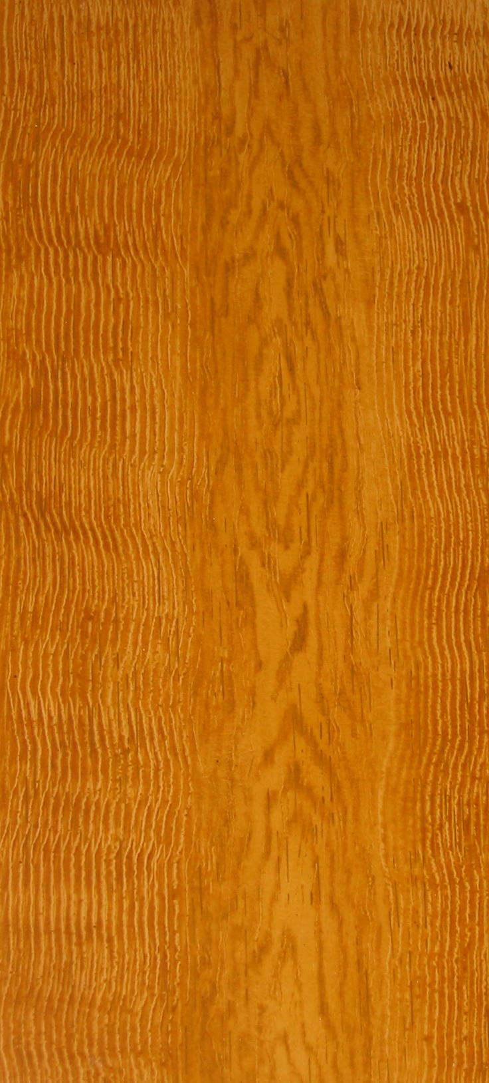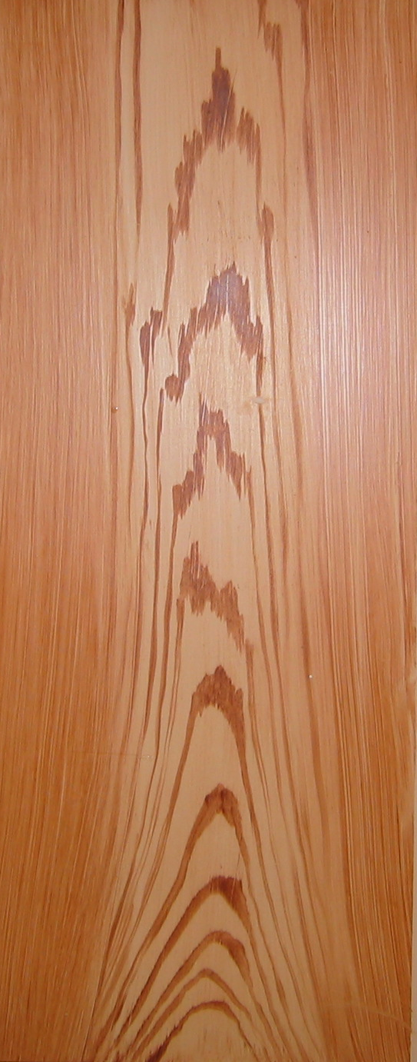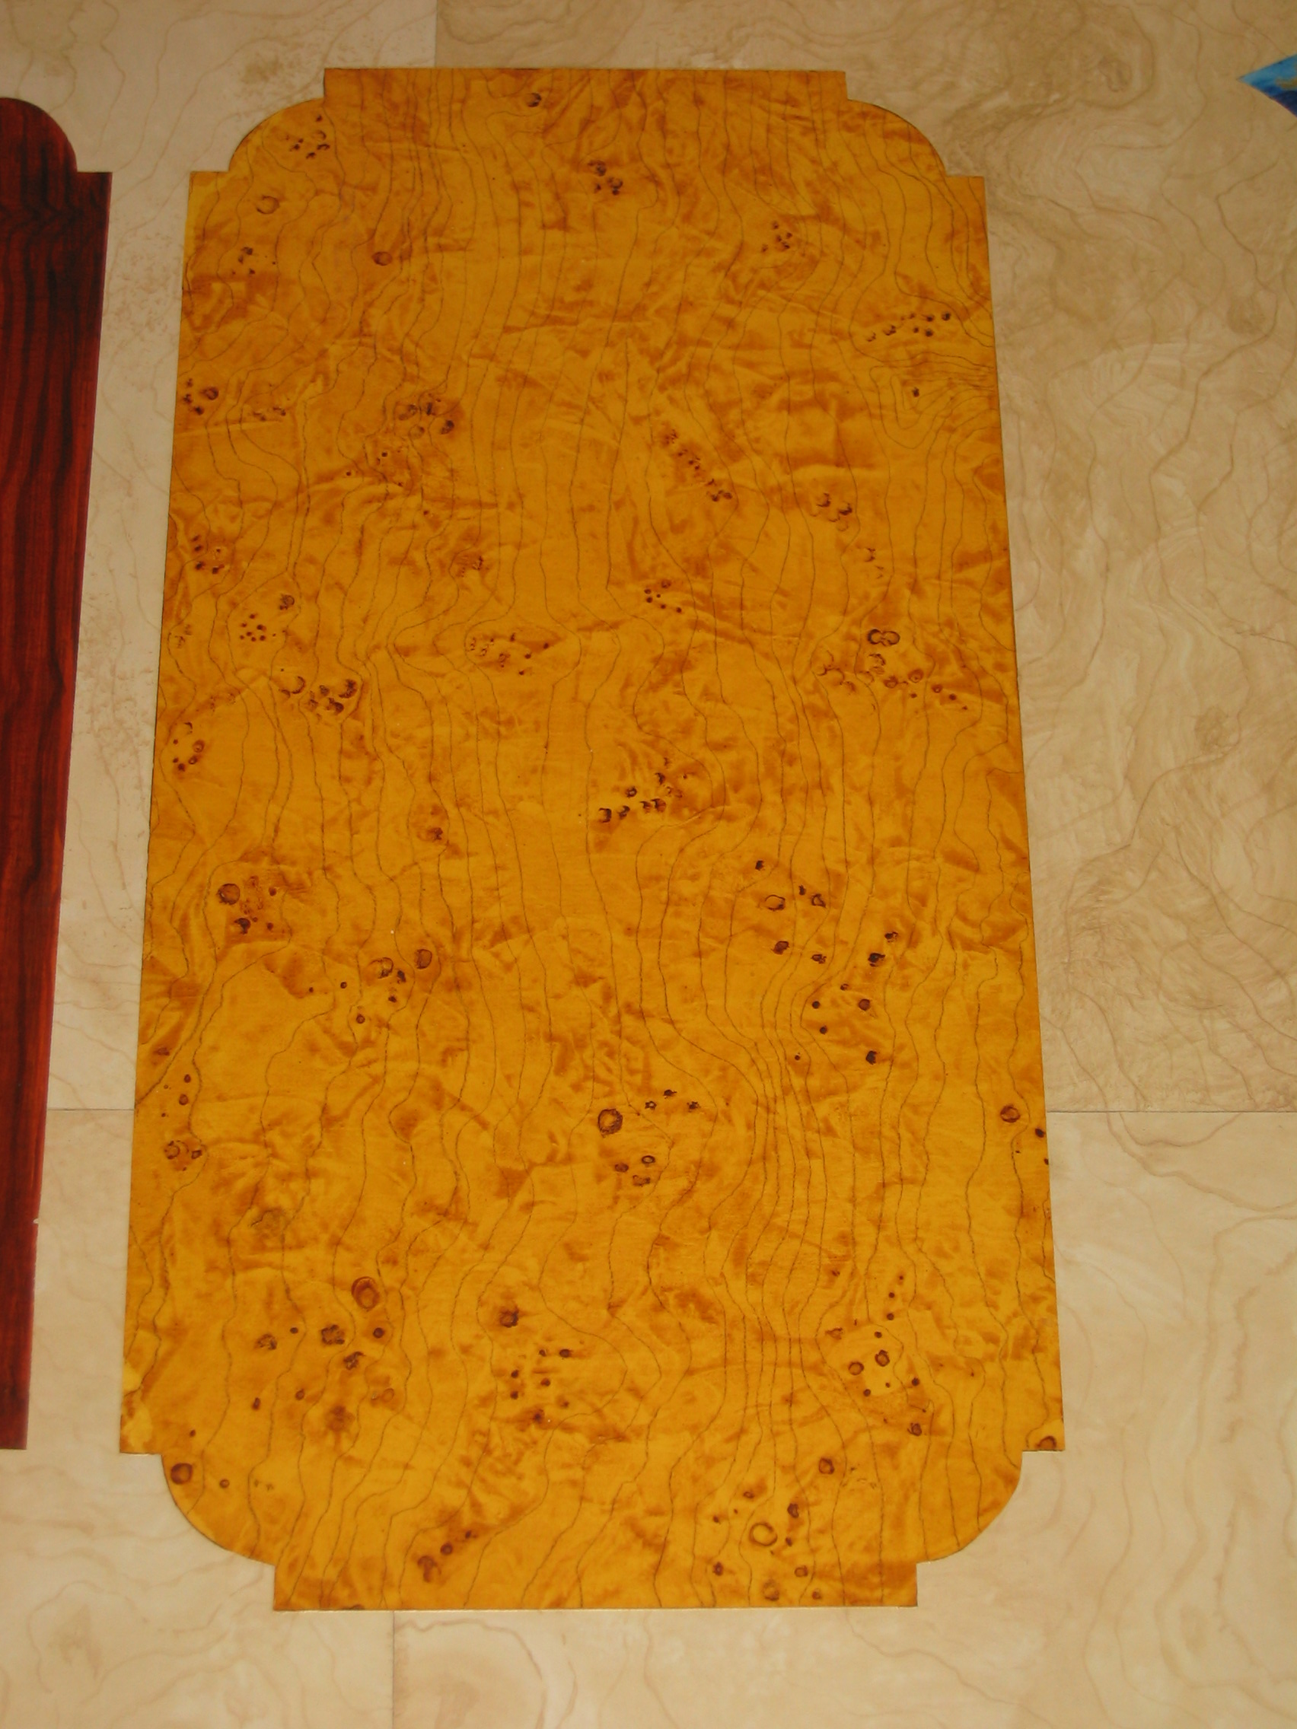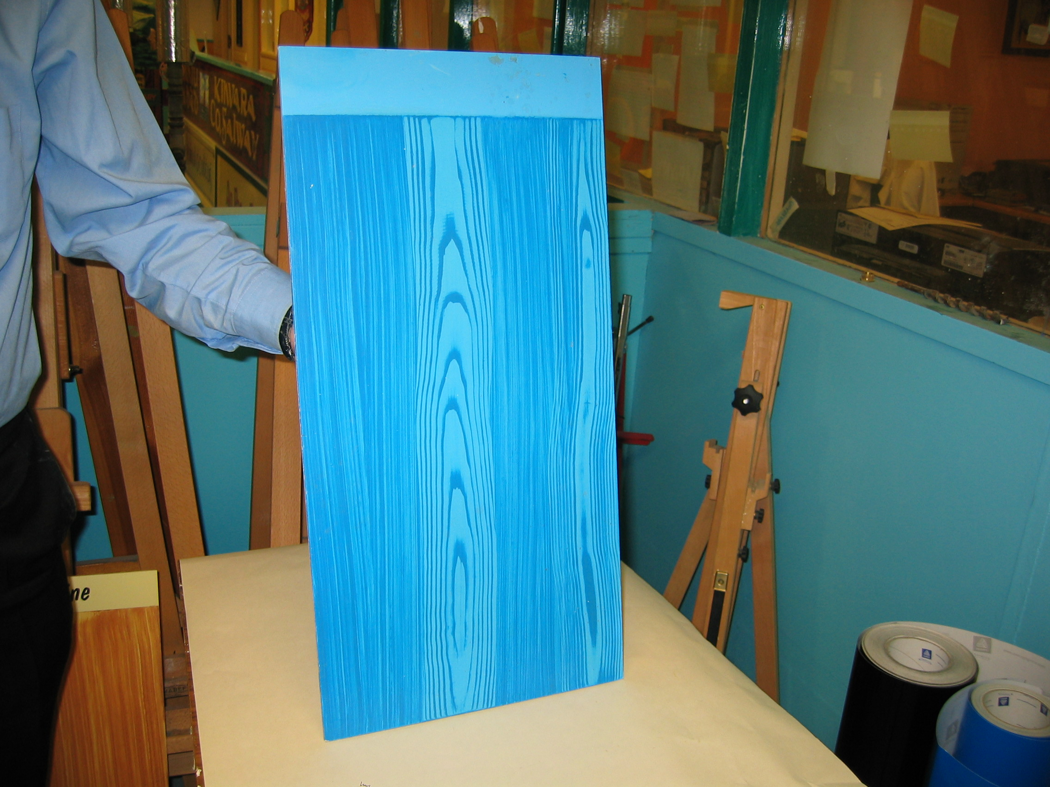

Learning Outcomes
By the end of this unit each apprentice will be able to:
- Mix and apply ground coats and scumbles to imitate oak, mahogany and pine
- Coat with eggshell varnish
- Produce a finished sample of brush graining representing oak, mahogany and pine
Module 3
Surface Preparation
Unit 1
Colour

Unit 2
Clear Coatings
Unit 3
Broken Colour
Unit 5
Industrial and Special Coatings
Unit 4
Brush Graining

1.0 Imitation oak, mahogany and pine
Key learning points
- Safety precautions in relation to oil impregnated rags
- Spontaneous combustion
- Tracing graining samples
- Types of graining tools
- Function of ground coats in graining
- Mixing ground coats and scumble to a suitable colour

1.1 Safety precautions in relation to oil impregnated rags
A clean cloth is an essential part of a painter’s equipment and should be in his/her possession at all times. Old cloths that have been used for wiping should be dampened and dumped immediately after use as they ignite due to spontaneous combustion. Cloths used for broken colour glazes and graining scumble are most dangerous and must be treated as such. Never leave them lying around during lunch breaks or when leaving work at the end of the day. Immerse in a bucket of water if a metal bin with cover is not available.

1.2 Spontaneous combustion
Some materials used by the painter can ignite spontaneously without flame or spark.
- Oil or thinners soaked rag if rolled up and left in a heap or bin
- Paint soaked rubber if placed in an enclosed bin may smoulder or burn
- Compacted recently stripped wallpaper.
Always remove these items from work areas and store outside as soon as possible for removal later.

1.3 Tracing graining samples
When beginning to learn the art of graining it is very important to draw the grain by copying real samples.
- Draw a small section of the sample at a time and perfect it
- Draw another small section
- Put them together to form one large piece
- Draw them without looking at sample
Another way of copying wood samples is to take a piece of tracing paper and lay it down on a piece of wood. Holding it firmly in place and rubbing over with a soft pencil the grain will be imprinted on the paper.
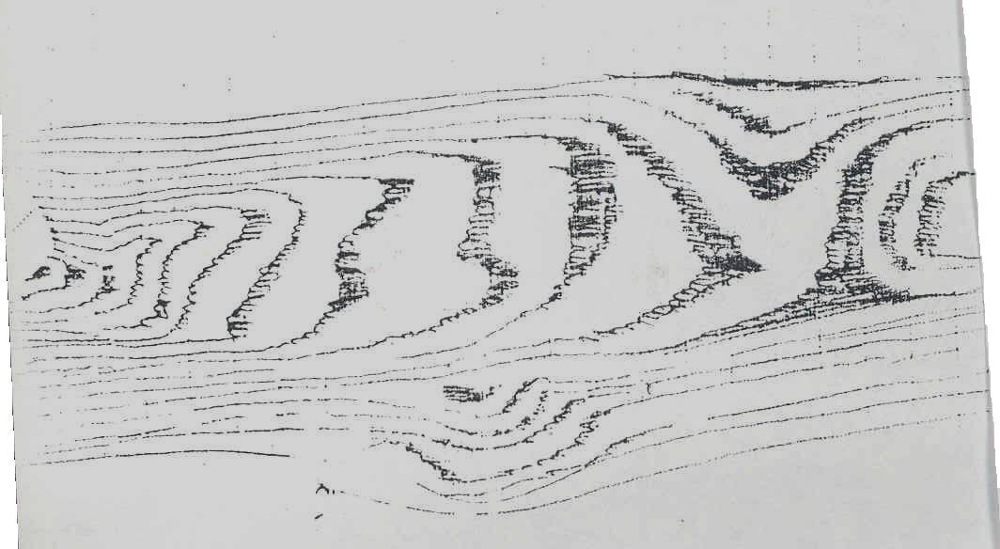

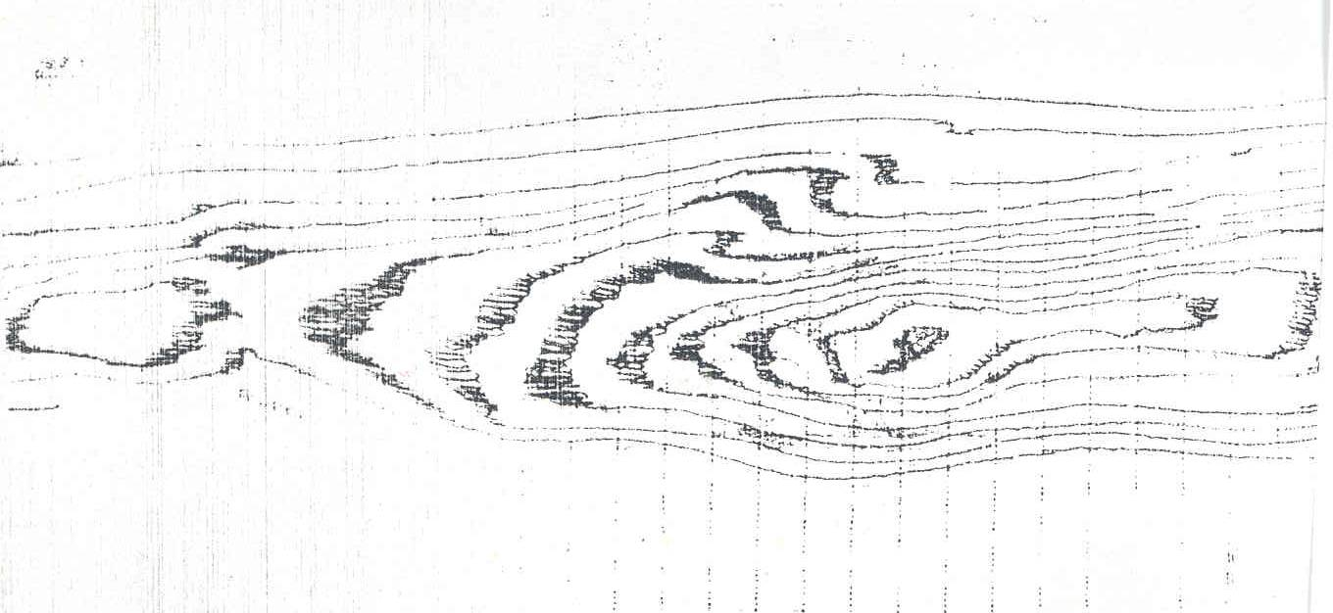

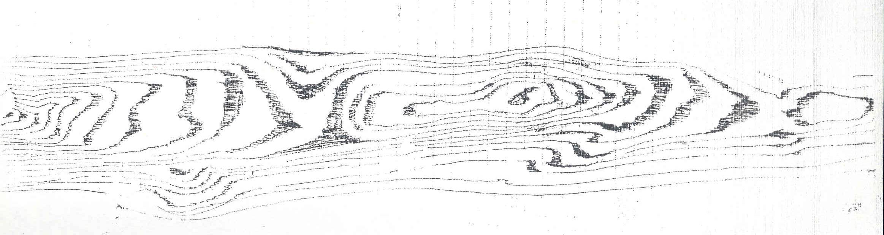

1.4 Types of graining tools
Veining horn
A piece of celluloid, plastic or even a specially shaped piece of timber or ordinary rubber used a thumb piece in conjunction with a piece of clean soft cloth is essential for the production of wiped out feature in the imitation of pitch pine, oak etc.
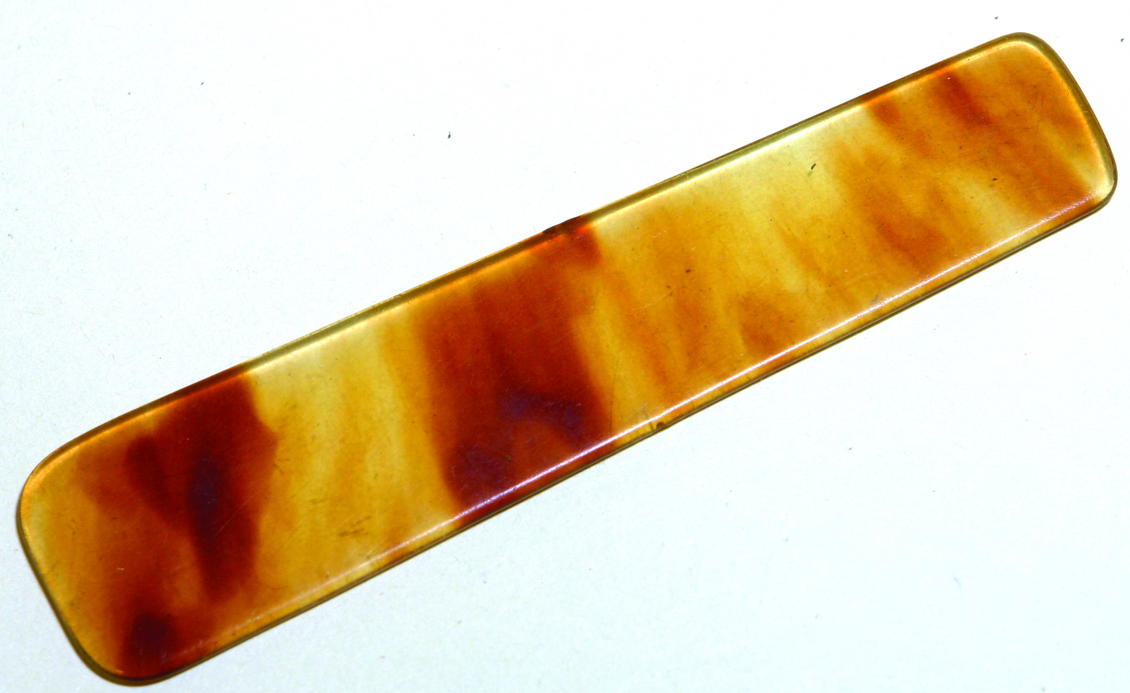
Combs:
Steel graining combs are essential in the graining of oak and other timbers. These range from 100mm to 25mm combs. The combs can be obtained with teeth of various thicknesses. Rubber combs have graded gap sizes are also popular. Many grainers prefer to make their own combs from leather, cork, celluloid etc. Plastic type are also available.
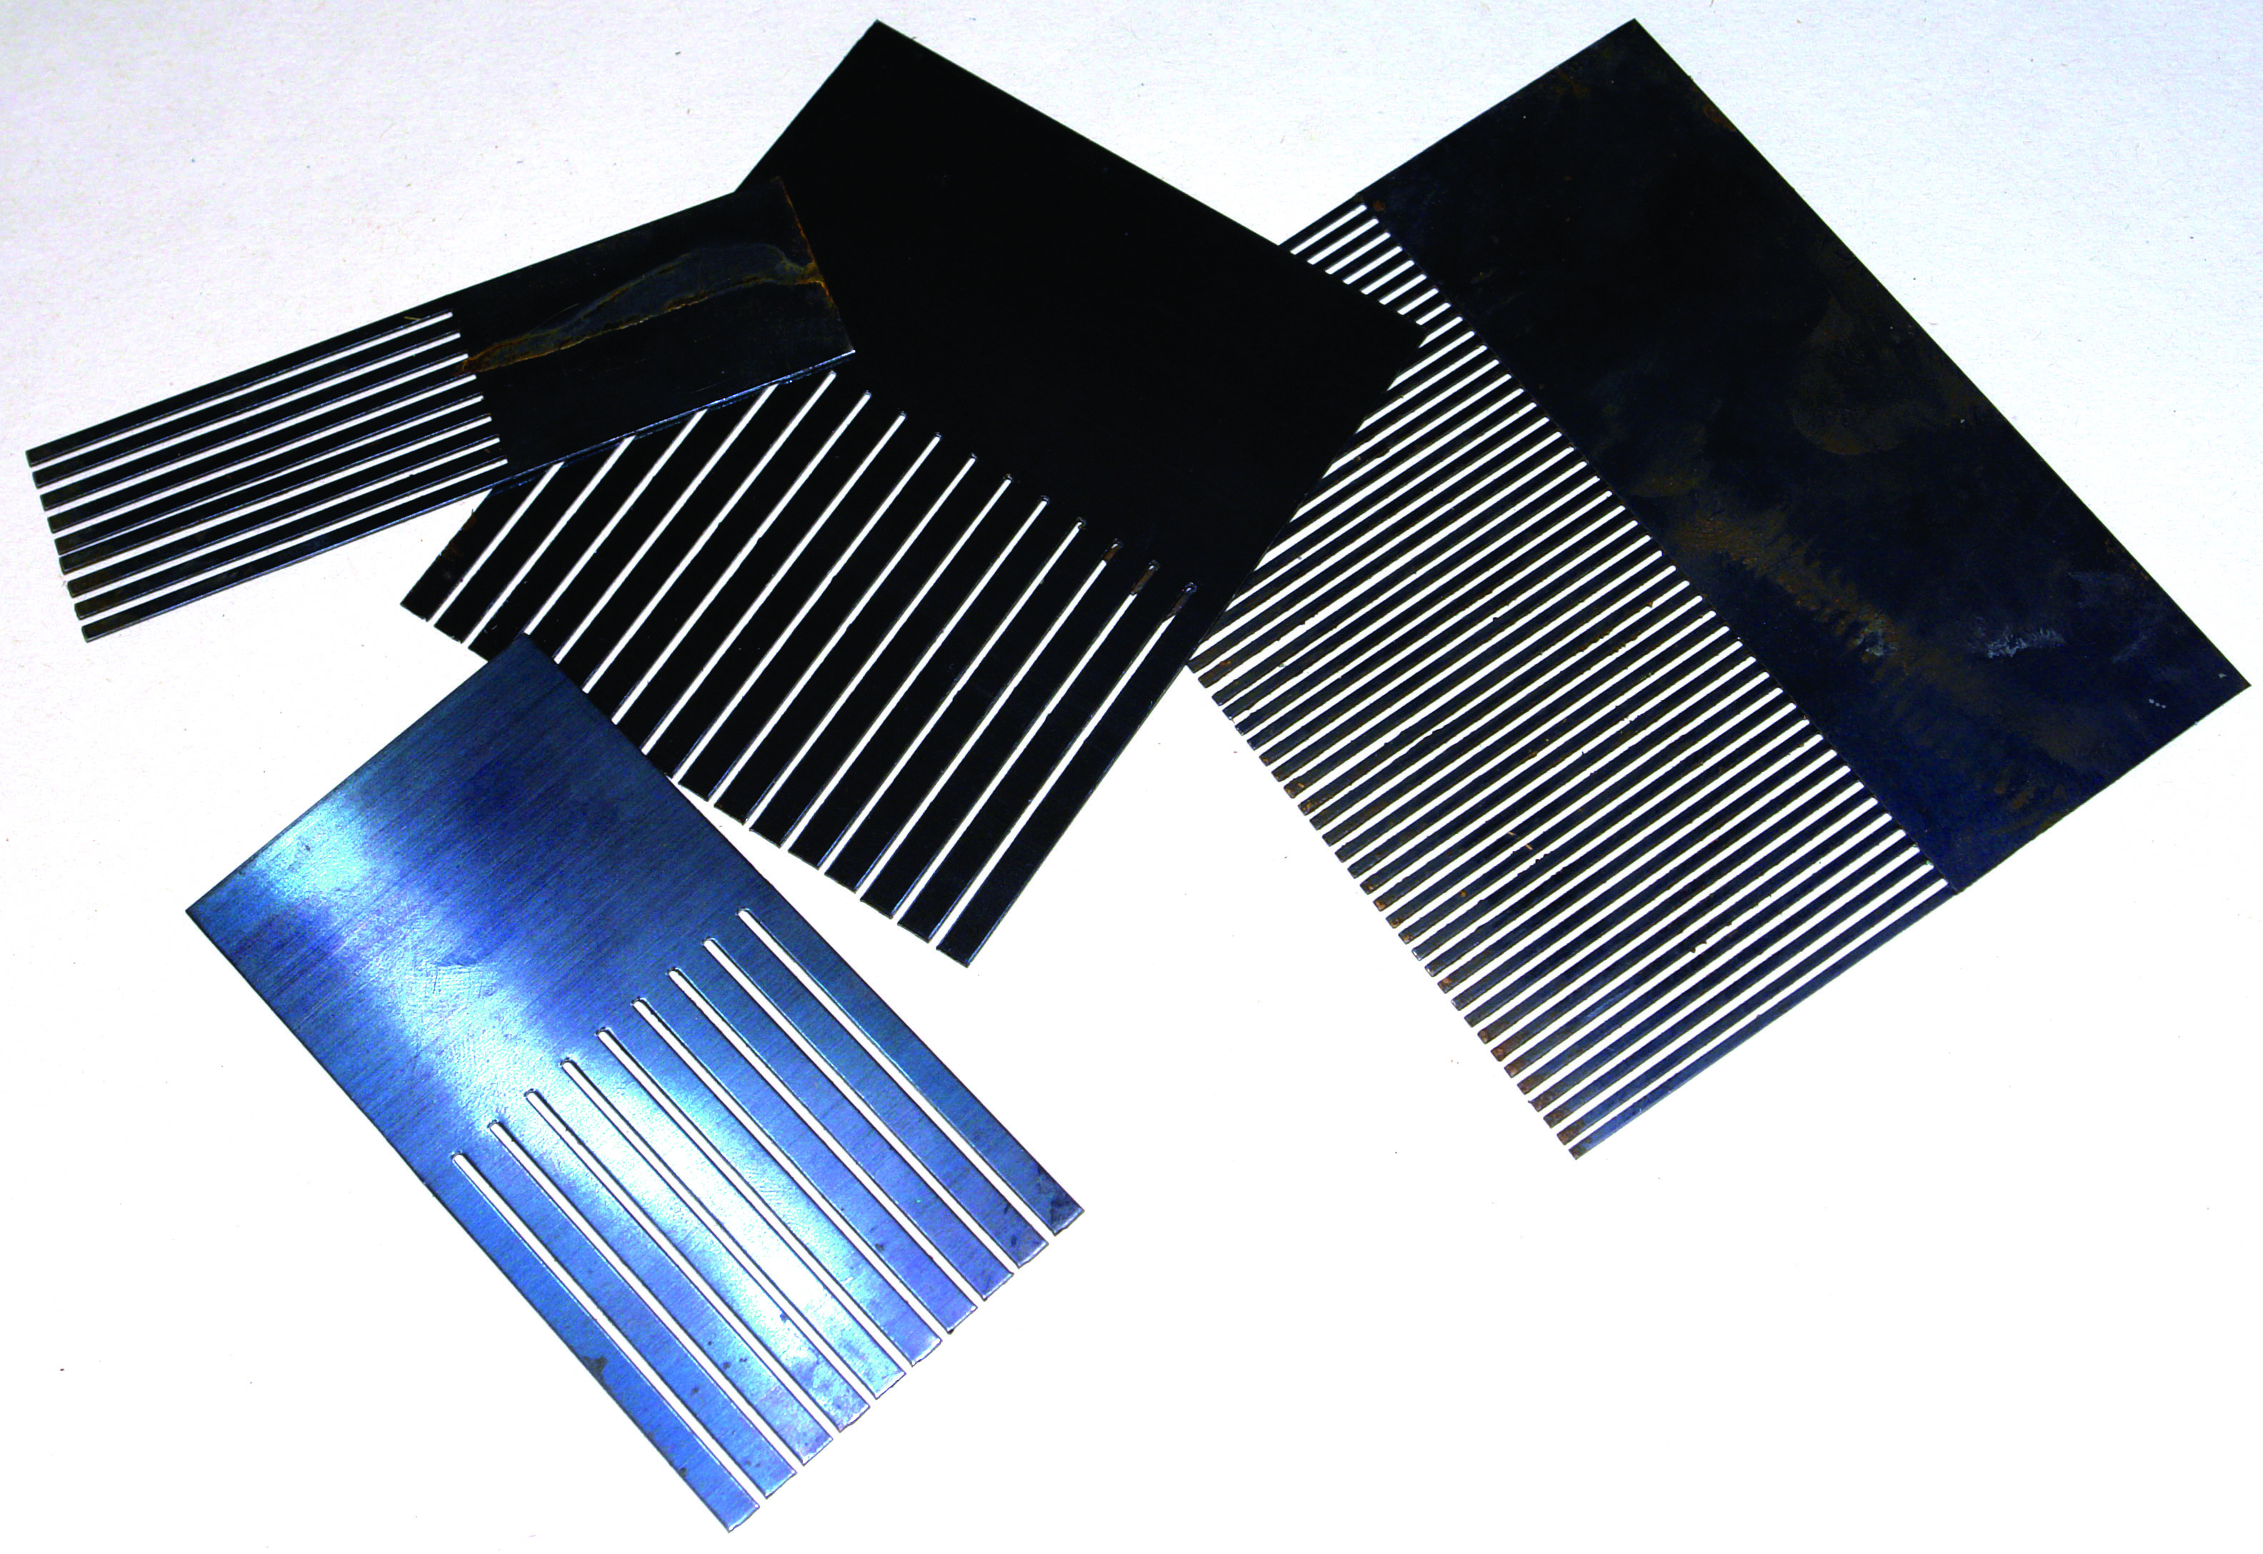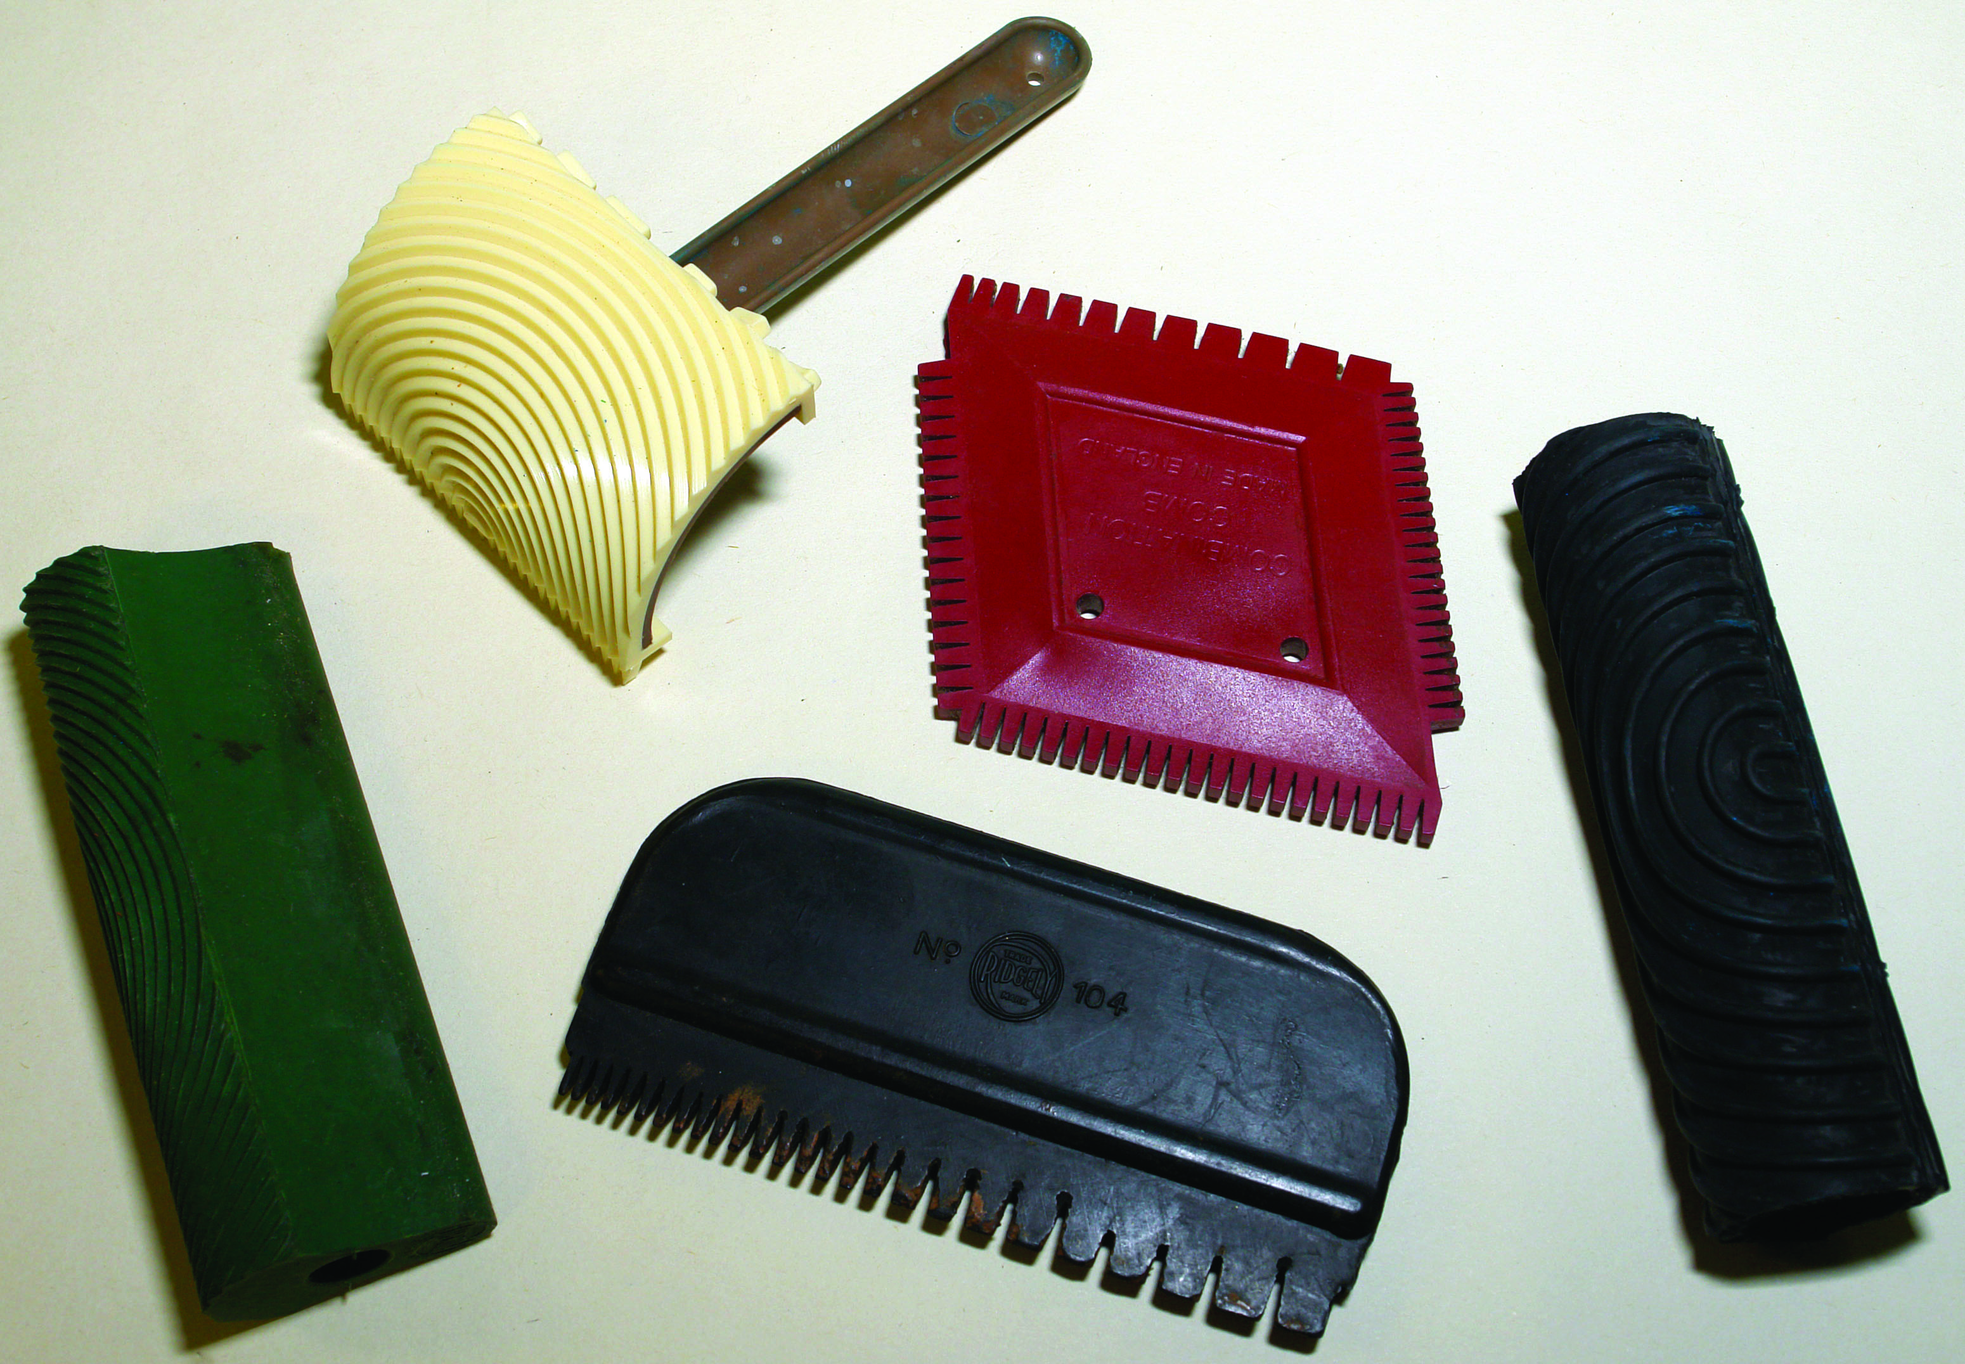
Steel type Rubber & Plastic type
Jamb duster:
A plain straight grain effect is produced by dragging the duster through the wet scumble. Another very different effect can be produced by pushing.
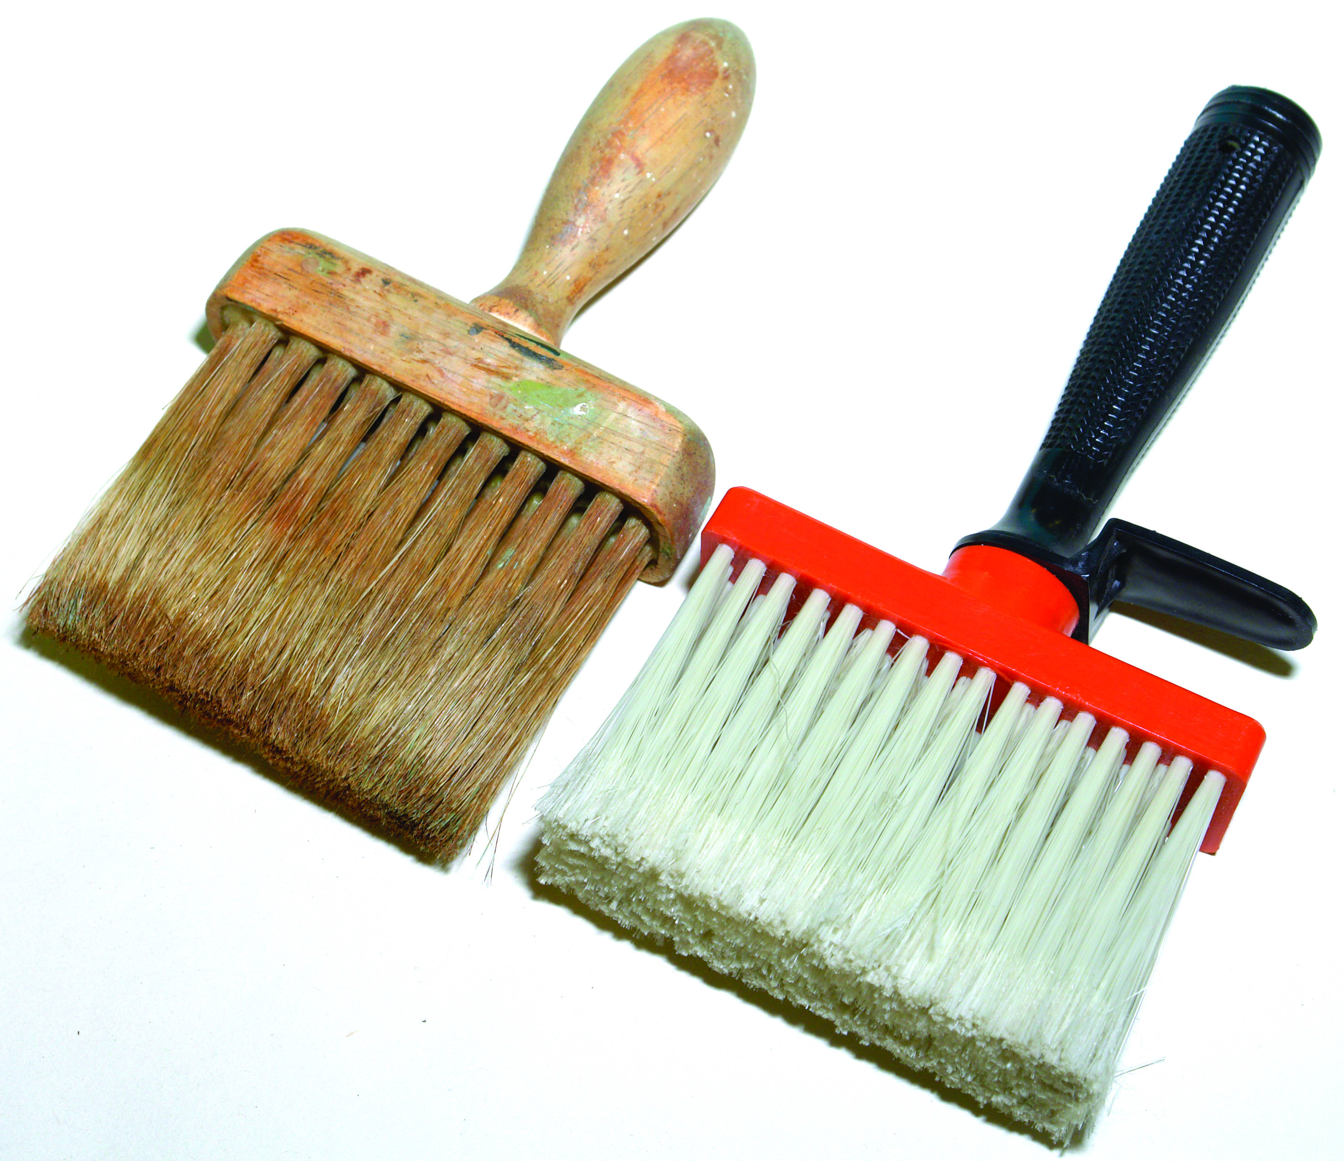
Jamb dusters

The flogger
A long thin brush used to flog wet colour both in oil and water to simulate the pores of hardwoods etc.
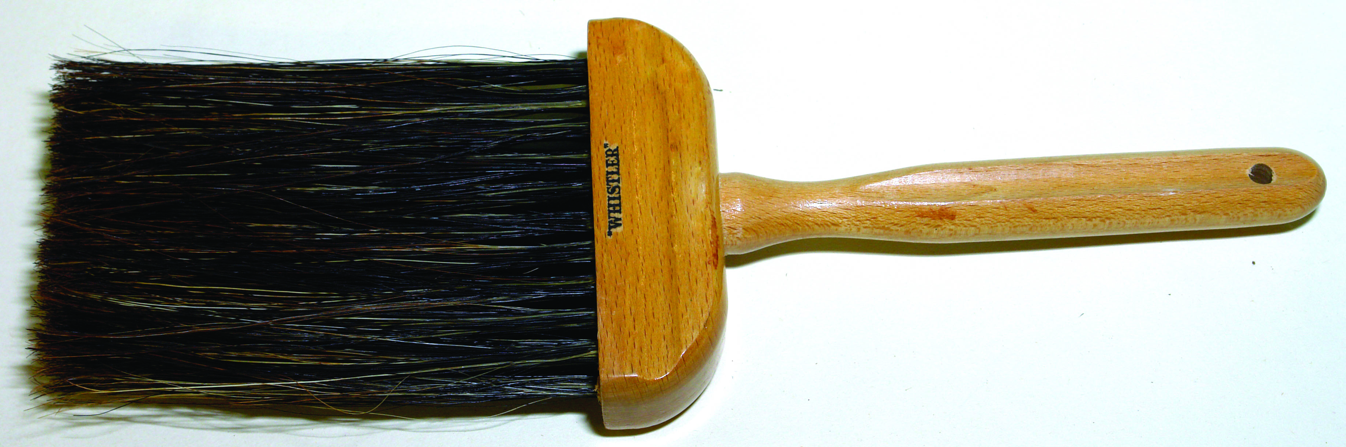
The flogger
Mottlers:
This brush is employed to produce highlights and shades in graining. This tool is generally used in watercolour, although it has great possibilities in oil colour.
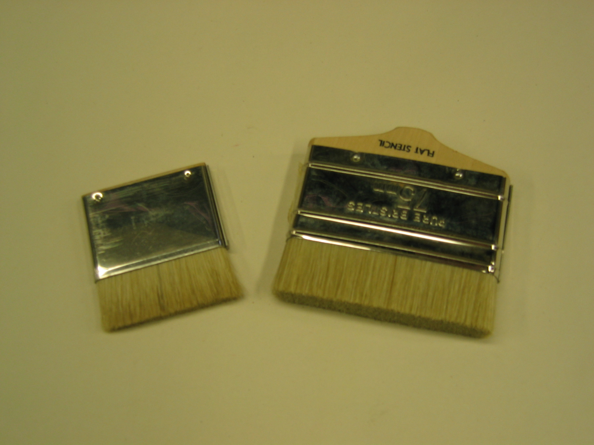
Mottlers
Overgrainers: Pencil overgrainers
These are long thin brushes used in the finishing or over graining on almost any finished job. They are equally efficient in oil or watercolour and save a lot of time. Normally, they are 36mm to 62mm wide. This type of brush produces “grainy” parallel lines. This tool should be used at an angle of 90o to the surface being painted. This tool is a combination of 4 or 6 sable pencils set into a single handle; it is invaluable in the imitation of walnut etc.
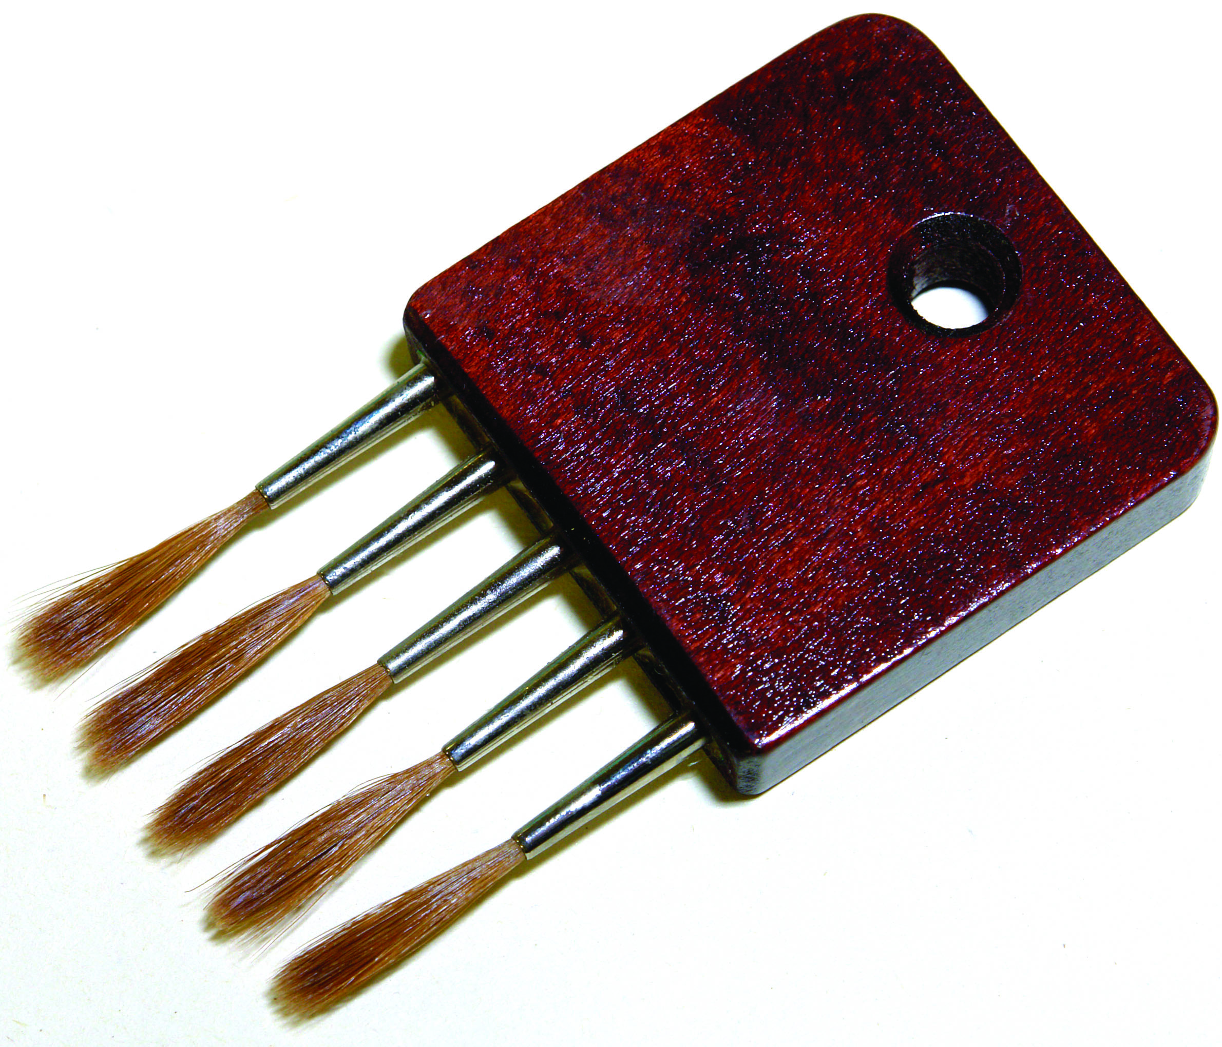
Pencil overgrainers

Softeners:
Softeners are of two varieties, badger and hog’s hair. The badger is used to soften the lines in watercolour. The hog hair to soften the lines in oil colour.
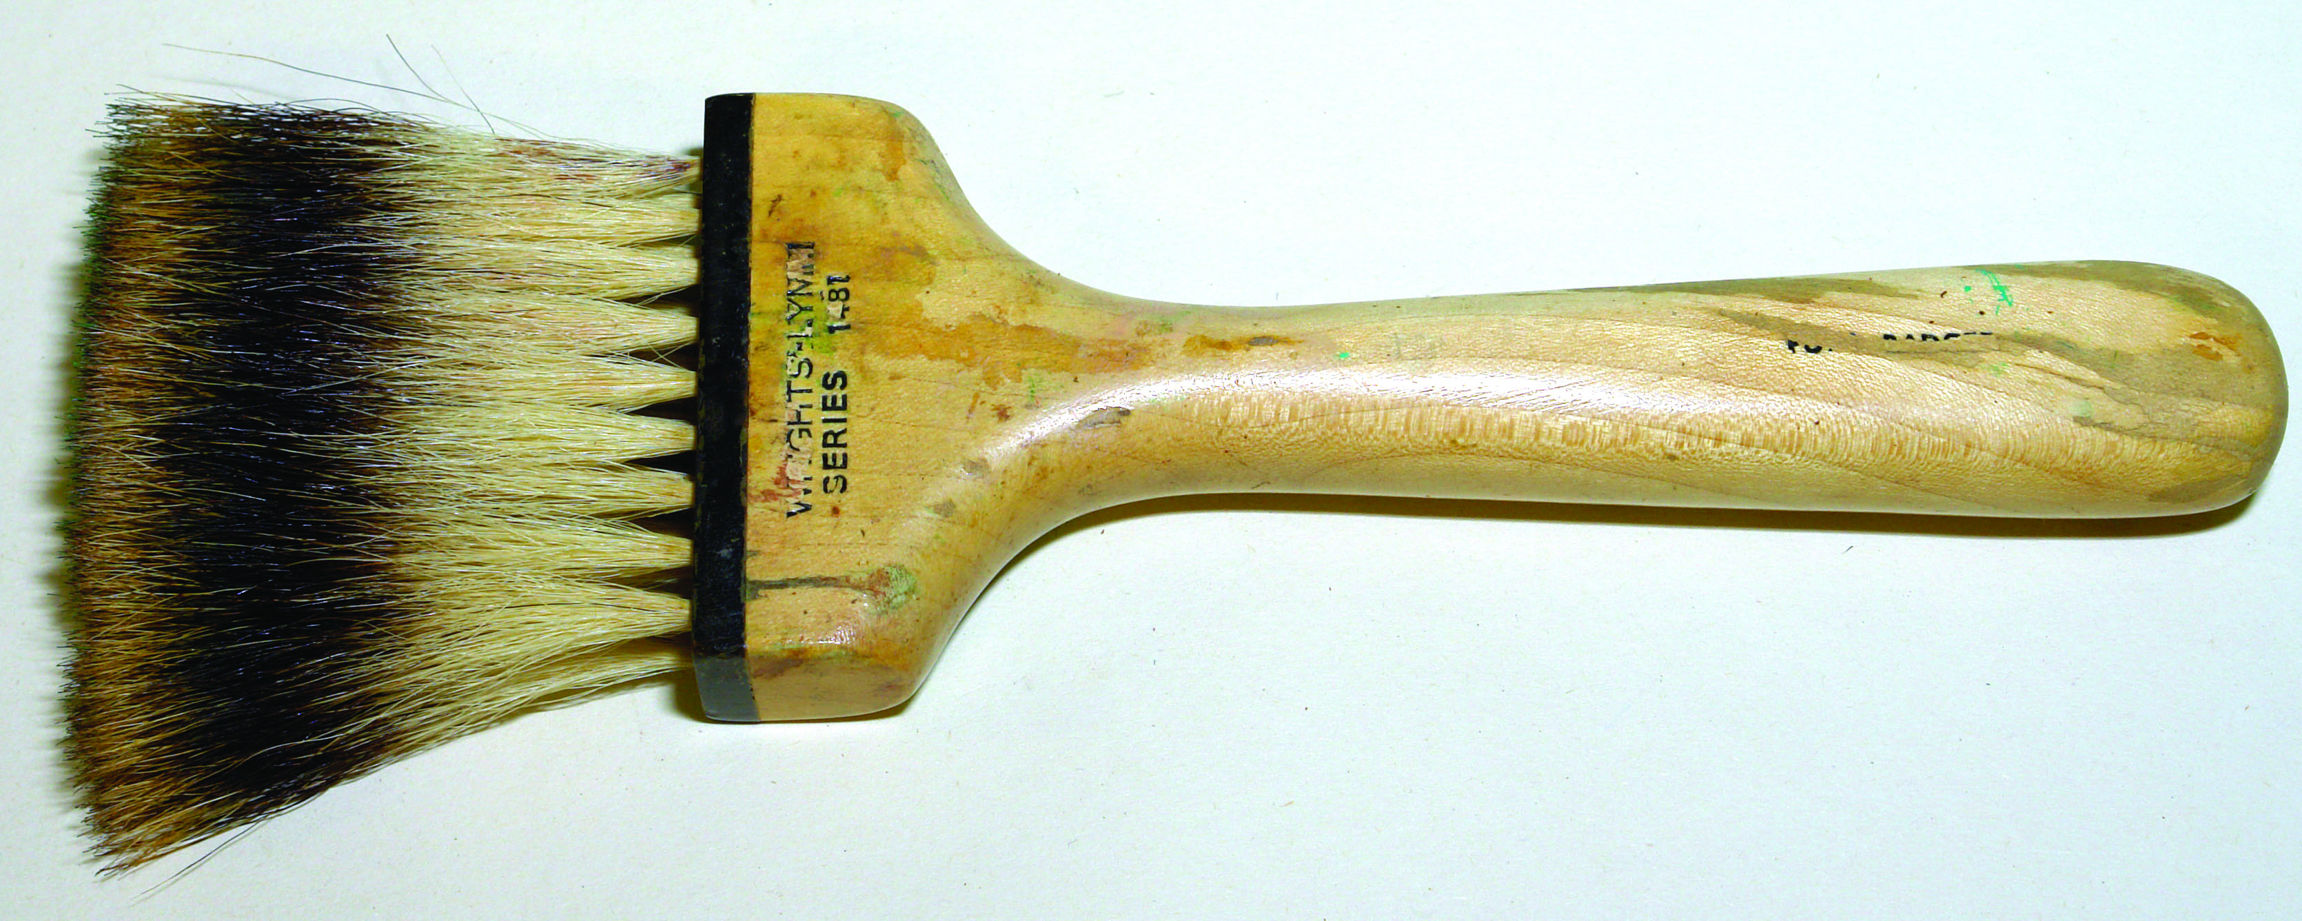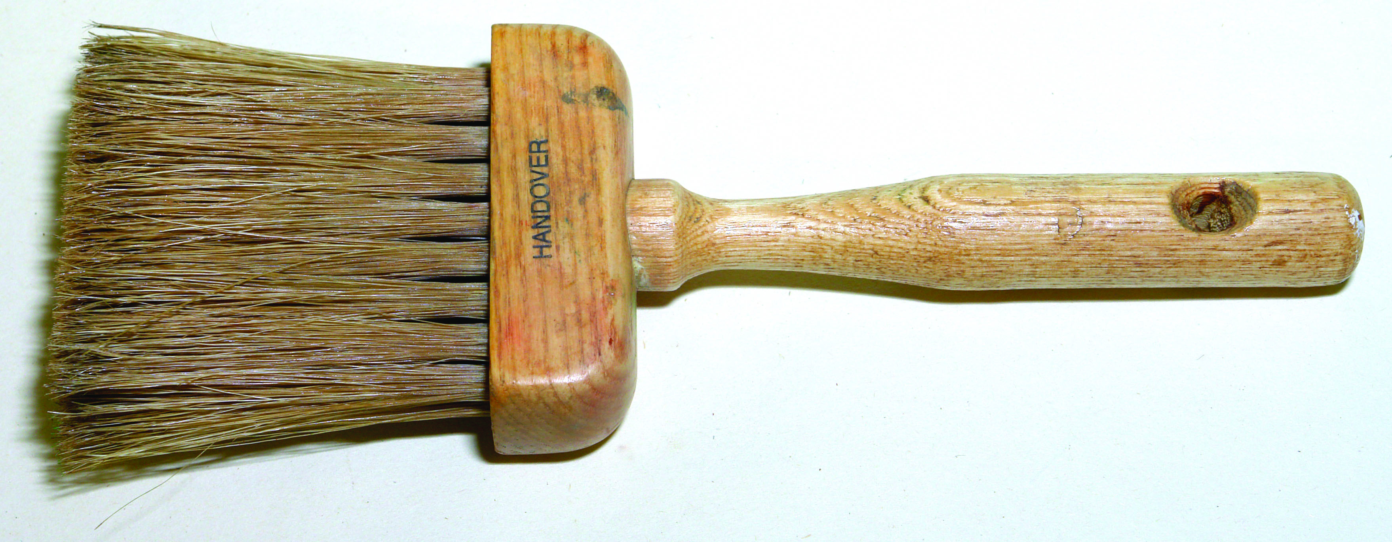
Badger softener Hog hair softener
Fan fitch:
This tool, as its name implies, is fan-shaped and is used in the graining of birch, walnut and pollard oak.
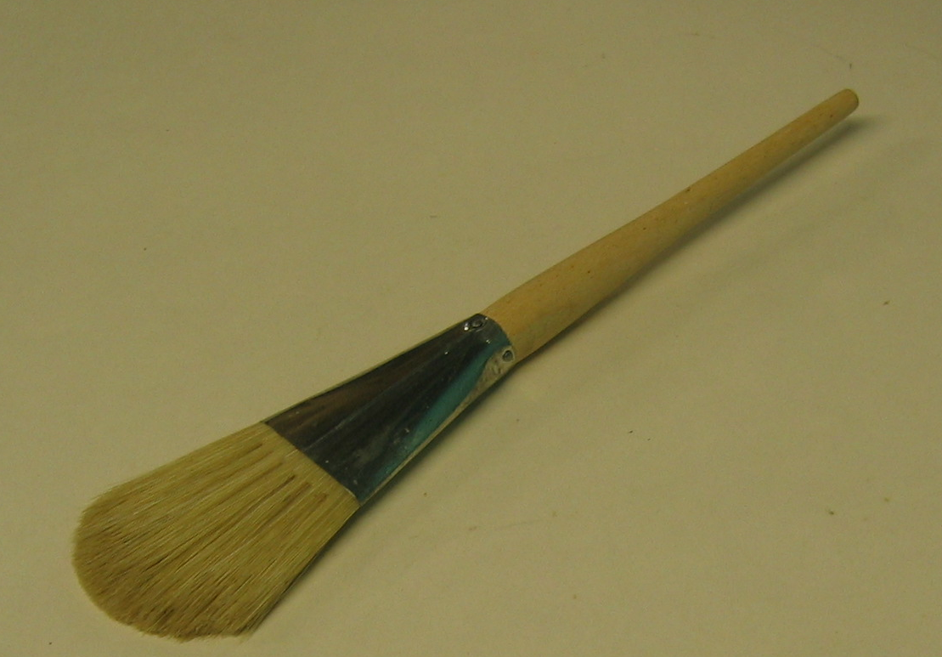
Check roller:
A series of approximately 10 serrated discs mounted on a roller. This tool is often used to produce the dark colour pores in timber. A brush similar to mottler, already dipped in dark colour, is clipped on to the tool. As the discs revolve they pick up small quantities of colour and pass into the surface being treated.
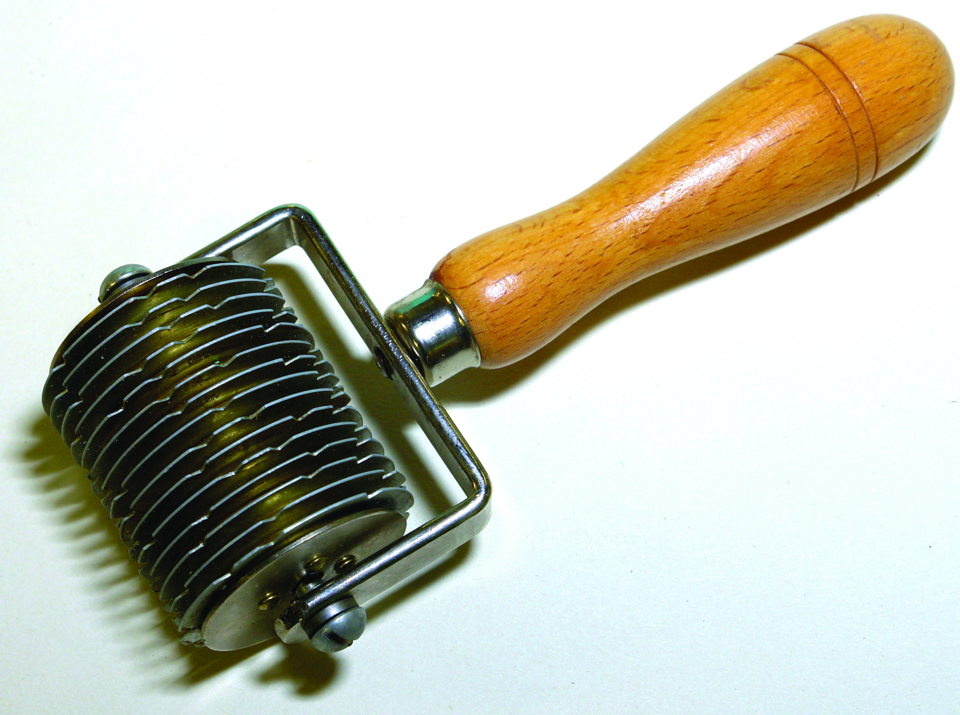
Check roller
Many of the tools mentioned above are improvised by most craftsmen. Other various items come into use from time to time such as stipples, goose feather, chamois, sponges, sable writers etc.

1.5 Function of ground coats in graining
Graining can only be achieved when all the elements in the system are correctly executed. The ground colour is the final coat before applying the graining scumble and it must be well prepared
For oil paints it must be
- The correct colour to capture the colour of the wood being imitated
- An eggshell ground to allow the scumble to be worked.
- Hard dry to prevent being worked up by the solvents of the scumble.
- Non porous to avoid the scumble showing as dry spots.
- Smooth, as applied scumble will collect in any irregularities shoeing darker and spoiling the effect.
For water based the same rules apply but the ground will be flat instead of eggshell otherwise cissing would occur.
Cissing
When a paint or varnish coating fails to form a continuous film on the surface it has been applied to. The paint gathers in some places and recedes in others.

1.6 Mixing ground coats and scumbles to a suitable colour
Ground colours for graining:
When mixing ground colours make sure that in each case they are a little lighter than the glaze that is to be used over them.
GROUND COLOURS FOR GRAINING
SCUMBLE TYPE  RATCLIFFES | GROUND COLOUR  RATCLIFFES U/C | COLOUR  DIMENSIONS NO. | BS 4800 NO
MEDIUM OAK | NO.2  CHROME BUFF | 66YY80322 | O8C35
LIGHT OAK | NO.2  CHROME BUFF | 66YY80322 | TINT OF  O8C35
DARK OAK | NO.4  MID STONE | 2010Y20R
MAHOGANY | NO.6  MID. VENETIAN | 4030Y50R | O4D44
PITCH PINE | NO.2  CHROME BUFF | 66YY80322 | O6C33
Ground Colours mixed from stainers:
Light Oak------------Pale Buff ------------White + Golden Ochre + Raw Umber
Dark Oak------------Deep Buff White + Golden Ochre + BurntUmber
Mahogany-----------Rich Terracotta White Venetian+ Red +Burnt UmberS
Pitch Pine Warm Cream White + Yellow Ochre + Burnt Sienna
Scumble colours mixed from stainers:
Light Oak----------Raw Umber + Raw Sienna
Medium Oak------Burnt Umber +Raw Sienna + Black
Dark Oak ---------Burnt Umber + Raw Sienna + Black
Mahogany---------Burnt Umber + Burnt Sienna
Pitch Pine---------Raw & Burnt Sienna + Burnt Umber
The stainers can be difficult to procure at times and some manufacturer’s undercoats can be very near the required ground colour and need very little alteration. So a ready-made undercoat or eggshell finish can be very helpful and labour saving.
The same can be said when mixing scumble from stainers and by intermixing different prepared scumble a very satisfactory colour can be achieved.
Graining colour:
Oil:
Oil based scumble or a mixture of oil stainers mixed with equal parts linseed oil, and white spirit with a little added driers to produce the graining material. An addition of transparent oil glaze is favoured by some painters. This can help to keep the scumble open after marking with brushes, combs etc. The colour of the ground colour and the graining colour must be close otherwise a poor representation of the wood is produced.
Water based:
Acrylic Scumble. The same principles apply to coloured grounds and scumble colours. Ready made acrylic scumble or the clear glaze tinted with stainers tinted with acrylic stainers can achieve a similar outcome but with a must faster drying time. Less time is offered to the beginner but practice and experience overcomes these problems.

2.0 Coat With Eggshell Varnish
Key learning points
- Identification and application of ground coats, scumble and varnishes
- Cleaning and maintenance of brushes and tools
- Clean and safe work practice
- Geometry-angles and intersecting lines, angles and parallel lines

2.1 Ground coats, scumbles and varnishes
Application of ground coats:
- Should be the correct colour
- Grit free
- Brush mark free
- Hard dry
Application of scumble:
Rubbing in the scumble must be carried out on a hard dry suitably coloured ground coat. The correct colour will be finalised by trying samples and adjusting.
Worn brushes are best for applying as they enable the scumble to be spread evenly - Apply sparingly
The scumble should not be “muddy” looking.
Thin with white spirit and linseed oil to achieve a transparent mixture.
It should not set up quickly as it will not allow sufficient time for marking.
Appliation of varnish:
Successful varnishing depends on the cleanliness of the brush, material and surface.
Varnish:
- If the varnish has been previously used it should be strained.
- Eggshell varnish should be well stirred.
- Read the manufacturers instructions.
Brushes:
- Broken in brushes are best as new bristle brushes shed small hairs
- Synthetic brushes do not.
- Brushes used for varnishing should be kept separately and never used for painting.
Surface:
- Use a tack rag to remove any surface dust
- Place clean paper under the item being varnished to avoid dust being picked up by brush.
Application:
- Apply a full even coat with no misses or runs
- Keep wet edge alive to avoid flashing

2.2 Cleaning and maintenance of brushes and tools
Specialist brushes that have been used in for graining are expensive and need care and attention when using and storing. These brushes are not used regularly so when required they must be in good condition. If properly cared for these brushes will last the working life of the craftsperson.
All graining brushes if used in oil based materials should be
- Washed out in white spirit several times to ensure that all the scumble has been removed
- Wash in warm water and soap
- Leave to dry before storing
- Store in a clean dry area
Tools such as combs should be wiped clean and dried and placed in its special protective wallet.
When using water scumble the washing out of the brushes must be thorough using warm water and soap. Finally rinsing in clean warm water and leaving to dry before storing.

2.3 Clean and safe work practice
Clean working practice leads to safe work practice. Decorative effects such as graining cannot be carried out efficiently in an untidy environment. The cleanliness or otherwise of the area will show in the work.
Cleanliness:
- Vacuum area to avoid raising dust
- Cover area
Safety:
- Do not store used white spirits
- Cover and store all mixed scumble
- Dampen and remove used cloths to avoid spontaneous combustion.
- Ensure proper ventilation due to the high solvent content of the white spirit
- Wash hands with recommended painters hand cleaner

2.4 Geometry-angles and intersecting lines, angles and parallel lines
Reference Module 1 Unit 4 1. 8

3.0 Brush Graining Representing Oak, Mahogany and Pine
Key learning points
- Flogging, combing, dragging and softening
- Graining with brush and comb
- Matching existing work

3.1 Flogging, combing, dragging and softening
Flogging: The surface of hardwood
Flogging:
Most hard woods have very prominent pores. They are a distinctive feature of the grain. Flogging is a way of imitating this feature. The flogger is a long haired brush used for this purpose. The wet scumble is flogged with the side of the bristles the flogger working form the bottom of the work upwards. This is an easy task to master and practice will bring personal techniques.
If the scumble is allowed to set before flogging commences the pores will be finer. For maximum contrast the scumble should be applied “very wet”.
Combing:
A simple method of producing grain. Generally used in the imitation process of oak and pitch pine.
Metal combs are used for oak while rubber is used for pitch pine.
Method using the metal comb
Apply scumble to the panel.
Select a 75mm metal comb and cover it with a piece of lint free cloth pulling it tightly. Apply a little scumble to the top edge of the cloth to avoid absorbing too much scumble when drawing the first series of combing lines. Draw down through the wet scumble forming lines. Expose a new section of the cloth and do exactly the same again. Repeat this process until the panel is complete.
Now select a 25mm comb and at an angle of 30º flick upwards across the lines breaking them up.
Some execute this work without covering with the comb with a cloth. A similar effect is produced the comb being wiped after each stroke. This is generally used as the background or first stage when imitating quartered oak.

Using the rubber comb:
When graining pine the scumble is applied and the heart painted in the rubber combs which have teeth varying from wide to narrow on the one piece are pulled through the wet scumble following the painted grain. Clean after each stroke.
Dragging:
A subtractive simple technique and it means drawing a clean dry dragging brush or dusting brush through wet scumble exposing the ground colour in straight lines. A paint brush does not give the same effect. While it is a simple task it should be performed very carefully.
Softening:
In the softening technique the scumble when applied can be softened in different directions to blend the scumble by lightly brushing over the surface in different directions. This gives a blending tonal effect from light to dark. These brushes are very soft and leave no brush marks.
When the grain is pencilled in the harsh lines can be softened by lightly softening outwards. This softening must be completed before the work sets up otherwise the brush marks will show.
When carrying out this work on water scumble the softening must be carried out immediately as the work dries very quickly. After practicing this work the time taken for drying will become evident.
The hog hair is used with oil scumble and the badger used with water scumble.

3.2 Graining with brush and comb
Sometimes called brush graining and is the most basic form of graining.
The simplest way of all to obtain ‘woody’ effect. An ideal treatment for skirtings, architraves etc. It is a way of explaining to the beginner how important the relationship between ground colour and the scumble is. A dry brush, jamb duster is passed or drawn over the freshly applied scumble opening up the scumble.
This is produced by obtaining first a coloured ground, say light or deep buff, then applying a darker over it and while it is still wet drawing a brush across it so as to remove hair like parts of the paint, exposing the colour underneath. The effect is very good and very many different effects may be produced by varying the ground and that of the graining colours. Another advantage is the cheapness of the method.

Instead of dragging push the brush to give a different effect.
This process is of limited value as it gives a mechanical effect if used too much. It is best used as a ground for further treatment. Each member of a piece of woodwork must be treated individually
This is produced by obtaining first a coloured ground, say light or deep buff, then applying a darker over it and while it is still wet drawing a brush across it so as to remove hair like parts of the paint, exposing the brighter colour underneath. The effect is very good and very many different effects may be produced by varying the ground and that of the graining colours. Another advantage is the cheapness of the method.
Brush graining is not only cheap and effective in appearance, but is very durable and it makes no pretension to copy the appearance of real wood, but merely to produce a pleasing surface, which suggests wood.
The method of application being that the ground colour is put on in the usual manner; a coat of graining colour is then given and while wet is flogged or manipulated with a flogger, or alternatively a dry brush is drawn over the surface so that portions of the graining colour are removed, as already explained, in minute hair-like lines exposing the ground colour beneath. The work is then left to dry and coated with varnish, gloss or flat whichever type of finish is required.
The combing process can be carried out in the same manner substituting the combs for the drag brush.
Steps in graining a painted door:
- Remove fittings and wash with white spirit, especially around handles.
- Rub down with wet and dry paper grade 120/180. Wash off and dry.
- Spot fill if necessary.
- Apply two coats of ground colour. Leave to dry for a day between coats. Always rub down lightly between coats.
- Mix and apply scumble to correct consistency by adding linseed oil, white spirit, transparent oil glaze and driers. Leave to dry for a day.
- Apply a full coat of varnish.
- Clean and replace fittings.
Explination of terms:
Stain:
A solution containing a soluble dye. The solution can be water, spirit or oil soluble dyes. Used to change the colour of timber by penetrating it but not obliterating the material grain.
Scumble:
Semi-transparent pigments (oil or water based) which is applied over a hard ground of suitable colour and while it is still wet it is manipulated to imitate the natural grain of timber.
Glaze:
A transparent or semi-transparent colour applied over another to give a broken colour effect.

3.3 Matching existing work
This is a very difficult area for a beginner but it is a very common request. One example would be to match a older door frame to a newly installed hardwood door.
The lightest colour of the hardwood will be the ground colour and a match for this can be taken from a colour card. Generally needs a little adjustment. Paint up a small sample board and apply the ground colour. Intermixing scumbles and making tests will bring the job to a reasonable match.

Summary
Graining as a regular job of painting and decorating is perceived to a large extent as out of date. This is not strictly true, because whereas in times past it was in everyday use, today it is a more specialist area of decoration. The proof of the fact that is still a highly sought after effect can be seen in the amount of DVDs, books ,internet articles and catalogues of tools available along with the variety of ready made materials on the market.
Today graining is no longer restricted to wood colours and is very successfully produced in any colour on wood work and furniture.

Suggested exercises
- Prepare three panels for mahogany, pitch pine and oak .
- Mix and apply scumbles to suit and manipulate with graining tools and brushes produce the desired effect.
- Finish with an eggshell varnish.

Self test
Q. 1 Name three graining tools
Q.2 Explain the following materials
- A stain
- A glaze
- A scumble
Q.3 What is spontaneous combustion? How is it avoided?
Q.4 Match the wood colour the following ground colours
- Warm cream
- Terra cotta
- Pale buff
Q.5 Why is transparent glaze added to scumble
Q.6 What are the following graining tools used for
- Flogger
- Hog hair softener
- Badger softener
- Check roller
- Dragging brush

Recommended Additional Resources
Parry’s Graining and Marbling (ISBN 0-00-383131-0)
Authors Brian Rhodes and John Windsor.

The Handbook of Painted Decoration (ISBN 0-500-01712 3)
Yannick Guegan and Roger Le Puil

The Art of Woodgraining (ISBN 0-356 17536 7)
Stuart Spencer

Leonard Pardon Graining DVDs
JH Ratcliffe’s Graining DVDs


27-33 Upper Baggot Street
Dublin 4

