Trade of Plumbing
Module 2: | Domestic Hot and Cold Water Service
Unit 12: | Above Ground Sanitary Pipework
 | Phase 2

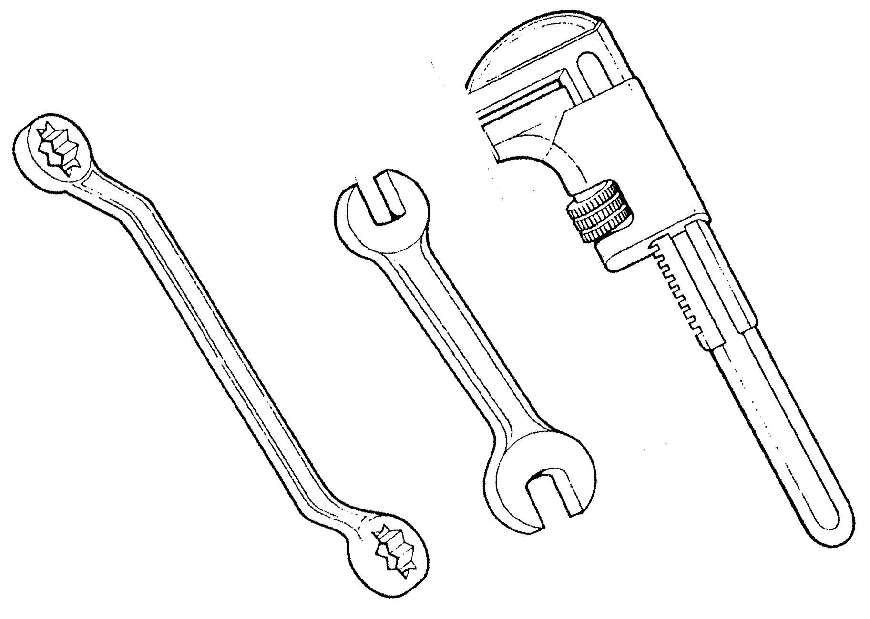

Table of Contents
List of Figures 4
List of Tables 5
Document Release History 6
Module 2 – Domestic Hot and Cold Water Services 7
Unit 12 – Above Ground Sanitation Pipework 7
Learning Outcome: 7
Key Learning Points: 7
Training Resources 8
Key Learning Points Code 8
Above Ground Sanitation 9
Terminology 9
Stack 9
Waste Pipe Connections 10
Traps 11
Trap Seals 12
Loss of Trap Seals 13
One Pipe System 15
Principle 15
Trap Ventilating 15
Air Compression 15
Main Vent Stack 15
Use of System 15
Single Stack System 17
Principle 17
Air Compression 17
Design Considerations 17
Resealing Traps 19
Rainwater 20
Self Assessment 25
Exercise: 25
Index 27

List of Figures
Figure 1. Discharge Stack, Ventilation Stack, and Branch Discharge Pipe 11
Figure 2. Types of Traps 12
Figure 3. Examples of Trap Losses 14
Figure 4. One Pipe System 16
Figure 5. Single Stack System 18
Figure 6. Resealing Traps 19
Figure 7. Rainwater Pipes 21
Figure 8. Gutters and Rainwater Pipes 23
Figure 9. Support Centres for Gutter 24
Figure 10. Types of Traps 26

List of Tables

Document Release History
Date | Version | Comments
June 2006 | V.1.0
14/02/14 | 2.0 | SOLAS changeover

Module 2 – Domestic Hot and Cold Water Services

Unit 12 – Above Ground Sanitation Pipework
Duration 18 hours

Learning Outcome:
By the end of this unit each apprentice will be able to:
- List and describe the various systems of above ground sanitary pipework.
- Explain the causes of loss of trap seals and preventative measures.
- Assemble soil and waste pipework project.

Key Learning Points:
Rk | Principles and terminology of above ground sanitation.
Rk | Types of above ground sanitary systems - two pipe, one pipe, single stack.
Rk | Advantages and disadvantages of different systems.
Rk | Building regulations - drainage and waste water disposal.
Rk | Types and purpose of traps, depth of seal.
Rk Sc | Loss of trap seal.
P | Problem solving.
Rk | Pipe sizes, materials and joints.
Rk | Ventilation.
Rk | Connection of washing machines/dishwashers to sanitary pipework.
Rk | Prevention of cross flow.
Rk | Testing above ground sanitary pipework.
Rk | Access for maintenance and cleaning.
Sk H | Preparation of pipe for jointing.
Sk H | Use of solvent cement.
Sk | Methods of jointing and assembly.
Sk | Interpretation of drawings.
Sk | Preparation of materials list.
P | Planning, communication.
Sk | Bracketing soil and waste pipework.
P | Working independently.
P | Good working practice.

Training Resources
- Classroom facilities and information sheets.
- Building regulations technical guidance document H - drainage and waste water disposal.
- Workshop facilities, sample traps, waste pipes and fittings.

Key Learning Points Code
M = Maths D= Drawing RK = Related Knowledge Sc = Science
P = Personal Skills Sk = Skill H = Hazards

Above Ground Sanitation
The Great Plague of London during the 17th century was the direct result of poor sanitation and overcrowding living conditions. It swept large areas of the country and caused many deaths, but it should not be assumed that this was the only outbreak of its type. Such epidemics have occurred throughout the history and are still rife in under-developed countries, though fortunately nowadays they are fairly localised.
It was not until early Victorian era that forward thinking people associated the terrible toll of human life with the lack of effective sanitation. In 1875 the London County Council first laid down a system of by-laws or rules to which the installation of sanitary systems had to conform. Other local authorities quickly followed, each producing their own local by-laws. While in most cases these by-laws were very similar, the differences which did occur were due largely to their interpretation by individual local authorities. So it will be seen that the sanitary pipework systems as we know today are the product of necessity and legislation by successive governments and local authorities in comparatively recent years.

Terminology
To avoid confusion, some knowledge of the terms relating to sanitary pipework is necessary.
The terms “soil pipe” and “waste pipe” are both derived from the original two-pipe system of sanitation where a soil pipe was connected to a WC and a waste to an ablutionary fitting. These terms are not generally used now; both being designated “discharge pipes”.
The general arrangement of a well designed discharge pipe system should embody the following features. It should permit the speedy removal of waste to the underground drainage system and must prevent the ingress of foul air into the building by efficient trapping and maintenance of the trap seals. Adequate provisions should be made for access in the event of blockages in the system and materials should be chosen to ensure a trouble-free and corrosion-resistant life.

Stack
The terms “stack” relates to a vertical pipe. The portion of which carries waste water is referred to as the “discharge stack”, and the part which does not carry waste is called the “ventilation stack”. A pipe carrying waste water from a fitting or group of fittings to the main discharge pipe is called a “branch discharge pipe”. These terms are important and are clearly shown in Fig 1.

Waste Pipe Connections
For general purposes all water discharged from a waste or soil appliance is deemed to be contaminated and must be disposed of in a safe and efficient manner.
For this purpose all sanitary fixtures must be connected to a waste pipe. The sizes for the appliances are given in the tables below.

Appliance | Waste Size
Sinks | 40 mm
Shower Trays | 40 mm
Baths | 40 mm
Wash Basins | 32 mm
Bidets | 32 mm
Bowl Urinals | 32 mm
Drinking Fountains | 32 mm
W.C. Pan and all Soil Appliances | 100 mm
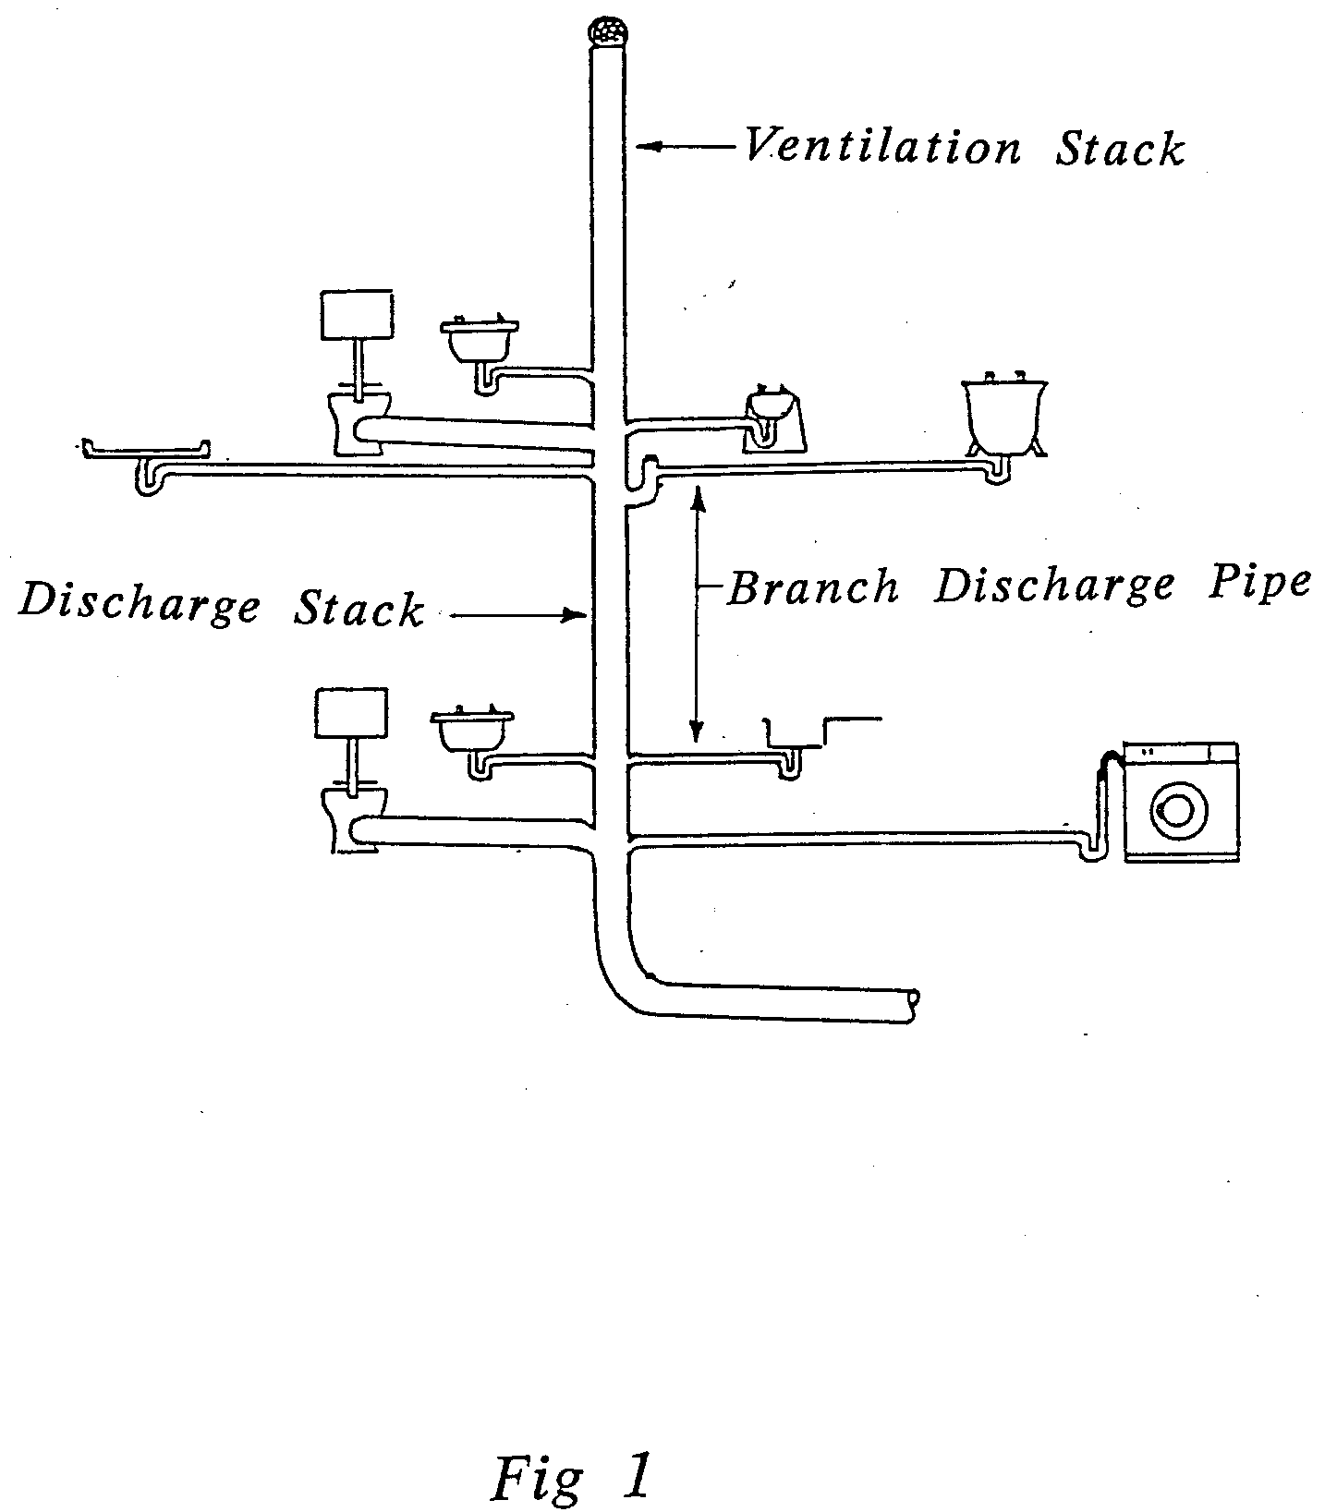
- Discharge Stack, Ventilation Stack, and Branch Discharge Pipe

Traps
A trap is a fitting or part of an appliance designed to retain a body of water thus preventing the passage of foul air. Traps should be fitted close to a waste or soil appliance, unless the appliance has an integral trap.
There are many different types of traps:
- “S” traps - Vertical outlet
- “P” traps - Horizontal outlet
- “Bottle” traps - Horizontal outlet
- “Running” traps - Horizontal outlet

Trap Seals
The depth of the trap would depend upon the circumstances and the usage of the pipe, but in general pipes of less than 50mm internal bore (e.g. baths, wash hand basins, sinks etc) would have a trap with a seal of not less than 75mm. For pipes with a larger internal bore than 50mm (e.g. WC pans, slop hoppers etc) a trap with a seal of 50mm is required, the reason being that it is much less likely that trap seal loss will occur in a pipe so large.
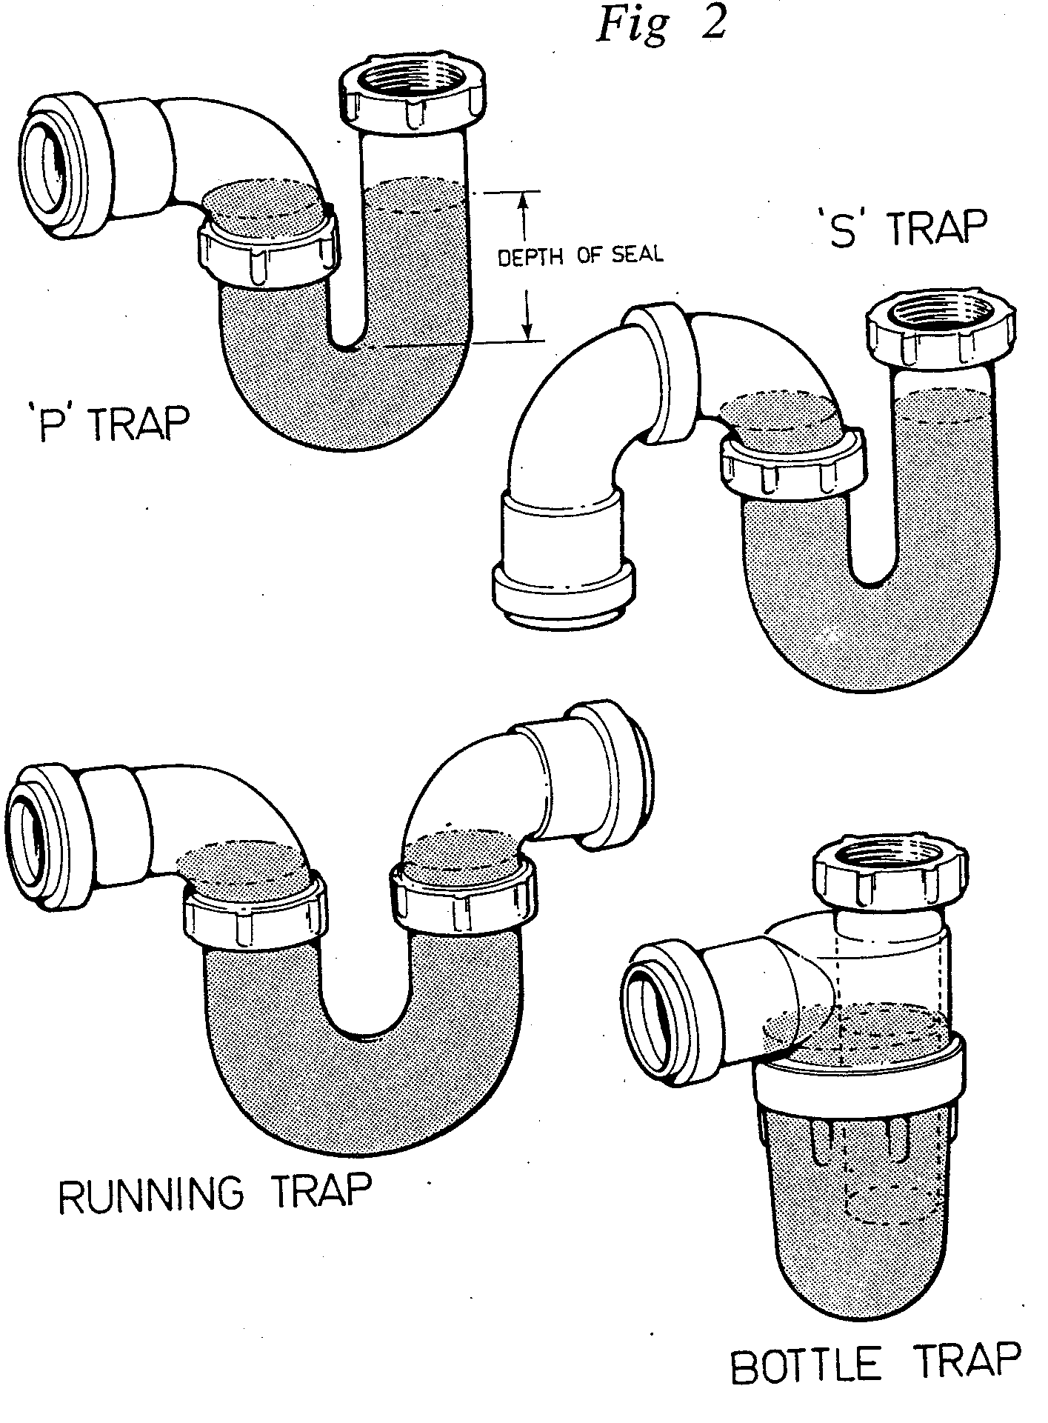
- Types of Traps

Loss of Trap Seals
The most likely ways for traps to loose their seal are:
- Leakage: This will allow water in the trap to empty onto the floor and is consequently soon noticed and repaired.
- Siphonage: This may be either self siphonage or induced siphonage. Self siphonage occurs when a waste pipe is flowing full bore and, because of the absence of the absence of an anti-siphon facility, a vacuum is formed and the trap becomes unsealed.
Induced siphonage occurs when two or more waste pipes are connected together. The water from the farther sanitary fitting, flowing past the branch connection of the nearer fittings, withdraws air from the branch pipe of the nearer one. A partial vacuum is thus created on the outlet side of the trap on the nearer fitting and siphonic action as created, emptying the trap.
- Compression: When water is discharged from an application at a higher level the air in the vertical pipe may become compressed sufficiently to “blow” out the seal in the lower appliance.
- Capillary Attraction: If a piece of absorbent material is caught in the outlet of the trap with one end dipping in the water and the other end hanging over the outlet, the water may be drawn out by capillary action through the metal.
- Wavering Out: This is caused by gusts of wind passing over the top of the vent pipe and is often noticed in a WC trap on a windy day. The wind withdraws some of the air from the stack, thus creating a partial vacuum on the outlet side of the trap, and setting up siphonic action. The gusts of wind cause the water in the trap to sway backwards and forwards until the seal of the trap is broken.
- Evaporation: If the appliance is not in use for a long period of time the water in the trap will evaporate.
- Momentum: This is caused by the sudden discharge of water into the trap. The force of the water may be sufficient to unseal the trap. The discharge of a bucket full of water into a WC is the most usual cause.
Some examples of trap losses can be seen in Fig 3.

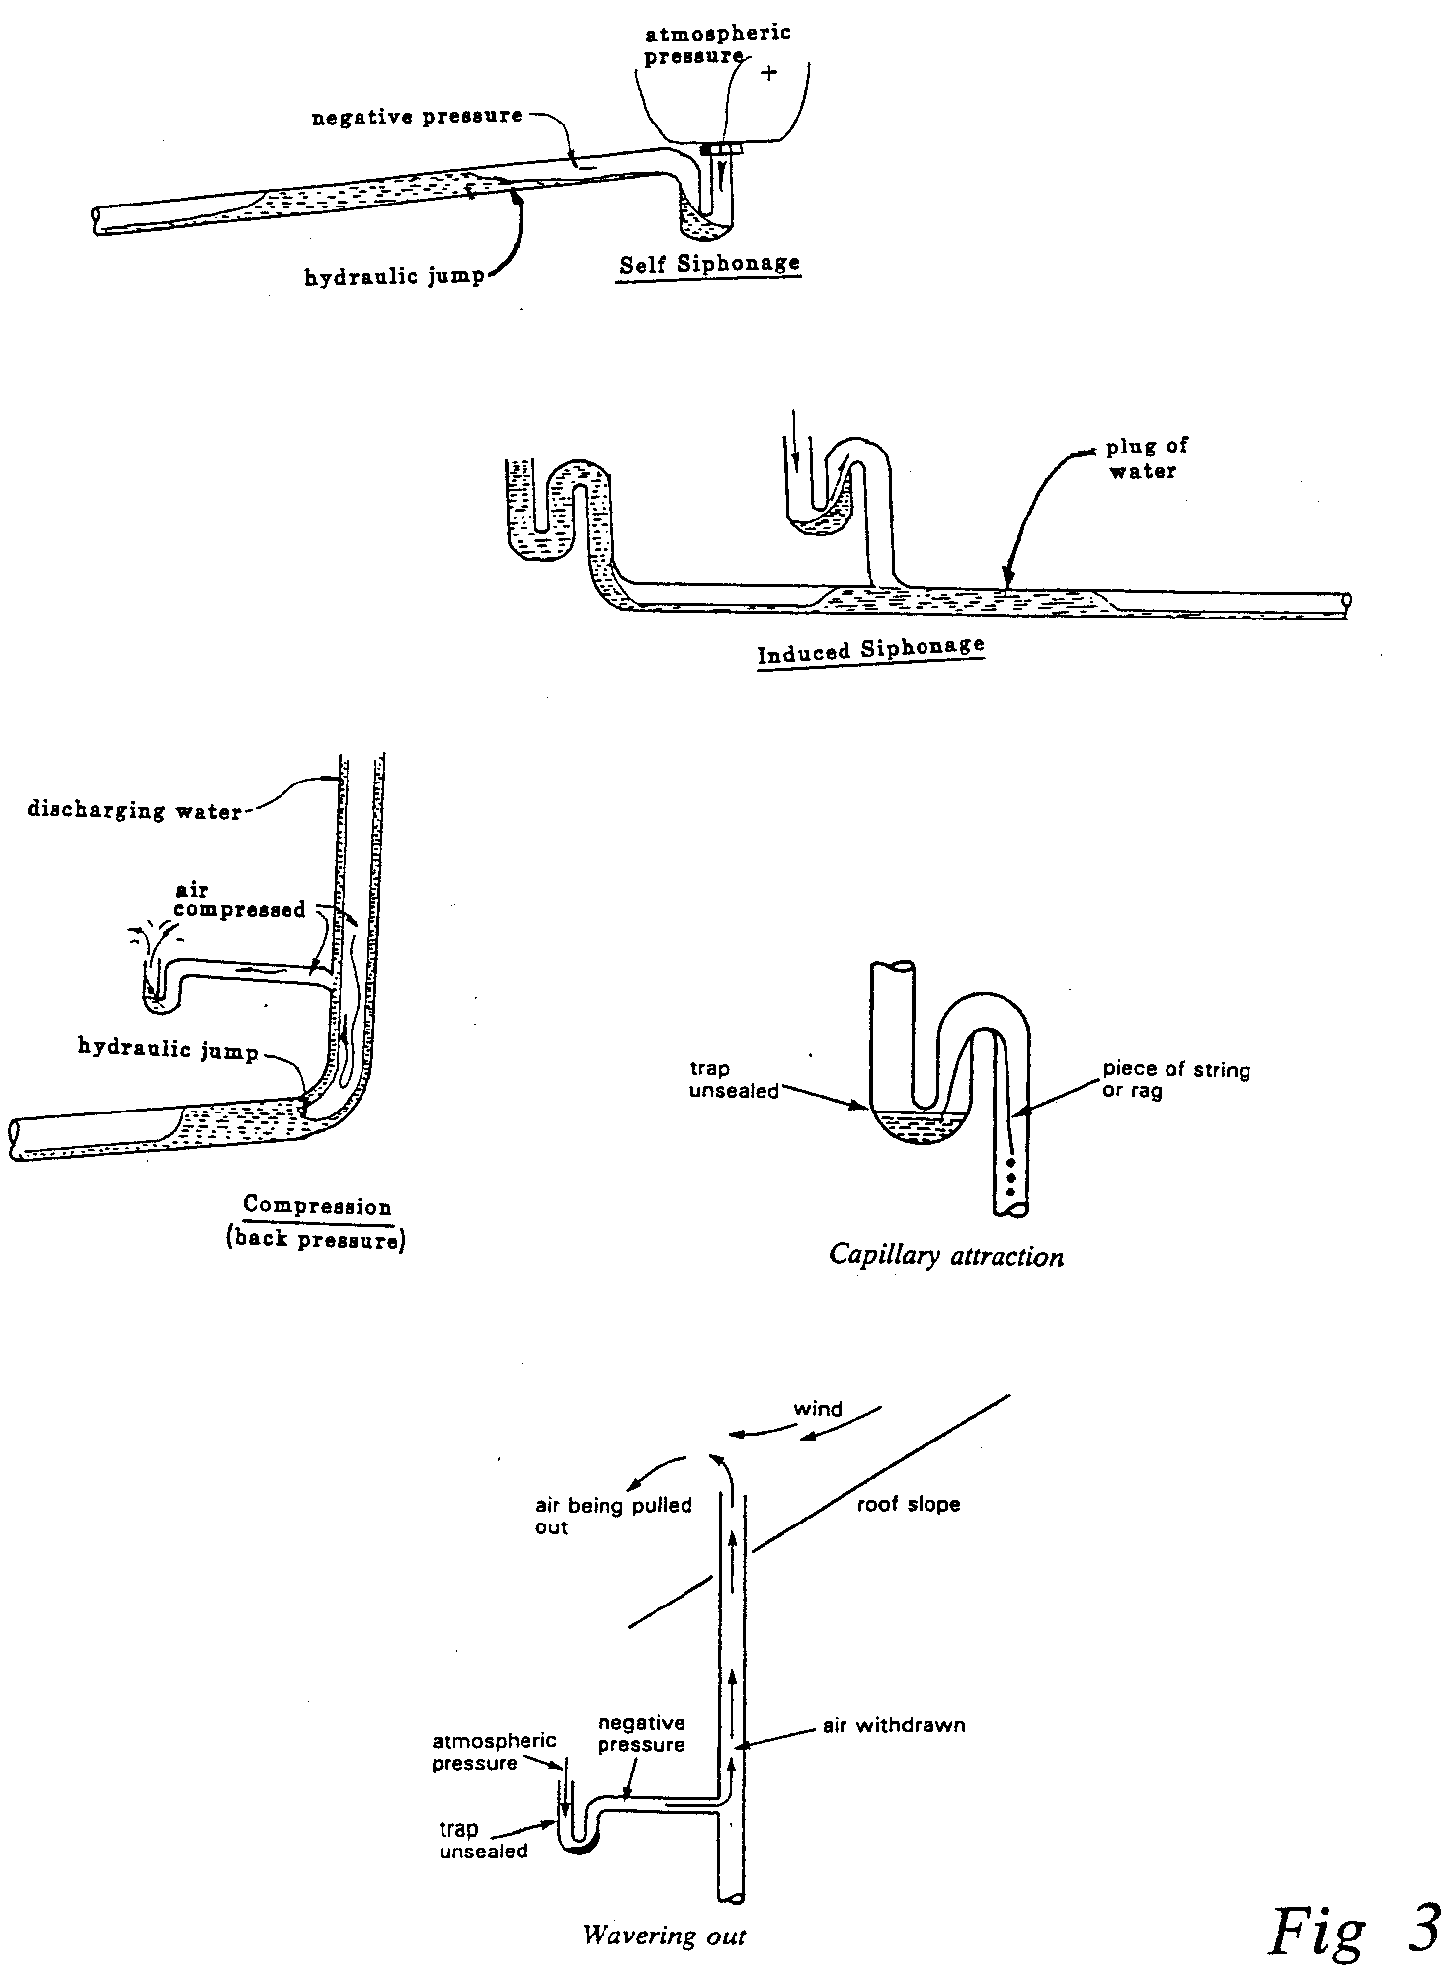
- Examples of Trap Losses

One Pipe System
This system was first used in the USA but it was some time before it was accepted in this country. It was, however, eventually accepted and was used extensively up to recently.

Principle
Soil and waste fitting discharges are carried by one main soil and waste pipe connected directly to the drain.

Trap Ventilating
Every trap in the system must be ventilated with a pipe not less than 32mm in diameter. This ensures a good circulation of air in the system, preventing siphonage and back pressure.

Air Compression
To prevent air being compressed at the bottom of the mains soil and waste stack and possible disturbance of the water seals of the traps on the lowest sanitary fittings, and additional vent or air relief pipe is sometimes required.
The main vent stack should be carried down and connected either into the horizontal drain or, at the top of the manhole.

Main Vent Stack
The top of the vent stack may be either carried up independently from the main soil stack or connected to the main soil and waste stack above the highest fitting.

Use of System
It is particularly suitable for apartments, offices, hotels, etc where sanitary fittings are grouped above each other on successive floors. Fig 4 shows the layout of the system for a three storey building. The main oil and vent pipes are better fixed internally inside a duct, as this prevents freezing, makes maintenance easier, and dispenses with unsightly external pipes.

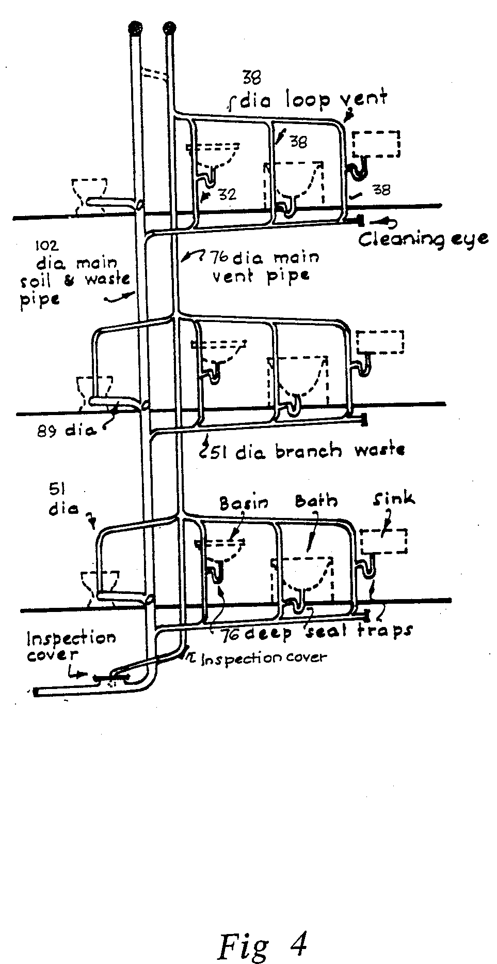
- One Pipe System

Single Stack System
The desire for economy and efficiency in the extensive post-war building programmes directed the attention of the Building Research Station to this problem and as a result of studies and laboratory work carried out there it became apparent the undesirable air pressure fluctuations in drainage pipework could, in a certain range of circumstances, be eliminated by the observation of simple rules without the necessity for trap ventilating pipes.
The method of design resulting was called “The Single Stack System”.
Initially it was limited to five storeys in its application; after some years modification were proposed which enabled buildings up to 10 storeys to be served, while recently installations up to 20 storeys high, using 150mm diameter stack, have been considered feasible.

Principle
The single stack system depends for its performance in retaining trap seals:
- By preventing pressure fluctuations arising from the operation of other sanitary appliances:
(a) By connecting each appliance separately to the stack;
(b) By limiting the flows in the stack to values at which plugs of water will not alter;
(c) By maintaining a straight stack to avoid plug formation.
- By preventing self siphonage arising from the operation of sanitary appliances. This is achieved by careful control of the diameter, length, fall and connection to the stack of the waste pipe servicing the appliance, thereby eliminating the need for trap ventilating pipes.

Air Compression
The bend at the foot of the stack must be a slow radius bend. This is to prevent compression of the air at the base of the stack.

Design Considerations
This lowest connection to the discharge stack must be a minimum distance of 450mm above the invert of the drain. Should the building be over three storeys high this distance should be increased to 750mm, and for buildings over five storeys all ground floor appliances should not connect into the stack.
All fittings must be grouped closely to the main stack so that branch pipes are as short as possible.
Maximum distances and gradients must be observed at all times for safe and efficient operation of this system (see Fig 5).
Traps of less than 50mm internal bore should have a seal of not less than 75mm. Wcs etc should have a seal of 50mm.

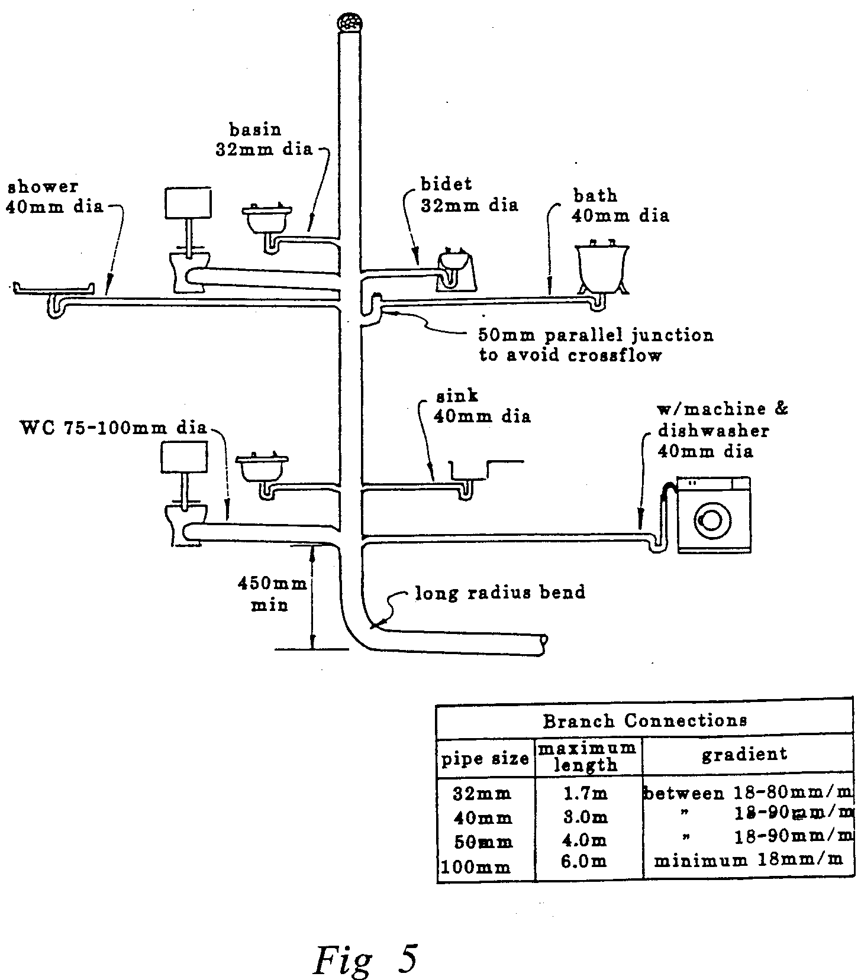
- Single Stack System

Resealing Traps
In certain circumstances where design criteria cannot be achieved permission may be granted for the use of resealing or anti-siphon traps. These are designed to maintain their water seal should a partial vacuum be created in the waste discharge pipe. There are various designs; the most common one used today incorporates an anti-vacuum valve. Should the pressure drop inside the discharge pipe this valve opens under atmospheric pressure giving a state of equilibrium inside the pipe.
The other types of resealing traps work on the principle of retaining the water in a reserve chamber should the conditions be right for siphonic action to take place.
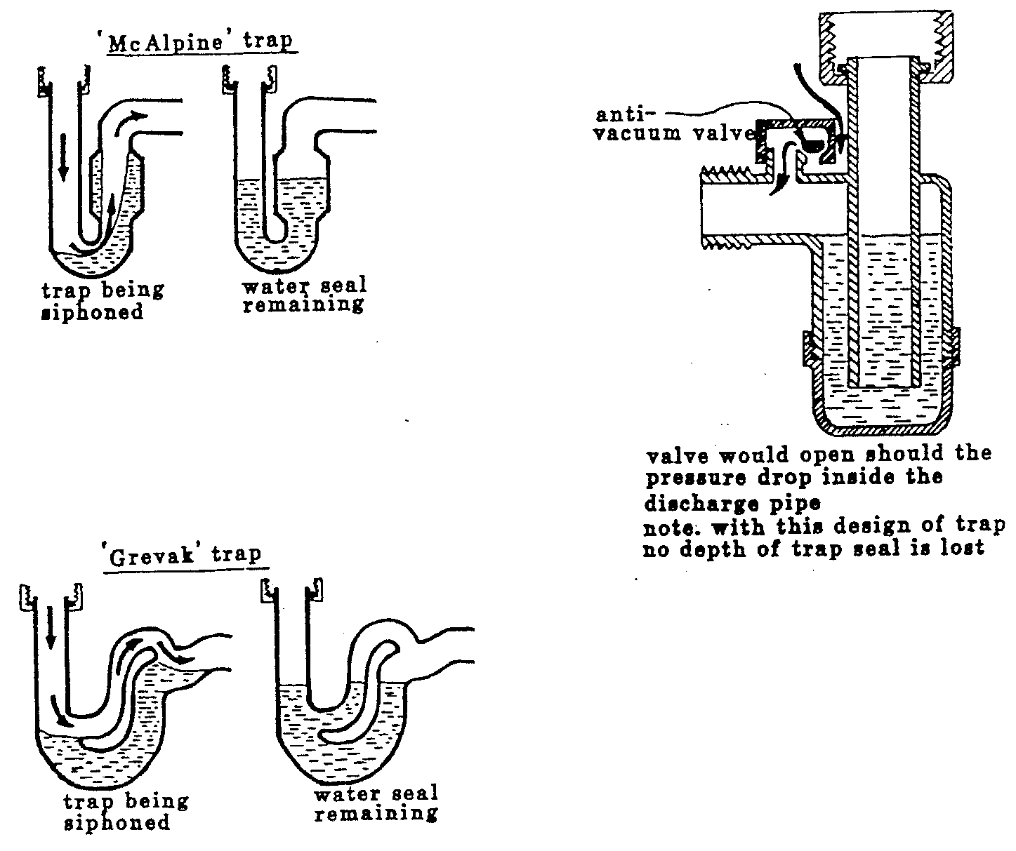
- Resealing Traps

Rainwater
Damp buildings are cold and unhealthy: moreover, dampness will hasten the decay of timber and other materials to such an extent that the useful life of the buildings will be seriously reduced. Thus, the exclusion of dampness is an essential part of good building work, and one in which the plumber is directly concerned.
Dampness in the form of rainwater may penetrate through walls and it is part the plumbers’ job to remove this rainwater in a safe and efficient manner. This is usually achieved by providing gutters and downpipes.
Pitched roofs are normally provided with eaves gutters to catch the rain running off and with downpipes to carry the water to the below ground drainage system. Half round gutters are normally used in this case. These are purchased ready made and can be manufactured from PVC, asbestos, cast iron and aluminium.
Where two pitched roofs adjoin each other the space between them is known as a valley and a “valley gutter” has to be provided in this situation. Valle gutters can be either rectangular or trapezoidal in shape and it is usual to provide a minimum of 300mm between the edges of the roofs to provide for walking space along the gutter. These are usually made on site by the plumber from lead, aluminium or copper. Depending on their shape, valley gutters will sometimes be referred to as box gutters.
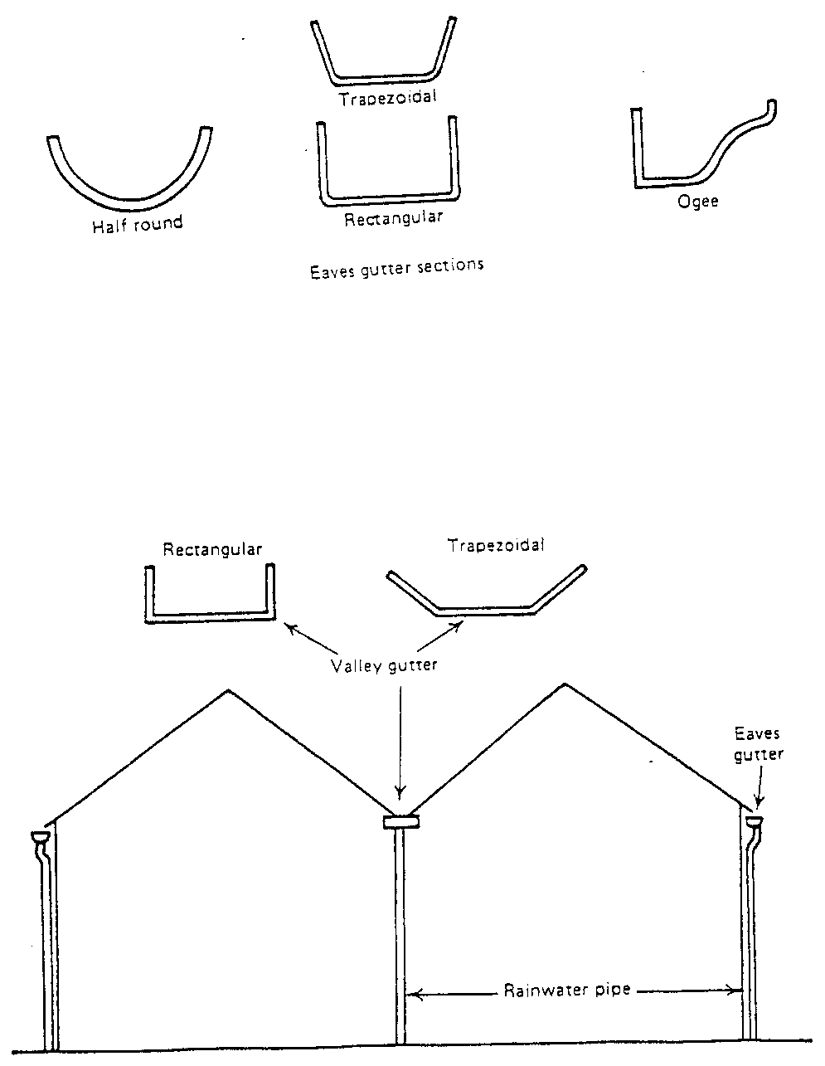
- Rainwater Pipes

SIZE OF EAVES GUTTER AND RAINWATER PIPES
Note: The minimum fall of the gutter is 1 in 600.
Diameter of gutter (mm) | Diameter of rainwater pipe (mm) | Application
75 | 50 | Domestic garages, garden sheds, greenhouses, dormer, bay windows
100 | 63 | Houses, flats, small shops and offices, garage blocks, site huts
125 | 75 | Large houses, offices, flats and shops, farm buildings, industrial buildings
150 | 100 | Large roof areas of agricultural, commercial and industrial buildings, warehouses, supermarkets and stores

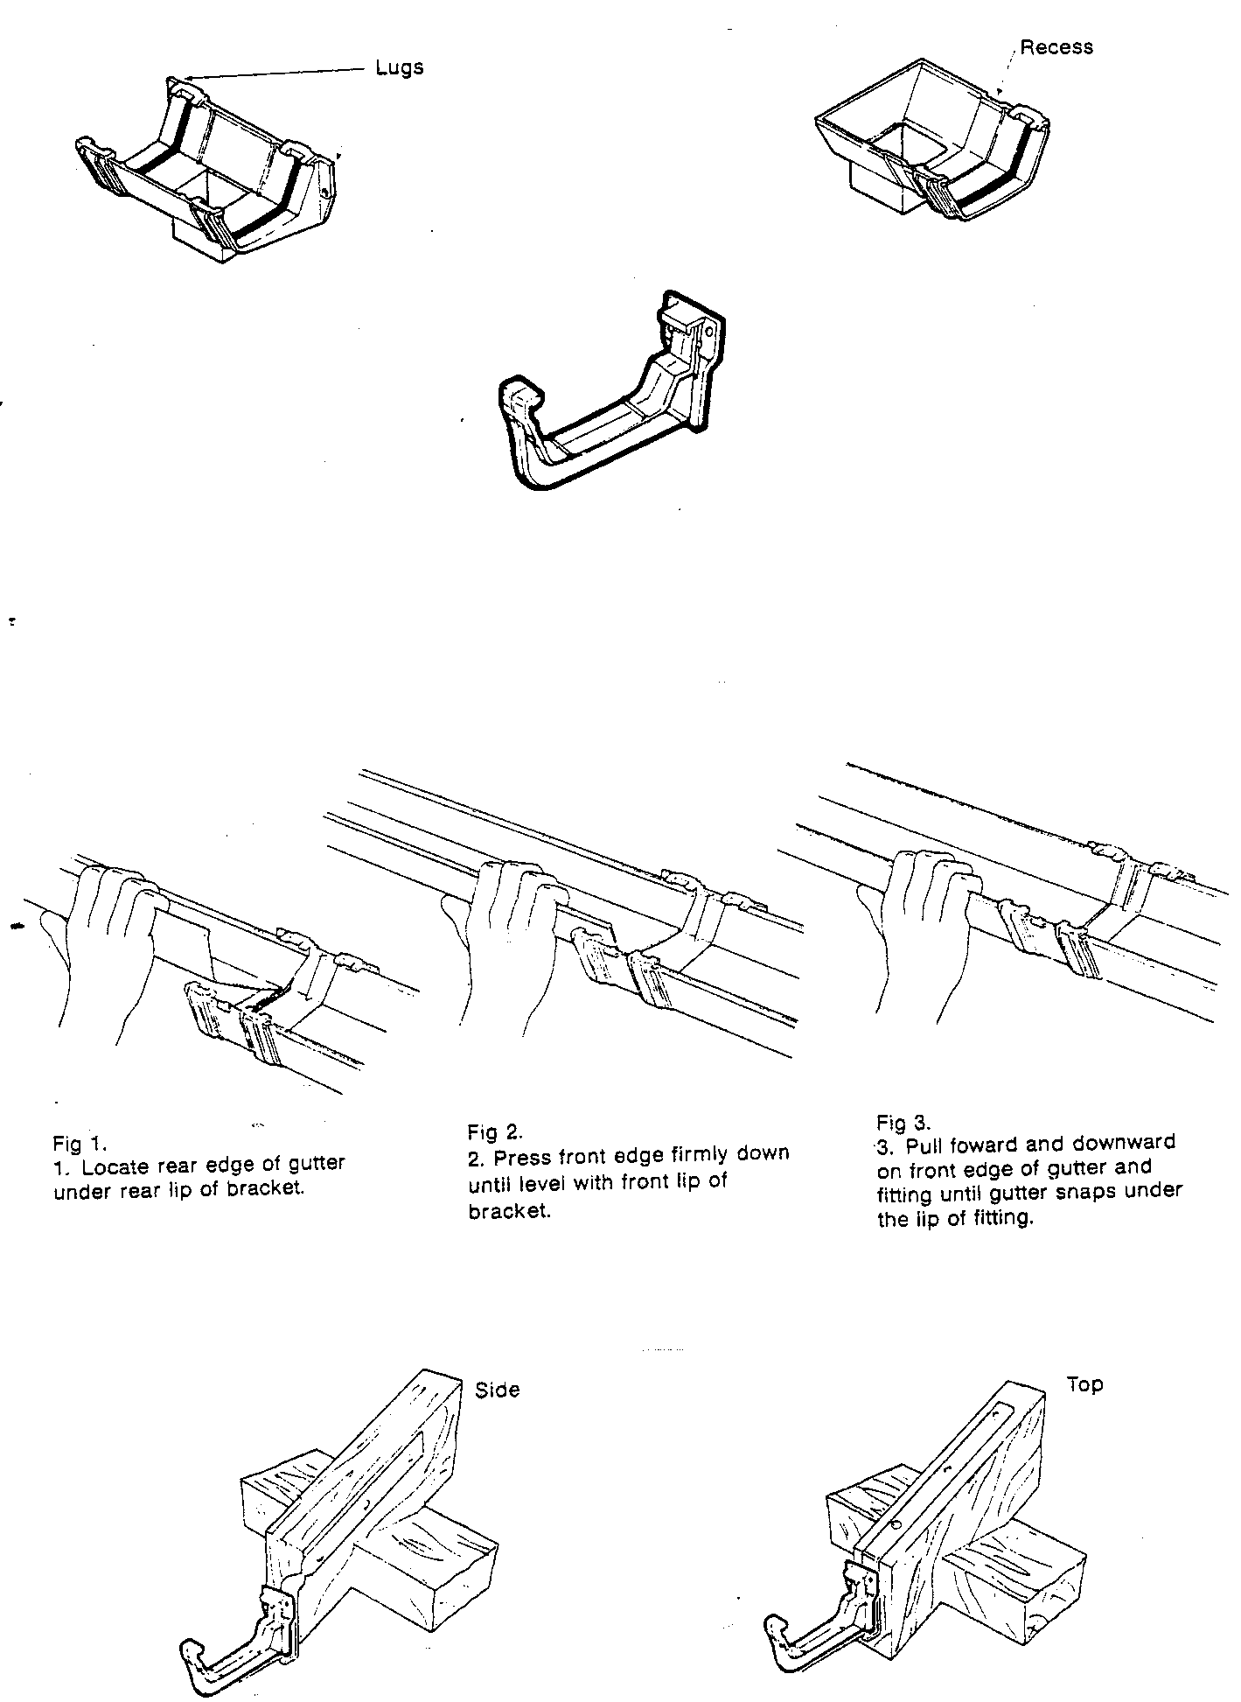
- Gutters and Rainwater Pipes

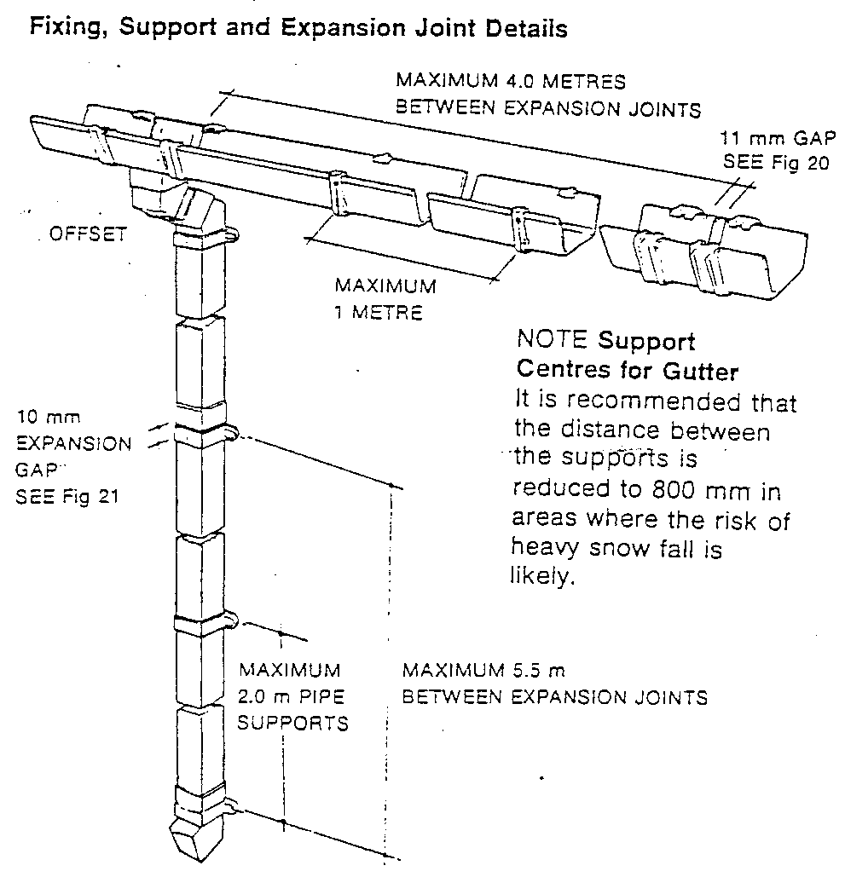
- Support Centres for Gutter

Self Assessment

Exercise:
- Apprentice to assemble soil and waste pipework exercise as per Exercise no. 2.2.12. in the curriculum document.
- Apprentice to answer sample questions on Unit Exercise/Procedure No. 2.2.12. in the curriculum document.
- Sketch an 'S' trap and show clearly the depth of seal.
- Sketch a running trap, showing the depth of seal and give one example of an installation where it could be used.
- State why it is necessary to fit a trap to a sanitary appliance.
- Explain how induced siphonage could occur on a row of six wash basins connected into a common waste pipe which has no vent.
- Describe the problems that could arise if compression occurred at the bottom of a 100mm diameter soil stack which has a wash hand basin and WC connected on the ground floor.
- Describe how self-siphonage may occur within the waste pipe of a wash basin.
- Describe the purpose of a resealing trap.
- Sketch and describe three types of resealing/anti-siphon traps.
- Identify the 5 types of traps shown in Figure 10 below.
- Name 2 ways a trap could loose its seal:-
(i)
(ii)
- Name 2 types of above ground drainage systems:-
(i)
(ii)
- What is the main advantage of the separate system of underground drainage?
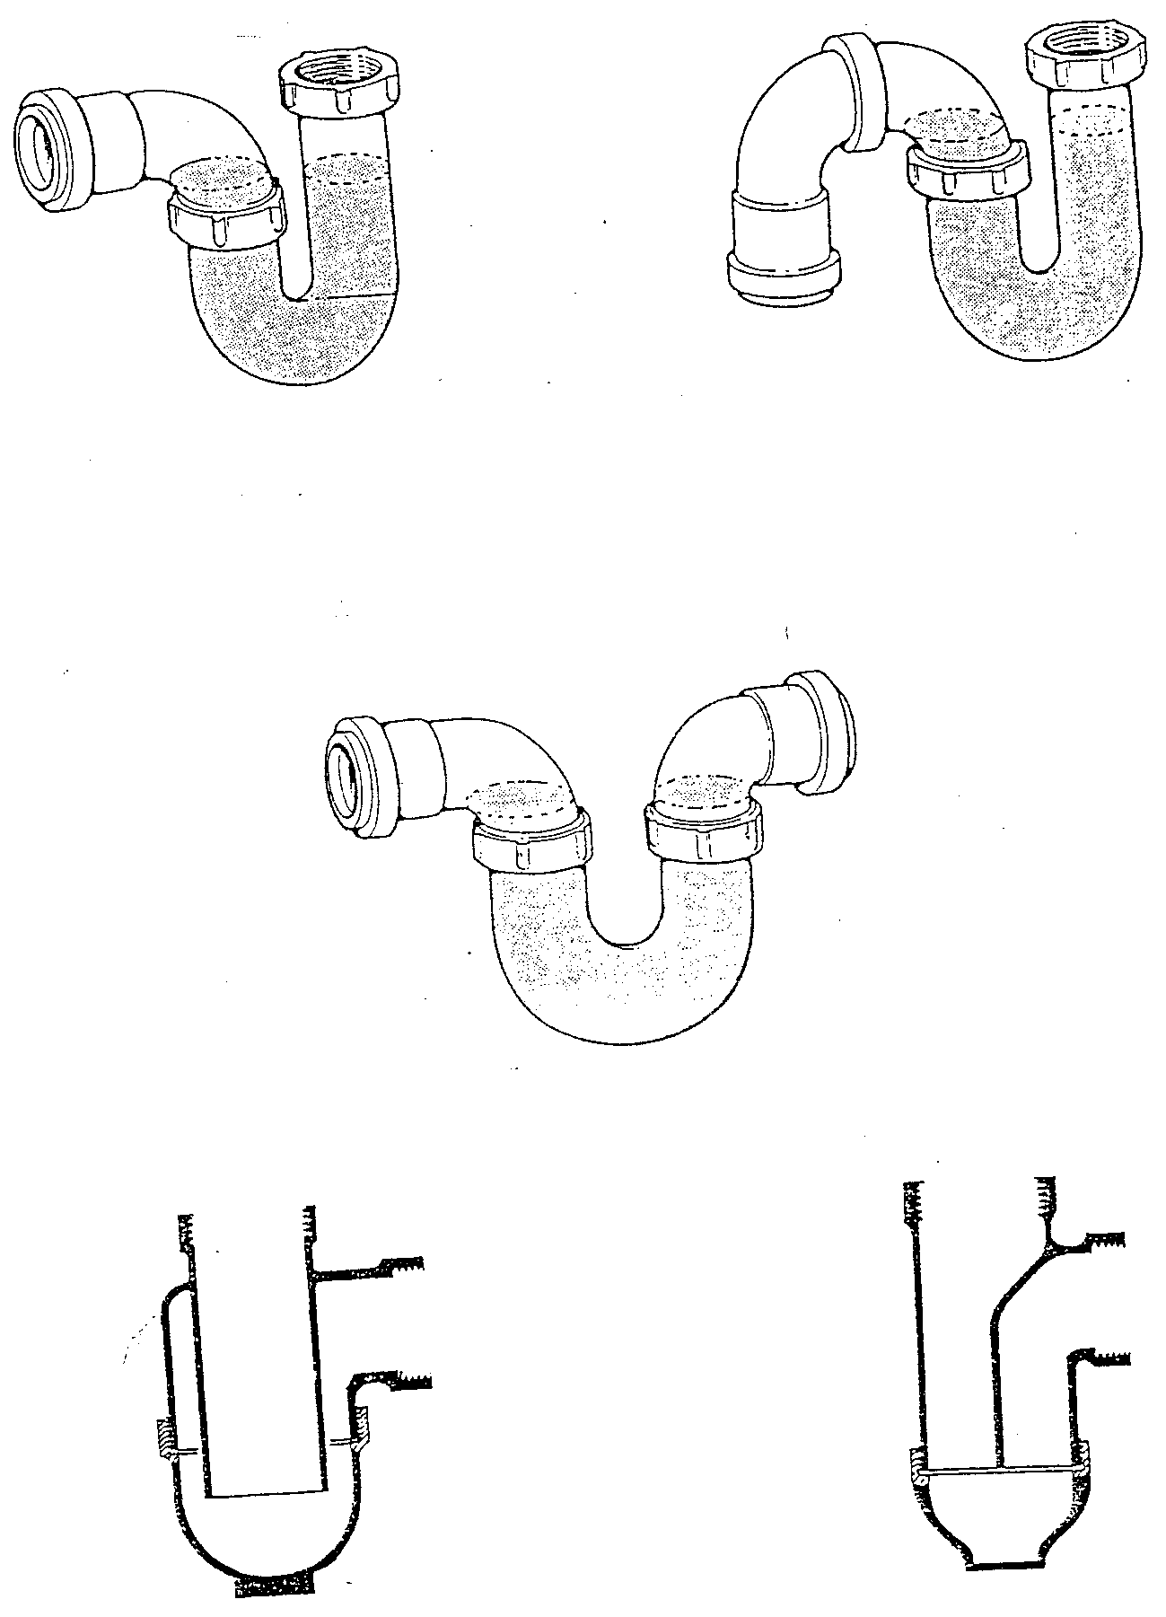
- Types of Traps

Index

A
Above Ground Sanitation, 9
B
branch discharge pipe, 9
C
capillary attraction, 13
compression, 13
D
discharge pipes, 9
discharge stack, 9
E
evaporation, 13
L
leakage, 13
M
momentum, 13
O
one pipe system, 15
air compression, 15
main vent stack, 15
principle of, 15
trap ventilation, 15
use of, 15
P
pitched roofs, 20
R
rainwater, 20
resealing traps, 19
S
single stack system, 17
air compression, 17
design considerations, 17
principle of, 17
siphonage, 13
stack, 9
Stack, 9
T
Terminology, 9
trap, 9, 11, 12, 13, 15, 17, 25
bottle traps, 11
P traps, 11
running traps, 11
S traps, 11
types of, 11
trap seals, 12
loss of, 13
V
ventilation stack, 9
vertical pipe, 9
W
waste pipe, 10
Waste Pipe Connections, 10
wavering out, 13

