Trade of Plumbing
Module 2: | Domestic Hot and Cold Water Service
Unit 13: | Below Ground Drainage
 | Phase 2

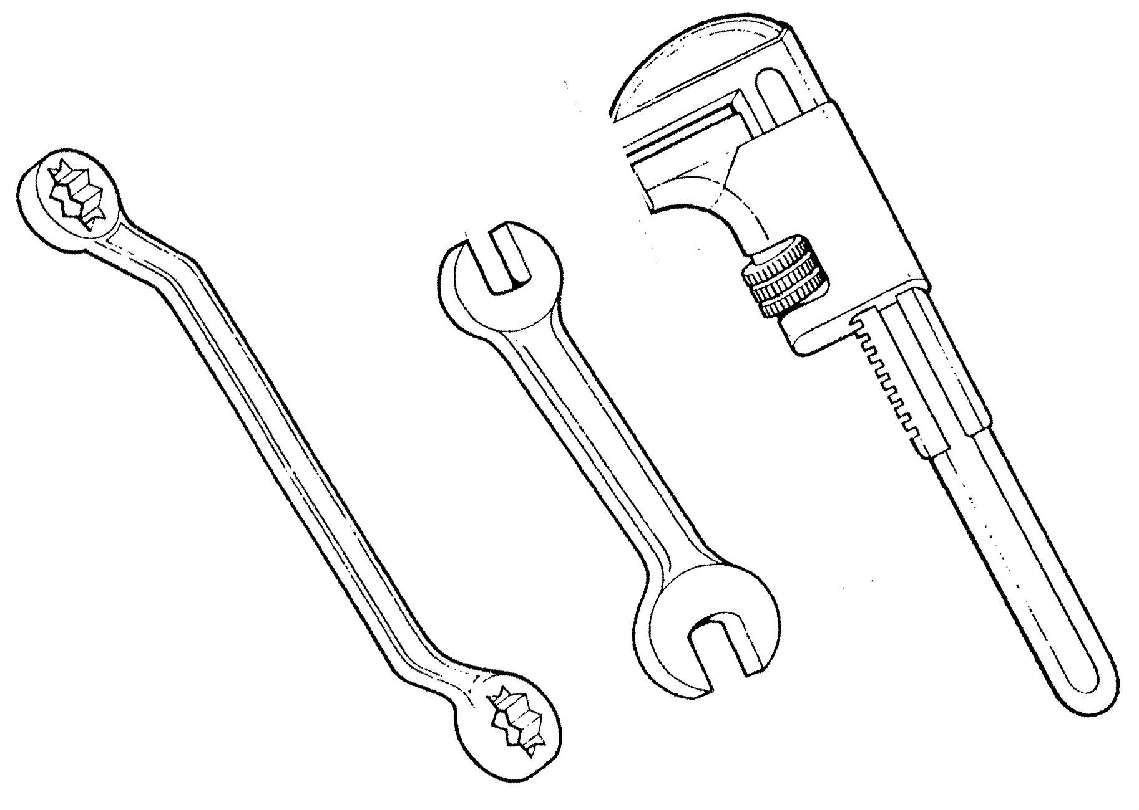

Table of Contents
List of Figures 5
List of Tables 6
Document Release History 7
Module 2 – Domestic Hot and Cold Water Services 8
Unit 13 – Below Ground Drainage 8
Learning Outcome: 8
Key Learning Points: 8
Training Resources: 8
Key Learning Points Code: 9
Below Ground Drainage 10
Combined System of Underground Drainage 11
Separate System of Underground Drainage 13
Access to Drains 16
Protection of Pipework 19
General Provisions 19
Allowance For Settlement Protection of Buildings 21
Drains penetrating walls 21
Trenches close to building foundations 21
Drains Below Buildings 23
Setting Out The Fall 23
Determining Drainage Levels 26
Choice of Gradient 26
Drainage Calculations 26
Ventilation of Drains 28
Drain Testing 31
Water Tests 31
Final Water Test 31
Air Tests 32
Smoke Tests 35
Gullies and Traps 37
Petrol Interceptor 37
Yard and Garage Gullies 37
Anti-Flood Gullies 37
Grease Trap 37
Intercepting Trap 37
Gulley Trap 37
Armstrong Junction 38
Drainage Terms 42
Self Assessment 44
Exercise: 44
Index 45

List of Figures
Figure 1. Combined System of Underground Drainage 12
Figure 2. Partially Separate System of Underground Drainage 14
Figure 3. Partially Separate System 15
Figure 4. Figures 4, 5, 6 and 7 17
Figure 5. Figure 8 - Manhole 18
Figure 6. Figure 9 – Protection of Drainage Pipework 20
Figure 7. Figure 10 - Drains Penetrating Walls 22
Figure 8. Traditional Methods of Bedding 23
Figure 9. Figure 11 – Gradient Board 24
Figure 10. Figure 12 – Setting out the Fall 25
Figure 11. Questions 27
Figure 12. Figure 13 – Ventilation of Drains 29
Figure 13. Figure 14 – Ventilation of Drains 30
Figure 14. Water Test 32
Figure 15. Air Test on Soil and Waste Disposal Systems 33
Figure 16. Air Tests 34
Figure 17. Smoke Tests 36
Figure 18. Petrol Interceptors 38
Figure 19. Grease Traps and Gullies 39
Figure 20. Figure 5 and Figure 6 40
Figure 21. Armstrong Junction 41
Figure 22. Fig 1, 2 & 3 - Haunching, Benching, and Invert 43

List of Tables

Document Release History
Date | Version | Comments
June 2006 | V.1.0
17/02/14 | 2.0 | SOLAS transfer

Module 2 – Domestic Hot and Cold Water Services

Unit 13 – Below Ground Drainage
Duration 12 hours

Learning Outcome:
By the end of this unit each apprentice will be able to:
- Describe the principles of below ground drainage.
- List and describe the types and components of domestic below ground drainage systems.
- Calculate the correct gradient for underground drainage pipes.
- Draw a plan view of domestic drainage systems.

Key Learning Points:
Rk | Principles and terminology of below ground systems of drainage.
Rk | Types of below ground drainage systems – separate, combined, partially separate.
D | Plan views of domestic systems.
Rk | Building regulations – drainage and waste water disposal.
Rk | Drainage materials and joints.
Rk | Protection of drainage pipework.
Rk | Drainage system components – gullies, traps, interceptors, etc.
Rk | Means of access, rodding, inspection chambers etc.
Rk | Ventilation of drains.
Rk M | Pipe sizes, setting out drain levels, calculation of pipe fall, Maguire's rule.
Rk | Drain testing.
Rk H | Hazards associated with working with drains – trench collapse, dangerous gasses, disease etc.

Training Resources:
- Classroom facilities and information sheets.
- Building regulations technical guidance document H – drainage and waste water disposal.

Key Learning Points Code:
M = Maths D= Drawing RK = Related Knowledge Sc = Science
P = Personal Skills Sk = Skill H = Hazards

Below Ground Drainage
This is a system of pipes which conveys surplus water or liquid sewage away from the building in the most speedy and efficient way possible to the sewer without any risk of nuisance or danger to health and safety. There are three types of below ground drainage systems: the COMBINED, the SEPARATE, and the PARTIALLY SEPARATED.
When designing any drainage system one must observe the following principles:
- Provide adequate access points.
- Keep pipework as straight as possible between access points and for all bends over 45º and access point should be provided.
- Ensure all pipework is adequately supported (see bedding and drains penetrating walls).
- Ensure the pipe is laid to a self cleansing gradient (see Maguire’s rule).
- Ensure the drainage system is well ventilated (see ventilation of drains).
- The whole system must be water tight including inspection chambers.
- Drains should not be run under buildings, unless this is unavoidable or by so doing it would considerably shorten the route of pipework.
- The minimum internal diameter of a foul water drain is 100mm.

Combined System of Underground Drainage
In this case, as its name implies, both foul and surface water are discharged into the same sewer (see Fig 1). This system has the cheapest layout as it requires only one set of pipes, and during heavy rainfall both house drains and sewers are thoroughly flushed out.
Sewers are public authority drains to which private house drains are connected. This system has often been used in the past where raw sewage was disposed of without treatment, i.e. discharged into the sea or a water course. Due to public alarm at this unhealthy state of affairs, it is now considered to be unacceptable and all foul water must be treated before the effluent is discharged in such a way.
In many cases this, and the rapid growth of some urban areas, has put a serious strain on the capacity of existing sewage disposal plants, and many local authorities in urban areas now insist on the installation of separate systems.
There is a further disadvantage: in storms and periods of very heavy rainfall. Flooding and subsequent surcharging of the drains has been known to occur.

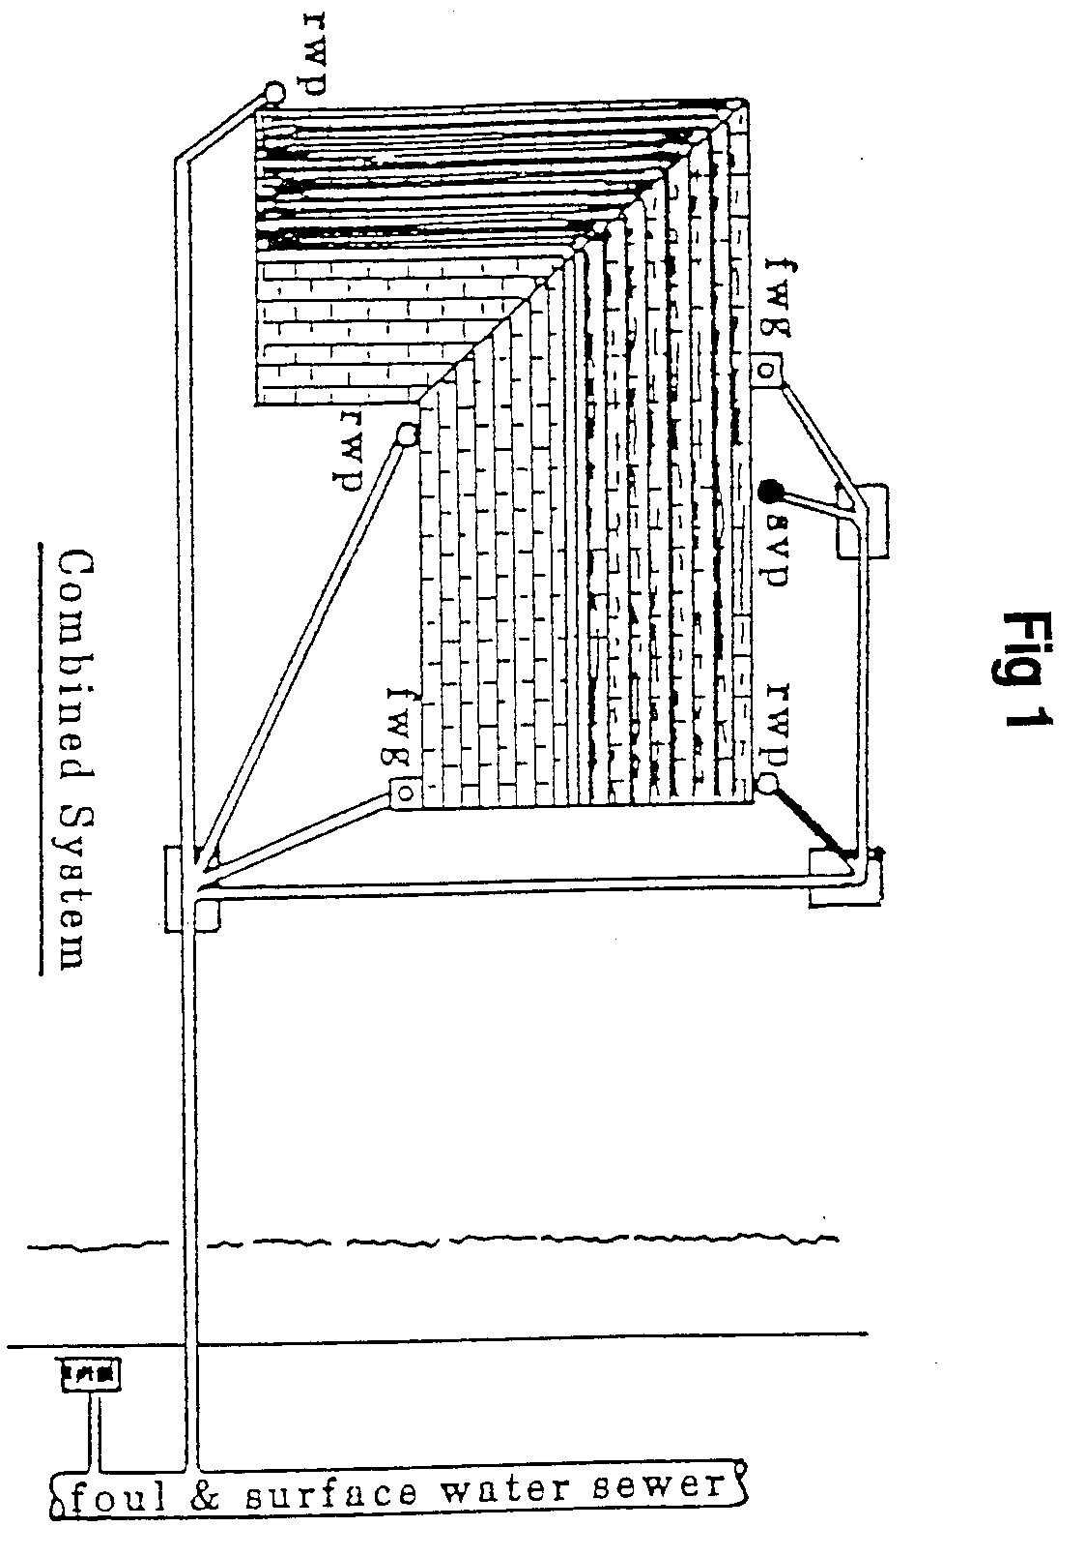
- Combined System of Underground Drainage

Separate System of Underground Drainage
This system requires the use of two sewers (see Fig 2), one carrying foul water to the treatment works, the other carrying surface water (which requires no treatment) to the nearest water course of river.
It is expensive to install, but from the local authorities’ point of view it is the most economical to operate because the volume of sewage to be treated is far smaller than the discharge from a combined system.
The biggest danger is that cross-connections may accidentally be made, i.e. foul water may be connected to a surface water drain. There is little chance of flooding at times of heavy rainfall, but the foul water sewers are not flushed periodically with relatively pure water as in combined systems.
It is the most commonly employed method of waste water disposal in new towns and urban areas, especially where large housing estates have been built, as plumbing arrangements and sewage plants, which may already be overloaded, have only to cope with foul water.
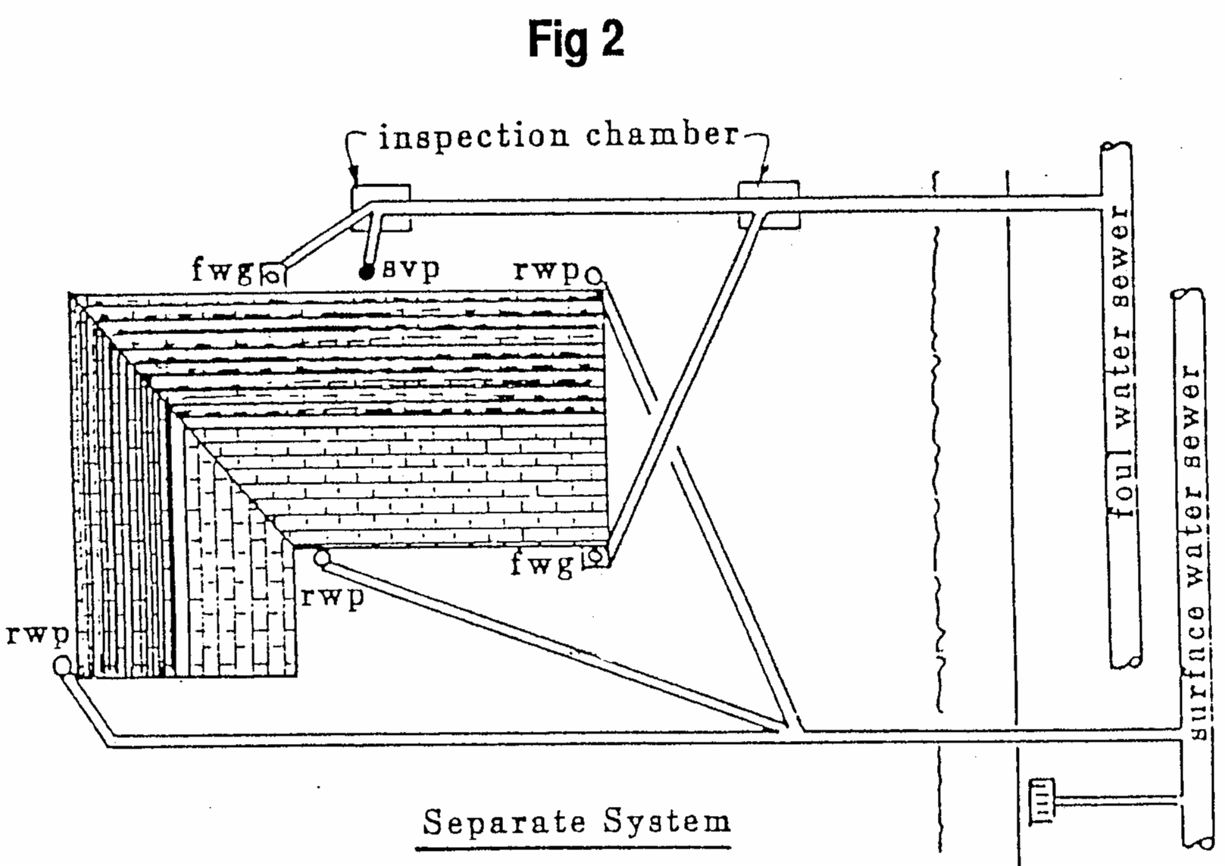
- Partially Separate System of Underground Drainage
This system probably originated when towns began to grow in size and local authorities found it necessary to try to reduce the loading on the combined system, which in most cases had hitherto been employed. This is something of a compromise between the previously mentioned systems.
It requires two sewers, one carrying water from paved areas and part of the roof, the other carrying foul water and water from the remainder of the roof as shown in Fig 3.
Some authorities permit the water falling on the front part of the premises to be discharged into the surface water sewer, water from other parts of the roof and paved yards at the rear of the premises being discharged into the foul water sewer.
The disadvantage of this system are similar to those of the combined system, but to a lesser degree.
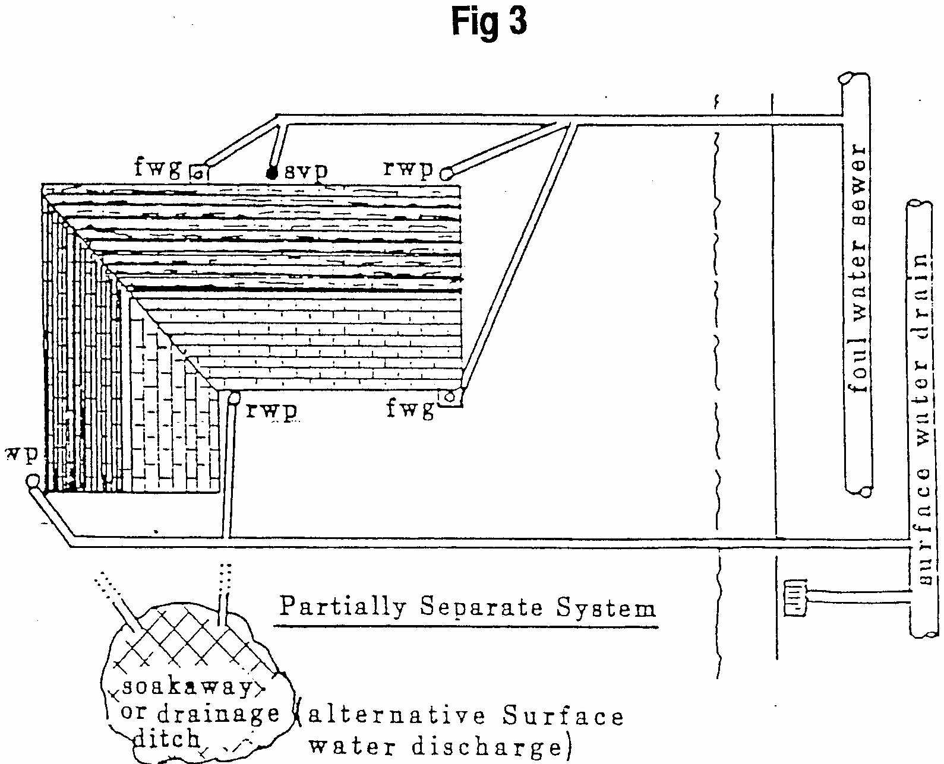
- Partially Separate System

Access to Drains
Although a good drainage system (whether carrying surface water or foul water) should be designed to avoid the possibility of a blockage, circumstances arise, often due to misuse, where this happens. It is therefore very important that adequate provision is made so that obstructions can be cleared with the minimum of trouble.
To enable internal inspection and testing of a drainage system or to provide a route in which the clearance of blockages can be achieved it is essential that sufficient provision is made for the internal access to the drain.
An access point should be provided at the following locations:
- At the highest point or head of the drain.
- At changes of gradient or direction (i.e. bends).
- At junctions or branches.
- At changes in pipe diameter.
- Between long drainage runs.
There are three types of access generally in use:
- Rodding eyes: A capped extension on the pipe where access can be gained to a drain or any discharge pipe for the purpose of cleaning with rods or inspection. The rodding point system, as it is generally known, is often run in uPVC pipe and with the omission of inspection chambers reduce the cost of installation considerably,
(see Figs 4 & 5).
- Access fittings: A fitting, such as a bend, branch or gully, which has a cover fitted, usually bolted to the fitting, in order to gain access. The cover may be located above ground or at ground level such as in the case of a gully. It may be located below ground, in which case it will need to be incorporated into an inspection chamber or manhole; alternatively a raising piece could be incorporated to allow termination at ground level. The access fitting, unlike the rodding eye, allows rodding in more than one direction, (see Fig 6 & 7).
- Inspection chambers and manholes: A chamber constructed of brick, concrete or plastic and designed to expose a section of open pipe, in the form of a channel at its base. The definition of an inspection chamber or manhole is based on size. If the chamber is large enough to work in it is identified as a manhole, which would certainly be the case in all chambers over 1m deep. All chambers are provided with some form of cover located at ground level and when positioned internally within a building it should be bolted down with a greased double seal incorporated to prevent the passage of odours.
When a chamber is constructed in brickwork or concrete its wall thickness should be adequate to resist any external pressures caused by the surrounding ground; in all cases it should be at least 200mm thick. The base of the chamber should be benched up to allow any rising water flow back into the channel. In chambers over 1m deep step irons or a ladder will need to be included, (see Fig 8).
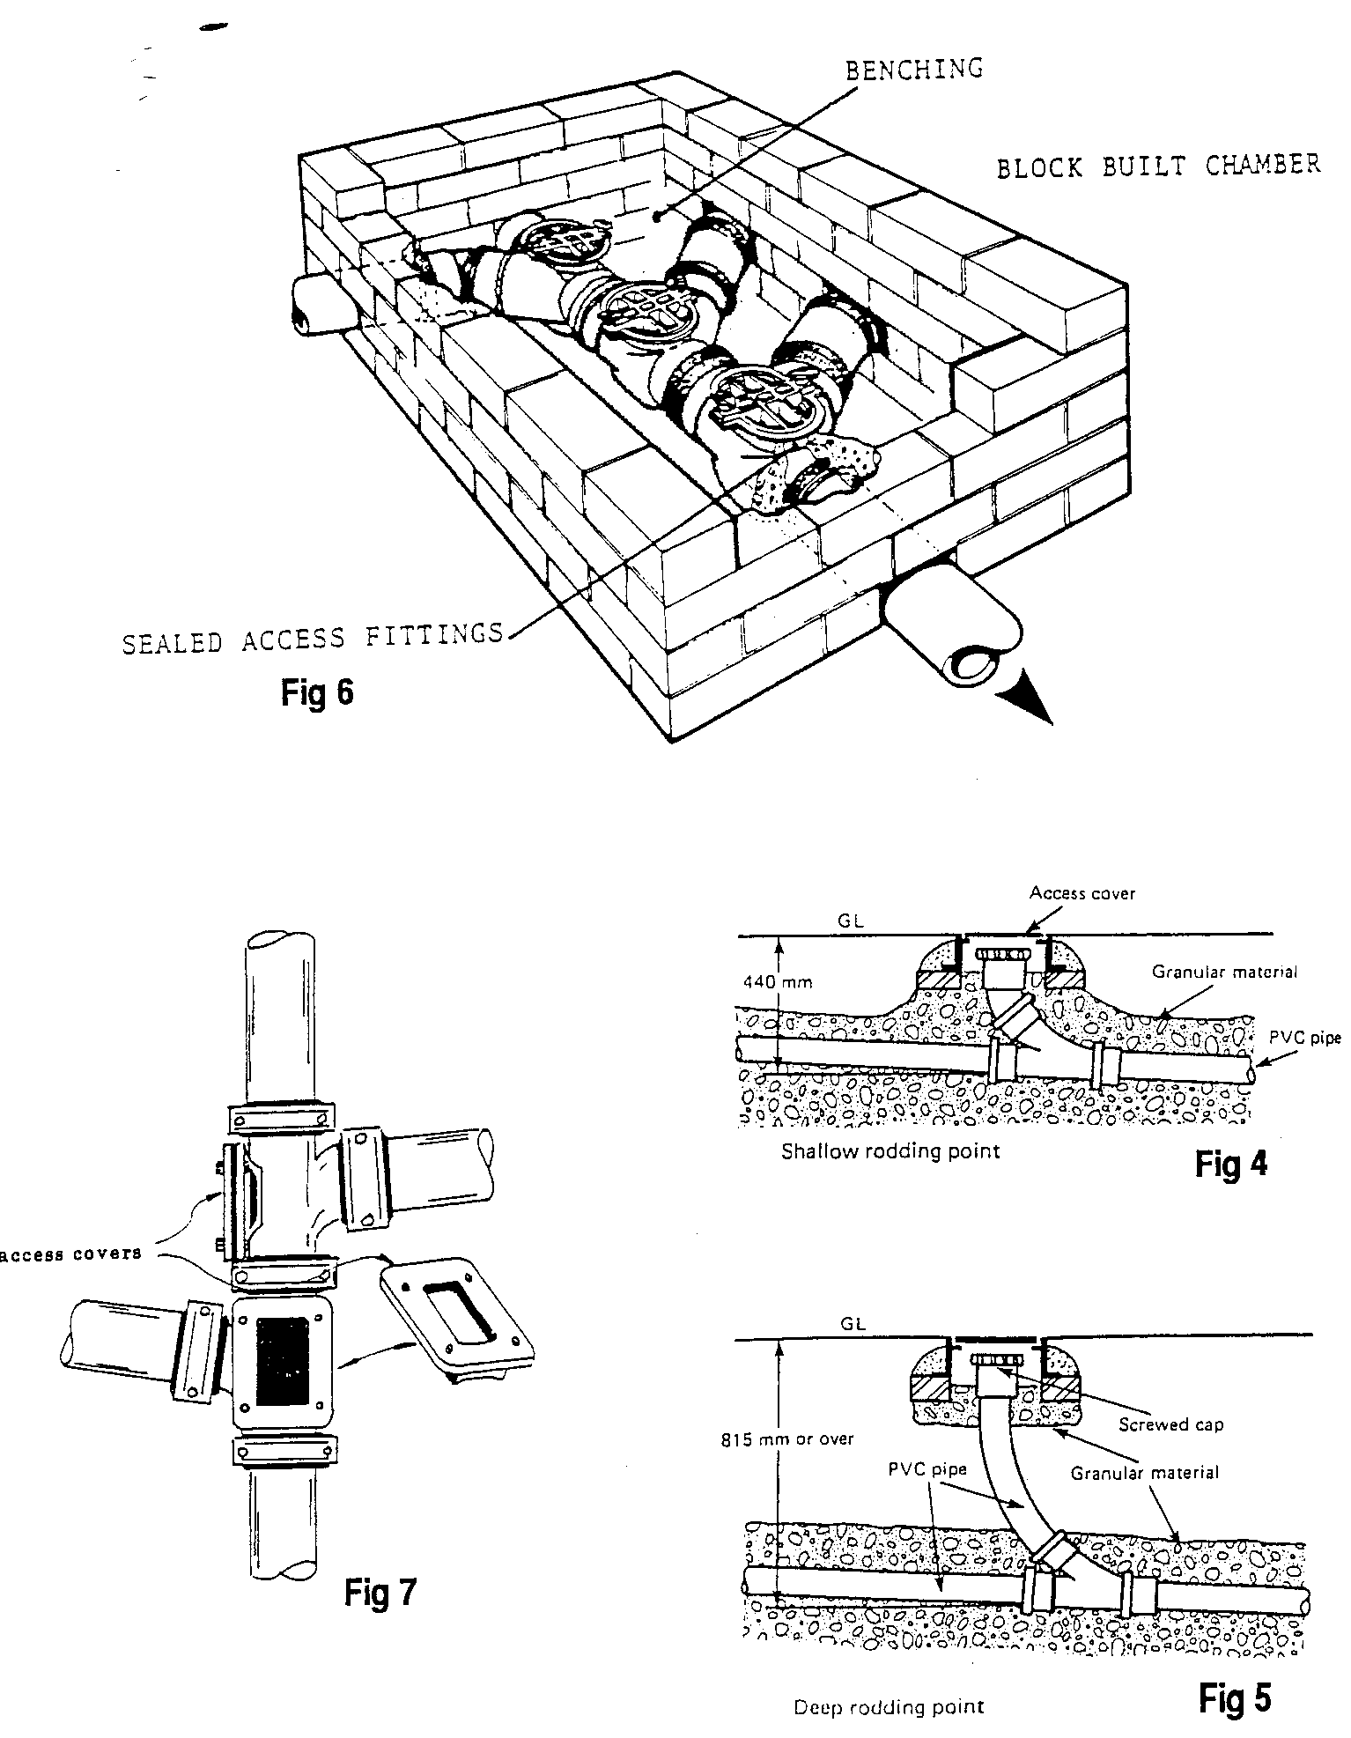
- Figures 4, 5, 6 and 7
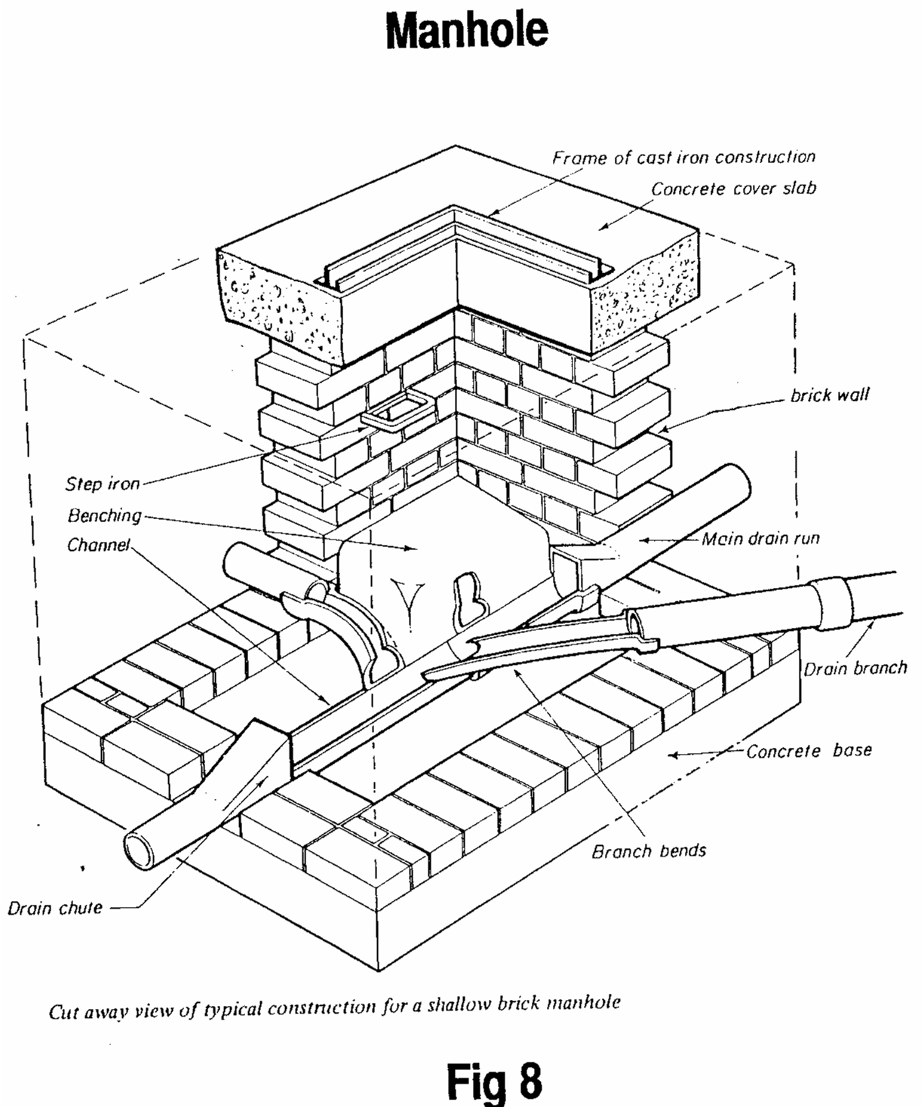
- Figure 8 - Manhole

Protection of Pipework

General Provisions
When the drainage pipe is positioned in the ground it must be protected from damage due to ground movement, etc. This is usually achieved by laying the pipe on a granular bedding material and covering the pipe with soil which is free from large stones or other such material. Different circumstances, such as the size of the pipe and the depth to which it is laid, call for different types of bedding. The bedding can either be for rigid or flexible pipes.
Rigid pipe materials include clayware, concrete and cast iron whereas flexible pipes include the various plastics. If the ground is stable some authorities will permit drainage pipes to be laid directly onto the trench bottom, although the main difficulty is ensuring a steady gradient. The purpose of the granular material is to distribute any excessive loads more evenly around the surface of the pipe, preventing its distortion and possible damage.
Where a pipe does not have the recommended cover it may require additional protection from damage by several methods including encasement in concrete in the case of rigid pipes, allowing for movement at joints or covering the bedding material with some form of paving slab.
Fig 9 shows some examples of how drainage pipework is protected.

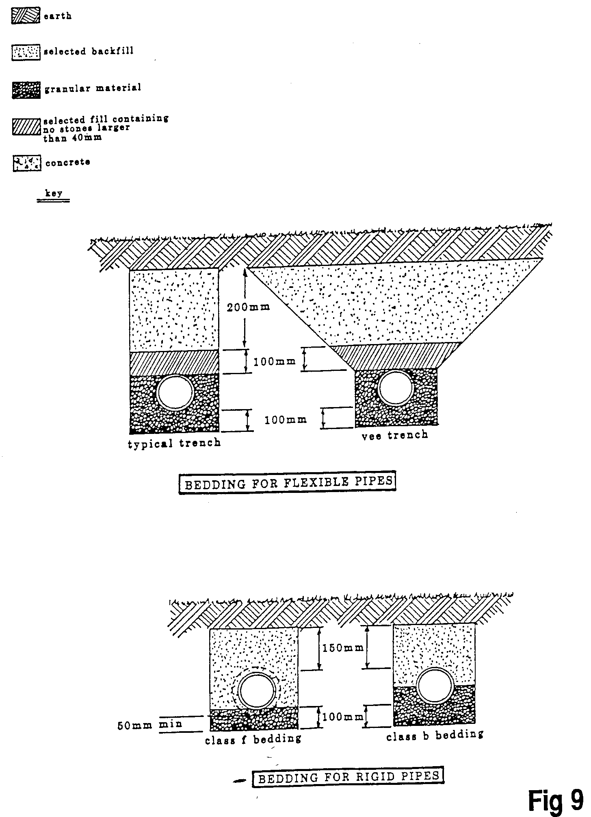
- Figure 9 – Protection of Drainage Pipework

Allowance For Settlement Protection of Buildings

Drains penetrating walls
Should a drainage pipe have to run through a wall or foundation, special precautions will need to be taken to ensure the pipe does not fracture. This is best achieved by either of the following methods:
- Forming an opening through the wall giving a 50mm space all around the pipe which is masked off with a rigid sheet material.
- Bedding into the wall a short length of pipe onto which is connected two 600mm long pipes, either side of the wall (all joints being made good using flexible connectors). Should the pipe or wall move, the three pipes would act as rockers, allowing for movement.

Trenches close to building foundations
Where a drainage trench is excavated lower than the foundations of any building, and within 1m, the trench should be filled with concrete up to the lowest level of the foundation. Distances greater than 1m should be filled with concrete to a level equal to a distance from the building, less 150mm (see the Building Regulations), (see Fig 10).
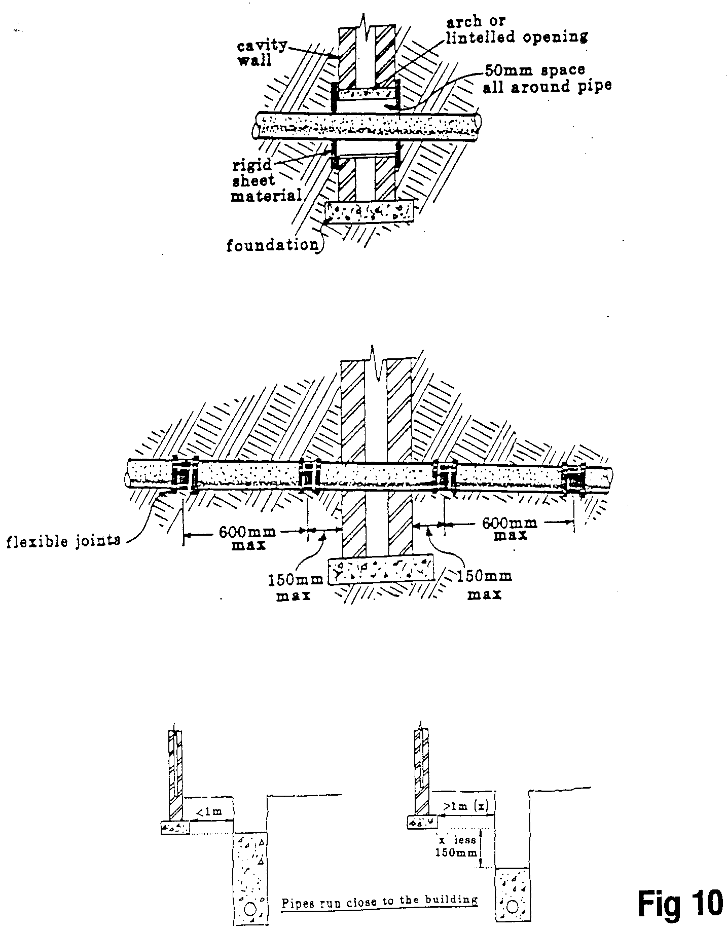
- Figure 10 - Drains Penetrating Walls

Drains Below Buildings
Where a drain is run under a building it should be surrounded with at least 100mm of granular material. If the crown (top) of the pipe is within 300mm of the underside of the oversite concrete slab it should be encased in concrete and be incorporated into the slab.
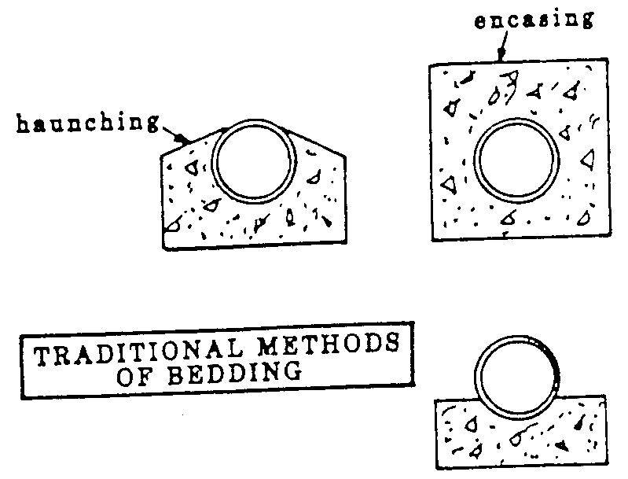
- Traditional Methods of Bedding

Setting Out The Fall
The method used to ensure the pipe is laid to the correct gradient will depend upon the length of drainage run, and for short sections a gradient board, or incidence board, is used.
The gradient board is a plank of wood cut to the required gradient of a drain and used in conjunction with a spirit level. If a drain run is to have a fall of 1 in 40 the drop in depth over 1m would be (1 ÷ 40 = 0.025m) 25mm. So to make a simple gradient board, take a straight plank 1m long and cut it at an angle (see Figure 11).
Where a long drainage run is to be installed the method used to determine the fall should be carried out using sight rails and traveller (sometimes called a boning rod). First the site rails are positioned at either end of a drainage run at different heights, the difference being that of the required gradient.
This process is done by a site surveyor, using a site level, or by using a water level to give an accurate transference of levels between each end of the drainage run. Then the trench is excavated to the required fall or backfilled as necessary. Two operatives are then used; one sighting his eye between the site rails and instructing his partner to raise or lower the traveller by lifting or lowering the boning rod as necessary (see Figure 12).
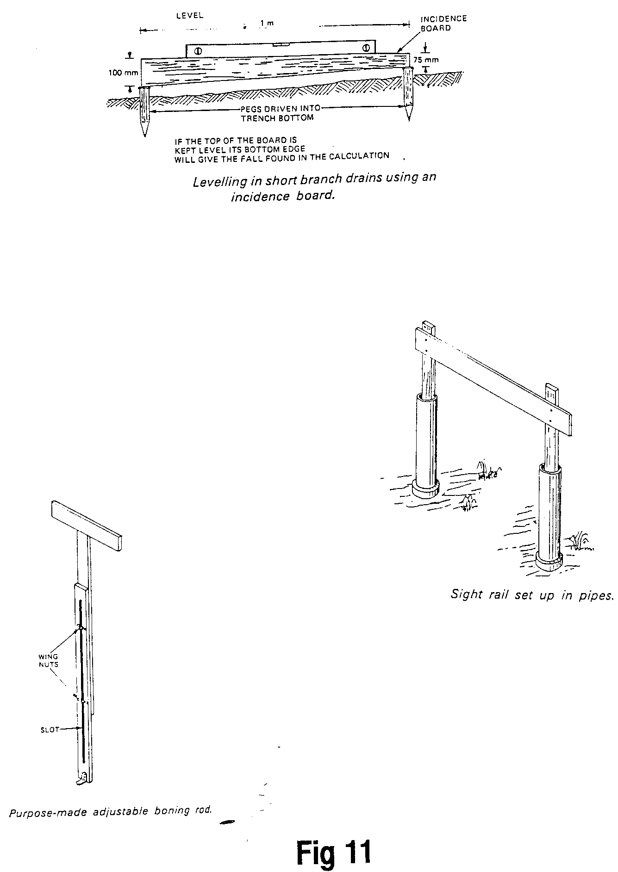
- Figure 11 – Gradient Board

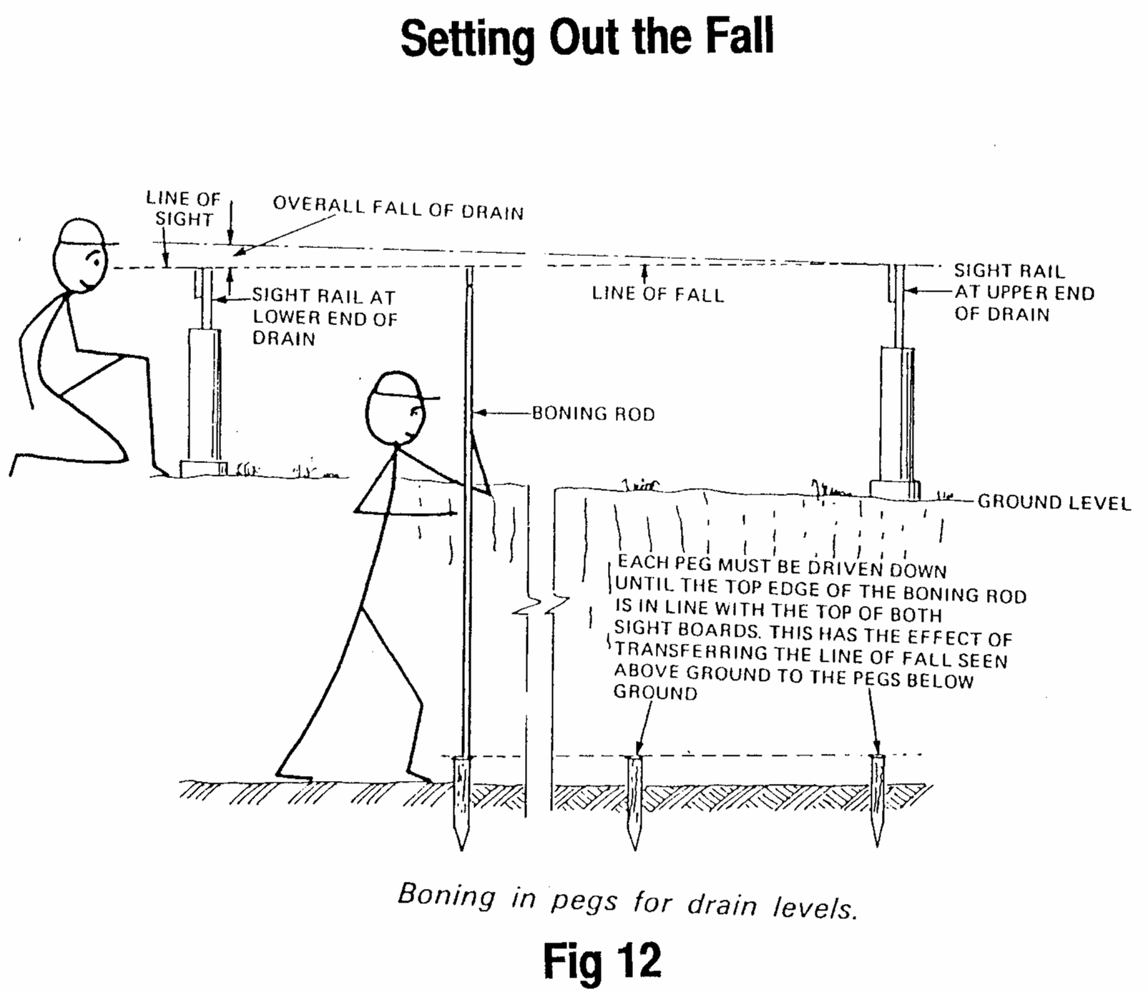
- Figure 12 – Setting out the Fall

Determining Drainage Levels

Choice of Gradient
The flow capacity of a pipe will depend upon the gradient, fall or incline on which the pipe is laid. Increasing the gradient increases the capacity. It is essential that the pipe is laid to a self-cleansing gradient.
If the water flows too slowly it will have insufficient velocity and impetus to carry with it any solid matter; however, where it flows too fast the water will leave the solids behind.
The amount of flow passing through the pipe also has a bearing upon the gradient; and where intermittent flow can be expected, giving shallow depths of water flow, it is advisable to increase the gradient. Maguire’s Rule is sometimes used to determine self-cleansing gradients with intermittent or low-flow rates and is based on a calculation in which the pipe diameter is divided by 2.5: for example, 100mm ÷ 2.5 = 40. Therefore, the fall will be 1:40.
Maguire’s Rule
Pipe Diameter (mm) | Recommended Fall
100 | 1 in 40
150 | 1 in 60
225 | 1 in 90

Drainage Calculations
To calculate the difference in levels of the two ends of a drain a simple formula is used which is:
Length of run ÷ Gradient
The gradient is always expressed as “1 in a given distance”, e.g.:
1:40 means a drop of 1mm in 40mm or 1 metre in 40 metres
1:60 means a drop of 1mm in 60mm or 1 metre in 60 metres

Example 1: If a 100mm drain pipe 70m long is laid to a gradient of 1:40 what would be the difference in level of the two ends.
Length of Run
Gradient

= 70
40

= 1.75m or 1,750mm

Question 1: If a 100mm drain pipe 90m long is laid to a gradient of 1:120 what would be the difference in level of the two ends?

Question 2: If a 150mm drain pipe 150m long is laid to a gradient of 1:60 what would be the difference in level of the two ends?
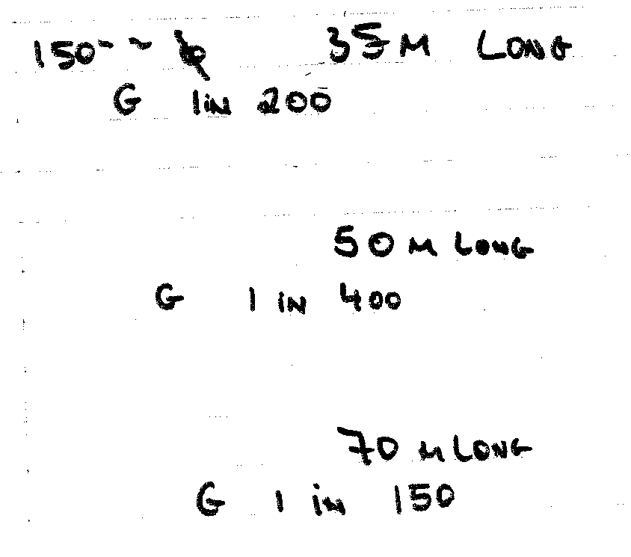
- Questions

100mm pipe 100m long
Laid to gradient of 1 in 100
What is the difference in level?
Answer = 1m

100mm pipe 100m long
Laid to a gradient of 1 in 50

What is the difference in level? 100 Length of pipe
Answer = 2m 50 Gradient

100mm pipe 100m long
Laid to a gradient of 1 in 25

What is the difference in level? 100
Answer = 4m 25

100mm pipe 100m long
Laid to a gradient of 1 in 120

What is the difference in level? 90
Answer = .75m or 750mm 120

Ventilation of Drains
Underground systems of drainage must be well ventilated for two main reasons:
- To maintain an equilibrium of pressure between the air inside the drain and that of the atmosphere. If, for instance, the air pressure in the drain was lower than that of the atmosphere, the trap seals of gulleys and WCs would very quickly be destroyed and foul air from the sewer would be admitted to the building and its precincts.
- To prevent the build-up of foul air and possibly dangerous gases. Sewage is very quickly acted upon by bacteria which thrive and multiply in dark airless environments. Their action on the sewage produces gases which not only have an objectionable smell but are also potentially dangerous due to their flammability. The action of bacteria in breaking down the sewage is a perfectly normal one but it must be confined to sewage disposal works and not allowed to happen in a house drainage system.
The system of ventilation used will depend upon whether or not intercepting traps are used. When an intercepting trap is used it is housed in an inspection chamber which is ventilated to the atmosphere via a fresh air inlet (see Fig 13).
The upper end or highest point of the drain should also terminate as a vent pipe which in effect acts as a flue through which drain air can be discharged to the atmosphere. As hot water is often discharged into a drain, the air it contains is warmer than that of the atmosphere, and air movement through the system occurs due to convection.
Where no interceptor is fitted (and this is the case in most modern developments) both the house drains and the public sewers are ventilated in the following way. Air is admitted into the sewer via the sewer ventilating pipes, or more commonly through the holes that can be observed in sewer manhole covers. This flow of air passes through the drainage pipework system and re-enters the atmosphere via the main ventilating stack on each building. It ensures a thorough air flush of both sewers and house drains. Figure 14 illustrates this method of drain ventilation. It must be emphasised that drain ventilation pipes should be fitted at the highest point of the drain, thus avoiding long unventilated branches.
The vent stack should be terminated at least 900mm above any window within a horizontal distance of 3m from the stack, and a wire balloon should be fitted to the top of the pipe to prevent the nesting of birds or the entry of debris.
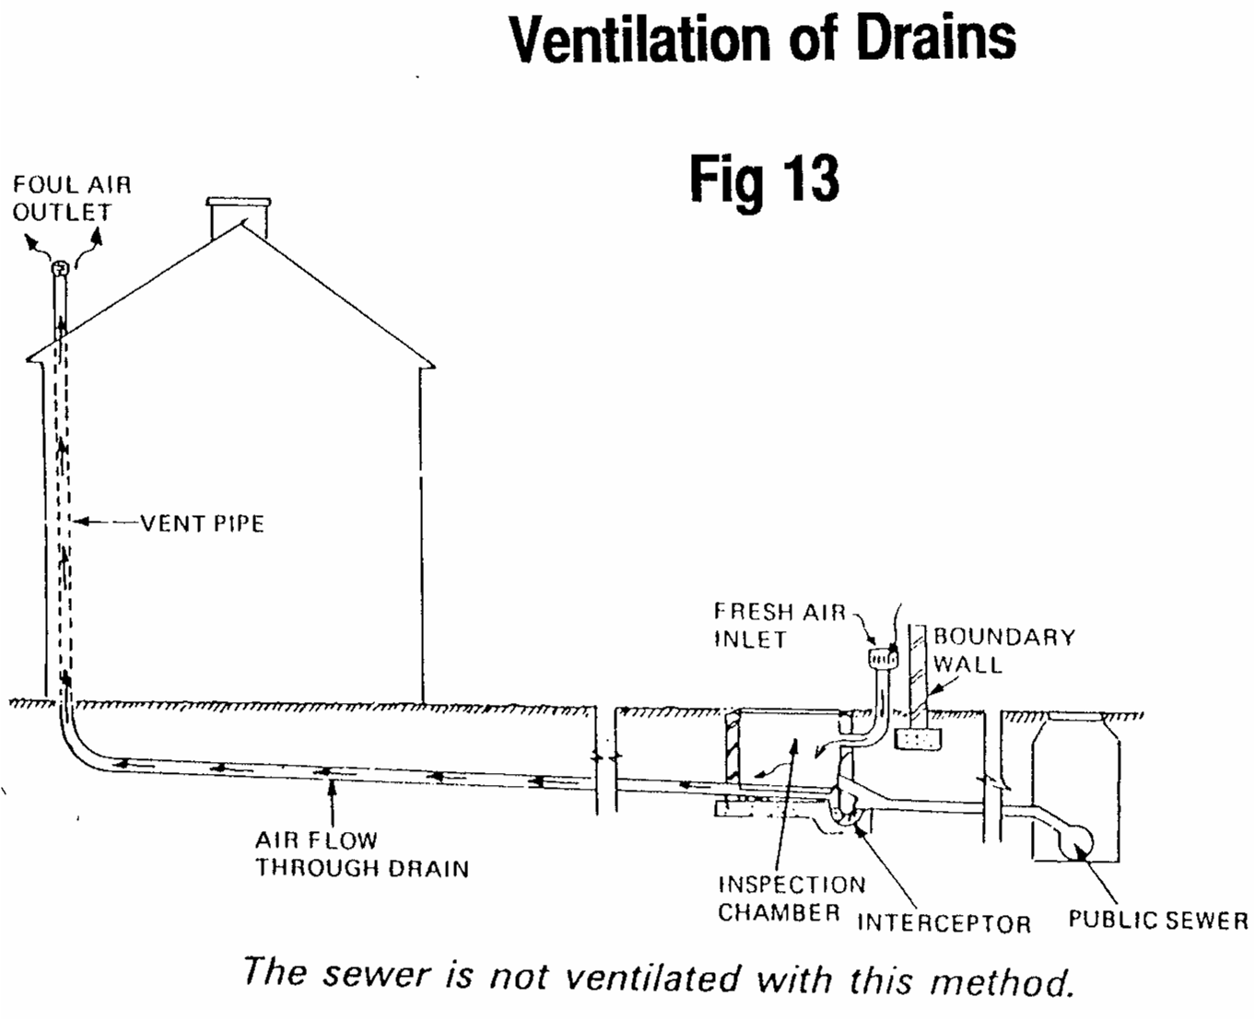
- Figure 13 – Ventilation of Drains
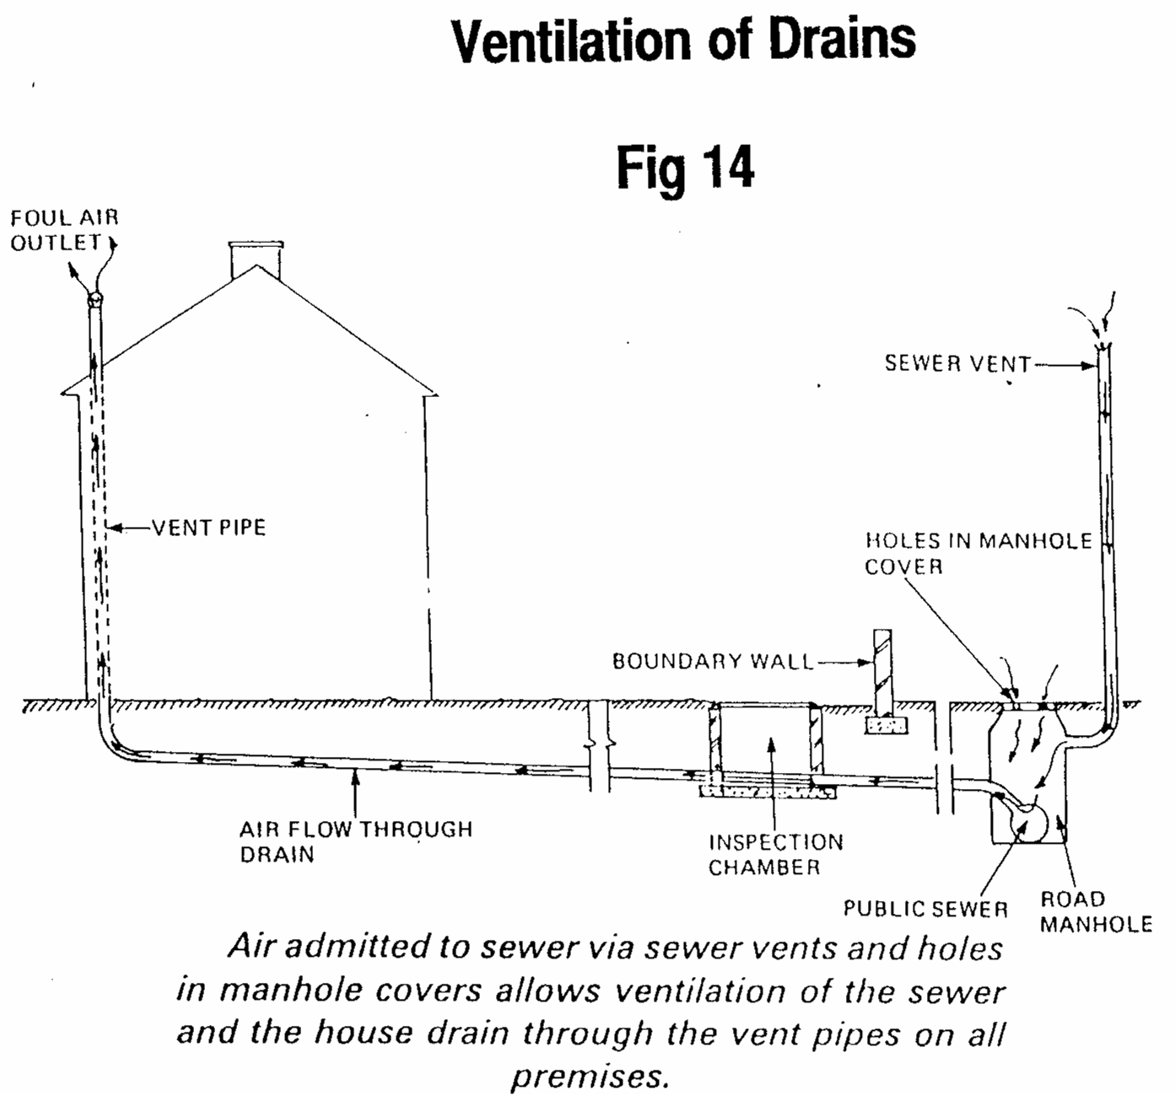
- Figure 14 – Ventilation of Drains

Drain Testing
After the drain has been laid and before backfilling, or pouring concrete or granular material round the pipes, it should be tested.
The three main methods of testing underground drains for soundness are:
- Water Tests.
- Air Tests.
- Smoke Tests.
If any leak occurs, the defective pipe or joint should be rectified and the drain again tested. Wherever possible, testing should be carried out between the manholes and short branch drains tested along with the main drainage system. Long branch drains and manholes should be tested separately. The test before backfilling should be carried out as soon as is practicable and the pipe should be supported to prevent any movement of the drain during the test.

Water Tests
- The drain should be filled with water, to give a test pressure equal to 1.5m of water above the soffit of the drain at the high end, but not more than 4m head of water above the soffit of the drain at the low end. Steeply grade drains should be tested in stages, so that the head of water at the lower end does not exceed 4m.
- The pipeline should be allowed to stand for two hours and topped up with water.
- After two hours the loss of water from the pipeline should be measured by noting the quantity of water needed to maintain the test head for 30 minutes. The fall of water needed in the vessel or stand pipe may be due to one or more of the following:
- Absorption by pipes or joints;
- Trapped Air;
- Sweating of pipes and joints;
- Leakage from defective pipes or joints;
- Leakage from stoppers.

Final Water Test
The rate of water loss should not exceed 1 litre/hour per metre diameter, per metre run of pipe. For various pipe sizes the rate of loss per metre run during the 30 minute period is 0.05 litre for 100mm pipe, 0.08 litre for 150mm pipe, and 0.12 litre for a 225mm pipe.
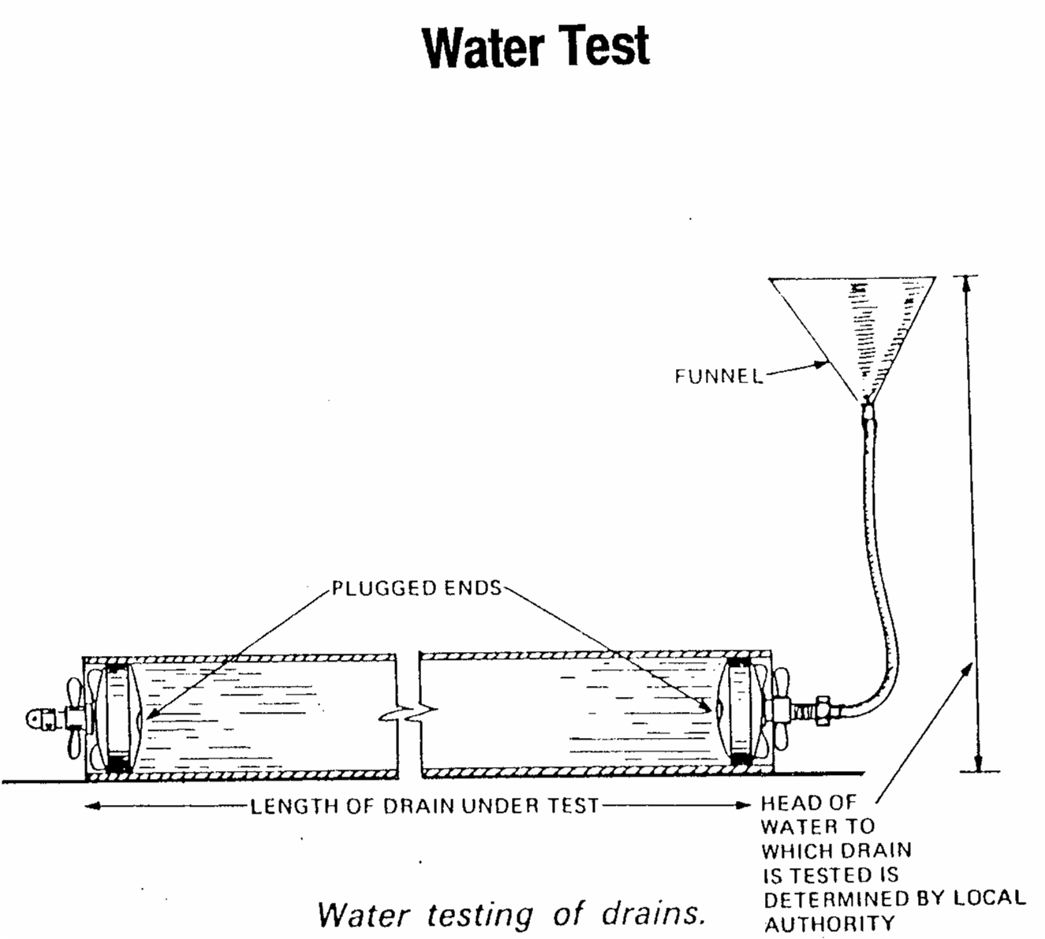
- Water Test

Air Tests
An air test is usually applied if there is insufficient water available for testing, or if there is difficulty in its disposal on completion of the test. Air tests are usually pressurised to 100mm (as shown on a U-gauge) for 10 to 15 minutes, during which time the pressure drop on the gauge must not be more than 25mm.
An advantage with air testing is that all parts of the drain are subjected to the same pressure, unlike water testing where the lower end is at a higher pressure than the inlet.
A tee piece with three valves is connected to a manometer (U-gauge), hand pump and a hose. The hose is passed through the seal of a Gulley Trap. With Valves A and C open and Valve B closed, air is pumped into the system.
The air pressure is checked periodically by opening Valve B. When the test pressure is reached, Valve A is closed and Valve B is opened. The air pressure is now recorded on the U-Gauge. If the system is sound the difference in levels in the manometer will be retained. Should there be a leak the levels will return to zero.
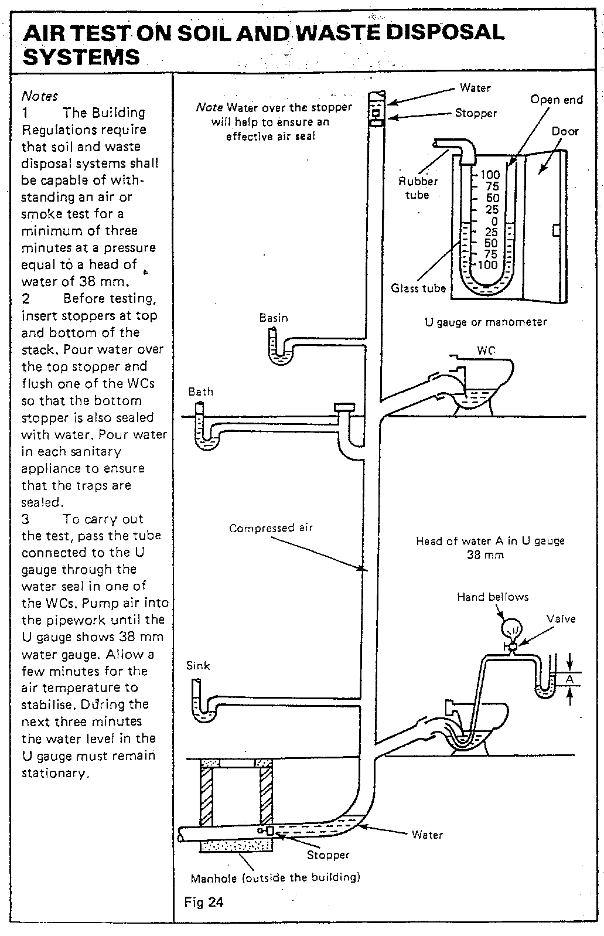
- Air Test on Soil and Waste Disposal Systems
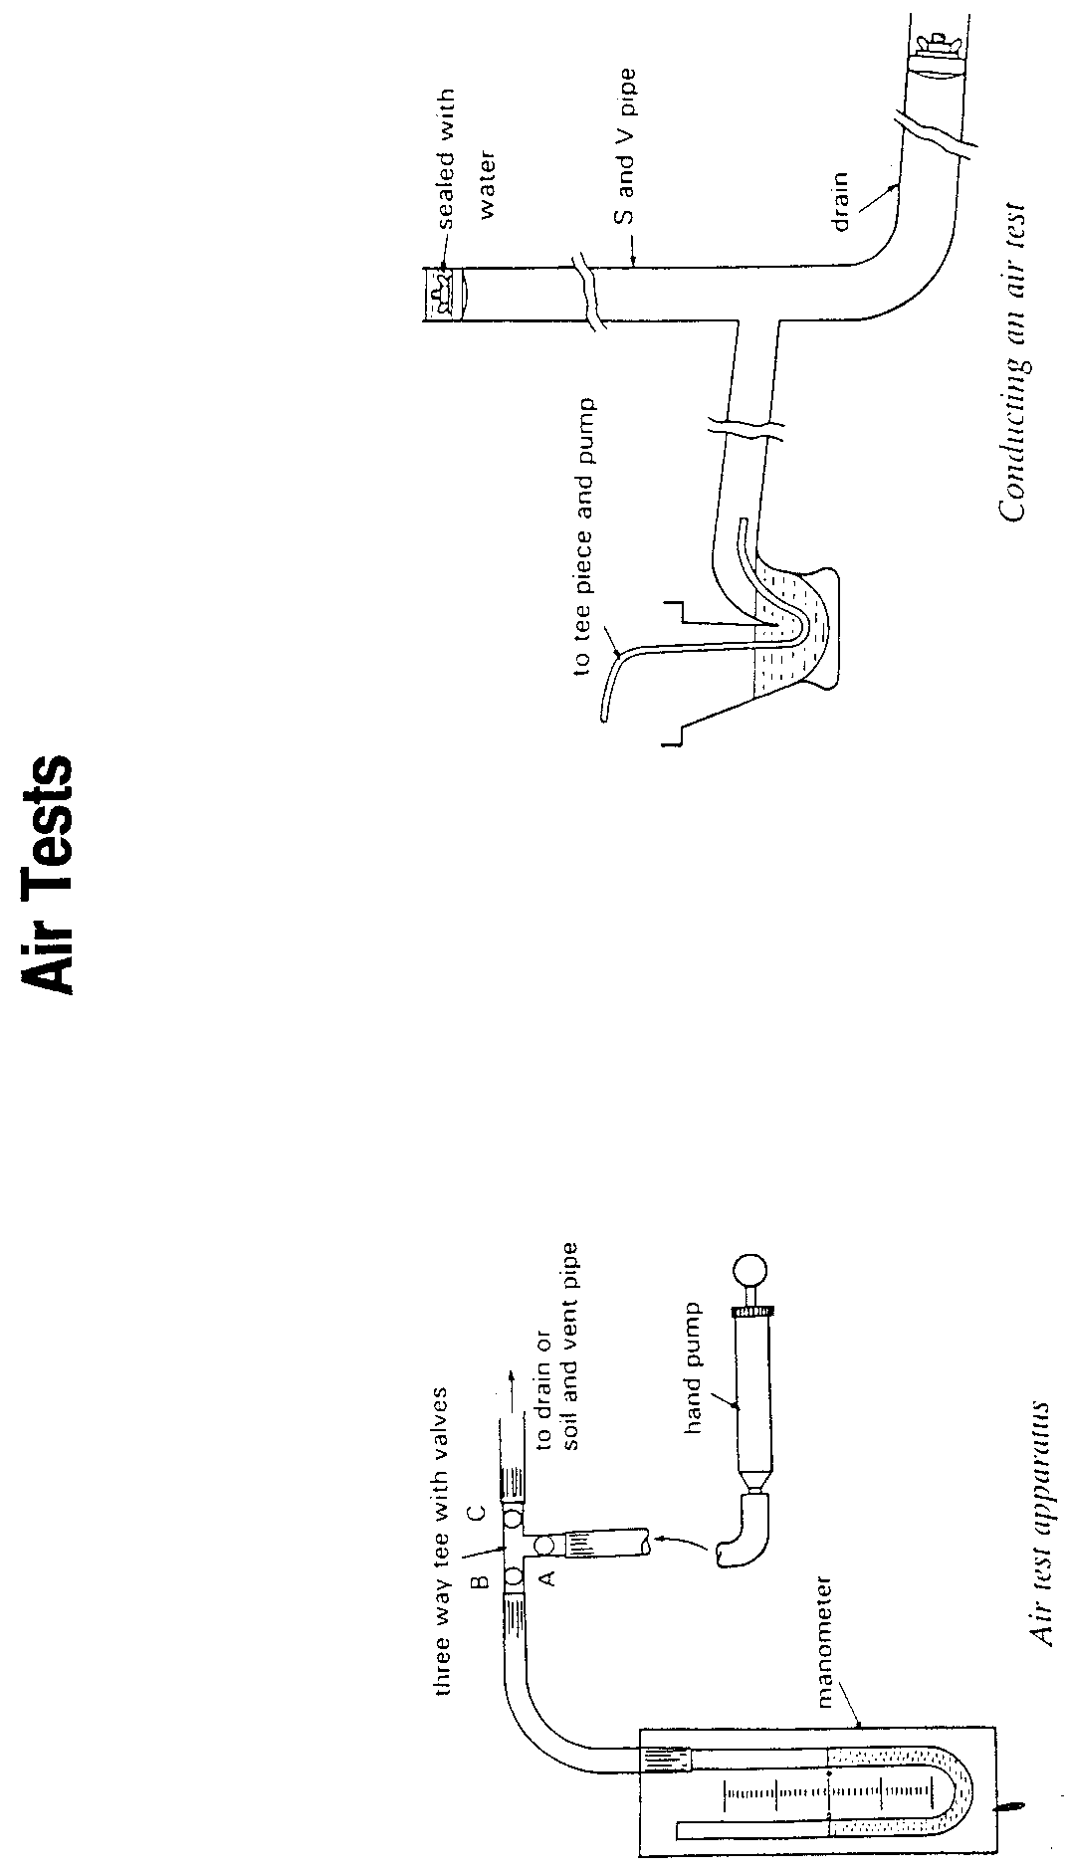
- Air Tests

Smoke Tests
The smoke test is used both for testing the soundness of the system and for tracing a suspected leak. It can be used equally well for the testing of above ground soil, waste and vent pipes.
All water seals must be charged with water and all branch drains and vents must be sealed except one. Smoke is then pumped into the system through a test plug which is fitted in the lowest point of the drain or stack.
The highest vent is left open until smoke begins to escape. At this point the vent is then sealed and pumping continues until sufficient pressure is built up inside the smoke machine to raise the dome approximately 50mm. Pumping now ceases and the system remains under test for 5 minutes. If the dome remains in the elevated position the system is sound. Should the dome fall or fail to rise a leak is indicated. Pumping is continued while the system is checked for smoke leakage.
This test should not be used on plastic systems, because of the detrimental action between the smoke and some types of plastic.
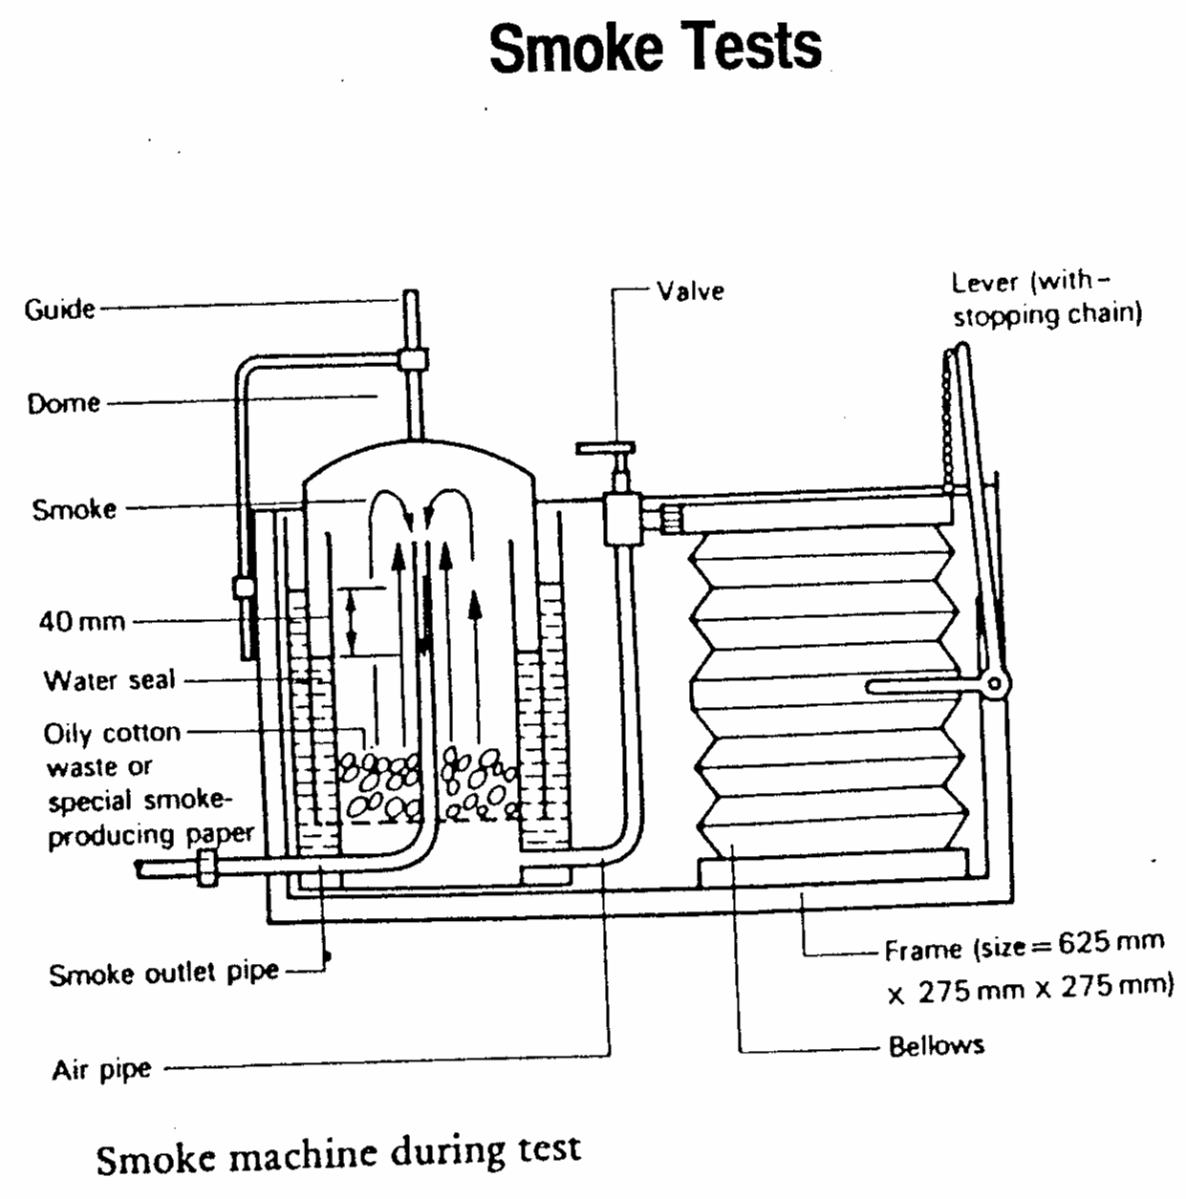
- Smoke Tests

Gullies and Traps
The design of a drainage system may allow the incorporation of any one of a whole series of gullies or traps to help ensure that design performance is met.

Petrol Interceptor
An arrangement of inspection chambers designed to prevent petroleum spirit from entering the public sewer. A petrol interceptor is designed in such a way that may be present can rise to the surface of the stored water (petrol being lighter then water) and evaporate safely into the atmosphere. Notice that in the first chamber, the exit pipe is shorter than the following two; this is to allow grit and sludge to settle and accumulate without blocking the pipe end. For a single garage a deep GARAGE GULLY may be sufficient (see Fig 1).

Yard and Garage Gullies
A large gully which includes a sediment bucket to collect any grit or slit which might otherwise block the outlet pipe. The bucket should periodically be removed for cleansing purposes (see Fig 2).

Anti-Flood Gullies
A fitting designed to prevent surcharging or flooding of surface water drains. With the ball type shown, when backflow or surcharging occurs the ball rises onto the underside of the access cover until it finally sits into the rubber seating, preventing any further flow in either direction until the flood water subsides (see Fig 3).

Grease Trap
A grease trap is a device which houses a quantity of water and is designed so that should grease from canteen kitchens be discharged into the drains it would, when reaching the water, cool and solidify. Lighter solids would rise to the surface and collect in a solid cake; heavier solids would sink and collect in the galvanised tray. Periodically the tray should be lifted out, removing all the grease which has accumulated. Some grease traps are designed to be fitted under sinks but in most cases the trap is fitted externally to the building (see Fig 4).

Intercepting Trap
A type of running trap usually found in older properties in the inspection chamber nearest the main sewer. The prime function of an intercepting trap is to prevent sewer gas from entering the house drains, but nowadays because drainage systems are better designed and sewer gases seldom cause trouble in most cases an intercepting trap is omitted. In the past the intercepting trap proved a common cause of blockages owing of the collection of debris in the trap (see Fig 5).

Gulley Trap
The gulley is a drainage fitting designed to receive surface and/or foul water from waste pipes. The purpose of a gulley trap is to provide a trap preventing odours from the drain entering the atmosphere (see Fig 6)

Armstrong Junction
A type of access junction (often referred to as AJ) is basically a miniature manhole, (see Fig 7).
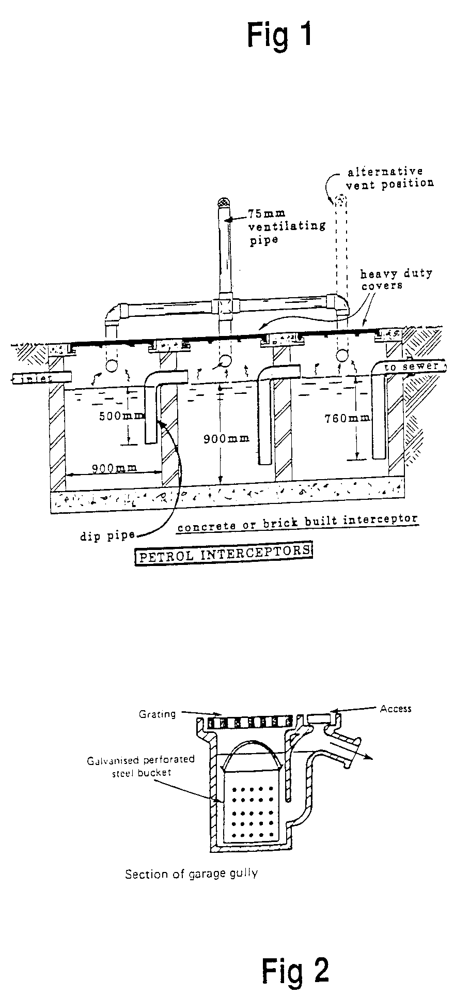
- Petrol Interceptors
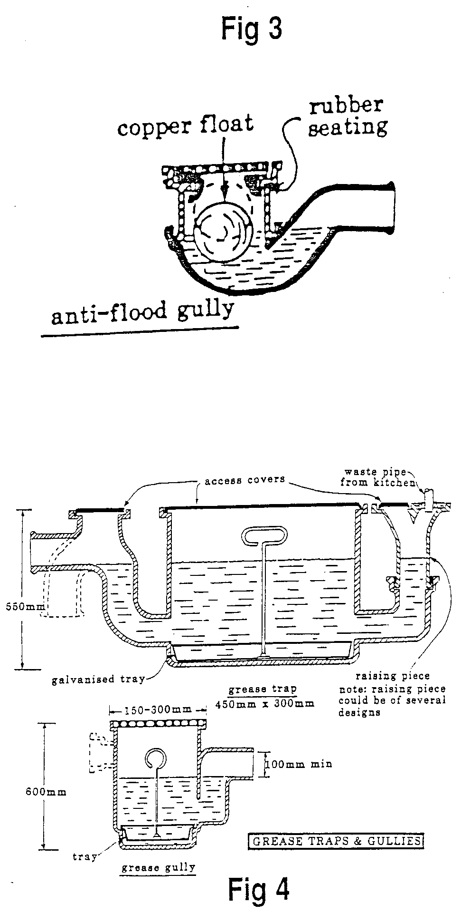
- Grease Traps and Gullies
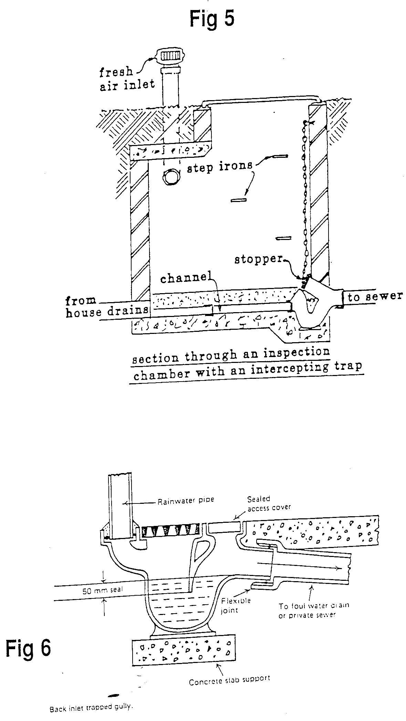
- Figure 5 and Figure 6

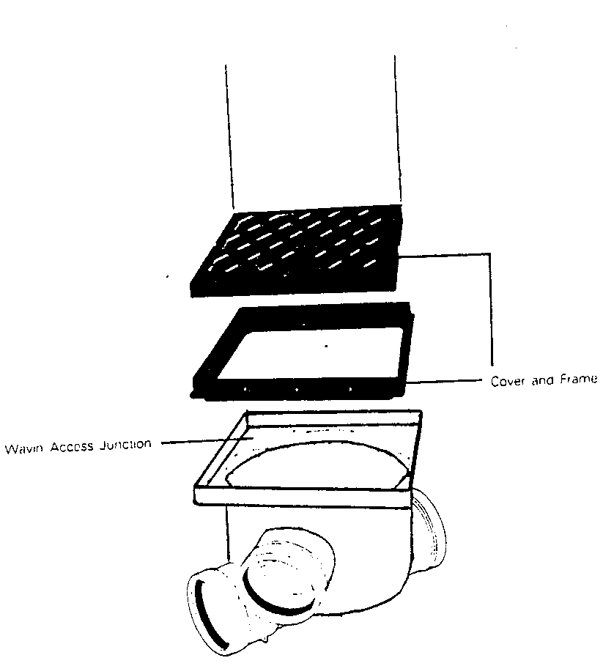
- Armstrong Junction

Drainage Terms
Haunching
The concrete which slopes from the top of a drainage pipe down to the bedding (see Fig 1).
Benching
The sloping sides constructed at the base on an INSPECTION CHAMBER to prevent the accumulation of solid deposits (see Fig 2).
Invert
The lowest point of the internal surface of a drain, sewer or channel (see Fig 3)
Soffit
The highest point of the internal surface of a pipeline at any cross-section (see Fig 5)
Manhole
A chamber usually constructed of brick or concrete and designed to expose a section of open pipe, in the form of a channel at its base. If the chamber is large enough to work in it is identified as a manhole, which would certainly be the case in all chambers over 1 metre deep.
Self Cleansing Gradient
The slope to which a horizontal discharge pipe or drain is laid. If the pipe is laid with too steep a fall the water will flow through the pipe very fast and leave the solid matter behind. Equally if the gradient is too shallow the water will flow very slowly and be insufficient to carry along with it any solid matter.
Self Cleansing Velocity
The velocity or speed at which water flows through a pipe or channel to ensure that no deposits of solid matter are left behind.
Drain Plug
A removable expandable device used for sealing off a portion of drain, normally for testing purposes.
Cleaning Eye
An access opening in a pipe or pipe fitting arranged to facilitate the clearing of obstructions and fitted with a cap, plug or cover plate.

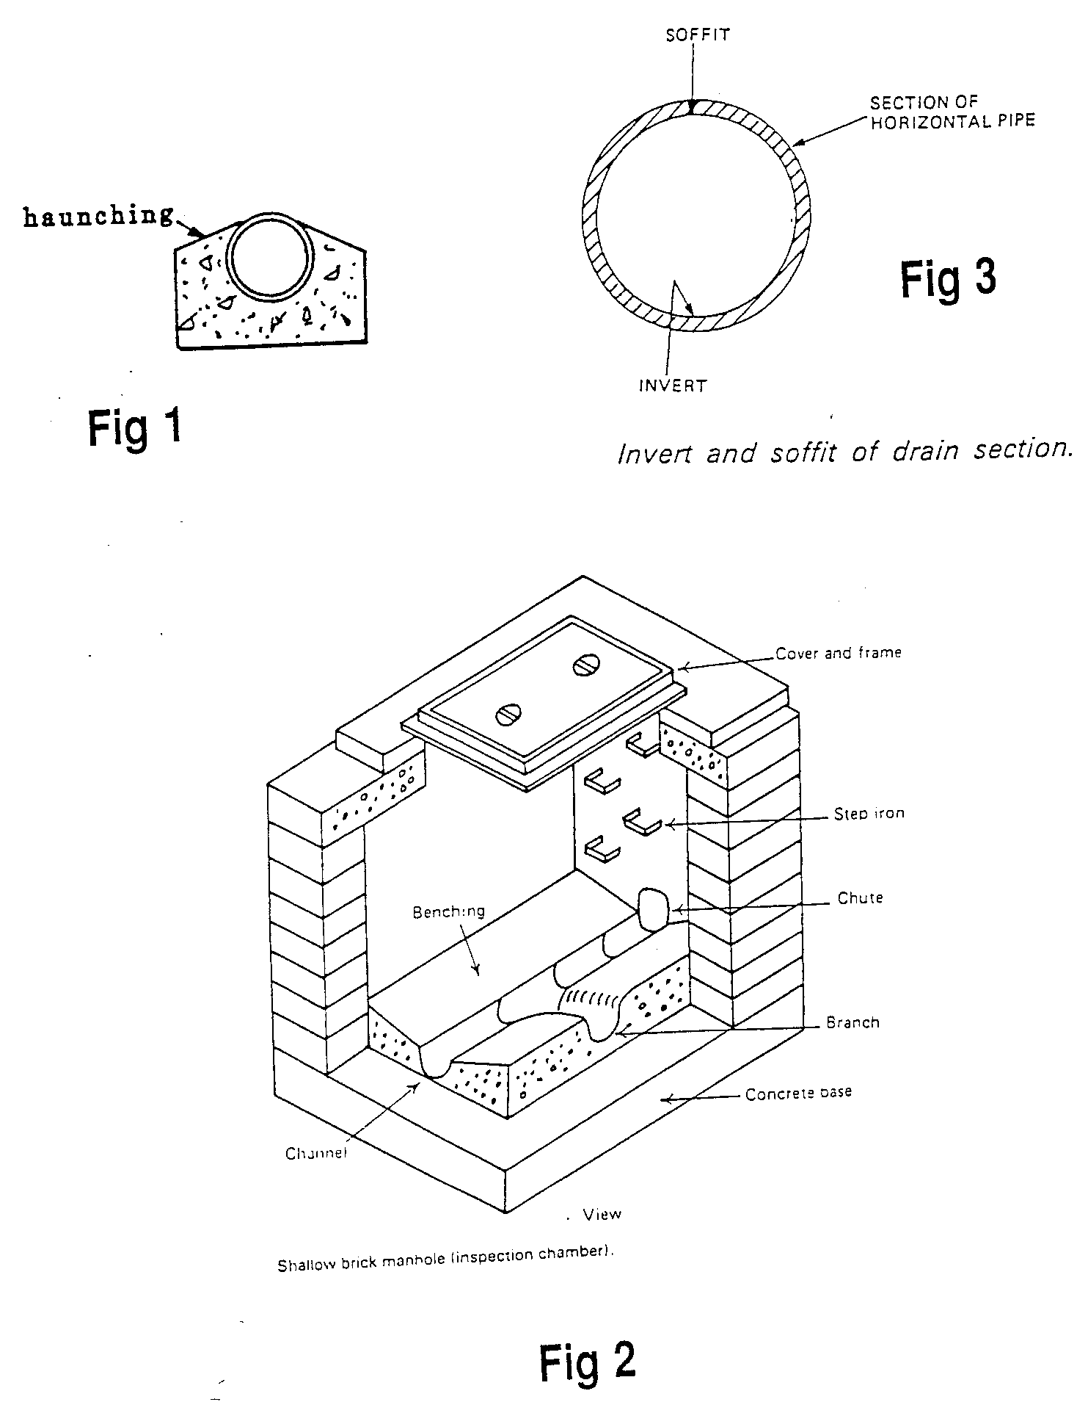
- Fig 1, 2 & 3 - Haunching, Benching, and Invert

Self Assessment

Exercise:
- Apprentice to answer sample questions on Exercise/Procedure No. 2.2.13. in the curriculum document.
- List the basic principles that should be followed when installing an underground system of drainage.
- Describe, using a sketch, the separate system of underground drainage
- Explain the terms self-cleansing gradient, benching, invert level.
- Explain the importance of ventilation for underground drainage systems.
- State the minimum pipe size permissible for underground drainage and using Maguire's rule calculate the recommended gradient.
- A Ø150 mm pipe 60 m in length is to be laid according to Maguire's rule. Calculate the difference in levels at either end of the pipe.
- Draw a plan view of a domestic combined system of drainage.

Index

A
access fittings, 16
Access to Drains, 16
air tests, 31
Air Tests, 31, 32, 34
Armstrong junction, 38
B
Below Ground Drainage, 10
below ground drainage systems, 10
types of, 10
C
combined below ground drainage system, 10
Combined System of Underground Drainage, 11
copper pipes
assembly of, 8
D
drain testing, 31
methods of, 31
Drain Testing, 31
drainage
benching, 42
cleaning eye, 42
drain plug, 42
haunching, 42
invert, 42
manhole, 42
self-cleansing gradient, 42
self-cleansing velocity, 42
soffit, 42
terms, 42
drainage calculations, 26
drainage levels, 26
drains, 10, 13, 16, 23, 26, 27, 28, 31, 32, 35, 37, 42
internal access to, 16
G
gradient, 10, 16, 19, 23, 26, 27, 28, 42
grease trap, 37
Grease Trap, 37
gulley trap, 37
gullies, 37, 39
anti-flood, 37
yard and garage, 37
I
inspection chambers, 10, 16, 37
intercepting trap, 37
M
Maguire’s rule, 10
Maguire’s Rule, 26
manholes, 16, 31
P
partially separated below ground drainage system, 10
petrol interceptor, 37
Petrol Interceptor, 37
pipework, 10, 19, 28
pipework protection, 19, 20, 21
R
rodding eyes, 16
S
separate below ground drainage system, 10
Separate System of Underground Drainage, 13
sewers, 11
smoke tests, 31, 35, 36
T
traps, 37, 39
V
ventilation of drains, 10, 28
W
water tests, 31

