Trade of Plumbing
Module 3: | Domestic heating/MMA Welding
Unit 5: | Manual Arc Welding
 | Phase 2

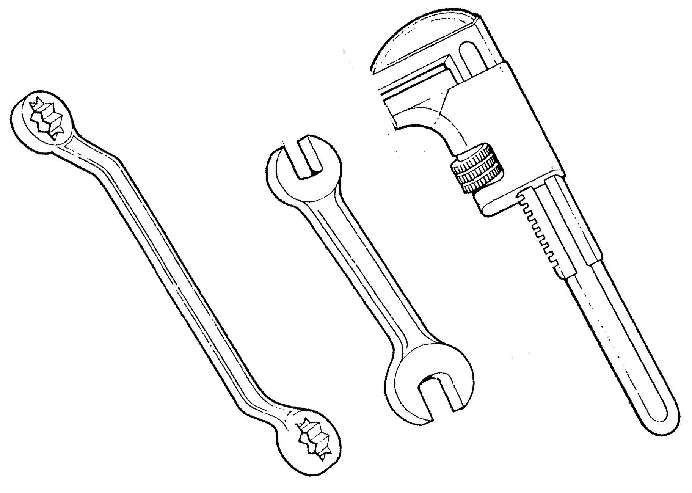

Table of Contents
List of Figures 6
List of Tables 8
Document Release History 9
Module 3 – Domestic Heating / MMA Welding 10
Unit 5 – Manual Arc Welding 10
Learning Outcome: 10
Key Learning Points: 10
Training Resources 10
Key Learning Points Code: 10
Manual Metal Arcing 11
Protection for Operator 12
Protection for Others 13
General Protection 13
Fire Extinguishers 13
Access and Exits: 13
Weld Symbols on Drawings 14
B.S. symbols for a variety of weld types 16
Intermittent welds 21
The Manual Metal Arc Process 21
Manual metal arc welding equipment 22
Welding Techniques 24
Current too low 24
Current too high 25
Correct Current 25
Arc Length 26
Speed of Travel 27
Too Fast 27
Too Slow 27
Weld Defects and Their Causes 28
Lack of Penetration 28
Lack of Fusion 29
Porosity 29
Slag Inclusion 30
Undercut 30
Overlays 31
Crackling 31
Blowholes 32
Burn Through 32
Excessive Penetration 33
Control of Distortion 34
Expansion and Contraction in Welding and Cutting Processes 34
Incorrect edge preparation 34
Electrodes 36
Functions of the Electrode Coating 37
American Welding Society (AWS) Classification System for Electrodes 38
Mild steel electrodes 38
Hazards and Safety 39
Arch Flash 40
AC and DC Welding Plants 43
Types of Welding Plant 43
Direct Current (d.c.) 43
Alternating Current (A.C.) 45
Effect of Short Circuiting 46
The Advantage and Disadvantages of A.C. and D.C. Welding 47
The Advantage of A. C. Welding Plants 47
The Disadvantages of A. C. Welding Plants 47
The Advantages of D.C. Welding 47
Disadvantages with D.C. Welding 47
Arc blow 47
Power Supply 48
Alternating Current (A.C.) 48
Direct Current (D.C.) 48
Advantages of A.C. Welding Sets 49
Disadvantages of A.C. Welding Sets 49
Advantages of D.C. Welding Sets 49
Disadvantages of D.C. Welding Sets 49
Electrodes 49
Care of Electrodes 50
Types of Flux 50
Faults & Imperfections in Arc-Welding 51
Types of Joints 52
Self Assessment 53
Exercise 1: 53
Exercise 2: 54
Index 56

List of Figures
Figure 1. Basic B.S. 499 weld features 15
Figure 2. B.S weld symbols 1. 16
Figure 3. B.S weld symbols 2. 17
Figure 4. B.S weld symbols example 1. 18
Figure 5. B.S weld symbols example 2. 19
Figure 6. 6mm fillet weld 19
Figure 7. Unequal leg fillet weld 20
Figure 8. Size of the members 20
Figure 9. Information on side of the symbol 20
Figure 10. Intermittent welds 21
Figure 11. Arc - spark 21
Figure 12. Arc – spark area 21
Figure 13. Electrode mix area 22
Figure 14. Metal-arc welding process 22
Figure 15. Creating an arc – stage 1. 23
Figure 16. Creating an arc – stage 2. 23
Figure 17. Creating an arc – stage 3. 24
Figure 18. Current too low 24
Figure 19. Current too high 25
Figure 20. Correct current 25
Figure 21. Arc length 26
Figure 22. Speed of travel – too fast 27
Figure 23. Speed of travel – too slow 27
Figure 24. Lack of penetration 28
Figure 25. Lack of fusion 29
Figure 26. Porosity 29
Figure 27. Slag inclusion 30
Figure 28. Undercut 30
Figure 29. Overlay 31
Figure 30. Crackling 31
Figure 31. Blowholes 32
Figure 32. Burn Through 32
Figure 33. Excessive Penetration 33
Figure 34. Distortion / Presetting / Backstepping / Skip-welding 35
Figure 35. Electrodes 36
Figure 36. Electrode coating 37
Figure 37. Welding shield 39
Figure 38. Arc flash 40
Figure 39. Goggles 40
Figure 40. Welding screen 41
Figure 41. Welding precautions 41
Figure 42. Damaged welding cables 42
Figure 43. Direct current (d.c.) 43
Figure 44. Electrode becomes too hot 43
Figure 45. D.C. power source – generator 44
Figure 46. D.C. power source – rectifier 44
Figure 47. A.C. direction current flow 45
Figure 48. A.C. supply voltage 45
Figure 49. A.C. alternating-current 46
Figure 50. A.C welding generator 46
Figure 51. Welding Processes 48
Figure 52. Welding Positions 52
Figure 53. Types of joints exercise 54
Figure 54. Types of joints exercise answers 55

List of Tables

Document Release History
Date | Version | Comments
June 2006 | V.1.0
26/02/14 | 2.0 | SOLAS transfer

Module 3 – Domestic Heating / MMA Welding

Unit 5 – Manual Arc Welding
Duration 36 hours

Learning Outcome:
By the end of this unit each apprentice will be able to:
- Describe the manual arc welding process and equipment.
- Describe welding defects and their causes.
- Set up manual arc welding equipment.
- Weld butt, lap and fillet joints on mild steel plate.

Key Learning Points:
Rk | Manual arc welding process.
Rk | Manual arc welding equipment – AC and DC plant, leads, holder, electrodes etc.
Rk Sc | Weld defects, causes and prevention.
Sk | Setting up manual arc welding equipment.
Sk | Selecting correct current and electrodes.
Rk | Care of electrodes.
Sk | Welding techniques for butt, lap and fillet joints.
H | Hot metal, arc eye, electric shock etc.
P | Working independently.
P | Good working practice.

Training Resources
- Classroom facilities and workshop sheets.
- Information sheets.
- Sample defective welds.

Key Learning Points Code:
M = Maths D= Drawing RK = Related Knowledge Sc = Science
P = Personal Skills Sk = Skill H = Hazards

Manual Metal Arcing
Manual metal arc welding was first invented in Russia in 1888. It involved a bare metal rod with no flux coating to give a protective gas shield. The development of coated electrodes did not occur until the early 1900s when the Kjellberg process was invented in Sweden and the Quasi-arc method was introduced in the UK. It is worth nothing that coated electrodes were slow to be adopted because of their high cost. However, it was inevitable that as the demand for sound welds grew, manual metal arc became synonymous with coated electrodes.
When an arc is struck between the metal rod (electrode) and the workpiece, both the rod and workpiece surface melt to form a weld pool. Simultaneously melting of the flux coating on the rod will form gas and slag which protects the weld pool from the surrounding atmosphere. The slag will solidify and cool and must be chipped off the weld bead once the weld run is complete (or before the next weld pass is deposited).
The process allows only short lengths of weld to be produced before a new electrode needs to be inserted in the holder. Weld penetration is low and the quality of the weld deposit is highly dependent on the skill of the welder.

Protection for Operator
- No open-neck shirts;
Ultra-violet rays will burn the skin. It is most definitely not similar to sun tanning.
- Regulation inflammable overalls only;
Arc-welding produces large amounts of hot sparks which will set flammable clothing alight.
- No trainers/runners to be worn;
The steel metal plate used are heavy and sharp. Wear steel toe-cap boots.
- Overalls not around waist;
Sparks will set casual tops alight
- Always wear protective clothing;
Arc-welding produces heat, glare, sparks, ultra-violet & infra-red rays and harmful fumes. Welding gauntlets must be worn at all times. Face masks are designed to deflect fumes and should therefore be held close to the face. Gas welding goggles will not afford protection for the face against the light intensity or the radiation and must not be used. Shade 11 EW filters are required in the face mask for manual metal arc welding. Always wear protective goggles when chipping slag.
- Ensure adequate ventilation;
Ventilation at source, when welding inside buildings, is a formal factory regulation and is there to protect the operator and others. Welding of some materials (i.e. galvanised steel) produces highly toxic fumes
- Check your surroundings;
Remember when you are welding behind a dark face mask you will be unaware of what is happening around you. Clear the surroundings of flammable material and ensure there is a fire extinguisher available.
- Examine all welding cables;
Check for any loose connections that would cause arching thereby creating a hazard. Ensure your surroundings are dry and where possible stand on a timber “duck-board”.
- Never weld enclosed tanks;
Tanks which have contained flammable material may still hold traces of the substance within the seams.
Containers such as this (i.e. petrol tanks, solvent tanks) should be thoroughly purged with running water
- Do not wells over Paint/Oils/Grease/Solvents;
Striking the arc will prove difficult and toxic fumes will be produced

Protection for Others
- Screen rays from others;
Before welding, ensure others are protected from the light rays by erecting screens. Ultra-violet rays cause the condition known as “arc-eye” which is really conjunctivitis. If affected, the eyes should be thoroughly washed with an eye bath. If the condition persists, medical advice should be sought.
- Safe removal of a victim;
An individual who has been electrocuted could still be in contact with the power source and therefore should be removed with the use of non-conducting material to protect the rescuer.
Onlookers to the welding process must be informed of the need to wear protective clothing.

General Protection

Fire Extinguishers
- Carbon tetrachloride. (C.T.C.)
Effective for all types of fires but not to be used adjacent to live high voltage. The gas is poisonous. Not to be used in confined spaces.
- Carbon Dioxide (CO2).
May be used on electric motors, switchgear and transformers up to 10 KV.
- Foam.
Suitable for oil fires but is a conductor and should not be used on live electrical equipment.

Access and Exits:
- Ensure adequate clear access is available to the work area in the event of injury.
- Exits must be kept be free of obstacles.
- When welding inside large vessels a safety harness must be worn.

Weld Symbols on Drawings
Engineering drawings are descriptions of manufactured objects in terms of shape. surface, finish and material. In many industries it is customary to draw the shape of the component without indicating how that shape is achieved. The drawing is a description of a requirement produced by the designer for the instruction of the manufacturer. In theory, the manufacturer knows best how to produce an object with the resources he has. In practice, of course. the designer compromises and produces designs which are capable of production by the techniques ,of which he is aware. For example, a round hole can be drilled, bored or punched. and can be finished by reaming, but whichever method is used, the lines on the drawing are the same and whichever method is used, the material is not changed in its characteristics.
A welded joint offers a range of considerations which do not arise in other forms of manufacture. Firstly, there are far more techniques for making a welded joint than in many other manufacturing operations. This means that the designer has far less chance of foreseeing the manufacturer’s methods. Secondly, the properties and integrity of the joint will depend on the manner in which the weld is made Despite this, the designer can still indicate the type of joint he requires. provided that he is prepared to accept that he may not be able to completely define the joint in the earlier stages of a design.
In some industries it is customary for the manufacturer to produce shop drawings which contain details of weld preparations and reference to established welding procedures not shown in detail on the designer’s drawings. The range of British Standard symbols which can be used on a drawing to indicate a weld detail are described here.

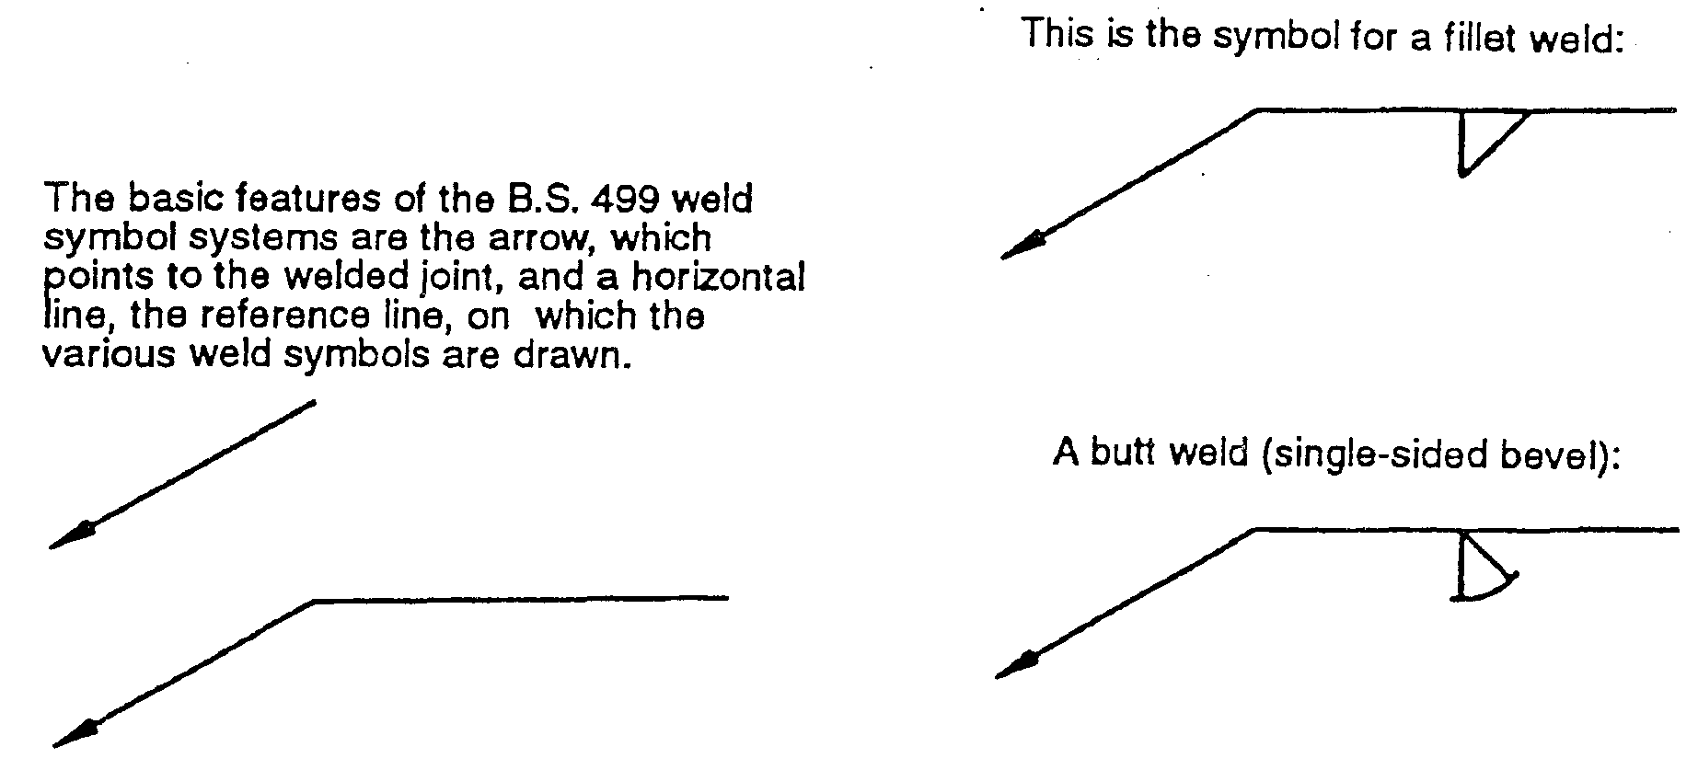

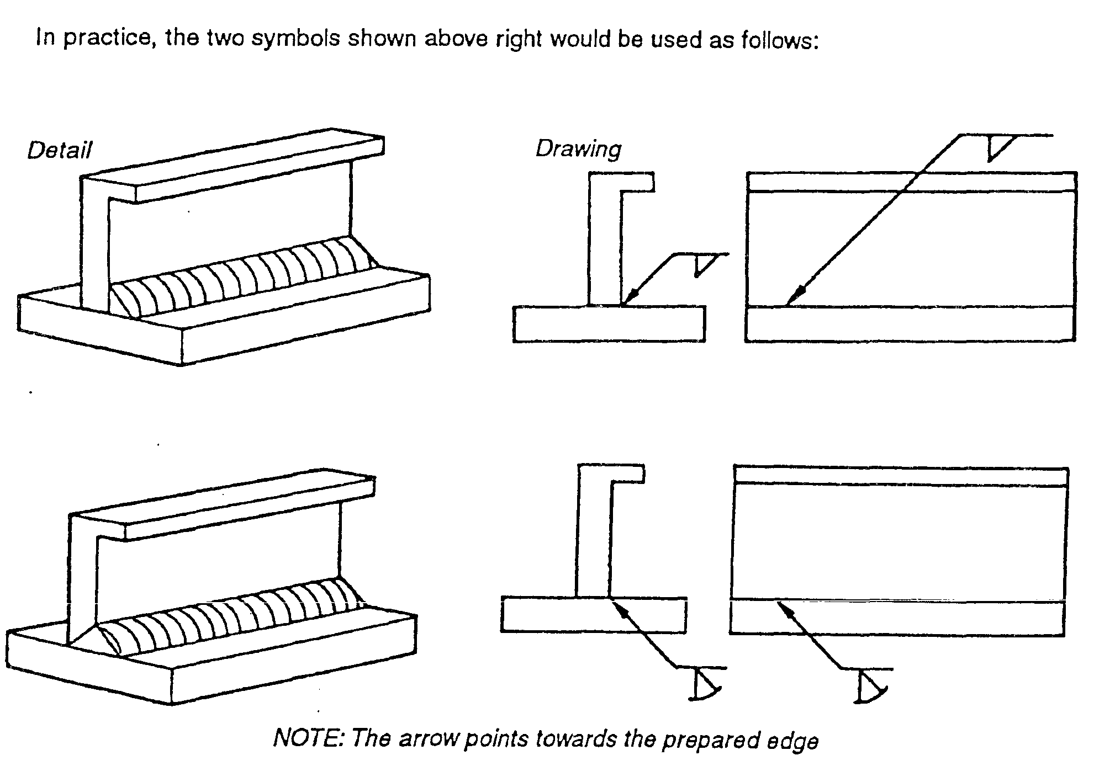
- Basic B.S. 499 weld features

B.S. symbols for a variety of weld types
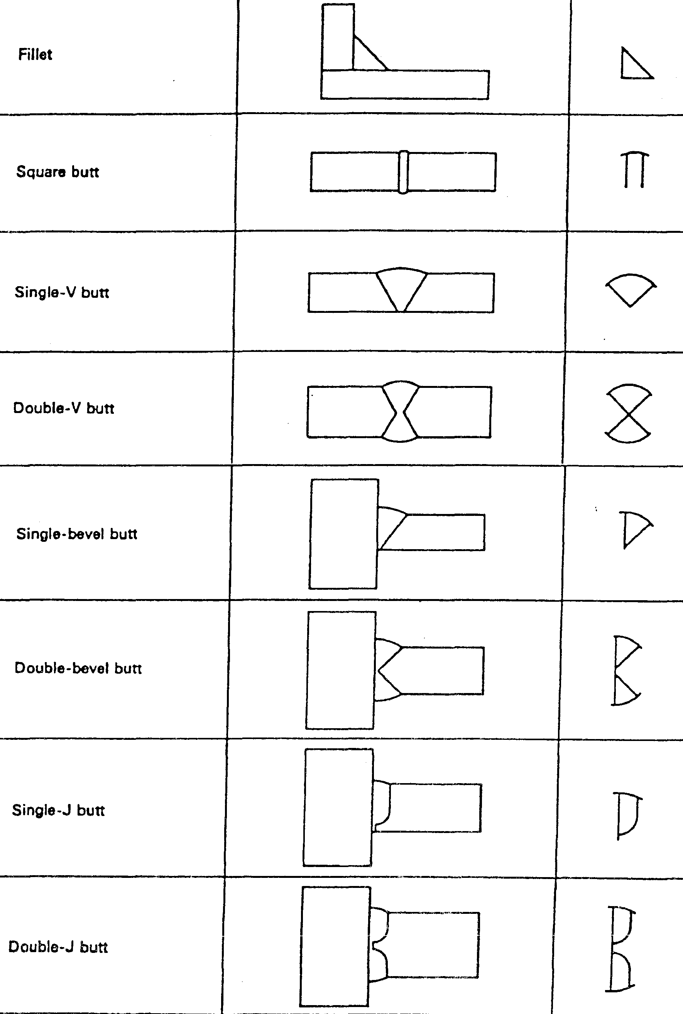
- B.S weld symbols 1.

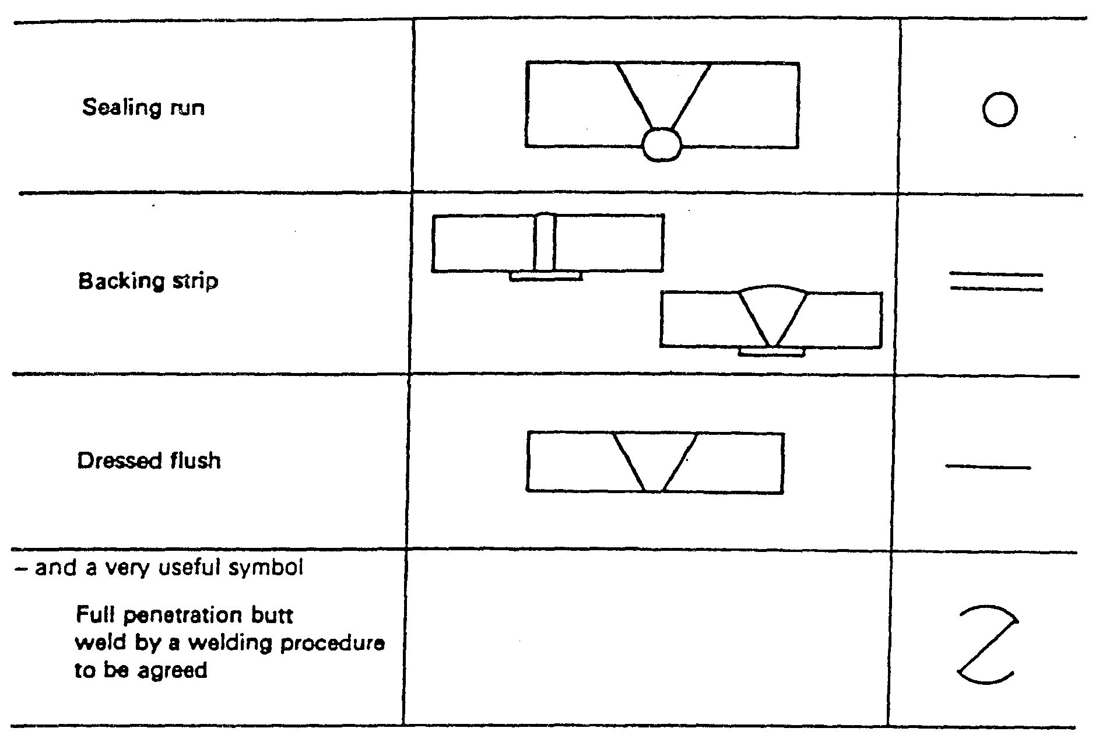
- B.S weld symbols 2.
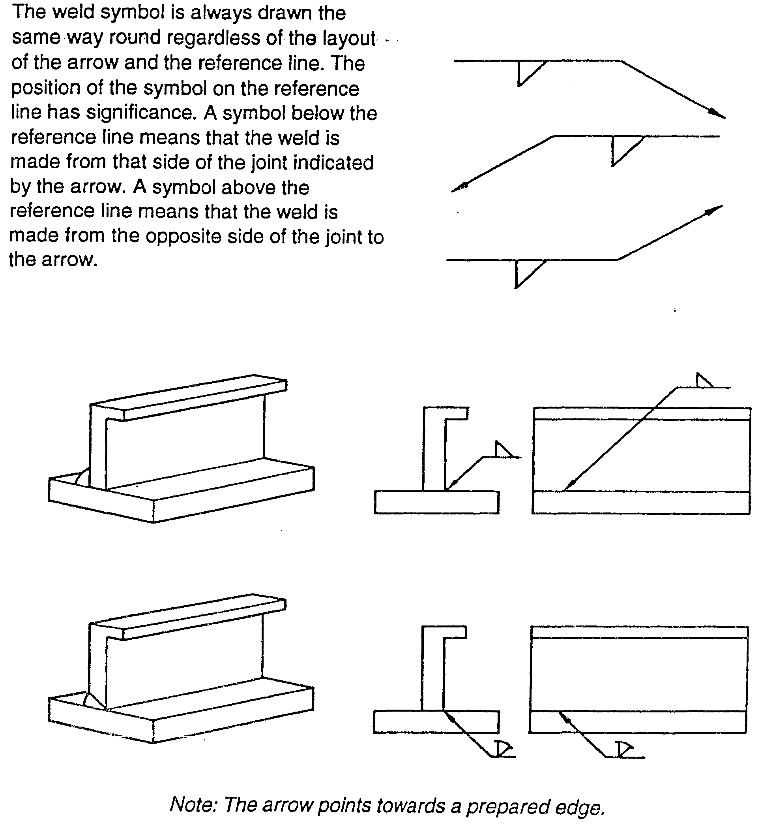

- B.S weld symbols example 1.
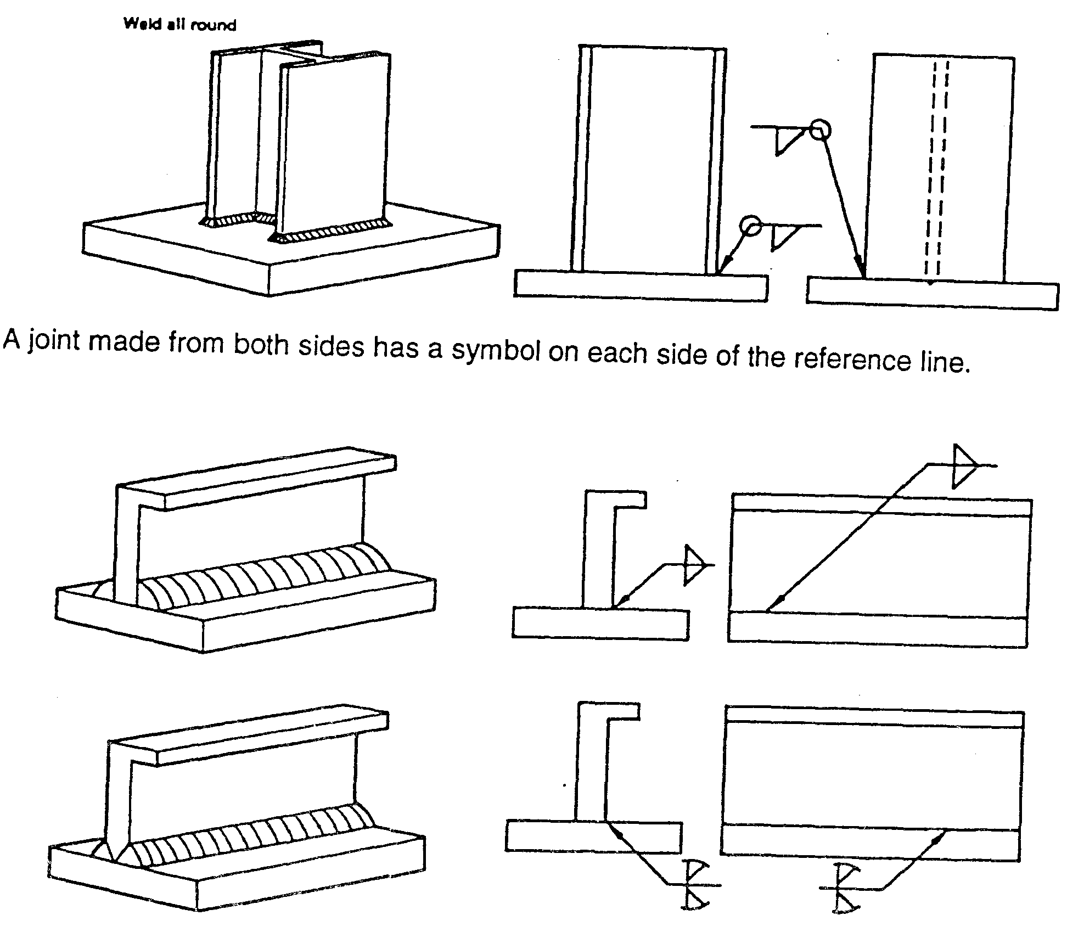

- B.S weld symbols example 2.
Weld size can be indicated on the symbol. 6 mm fillet weld. The drawing must state whether a throat or leg dimension is quoted.
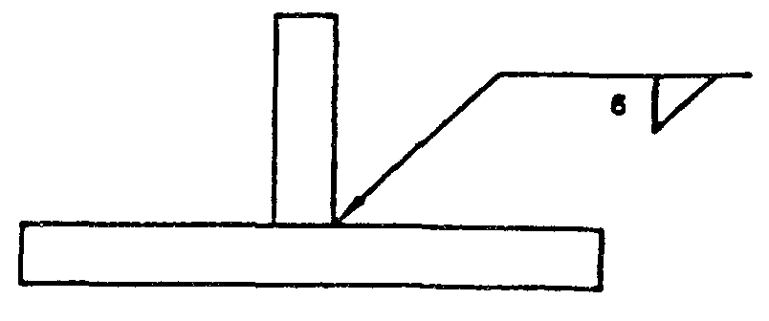
- 6mm fillet weld

Unequal leg fillet weld. This must be defined by leg length. A diagram of weld ) shape is required here.
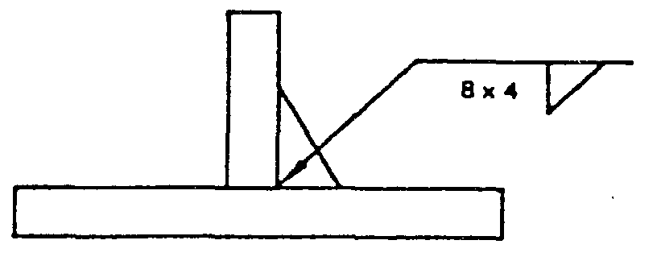
- Unequal leg fillet weld
A diagram is not required here because the size of the members indicates the weld orientation.
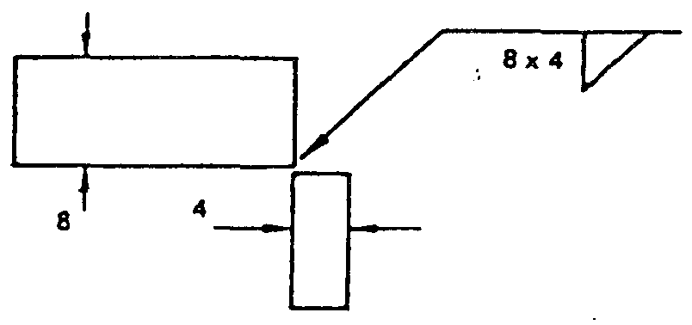
- Size of the members
Information other than weld size may be written to the right of the symbol.
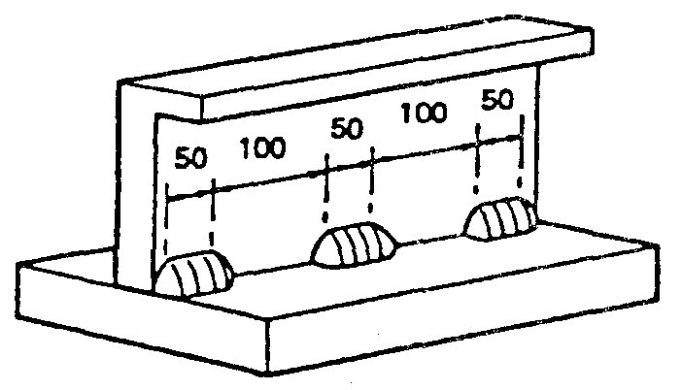
- Information on side of the symbol

Intermittent welds
The figure in brackets is the space length. 50 before (100) indicates that the weld is at the beginning. (100) 50 would indicate a space first then a weld although such an arrangement would not represent good practice.
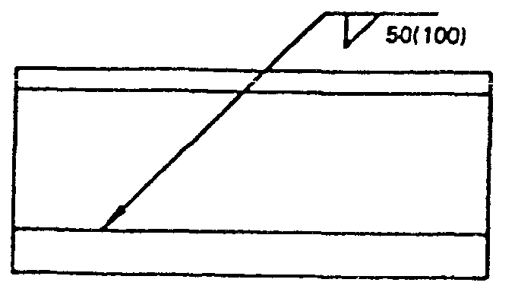
- Intermittent welds

The Manual Metal Arc Process
When two wires which form part of an electrical circuit are brought together arid then pulled slowly apart, an electric spark is produced across their ends.
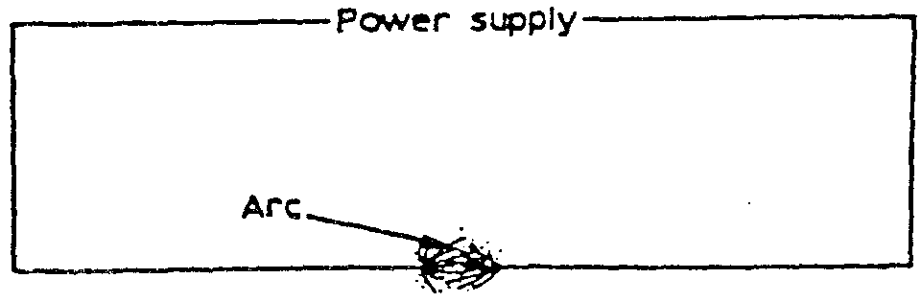
- Arc - spark
This spark, or arc as it is called, has a temperature of up to 3,600°C. As the arc is confined to a very small area it can melt metal almost instantly.
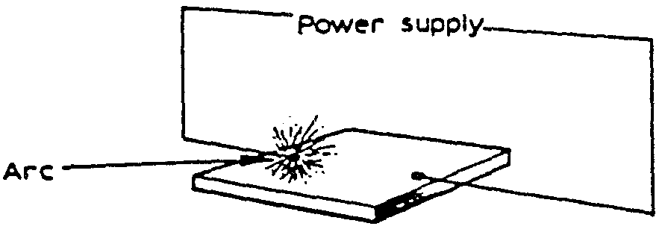
- Arc – spark area
If one of these wires is connected to the job and the other to a wire rod or electrode, as it is usually called, the heat of the arc melts both the metal of the job and the point of the electrode. The molten metal from the electrode mixes with that from the job and forms the weld. It is important to realize that tiny globules of the molten metal from the electrode are forced through the arc (they do not fall by gravity). If this were not so it would be impossible to use this process for overhead welding.
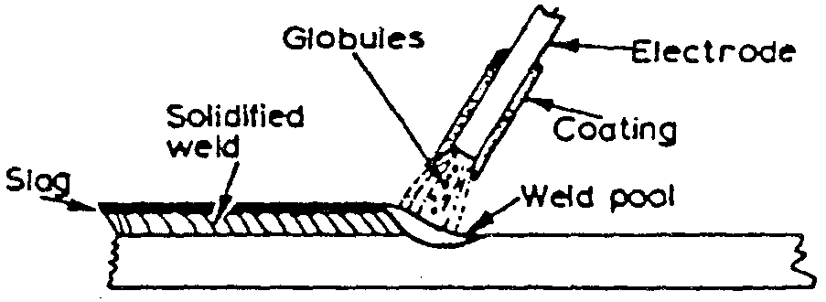
- Electrode mix area

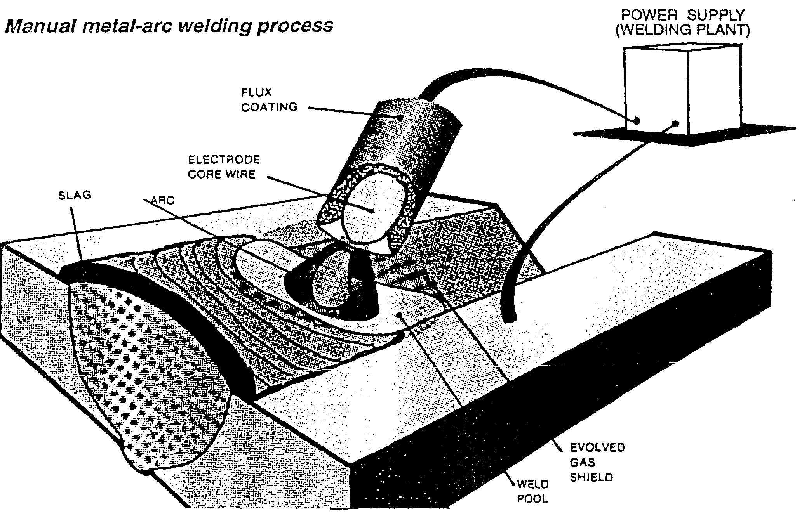
- Metal-arc welding process

Manual metal arc welding equipment
Manual metal arc welding equipment To create the arc discussed earlier it is necessary to have a voltage to drive the current (which supplies the required heat) through the circuit. A voltage of between 60 and 100 V is required to create the arc, but once it has been obtained only 20—40 V are required to maintain it.
The following stages occur when creating an arc:
With the welding plant switched on, N0- or Open-circuit voltage and before welding commences, no current passes through the leads and the arrimeter reads zero. A voltage has been applied to the circuit, however, and the voltmeter will read the open-circuit or no-load voltage (i.e. between 60 and 100 V).
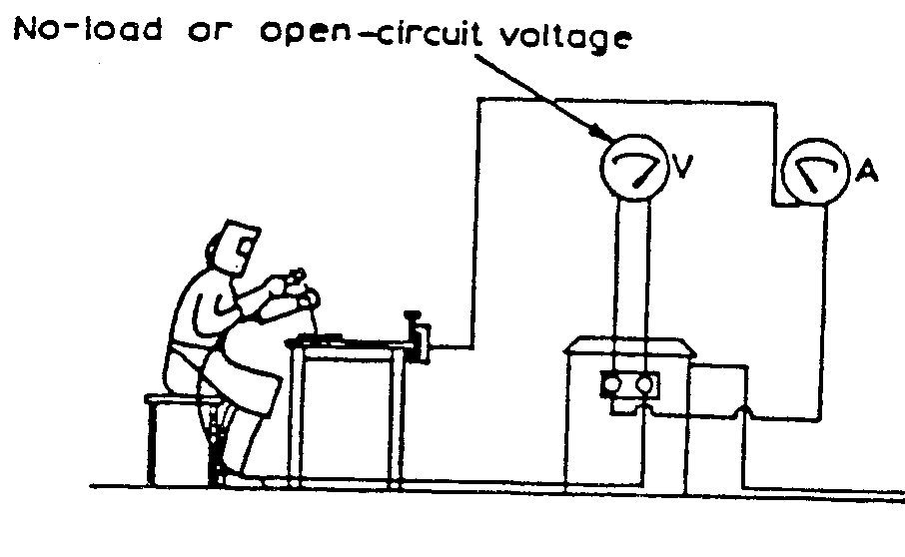
- Creating an arc – stage 1.
When the electrode is brought into contact with the job a large current, called the short-circuit current, passes through the leads, and the ammeter will deflect a large amount. While this is happening, however, the voltage drops almost to nothing. The tip of the electrode becomes hot because of the resistance created between it and the job.
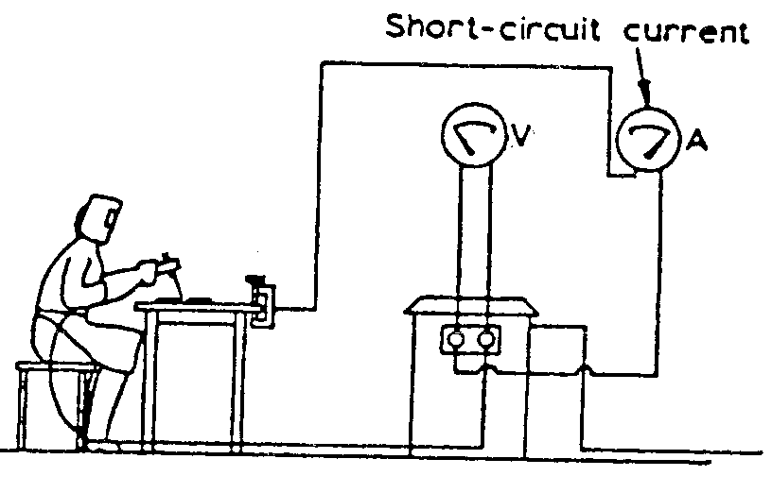
- Creating an arc – stage 2.
If the electrode is slightly withdrawn an arc is formed between the electrode and the job. The air between the two conducts the welding current. As the arc is formed the voltage rises to between 20 and 40 V and the current falls to the value to which it has been set (i.e. the welding current).
The arc is then in the normal welding condition. The heat generated by the arc melts both the workpiece and the electrode, and metal is deposited in the weld pool. During the depositing of the weld metal, variations in both the voltage and current of the arc can occur and the welding plant must be capable of coping with these changes.
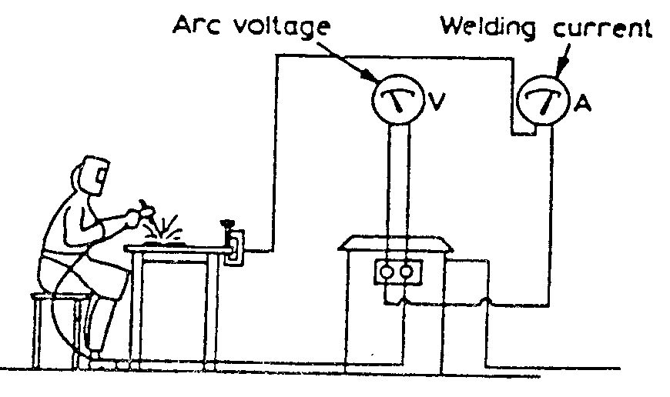
- Creating an arc – stage 3.

Welding Techniques

Current too low
If the current value is too low the resulting weld has poor penetration, due to the lack of heating to create complete fusion. The weld filler metal tends to heap up on the surface of the plate without fusing to it and the arc has an unsteady sputtering sound.
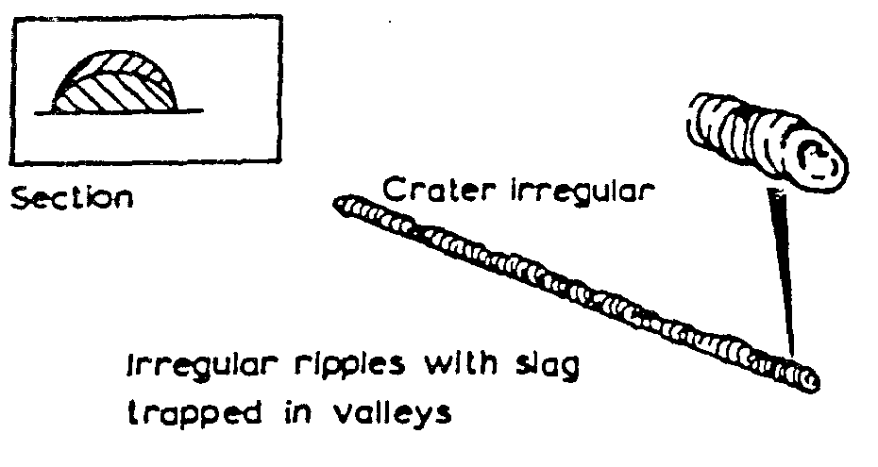
- Current too low

Current too high
When the current value used is too high the electrode becomes red hot and a large amount of spatter takes place. This can result in blowholes being formed in the plate, excessive penetration resulting in weld metal beads on the underside of the plate, undercut along the edge of the weld and excessive oxidation and slag which is hard to remove. The arc has a fierce crackling sound.
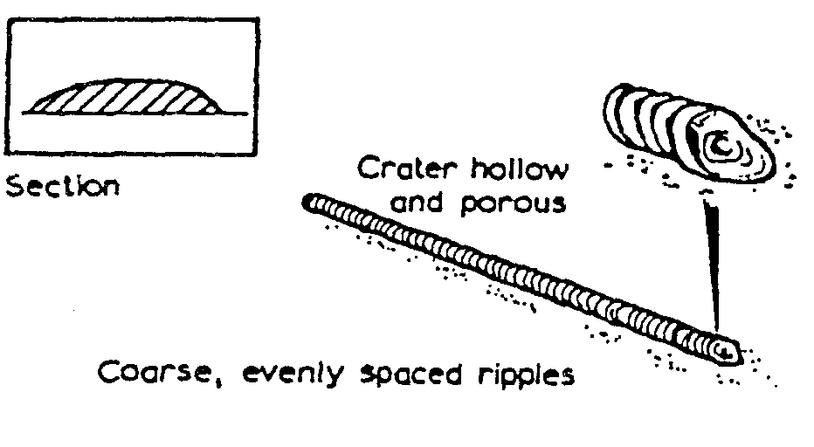
- Current too high

Correct Current
With the correct current the arc has a steady crackling sound. The weld formed has good penetration and is easily controlled.
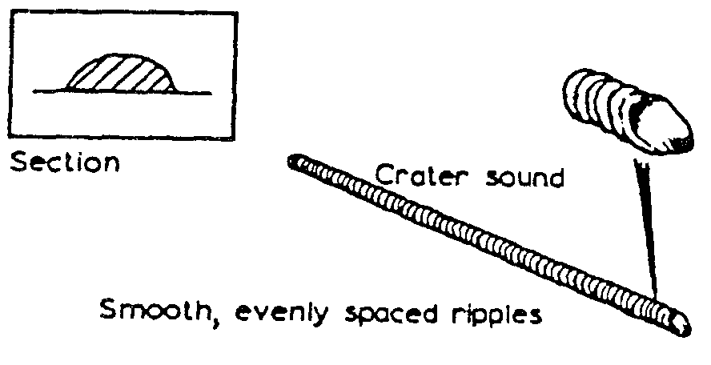
- Correct current

Arc Length
The arc length is the distance between the tip of the electrode and the surface of the weld pool. It should be approximately equal to the diameter of the wire core of the electrode being used. When this distance is correct the electrode metal is deposited in a steady stream of metal particles into the weld pool. If the arc length is reduced it becomes difficult to maintain the arc, due to the increase in welding current that takes place, and it can result in the electrode becoming welded to the weld pool. Also, if the arc length is increased the welding current is reduced, resulting in a poor weld being produced, and the protective gas shield produced from the electrode surrounding the weld pool cannot efficiently prohibit the formation of oxides, etc., in the weld.
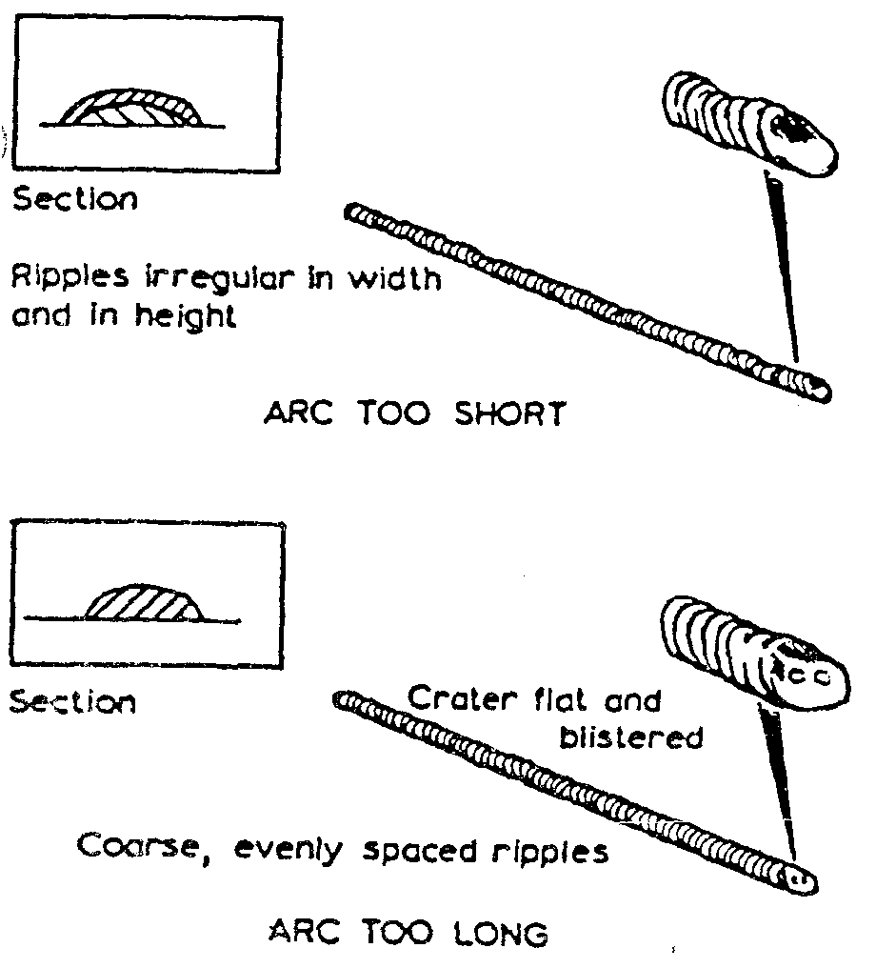
- Arc length

Speed of Travel

Too Fast
A fast rate of travel results in a thin deposit of the filler metal and can result in insufficient fusion of the filler metal with the base metal. The surface of the weld has elongated ripples and a porous crater.
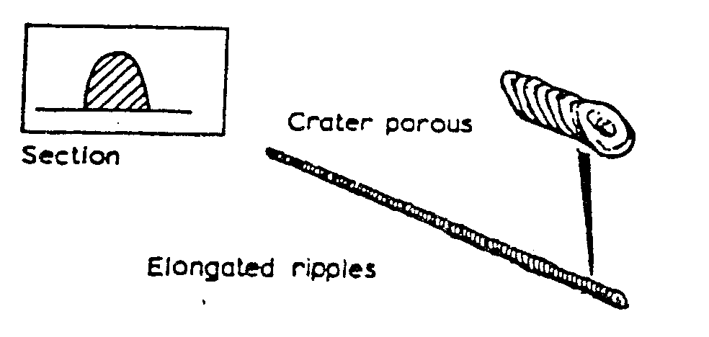
- Speed of travel – too fast

Too Slow
Too slow a rate of travel gives a wide thick deposit of the filler and it can allow the slag to flood the weld pool making it difficult to deposit the filler metal. The surface of the weld appears as coarse ripples and has a flat crater.
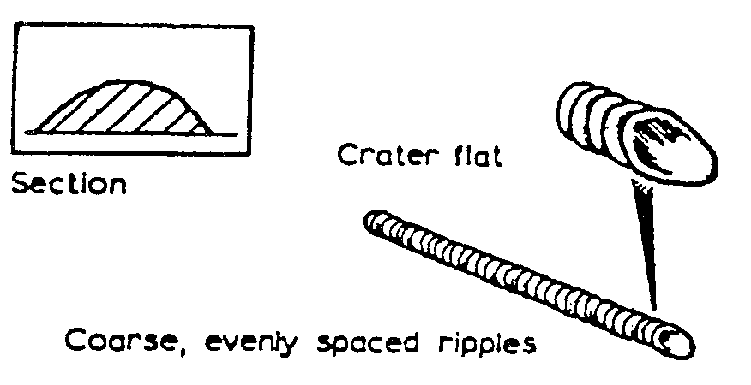
- Speed of travel – too slow

Weld Defects and Their Causes

Lack of Penetration
Lack of penetration is the failure of the filler metal to penetrate into the joint. It is caused by:
- Incorrect edge penetration.
- Incorrect welding technique.
- Inadequate de-slagging.
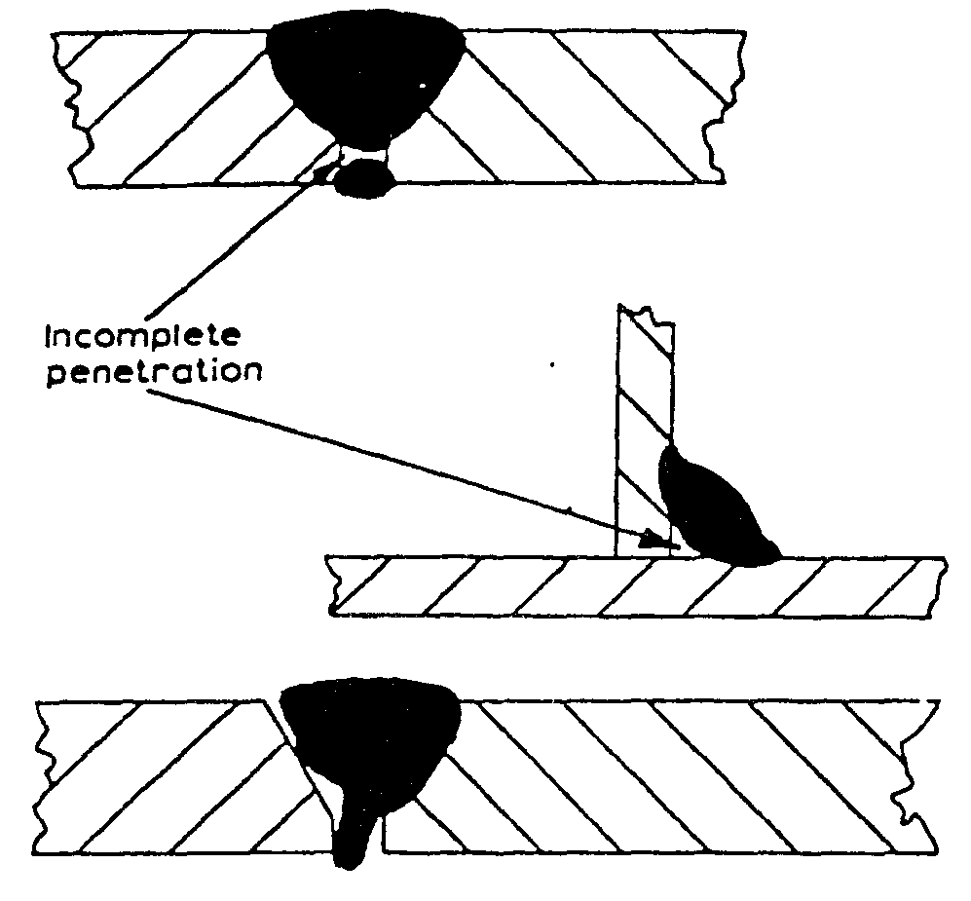
- Lack of penetration

Lack of Fusion
Lack of fusion is the failure of the filler metal to fuse with the parent metal. It is caused by:
- Insufficient heat.
- Too fast a travel.
- Incorrect welding technique.
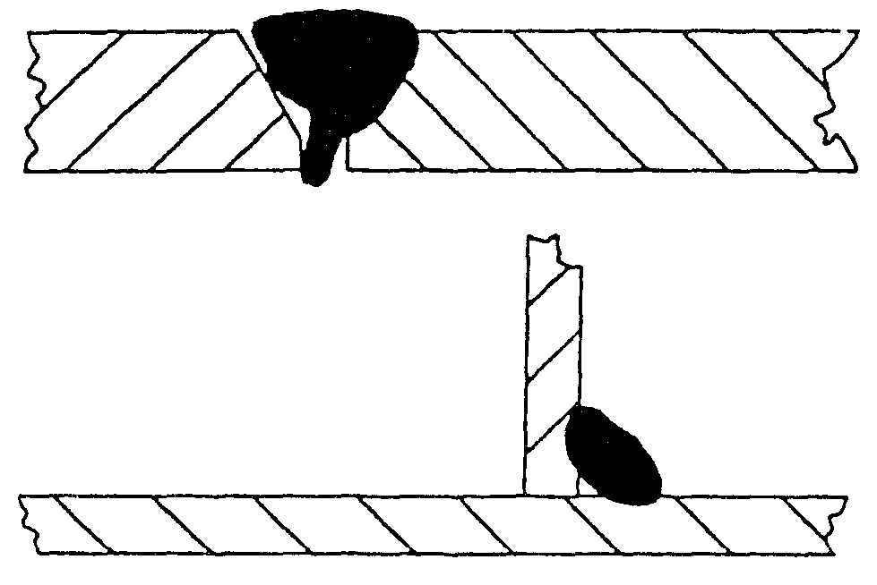
- Lack of fusion

Porosity
Porosity is a group of small holes throughout the weld metal. It is caused by the trapping of gas during the welding process, due to chemicals in the metal, dampness, or too rapid cooling of the weld.
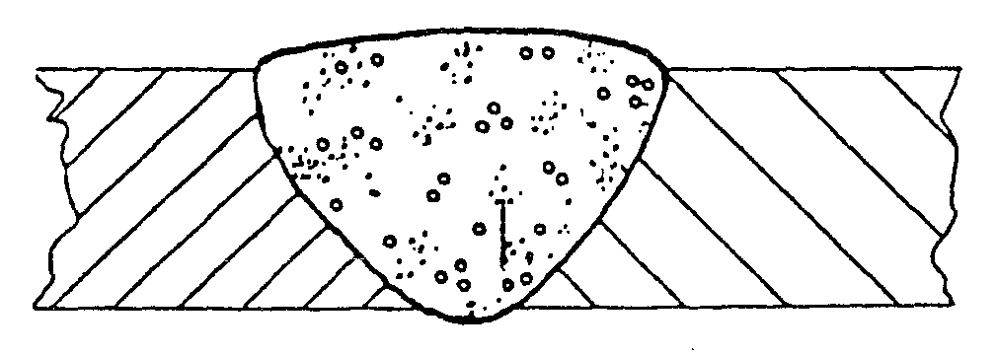
- Porosity

Slag Inclusion
Slag inclusion is the entrapment of slag or other impurities in the weld. It is caused by the slag from previous runs not being cleaned away, or insufficient cleaning and preparation of the base metal before welding commences.
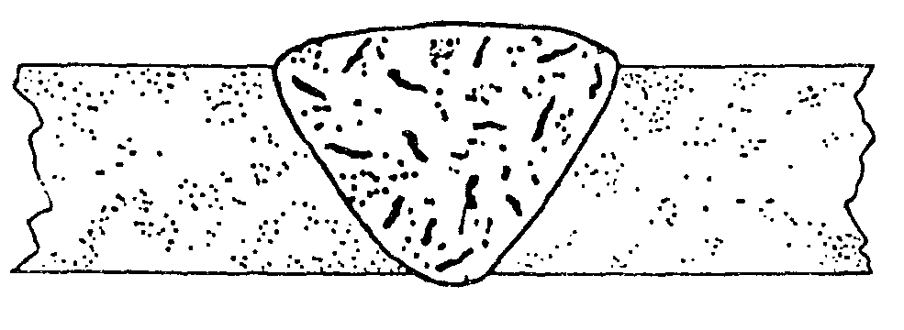
- Slag inclusion

Undercut
Undercuts are grooves or slots along the edges of the weld caused by:
- Too fast a travel.
- Too great a heat build-up.
- Bad welding technique.
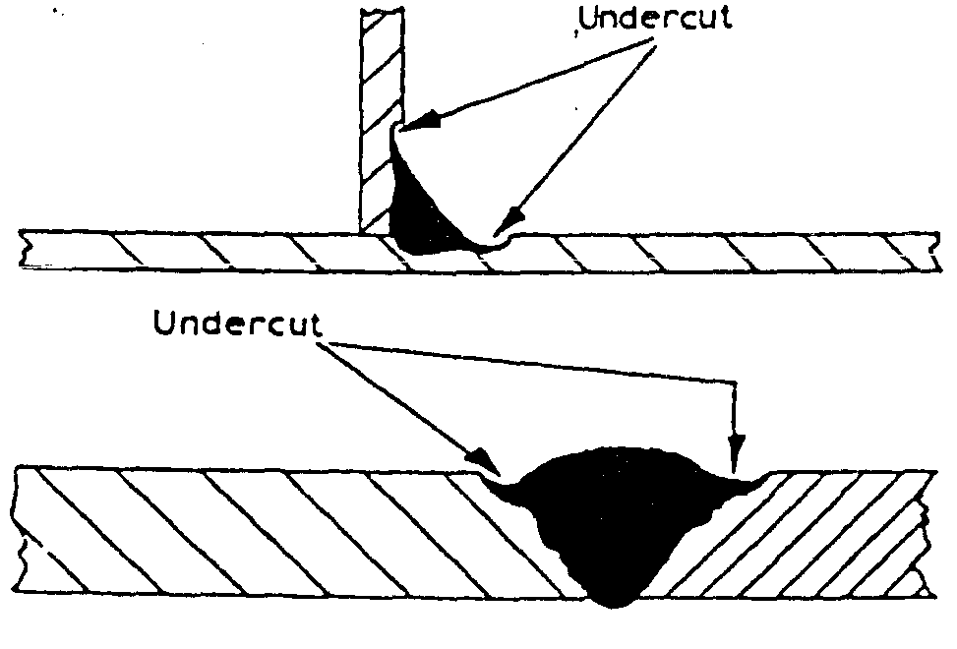
- Undercut

Overlays
Overlays consist of metal that has flowed on to the parent metal without fusing with it. The defect is caused by:
- Insufficient heat.
- Contamination of the surface of the parent metal.
- Bad welding technique.
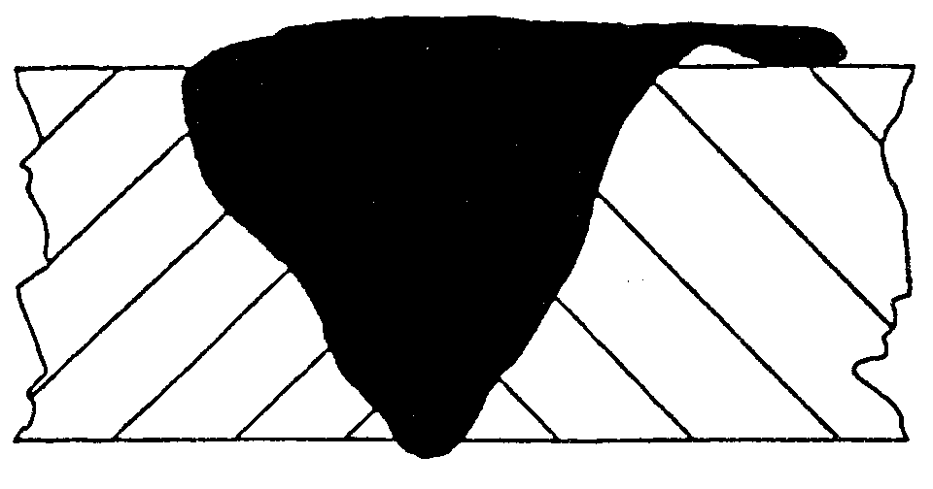
- Overlay

Crackling
Cracking is the formation of cracks either in the weld metal or the parent metal. It is caused by:
- Bad welding technique.
- Unsuitable parent metals used in the weld.
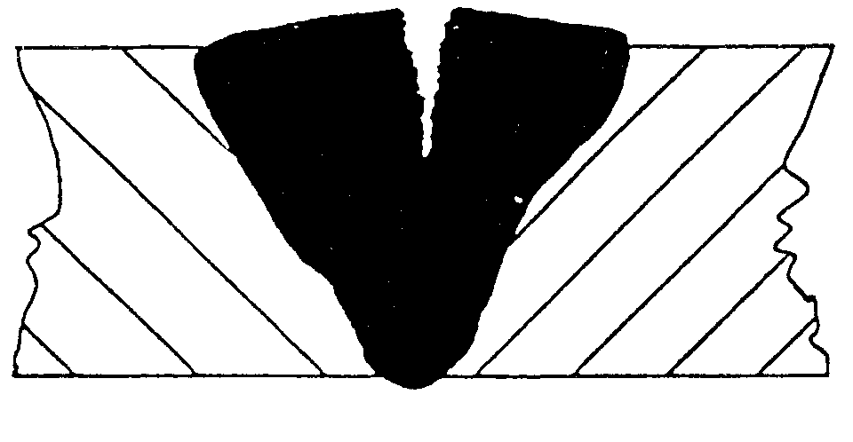
- Crackling

Blowholes
Blowholes are large holes in the weld caused by:
- Gas being trapped, due to moisture.
- Contamination of either the filler or parent metals.
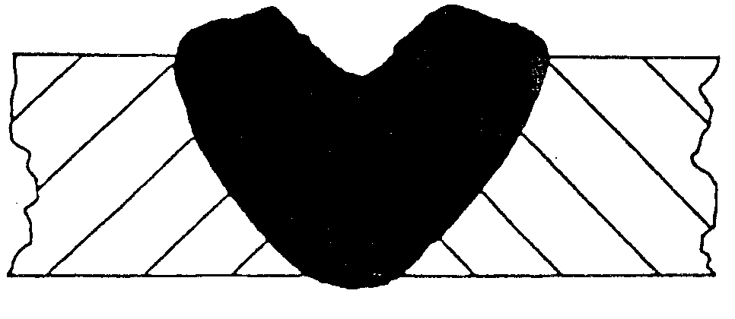
- Blowholes

Burn Through
Burn through is the collapse of the weld pool due to:
- Poor edge preparation.
- Too great a heat concentration.
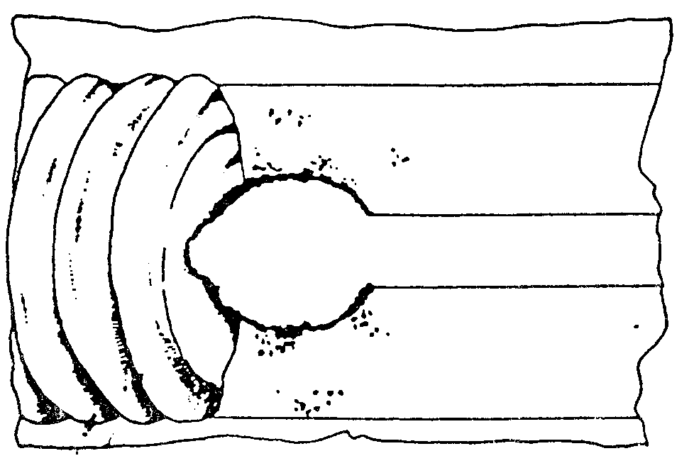
- Burn Through

Excessive Penetration
Excessive penetration is where the weld metal protrudes through the root of the weld. It is caused by:
- Too big a heat concentration.
- Too slow a travel.
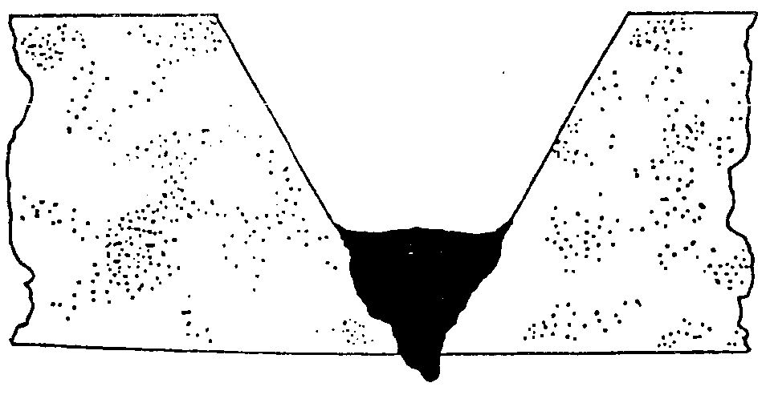
- Excessive Penetration

Control of Distortion

Expansion and Contraction in Welding and Cutting Processes

Incorrect edge preparation
As has been seen earlier, when a piece of metal is heated it expands and, on cooling down, contracts. With welding and cutting processes the heating takes place over a localized area of the metal and expansion can only take place in that portion of the metal. The subsequent contraction that takes place on cooling can result in forces causing distortion or, even worse, cracking of the metal. When a weld bead is deposit ed on the joint between two plates, the molten metal passing through the arc is at a very high temperature. The arc melting the edges of the joint and the filler and base metal fuse together. As the arc moves across the joint the deposited bead starts to cool and considerable contraction forces are set up in the weld area.
As the deposited metal was at a higher temperature than the parent metal it will contract more and also, since its volume is greater, there is a large volume of metal shrinkage. The result is distortion of the joint. The following are several ways of controlling the effect of distortion during welding; presetting; backstepping or stepwelding, jigging, and preheating. They are described and shown below:
- Presetting:
This entails setting the joint out of alignment prior to welding so that after contraction has taken place the joint is aligned.
- Backstepping or stepwelding:
This entails welding the joint in short steps, ensuring that expansion and contraction zones are placed next to one another.
- Jigging:
This entails holding the metal being welded in a jig, restraining the distortion mechanically.
- Preheating:
This entails heating the metal to be welded prior to welding, and has the effect of allowing equal contraction to take place in both the weld and parent metal.
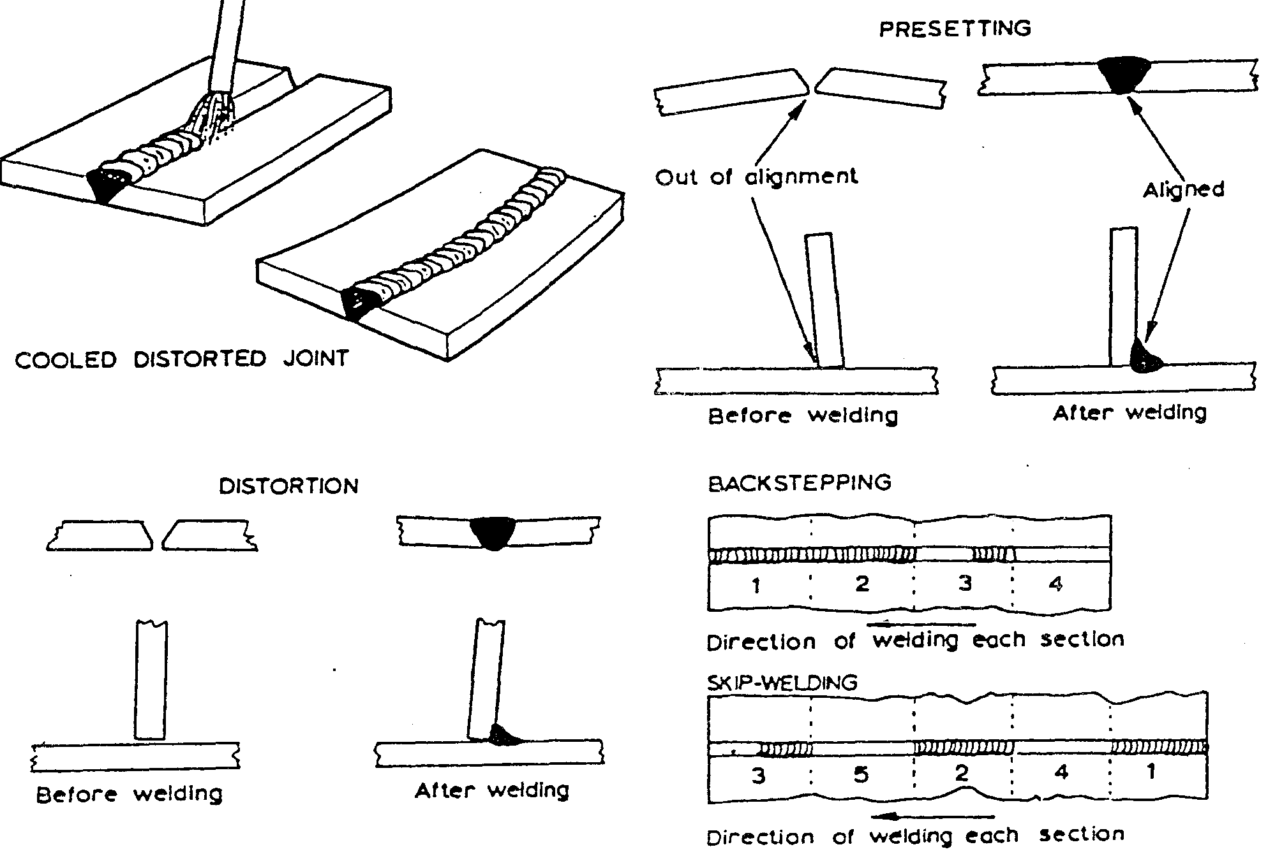
- Distortion / Presetting / Backstepping / Skip-welding

Electrodes
When a piece of metal is heated in the atmosphere it combines with the oxygen and nitrogen to form oxides and nitrides which combine with the metal. If these were allowed to form in the weld it would result in a poor quality, weak and brittle weld.
It is therefore necessary to protect the weld area from the air. This can be done either by surrounding the weld area by an inert gas or by the use of suitable fluxes.
It is usual, with manual metal arc welding, to use coated electrodes. These electrodes consist of a metal core surrounded by a layer of suitable flux coating.
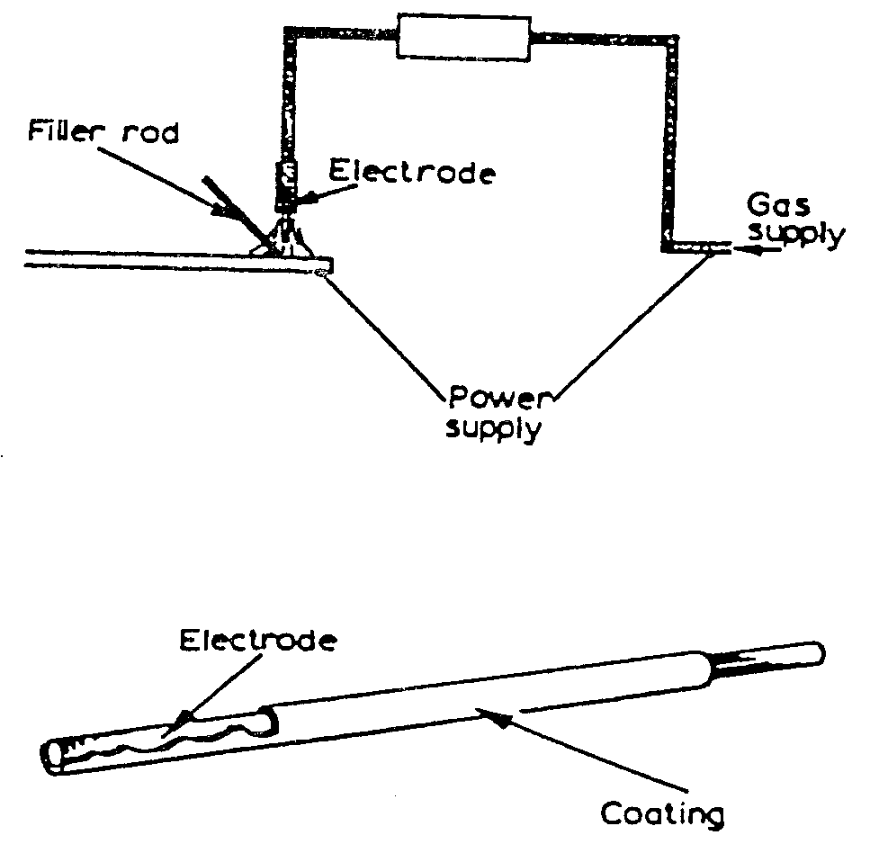
- Electrodes

Functions of the Electrode Coating
The six main functions of the electrode coating are as follows:
- To act as a flux and remove the impurities from the surfaces being welded.
- To form a slag over the weld, which does the following: protects the molten metal from contact with the air; slows down the cooling rate of the weld, helping to prevent brittleness of the weld; and provides a smoother surface by preventing ripples caused during the welding process.
- It forms a neutral gas atmosphere, which helps to protect the molten weld pool from oxygen and nitrogen in the surrounding air.
- It helps to stabilise the arc, allowing a.c. to be used.
- It can add certain constituents to the weld by replacing any lost during the welding process.
- It can speed up the welding process by increasing the speed of melting of the metal and the electrode.
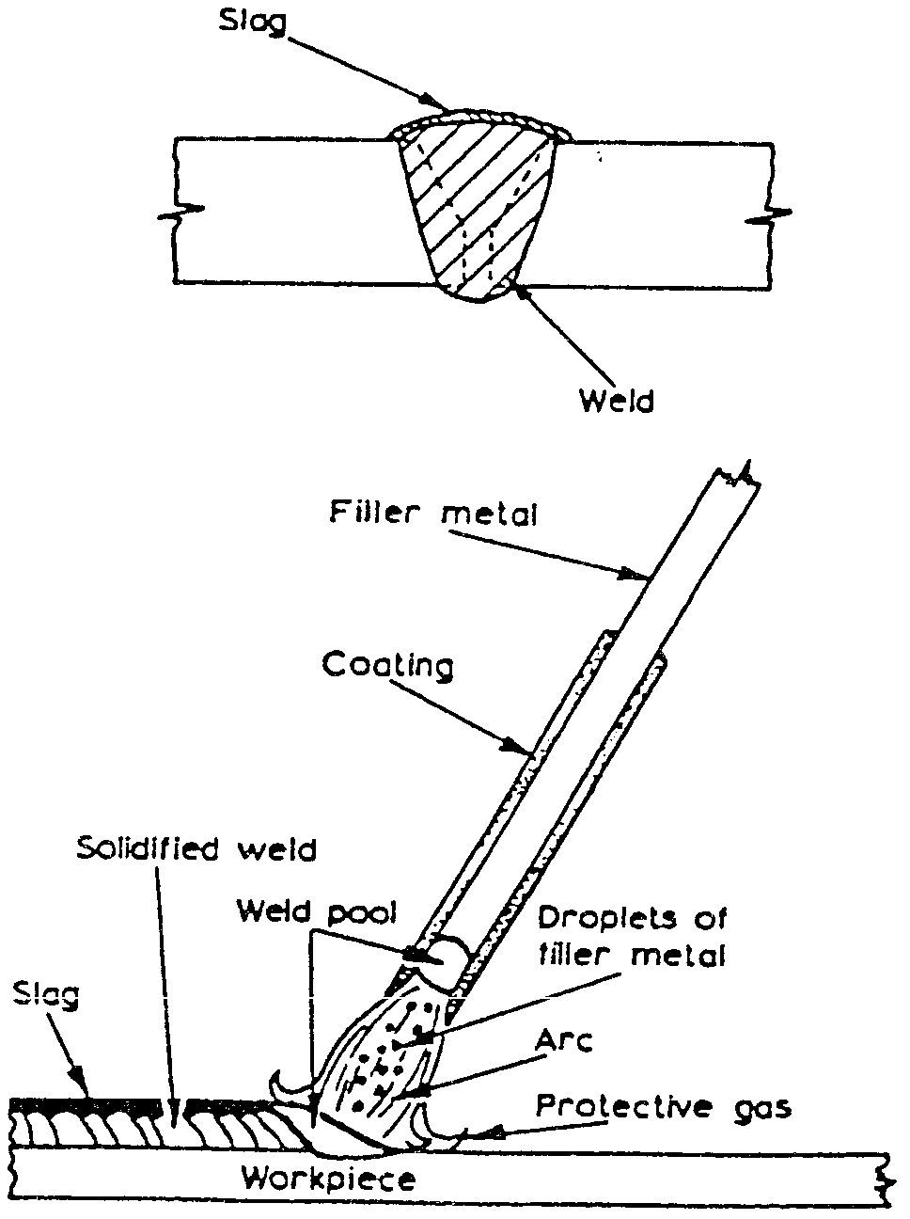
- Electrode coating

American Welding Society (AWS) Classification System for Electrodes

Mild steel electrodes
The method of classifying of electrodes is based on the use of a four-digit number, preceded by the letter ‘E’ for ‘Electrode’.
The first two digits designate the minimum tensile strength of the weld metal (in 1,000 psi) in the as-welded condition.
The third digit indicates the position in which the electrode is capable of making satisfactory welds.
The fourth digit indicates the current to be used, and the type of flux coating.
For example, the classification of E6012 electrodes is derived as follows:
- E 601 2 = Metal arc welding electrode.
- E 601 2 = Weld metal UTS 60,000 psi mm.
- E 601 2 = Usable in all positions.
- E 601 2 = Rutile type coating: AC or DC negative.
The detail of the classification is shown below:
First and second digits:
- E 6Oxx - As-welded deposit. UTS 60.000 psi mm. for E 6010, E 6011, E 6012, E 6013, E 6020, E 6027 UTS.
- E 7Oxx - As-welded deposit, UTS 70.000 psi mm. for E 7014, 7015, 7016, 7018, E 7024 and E 7028.
Third and fourth digits:
The third and fourth digits indicate positional usability and flux coating types e.g.
- Exxl0 - High cellulose coating. bonded with sodium silicate. Deeply penetrating. forceful, spray-type arc. Thin, friable slag. All-positional. DC. electrode positive only.
- Exx11 - Very similar to Exxl 0, but bonded with potassium silicate to permit use on AC or DC positive.
- Exxl2 - High rutile coating, bonded with sodium silicate. Quiet arc, medium penetration. all-positionat. AC or DC negative.

Hazards and Safety
REMEMBER: WELDING RAYS ARE VERY DANGEROUS. ALWAYS WEAR A WELDING SHIELD.
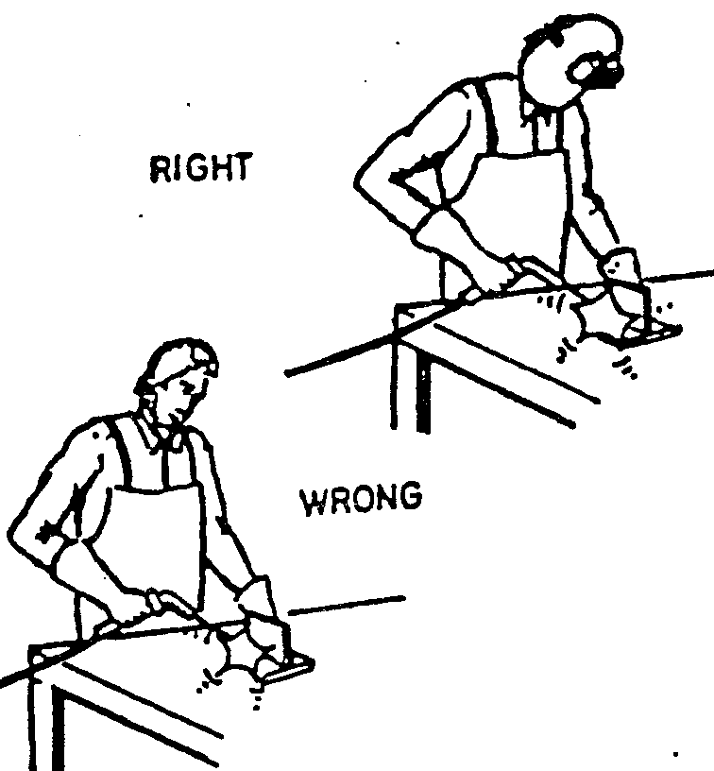
- Welding shield

Arch Flash
When a welding flash causes arc rays to come into contact with unprotected eyes, the injury is called arc flash. This usually happens if the helmet is raised and an arc is struck during arc welding. If the flash is frequent enough or severe enough, the eyeballs become covered with many small water blisters. The eyelids moving against the eyeballs cause irritation and pain. The eyes are also hurt by bright light and will water profusely. In extreme cases blindness will occur for two or three days. If exposed to arc flash, a welder should wear dark glasses and avoid any welding for several days.

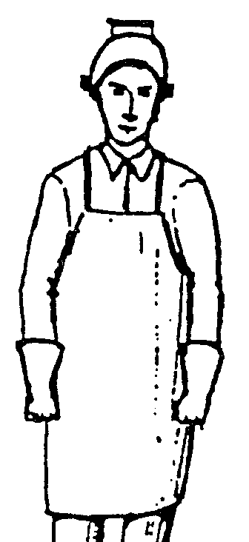
- Arc flash

ALWAYS WEAR GOGGLES WHEN CHIPPING SLAG AS IT WILL BE HOT AND SHARP.
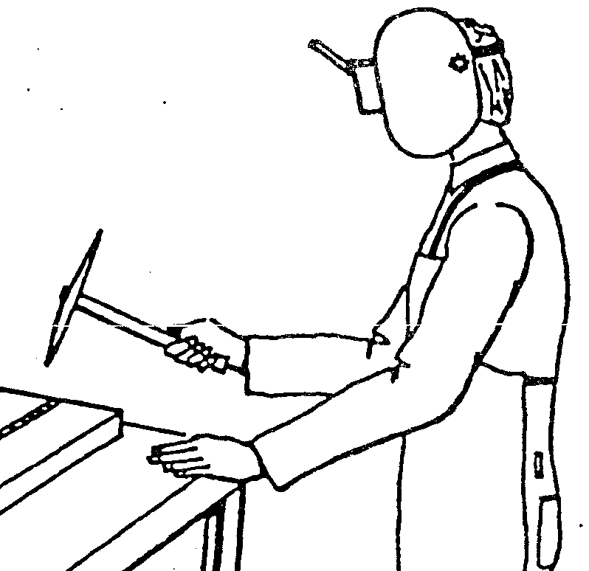

- Goggles

ALWAYS SCREEN YOUR WELDING FROM OTHERS TO AVOID RISK OF ARC FLASH .
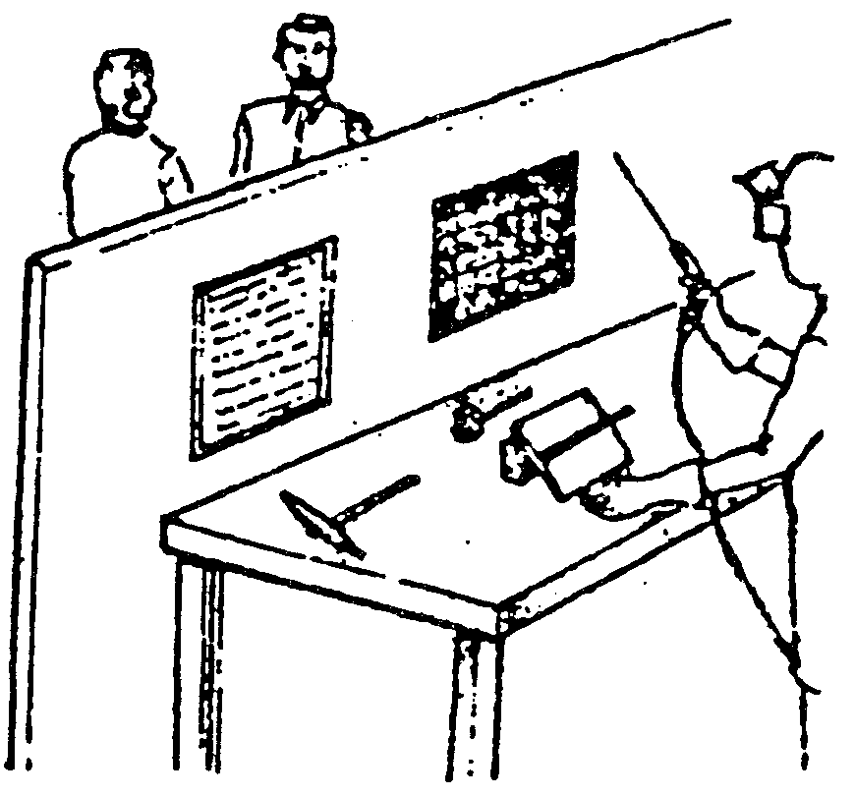
- Welding screen
NEVER WELD AN ENCLOSED TANK UNTIL THE FOLLOWING PRECAUTIONS HAVE BEEN TAKEN:
- It must be drained.
- It must be flushed.
- It must be vented.
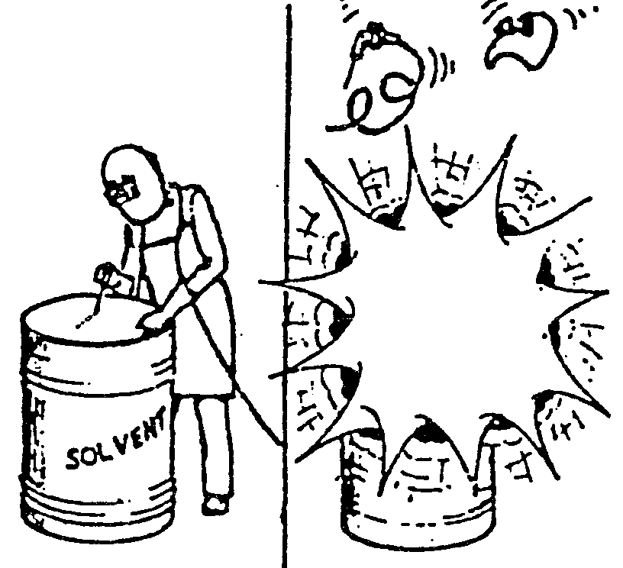
- Welding precautions

ALWAYS EXAMINE WELDING CABLES FOR DAMAGE PEPORT.
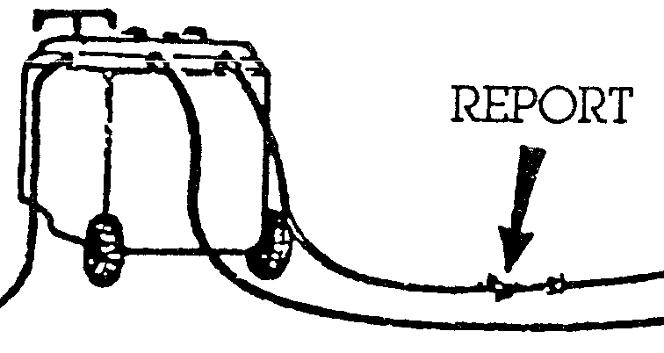
- Damaged welding cables

AC and DC Welding Plants

Types of Welding Plant

Direct Current (d.c.)
With this system the current passes in one direction only. The heat generated is split into two parts, two-thirds goes to the positive pole and one-third to the negative pole. This is important as it determines the design of the electrode to be used.
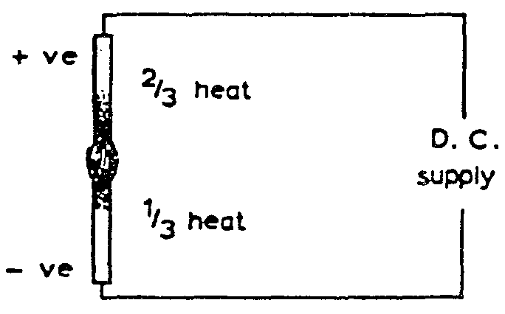
- Direct current (d.c.)
If a light-coated electrode is connected to the positive terminal it quickly becomes too hot to use for welding. But if the workpiece is connected to the positive terminal and the electrode to the negative terminal, the weld pool becomes the hottest part and the electrode stays beneath its critical heat value.
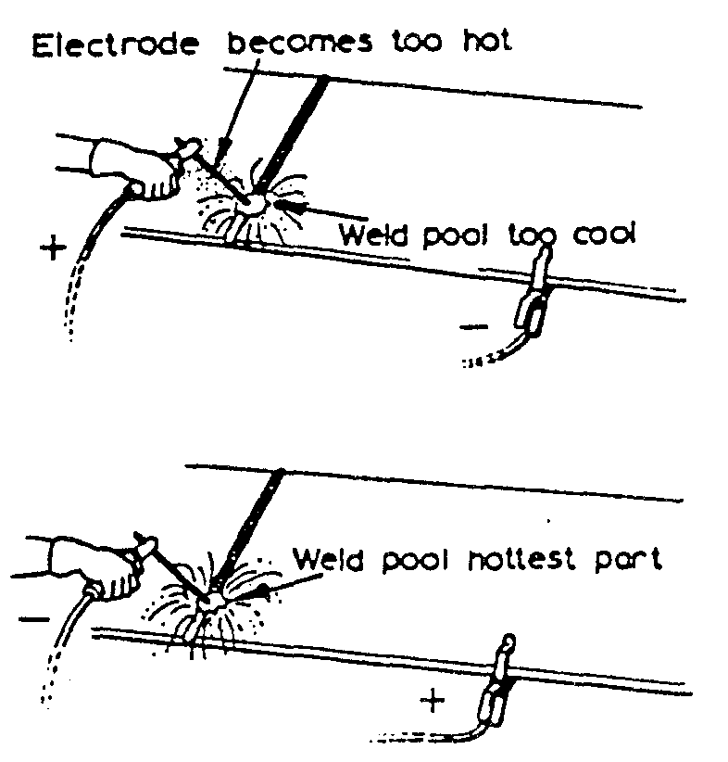
- Electrode becomes too hot
The polarity of the electrode, when using d.c. for welding, is most important and the electrode manufacturer’s recommendations should be strictly adhered to, except in exceptional circumstances where the work must be kept as cool as possible. The terms used by British Standards for electrodes state that:
Electrodes connected to the positive terminal are called electrode positive, and electrodes connected to the negative terminal are called electrode negative.
Basic equipment— (1) a generator driven either from d.c. mains (motor generator) or by a petrol or diesel engine; (2) an a.c./ d.c. motor generator set; or (3) rectifying equipment.
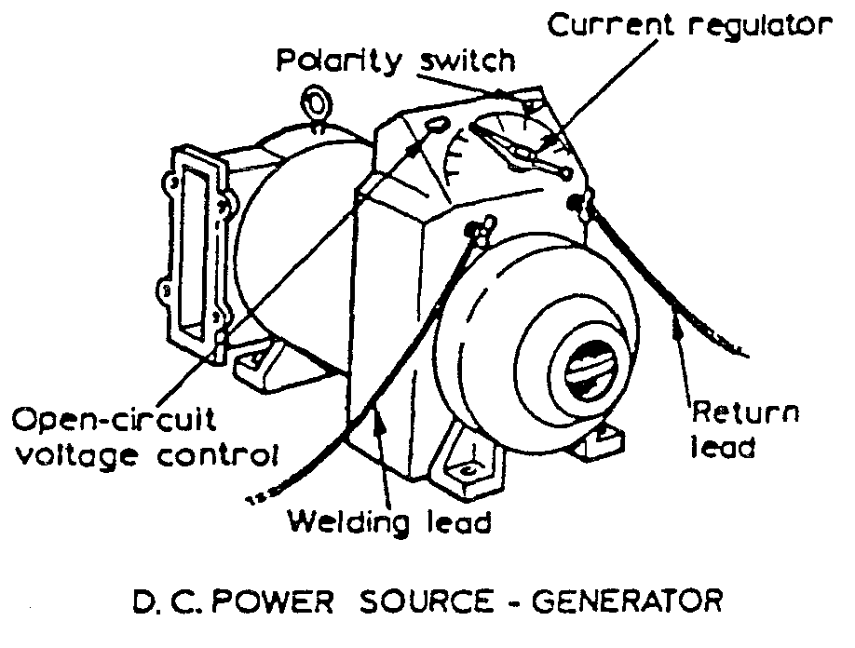
- D.C. power source – generator
The generator must supply an open-circuit voltage of about 60 V which will drop to approximately 20 V when the arc is struck. Generators can be obtained with various current ratings from 100 to 600 A, and the modern types automatically adjust themselves to allow for the voltage fluctuations of the arc. Normally only one welder can work from a set.
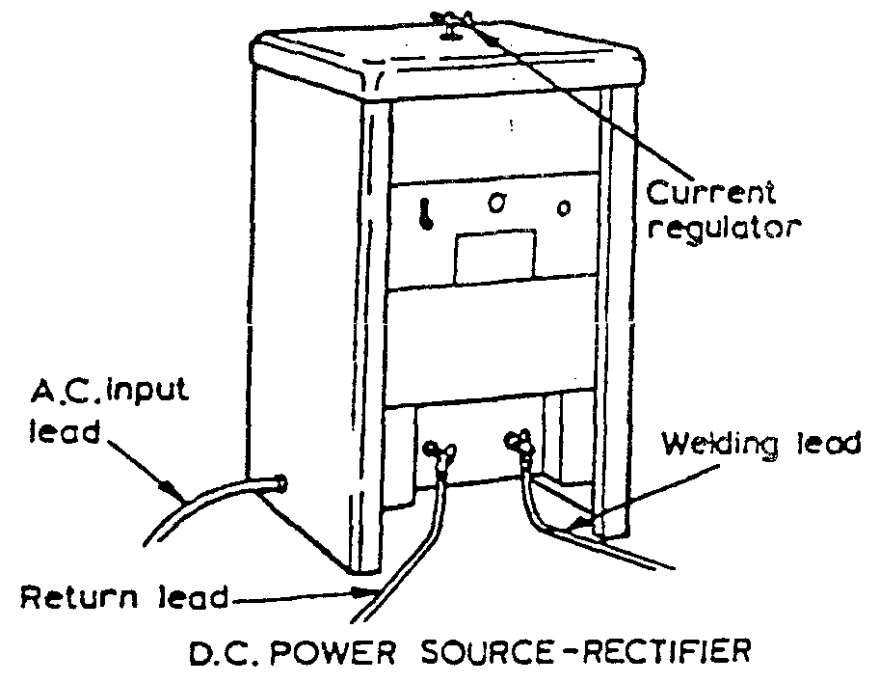
- D.C. power source – rectifier

Alternating Current (A.C.)
With a.c., the direction of the current flow continually changes. This reverse in direction takes place 50 times per second. Because of this reversal of the current flow the two poles are maintained at the same temperature, and reversal of the terminals has no effect as is the case with d.c.
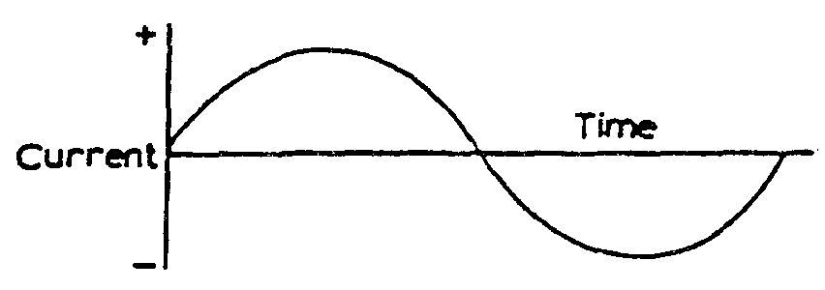
- A.C. direction current flow

The a.c. plant consists of a transformer which will reduce the supply voltage down to the required open-circuit voltage, i.e. 60 - 100 V. Various types of set are available giving different current ranges. Depending on the set, current values from 20 A up to 500 A can be obtained.
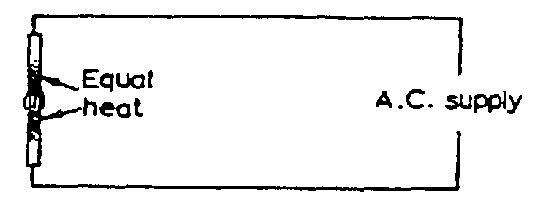
- A.C. supply voltage
Alternating-current welding plant is cheaper to buy than the equivalent direct current set, requires less maintenance, is quieter in operation, and the running costs are lower. The use of a.c. equipment is dependent upon an a.c. supply being available, and therefore when welding on sites it is not usually possible and a d.c. engine-driven generator is used.
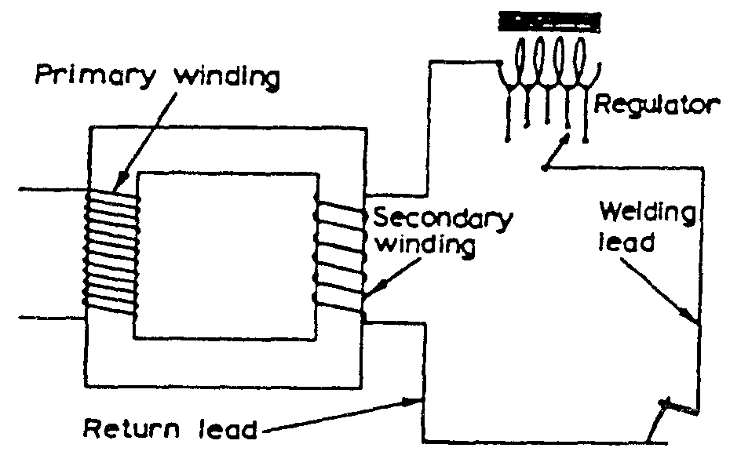
- A.C. alternating-current

Effect of Short Circuiting
When the welder strikes his arc the welding generator is subjected to a short circuit and the current passing through the windings of the generator increases. If this increase in current is not controlled the windings will overheat, resulting in damage to the generator. In most cases this short-circuit current should not exceed 150% of the normal welding current and overload devices are fitted to protect the equipment.
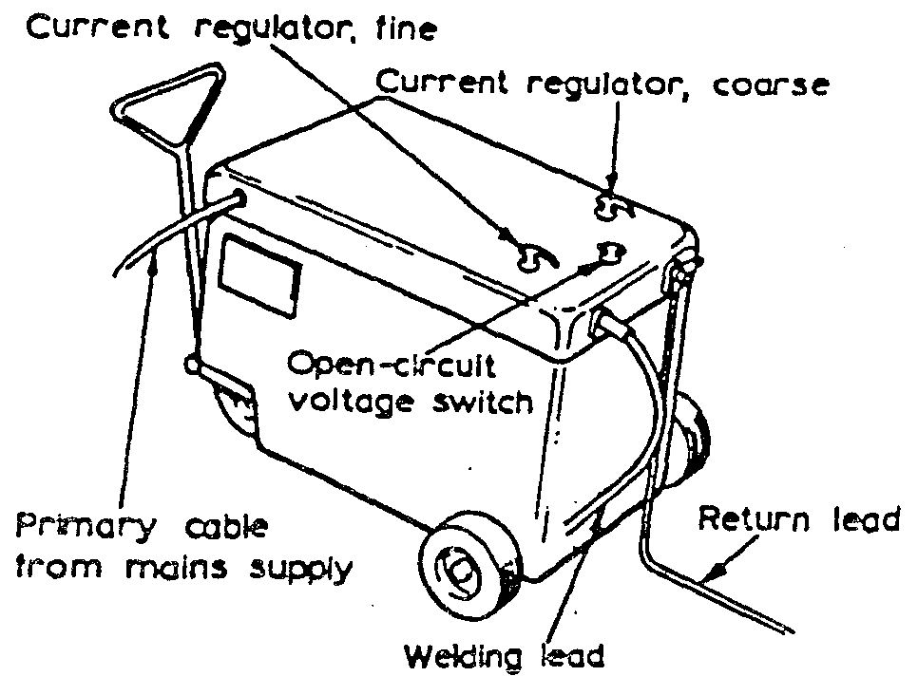
- A.C welding generator

The Advantage and Disadvantages of A.C. and D.C. Welding

The Advantage of A. C. Welding Plants
- They are cheaper to buy than D.C. Sets. The initial cost is approx. V of that required for a D.C. set of equivalent rating.
- Little or no maintenance cost, this is because there are no moving parts in an A.C. Transformer.
- There is no “Arc Blow” as with D.C.

The Disadvantages of A. C. Welding Plants
- Non ferrous electrodes are not so well deposited.
- The electric shock hazard is more pronounced with A.C. than with D.C.

The Advantages of D.C. Welding
- They can be used to deposit both ferrous and non-ferrous electrodes.
- Smoother welding giving an advantage when welding thin sheet metal.
- Safer to use in damp conditions where risk of electric shock is greater i.e. boiler work etc.
- Petrol or diesel sets can be used in remote areas where there is no mains supply. Site work etc.

Disadvantages with D.C. Welding
- More expensive to purchase than A.C. Sets.
- Perodic maintenance of the plant is necessary because of the moving parts.
- Troubles from “Arc Blow”.

Arc blow
“Arc Blow” is encountered with D.C welding equipment. The arc is forced away from the weld point notably when welding in corners. The conductors carrying the current namely the welding lead from the set, and the return lead from the work piece are carrying current in opposite direction so that a repulsive magnetic force is set up which effects the D.C. Welding Arc.
This conditions occurs most when using currents above 200 or below 40 amps. The best method of connections are:
- Weld away from the earth connection.
- Change the position of the earth wire on the work.
- Wrap the welding cable a few turns around the work, if possible on girders etc.
- Change the position of the work on the table if working at a bench.

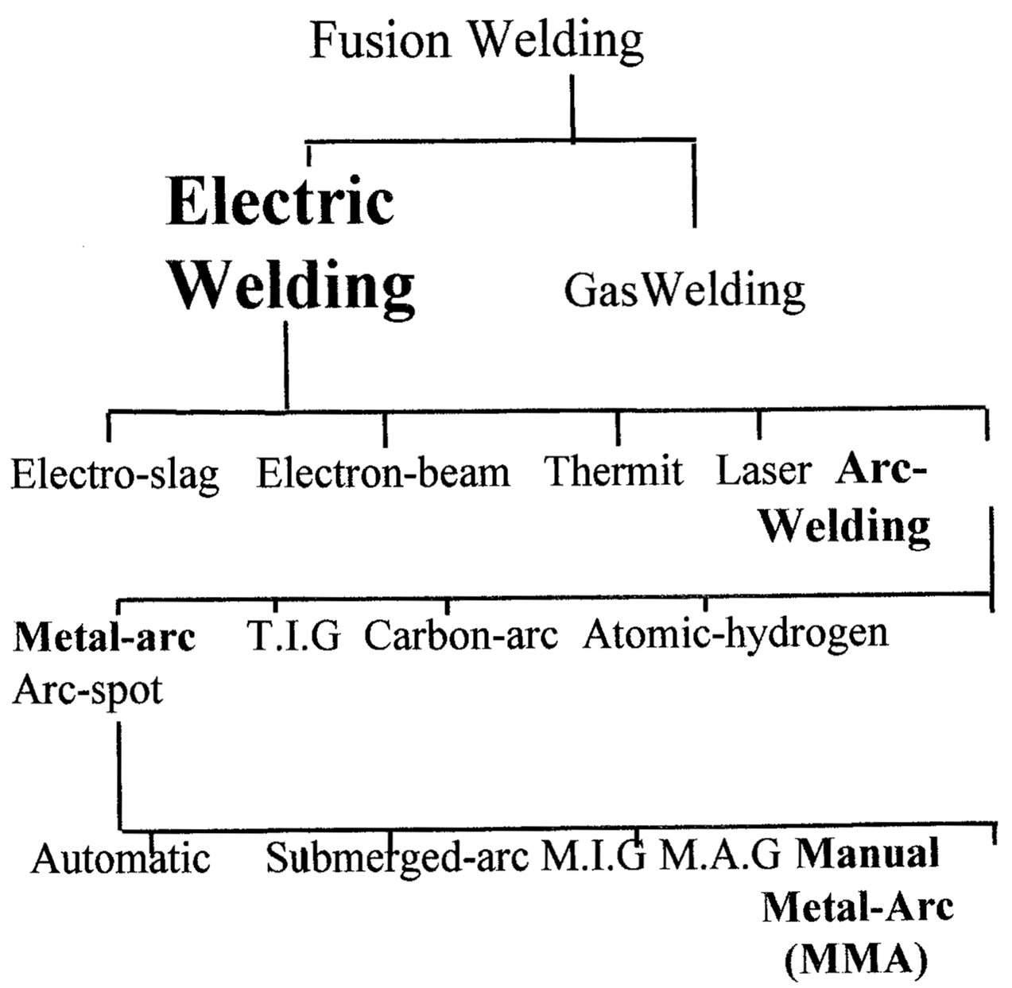
- Welding Processes

Power Supply

Alternating Current (A.C.)
Alternating current is the primary form of electrical power supplied to domestic and industrial users. It has no fixed polarity and alternates between positive (+) and negative (-) at approx. 50 to 60 cycles per second. It is the most common form of power used when welding mild steel.

Direct Current (D.C.)
Direct current flows in a straight line from positive to negative continuously. Approx. 60% of the heat generated is at the positive pole. This feature is used to advantage when welding cast iron. Ferrous and non-ferrous metals can be welded with D.C. It is the most common form of power used on site where grid power is not available. Welding with D.C. can produce “arc-blow” which is a phenomenon which causes the globule of metal transferring from the electrode to waver. If contained it has no negative effect on the finished weld. Moving the return cable further from the arc will reduce the effect.

Advantages of A.C. Welding Sets
- Cheaper than D.C. sets.
- Low maintenance – no moving parts.
- No arc-blow (arc-blow is a phenomenon associated with D.C. welding which causes the globule of metal streaming from the arc to deflate or wander as a result of the magnetic forces of the current. Its’ effect may be reduced by placing the return cable further from the arc area. The quality of the finished weld is unaffected by arc-blow.).

Disadvantages of A.C. Welding Sets
- Unsuitable for non-ferrous electrodes.
- Greater danger of electric shock.

Advantages of D.C. Welding Sets
- Ideal for ferrous or non-ferrous electrodes.
- Deposits a smoother weld (an advantage when welding thin sheet-metal).
- Safer to use in damp conditions.
- Petrol or Diesel sets (where no mains supply available).

Disadvantages of D.C. Welding Sets
- More expensive than A.C. sets.
- Need more maintenance (more moving parts).
- Prone to arc-blow.

Electrodes
Manual Metal Arc welding electrodes are manufactured with a deoxided core wire surrounded with an appropriate coating or “flux”.
The coating:
- Stabilize the arc.
- Protects the molten metal from contamination during welding.
- Protects the weld while cooling.
ELECTRODES COME IN A RANGE OF SIZES:
- 2mm.
- 2.5mm.
- 3.2mm.
- 4mm.
- 5mm.
- 6mm.

Care of Electrodes
Electrodes for welding mild steel should be kept dry to avoid the possibility of porosity. They should be kept in the packet in which they came to ensure correct identification and to avoid damage to the coating.
They should not be bent to avoid breaking of the coating and subsequent contamination of the weld.

Types of Flux
- Cellulosic:
Give a deep penetrating arc and are commonly used in the “stovepipe” welding technique.
- Rutile:
Contain high proportion of titanium oxide (rutile). These are the most common electrodes used in this module.
- Basic:
High in calcium carbonate. Used for the high tensile steels.

Faults & Imperfections in Arc-Welding
FAULT | DESCRIPTION | CAUSES
Porosity | A group of trapped gas pores | Contamination of parent metal or filler metal. Moisture trapped between surfaces. Too rapid cooling of parent metal.
Slag Inclusion | Slag trapped in weld.  Filler metal and parent metal not fully fused. | Welding current too low. Gap too close. Incorrect angle. Electrode too large.
Lack of Fusion | Discontinuity of weld or failure to secure weld. | Welding current too low or inadequate heat. Too rapid travel of the electrode.
Lack of penetration | Failure of weld metal to extend into or fill the root of the weld. | Unsuitable edge or joint preparation. Current too low. Incorrect welding technique.
Undercutting | A groove or hollow cut in the surface or fusion face of the parent metal at the toe of a run. | Wrong manipulation of the electrode. Moving the electrode too quickly over heating area. Welding current too high. Arc too long.
Excess spatter | Tiny globules of unfused filler metal splashed around weld area. | Current too high. Gap too long.
Unequal leg length | Distance from toe to root unequal in fillet or lap weld. | Incorrect electrode angle.

Types of Joints
- Fillet.
- Square Butt.
- Corner Joint.
- Lap Joint.
- Single Vee.
- Double Vee.
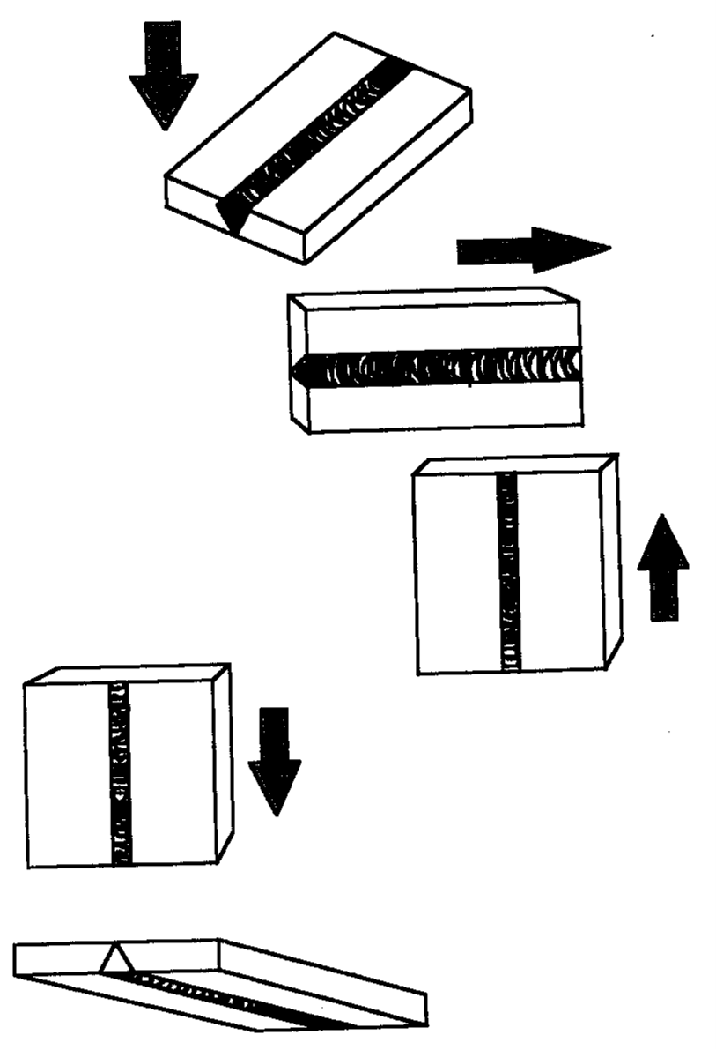
- Welding Positions
F = Flat / Downhand.
H = Horizontal / Vertical.
V = Vertical (upwards).
D = Vertical (down).
O = Overhead.

Self Assessment

Exercise 1:
- List four safety precautions to be observed when operating MMA welding plant
- List three weld defects that occur in MMA welding and the factors that cause them
- Using a simple line diagram describe the MMA welding process
- State the types of MMA welding plant and the advantages and disadvantages of each.
- Complete Exercises No. 2.3.5a and 2.3.5b in the curriculum document.

Exercise 2:
Identify the type of joints used in welding for the images below:
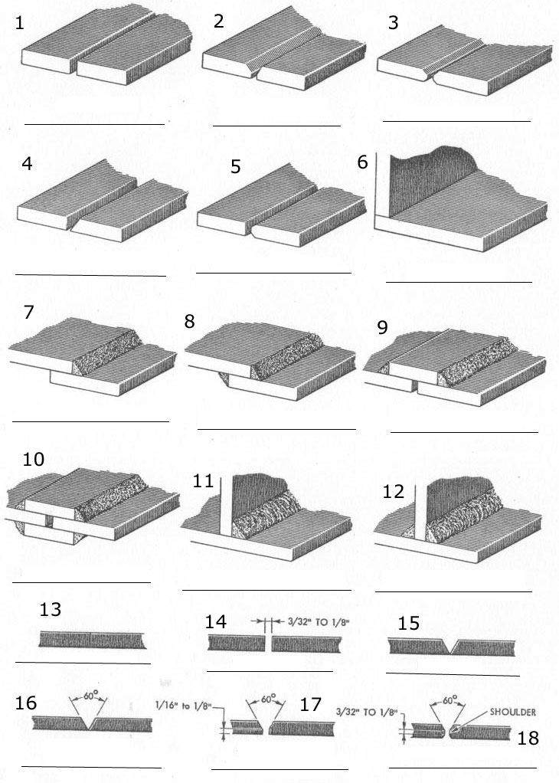
- Types of joints exercise
Exercise 2 answers.
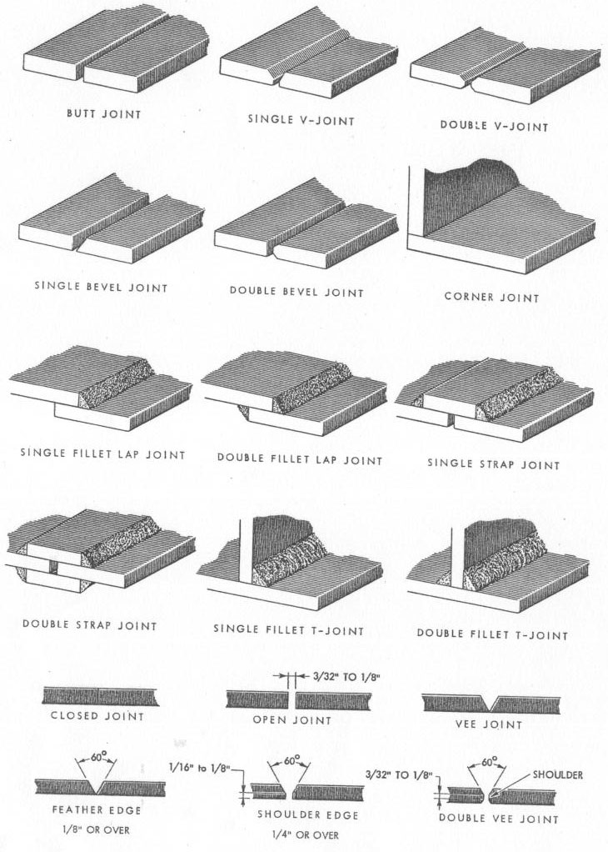
- Types of joints exercise answers

Index

A
Access and Exits:, 13
arc welding, 11, 12
faults and imperfections, 51
B
basic flux, 50
C
carbon dioxide, 13
Carbon tetrachloride, 13
cellulosic flux, 50
E
electrodes, 49
care of, 50
F
Fire Extinguishers, 13
flux, 50
types of, 50
foam, 13
J
joints, 52
types of, 52
K
Kjellberg process, 11
O
operator protection, 12
P
power supply, 48
alternating current, 48
direct current, 48
protection, 13
for operator, 12
for others, 13
general, 13
Q
Quasi-arc method, 11
R
rutile flux, 50
W
welding sets, 49
A.C., 49
advantages of A.C., 49
Advantages of D.C., 49
D.C., 49
disadvantages of A.C., 49
disadvantages of D.C., 49

