Trade of Plumbing
Module 1: | Thermal Process and Mild Steel Pipework
Unit 9: | Oxy-Acetylene Welding Safety and Plant
 | Phase 2

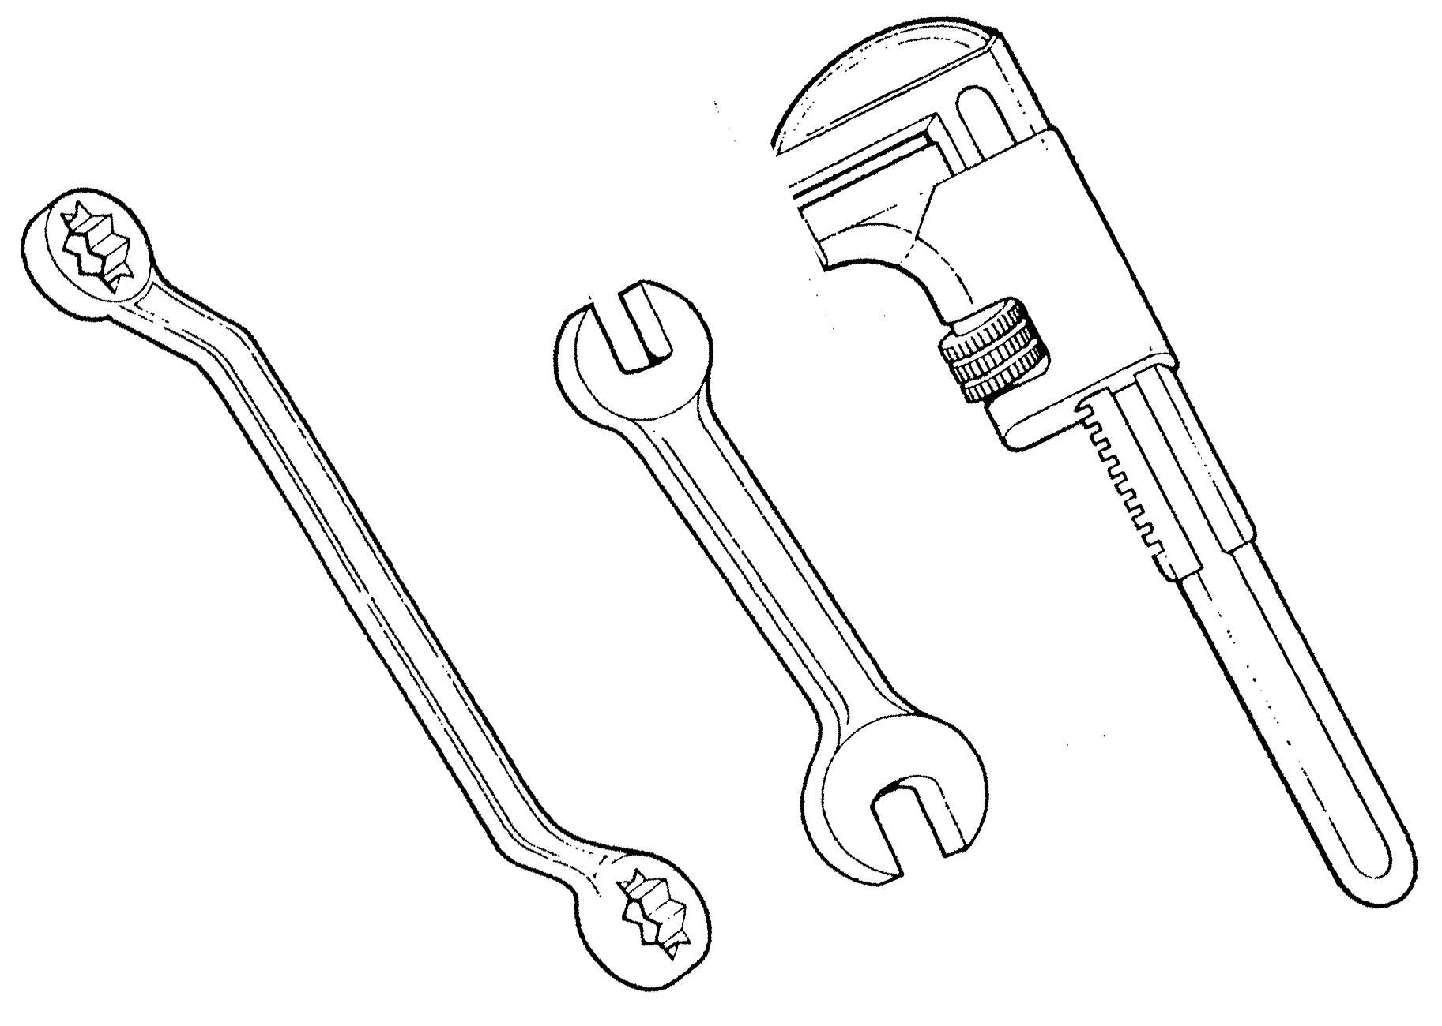

Table of Contents
List of Figures 5
List of Tables 6
Document Release History 7
Module 1 –Thermal Process and Mild Steel Pipework 8
Unit 9 – Oxy-acetylene Welding - Plant and Safety 8
Learning Outcome: 8
Key Learning Points: 8
Training Resources: 8
Exercise: 8
Key Learning Points Code: 8
Oxygen 9
Acetylene 10
Acetone 10
Hoses 14
Hose Check Valves 14
The Blowpipe 14
Ancillary Equipment 14
Welding Safety 16
Hose and Hose Fittings 17
Flashback Arrestors 17
Economiser 17
Acetylene Withdrawal Rates 17
Operating Instructions for Gas Welding and Cutting Equipment 18
Gas Pressure Regulator 20
Before the regulator is fitted to the cylinder 20
Connecting to the cylinder 20
Commencing Operation 20
Finish of Operation 20
Safety Points to Observe 20
Notice OR 14 and HR 14 Regulators 21
Shielding Gas Regulators for Welding 21
Heating Nozzles & Attachments 23
Oxy-Acetylene 23
Oxy-Propane 23
Data Tables 24
Combined Welding and Cutting Blowpipes 24
Important 24
Changing from Cutting to Welding 24
Changing from Welding to Cutting 25
DH Lightweight Type Blowpipe 26
Self Assessment 29
Index 32

List of Figures
Figure 1. Oxy-Acetylene Flame Type 11
Figure 2. Flashback Arrestors 15
Figure 3. Flame Cleaning, Super Heating with Propane, and Heating 18
Figure 4. Two-Stage Regulators 19
Figure 5. Welding and Cutting Data 22
Figure 6. Assembly Instructions for DH Lightweight Blowpipe 26
Figure 7. Volumes of Acetylene into Acetone 28

List of Tables
Table 1. DH Lightweight Blowpipe Parts 26

Document Release History
Date | Version | Comments
June 2006 | V.1.0
04/03/14 | 2.0 | SOLAS transfer

Module 1 –Thermal Process and Mild Steel Pipework

Unit 9 – Oxy-acetylene Welding - Plant and Safety
Duration – 6.5 Hours

Learning Outcome:
By the end of this unit each apprentice will be able to:
- Describe the components and their function of oxy-acetylene welding plant.
- Describe the hazards and safety features of oxy-acetylene welding plant.
- Set up oxy-acetylene welding plant.
- Describe the correct lighting up and shutting down procedure.

Key Learning Points:
Rk | Components of oxy-acetylene welding plant.
Rk H | Hazards associated with oxy-acetylene welding plant – pressurised cylinders, contact with oil/copper, fire, lack of ventilation etc.
Rk Sk | Identification and contents of cylinders.
Rk | Safety features of oxy-acetylene welding plant.
Rk H | Procedures in the event of cylinders catching fire.
Sk | Assembly of plant.
Rk Sk | Handling and storage of cylinders.
P | Good working practice.
Rk Sk | Lighting up and shutting down procedure.

Training Resources:
Classroom facilities, information sheets, workshop facilities, oxy-acetylene welding plant, oxy-acetylene welding safety videos.

Exercise:
- Assemble oxy-acetylene welding equipment/plant.
- Open oxy-acetylene equipment and check for leaks.

Key Learning Points Code:
M = Maths D= Drawing RK = Related Knowledge Sc = Science
P = Personal Skills Sk = Skill H = Hazards

Oxygen
The commercial method of producing oxygen is to abstract it from the atmosphere by a process of distillation.
The composition of gases which make up the atmosphere is:
Nitrogen 75%
Oxygen 23%
Other Gases 2%
100%
In brief, the air is compressed, causing it to liquefy. In this state the oxygen separates from the nitrogen and can be filtered off.
Oxygen does not burn but supports combustion, i.e. it is essential that it is present for combustion to take place. Oxygen cylinders are coloured black and have right-hand threads as does all equipment associated with them.
Oxygen cylinders are hollow and when fully charged can be pressurised up to 175 atmospheres or 2,500 lbs/sq”.
1 Atmosphere = 101.3 Kn/M²
150 Atmospheres = 15,195 Kn/M²
175 Atmospheres = 17,727 Kn/M²

Acetylene
Acetylene is produced by the reaction of Calcium Carbide and Water. Calcium Carbide has the appearance of small grey stones. It belongs to the class of substances known as Hydrocarbons.
Inside the cylinder is a Porous Mass – known as Kapok or Charcoal. Its purpose is to break up the internal volume of the cylinder into a number of small compartments.
This is a safety precaution because should the Acetylene start to decompose or become unstable within the cylinder, it is impossible for the reaction to spread throughout the whole mass.

Acetone
Acetone is a spirit with an affinity for Acetylene. Under normal atmospheric conditions Acetone will dissolve 25 times its own volume of Acetylene. Since the Acetylene cylinder is charged to 15 atmospheres the Acetone is capable of holding 375 times its own volume, i.e. 25 x 15 = 375.
To avoid disturbing the Acetone when moving the cylinder it is absorbed by the Charcoal or Kapok filling.
Acetylene cylinders are coloured maroon and should always be used in the upright position. All the equipment associated with Acetylene has left hand threads. They are identified by a notch on each hexagonal nut. When full all Acetylene cylinders are charged to a pressure of 15 atmospheres.

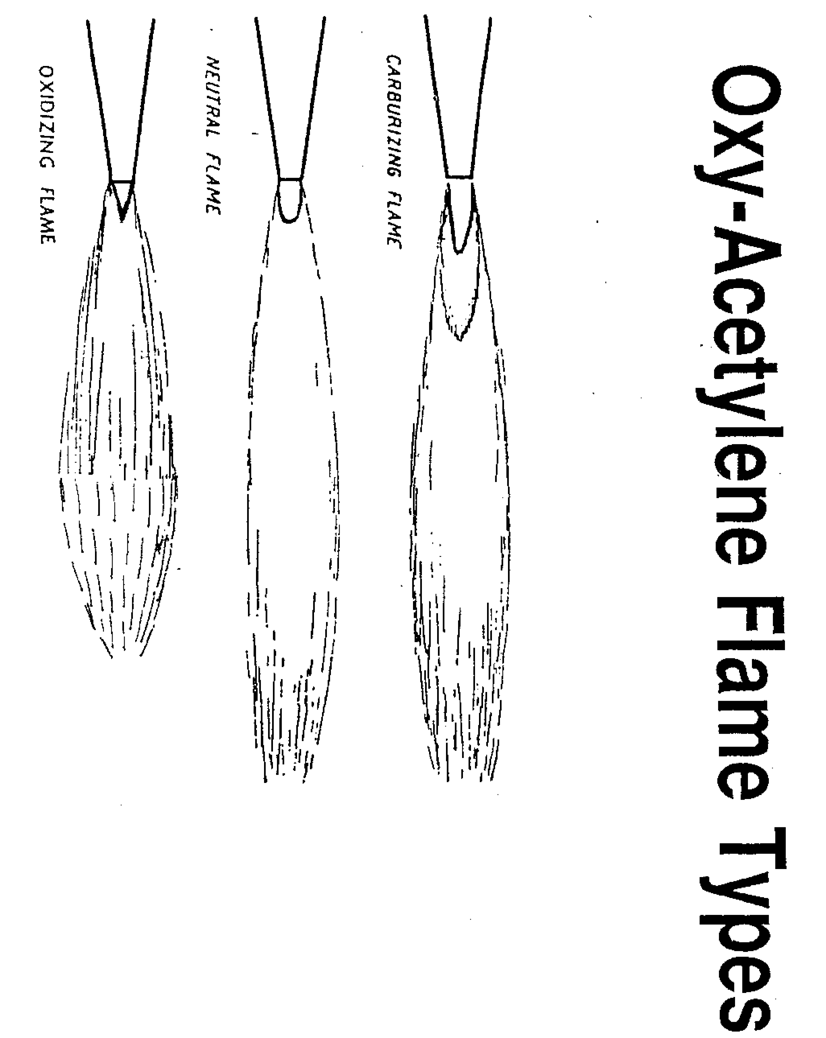
- Oxy-Acetylene Flame Type
1 Atmosphere = 101.3 Kn/sq metre
15 Atmosphere = 101.3 x 15 = 1,519.5 Kn/Sq metre
Note: In many books the pressure of a fully charged Acetylene Cylinder may be show between:
1,551 Kn/Sq Metre and 1,570 Kn/Sq metre
1,000 Newtons = 1 Kilo Newton (Kn)
1,000 Kilo Newtons = 1 Mega Newton (Mn)
1,519 Kn = 1.5 Mn
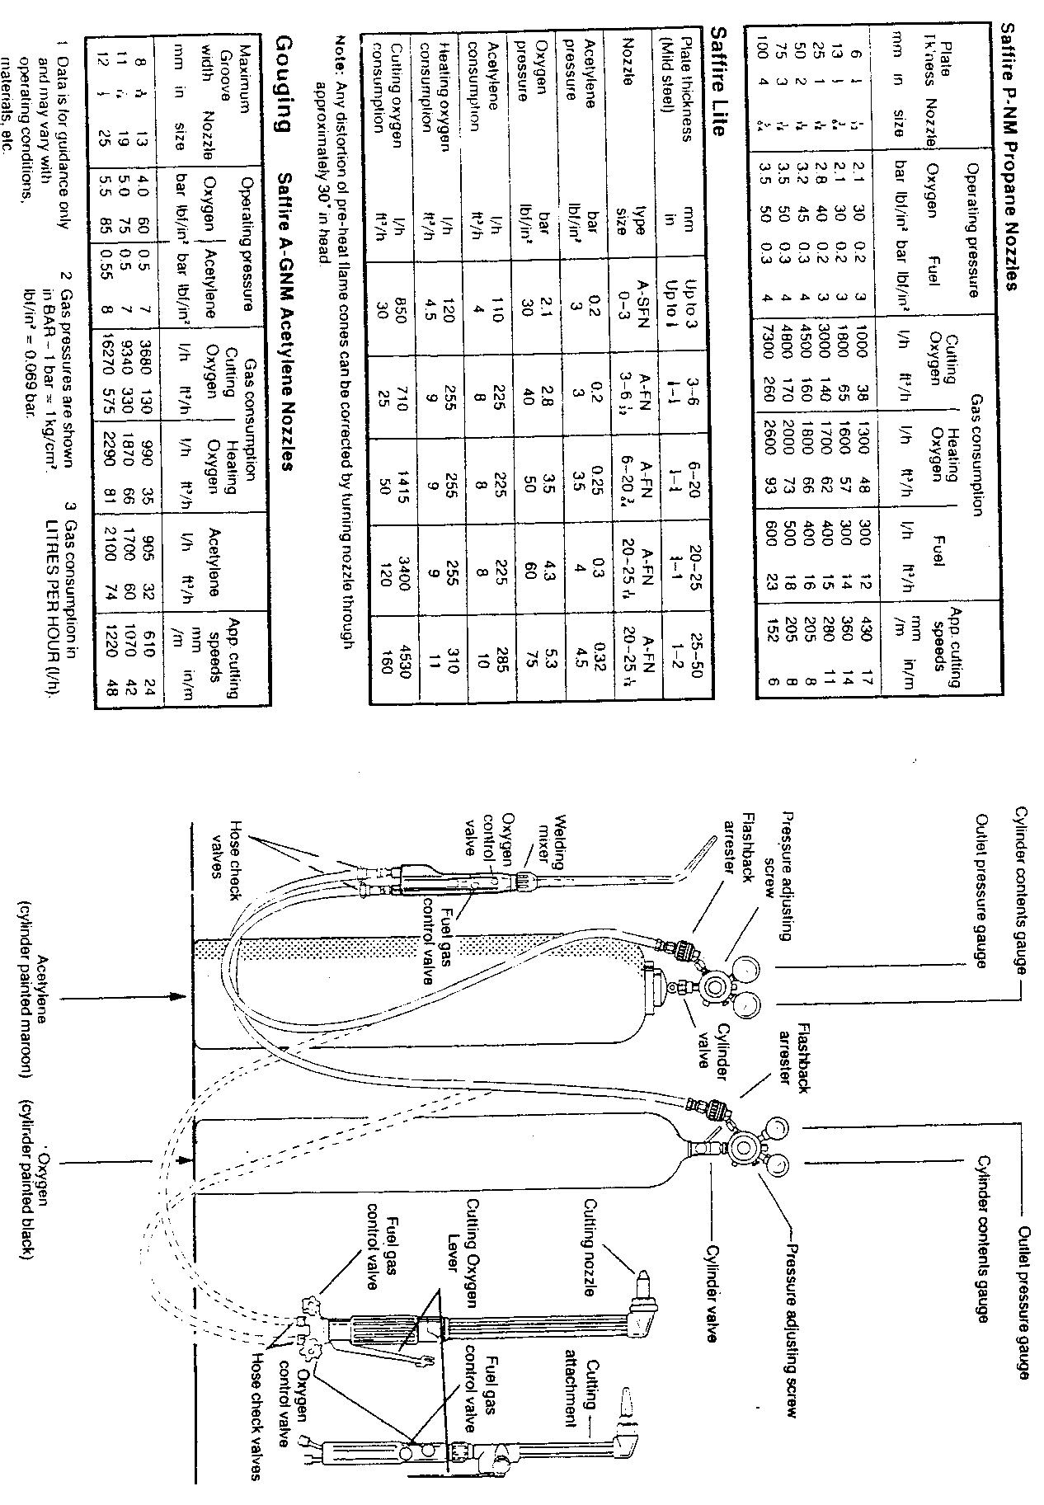
Flashback Arrestors
Flashback arrestors are fitted to the regulators on both the oxygen and acetylene cylinders. The purpose of these is to prevent flames getting back into the cylinders in the event of a backfire or similar accident. There are two types of flashback arrestors – a disposable type and a re-settable type.

Hoses
These carry the gases from the regulators to the blowpipe. They are rubber backed with canvas reinforcement. The oxygen hose is blue in colour with right-hand threads on all connections. The acetylene hose is red with left-hand threads on all connectors.
One end of the hose is connected to the flashback arrestor at the cylinder end, while the other end is connected to a hose check valve at the welding blowpipe end.

Hose Check Valves
Hose check valves, or hose protectors, are fitted between welding blowpipe and the hoses. They are marked “fit to blowpipe” or with a directional arrow to ensure that they cannot be fitted incorrectly. Should they be fitted incorrectly, i.e. attached to the regulator, no gas will flow through them. Basically they are spring loaded non-return valves designed to close in the event of a backfire taking place in the welding blowpipe.

The Blowpipe
There are several makes of gas welding blowpipes on the market all of which are supplied with detachable nozzles of different sizes. These numbered nozzles indicate the approximate consumption of gas in litres per hour. Usually they are numbered 1-2-3-5-7-10 etc. The greater the number the larger the hole size. Therefore the larger the nozzle the greater the amount of heat which can be achieved. The blowpipe is simply a mixing device to supply approximately equal volumes of oxygen and acetylene to the nozzle, and is fitted with regulating valves to vary the pressure of the gas, as required.

Ancillary Equipment
A spindle or bottle key is used to open the valves on both cylinders. Each valve should only be opened approximately ½ turn and during use the key should be left in the position on the acetylene cylinder, so that it can be turned off immediately in the event of an emergency.
Spark lighters are used to ignite the gases. Do not use matches as these could constitute a hazard.
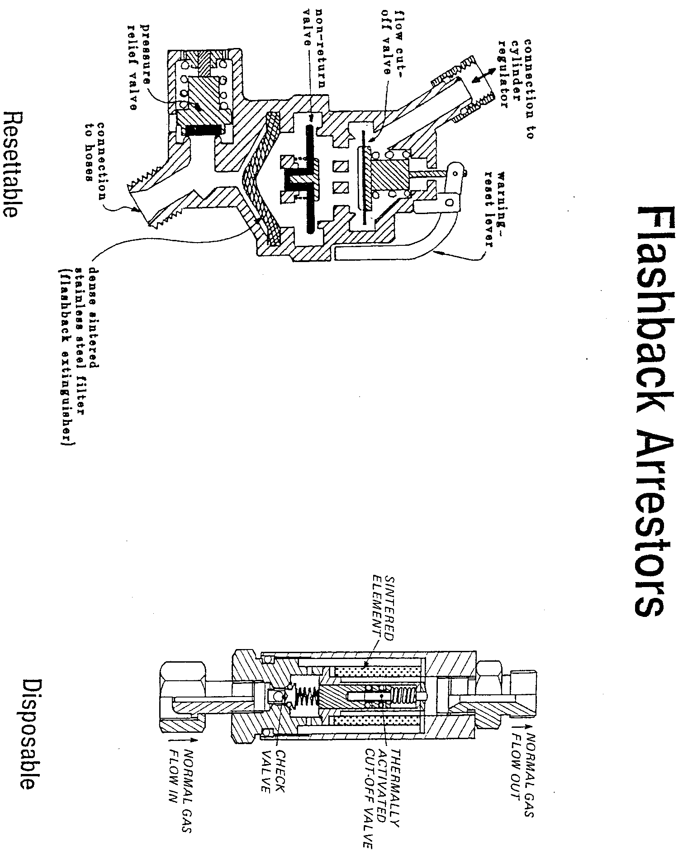
- Flashback Arrestors

Welding Safety
When welding
- Always wear protective clothing, i.e. flame retardant overalls.
- Always wear the correct eye goggles.
- Always have the spindle key in the acetylene cylinder valve.
- Always keep cylinders secured in an upright position.
- Always check for leaks with a soapy solution, NEVER with a naked flame.
- Never carry out makeshift repairs on welding equipment.
- Never allow oil or grease to come in contact with oxygen equipment.
- Never weld an enclosed vessel, i.e. petrol / oil drums until they have been thoroughly cleaned.
- Never work in an enclosed vessel on your own and always leave the cylinders outside. If working in an enclosure vessel, adequate ventilation should be provided and fire fighting equipment should be available.
- In the event of a serious flashback or backfire plunge the blowpipe in a bucket of cold water, leaving the oxygen running to prevent water entering the blowpipe.
- Should the hoses become damaged, turn off the supply of gas at the cylinder and inform your supervisor.
- Don’t forget, this equipment, if misused or damaged can be dangerous. If in any doubt seek assistance and clarification from your supervisor.
- Lighting Up.
When the equipment is initially set up and before lighting up it should be checked for leaks. Never use a naked flame to check for leaks. The correct method is to use soapy water.
Only when the equipment is in a sound working condition can you proceed to the pressure adjustment, lighting up and flame setting required.
Before opening the cylinder outlet valves check that the regulator control screw is in the slackened position, i.e. turned fully in an anti-clockwise direction.
Slowly open the cylinder valve until gas is registered on the contents gauge. Turn the regulator adjusting screw in a clockwise direction until the recommended working pressure is indicated. When this procedure is applied to both cylinders the system is fully charged and ready for lighting up.
Slowly open the acetylene valve on the blowpipe. This allows acetylene gas to flow through the nozzle where it is ignited by means of a spark lighter. The acetylene flame should be adjusted until it cases to smoke and there is no gap between the base flame and the welding tip. The oxygen valve is then opened and adjusted until a neutral flame is achieved. A neutral flame is a mixture of equal amounts of oxygen and acetylene gas and is used for all autogenous welding operations.
To extinguish the flame turn off the acetylene valve on the blowpipe. This will cause the flame to go out. The oxygen valve is then turned off. If the equipment is not to be used for a long period of time, i.e. lunch breaks etc, the valves on the cylinders should be closed. Both blowpipe valves should be opened fully until gas ceases to flow and then closed again.
The pressure adjusting screw on the regulators should be slackened by turning in an anti-clockwise direction.

Hose and Hose Fittings
It is always recommended to buy and use fitted hoses. Factory fitted hose offers the customer the additional advantage of a ‘gas system’ which has been assembled and tested on a closely monitored production line to BS 1389.

Flashback Arrestors
When resetting Oxygen Arrestors where the pressure is above 1.5 bar (22 psi) it is recommended that the supply is closed and the connecting nut between the arrestor and the regulator loosened to vent the locked up gas prior to resetting. This will avoid the need to apply excessive force which could strain the reset mechanism.

Economiser
- Remove the blowpipe from the hook.
- Open both the fuel gas and the oxygen cylinder valves.
- Adjust the regulators to the recommended operational pressures for the nozzle in use. Pressures must be obtained in gas flow conditions with the blowpipe gas control valves being opened and closed alternatively – commencing with the acetylene.
- Ignite and adjust the pilot flame on the economiser to ½” to 1” flame length.
- Open the blowpipe fuel gas control valve, light the blowpipe, adjust the fuel gas control valve until any smoke is lost in the flame, open the oxygen control valve, adjust and trim to neutral flame or normal size for nozzle being used.
- Place the blowpipe on the hook.
- If the economiser valves are properly adjusted the blowpipe flame should go out within a few seconds, with the fuel gas being shut off first.
Note: There should be no smoky flame on shut-off. Although a slight snap is normal, a loud bang indicates that the economiser valves need to be adjusted to ensure that the fuel gas stream is shut off before the Oxygen.

Acetylene Withdrawal Rates
When consumption rates of acetylene exceed 1 cu. metre per hour (35 cu. ft. per hour) for 10 min or longer is essential to manifold two or more cylinders together.

Operating Instructions for Gas Welding and Cutting Equipment
PLEASE INSURE THAT THESE INSTRUCTIONS ARE GIVEN TO THE OPERATOR
The Health & Safety at Work etc. Act 1974 states that employers are “to take such steps as are necessary to secure that persons supplied by that person with the article are provided with adequate information about the use for which the article is designed or has been tested and about any conditions necessary to ensure that it will be safe and without risk to health.”
(Section 2(2) (c))
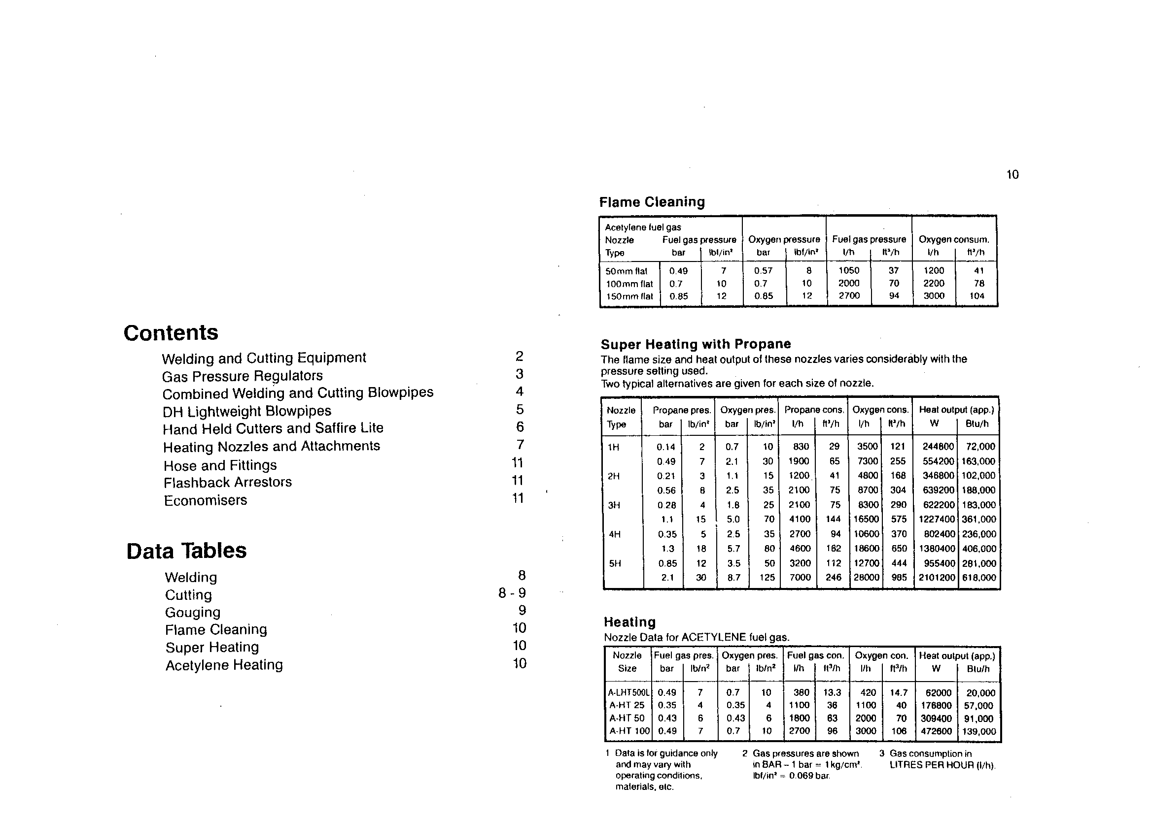
- Flame Cleaning, Super Heating with Propane, and Heating

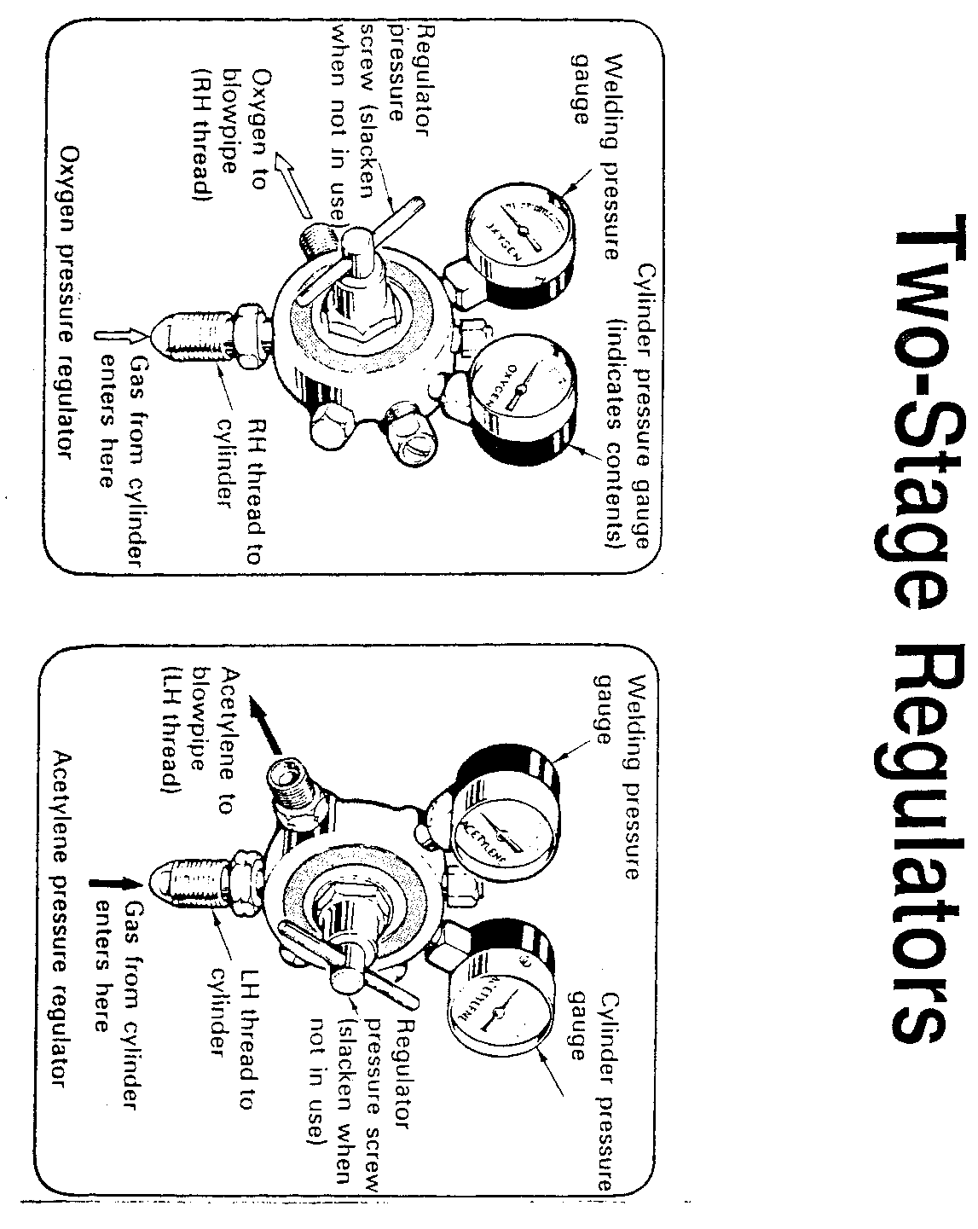
- Two-Stage Regulators

Gas Pressure Regulator
Pressure regulators are precision manufactured instruments which, with correct use will provide reliable and trouble free service.

Before the regulator is fitted to the cylinder
Check that the cylinder valve outlet and the regulator inlets are free from oil, grease and damage.
Open the cylinder valve momentarily to eject any water or foreign matter from the seating (except in the case of hydrogen). Ensure that the blast is not directed at persons or naked flames.

Connecting to the cylinder
Connect the regulator to the cylinder valve (left hand for acetylene and other combustible gases, right hand for oxygen and other non-combustible gases), using the correct spanner and ensure a gas tight seal. Do not use any form of jointing paste or tape between regulator and cylinder valve. Check that the pressure adjusting screw of the regulator is fully released (turned fully anti-clockwise).

Commencing Operation
Connect the downstream equipment and open the cylinder valve slowly. Check all joints for leaks using a 0.5% Teepol in water solution. The contents of the cylinder will register on the cylinder contents gauge and will decrease to zero as the cylinder empties. The contents are generally shown in the bars and lbf/in².
(1 bar = 14.5 lbf/in²).
To set pressure, screw the pressure adjusting knob clockwise until the required outlet pressure registers on the outlet gauge. When gas is flowing, there maybe a reduction in pressure, and adjustments should be made. Purge the gas line before lighting the equipment.

Finish of Operation
When work has stopped, close the cylinder valve, vent gas from the system and unscrew the pressure adjusting knob.

Safety Points to Observe
- Avoid knocks or bangs.
- Do not use the regulator for the other than the gas specified.
- Do not use the regulator for pressures greater than the pressure specified on the regulator.
- Do not change fittings between ports on regulators.
- Regulators are less likely to be damaged when the cylinders are secured on a trolley.
- Inspect the regulator periodically for damage or signs of misuse and the gauges for accuracy.
- Test the gauges using a 0.5% Teepol in water solution.
- Regulations exist governing the use of acetylene and users should comply with Order in Council No. 30 and seek guidance if in doubt from HM Inspectorate of Explosives.
- Hydrogen regulators should be Service Exchanged after five years service.

Notice OR 14 and HR 14 Regulators
The ISO recommended minimum inlet pressure to give the minimum rated performance is based on the formula 2p + 1 bar where p = selected outlet pressure.
Where low outlet pressures (less than 0.7 bar = 10lbf/in²), the control valve may not give 100% shut off and the outlet pressure may rise until the internal friction has been overcome.

Shielding Gas Regulators for Welding
These regulators are fitted with a flow gauge calibrated in litres per minute (L/min) and cubic feet per hour (ft³/h) to measure the rate of gas delivery. The adjustment controls this flow through the metering outlet orifice and will ensure and even steady delivery of gas. This feature improves weld quality by ensuring adequate shielding of weld pool and enables gas consumption to be moved.
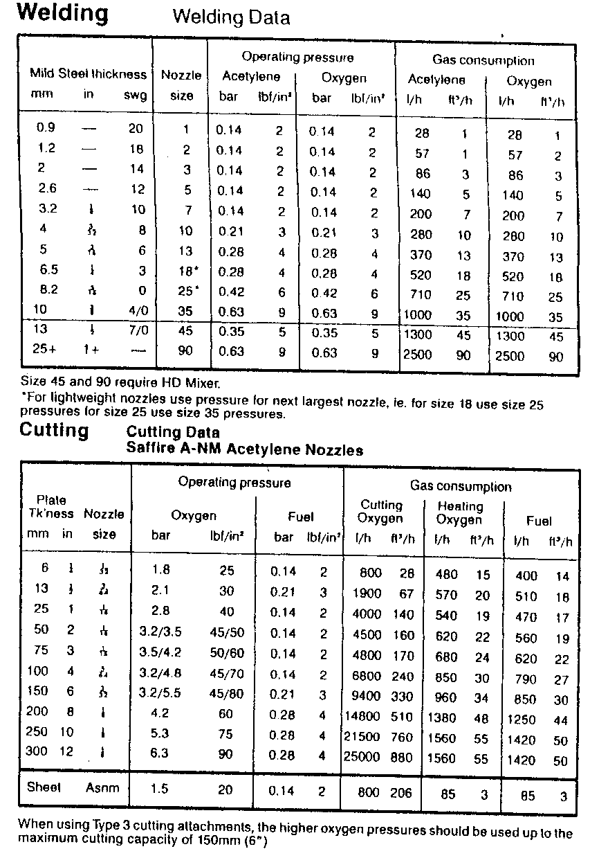
- Welding and Cutting Data

Heating Nozzles & Attachments

Oxy-Acetylene
Open the fuel gas valve on the blowpipe and light with a sparklighter, ensuring the flame is directed away from cylinder or any combustible materials. Increase flow of fuel gas until the flame ceases to smoke and leaves the end of the nozzle by about 3mm (⅛ “) then gently reduce the flow until the flame is making contact with the nozzle again.
Open the oxygen valve; the flame colour will change from yellow to blue. Slowly increase oxygen until feathering of cone at nozzle tip disappears. Increase fuel gas until faint transparent bluish flicker or feathering appears at the end of the centre cone. Increase oxygen again until this flicker all but disappears. Continue to adjust in this way until the size of the flame required for the work in hand is reached.

Oxy-Propane
It is necessary to hold the nozzle at the angle to about 45° to a non-flammable surface when lighting an oxy-propane superheating nozzle.
Open the fuel gas valve on the blowpipe and light the nozzle with a sparklighter. Increase the propane until flame ceases to smoke. Progressively increases oxygen and then propane until required size of flame is obtained.
Continue to increase oxygen flow. It will be observed that the length of the inner cone decreases as the oxygen flow increases. Slowly increase the oxygen until it is no longer possible to decrease the size of these cones, which should now be bluish in colour. The flame should have a distinctive roaring sound.
Note 1: When using a nozzle mix cutter for super heating and adapter is required between the nozzle and the cutter head. This adapter blanks off the normal heating oxygen stream and the oxygen control valve should therefore be left closed. The fuel gas control valve and cutting oxygen lever only should be used.
Note 2: Never starve heating nozzles or attachments. Always err on the side of caution and set a larger flame. Flames that are smaller than the nozzle is designed for will overheat and cause backfires. If a backfire occurs or a hissing sound is heard from the nozzle, immediately turn off the flow of oxygen. This may well cause an unpleasant crack or bang but is the quickest and safest way of extinguishing the flame and ensuring the flame that a potentially dangerous flashback is averted.

Data Tables
Please note the following data is given as an approximate guide. Working conditions, length and diameter of hose, provision of non return valves and flashback arrestors and their fitness for use, will all have an effect on the pressure and flows obtainable at the nozzle. A stable flame of the type required for the job in hand is the true proof that the correct conditions have been met. It is wise always to err on the side of caution and set a flame a little larger than which could suffice for the process.

Combined Welding and Cutting Blowpipes
(Apart from Saffire Lite)
- Examine the blowpipe for signs of damage.
- Connect the hoses to the blowpipe inlets and tighten gas with the correct spanner. Check that the hose check valves – are indicating flow in the correct direction.
- Select the correct nozzle for the work in hand, using the information on the data chart. Then tighten the nozzle by hand into the mixer if welding, or by using the correct spanner into the head if cutting.
- With the blowpipe valves closed set the pressures required on the regulator gauges, again using the information given on the data chart.
- Purge each hose, alternately by opening the gas valves and allowing gas to flow from the nozzle, thereby allowing mixed gas/air to be expelled. Close the valves.

Welding
- Open the fuel gas valve on the blowpipe and light with a sparklighter. Adjust the fuel gas until flame just ceases to smoke. Open oxygen valve and adjust to the neutral condition. Flame adjustment should always be gradual to avoid flame snapout.

Cutting
- Open the oxygen valve on the shank as far as it will go – i.e. in an anti-clockwise direction. This valve must be left in this position while cutting.
- Purge the shank by opening the fuel gas valve on the shank and the heating oxygen valve on the cutting attachment one at a time for a few seconds. Close one valve before opening the other.
- Open the fuel gas valve on the shank and light the fuel gas with a sparklighter. Adjust fuel gas until flame just ceases to smoke. Shut off the gas supply at the cylinder. Open blowpipe valves to remove residual gas from the system. Relax the pressure adjusting screw on the regulator and close the blowpipe valves.

Important
- In the event of a backfire close the oxygen valve first followed by the fuel gas valve.
- In the event of a gas leak, check the conditions of the interconnecting ‘O’ rings. Replace if damaged.

Changing from Cutting to Welding
When changing from cutting to welding ensure that the oxygen valve on the shank is closed and vent oxygen by depressing the cutting oxygen lever.

Changing from Welding to Cutting
In the changing from welding to cutting remove mixer and swaged nozzle from shank and fit cutting attachment by pressing firmly to shank until serrations engage. It is essential that pressure be applied to seat the attachment onto the serrations as the nut will not pull them together.

DH Lightweight Type Blowpipe

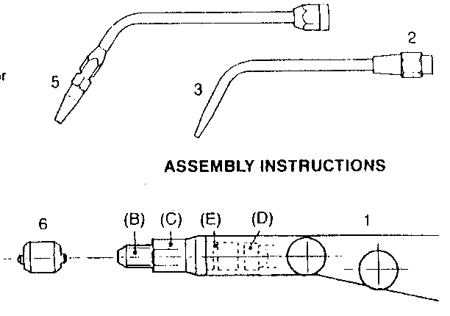

- Assembly Instructions for DH Lightweight Blowpipe

- DH Lightweight Blowpipe Parts
Item | Description
1. | Shank
2. | Rotating Adaptor
3. | Swaged Nozzle
4. | Neck
5. | Tip
6. | Mixer
When using DH Neck and DH Nozzles:
- Screw DH nut to connection (B), locate neck in required welding position and tighten with spanner.
- Screw DH Nozzle to neck and tighten.
Note: DH neck should be left attached to shank when changing Nozzles.
When using swaged welding Nozzles with Rotating Adaptor:
- Screw adaptor into shank hand tight then tighten adaptor just enough to prevent insert from rotating.
- Screw in Nozzle firmly then loosen adaptor.
- Position swaged Nozzle to required angle and tighten adaptor nut firmly.

To Clean Mixer
Mixer should not be removed unless flow restriction is experienced.
- Remove Nozzle, Neck / Adaptor.
- Unscrew and remove locking nut (C).
- Unscrew and remove carefully mixer location piece (B).
- Extract Mixer (D) and clean mixer ports carefully with copper wire. Fit new ‘O’ ring (E).
- To replace mixer: Support Mixer on the location piece (B).
- Invert Shank and screw location piece into position.
- Replace locking nut (C).

DH and Saffire Lite in Welding Mode
- Examine the blowpipe for signs of damage.
- Connect the hose to the blowpipe inlets and tighten gas tight with the correct spanner. Check that the hose check valves are indicating flow in the correct direction.
- Select the correct nozzle for the work in hand, using the information on the data charts and secure gas tight into the head with correct spanner.
- With the blowpipe valves closed set the pressure required on the regulator gauges.
- Purge each hole alternately by opening the gas valves and allowing gas to flow from the nozzle, thereby allowing mixed gas/air to be expelled. Close the valves.
- Open fuel gas valve on blowpipe and light the fuel gas with a sparklighter. Adjust fuel gas until flame just ceases to smoke. Open oxygen valve and adjust to the neutral condition. Flame adjustments should always be gradual to avoid flame snapout.
- When the operation is completed the blowpipe should be extinguished by first closing the fuel gas valve followed by closing the oxygen valve. Shut the gas supply at the cylinder. Open blowpipe valves to remove residual gas from the system. Relax the pressure adjusting screw on the regulator and close the blowpipe valves.

Important
In the event of flashback close the oxygen valve first, by the fuel gas valve.

Hand Held Cutters and Saffire Lite in Cutting Mode
- Examine the blowpipe for signs of damage.
- Connect the hoses to the blowpipe inlets and tighten gas tight with the correct spanner. Check that the flow direction arrows – located on the hose check valves – are indicating flow in the direct direction.
- Select the correct nozzle for the work in hand using the information on the data charts and secure gas tight into the head with the correct spanner.
- With the blowpipe valves closed set the pressure required on the regulator gauges.
- Purge each hose alternately by opening the gas valves and allowing the gas to flow from the nozzle thereby allowing mixed gas/air to be expelled. Close the valves.
- Open fuel gas valve on blowpipe and light the fuel gas with a sparklighter. Adjust fuel gas until flame just ceases to smoke. Open oxygen valve and adjust to the neutral condition. Flame adjustment should always be gradual to avoid flame snapout.
- When an operation is completed the blowpipe should be extinguished by first closing the fuel gas valve followed by closing the oxygen valve. Shut the gas supply at the cylinder. Open blowpipe valves to remove residual gas from the system. Relax the pressure adjusting screw on the regulator and close the blowpipe valves.

Important
In the event of flashback close the oxygen valve first, followed by the fuel gas valve.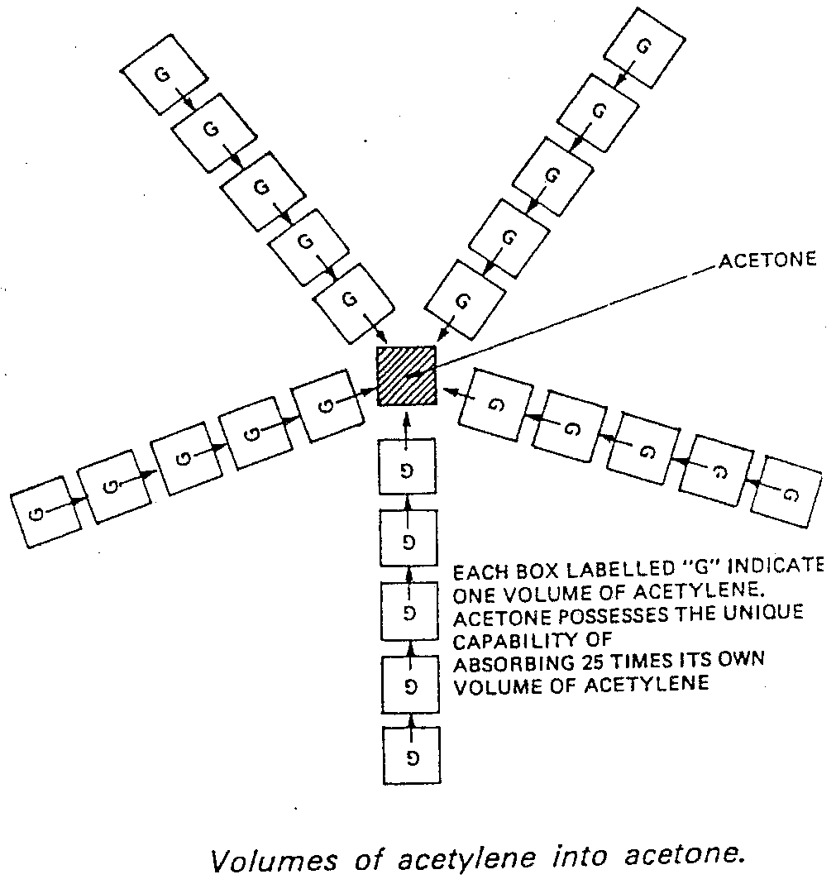
- Volumes of Acetylene into Acetone

Self Assessment
- State the purpose of the following components;
a) Regulator
b) Flashback arrestor
c) Hose check valves
d) Mixing chamber
- Describe the safety precautions to be observed when welding in confined spaces.
- List 3 ways in which an acetylene cylinder can be identified.
- Describe the correct procedures when lighting up and shutting down oxy-acetylene welding plant.
- Set up oxy-acetylene welding plant and check for leaks.
a) Butt weld and branch weld mild steel pipe Nos. 2.1.10a and 2.1.10b shown in the curriculum document.
b) Describe using a sketch the three types of oxy-acetylene flame.
c) Describe the rightward welding technique.
- The acetylene cylinder must be used in a vertical position during the welding process to:
a) Prevent the escape of acetone.
b) Allow the acetylene gas to leave the cylinder.
c) Enable safe erection of equipment.
d) Conserve floor space.
- An overheated blowpipe should be cooled by placing the blowpipe:
a) In water with oxygen valve open.
b) In water with acetylene valve open.
c) Unattended on the bench to cool naturally.
d) In water with both valves open.
- An oxidizing flame has:
a) Insufficient oxygen.
b) An excess of oxygen.
c) Equal amounts of each gas.
d) A large inner cone.
- Bronze welding is:
a) Silver soldering.
b) Soft soldering.
c) Hard soldering.
d) Autogenous.
- Before connecting regulators to gas cylinders you should:
a) Clean the threads with oily waste.
b) Open the valve on the regulator.
c) Lay the cylinder on its side.
d) Open the cylinder valve momentarily to dislodge any dirt.
- For which type of joint is silver solder used?
a) Wiped joint.
b) Gas pipe joint.
c) Bell type joint.
d) Capillary joint.
- When bronze welding copper pipes using an oxy-acetylene flame, it should be:
a) Neutral.
b) Slightly carburising.
c) Slightly oxidising.
d) Feathered at the inner core.
- The threads used on acetylene pipes and equipment are:
a) Left-hand.
b) Right-hand.
c) Either left or right will do.
d) The same as those used for oxygen equipment.
- One of the purposes of using a flux is to:
a) React with a base metal.
b) Lower the solder’s melting point.
c) Increase the conductivity.
d) Prevent oxidation.
- Acetylene gas should never be conveyed in:
a) Copper tubes.
b) Low carbon steel tubes.
c) Stainless steel tubes.
d) Pressure hose containing rubber.

Answers are on the next page.

Q6 (a)
Q7 (a)
Q8 (b)
Q9 (c)
Q10 (d)
Q11 (d)
Q12 (c)
Q13 (a)
Q14 (d)
Q15 (a)

Index

A
acetone 10
acetylene 10
atmosphere 9
B
blowpipe 14
C
calcium carbide 10
charcoal 10
D
distillation 9
F
flashback arrestors 14
H
hose
check valves 14
fittings 17
hoses 14
hydrocarbons 10
K
kapok 10
O
oxy-acetylene 24
oxygen 9
oxygen arrestors 17
oxy-propane 24
P
pressure regulators 21
S
saffire lite 28
spindle 14
W
welding 16

