Trade of Plumbing
Module 2: | Domestic Hot and Cold Water Service
Unit 9: | Valves and Taps
 | Phase 2

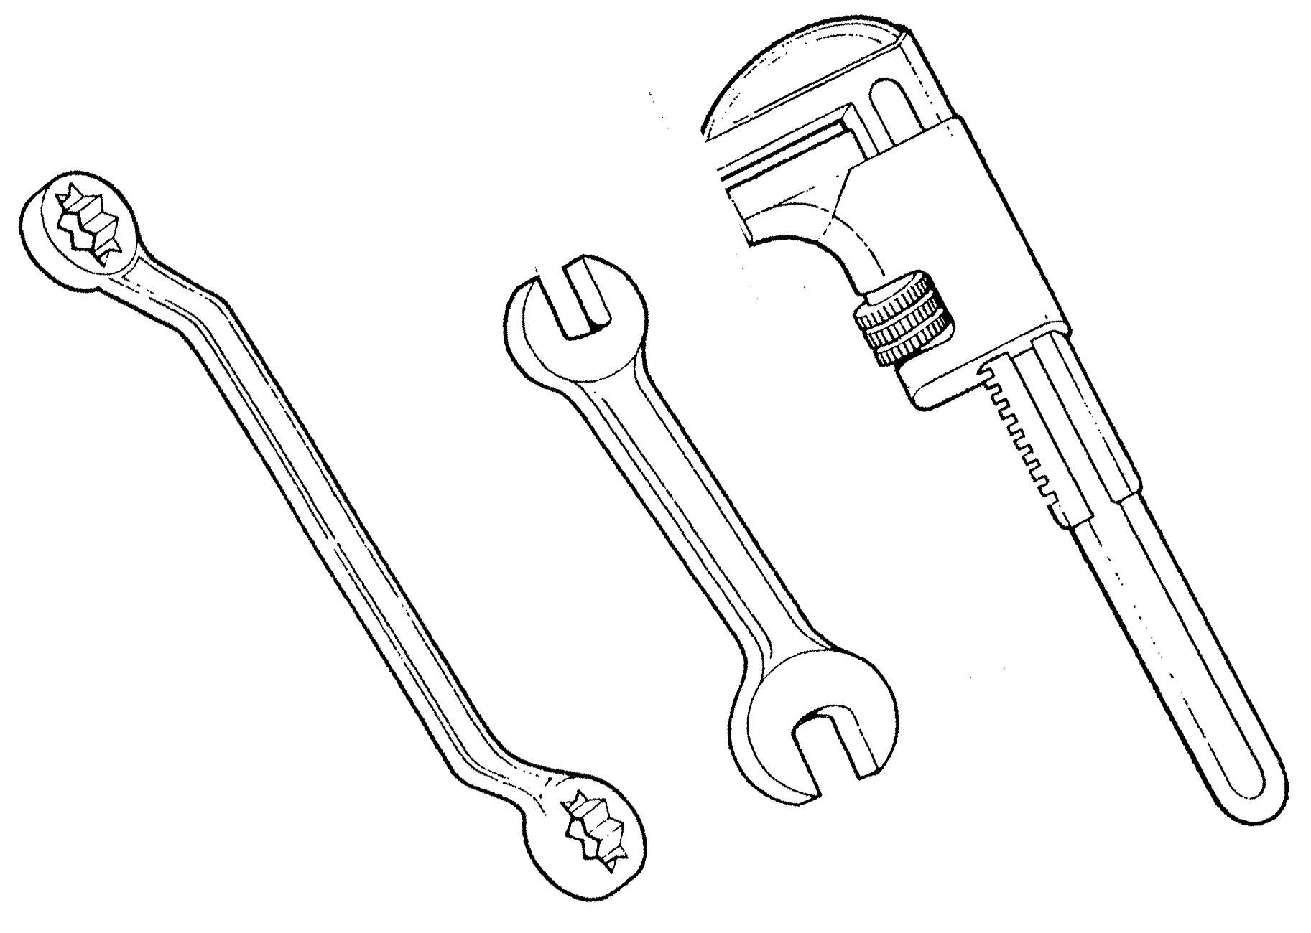

Table of Contents
List of Figures 4
List of Tables 5
Document Release History 6
Module 2 – Domestic Hot and Cold Water Services 7
Unit 9 – Valves and Taps 7
Duration – 11 Hours 7
Learning Outcome: 7
Key Learning Points: 7
Training Resources: 7
Exercise: 8
Key Learning Points Code 8
Valves and Taps 9
Back Siphonage 19
Self Assessment 21
Index 22

List of Figures
Figure 1. Stopcock 11
Figure 2. Gate Valve 12
Figure 3. Drain-off Cock 13
Figure 4. Bib Tap 14
Figure 5. Pillar Tap 15
Figure 6. Mixer Tap 16
Figure 7. Plug Cock 17
Figure 8. Repacking Glands on Radiator Valves 18
Figure 9. Draw off Taps 20

List of Tables
Table 1. Common Valves and Taps 9
Table 2. Back Siphonage 19

Document Release History
Date | Version | Comments
June 2006 | V.1.0
04/03/14 | 2.0 | SOLAS transfer

Module 2 – Domestic Hot and Cold Water Services

Unit 9 – Valves and Taps

Duration – 11 Hours

Learning Outcome:
By the end of this unit each apprentice will be able to:
- Describe the types and application of valves and taps used in domestic plumbing systems.
- Describe the operation and components of valves and taps.
- Replace stopcock, tap and ballvalve washers.

Key Learning Points:
RK | Types and application of taps – pillar taps, mixer taps, monobloc taps, bib taps, push taps and lever taps etc.
RK | Types and application of valves – stopcocks, gate valves, lever valves, drain cocks etc.
RK | Operation and components of taps and valves.
RK | Types, components and operation of float assisted valves – high pressure, low pressure, diaphragm, Portsmouth (BS), equilibrium.
RK | Ball valve problems – water hammer, leaking, sticking, furring, cavitaion.
Sk | Replacement of tap and valve washers.
Sk | Identification of different types of washers, o rings etc.
Sk | Use of tap re-seating tools.
P | Good working practice.
P | Problem solving.
P | Working independently.

Training Resources:
- Classroom facilities, workshop facilities.
- Information sheets.
- Sample taps, valves and washers.

Exercise:
- Apprentice to dismantle and replace washers in pillar taps and ballvalves.
- Apprentice to replace the packing in a stopcock.
- Apprentice to answer sample questions:

Key Learning Points Code
M = Maths D= Drawing RK = Related Knowledge Sc = Science
P = Personal Skills Sk = Skill H = Hazards

Valves and Taps
Valves and taps are devices designed to regulate, open or close the flow of liquid or gas in a pipeline. They should be made of brass, gun metal or other corrosion resisting alloys. They may be made by casting metal into moulds or by hot pressing metal between dies.
Some of the more common valves and taps and their uses are given in the table below.
- Common Valves and Taps
Valve / Tap | Use
Stopcock | Used on incoming high pressure water mains.
Gate valve | Used on low pressure pipework.
Drain off cock | Used to drain pipework
Bib tap | A well mounted tap primarily used over sinks and also for outdoor use.
Pillar tap | Used on sinks, wash hand basins and baths.
Mixer taps | A tap in which hot and cold water are delivered through a common spout. Used on sinks, wash hand basins and baths.
Plug cock | A quick closing valve used mainly on gas installations.
Radiator valves | Used to control the flow of water to and from radiators.
- Stopcocks are used on high pressure water mains. They must be fitted the correct way round, so that the water passing through the valve pushes the jumper up from its seating. For this reason stopcocks are stamped with an arrow indicating the direction of the water flow.
- Gate Valves are used to control the flow of fluids in low pressure systems, such as distribution pipework from storage cisterns, or heating systems. Gate valves do not have washers fitted and therefore there is no restriction to the flow of liquids through them. A wedge shaped gate closes into a matching seating when the valve is operated.
- Drain off cock (DOC) is used to drain boilers, cylinders, sections of pipework etc. They are usually fitted at low points in plumbing and central heating systems.
- Bib taps are fixed to the wall with a back plate. They are used with Belfast and cleaner’s sinks and are useful for filling buckets. Bib taps are often fitted externally for outside use. A hose union connection is also available. Bib taps can be plain or chromium plated.
- Pillar taps are manufactured with long inlet threads which allow them to be fitted through sanitary appliances and thereby clamped in position. When fitting pillar taps it is essential to ensure that an adequate “air gap” is allowed for, to prevent back siphonage.
- Mixer taps are designed to deliver hot and cold water through a common spout. There are two basic designs of mixer taps: in which the hot and cold water is mixed in the tap body or spout (single outlet mixer), and those in which the hot and cold water do not actually mix until it is discharged from the outlet nozzle (double outlet mixer). The first type is only suitable for use when the water from the hot and cold supplies are at equal pressures. Failure to observe this could result in the water having greater pressure flowing back down the other feed pipe. This results in unsatisfactory water flows discharging from the nozzle outlet. There is also a risk of contamination from stored water getting into the mains water supply.
- Many mixing taps are fitted with a swivel outlet. This allows the water to be discharged at various positions and proves useful with modern sinks which often have more than one bowl. One major drawback to mixer taps with a swivel outlet is the fact that the neoprene “O” ring used to ensure a watertight seal tends to wear out and therefore requires frequent replacement.
- Plug cocks can be fully opened or closed by turning the square top through one quarter of a turn. This means that the valve can be closed very quickly, and for this reason it is not used on water supply systems because of the risk of water hammer. Plug cocks have a square head into which a slot is cut; if this slot is in line with the pipe it means the valve is open; if the slot is at right angles to the pipe the valve is closed. Plug cocks are used almost exclusively on gas services.
- Radiator valves are fitted to radiators and convector heaters. In general one valve is fitted to each end. They may be straight or angle pattern with a wheelhead or lock-shield cover. The lock-shield valve is used when balancing the heating system, ensuring an equal distribution of hot water. It the radiator has to be taken down, the lock-shield valve can be shut off. The wheelhead valve is used to turn the heater on or off. Thermostatic radiator valves are also available. These valves are fitted with a built-in heat sensor. They are designed to open and close automatically, allowing hot water to the radiator as heat is required.
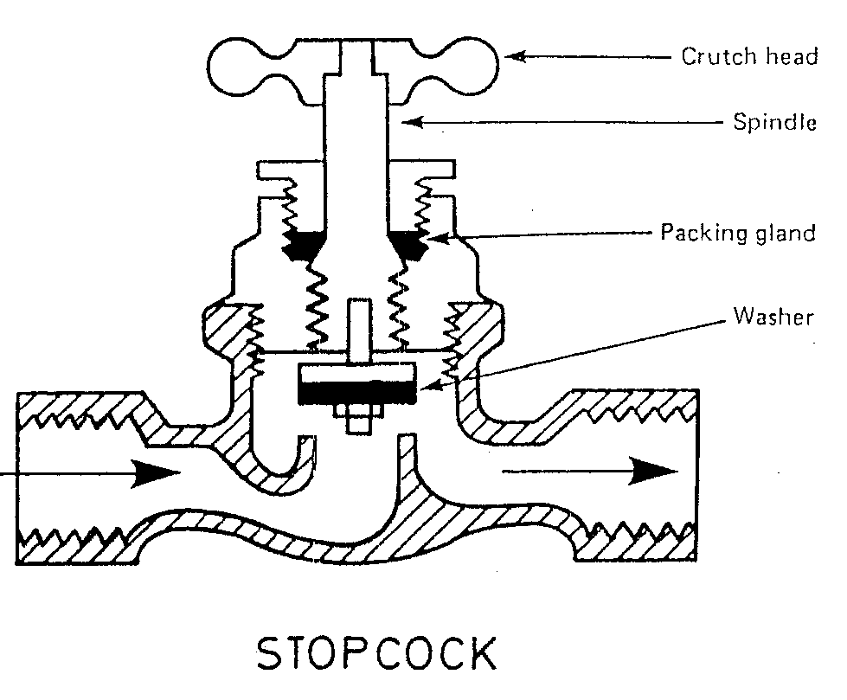
- Stopcock
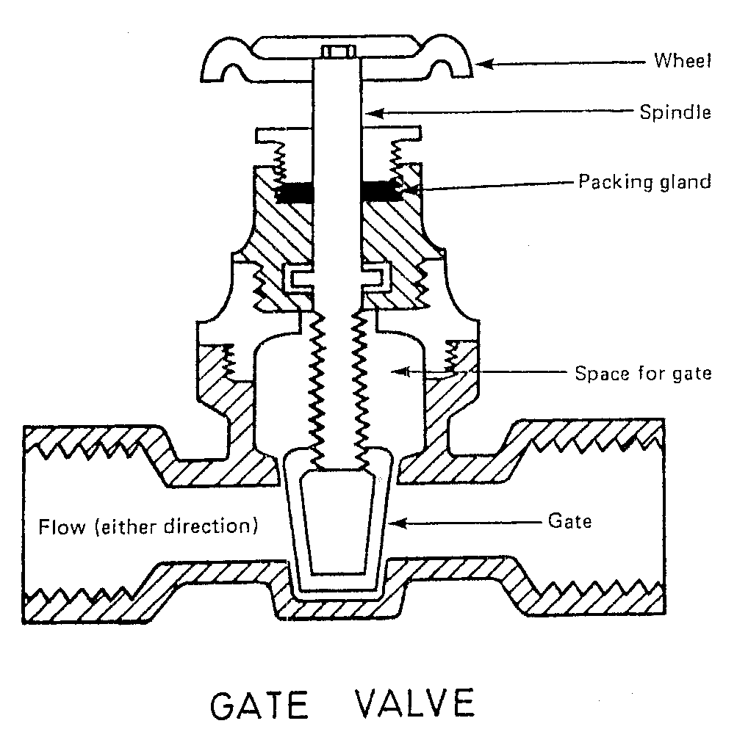
- Gate Valve
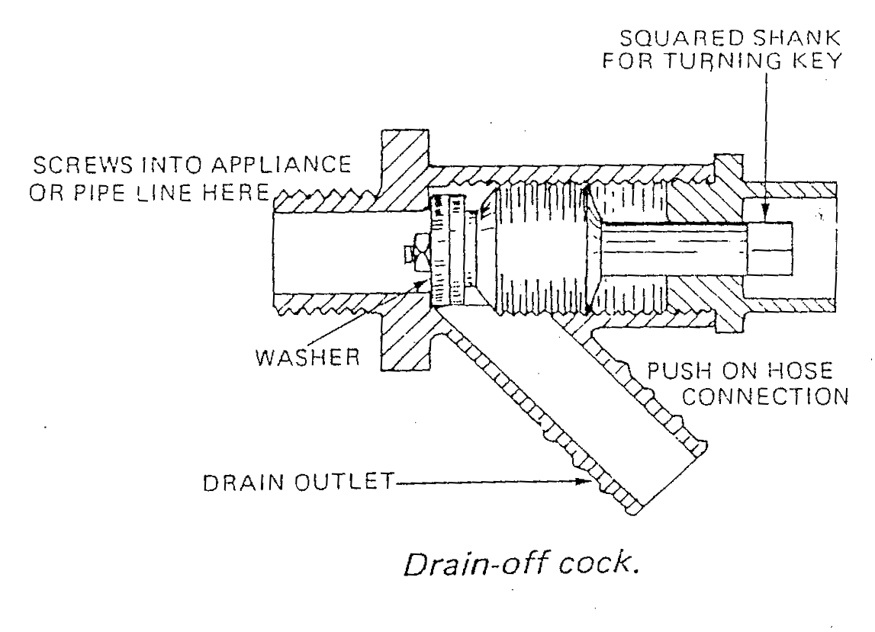
- Drain-off Cock
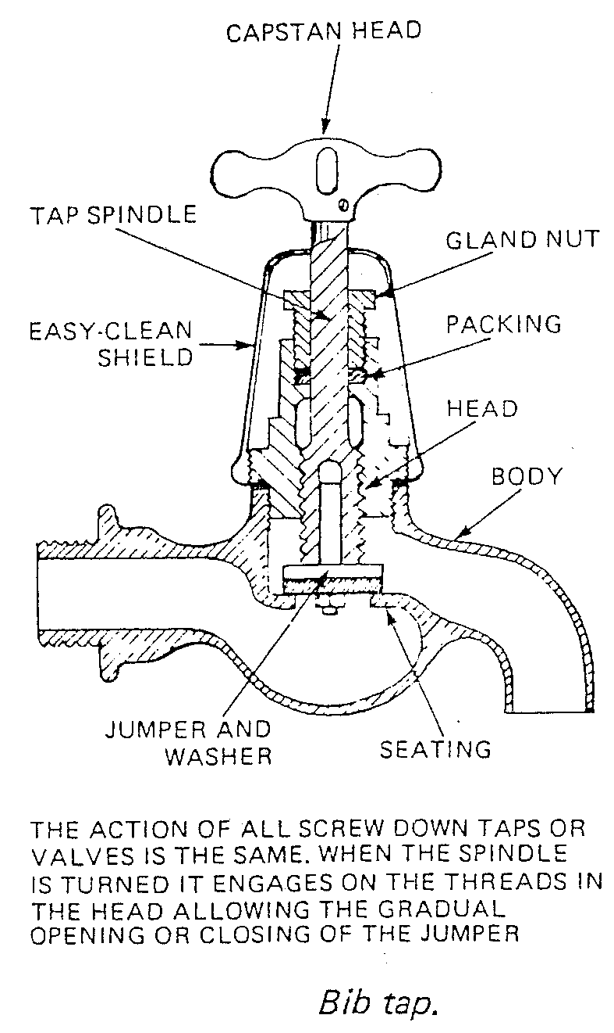
- Bib Tap
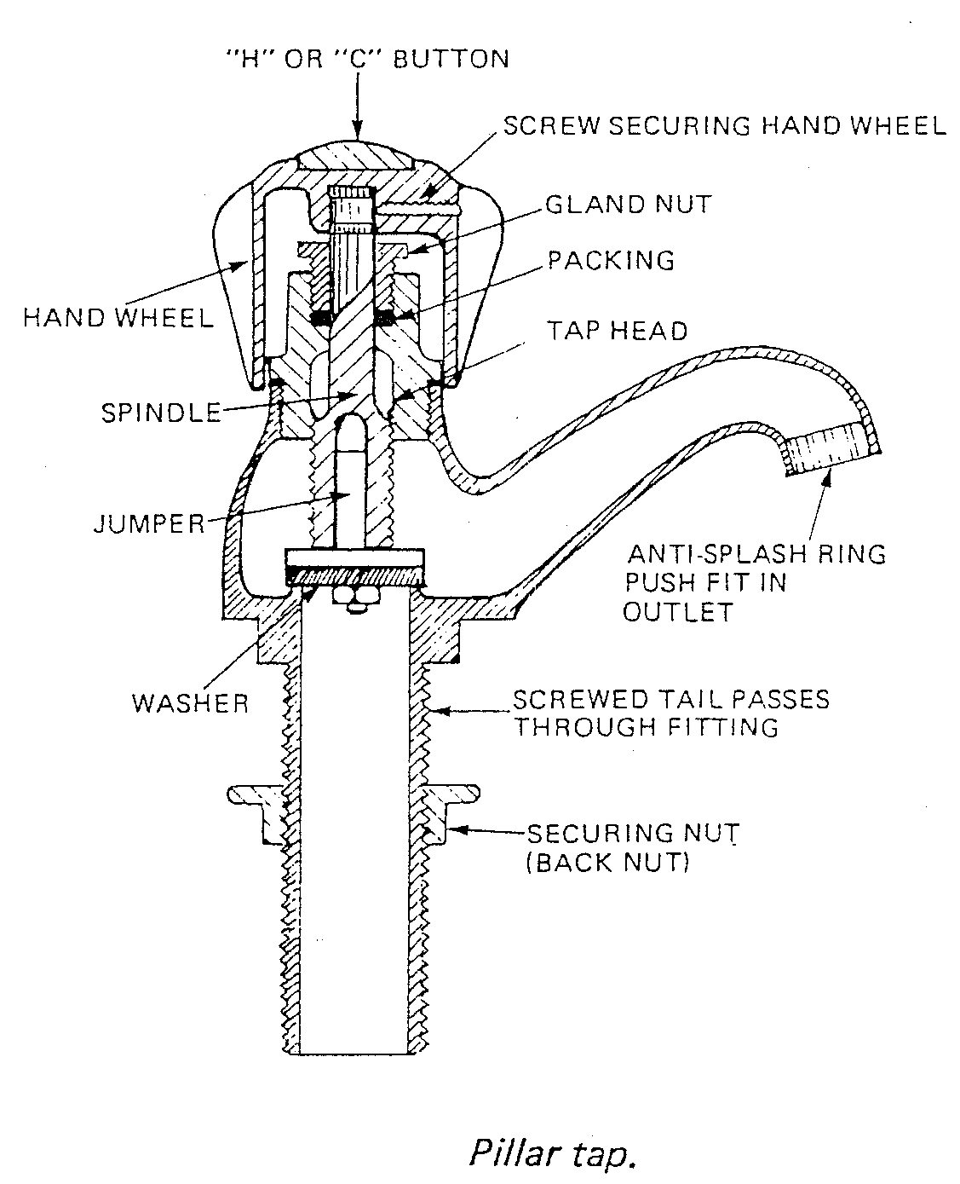
- Pillar Tap
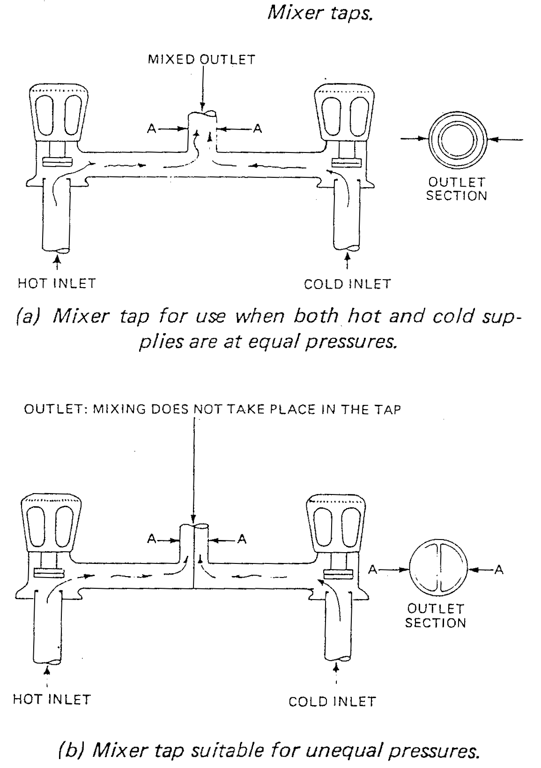
- Mixer Tap
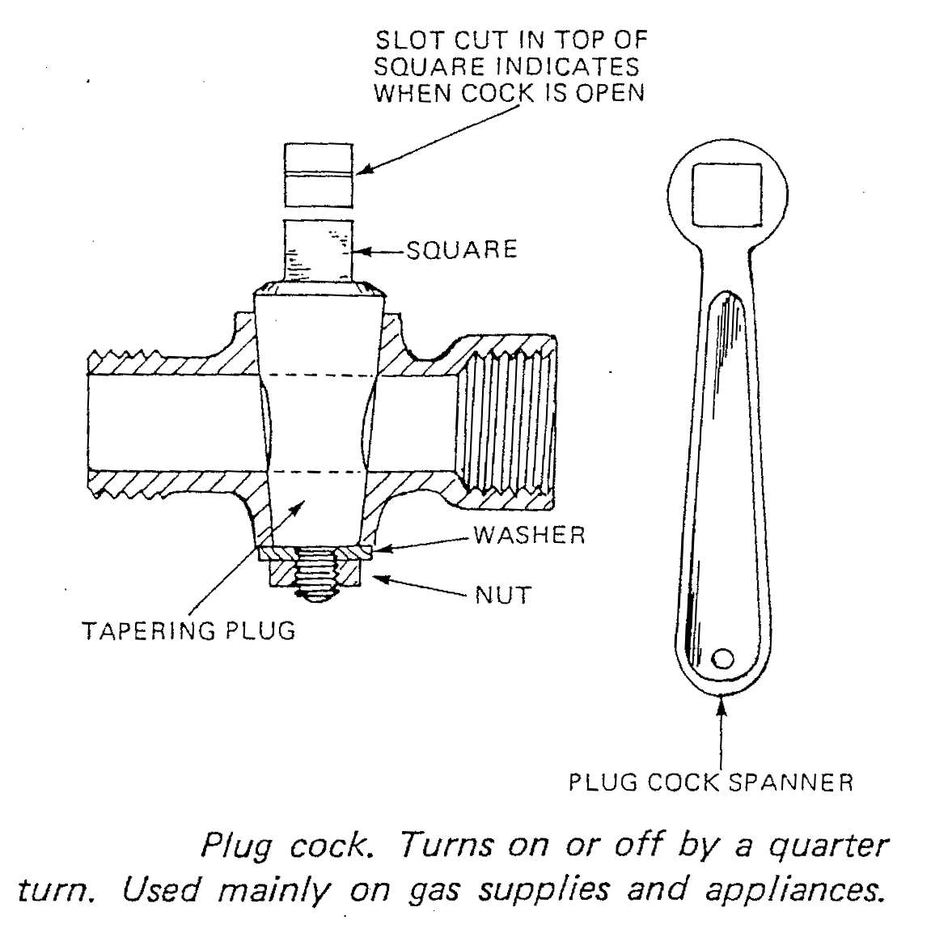
- Plug Cock
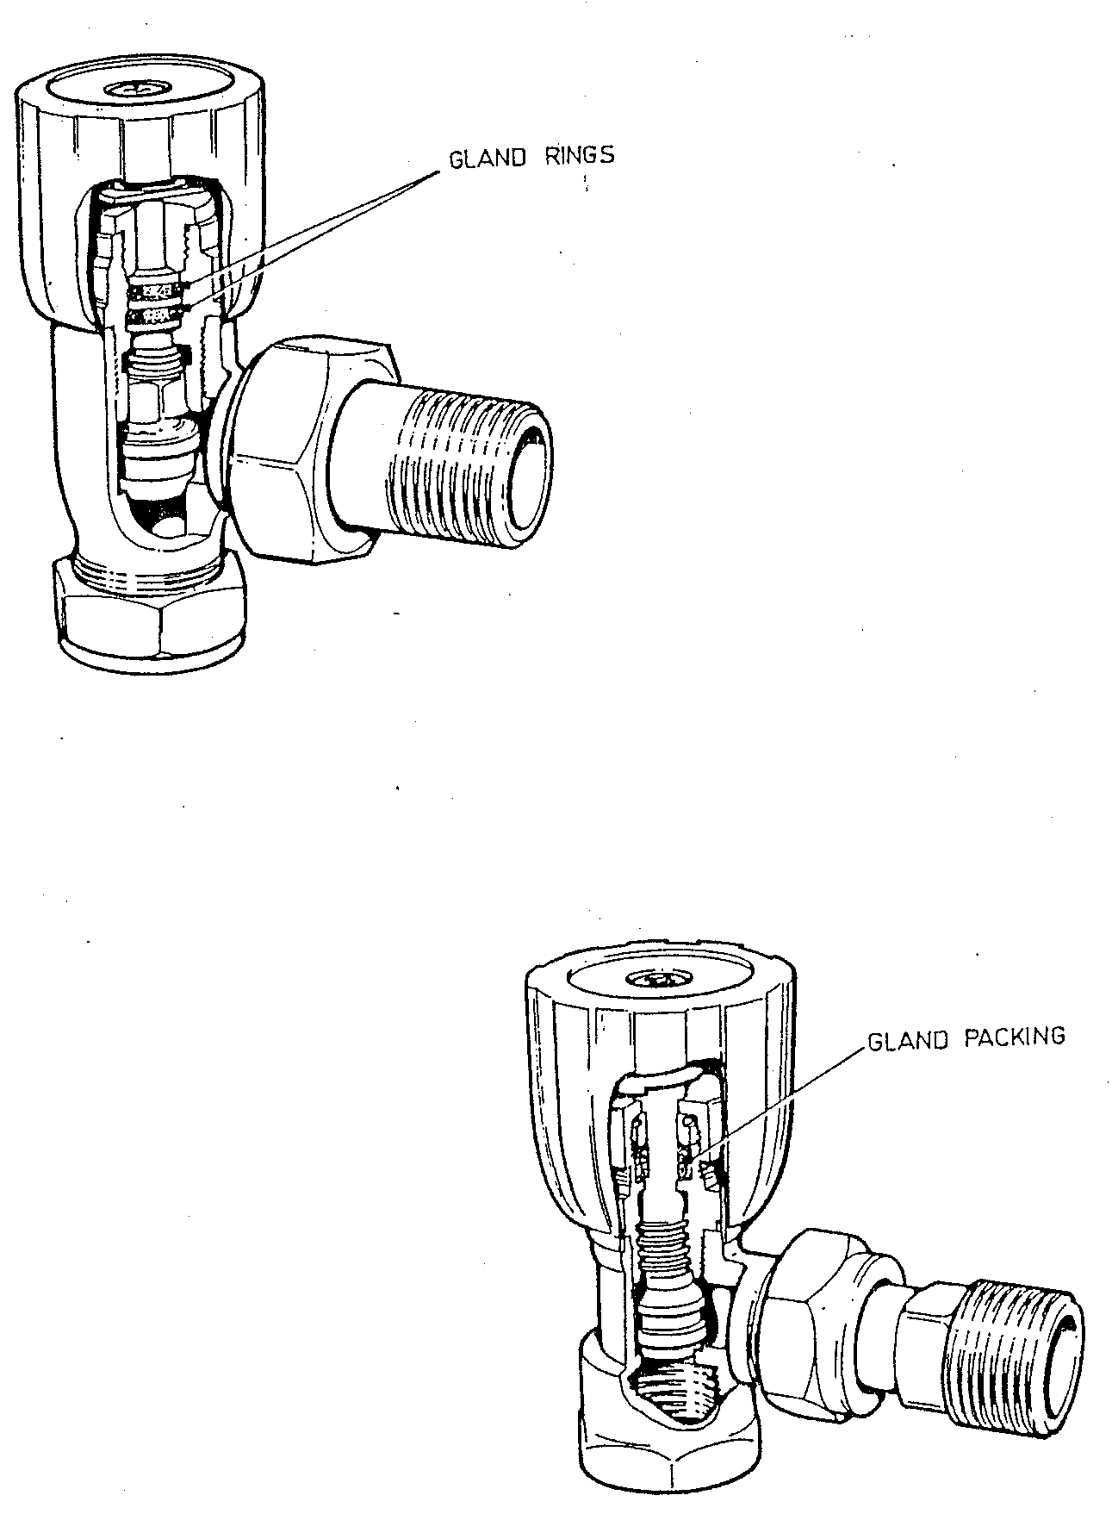
- Repacking Glands on Radiator Valves

Back Siphonage
The backflow of water by siphonic action from an appliance or storage cistern into the pipe feeding it, thus contaminating the water supply. To overcome the problems caused by back-siphonage the water authority lay down strict guidelines which must be observed and any pipe on mains supply connected to appliances and cisterns must have some means of backflow prevention. This could be achieved by ensuring that where an outlet discharges allowance is made for an air gap of at least that shown in the chart.
- Back Siphonage
Internal Pipe Diameter | Vertical distance (air gap) between outlet and highest possible water level
Up to 14mm  15mm – 21mm  22mm – 41mm  Over 41mm | 20mm  25mm  70mm  Twice the internal bore of the inlet pipe
If a specified air gap cannot be achieved some other means of backflow prevention must be catered for. In the case of hose pipes and shower hoses connected to the mains supply a double check valve assembly or similar arrangement such as a check valve followed by an anti-vacuum valve must be used.
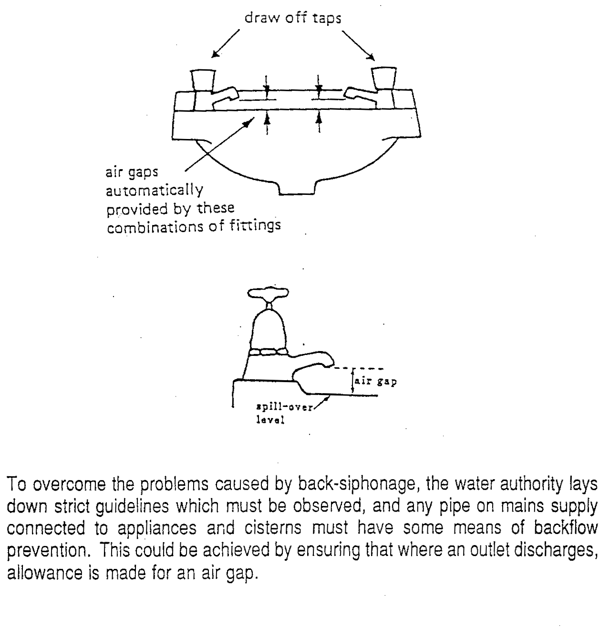
- Draw off Taps

Self Assessment
- State where the following valves and taps are used:
a) Stopcock,
b) Gatevalve,
c) High neck pillar tap
d) Bib tap
- Water is seen to be flowing from the overflow pipe of a storage cistern. Give reasons for this and how the problem could be rectified.

Index

B
Back Siphonage 19
bib taps 9
D
drain of cock 9
G
gate valves 9
M
mixer taps 10
P
pillar taps 9
plug cocks 10
S
stopcock 9
stopcocks 9
T
taps 9
V
valves 9

