Trade of Electrician

Standards Based Apprenticeship

Earthing and Bonding

Phase 2

Module No. 2.2

Unit No. 2.2.6.

COURSE NOTES

Created by Eugene Trindles – Cork TC

Revision 1 April 2000 by
Eugene Trindles – Cork TC
Charlie Walsh - Athlone TC

Revision 2 Nov. 2002 by
Eugene Trindles – Cork TC
Chris Ludlow – Dundalk TC

Revision 3 May 2006 by
Chris Ludlow – Dundalk TC

Revision 4. Feb 2008 By
Chris Ludlow - Dundalk TC

Revision 5. July 2009 By
Chris Ludlow - Dundalk TC

Revision 6. October 2009 By
Chris Ludlow - Dundalk TC

Revision 5, November 2013
SOLAS

Compiled by Liam Carroll – Certification & Standards

Published by


27-33 Upper Baggot Street
Dublin 4
Ireland

© SOLAS - 2013

All rights reserved. No part of this publication may be reproduced, stored in a retrieval system or
transmitted in any form or by any means, electronic, mechanical, photocopying, recording or
otherwise, without the prior permission of the copyright owner.
Table of Contents
Introduction 4
Definitions 5
Earthing 6
Types of System Earthing 11
Equipotential Bonding 14
Unit Related ETCI Rules 20

Introduction

Welcome to this section of your course, which is designed to enable you the learner, understand the terms earthing and bonding. It is vitally important to be able to distinguish between them. There is a lot of confusion in this area on the part of a large number of people working with electricity.

Objectives

By the end of this unit you will be able to:

- Understand the term “earthing” and the reasons for earthing
- Explain important terms associated with earthing
- Install an earthing system in a domestic installation
- Understand the term “bonding” and the basic reasons for bonding
- Explain important terms associated with bonding
- Install a main bonding system in a domestic installation
- Install a local bonding system in a domestic installation

Reasons

Understanding this information will allow you install correctly the safety aspects of the installation.
Definitions

Normal Supply: An electricity supply taken from the supply authority ( DSO ) or alternatively from the proprietor’s own generating plant

Earthing: The connection of the exposed conductive parts of an installation to the main earthing terminal or bar.

Main Earthing Terminal ( MET ) or Bar: A terminal or bar provided for the connection of protective conductors, main equipotential bonding conductors and conductors for functional earthing if any, to the means of earthing.

Main Protective Conductor: A conductor that connects the main earthing terminal or bar to the supply neutral.

Earthing Conductor: A conductor connecting the main earthing terminal or bar to the earth electrode.

Earth Electrode: A conductive part or a group of conductive parts in intimate contact with, and providing an electrical connection with, earth.

PEN Conductor: An earthed conductor combining the functions of both protective conductor and neutral conductor.
Note: The acronym PEN comes from the combination of the symbols PE for the protective conductor and N for the neutral conductor.

Bonding: See Equipotential Bonding.

Equipotential Bonding: Electrical connections intended to maintain exposed conductive parts and extraneous conductive parts at the same or approximately the same potential, but not intended to carry current in normal service.

Equipotential Bonding Conductor: A protective conductor for ensuring equipotential bonding.

Earthing

Earthing is defined as “The connection of the exposed conductive parts of an installation to the main earthing terminal”.

Main Earthing Terminal

Every installation must have a main earthing terminal. In domestic installations it is usually a brass bar located at the top, bottom or side of the distribution board. It should have a suitable range of terminals for all the conductors required to be terminated.

The following conductors may be connected to the main earthing terminal:

- The Main Protective Conductor in TN systems
- Earthing Conductor
- Functional Earthing Conductors ( communication systems )
- Main Equipotential Bonding Conductors
- Protective Conductors

The main earthing terminal must be easily accessed. This is primarily to allow disconnection of any of the above conductors as required when testing the installation.

Main Protective Conductor

The main protective conductor connects the DSO neutral to the consumer’s earth electrode via the main earthing terminal. It is commonly called the Neutralising Conductor. It must be insulated and have the same cross-sectional area as that of the earthing conductor if both are manufactured from the same material. If made from different materials they must have an equivalent current carrying capacity.

Earthing Conductor

The earthing conductor must have green / yellow insulation over a copper conductor. It connects the earth electrode to the main earthing terminal. The cross-sectional area of this conductor ( SE mm² ) is dependent on the cross-sectional area of the largest phase conductor in the installation ( S mm² ), in accordance with the ETCI Rules.

- S = The cross-sectional area of the largest phase conductor.
- SE = The cross-sectional area of the earthing conductor.

Where the cable is exposed it should be protected by either steel or heavy duty PVC conduit or piping.
Protective Conductor

All circuits unless specifically designed for a non-conducting location will have a protective conductor ( PE ) included. They must be capable of carrying the maximum possible earth fault current to the DSO neutral, via the main earthing terminal.
They only have to carry this fault current for the time required to operate the circuit protective device. In general, this time will not exceed five seconds. In the event of a fault, they prevent exposed conductive parts becoming live with respect to earth.

The protective conductor may be a:
- Separate conductor
- Cable core
- Cable armour
- Metallic conduit
- Metallic trunking

See Figure 1.

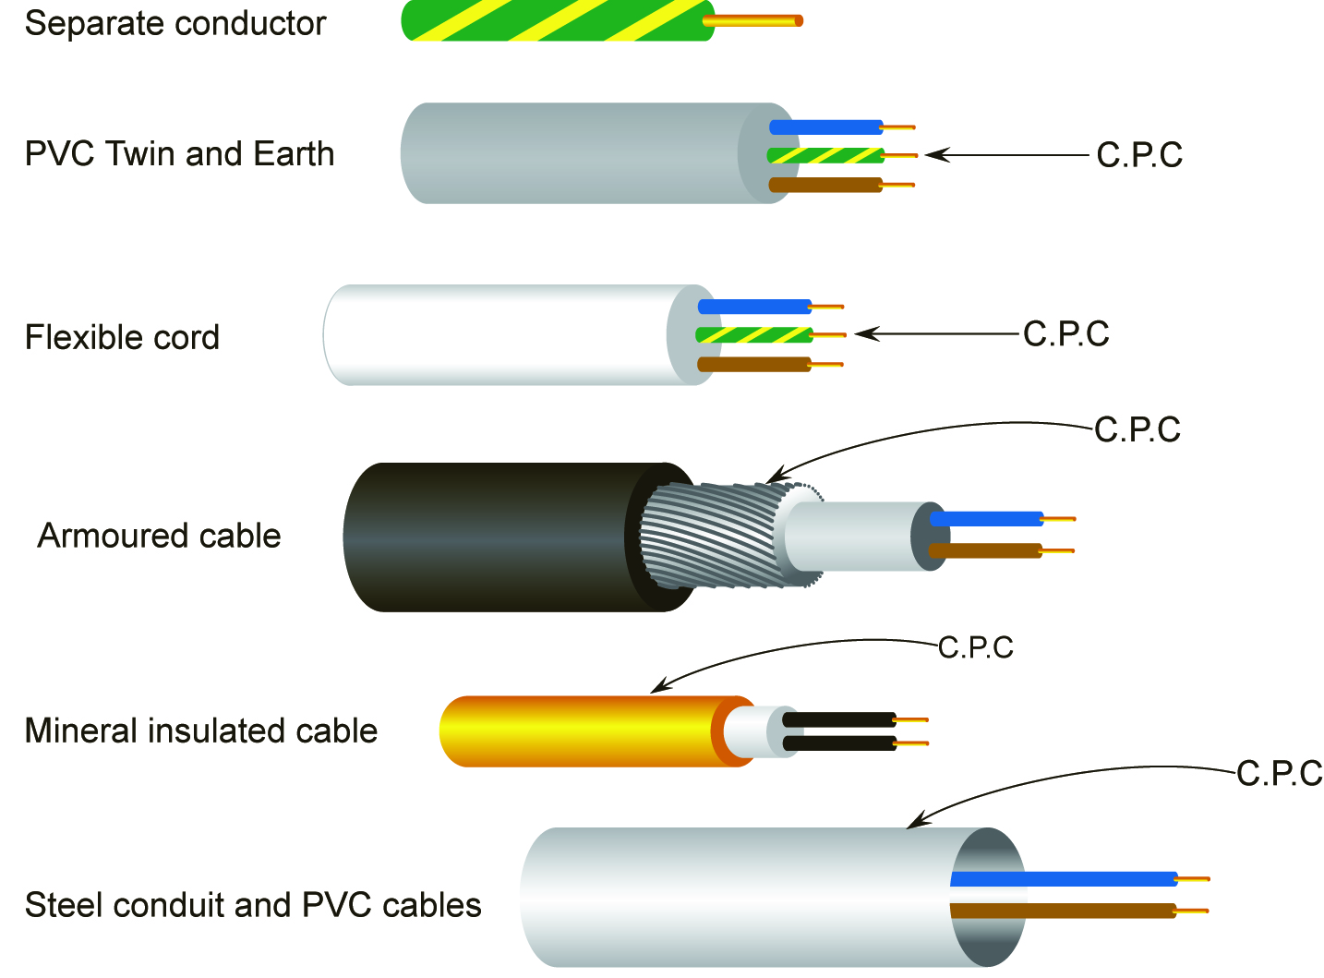

Figure 1.
Earth Electrode

The earth electrode can be any of the following types
- Earth rods or pipes
- Earth tapes or wires
- Earth plates
- Metallic reinforcement of concrete foundations buried in the ground may also serve as an earth electrode.
See Figures 2 and 3.

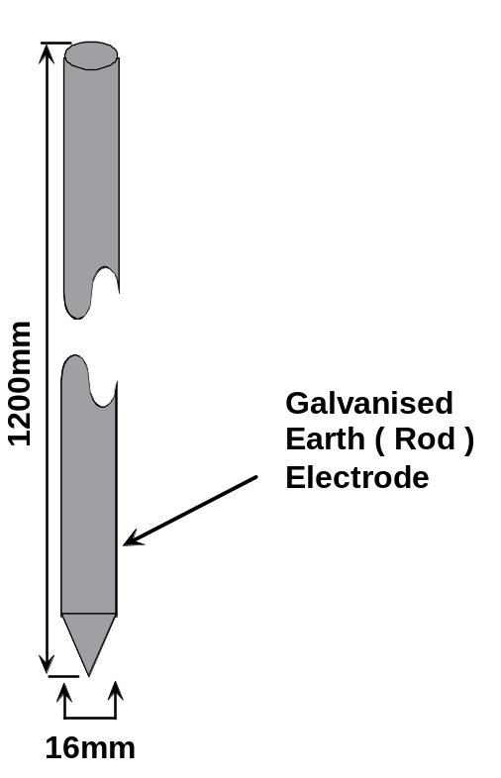 | 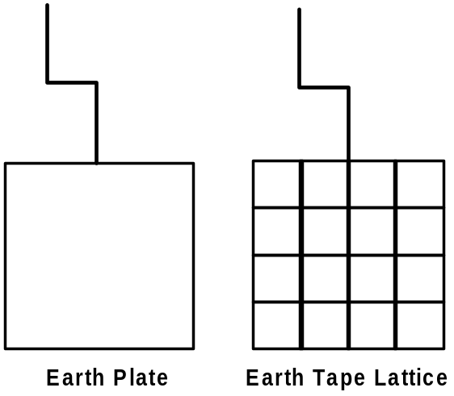
Figure 2 | Figure 3

The galvanised earth electrode above is generally sufficient for a domestic installation.
The ETCI Rules cover more specific requirements for types of earth electrode.

Function of the Earth Electrode

The function of the earth electrode is to maintain a connection between the general mass of earth and metallic parts of the consumer’s installation. These can then be regarded as being at zero potential. The earth electrode must be continuously effective and capable of carrying earth leakage and earth fault currents, which may arise.
The effectiveness of an earth electrode in conducting fault currents will depend on its contact with earth. Its contact with earth will vary depending on the type of soil in the area. The soil may be heavy sticky soil, sandy soil, soil containing a large peat content, gravel or rocky soil etc. Heavy sticky soil allows a low resistance connection to earth. Rocky soil results in difficulty in making a good connection to earth.

Location and Installation of the Earth Electrode

In a domestic installation the earth electrode is normally located external to the building. It is usually installed close to the meter cabinet. It is driven vertically into the ground and a connection made to the protruding end. When driving the electrode, care should be taken to avoid damaging it. Ensure that the electrode does not become fouled on any foundation work or underground services.
In some cases it may not be possible to drive the electrode down to its full length e.g. if rock is encountered. In such a case an alternative method must be used. The electrode may be buried horizontally or one of the other recommended earth electrode types may be used. It is not permitted to reduce the physical size of the electrode by cutting it. This will reduce its contact area and impede its effectiveness.
The earthing conductor is connected to the earth electrode by a clamp supplied with the electrode solely for this purpose. The connection must be mechanically and electrically sound, keeping in mind that in the event of an earth fault the connection would have to carry a substantial fault current. The connection is then sealed with a protective tape. This tape must be capable of withstanding deterioration from weather and chemical influences. It must also resist any attack by rodents and termites.
The earth connection must be in an enclosure with a removable inspection cover. The cover must be labelled “SAFETY ELECTRICAL CONNECTION DO NOT REMOVE”
In public places this connection may be buried or hidden but in such instances it must be available for inspection at the first energisation of the installation.
Waterproof Tape

Denso tape is generally used to protect the termination at the earth electrode. Although it is easily applied, it leaves a sticky residue on everything it comes into contact with. It has stood the test of time. Terminations have been found to be in excellent condition after exposure to arduous conditions for many years. It provides protection against the ingress of water and against damage by chemical action, rodents and termites.


Figure 4

Another form of protection, which may be used is a self-amalgamating tape. This tape relies on an internal chemical action between its layers. The action of stretching the tape around a connection activates a chemical process. After a period of about thirty minutes the tape will have formed into a solid rubber mass around the connection.

Earth Electrode Connection

Figure 5 shows a suitable type enclosure for housing the earth electrode connection.
Figure 6 shows the earthing conductor connected to the earth electrode.
Figure 7 shows the connection protected by Denso tape.
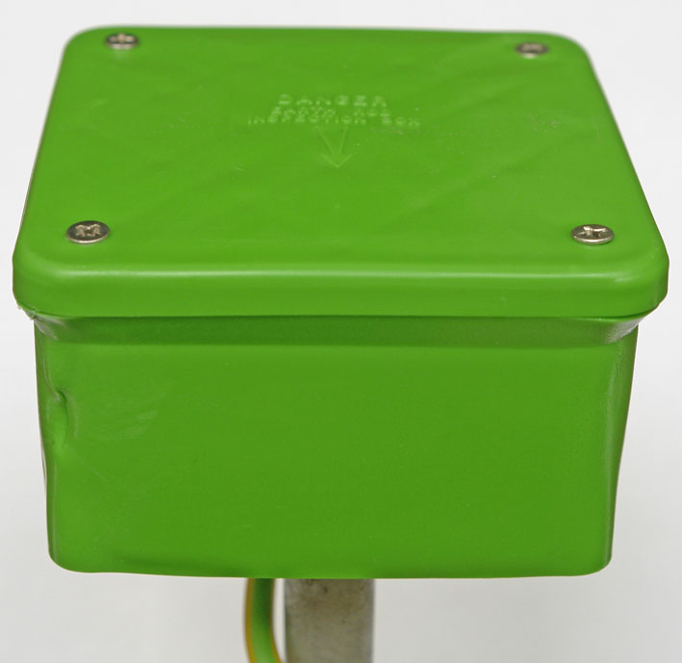
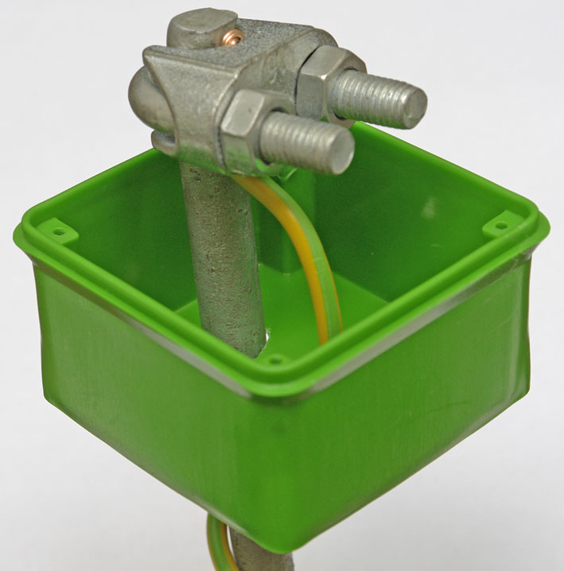
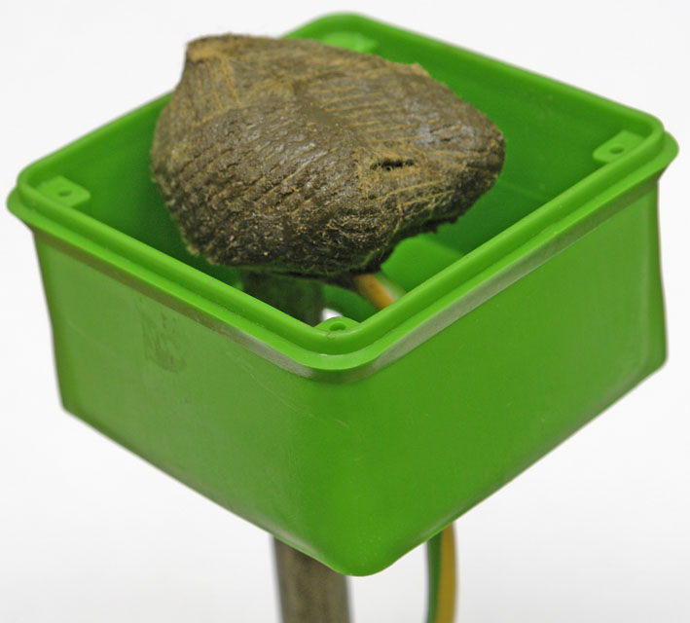

Figure 5 Figure 6 Figure 7
Types of System Earthing

There are three types of system earthing used today.
These are: -
- TN System
- TT System
- IT System

The TN system is the type used in this country. It is commonly referred to as a “neutralised system”. This basically means that the supply neutral is connected to earth at the supply point.

There are three variations of this system; the one we use in Ireland is the TN-C-S system. The two other variations are the TN-C system and the TN-S system.

Although all three are TN Systems the difference between them is in the way that the neutral and protective conductors are arranged.

In the TN-C-S System the neutral and protective conductor functions are combined in a single conductor in part of the system.

- T = Direct connection of one point to earth.

- N = Direct electrical connection of the exposed conductive parts to the earthed
conductor of the supply system. In AC systems the earthed
conductor is normally the neutral conductor.

- C = Neutral and protective functions combined in a single conductor
( known as PEN conductor )

- S = Neutral and protective functions provided by separate conductors.

TN-C-S System

The 230 Volt single phase supply to a premises is taken from the secondary winding of a DSO transformer. One terminal of this secondary winding is connected to earth ( ground ). This terminal becomes the neutral for the system. The neutral conductor is therefore at earth potential ( zero volts ).
A two core concentric cable is generally used to connect from the supply network to the premises. The centre core is the phase conductor. The outer core performs the functions of neutral and protective conductors. This conductor is known as a PEN conductor. It is terminated at the DSO main fuse unit.

PEN = PE for protective conductor ( protective earth ), N for neutral conductor.

From this point on, the neutral and protective conductors are separated and must not be connected together, anywhere throughout the entire installation. The protective conductor is referred as the Main Protective Conductor. It is connected to the Main Earthing Terminal of the installation. This means that the Main Earthing Terminal is solidly connected to the DSO neutral.

At each installation an earth electrode is provided. The earth electrode is connected to the Main Earthing Terminal and therefore to the DSO neutral. This arrangement provides the consumer with an earth terminal, which is connected to the neutral conductor of the system, thereby providing a low impedance ( low resistance ) path for the return of earth fault currents.
Impedance is the ratio of AC voltage and current. The Ohm is the unit of impedance.
Its symbol is the letter Z.
TN-C-S System Earthing

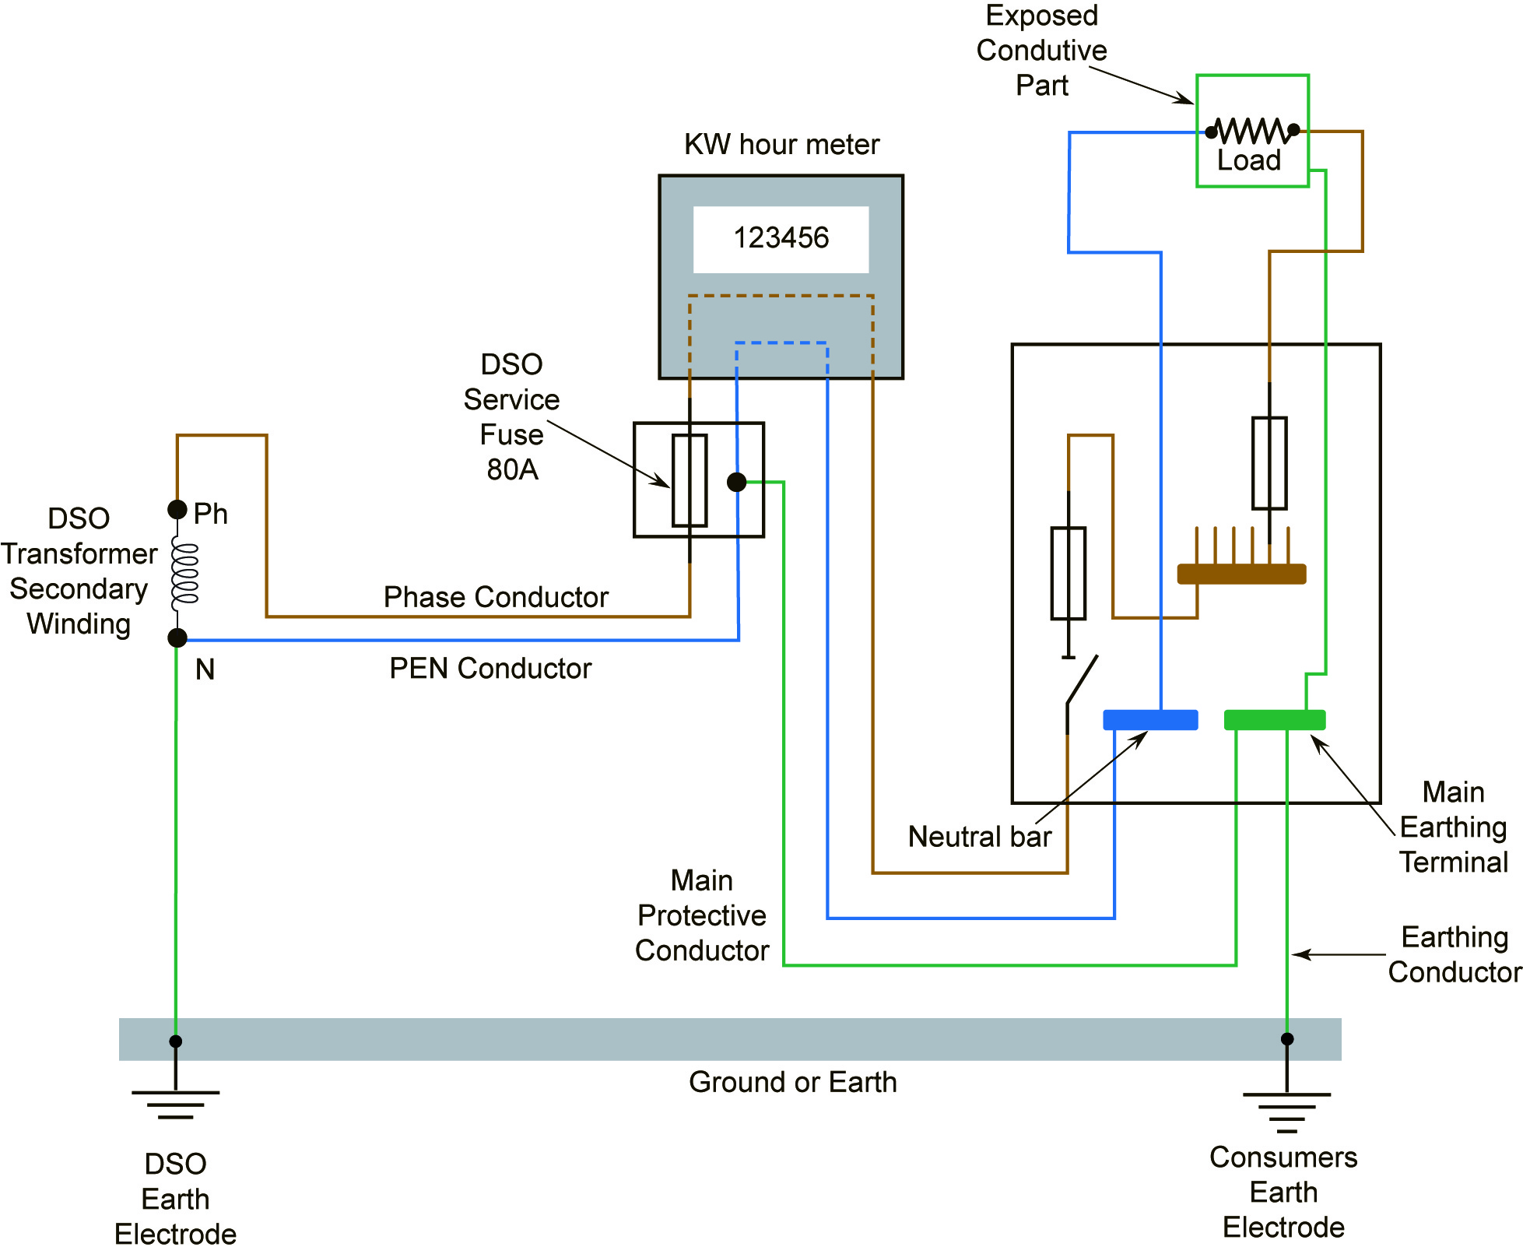

Figure 8.
Equipotential Bonding

Bonding and earthing are two different operations. They must not be confused.

Bonding simply means making an electrical connection between all metal enclosures etc., of the installation ( “exposed conductive parts” ) and the metal of all non-electrical services ( “extraneous conductive parts” ). This is done to ensure that no potential difference can appear between any of these items under fault conditions. A potential difference appearing between any two simultaneously accessible parts introduces the risk of shock to persons or animals in the area.

There are two types of equipotential bonding:
- Main Equipotential Bonding
- Supplementary Equipotential Bonding

Main Equipotential Bonding

Main equipotential bonding connects together all conductive parts of the main engineering services in an installation, to the main earthing terminal. Examples of the main engineering services are:
- Metal pipes for central heating, gas, water
- Metal ducting for heating and air conditioning systems
- Structural metal parts of the building
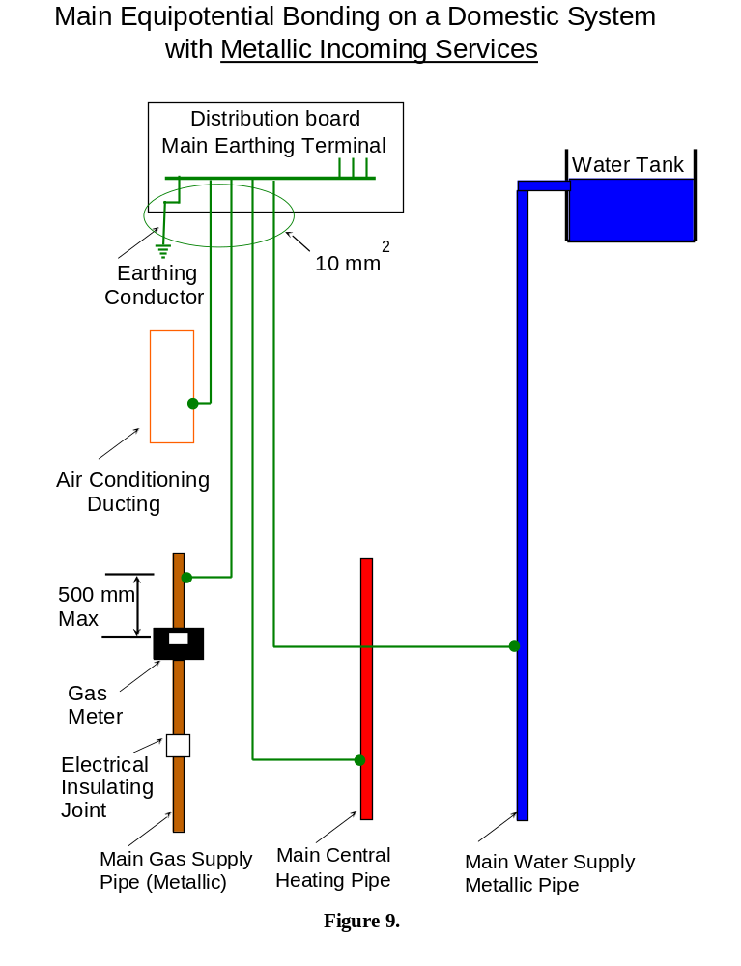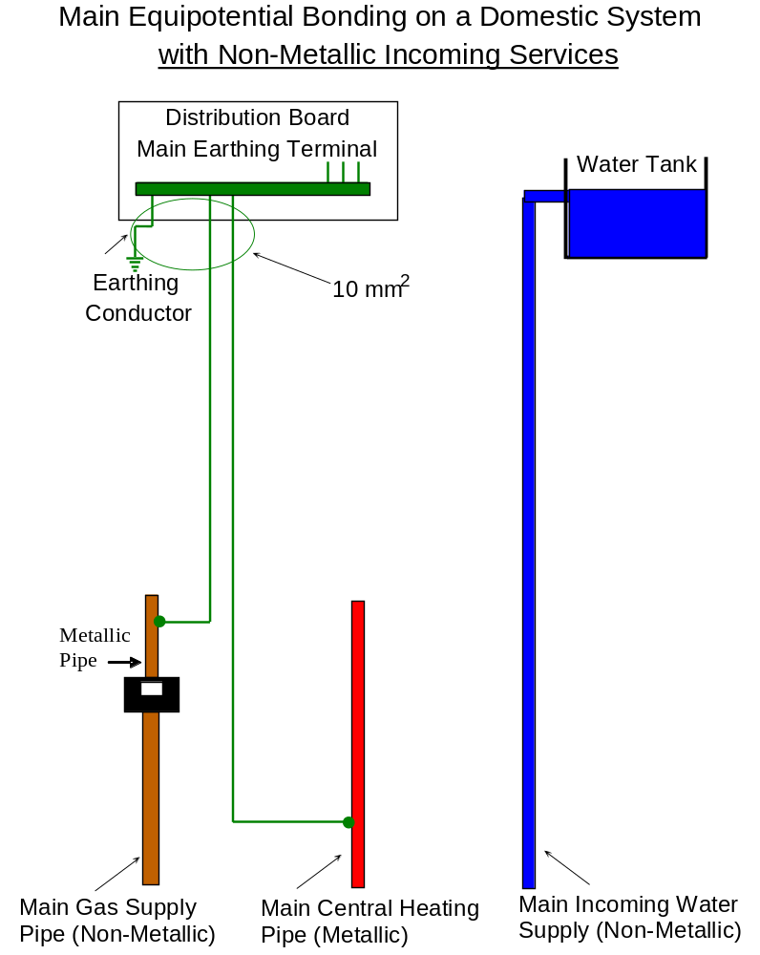

Figure 10.
Supplementary Equipotential Bonding

Supplementary equipotential bonding is generally applied to a location in an installation. It connects together all extraneous conductive parts and all exposed conductive parts in the location.
Water may conduct electricity. Extra safety measures should be applied to locations where electrical equipment is used in close proximity to water or steam. Kitchens, utility rooms, bathrooms and shower rooms are such locations.

Equipotential Bonding in a Kitchen / Utility Room

In kitchens and utility rooms, all extraneous conductive parts such as metal sinks and metal pipes must be bonded together. This equipotential bond must then be connected to a local protective conductor.

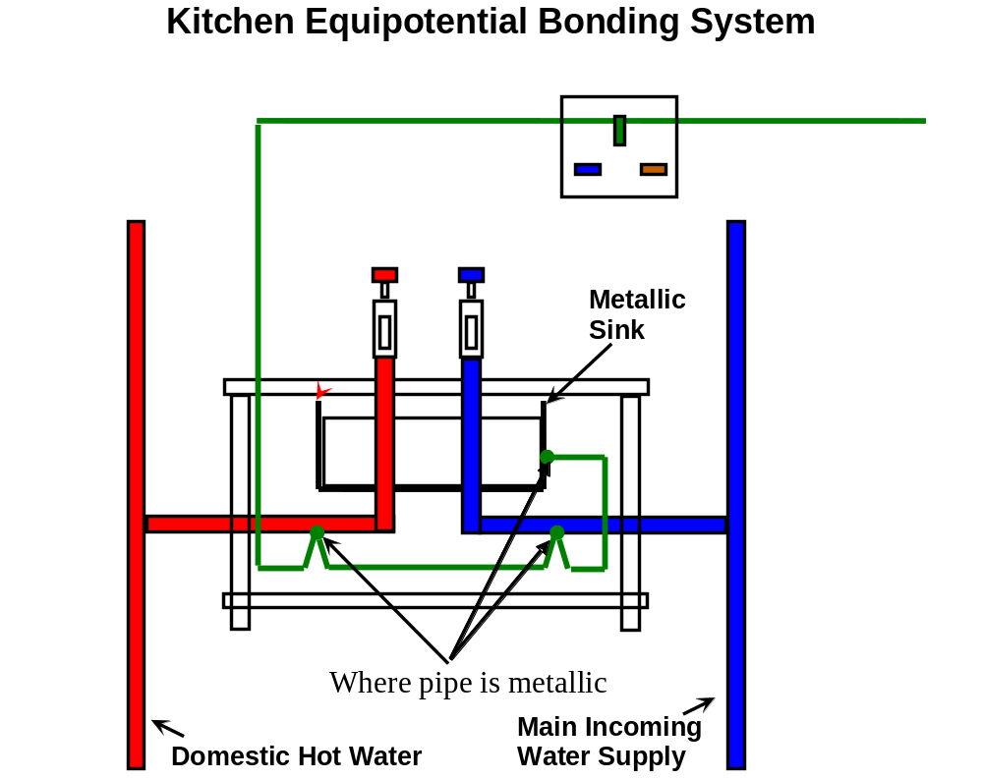

Figure 11

Note: Even if both pipes are plastic the sink must be bonded.
Equipotential Bonding in a Shower or Bathroom

Showers and baths provide an increased risk of shock hazard due to the reduction of body resistance ( skin wet ) and the possibility of contact with earth potential. Extraneous conductive parts and exposed conductive parts in an area containing a shower or bath are treated as being within zoned areas.

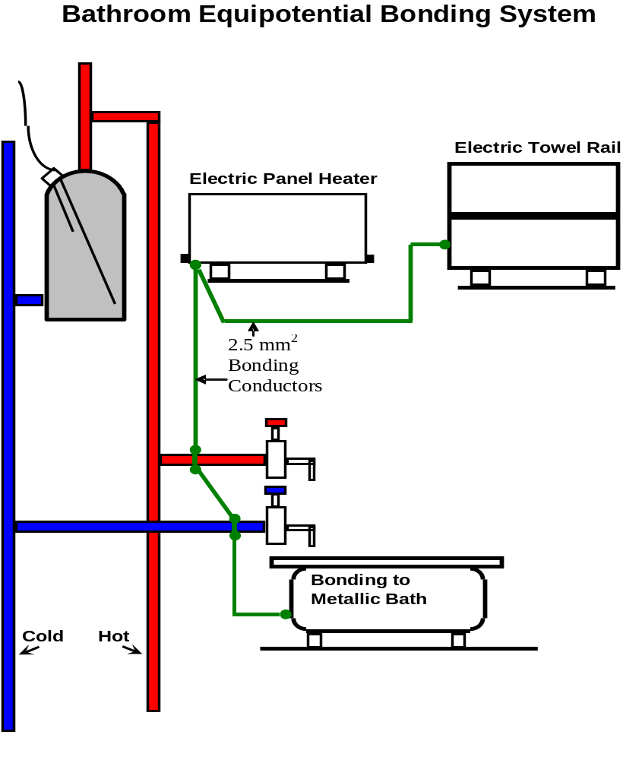
Figure 12.
Bonding Clip

The type of bonding clip used is corrosion resistant and adjustable to fit several sizes of pipe. A locking device is provided to ensure that the clip cannot work loose through expansion / contraction caused by heating / cooling or by vibration. The pipe should be first cleaned to remove any residue from building materials or oxidisation that may have built up over years on an older installation. The clip should be tightly fitted and the locking device secured to ensure good electrical contact with the pipe. A terminal is provided for the electrical connection to be made. This connection must be properly terminated, taking into account the type and size of conductor(s) involved. A metallic label must be fitted with the words “SAFETY ELECTRICAL CONNECTION DO NOT REMOVE” embossed on it.
See Figure 13.



Figure 13

Figure 14 shows a main bonding conductor connection.

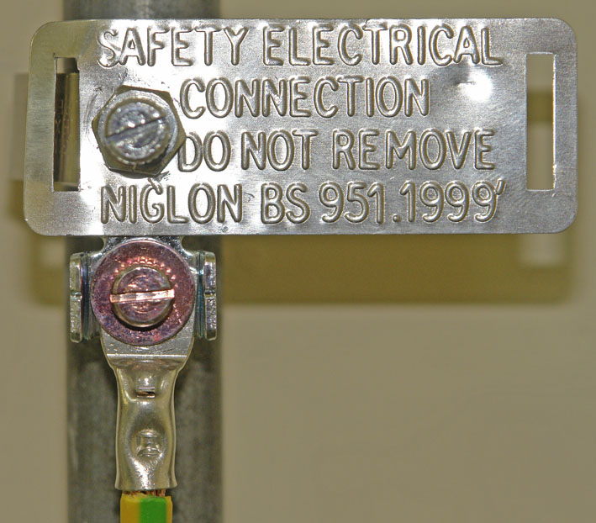

Figure 14
Unit Related ETCI Rules

Types of Distribution System | 312  312.2, 312.2.1 ( a only )
Protection against Electric Shock | 411  411.3, 411.3.1, 413.3.2  411.4, 411.4.1 ( a only )
Additional Protection against Electric Shock | 416  416.2, 416.2.1, 416.2.2, 416.2.3
Earthing and Bonding | 541  541.1 ( except note 1 )
Earthing Arrangements | 542  542.1, 542.1.2, 542.1.4  542.2, 542.2.2  542.2, 542.2.3 ( b item 1 only ), 542.2.6  542.3, 542.3.1, 542.3.2, 542.3.3, 542.3.4, 542.3.5  542.4, 542.4.1 ( items 1- 3 only ), 542.4.2
Protective Conductors | 543  543.1, 543.1.1 ( domestic only ), 543.1.3  543.1.4 ( item 1 only )  543.2, 543.2.1 ( items 1,2 and 4 ), 543.2.3  543.3, 543.3.1, 543.3.2, 543.3.3  543.4, 543.4.1, 543.4.2
Main Equipotential Bonding Conductors | 544  544.1, 544.1.1, 544.1.2, 544.1.3, 544.1.4  544.1.5, 544.1.6
Supplementary Equipotential Bonding Conductors | 544  544.2 all
Equipotential Bonding in a Shower or Bathroom | 701  701.54, 701.544 all
Tables | 54A  54B  54C
Figures | 54.1  701.1  701.2

