TRADE OF HEAVY VEHICLE MECHANIC

PHASE 2

Module 1
Induction/Customer Care/Bench Fitting/Welding

UNIT: 5

Oxy-Acetylene Heating and Cutting

Table of Contents
Aims and Objectives 1
Learning Outcome: 1
Setting up an Oxyacetylene torch 1
1. Preparation and safety 1
2. Step-by-step instruction 3
Preparation and safety 5
Step-by-step instruction 5
Preparation and safety 5
Flame-cutting equipment 7
Lighting and adjusting the cutting flame 8
Cutting technique 9
Nozzle cleaning 12
Using an Oxyacetylene torch 13
1. Preparation and safety 13
2: Step-by-step instruction 14

Aims and Objectives

Learning Outcome:
By the end of this unit each apprentice will be able to:
- Identify and state the function of common items of oxy-acetylene welding, brazing, cutting and heating equipment
- State the safety precautions to be observed when using this equipment
- Light up, adjust gas pressures and use ox
- Cut mild steel pieces to size, using oxy-acetylene or oxy-propane cutting equipment
- Use oxy-acetylene or oxy-propane gases to heat components correctly

Setting up an Oxyacetylene torch

1. Preparation and safety

Objective
- Set up an Oxyacetylene torch for Welding and Brazing.

Safety check
- Oxygen and acetylene cylinders must be securely stored in an upright position.
- An oxyacetylene torch can produce a large amount of heat. Be aware that any objects you direct the flame towards will become hot.
- Always have a suitable fire extinguisher near your work area.
- Do not use an oxyacetylene torch near any flammable materials.
- Make sure that you understand and observe all legislative and personal safety procedures when carrying out the following tasks. If you are unsure of what these are, ask your supervisor.

Points to note
- If a cylinder falls over and breaks the main valve off, the cylinder will become a missile and cause extreme damage.
- Wear a leather apron or similar protective clothing and welding gloves when using an oxyacetylene torch. T-shirts, nylon and polyester blend clothing will not provide enough protection. Ultraviolet light and sparks of hot metal will pass through them.
- Always use proper welding goggles. Do not use sunglasses because they do not filter the extreme ultraviolet light as effectively. The plastic used in sunglass lenses will not protect your eyes from sparks.
- Never point the lighted flame toward another person or any flammable material.
- Always light the oxyacetylene torch with the striker. A cigarette lighter or match would put your hand too close to the igniting tip.
- Wherever possible, use a heat shield behind the component you are heating. This will prevent nearby objects from becoming hot.
- After heating a piece of metal, label it as "HOT" with a piece of chalk so that others will not attempt to pick it up.

Component identification
- Some parts of this illustration are labeled. It is important to learn the names of these equipment components.
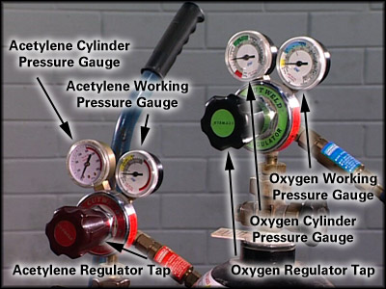

2. Step-by-step instruction
- Check equipment: First, make sure that the gas flow from both the oxygen and the acetylene cylinders is turned off tightly. The two cylinders are secured in an upright position. This is usually on a wheeled trolley. Look at the hose pressure and cylinder pressure gauges on top of each cylinder. Both gauges on each cylinder should read zero. If both gauges do not read zero, turn the main cylinder valve on the top of the cylinder clockwise, to close it completely. Then you must purge the system of any gas.
- Purge the system: To purge the system, make sure the main cylinder valve is closed tightly. Pick up the torch handle and note that it has two hoses attached. One hose supplies acetylene, the other oxygen. Turn the oxygen regulator under the gauges clockwise, and open the oxygen valve on the handle. This will purge any gas that may still be in the system and the gauges should both drop back to zero. Repeat this procedure with the acetylene cylinder.
- Install the torch handle: The torch handle is the connection between the hoses and the working tips. It consists of a body and two taps. It’s used for both welding, Brazing and heating. Different attachments are connected to the handle to enable cutting. Examine the connections. One connection is marked “OX”, and is for the oxygen hose. The other is marked “AC”, and is for the acetylene hose.
- Connect the hoses: As a further safety precaution, you’ll find the oxygen connector is right hand thread and the acetylene connector is a left hand thread.
- Install the correct tip: Welding tips come in sizes that are stamped with a number. Number one is the smallest tip. The larger the number, the larger the tip and the greater the heat that it will provide. Select the tip size suitable for the task and screw it onto the end of the torch handle. Hold the torch handle in your hand, so that you can comfortably adjust the oxygen and acetylene taps. Position the tip so that it faces away from you. Gently tighten the tip-securing fitting.
- Adjust the pressure of the gas flow: You are now ready to adjust the gas pressure for heating. Look at the two valves on the torch handle. The valve next to the oxygen hose controls the flow of oxygen to the tip. Close it tightly clockwise. The valve next to the acetylene hose controls the flow of acetylene to the tip. Also, close it tightly clockwise.
- Turn on the gases: Now that you’re ready to use the torch, turn the main valve on the top of each cylinder counter-clockwise half a turn to open the valve. The needle on the cylinder pressure gauge will rise to show you the pressure in the cylinder. Turn the oxygen regulator handle clockwise until the needle in the gauge registers 2-5 PSI. Turn the acetylene regulator handle clockwise until the needle in the gauge registers 2-5 PSI. This is your working pressure for welding light plate.
- Check the area: Before you light the torch, check the area you’re working in to make sure there are no flammable materials or fluids nearby. Workmates should also be clear of the area. The welding flame is not only extremely hot; it also produces dangerous ultra violet rays, which will damage your eyes. It is absolutely vital that you are wearing the right safety gear: gloves and tinted goggles or face mask. So put them on and adjust them comfortably.
- Ignite the torch: Now you are ready to ignite the torch with the striker. The tip of the torch must be pointing downwards away from your body and away from the gas cylinders. Turn the acetylene valve on the torch handle slightly towards the ‘ON’ position. You should hear the gas hissing. Hold the striker against the tip of the torch with the lighter cup between the torch and you. Flick the striker to create the spark that will ignite the gas at the tip of the torch. Open the acetylene valve slowly until the sooty smoke produced by the torch disappears. Then slowly open the oxygen valve on the torch handle.
- Adjust the flame: As you open the oxygen valve, you will see the color of the flame change. The pure acetylene flame is yellow, and it will change to blue as you add the oxygen. Continue to open the oxygen valve until you can observe a small, sharp blue cone in the center of the torch flame. This is the “neutral”, you can now adjust to the desired flame, for the task you are doing. ( Welding, brazing )

Preparation and safety

Objective
- Set up an Oxyacetylene torch for Heating.
Safety check and Points to note: are the same as for welding and brazing.
Heating a component with an oxyacetylene torch uses the same nozzle set up as welding. The main difference is the increase in gas pressure. The pressure is increased to 10 psi for oxygen and 5 psi for acetylene. As you open the oxygen valve, you will see the color of the flame change. The pure acetylene flame is yellow, and it will change to blue as you add the oxygen. Continue to open the oxygen valve until you can observe a small, single light blue cone in the center of the torch flame. This is the “neutral” flame which is used for general heating.

Step-by-step instruction
- Check equipment:
- Purge the system:
- Install the torch handle:
- Connect the hoses:
- Install the correct tip:
- Adjust the pressure of the gas flow:
- Turn on the gases:
- Check the area:
- Ignite the torch
- Adjust the flame.

Preparation and safety

Objective
- Set up an Oxyacetylene torch for Cutting.
Safety check and Points to note: are the same as for welding and brazing.

The oxy-fuel cutting process
Flame Cutting is made possible because Iron burns in pure oxygen when heated to its ignition temperature of 890°C. The process consists of creating a local hot spot on the surface-of the steel with a flame to ignition temperature, then directing a high pressure jet of pure oxygen on to the pre-heated spot. A vigorous and rapid chemical reaction takes place. The action of the cutting torch is that the jet of pressure oxygen being directed on to the hot metal oxides it and since the oxide it and since the oxide has a lower melting point than the surrounding steel it melts immediately and is blown through by the stream of oxygen. The edges of the cut will be subject to some hardening because of the rapid rate in which the heat is conducted away from the cutting area. However for steels below 0, 3% carbon content it is unlikely to cause a problem.
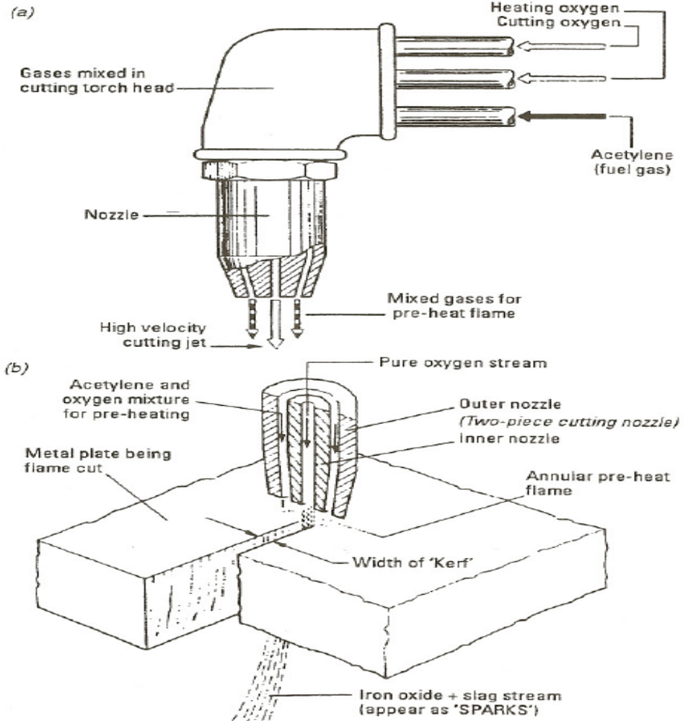
The action of oxygen cutting

Flame-cutting equipment
Since the oxygen-cutting process involves directing a high-pressure jet of oxygen continuously on to an area of steel that has been previously heated to ignition temperature, the basic equipment combines a preheating flame and a pure oxygen source. Both these requirements are provided by a specially designed cutting torch and nozzle combination which is connected to a FUEL GAS and an OXYGEN supply, in the same manner as a gas-welding torch. The cutting torch and nozzle combinations are of' varying design, depending on the specific type of cutting to be employed. The equipment required for gas welding has already been described and oxy-gas cutting equipment is basically similar except for the following items:
Cutting torch The torch is of similar construction to that used for welding. The oxygen and fuel gas are mixed to form the preheating flame and a separate supply tube is incorporated to supply additional oxygen required for the cutting process. This oxygen supply is controlled by a separate valve lever on the torch.
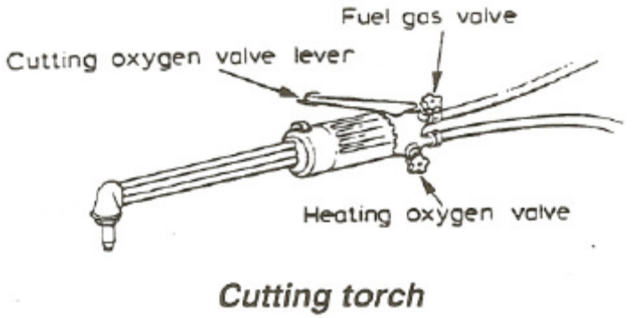
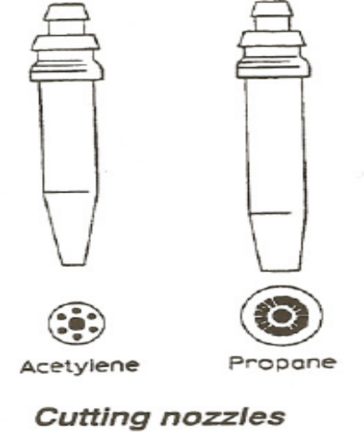
Nozzles The nozzles used for cutting differ from the welding nozzles in that there is a central hole through which the cutting oxygen passes, and around this there are a series of holes or flutes which deliver the oxy-fuel-gas mixture for the preheating flame. The size of the nozzles is determined by the diameter of the central hole or orifice .It is important to ensure that the correctly designed nozzle is used with the various

Lighting and adjusting the cutting flame
The procedure used for lighting a welding torch is adopted when lighting a cutting torch, but with one important difference. The fuel gas regulator is set to the correct working pressure in the normal way and the oxygen regulator is set to the correct working pressure with the cutting oxygen valve on the torch in the open position. The fuel gas is lit and the flame adjusted, in the same manner as for a welding torch, until it ceases to smoke. The heating oxygen valve is then opened and adjusted (similar to the neutral flame setting) until there is a series of nicely defined white inner cones in the flame (in the case of the multi-port nozzle) or a short white conical ring, if the nozzle is of the annular port type. At this stage the cutting oxygen valve is opened and the flame readjusted to a neutral condition. The oxygen cutting valve is then closed and the torch is ready for use.

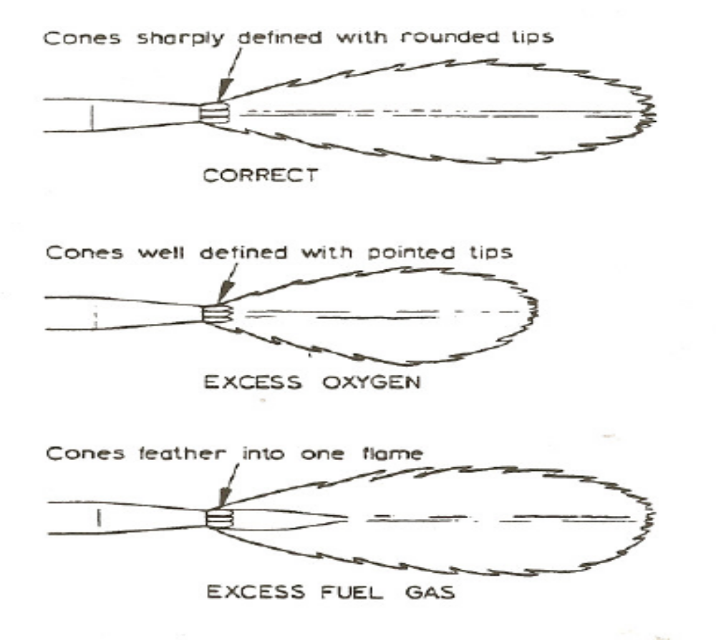

Cutting technique
The plate should be cleaned in the area where cutting will take place, and then positioned so as to be convenient for working (if possible). Invariably the flat position is the most convenient. The blowpipe should be held in a balanced position so that freedom of movement is possible. Hold the nozzle 3-5mm above before the plate surface and continue preheating until a bright red spot develops at the plate edge. The cutting oxygen valve should then be opened slowly until full flow is achieved. The blowpipe should then be moved at a steady speed along the line of the desired cut. In general, the speed will be correct when the slag sprays downwards immediately beneath the nozzle (i.e. zero drag). Care should be taken to ensure that complete penetration of the plate is achieved. The number of cutting interruptions should be kept to a minimum by ensuring that as long a cut as is possible is made. When it is necessary to interrupt a cut, a small hole adjacent to the kerf should be made in the unwanted plate and the cutting oxygen turned off before the blowpipe is withdrawn. To recommence the cutting, start in the area of the hole and as cutting commences continue as before.

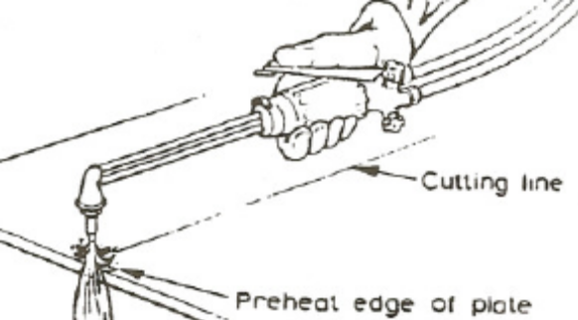

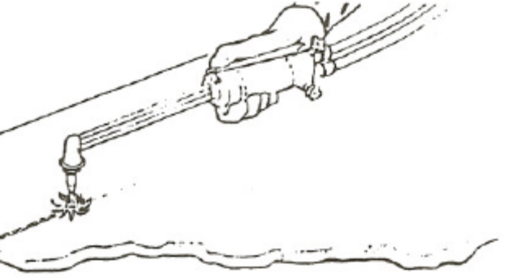
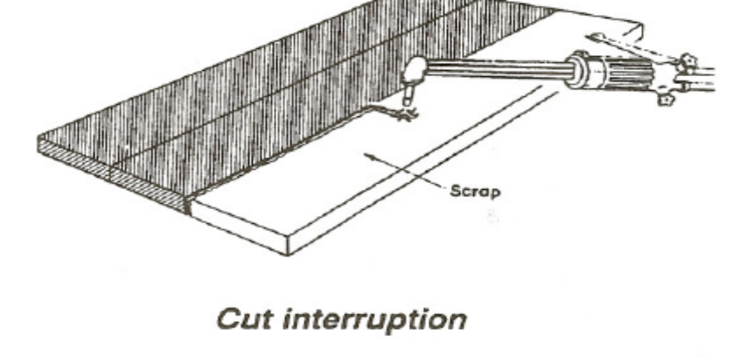
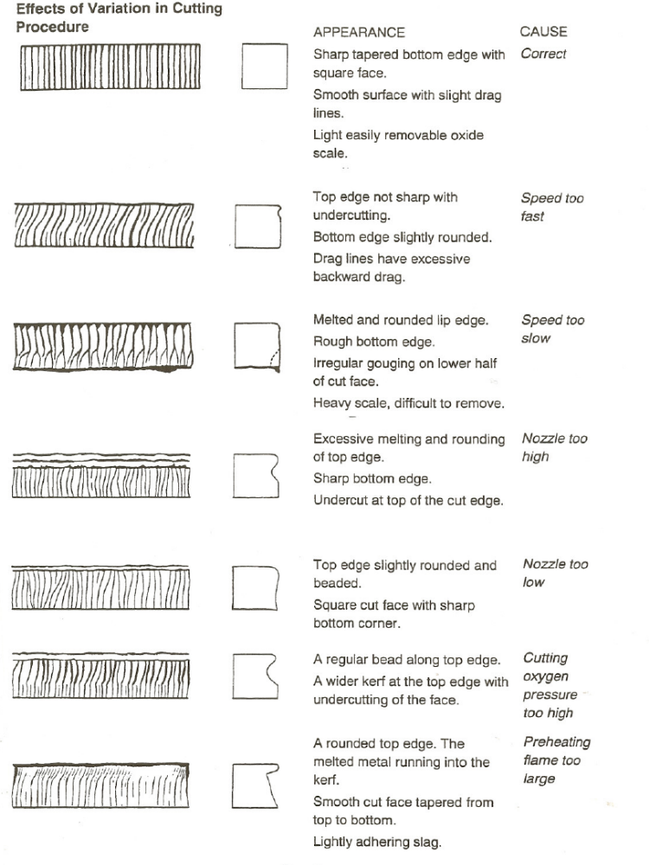

Nozzle cleaning
Holes must only be cleaned with a special nozzle cleaner of correct size. Hold at right angles to the nozzle end.
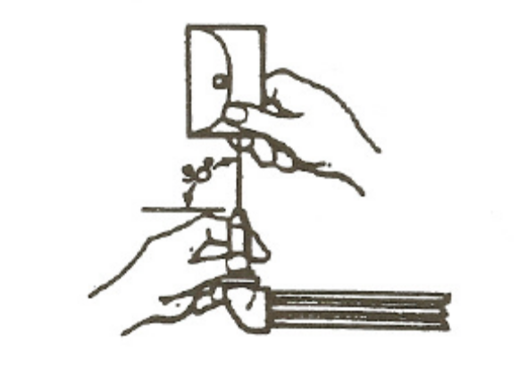
If end of nozzle is damaged rub with a piece of fine emery paper laid on a piece of glass. Hold nozzle at right angles to glass so that edges of holes are made sharp and square.
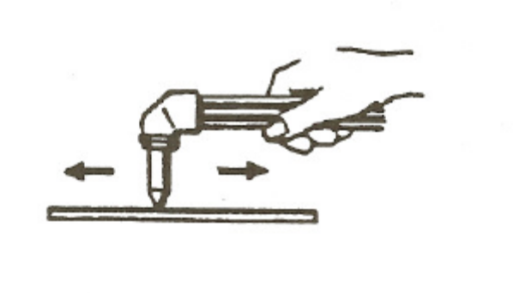
Clean dirty nozzles by immersion in a solution containing nozzle cleaning compound
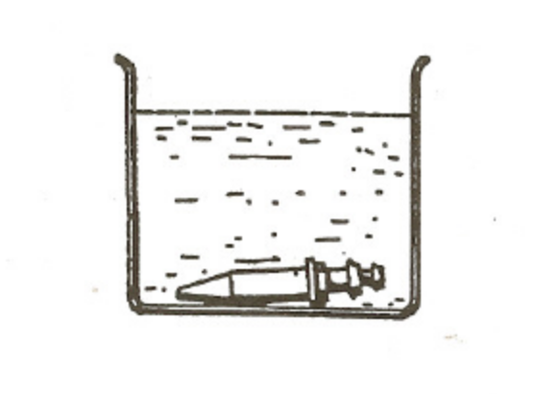

Using an Oxyacetylene torch

1. Preparation and safety

Objective
- Use an oxyacetylene torch for heating.

Safety check
Oxygen and acetylene cylinders must be securely stored in an upright position.
An oxyacetylene torch can produce a large amount of heat. Be aware that any objects you direct the flame towards will become hot.
Always have a suitable fire extinguisher near your work area.
Do not use an oxyacetylene torch near any flammable materials.
Make sure that you understand and observe all legislative and personal safety procedures when carrying out the following tasks. If you are unsure of what these are, ask your supervisor.

Points to note
If a cylinder falls over and breaks the main valve off, the cylinder will become a missile and cause extreme damage.
Wear a leather apron or similar protective clothing and welding gloves when using an oxyacetylene torch. T-shirts, nylon and polyester blend clothing will not provide enough protection. Ultraviolet light and sparks of hot metal will pass through them.
Always use proper welding goggles. Do not use sunglasses because they do not filter the extreme ultraviolet light as effectively. The plastic used in sunglass lenses will not protect your eyes from sparks.
Never point the lighted flame toward another person or any flammable material.
Always light the oxyacetylene torch with the striker. A cigarette lighter or match would put your hand too close to the igniting tip.
Wherever possible, use a heat shield behind the component you are heating. This will prevent nearby objects from becoming hot.
After heating a piece of metal, label it as "HOT" with a piece of chalk so that others will not attempt to pick it up.

2: Step-by-step instruction
- Light the torch and adjust neutral flame: Light the torch and adjust the gas flow so that you have a neutral flame.
- Heat for 'Removal': Place a flywheel and ring gear assembly on a set of insulating spacers, to elevate it from the working surface. Direct the flame onto the ring gear and apply the heat until smoke starts to appear. Stop applying the heat. At this stage, the ring gear is hot enough to remove by gently tapping with a hammer and drift. DO NOT TOUCH the metal with your hands. Use welding Gloves and tools that are designed for use in a hot environment.
- Heat to 'Red Hot': Direct the flame to the component you wish to heat. If the component is made from thin metal it will heat quicker than one that is thicker. Apply the heat evenly, until you notice the object begin to glow red. Once the glow is uniform, the metal will now be hot enough to manipulate. Once again DO NOT TOUCH the metal with your hands. Use welding gloves and tools that are designed for use in a hot environment.
- Shut down: When you have finished the job, you will need to shut down the equipment. Turn off the acetylene valve on the torch handle. This will extinguish the flame. Turn off the oxygen valve on the torch handle. Next, remove your safety goggles or mask and your welding gloves. Turn the main cylinder valve clockwise on the top of both gas cylinders. Now open the two valves on the torch handle to “bleed” the system. Turn both the oxygen and acetylene regulator handles counter-clockwise until they are loose. Close both valves on the torch handle. Put the handle and tips away, and return the gas cylinders and their hoses to their proper storage area.


27-33 Upper Baggot Street
Dublin 4

