TRADE OF HEAVY VEHICLE MECHANIC

PHASE 2

Module 1
Induction/Customer Care/Bench Fitting/Welding

UNIT: 6

Electric Arc and Metal Inert Gas (MIG) Welding

Table of Contents
Aims and Objectives 1
Learning Outcome: 1
Manual Arc Welding 2
Welding Techniques 3
Hazards and Safety Precautions 16
Metal Inert Gas (MIG) or Gas Shielded Metal Arc Welding 16
Description of the Process 16
Spray transfer 18
Applications 18
FACT SHEET 19

Aims and Objectives

Learning Outcome:
By the end of this unit each apprentice will be able to:
- Identify and state the function of common items of manual/arc welding equipment
- Identify and state the function of Metal Inert Gas (MIG) welding equipment
- Identify and state the function of Tungsten Inert Gas (TIG) welding equipment
- State the safety precautions to be observed when using this equipment
- Weld the following joints: Lap and butt, fillet single run and multi-run

.

Manual Arc Welding
The manual metal arc process when two wires which form part of an electrical circuit are brought together and then pulled slowly apart, an electric spark is produced across their ends. This spark, or arc as it is called, has a temperature of up to 3,600°C. As the arc is confined to a very small area it can melt metal almost instantly. If one of these wires is connected to the job and the other to a wire rod or electrode, as it is usually called, the heat of the arc melts both the metal of the job and the point of the electrode. The molten metal from the electrode mixes with that from the job and forms the weld. It is important to realize that tiny globules of the molten metal from the electrode are forced through the arc (they do not fall by gravity). If this were not so it would be impossible to use this process for overhead welding.
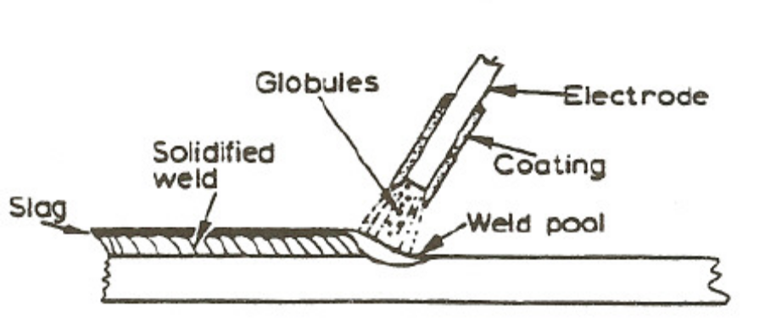

Manual metal arc welding equipment
To create the arc for welding, a voltage between 60 and 100 Volts is required to create the arc, but once it has been established, 20–40 Volts is required to maintain it. The following stages occur when creating an arc:
- With the welding plant switched on, and before welding commences, no current passes through the leads and the ammeter reads zero. A voltage has been applied to the circuit, however, and the voltmeter will read the open-circuit or no-load voltage (i.e. between 60 and 100 V).
- When the electrode is brought into contact with the job a large current, called The Short-circuit Current, passes through the leads, and the ammeter will deflect a large amount. While this is happening, however, the voltage drops almost to nothing. The tip of the electrode becomes hot because of the resistance created between it and the job.
- If the electrode is slightly withdrawn an arc is formed between the electrode and the job. The air between the two conducts the welding current. As the arc is formed the voltage rises to between 20 and 40 V and the current falls to the value to which it has been set (i.e. the welding current). The arc is then in the normal welding condition. The heat generated by the arc melts both the work piece and the electrode, and metal is deposited in the weld pool. During the depositing of the weld metal, variations in both the voltage and current of the arc can occur and the welding plant must be capable of coping with these changes.

Welding Techniques
Current too low: If the current value is too low the resulting weld has poor penetration, due to the lack of heating to create complete fusion. The weld filler metal tends to heap up on the surface of the plate without fusing to it and the arc has an unsteady sputtering sound.
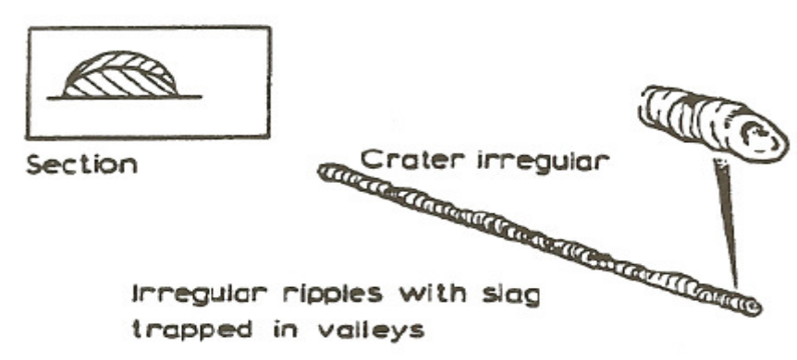
Current too high: When the current value used is too high the electrode becomes red hot and a large amount of spatter takes place. This can result in blowholes being formed in the plate, excessive penetration resulting in weld metal beads on the underside of the plate, undercut along the edge of the weld and excessive oxidation and slag which is hard to remove. The arc has a fierce crackling sound
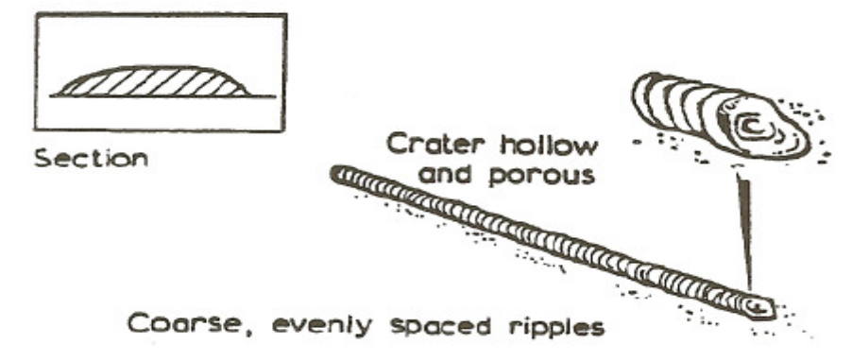
Correct current: With the correct current the arc has a steady crackling sound. The weld formed has good penetration and is easily controlled.
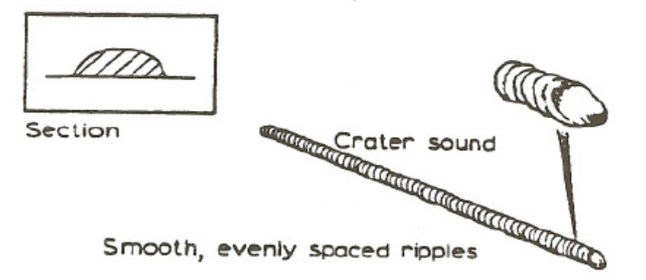
Arc length: The arc length is the distance between the tip of the electrode and the surface of the weld pool. It should be approximately equal to the diameter of the wire core of the electrode being used. When this distance is correct the electrode metal is deposited in a steady stream of metal particles into the weld pool. If the arc length is reduced it becomes difficult to maintain the arc, due to the increase in welding current that takes place, and it can result in the electrode becoming welded to the weld pool. Also, if the arc length is increased the welding current is reduced, resulting in a poor weld being produced, and the protective gas shield produced from the electrode surrounding the weld pool cannot efficiently prohibit the formation of oxides, etc., in the weld.
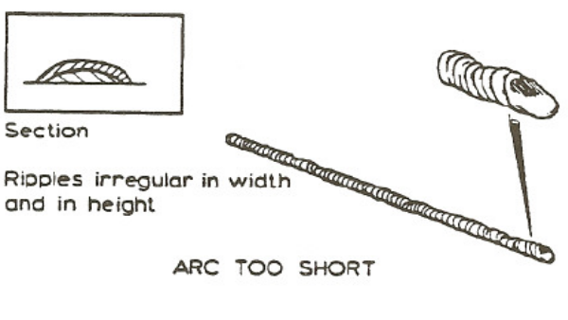

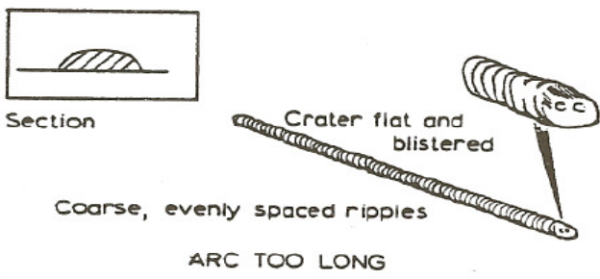
Speed of travel: A fast rate of travel results in a thin deposit of the filler metal and can result in insufficient fusion of the filler metal with the base metal. The surface of the weld has elongated ripples and a porous crater. Too slow a rate of travel gives a wide thick deposit of the filler and it can allow the slag to flood the weld pool making it difficult to deposit the filler metal. The surface of the weld appears as coarse ripples and has a flat crater.
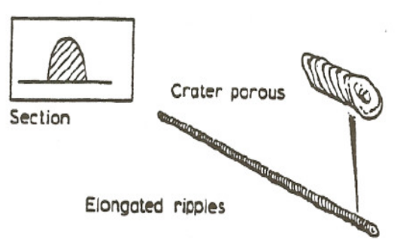

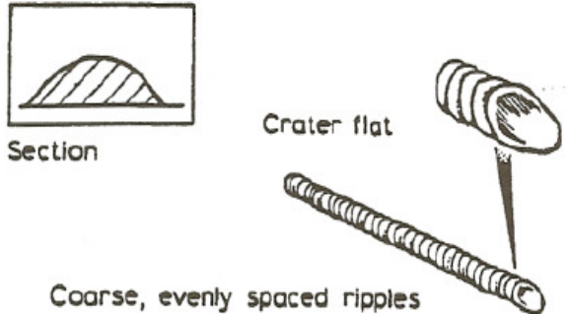
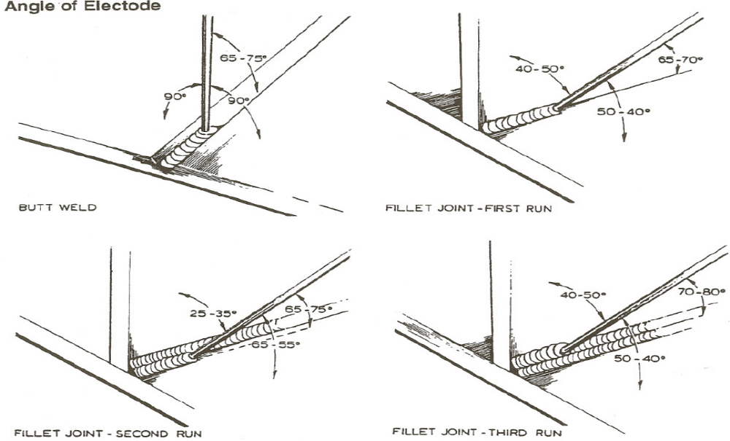
Angle of Electrode: When welding it is important to maintain the correct angle of the electrode as this will deliver a uniform deposit of filler rod in to the work piece.
When the weld is completed with the correct current, arc length, speed of travel and electrode angle, the deposit will be of regular thickness and width and the surface will have even, smooth ripples, and be free from slag entrapment and porosity.

Weld defects and their causes
Lack of penetration: is the failure of the filler metal to penetrate into the joint, caused by:
      - Incorrect edge penetration
      - Incorrect welding technique
      - Inadequate de-slagging.
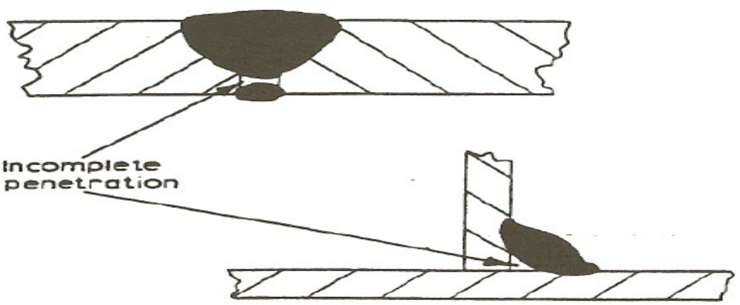
Lack of fusion: is the failure of the filler metal to fuse with the parent metal. It is caused by:
- Insufficient heat
- Too fast a travel
- Incorrect welding technique.
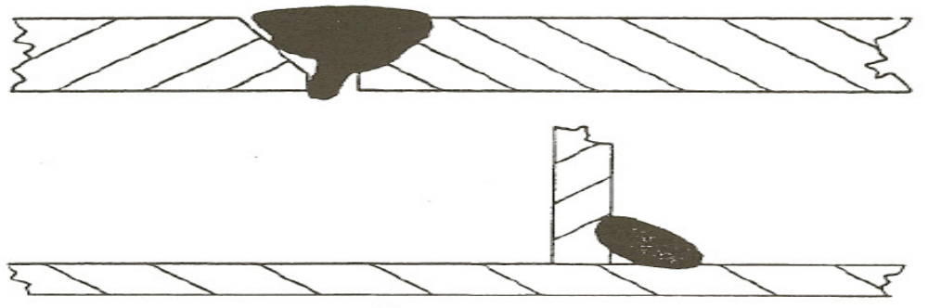
Porosity: is a group of small holes throughout the weld metal, caused by:
- Trapping of gas during the welding process, due to chemicals in the metal, dampness, or rapid cooling of the weld.
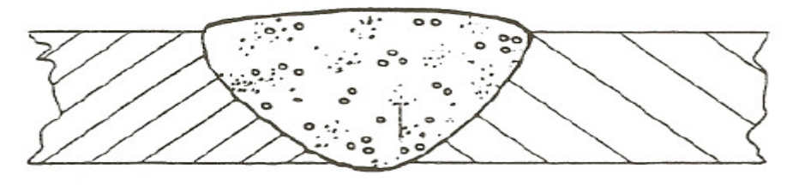
Slag inclusion: is the entrapment of slag or other impurities in the weld, caused by :
- Slag from previous runs not being cleaned away, or insufficient cleaning and preparation of the base metal before welding commences.
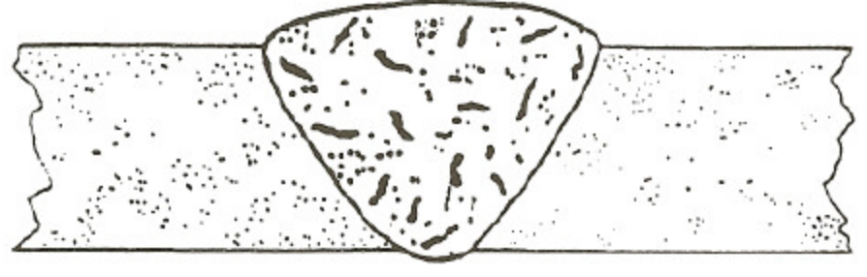
Undercut: are grooves or slots along the edges of the weld caused by:
- Too fast a travel
- Too great a heat build-up
- Bad welding technique.
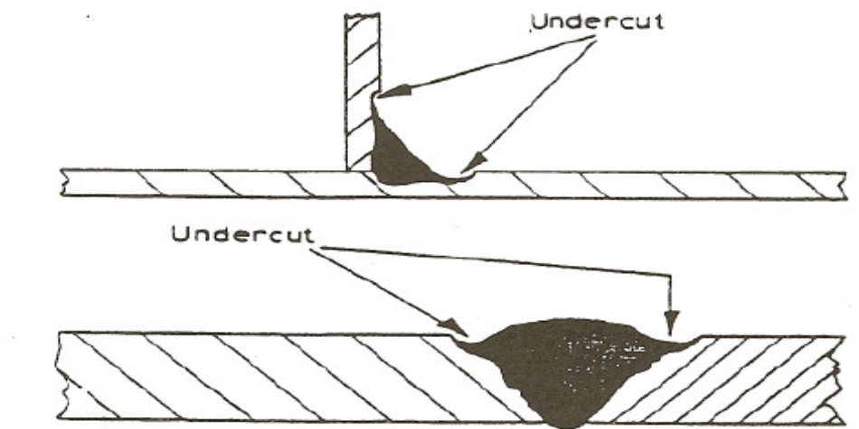
Overlays: consist of metal that has flowed on to the parent metal without fusing with it, caused by:
- Insufficient heat.
- Contamination of the surface of the parent metal.
- Bad welding technique.
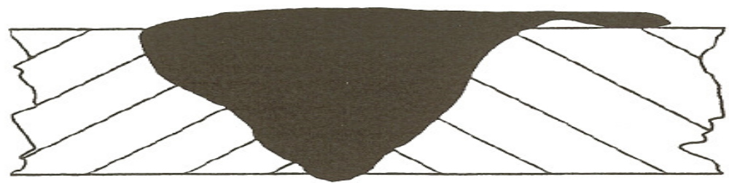
Cracking: is the formation of cracks either in the weld metal or the parent metal, caused by:
- Bad welding technique
- Unsuitable parent metals used in the weld.
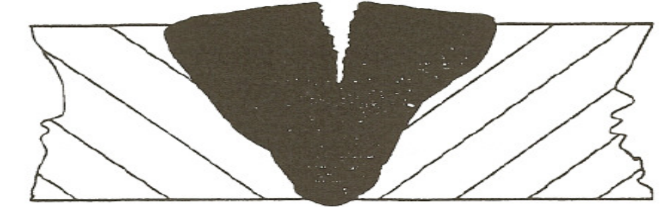
Blowholes: are large holes in the weld, caused by:
- Gas being trapped, due to moisture
- Contamination of either the filler or parent metals.
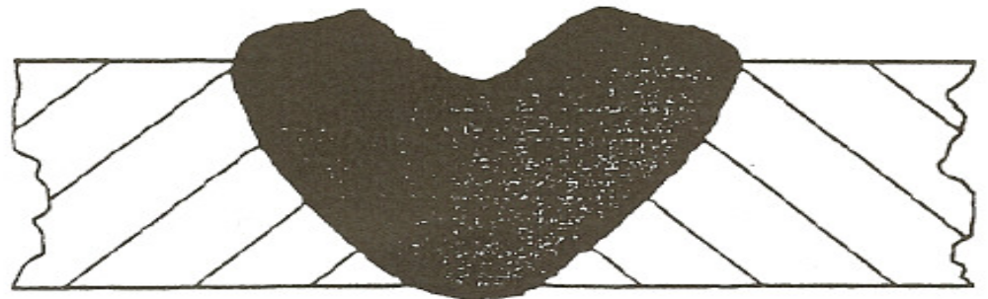
Burn through: is the collapse of the weld pool due to:
- Poor edge preparation
- Too great a heat concentration.
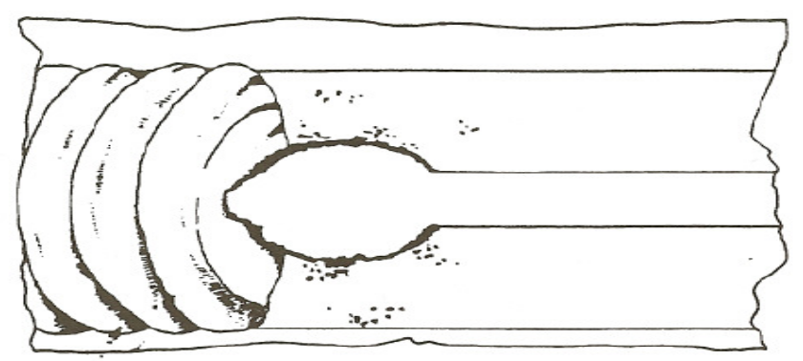
Excessive Penetration: is where the weld metal protrudes through the root of the weld, caused by:
- Too big a heat concentration.
- Too slow a travel.
- Incorrect edge preparation.
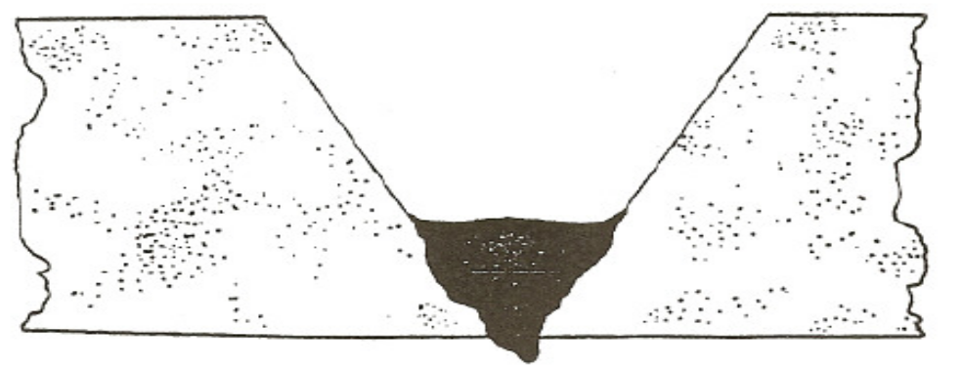

Control of distortion
Expansion and contraction in welding and cutting processes
When a piece of metal is heated it expands and, on cooling down, contracts. With welding and cutting processes the heating takes place over a localized area of the metal and expansion can only take place in that portion of the metal. The subsequent contraction that takes place on cooling can result in forces causing distortion or, even worse, cracking of the metal. When a weld bead is deposited on the joint between two plates, the molten metal passing through the arc is at a very high temperature. The arc melting the edges of the joint and the filler and base metal fuse together. As the arc moves across the joint the deposited bead starts to cool and considerable contraction forces are set up in the weld area. As the deposited metal was at a higher temperature than the parent metal it will contract more and also, since its volume is greater, there is a large volume of metal shrinkage. The result is distortion of the joint.
The following are several ways of controlling the effect of distortion during welding:
- Presetting entails setting the joint out of alignment prior to welding so that after contraction has taken place the joint is aligned.
- Backstopping or step welding entails welding the joint in short steps, ensuring that expansion and contraction zones are placed next to one another.
- Jigging entails holding the metal being welded in a jig, restraining the distortion mechanically.
- Preheating entails heating the metal to be welded prior to welding, and has the effect of allowing equal contraction to take place in both the weld and parent metal.
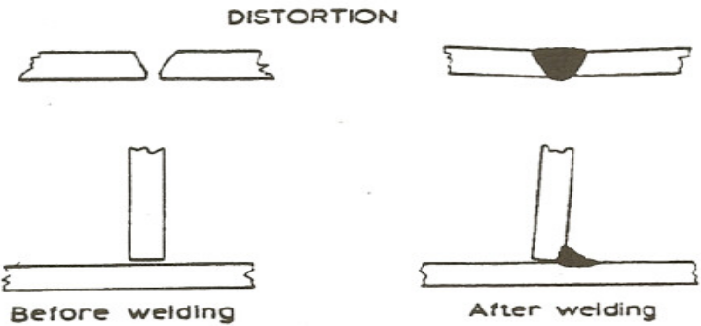

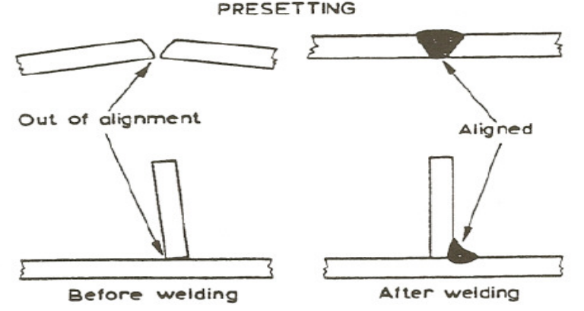

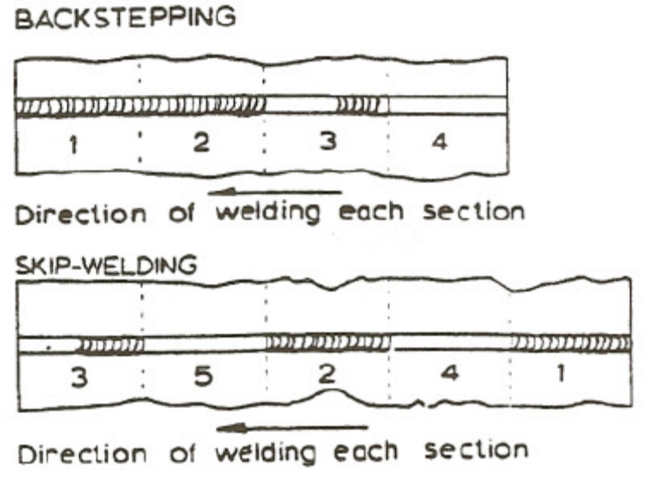
Electrodes When a piece of metal is heated in the atmosphere it combines with the oxygen and nitrogen to form oxides and nitrides which combine with the metal. If these were allowed to form in the weld it would result in a poor quality, weak and brittle weld. It is therefore necessary to protect the weld area from the air. This can be done either by surrounding the weld area by an inert gas or by the use of suitable fluxes. It is usual, with manual metal arc welding, to use coated electrodes. These electrodes consist of a metal core surrounded by a layer of suitable flux coating.
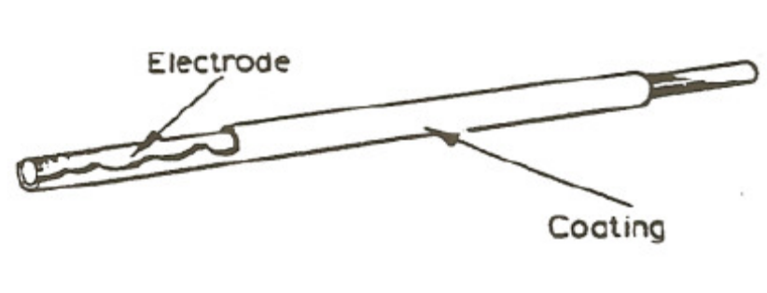
Functions of the Electrode Coating: The six main functions of the electrode coating are as follows:
- To act as a flux and remove the impurities from the surfaces being welded.
- To form a protection layer (slag) over the weld, which prevents contact with the air as it starts to cool down. This stops the weld forming brittleness and provides a smoother surface by preventing ripples caused during the welding process.
- It forms a neutral gas atmosphere, which helps to protect the molten weld pool from oxygen and nitrogen in the surrounding air.
- It helps to stabilize the arc, allowing Alternating Current (A.C) to be used.
- It can add certain constituents to the weld by replacing any lost during the welding process.
- It can speed up the welding process by increasing the speed of melting of the metal and the electrode.
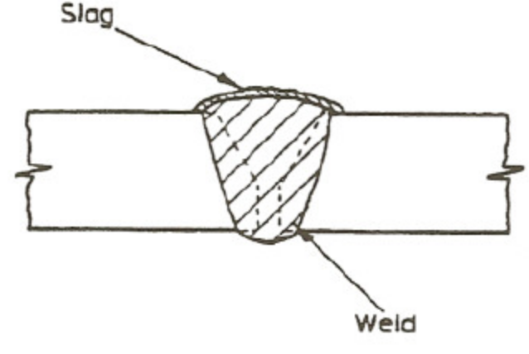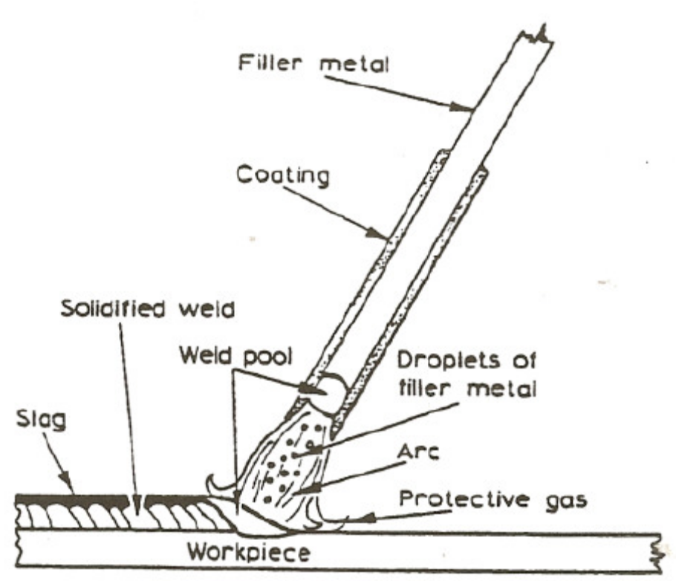
American Welding Society (AWS) classification system for electrodes
Mild steel electrodes :The method of classifying of electrodes is based on the use of a Four-digit number, preceded by the letter ‘E’ for ‘Electrode’. The first two digits designate the minimum tensile strength of the weld metal (in 1,000 psi) in the as-welded condition. The third digit indicates the position in which the electrode is capable of making satisfactory welds. The fourth digit indicates the current to be used, and the type of flux coating.
For example, the classification of E6012 electrodes is derived as follows:
E = Metal arc welding electrode.
60 = Weld metal UTS 60,000 psi min.
1 = Usable in all positions.
2 = Rutile type coating: AC or DC negative.
The detail of the classification is shown below:
First and second digits
E 60xx As-welded deposit. UTS 60.000 psi min. for E 6010, E 6011,
E 6012, E 6013, E 6020, E 6027 UTS.
E 70xx As-welded deposit, UTS 70.000 psi min. for E 7014, E7015, E7016,E 7018, E 7024 and E 7028.
Third and fourth digits
The third and fourth digits indicate positional usability and flux
coating types e.g.
Exx10 = High cellulose coating, bonded with sodium silicate, deeply penetrating, forceful, spray-type arc, thin, friable slag, all-positional. (Direct Current DC), electrode positive only.
Exx11 = Very similar to Exx10, but bonded with potassium silicate to permit use on AC or DC positive.
Exx12 = High rutile coating, bonded with sodium silicate. Quiet arc, medium penetration, all-positional, on (AC or DC) negative.
Arc Flash: When a welding flash causes arc rays to come into contact with unprotected eyes, the injury is called arc flash. This usually happens if the helmet is raised and an arc is struck during arc welding. If the flash is frequent enough or severe enough, the eyeballs become covered with many small water blisters. The eyelids moving against the eyeballs cause irritation and pain. The eyes are also hurt by bright light and will water profusely. In extreme cases blindness will occur for two or three days. If exposed to arc flash, a welder should wear dark glasses and avoid any welding for several days.
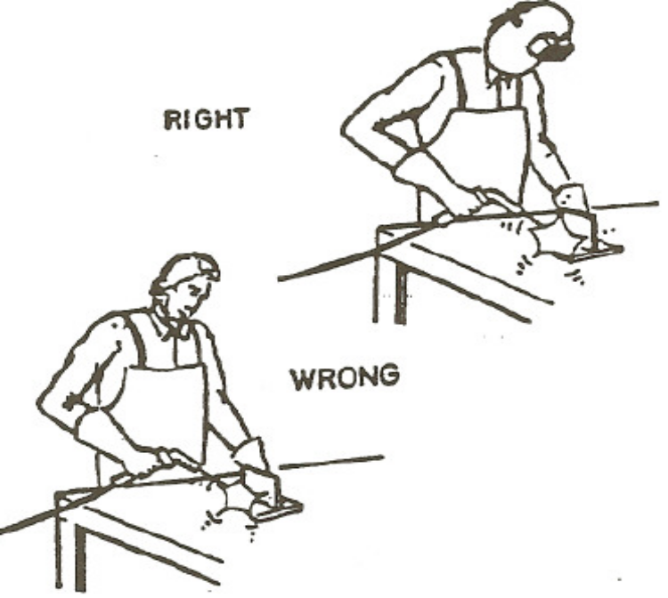

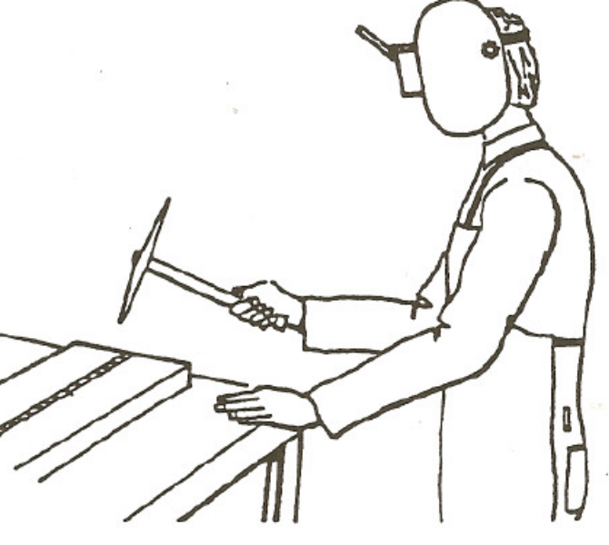

Hazards and Safety Precautions

REMEMBER: Safety is your business
1) Welding rays are very dangerous. Always wear a Welding-shield.
2) Always wear goggles when chipping slag as it will be hot and sharp.
3) Always screen your welding from others to avoid risk of Arc-flash.
4) Never weld an enclosed tank , before you take the fallowing precautions:
                - It must be drained
                - It must be flushed
                - It must be vented
5) Always examine welding cables for damage.

Metal Inert Gas (MIG) or Gas Shielded Metal Arc Welding
MIG belongs to the category of consumable electrode electric arc welding techniques. This term is a common name for all the welding processes, which involve shielding the arc with inert gas, CO2, and various gas mixtures provided by external source and use a consumable wire as one of the electrodes.

Description of the Process
The consumable electrode wire is carried on a spool and fed automatically to a manually operated or automatic gun and through a nozzle into the weld arc. In addition to the electrode wire, a shielding gas is fed to the gun together with welding current supply and cooling water. MIG requires a DC power supply of reverse polarity. In addition to the use of inert gas, deoxidisers are usually present in the electrode itself, which prevents oxidation of the weld pool. The process thus results in welds free of slag, which can be deposited in multiple layers. In manual MIG welding, metal is transferred in globules or droplets from electrode to the work piece. If the current is increased the rate of transfer of the droplets across the arc increases and they become smaller in volume. The transfer occurs in the form of a fine spray.

Gases
The title MIG is not true as not inert gases are used in the process, such as CO2 and oxygen. The title metal Active Gas (MAG) is used in these cases

Argon
Although argon is very suitable for non-ferrous metals and alloys, if it is used for welding steel the process becomes unstable and the weld profile uneven. Mixtures of argon and oxygen result in more stable process and gives optimum welding conditions for various metals.

Helium
If helium is used as the shielding gas, it requires significantly greater gas flow than argon. It is usually used mixed with argon e.g. argon – 15% helium for certain high nickel alloys, argon – 50% helium for copper welding

Carbon Dioxide
Pure CO2 is the cheapest of the shielding gases and can be used for welding steel up to 0.4% C and low alloy steel. CO2 is not suitable for stainless steel because the corrosive resistance of the weld is reduced

Argon + CO2 (5% and “20%)
The addition of CO2 to argon for the welding of steels improves the ‘wetting’ action, reduces surface tension and makes the molten pool more fluid. The mixture is more expensive than pure CO2 but gives a smoother, less critical arc with reduced spatter and a flatter weld profile.

Argon + Nitrogen (15-20%)
The mixture can be used instead of pure argon for copper welding. Arc voltages are higher, giving greater heat output for a given current value thus reducing the pre-heating requirements. If pure nitrogen is used the droplets are of coarse size and there is more spatter and porosity with poor weld appearance.

Spray transfer
In MIG metal is transferred to the work piece by two basic mechanisms: Short circuit (or dip transfer) and by Spray transfer.
Short circuit transfer occurs when low arc voltages and currents are deployed. Under these conditions the metal from the electrode is transferred to the work piece in individual droplets when the electrode tip touches the molten weld arc and causes short circuit. In manual metal arc, welding metal is transferred in globules from electrode to the work piece. If the current is increased to the continuously fed gas shielded wire, the transfer rate increases and become smaller in volume. The transfer occurs in the form of a fine spray and is called Spray transfer.

Applications
The process is suitable for a great variety of ferrous and non-ferrous metals. The temperatures involved are relatively low and hence the process is suitable for thin sheet sections (less than 6 mm).
MIG and TIG are competing more or less for similar welding applications. However, TIG welding becomes troublesome when currents increase above 300 A. The MIG welding process does not suffer from these disadvantages. Thus larger welding currents can be used with bigger deposition rates.
The process is particularly suitable for aluminum, magnesium alloys, plain and low-alloy steels, stainless and heat resistance steels, copper and bronze.
It is versatile process and relatively easy to train operators. It lends itself to automation and it is used in conjunction with robotics.

FACT SHEET
Other welding processes
For additional welding techniques please refer to the hyperlink
http://www.twi.co.uk/j32k/Menu/232
Welding Internet Resources
The Welding Institute provides information on a wide range on welding techniques.
http://www.twi.co.uk/j32k/Menu/230


27-33 Upper Baggot Street
Dublin 4

