TRADE OF HEAVY VEHICLE MECHANIC

PHASE 2

Module 2
Basic Electricity/Batteries

UNIT: 2

Basic Electricity

Table of Contents
1. Learning Outcome 1
1.1 Key Learning Points 1
2.0 Electricity 2
2.1 Composition of Substances 3
2.2 Free Electrons 3
2.3 Static Electricity and Dynamic Electricity 4
2.4 Laws of Electric Charge 6
2.5 Conductors and Insulators 8
2.6 Current 8
2.7 The Ampere 9
2.8 The Coulomb 10
2.9 The Electrical Circuit 11
2.10 Voltage 14
2.11 Ohm’s Law 15
2.12 Resistance 16
2.13 Power (watt) 19
2.14 Example of the Term “Voltage Drop” 21
2.15 Electrical Circuit Requirements 22
2.16 Electrical Measurement 22
2.17 The Multi-meter 22
2.18 The Ammeter 24
2.19 Voltmeter 25
2.20 The Ohmmeter 26
2.21 Clamp Meters 27
2.22 Electric Circuits 27
2.23 Open Circuit (break) 32
2.24 Short Circuit 33
2.25 The Effects of an Electric Current 34
2.26 Alternating Current (AC) 37
2.27 Frequency ( Symbol f ) 37
2.28 Graphical Symbols 38
2.29 Primary Automobile Terminal Designations 39
2.30 Graphical Symbols DIN 72552 39

1. Learning Outcome
By the end of this unit each apprentice will be able to::
- Describe static and dynamic electricity
- Describe the following three properties of electricity: voltage, current, resistance
- Define the terms: coulomb, ampere, volt, ohm, watt
- Describe electrical current i.e. direct - alternating
- Describe the effects of current flow and the use of each effect on the motor vehicle
- On a circuit training board, construct simple series and parallel circuits measure current and voltage values and calculate the resistance in these circuits using Ohm’s law
- Use an Ohm Meter to measure a selection of fixed resistors
- On a circuit training board, carry out recommended fault finding procedures for open circuit and excessive resistance and current drawn, using multi-meter/ test lamp and grip on ammeter
- State Kirchhoff’s laws
- On a circuit training board, construct circuits, to verify Kirchhoff’s laws

1.1 Key Learning Points
- Molecular theory: substance, atoms, molecules, free electrons, DC
- flow of electrons, static electricity
- Effect of electricity: ;heating effect; bulb, glow plug, welder, chemical effect: battery, electro plating, electrolysis, magnetic effect; solenoid motors, alternators etc
- Quantity and Flow Rate i.e. coulombs and amperes
- Magnetic effect in a straight conductor and operation of moving coil meter
- Resistance: materials; cross-sectional area, length, temperature, definition of resistance unit of measurement, ohm meter, rheostat
- Potential : Definition of volt. Voltmeter, sources of voltage
- Ohm’s Law: Measuring volts, amps, ohm’s, Amps V volt experiment, Amps V, Ohm’s experiment, Ohm’s Law V = I x R
- Series Circuits: Stating Kirchoff’s 2nd law: the sum of the voltage drops across the loads equals the supply voltage Parallel Circuits: Stating Kirchoff’s 1st Law: sum of the current flows towards a point is equal to the sum of the current flow from that point
- Series/parallel circuit: description
- Power: Watts - Kilowatts method of calculation Watt = Volts x Amps
- Method of connecting up voltmeter, ammeter and ohmmeter
- Care and use of multi-meter and other measuring equipment

2.0 Electricity
Our world is made up of various materials e.g.; it contains soil, water, rock, sand etc., and is surrounded by an invisible layer of gas called air. The scientific name given to each of these materials is matter.
“Matter is anything which occupies space and which has mass”
All matter is composed of atoms, which often arrange themselves into groups called molecules. An atom is the basic building block of matter.
Atoms are made up of smaller particles called Protons, Neutrons and Electrons.

Definitions:
Atom: The smallest portion of an element that still exhibits all the characteristics of that element.
Molecule: The smallest piece of material, which has all the same properties as the material itself, is called a molecule. A molecule is a group of atoms of one element or several elements.
Proton: The Proton is a particle of matter having a Positive charge of electricity. It is situated in the nucleus (or core) of the atom.
Neutron: The Neutron is a particle of matter, which is electrically Neutral. It is also situated in the nucleus of the atom.
Electron: The Electron has a Negative charge of electricity. The electrons orbit the nucleus of the atom at great speed.

2.1 Composition of Substances
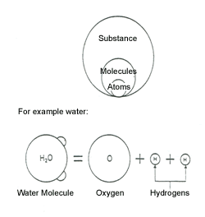
When we divide any substance into smaller parts without altering its original nature, we will eventually have particles called molecules. When we further divide molecules, we will find that they are made of atoms. All atoms are composed of a central nucleus surrounded by a cloud of extremely tiny particles, called electrons, circling around it in various orbits.
The nucleus is in turn composed of equal numbers of particles called protons and neutrons (except for hydrogen, which lacks a neutron). Since the number of positively-charged protons in an atom is normally equal to the number of negatively-charged electrons, the atom is electrically neutral overall. Because it is a basic law of nature that unlike charges attract each other, while like charges repel, the electrons stay in their orbits due to their attraction to the positive charge of the nucleus.

2.2 Free Electrons
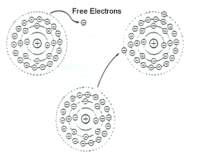
The electron or electrons that are in the outermost orbit are called valence electrons. Since these outer electrons are only slightly attracted by the nucleus, they tend to fly out of orbit and often attach themselves on to other atoms in copper, silver or other metals, valence electrons are moving about freely away from the nucleus these electrons are thus called free electrons.
Various characteristics and actions of electricity, such as static electricity sparks, or the heating, chemical or magnetic action brought about by an electrical current flow, are caused by these free electrons.

2.3 Static Electricity and Dynamic Electricity
There are two kinds of electricity: static and dynamic. Dynamic electricity can be further divided into direct current (DC) and. alternating current (AC).

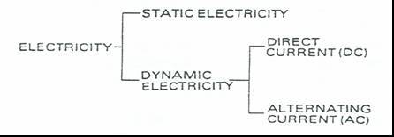

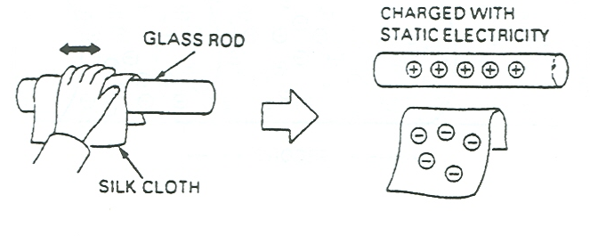
Static Electricity - When a non-conductive substance such as a glass rod is rubbed with a silk cloth, the surfaces of both the rod and the cloth become charged with electricity, one positively and one negatively. Unless the two materials touch, or are connected by a conductor, the electricity will remain in the glass rod and silk cloth. Since it does not move, this type of electricity is called static electricity. In terms of free electrons, static electricity refers to a state of electricity in which free electrons are separated from their atoms and do not move about on the surface of the substance.
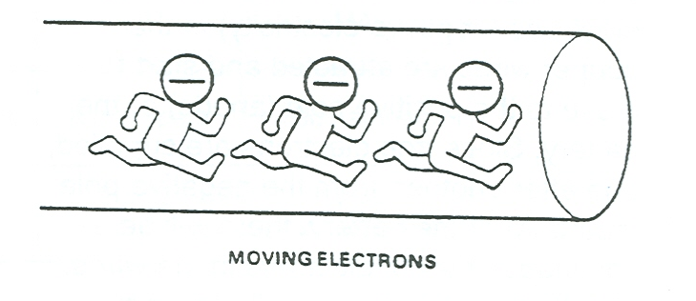
Dynamic.Electricity - Dynamic electricity refers to a state of electricity in which there is a flow of free electrons, that is, electrons that are separated from their atoms and moving about inside the conductive substance. When the free electrons are moving in' a constant direction the state of dynamic electricity is called direct current (DC). When the direction of motion and the amount of current vary periodically with time, the state of dynamic electricity is called alternating current (AC).
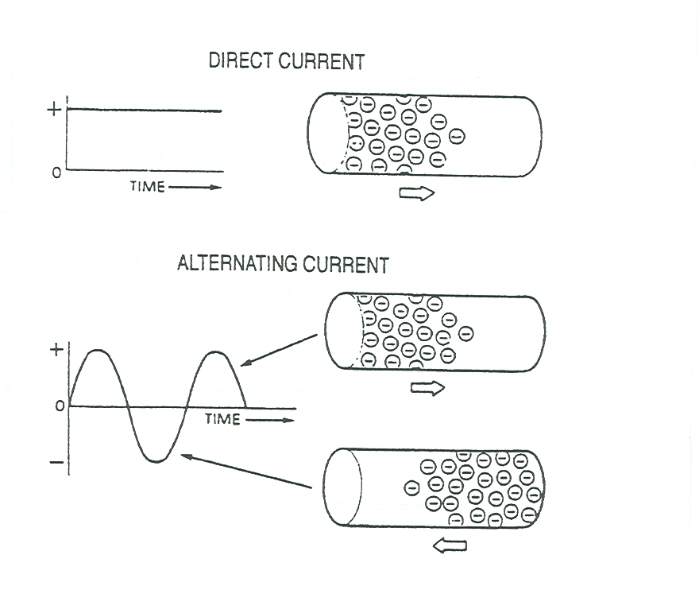

Simplified Representation of Atoms
The models of three different atoms are shown in Figures 1a, 1b and 1c. They illustrate how the electron(s) are arranged around the nucleus.
Figure 1a represents the simplest atom of all - the Hydrogen atom, which consists of a single electron orbiting a nucleus, which, is composed of a single proton.
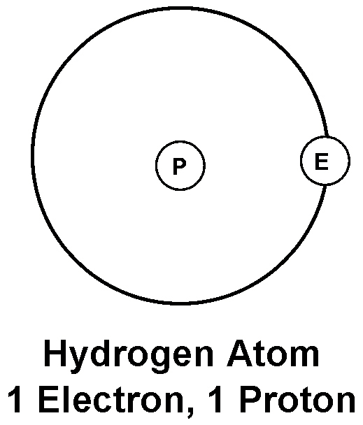

Figure 1b illustrates the vehicle on atom, which contains 6 electrons orbiting a nucleus of 6 protons and 6 neutrons.
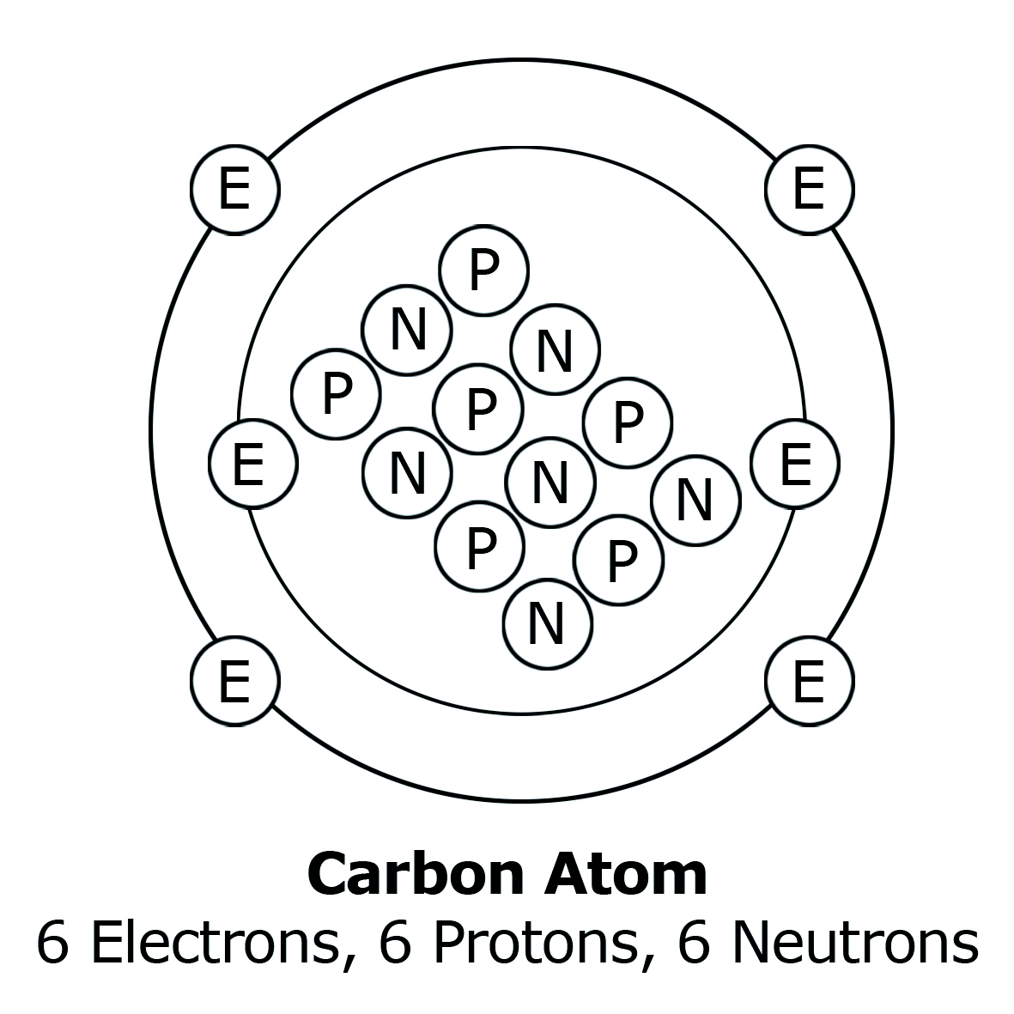

Figure 1c illustrates the copper atom, which contains 29 electrons and a nucleus of 29 protons and 35 neutrons.
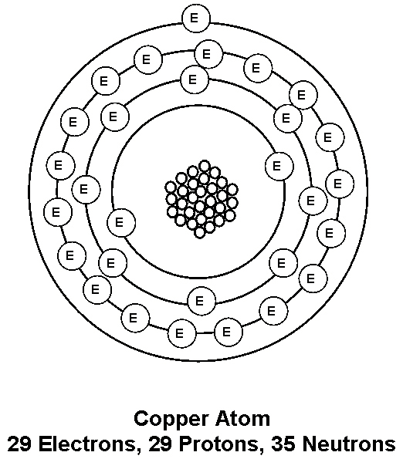

2.4 Laws of Electric Charge
There are basic laws of nature, which describes the action of electric charges. These laws state:
1. Like charges repel each other
2. Unlike charges attract each other.
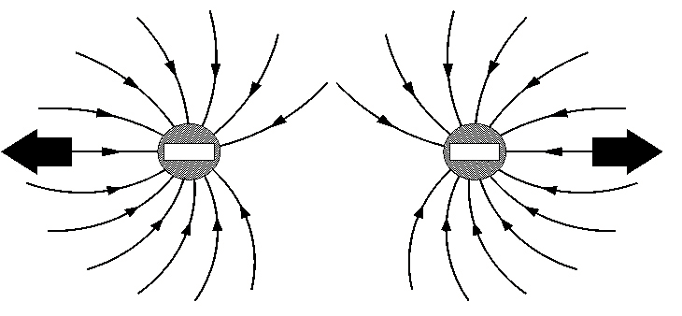

Electrons Repel

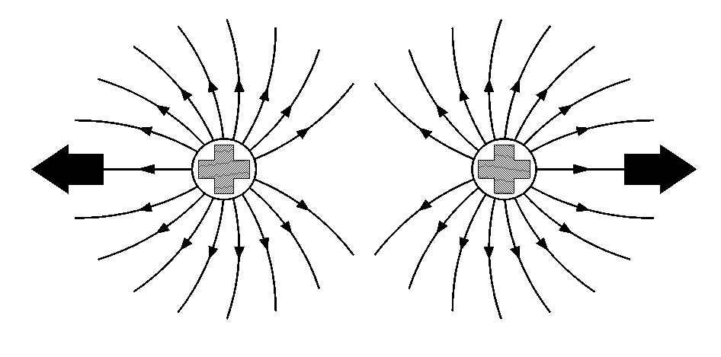

Protons Repel

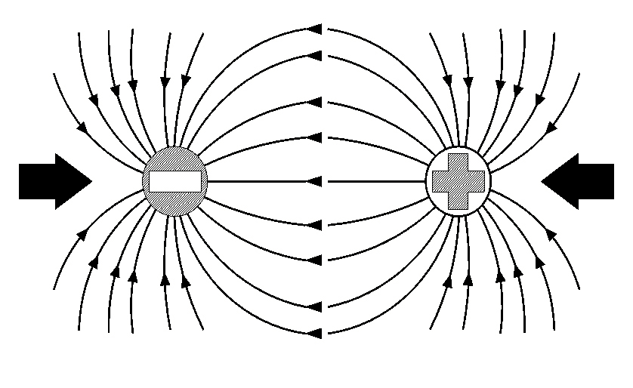

Electrons and Protons Attract

Coulomb's Law
Charles Coulomb (1736-1806) came up with a law to describe the force that one electric charge exerts on another electric charge. Coulombs law states that:
"The force that one particle exerts on another particle is directly proportional to the product of their charges and inversely proportional to the square of their separation."

The Balanced Atom
In the previously mentioned examples (hydrogen, carbon and copper) you may have noticed that the number of electrons is always equal to the number of protons. This is normally true of any atom. When this is the case, the atom is said to be neutral, balanced or normal. However, external forces can upset this state.

2.5 Conductors and Insulators
In some materials the electrons in the outer orbits are easily moved, they tend to transfer themselves from atom to atom and so can wander freely about inside the material. Such a movement of electrons constitutes an electric current and those materials in which electric currents can flow freely are called conductors. Some typical conductors are copper, brass, silver, gold, carbon, mercury etc.
In other materials the electrons are tightly bound to their own particular atoms, with the result that electric currents cannot flow freely in them. These materials are known as insulators. Some typical insulators are PVC (Poly-vinyl chloride), rubber, plastic, glass, paper, oil etc.
Matter that has 4 electrons in its outer shell is neither a good electrical conductor nor a good electrical insulator. It is the base material used to produce semiconductors, e.g. silicon.

2.6 Current
Electric current is the movement of free electrons. Electrons have a negative charge and are attracted to a positive charge. In a battery a chemical reaction takes place that forces electrons towards a negative plate and away from the positive plate. The symbol for a Battery is shown below in Figure 2. The positive plate is represented by the longer line.
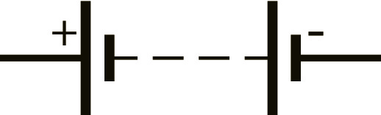
Figure 2
When a battery is connected as shown in Figure 3 below, the free electrons in the conductor drift in one direction only, away from the negative plate and towards the positive plate. Current that flows in one direction only, is called Direct Current (DC).
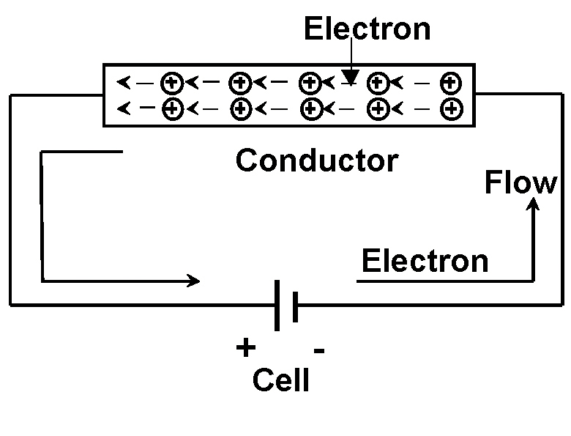
Figure 3
The electrons close to the positive plate of the battery are attracted to it. Each electron that enters the positive plate causes an electron to leave the negative plate and move along the circuit. The number of electrons in the conductor remains constant.
The movement of electrons in a circuit is from negative to positive. Long before this theory was proposed, it was thought that current flowed from the positive plate to the negative plate of a cell. This direction of current flow is now called conventional current flow. We say that conventionally current flow is from Positive to Negative, Electron flow is from negative to positive. In this course we will use conventional current flow in all diagrams

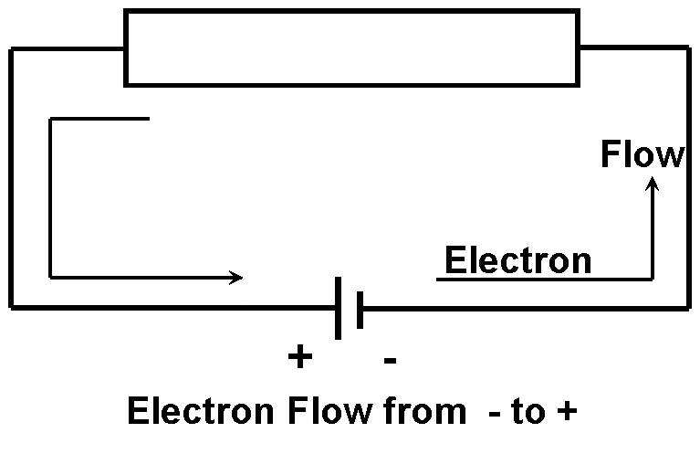
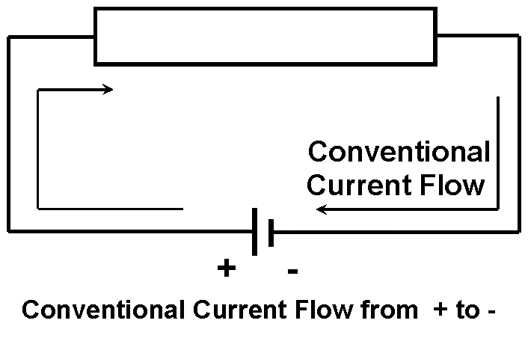

2.7 The Ampere
The Ampere is the System International or (SI) unit of measurement used to express the rate of current flow in a circuit.
This movement of electrons within a conductor is known as an Electric Current and is measured in Amperes (Amps), symbol I.
When 6.28 x 1018 electrons pass a given point in one second a current of One Ampere is said to flow in that circuit. See Figure 4.

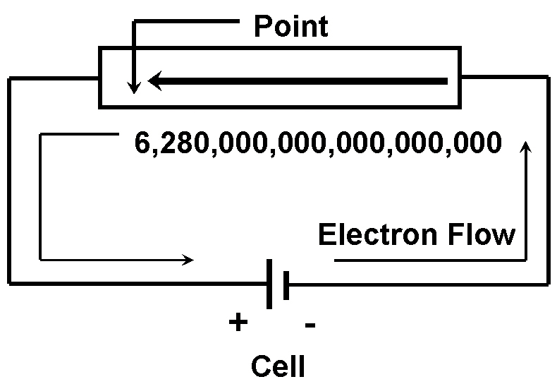
Figure 4

2.8 The Coulomb
As can be seen the number of electrons passing a given point is exceptionally large so a unit called a Coulomb is used. A coulomb is the quantity of electricity, which passes a point when a steady current of 1 Ampere flows for one second.
Formula: Q = I x t
Where: Q = Quantity of Electricity (Coulombs)
I = Current in Amperes (Amps)
T = the time for which current flows measured in seconds.

2.9 The Electrical Circuit
To have a continuous current flowing, there must be a complete circuit. If the circuit is broken, by opening a switch for example, the electron flow and therefore the current will stop immediately. To cause a current to flow continuously around a circuit, a driving force is required, just as a circulating pump is required to drive water around a central heating system. See Figure 5.
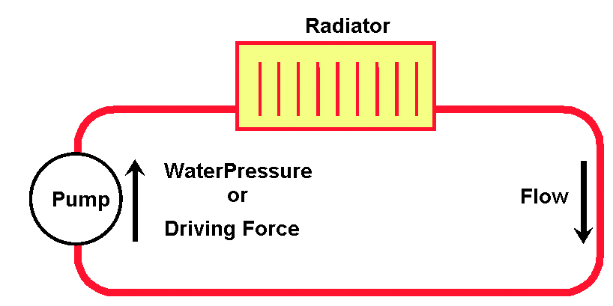
Figure 5
This driving force is the electromotive force (abbreviated to EMF) and is the energy, which causes the current to flow in a circuit. Each time an electron passes through the source of EMF, more energy is provided to send it on its way around the circuit. See Figure 6.
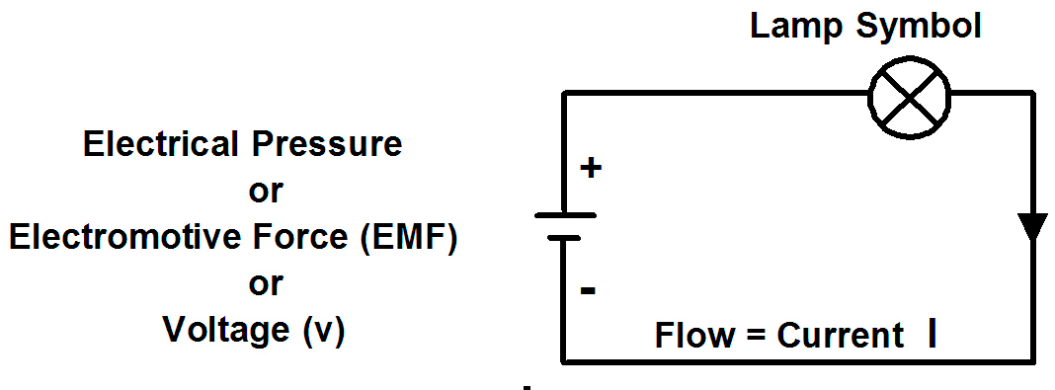Figure 6.
A circuit must have:
1. A source of supply (EMF).
2. A load (Lamp).
3. Connecting cables (Conductors).
The source of supply is always associated with energy conversion.
- Generator (converts mechanical energy to electrical energy)
- Battery (converts chemical energy to electrical energy)
The source of supply will have pressure called Voltage or Electromotive Force, (both measured in Volts).
Note:
The international symbol for “supply voltage” or “voltage drop” has changed from V to U, the symbol for the unit of voltage (the volt)
remaining as V.
The load is any device that is placed in the electrical circuit that produces an effect when an electric current flows through it. When an electric current flows through an incandescent lamp, the lamp gives off light from heat.
The connecting leads or cables form the circuit to complete it. The cable consists of the conductor to carry the current and the insulation to prevent leakage just like the water pipes must have a bore to carry the water and the pipe material (e.g. copper) to prevent leakage.

In all circuits we use Fuses
A fuse is not required to make a circuit work. It is a deliberate “weak link” in the circuit, which will break when too much current flows. The symbol below represents a fuse.
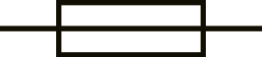

Earth Return
In an automobile the steel body of the vehicle is used as one of the conductors. A cable connects the negative plate of the battery to the steel bodywork of the vehicle. A cable supplies current from the positive terminal of the battery to the load (e.g. a light bulb), usually through a control device such as a switch.
The other side of the load is then connected to the steel bodywork completing the return circuit to the negative terminal of the battery through the vehicle bodywork.
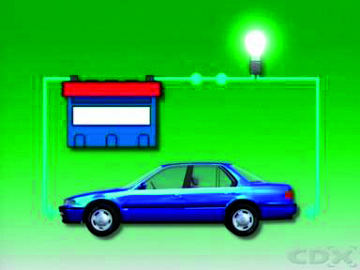

Ground
Ground is a term used to indicate connecting a component to the vehicle frame or chassis.
Current flows from the positive terminal of the battery, through a controlling device such as a switch, then through the component. The return path is through the vehicle chassis or frame, to complete the circuit, and allow the component to operate.
Using the vehicle frame in this way simplifies the circuit wiring
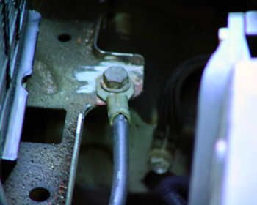

Note:
Circuits also usually contain some form of control in the form of a switch that can be used to turn on and off the load.

Circuit Analogy
The simplest analogy of an electric circuit is to consider a hosepipe connected to a tap. The rate of flow of water from the end of the hosepipe will depend upon the water pressure at the tap and the flow of water through the hosepipe, which will be restricted by its inner walls, particularly where, bends and kinks occur. If there are many restrictions, this will be noticeable, as the water will flow out of the ose at reduced pressure. See Figure 7.
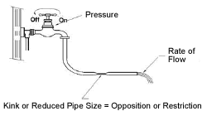
Figure 7.

2.10 Voltage
In the same way, current flows through conductors by means of an electric pressure from a battery or generating source. This source of electric pressure, called electromotive force (EMF), provides the energy to move current through the circuit. Electromotive force is referred to as the supply voltage (U) and for a stable supply the current (I) allowed to flow is determined by resistance (R) of the circuit. There will be a pressure drop across different parts of the circuit and this is called Potential Difference (PD). Unlike the hosepipe analogy, the electric circuit needs a ‘go’ and ‘return’ conductor to form a closed loop or circuit, and these conductors must offer a low resistance path to the flow of current. Most metallic conductors satisfy this requirement. See Figure 8.The term Voltage is often used when referring to either EMF or PD because both are measured in Volts.
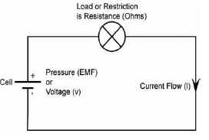
Figure 8
Every circuit offers some opposition or restriction to current flow, which is called the circuit resistance. The unit of resistance is the Ohm, symbol (Ω), pronounced Omega. At this stage, conductor resistance is ignored and the load resistance is treated as the total opposition to the current flow. (The letter R is sometimes used instead of (Ω)

2.11 Ohm’s Law
Ohm’s Law states that the current (I) flowing through a circuit is directly proportional to the potential difference (U), across that circuit, and inversely proportional to the resistance (R), of that circuit, provided the temperature remains constant.
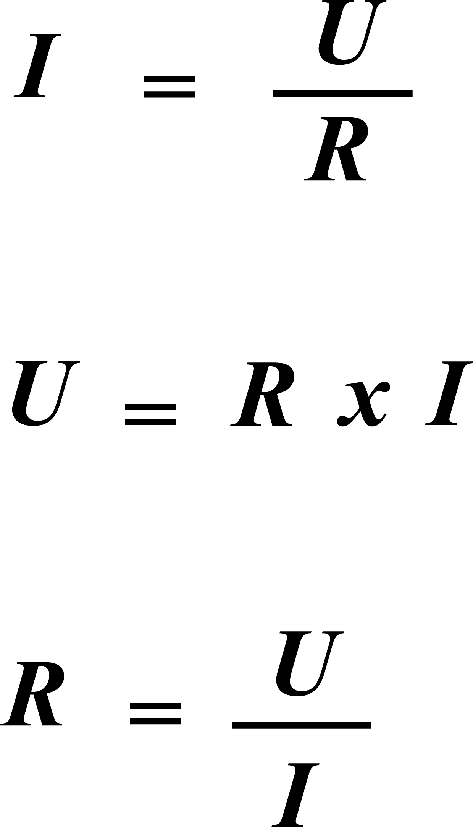
This formula can also be written as:
or

The Magic Triangle
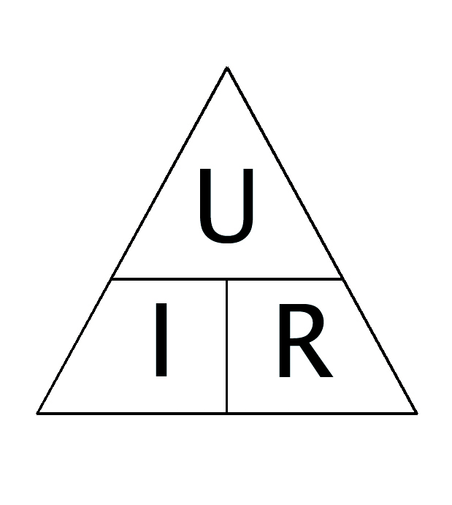
Now consider any circuit in which you know the values of any two of the three factors - voltage, current and resistance - and you want to find the third.
The rule for working the “Magic Triangle” to give the correct formula is as follows:
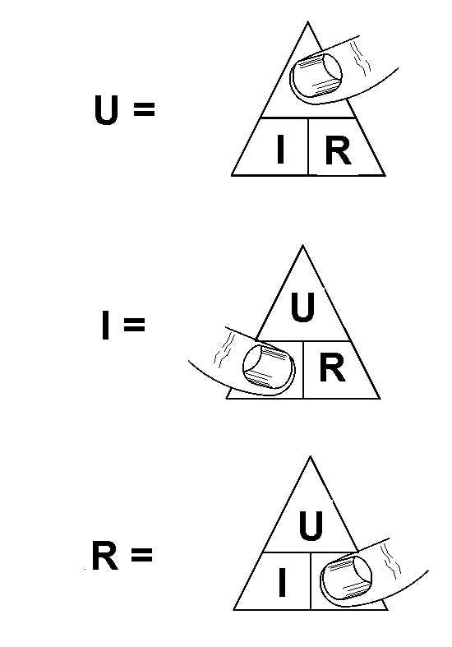
Place your thumb over the letter in the triangle whose value you want to know and the formula for calculating that value is given by the two remaining letters.

2.12 Resistance
The following three factors determine the resistance of a conductor at a constant temperature:
1. Composition of conductor material.
2. Length of conductor.
3. Cross sectional area of conductor.

Resistivity
The first of these is the resistivity of the conductor material, or how good a conductor the material is (copper is a better conductor than aluminium, but neither is as good as silver).
The resistivity of a material is defined as the resistance measured between the opposite faces of a unit cube of the material.
The resistance between opposite faces of a cube of material is called resistivity or specific resistance.
Symbol = Greek letter ρ (pronounced Rho)
Resistance (R) is proportional (∞) to Resistivity (ρ)
R ∞ ρ
Resistivity of Different Materials
The values of resistivity for different conductor materials makes it clear that conductor resistance will depend on the material from which it is made, as well as, its length and cross-sectional area. The table below shows clearly why copper is so widely used as a conductor material. It is second only to silver in its resistivity value. Aluminium is about half as resistive again as copper, but its lightness and cheapness have led to its increasing use as conductors.

Resistivity of Common Conductors Materials
Material Resistivity (10-8 ohm metres)
Silver 1.63
Copper (annealed) 1.72
Aluminium 2.85
Brass 6.0. - 9.0
Iron 10
Tin 11.4
Lead 21.9
Mercury 95.8
Note: the lower the value, the better the conductor.

Length of Conductor
The resistance of a conductor depends on its length. If we increase the length of conductor leaving the area the same, its resistance will increase.
If the length of conductor is doubled, its resistance is doubled. The resistances are in series. The resistance of a conductor is directly proportional to its length. If the length of a conductor is halved its resistance is halved.
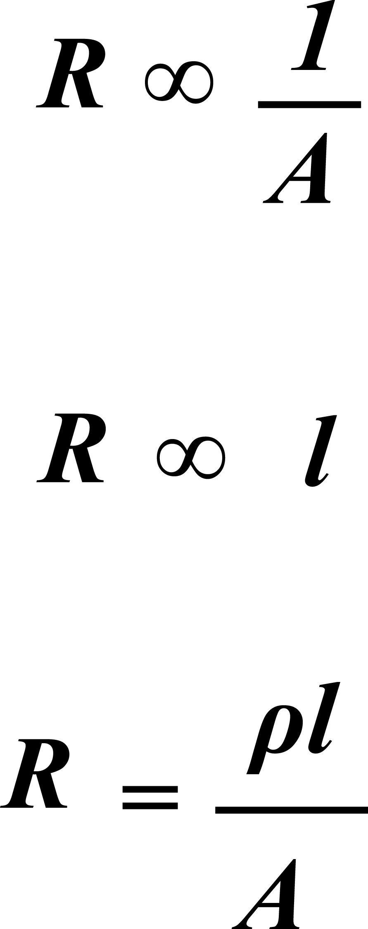

Cross-Sectional Area of a Conductor
The resistance of a conductor depends on its cross-sectional area. If we increase the CSA of conductor leaving the length the same, its resistance will decrease.
If the CSA of the conductor is doubled, its resistance is halved. The resistances are in parallel. The resistance of a conductor is inversely proportional to its cross-sectional area.

Temperature Coefficient of Resistance
The temperature coefficient of resistance is the change in resistance of a conductor resulting from a change in temperature of one degree centigrade.
- The resistances of conductors vary with temperature changes (up or down).
- The resistance of most conductors (including copper) increase as their temperature increases and are said to have a positive temperature coefficient (P.T.C.) of resistance.
- The resistance of carbon decreases as its temperature increases and is said to have a negative temperature coefficient (N.T.C.) of resistance.
- Most insulators have a negative temperature coefficient of resistance.
In summary for a given temperature the Resistance of a conductor is
R= Resistance
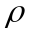= Resistivity of the material (ohm metre)
=Length of the conductor (metre)
A= Cross sectional area of conductor (metre2)

2.13 Power (watt)
The rate at which the work is done is called power. Power is represented by the symbol P.
The basic unit in which electric power is measured is the Watt. The Watt is defined as, the rate at which work is done in a circuit when an EMF of one Volt causes a current of one Amp to flow.

Power = Voltage x Current
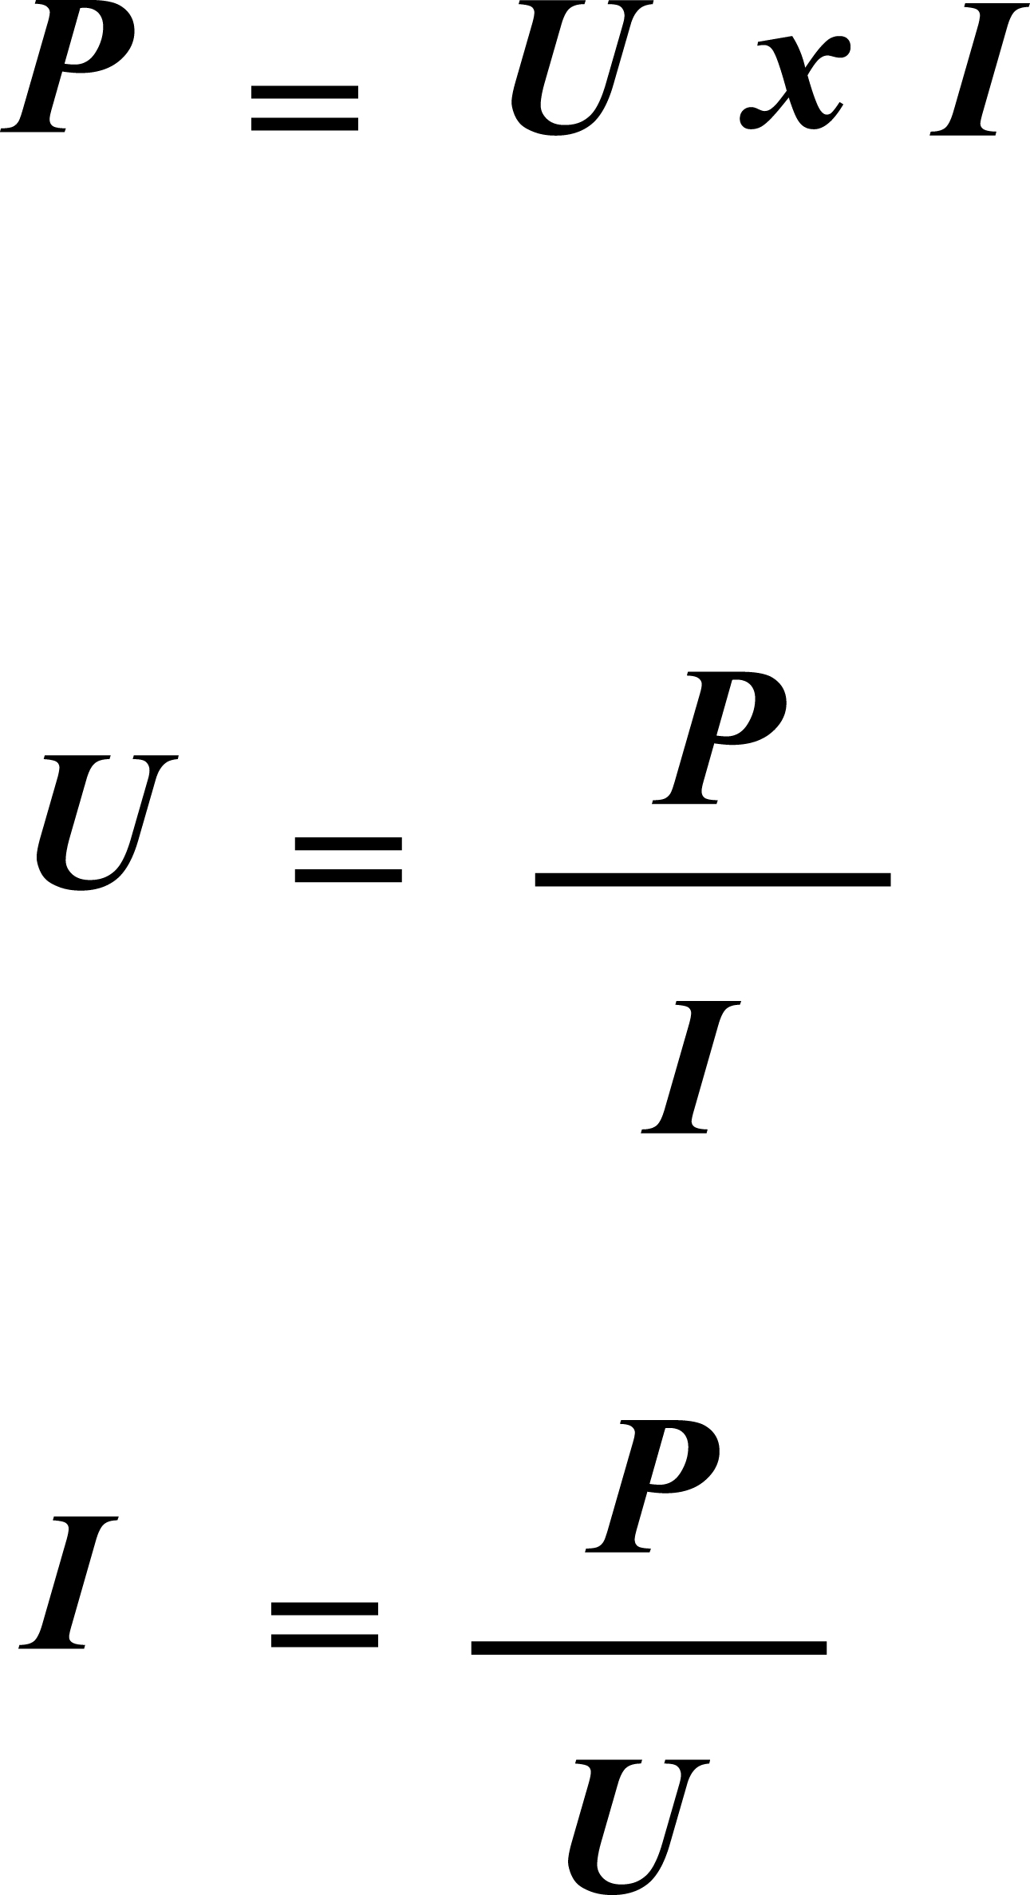

The Power Triangle
This power triangle can be used in the same way as the Ohms Law Triangle.
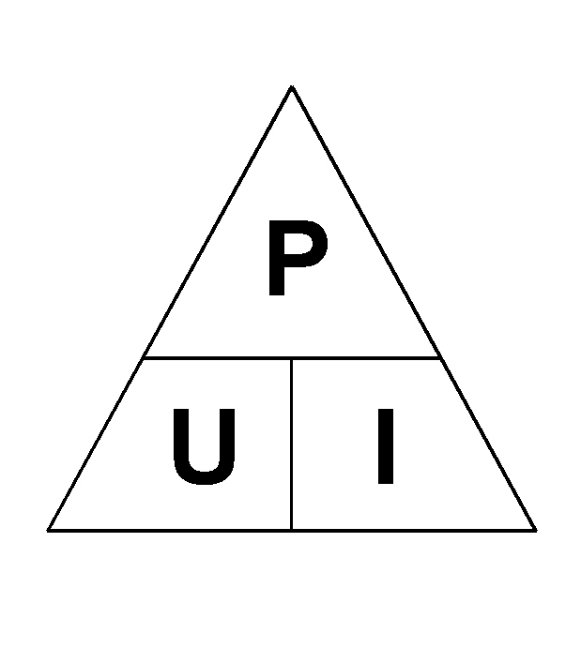

Example: Calculate the Power used or dissipated by the resistor in the circuit
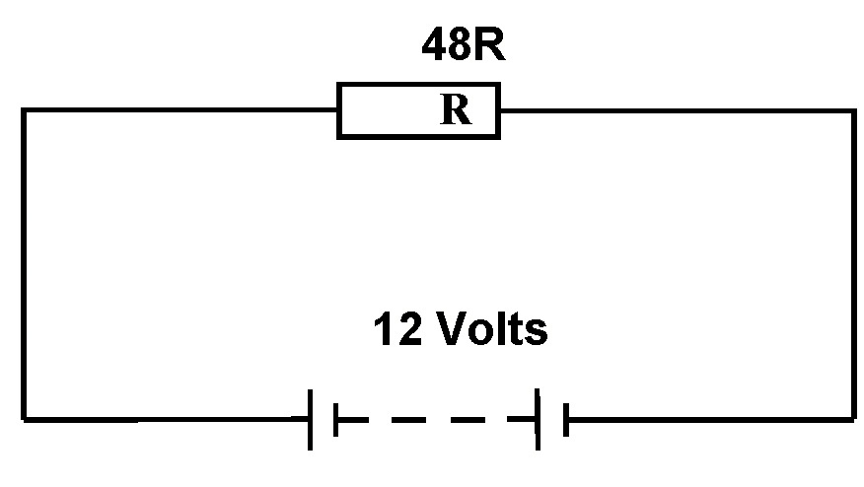

Solution:
From Ohm’s law:
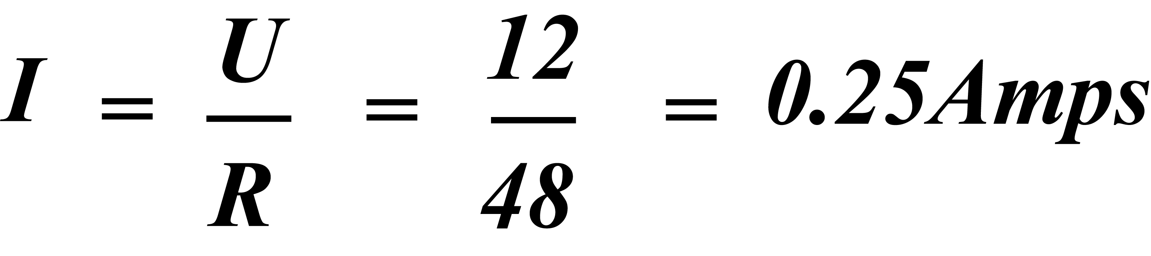
P = U x I, therefore: P = 12 x 0.25 = 3 W

2.14 Example of the Term “Voltage Drop”

Series Circuit Volt Drop
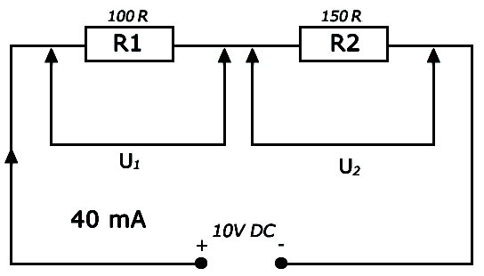
Refer to fig above: -- A 40 mA current flows through BOTH the 100R resistor and the 150R resistor. If we wish to calculate the volt drop across each resistor we can apply Ohm’s Law.

Notice that U1 is applied across R1 and that U2 is applied across R2
U1 = I × R1
U1 = 0·04 × 100 (40 mA = 0.04 A)
U1 = 4 Volts. (There is a volt drop of 4 Volts across the resistor R1).
U2 = I × R2
U2 = 0·04 × 150
U2 = 6 Volts. (There is a volt drop of 6 Volts across the resistor R2).
Note: the circuit voltages must add up to the applied voltage.

2.15 Electrical Circuit Requirements
One of the basic requirements that a circuit must have is over current protection, for the protection of the cables and accessories in the circuit. A fuse or circuit breaker is fitted as close to the origin of the circuit as possible to cut off the supply if too much current flows in the circuit. This is called circuit protection.

Circuit Control (switch)
Another basic function is the control of the circuit. A switch must be fitted to the circuit to turn the supply on and off. This is called circuit control. The principles of circuit protection and circuit control are illustrated in diagram below.
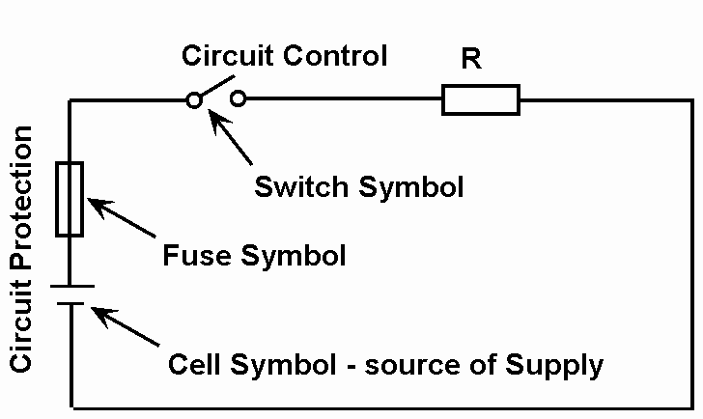

2.16 Electrical Measurement
Meters are used to measure circuit Current (Ammeter), Voltage (Voltmeter) or Resistance (Ohmmeter).

2.17 The Multi-meter
A Multi-meter is an instrument that can be set to measure voltage, current or resistance. Most modern Multi-meters have a number of other functions such as diode checking, dwell, rpm and capacitance measurement to name but a few. These instruments can measure Direct Current (DC) or Alternating Current (AC) over several ranges. The main types are:
- Volt-Ohm-Millie-ammeter (VOM) (Analogue)
- Digital Multi-meter ( DMM )

Comparison of Analogue and Digital Multi-meters
Analogue Type- Features: Digital Type- Features:
Analogue Display Digital Display
Manual Range Setting Range Setting Automatic / Manual
It is most important that the instruction manual supplied with a meter is studied prior to operation of the meter. These manuals normally contain warnings and information, which must be followed to ensure safe operation and retain the meter in a safe condition.
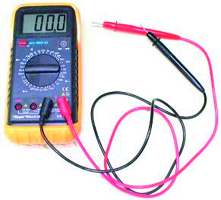
Digital Multi-meter

Meter Operating Suggestions
- Ensure that the instrument is set to measure the desired unit e.g. Volts to measure voltage.
- Set the range switch to the proper position before making any measurement.
- Ensure the instrument test leads are connected to the appropriate jack sockets. When the voltage, current or resistance to be measured is not known, always start with the highest range first and work your way down to a lower range that gives an accurate reading.
- Always observe correct test lead polarity when making DC voltage and current measurements.
- Set the range selector switch to the OFF position when the tester is not in use or during transit.
- Remove the battery before storing the meter for a long period of time.
Great care must be taken to ensure that the instrument range setting is not exceeded when measuring a voltage or current.

2.18 The Ammeter
The device, which is used to measure the rate of current flow through a conducting material, and to display this information in such a way that you can use it, is called an “ammeter”. An ammeter indicates, in terms of amperes, the number of coulombs passing a given point in a circuit, in one second. To be able to do this, the ammeter must somehow be connected into the circuit in such a way that it is able to measure all the electrons passing. One way to do this is to break the conductor, or “open the line” as it is called, and to physically connect in the ammeter. When an ammeter is inserted in this way into a circuit being used to carry current to an electric lamp or resistor, the ammeter is said to be “in series” with the lamp or resistor.
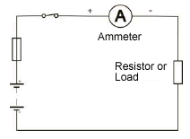
Note: The ammeter may be damaged if incorrectly connected.
A direct current (DC) meter must be connected with the correct polarity for the meter to read up-scale. Reversed polarity makes the meter read down scale, forcing the pointer against the stop at the left, which may damage the needle or pointer.

Activity
Install an ammeter into a circuit as shown and measure the current.
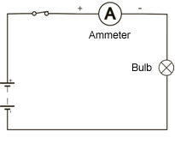
Use different bulbs to demonstrate different current values.

2.19 Voltmeter
A voltmeter measures electromotive force (EMF) or potential difference (PD), and it must be connected across the supply or load resistance in order to indicate the voltage. That is, it must be connected in parallel with the component.
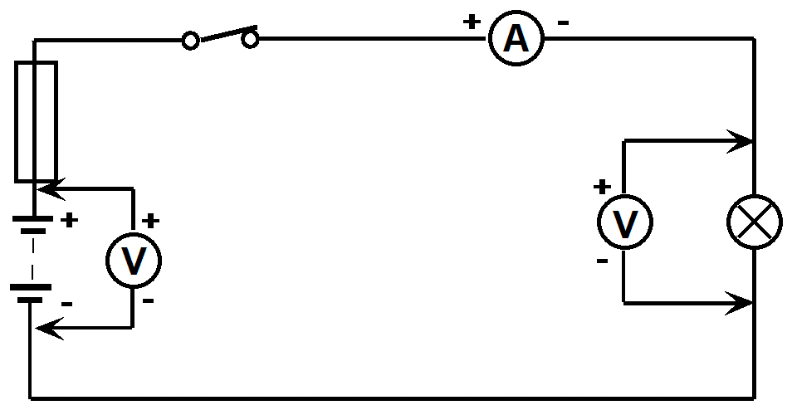
Note: The voltmeter may be damaged if incorrectly connected.
A DC voltmeter (analogue type) must be connected with the correct polarity for the meter to read up scale. When selecting a meter to measure voltage, choose one having a maximum range a good deal higher than the value of any voltage you expect to be measuring. The reason for this is that a voltage in excess of the maximum rated value of the meter will not only fail to register properly on the scale, but will probably cause serious damage to the meter.

Activity
Measure the voltage at the supply (EMF) and the voltage across the load (PD) for the circuit shown.
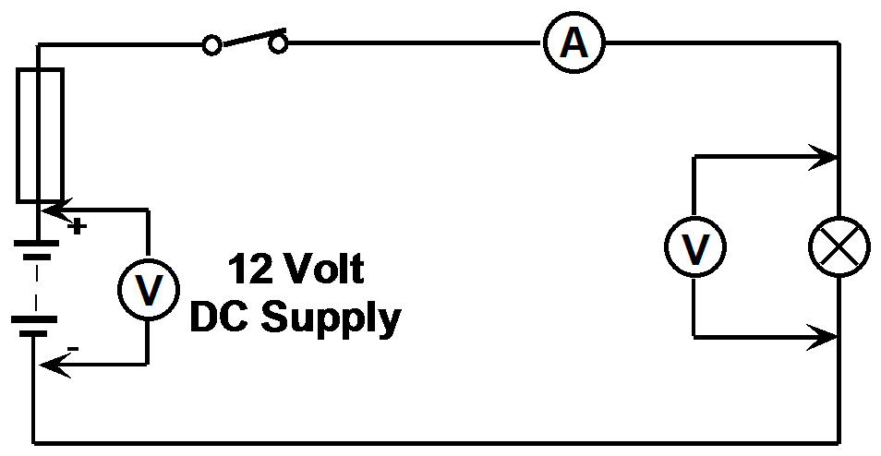

2.20 The Ohmmeter
The ohmmeter is a useful instrument, which can be used to check the electrical continuity of components and to measure their resistance. The instrument is powered by its own internal battery. Before connecting an ohmmeter in circuit it is important to ensure that:
- There is no voltage across the component (supply disconnected);
- The component to be measured is not connected in parallel with any other component;
- Check for Zero Ohms with the leads connected together.
Note Repeat step 3, if the position of the scale multiplier switch is changed.
Measurements are taken by connecting the meter across the unknown resistor as shown. It is important to select the most suitable scale for the resistance under test if the resistance ranges are to be set manually. Some meters have automatic ranging.
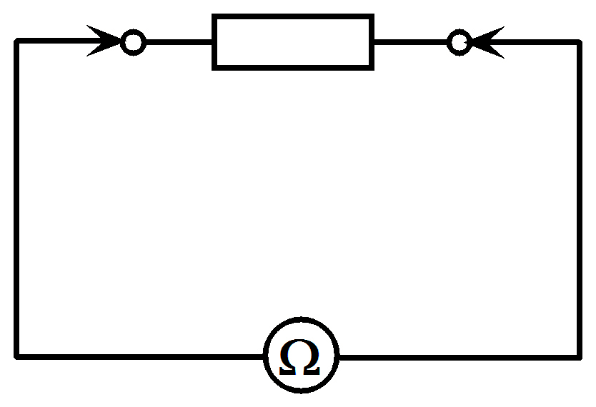

2.21 Clamp Meters
Measure (AC or DC) amperage without contacting conductors.
All current-carrying wires produce a magnetic field, the strength of which is in direct proportion to the strength of the current. By building an instrument that measures the strength of that magnetic field, a no-contact ammeter can be produced. Such a meter is able to measure the current through a conductor without even having to make physical contact with the circuit.
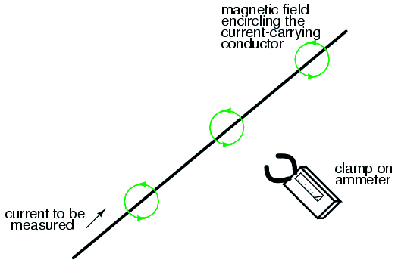
Ammeters of this design are made, and are called "clamp-on" meters because they have "jaws" which can be opened and then secured around a circuit wire. Clamp-on ammeters make for quick and safe current measurements, especially on high-power industrial circuits.
Because the circuit under test has had no additional resistance inserted into it by a clamp-on meter, there is no error induced in taking a current measurement.
Modern designs of clamp-on ammeters utilize a small magnetic field detector device called a Hall-effect sensor to accurately determine field strength.

2.22 Electric Circuits

The Series Circuit
In a series circuit there is only one path for the current to follow. Where two or more resistances are connected end to end they are said to be connected in series. The figure below shows three resistors connected in series in a circuit.
The same current flows through each component in a series circuit.
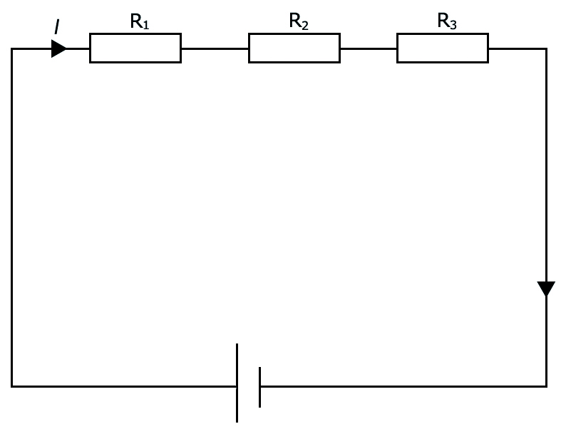
The formula used to find the total resistance (RT) for the circuit is shown below.
Formula RT = R1 + R2 + R3
Example:
What is the total resistance in this circuit?
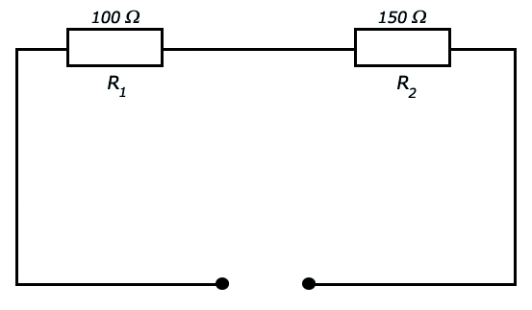
RT = R1 + R2
RT = 100 + 150
RT = 250Ω

Series Circuit Volt Drop
The Total resistance of the circuit shown below is 100Ω + 150Ω or 250 Ω.
From ohms law we can calculate that a current of 40 mA flows through BOTH the 100R resistor and the 150R resistor.
I = V/R
I = 10/250
I = 0.04A (or 40mA)
If we wish to calculate the voltage drop across each resistor we can apply Ohms Law.
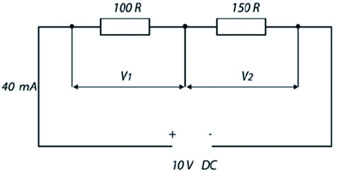
V1 is applied across the 100R resistor and V2 is applied across the 150R resistor.
U1 = I x R1
= 0.04 x 100 (40mA is 0.04 Amps)
= 4 Volts
There is a drop of 4 Volts across the 100 Ω resistor.
U2 = I x R2
= 0.04 x 150
= 6 Volts
There is a drop of 6 Volts across the 150Ω resistor.
In a series circuit the sum of all the volt drops is equal to the applied voltage.
UT =U1 + U2
10 Volts = 4 Volts + 6 Volts

Summary Of A Series Circuit
- In a series circuit the same current flows in all resistances.
- If there is a break in the circuit no current flows in any part of the circuit.
- The total resistance is the sum of all resistors in the series circuit.
RT = R1 + R2 + R3 + . . . . . RN
- The sum of all the volt drops in the circuit is equal to the Applied Voltage.
VT = V1 + V2 + V3 + . . . . . VN
- The Volt Drop is proportional to the value of resistors in the circuit.
The larger the resistor the larger the voltage drop across it
(for any given current).
- An example of a Series Circuit is a Christmas tree lighting set.

Parallel Circuits
A circuit with two or more paths for current to follow, with all resistance located in those separate paths, is called a Parallel Circuit. A parallel circuit is one that provides more than one path for the current to flow.
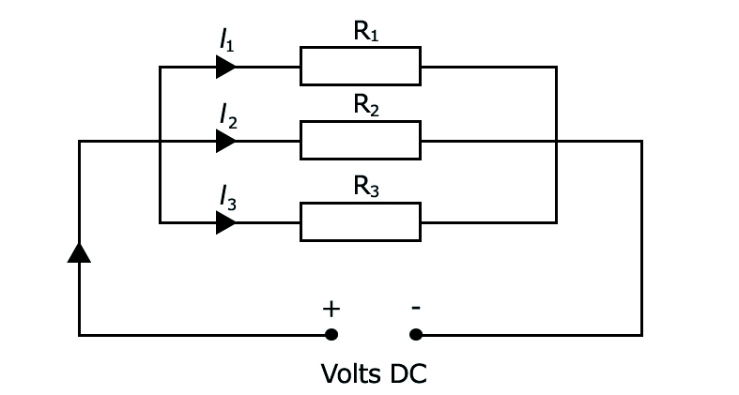
Fig. 31
Refer to Figure 31. Here the circuit current (IT) divides itself among the resistors, so that some current flows through R1 (I1), some through R2 (I2) and some through R3 (I3).
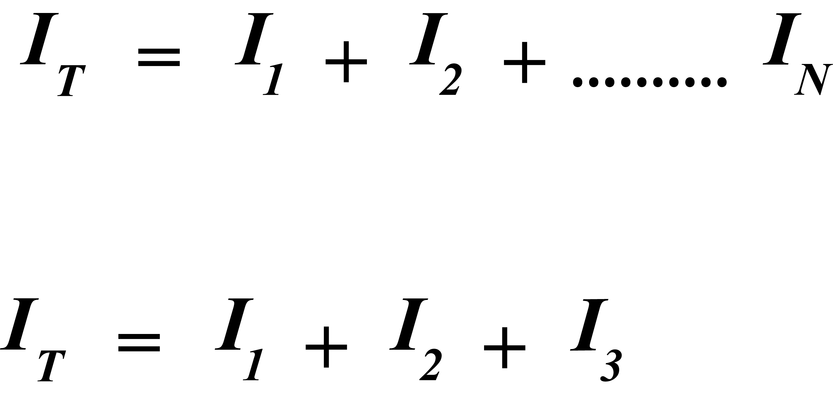
From Ohm s Law
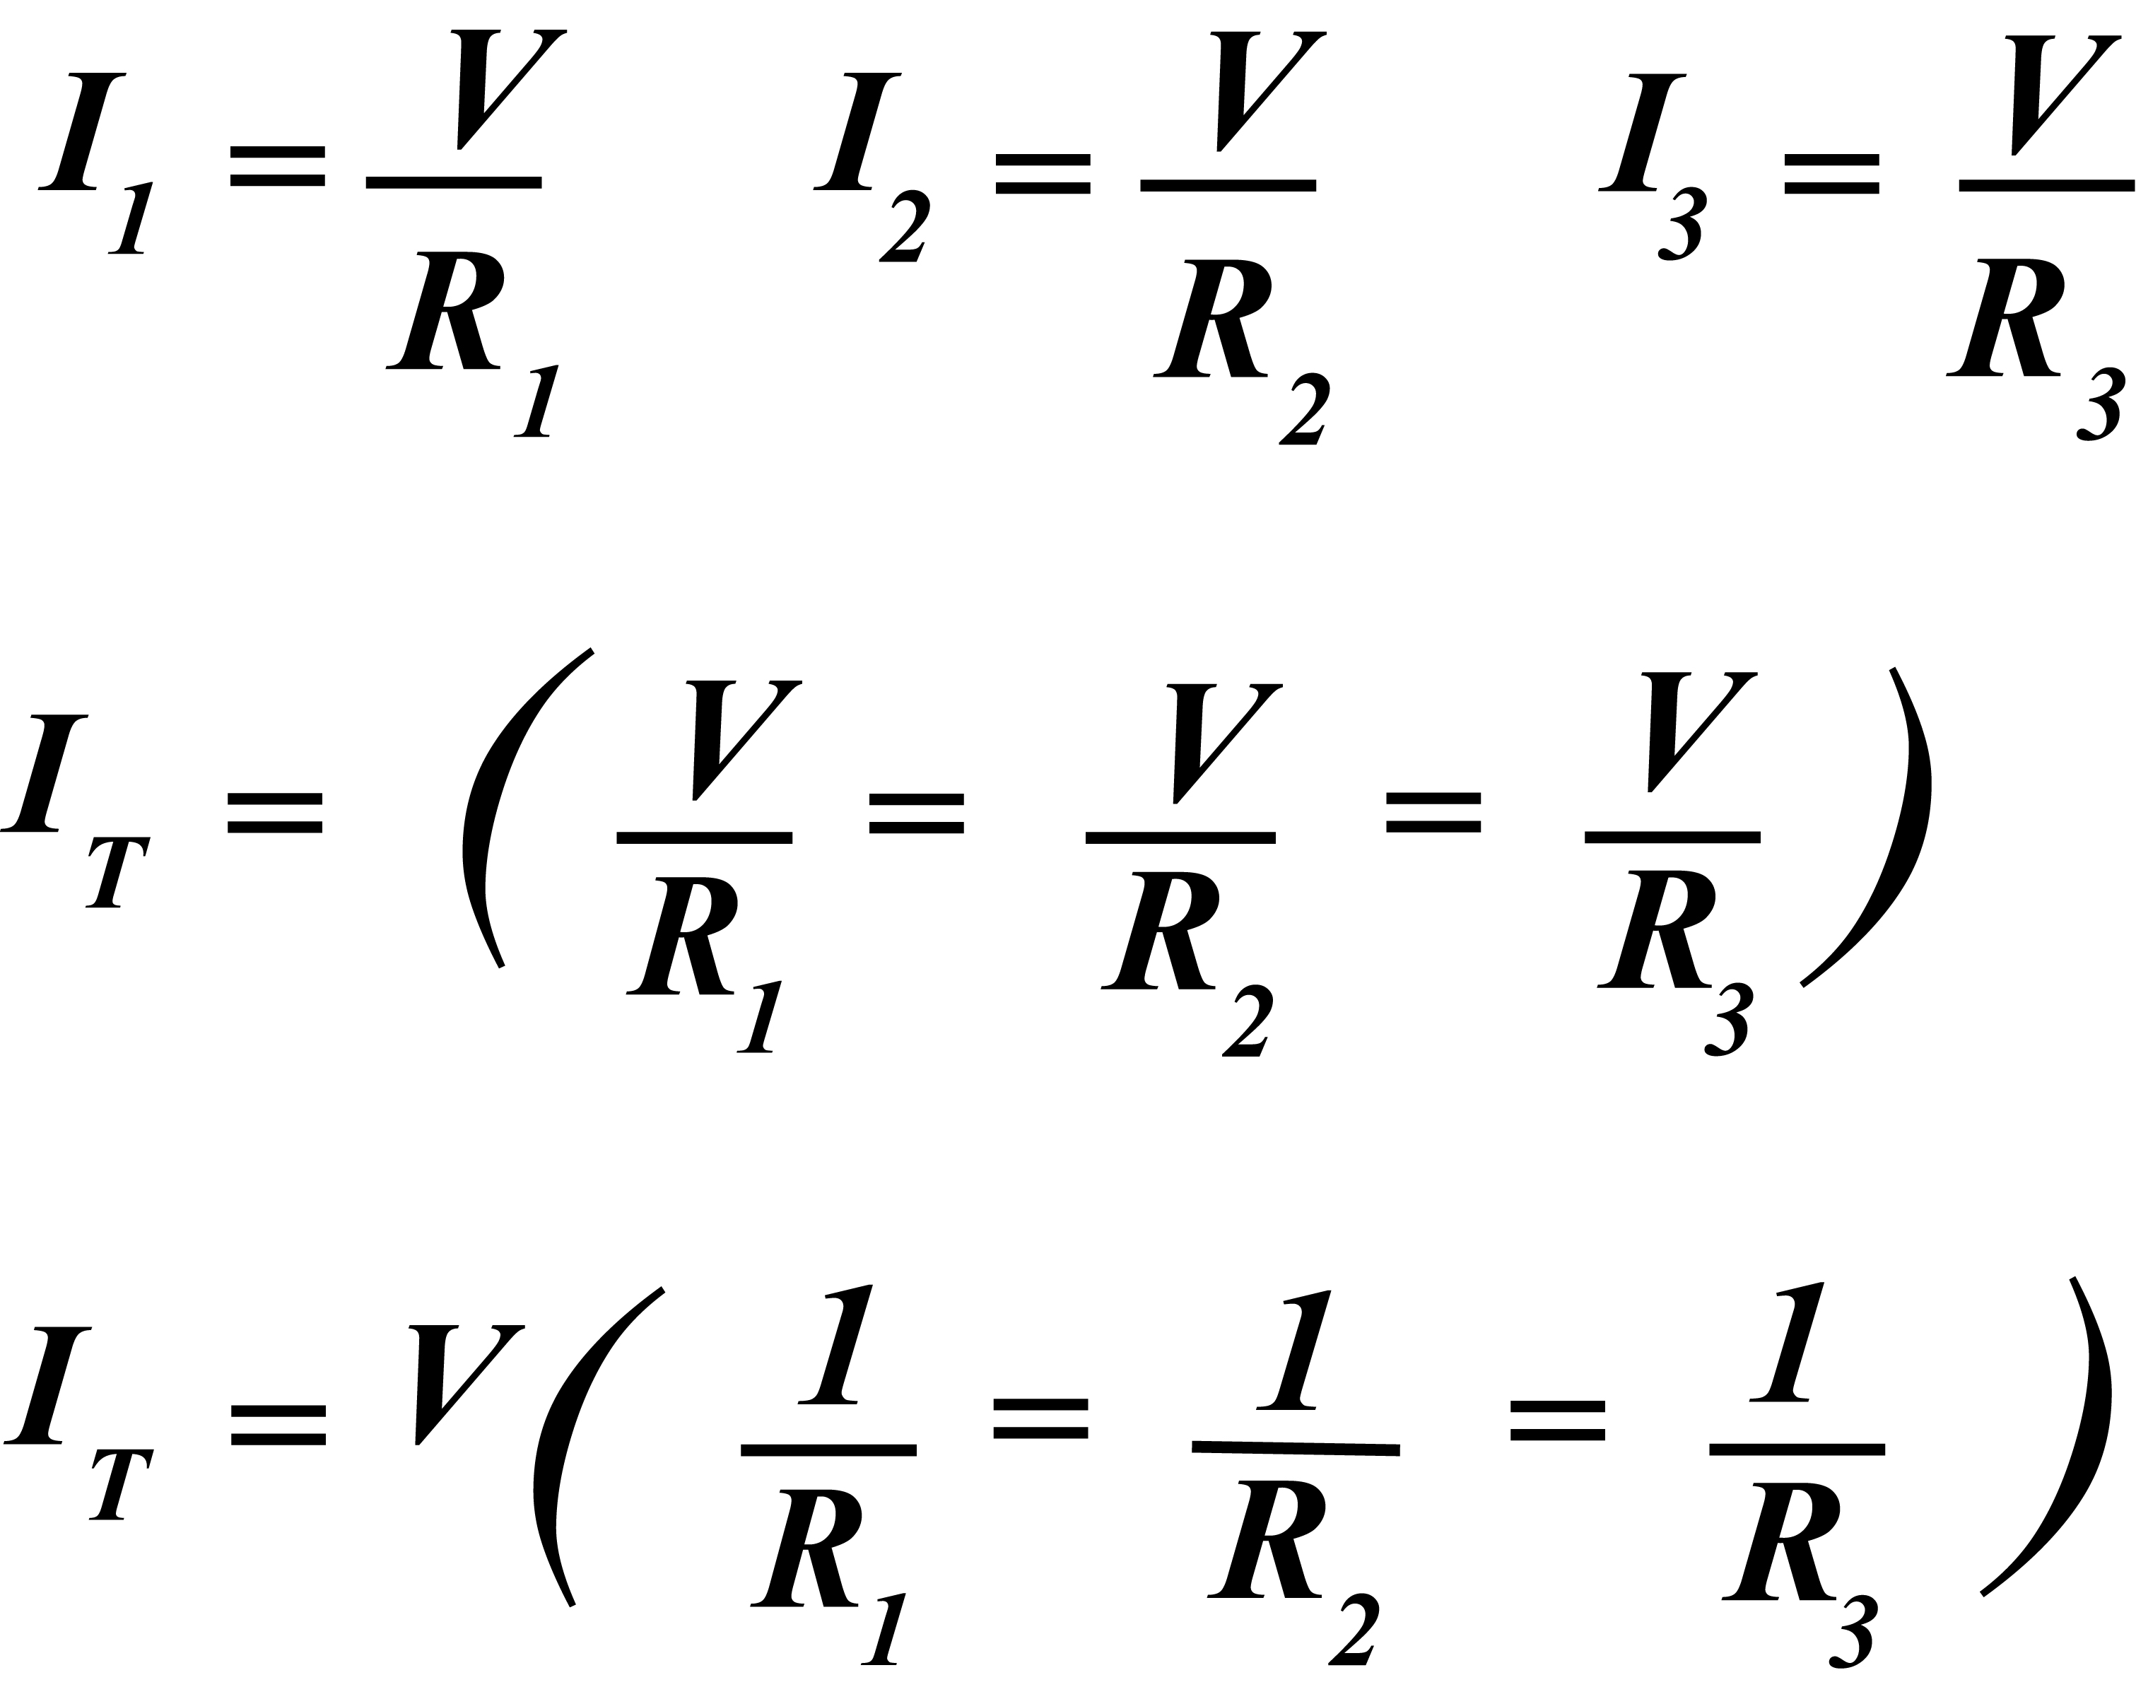
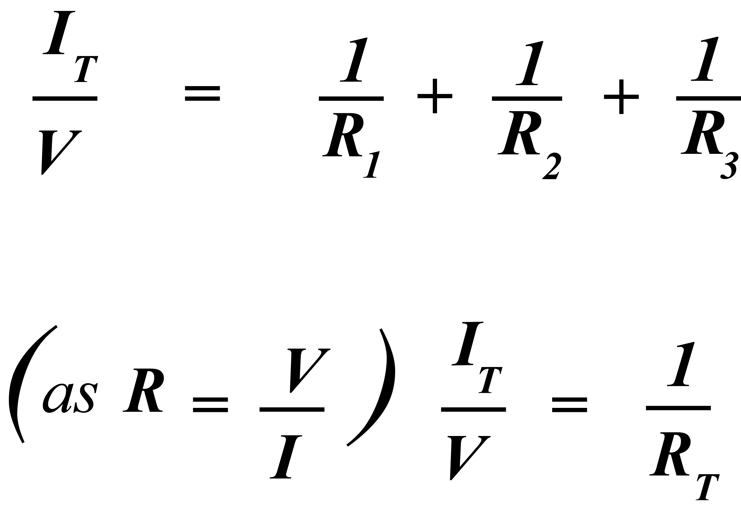
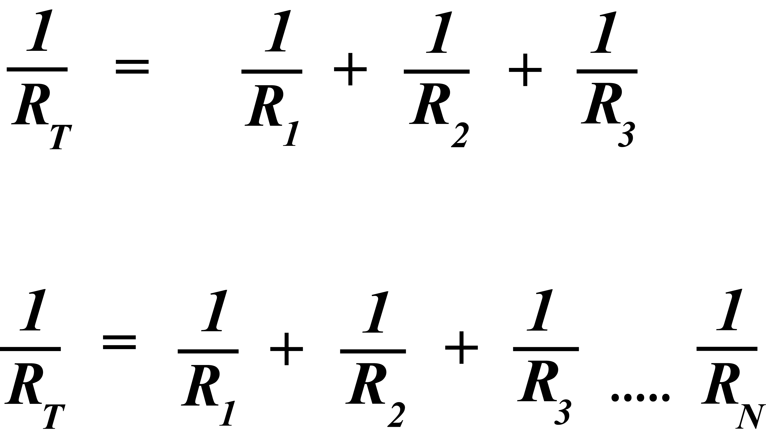

The total resistance of a parallel circuit is found by this formula:
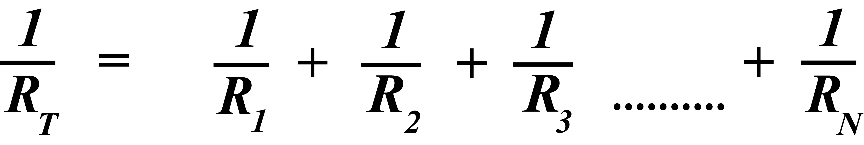
The total resistance in a parallel branch is always less than the smallest resistance in the branch.

Summary of Parallel Circuits
- There is only one voltage across all resistors in a parallel branch.
- The total current IT is equal to the sum of all the branch currents
- The total resistance of a parallel circuit is less than the resistance of the smallest branch.
- The total resistance is calculated by:
- An open circuit in one branch results in no current in that branch but the other branches are unaffected.
- A short-circuit in any branch results in a short circuit for the whole network and an excessive current flow in the total circuit.
- When electrical devices are connected to the vehicle battery they are connected in parallel with each other

2.23 Open Circuit (break)
An open circuit exists, when there is a break in the circuit, which will stop current flowing. See Figure 14.
- A switch is open.
- A fuse is blown or a circuit breaker is tripped.
- A physical break in the resistor or element.
- A connecting cable is broken.
An open circuit exists, when a break occurs in a circuit resulting in an extremely high resistance in the circuit. This value of extremely high resistance is referred to as infinity, denoted by the symbol-∞.
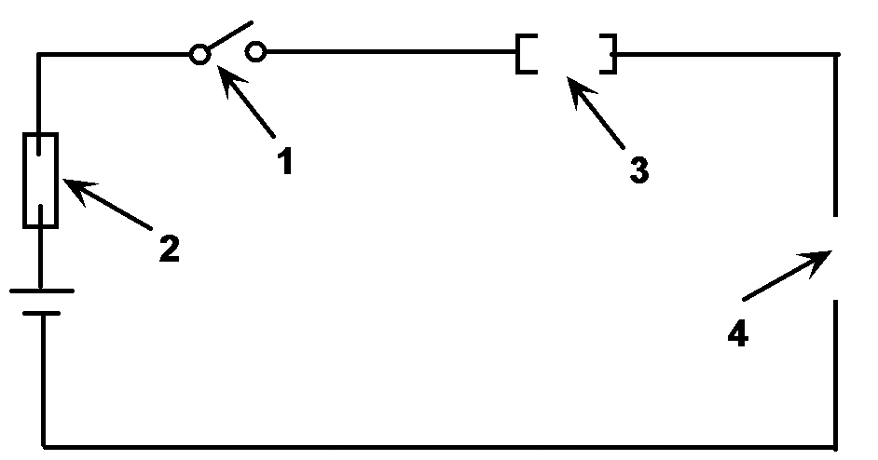
Figure 14.

2.24 Short Circuit
Current will flow through the path of least resistance or opposition in a circuit.
A short circuit occurs when the resistance or opposition in a circuit is very low and usually results in a dangerously high current flowing.
Assume a supply of 12 Volts and the circuit resistance of 0.1Ω.
From Ohm’s Law
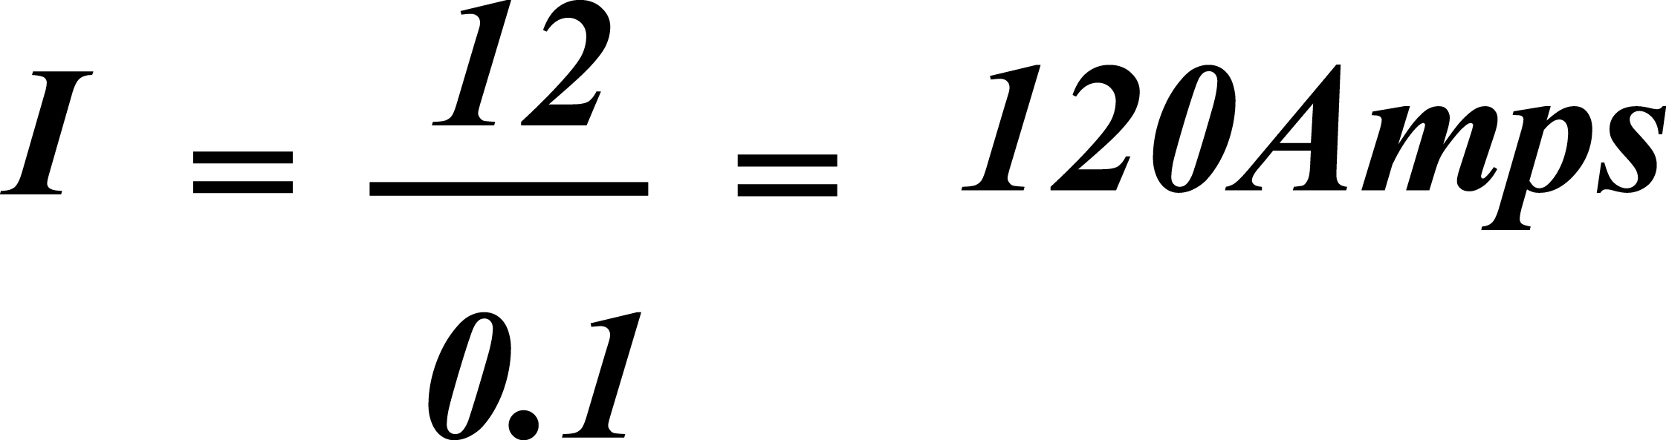
This is a very large current and if allowed to flow would cause cables to melt.
A short circuit can occur for several reasons as shown below:
- The “load” is shorted out and the current takes the path of least resistance to ground.
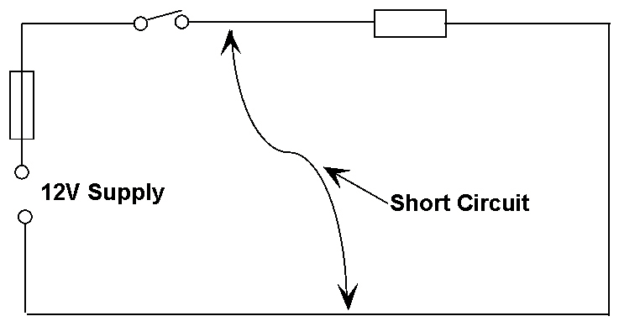
- The connecting cables are damaged prior to or after the wiring process.
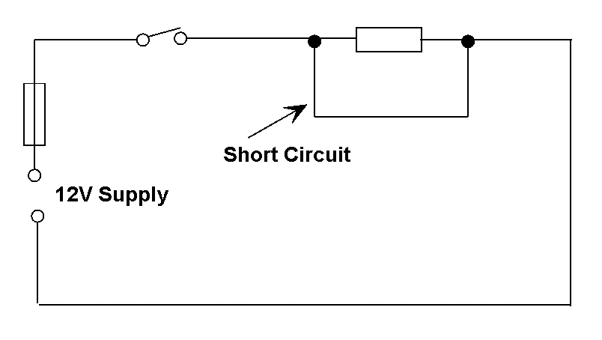
- The connecting cables in the circuit are connected together during the wiring process.

2.25 The Effects of an Electric Current
When an electric current flows in a circuit it can have one or more of the following effects:
- Heating Effect
- Magnetic Effect
- Chemical Effect

The Heating Effect
The movement of electrons in a circuit, which is the flow of an electric current, causes an increase in the temperature of the load resistance. The huge amount of electrons being pushed through the load resistance results in high friction and collision of these electrons.
The amount of heat generated depends upon the type and dimensions of the load resistance wire and the quantity of current flowing.
By changing these variables, a resistance wire may be operated at different temperatures to give different effects, e.g. an ordinary light bulb or an electric heater. See Figure 15.

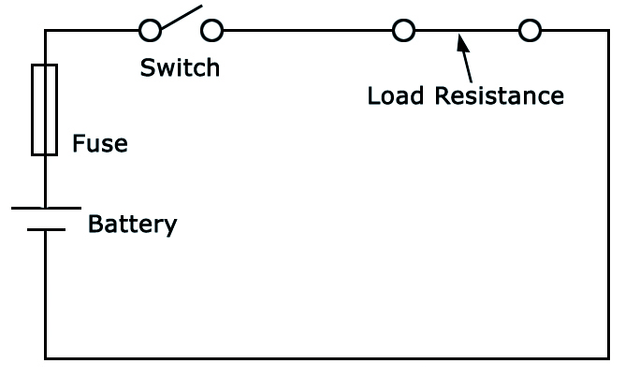
Figure 15

The Magnetic Effect
Whenever a current flows in a conductor a magnetic field is set up around that conductor. See Figure 16 below.
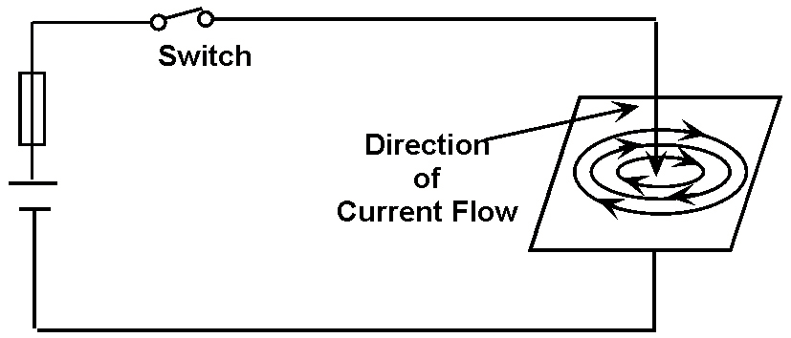
Figure 16.
This magnetic field increases in strength if the current is increased and collapses if the current is switched off.
A “current carrying conductor”, wound in the form of a solenoid (coil), produces a magnetic field very similar to that of a permanent magnet, but has the advantage in that it can be switched on or off by any switch controlling the circuit current.
The magnetic effect of an electric current is the principle upon which electric bells, relays, moving coil instruments, motors and generators work.
The strength of the magnetic field is directly proportional to the current in the circuit. The “clamp on” type ammeter measures the strength of the magnetic field and produces a reading in Amps.

Right Hand Grip Rule and Corkscrew Rule
There is a definite relationship between the direction of current flow in a conductor and the direction of the magnetic field around that conductor. The direction can be determined by the use of either the Right Hand Grip Rule or the Corkscrew Rule.

Right Hand Grip Rule
In a current carrying conductor, which is a straight wire, the direction of the magnetic field lines may be found quite simply by using the method. Fig 17A.
Thumb points in the direction of the conventional current, fingers curl in the direction of magnetic field.
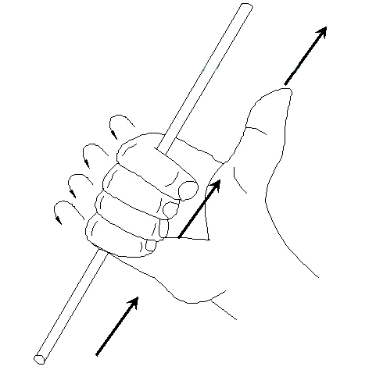
Fig 17A

Corkscrew Rule
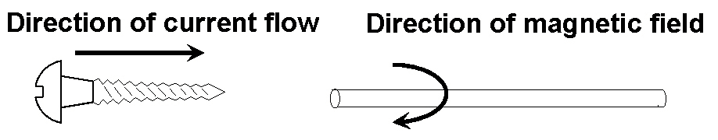
Fig 17 C
Refer to Figure 17C, visualise a screw being twisted into or out of the end of a conductor in the same direction as the current flow. The direction of rotation of the screw will indicate the direction of the magnetic field.

The Chemical Effect
When an electric current flows through an electrolyte (conducting liquid / paste), this electrolyte is separated into chemical parts. The two conductors, which make contact with the electrolyte, are called the anode (positive plate) and the cathode (negative plate).
An anode or cathode of dissimilar metals placed in an electrolyte can react chemically and produce an EMF. When a load is connected across the anode and cathode, a current will flow in the circuit. See Figure 18.
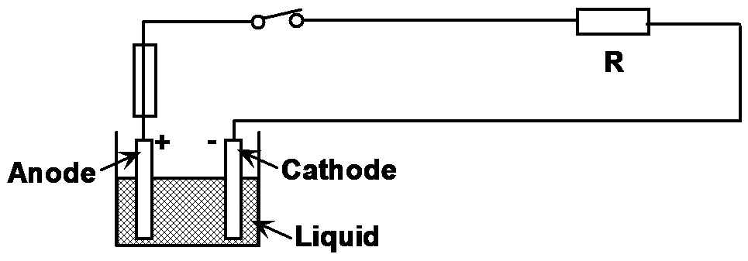
Figure 18.

2.26 Alternating Current (AC)
Alternating Current acts in two directions (positive and negative) and has a shape, which is shown in the drawing, this shape is called a sine wave.
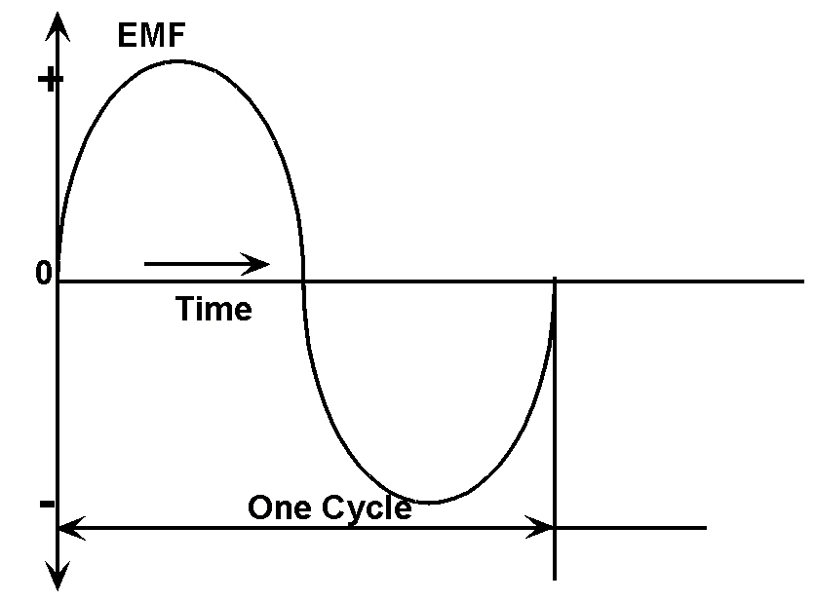
A sine waveform consists of equal positive and negative half cycles. Figure above shows the variation of the Voltage over time and is termed one cycle.

2.27 Frequency ( Symbol f )
This is the number of cycles completed in one second (t). It is measured in cycles per second or Hertz (Hz). A frequency of 50 Hz is the standard for the supply system in Ireland.

2.28 Graphical Symbols

Symbols used in Electric Circuits
Battery | 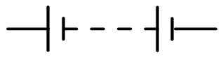
A load/ Resistor - Fixed Value
Resistor - Variable | 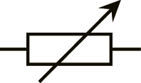
Ammeter | 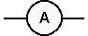
Voltmeter | 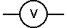
Ohmmeter | 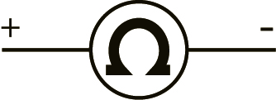
Cables Crossing (not jointed)
Cables Crossing (formerly) | 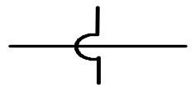
Cables Jointed | 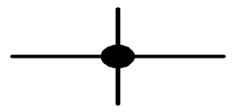
Bulb (a load) | 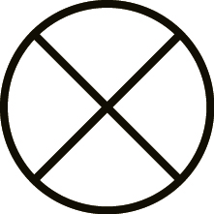
A Fuse
Switch Open | 
Switch closed in circuit
Diagrams switches are shown in their At Rest position.

2.29 Primary Automobile Terminal Designations
(Terminal Numbers used in Working Diagrams) (DIN Standard)
30 PERMANENT LIVE
15 LIVE WITH
31 EARTH
58 PARKING LIGHT (SIDE LIGHT)
56A HEADLIGHTS
56B DIMS
54 BRAKE LIGHTS
49 INDICATORS

2.30 Graphical Symbols DIN 72552

Electric terminal numbers
Automobile electric terminal numbers according to DIN 72552
For almost every contact in a vehicle there is a number code to standardise vehicle wiring. These numbers are defined in DIN 72552. This table gives most frequently used numbers for starter systems.
Contact ID | Identification
15 | battery+ through ignition switch
30 | from battery+ direct
50 | starter control
31 | return to battery- or direct to ground
Additional information is available from the “Autodata” materials supplied to FAS centres
Source: Bosch Automotive Handbook, 3rd edition


27-33 Upper Baggot Street
Dublin 4

