TRADE OF
Industrial Insulation

PHASE 2

Module 2

Geometry & Pattern Development

UNIT: 11

Valves & Flanges

Produced by

In cooperation with subject matter expert:

Michael Kelly

© SOLAS 2014
Table of Contents
Unit Objective 1
Introduction 2
1.0 Eccentric Reducer – Radial line Development 3
1.1 Concentric and Eccentric Reducers – Definition 3
1.2 Applications of an Eccentric Reducer 3
1.3 Geometry of Right Cones and Eccentric or Oblique Cones 4
1.4 Application of BS 8888:2004 Drawing Standards 4
2.0 Developing an Eccentric Reducer 5
2.1 Developing an Eccentric (Flat Back) Reducer /Oblique Cone Using the Radial line Method 5
2.2 Developing an Offset Round Taper Using the Triangulation Method 6
2.3 True Length Lines 7
3.0 Fabricating an Eccentric Reducer 8
3.1 Swage Allowances 8
3.2 Assembly Hole Location 8
3.3 Design of Joint Location for Manufacture 8
3.4 Communication through engineering Drawings 8
Summary 10

Unit Objective
By the end of this unit each apprentice will be able to:
- Identify the characteristics of an eccentric reducer.
- Identify the geometrical differences between right cones and eccentric or oblique cones.
- Accurately develop patterns for an eccentric cone using both radial line projection and triangulation.
Module 2
Geometry & Pattern Development
Unit 1
Basic Construction
Unit 6
One Piece Pyramid
Unit 5
Cones and Pyramids
Unit4
Equal and Unequal Tee Pieces
Unit 3
Parallel Line Development
Unit 2
Orthographic Projections
Unit7
Segmented Radius Bends
Unit 8
Triangulation
Unit 9
Tapered or Conical Tee
Unit 10
Flattened Bends and Straights
Unit 11
Valves and Flanges
Unit 12
Eccentric Reducer - Radial Line and Triangulation

Introduction
An Eccentric reducer is a conical shaped fitting that enlarges or reduces the diameter however it is not symmetrical about the centreline. Eccentric reducers are used in pipe-work systems to reduce the diameter of a pipe from one size to a smaller or larger size. In metal work eccentric reducers are also used to reduce or enlarge the diameter of ventilation ductwork. Eccentric reducers are known as reducers which are flat on one side and are generally used where ductwork is installed onto a flat surface, for example, onto a wall or tight to a ceiling slab.

1.0 Eccentric Reducer – Radial line Development

Key Learning Points
- Identification and characteristics of an eccentric reducer
- Applications of eccentric reducers
- Comparison of the geometry of right cones and eccentric or oblique cones
- Application of BS 8888:2004 drawing standards
- Identification of the need for true lengths

1.1 Concentric and Eccentric Reducers – Definition
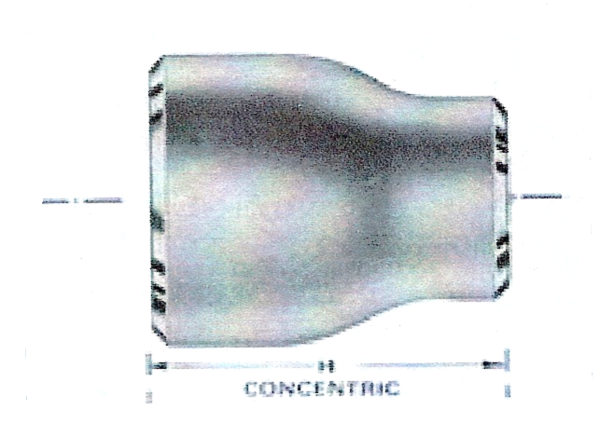
Concentric reducers are a symmetrical, conical shaped fitting that enlarges or reduces a diameter equally about a centreline.
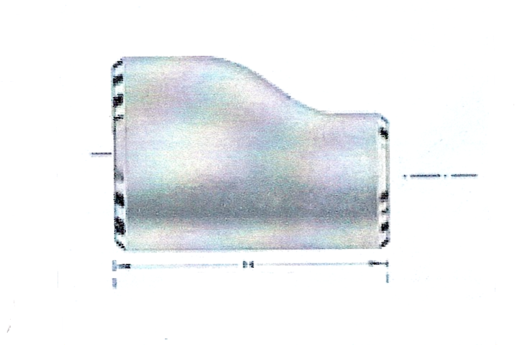
An Eccentric reducer is a conical shaped fitting that enlarges or reduces the diameter, however it is not symmetrical about the centreline.

1.2 Applications of an Eccentric Reducer
Eccentric reducers are used in pipe-work systems to reduce the diameter of a pipe from one size to a smaller or larger size.
In metal work eccentric reducers are also used to reduce or enlarge the diameter of ventilation ductwork. Eccentric reducers are known as reducers which are flat on one side and are generally used where ductwork is installed onto a flat surface, for example, onto a wall or tight to a ceiling slab.
In cladding work eccentric reducers are sometimes used where one pipe branches into another or as flashing pieces.

1.3 Geometry of Right Cones and Eccentric or Oblique Cones
A right cone has its apex directly above the centre of its base and forms a 90º angle with the base.
An eccentric or oblique cone has its apex away from the centre of its base and does not form an angle of 90º.
When developing or fabricating a concentric or eccentric reducer we always put the joint on the shortest side of the pattern unless otherwise stated on the drawing.

1.4 Application of BS 8888:2004 Drawing Standards
Because of the small scale used in most drawings, standard graphic symbols are used to present complete information concerning construction items and materials. These typical symbols are used so frequently in construction drawings that their meanings must be familiar not only to the draughts person, but to the user or fabricator as well.
Refer to module 2 – unit 1 and unit 2.

2.0 Developing an Eccentric Reducer

Key Learning Points
- Plan and elevation layout.
- Determination of true lengths
- Pattern development of eccentric and oblique cones using radial line
- Pattern development of eccentric and oblique cones using triangulation

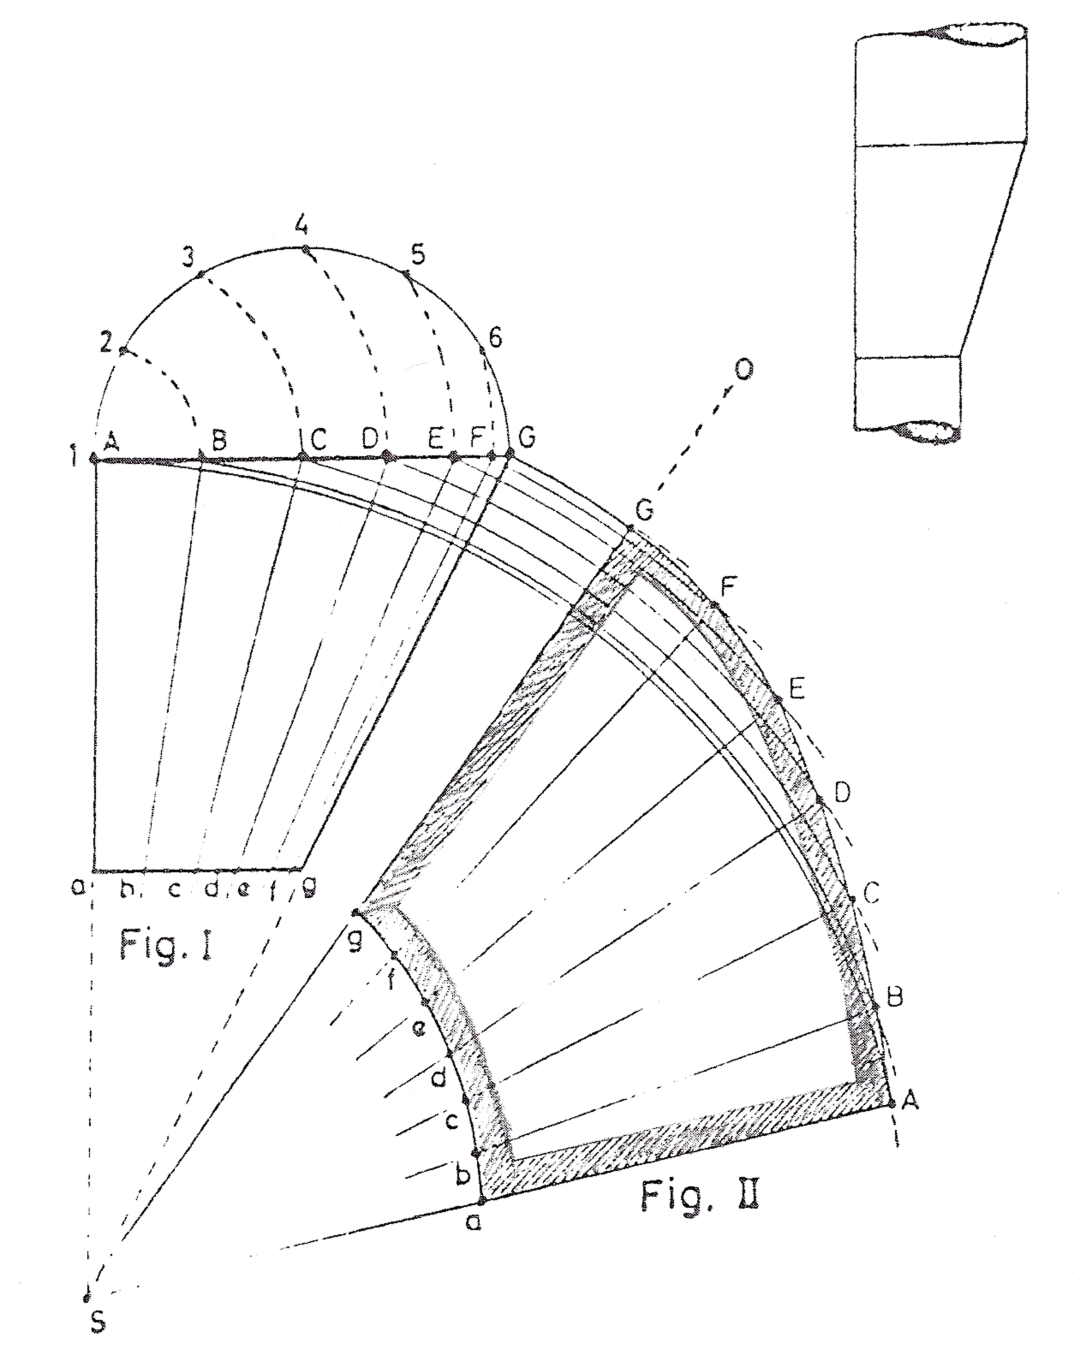
2.1 Developing an Eccentric (Flat Back) Reducer /Oblique Cone Using the Radial line Method
Figure I – Elevation.
Figure II – Half a development with the seam on the line Gg.
In figure I first draw the outline of the given cone agGa and find the vertex S by extending the two side lines Gg and Aa. Now draw a semicircle on the base line AG and divide it into 6 equal parts. Draw arcs with centre 1 and radii distances 1 to 2, 1 to 3, 1 to 4, etc. intersecting the base line AG at points B to F. The connecting lines BS, cS, etc. In their turn intersect the smaller diameter of the cone ag at points b to f. The generating lines Bb, Cc, etc. correspond to their true lengths.
For the development in figure II first determine a starter line at random; here it is shown as SO. Now draw arcs with centres at S and radii SA, SB etc. The arc with radius SG intersects the previously drawn starter line SO at point G. With the centre at G and radius 1 to 2 (1/12 of the circumference) in figure I draw another arc intersecting the arc with centre at S and radius SF at point F. With the centre at F and radius 1 to 2 again draw an arc intersecting the arc with centre at S and radius SE at point E. Proceed thus until all points up to A are found, and connect points A to G. This connecting line is half the circumference for the base of the cone. Now connect points A to F with S, and on these lines from points to G lay off the respective generating lines a, Bb, etc.
It is important to make sure to check this curved length AG as not to do so may result in a diameter that is either too big or too small. The same should be done with the curved length ag for the small diameter of the cone.

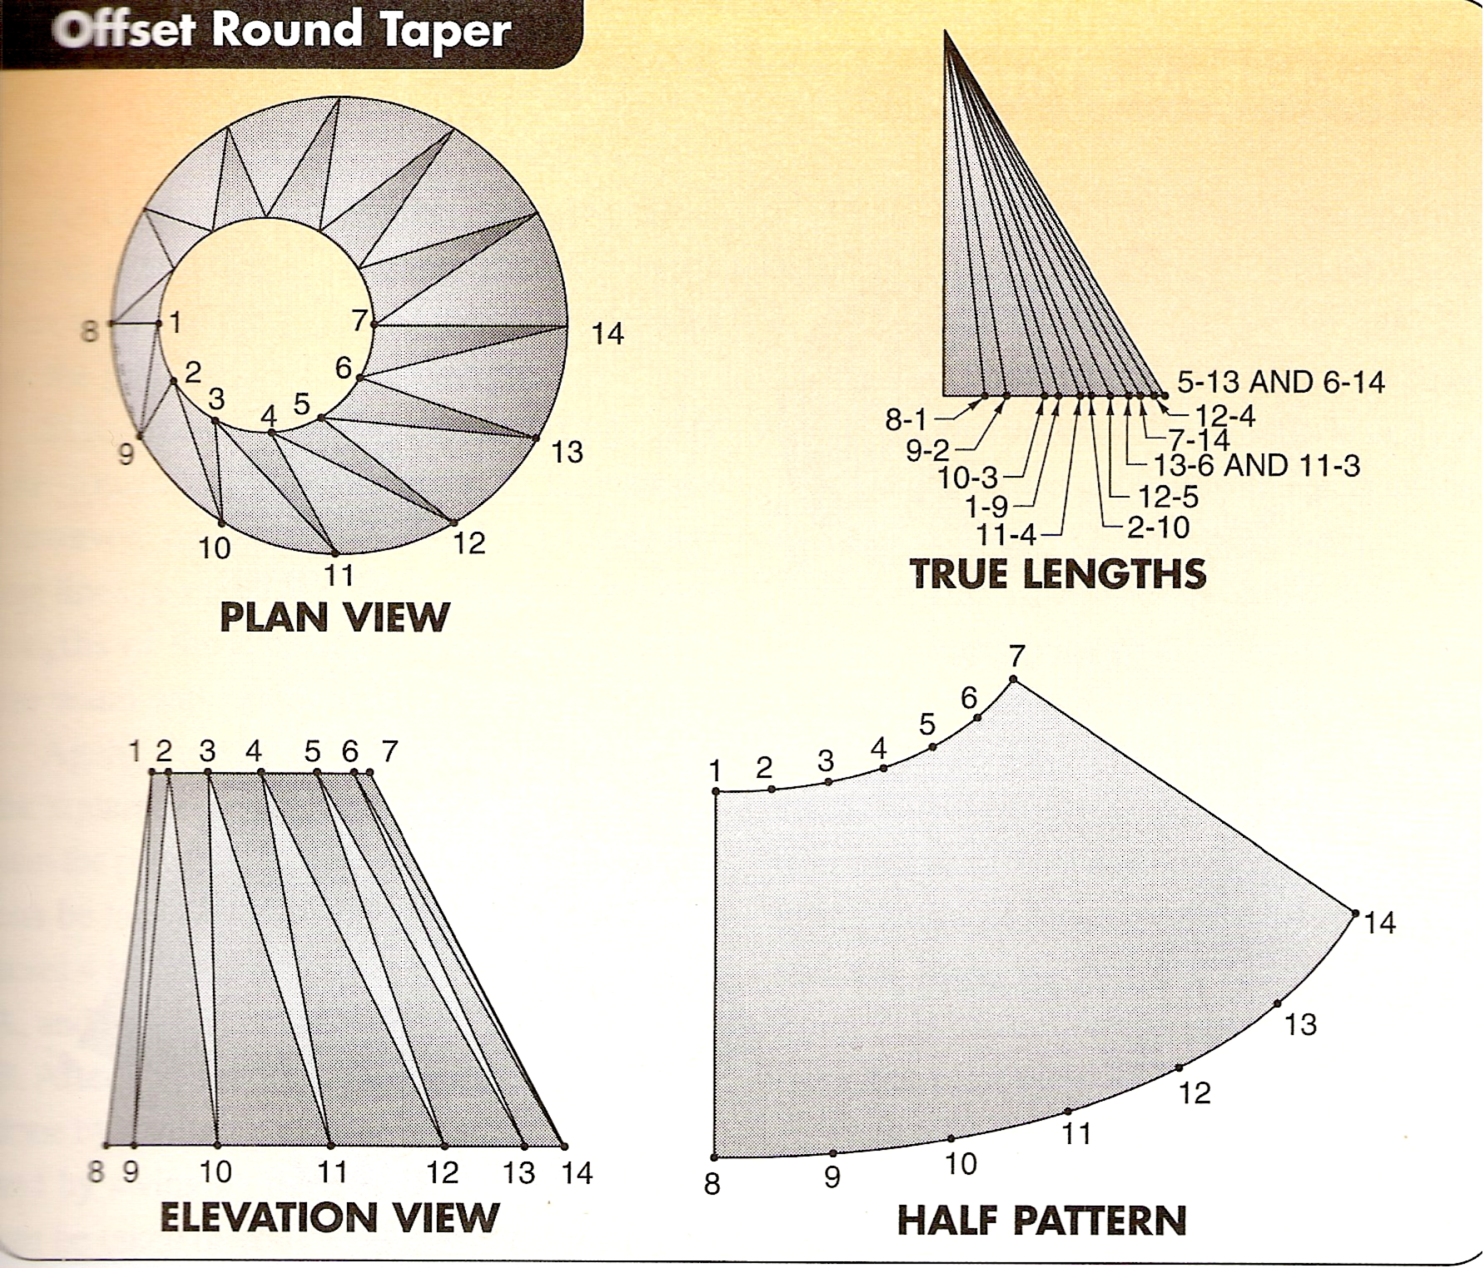
2.2 Developing an Offset Round Taper Using the Triangulation Method
The plan and elevation of an offsetting round taper are shown above. The first step in developing the pattern is to determine the measuring lines on the plan view. This is done by dividing both circles into 12 equal parts. This procedure is very similar to date in parallel line development. After the circles are divided into equal parts, the measuring lines are drawn as shown. The first triangle formed is 8-9-1.
After the plan view is drawn, the measuring lines located, and the true lengths found, the pattern can be started. This is done by drawing a line and marking the true length line 8-1 on it. This gives two known points from which to measure. Next, locate point 9 by taking the distance 8-9 from the plan view and swinging it from point 8. Next take the true length of line 1-9 from the true length triangle. Then swing it from point 1. The intersection of these two arcs gives point 9.
Point 2 is located next by measuring from points 1 and 9. After 2 is found, then 10 is located by measuring from 2 and 9. After 10 is found, then 3 is located by measuring from points 2 and 10. Points 11, 4, 12, 5, 13, 6, 14, and 7 are found in the same manner and in the order given. If the plan view is thought of as a road map and the measuring lines are followed, there should be little trouble in finishing the pattern. Use care when taking measurements.

2.3 True Length Lines
The apprentice will come across true lengths and false lengths many times during their career. It is important to recognise the difference. To obtain the true length of any line, place the plan length against the vertical height at right angles and measure the diagonals. If a line has a plan length but no vertical height, then the true length is the plan length, taken from the plan. If a line has a vertical height but no plan length then its’ true length is taken from the elevation.

3.0 Fabricating an Eccentric Reducer

Key Learning Points
- Allocation of swage allowances
- Design of joint location for manufacture. Assembly hole location and lap allowances. Communication through drawings and sketches.

3.1 Swage Allowances
Once the development or pattern has been marked out on metal, allowances must be added to the outside of the pattern for joints, seams, swages etc. Depending on the type of joint or seam, the correct amount of material must be added onto the pattern before it is cut out.
Refer to module 1 – unit 5 – General allowances for insulation and cladding.

3.2 Assembly Hole Location
Refer to module 1 – unit 6 – Marking, Cutting, Punching, Rolling, Seam swaging and Screwing.

3.3 Design of Joint Location for Manufacture
When we develop patterns, we generally keep the joint on the shortest side unless otherwise stated on the drawings. The joint location on a fitting should be designed for the location in which it will be installed. Joint location is very important when cladding is installed on exposed pipe work as the ingress of water through the joints will result in damage to the insulation underneath.
From an appearance point of view, it is always best to keep the joints out of view or hidden if possible. The overall appearance of a job may rest on the location of joints and how the job is assembled. A lot of thought and planning is required before starting to manufacture cladding pipe work and fittings.

3.4 Communication through engineering Drawings
An engineering drawing is a graphical language or an international language, and is one of the main forms of communication in the workshop or on site. In oral or written communication were the only means of communication when dealing with technical matters, misunderstandings could arise, particularly in relation to shape and size which could have serious implications for a company. Jobs fabricated and installed incorrectly could lead to wasted time and materials, loss of profits, bad customer relations, breach of contract and litigation. However, the universally accepted methods used in graphical communication through engineering drawings helps to eliminate many of the difficulties mentioned above by proper representation and layout of the job with all the details and information shown on the drawings. Mistakes can still be made, however, they are vastly reduced by good engineering drawing practice.
To ensure uniformity of interpretation the British Standards Institution have produced a booklet entitled BS 8888: 2004.

Summary
An Eccentric reducer is a conical shaped fitting that enlarges or reduces the diameter however it is not symmetrical about the centreline.
Eccentric reducers can be developed using both the radial line method or the triangulation method of pattern development. A clear understanding of both of these methods of development is required before attempting to develop such fittings.
When we develop patterns, we generally keep the joint on the shortest side unless otherwise stated on the drawings. The joint location on a fitting should be designed for the location in which it will be installed. Joint location is very important when cladding is installed on exposed pipe work as the ingress of water through the joints will result in damage to the insulation underneath. From an appearance point of view, it is always best to keep the joints out of view or hidden if possible. The overall appearance of a job may rest on the location of joints and how the job is assembled. A lot of thought and planning is required before starting to manufacture cladding pipe work and fittings.
An engineering drawing is a graphical language or an international language, and is one of the main forms of communication in the workshop or on site. In oral or written communication were the only means of communication when dealing with technical matters, misunderstandings could arise, particularly in relation to shape and size which could have serious implications for a company.

Castleforbes House
Castleforbes Road
Dublin 1

