TRADE OF
Industrial Insulation

PHASE 2

Module 2

Geometry & Pattern Development

UNIT: 2

Orthographic Projections

Produced by

In cooperation with subject matter expert:

Michael Kelly

© SOLAS 2014

Table of Contents
Unit Objective 1
Introduction 2
1.0 First and Third Angle Orthographic Projection 3
1.1 Orthographic Projection – Definition 3
1.2 Primary or Principal Planes of Projection 4
1.3 First Angle Projection 4
1.4 Constructing an Orthographic Drawing 8
1.5 Third Angle Projection 9
1.6 First and Third Angle Orthographic Projection Symbols 10
1.7 Standard Drawing Abbreviations and Symbols 11
2.0 Engineering Drawings 12
2.1 Engineering Drawings- A graphical Language 12
2.2 Functions of an Engineering Drawing 12
2.3 Lines and Letters 13
2.4 Dimensioning 15
2.5 Scales 19
Summary 20

Unit Objective
By the end of this unit each apprentice will be able to:
- State the difference between first and third angle orthographic projections.
- Construct simple orthographic drawings in first and third angle.
- Correctly interpret and obtain information from simple blueprints and working drawings.
- Use dimensioning techniques and conventional symbols to BS:8888: 2004.
- Efficiently sketch a sheet metal component.
Module 2
Geometry & Pattern Development
Unit 1
Basic Construction
Unit 6
One Piece Pyramid
Unit 5
Cones and Pyramids
Unit4
Equal and Unequal Tee Pieces
Unit 3
Parallel Line Development
Unit 2
Orthographic Projections
Unit7
Segmented Radius Bends
Unit 8
Triangulation
Unit 9
Tapered or Conical Tee
Unit 10
Flattened Bends and Straights
Unit 11
Valves and Flanges
Unit 12
Eccentric Reducer - Radial Line and Triangulation

Introduction
Orthographic projection is a means of representing a three dimensional object on a plane surface. Two principal planes are used in orthographic projection, one horizontal and one vertical. Collectively, these two planes have come to be called the planes of reference. Orthographic projection uses multiple views of an object, from points of view rotated about the objects centre through increments of 90 degrees.

1.0 First and Third Angle Orthographic Projection

Key Learning Points
- Identification of planes of projection
- Relative positions for first and third angle orthographic projection
- First and third angle orthographic projection symbols
- Use of elevations, plans and end elevations
- Alignment of views
- Information transfer from one view to another
- Standard abbreviations and symbols used in drawings
Often, a three dimensional object must be represented with precision and clarity on a plane surface. Pictorial representations of a three-dimensional object on a plane are adequate only if the object is simple, however a different method of representation must be used for more complex objects – one that will show the true shapes of their surfaces.
By observing the shadows of objects cast by light sources, it can be seen that an object can be ‘projected’ onto a two-dimensional surface (i.e. a plane of projection) by projecting points of the object onto the surface and joining them in order.

1.1 Orthographic Projection – Definition
Orthographic projection is a means of representing a three-dimensional object in two dimensions. It uses multiple views of an object, from points of view rotated about the objects centre through increments of 90 degrees. Equivalently, the views may be considered to be obtained by rotating the object about its centre through increments of 90 degrees.
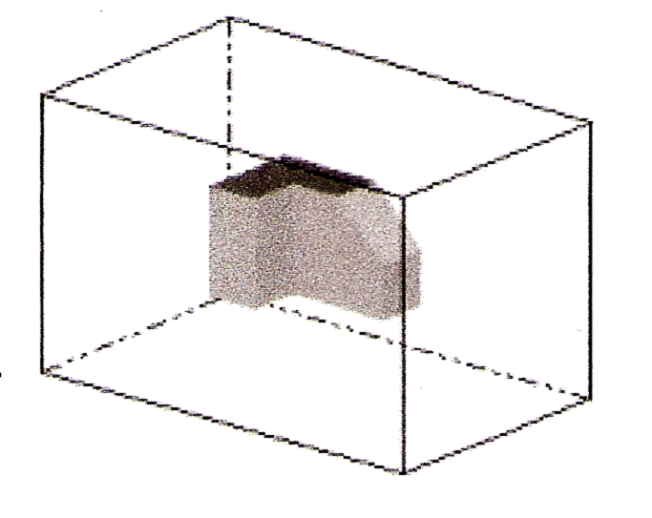
The views are positioned relative to each other according to either of two schemes: first-angle or third-angle projection. In each- the appearances of views may be thought of as being “projected” onto planes that form a transparent “box” around the object.

1.2 Primary or Principal Planes of Projection
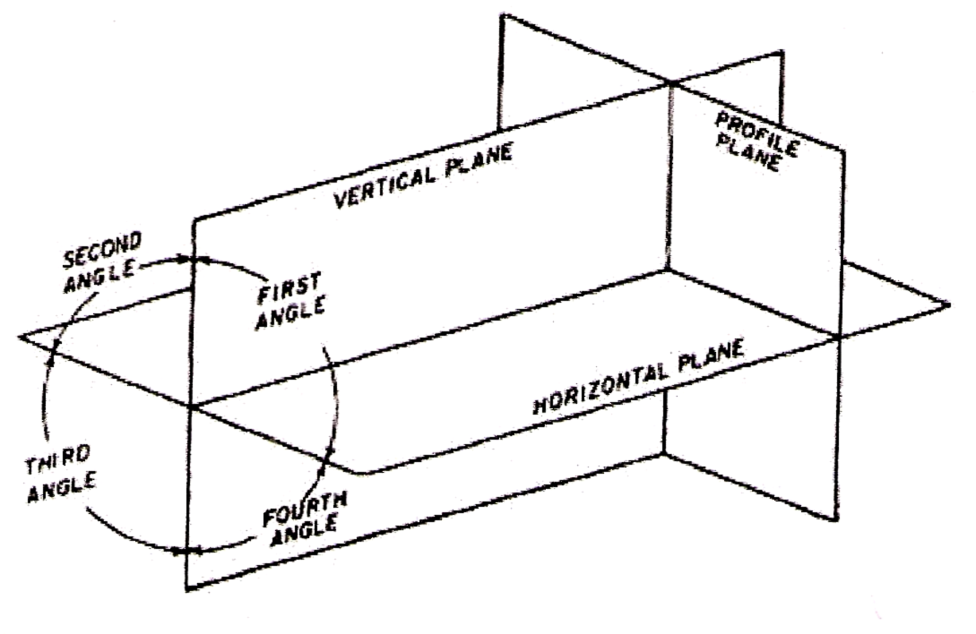
When drawing a number of views of an object, the object is viewed through a plane of projection from a point at infinity, thereby obtaining an accurate outline of the visible face of the object. However, the projection of one face will not provide an overall description of the object; other planes of projection must be used. Establishing an object’s true height, width and depth requires a front, top and side views, which are called the principal planes of projection. The three principal (or primary) planes of projection are known as the vertical, horizontal and profile planes. The angles formed between the horizontal and the vertical planes are called the first, second, third and fourth angles as shown in the diagram below. For practical purposes only the first and third angle is used.
Principal planes of projection.

1.3 First Angle Projection
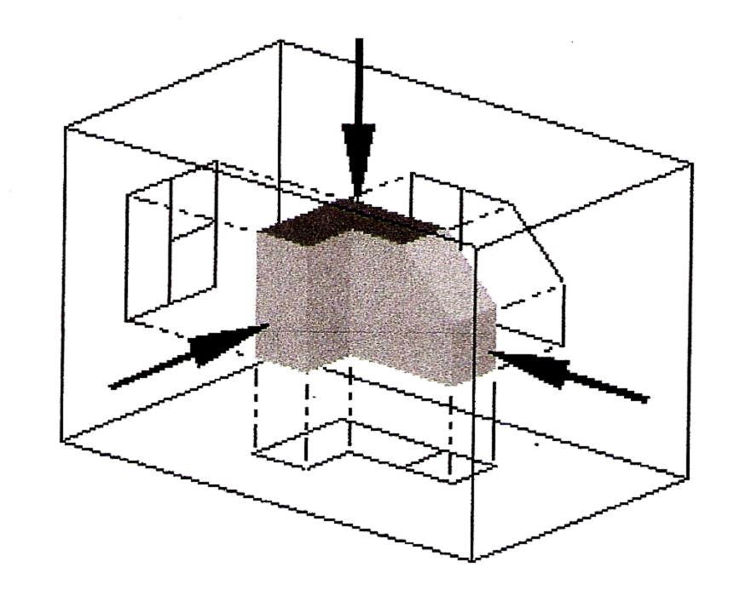
In first angle projection, each view of the object is projected in the direction (sense) of sight of the object, onto the interior walls of the box.
A two dimensional representation of the object is then created by “unfolding” the box, to view all the interior walls.
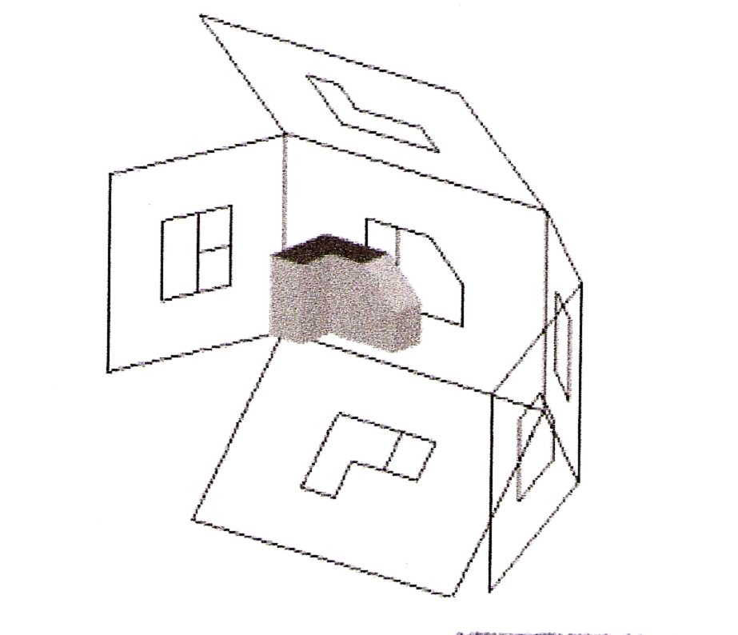
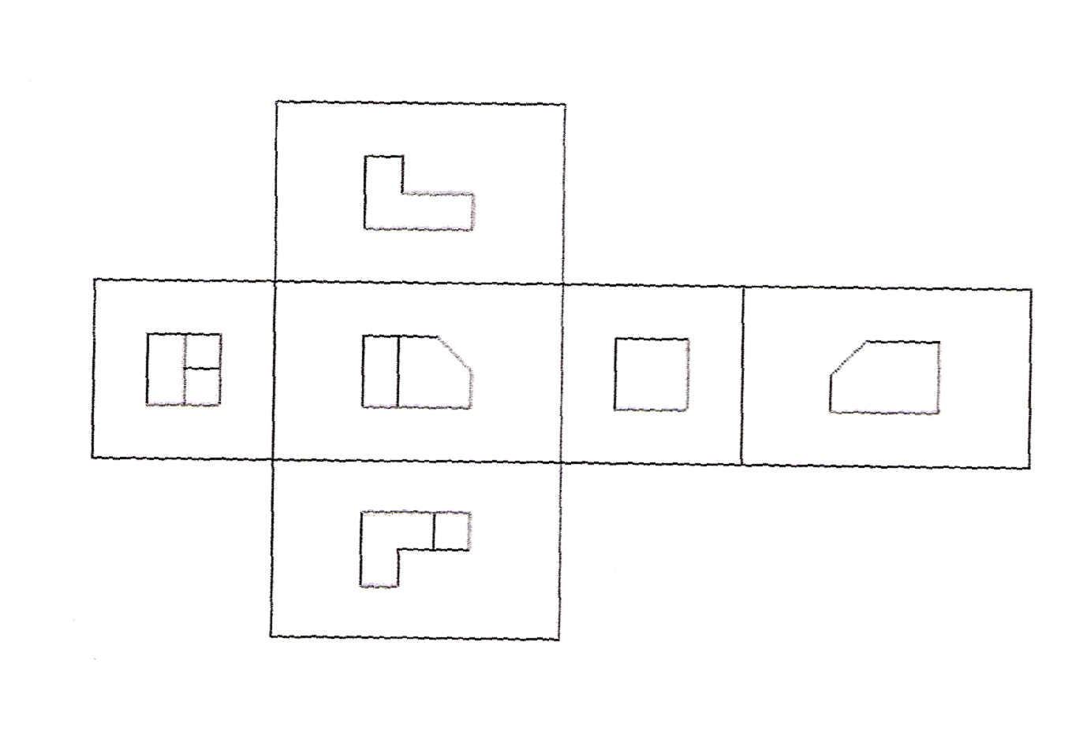
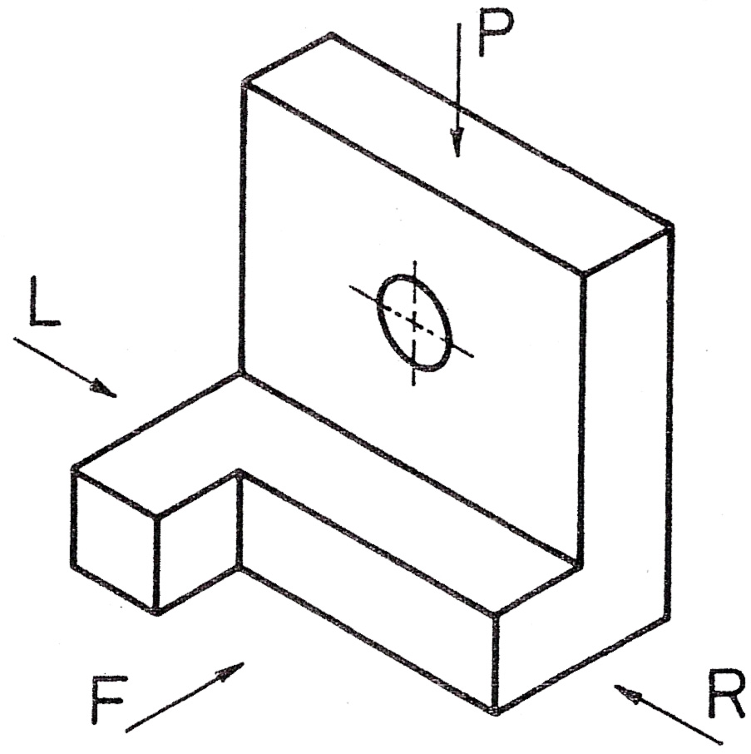
The pictorial drawing, see Fig. 1, indicates the shape of the component with a single view.
An orthographic drawing indicates the shape of a component by using a number of views each looking at a different face of the component. Usually, however, three views are shown in order to clarify internal and external detail:
- A Front view
- A Plan view
- A Side view
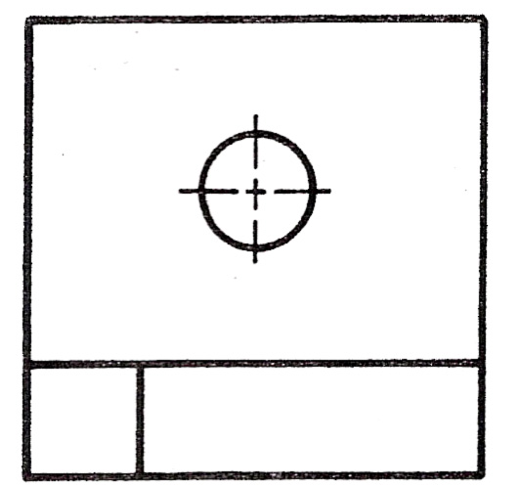
- The front view, or front elevation (Fig. 2), represents what is seen when looking at the front of the component in the direction of arrow F.
Fig. 2
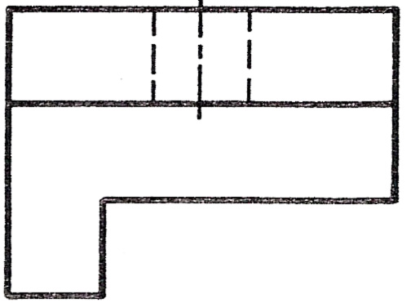
- The plan view (Fig. 3) represents what is seen when looking at the top of the component in the direction of arrow P at 90° to arrow F.
Fig. 3
- A side view, or side elevation (Fig. 4 and 5), represents what is seen when looking at the side of the component in the direction fo either arrow R or arrow L. Theses arrows are at 90° to both arrow F and arrow P.

View looking in direction of arrow R.  Right-Hand Side View (R). | 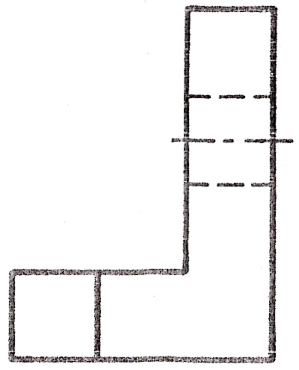 | 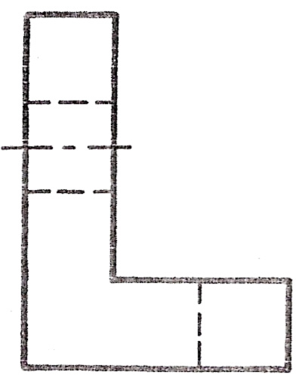 | View looking in direction of arrow L.  Left-Hand Side View (L).
The separate views of the component are combined to form a complete orthographic drawing as shown below.
The front and side views are drawn in line with each other so that the side view may be “projected” from the front view and visa versa.
The plan view is drawn in line with and below the front view. In other words, the plan is projected from the front view.
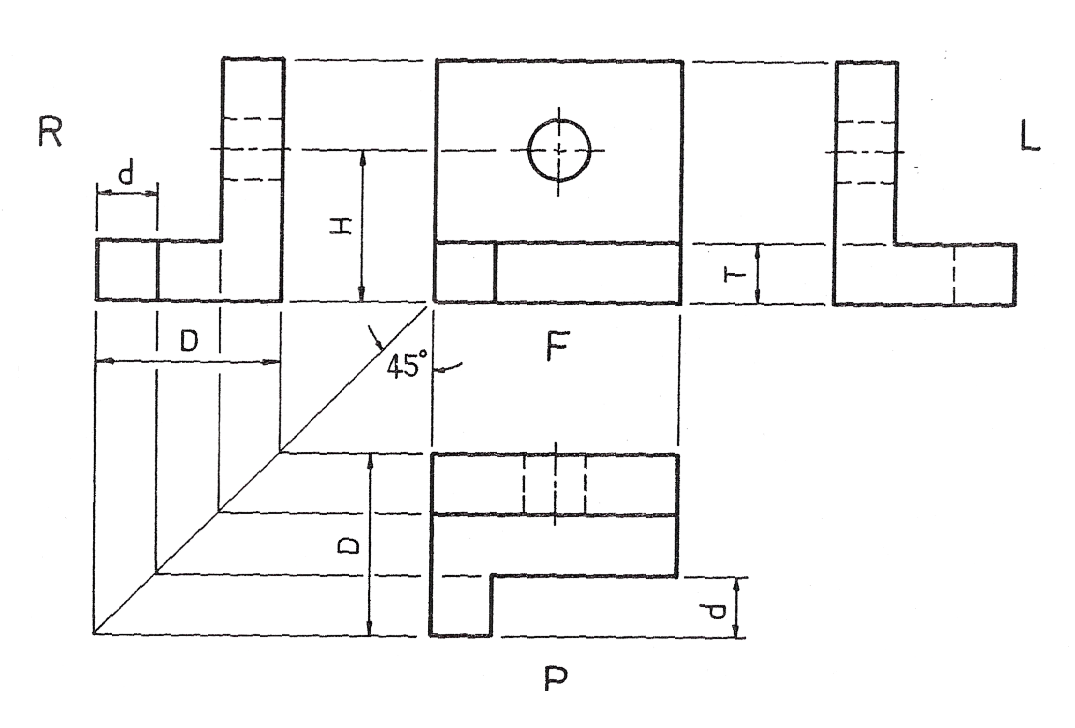
Points to note when making a drawing using first angle orthographic projection:
- Corresponding heights in the front view and side view are the same. For example, the height of the hole from the base, H, is the same in both front and side views. The thickness of the base, T, is the same in both front and side views.
- Widths in the side view correspond to depths in the plan. For example, the total width, D, in the side view is the same as the total depth, D, in the plan. The width, d, is the same in both plan and side views. Projection of widths from side view to plan is made easier by using the 45º swing line as shown above.
- The plan view is usually projected below the front view. It can be above but this would be called an “inverted” plan.
- The R.H. side view is shown on the L.H. side of the front view.
- The L.H. side view is shown on the R.H. side of the front view.
Note: Drawings should be read (or interpreted) by viewing from the R.H. side or bottom R.H. corner of the drawing.

1.4 Constructing an Orthographic Drawing
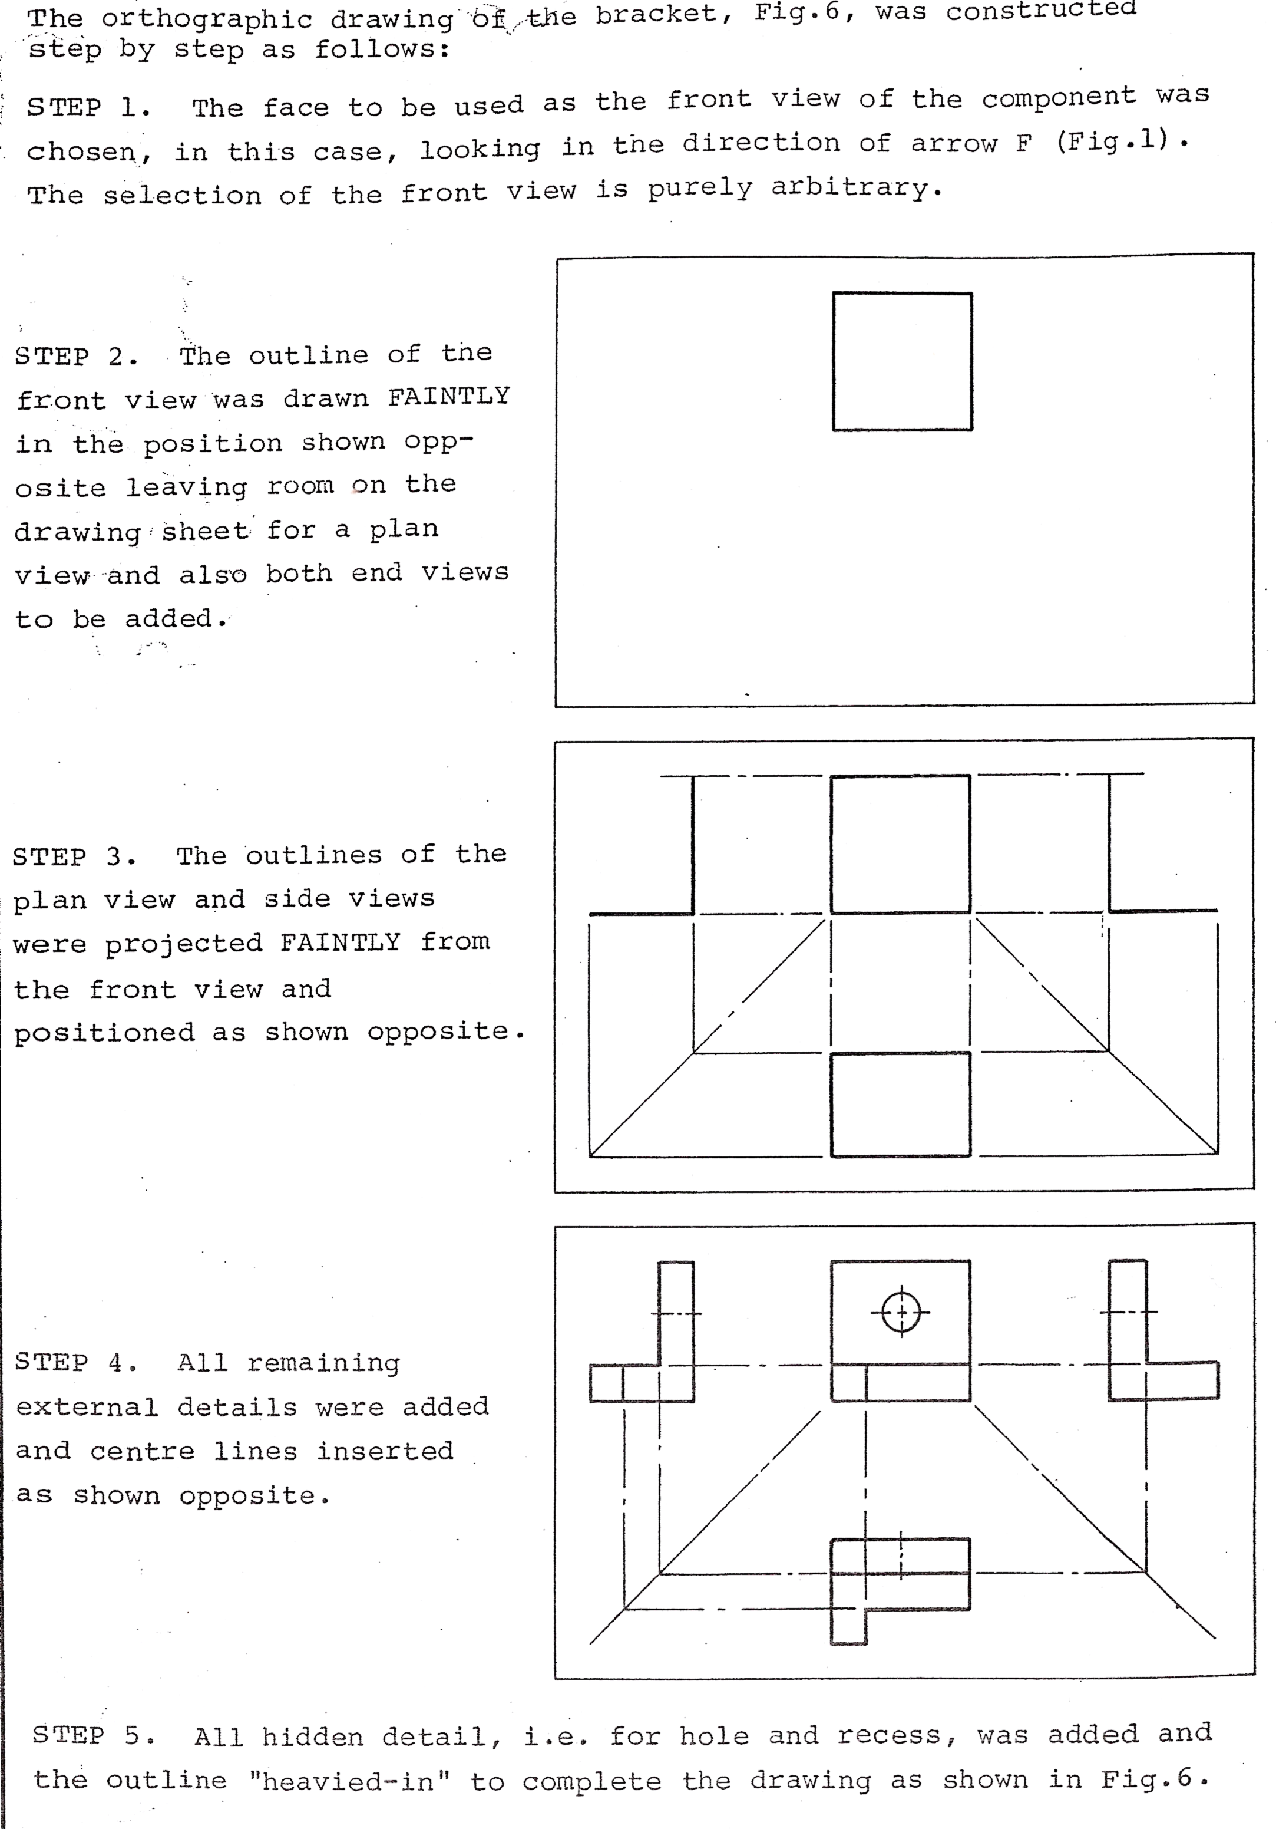
- The face to be used as the front view of the component was chosen, in this case, looking in the direction of arrow F (fig.1) above. The selection of the front view is purely arbitrary.
- The outline of the front view is drawn faintly in the position shown above leaving room on the drawing sheet for a plan view and also both end views which will be added.
- The outlines of the plan view and side views are projected faintly from the front view and positioned as shown above.
- All remaining external details were added and centre lines inserted as shown above.
- All hidden detail, i.e. for hole and recess, are added and the outline is made more prominent to complete the drawing as shown above.

1.5 Third Angle Projection
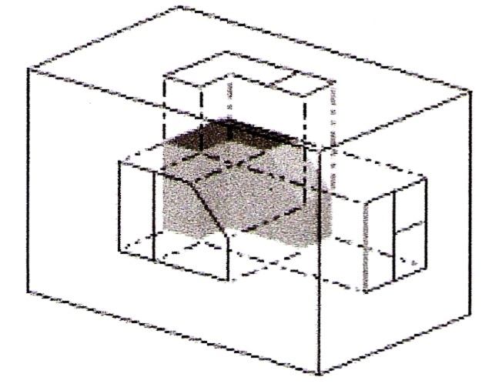
In third angle projection, each view of the object is projected opposite to the direction (sense) of sight of the object, onto the interior walls of the box.
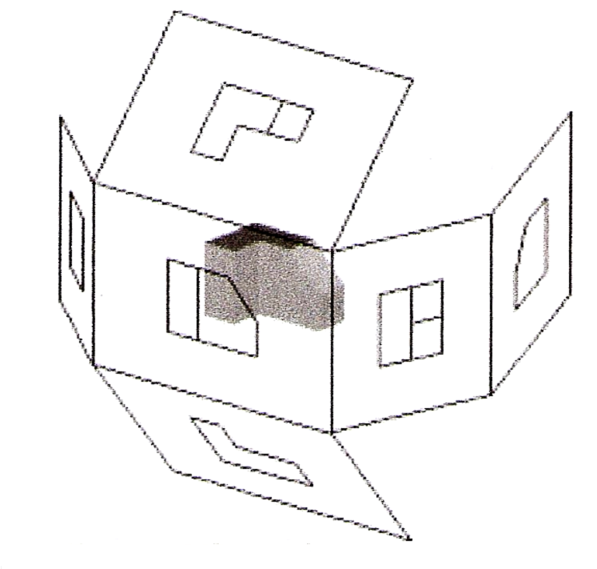
A two dimensional representation of the object is then created by “unfolding” the box, to view all the interior walls.

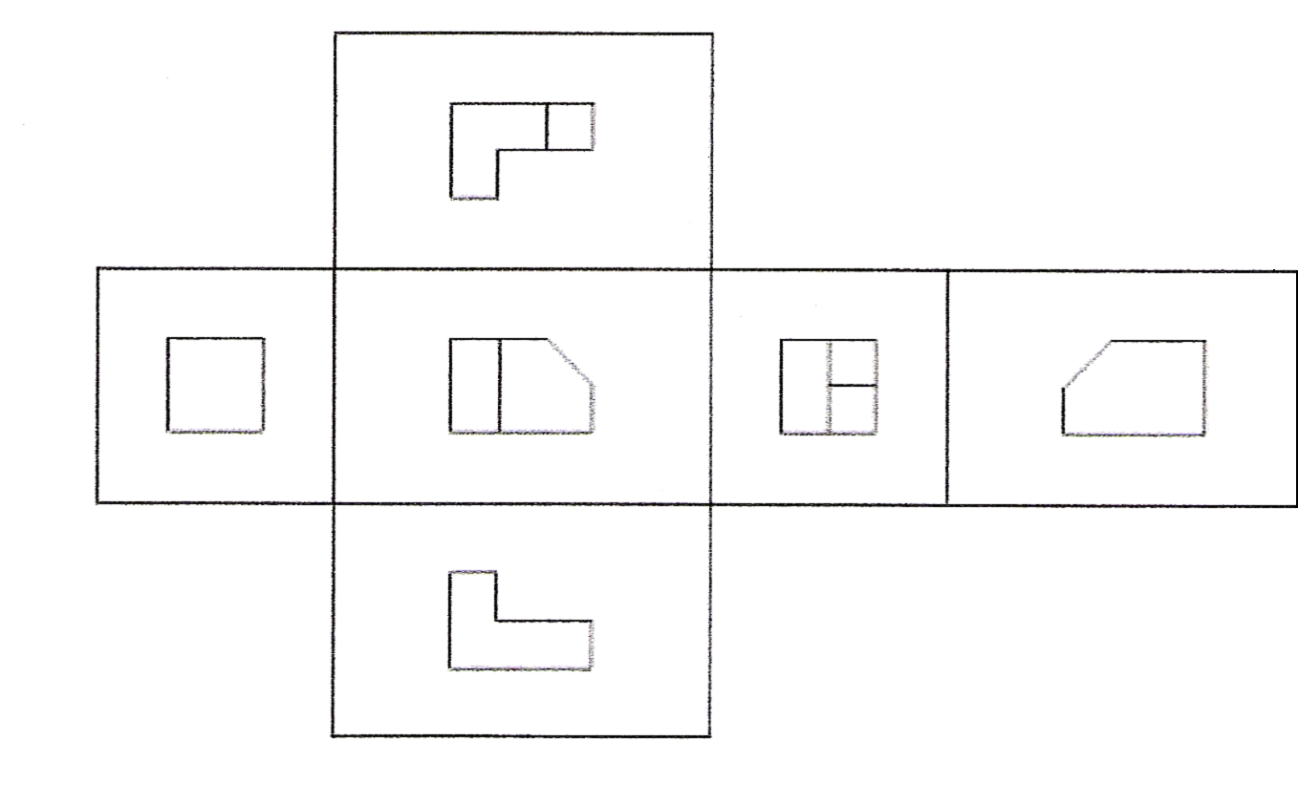
Additional Information
The term “third-angle” is used because, compared to “first-angle” projection, the directions of projection are rotated through two right angles about the object. Second-angle and fourth-angle projection also are defined, but do not result in useful images.
Third-angle projection is often considered to be more intuitive than first-angle projection.
While third-angle projections are prevalent in the USA and Canada, First-Angle projection is more popular in Europe and Asia.

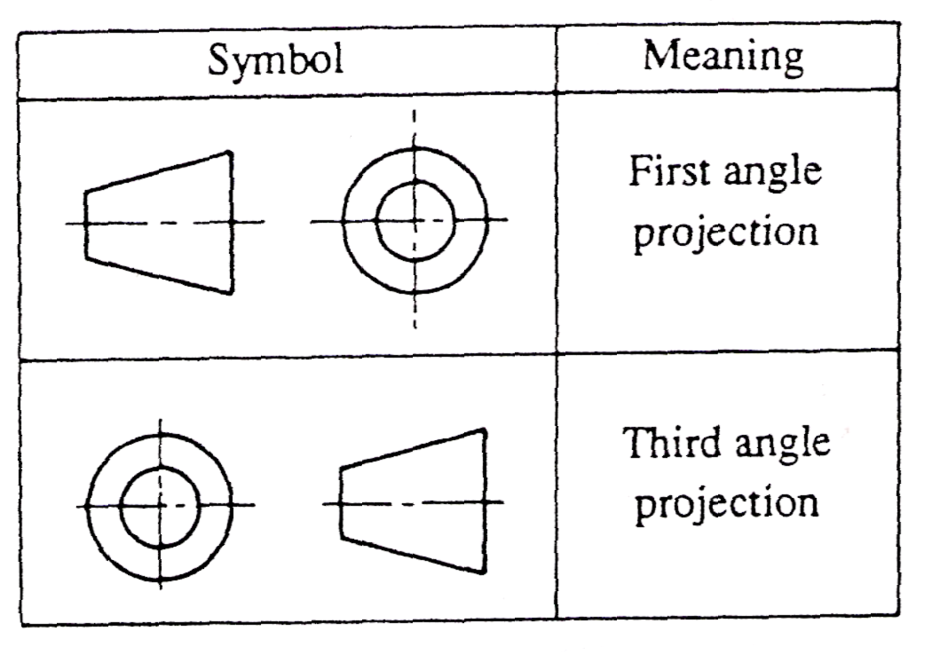
1.6 First and Third Angle Orthographic Projection Symbols
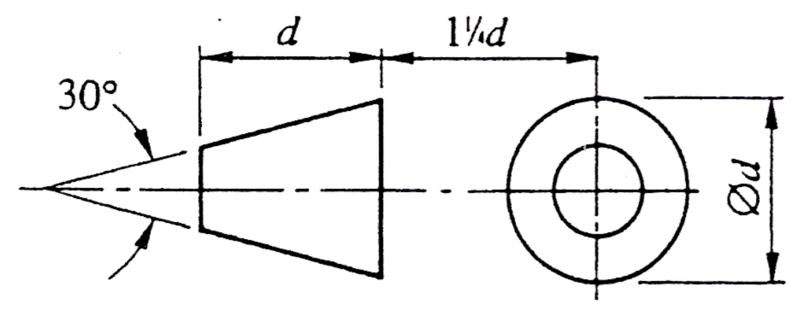
Standard Symbols
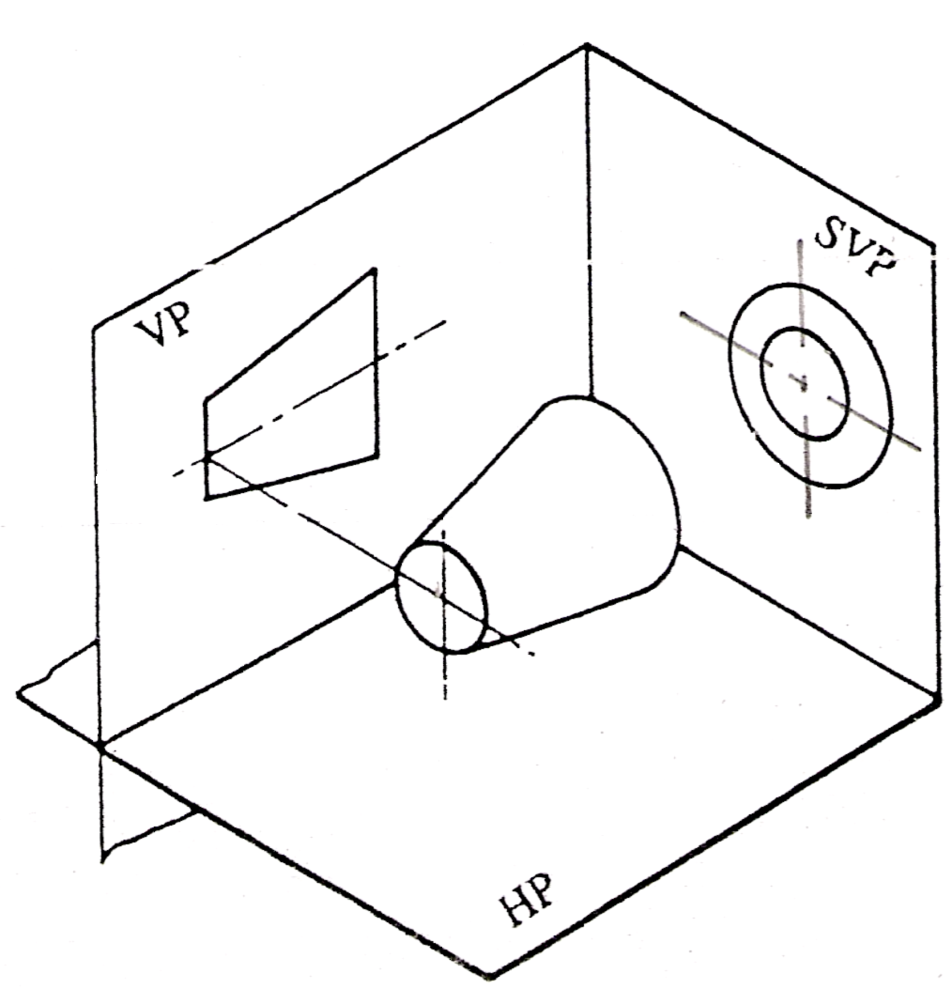
Recommended Proportions for symbols: The symbols for first and third angle are based on the frustum of a cone as shown.
Frustum of cone in the first quadrant: First-angle projection; View from the left appears on the right.

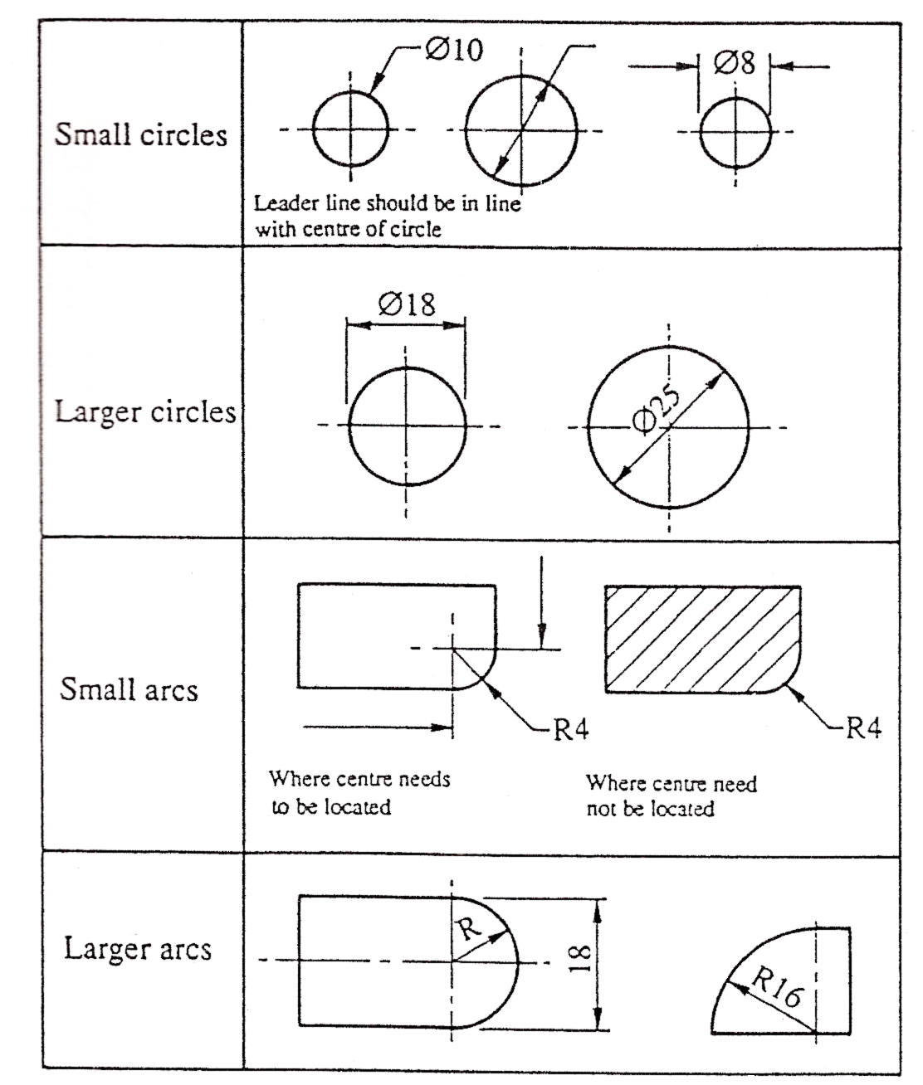
1.7 Standard Drawing Abbreviations and Symbols
Some commonly used symbols and abbreviations.

2.0 Engineering Drawings

Key Learning Points
- Drawing construction techniques
- Dimensioning techniques to BS 8888: 2004
- Freehand sketching
- Neatness and accuracy in drawing
- Logical approach to drawing and adherence to drawing standards
- Use of hidden detail
- Use of centre lines

2.1 Engineering Drawings- A graphical Language
An engineering drawing is a graphical language or an international language, and is one of the main forms of communication in the workshop or on site. In oral or written communication were the only means of communication when dealing with technical matters, misunderstandings could arise, particularly in relation to shape and size which could have serious implications for a company. Jobs fabricated and installed incorrectly could lead to wasted time and materials, loss of profits, bad customer relations, breach of contract and litigation. However, the universally accepted methods used in graphical communication through engineering drawings helps to eliminate many of the difficulties mentioned above by proper representation and layout of the job with all the details and information shown on the drawings. Mistakes can still be made, however, they are vastly reduced by good engineering drawing practice.
To ensure uniformity of interpretation the British Standards Institution have produced a booklet entitled BS 8888: 2004.

2.2 Functions of an Engineering Drawing
Drawing office personnel use an engineering drawing to transfer a mental picture of an object to the workshop or site. To avoid any confusion to the receiver the following rules should be followed.
- A drawing should be accurate.
- Lines should be clear and distinct.
- Components names and terms used must comply with correct engineering terminology.
- A drawing must give sufficient information to enable the craftsperson to convert the information given into a finished component or job without further contact with the drawing office.
- As a draughts person is human and subject to human error, all working drawings must be subject to an independent check. One small error in the drawing office can be the cause of wasted time and materials.

2.3 Lines and Letters

Types of Line
The types of line for engineering drawings recommended in the British Standards Institution in BS 8888: 2004. Two line thicknesses are recommended: thick 0.7mm wide and thin 0.3mm wide. For pencil drawings the recommendation can be interpreted as meaning that thick lines should be approximately twice as wide as thin lines.
The visible outlines of the object are drawn in continuous thick lines. They should be the most prominent lines on the drawing.
He hidden outlines of the object are represented by lines made up of short thin dashes. The dashes and the gaps between them must be consistent in length and approximately to the proportions as shown. At corners and tangent points of arcs, dashes should meet.
The continuous thin line is used for dimension lines, projection lines, leaders for notes, hatching or section-lining, the outlines of adjacent parts and revolved sections and fictitious outlines.
The limits of partial views and sections are shown by continuous irregular lines when the line is not an axis. These lines are thin and drawn freehand.
Centre lines and the extreme positions of moveable parts are shown by thin chain lines. These comprise of long dashes alternating with short dashes, not dots, proportioned approximately, as shown. The lengths of the dashes and their spacing may be extended for very long lines.
Cutting planes for sections are represented by chain lines, thick at their ends and at changes of directions, thin elsewhere.
Thick chain lines indicate surfaces which have to meet special requirements. The lengths of the parts of these lines and the spacing between them should be similar to those of thin chain lines.
All chain lines must begin and end with a long dash. Centre lines should extend beyond the feature to which they refer for a short distance only, unless required for dimensioning. They should not be drawn through the spaces between views and must not end at another line of the drawing. Also they must cross each other at solid parts of the lines.
Chain lines having angles formed in them should be drawn with long dashes meeting at the angles. Arcs should join at tangent points.
Arrowheads at the end of dimension lines must touch the projection lines and those at the end of leaders must touch another line on the drawing. They must be sharp, black, filled-in and about 3mm long.

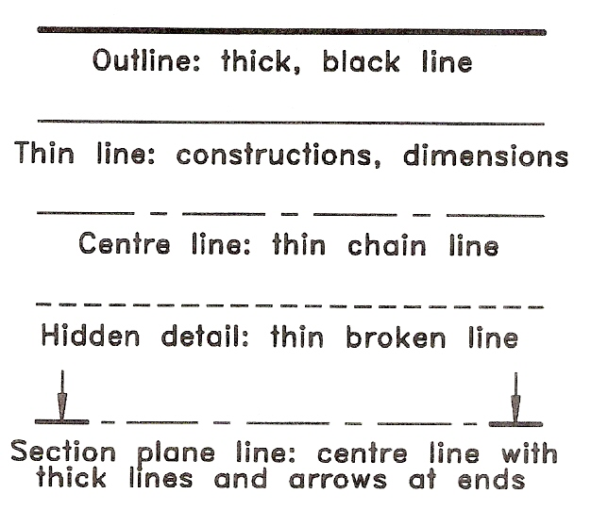
Lettering and Numbering
The essential features of lettering on engineering drawings are legibility, uniformity and the ability to be produced rapidly. Legibility and speed are achieved by the use of block, single-stroke style which may be either upright or sloping. Students are recommended to use the upright style as it is easier to produce. Single-stroke lettering has all the strokes of uniform thickness, and each stroke is produced by one movement of the pencil. Capital letters are preferred to lower-case ones, being less congested and less likely to be misread when reduced in size on prints. Lower-case letters should, however, be used when they are part of a standard symbol, code or abbreviation.
A suitable alphabet and figures are shown and this model should be consulted frequently in the early stages until the character forms are memorized. Note that the characters have the simplest possible forms. Flourishes and ornament are out of place on an engineering drawing.
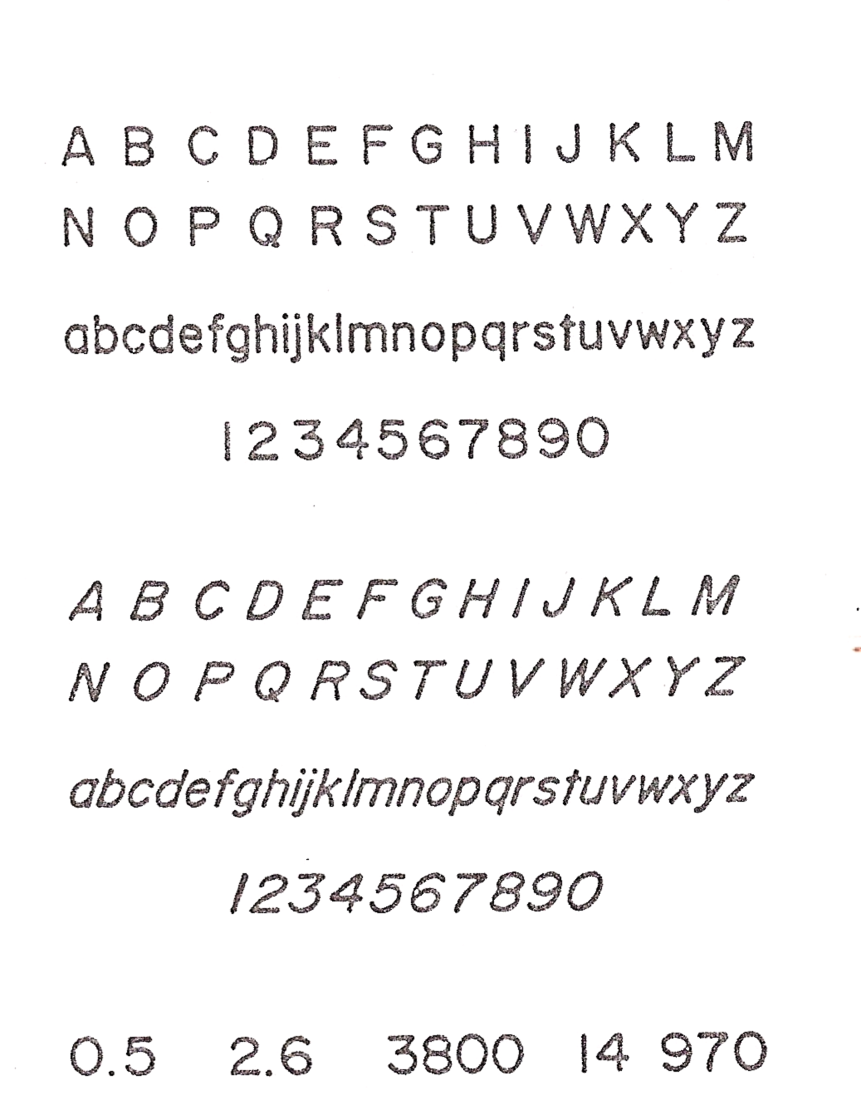
All pencil lettering should be produced freehand and drawn between a pair of faint guide lines. For dimensions and notes a character height of about 3mm should be used, and characters should be about the same height. Titles ar generally made in larger characters. Characters must touch the guidelines and be consistent in width. As an aid to spacing words consistently, imagine an “I” to be placed between them. The space between lines of lettering should not be less than half the character height.

2.4 Dimensioning
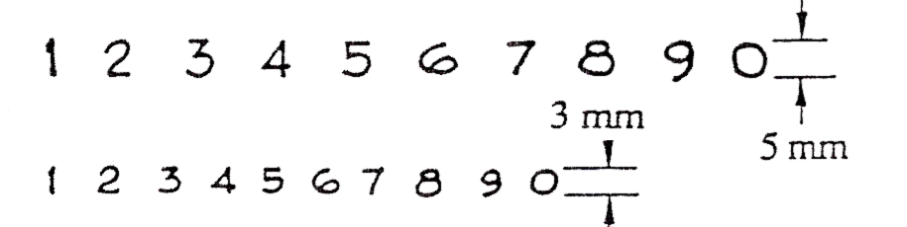
The addition of sizes and measurements to a drawing is known as “dimensioning”. Dimensions tell us the exact distance between two points of surfaces, therefore it is essential that they are legible. Take particular care in writing dimensions and base them on the numerals shown below.
- Use guidelines for dimensions.
- In general, most dimensions will be 3 mm high.
- Lettering stencils contain numerals of corresponding size.

Using Decimal Notation
- The decimal marker should be bold, clear and placed on the bottom guideline of the figures.
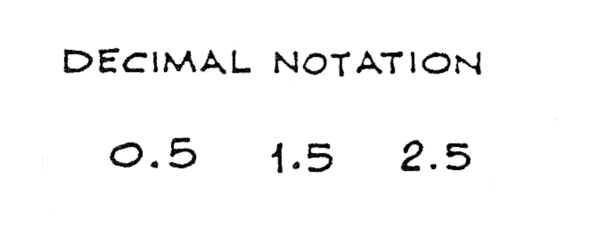
- When a value is less than 1, place a zero in front of the decimal marker as shown below.

Elements of Dimensioning
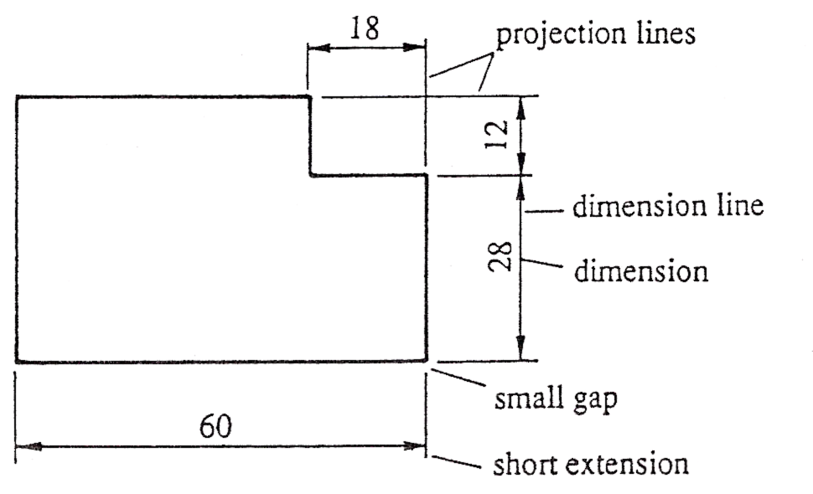
He dimensioning of every object will involve the elements shown in the diagram below. Consider this object to be a piece of sheet metal. Both projection and dimension lines are thin continuous lines.

Termination of Dimension Lines
Depending on the situation, dimension lines can end in any of the following ways:
- Solid arrowheads, enclosing an angle not greater than 45º. They are usually drawn as indicated and are about 3mm long.
- Open arrowheads, enclosing a 90º angle.
- Short oblique strokes with their centres at the end of the dimension line.
- Dots or circles at the end of the dimension line.
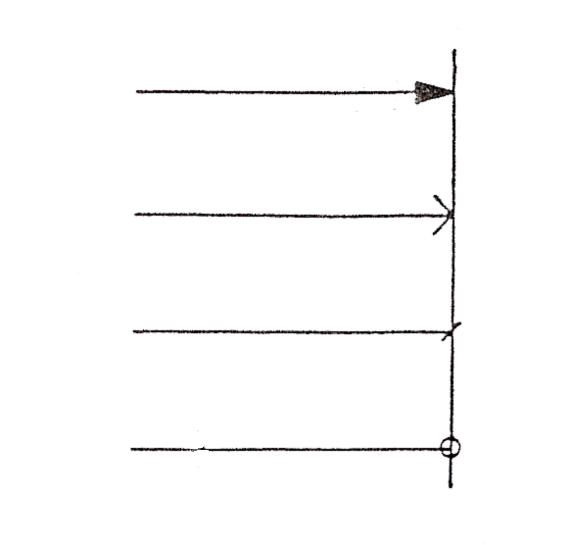
For general use, solid arrowheads are preferred. In general, only one type of “ending” should be used on any drawing.
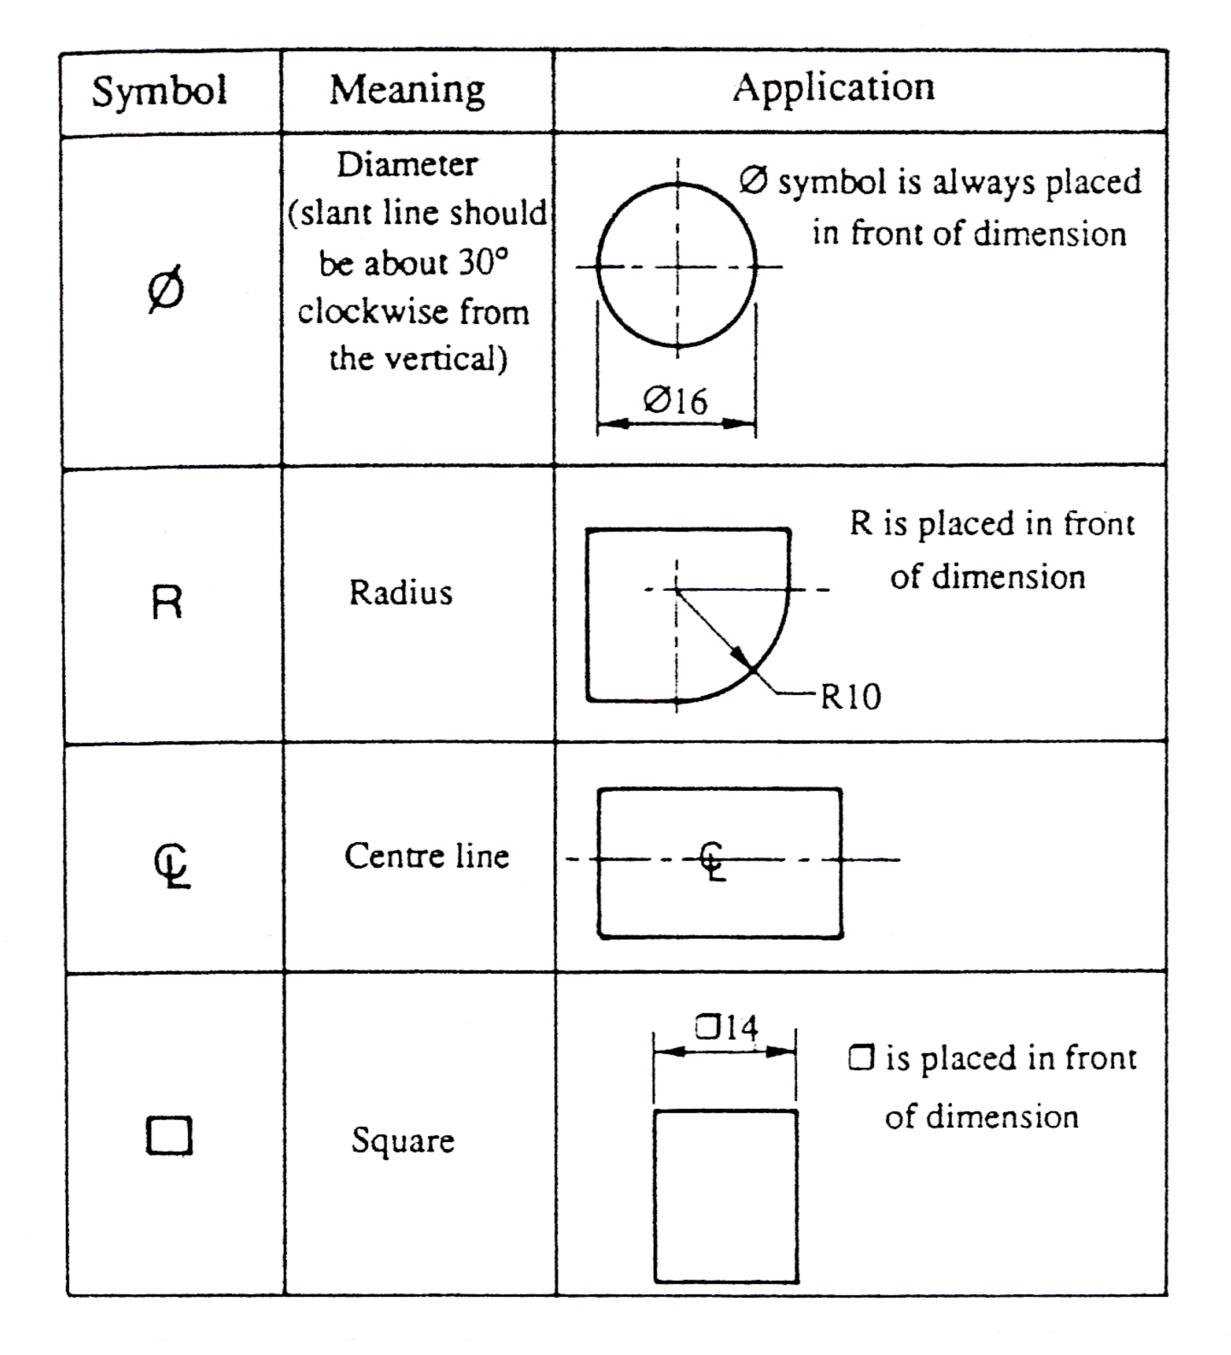
Dimension line endings

Dimensioning Circles and Arcs

Methods of Dimensioning
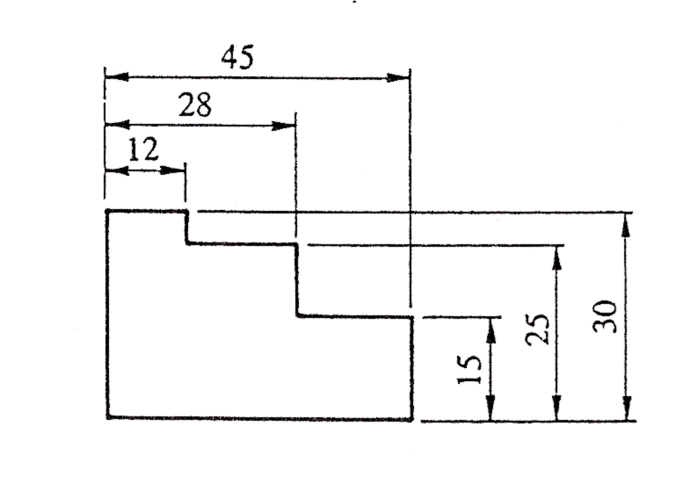
Parallel dimensioning consists of a number of dimensions originating from a datum feature. This type of dimensioning is used where a high standard of accuracy is required.
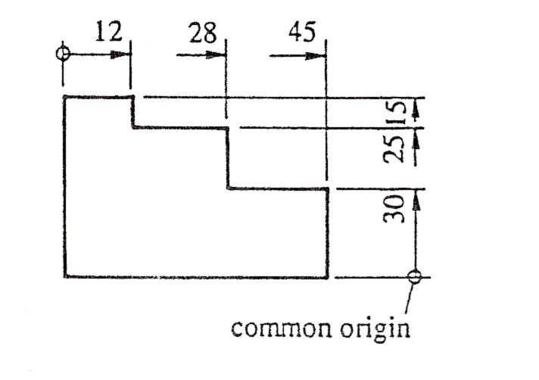
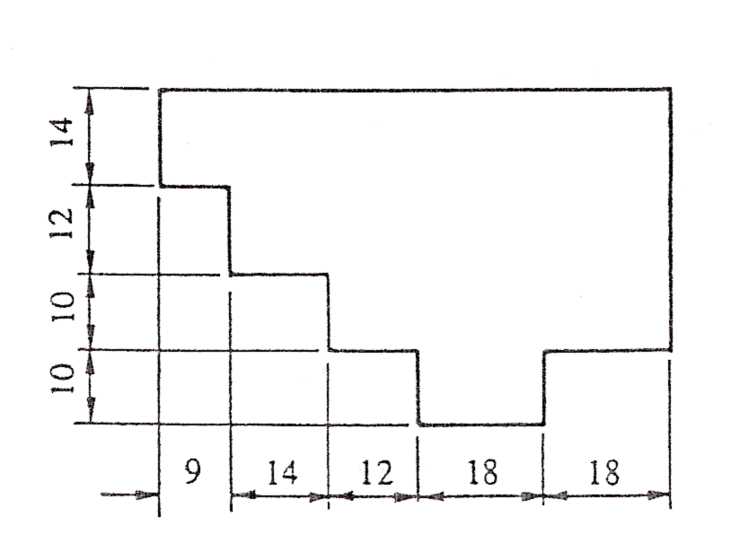
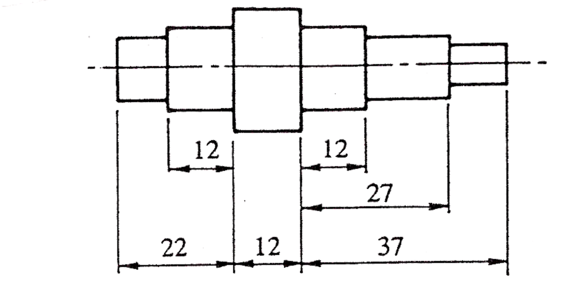
Superimposed running dimensioning is simplified parallel dimensioning, and may be used where space is limited. The common origin is indicated as shown in the figure above. Dimensions are placed near the arrowhead and clear of the dimension line.
Chains of dimensions are used where the adding together of measurements does not affect the accuracy of the component.
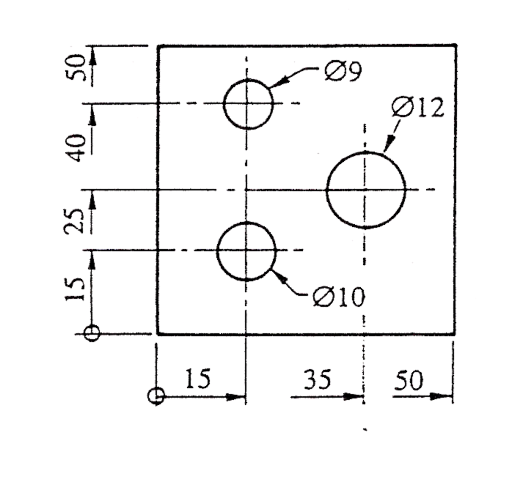
Combined dimensioning uses both chain dimensioning and parallel dimensioning.
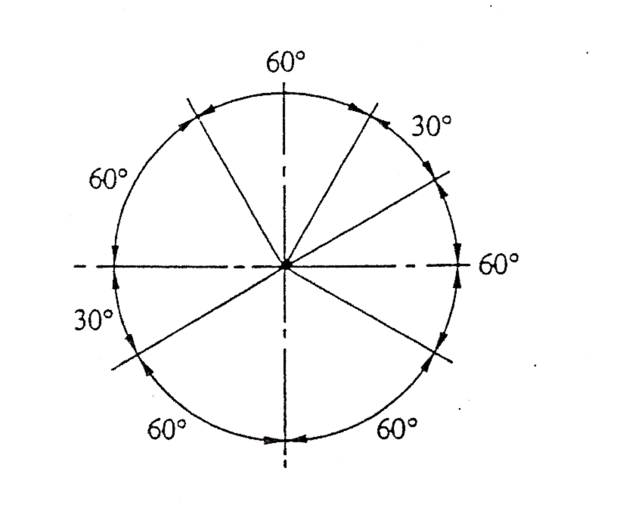
Dimensioning by coordinates: superimposed running dimensions may be used in two directions at right angles as shown in the figure above. The common origin can be any suitable datum feature.
Dimensioning angles: note that all dimensions are outside the arcs and are horizontal.
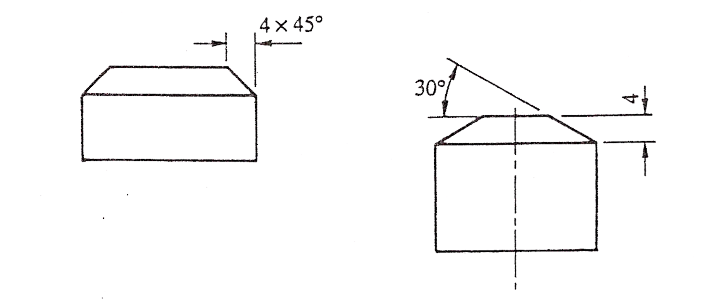
Dimensioning chamfers: It is important to realise that dimensions should not be added to a drawing in a random fashion.

2.5 Scales
All drawings should be made in full size if possible, but if the size of the object is such as to make this impossible thy must be drawn in proportion, that is, to a uniform scale. The scale used must be stated on the drawing as a ratio or representative fraction, for example scale 1:2 which means half size. It is common for a note to warn against scaling the drawing since prints may stretch or shrink.
Scale multipliers and divisors of 2,5 and 10 are recommended and representative fraction of the most commonly used scales are:
1: 1 Full size
1: 2 Half full size
1 :5 One-fifth full size
1: 10 One-tenth full size
2: 1 Twice full size
5: 1 Five times full size
10: 1 Ten times full size

Summary
Orthographic projection uses multiple views of an object, from points of view rotated about the objects centre through increments of 90 degrees. In first angle projection, each view of the object is projected in the direction (sense) of sight of the object. In third angle projection, each view of the object is projected opposite to the direction (sense) of sight of the object.
An engineering drawing is a graphical language or an international language, and is one of the main forms of communication in the workshop or on site. In oral or written communication were the only means of communication when dealing with technical matters, misunderstandings could arise, particularly in relation to shape and size which could have serious implications for a company. An engineering drawing is used to transfer a mental picture of an object from the drawing office to the workshop or site.
A drawing must give sufficient information to enable the craftsperson to convert the information given, into a finished component or job without further contact with the drawing office.
The types of line for engineering drawings recommended in the British Standards Institution in BS 8888: 2004. Two line thicknesses are recommended: thick 0.7mm wide and thin 0.3mm wide.
All drawings should be made in full size if possible, but if the size of the object is such as to make this impossible thy must be drawn in proportion, that is, to a uniform scale. The scale used must be stated on the drawing as a ratio or representative fraction, for example scale 1:2 which means half size. It is common for a note to warn against scaling the drawing since prints may stretch or shrink.

Castleforbes House
Castleforbes Road
Dublin 1

