TRADE OF
Industrial Insulation

PHASE 2

Module 4

Insulation – Materials, Science and Application

UNIT: 1
Basic Insulation Science &
Principles

Produced by

In cooperation with subject matter expert:

Michael Kelly

© SOLAS 2014

Table of Contents
Introduction 1
Unit Objective 2
1.0 Insulation 3
1.1 Reasons for Using Insulation (Hot and Cold Work) 3
1.2 Benefits of Insulating Process Systems 3
1.3 Economic Considerations in the Use of Insulating Materials 4
2.0 Basic Principals of Heat Flow, Heat Transfer and Heat Measurements 5
2.1 Principals of Heat Flow and Heat Transfer 5
2.2 Conduction, Convection and Radiation 5
2.3 Explaining Conduction, Convection and Radiation 10
2.4 Principals of Heat Loss 11
2.5 Reducing Heat Loss 12
2.6 Density 14
3.0 Temperature 15
3.1 Basic SI and Derived Units 15
3.2 Temperature Scales: Celsius, Kelvin (Absolute) and Fahrenheit 15
3.3 Converting Temperatures Scales 17
3.4 Principles of Temperature Measurement 17
3.5 Thermometers 17
3.6 Thermocouples 18
Summary 19

Introduction
Many industrial facilities involve the transportation, storage or handling of fluids and other materials at demanding temperature (high or low) – e.g. furnaces, boilers, refrigeration plants. The correct application of thermal insulation can significantly reduce operating costs and may even prevent plant breakdown.
Of course the importance of energy efficiency has now gone beyond the requirements of cost saving and plant/personnel protection. With the adoption of the Kyoto Protocol in December 1997, the issue of minimising carbon dioxide emissions has become a key factor. Whilst carbon dioxide savings will depend on the source of primary energy as well as the amount of energy used, it is vital that every effort is made to save energy use in the industry sector. According to EU figures, industry accounted for nearly 20% of all emissions in 1990 (640 million tonnes). More appropriate insulation of high and low temperature installations can be a key contributor to the success of the Protocol and the welfare of our future environment.
Module 4
Insulation – Materials, Science & Application
Unit 1
Basic Insulation Science & Principles
Unit 2
Insulation Materials & System Design
Unit 3
Insulation Thickness, Thermal Conductivity & Performance Criteria
Unit 8
Sprayed or Blown Fibre & Ceramic Fibre (Blanket)
Unit 7
Calcium Silicate & Magnesia
Unit 6
Cellular Glass or Foamed Glass
Unit 5
Glass Mineral Fibre & Rockwool
Unit 4
Insulation – Terms, Definitions & Formula
Unit 15
Finishing Materials & Cladding
Unit 14
Acoustics/ Noise Abatement
Unit 13
Fire Protection
Unit 12
Asbestos
Unit 11
Polystyrene, Phenolic Foam & Polyisocyanurate Foam
Unit 10
Nitrile Rubber
Unit 9
Vermiculite

Unit Objective
By the end of this unit each apprentice will be able to:
- List and describe the benefits of insulating mechanical and process systems and equipment.
- State the basic principles of heat flow, heat transfer and heat measurement.
- Measure temperature using a range of devices.

1.0 Insulation

Key Learning Points
- Reasons for insulation (hot and cold work)
- Conservation of energy
- Control of condensation at external surfaces
- Benefits of insulating process systems
- Economic considerations in the use of insulating materials
- Evaluation of data sheets and manufacturers’ information.

1.1 Reasons for Using Insulation (Hot and Cold Work)
The reasons for the use of insulation generally fall into one of the following categories:
- To save Energy – Good insulation saves money and reduces emissions.
- To help maintain process temperatures.
- To protect site personnel from burns.
- To prevent condensation from forming.
- To protect equipment from corrosion.
- To provide fire protection.
- To provide acoustic insulation.
Thermal insulation can accomplish much of this. The level of importance varies from project to project. It is always advisable to check the manufacturers’ data sheets before choosing an insulation product to ensure that the insulating properties of the material will suit the application.

1.2 Benefits of Insulating Process Systems
- Insulation is a cost – effective, energy – saving product that saves money for individuals and businesses through lower utility bills while increasing the comfort levels for all building occupants
- Adequate levels of insulation for industrial processes have helped make industry more efficient and more profitable by cutting energy losses and decreasing production costs.
- By avoiding the added energy generation necessary to heat and cool buildings, insulation continues to be a benefit to the environment by helping to reduce pollution emissions. Insulation products play a significant energy – savings role by reducing energy use in homes, office buildings and manufacturing plants.
- While the energy savings from insulation are significant, so are the environmental benefits.
- By making buildings and process systems more energy efficient, insulation helps reduce the amount of fossil fuel combustion needed to heat and cool homes, businesses and factories. That, in turn, decreases the amount of carbon dioxide emitted into the atmosphere. Because carbon dioxide is one of the principal Greenhouse Gases contributing to global warming, insulation plays a significant role in protecting the environment.

1.3 Economic Considerations in the Use of Insulating Materials
- To reduce climate change levy.
- To save energy money by reducing energy costs.
- To reduce running costs of a plant or factory.
- To maximise return on investment for the owner.
- (To reduce fuel consumption, and hence overall costs of operation.
- Benefits of higher profits to the owner.
- To protect personnel from burns thus avoiding lost work time and possible claims for injury.

2.0 Basic Principals of Heat Flow, Heat Transfer and Heat Measurements

Key Learning Points
- Conduction,
- Convection and Radiation
- Definition of Density
- Principles of heat loss
- Heat flow and heat transfer
- Reduction of heat loss (or gain)

2.1 Principals of Heat Flow and Heat Transfer
Heat (thermal energy] always moves from hot places to cold places. This is called heat transfer. Sometimes you want to make it easy for heat to go from one place to another. Sometimes you want to keep heat in one place. So you need to know how heat travels.

2.2 Conduction, Convection and Radiation

Conduction
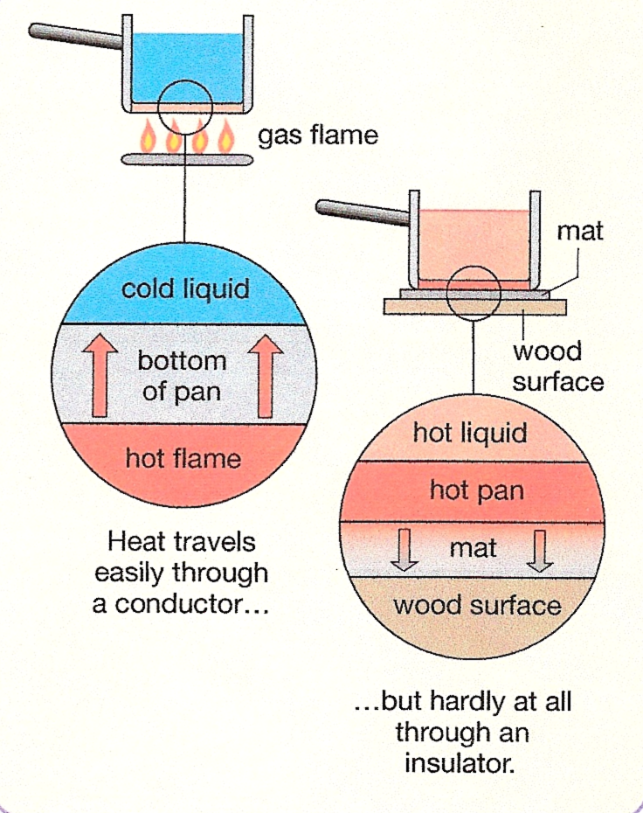
If you put a solid between somewhere hot and somewhere cold, heat has to travel through the solid. This is called conduction. There has to be a substance there for conduction to happen. Heat passes easily through some solids, for example metals. We call these conductors. Other solids conduct heat badly, and we call these insulators.

Convection in Liquids
The water in a kettle is a liquid. Liquids can flow. The heating element in an electric kettle is at the bottom, but it still heats al the water in the kettle .This diagrams show how it does this. Each time the water moves around the kettle it gets a little bit hotter. Hot liquids move and carry heat with them. This is called convection.
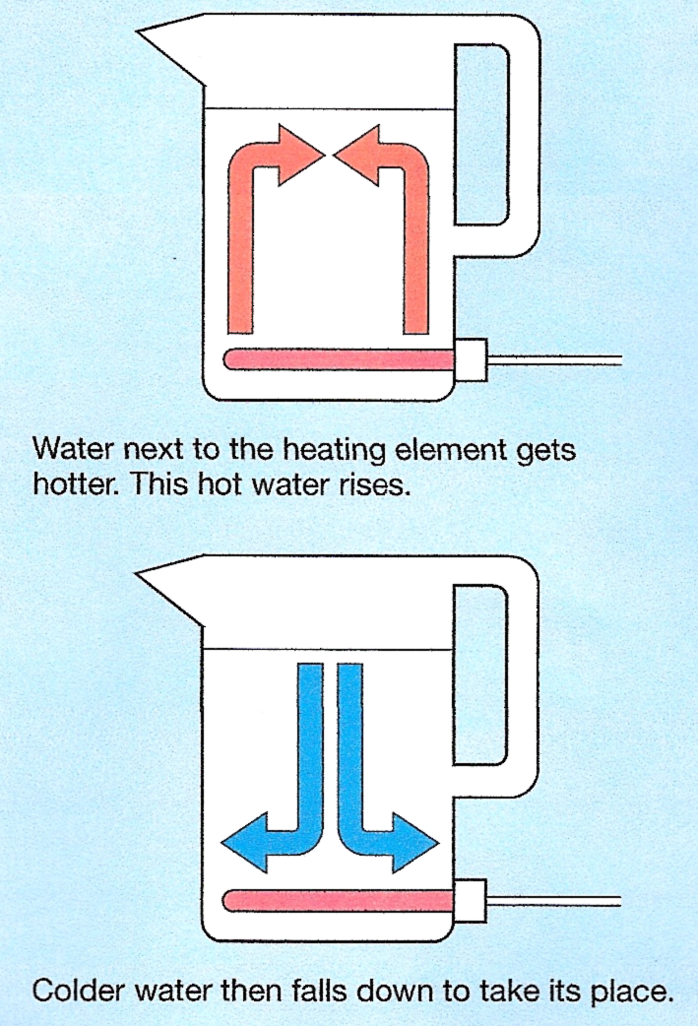

Convection in Gases
The air in a room is a gas. Gases can also flow. Heaters are usually near the floor, but the whole of the room gets heated. The diagrams show how heaters do this. Hot gases, like hot liquids, move around and transfer heat by convection as they do so. Convection only happens in liquids and gases. It needs a substance that can flow.
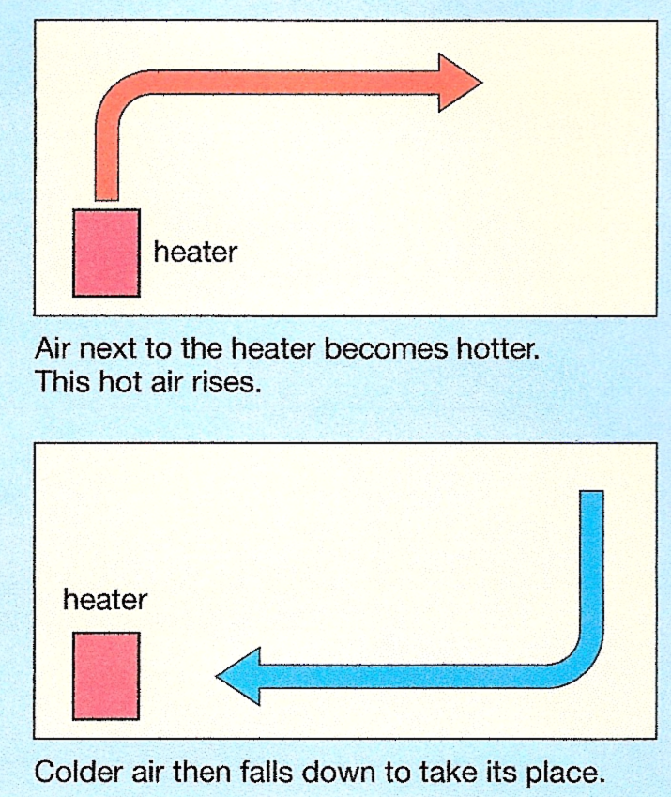
Convection

Radiation
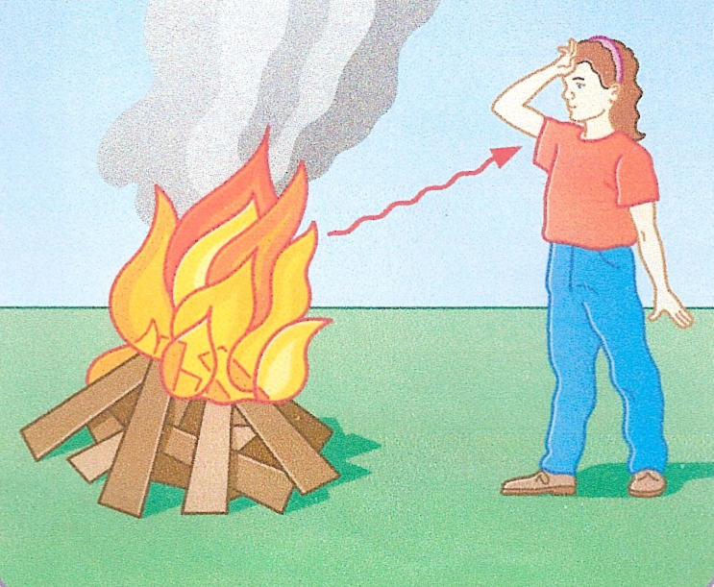
When you stand near to a roaring bonfire, you can feel the heat from the bonfire falling on your face. This happens because hot objects transfer heat by sending out rays. This method of energy transfer is called radiation.

Thermal energy is transferred from the fire to the face by radiation. No substance (solid, liquid or gas) is needed so the radiation can travel through empty space.

Thermal Radiation
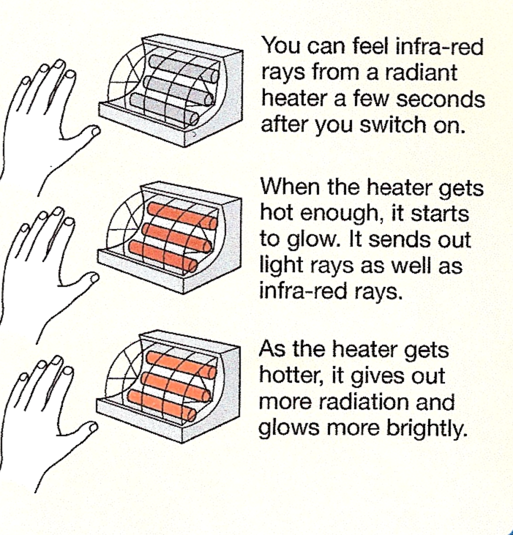
All object give out energy as thermal radiation. This energy travels as infra-red rays. You can’t see infra-red rays. You can feel infra-red rays from a hot object when they raise the temperature of your skin.

Energy from the Sun
There is empty space between the Sun and us. Because there is no substance to travel through, heat from the Sun can’t reach us by conduction or convection. Only radiation can travel through empty space.
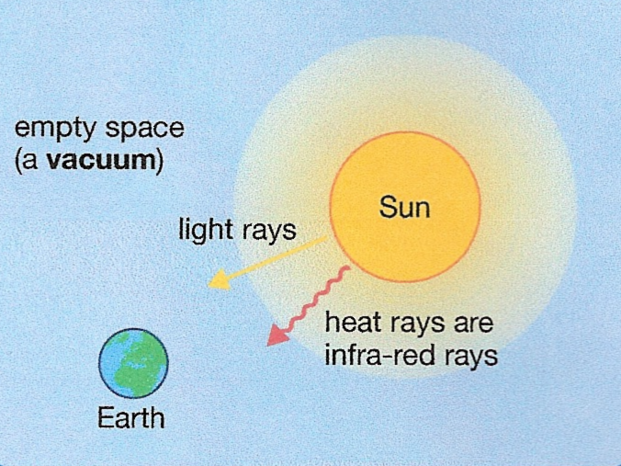
Some of the energy travels as light rays that we can see. Some of the energy travels as infra-red rays that we can feel.
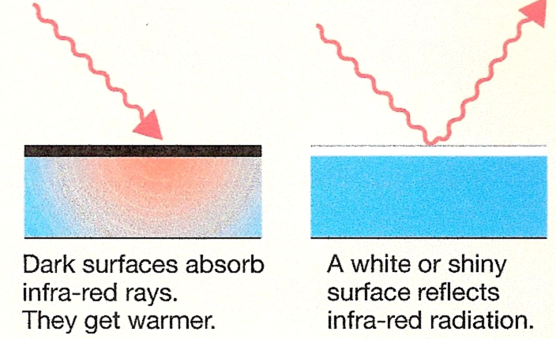

How Can You Capture the Energy in Infra-Red Rays?
Dark matt (dull) surfaces are good absorbers of infra-red rays. This means that they soak up infra-red radiation very well.
Light, shiny surfaces do not absorb infra-red rays very much. They are good at reflecting the rays away from themselves.
What makes a good radiator?
Dark matt surfaces give out heat very well. We say that they are good emitters of infra-red rays. This means they give out infra-red rays very well. Light, shiny surfaces don’t give out as much radiation as dark surfaces at the same temperature. They are poor emitters of infra-red rays

Using the Sun’s Energy
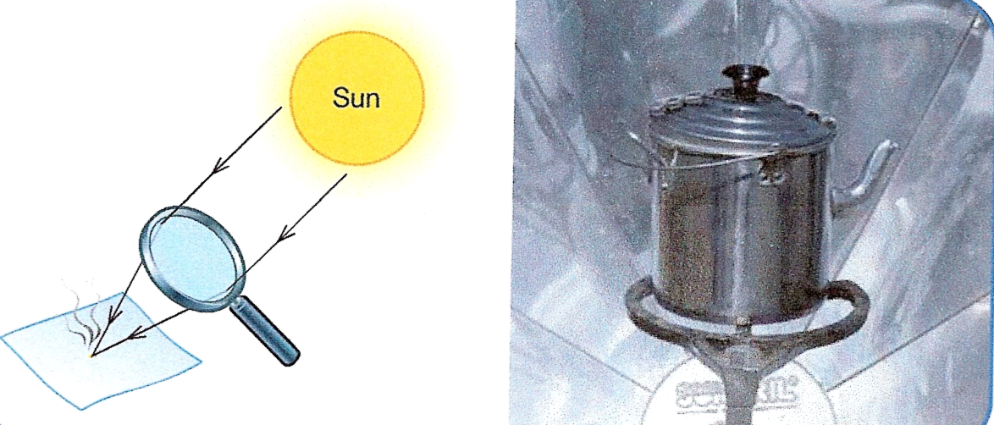
Energy reaches the earth from the Sun. We can make use of this energy if we trap it or concentrate it.
A lens focuses sunlight to a bright spot. The concentrated energy can set fire to the paper. Mirrors on the solar cooker reflect sunlight into a small space. The energy can boil water.

How Can We Trap Radiation from the Sun?
The diagram shows how a glass window can trap energy from the Sun inside a house.
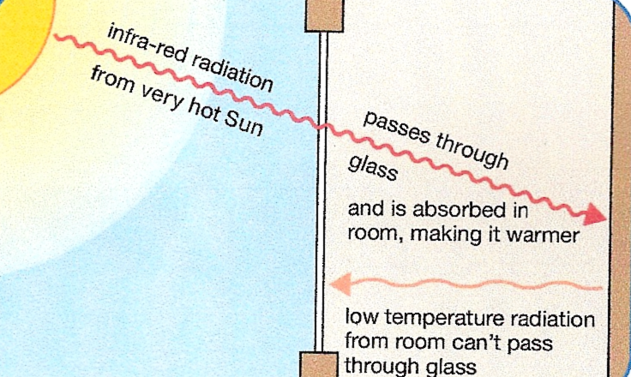

Solar Cookers Save Lives
Refugees in some camps in Africa have no fuel wood. So they’ve been given solar cookers. Their water is full of bacteria and must be heated above 65 C for several minutes to make it safe.
The cooker is made from a curved card sheet. The front surface of the card is painted silver or coated with metal foil. The card concentrates sunlight on a cooking point at its centre. The pot is made from metal. Its outside surface is blackened.
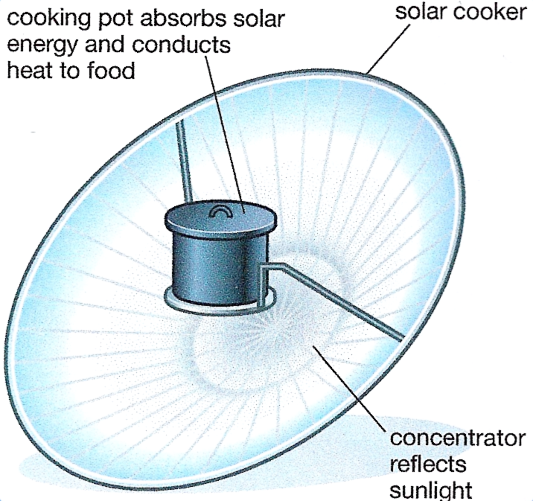

How Does a Solar Panel Work?
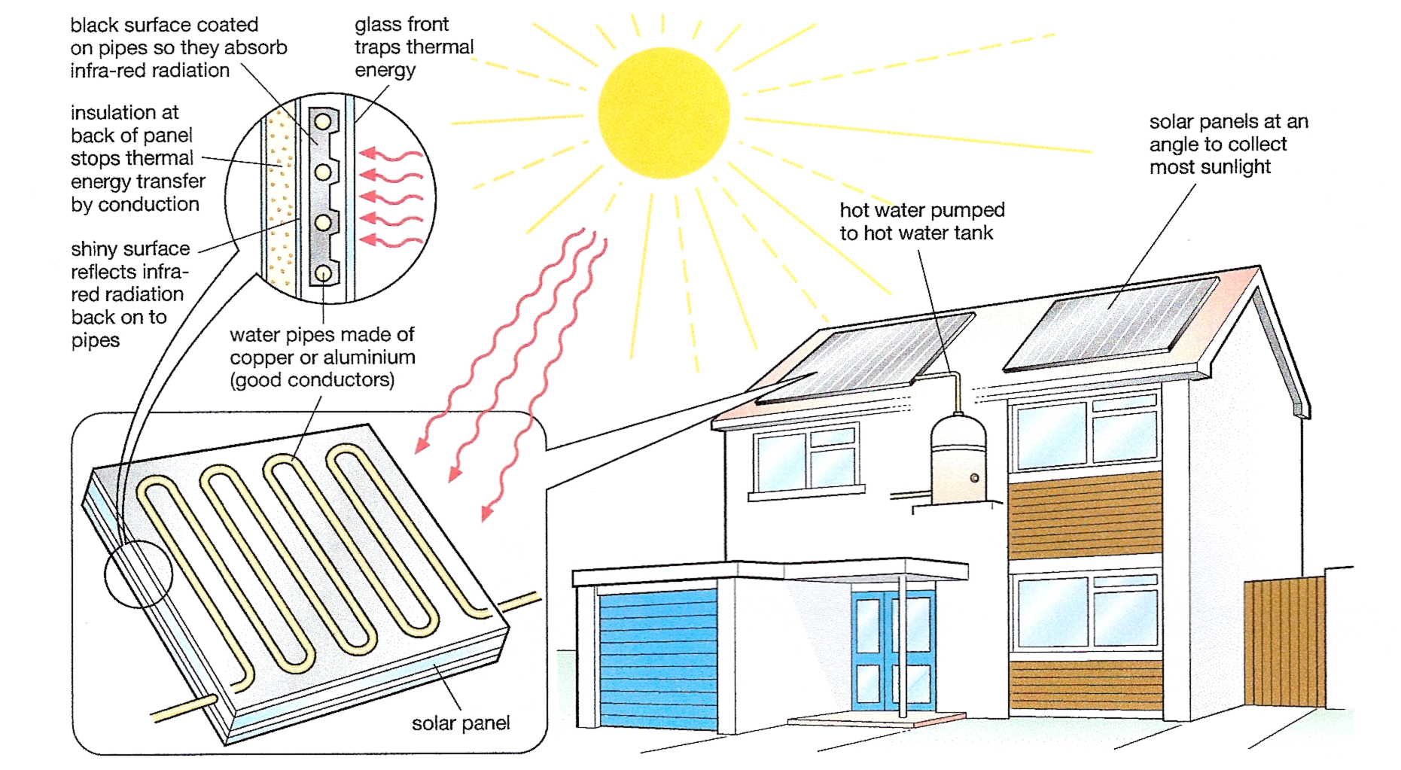
Some houses have solar panels on the roof. These use energy radiated by the Sun to heat water. The diagram shows how solar panels work.

2.3 Explaining Conduction, Convection and Radiation

Explaining Conduction
If you put one end of a metal bar in a flame, heat moves from hot to cold – the far end of the bar soon gets hot too. Heat travels through the metal by conduction. Conduction is the movement of heat from particle to particle through a substance. Hot particles moves faster than cold particles. They collide with their cooler neighbours and pass on energy.

Explaining Convection
Convection, happens because fluids [liquids and gases] expand when they are warmer. The particles move about faster and take up more space. This means warm fluid is lighter than the same volume of cold fluid. A light fluid floats on top of a heavier one, so hot fluid will float upwards through cold fluid.

Explaining Radiation
Matter is made of particles. Some of the particles have a charge. Heat makes the particles jiggle about. When charged particles move like this, they give out electromagnetic radiation. The hotter something is, the faster its particles move and the more radiation it emits. Electromagnetic radiation travels as waves through empty space. The radiation from a hot object is absorbed by the charged particles in any object it falls on. In this way, heat is transferred.

2.4 Principals of Heat Loss
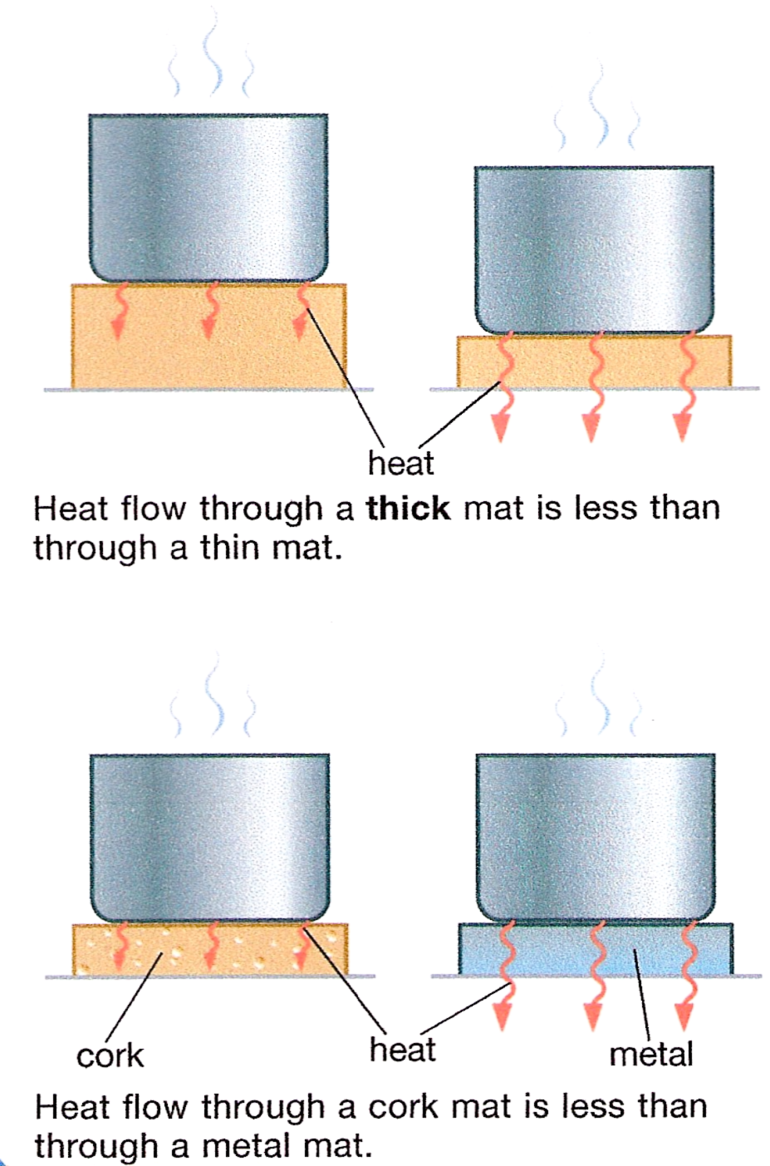
A table mat protects a wooden table by reducing conduction from a hot pan to the table surface. Different materials transfer heat at different rates. We say that a good conductor like copper has a high conductivity. An insulator such as cork has a low conductivity.

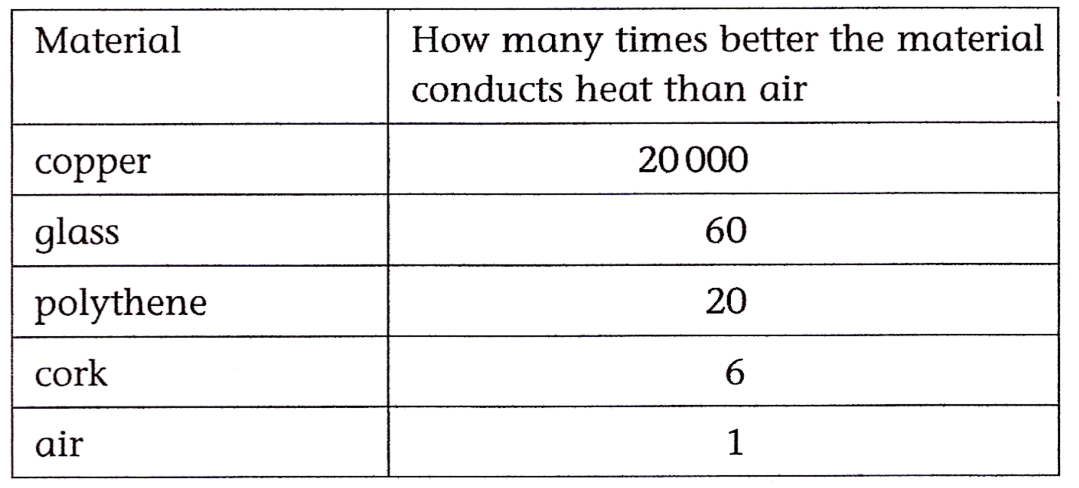
The conductivity of different materials compared with air.
You can keep a drink hot all day in a vacuum flask. Its design prevents heat loss by conduction, convection and radiation.
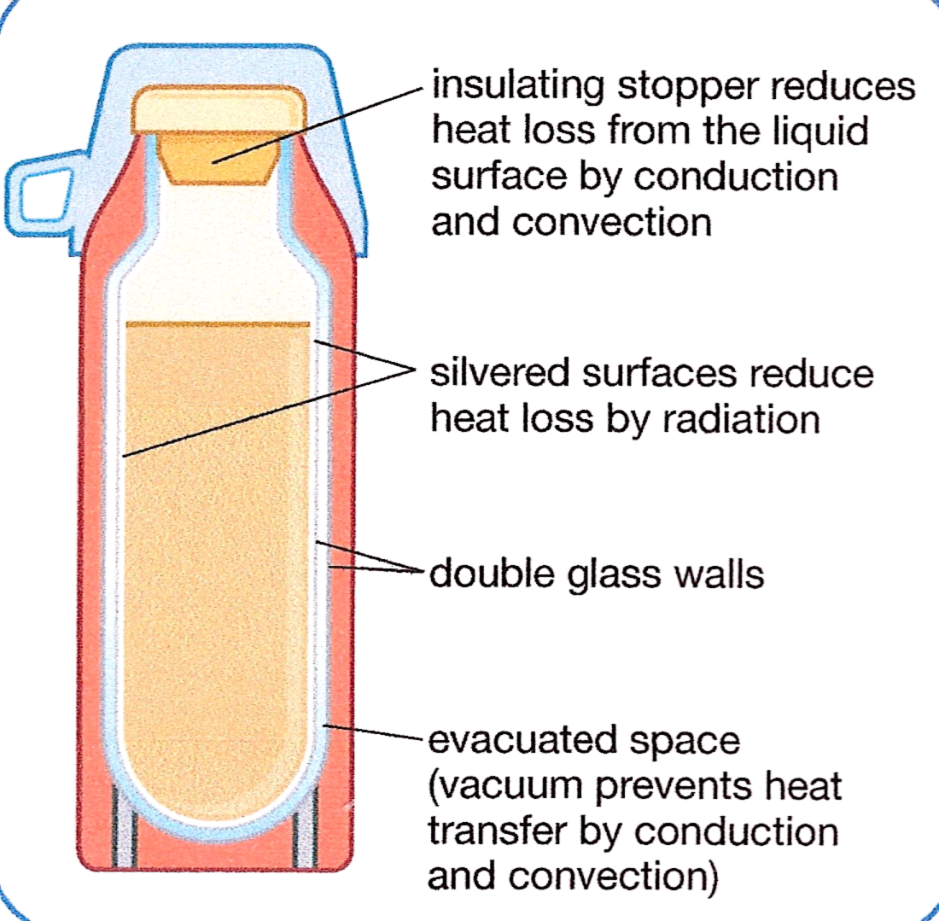

2.5 Reducing Heat Loss
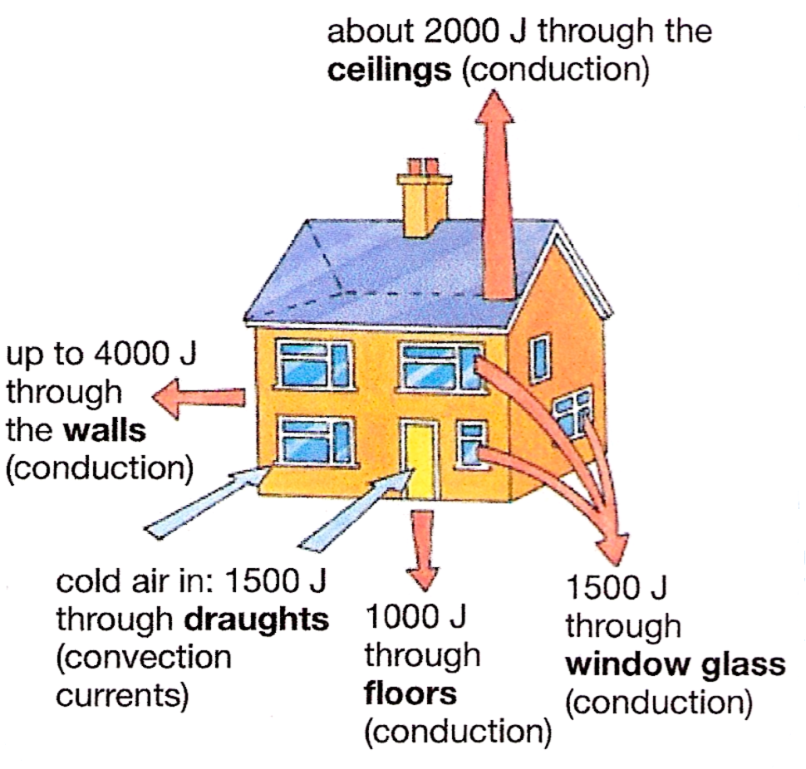
All buildings loose heat in various ways. This costs money and wastes fuel.

Thermal energy lost from a poorly insulated house.
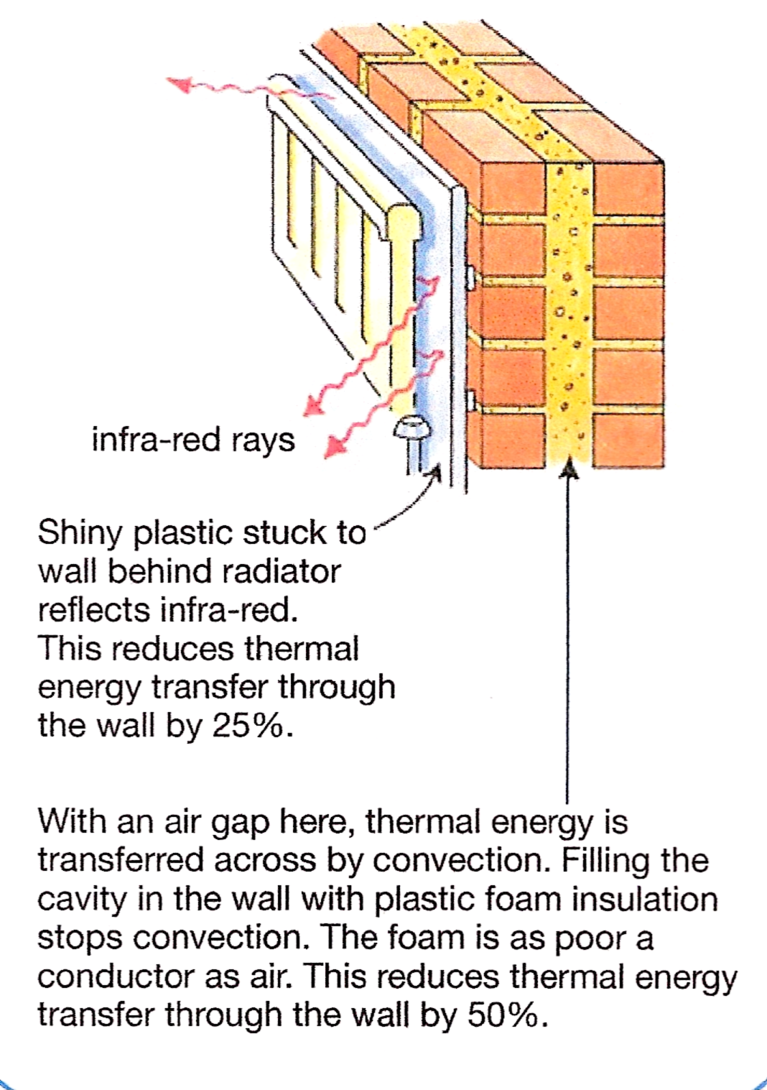
The heat from the back of a radiator is transferred to the wall by radiation. The heat then moves through the wall by conduction. The following diagram shows how to reduce heat loss.

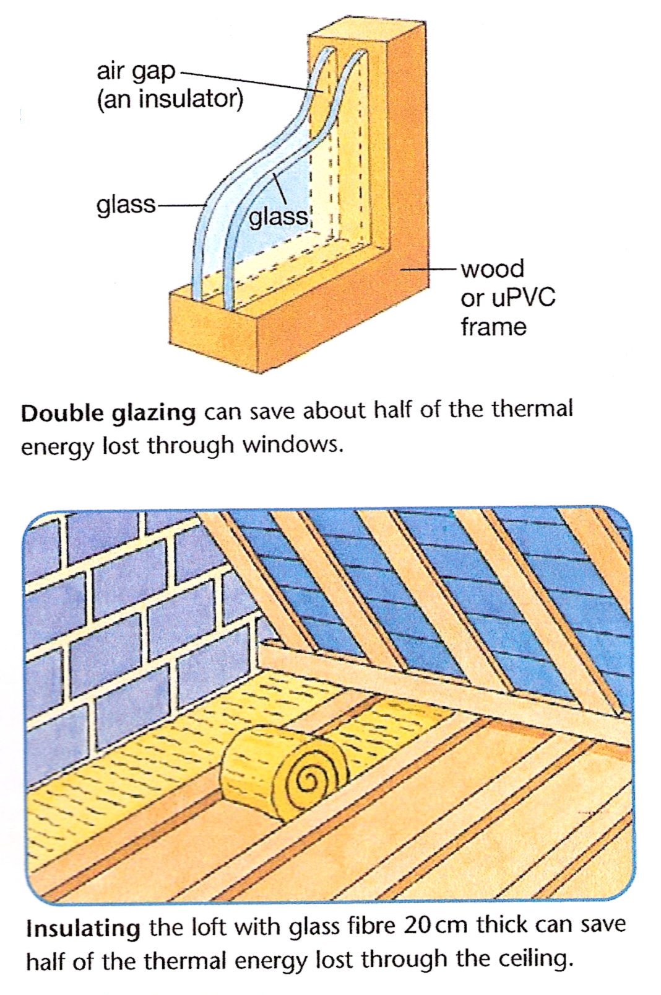

Why do Foam and Fibres Make Good Insulators?
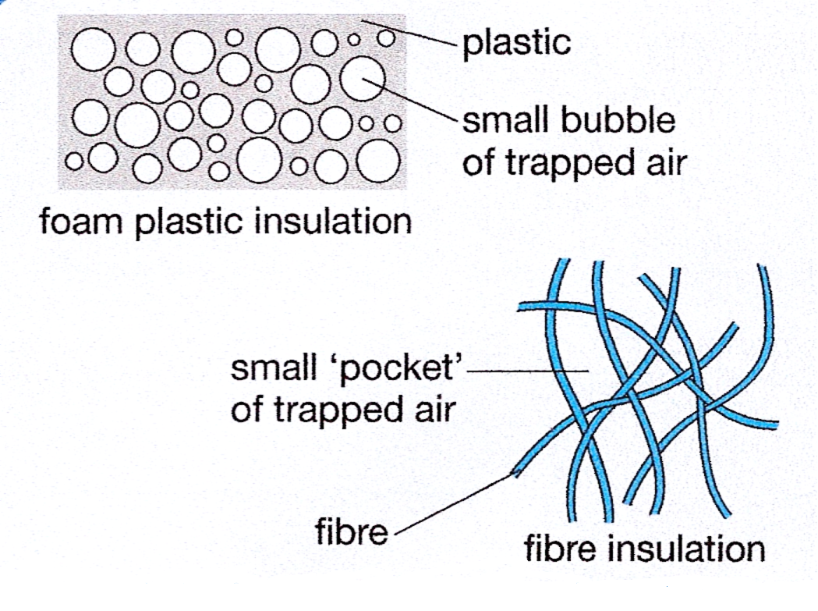
Air, like all gases, is a very poor conductor. But to use it as an insulator, we must stop it moving about.

2.6 Density
Refer to Module 4 – Unit 5 – section 2.6

3.0 Temperature

Key Learning Points
- Basic SI units
- Temperature scales: Celsius
- Kelvin (absolute)
- Conversion of temperature from Celsius to Kelvin, Kelvin to Celsius
- Heat measurement: use of thermometers and thermocouples.

3.1 Basic SI and Derived Units

Basic Units Unit Symbol
Length Metre m
Mass Kilogram kg
Time Second s
Temperature absolute Degree Kelvin K
Electric current Ampere A

Derived Units Unit Symbol
Area Square metre m²
Volume Cubic metre m³
Density Kilogram per cubic metre kg/m³

3.2 Temperature Scales: Celsius, Kelvin (Absolute) and Fahrenheit

Celsius Temperature Scale
Celsius temperature scale also called centigrade temperature scale, is the scale based on 0 for the freezing point of water and 100 for the boiling point of water. Invented in 1742 by the Swedish astronomer Anders Celsius, it is sometimes called the centigrade scale because of the 100-degree interval between the defined points. The Celsius scale is in general use where metric units have been accepted, and it is used in scientific work everywhere.

Kelvin Temperature Scale
Kelvin temperature scale is the base unit of thermodynamic temperature measurement in the international system (SI) of measurement. It is defined as 1/273.15 of the triple point (equilibrium among the solid, liquid, and gaseous phases) of pure water. The Kelvin (symbol K without the degree sign) is also the fundamental unit of the Kelvin scale, an absolute temperature scale named for the British physicist William Thomson, Baron Kelvin. Such a scale has as its zero point absolute zero, the theoretical temperature at which the molecules of a substance have the lowest energy. Many physical laws and formulas can be expressed more simply when an absolute temperature scale is used; accordingly, the Kelvin scale has been adopted as the international standard for scientific temperature measurement. The Kelvin scale is related to the Celsius scale. The difference between the freezing and boiling points of water is 100 degrees in each, so that the Kelvin has the same magnitude as the degree Celsius.

Fahrenheit Temperature Scale
Fahrenheit is the temperature scale proposed in 1724 by, and named after, the physicist Daniel Gabriel Fahrenheit. Today, the scale has been replaced by the Celsius scale in most countries; it is still in use for non-scientific purposes in the USA and a few other nations.
On the Fahrenheit scale, the freezing point of water is 32 degrees Fahrenheit (ºF) and the boiling point 212 ºF, placing the boiling point and the freezing point at exactly 180 degrees apart. A degree on the Fahrenheit scale is 1/180 of the interval between the freezing point and the boiling point.
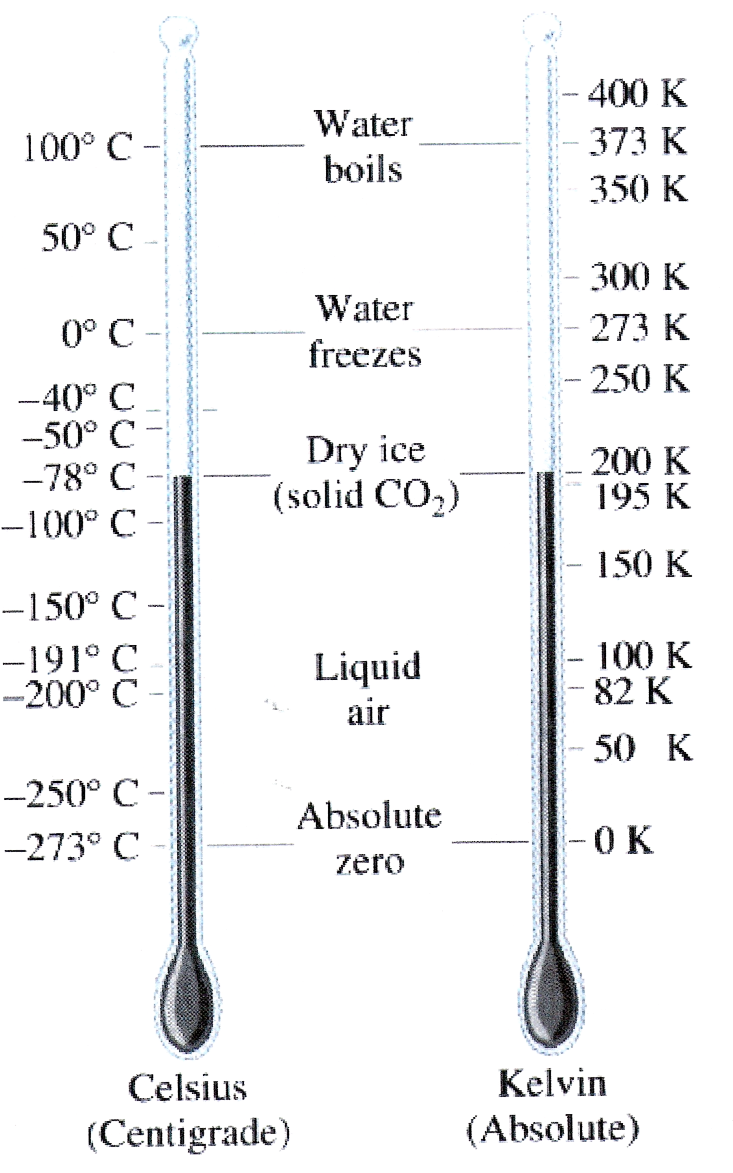

3.3 Converting Temperatures Scales
From ºC to K (Kelvin) = ºC + 273.15
From K (Kelvin) to ºC = K – 273.15

3.4 Principles of Temperature Measurement

Temperature and Heat
It is important to realise that although heat affects the temperature of a body, heat and temperature are not the same thing. Temperature indicates the level of heat in a body not the amount of heat.
Temperature is the property which determines the whether heat will flow and in which direction it will flow. Heat will only flow from one body to another if there is a difference in temperature between them. Heat will always flow from the body of higher temperature to that at lower temperature.
- Heat is the energy stored inside something.
- Temperature is the measurement of how hot or cold a body is.

3.5 Thermometers
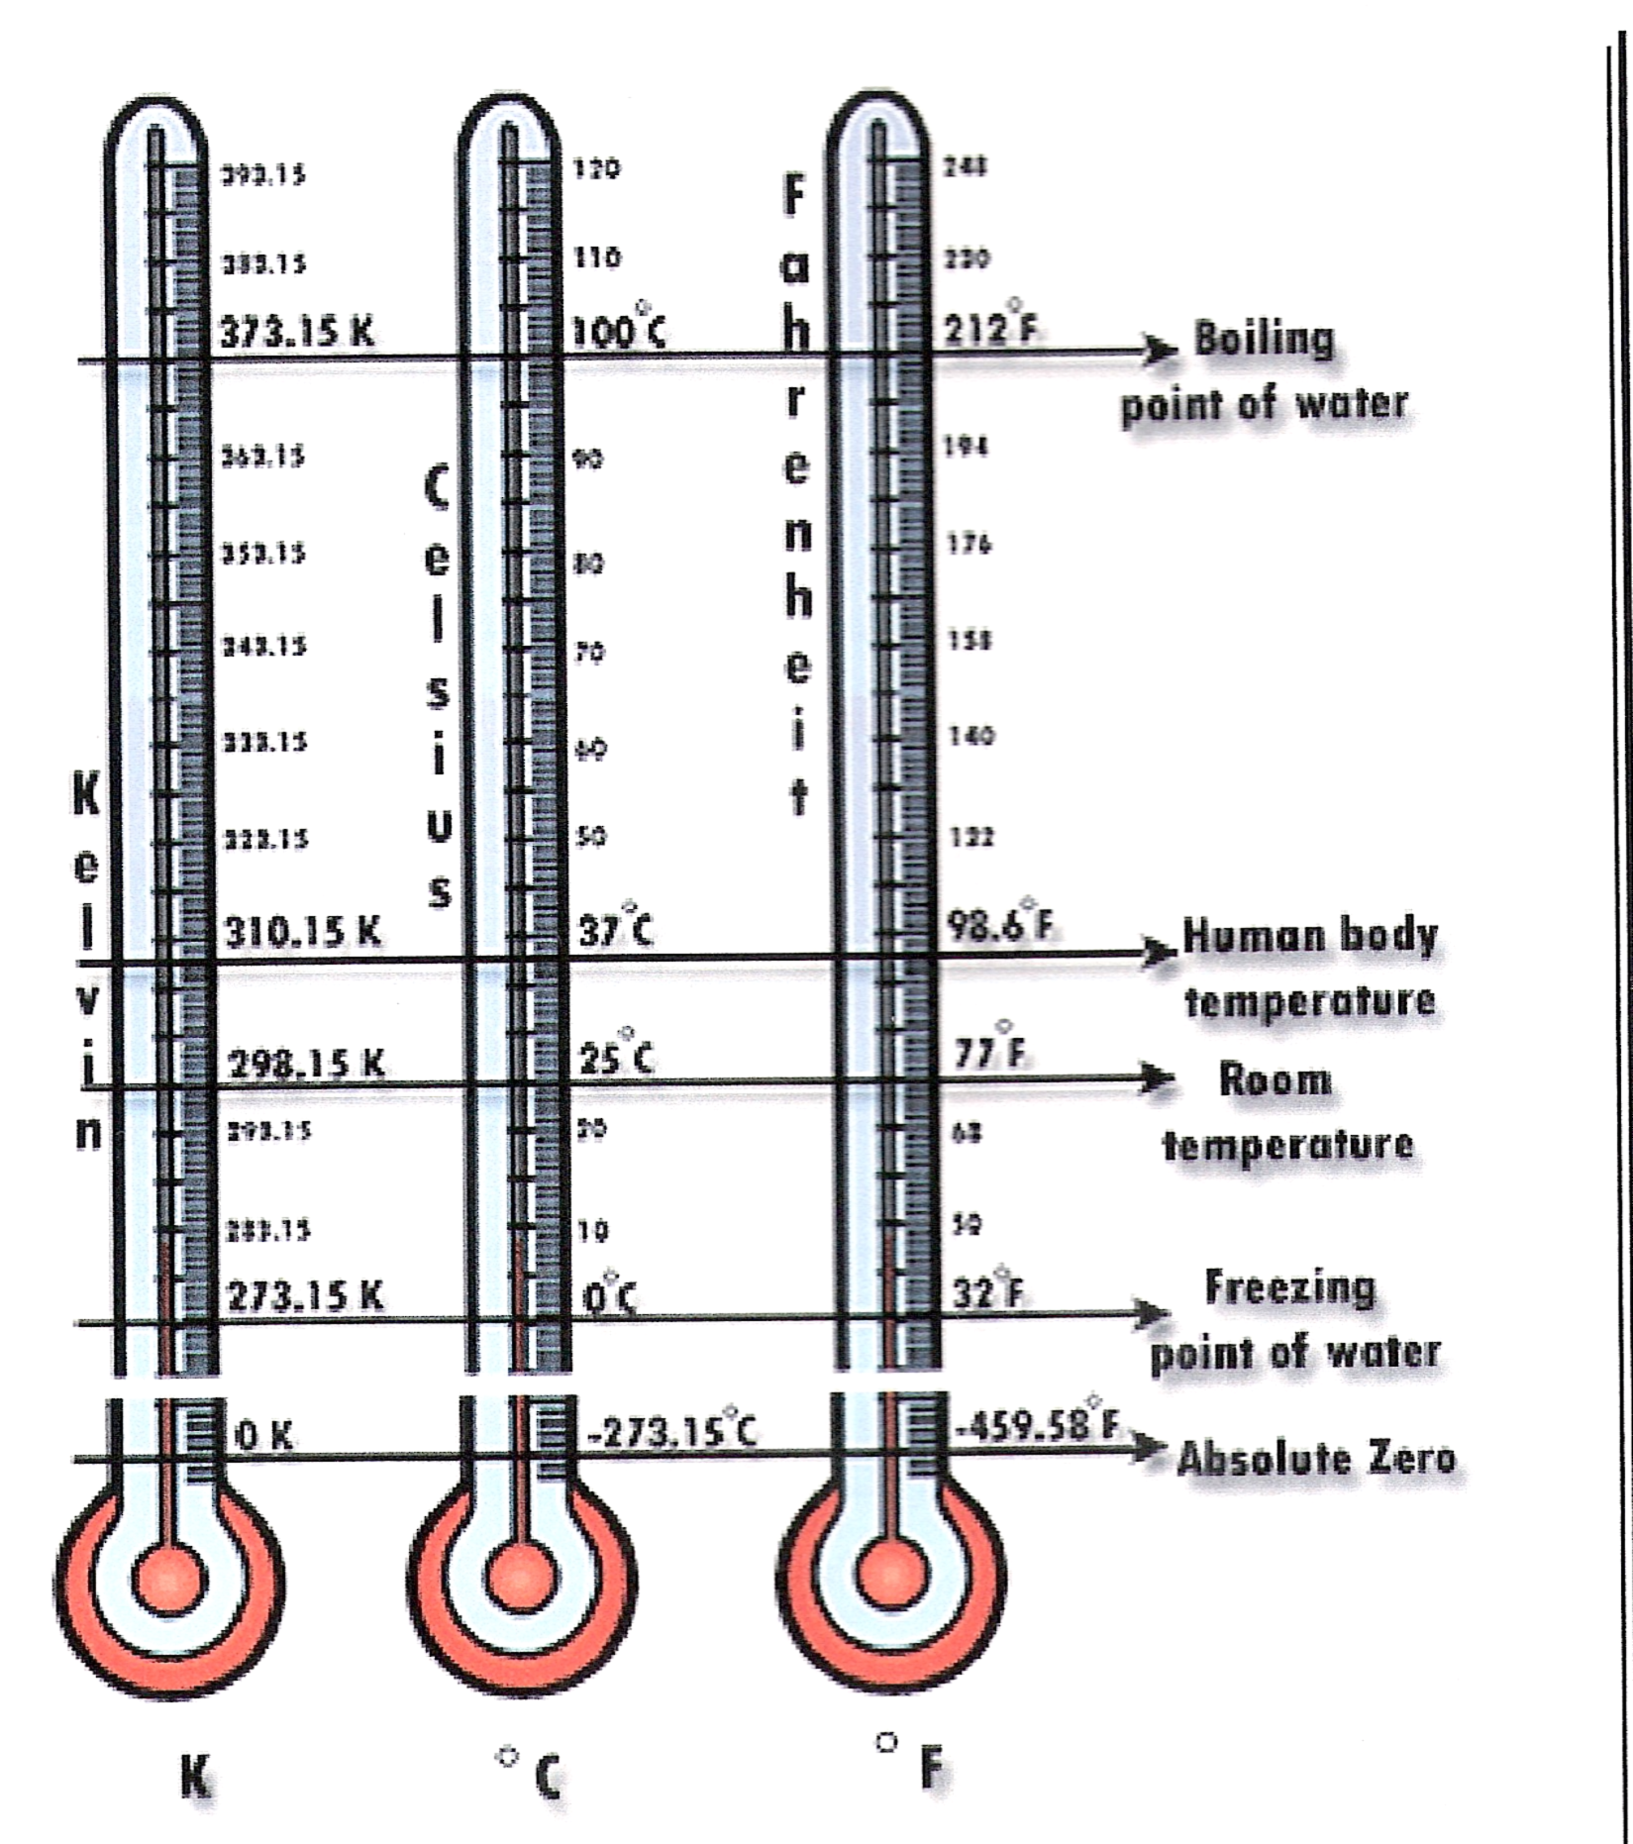
Thermometers measure temperature, by using materials that change in some way when they are heated or cooled. In a mercury thermometer the liquid expands as it is heated and contracts when it is cooled, so the length of the liquid column is longer or shorter depending on the temperature. Modern thermometers are calibrated in standard temperature units such as Fahrenheit, Celsius or Kelvin.
Although it may seem confusing, each of the three temperature scales allows us to measure in a slightly different way.

3.6 Thermocouples
A thermocouple or thermocouple thermometer is a junction between two different metals and produces a voltage related to a temperature difference. Thermocouples are a widely used type of temperature sensor for measurement and control and can also be used to convert heat into electric power. They are inexpensive and interchangeable, are supplied fitted with standard connectors, and can measure a wide range of temperatures. The main limitation is accuracy: system errors of less than one degree Kelvin can be difficult to achieve.

Summary
Insulation is the most effective way to improve the energy efficiency of a building. Insulation of the building envelope helps to retain heat during the winter and keep the building cool during the summer. Insulation when used in an industrial application helps to reduce energy costs, maintain process temperatures, protect equipment from corrosion and protects site personnel from burns.
The term ‘insulation’ refers to materials which provide substantial resistance to heat flow. All materials allow a measure of heat to pass through them. Some, such as metal, glass or air, allow heat to pass through them more easily. Others such as wool, thick clothing and mineral fibres, are much more resistant to heat flow, and are referred to as ‘insulators’.

Castleforbes House
Castleforbes Road
Dublin 1

