TRADE OF
Industrial Insulation

PHASE 2

Module 4

Insulation – Materials, Science and Application

UNIT: 11

Polystyrene, Phenolic Foam & Polyisocyanurate Foam

Produced by

In cooperation with subject matter expert:

Michael Kelly

© SOLAS 2014
Table of Contents
Introduction 1
Unit Objective 2
1.0 Polystyrene Foam 3
1.1 Product Composition and Characteristics of Polystyrene Foam 3
1.2 Properties, Uses and Applications 4
1.3 Forms of Supply and Identification 4
1.4 Thickness and Density Range 4
1.5 Service Temperature Range 4
1.6 Fire Characteristics 4
2.0 Phenolic Foam 5
2.1 Product Composition and Characteristics 5
2.2 Properties, Uses and Applications 5
2.3 Forms of Supply 6
2.4 Thickness, Density and Temperature Range 6
2.5 Fire Performance 6
3.0 Polyisocyanurate Foam 7
3.1 Product Composition and Characteristics 7
3.2 Properties, Uses and Applications 7
3.3 Forms of Supply 8
3.4 Thickness and Density Range 8
3.5 Reaction to Fire Characteristics 8
4.0 Vapour Barriers 9
4.1 Vapour Barriers Used With Polystyrene and Phenolic Foam 9
4.2 Adhesives and Sealants 9
4.3 Handling/ Application Information 10
4.4 Multi-Layering of Insulation and Vapour Barriers 11
5.0 Types of Insulation Finishes 12
5.1 Finishing Materials 12
6.0 Health and Safety 13
6.1 Safe Handling of Materials 13
6.2 Disposal of Materials 13
Summary 14

Introduction
Polystyrene, Phenolic foam and Polyisocyanurate foam insulation products are designed for the thermal insulation of pipes, ducts, tanks and vessels for commercial and process industry applications. These insulation products have been developed and designed to provide optimum performance with regard to insulation efficiency, fire resistance, low smoke emission, environmental safety and cost.
Module 4
Insulation – Materials, Science & Application
Unit 1
Basic Insulation Science & Principles
Unit 2
Insulation Materials & System Design
Unit 3
Insulation Thickness, Thermal Conductivity & Performance Criteria
Unit 8
Sprayed or Blown Fibre & Ceramic Fibre (Blanket)
Unit 7
Calcium Silicate & Magnesia
Unit 6
Cellular Glass or Foamed Glass
Unit 5
Glass Mineral Fibre & Rockwool
Unit 4
Insulation – Terms, Definitions & Formula
Unit 15
Finishing Materials & Cladding
Unit 14
Acoustics/ Noise Abatement
Unit 13
Fire Protection
Unit 12
Asbestos
Unit 11
Polystyrene, Phenolic Foam & Polyisocyanurate Foam
Unit 10
Nitrile Rubber
Unit 9
Vermiculite

Unit Objective
By the end of this unit each apprentice will be able to:
- List and describe the properties, uses and applications of Polystyrene, Pnenolic Foam and Polyisocyanurate Foam.
- Identify samples of Polystyrene, Pnenolic Foam and Polyisocyanurate Foam.
- Demonstrate the safe handling and applications of the materials.

1.0 Polystyrene Foam

Key learning Points
- Material composition of polystyrene foam
- Thickness and density range. Service temperature range
- Reaction to fire characteristics
- Forms available of polystyrene foam

1.1 Product Composition and Characteristics of Polystyrene Foam
Polystyrene thermal insulation is rigid, cellular foam insulation. It is commonly classified as either “Expanded Polystyrene Foam (EPS)” or “Extruded Polystyrene Foam (XPS)”.

Expanded Polystyrene
Expanded polystyrene grains are heated by steam, which causes them to expand. They are then conditioned and, as they cool, the steam in the voids within the board condenses, thus permitting air to diffuse into them. After conditioning, the granules can be cast into moulds and further expanded using blown steam. The granules tend to fuse together, forming rigid blocks. The blocks are then cut to shape depending on the customer’s requirements. The material has similar characteristics to polyurethane with excellent resistance to moisture with a high compressive strength. The approximate maximum operating temperature is 80ºC.

Extruded Polystyrene
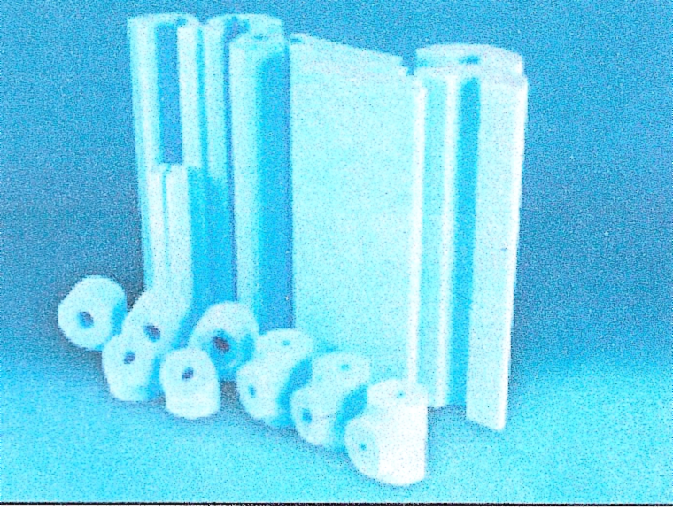
This is produced by a continuous extrusion process based on the steam injection process. This results in a continuous product with a smooth-surface skin and enhances the mechanical properties.

1.2 Properties, Uses and Applications
Polystyrene is an excellent insulator. It is light in weight, clean and easy to handle and is cost effective. Not only has it the capability to insulate against noise and extreme temperature but it is also waterproof and long lasting. The combination of these qualities makes polystyrene an exceptionally useful product. The normal density range is 15 to 35 Kg/m³.
Polystyrene is used within the packaging industry as a high packaging solution to protect a large range of products from damage during transport and storage.
It is used in industrial insulation for insulation on pipe work, equipment, tanks, and ducts operating at temperatures below ambient. These include food and beverage lines, and refrigeration lines. Polystyrene is also used in construction for ceiling tiles, wall insulation and floor thermal insulation.

1.3 Forms of Supply and Identification
Expanded polystyrene is generally white in color and is mainly available in 2.4mt x 1.2mt sheets. Extruded polystyrene is available in pre-formed slabs and sheets and pre-formed pipe sections. Sheets are typically available in 2.4mt x 1.2mt or 2.4mt x .6mt.

1.4 Thickness and Density Range
The thickness of polystyrene varies depending on the application. Sheets of polystyrene for wall and floor insulation vary from 12mm to 50mm thick and larger thicknesses are available on request. He normal density rang of polystyrene is between 15 to 35 Kg/m³.

1.5 Service Temperature Range
The approximate maximum continuous operating temperature is 80ºC.

1.6 Fire Characteristics
Expanded polystyrene foams are flammable, although fire-retardant grades are available.

2.0 Phenolic Foam

Key Learning Points
- Material composition of phenolic foam
- Thickness and density range
- Service temperature range
- Reaction to fire characteristics
- Forms available of phenolic foam

2.1 Product Composition and Characteristics
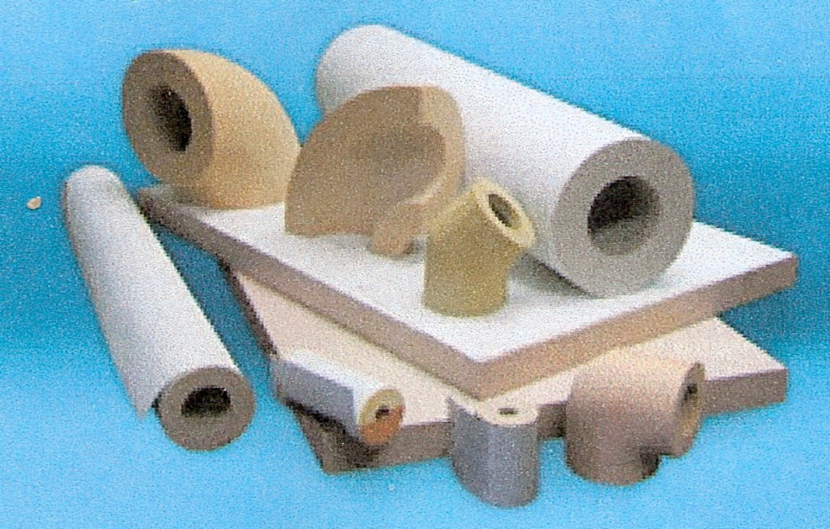
Phenolic insulation is rigid foam insulation with a closed cell structure. The exceptionally high level of closed cells and the fine cell structure gives phenolic foam exceptional thermal properties. Closed cell phenolic foams are the most thermally efficient insulation materials commonly available. The product is manufactured in a number of forms including blocks, continuously produced flexible faced laminate, rigid faced laminates and composite panels in addition to highly specialised applications such as fire doors and moulded products. Being based on phenolic resin it has outstanding fire characteristics and extremely low smoke emission when exposed to a flame source.

2.2 Properties, Uses and Applications
The exceptionally low thermal conductivity of closed cell phenolic foam boards means that appropriate insulation efficiency can be achieved with the thinnest possible material. This can be a significant advantage in building regulations, for example, in plaster board dry wall lining systems where internal room space is maximised and in cavity wall applications where the building envelope thickness is minimised.
It has excellent moisture resistance as a result of low water vapour permeability and 90% closed cell structure. It is also non-fibrous which is particularly relevant for use in hospitals, food preparation areas and breweries.
Phenolic foam is also used extensively in industrial heating and ventilation applications such as pipe equipment, tanks and duct insulation. It is also used in building applications such as roofing, flooring, cavity walls and in the food processing industry for steel faced panels.

2.3 Forms of Supply
Phenolic foam is available in pipe sections, blocks, rolls and slabs.
Cut pipe sections, bends etc are available to fit all standard steel pipes up to 610mm OD and light gauge copper pipes up to 158mm OD in wall thickness up to 50mm

2.4 Thickness, Density and Temperature Range
Phenolic foam is available from 20mm to 50mm thick.
The density range is from 35 to 200 Kg/m³ normal density.
The approximate maximum continuous operating temperature is 120ºC.

2.5 Fire Performance
The fire performance of phenolic foam is exceptional. It combines zero or very low flame spread with negligible smoke emission and a very low level of toxic gas emission.

3.0 Polyisocyanurate Foam

Key Learning Points
- Material composition of polyisocyanurate foam
- Thickness and density range
- Service temperature range
- Reaction to fire characteristics
- Forms available of polyisocyanurate foam

3.1 Product Composition and Characteristics
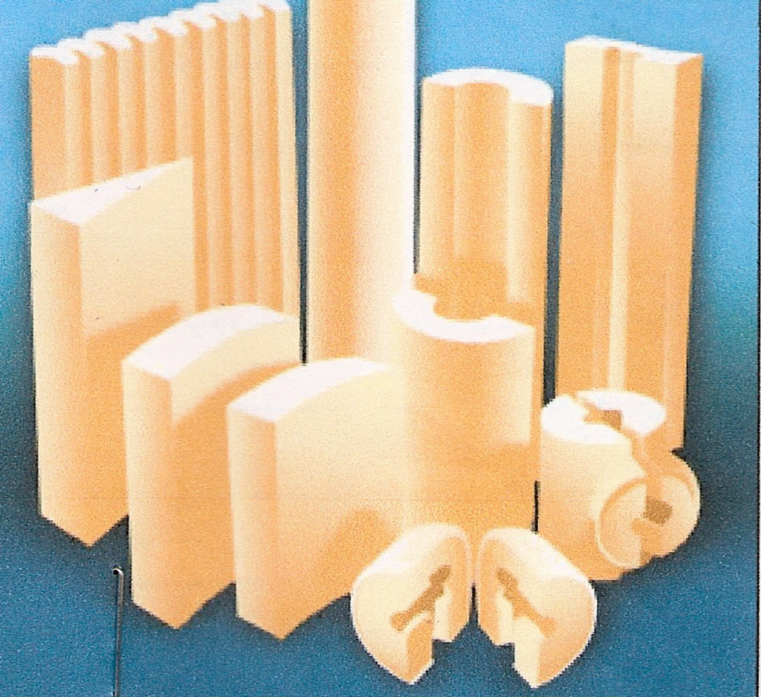
Polyisocyanurate (polyiso or PIR) is a closed cell, thermoset plastic rigid foam formed spontaneously when isocyanurate and polyether are mixed in the presence of a catalyst that help the molecules to rearrange and join, and a blowing agent to create the closed cells. Polyisocyanurate foam is similar in physical form to polyurethane foam but has improved dimensional stability over a wider operating temperature range, as improved insulating characteristics and fire/smoke resistance.

3.2 Properties, Uses and Applications
Compared to other forms of foam insulation, polyisocyanurate foam insulation has a higher R-value. It is lightweight, has good workability and has low thermal conductivity which means thinner insulation for any specified insulation level. The insulation performance is extremely high for the thickness of insulation. It has good mechanical properties and mechanical strength which fulfills all the requirements made of insulation materials used in the building industry. Due to its closed cell structure it does not absorb moisture.
Typical uses and applications for polyisocyanurate include roofing, walls floors and ceilings as well for use on pipelines, cryogenic applications, chilled water and low temperature steam systems.
The approximate maximum continuous operating temperature is 140ºC.

3.3 Forms of Supply
Polyisocyanurate is available in pre-formed slabs/boards, pipe sections and spray/foam in situ.

3.4 Thickness and Density Range
Polyisocyanurate boards can be manufactured in various thicknesses up to 200mm,
The normal bulk density is 30kg/m³ to 60 kg/m³.

3.5 Reaction to Fire Characteristics
Polyisocyanurate products are combustible however some products are treated with a fire retardant depending on their applications.

4.0 Vapour Barriers

Key Learning Points
- Vapour barriers used with polystyrene and phenolic foam
- Multi-layering and vapour barriers. Application method and appropriate sealant and adhesives
- Typical adhesives used with polystyrene and phenolic foam

4.1 Vapour Barriers Used With Polystyrene and Phenolic Foam
A vapour barrier must be used over the insulation on all plant operating at temperatures below the ambient air. The vapour barrier should be applied such that it is continuous and gives protection to the whole surface of the insulation which it covers. It should not be pierced or otherwise damaged. Means of load distribution must be provided at points of support as necessary. He material selected for use s a vapour barrier must be compatible with the thermal insulation which it is to protect.
Typical examples of vapour barriers are:
- Wet applied systems such as solvent based polymers, vinyl emulsions and bitumen emulsions with or without elastomeric latex. Frequently, these are reinforced with cotton scrim or glass mesh fibres.
- Elastomer sheets with all joints overlapped and continuously vapour sealed. Good at accommodating movement due to contraction.
- Polyvinyl chloride, polyethylene, polyisobutylene (PIB) or other suitable plastic tape or sheet. Used for wrapping small irregular shaped areas or where are coloured decorative finish is required.
- Epoxy and polyester resins. Used to provide a multi-purpose barrier to water vapour, weather and chemicals.
- Reinforced aluminium foils, building sheet or plastic film with all joints adequately overlapped and continuously vapour sealed.
When the operating temperature of the equipment cycles above and below the temperature of the ambient air, it will be necessary to design a vapour barrier/ breather system.

4.2 Adhesives and Sealants
Multi-purpose adhesives and sealants are available for bonding of hard insulating foams like polystyrene, phenolic and polyisocyanurate. Adhesives are available in an aerosol can, container or bulk form. When the adhesive is fully dried, it is designed to provide strength greater than the internal strength of most polystyrene foams.

4.3 Handling/ Application Information
- Read and fully understand the manufacturer’s data sheets before using theee product.
- For best results, all surfaces to be bonded must be clean, dry and free from dirt, dust, oil, loose paint, grease etc.
- The temperature of the adhesive/sealant and the surface to be bonded should be between 16-27ºC as temperatures outside this range may affect the bonding range and sprayability of the substance.
- Once the adhesive/sealant as been applied, allow the substance to dry until tacky then apply the insulation to the surface. Apply sufficient pressure to ensure intimate contact between the insulation and the surface being insulated.
- Excess adhesive/sealant should be removed using a cloth and a solvent substance. When using solvents, extinguish all ignition sources and follow the manufacturer’s precautions and directions of use.

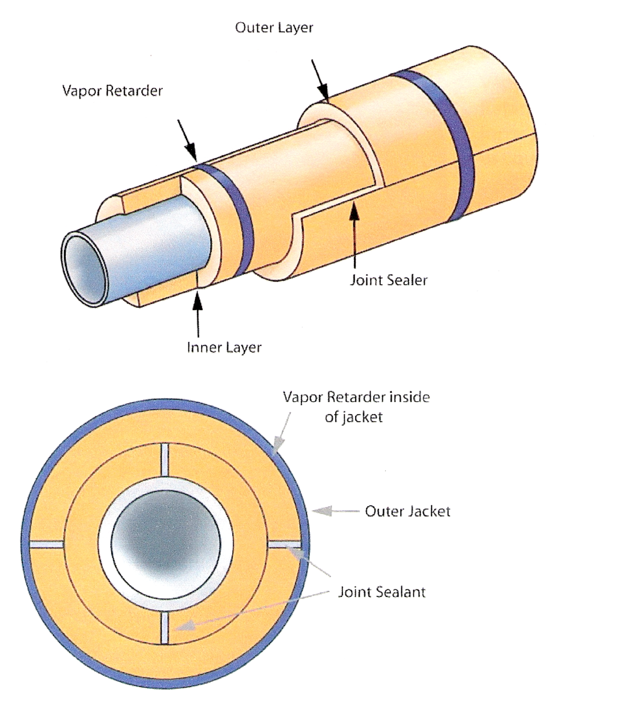
4.4 Multi-Layering of Insulation and Vapour Barriers
- Inner layer longitudinal joints at 12 and 6 O’clock. Outer layer at 3 and 9 O’clock.
- Staggered half round segments on each layer and between the two layers as shown above.
- Use a thin coat of sealant over the full depth of the joint. Any excess of sealant should be spread over the outside of the joint.

5.0 Types of Insulation Finishes

Key Learning Points
- Appropriate finishing materials
- Finishing and cladding applications

5.1 Finishing Materials
Insulation finishes are applied over the insulation to provide a vapour barrier, weather protection, protection from mechanical damage and improved aesthetics. Some finishes would include:
- Aluminium foil.
- Mastic and coating finishes.
- Flexible plastic sheet or elastomers sheet.
- Rigid PVC sheeting.
- Sheetmetal cladding.
- Polyisobutylene sheet.
Refer to Module 4 – Unit 15 – Finishing materials and cladding.

6.0 Health and Safety

Key Learning Points
- Demonstration of safe handling of these materials
- Safe disposal of waste material and adhesives

6.1 Safe Handling of Materials
Gloves should be worn when handling insulation products. The foam insulation is easily cut using a trimming knife or hand saw. When working in elevated positions or in strong winds care should be taken that the insulation panels are not blown away. When cutting, avoid dust generation, wear a dust mask to eliminate inhaling the dust particles. Eye protection should be worn if cutting the insulation with a mechanical saw.

6.2 Disposal of Materials
Waste material should be disposed of correctly and in accordance with local authority regulations. Dispose of waste materials regularly to avoid possible ignition or wind dispersal. Ensure polythene packaging is kept away from children.

Summary
Polystyrene, Phenolic foam and Polyisocyanurate foam insulations are lightweight, have good thermal efficiency, flexible and are water resistant. These foam insulations are used considerably in the industrial insulation industry for insulating ventilation systems, air-conditioning systems, pipe systems, tanks and vessels. They are also used considerably in the building industry for insulating floors, cavities and ceilings.
These products are available in slabs, boards, pipe sections and pre-formed sections. Their maximum operating temperature range is between 80ºC for polystyrene and 140ºC for polyisocyanurate with the maximum operating temperature of phenolic foam at 120ºC. They can be manufactured with a fire retardant to reduce their combustability.

Castleforbes House
Castleforbes Road
Dublin 1

