TRADE OF
Industrial Insulation

PHASE 2

Module 4

Insulation – Materials, Science and Application

UNIT: 3

Insulation Thickness, Thermal Conductivity & Performance Criteria

Produced by

In cooperation with subject matter expert:

Michael Kelly

© SOLAS 2014

Table of Contents
Introduction 1
Unit Objective. 2
1.0 Selection of Correct Insulation Material Thickness for a Specified Application 3
1.1 Range of Insulation Materials – Indoor/Outdoor Applications 3
1.2 Use of Data Sheets for Material Selection, Thermal Conductivity and Performance Criteria 5
1.3 Effects of Environmental Conditions 5
1.4 Integration of New Technologies and Materials 5
2.0 Selection of Appropriate Material Thickness and Performance Criteria 6
2.1 Thickness Selection and Performance Requirements for Insulating Materials 6
2.2 Thermal Conductivity 6
2.3 Multiple Layering of Insulation – Staggering of Joints. 7
3.0 Calculation of Material Thickness to Achieve Heat Loss Values 8
3.1 Heat Loss Calculations 8
3.2 Area, Volume and Density 8
3.3 Heat Loss and Insulation Thickness 9
Summary 10

Introduction
Selecting the correct insulating material for a specified application is of the utmost importance. There are a number of factors to be taken into account when designing an insulating system, including temperature, location, safety, corrosion and cost of materials and installation. Designing a system which includes all of the above requires the designer to have an in depth knowledge of different insulating materials. We can make this job a little easier by consulting with insulation manufacturers’. They will provide you with the necessary details including material data sheets, forms of supply and costs.
Module 4
Insulation – Materials, Science & Application
Unit 1
Basic Insulation Science & Principles
Unit 2
Insulation Materials & System Design
Unit 3
Insulation Thickness, Thermal Conductivity & Performance Criteria
Unit 8
Sprayed or Blown Fibre & Ceramic Fibre (Blanket)
Unit 7
Calcium Silicate & Magnesia
Unit 6
Cellular Glass or Foamed Glass
Unit 5
Glass Mineral Fibre & Rockwool
Unit 4
Insulation – Terms, Definitions & Formula
Unit 15
Finishing Materials & Cladding
Unit 14
Acoustics/ Noise Abatement
Unit 13
Fire Protection
Unit 12
Asbestos
Unit 11
Polystyrene, Phenolic Foam & Polyisocyanurate Foam
Unit 10
Nitrile Rubber
Unit 9
Vermiculite

Unit Objective.
By the end of this unit each apprentice will be able to:
- Select correct insulation material thickness for a specified application from product data sheets.
- State the criteria for selection of appropriate material thickness for specific purposes.
- Calculate the material thickness to achieve the required heat loss values.

1.0 Selection of Correct Insulation Material Thickness for a Specified Application

Key Learning Points
- Range of insulation materials–Indoor/Outdoor applications
- Use of data sheets for material selection, thermal conductivity and performance criteria.
- Effects of Environmental Conditions
- Integration of new technologies and materials

1.1 Range of Insulation Materials – Indoor/Outdoor Applications
The following table illustrate the name of the insulation material and its temperature application.
Name of Insulation Material | Temperature | Areas of Application | Remarks
Glass Mineral Wool | Up to 230° C | Attic Insulation | Made from Sand and recycled glass
 |  | Cavity Wall Insulation | Limestone and Soda Ash
 |  | Sound Insulation | Non-Combustible
 |  | Industrial Plant/Pipe work | Lightweight
 |  | Ventilation Ductwork | Cost Effective
Rock Mineral Wool | Up to 850° C | Floor, Wall, Roofs and | Made mainly from volcanic rock
 |  | Boiler room insulation | Typically basalt and/or docomite
 |  | Ventilation Plant | Resists high temperatures
 |  | Acoustic Ceilings | Water repellent
 |  | Partition Panels | Cost effective
 |  | Industrial Plant/Pipe work
Polystyrene Foam | Up to and not more than +75°C | Roofing, cold storage refrigerated transport. | Non toxic and non irritant. Resistant to water penetration, low cost (i.e. lower than mineral wools).
(PUR) Mixture of agents and additives | -185°C to +110°C |  | Very low thermal conductivity. Slightly more expensive but installation costs are lower.
(PIR) Polyisocyanurate | -185°C to +140°C | Petrochemical equipment, buildings, refrigerated vehicles, tankers and ducting. | More expensive better fire performance.
Phenolic Foam | -185°C to +120°C | Air conditioning ducting, dry lining, sandwich panels insulation. | Very low thermal conductivity. Does not melt when exposed to flame.
Nitrile Rubber | -40°C to +105°C | Heating water, steam and condensate. Chilled water and refrigeration ductwork. | Resistant to oil chemical and ozone lightweight and flexible.
Calcium Silicate | 37.8°C to +648.9°C | Back up insulation in the refractory industry, boilers ducting and process pipe work. | More expensive than mineral wool.
Cellular Glass | -267.8°C to 482.2°C | Process plant application and wide range of building application. | Resistant to water vapour, high compressive strength and good chemical resistance. Non- combustible. High production cost.
Expanded Vermiculate | Up to 1000°C | Cementitious binders to produce sprays or boards as a fire protection product. | Naturally occurring material, light weight, granular material, insert and high melting point.
Perlite | Up to 650°C | It is often used as a form of loose fill insulation. | Naturally occurring material. Cheaper than mineral wool.

1.2 Use of Data Sheets for Material Selection, Thermal Conductivity and Performance Criteria
The use of manufacturer’s data sheets in selecting the correct material is a vital part of the system design and installation procedures. The manufacturer’s data sheets generally contain information on the following:
- Conformity to standards.
- Description of the product.
- Environmental impact of the product.
- Performance and properties.
- Hazards associated with the product.
- Safety precautions.
- What to do in case of an emergency.

1.3 Effects of Environmental Conditions
To offset the effects of installing thermal insulation in various types of adverse environmental conditions, insulation materials should have:
- Resistant to attack by chemicals with which they may have come into contact with. If this is not practical, then the insulation should be provided with a resistant coating or jacket.
- Resistance to moisture sufficient that they do not deteriorate under wet conditions. This is particularly important when operating in the open.
- Resistance to vibration, mechanical shock, and abrasion or, as most insulants by their nature are mechanically weak, at least protection against damage by same.
- Weathering and protection for the purpose of elimination of ingress of moisture, protection against fire and mechanical damage and against corrosion.

1.4 Integration of New Technologies and Materials
New materials are being developed on a constant basis, which are more energy efficient and cost effective. Architects and engineers are using processes that are environmentally responsible and resource-efficient throughout a building's life-cycle: from design, construction, operation, maintenance and renovation. This practice expands and complements the classical building design concerns of economy, utility, durability, and comfort. Innovations and new technological advances in the research and design of insulation materials is playing a major part in the energy efficiency of “green” buildings.

2.0 Selection of Appropriate Material Thickness and Performance Criteria

Key Learning Points
- Thickness selection criteria
- Multi-layering of insulation; staggering of joints
- Thermal conductivity
- Performance criteria for insulating materials

2.1 Thickness Selection and Performance Requirements for Insulating Materials
In deciding on a certain type and thickness of insulation to be used for a particular application, a number of factors or performance requirements for the insulation system need to be considered. The selection of materials and the insulation thickness to be specified shall be determined according to the intended function of the insulation.
The performance requirements shall be specified in according with the appropriate clauses and tables of the British Standard BS5422:2001, which shall be determined from the following factors:
- System operating temperature.
- Design ambient air temperature.
- Relative humidity of the ambient air.
- Air Velocity
- Location of the plant (indoors or outdoors).
- Pipe Diameter (or flat surface dimensions).
- Orientation of pipes (horizontal or vertical).
- Vertical dimensions of flat surfaces.
- Emissivity of outer surface.
For refrigerated, chilled or other cold applications, the following performance requirements, if applicable, shall also be specified in according with the appropriate clauses and tables of this standard:
- Resistance of the insulation material to the passage of water.
- Permanence of any vapour barriers used.
Refer to BS5422:2001 page 81, for selecting the correct insulation thickness for a particular application.

2.2 Thermal Conductivity
Refer to module 4 – unit 2 – section 2.5

2.3 Multiple Layering of Insulation – Staggering of Joints.
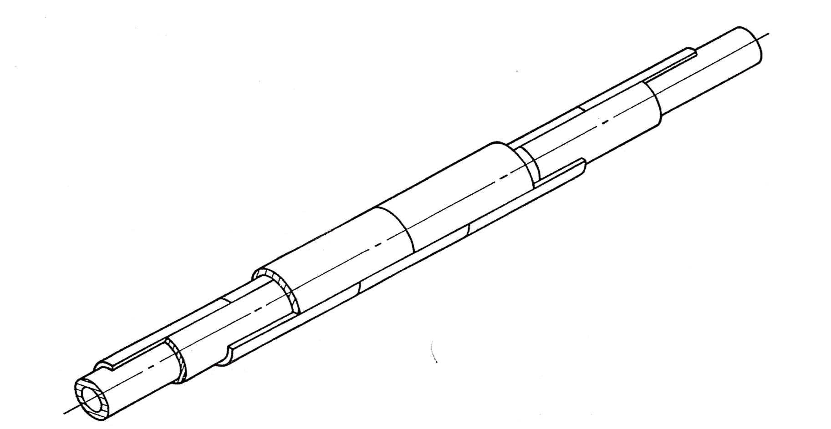
Pipe work is usually insulated with pre-formed pipe section that should be fitted closely to the pipe, and any unavoidable gaps in circumferential or longitudinal joints should be fitted with, compatible insulating material. Total insulation thicknesses greater than 75mm should be applied in multi-layers with all joints in adjacent layers staggered. As shown in the drawing.
Typical method of staggering insulation sections on a straight pipe.
Each section should be held in place by circumferential bands or tie wire at not greater than 50mm to the end of the section. Over tightening of bands or wires should be avoided to prevent cracking of rigid material or opening of joints of flexible material. After tightening, the ends should be pressed into the insulating material to prevent damaging a vapour barrier (if in place) or an outer finishing material.

3.0 Calculation of Material Thickness to Achieve Heat Loss Values

Key Learning Points
- Heat loss calculations
- Area, Volume and Density
- Heat loss and insulation thickness

3.1 Heat Loss Calculations
Pipe Insulation is thermal insulation used to prevent heat loss and gain from pipes, to save energy and improve effectiveness of thermal systems.
The benefits include, in addition to reducing costs and environmental impacts of energy consumption:
- Reducing or eliminating condensation on cold pipes.
- Protection from dangerous pipe temperatures.
- In domestic hot-water systems, the water temperature at the point of use can be closer to the temperature at the water heater, and wait time for hot water can be reduced.
- Control of noise.
- Reduction of unwanted heat gain to air-conditioned spaces.
The heat flow through pipe insulation with outer diameter d_{o} and inner diameter (of the insulation--equal to outer diameter of the pipe) d_{i} is
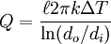
where is the length of the pipe, k is the thermal conductivity of the insulation material, and ΔT is the temperature difference between the inner and outer walls of the insulation. If the insulation is sufficiently thick and has sufficiently low thermal conductivity, the outside surface of the insulation will be close to the ambient temperature, and ΔT may be approximated as the temperature difference between the temperature of the fluid in the pipe and the ambient temperature.

3.2 Area, Volume and Density

Area of a Square
The area of a Square = Length of Side x Length of Side.
Example: Duct Size = 0.6m x 0.6m.
Area of Duct = 0.36m square.

Volume
The volume of a duct = Length of Side x Length of Side x Height.
Example: A duct section is 600mm x 600mm x 600mm long.
Calculate the volume of the duct = .6m x .6m x .6m long
Volume of duct = 0.216m³ or 0.216 cubic metres.

Density
Density is defined as mass per unit volume.
Density can be calculated using the formula: d = m ÷ v
where d = density, m = mass, v = volume
The greater the density, the more mass per unit volume.
The unit of density derived from SI units is kilograms per cubic meter, kg/m³ or kgm⁻³.

3.3 Heat Loss and Insulation Thickness
Insulation is available in nearly any material imaginable. The most important characteristics of any insulation material include a low thermal conductivity, low tendency toward absorbing water, and of course the material should be inexpensive. In the chemical industry, the most common insulators are various types of calcium silicate or fibreglass. Calcium silicate is generally more appropriate for temperatures above 225 ⁰C, while fibreglass is generally used at temperatures below 225 ⁰C.
Since heat loss through insulation is a conductive heat transfer, there are instances when adding insulation actually increases heat loss. The thickness at which insulation begins to decrease heat loss is described as the critical thickness. Since the critical thickness is almost always a few millimeters, it is seldom (if ever) an issue for piping.

Summary
Insulation is available in nearly any material imaginable. The most important characteristics of any insulation material include a low thermal conductivity, low tendency toward absorbing water, and of course the material should be inexpensive.
The use of manufacturer’s data sheets in selecting the correct material is a vital part of the system design and installation procedures. Care should be taken when calculating heat loss through insulation to ensure that the correct amount and type of insulation is used.

Castleforbes House
Castleforbes Road
Dublin 1

