TRADE OF
Industrial Insulation

PHASE 2

Module 5

Ductwork & Vessels

UNIT: 10

Dressing Pieces

Produced by

In cooperation with subject matter expert:

Michael Kelly

© SOLAS 2014
Table of Contents
Unit Objective 1
Introduction 2
1.0 Dressing Pieces 3
1.1 Accurate Measuring and Sketching 3
1.2 Accurate Cutting of Dressing piece. 3
1.3 Importance of Weathering 4
1.4 Importance of Safety with Recessed Pieces 4
1.5 Importance of Thermal Movement Allowance 4
1.6 Piping Cut-Outs: Tank Supports and Man-way covers 4
1.7 Removal of sharp edges. 5
2.0 Finish and Appearance 6
2.1 Professional Attitude to Finish and Safety 6
2.2 Estimation of Planning, Production, Fitting and Finishing Times for Dressing Pieces 6
2.3 Effects of Expansion: Co-Efficient of Linear Expansion on Different Materials 7
2.4 Use and Properties of Sealants 7
2.5 Use of Pop Rivets and Associated Tooling 7
Summary 8

Unit Objective
By the end of this unit each apprentice will be able to:
- Measure and sketch various dressing pieces to suit industrial applications.
- Accurately mark out and fabricate various dressing pieces.
- Estimate production and fitting times for dressing pieces.
Module 5
Ductwork & Vessels
Unit 1
Measuring: Ductwork & Other Large Areas
Unit 2
Rectangle to Round (Concentric)
Unit 3
Off-Centred Rectangle to Round
Unit 5
Offset (Duct) Rectangular
Unit 4
Radius Bend (Duct)
Unit 6
Hoppers (Rectangle to Rectangle)
Unit 7
Vessels: Storage & High Pressure
Unit 8
Moving Joints & Support Systems
Unit 9
Scale Drawing & Applications
Unit 10
Dressing Pieces

Introduction
Dressing pieces are an important part of the overall cladding system. They are the finishing piece around man-ways, access hatches, piping cut-outs and tank supports. Great care and attention to detail is required when designing, manufacturing and fitting dressing pieces. They have to be in proportion to the surrounding cladding, free from sharp edges and burrs and sealed correctly so as to eliminate the ingress of water into the insulation below. The overall finish of a cladding system can very often hinge on the professional finish of dressing pieces.

1.0 Dressing Pieces

Key Learning Points
- Accurate measuring and sketching
- Accurate cutting of dressing pieces
- Importance of weatherproofing
- Importance of safety with recessed pieces
- Importance of thermal movement allowance
- Cut-outs for pipe-work on tanks and vessels
- Removal of sharp edges

1.1 Accurate Measuring and Sketching
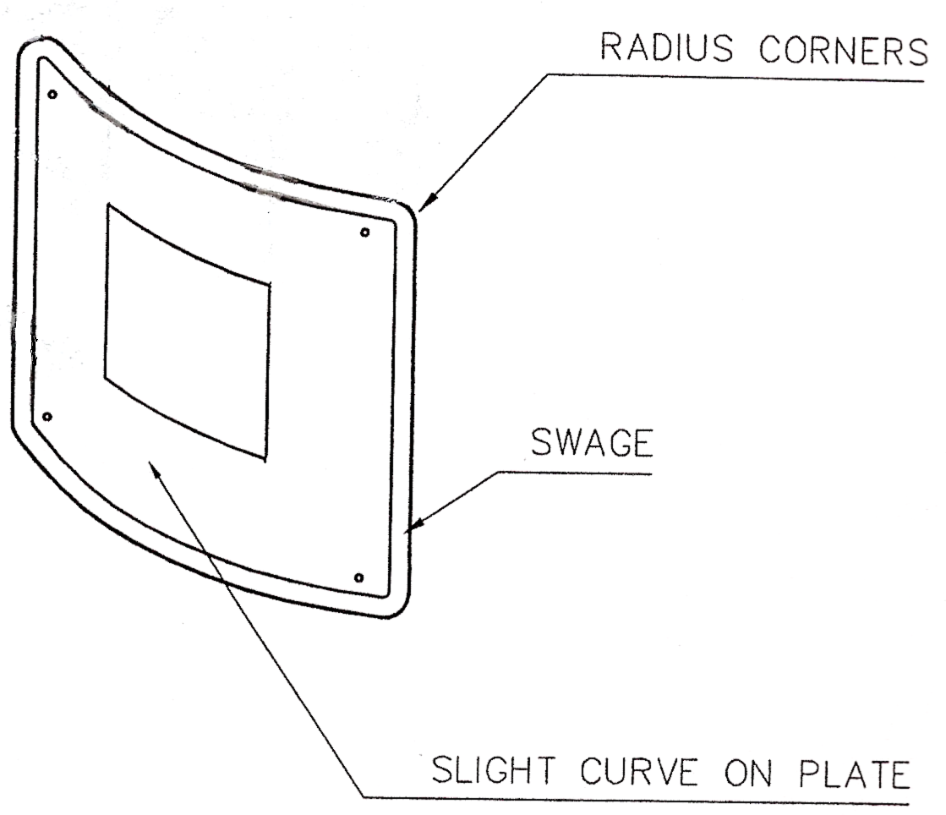
The dressing piece should b accurately measured using a 2 metre rule or tape rule. It would be important to make sure that the dressing piece is the correct size and in proportion to the equipment it is being fitted to, so that it would blend in and enhance the overall finish of the job. Dressing pieces which are manufactured correctly give the job that professional look.
Dressing piece to suit curvature.

1.2 Accurate Cutting of Dressing piece.
After the dressing piece has been marked out, it can be cut using the guillotine or bench shears, and then de-burred. Next it is punched and swaged before it is fitted onto the metal cladding.
Dressing pieces are usually very simple pieces to manufacture, however the important point is that they should be neat and well finished, with holes evenly spaced out to give the dressing piece a professional finish.

1.3 Importance of Weathering
Water is the number one enemy of any insulation system. It is vitally important that water is kept out of the insulation system at all costs. Water will enter the insulation system through damaged cladding, badly sealed joints, poorly designed dressing pieces or around openings where pipe-work etc. connects with tanks or storage vessels for example.
All joints should be fully sealed to prevent the ingress of water into the insulation system, thereby preventing major problems in the future such as corrosion and the overall failure of the insulation system.

1.4 Importance of Safety with Recessed Pieces
As mentioned in section 1.2 above, it is very important that the dressing piece is neatly manufactured and has a professional finished when it is installed. The dressing piece should always be free from burrs and sharp edges. Recessed pieces should be made in such a way as to allow enough room for a person to get their hand in to access the part that has been enclosed by the recessed piece of cladding.
The recessed piece should be free from burrs and sharp edges. Once the recessed piece has been installed, it should be thoroughly checked for sharp edges and burrs. Use a flat file to remove any burrs and be careful not to scratch or mark the cladding when doing so.

1.5 Importance of Thermal Movement Allowance
As insulated systems expand and contract on a regular basis or cycle, it is very important to allow extra space around pipe-work etc. when fitting a dressing piece, so as to allow for this expansion and contraction.

1.6 Piping Cut-Outs: Tank Supports and Man-way covers
Dressing pieces fitted around supports for holding round horizontal tanks need to be measured very carefully. The finished dressing pieces should sit neatly in and around the tank supports to finish off the cladding and give a professional finish to the job.
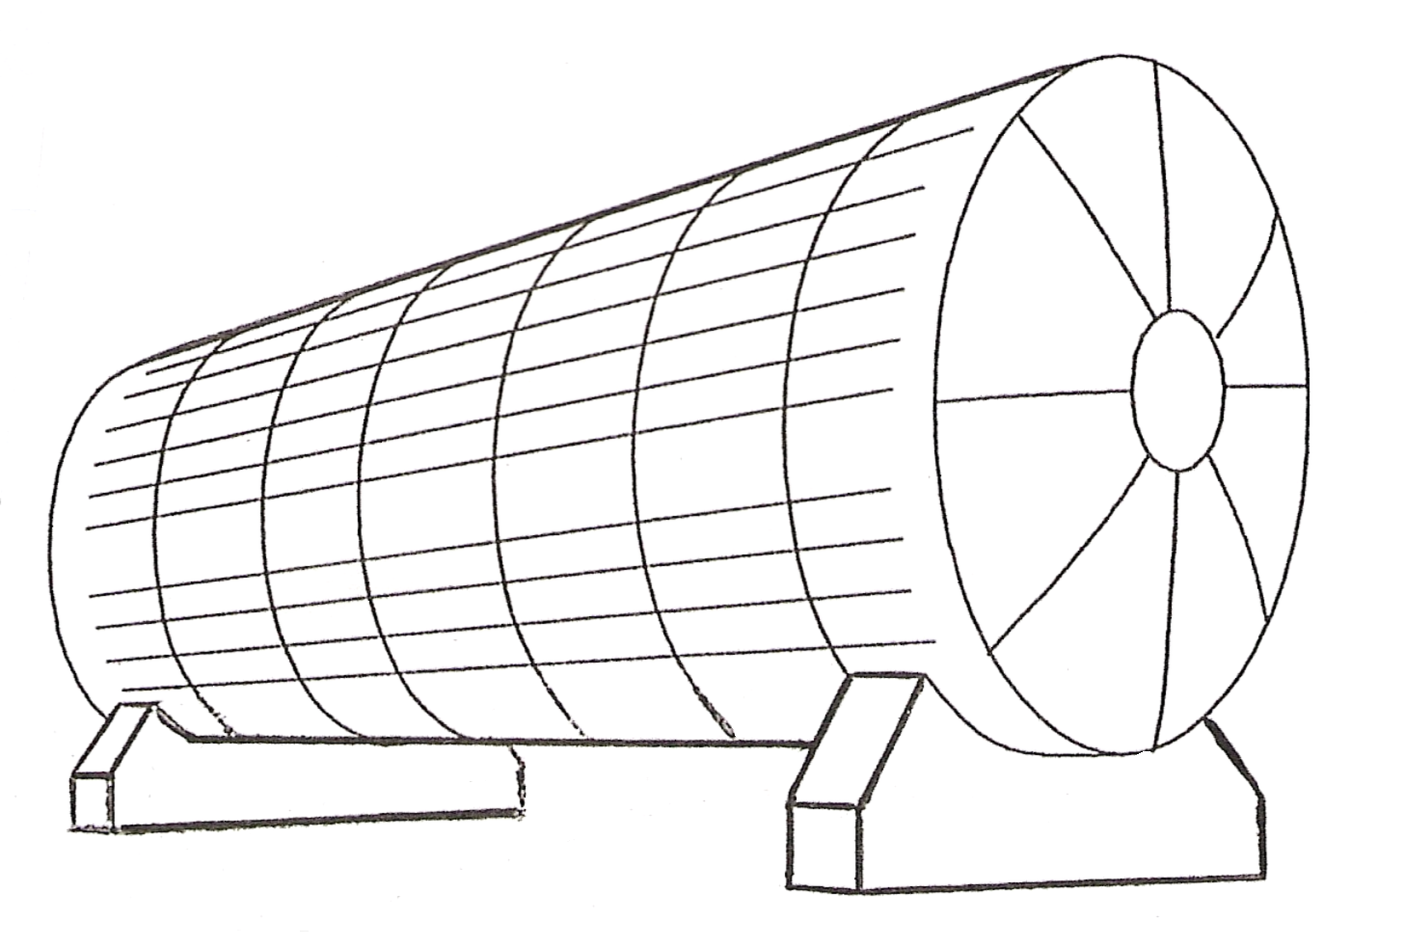
After measuring, the dressing pieces are cut out, punched, rolled, swaged and fitted using self-tapping screws or rivets for a neat finish. They are then sealed using an appropriate sealant to prevent the ingress of water.

Man- Ways
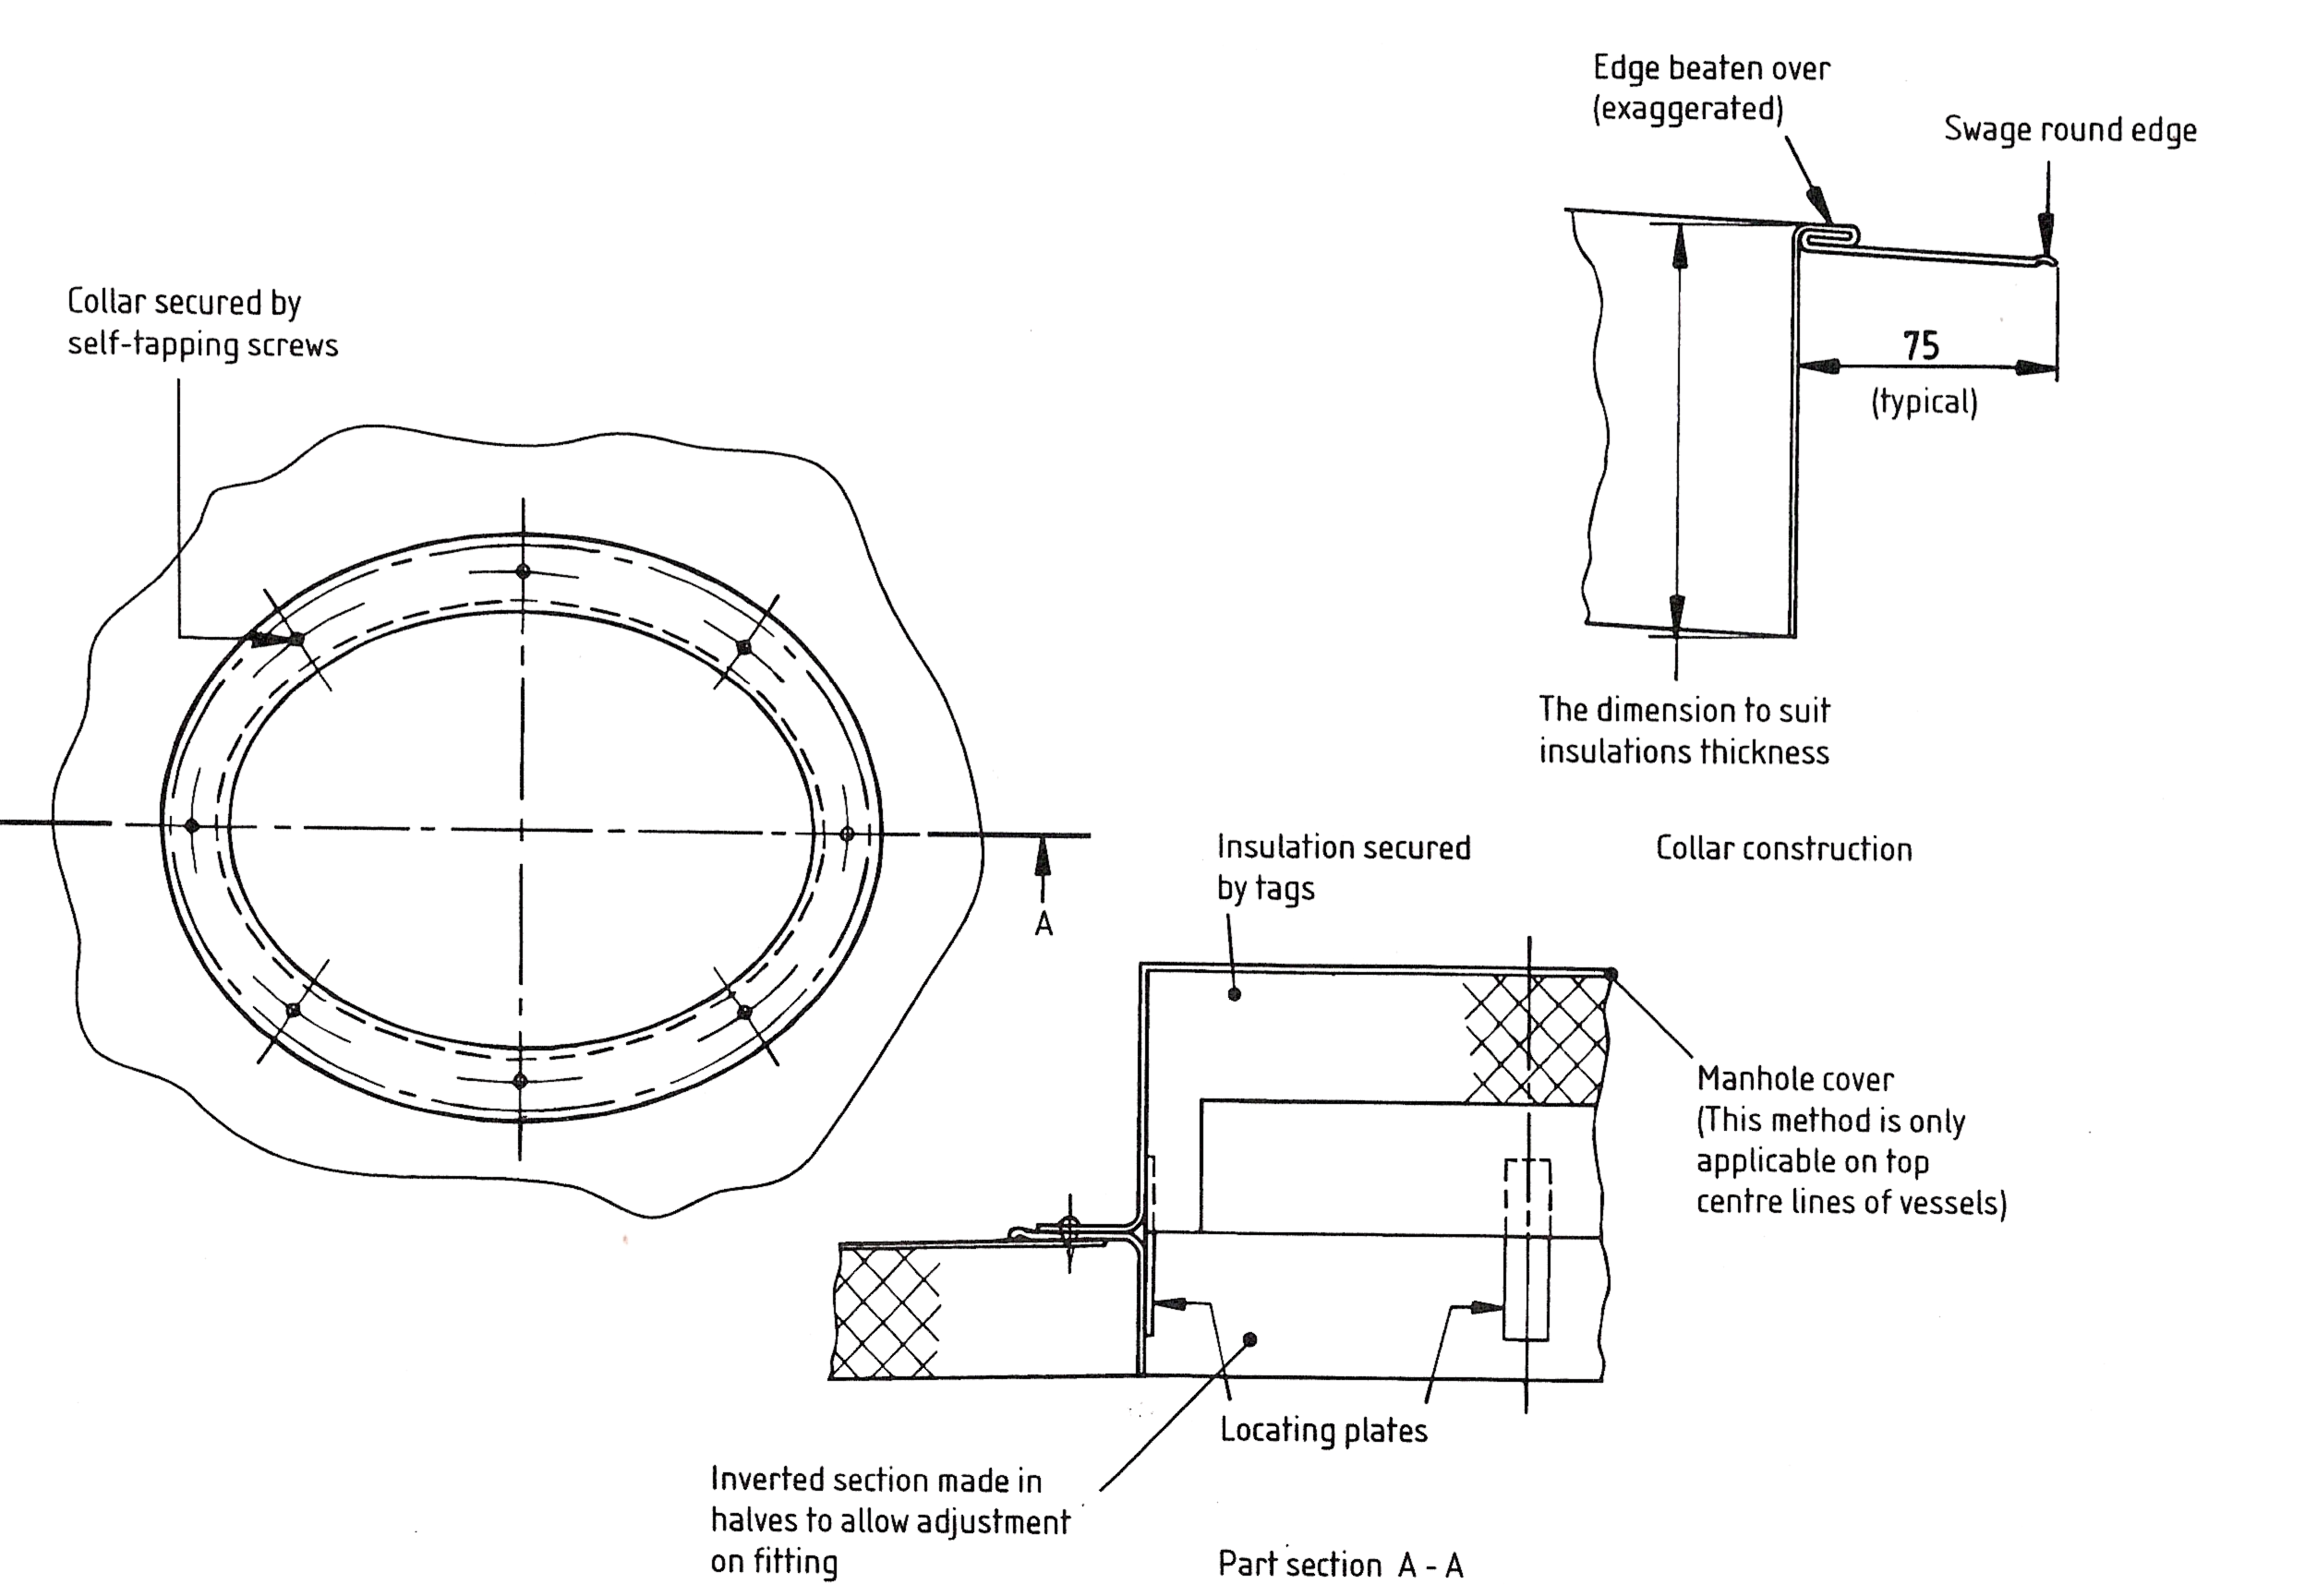
Man-ways or manholes allow a person to access the inside of a tank or vessel. The diagram below shows an arrangement of a finishing collar and cover over a manhole on top of a vessel. The collar and cover are secured with self-tapping screws as the cover may need to be removed from time to time for inspection purposes.

1.7 Removal of sharp edges.
Sharp edges or burrs should be removed from dressing pieces as they can be a danger to the person making them by way of cuts to the hands. It is always a good idea to de-burr the piece of material before and after forming i.e. swaging, rolling etc. Dressing pieces should always have rounded corners both for appearance and to compliment the overall finish of the job.

2.0 Finish and Appearance

Key Learning Points
- Professional attitude to finish and safety
- Estimation of manufacture and installation times
- Use and properties of sealant
- Use of pop rivets and associated tooling
- Effects of expansion on different materials

2.1 Professional Attitude to Finish and Safety
“Small things make perfection, but perfection is no small thing”. On any job it is important to do the small things correctly, because they all add up to the overall finish of the job. If the small jobs are done badly such as; incorrect patterns and developments, bad cutting out of patterns, punched holes not on centre and out of alignment, the overall fitting together of the job will be poor and the overall finish of the job will be less than satisfactory.
The same can be said regarding safety. The prevention of accidents is the responsibility of every person, employer and employee alike, and the combined efforts of both management and the workforce can go a long way towards establishing and maintaining a safe place of work. Some safety precautions which should be taken on site are:
- All safety rules and regulations should be adhered to at all times.
- Personnel protective equipment (PPE) must be worn at all times.
- Hazards on site or in the workshop should be identified and eliminated or reduced to an acceptable level.
- The work area should be kept clean and tidy at all times so as to eliminate slips, trips and falls.

2.2 Estimation of Planning, Production, Fitting and Finishing Times for Dressing Pieces
As dressing pieces are a very important part of any job due to the importance of finish and appearance. Dressing pieces can be time consuming due to the care and attention to detail that is required to have them fitting and looking well on the job.
Depending on the number of dressing pieces and their complexity, the production and fitting times can vary quite dramatically. It is always a good rule of thumb to over-estimate the time required for manufacture and installation slightly so if any delays are incurred due to unforeseen circumferences, they are allowed for in the quotation.

2.3 Effects of Expansion: Co-Efficient of Linear Expansion on Different Materials
Refer to module 5 – unit 8 – section 2.6.

2.4 Use and Properties of Sealants
Refer to module 4 – unit 15 – Finishing materials and cladding.

2.5 Use of Pop Rivets and Associated Tooling
Refer to module 1 – unit 4 – Notching, folding and joining.

Summary
Dressing pieces or finishing pieces are an integral part of the overall cladding system. Dressing pieces should be fitted neatly and add to the overall appearance of the job. Great care should be taken when designing a dressing piece to ensure that it is in proportion to cladding around it, it is free from sharp edges, that it sheads water and that it is sealed correctly to the cladding.
Thermal expansion occurs in all pipe-work systems due to changes in temperature. The co-efficient of linear expansion explains that for every one degree increase in temperature a relative change in the length of the pipe-work system also occurs. This change in length will differ slightly depending on the material used. The design, manufacture and installation of dressing pieces must also take into consideration this expansion and contraction of materials.

Castleforbes House
Castleforbes Road
Dublin 1

