TRADE OF
Industrial Insulation

PHASE 2

Module 6

Insulation & Cladding the Training Rig

UNIT: 2
Selection & Cutting of Insulation Materials

Produced by

In cooperation with subject matter expert:

Michael Kelly

© SOLAS 2014
Table of Contents
Introduction 1
Unit Objective 2
1.0 Material Selection 3
1.1 Interpretation of the Supplier Works Specification 3
1.2 Use of Data Sheets and Manufacturers’ Catalogues 4
1.3 Correct Selection of Material Type and Form 4
1.4 Accurate Estimation of Materials 5
2.0 Marking Out and Cutting 6
2.1 Accurate Marking out of Insulation Materials 6
2.2 Efficient Use of Materials and Reducing Waste 34
2.3 Neat Layout of Work Space and Tools 34
2.4 Accurate Cutting of Materials and Minimising Waste 35
2.5 Storage of Cut Materials in an Orderly Fashion for Fitting 35
2.6 Safe Disposal of Waste Materials 35
Summary 36

Introduction
Selecting the correct insulation material for a particular project requires skill and knowledge. Information on all insulation products is readily available through manufacturers’ catalogues, project specifications and the internet. There are a number of factors to be taken into account when selecting the correct product including temperature, location, safety, corrosion and cost of materials.
Module 6
Insulating & Cladding the Training Rig
Unti 1
Measuring the Training Rig
Unit 2
Measuring the Training Rig
Unit 3
Insulation of the Training Rig (Hot & Cold Work)
Unit 5
Cladding of Training Rig
Unit 4
Substructure & Support Systems

Unit Objective
By the end of this unit each apprentice will be able to:
- Select the appropriate insulation material.
- Calculate material requirements.
- Accurately cut a selection of insulation materials.

1.0 Material Selection

Key Learning Points
- Interpretation of the supplier works specification
- Use of data sheets and manufacturers’ catalogues
- Correct selection of material type and form
- Application of independent selection criteria
- Accurate estimation of materials

1.1 Interpretation of the Supplier Works Specification
Properly engineered specifications are vital to the overall success to any thermal insulation project. If a specification is poorly written, it can have a negative effect on the overall efficiency and operation of an insulation system. This can lead to improper selection of materials and systems as well as leaving the contractor unsure of what the specification really requires. It is important that the specification is written in clear and concise language. This is to ensure that there is no confusion and ambiguity and that the contract is carried out to the highest standards. A properly engineered insulation specification will optimise the capital expenditure and give a good return on the investment, as well as ensure the intended service life of the project is maintained.
Most specifications are composed of general conditions, project requirements, drawings, standards, a scope of works and technical information such as insulation thickness etc. Insulation thickness is the primary means of energy conservation through the reduction of heat loss, but ignoring other factors can cause an excessive loss of energy. So it is very important to adhere to the specification to ensure that the contract is carried out properly.
The selection of insulating materials must be precise. The criteria for selecting insulating materials should at minimum, be influenced by the following questions:
Is the insulation system designed to reduce energy loss from a hot surface or to reduce the absorption of heat and provide anti-sweat protection for cold surfaces?
- Will the insulation system be indoors or outdoors?
- Will the insulation system be above or below ground?
- Must the insulation system be protected from mechanical abuse?
- What is the probable incidence of fire?
A wide variety of insulation materials and methods of application are employed to facilitate the application of insulation, thereby reducing the overall cost of the insulation contract.

1.2 Use of Data Sheets and Manufacturers’ Catalogues
Up-to date manufacturers’ literature should be reviewed prior to specifying an insulation material to ensure that the material will perform as expected. Manufacturers’ data sheets and catalogues generally outline the following:
- A description of the product including benefits of the product, density, thermal conductivity and overall performance.
- Structure – open cell or closed cell structure, high density.
- Temperature range – minimum and maximum temperature range.
- Thermal performance – Thermal conductivity values and performance.
- Moisture resistance – details and general information.
- Chemical resistance and compatibility – its resistance to oils, solvents, chemicals and adhesives etc.
- Fire performance – Resistance to burning and spread of flame.

1.3 Correct Selection of Material Type and Form
In selecting the correct type of material and supply form for a project, it is important to refer to the design data sheet and specification. This will indicate the pipe diameter, temperature range, insulation thickness and the method of installation i.e. multi-layers. The specification will indicate the insulation thickness for the first and second layers and the preferred method of installation.
Another method of selecting the correct material and forms of supply is to use the manufacturers’ catalogues as mentioned in section 1.2. These will recommend for example:
- The use of glass/rock wool rigid pre-formed process pipe sections for steam and process pipe-work.
- Rock mineral wool rigid, semi-rigid and flexible slabs for thermal, acoustic and fire insulation.
- The use of rock mineral wool lamella mat for the insulation of heating and ventilation pie-work and ductwork.
- The use of rock mineral wool wired mattress for the insulation of high temperature ducts, process pipe-work, tanks, vessels and boilers.
- The use of nitrile foamed rubber (Armaflex) for hot and cold pipe-work, ductwork and vessels.
- The use of phenolic foam insulation pipe sections bends and slabs for pipe-work, vessels and ductwork.

1.4 Accurate Estimation of Materials
In module 6 – unit 1 – section 2.1, is an isometric drawing of the training rig. For this exercise we will consider leg 1 of the rig.
When measuring the pipe-work for estimating the amount of thermal insulation required for the job it is usual to measure on the centre line of the pipe-work through all the fittings to arrive at a total length required. Add 10% to the total length of material for waste and cutting allowances. Consult with the manufacturers’ catalogues for the lengths of pipe sections available, usually 1 metre of 1.2 metre lengths, and simply divide the total length of the job by the available section lengths and this will give you the total lengths of pipe sections required.

Example
To find the amount of insulation material required to cover a vessel similar to the one on the training rig, firstly the measurements of the vessel must be taken.
Diameter of vessel: 600mm
Height of vessel: 2500mm
Thickness of insulation to be used: 50mm

Solution
Diameter of vessel: 600mm
Diameter of vessel plus insulation: 600mm + 50mm +50mm =700mm or 0.7m
Circumference of vessel: 0.7 x 3.14 = 2.198 metres.
Area of vessel: 2.198 m x 2.5m high = 5.495m²
Area of ends of vessel by 2 = πr² x 2 = 3.14 x 0.35² x 2 = 0.7693m²
Total area of insulation required = 5.495m² + 0.7693² = 6.2643m²
For estimating purposes it is advised to add 10% to this figure to allow for waste and cutting allowances.
Check manufacturers’ catalogues for information and advice on the types of insulation available for covering vessels, including the forms and densities available, typical construction methods and information on banding, circumferential support rings, securing methods etc. It is also advised to consult with BS: 5970: 2001

2.0 Marking Out and Cutting

Key Learning Points
- Accurate marking out
- Neat layout of workspace and tools
- Safe use of tools and equipment
- Accurate cutting of material for fit and to minimise wastage
- Storage of cut materials in an orderly fashion for fitting
- Safe disposal of waste materials

2.1 Accurate Marking out of Insulation Materials
For this example Armaflex insulation will be used for demonstration purposes. We have taken a large excerpt from the manufacturers’ catalogue to demonstrate the level of information available and the correct application methods. It is worth noting that the application methods used in this example can also be used for other rigid and semi-rigid products, however it is important that you refer to the relevant manufacturers’ catalogues for installation instructions.

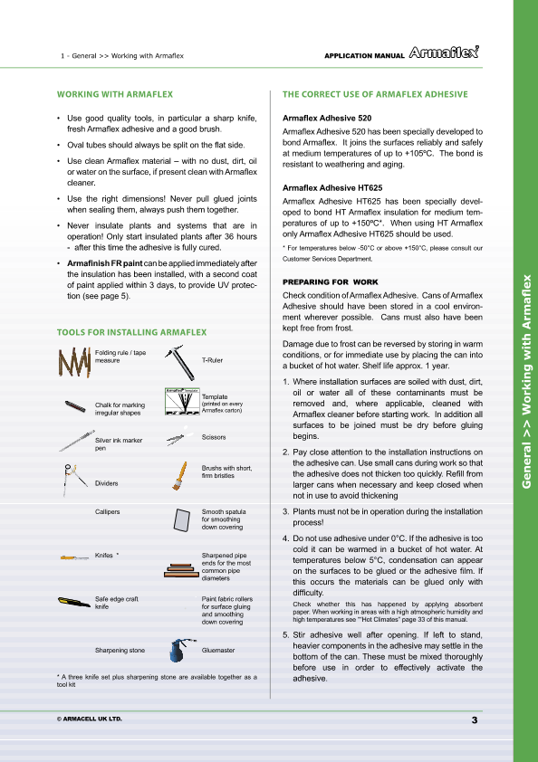

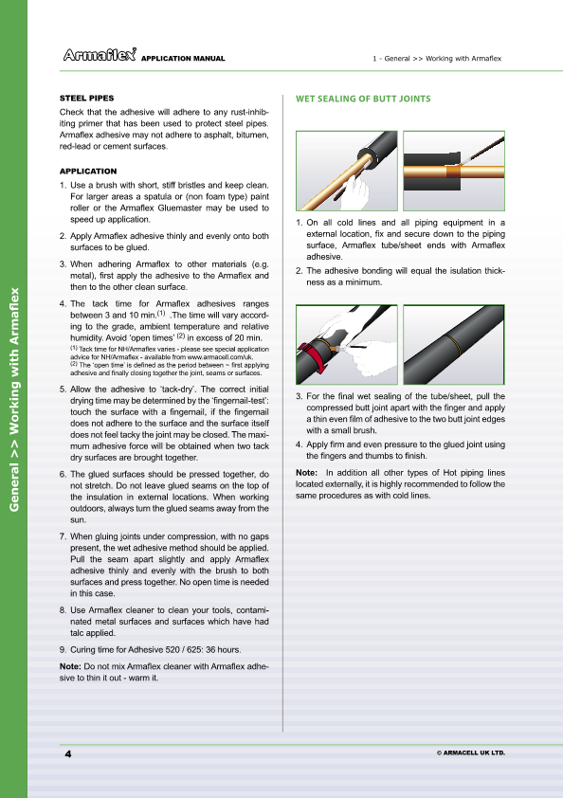

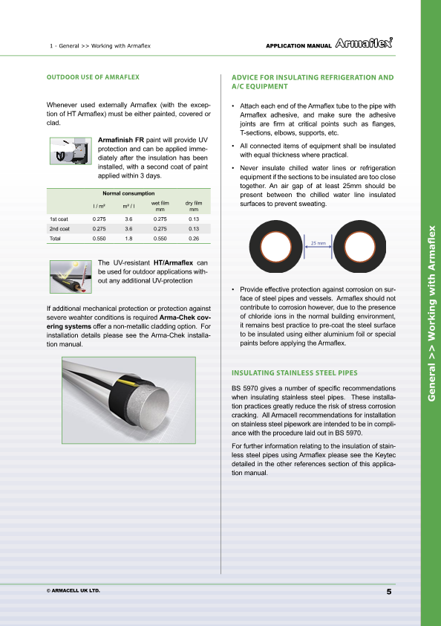

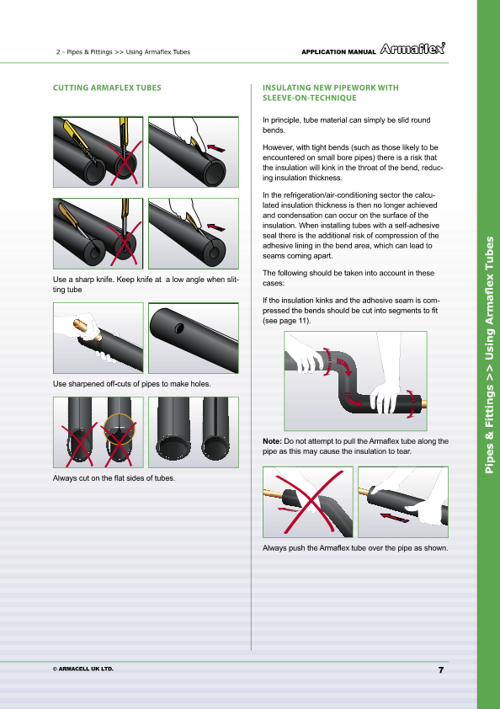

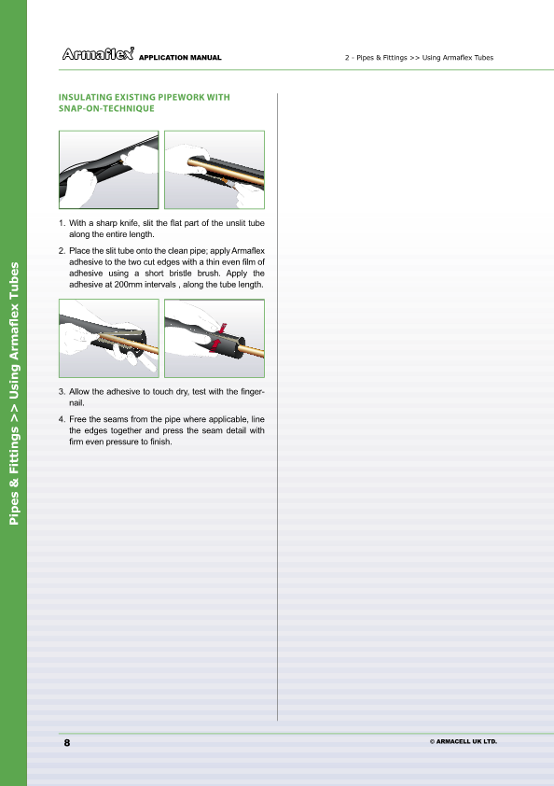

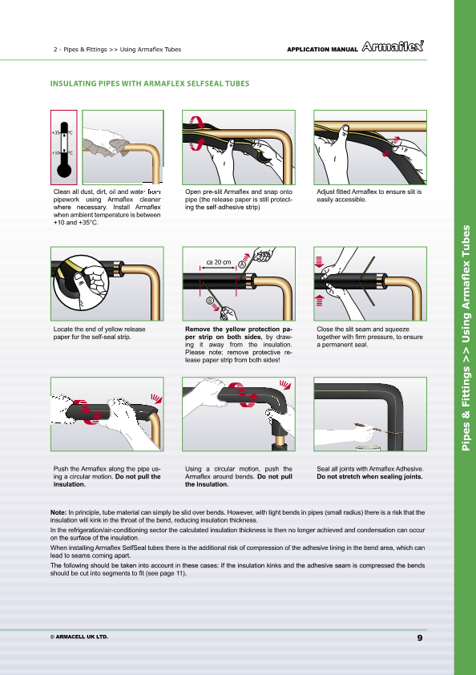

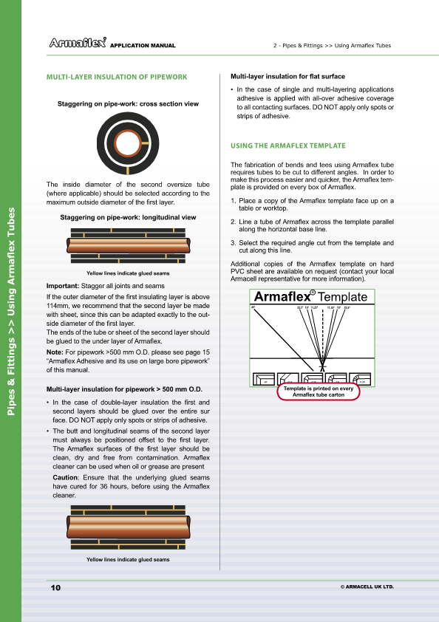

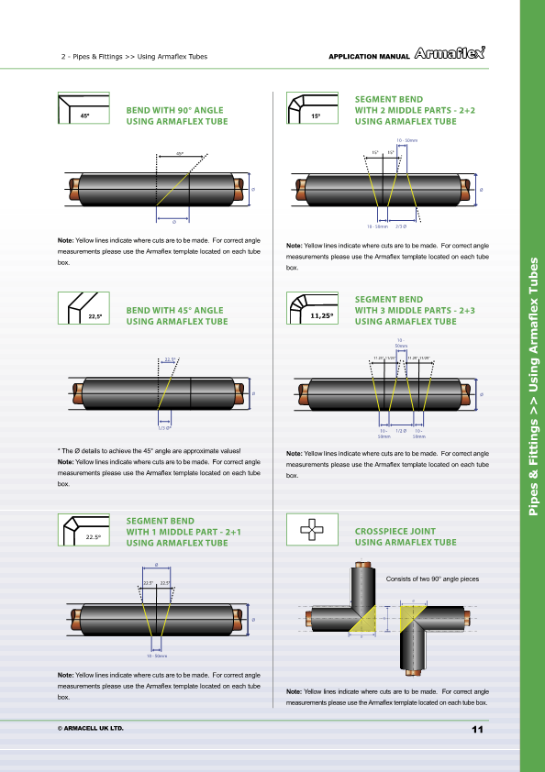

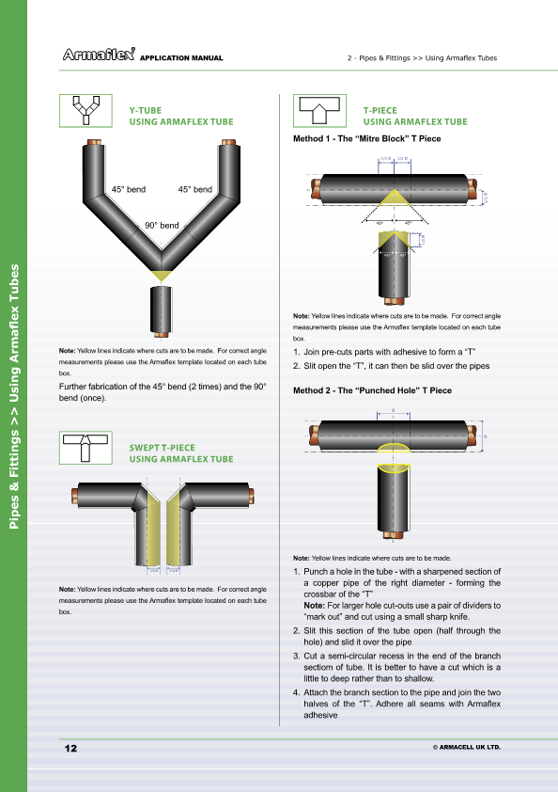

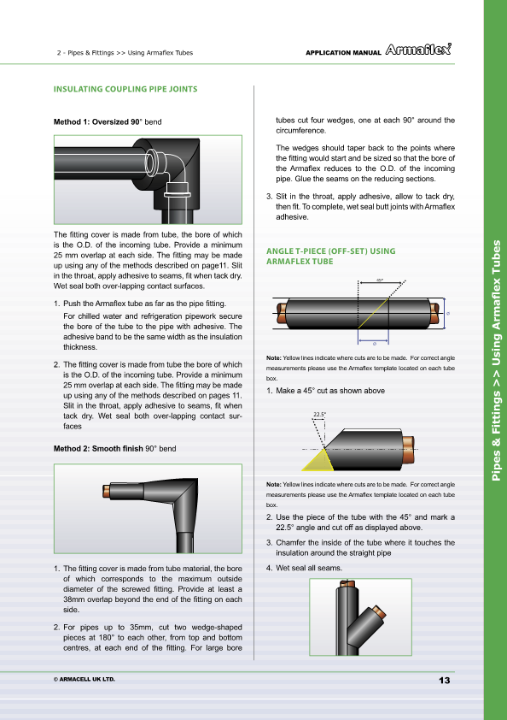

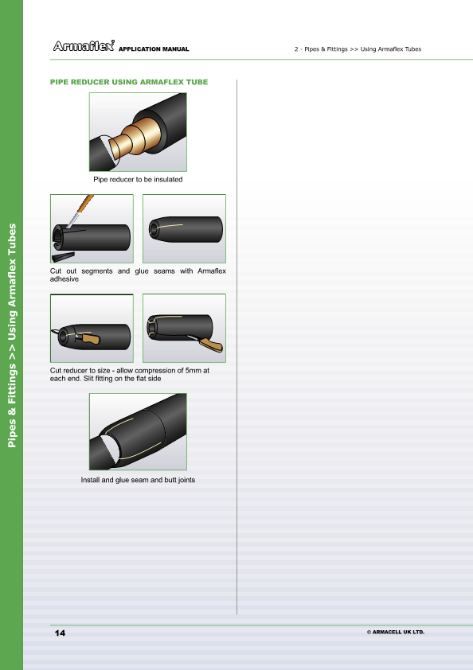

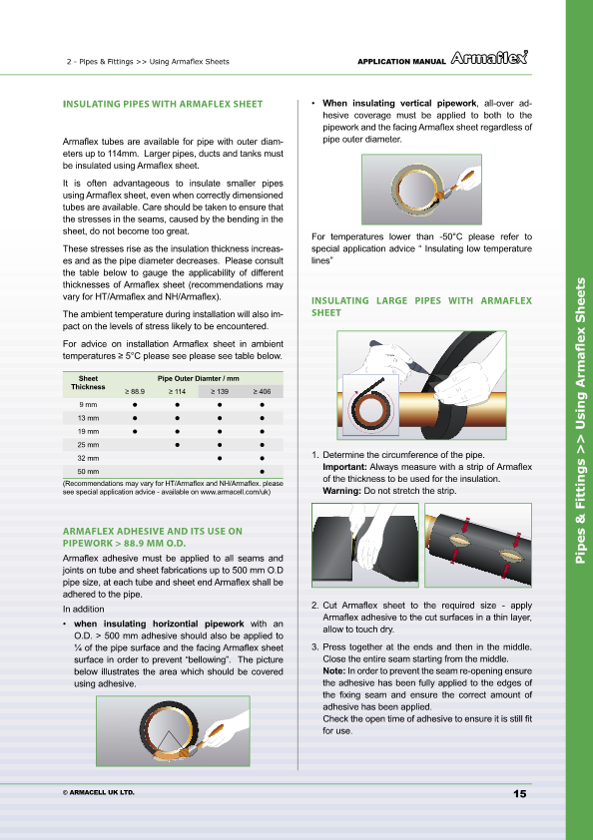

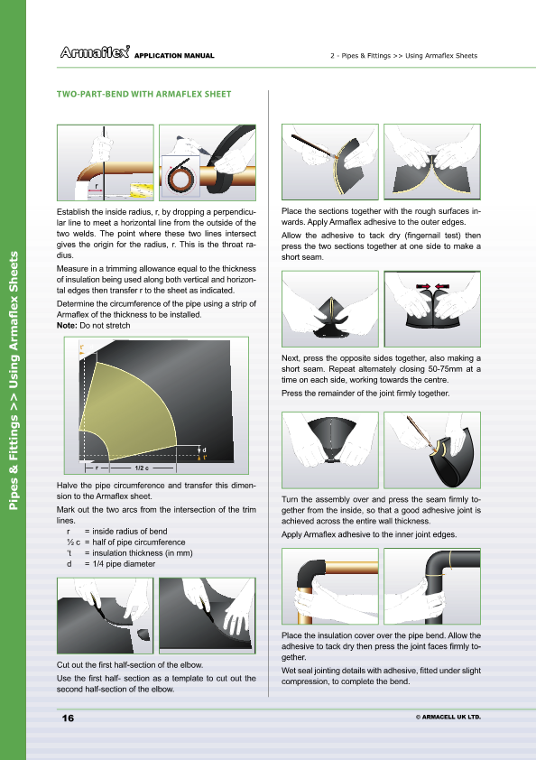

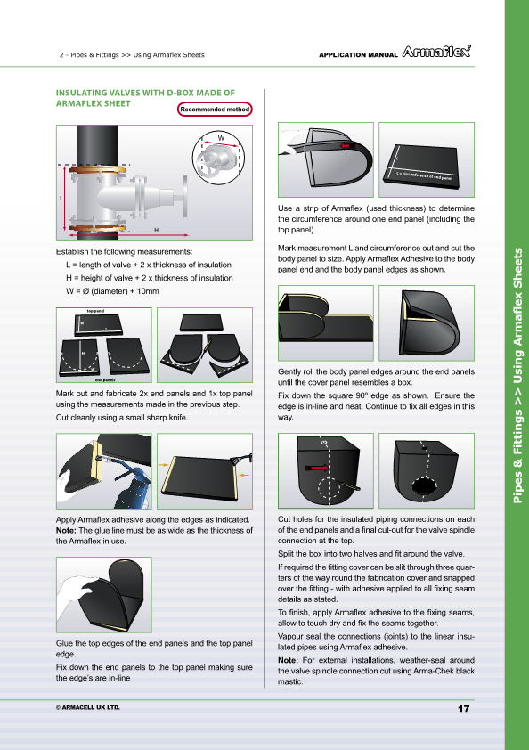

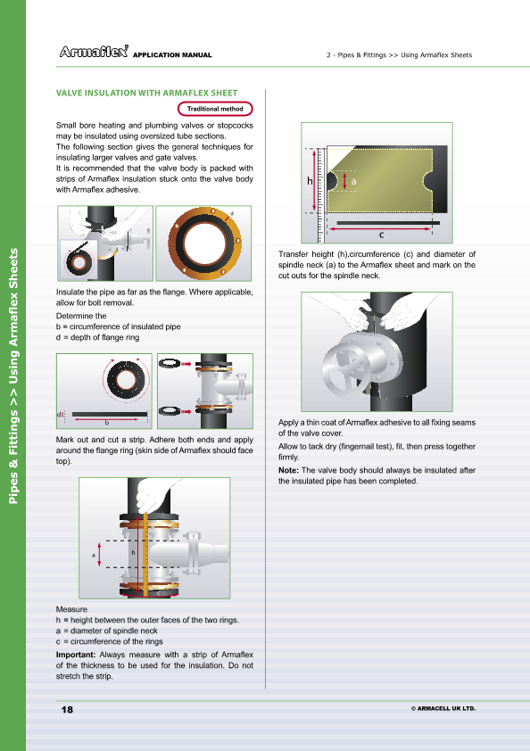

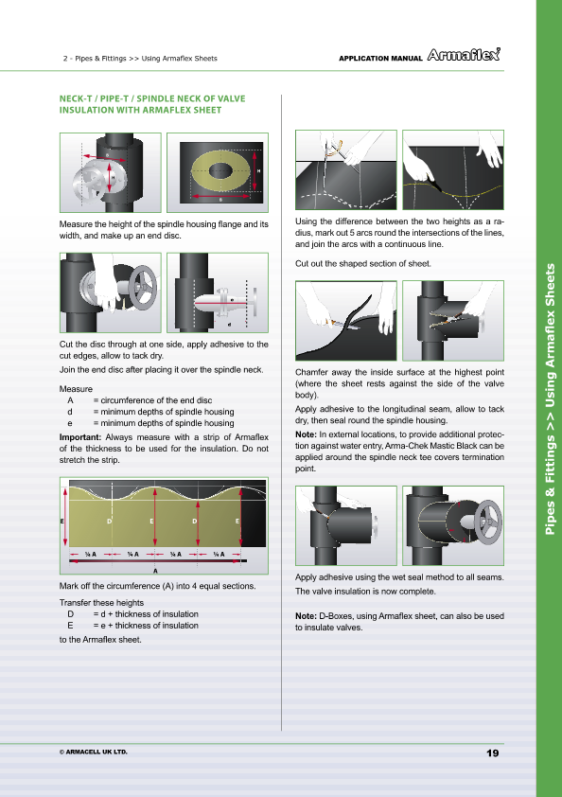

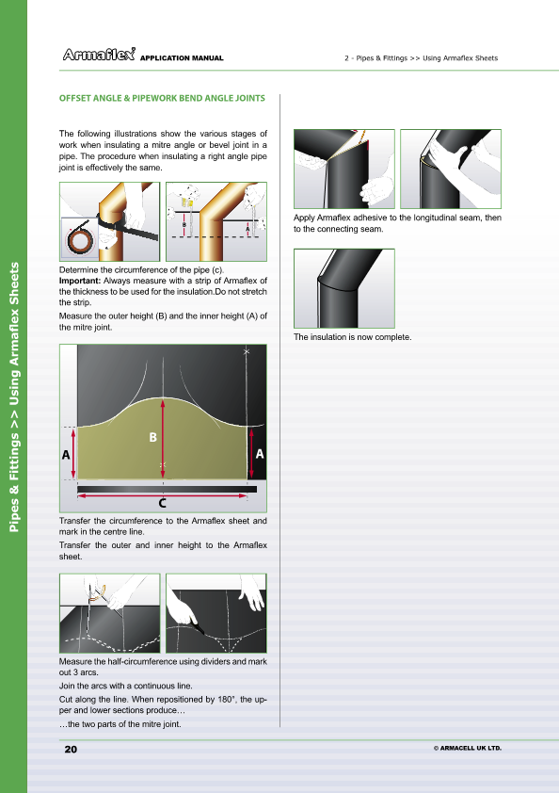

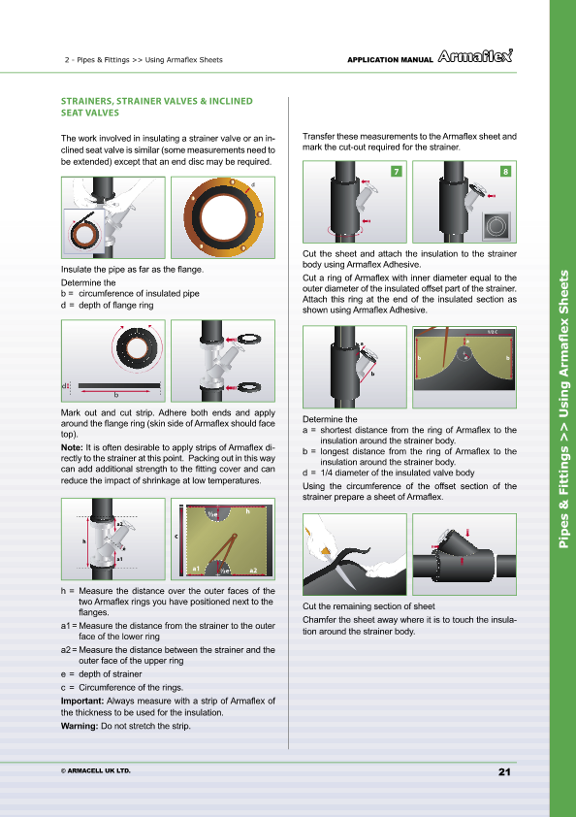

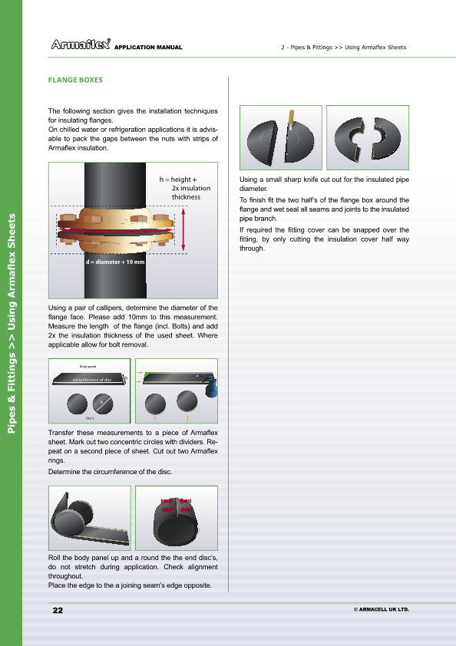

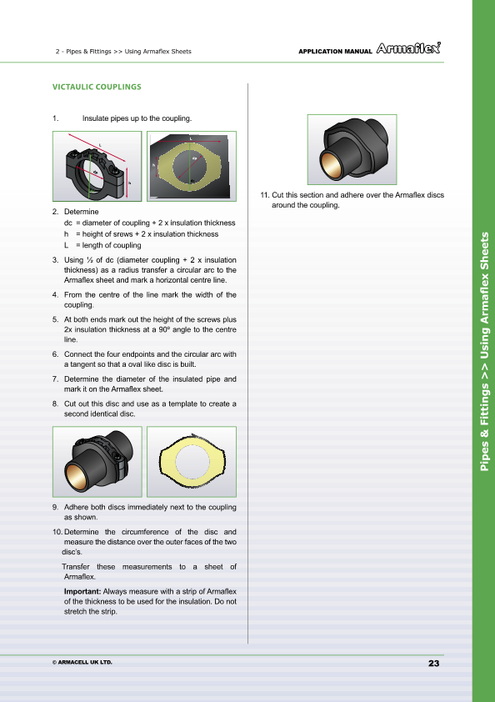

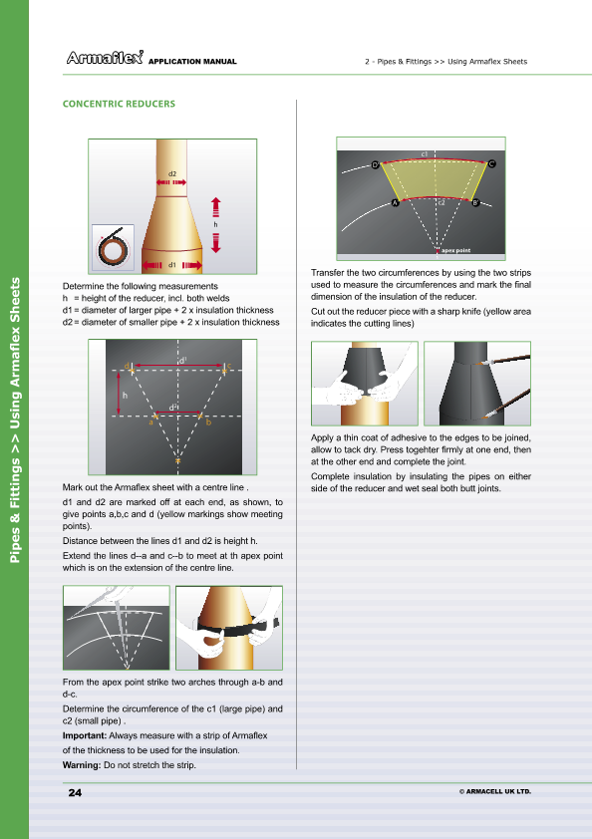

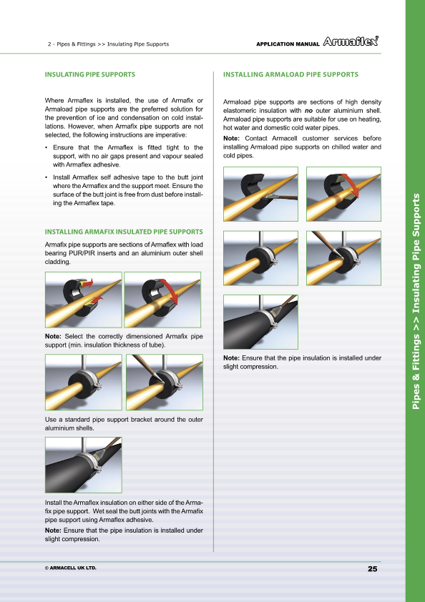

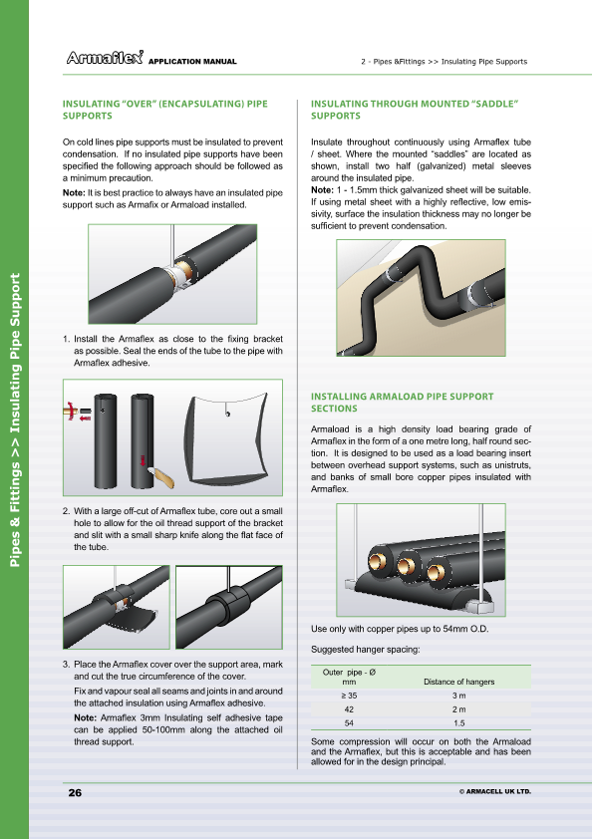

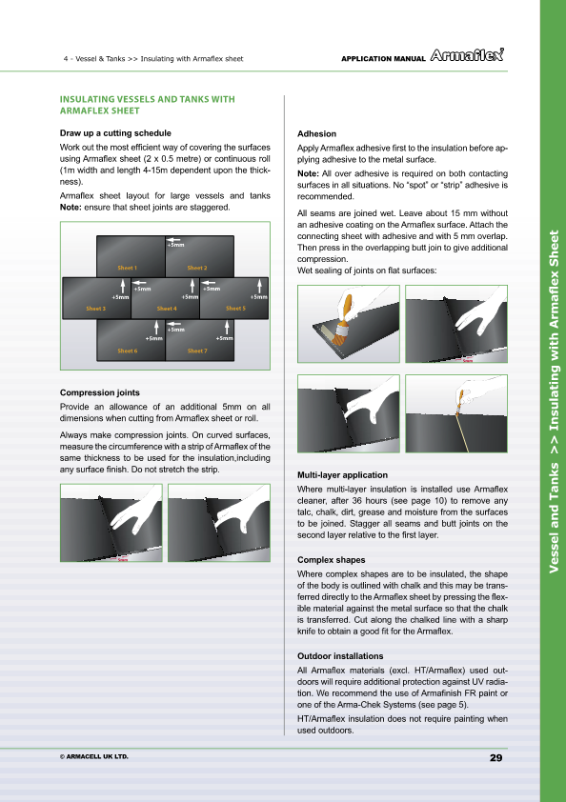

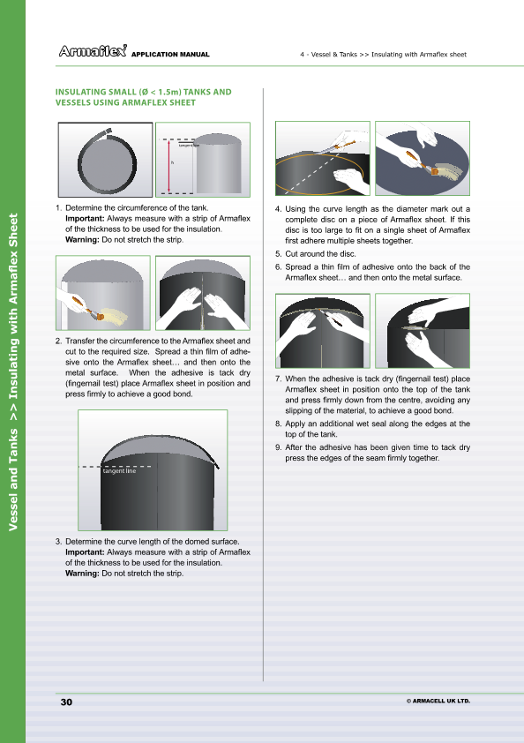

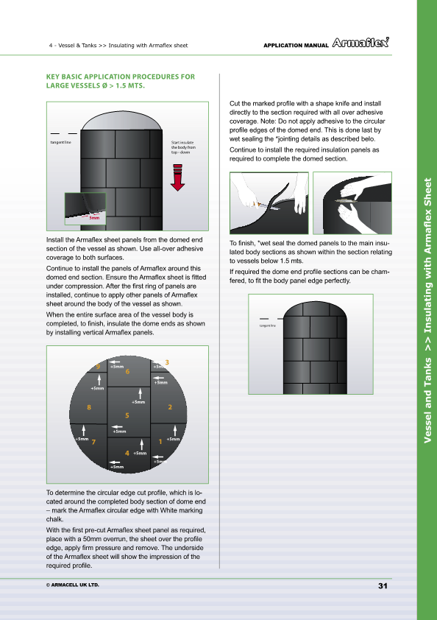

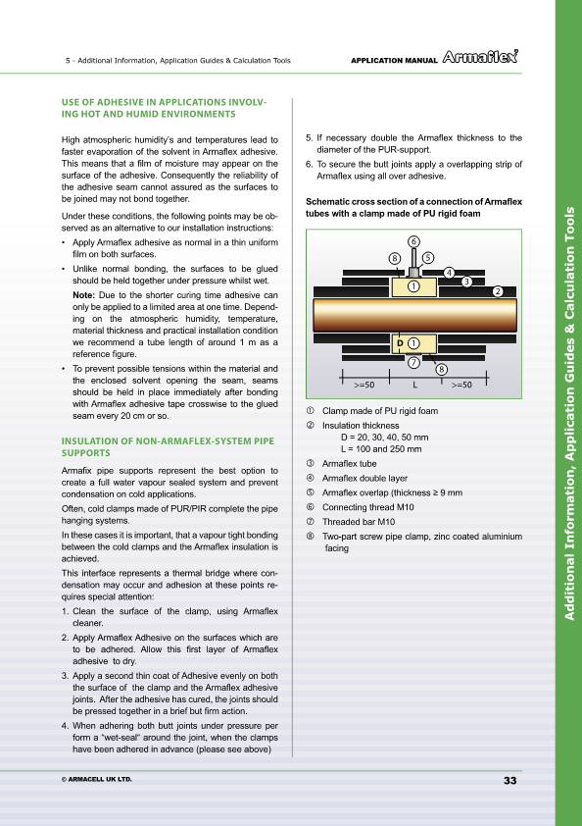

2.2 Efficient Use of Materials and Reducing Waste
As mentioned earlier in the course notes (module 5 – unit1 – section 1.4), poor measuring of jobs, lack of foresight, mistakes in manufacturing, poor fitting of lagging and cladding, reworking of jobs, all lead to inefficient use and waste of time and materials. Proper planning, well trained staff, good measurements and good fabrication/ installation methods will lead to the efficient use of time and materials and help reduce waste.

2.3 Neat Layout of Work Space and Tools
There are many benefits to be gained both for the employee and the employer by having a neat and tidy work space.
Benefits to the Employee
- It will make the workspace more pleasant to work in.
- It will make the job more satisfying.
- It will make you more efficient.
- It will make the workspace safer to work in.
- It will help to remove obstacles and frustrations in your work.
- It will make it easier to communicate to other employees.
- It will create a better work ethos.
Benefits to the Employer
- Reduction in accidents.
- Better quality products.
- Lower costs, everything in its place, easier to control stock.
- More efficient use of materials and a reduction of waste.
- Building customer confidence through more efficient production and quicker delivery times.

The 5 “S” Method
(1) Sort
Sorting means looking at your work area and deciding what items are needed and what items are not needed. You get rid of the items which you don’t need which will eliminate cluttering of the work area and create much needed space.
(2) Set in Order
Set in order means keeping needed items in the correct place to allow easy and immediate retrieval. This could mean tidying your toolbox and putting the tools in their proper place or organising better storage facilities for workshop tools close to where they will be needed.
(3) Shine
Shine means keeping your work area swept and clean on a daily basis, both in the workshop and on site. This gives the work area a clean appearance and makes it safer to work in.
(4) Standardize
This stage means making the first three steps mentioned above a habit. People must know their responsibilities and make the system a part of their work.
(5) Sustain
This means making it a habit of properly maintaining correct procedures over time. No matter how well the other parts of the system are implemented, it will not work for long without a commitment from all employees and the employer to sustain the system.

2.4 Accurate Cutting of Materials and Minimising Waste
Refer to section 2.1 above.

2.5 Storage of Cut Materials in an Orderly Fashion for Fitting
- All insulation materials should be stored in a clean dry area until required.
- Slab insulation should be stored flat and packs of slab insulation should not stacked any more than four high.
- Insulation to be fitted on pipe-work should be located close to the section of pipe-work without causing an obstruction or trip hazard.

2.6 Safe Disposal of Waste Materials
Waste material should be disposed of correctly and in accordance with local authority regulations. Dispose of waste materials regularly to avoid possible ignition or wind dispersal. Ensure polythene packaging is kept away from children. Recycle all waste materials when possible. If recycling facilities are not available on site, remove the waste materials and dispose of them at the nearest recycling facility.

Summary
The use of manufacturer’s data sheets in selecting the correct material is a vital part of the system design and installation procedures. Manufacturer’s data sheets will provide such information as sizes available, density and application techniques. These data sheets provide a wealth of information which makes it easier for the person fabricating and installing the product.
Proper planning, well trained staff, good measurements and good installation techniques will reduce waste of materials and increase the efficiency of the overall installation of the job.

Castleforbes House
Castleforbes Road
Dublin 1

