TRADE OF
Pipe Fitting

PHASE 2

Module 1

Introduction to Pipe Fitting

UNIT: 1

Induction

Produced by

In cooperation with subject matter expert:

Finbar Smith

© SOLAS 2014
Table of Contents
Introduction 1
Unit Objective 2
1.0 Health, Safety and Behaviour Guidelines 3
1.1 Behaviour Guidelines 3
2.0 Phase 2 Apprentice Pipefitting Training Course 5
2.1 Pipefitting Training Course Structure 5
3.0 Fire Extinguishers 7
3.1 Using Fire Extinguishers 7
4.0 Procedures in Accident or Emergency Events 11
4.1 Evacuating in an Emergency 11
5.0 Safety in the Workshop and Personal Safety 13
5.1 Safety in the Workshop 13
5.2 Personal Safety Behaviour in the Workshop 14
6.0 Time Keeping 15
6.1 Sample Example of Time Sheet 15
6.2 Filling out a Time Sheet 15
Self Assessment 16
Suggested Exercises 18
Training Resources 19
Suggested Further Reading 20

Introduction
There are five Units in Module 1. Unit 1 focuses on Induction, Fire Drill and Behaviour Guidelines, Unit 2; Manual handling, Unit 3; Health and Safety, Unit 4; Basic Engineering and Unit 5; Information Technology basics.
In this unit you will receive instruction on induction, fire drill and behaviour guidelines for the training centre.
Module 1
Introduction to
Pipe Fitting
Unit 1
Induction
Unit 2
Manual Handling
Unit 3
Health & Safety
Unit 4
Basic Engineering
Unit 5
Information Technology
Basics

Unit Objective
By the end of this unit each apprentice will be able to:
- Describe the responsibilities of all personnel, fire drill procedures and course participant personal behaviour guidelines that apply to the Training Centre/premises
- Describe the structure of the Phase 2 Apprentice Pipe Fitting training course
- Demonstrate the location and use and limitations of the appropriate fire extinguisher for an identified fire incident
- Describe the procedures to be followed in accident or emergency events
- Identify the difference between an unsafe and safe workshop environment and how personal behaviour effects safety in the workshop.
- Demonstrate the importance of correct time keeping

1.0 Health, Safety and Behaviour Guidelines

Key Learning Points
- Fire alarm sound, emergency exit route, designated safe area, the location and function of Safety statements, responsibilities of all personnel i.e. identification of hazards, their removal, reduction, drawn to the attention of others etc. and personal safety recommendations applicable to the pipefitting workshop/equipment, chemicals, oils etc., e.g. voltage outlets -110V/220V/380V, cutting equipment, welding equipment - eye wash – first aid station, compressed air, tyre fitting machine etc.
- Course participant guidelines; Training Centre rules on: time, attendance, expected learning outcomes, personal behaviour on training premises e.g. operation of hazardous equipment inside workshop or training areas, computer user policy, racism, sexual harassment, drugs, alcohol, smoking, environmental materials, recycling etc. and disciplinary procedures
- Fire drill, location and use of fire alarm, emergency exit procedure, location, selection and use of correct fire extinguisher for electrical, chemical and carbonaceous fires, location and use of fire blanket

1.1 Behaviour Guidelines
You will have to work closely as a group for the duration of your course therefore you will be asked as a group to agree a “Code of personal Behaviour”. Please refer to your instructor for information, which is available from the training centre induction pack. Please refer to the key learning points within this unit.
- Respect for each individual.
- Respect property of others.
- Use of inappropriate language.
- Sexual harassment.
- Bullying.
We regard bullying to include:
- Ridiculing
- Verbal harassment
- Aggressive behaviour
- Intimidation and threats
- Personal insults and name calling
- Uncomplimentary remarks causing serious offence
When the group have agreed a “Code of Personal Behaviour” you will be asked to sign the rules of the course. A breach of the rules or code may result in disciplinary action.

2.0 Phase 2 Apprentice Pipefitting Training Course

Key Learning Points
- Training course structure; duration, modular block form, theory and practical assessment outlines, repeat/re-sit policy

2.1 Pipefitting Training Course Structure
Note: The instructor will explain the theory and practical assessments and outline the repeat/re-sit policy within SOLAS.
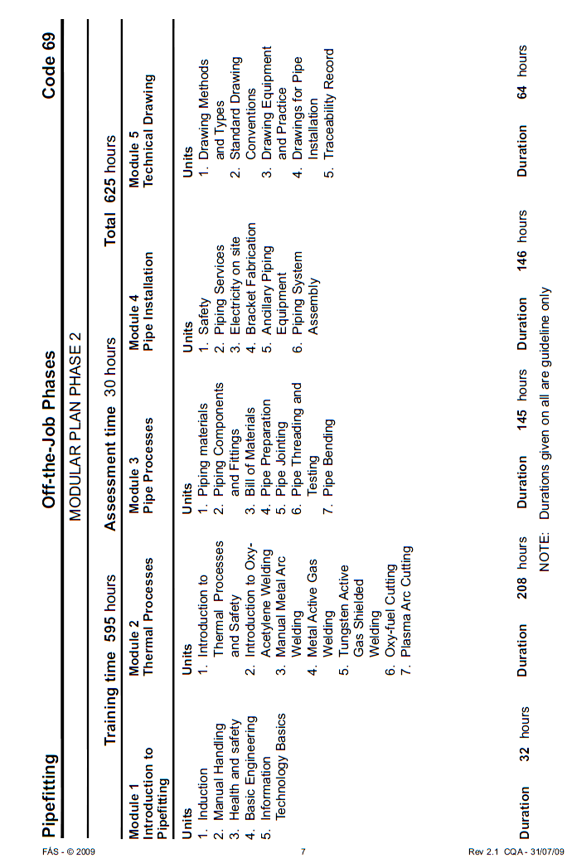

3.0 Fire Extinguishers

Key Learning Points
- Identifying the appropriate fire extinguisher type, its recommended storage location in the FÁS workshop and demonstrating its method of operation on an identified fire incident

3.1 Using Fire Extinguishers
Note: The instructor will make you aware of the fire fighting equipment within the training centre.

Preparation and Safety
Objective
Locate workplace fire extinguishers and identify applications and operating procedures.
Personal Safety
Whenever you perform a task in the workshop you must use personal protective clothing and equipment that is appropriate for the task and which conforms to your local safety regulations and policies. Among other items, this may include:
- Work clothing - such as coveralls and steel-capped footwear
- Eye protection - such as safety glasses and face masks
- Ear protection - such as earmuffs and earplugs
- Hand protection – such as rubber gloves and barrier cream
- Respiratory equipment – such as face masks
If you are not certain what are appropriate or required, ask your instructor.
Safety Check
- Do not attempt to fight a fire unless you have a fire extinguisher large enough to extinguish the fire. Many small extinguishers empty in 8 to 10 seconds.
- Never try to extinguish a fire that is spreading rapidly.
- Do not try to put out a fire unless you know what type of fire is burning. Using the wrong fire extinguisher will make the fire worse.
- Test the fire extinguisher before you attempt to extinguish a fire.
- Do not inhale any fumes from a fire. Fire gives off toxic gases.
- Do not use water on grease fires, electrical fires or fires where electrical wiring is present.
- If you cannot fight the fire, leave the area and call the fire department.
- See your local fire department for a demonstration of the appropriate procedure in your jurisdiction.
- Make sure that you understand and observe all legislative and personal safety procedures when carrying out the following tasks. If you are unsure of what these are, ask your instructor.
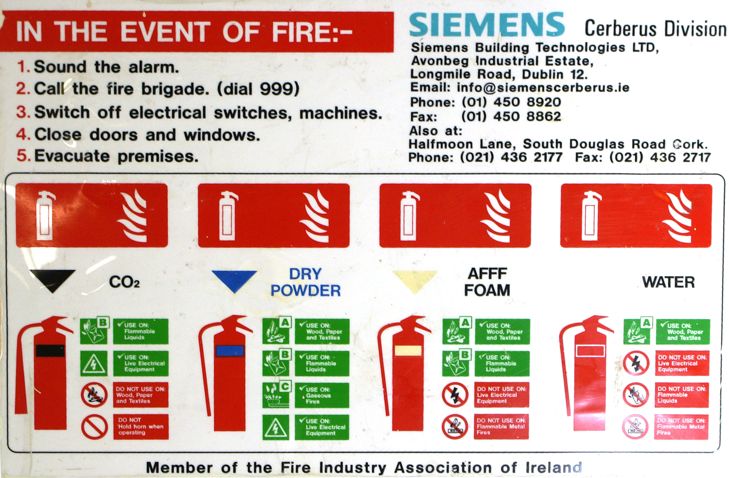
Points to Note
- Each workshop will have a fire fighting procedure. There should be a workshop fire warden and fire officers. Understand clearly the fire fighting policy for your workshop.
- Fire extinguishers will be located in easily accessible places. Do not block access to fire extinguishers with workshop equipment and clutter.
- Fire extinguishers either smother or quench a fire. A fire extinguisher that smothers a fire does not remove heat. Keep a watch over the fire. Even though the fire may seem to be out, it may restart.
- Workshops will have various fire fighting tools: fire hoses, fire buckets, fire blankets and fire extinguishers. Each has a specific application and method of use. Familiarise yourself with each of these tools.
- Fire blankets are manufactured from fire retardant material and have multiple uses. They can be used to smother a fire in a cleaning station or wrap around clothing that has caught on fire. They may be used to shield people from fire when evacuating a building or be used as a stretcher to carry injured or unconscious people.
- Never use water on a fuel-based fire. The fuel will float on the water and spread further.
- The only exception to this is in the case of a fire fuelled by methanol. Methanol is heavier than water and burns with an invisible flame. Use a water extinguisher on a methanol fire.
- Fire buckets contain sand that can be thrown over a fire to smother it. Do not be too quick to empty all the sand in one throw. You may not completely cover the fire the first time.
Fighting a Fire
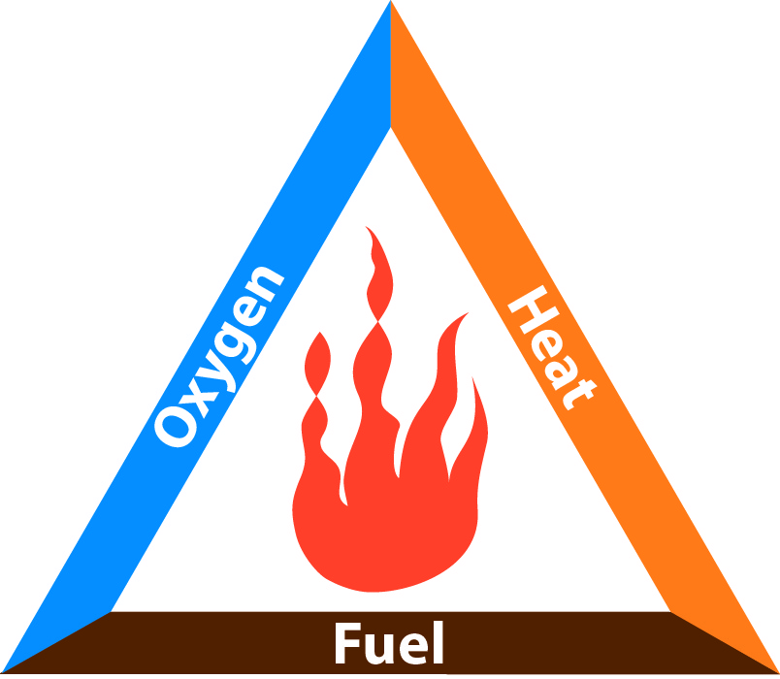
- Three elements must be present at the same time for a fire to occur: fuel, oxygen and heat. These three elements are demonstrated by the fire triangle. The secret of fire fighting involves the removal of one of these elements, usually the oxygen or the heat.
- Know how to operate the extinguisher. Read the instructions when you purchase the extinguisher. You will not have time to read them once a fire has started.
- Never turn your back on a fire or allow a fire to get between you and a means of escape. If you are fighting a fire outside, always have the wind at your back.
- If possible, get an assistant to guide you and inform you of the fire's progress.
- If a fire occurs in your work area, remember the PASS word: Pull, Aim, Squeeze, Sweep
- PULL out the pin that locks the handle at the top of the extinguisher to prevent accidental use.
- Carry the fire extinguisher in one hand and use your other hand to AIM the nozzle at the base, or seat, of the fire. Some fire extinguishers need to be turned upside down to operate. Check which way to hold the extinguisher you've chosen.
- Stand about 2.8 m (8 ft) away from the fire and SQUEEZE the handle to discharge the fire extinguisher.
- Remember that if you release the handle on the extinguisher, it will stop discharging.
- SWEEP the nozzle from side to side at the base of the fire. Watch the fire. Although it may appear to have gone out, it may re-ignite.
- If the fire is indoors, you should be standing between the fire and the nearest safe exit. If the fire is outdoors, you should be standing facing the fire with the wind on your back, so that the smoke and heat are being blown away from you. Again, make sure that you have a means of escape, should the fire get out of control.
- When you are quite sure that the fire is out, report it to your instructor. Also report what actions you took to put out the fire.
- Once the circumstances of the fire have been investigated and your instructor or the fire brigade has given you the all clear, clean up the debris and submit the used fire extinguishers for inspection and re-filling.
Fire Classifications
There are 5 classes of fire.
- "A" class fires involve wood, paper, cloth, rubber and trash.
- "B" class fires involve flammable liquids, such as oil, paint, petrol, grease and tar.
- "C" class fires involve flammable gases, such as LPG, Natural Gas, Acetylene, etc.
- "D" class fire is fuelled by combustible metals - magnesium, potassium turnings and metal shavings. They are not as common as "A", "B", or "C" class fires.
- "E" class fires need electricity to feed the fire. This class includes wiring, damaged appliances, circuit breakers and fuse boxes. Once the electrical supply has been disconnected, the fire changes to the class of fuel it is burning.
Fire Extinguisher Types
There are four types of fire extinguisher. Each type can be used for one or more classes of fire.
- Water extinguishers contain water pressurized by an inert gas or compressed air. The water quenches the heat from the fire to below its vaporization point. They should only be used on class "A" fires.
- Carbon dioxide fire extinguishers are most effective when used against "B", "C" and "E" class fires. The gas is heavier than air and provides an inert blanket that smothers the fire. A carbon dioxide fire extinguisher will spray small ice particles with the gas. This is normal.
- Dry Powder fire extinguishers contain a fine powder, usually sodium bicarbonate, held under pressure by an inert gas. The extinguisher smothers the fire with a fine powder. These extinguishers are good to fight any fuel or liquid fire.
- Foam fire extinguishers contain a chemical that forms a soft foam that floats over the target area and smothers the fire. These are effective fighting liquid, gaseous, paper or wood fires.
Fire Extinguisher Suitability
You will often see more than one symbol on a fire extinguisher. This identifies the extinguisher as suitable for more than one class of fire.

4.0 Procedures in Accident or Emergency Events

Key Learning Points
- Procedures to be adopted in accident or emergency events e.g. contact Instructor, First Aid Officer and Safety Officer/Assistant Manager etc.

4.1 Evacuating in an Emergency
Note: Examples only, please follow your training centre procedures

Preparation and Safety
Objective
Carry out emergency evacuation procedures.
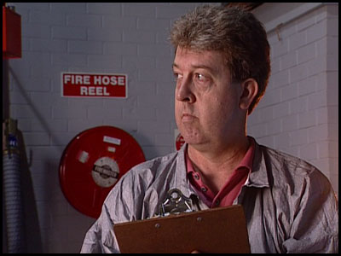
CDXGS31\AT174AU\dswmedia\video\emergproc.mpg
Is the video available and applicable and available to the pipefitting training centre?
Safety Check
- Make sure you understand and observe all legislative and personal safety procedures when carrying out the following tasks. If you are unsure of what these are, ask your instructor.
Points to Note
- Emergency evacuation procedures are designed for the specific requirements of your workshop and region. If there are no evacuation procedures in your workshop, consult your local police and fire departments for specific information.
- Evacuation procedures will also vary depending on the nature of the emergency.
- In the case of a building fire, the procedure will involve leaving a building and moving to an "assembly point" outside. The emergency procedure for a hurricane or cyclone warning, however, requires you to "take cover" inside a designated shelter.
Other evacuation procedures provide action for emergencies such as:
- Bomb Threats
- Civil Unrest
- Chemical Spills
- Bushfire/Wildfire
If you have any questions about evacuation procedures, contact your national health and safety authority.
If your instructor assigns you a task, like assisting in an evacuation, it is because he or she believes you are capable of fulfilling that role. Once you have completed that task, notify your instructor.

Step-by-Step Instruction
- Don’t panic! The first Rule when you have an emergency, or if you hear the alarm at your workshop is: “DON’T PANIC!” Follow the emergency procedures that apply in your workshop.
- Who’s in charge? Determine who’s in charge. He or she should have a list of all personnel who are working in the area. Follow their directions and evacuate the area by the nearest emergency exit.
- Secure your workplace. If you have time, turn off the electrical supply to all operating equipment. Turn off the taps and put lids on any containers of flammable liquids. Check small rooms, such as offices or rest rooms to make sure nobody is in them. If you are the last one out of an area, close all doors and windows on your way out.
- Assemble and count. Once you have all met at the appropriate assembly point, count your co-workers and report anyone missing to your instructor. Report the emergency to the appropriate authorities. That may be Garda, fire, ambulance or other regional emergency body. Be aware that emergency vehicles or personnel may be arriving on site and may need direction. If this is not your task, stay out of the way.

5.0 Safety in the Workshop and Personal Safety

Key Learning Points
- Identify hazards that exist in the workshop environment and outline ways to prevent or minimise those hazards.
- Identify unsafe personal behaviours that could cause injury to oneself or others
- Outline the responsibilities of individuals and groups to maintain safe work practices.

5.1 Safety in the Workshop
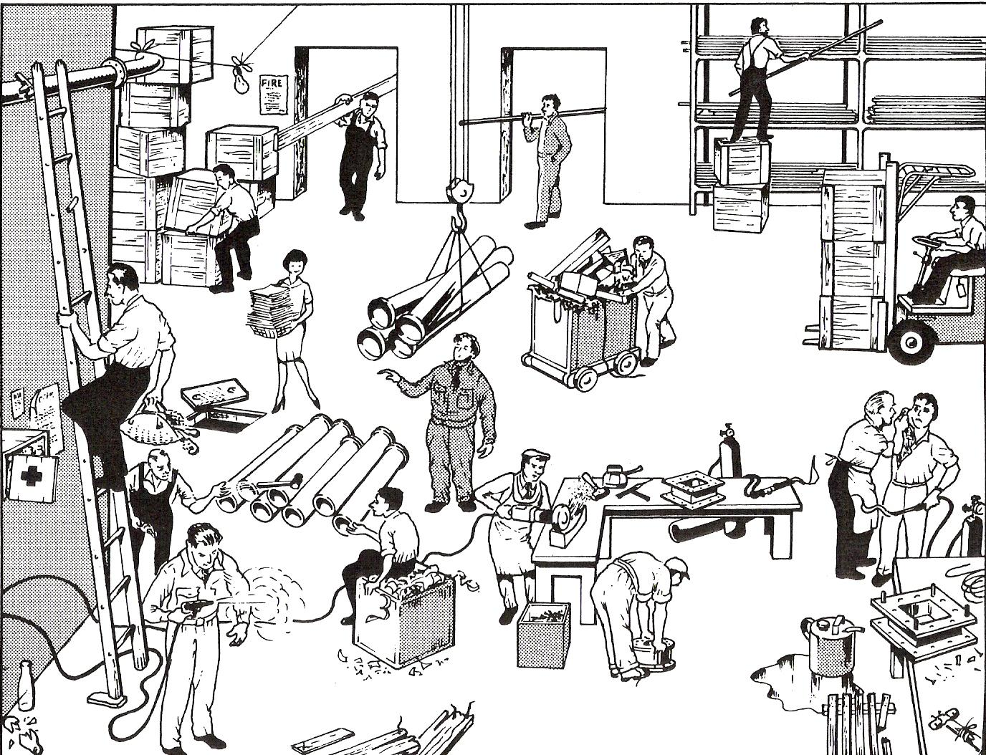
List all instances of unsafe practice that you can detect. (Courtesy of “What’s Wrong” Safety Posters)

5.2 Personal Safety Behaviour in the Workshop
Personal behaviour is a major contributing factor to Health and Safety in a workshop is very important. If a person uses equipment, tools and machinery, he/she should have received safety training. This should ensure that he/she feels confident in the use of machines and can operate them without having an accident or causing an accident to other people
- Never be under the influence of drugs or alcohol when working in a workshop.
- Always listen carefully to the person in charge and follow instructions.
- Do not run in the workshop, you could ‘bump’ into another person and cause an accident.
- Know where the emergency stop buttons are positioned in the workshop. If you see an accident at the other side of the workshop you can use the emergency stop button to turn off all electrical power to machines.
- Always wear personal protective equipment appropriate to the work being carried out.
- Bags should not be brought into a workshop as people can trip over them.
- When learning how to use a machine, listen very carefully to all the instructions given by the person in charge. Ask questions, especially if you do not fully understand.
- Do not use a machine if you have not been shown how to operate it safely by the person in charge.
- Always be patient, never rush in the workshop.
- Always use safety guards when working on a machine.
- Keep hands away from moving/rotating machinery.
- Use hand tools carefully, keeping both hands behind the cutting edge.
- Report any damage to machines/equipment as this could cause an accident.
- Never work alone in a workshop, there should always be at least two people
- A first aid kit must be placed in the shop, and a member of staff should be assigned to keep it well stocked.

6.0 Time Keeping

Key Learning Points
- Identify the importance of filling out time sheets correctly and accurately.
- Outline the critical information on time sheets such as time, description of work and job coding where applicable.
- Identify that work sheets are used for tracking costs on projects, client billing as well as tracking pay to the pipefitter.
- Different types of time keeping systems, paper based systems, clock cards, electronic systems with fingerprint recognition.
- Legal obligations and company policies for using clock-in systems

6.1 Sample Example of Time Sheet
(Available from your instructor)

6.2 Filling out a Time Sheet
Objective
Record working time correctly and fill out a time sheet accurately.
Points to Note
- Basic information such as time, date and client name/location.
- Employee supplied information such as name, start and finish times.
- Employer supplied information, such as job coding.
- Client supplied information, such as description of work, location of work and authorising/verification signatures.

Self Assessment
Q1: The yellow painted lines on a workshop floor indicate; (Tick ONE box only)
 1. Where you can walk
 2. Where you should not walk
 3. A clear zone away from tools and equipment
 4. An emergency evacuation path

Q2: According to the “Fire Triangle”, which element do you need to remove to extinguish a fire? (Tick ONE box only)
 1. Oxygen and heat
 2. Heat and fuel
 3. Fuel and oxygen
 4. Fuel, heat, or oxygen

Q3: When treating a burn, you should; (Tick ONE box only)
 1. Not apply any ointments or lotions
 2. Cover the burn with a tight dressing
 3. Puncture blisters
 4. Give alcohol

Q4: If an object is embedded in the eye, you should; (Tick ONE box only)
 1. Not attempt to remove it
 2. Remove it with surgical tweezers
 3. Flush the eye with hot water
 4. Do nothing. It will come out by itself

Q5: In the case of a building fire the procedure will involve leaving a building and…(Tick ONE box only)
 1. Staying outside until the all clear is given
 2. Assembling at assembly point
 3. Going home
 4. Closing and locking all doors

Q6: The first rule in the case of an emergency is; (Tick ONE box only)
 1. Wait for confirmation
 2. Ignore the warning; it is a “drill”
 3. Run outside
 4. Don’t panic

Q7: In an emergency evacuation, when meeting at an appropriate assembly point, you should... (Tick ONE box only)
 1. Get comfortable
 2. Count your co-workers
 3. Go back and get your possessions
 4. Talk amongst yourselves

Q8: A person is allowed use workshop machinery when. (Tick ONE box only)
 1. They are confident they can use it
 2. They are properly trained in its correct use
 3. The workshop is empty
 4. They have their hair and loose clothing secured

Q9: Time keeping is used for: (Tick ONE box only)
 1. To track employee movement
 2. For job costing, employee payment and client billing
 3. So that clients know what work is completed.
 4. To collect employee fingerprints

Suggested Exercises
- Under supervision, demonstrate to approved personnel, e.g. Safety Officer, the use of fire extinguisher
- Demonstrate the most appropriate behaviour for performing pipe fitting operations at a bench vice in the workshop area
- Demonstrate the use of the workshop 'fixed' equipment and its safety features e.g. emergency stop buttons etc.

Training Resources
- Information in book/electronic form on the Health, Safety and Fire Drill recommendations for the pipefitting workshop/training area, the associated SOLAS guidelines on course participant behaviour, discipline and reporting procedures
- Fire extinguishers and personnel qualified to carry out practical demonstrations
- Workshop area with approved welding/pipefitting/fire evacuation capability

Suggested Further Reading
Title | Author | Ref. Code
FAS Induction Book - “Code of Behaviour & Health & Safety Guidelines” | FAS
Basic Welding and Fabrication | W Kenyon | ISBN 0-582-00536-L
Fundamentals of Fabrication and Welding Engineering | FJM Smith | ISBN 0-582-09799-1

Videos:
Understanding welding fumes
Welder on Site…Be Aware (Vocam)
Powered hand tool safety (Vocam)
Industrial Ergonomics (Vocam)

Available from:
Vocam Ireland
Circle Organisation Ltd
Friar Street, Thurles, Co Tipperary, Ireland
Tel: +353 504 24666

Castleforbes House
Castleforbes Road
Dublin 1

