TRADE OF
Pipefitting

PHASE 2

Module 1

Introduction to Pipefitting

UNIT: 4

Basic Engineering

Produced by

In cooperation with subject matter expert:

Finbar Smith

© SOLAS 2014
Table of Contents
Unit Objective 1
Learning Outcome 2
1.0 Basic Engineering Mathematics 3
1.1 SI Units 3
1.2 Metric Prefixes 3
1.3 Examples of SI Conversions 3
1.4 Fractions 4
1.5 Types of Vulgar Fraction 5
1.5 Metric v Imperial Measurements 6
1.6 Perimeter of Regular Shapes 7
1.7 Area of Regular Shapes 8
2.0 Pedestal Drill 10
2.1 Component Identification 10
2.2 Personal Protective Equipment 10
2.3 Safe Work Practices Procedure 10
3.0 Drilling and Tapping Exercise 12
3.1 Taps 12
3.2 Tap Wrench 13
3.3 Tapping 13
3.3 Tapping a Blind Hole 14
3.4 Stocks and Dies 16
3.5 Screwing 16
3.6 Screw Thread Terminology 18
3.7 Tapping Drill Sizes for ISO Metric Threads 19
4.0 Safety Precautions and Procedures 20
4.1 Hazard Avoidance: General Workshop Safety 20
4.2 Safe Disposal of Waste Materials and Tools 20
5.0 Correct Use of Hand Tools to Complete Metalwork Exercise 21
5.1 Hacksaw Blade Selection and Assembly 21
5.2 Hand Hack-Sawing Techniques 21
5.3 Calculation of Material Requirements, Including Excess Material 21
6.0 Grinding Equipment 22
6.1 Component Identification 22
6.1 Step by Step Instruction 24
6.2 Grinding Wheel 24
6.3 Wheel Inspection 25
6.4 Portable Grinding Equipment 25
7.0 Properties of Metals and Pipe Alloys 28
7.1 Properties of Metals 28
7.2 Metal Alloys 28
Suggested Exercises 29
Self Assessment 30
Additional Resources 31

Unit Objective
There are five Units in Module 1. Unit 1 focuses on Induction, Fire Drill and Behaviour Guidelines, Unit 2; Manual handling, Unit 3; Health and Safety, Unit 4; Basic Engineering and Unit 5; Information Technology basics.
In this unit you will receive instruction on math’s and basic engineering in a workshop environment.
Module 1
Introduction to Pipe Fitting
Unit 1
Induction
Unit 2
Manual Handling
Unit 3
Health & Safety
Unit 4
Basic Engineering
Unit 5
Information Technology
Basics

Learning Outcome
By the end of this unit each apprentice will be able to:
- Outline the units of SI system and apply their use for mathematical calculations.
- Perform basic mathematical calculations, conversions from fractions to decimals and imperial to metric.
- Perform mathematical calculations to calculate perimeters and surface areas of regular shapes.
- Identify the main components of a pedestal drill and demonstrate it correct and safe use for a drilling and tapping exercise.
- Describe and observe the correct safety procedures used while completing sample metalwork exercises.
- Describe and demonstrate the correct use of basic hand tools while completing sample metalwork exercises.
- Demonstrate the operation and safety controls for workshop grinding tools.
- Describe the physical properties of metals and metal alloys used in the pipefitting trade.

1.0 Basic Engineering Mathematics

Key Learning Points
- Explanation of SI units
- Basic calculations for addition, subtraction, multiplication and division.
- Conversions from fractions to decimal and from fractions to decimal
- Conversions from imperial to metric and from metric to imperial
- Calculate the perimeter of regular shapes
- Calculate the surface area of regular shapes

1.1 SI Units
A unit is what we use to indicate the measurement of a quantity. For example, the unit of pressure is the Pascal. The unit of length could be the Inch or the Metre. However, the Metre is the SI unit of length.
In order that we all work to a common standard, an international system is used. It is known as the SI system (System International). This system is used throughout the course. A number of prefixes will be used e.g. millimeters or millibars for pressure.

1.2 Metric Prefixes
Prefix | Symbol | Multiplying Factor | Power Index
Mega | M | 1 000 000 | (106)
Kilo | k | 1 000 | (103)
hecto | h | 100 | (102)
deca | da | 10 | (101)
unit |  | 1 | (100)
deci | d | 0.1 | (10-1)
centi | c | 0.01 | (10-2)
milli | m | 0.001 | (10-3)
micro | μ | 0.000 001 | (10-6)
nano | n | 0.000 000 001 | (10-9)
pico | p | 0.000 000 000 001 | (10-12)
Table 1 - Common Metric Prefixes

1.3 Examples of SI Conversions
- To convert metres to millimetres multiply by 1,000 (10³)
- To convert pascals to bar multiply by 0.00001 (10⁻⁵)
- To convert milliamps to amps multiply by 0.001 (10⁻³)
- To convert microamps to milliamps multiply by 0.001 (10⁻³)
Sample Calculations
Convert the following:
- 5 Metres to millimetres
- 4,500 millimetres to Metres
- 100,000 Pascals to Bar
- 13 Bar to Pascals
Solutions
- 5 Metres = 5,000 mm
- 4,500 millimetres = 4.5m
- 100,000 Pascals = 1 Bar
- 13 Bar to 1,300,000 Pascals

1.4 Fractions
With the introduction of a metric system the use of vulgar fractions will give way largely to decimal fractions. It will still be necessary however to understand the meaning of vulgar fractions and their manipulation, particularly their conversion to decimal form.
If you cut a brick into two equal parts, each part will be one half of the brick; this may be written “½”.
So one half = ½ (This is a fraction.)
Take a sheet of lead and cut it into four equal parts; each part will represent one quarter; this may be written “¼”.
So one quarter = ¼ (This is a fraction.)
Cut a piece of timber into six equal parts; each part is one sixth of the whole. Take five of these parts and you now have five sixths of the whole; this may be written . (This is a fraction.)
Notice that in each case the lower part of the fraction indicates the number of parts into which the whole unit is divided; this is called the denominator.
Notice also that the upper part of the fraction indicates the number of parts being used; this is called the numerator.
Thus 5 Numerator
6 Denominator
means that the whole unit is divided into 6 parts and 5 of them are being used.
The line between the numerator and the denominator is called the bar of the fraction. Fractions written in this form are called vulgar fractions (as opposed to decimal fractions which we shall meet later).

1.5 Types of Vulgar Fraction
If the numerator is smaller than the denominator then the fraction is called a proper fraction
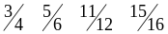e.g. are all proper fractions.
Each is less than 1 and therefore truly a part of a whole one, hence the term proper. If, however, the numerator is greater than the denominator then the fraction is called an improper fraction
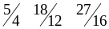e.g. are all improper fractions.
Obviously each is greater than 1 so cannot be a part of a whole one, hence the term improper. In this case we may obtain what is called a mixed number by dividing the denominator into the numerator and writing down the remainder as a proper fraction.
Examples
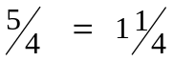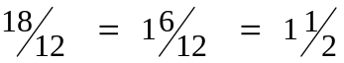
Notice in the second example that the method of cancellation is used to reduce the proper fraction to its lowest terms. Cancellation is the division of both the numerator and the denominator by a common factor, preferably their HCF.
Many simple problems may be solved by the use of fractions, provided the methods are clearly understood.
Sample Conversions From Fractions To Decimal And Decimal To Fraction
Convert the following fractions to decimal:
- ¼ to decimal = 0.25
- 3/8 to decimal = 0.375
- 2/3 to decimal = 0.666
- 9/6 to decimal = 1.5
Convert the following decimals to fractions:
- 0.5 to fraction = 1/2
- 0.875 to fraction = 7/8
- 0.333 to fraction = 1/3
- 1.25 to fraction = 1 ¼

1.5 Metric v Imperial Measurements

Imperial Measurement System
The Imperial measurements system is based on nature and everyday activities. For example, a league is based on the distance that can be walked in an hour. A grain (used to measure small quantities of precious metals) is the weight of a grain of wheat or barleycorn.
Such natural measures were well suited in a simple agricultural society. However, as trade and commerce grew, it was necessary to have more consistent measures (after all, not all grains of wheat have the same weight). Consequently, metal weights and lengths were produced to represent exact measures; these metal representations where then used to produce official scales and measurements to ensure that trade was based on standard quantities.

Metric Measurement System
The metric system is a relatively modern system (just over 200 years old) which has been developed based on scientific principles to meet the requirements of science and trade. Consequently, the metric system offers a number of substantial advantages:
- Simplicity. The Metric system has only 7 basic measures, which are the metre, kilogram, second, ampere, kelvin, mole, and candela, which are the units for length, mass, time, electrical current, temperature, quantity of substance, and luminous intensity, respectively plus a substantial number of measures using various combinations of these base measures.
- Ease of calculation. All the units in the metric system are multiplied by 10 (to make larger units) or divided by 10 (to make smaller units). For example a kilometer is 1000 meters (10 * 10 * 10), which means calculations can be done easier and faster in the metric system.
- International Standard. With the exception of the USA, all major countries have converted to the metric system (although in some countries, such as the UK, the conversion to metric is not yet complete). Consequently, for any international communication (trade, science, etc.) the metric system is the most widely used and accepted.
The pipefitting trade in Ireland and England, still use imperial sizes for pipe diameters while lengths of pipe are given in metric dimensions. To add further confusion, mainland European countries have adopted metric DN standards which give pipe diameters in millimeters so great care and attention should be given when specifying pipe and fittings for supply.
Sample Conversions from Imperial to Metric and Metric to Imperial
Convert the following imperial dimensions to metric dimensions:
- Convert 1” to metric mm = 1 x 25.4 = 25.4mm
- Convert 1’ 4” to metric mm = 16” x 25.4 = 406.4mm
- Convert 3.0m to imperial yards = 3.0 x 1.09 = 3.27 yards
- Convert 76.2mm to imperial inches = 76.2 / 25.4 = 3”

1.6 Perimeter of Regular Shapes
The perimeter is the total distance around the outside of a 2D shape. You calculate it by adding together all the lengths of a shape.
120mm
60mm
Example 1: Calculate the perimeter of a rectangle
Perimeter = 120mm + 60mm + 120mm + 60mm = 360mm

Example 2: Calculate the perimeter of a triangle
Perimeter = 60mm + 60mm + 60mm = 180mm
60mm
60mm
60mm

Example 3: Calculate the perimeter of a circle (also known as the circumference) where π = 3.14
Circumference is given by the fomulae 2πr = 2 x π x 60mm = 2 x 3.14 x 60 = 376.8mm
r = 60mm

1.7 Area of Regular Shapes
Area is the amount of surface a shape or solid covers. It is measured in square units and there are various formulae for calculating the area of regular shapes
60mm
Example 1: Calculate the area of a cube
Surface area of a cube = W x H x No. of faces
Therefore 60mm x 60mm x 6 = 21,600mm²

Example 2: Calculate the area of a triangle
60mm
60mm
Area of a triangle = ½ B x H where B = base and H = height
Therefore ½ x 60mm x 60mm = 1800mm²
Example 3: Calculate the area of a circle where π = 3.14
Area = 2πr² = 2 x π x 60² = 2 x 3.14 x 60² =22,608mm²
r = 60mm

Example 4: Calculate the surface area of a cylinder where π = 3.14
Surface Area = Area of the 2 circular ends plus the surface area of the barrel
r = 60mm
L = 140mm

Surface area of the 2 ends = 2 x 2πr²
2 x 2 x π x 60² = 2 x 2 x 3.14 x 60² =45,216mm²
Surface area of the Barrel = 2πr x L (Circumference x Length)
2 x π x 60 x140 = 2 x 3.14 x 60 x 140 = 52,752mm²
Therefore the total surface area = 45,216mm² + 52,752mm² = 97,968 mm²

2.0 Pedestal Drill

Key Learning Points
- Set up, adjust and use a Pedestal drill safely

2.1 Component Identification
Some parts of this illustration are labeled. It is important to learn the names of these equipment components.
Insert photo of a pillar drill here with the following parts highlighed!
Figure 1 – Pillar Drill with main components labelled
- Isolation switch
- Stop button
- Emergency stop
- Chuck.
- Chuck Guard
- Vice.
- Speed setting levers.

2.2 Personal Protective Equipment
- Overalls,
- Safety shoes,
- Safety glasses
- Gloves.

2.3 Safe Work Practices Procedure
- Inspect equipment to ensure there are no obvious defects.
- Check that the vice is clamped properly.
- Check that the chuck guard is in working order and is in position.
- Ensure correct sized drill bit is used and correctly tightened in chuck - remove key.
- Insert material to be drilled in vice and securely tighten.
- Adjust table up or down to correct height and lock in position.
- Select drill speed (using levers).
- Turn on isolator and press START button.
- Turn on START switch and turning the lever, drill the material.
- When finished drilling, withdraw and power down.

Safety Issues:
- Ensure that all personal protection is worn at all times.
- Ensure that no loose clothing, particularly loose cuffs, ties etc. are worn.
- Ensure that vice is clamped properly to drill frame and that material is clamped properly to vice.
- Ensure chuck is tightened properly and key is removed from chuck.
- Ensure chuck guard is in place.
- Ensure eye protection is worn at all times.

3.0 Drilling and Tapping Exercise

Key Learning Points
- To complete a drilling and tapping exercise in a safe manner.

3.1 Taps
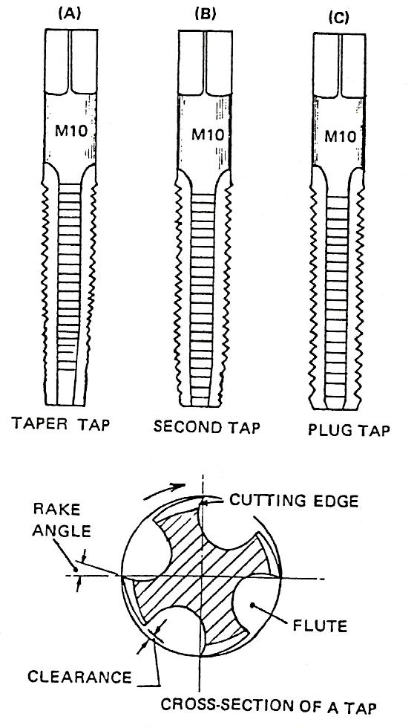
Taps are used for cutting internal threads, such as the thread on a nut. This is called tapping. There are three kinds: taper tap, second or intermediate tap and plug or bottoming tap.
Figure 2 – Taps
Taper tap: This is tapered over the first 8 to 10 threads, allowing it to enter the hole and gradually cut to the full thread depth.
Second tap: This is tapered over the first four threads or so, and is used after the taper tap when tapping a deep hole or a blind hole.
Plug tap: This has only a short taper, one or two threads. It is used for finishing the thread at the bottom of a deep or a blind hole.
Taps are made from high-speed steel. They are hard and brittle and must be used with care to avoid breaking them, especially the smaller ones. The flutes along the body provide the cutting edges, also spaces for the chips being cut, and passageways for the cutting fluid to reach the cutting edges. The ends are square for gripping in a tap wrench. Taps should always be cleaned after use.

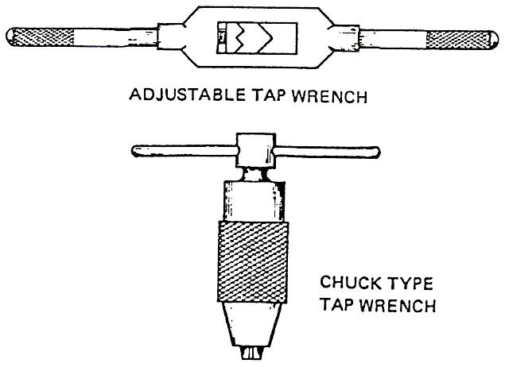
3.2 Tap Wrench
A tap wrench is used to rotate taps. There are two types shown in Figure 3.

Figure 3 - Tap Wrenches

3.3 Tapping
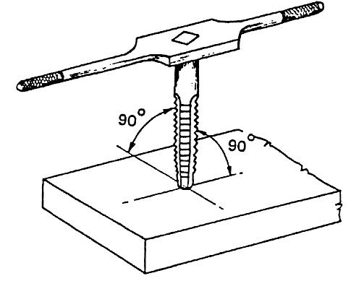
When mating parts are being threaded, the tapping should be done first. The reason for this is that the size of the tap is fixed, but the die for cutting an external thread can be adjusted slightly, so that the thread on the bar can be progressively deepened until it just fits the tapped hole.

Figure 4 – Tapping
Before tapping, a 'tapping size' hole is drilled. This is smaller than the size of the tap. The drill size can be got from a table. If a table is not available, it may be got by trying the taper tap in the drill gauge until the hole is found into which it fits to a depth of three threads. Another method is to select the drill which just passes through a nut with the same size and type of thread.
To tap the hole, grip the taper tap in the tap wrench and enter it in the hole. Apply a slight downward pressure, keeping the tap in line with the hole, and turn it clockwise until it starts to cut. When it has just gripped, check if it is square with the face of the work. Correct, if necessary, and apply a cutting fluid, unless tapping cast iron or brass. Rotate the tap clockwise again for about half a turn, and then reverse it about a quarter of a turn to break off the chips. Continue in this manner, gradually screwing the tap into the hole.
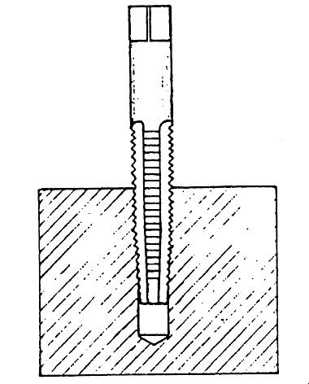
If the hole is all the way through and the material is thin, the thread can be finished with the taper tap. If the material is thick, the second tap must be used after the taper tap, and sometimes the plug tap, depending on the depth of the hole. The second and plug taps must be also reversed about every half turn, to break off chips.

3.3 Tapping a Blind Hole
Figure 5 - Tapping a Blind Hole
A blind hole cannot be threaded at its bottom with a taper tap. Therefore, the second and plug taps must also be used. The taper tap is used first, and then the second tap and finally the plug tap to finish the thread to the bottom. During the tapping, the tap must be withdrawn from time to time to remove swarf from the hole and from the tap flutes. Care must be taken to avoid breaking the tap by forcing it against the bottom of the hole. If the blind hole is shallow, it may not be possible to start the thread with the taper tap. It should therefore be drilled deeper than the required length of thread, if possible. If not; it may be started with the second tap, but special care must be taken.
Examples of common tapping faults and their possible causes are given in the table below:
Fault | Causes
Broken tap | - Tapping hole too small.  - Not reversing tap to break off chips.  - Tap not in alignment with hole.  - Not starting with taper tap.  - Attaching wrench while tap is in hole.
Shallow thread | Tapping hole too big.
Stripped thread | - Not reversing tap.  - Tap flutes clogged.  - Lack of cutting fluid.
Rough thread | - Lack of cutting fluid.  - Tap flutes clogged.
Bolt not square with work face | Hole not drilled square with work face.
Table 2 - Common Tapping Faults
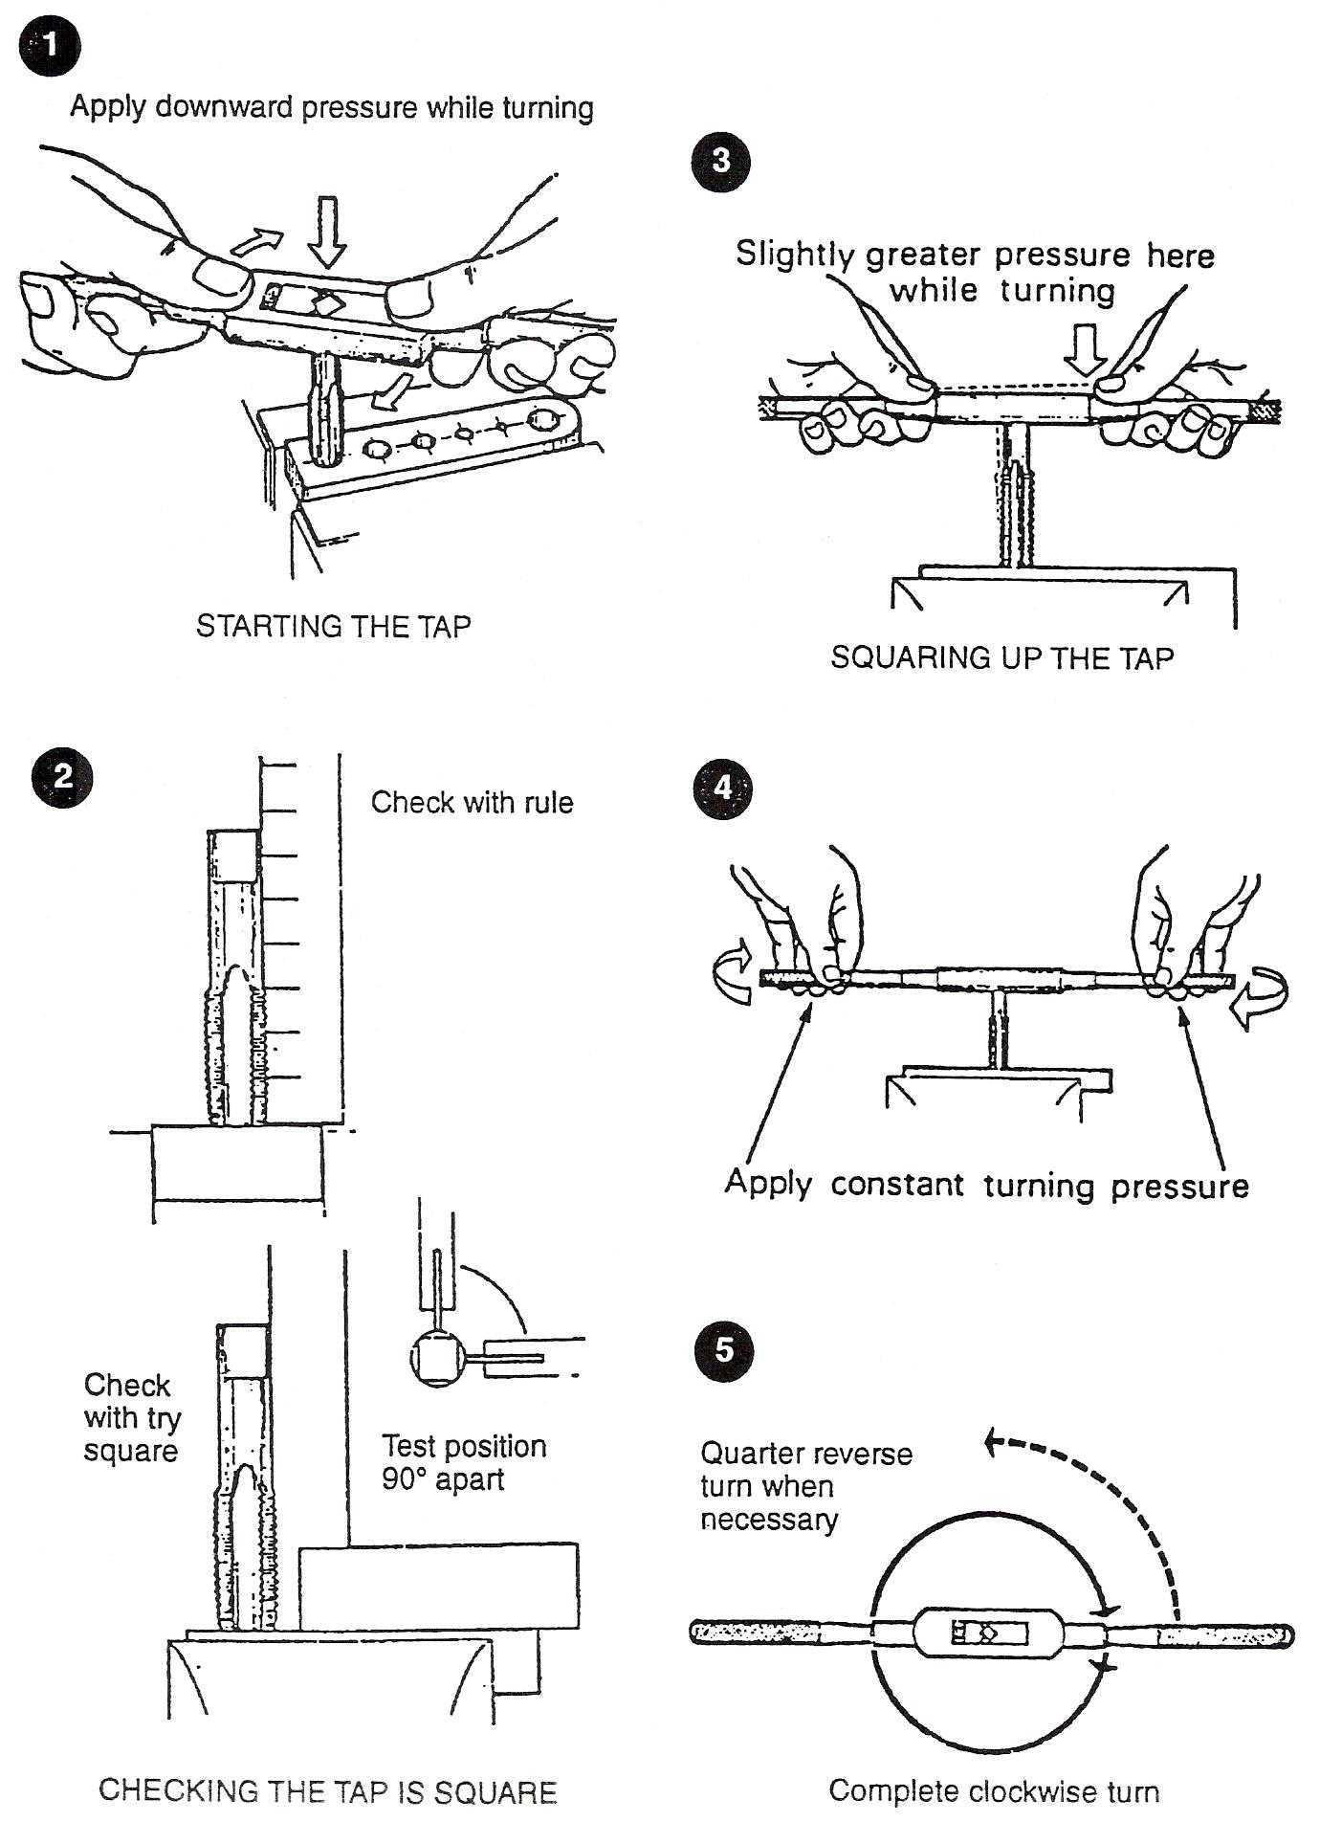
Figure 6 - Tapping a Through Hole

3.4 Stocks and Dies
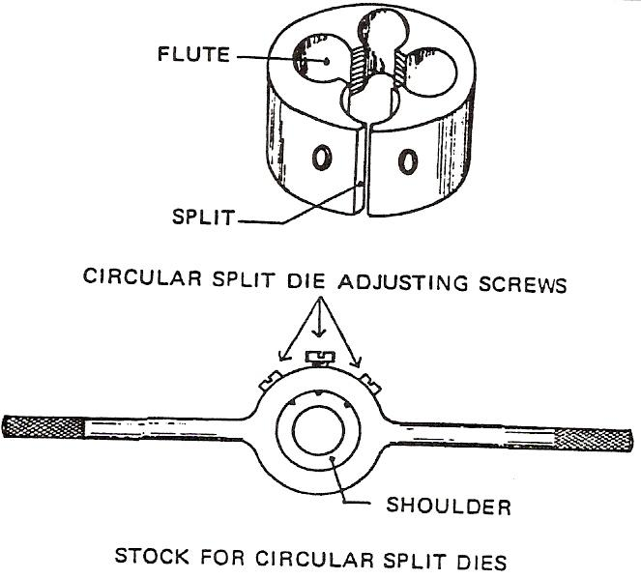
Stocks and dies are used for cutting external threads on round bars and on pipes. This is called screwing. The dies are made from high carbon steel or from high-speed steel. They are held in stocks to rotate them.
Figure 7 - Stocks and Dies

There are different forms of stocks and dies avai1able. Circular split dies are the ones mostly used in school workshops. The split permits a small amount of opening and closing of the die. The point of the central adjusting screw in the stock fits into the split in the die. To open the die, the screws at either side are slackened off and the centre one tightened. After adjusting, the side screws are retightened to lock the die in the stock. To close the die, the centre screw is slackened off and the side screws tightened. The first two or three threads on one side of the die are chamfered to make starting easier.
Before fitting the die, the stock recess must be thoroughly cleaned out to allow the die to seat properly. When fitted, the die chamfer must be on the underside and the stock retaining shoulder on top.

3.5 Screwing
The end of the bar should be chamfered to help start the die. If using a circular split die, it should be opened fully to take a light first cut.
Place the die on the end of the bar with its chamfered side down. Rotate the die, keeping it square with the bar, and apply downward pressure until it begins to cut. Check for squareness and correct if necessary. Continue rotating, reversing after about each full revolution, to break off the chips. Apply cutting fluid as for tapping.
When the required length is reached, remove the die by turning it in the opposite direction. Clean the thread and try a nut on it, or try it in a tapped hole. If too tight, close the die slightly and take another cut, as before. The deepening of the thread must continue until the nut can be just screwed on by hand without any slackness.
After grinding the chamfer on the edge of the material the sequence for cutting the thread is shown in the following diagrams.
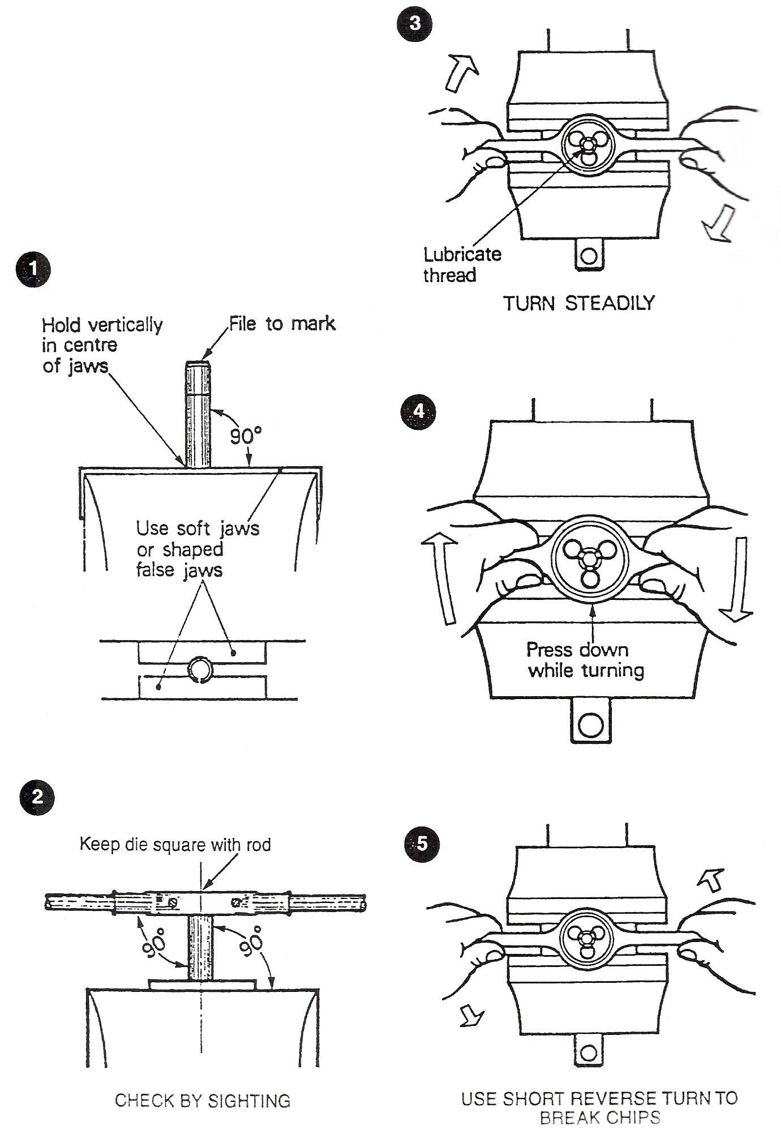
Figure 8 - Sequence of Cutting a Thread

Fault | Causes
Broken die teeth | - Oversize bar.  - Jerking the die.  - Not starting with chamfered side of die.  - Die not square with bar.  - Not reversing die.

Stripped thread | - Cut too heavy.  - Deepening the cut after it has been started.  - Lack of cutting fluid.  - Not reversing die.  - Clogged flutes.
'Drunken' thread (Bar going from side to side as it is screwed into tapped hole). | Not starting die square with bar.
Difficulty in starting die square. | Uneven chamfer on bar. Broken teeth on starting side of die.
Rough threads | - Lack of cutting fluid.  - Cut too heavy.  - Clogged flutes.
Bar end twisted off. | Over-size bar. Cut too heavy
Table 3 - Faults Which May Occur When Screwing

3.6 Screw Thread Terminology

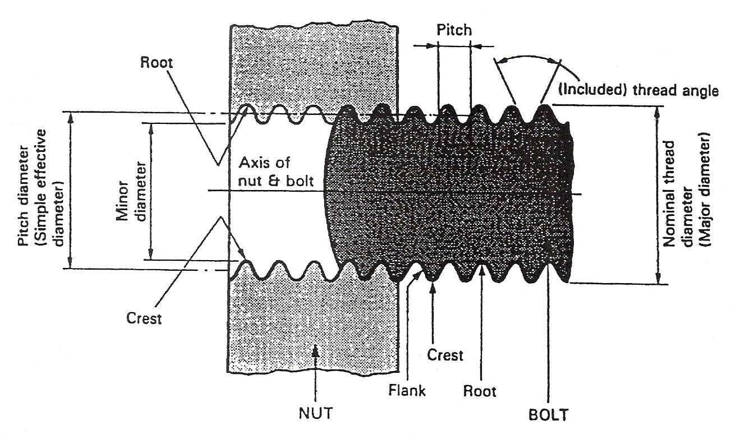
Figure 9 - Screw Thread Terminology

3.7 Tapping Drill Sizes for ISO Metric Threads

Nom. Dia. Tap m/m | Pitch m/m | Tapping Drill | Nom. Dia. Tap m/m | Pitch m/m | Tapping Drill
2.0 | 0.40 | 1.65 or 1.60 m/m | 14.0 | 1.50 | 12.50 or 12.60 m/m
2.2 | 0.45 | 1.80 or 1.75 m/m | 14.2 | 1.25 | 12.80 or 12.90 m/m
2.5 | 0.45 | 2.10 or 2.05 m/m | 16.0 | 2.00 | 14.00 m/m
3.0 | 0.50 | 2.55 or 2.50 m/m | 16.0 | 1.50 | 14.50 or 14.60 m/m
3.5 | 0.60 | 2.95 or 2.90 m/m | 18.0 | 2.50 | 15.50 or 39/64"
4.0 | 0.70 | 3.30 m/m | 18.0 | 1.50 | 16.50 m/m
5.0 | 0.80 | 4.20 m/m | 20.0 | 2.50 | 17.50 or 11/16"
5.0 | 0.50 | 4.50 m/m | 20.0 | 1.50 | 18.50 m/m
6.0 | 1.00 | 5.10 or 5.00 m/m | 22.0 | 2.50 | 19.50 or 19.75 m/m
6.0 | 0.75 | 5.20 or 5.30 m/m | 24.0 | 3.00 | 21.00 or 21.25 m/m
7.0 | 1.00 | 6.10 or 6.00 m/m | 27.0 | 3.00 | 24.00 or 24.25 m/m
8.0 | 1.25 | 6.90 or 6.80 m/m | 30.0 | 3.50 | 26.50 or 1.3/64"
8.0 | 1.00 | 7.00 or 7.10 m/m | 33.0 | 3.50 | 29.50 or 1.5/32"
9.0 | 1.25 | 7.90 or 7.80 m/m | 36.0 | 4.00 | 32.00 or 1.1/4"
10.0 | 1.50 | 8.60 or 8.50 m/m | 39.0 | 4.00 | 35.00 or 1.3/8"
10.0 | 1.25 | 8.80 or 8.90 m/m | 42.0 | 4.50 | 1.31/64" or 37.50 m/m
10.0 | 1.00 | 9.00 or 9.10 m/m | 45.0 | 4.50 | 1.39/64" or 40.50 m/m
11.0 | 1.50 | 9.60 or 9.50 m/m | 48.0 | 5.00 | 1.45/64" or 43.00 m/m
12.0 | 1.75 | 10.40 or 10.20 m/m | 52.0 | 5.00 | 1.55/64" or 47.00 m/m
12.0 | 1.50 | 10.50 or 10.60 m/m | 56.0 | 5.50 | 2" or 50.50 m/m
14.0 | 2.00 | 12.20 or 12.00 m/m | 60.0 | 5.50 | 2.5/32"
Table 4 - Tapping Drill Sizes for ISO Metric Threads

4.0 Safety Precautions and Procedures

Key Learning Points
- Hazard avoidance
- General workshop safety
- Tool holding/usage/ housekeeping.
- Safe and environmentally sound disposal of waste materials and tooling

4.1 Hazard Avoidance: General Workshop Safety
It is important to keep the work area and the workshop clean and tidy. All tool and equipment must be returned to their respective toolbox or storage area when not in use. When using power tools always wear safety glasses, do not wear loose clothing and tie back long hair. Ensure that the floor is kept free of debris, oil and coolant spills. Clean up spills immediately.
- Care and use of hand tools:
- Select the correct size tool for the job.
- Do not use worn or damaged tools.
- Maintain tools in good condition.
- A cutting tool needs to be sharp to be safe.
- Store and carry tools safely
When the component has been cut on the band-saw, all burrs and sharp edges need to be removed with a file prior to marking-out. For sawing and filing the work should be held securely in a vice, adopting a comfortable balanced stance, maintaining a suitable grip.

4.2 Safe Disposal of Waste Materials and Tools
All waste materials, such as metal cut-offs and scraped parts, should be placed in special metal scrap bins, which can be sent for recycling.
All other waste such as oily paper, cloths, filings etc., should be removed from the workbench or floor using a brush and pan. This waste can be placed in the general disposal bins.

5.0 Correct Use of Hand Tools to Complete Metalwork Exercise

Key Learning Points
- Hacksaw blade selection and assembly (junior/senior),
- Hand hack-sawing technique and practice, power hack sawing.
- Calculation of the material requirement for the components to be manufactured, including necessary excess material.

5.1 Hacksaw Blade Selection and Assembly
Mild steel plates are cut using a hacksaw. The plates are cut close to the scribed lines, allowing additional material for filing to the finished size. For cutting solid metal such as mild steel, a blade with a staggered tooth set should be used, which prevent the blade wedging in the slot. For cutting tube or sheet metal, a waved blade with a fine pitch is used. A junior hacksaw blade is used for cutting small sections and in confined conditions.

5.2 Hand Hack-Sawing Techniques
The hacksaw is controlled with both hands. The saw should be kept straight and upright and should not be allowed to twist or move sideways. Proper technique will come with practice and experience and guidance from your instructor.

5.3 Calculation of Material Requirements, Including Excess Material
Mild steel plates are cut with a hacksaw to the marked-out dimensions, while allowing additional material for filing to the finished size. The drawing is used to calculate the material requirement for the component to be manufactured. Excess material is added because the material is roughly cut from standard bar stock using a band-saw. The excess material is removed afterwards with a hacksaw and a range of files. A basic level of maths is required such as addition, subtraction, multiplication, division, fractions, decimals and percentages.

6.0 Grinding Equipment

Key Learning Points
- Set up, adjust and use grinding equipment
- Observe the correct safety procedures while operating grinding equipment

6.1 Component Identification
Some parts of this illustration are labeled. It is important to learn the names of these equipment components.
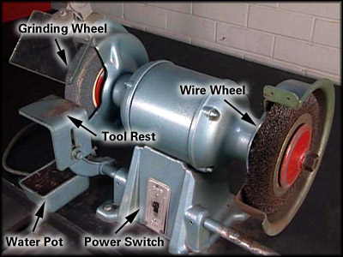
CDXGS31\GenServ31\AT175AU\dswmedia\video benchgrder.mpg

Personal Protective Equipment
Whenever you perform a task in the workshop you must use personal protective clothing and equipment that is appropriate for the task and which conforms to your local safety regulations and policies. Among other items, this may include:
- Work clothing - such as coveralls and steel-capped footwear
- Eye protection - such as safety glasses and face masks
- Ear protection - such as earmuffs and earplugs
- Hand protection – such as rubber gloves and barrier cream
- Respiratory equipment – such as face masks
If you are not certain what are appropriate or required, ask your instructor.

Safety Check
- Stand to the side of the grinder when starting the electric motor.
- Always wear full-face protection, ear protection, leather gloves and a leather apron.
- Use the safety shield fitted to the grinder. If it has been damaged, replace it.
- Do not grind on the side of the wheel because it may cause the wheel to shatter.
- Slowly and smoothly bring material into contact with the grinding wheel. Avoid bumping
- Do not jam work between the wheel and the tool rest
- Gradually apply pressure to the wheel. Do not use more pressure than is required for the task
- Do not press hard on a dull wheel as this can produce excessive heat which can weaken the wheel, making it more susceptible to shattering
- Move the material back and forth over the face of the wheel. This helps prevent grooves from forming
- Remember to use the right wheel for the job. If you apply the wrong material to a wheel you may damage it
- Make sure you understand and observe all legislative and personal safety procedures when carrying out the following tasks. If you are not sure of what these are, ask your instructor.

Points to Note
- The bench grinder turns an abrasive wheel or wire brush wheel at high speed. These wheels are used to remove metal from a work piece, sharpen tools and clean parts.
- The type of wheel you use will depend on the type and the hardness of the material.
- Whether you are grinding or polishing, use the correct wheel for the material you are grinding or buffing.
- Ask your instructor to demonstrate the differences between grinding wheels for soft and hard materials and wire brush wheels.
- As the abrasive wheel wears down, the gap between the wheel and the tool rest will increase.
- Make sure the tool rest is as close as possible to the grinding wheel, but not touching it. It needs about a 1.5 mm gap.
- The face of the abrasive wheel must be kept square. This is done with a dressing tool, which removes some of the abrasive compound.
- If the abrasive wheel is not square, ask your instructor to demonstrate the use of the dressing tool.
- When grinding metal, it must not overheat. This will affect its hardness. If the metal becomes too hot and is allowed to cool slowly, it may become soft. If it is cooled quickly (quenched), it may become brittle.
- As you shape the metal, dip it into the water pot attached to the bottom of the grinder. This will prevent the metal from getting too hot.
- Some bench grinders are not supplied with a water pot. If this is the case, you will need to have a water pot located near the grinder so that you can cool the piece you are grinding.

6.1 Step by Step Instruction
- Set up the bench grinder
Before you start using the bench grinder, it’s vital that you set it up correctly. When operating, the abrasive wheel turns at high speed and produces dangerous and hot flying particles and sparks. Make sure the grinder is both switched off and disconnected from the power supply before you attempt to adjust it.
- Use the correct safety equipment
Certain safety attachments MUST be in place before operating the grinder. They are the wheel guard, the see-through safety shield, the tool rest, a water pot and a full-face protector.
- Use the correct wheel
The grinder may have abrasive grinding wheels for removing metal, a wire wheel to clean parts, or both. Make sure the wheel you’re using is appropriate for the job.
- Adjust the tool rest
With the correct wheel fitted to the grinder, adjust the tool rest. Position it so there’s at least 1.5 mm gap between the wheel and the tool rest and that it is the same height as the centre of the wheel. To adjust the tool rest, locate the adjusting bolt and loosen it with a box wrench. Set the tool rest at the right height and distance from the wheel and then tighten the adjusting bolt. If you are unsure of how to do this, ask your instructor.
- Safely use the grinder
Connect the grinder to the power supply. Adjust your face protector, stand to the side of the wheel and switch the grinder on. Once the grinder is up to speed, move to the front of the wheel, hold the part firmly onto the tool rest and move it slowly and gently forward until it comes into contact with the wheel. The grinding wheel removes the metal it contacts. Occasionally dip the part into the water to keep it cool.
- Shut down
When you have finished, turn off the power and unplug the grinder.

6.2 Grinding Wheel
The abrasive wheel or grinding wheel consists of two constituents:
- The Abrasive That Does The Cutting.
- The Bond That Holds The Abrasive Particles Together.
The specification of a grinding wheel gives a clue as to its construction and suitability for a particular operation. For example a wheel carrying the marking:
38A60-J5VBE
would indicate that the wheel has an aluminium oxide abrasive; that the abrasive grit is medium to fine in grain size; that the grade is soft; that the structure shows medium spacing; that a vitrified bond is used. How the code marked on the wheel can indicate all this information required in selecting the correct wheel for a particular job will now be examined in some detail.

Manufacturer’s Type Code | BS Code | Abrasive | Application
- | A | Aluminium oxide | A high strength abrasive for hard, tough materials
32 | A | Aluminium oxide | Cool; fast cutting, for rapid stock removal
38 | A | Aluminium oxide | Light grinding of very hard steels
19 | A | Aluminium oxide | A milder abrasive than 38A used for cylindrical grinding
37 | C | Silicon carbide | For hard, brittle materials of high density such as cast iron
39 | C | Silicon carbide (green) | For hard, brittle materials such as tungsten carbide
Table 5 - Manufacturer's Type Code
Grade: This indicates the strength of the bond and therefore the 'hardness' of the wheel. In a hard wheel the bond is strong and securely anchors the grid in place and therefore reduces the rate of wear. In a soft wheel the bond is weak and the grit is easily detached resulting in a high rate of wear.
The bond must be carefully related to the use of the wheel. If it is too hard the wheel will glaze and become blunt, if it is too soft it will wear away too quickly. This would be uneconomical and also cause loss of accuracy.
Very Soft | Soft | Medium | Hard | Very Hard
EFG | HIJK | LMNO | PQRS | TUWZ
Table 6 – Grade
Due to the nature of its construction a grinding wheel can, if not carefully treated, crack or shatter during use. To reduce the dangers of flying particles causing injury the wheel must be guarded with only the work area exposed. Examine the wheel frequently for cracks or other defects.
When grinding, move the work from side to side to avoid cutting grooves in the wheel. Use the front of the wheel as much as possible. If the side of the wheel is used, avoid using too much force.

6.3 Wheel Inspection
Vitrified bond wheels can be checked with a procedure called the ring test:. Please note this type of test should only be carried out by qualified personnel.
- Tap the wheel with a non-metal object
- If the wheel is in good condition it will ring clearly
- Damaged wheels give a dull or chattering sound

6.4 Portable Grinding Equipment
Portable grinding machines are often used for smoothing down welded joints and seams and generally do much of the fabrication workshop jobs which would otherwise be done by the laborious methods of chiselling and filing.
These portable tools are basically of two types, ELECTRIC and PNEUMATIC, and the three most commonly used variations of portable grinders are:
- The Straight Grinder
- The Angle Grinder
- The Sander Grinder
Usually two sizes are available:
- Grinding wheel diameter 102 mm
Grinding wheel thickness 19 mm
Spindle speed (running light) 8400 rev/min
- Grinding wheel diameter 127 mm
Grinding wheel thickness 19 mm
Spindle speed (running light) 6600 rev/min
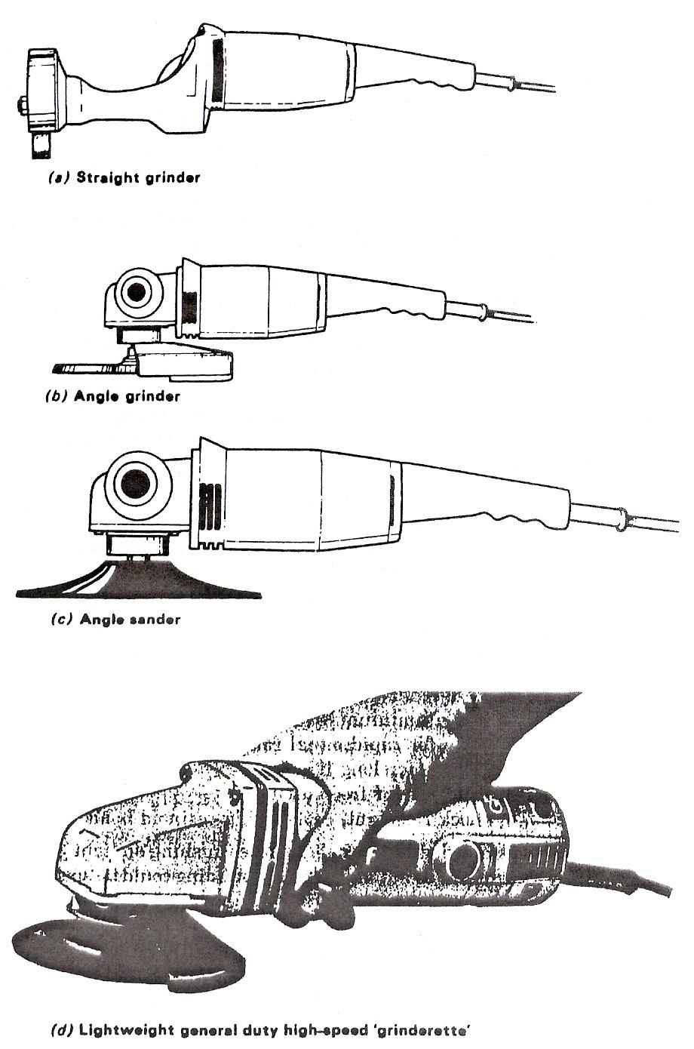
Figure 10 - Portable Electric Grinding Machines
Figure 10 and 11 illustrates electrically-powered portable grinders. Figure 10(a) shows a 'straight' portable grinder. This uses an ordinary grinding wheel, cutting on its periphery as in tool grinding.
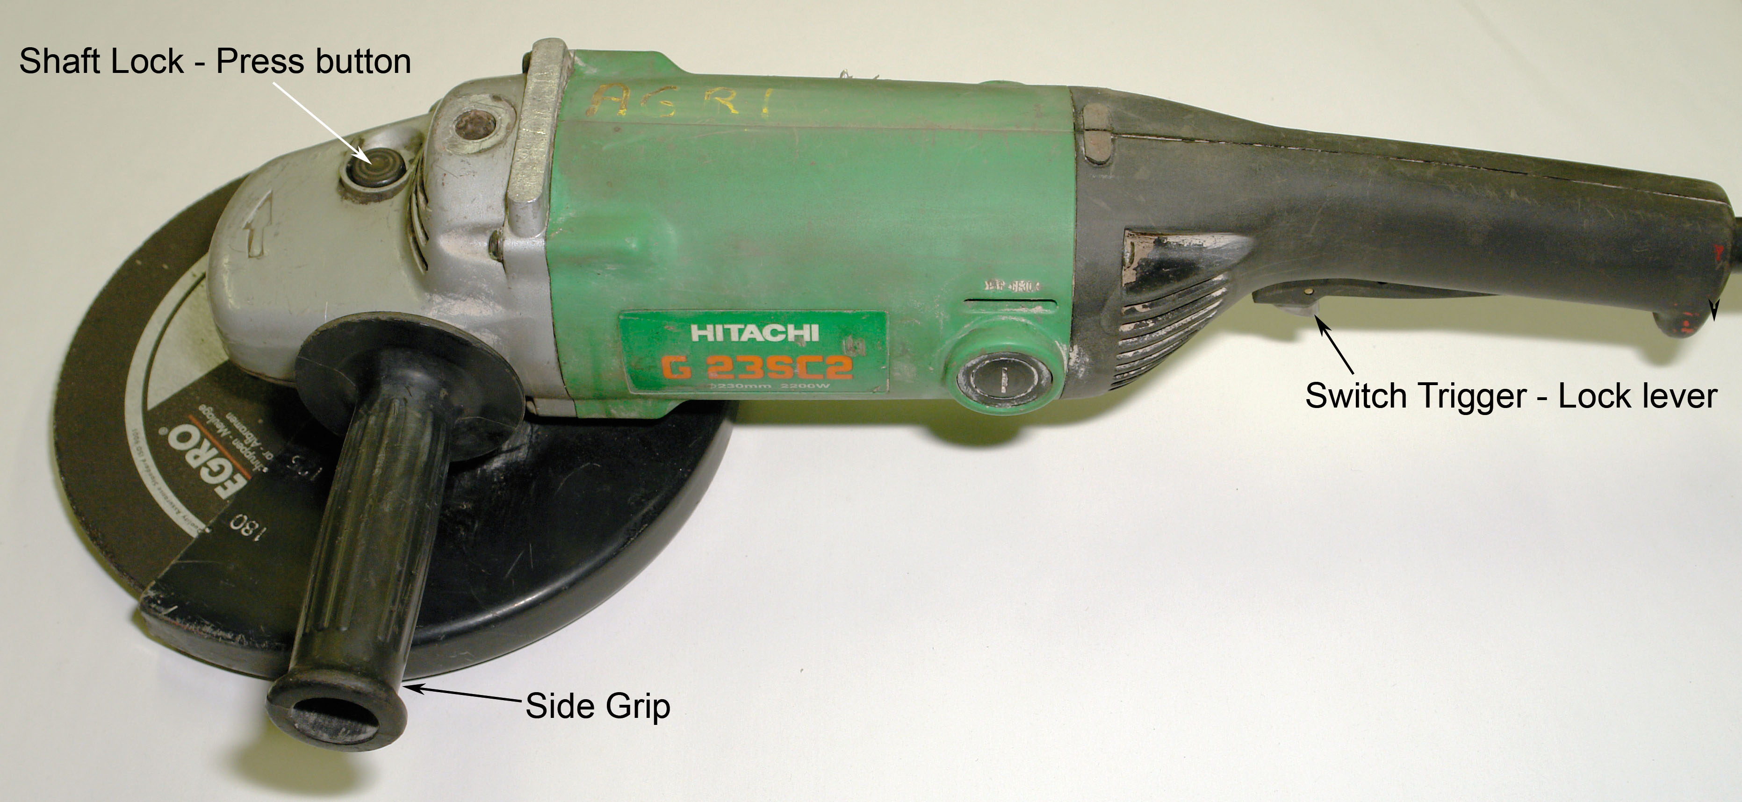
Figure 11 - Portable Electric Grinding Machines (continued)

Safety for Portable Grinding Equipment
Hand-powered tools with exposed rotating heads must be switched off and have stopped revolving before being laid down. Otherwise, they can spin themselves off scaffolding, for instance, causing damage and injury.
Power grinders and cutting-off wheels must have guards for protection and to prevent oversize wheels being used.
ALWAYS USE THE CORRECT SIZE AND TYPE OF WHEEL FOR THE JOB - if it is too hard or too fine it becomes glazed. The operator must then use excessive pressure resulting in more breakages and reduced productivity.
Pneumatic grinders must have a mechanical governor to prevent the spindle exceeding its maximum speed.

7.0 Properties of Metals and Pipe Alloys

Key Learning Points
- Properties of Metals
- How metal alloys are created
- Properties of nickel based alloys

7.1 Properties of Metals
When describing metals we think of sometimes shiny, strong, solid and heavy, however this is not always the case. Sodium is classed as a metal but is lighter that water, mercury is a liquid at room temperature. Some of the main properties of metals are:
- Good conductors of heat and electricity
- Malleable and ductile to some extent
- Materials with a high density
- Material with a high tensile strength
- Solid at room temperature (except for mercury)
- Capable of taking a shine
- Electron donors which form oxides

7.2 Metal Alloys
Great advancements have been made in the development of metals by alloying, which is the mixing of a number of metals and sometimes other elements, and by heat treatments. Metals with improved properties such as extra strength, hardness and improved resistance to corrosion have been created. This has increased their use and their suitability for different applications.
Nickel and nickel-base alloys are vitally important to the modern pipe industry because of their ability to withstand a wide variety of severe operating conditions involving corrosive environments, high temperatures, high stresses, and combinations of these factors. Nickel is one such metal which is mixed There are several reasons for these capabilities. Pure nickel is ductile and tough. Nickel has good resistance to corrosion in the normal atmosphere, in natural freshwaters and in de-aerated non-oxidizing acids, and it has excellent resistance to corrosion by caustic alkalis. Therefore, nickel offers very useful corrosion resistance itself and provides an excellent base for developing specialized alloys. Intermetallic phases can be formed between nickel and some of its alloying element: this enables the formulation of very high strength alloys for both low- and high-temperature service with excellent corrosion resistant properties which make them ideal for pipes to transfer corrosive liquids.

Suggested Exercises
- Demonstrate the correct method of using a pedestal drill
- Complete an exercise which includes a drilling and tapping function
- Demonstrate the correct method of using a portable grinder

Self Assessment
Q1: Once a hand tool has been identified as irreparably faulty, you should; (Tick ONE box only)
 1. Dispose of it
 2. Purchase a replacement, then dispose of the faulty tool
 3. Keep on using it
 4. Borrow one from someone else

Q2: Which of the following is used to turn up a ring?

Additional Resources

Title | Author | Ref. Code
The Induction Book, “Code of Behaviour & Health & Safety Guidelines” | SOLAS
Basic Welding and Fabrication | W Kenyon | ISBN 0-582-00536-L
Fundamentals of Fabrication and Welding Engineering | FJM Smith | ISBN 0-582-09799-1
Workshop processes, practices and materials, 3rd edition, Elsevier Science & Technology | Black, Bruce J 2004 | ISBN-13: 9780750660730
New Engineering Technology | Lawrence Smyth & Liam Hennessy | ISBN 086 1674480

Videos:
- Understanding welding fumes
- Welder on Site…Be Aware (Vocam)
- Powered hand tool safety (Vocam)
- Industrial Ergonomics (Vocam)
Available from:
Vocam Ireland
Circle Organisation Ltd
Friar Street, Thurles, Co Tipperary, Ireland
Tel: +353 504 24666

Castleforbes House
Castleforbes Road
Dublin 1

