Trade of Sheet Metalwork
Module 1: | Sheetmetal Fundamentals
Unit 1: | Induction
 | Phase 2

Table of Contents
List of Figures 5
List of Tables 7
Document Release History 8
Module 1 – Sheetmetal Fundamentals 9
Unit 1 – Induction 9
Learning Outcome: 9
Key Learning Points: 9
Training Resources: 10
Exercise: 10
Key Learning Points Code: 10
Workshop Equipment 11
Bench Stakes 11
General Description of Bench Stakes 11
Mandrel 12
Hatchet Stake 12
Tinman’s Anvil 13
Pipe Stake 13
Funnel Stake 14
Blowhorn Stake 14
Half-Moon Stake 15
Bick Iron Stake 15
Creasing Stake 16
Drip Pan Stakes 16
Round Bottom Stakes 17
Ball Head Stake 17
Tinman’s Horse with Heads 18
Common Iron Stakes 19
Stake Holder 19
Hand Dollies 20
Tools 21
Hand Tools 21
Scriber 21
Straight Edge 22
Dividers 22
Steel Square 23
Steel Try Square 23
Combination Square 24
Swinging Blade Protractor 24
Trammel Points (Also called Beam Compass) 25
Rulers 25
Centre Punch 26
Solid Punches 26
Hollow Punches 26
Steel Circumference Rule 27
Tape Rule 27
Punches 28
Hand Groover 28
Rivet Set 29
Flat Cold Chisel 29
Stretching Hammer 30
Hollowing Hammer 30
Planishing Hammer 31
Boxwood and Rubber Mallets 31
Pear-Shaped Boxwood Mallet 32
Straight Snips 32
Cross Pein Hammer 33
Engineers Ball Pein 33
Vice Grips 34
Plain Screwdriver 34
Philips Screwdriver 34
Hack Saw 35
Files 35
Hand Lever Punch 36
Combination Snips 36
Side Cutting Pliers 37
Combination Pliers 37
Sand Bags 38
Hardwood Blocks 38
Soldering Irons 39
Pop Riveting Guns 40
Hand “Pop” Gun 40
Lazy Tongs 40
How to Identify the Proper Fire Extinguisher 42
Know your ABC for Fire Extinguishers 42
Self Assessment 43
Questions on Background Notes – Module 1.Unit 1 43
Answers to Questions 1-3. Module 1.Unit 1 46
Bibliography 49
Index 50

List of Figures
Figure 1 - Mandrel Stake 12
Figure 2 - Hatchet Stake 12
Figure 3 - Tinman's Anvil 13
Figure 4 - Pipe Stake 13
Figure 5 - Funnel Stake 14
Figure 6 - Blowhorn Stake 14
Figure 7 - Half-Moon Stake 15
Figure 8 - Bick Iron Stake 15
Figure 9 - Creasing Stake 16
Figure 10 - Drip Pan Stakes 16
Figure 11 - Round Bottom Stake 17
Figure 12 - Ball Head Stake 17
Figure 13 - Tinman's Horse with Heads 18
Figure 14 - Common Iron Stake 19
Figure 15 - Stake Holder 19
Figure 16 - Hand Dollies 20
Figure 17 - Scriber 21
Figure 18 - Straight Edge 22
Figure 19 - Dividers 22
Figure 20 - Steel Square 23
Figure 21 - Steel Try Square 23
Figure 22 - Combination Square 24
Figure 23 - Swinging Blade Protractor 24
Figure 24 - Trammel Points 25
Figure 25 - Rulers 25
Figure 26 - Centre Punch 26
Figure 27 - Solid Punch 26
Figure 28 - Hollow Punch 26
Figure 29 - Steel Circumference Rule 27
Figure 30 - Tape Rule 27
Figure 31 - Punches 28
Figure 32 - Hand Groover 28
Figure 33 - Rivet Set 29
Figure 34 - Flat Cold Chisel 29
Figure 35 - Stretching Hammer 30
Figure 36 - Hollowing Hammer 30
Figure 37 - Planishing Hammer 31
Figure 38 - Boxwood and Rubber Mallets 31
Figure 39 - Pear-Shaped Boxwood Mallet 32
Figure 40 - Straight Snips 32
Figure 41 - Cross Pein Hammer 33
Figure 42 - Engineers Ball Pein 33
Figure 43 - Vice Grips 34
Figure 44 - Plain Screwdriver 34
Figure 45 - Philips Screwdriver 34
Figure 46 - Hack Saw 35
Figure 47 - Files 35
Figure 48 - Hand Lever Punch 36
Figure 49 - Combination Snips 36
Figure 50 - Side Cutting Pliers 37
Figure 51 - Combination Pliers 37
Figure 52 - Sand Bags 38
Figure 53 - Hardwood Blocks 38
Figure 54 - Soldering Irons 39
Figure 55 - Hand "Pop" Gun 40
Figure 56 - Lazy Tongs 40

List of Tables

Document Release History
Date | Version | Comments
15/06/06 | First draft
28/03/14 | 2.0 | SOLAS transfer

Module 1 – Sheetmetal Fundamentals

Unit 1 – Induction
Duration – 14 Hours

Learning Outcome:
By the end of this unit each apprentice will be able to:
- State the attendance, safety and fire drill procedures that apply to the training establishment
- Select correct tool, type/sizes for different applications
- Identify various workshop layouts and machine types
- State the recommended fire extinguisher type for use with the following fires, “carbonaceous”, “liquid fuel” and “electrical”

Key Learning Points:
Rk | Training centre layout. Location of evacuation assembly points.
Sk | Location and use of fire fighting equipment.
P | Attendance and time-keeping procedures.
H | Safety procedures applicable to training location.
Sk | First aid procedures.
Sk | Identification of basic workshop equipment.
H | Accident reporting.
Sk | Tools, types and sizes.
Sk | Workshop cleaning routine – cleaning roster.
Sk | Identification and marking/engraving tool kit.
Sk | Care of tools and equipment.
Rk | Location and identification of special tools, equipment and consumables.

Training Resources:
Induction manual, safety videos and TV monitor. Fire extinguishers, types, fire blankets. Course manual and apprentice tool kit. Writing paper and pens etc. Workshop tools and equipment.

Exercise:
State the appropriate fire extinguisher for use with various types of fire. State the attendance and canteen procedures. State the procedure to be followed when entering another area.

Key Learning Points Code:
M = Maths D= Drawing RK = Related Knowledge Sc = Science
P = Personal Skills Sk = Skill H = Hazards

Workshop Equipment

Bench Stakes
Sheetmetal can be formed by bending or forming it over various shaped anvils known in the sheetmetal trade as stakes. These stakes vary in shape depending upon the work to be done on them. Square, round and conical work can be formed, and edges and seams can be finished on them. Stakes are used when a suitable machine is not available or when a machine is not readily adaptable to the work.
A bench plate or stake holder is used to hold the stakes while they are being used.

General Description of Bench Stakes
Stakes come in a variety of sizes and shapes. Stakes have shanks which fit into the holes in the bench plate or stake holder. The work is done on the heads or the horns of the stakes which are machined, polished and in some cases, hardened. Stakes are used for finishing many kinds of work; therefore, they should not be used to back up the work when cutting with a cold chisel.

Mandrel
This stake is a single horizontal metal bar. One end has a flat surface and the other end is rounded. The flat length has a slot cut in it which permits the stake to be fastened directly to the bench. This stake is used for forming, seaming or riveting. These stakes are available in various lengths and weights.

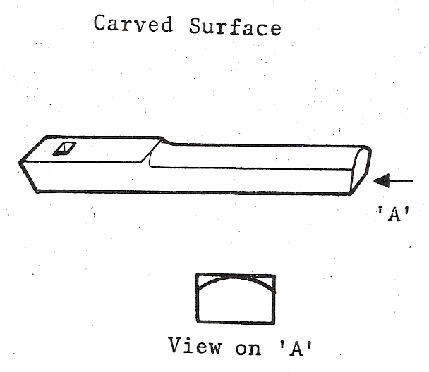
Figure 1 - Mandrel Stake

Hatchet Stake
The Hatchet Stake is a sharp, straight stake with a hardened and bevelled edge. It is used for making straight sharp bends, folding, bending edges and is used as a support when flanging.

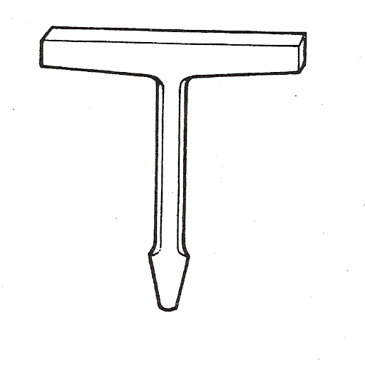
Figure 2 - Hatchet Stake

Tinman’s Anvil
The Tinman’s Anvil has a flat, square shaped head with a short shank and is used for general working operations.

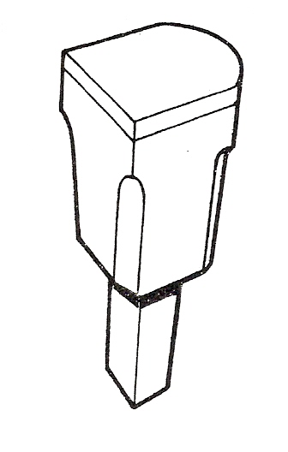
Figure 3 - Tinman's Anvil

Pipe Stake
The Pipe Stake consists of one or two cylindrical horns having different diameters. This stake is used for forming pipes and cylindrical work pieces. The stake with the two horns is called a Double Ended Pipe Stake.

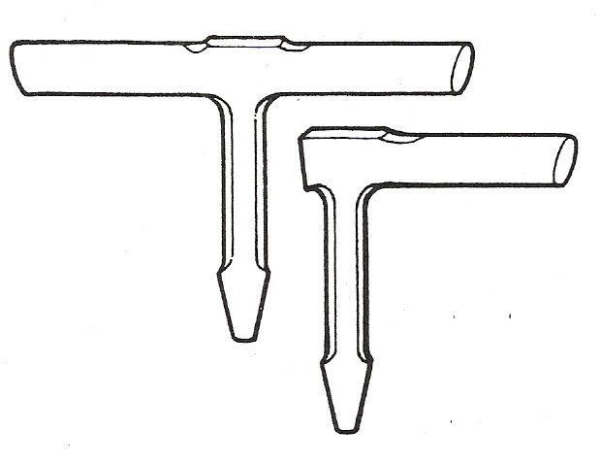
Figure 4 - Pipe Stake

Funnel Stake
The Funnel Stake has a thick tapered head and is used in forming, riveting and seaming tapered articles such as funnels.

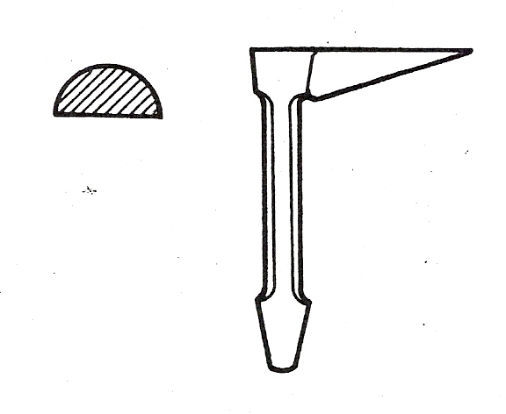
Figure 5 - Funnel Stake

Blowhorn Stake
The Blowhorn Stake has a short, tapered horn at one end and a long tapered horn at the other. It is used in forming, riveting and seaming abrupt and slender tapering objects.

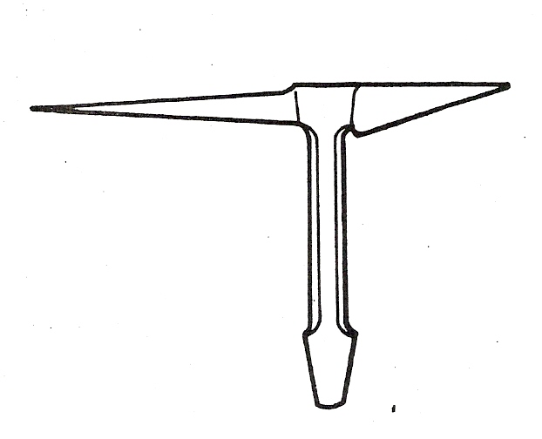
Figure 6 - Blowhorn Stake

Half-Moon Stake
The Half-Moon Stake consists of a single vertical shank with a half-rounded head on top. The stake is used for forming or shaping curved flanges.

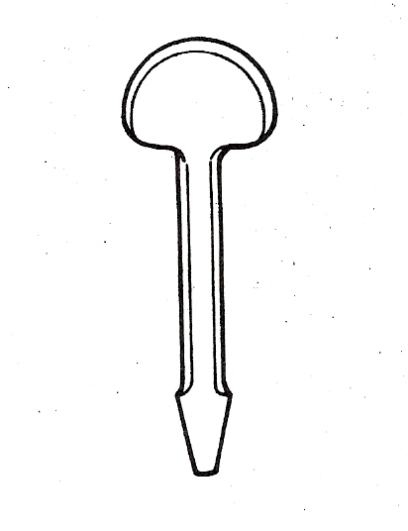
Figure 7 - Half-Moon Stake

Bick Iron Stake
The Bick Iron Stake has a square tapering, flat horn on one side and a round tapered horn on the other side. It serves as a general purpose anvil for riveting and shaping round and flat surfaces, straight bending and corner seams.

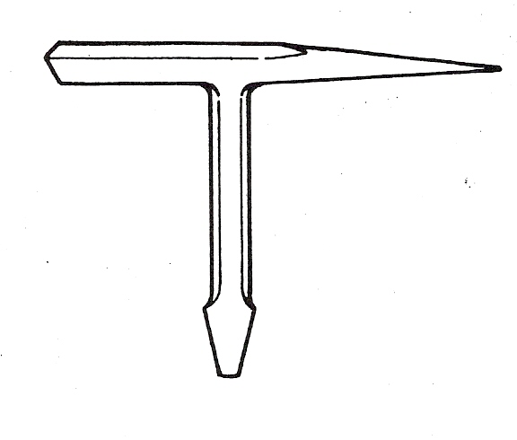
Figure 8 - Bick Iron Stake

Creasing Stake
This stake is available in two patterns. One has a double rectangular shaped horn and contains a number of grooved slots for creasing metal and bending wire; the other pattern has a round and tapered horn at one end and a rectangular shaped horn on the other and is used for forming, riveting or seaming small tapering objects.

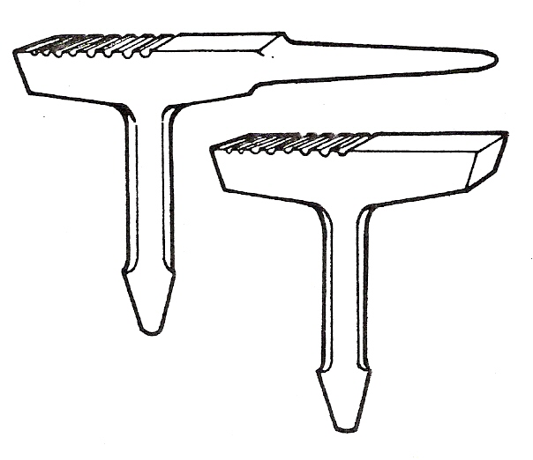
Figure 9 - Creasing Stake

Drip Pan Stakes
This is used for finishing off knocked-up joints on small trays and boxes. They are also used for general work in the sheet metal shop.

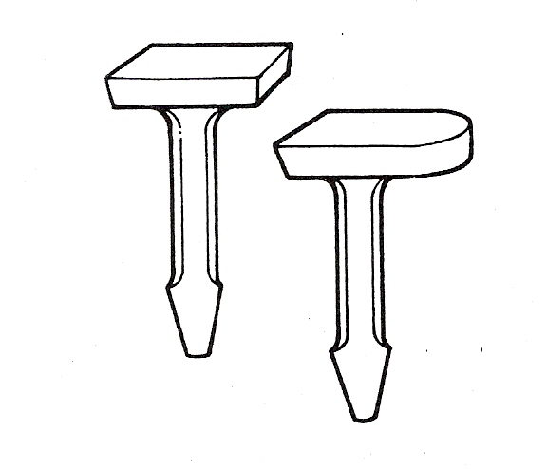
Figure 10 - Drip Pan Stakes

Round Bottom Stakes
The Round Bottom Stake consists of a single vertical piece with a flat round head on top. It is used for flanging circular and curved work.

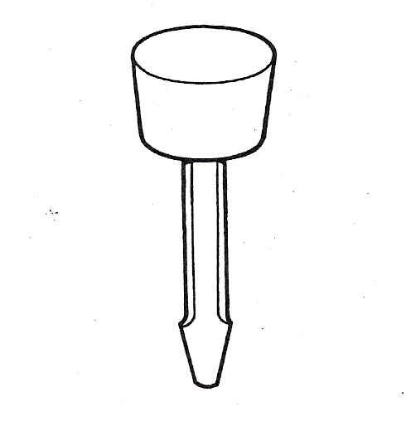
Figure 11 - Round Bottom Stake

Ball Head Stake
This is used in the process of raising and planishing a hollow article.

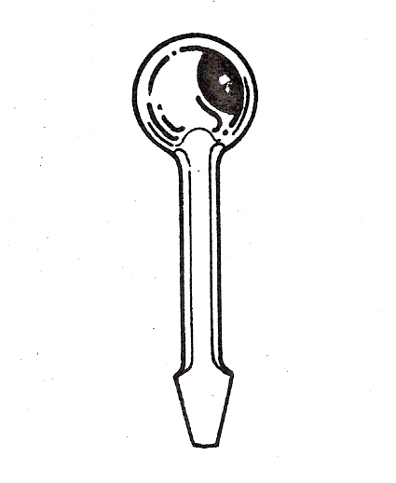
Figure 12 - Ball Head Stake

Tinman’s Horse with Heads
This stake has a holder (the horse part of the stake) which can take various shaped small heads. This stake is useful in many operations for which other stakes are not suitable.

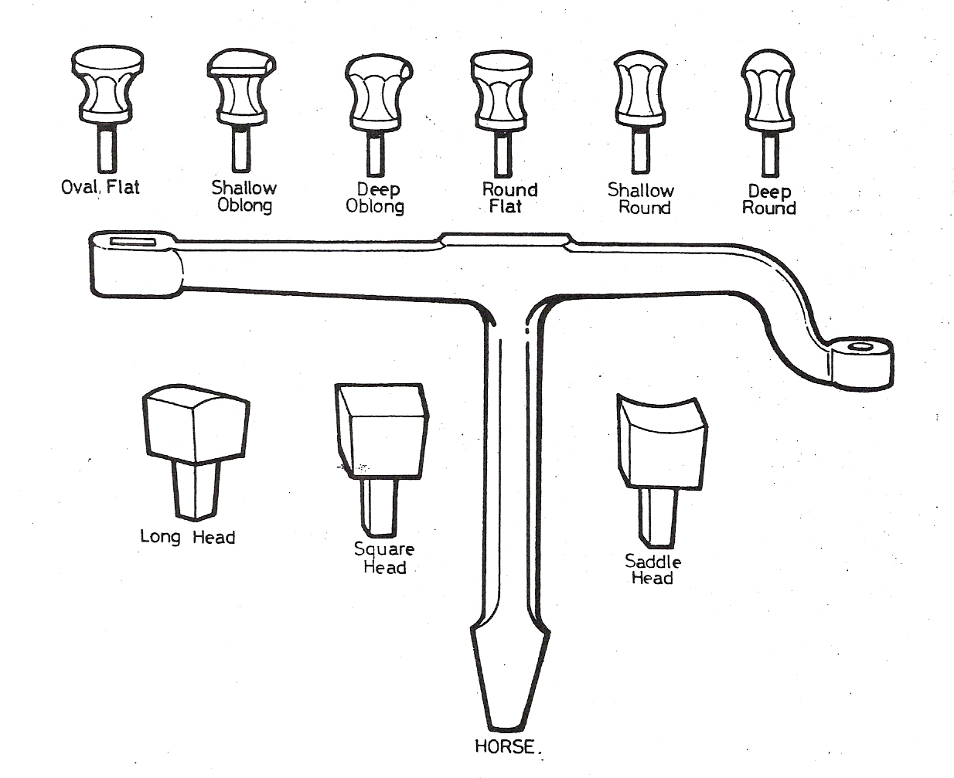
Figure 13 - Tinman's Horse with Heads

Common Iron Stakes
These stakes are usually found around any sheet metal shop. They are used as stakes for various purposes, depending on the nature of the work being formed.

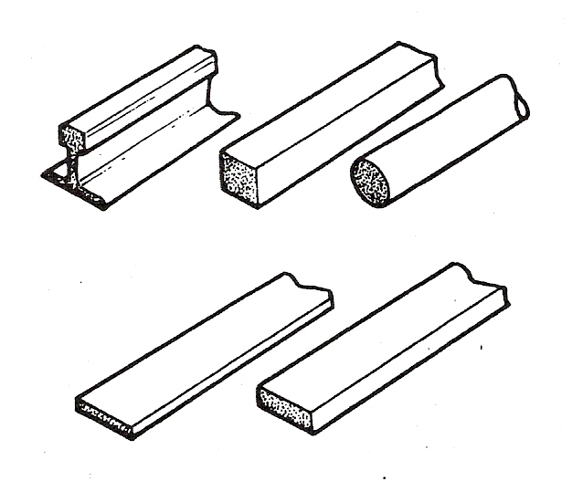
Figure 14 - Common Iron Stake

Stake Holder
This is used for holding stakes and is secured to the bench.

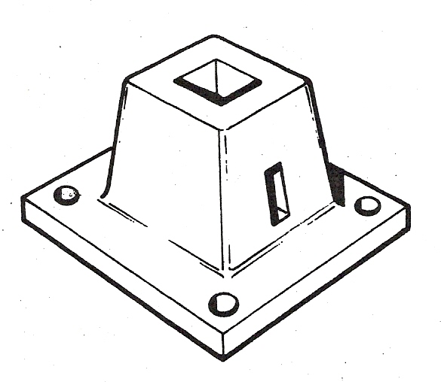
Figure 15 - Stake Holder

Hand Dollies
They are used in conjunction with the planishing hammer or cross as Pein Hammer, a support or anvil to smooth out panels, welds, kinks etc.

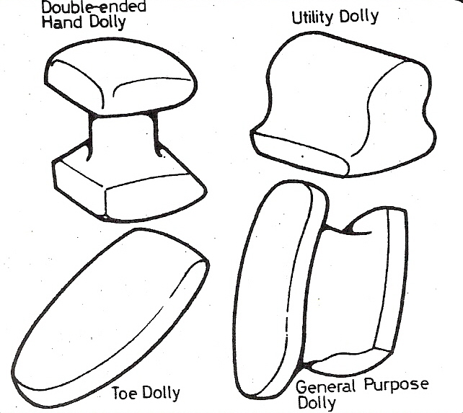
Figure 16 - Hand Dollies

Tools
One of the characteristics of the skilled worker is the way in which he selects and uses his tools. For this reason, it is essential that you know how to select and use both hand and machine tools correctly. If you do this you will save time and the work will be much easier. When you have selected the correct tool for the correct operation you have taken the first step in becoming a successful craftsman.

Hand Tools
Sheetmetal hand tools are used to scribe or measure lines, perform layout operations and shape or cut metals. Some of the hand tools in the following notes actually perform these operations while others, such as stakes and punches, serve as aids in performing them.
It is important to keep tools in good shape. Avoid tools going rusty by giving steel tools an occasional oiling. Tools with a sharp point should be stored carefully.

Scriber
This is used to mark lines on metal. It can be used in conjunction with a straight edge and square.

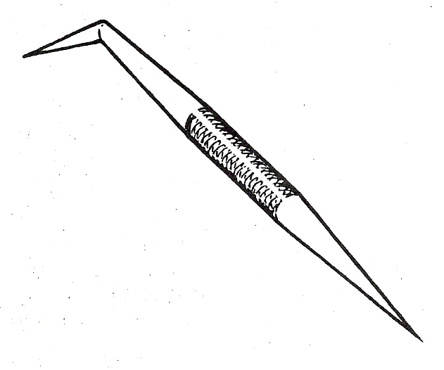
Figure 17 - Scriber

Straight Edge
The Straight Edge is used as a guide for a scriber or pencil when marking a straight line or drawing a line between two points. It is also used in conjunction with a square to draw lines at right angles.

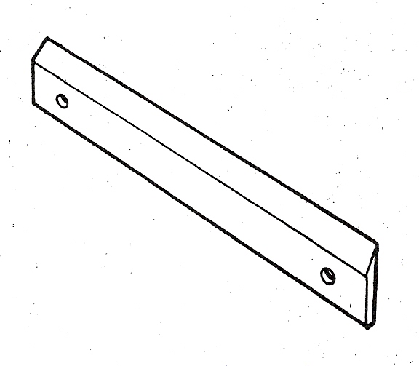
Figure 18 - Straight Edge

Dividers
This is made with each straight leg tapered to a needle point. Dividers are manufactured in various sizes and types and are used to space off equal distances, to divide lines into equal parts and to scribe arcs and circles. Spring loaded screw dividers are a more accurate type.

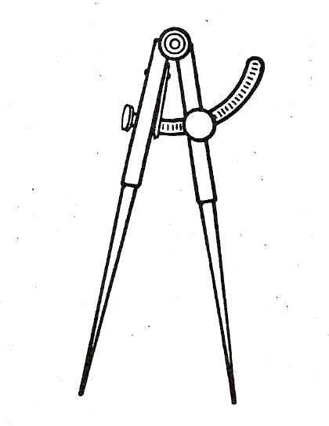
Figure 19 - Dividers

Steel Square
The flat Steel Square is used to layout right angles (90°) and can also be used as a scale. It is an invaluable tool for accurate layout work in pattern drafting.
The long arm is known as the body or blade, the short arm is known as the heel or tongue.
These squares come in various sizes.

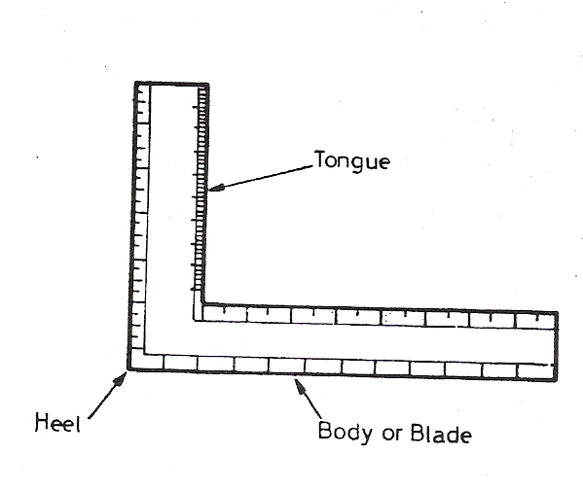
Figure 20 - Steel Square

Steel Try Square
It is used for marking and checking right angles (90°).
These squares come in various sizes.

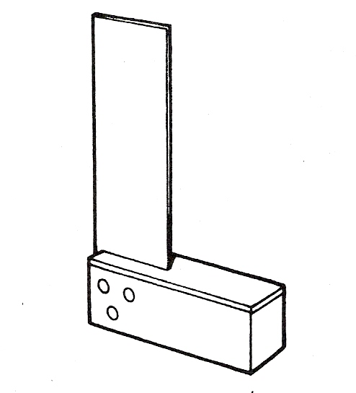
Figure 21 - Steel Try Square

Combination Square
This is one of the most useful and convenient tools for laying out small work. It is used as a square for measuring or laying out 90° or 45° angles.
A spirit level is mounted in the stock.

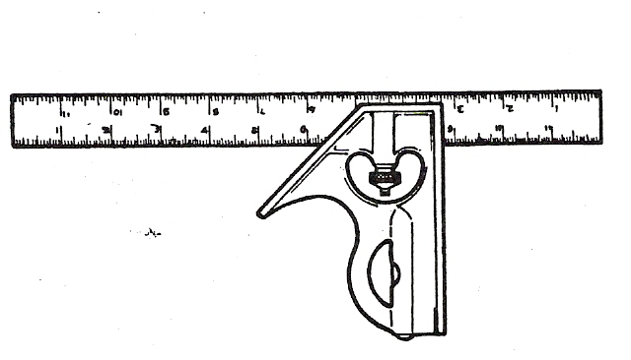
Figure 22 - Combination Square

Swinging Blade Protractor
This is a device for measuring and laying out angles from the edge of the work. This protractor consists of a head and a movable blade.
The head of the protractor has a semicircular scale graduated from zero to 180°.

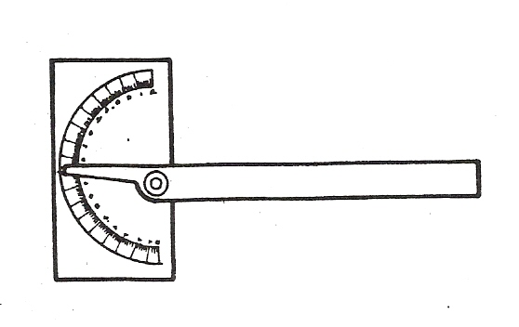
Figure 23 - Swinging Blade Protractor

Trammel Points
(Also called Beam Compass)
These are used for scribing large arcs and circles.
They are manufactured in various types with two straight, removable legs tapered to needle points and attached to separated heads or holders.
The heads or holders slide on wood or steel beams and are held in place by thumb screws. Either of the points can be removed and often one point has adjustment for fine settings. A special clamp for a pencil can be attached to one of the points.

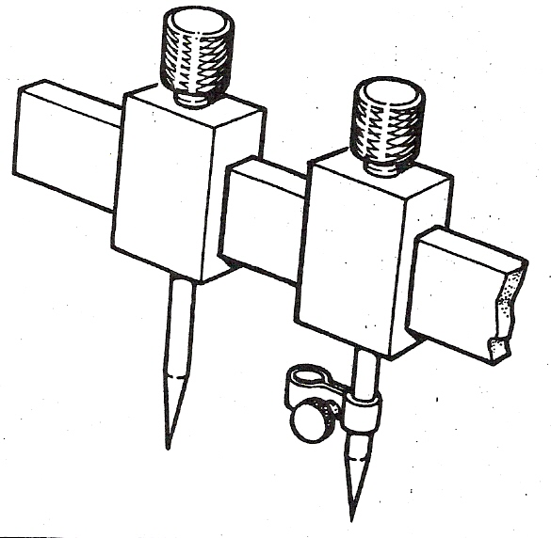
Figure 24 - Trammel Points

Rulers
Rulers are manufactured in a variety of types and lengths; each of which is designed for measuring or laying out different work.

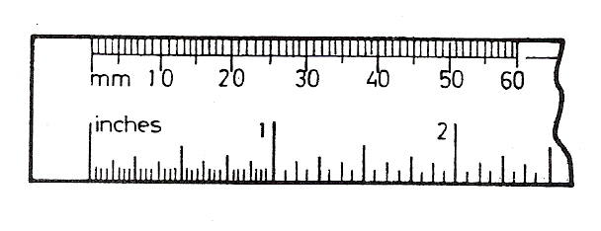
Figure 25 - Rulers

Centre Punch
Similar in design to the prick punch except that the tapered point is ground to an angle of 90° included. They are available in various shapes and sizes and are used for locating centres for drilling etc.

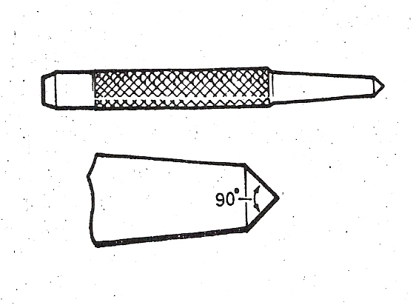
Figure 26 - Centre Punch

Solid Punches
Solid Punches are used to punch small holes in light gauge metal. These punches can be obtained in sets of various sizes.

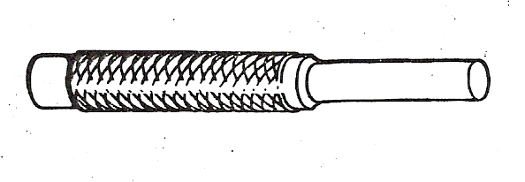
Figure 27 - Solid Punch

Hollow Punches
Hollow Punches are used for cutting circular holes ¼" or 6mm or larger from sheet metal. To avoid chipping the edges of the hollow punch the sheet metal should be placed over a block of lead.
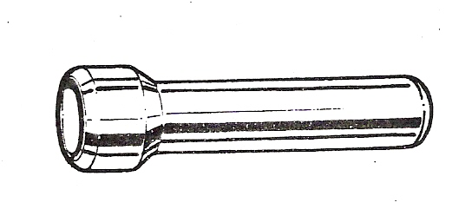
Figure 28 - Hollow Punch

Steel Circumference Rule
This is used much like the common rule. It is invaluable for laying out patterns. It is available in metric or imperial graduations. Its length is 24" or 600mm depending on the type. The purpose of this rule is for finding the circumference of cylinders and for angular measurement.

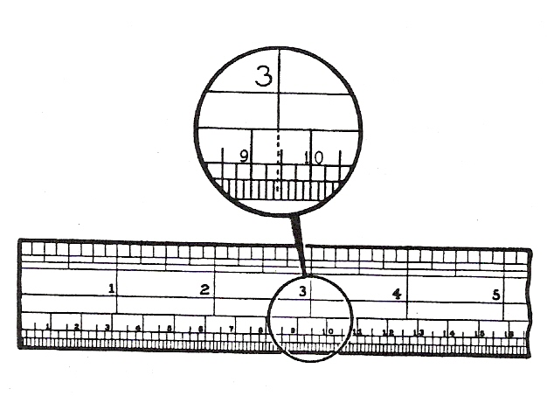
Figure 29 - Steel Circumference Rule

Tape Rule
The length varies from 6ft to 12ft or from 2m to 3.5m. It is very popular for measuring and laying out large jobs.

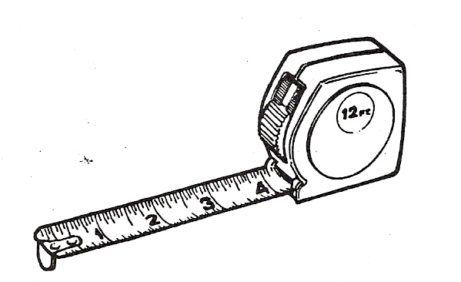
Figure 30 - Tape Rule

Punches
Prick Punches are made of tool steel and having a tapered point ground to approximately 30° included angle. These punches are used for making small dents or indentations and/or establishing points for dividers and trammel points.

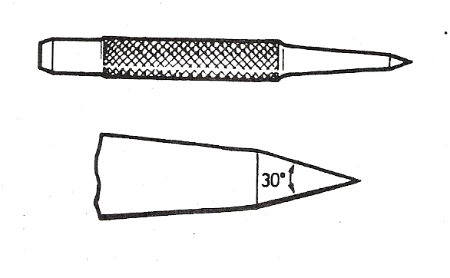
Figure 31 - Punches

Hand Groover
The Hand Groover is used when grooving a seam by hand. The end of the tool is recessed to fit over the joint making the grooved seam. It is available in various sizes.

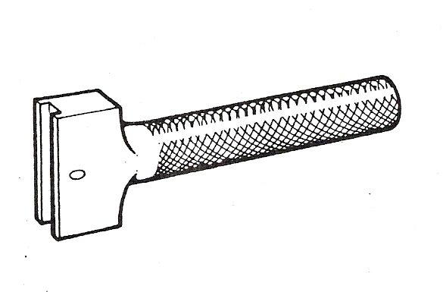
Figure 32 - Hand Groover

Rivet Set
The Rivet Set is made of tool steel. The deep hole in the bottom is used to draw a rivet through metal. The cup-shaped hole is used to form the finished head of the rivet. The hole in the side is to release the burrs that are punched through the metal. They are available in various sizes.

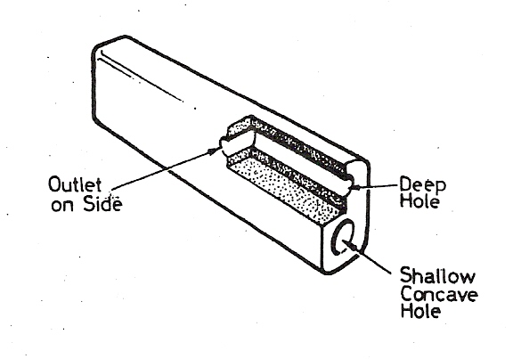
Figure 33 - Rivet Set

Flat Cold Chisel
This chisel is used widely by the sheet metal worker. It is used mainly for cutting sheetmetal, rivets, bolts and in chipping operations.

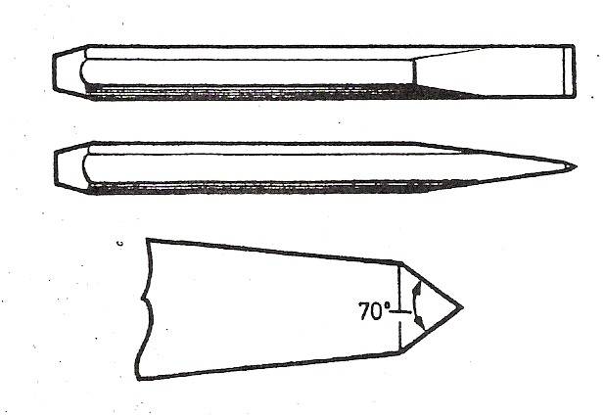
Figure 34 - Flat Cold Chisel

Stretching Hammer
This is used for stretching edges and flanges on curved work. It is normally used in conjunction with a stake.

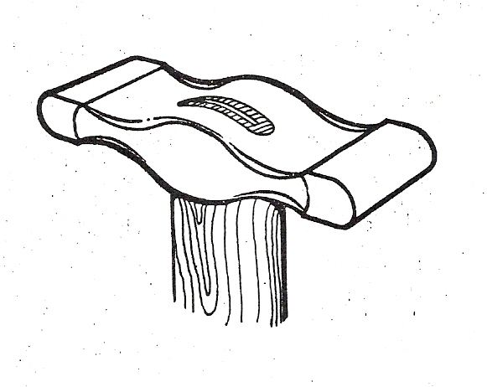
Figure 35 - Stretching Hammer

Hollowing Hammer
This is a shaping hammer used on mild steel in conjunction with a sandbag or wooden hollowing block, and to create a double-curved shape by hand.

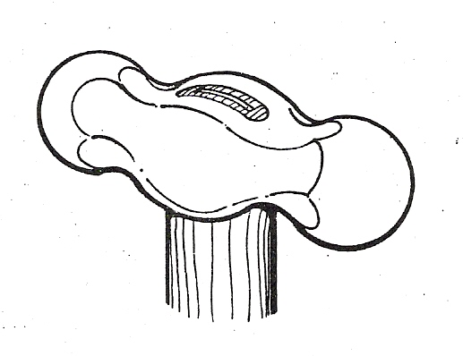
Figure 36 - Hollowing Hammer

Planishing Hammer
The principal purpose of the Planishing Hammer is for smoothing and finalising a surface after it has been roughed out to the required shape.

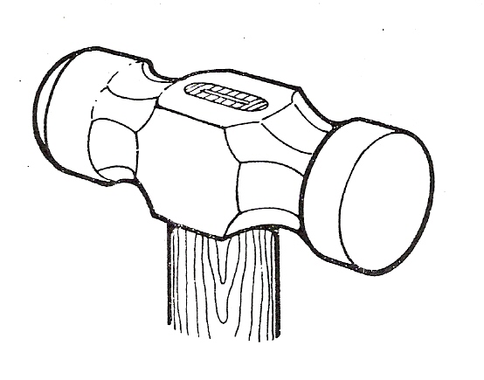
Figure 37 - Planishing Hammer

Boxwood and Rubber Mallets
These mallets can be used on mild steel, copper or aluminium to prevent marring the metal.

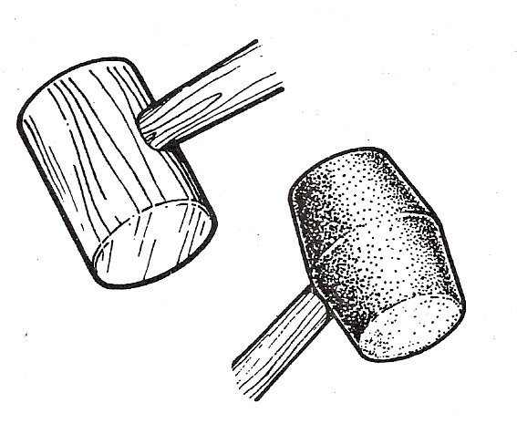
Figure 38 - Boxwood and Rubber Mallets

Pear-Shaped Boxwood Mallet
This mallet is used in conjunction with a sand bag or wood block for either hollowing or raising when shaping metal by hand to a double-curvature shape.

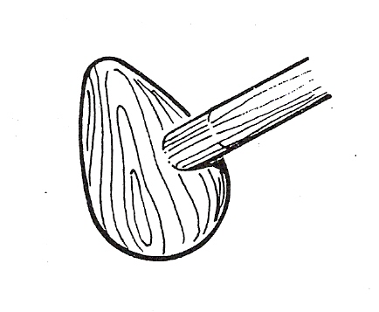
Figure 39 - Pear-Shaped Boxwood Mallet

Straight Snips
These snips are used for straight line cutting. They are available in many different sizes.

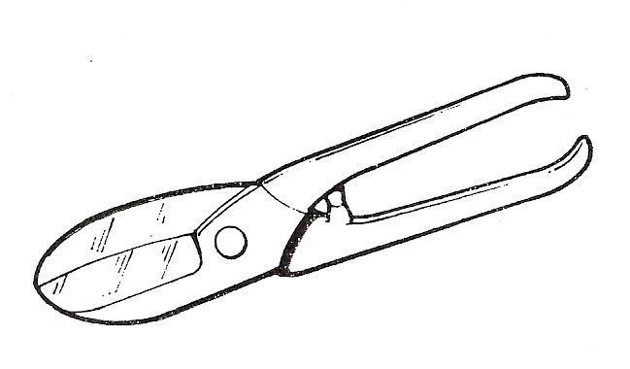
Figure 40 - Straight Snips

Cross Pein Hammer
This is used by the sheet metal worker for riveting, peening and for general use in the sheet metal shop.

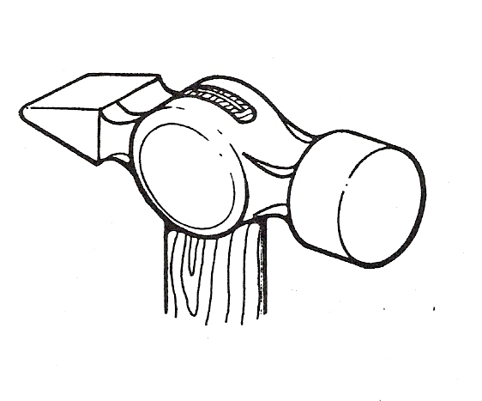
Figure 41 - Cross Pein Hammer

Engineers Ball Pein
This is used for striking chisels, punches, rivets etc. and for general engineering use.

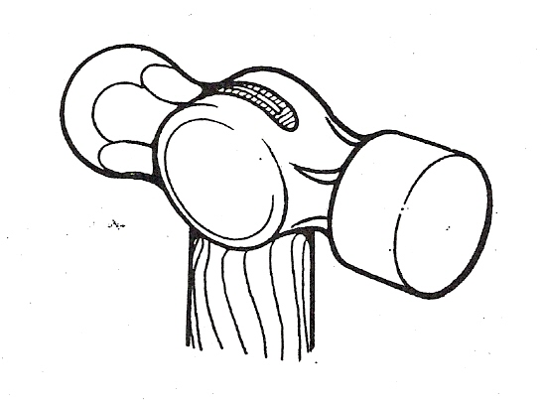
Figure 42 - Engineers Ball Pein

Vice Grips
Vice Grips are generally used for holding objects together. It acts as a clamp when spot welding, riveting, welding etc. It is available in various sizes.

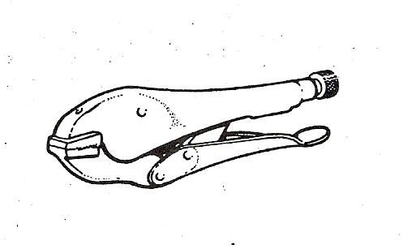
Figure 43 - Vice Grips

Plain Screwdriver
This is used primarily for tightening or loosening slotted screws. Screwdrivers are available in various lengths and with different types of handles e.g. wood, metal or plastic materials.

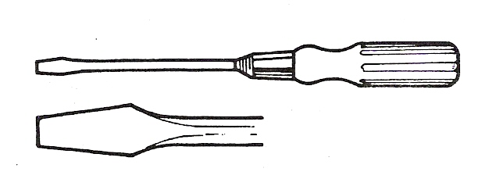
Figure 44 - Plain Screwdriver

Philips Screwdriver
This screwdriver has a cross-shaped tip. This fits into the head of a screw which has a recess of the same shape. This type of screwdriver will not slip and burr the end of the screw if the proper size is selected.

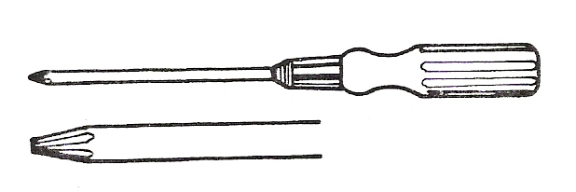
Figure 45 - Philips Screwdriver

Hack Saw
The Hack Saw is used for cutting materials by hand. It consists of a renewable hardened steel saw blade fitted into an adjustable frame, which is usually provided with a screw adjustment for controlling the tension of the blade. It is necessary to have both junior and senior hack saws in your tool kit.

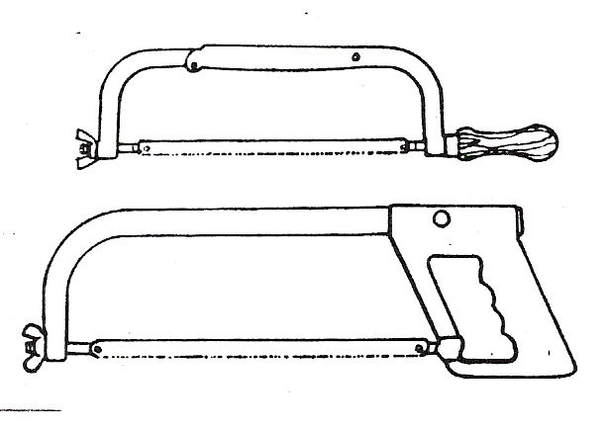
Figure 46 - Hack Saw

Files
There are many shapes and sizes of Files available with various grades of cut.
Files are used to remove burrs from sheets of metal, to straighten uneven edges and for various other operations that require a small amount of metal to be removed. They should always be used with a handle. Common types used by the sheet metal worker are: flat, square, round, half-round.

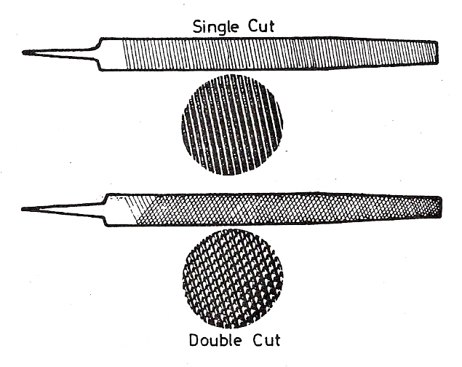
Figure 47 - Files

Hand Lever Punch
The Hand Lever Punch is used by the sheet metal worker for punching holes in sheet metal and button punching.

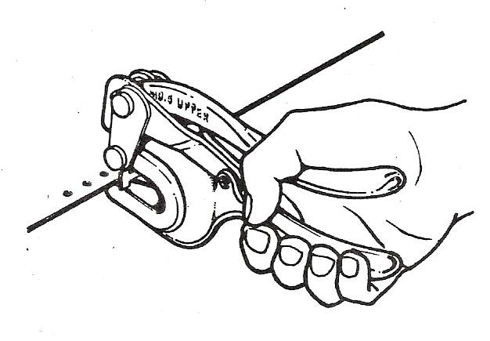
Figure 48 - Hand Lever Punch

Combination Snips
These snips are used to cut straight and irregular lines and curves. These are the snips used most commonly by the sheet metal worker. They are available in the same sizes and capacities as straight snips and are also available for right or left hand use.
Spring loaded snips known as aviation snips are very good for notching of jobs.

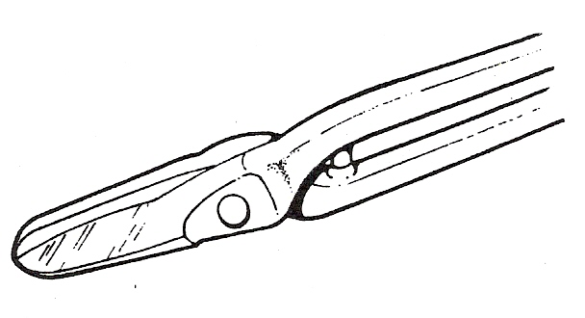
Figure 49 - Combination Snips

Side Cutting Pliers
These pliers have flat jaws grooved to hold the work, and are sharpened to cut light wire.

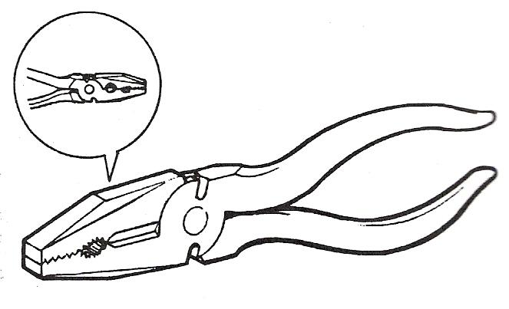
Figure 50 - Side Cutting Pliers

Combination Pliers
These are used for holding, cutting and bending work. The pliers are so constructed that the jaws can be adjusted for holding different sizes of work.

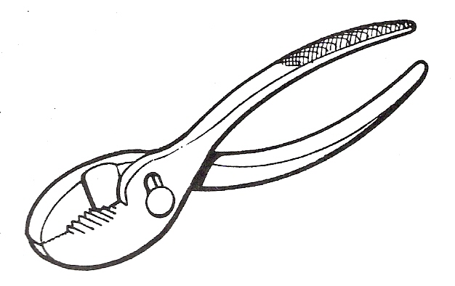
Figure 51 - Combination Pliers

Sand Bags
Sand Bags are leather bags made from two pieces of the finest leather, filled with very fine sand and stitched together. They are available in a variety of weights and sizes but are usually round or square in shape.

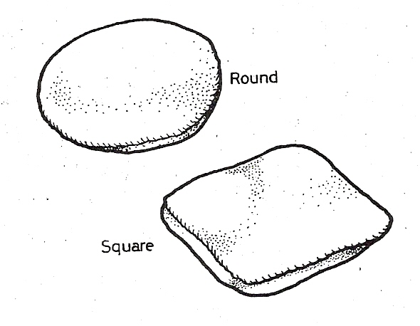
Figure 52 - Sand Bags

Hardwood Blocks
In some instances Hardwood Blocks are hollowed out to different depths and diameters. These blocks are used in the same manner as the sandbag for shaping metal, although the blocks are more solid and do not “give” as much as the resilient sandbags.

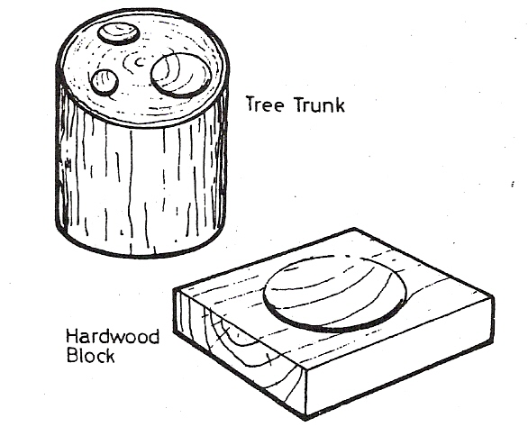
Figure 53 - Hardwood Blocks

Soldering Irons
A Soldering Iron consists of a forged piece of copper connected by an iron rod to a handle. The shape and the size of the bit varies with the type of work for which it is to be used. Electric soldering irons are also available.

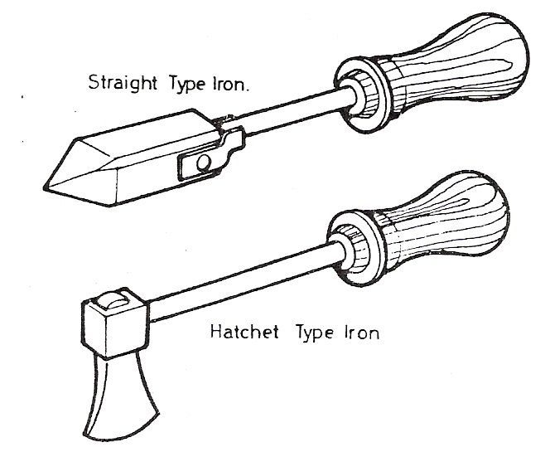
Figure 54 - Soldering Irons

Pop Riveting Guns
“Pop” Riveting Guns are used extensively with “pop” rivets for the assembly of light fabrications and are particularly useful for the assembly of ductwork where access is restricted to one side of the work only. There are three different types available: hand “pop” gun, lazy tongs and pneumatic (air).

Hand “Pop” Gun
Riveting in confined spaces requires the use of a hand “pop” gun. These are unsuitable for larger dimensions of rivets, due to the reduced amount of leverage available.

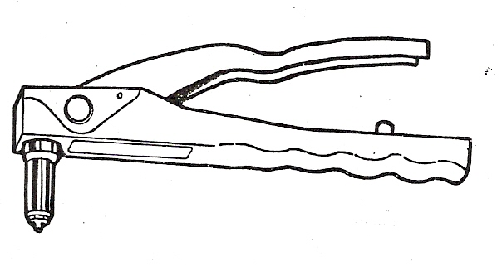
Figure 55 - Hand "Pop" Gun

Lazy Tongs
Lazy Tongs are used for the larger diameters of rivets, where sufficient working space is available to permit operation of the tool.
The construction of the tool permits a moderate pressure on the handle to provide a strong pulling force on the rivet mandrel.

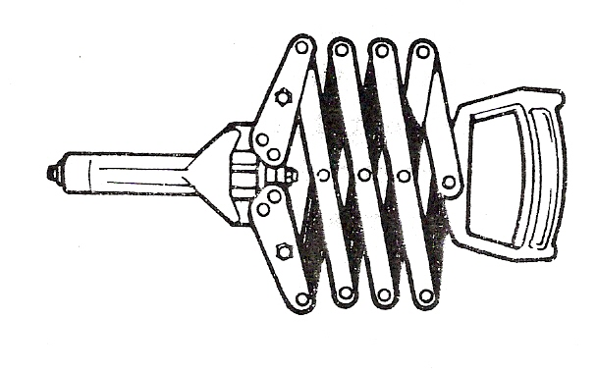
Figure 56 - Lazy Tongs

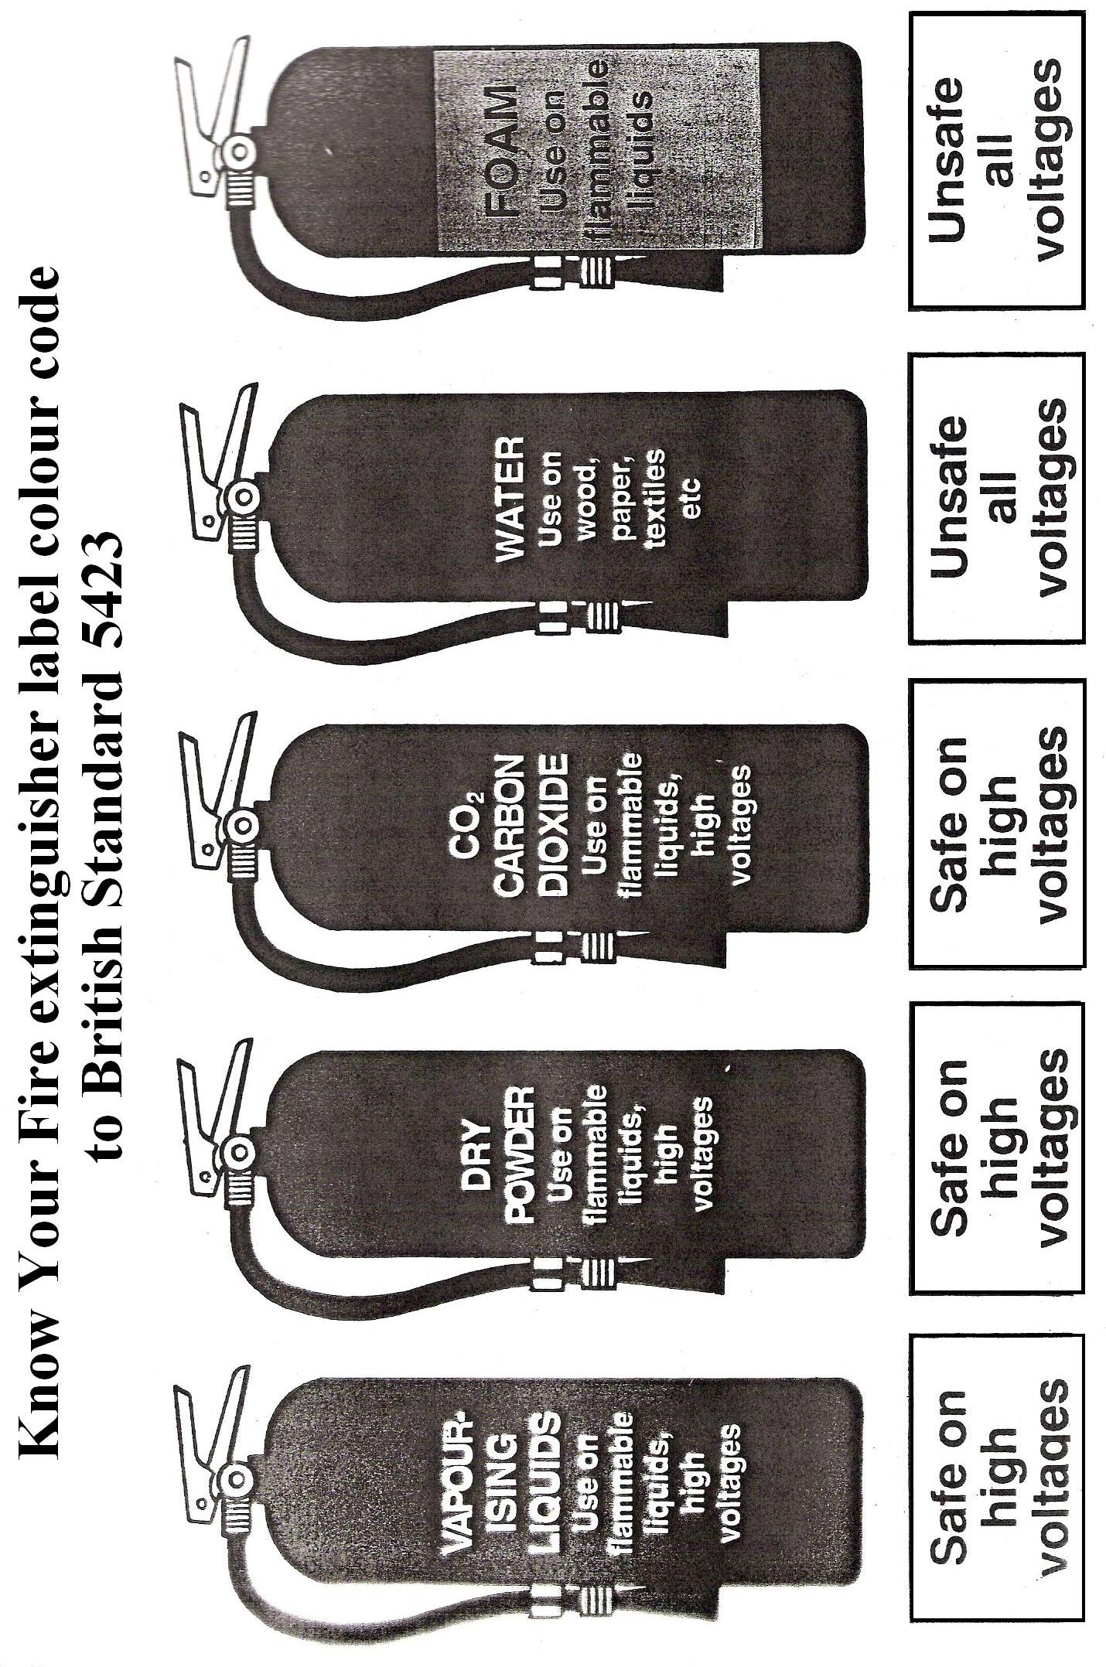

How to Identify the Proper Fire Extinguisher
All ratings are shown on the extinguisher faceplate. Some extinguishers are marked with multiple ratings, such as AB, BC and ABC. These extinguishers are capable of putting out more than one class of fire.
Class A and B extinguishers carry a numerical rating that indicates how large a fire an experienced person can safely put out with that extinguisher.
Class C extinguishers have only a letter rating to indicate that the extinguishing agent will not conduct electrical current. Class C extinguishers must also carry a Class A or B rating.
Class D extinguishers carry only a letter rating indicating their effectiveness on certain amounts of specific metals.

Know your ABC for Fire Extinguishers
Not all fire extinguishers can be effectively used on all fires. Some fires involve flammable liquids, some involve paper, and some involve electrical equipment. Fire extinguishers are classified by the type of fire they best extinguish.
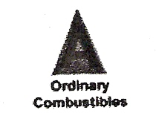
Class A Extinguishers will put out fires in ordinary combustibles, such as wood and paper. The numerical rating for this class of fire extinguisher refers to the amount of water the fire extinguisher holds and the amount of fire it will extinguish.
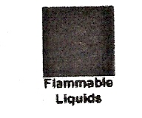
Class B Extinguishers should be used on fires involving flammable liquids, such as grease, gasoline, oil etc. The numerical rating for this class of fire extinguisher states the approximate number of square feet of a flammable liquid fire that a non-expert person can expect to extinguish.
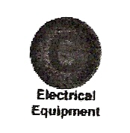
Class C Extinguishers are suitable for use on electrically energised fires. This class of fire extinguishers does not have a numerical rating. The presence of the letter “C” indicates that the extinguishing agent is non-conductive.

Self Assessment

Questions on Background Notes – Module 1.Unit 1

- Name and give one use for at least five different Stakes.

- Name and give one use for five Sheetmetal Tools.

3. Name three different types of fire extinguishers and the type of fire you would use
them on.

Answers to Questions 1-3. Module 1.Unit 1

1.

- Hatchet Stake
Used for making sharp straight bends and used as a support
when flanging.

- Tinman’s Anuil
Used for general work.

- Pipe Stake
For forming cylinders.

d. Funnel Stake
For forming , riveting, seaming tapered work pieces such as
funnels.

e. Blow Horn Stake
For working on long slender tapering objects.

f. Half Moon Stake
For curved flanges.

2.

a. Scriber
For marking the metal, used with straight edge or square.

b. Dividers
Used to scribe arcs and circles.

c. Steel Square
Used to layout 90°angle and also for measurement.

d. Trammel Points
Used for scribing large arcs and circles.

e. Centre Punch
Used for locating centres when marking out circles etc and
drilling holes.

- Stretching Hammer
For flanging.

3.

- Class A
For wood, paper and ordinary combustible materials

b. Class B
Used on fires involving flammable liquids such as grease, petrol
and oil.

c. Class C
For electrically energised fires.

Bibliography

Reference:
FAS Induction Book, “Code of Behaviour & Health & Safety Guidelines”.

Index

B
Ball Head Stake, 16
Bench Stakes, 10
General Description, 10
Bibliography, 43
Bick Iron Stake, 14
Blowhorn Stake, 13
Boxwood and Rubber Mallets, 30
C
Centre Punch, 25
Combination Pliers, 36
Combination Snips, 35
Combination Square, 23
Common Iron Stakes, 18
Creasing Stake, 15
Cross Pein Hammer, 32
D
Dividers, 21
Drip Pan Stakes, 15
E
Engineers Ball Pein, 32
F
Files, 34
Fire Extinguisher, 41
Know your ABC, 41
Flat Cold Chisel, 28
Funnel Stake, 13
H
Hack Saw, 34
Half-Moon Stake, 14
Hand “Pop” Gun, 39
Hand Dollies, 19
Hand Groover, 27
Hand Lever Punch, 35
Hand Tools, 20
Hardwood Blocks, 37
Hatchet Stake, 11
Hollow Punches, 25
Hollowing Hammer, 29
L
Lazy Tongs, 39
M
Mandrel, 11
P
Pear-Shaped Boxwood Mallet, 31
Philips Screwdriver, 33
Pipe Stake, 12
Plain Screwdriver, 33
Planishing Hammer, 30
Pop Riveting Guns, 39
Punches, 27
R
Rivet Set, 28
Round Bottom Stakes, 16
Rulers, 24
S
Sand Bags, 37
Scriber, 20
Side Cutting Pliers, 36
Soldering Irons, 38
Solid Punches, 25
Stake Holder, 18
Steel Circumference Rule, 26
Steel Square, 22
Steel Try Square, 22
Straight Edge, 21
Straight Snips, 31
Stretching Hammer, 29
Swinging Blade Protractor, 23
T
Tape Rule, 26
Tinman’s Horse with Heads, 17
Tinman's Anvil, 12
Tools, 20
Trammel Points, 24
V
Vice Grips, 33

