Sheet Metalwork
Module 1: | Sheet Metal Fundamentals
Unit 2: | Manual Handing
 | Phase 2

Table of Contents
List of Figures 5
List of Tables 6
List of Tables 6
Document Release History 7
Document Release History 7
Module 1 – Sheet Metal Fundamentals 8
Unit 2 – Manual Handling 8
Learning Outcome: 8
Key Learning Points: 9
Training Resources: 11
Exercise: 11
Key Learning Points Code: 11
Employee’s Duty 12
Basic Manual Handling Course 13
Course Objective 13
Course Aims 13
Disc Troubles 14
Stooping to Lift 15
Bending the Knees 16
Handling Loads 17
Avoid 17
Ensure 17
The Right Way 18
Moving Things the Wrong Way 19
Prevent Pain, Injuries and Damage 20
Lifting 22
Carrying 23
Uploading 24
Special Lifts 25
Awkward Objects and Overhead Lifts 26
Pushing and Pulling Safety 27
Special Objects Require Special Handling 28
Team Effort 29
Lifting and Lowering Whist Standing 31
Pregnant Employees Regulation 1994 32
Manual Handling Legal Obligations 33
Eight Principles of Lifting 34
Self Assessment 35
Answers to Questions 1-6. Module 1.Unit 2 39
Index 42

List of Figures
Figure 1. Stooping to lift 14
Figure 2. Bending the knees 15
Figure 3. The right way to move things 17
Figure 4. Moving things the wrong way 18
Figure 5. Prevent pain, injuries and damage 19
Figure 6. Prevent pain, injuries and damage continued 20
Figure 7. Lifting 21
Figure 8. Carrying 22
Figure 9. Uploading 23
Figure 10. Special lifts 24
Figure 11. Awkward objects and overhead lifts 25
Figure 12. Pushing and pulling safety 26
Figure 13. Special objects require special handling 27
Figure 14. Team effort 28
Figure 15. Handle objects safely 29
Figure 16. Lifting and lowering whist standing 30
Figure 17. Manual handling legal obligations 32

List of Tables

Document Release History
Date | Version | Comments
June 2006 | V.1.0
31/03/14 | 2.0 | SOLAS transfer

Module 1 – Sheet Metal Fundamentals

Unit 2 – Manual Handling
Duration – 3 Hours

Learning Outcome:
By the end of this unit each apprentice will be able to:
- List the main statutory requirements of both employers and employees in relation to manual handling and general safety in the workplace.
- Explain the structure of the spine.
- Explain the functions of muscles, tendons and ligaments.
- Explain the types of injury that may occur from lifting and handling loads.
- Explain the requirement for a pre-lift analysis of a load.
- Explain how the body should be positioned before attempting a lift.
- Explain and demonstrate good handling techniques for lifting workplace objects.
- Explain and demonstrate good handling techniques for pushing and pulling a workplace object.
- Demonstrate the correct procedures for team lifting a load.
- Describe the various types of handling devices and in what situations they may be used.
- Correctly demonstrate how to handle a typical workplace load using a handling aid.

Key Learning Points:
RK | Duty of employer towards employee to:  a). Take measures where possible to avoid manual handling.  b) Carry out risk assessment where manual handling is unavoidable to reduce dangers involved.  c). Provide employee with precise information about the load.
RK | Duty of employee to:  a) Take reasonable care for his safety and welfare and that of others in the workplace.  b) Use any equipment, protective clothing or other means provided by the employer for securing his safety and welfare in the workplace.  c) Report any problems or defects to his employer which might endanger health and safety.
RK | Structure of the spine: spinal cord, spinal canal, vertebrae, intervertebral discs.
H | Injuries resulting from lifting heavy loads (Prolapsed/slipped disc, cuts and abrasions, crushed feet and hands, muscle and joint strain).
RK | Pre-lift analysis of a load (Checking object for sharp edges, difficult to grasp, unstable, teamwork required).
H | Workplace obstacles/hazards such as slippery/uneven surfaces, poor lighting conditions, steps.
SK | Other factors that may hinder movement such as clothing or personal protective equipment.
SK | Use of good posture before beginning to lift a load.
SK | Raising a load correctly.
P | Putting the load down correctly.
RK | Coordination of team learning outcome when team lifting.
SK | Good handling techniques for pushing and/or pulling an object using a handling device.
P | Safe working practices at all times when handling heavy objects.

Training Resources:
- Information sheets, instructional videos, samples of various materials/objects typical of the apprentices’ workplace
- Various handling devices used in the apprentices’ workplace

Exercise:
- Apprentice to answer general questions on correct procedures for lifting heavy objects
- Apprentice to state the main obligations of employer and employee in relation to safe handling in the workplace
- Under supervision and using the correct handling techniques, the apprentice is required to lift a workplace object from:
    - Ground to ground
    - Ground to bench
    - Ground to height
    - Bench to bench
- Under supervision and using the correct handling techniques, the apprentice is required to operate a handling device to move a typical workplace object from one location to another

Key Learning Points Code:
M = Maths D= Drawing RK = Related Knowledge Sc = Science
P = Personal Skills Sk = Skill H = Hazards

Employee’s Duty
- Take reasonable care for his safety and welfare and that of others in the workplace.
- Use any equipment, protective clothing or other means provided by the employer for securing his safety and welfare in the workplace.
- Report any problems or defects to his employer which might endanger health and safety.

Basic Manual Handling Course

Course Objective
After completing the course participants will be able to demonstrate the ability to apply safe manual handling techniques in the workplace.

Course Aims
At the end of the training period participants will be able to:
Identify and avoid hazardous and unsafe manual handling situations.
Assess the characteristics of a load prior to lifting on the basis of weight, size, stability and position.
Assess their personal capacity to complete a manual handling task.
Apply the basic techniques involved in completing;
- A one person lift.
- A two person lift.

Disc Troubles
It is well known that the vertebral column, or spine, has the shape of an elongated S. At chest level it has a slight backwards curve called a kyphosis, and in the lumbar region it is slightly curved forewards, the lumbar lordosis. This construction gives the spine elasticity, to absorb the shocks of running and jumping.
The loading on the vertebral column increases from above downwards, and is at its greatest in the lower five lumbar vertebrae. Each pair of vertebrae are separated by an intervertebral disc. Degeneration of the discs first affects the margin of the disc, which is normally tough and fibrous. A tissue change is brought about by loss of water, with the result that the fibrous ring becomes brittle and fragile and loses its strength. At first the degenerative changes merely make the disc flatter, with the risk of damage to the mechanics of the spine, or even of displacement of the vertebrae. Under these conditions quite small actions such as lifting a weight, a slight stumble or similar incidents. may precipitate severe backache and lumbago. When degeneration of the disc has progressed further, any sudden force upon it may squeeze the viscous internal fluid out through the ruptured outer ring . and so exert pressure either on the spinal chord itself or on the nerves running out from it. This is what happens in the case of a “Slipped Disc” or disc herniation. Pressure on nerves, narrowing of the spaces between vertebrae, pulling and squeezing at adjoining tissues and ligaments of the joints are the causes of the variety of aches , muscular cramps and paralyses including lumbago and sciatica which commonly accompany disc degeneration.
Back troubles are painful and reduce one’s mobility and vitality. They lead to long absences from work, and in modern times are among the main causes of early disability. They are comparatively common in the age group 20 - 40. with certain occupations (labourer, farmer, porter, nursing staff, etc.) being particularly vulnerable to disc troubles. Moreover, workers with physically active jobs suffer more from ailments of this nature, and their work is more affected than in the case with sedentary workers.
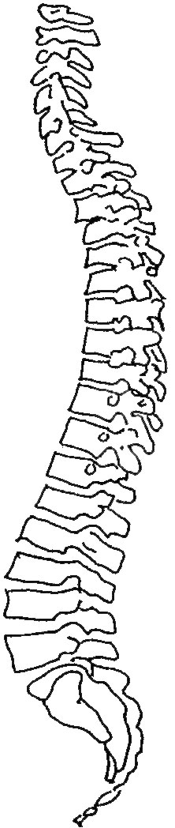

Stooping to Lift
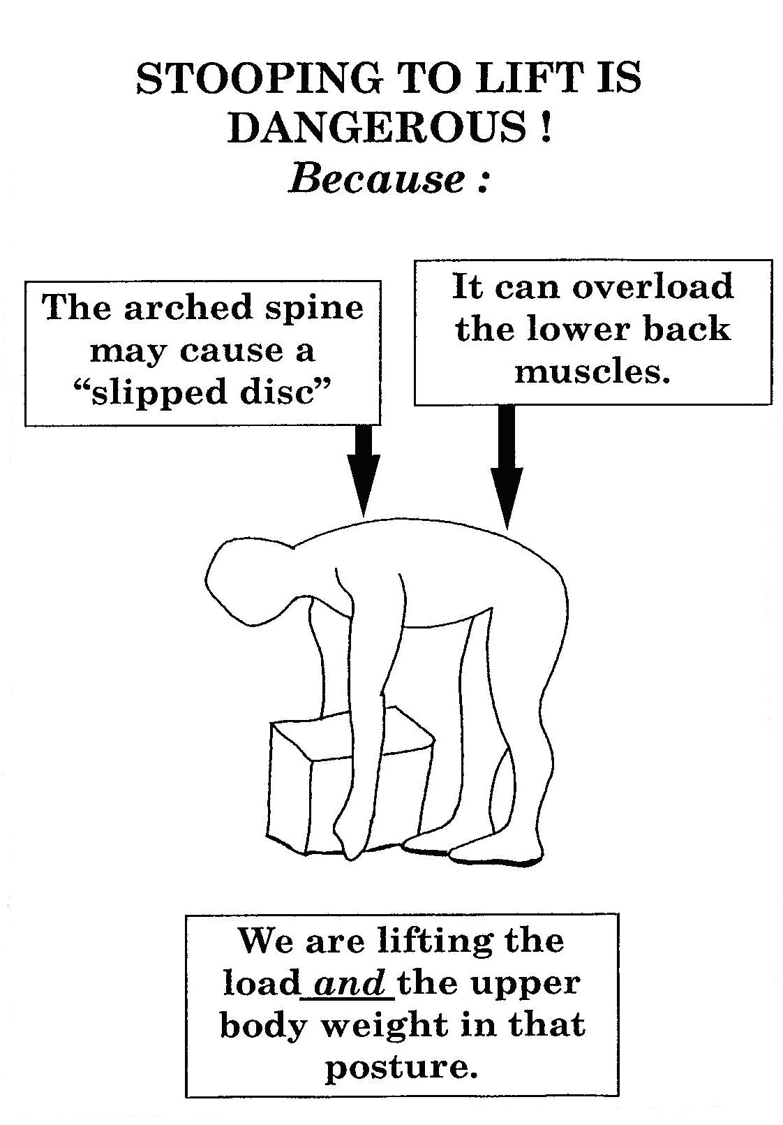
- Stooping to lift

Bending the Knees
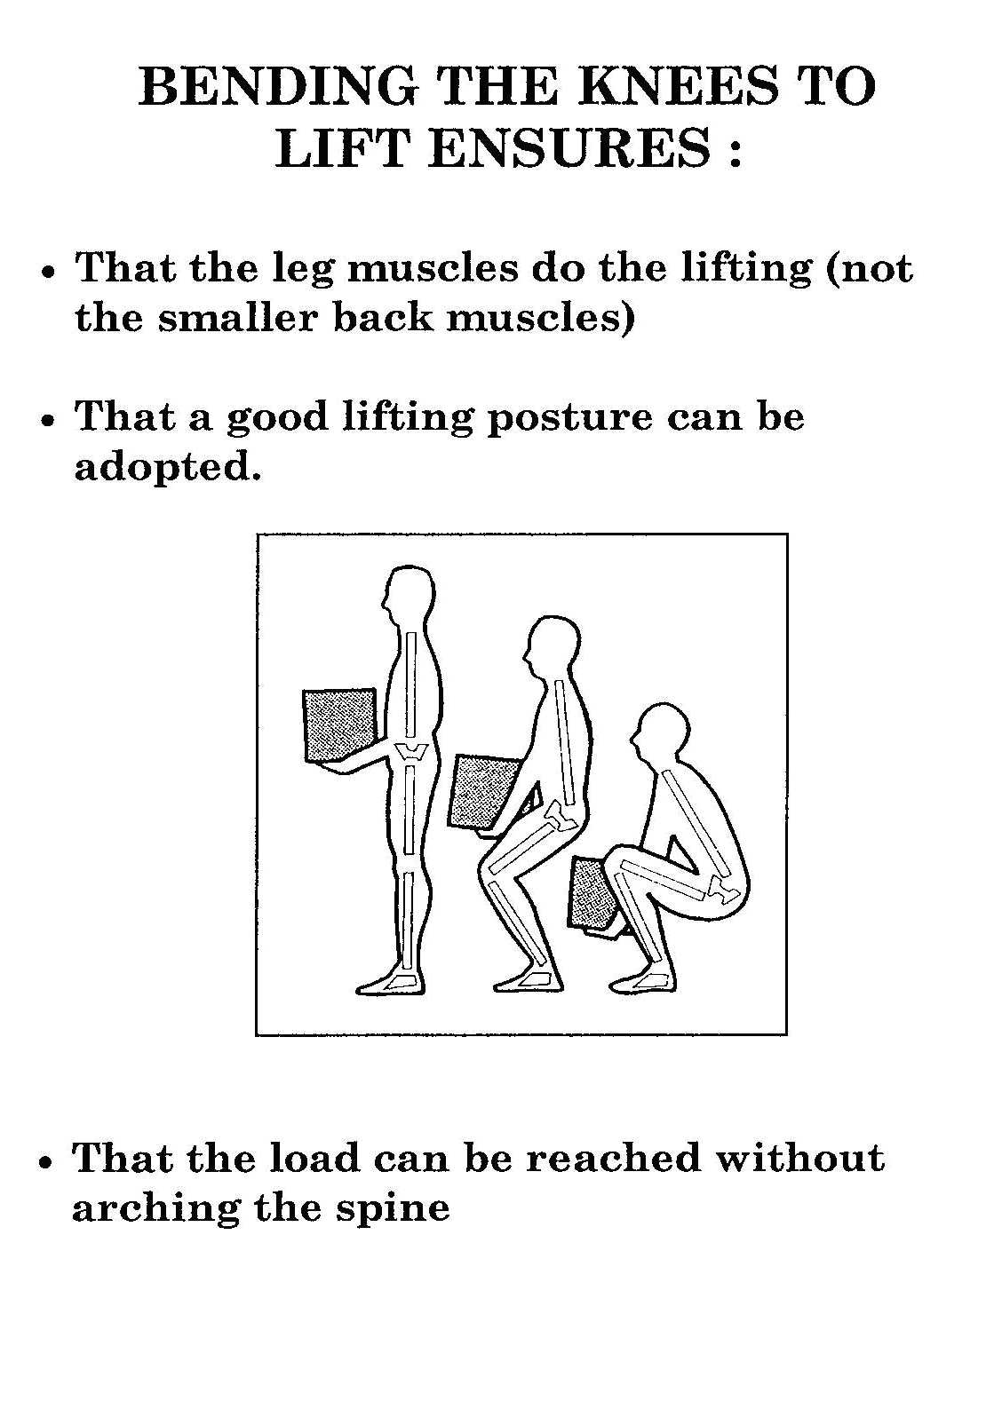
- Bending the knees

Handling Loads

Avoid
Very heavy loads.
Arching of the spine.
Excessive or repeated twisting.
Over-stretching or over-reaching.

Ensure
A good secure grip
Awareness of the weight and stability of the load.
Correct stance and lift posture.
Smooth quick lift.
Correct protective clothing and equipment.
Proper c0-0rdination of team lifts.

The Right Way
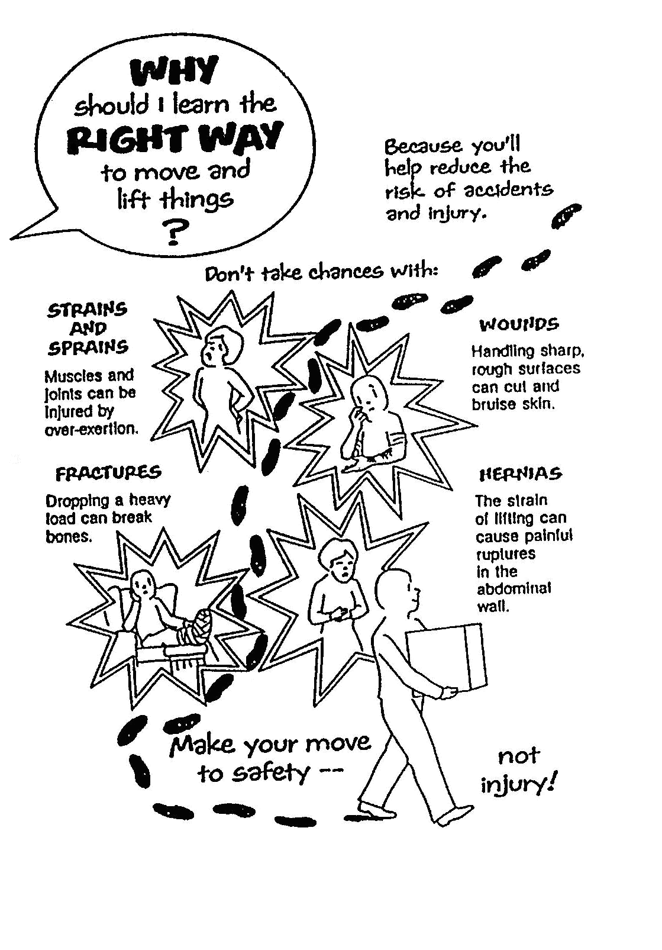
- The right way to move things

Moving Things the Wrong Way
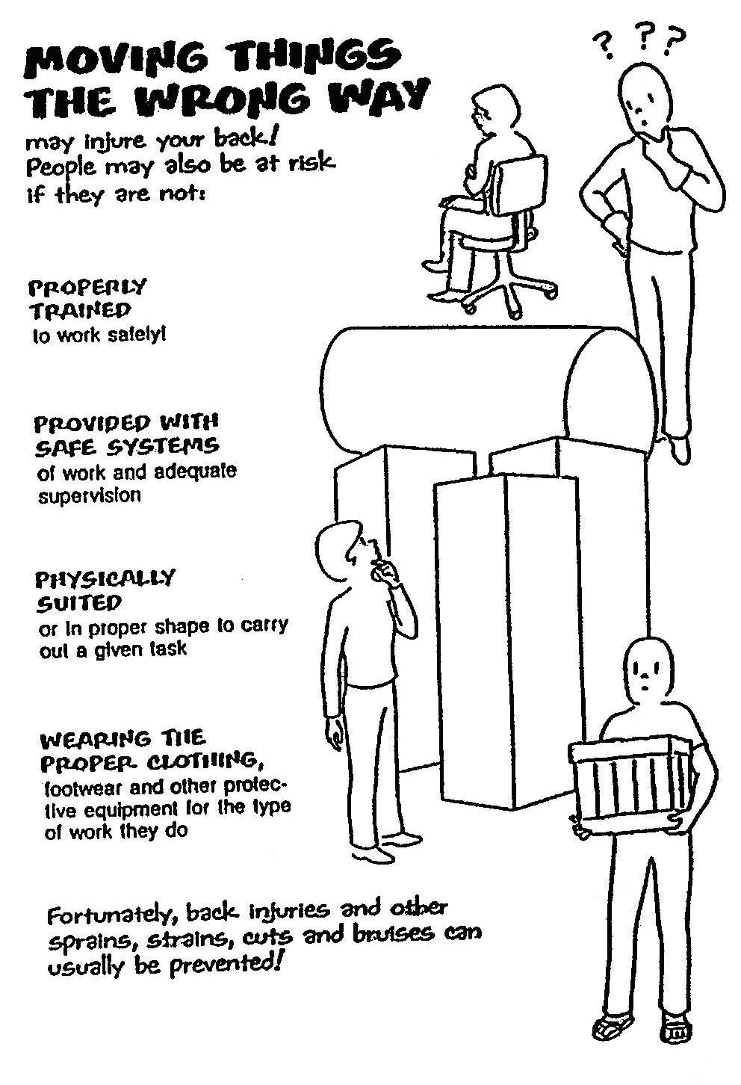
- Moving things the wrong way

Prevent Pain, Injuries and Damage
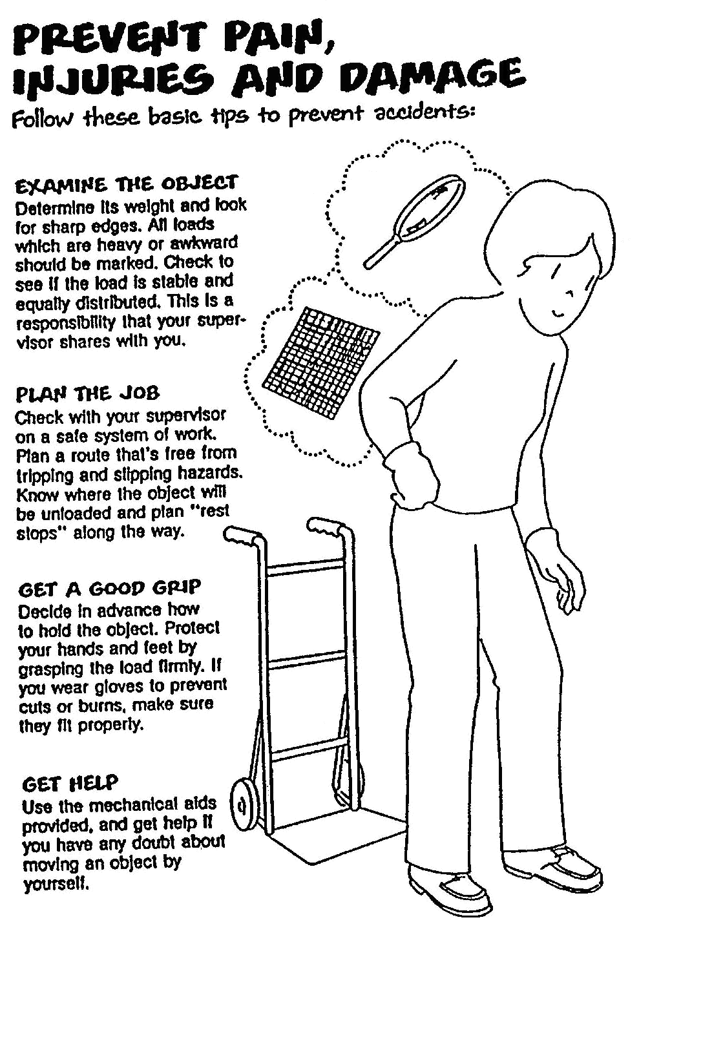
- Prevent pain, injuries and damage
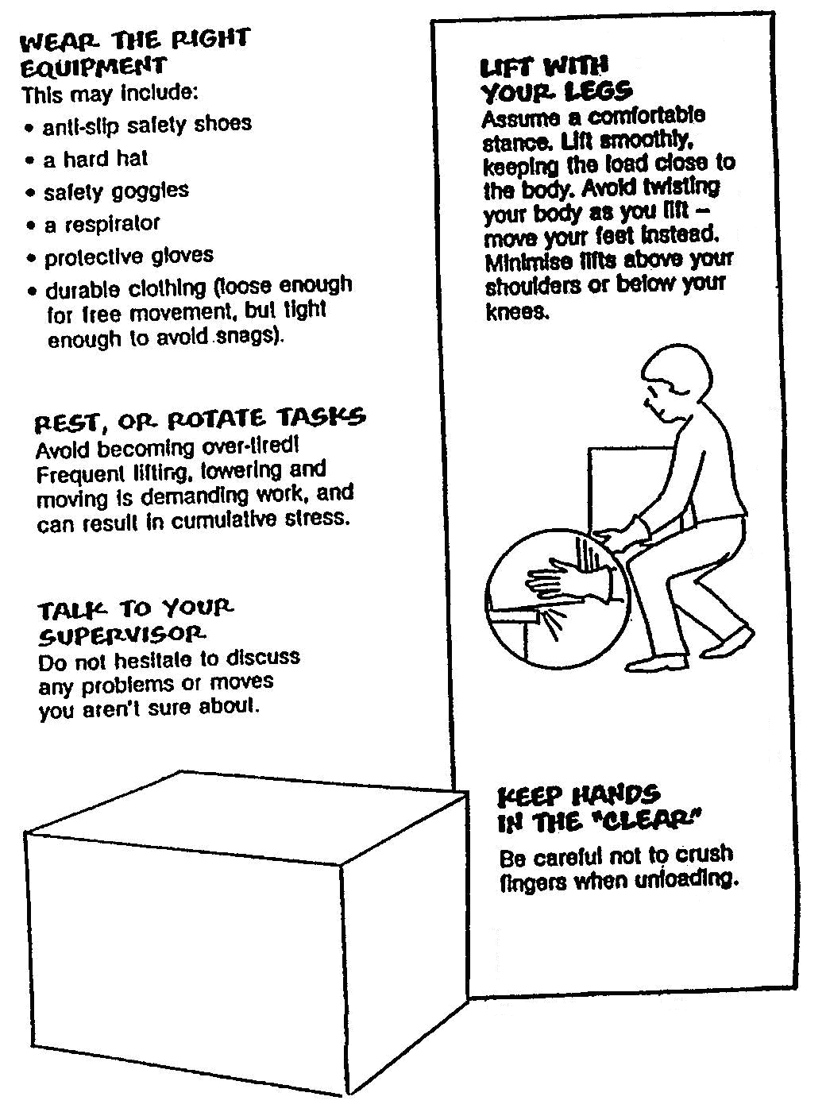
- Prevent pain, injuries and damage continued

Lifting
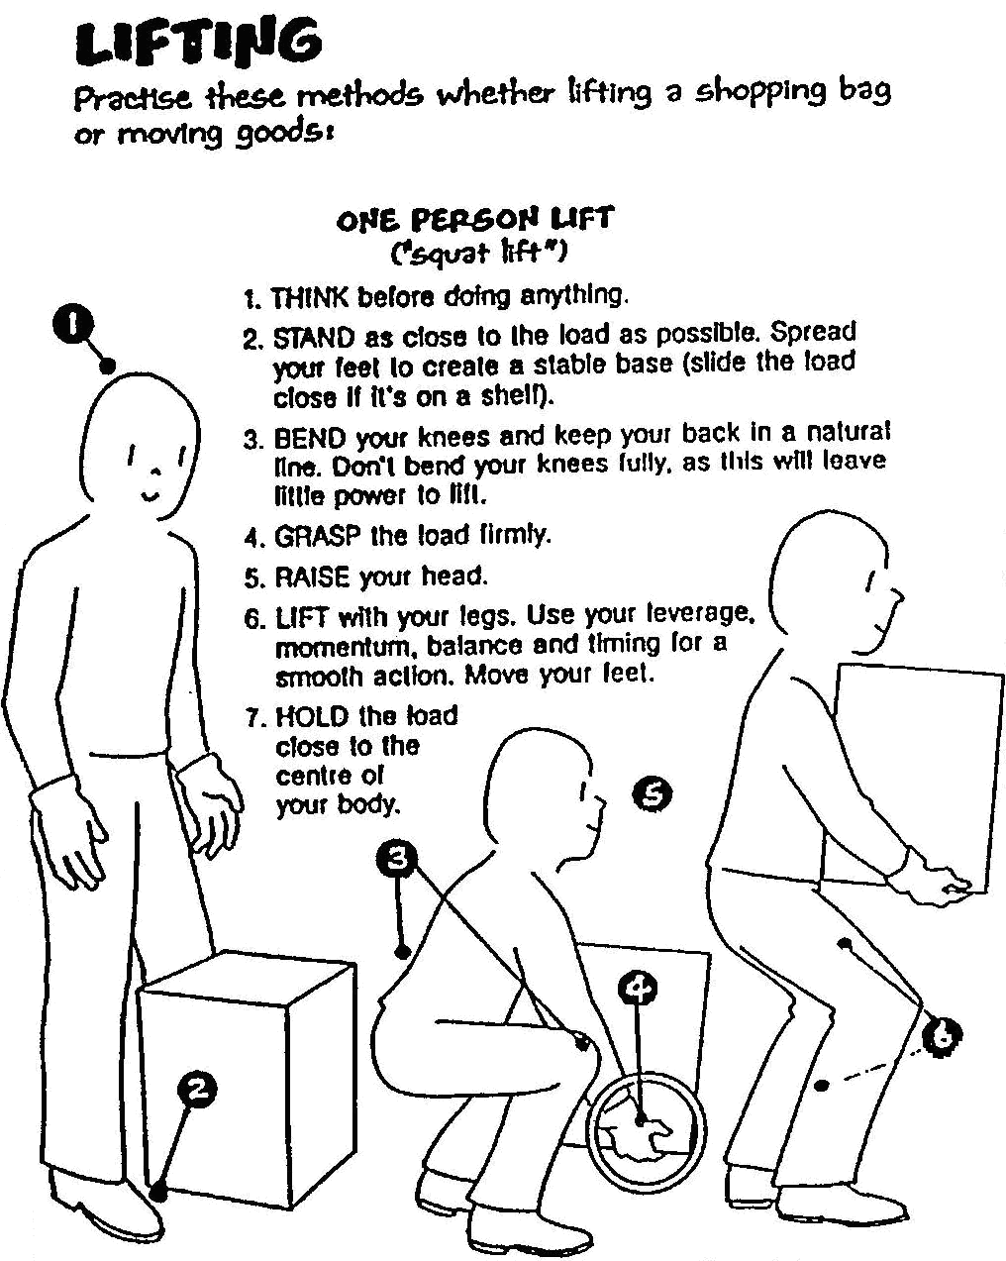
- Lifting

To avoid injury do warm-up exercises before lifting.

Carrying
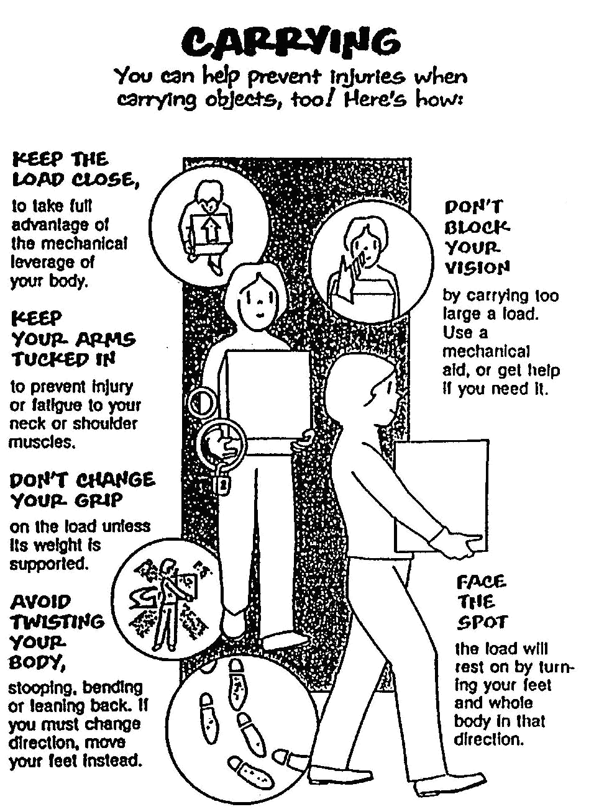
- Carrying

Uploading
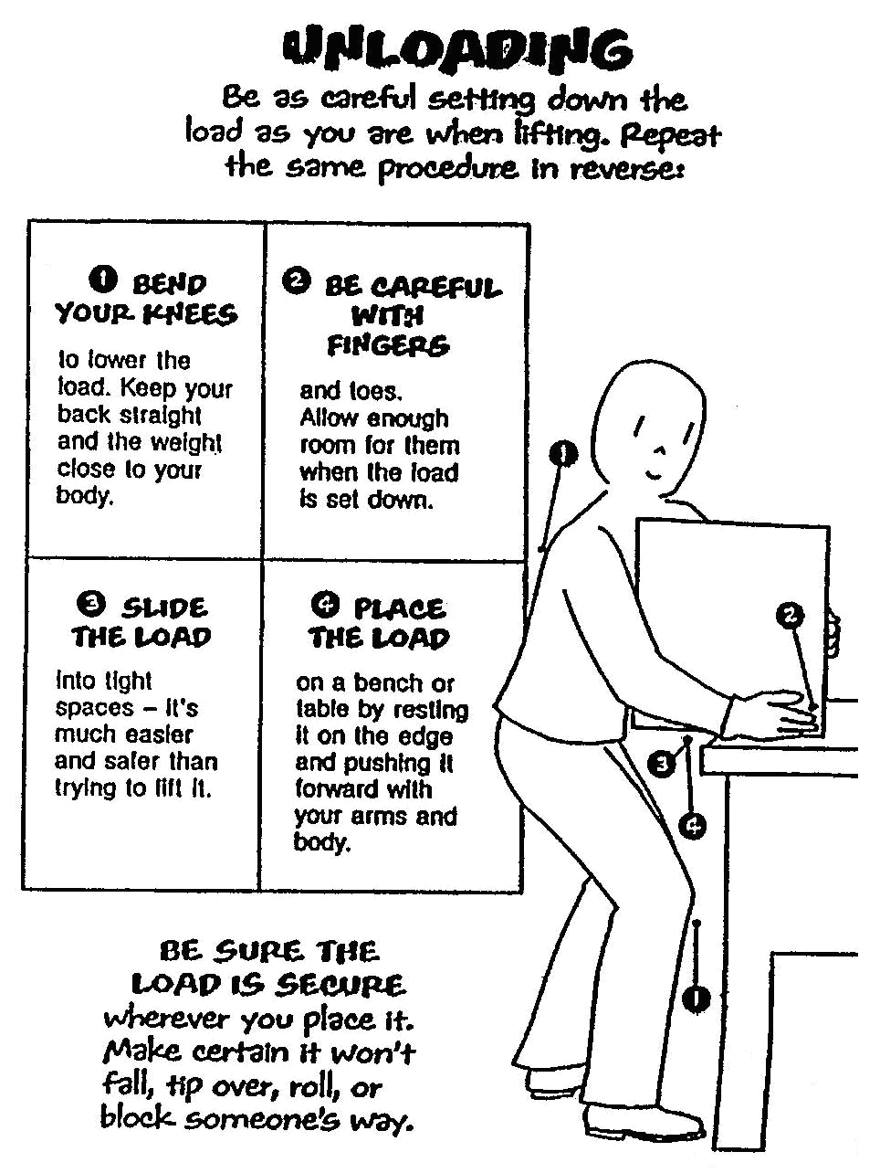
- Uploading

Special Lifts
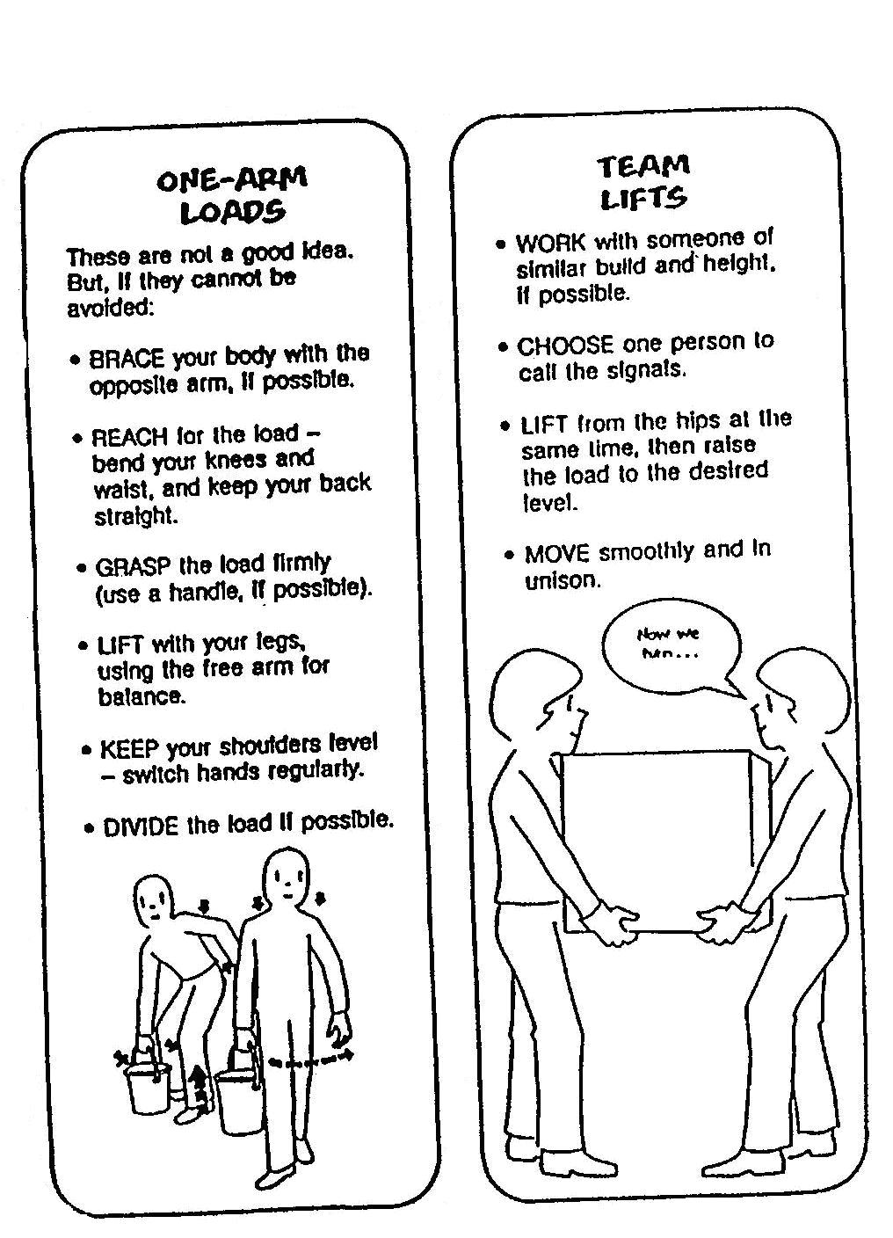
- Special lifts

Awkward Objects and Overhead Lifts
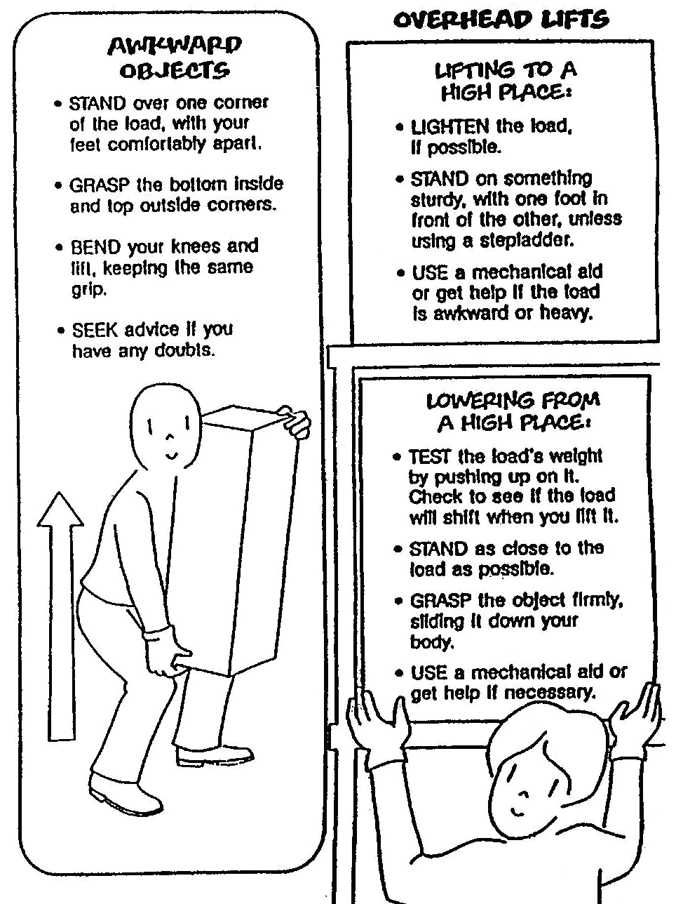
- Awkward objects and overhead lifts

Pushing and Pulling Safety
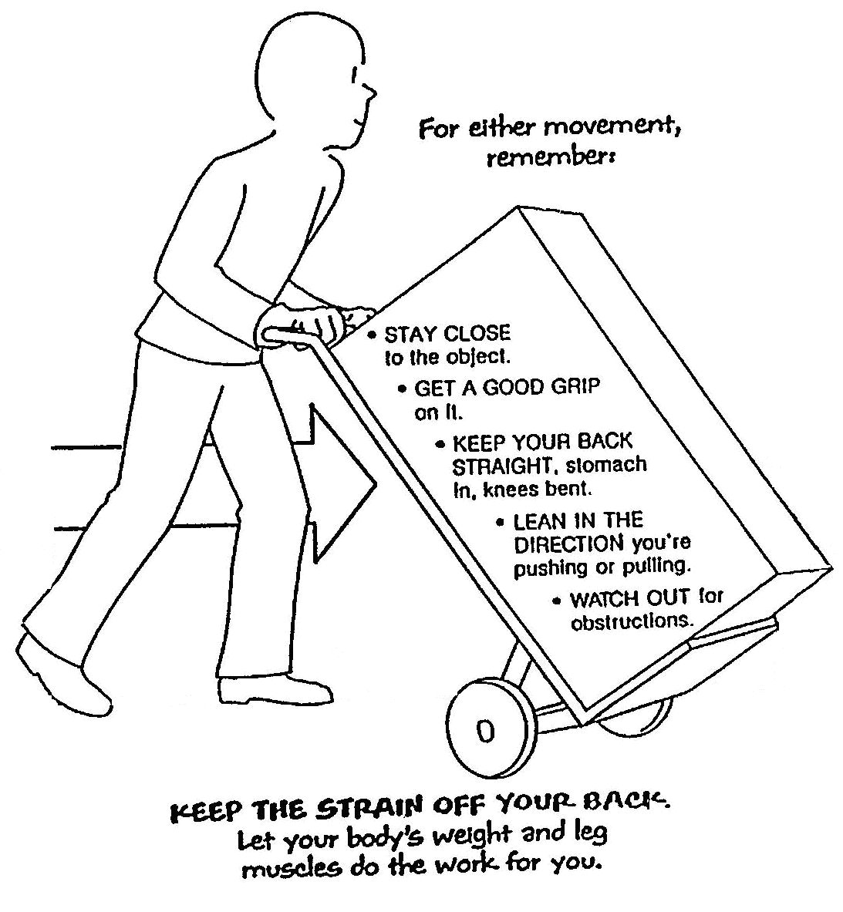
- Pushing and pulling safety

Special Objects Require Special Handling
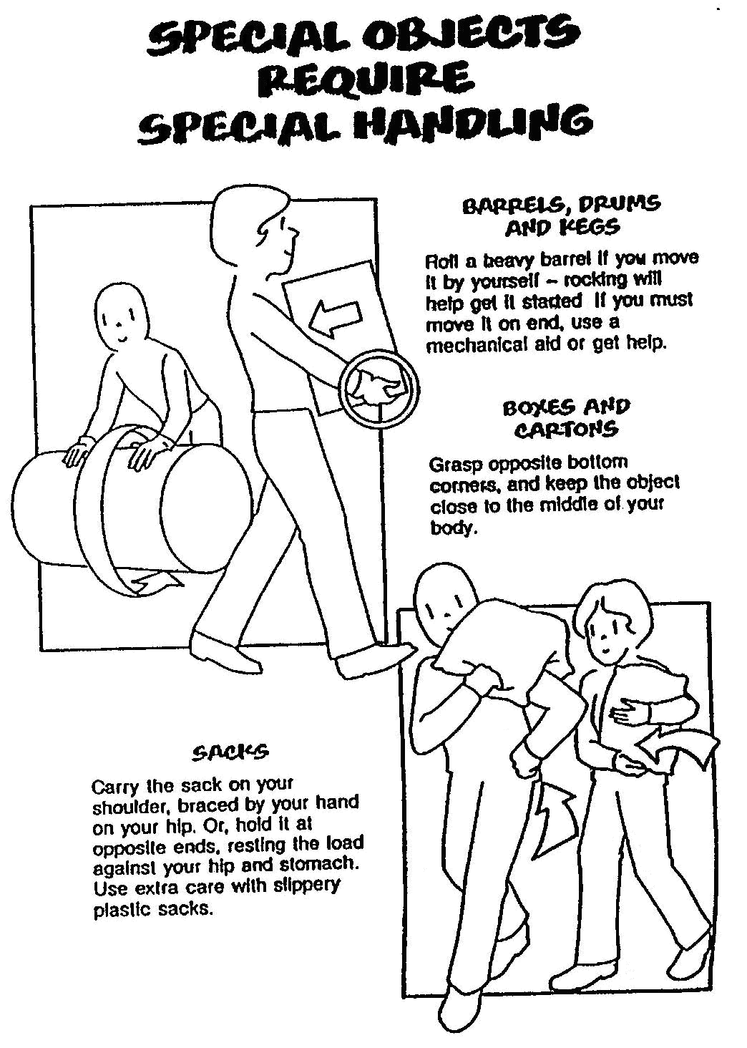
- Special objects require special handling

Team Effort
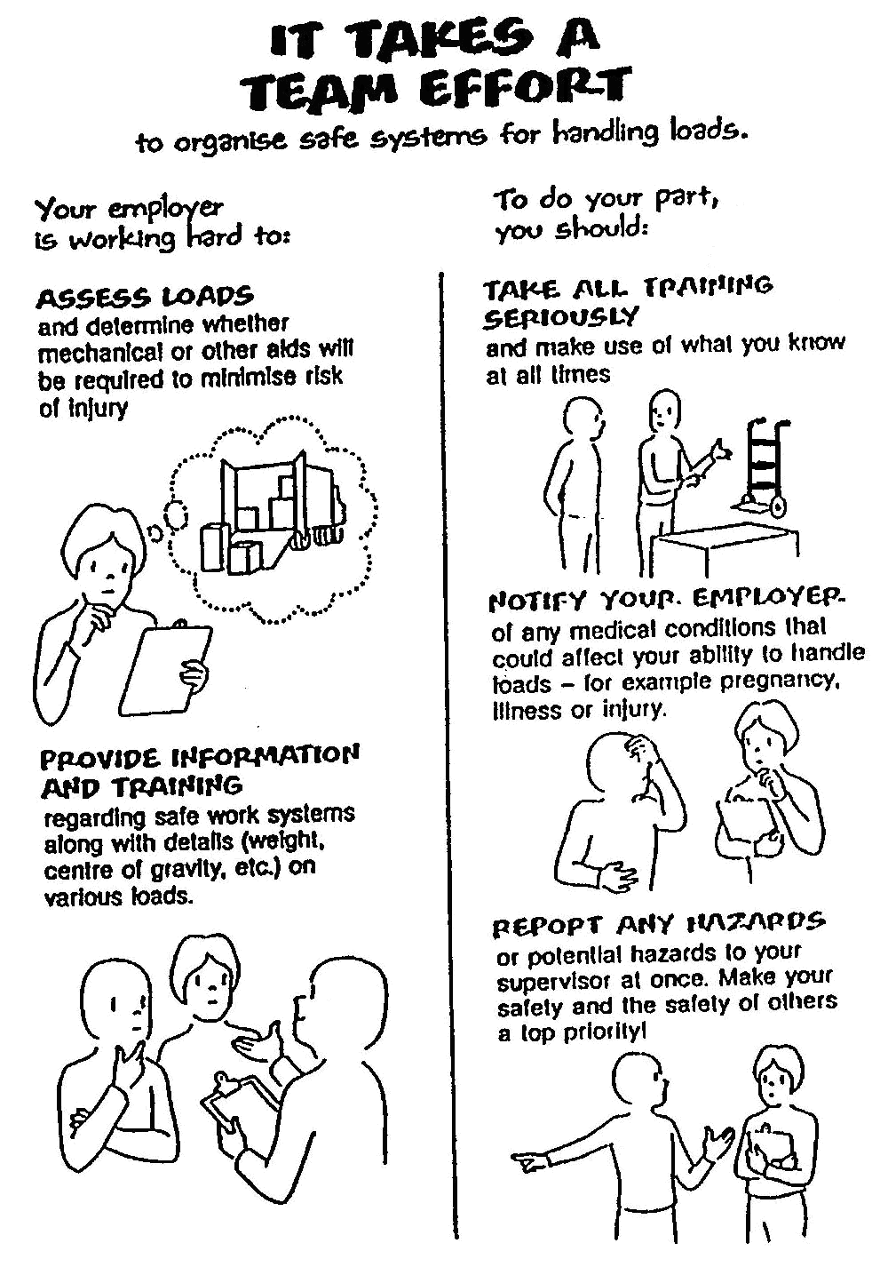
- Team effort

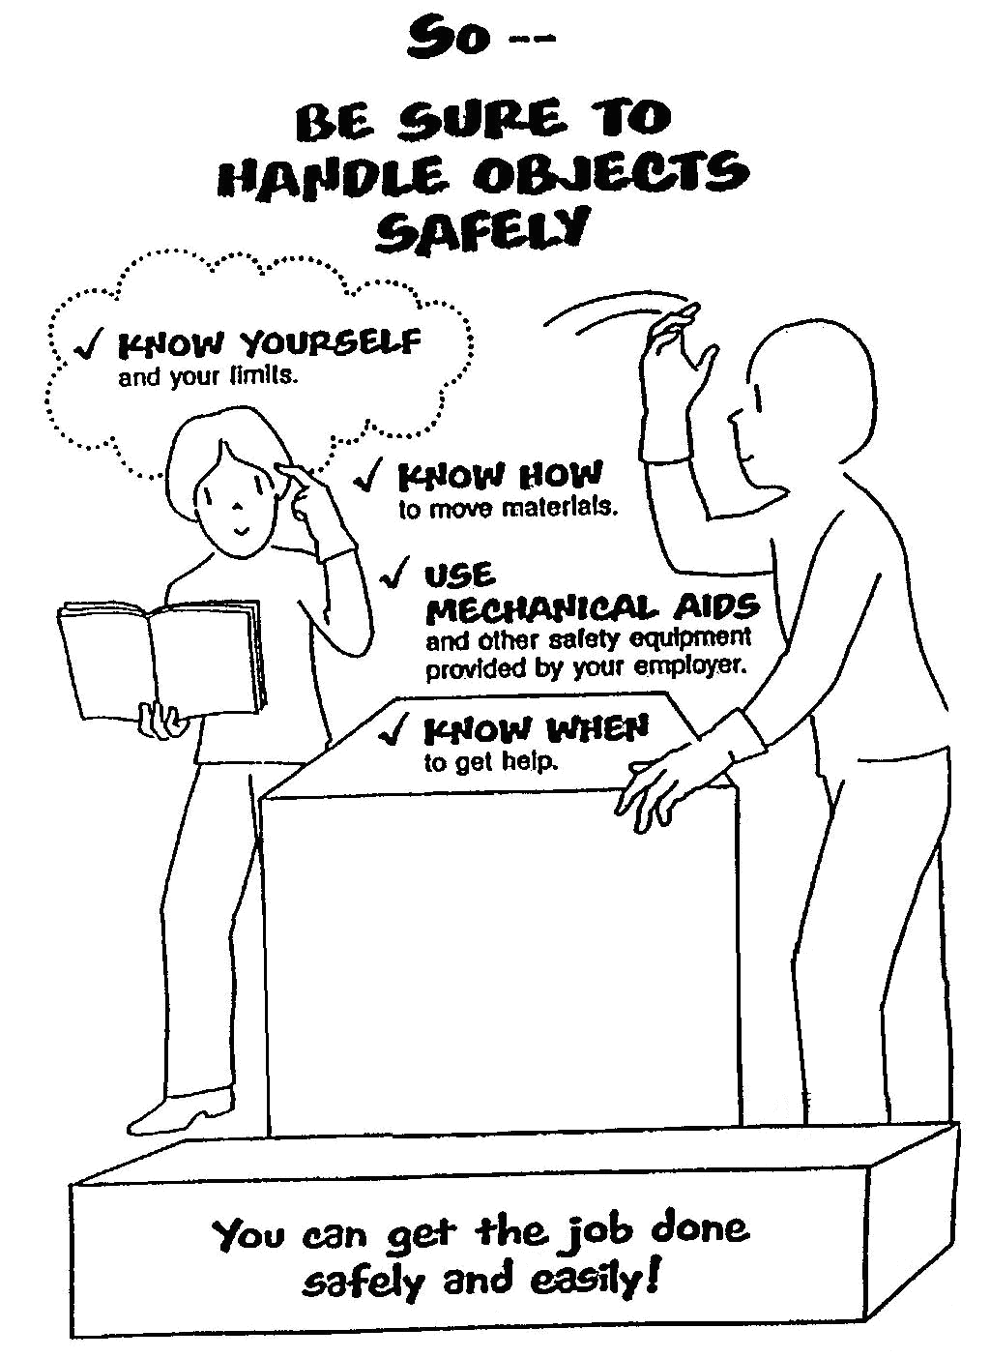
- Handle objects safely

Lifting and Lowering Whist Standing
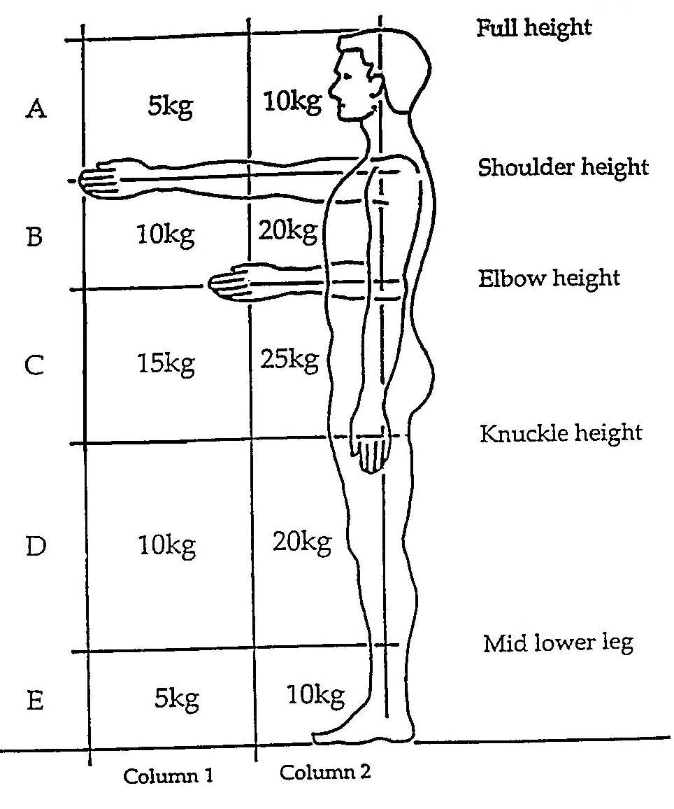
- Lifting and lowering whist standing

Pregnant Employees Regulation 1994
Risks due to manual work must be assessed for pregnant employees and employees who have recently given birth.
Health and safety leave must be given if the maternity employee cannot be protected from the risks identified.
Certification of risk by employer for social welfare purposes.

Manual Handling Legal Obligations
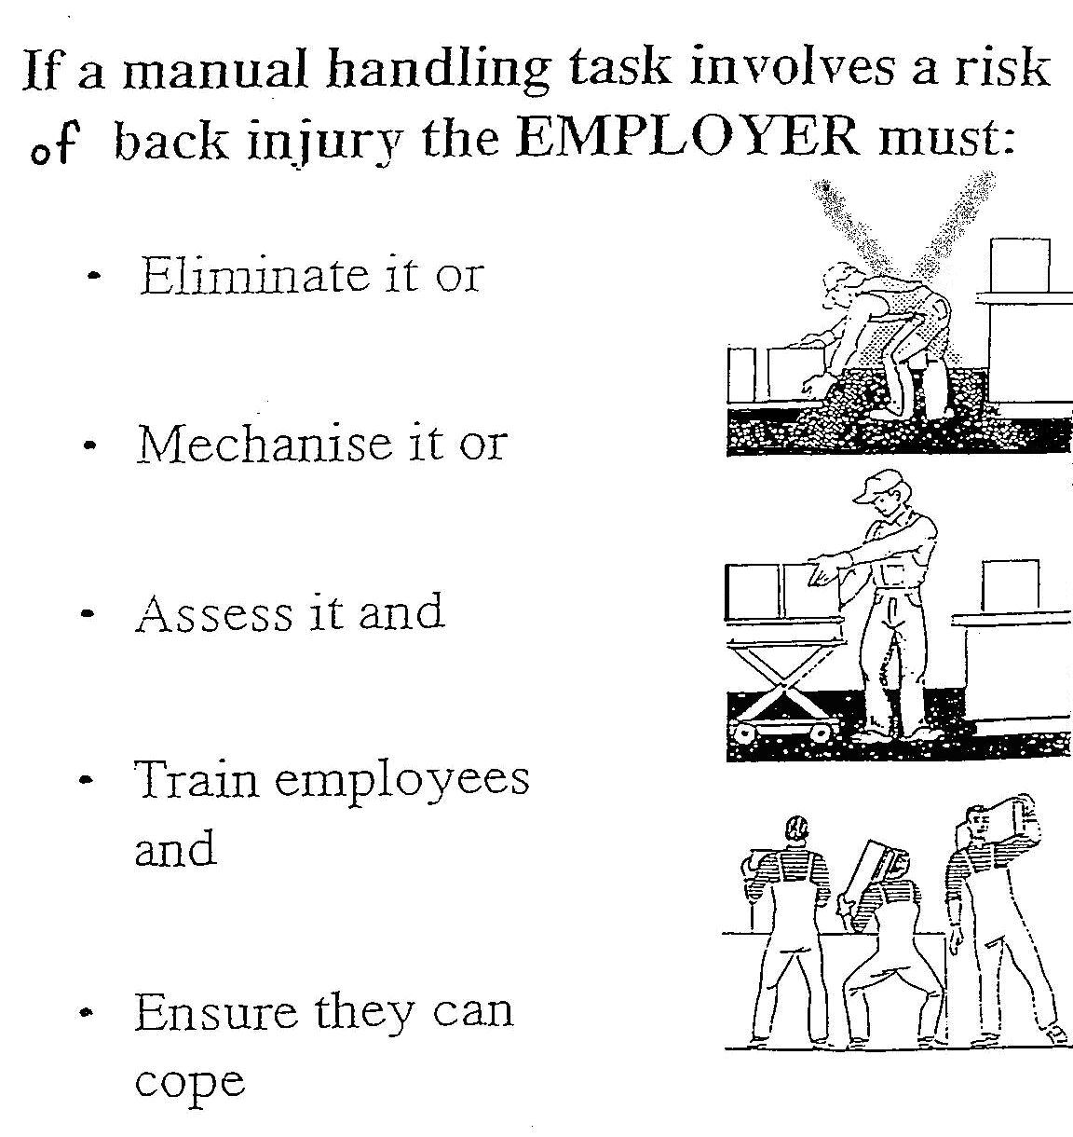
- Manual handling legal obligations

Eight Principles of Lifting
- Access – the area
Access – the load.
- Bend Knees.
- Broad stable base.
- Keep back straight (not necessarily erect)
- Firm palm grip
- Arms close to trunk
- Weight close to centre of gravity
- Point/pivot feet in direction of movement.
- Left with legs

Self Assessment
Questions on Background Notes – Module 1.Unit 2

1. Name three metals commonly used by sheetmetal workers.

2. Name three different areas of sheetmetal work.

3. How is stainless steel classified?

4. Name two types of finish on stainless steel.

5. Why use copper – give two reasons.

6. List four characteristics of lead.

Answers to Questions 1-6. Module 1.Unit 2

1.

Mild Steel
Galvanised Steel
Stainless Steel
Copper
Brass
Aluminium

2.

Heating and Ventilation
Catering
Aircraft
Transport
Sign Manufacture

3.

Stainless Steel:

Stainless Steel is classed by type number. E.g. Type 304.
There are a large number of grades available.
There is a handbook available to find the type of stainless steel
suited to each particular job.

4.

Types of finish: Dull finish
Mirror finish

5.

- High resistance to corrosion
- Appearance
- Working properties i.e. soft and malleable

6.

Lead:

- The heaviest metal a sheetmetal worker would use.
- It is very soft and easy to bend.
- Chemically the most inactive of metals. Exposure to air or burial in the ground would not effect it.
- Lead is resistant to most acids.
- Lead is gauged by the number of pounds per square foot.
- Lead can be soldered easily using rosin, the melting point of lead is 621°F.

Index

A
Awkward Objects 25
B
Bending the Knees 15
C
Carrying 22
Course Objective and Aims 12
D
Disc Troubles 13
E
Employee’s Duty 11
H
Handling Loads
Avoid 16
Ensure 16
K
Knees
Bending 15
L
Legal Obligations 32
Lift
Stooping 14
Lifting 21
Lifting and Lowering Whist Standing 30
Lifts
Overhead 25
Special 24
M
Manual Handling Legal Obligations 32
O
Overhead Lifts 25
P
Pregnant Employees 31
Prevent Pain, Injuries and Damage 19
Principles of Lifting 33
Pulling Safety 26
Pushing and Pulling Safety 26
R
Regulation 1994 31
Right Way 17
S
Special
Handling 27
Objects 27
Special Lifts 24
Stooping 14
T
Team Effort 28
U
Uploading 23
W
Wrong Way 18

