TRADE OF
VEHICLE BODY REPAIR

PHASE 2

Module 1

UNIT: 1
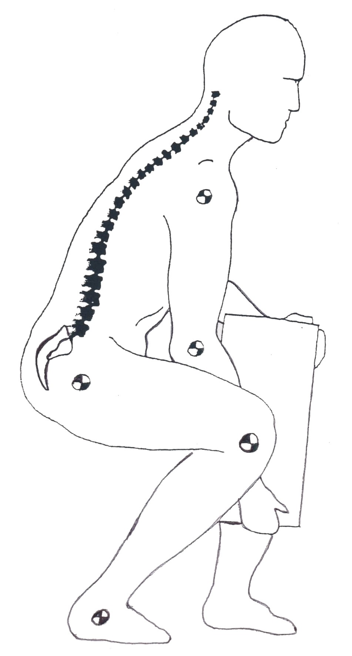
Manual Handling

Produced by

In cooperation with subject matter expert:
Maurice Stack
Some material courtesy of CDX Global and
FENC – Further Education National Consortium.
© SOLAS 2014
Table of Contents
Unit Objective
1.0 Manual Handling……...…………………………………………………………..1
1.1 Disc Troubles 1
1.2 Stooping to Lift is Dangerous! 3
1.3 Bending the Knees 4
1.4 Handling Loads 5
1.5 Prevent Pain, Injuries and Damage 8
2.0 Lifting………..…………………………………………………………………...10
2.1 Carrying 11
2.2 Uploading 12
2.3 Special Lifts 13
2.4 Awkward Objects and Overhead Lifts 14
3.0 Pushing and Pulling Safety……………………………………………………...16
3.1 Special Objects Require Special Handling 16
3.2 Team Effort 17
3.3 Lifting and Lowering Whist Standing 19
3.4 Pregnant Employees Regulation 1994 20
3.5 Manual Handling Legal Obligations 21
3.6 Eight Principles of Lifting 22
Self Test........................................................................................................................................24
Suggested Exercises.................................................................................................................24
Suggested Reading………………………………………………………………….24

Unit Objective
Learning Outcome:
By the end of this unit each apprentice will be able to:

- List the main statutory requirements of both employers and employees in relation to manual handling and general safety in the workplace
- Explain the structure of the spine
- Explain the functions of muscles, tendons and ligaments
- Explain the types of injury that may occur from lifting and handling loads
- Explain the requirement for a pre-lift analysis of a load
- Explain how the body should be positioned before
attempting a lift
- Explain and demonstrate good handling techniques for lifting workplace objects
- Explain and demonstrate good handling techniques for pushing and pulling a workplace object
- Demonstrate the correct procedures for team lifting a load
- Describe the various types of handling devices and in what situations they may be used
- Correctly demonstrate how to handle a typical workplace load using a handling aid

1.0 Manual Handling
1.1 Disc Troubles
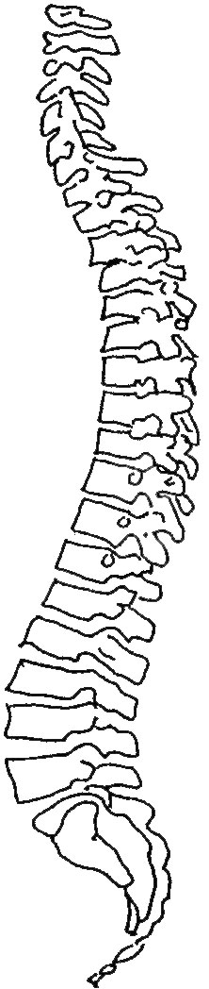
It is well known that the vertebral column, or spine, has the shape of an elongated S. At chest level it has a slight backwards curve called a kyphosis, and in the lumbar region it is slightly curved forwards, the lumbar lordosis. This construction gives the spine elasticity, to absorb the shocks of running and jumping.
The loading on the vertebral column increases from above downwards, and is at its greatest in the lower five lumbar vertebrae. Each pair of vertebrae are separated by an intervertebral disc.
Degeneration of the discs first affects the margin of the disc, which is normally tough and fibrous. A tissue change is brought about by loss of water, with the result that the fibrous ring becomes brittle and fragile and loses its strength. At first the degenerative changes merely make the disc flatter, with the risk of damage to the mechanics of the spine, or even of displacement of the vertebrae. Under these conditions quite small actions such as lifting a weight, a slight stumble or similar incidents. may precipitate severe backache and lumbago.
When degeneration of the disc has progressed further, any sudden force upon it may squeeze the viscous internal fluid out through the ruptured outer ring. and so exert pressure either on the spinal chord itself or on the nerves running out from it. This is what happens in the case of a “Slipped Disc” or disc herniation.

Pressure on nerves, narrowing of the spaces between vertebrae, pulling and squeezing at adjoining tissues and ligaments of the joints are the causes of the variety of aches, muscular cramps and paralyses including lumbago and sciatica which commonly accompany disc degeneration.
Back troubles are painful and reduce one’s mobility and vitality. They lead to long absences from work, and in modern times are among the main causes of early disability. They are comparatively common in the age group 20 - 40. with certain occupations (labourer, farmer, porter, nursing staff, etc.) being particularly vulnerable to disc troubles. Moreover, workers with physically active jobs suffer more from ailments of this nature, and their work is more affected than in the case with sedentary workers.

1.2 Stooping to Lift is Dangerous!
Because:
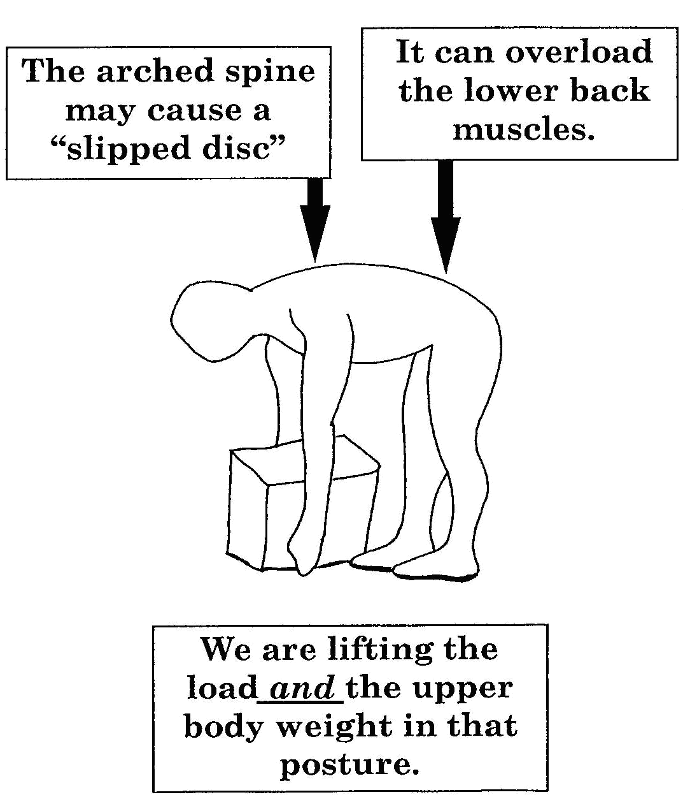
- Stooping to lift
1.3 Bending the Knees
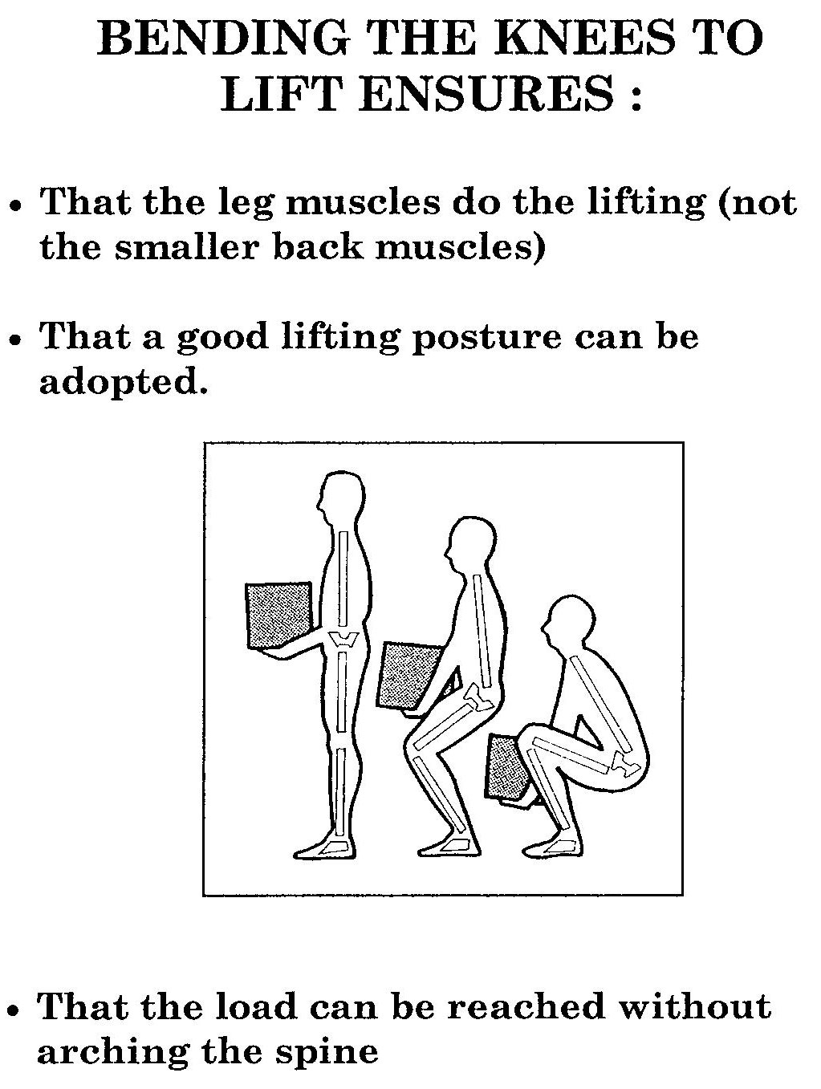
- Bending the knees

1.4 Handling Loads

Avoid
- Very heavy loads.
- Arching of the spine.
- Excessive or repeated twisting.
- Over-stretching or over-reaching.

Ensure
- A good secure grip
- Awareness of the weight and stability of the load.
- Correct stance and lift posture.
- Smooth quick lift.
- Correct protective clothing and equipment.
- Proper c0-0rdination of team lifts.

The Right Way
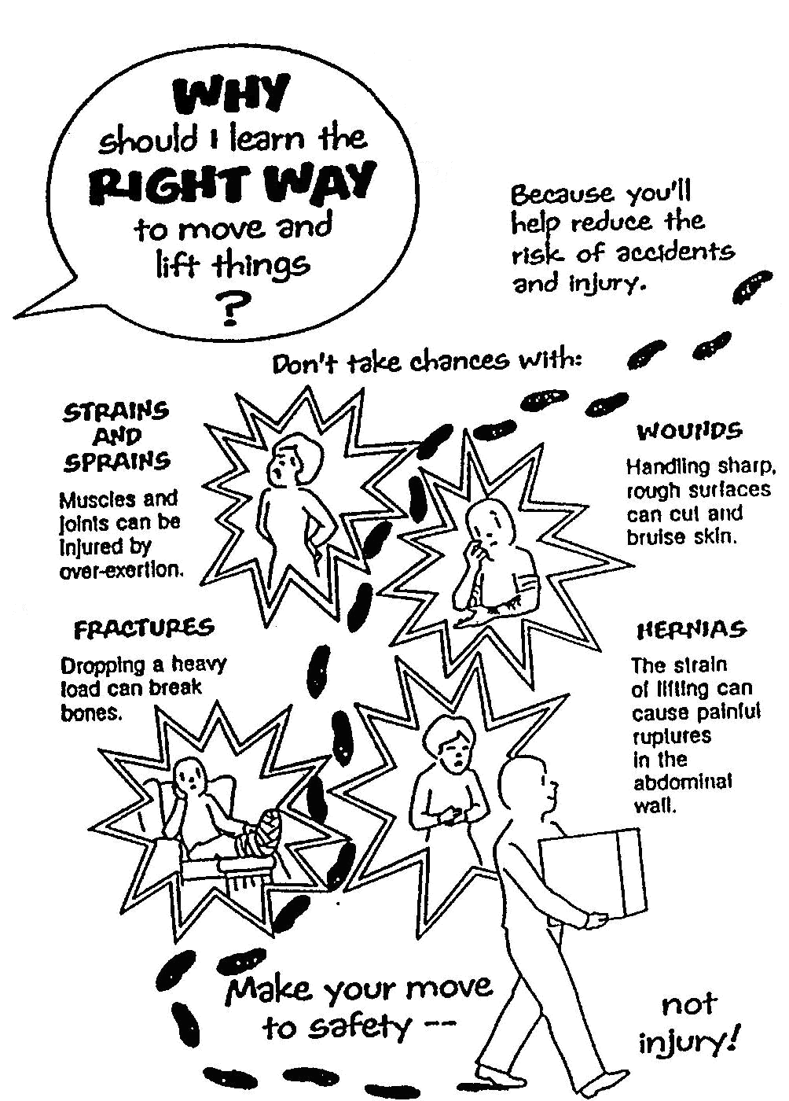
- The right way to move things

Moving Things the Wrong Way
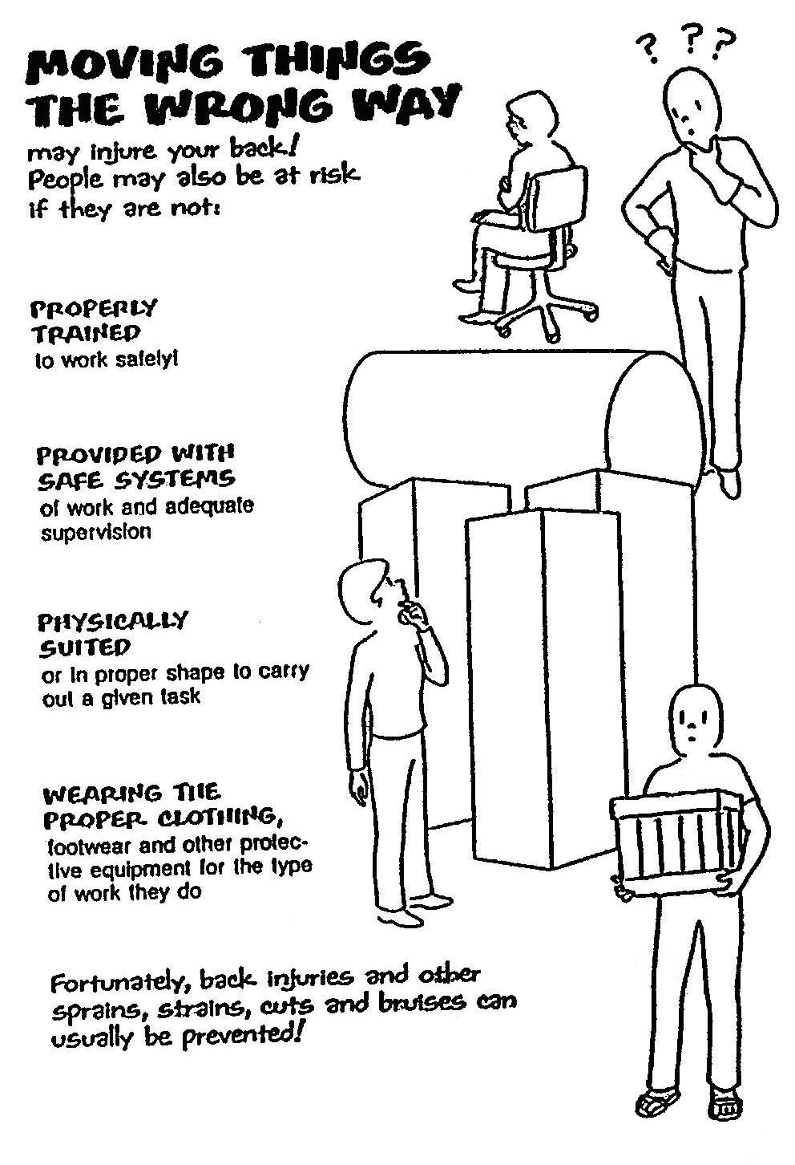
- Moving things the wrong way

1.5 Prevent Pain, Injuries and Damage
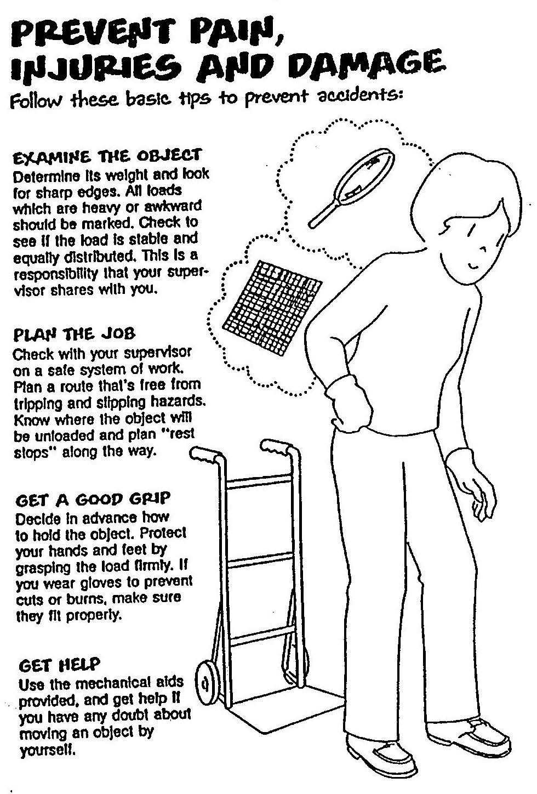
- Prevent pain, injuries and damage
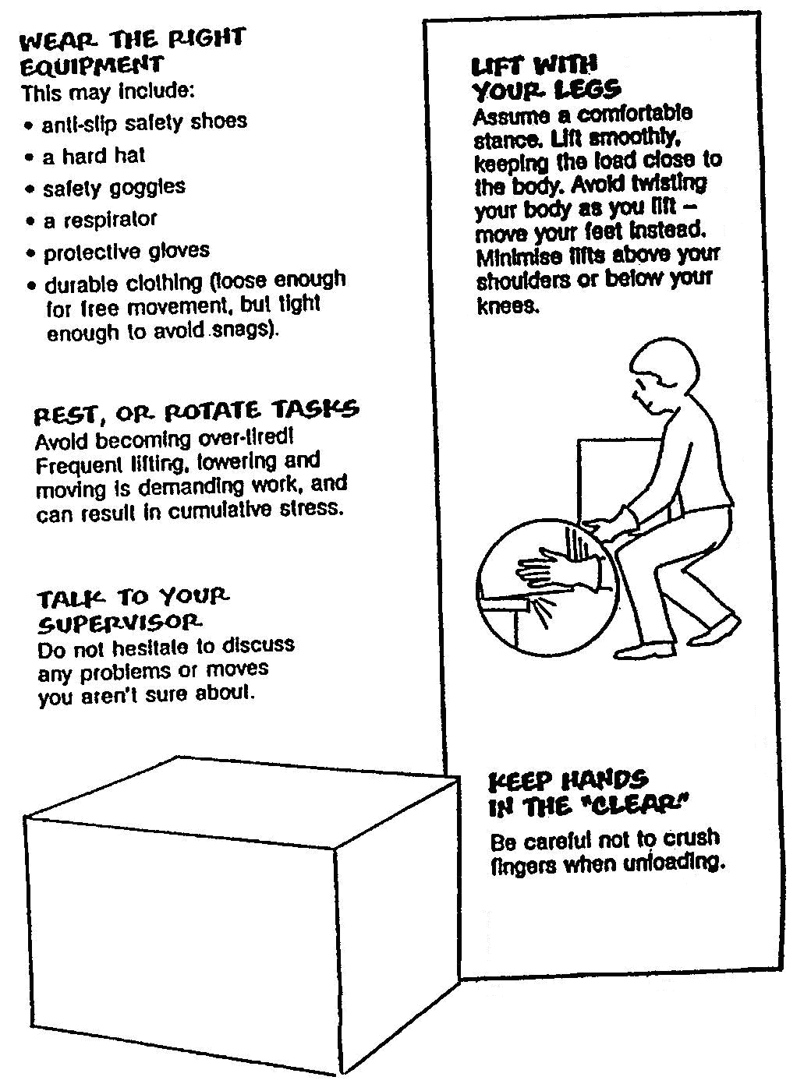
- Prevent pain, injuries and damage continued

2.0 Lifting
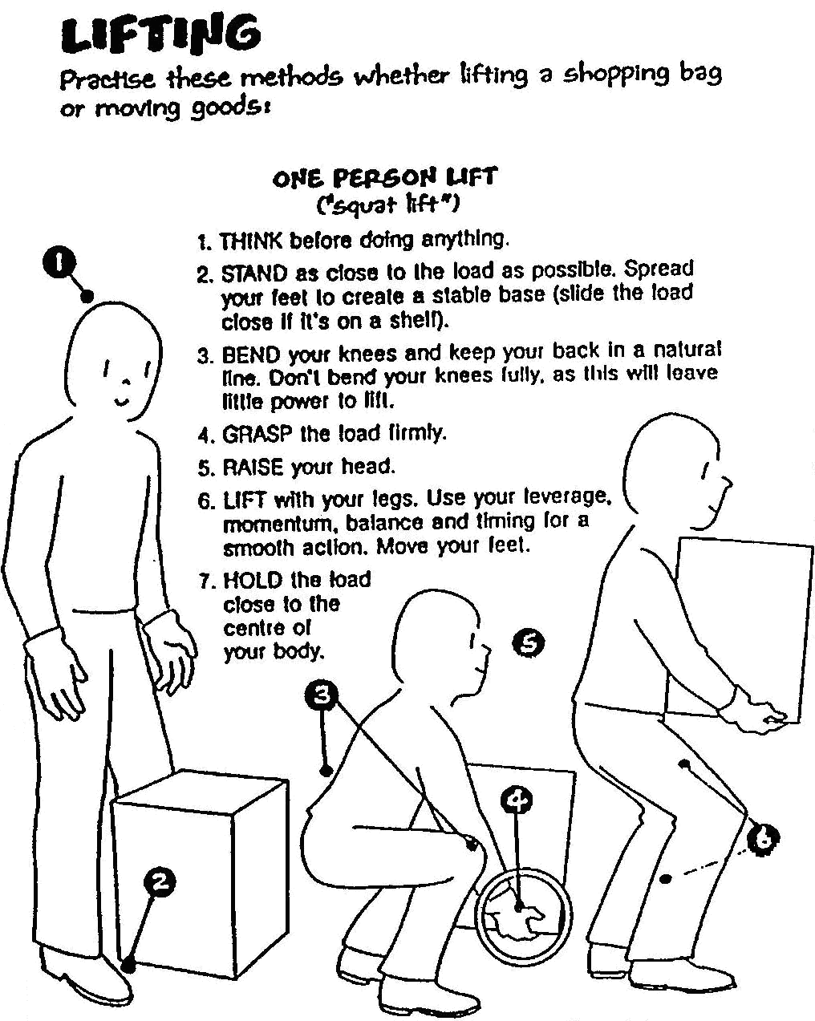
- Lifting

To avoid injury do warm-up exercises before lifting.

2.1 Carrying
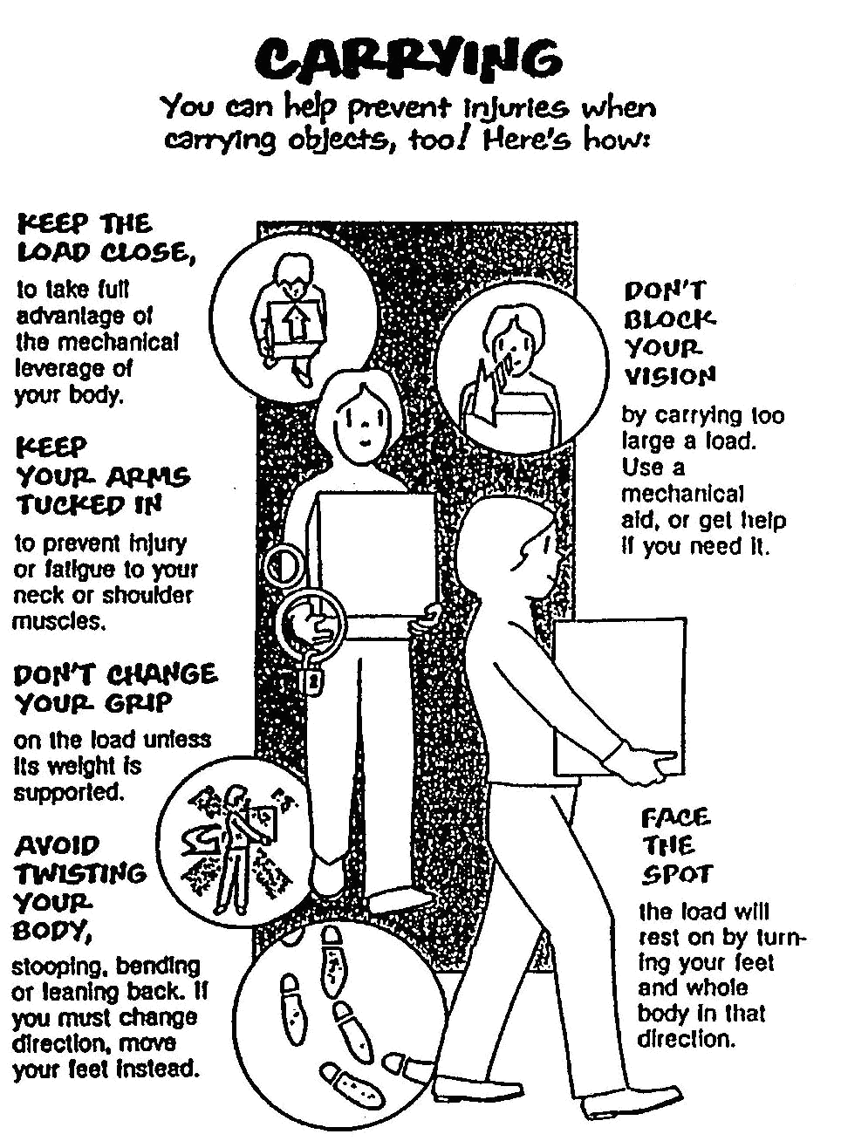
- Carrying

2.2 Uploading
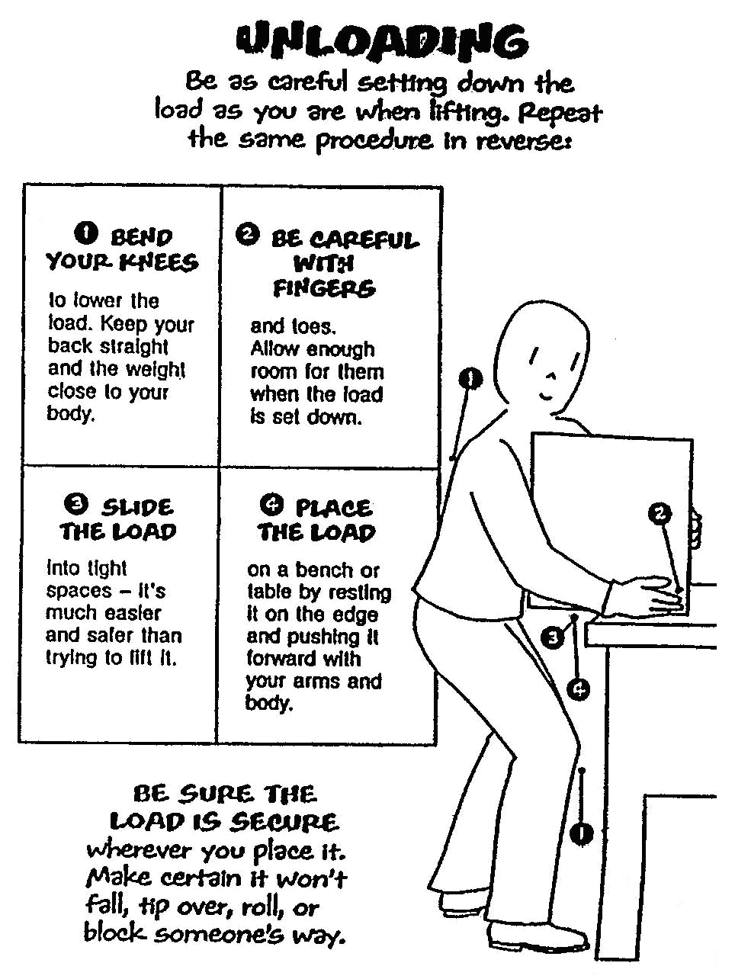
- Uploading

2.3 Special Lifts
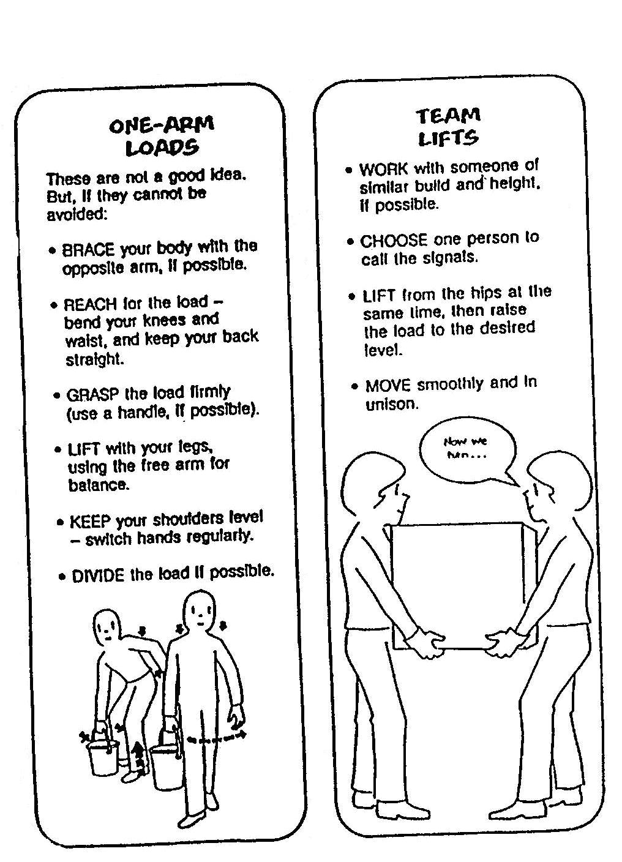
- Special lifts

2.4 Awkward Objects and Overhead Lifts
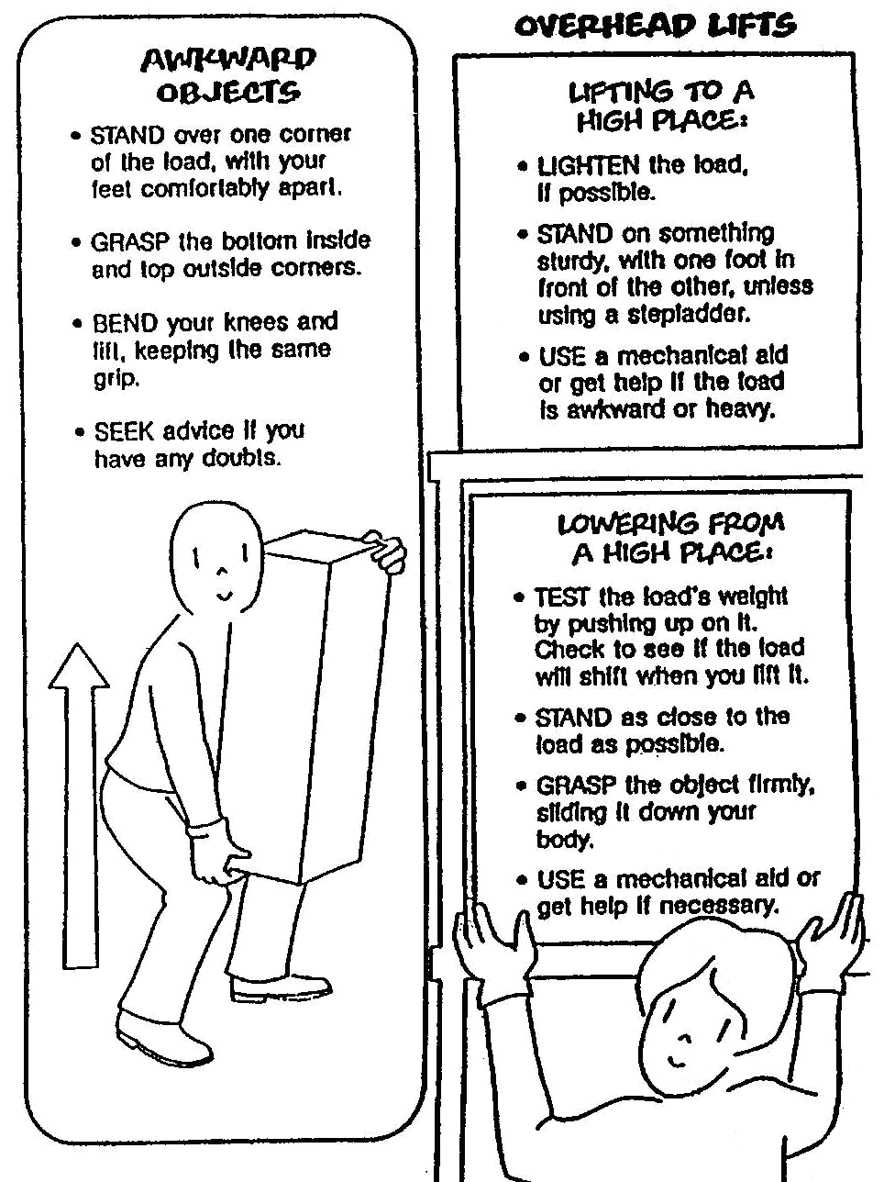
- Awkward objects and overhead lifts

3.0 Pushing and Pulling Safety
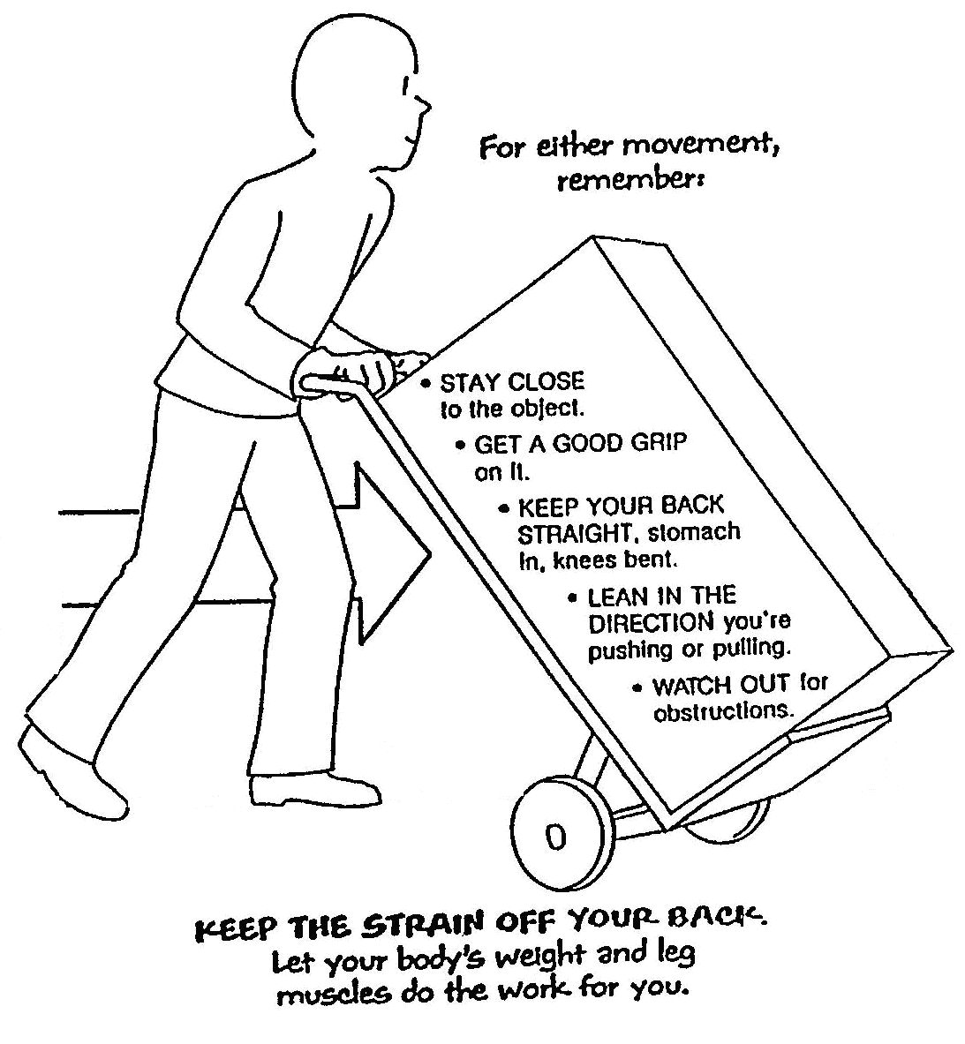
- Pushing and pulling safety

3.1 Special Objects Require Special Handling
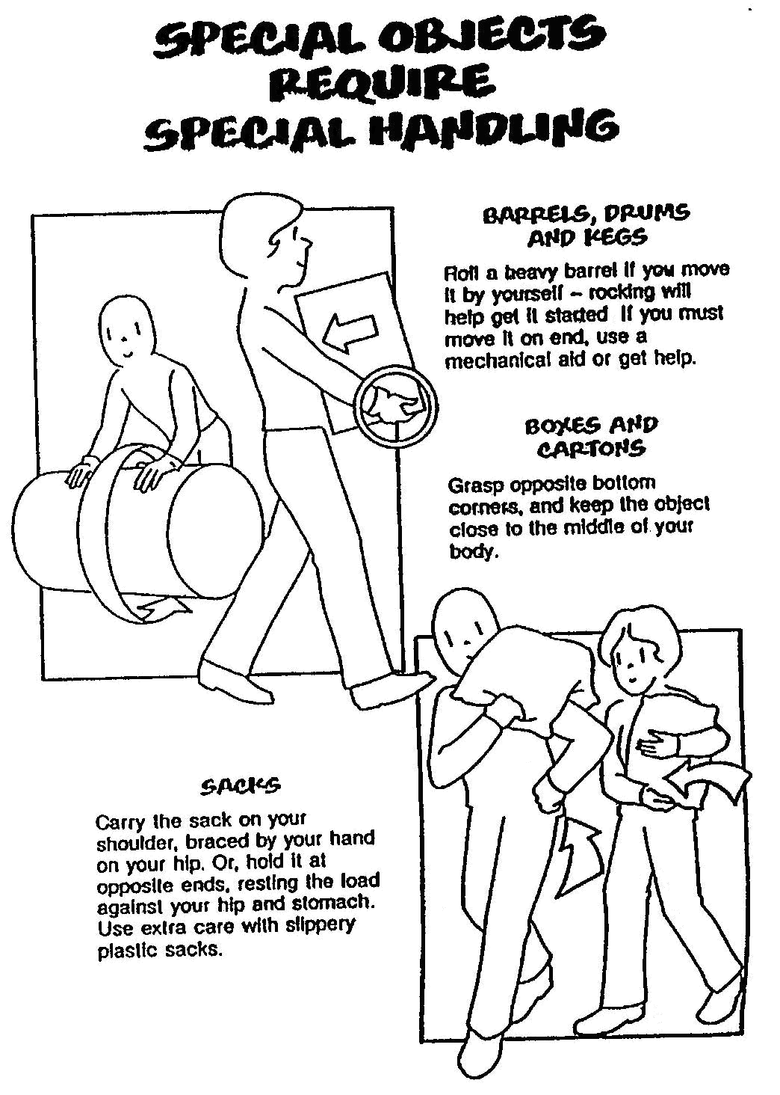
- Special objects require special handling

3.2 Team Effort
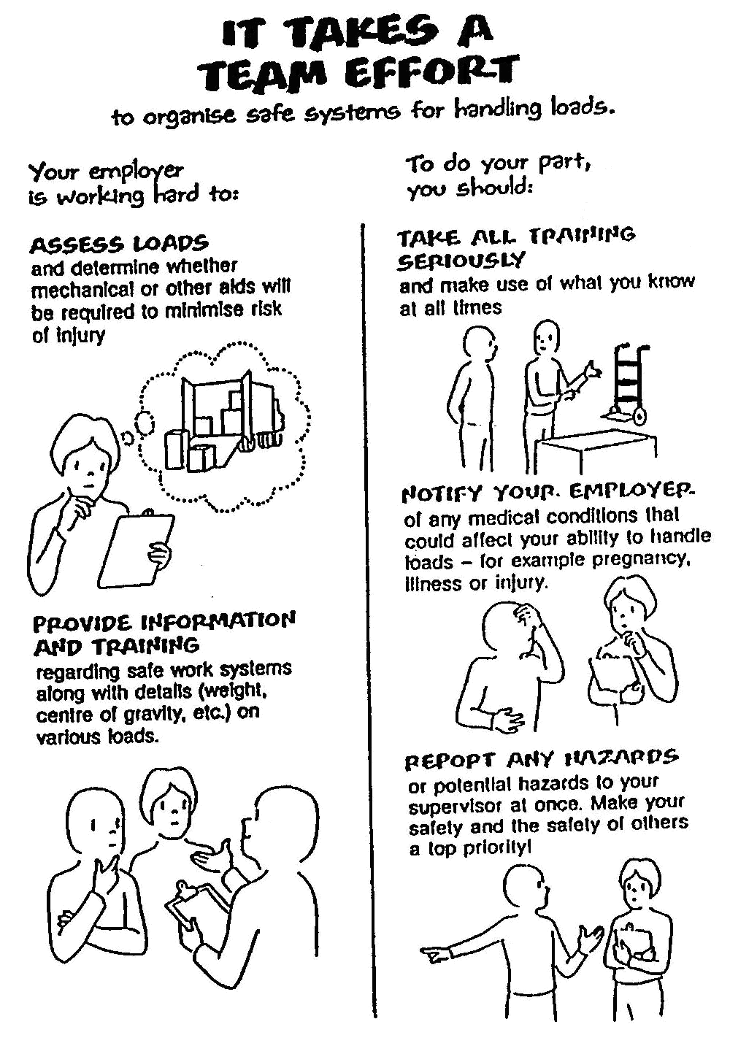
- Team effort

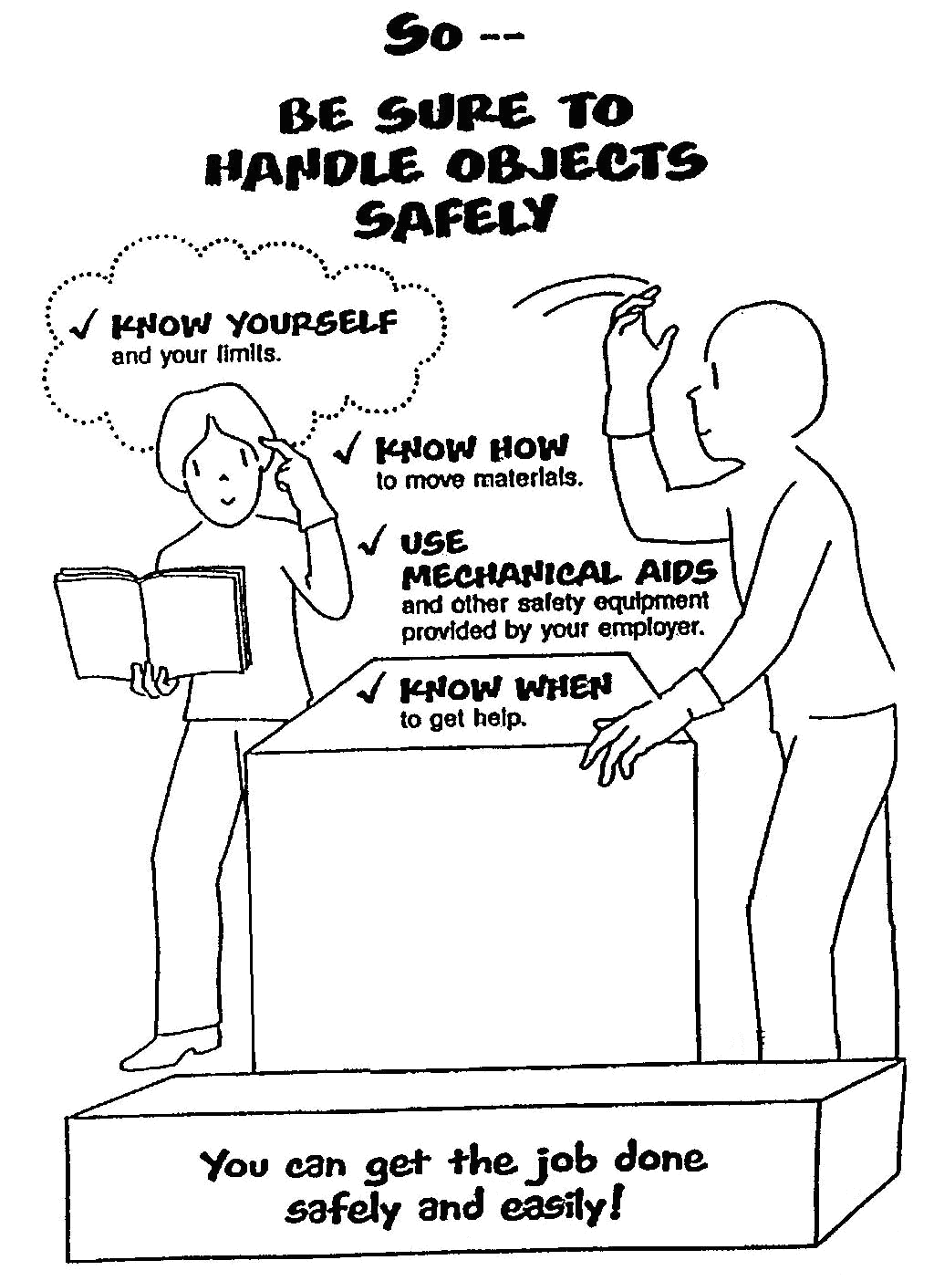
- Handle objects safely

3.3 Lifting and Lowering Whist Standing
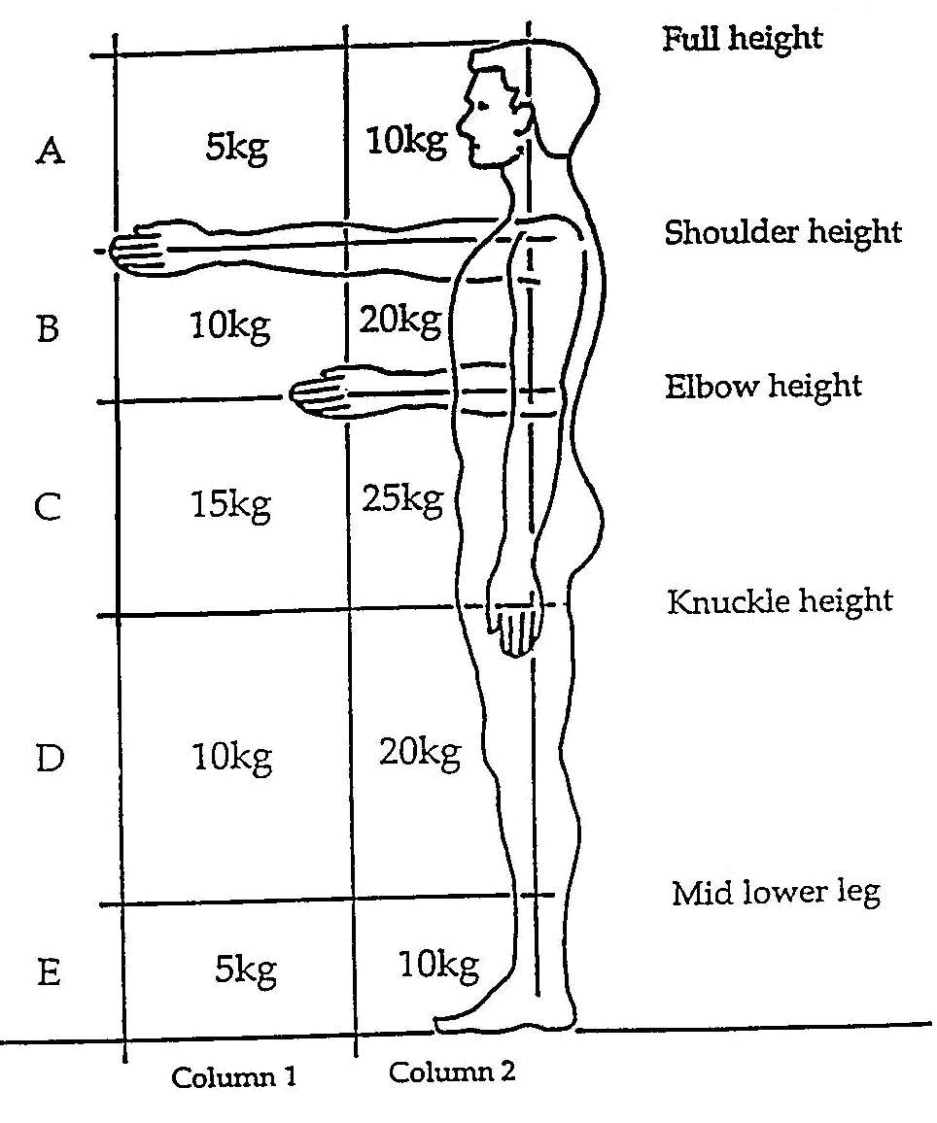
- Lifting and lowering whist standing

3.4 Pregnant Employees Regulation 1994
- Risks due to manual work must be assessed for pregnant employees and employees who have recently given birth.
- Health and safety leave must be given if the maternity employee cannot be protected from the risks identified.
- Certification of risk by employer for social welfare purposes.

3.5 Manual Handling Legal Obligations
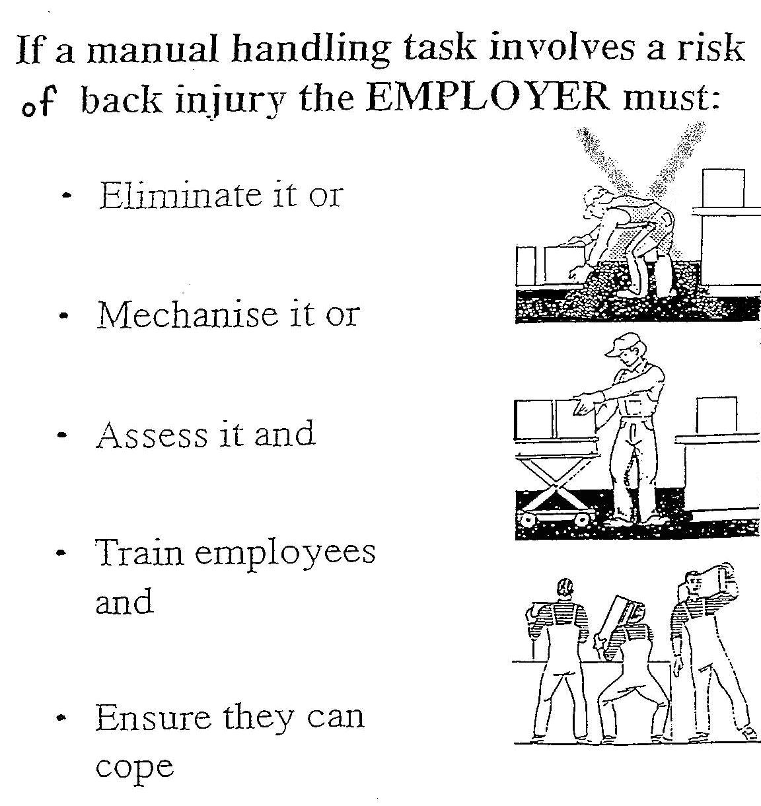
- Manual handling legal obligations

3.6 Eight Principles of Lifting
- Access – the area
Access – the load.
- Bend Knees.
- Broad stable base.
- Keep back straight (not necessarily erect)
- Firm palm grip
- Arms close to trunk
- Weight close to centre of gravity
- Point/pivot feet in direction of movement.
- Lift with legs

Self Test
Complete risk assessment worksheets provided.
Test
Test to be carried out at the end of training.

Suggested Exercises

Apprentice to answer general questions on correct procedures for lifting heavy objects.

Apprentice to state the main obligations of employer and employee in relation to Safe Handling in the workplace.

Under supervision and using the correct handling techniques, the apprentice is required to lift a workplace object from:
- Ground to ground
- Ground to bench
- Ground to height
- Bench to bench

Under supervision and using the correct handling techniques, the apprentice is required to operate a handling device to move a typical workplace object from one location to another.

Suggested Reading
@ www.nifast.ie

Manual Handling

Test Date ---------------------------------
Apprentice ---------------------------------
Instructor ---------------------------------
Test Result ---------------------------------

27-33 Upper Baggot Street
Dublin 4

